Supporting Information (SI)
Adsorption site regulations of [W-O]-doped CoP boosting the hydrazine oxidation-coupled hydrogen evolution at elevated current density
Ge Meng^{1, 2}, Ziwei Chang¹, Libo Zhu^{1, 2}, Chang Chen^{1, 2}, Yafeng Chen¹, Han Tian¹, Wenshu Luo^{1, 2}, Wenping Sun³, Xiangzhi Cui^{1, 2, 4,} *, and Jianlin Shi^{1, 2,} *
Ge Meng and Ziwei Chang contributed equally.
*Email: cuixz@mail.sic.ac.cn, jlshi@mail.sic.ac.cn.
- Supplementary section
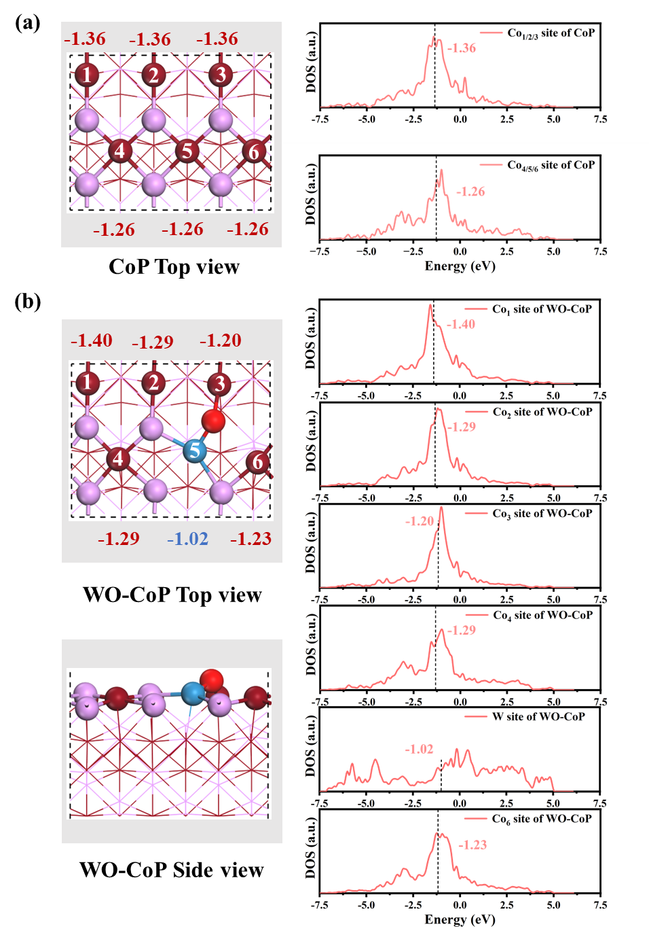
Figure S1. The calculated d-band center values of different sites in (a) pure CoP and (b) WO-CoP. (Co-Brownish red, P-pink atom, W-blue atom, O-red atom)

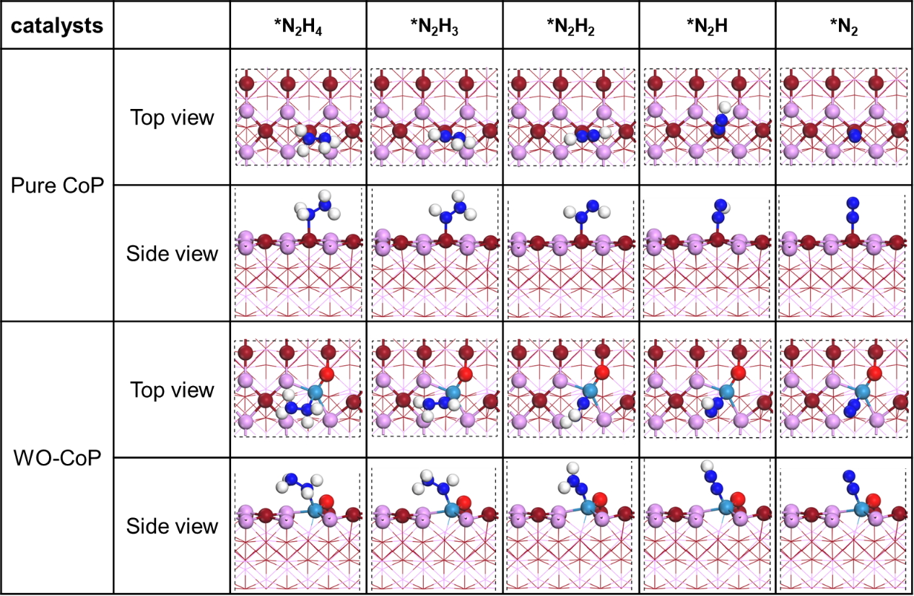
Figure S2. The optimized atomic structures of intermediates during N₂H₄ oxidation on the pure CoP (011) and W-O doped CoP (011) surface. (Co-Brownish red, P-pink atom, W-blue atom, O-red atom, H-white atom, N-dark blue atom)

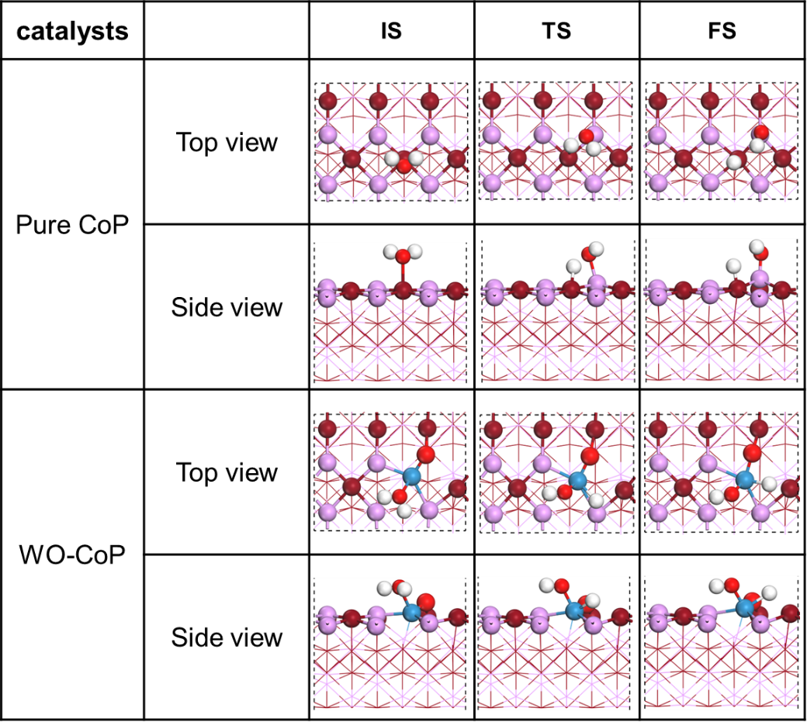
Figure S3. The optimized atomic structures of intermediates during water dissociation on the pure CoP (011) and W-O doped CoP (011) surface. (Co-Brownish red, P-pink atom, W-blue atom, O-red atom, H-white atom)

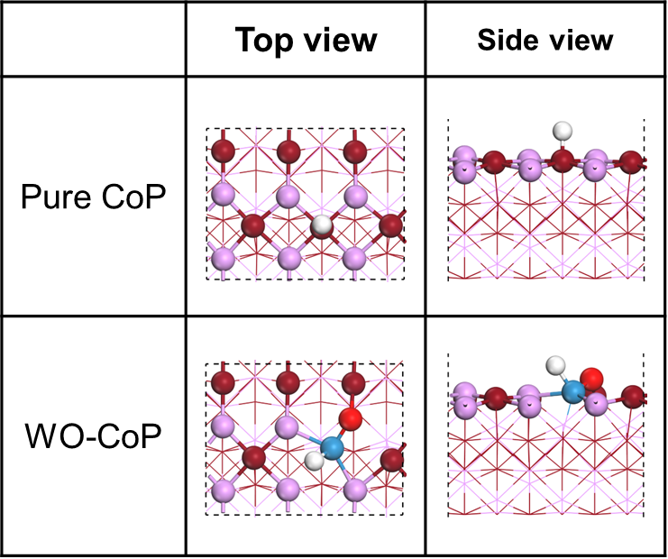
Figure S4. The optimized atomic structures of H_{ads} during hydrogen adsorption on the pure CoP (011) and W-O doped CoP (011) surface. (Co-Brownish red, P-pink atom, W-blue atom, O-red atom, H-white atom)

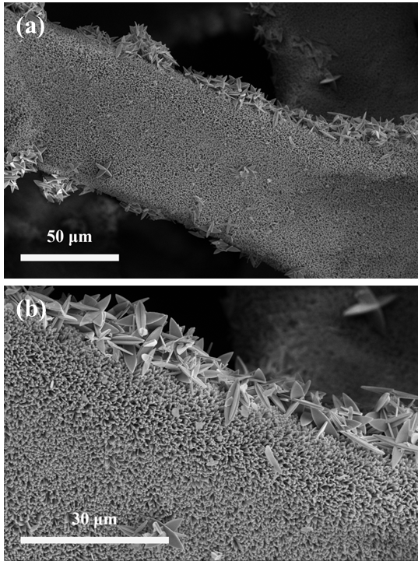
Figure S5. (a, b) SEM images of ZIF-L/NF precursor at different magnifications.

Figure S6. XRD pattern of ZIF-L.

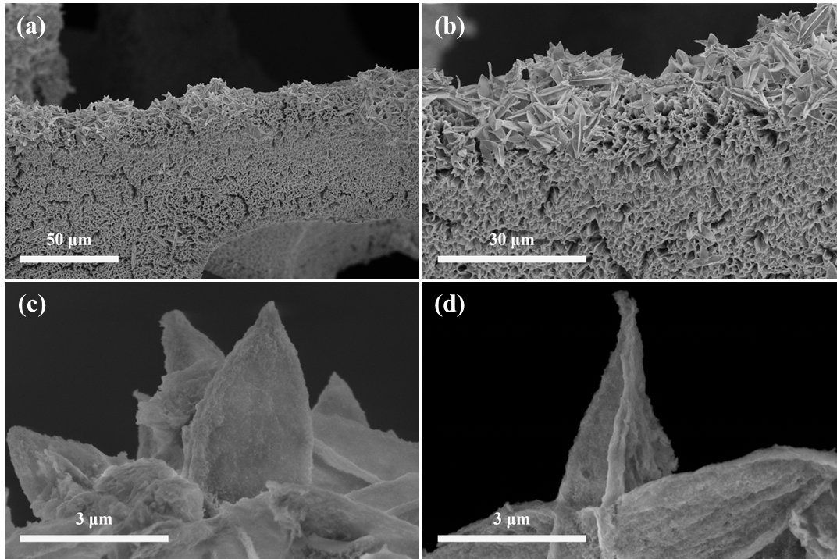Figure S7. (a-d) SEM images of 6W-O-Co/NF at different magnifications.

Figure S8. XRD pattern of 6W-O-Co.

Figure S9. Raman spectra of 6W-O-Co.

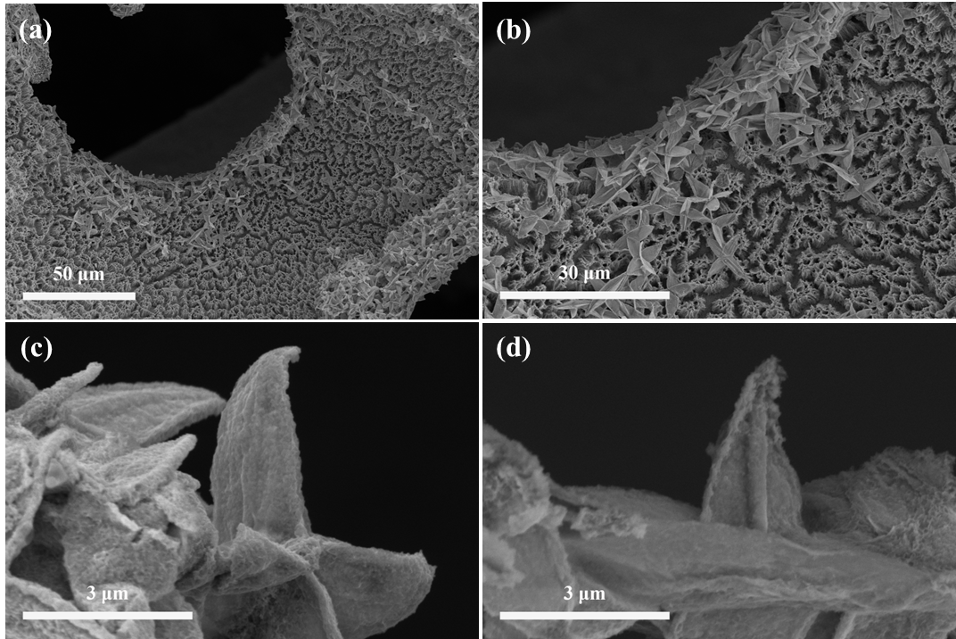
Figure S10. (a-d) SEM images of 6W-O-CoP/NF at different magnifications.
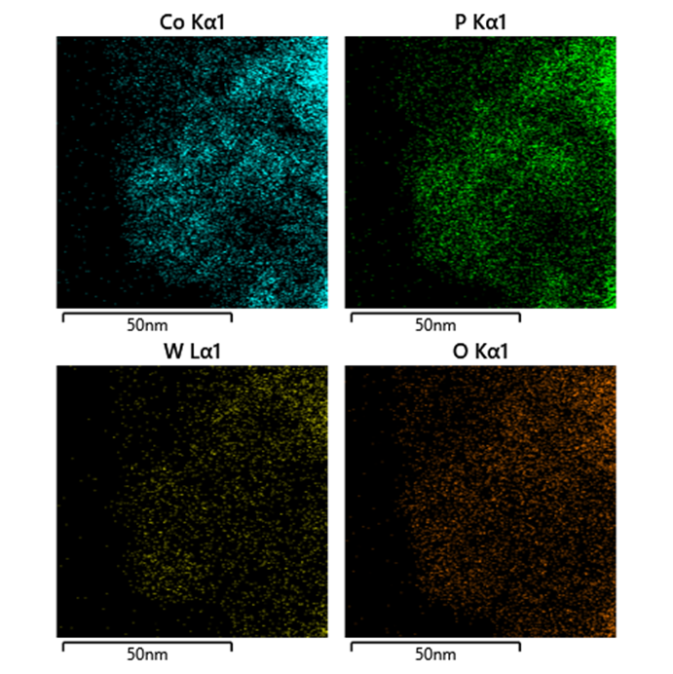
Figure S11. EDS mapping images of 6W-O-CoP/NF.

Figure S12. Raman spectra of 6W-O-CoP/NF and CoP/NF without etching and doping treatment.

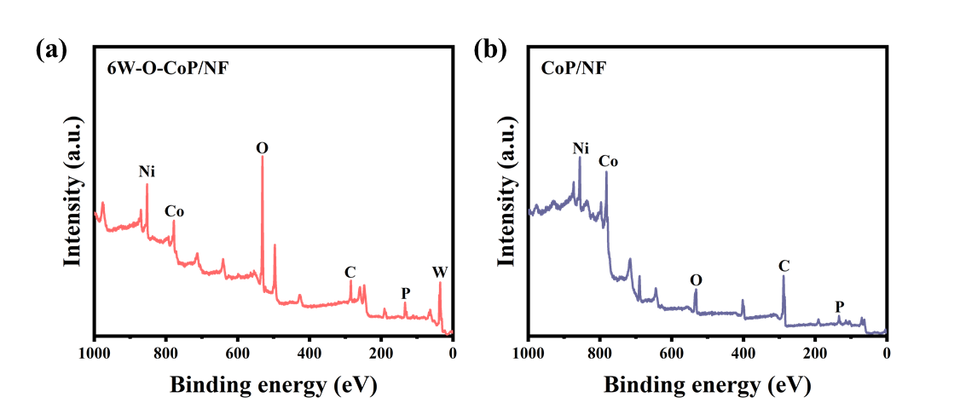
Figure S13. XPS full scan spectra of (a) 6W-O-CoP/NF and (b) CoP/NF.

Figure S14. High-resolution XPS spectra of P 2p in the prepared samples.

Figure S15. High-resolution XPS spectra of O 1s in the prepared samples.
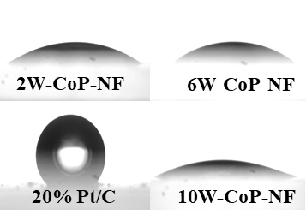
Figure S16. Water bubble contact angle measurement of the obtained catalysts.

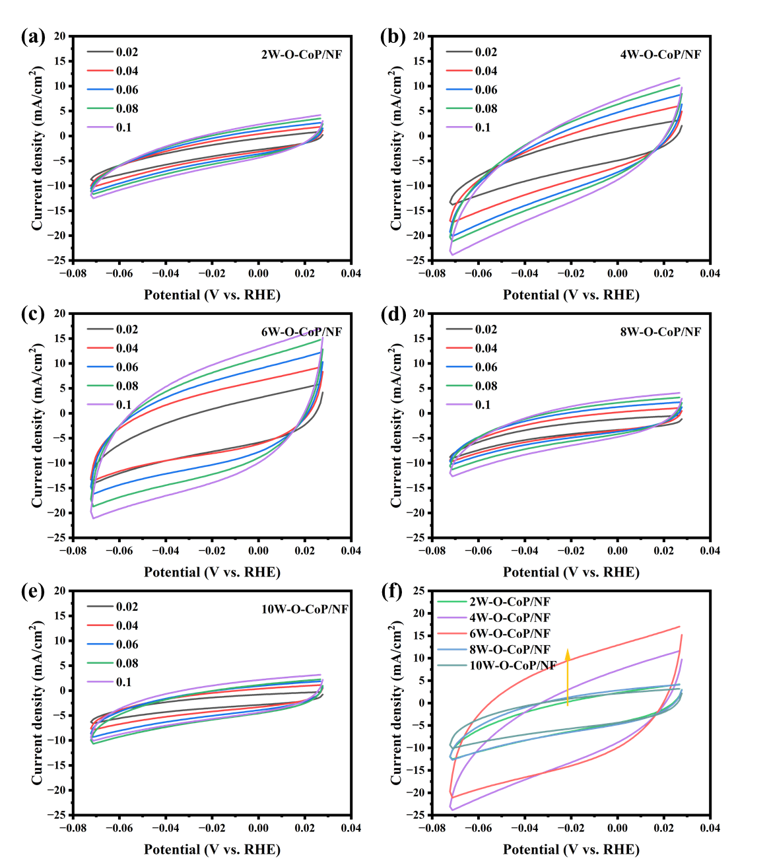
Figure S17. Cyclic voltammograms (CVs) of (a) 2W-O-CoP/NF, (b) 4W-O-CoP/NF, (c) 6W-O-CoP/NF, (d) 8W-O-CoP/NF and (e) 10W-O-CoP/NF at varied scan rate in 1.0 M KOH. (f) The corresponding CVs of xW-O-CoP/NF based catalysts at the scan rate of 100 mV/s.

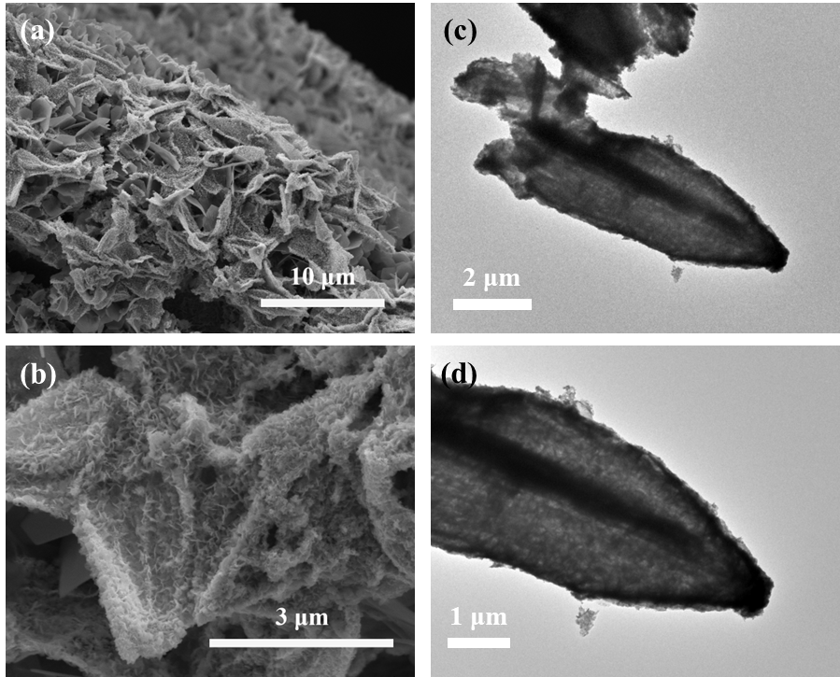
Figure S18. (a, b) SEM and (c, d) TEM images of 6W-O-CoP/NF catalyst after 10000 cycles of HER test at different magnifications.
Figure S19. XRD patterns of 6W-O-CoP/NF catalyst before and after 10000 cycles of HER test.
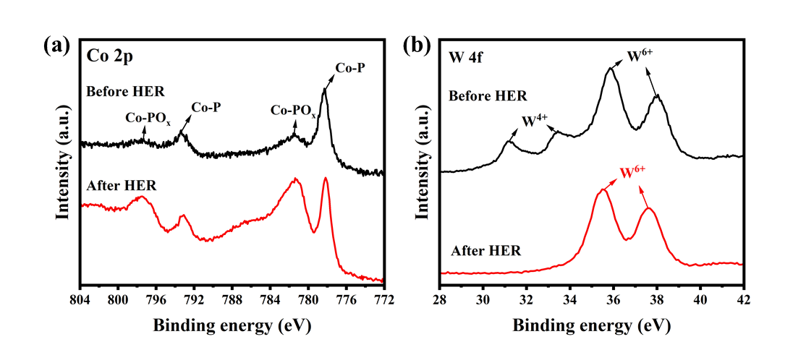
Figure S20. High resolution XPS spectra of (a) Co 2p and (b) W 4f for 6W-O-CoP/NF catalyst after HER 10000 cycles.
Figure S21. Stability measurement of 6W-O-CoP/NF at overpotential of -220 mV (vs. RHE) for 15 h.

Figure S22. Comparison between GC-measured and theoretically calculated H₂ quantities of 6W-O-CoP/NF at overpotential of -220 mV (vs. RHE).

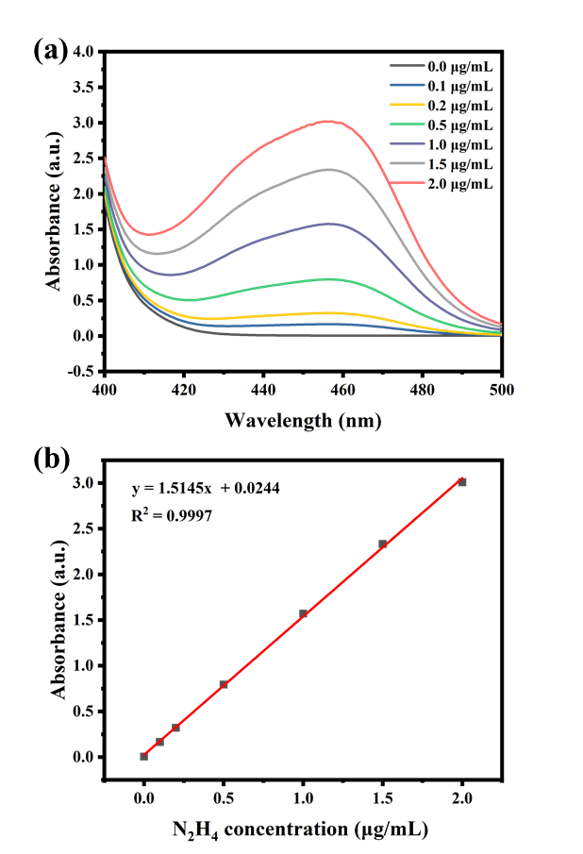
Figure S23. (a) UV-vis absorption spectra of different concentrations of hydrazine stained with color reagent. (b) Calibration curve for calculating the hydrazine concentration. The absorbance at 458 nm was measured by a UV-Vis spectrophotometer, and the fitting curve shows good liner relation of absorbance with N₂H₄ concentration (y = 1.5145x + 0.0244, R² = 0.9997).

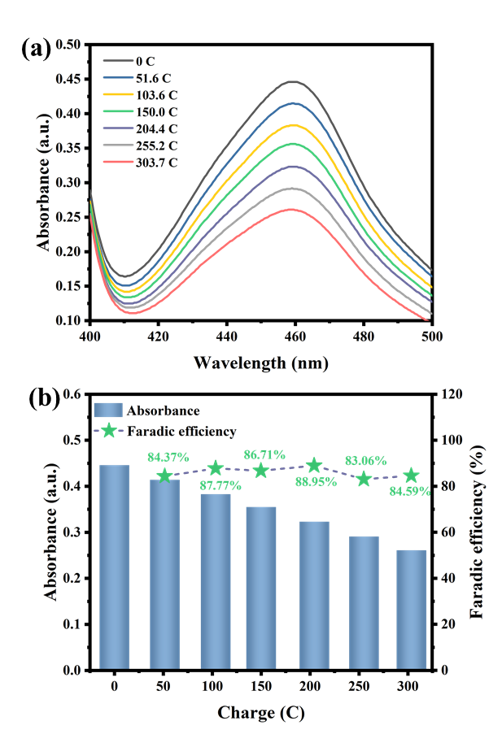
Figure S24. (a) UV-vis absorption spectra of hydrazine concentrations with different charge consumption during HzOR process. (b) The corresponding calculated utilization efficiency of N₂H₄.
HzOR measurement was conducted at constant potential. We would pause the test when reaching certain charge (0 C, 51.6 C, 103.6 C, 150.0 C, 204.4 C, 255.2 C and 303.7 C) and then record the time and extract the electrolyte from the reaction cell to measure the concentration of N₂H₄. Comparing the real and ideal concentration of N₂H₄ to determine the electro-oxidation efficiency of N₂H₄.

Figure S25. LSV curves of 6W-O-CoP/NF under different concentrations of hydrazine.

Figure S26. LSV curves of 6W-O-CoP/NF at different scan rate in 0.1M N₂H₄ + 1M KOH electrolyte.
Figure S27. LSV curves of obtained xW-O-CoP/NF catalysts in 1.0M KOH for OER.
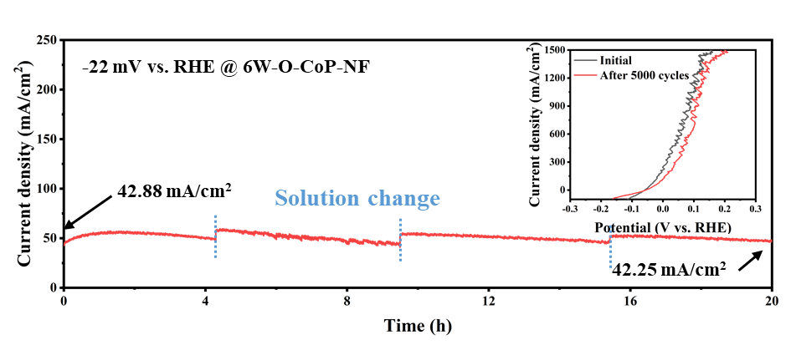
Figure S28. Stability measurement for 6W-O-CoP/NF at overpotential of -22 mV (vs. RHE) for 20 h (inset: the LSV curves before and after 5000 HzOR cycles).

Figure S29. Stability measurement for 6W-O-CoP/NF at overpotential of 28 mV (vs. RHE) for 10 h.

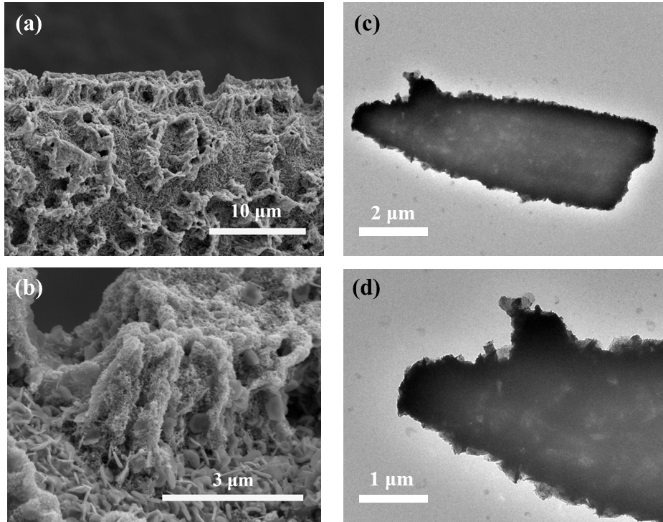
Figure S30. (a, b) SEM and (c, d) TEM images of the 6W-O-CoP/NF catalyst after 5000 cycles of HzOR test at different magnifications.
Figure S31. XRD patterns of 6W-O-CoP/NF catalyst before and after 5000 cycles of HzOR test.
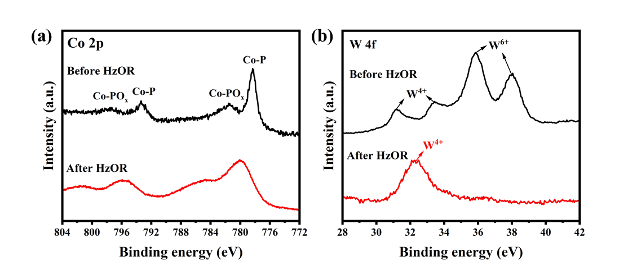
Figure S32. High resolution XPS spectra of (a) Co 2p and (b) W 4f for 6W-O-CoP/NF catalyst after 5000 cycles of HzOR test.

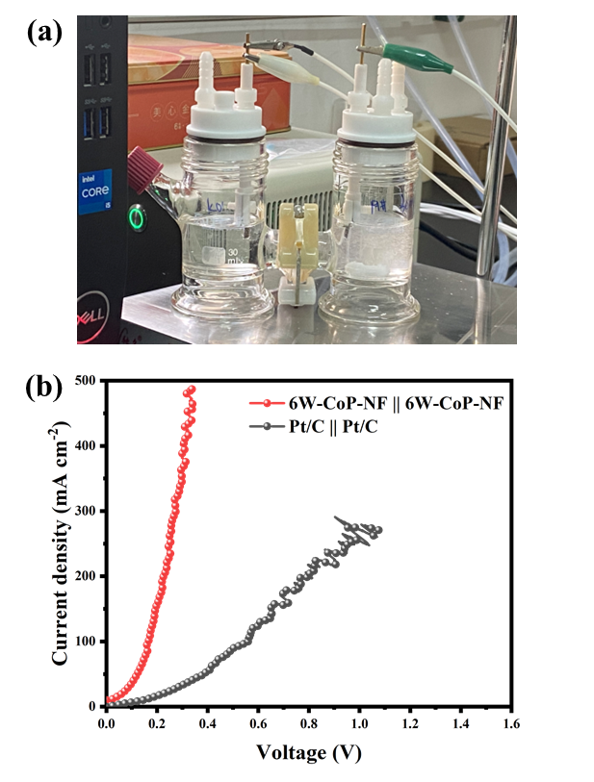
Figure S33. (a) The digital photo of assembled overall hydrazine splitting (OHzS) unit (6W-O-CoP/NF (+) || 6W-O-CoP/NF (-)). (b) LSV curves of OHzS electrolyzer equipped with 6W-O-CoP/NF (red) as both anode and cathode catalyst in 1.0 M KOH + 0.1M N₂H₄ electrolyte and that with commercial Pt/C as benchmarks measured for comparison (black).
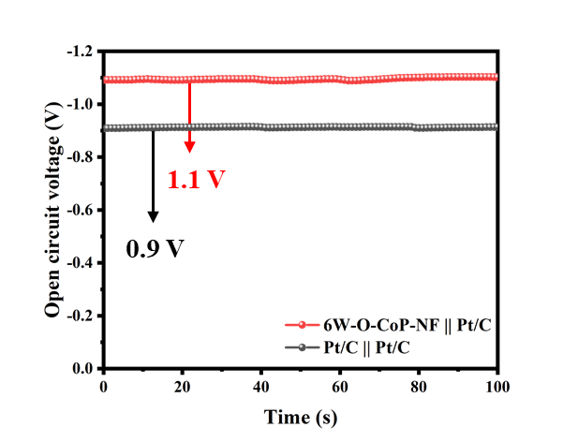
Figure S34. Open circuit voltages of 6W-O-CoP/NF || Pt/C and Pt/C || Pt/C.
Figure S35. The stability measurement of assembled DHzFC at different current density.
Figure S36. Digital photograph of different LEDs powered by the homemade DHzFC.

Table S1. Inductive Coupled Plasma (ICP) results of prepared samples.
Samples | W  (wt.%) | Co  (wt.%) | P  (wt.%)
0W-O-CoP/NF | 0.003 | 0.77 | 1.38
2W-O-CoP/NF | 0.93 | 0.77 | 0.87
4W-O-CoP/NF | 1.03 | 0.87 | 0.78
6W-O-CoP/NF | 1.39 | 0.97 | 1.06
10W-O-CoP/NF | 1.61 | 1.14 | 1.16

Table S2. Comparison of the HER performance in 1.0M KOH between 6W-O-CoP/NF in this work and various self-supported transition metal-based catalysts recently reported.
Materials | Current density  (mA/cm²) | Potential  (V vs. RHE) | Reference
6W-O-CoP/NF | 1000 | 185.6 | This work
A-NiCo LDH/NF | 1000 | 381 | ¹
Co-P Foam | 1000 | 290 | ²
P-MNS/NF | 1000 | 245 | ³
WMo-NiCoP/NF | 1000 | 249 | ⁴
NiCoS@CoCH | 1000 | 438 | ⁵
NiCo@C-NiCoMoO/NF | 1000 | 266 | ⁶
H-CoS@NiFe LDH/NF | 1000 | 375 | ⁷
N-NiMoS | 1000 | 322 | ⁸
NiCoP-CPF | 1000 | 295 | ⁹
Ru-CoO_{x}/NF | 1000 | 252 | ¹⁰

Table S3. EIS parameters of obtained catalysts in 1.0M KOH toward HER.
Materials | R (Ω) | R₁ (Ω) | R₂ (R_{ct}, Ω)
P-NF | 1.67 | 35.33 | 14.66
CoP/NF | 1.32 | 0.94 | 13.82
0W-O-CoP/NF | 1.27 | 0.81 | 6.29
2W-O-CoP/NF | 1.88 | 0.98 | 3.26
4W-O-CoP/NF | 1.77 | 0.88 | 2.54
6W-O-CoP/NF | 1.54 | 0.50 | 1.40
8W-O-CoP/NF | 1.55 | 0.40 | 4.64
10W-O-CoP/NF | 1.81 | 0.83 | 6.51

Table S4. Comparison of the HzOR performance between 6W-O-CoP/NF in this work and various catalysts recently reported.
Materials | Current density  (mA/cm²) | Potential  (V vs. RHE) | Tafel slope  (mV/dec) | Reference
6W-O-CoP/NF | 100  200  300 | -0.035  -0.019  -0.005 | 8.43 | This work
Ru-MPNC | 10  200 | -0.039  0.072 | 40 | ¹¹
FeWO₄/WO₃ | 10 | -0.034 | 45.1 | ¹²
NiCo-MoNi₄ | 10 | -0.03 | - | ¹³
Ni-C HNSA | 10 | -0.02 | 16.2 | ¹⁴
Mo-Ni₃N/NF | 10  200 | -0.0003  0.075 | 48 | ¹⁵
FeNiP-NPHC | 100 | 0.007 | 24 | ¹⁶
Ni-Co-Se | 300 | 0.4 | 88 | ¹⁷
PtCu-NA | 200 | 0.668 | 40 | ¹⁸
PW-Co₃N/NC | 200 | 0.027 | 14 | ¹⁹

Table S5. EIS parameters of obtained catalysts in 1.0M KOH + 0.1M N₂H₄ toward HzOR.
Materials | R (Ω) | R₁ (Ω) | R₂ (R_{ct}, Ω)
0W-O-CoP/NF | 1.46 | 0.98 | 1.53
2W-O-CoP/NF | 1.75 | 0.63 | 1.52
4W-O-CoP/NF | 2.50 | 0.12 | 1.32
6W-O-CoP/NF | 1.56 | 0.57 | 1.05
8W-O-CoP/NF | 1.53 | 0.71 | 1.35
10W-O-CoP/NF | 1.38 | 0.59 | 1.74

Table S6. Comparison of the DHzFC performance between 6W-O-CoP/NF in this work and various catalysts recently reported.
 | Power density  (mW/cm²) | Open circuit voltage(V) | Reference
6W-O-CoP/NF | 142 | 1.1 | This work
Ni₃N-Co₃N PNAs/NF | 60.3 | 1.00 | ²⁰
Mo Ni₃N/Ni/NF | 37.8 | 0.96 | ²¹
PW-Co₃N NWA/NF | 46.3 | 0.98 | ¹⁹
FeNiP-NPHC | 31 | 0.98 | ¹⁶
Cu-CoFe/Co/NC | 26.7 | 0.996 | ²²

- References
1. H. Y. Yang, Z. L. Chen, P. F. Guo, B. Fei, R. B. Wu, B-doping-induced amorphization of LDH for large-current-density hydrogen evolution reaction. Appl. Catal. B: Environ. 261, 118240 (2020). https://doi.org/10.1016/j.apcatb.2019.118240
2. Y. Li, B. Wei, Z. P. Yu, O. Bondarchuk, A. Araujo et al., Bifunctional Porous Cobalt Phosphide Foam for High-Current-Density Alkaline Water Electrolysis with 4000 h Long Stability. ACS Sustain. Chem. Eng. 8, 10193-10200 (2020). https://doi.org/10.1021/acssuschemeng.0c02671
3. Y. Tong, D. M. Feng, P. Z. Chen, Dual Modification Strategy of Nickel Sulfide as pH-Universal Catalysts for Hydrogen Production at Large Current Density. ACS Sustain. Chem. Eng. 9, 10601-10610 (2021). https://doi.org/10.1021/acssuschemeng.1c02807
4. X. Guo, M. G. Li, L. He, S. Geng, F. Y. Tian et al., Industrially promising NiCoP nanorod arrays tailored with trace W and Mo atoms for boosting large-current-density overall water splitting. Nanoscale 13, 14179-14185 (2021). https://doi.org/10.1039/D1NR03186D
5. X. Zhang, R. J. Zheng, M. T. Jin, R. Shi, Z. Ai et al., NiCoS_{x}@Cobalt Carbonate Hydroxide Obtained by Surface Sulfurization for Efficient and Stable Hydrogen Evolution at Large Current Densities. ACS Appl. Mater. Interfaces 13, 35647-35656 (2021). https://doi.org/10.1021/acsami.1c07504
6. G. F. Qian, J. L. Chen, T. Q. Yu, L. Luo, S. B. Yin, N-Doped Graphene-Decorated NiCo Alloy Coupled with Mesoporous NiCoMoO Nano-sheet Heterojunction for Enhanced Water Electrolysis Activity at High Current Density. Nano-Micro Lett. 13, 77 (2021). https://doi.org/10.1007/s40820-021-00607-5
7. Y. J. Lee, S. K. Park, Metal-Organic Framework-Derived Hollow CoS_{x} Nanoarray Coupled with NiFe Layered Double Hydroxides as Efficient Bifunctional Electrocatalyst for Overall Water Splitting. Small 18, 2200586 (2022). https://doi.org/10.1002/smll.202200586
8. C. Q. Huang, L. Yu, W. Zhang, Q. Xiao, J. Q. Zhou et al., N-doped Ni-Mo based sulfides for high-efficiency and stable hydrogen evolution reaction. Appl. Catal. B: Environ. 276, 119137 (2020). https://doi.org/10.1016/j.apcatb.2020.119137
9. X. G. Chen, X. Zhao, Y. Y. Wang, S. S. Wang, Y. Y. Shang et al., Layered Ni-Co-P Electrode Synthesized by CV Electrodeposition for Hydrogen Evolution at Large Currents. ChemCatChem 13, 3619-3627 (2021). https://doi.org/10.1002/cctc.202100707
10. D. L. Wu, D. Chen, J. W. Zhu, S. C. Mu, Ultralow Ru Incorporated Amorphous Cobalt-Based Oxides for High-Current-Density Overall Water Splitting in Alkaline and Seawater Media. Small 17, 2102777 (2021). https://doi.org/10.1002/smll.202102777
11. J. S. Wang, X. Y. Guan, H. B. Li, S. Y. Zeng, R. Li et al., Robust Ru-N metal-support interaction to promote self-powered H₂ production assisted by hydrazine oxidation. Nano Energy 100, 107467 (2022). https://doi.org/10.1016/j.nanoen.2022.107467
12. F. Shen, Z. L. Wang, Y. M. Wang, G. F. Qian, M. J. Pan et al., Highly active bifunctional catalyst: Constructing FeWO₄-WO₃ heterostructure for water and hydrazine oxidation at large current density. Nano Research 14, 4356-4361 (2021). https://doi.org/10.1007/s12274-021-3548-z
13. Q. Z. Qian, Y. P. Li, Y. Liu, Y. M. Guo, Z. Y. Li et al., Hierarchical multi-component nanosheet array electrode with abundant NiCo/MoNi₄ heterostructure interfaces enables superior bifunctionality towards hydrazine oxidation assisted energy-saving hydrogen generation. Chem. Eng. J. 414, 128818 (2021). https://doi.org/10.1016/j.cej.2021.128818
14. Y. Zhu, J. H. Zhang, Q. Z. Qian, Y. P. Li, Z. Y. Li et al., Dual Nanoislands on Ni/C Hybrid Nanosheet Activate Superior Hydrazine Oxidation-Assisted High-Efficiency H₂ Production. Angew. Chem. Int. Ed. 61, e202113082 (2022). https://doi.org/10.1002/anie.202113082
15. Y. Liu, J. H. Zhang, Y. P. Li, Q. Z. Qian, Z. Y. Li et al., Realizing the Synergy of Interface Engineering and Chemical Substitution for Ni₃N Enables its Bifunctionality Toward Hydrazine Oxidation Assisted Energy-Saving Hydrogen Production. Adv. Funct. Mater. 31 (2021). https://doi.org/10.1002/adfm.202103673
16. Q. P. Yu, X. B. Liu, G. S. Liu, X. P. Wang, Z. J. Li et al., Constructing Three-Phase Heterojunction with 1D/3D Hierarchical Structure as Efficient Trifunctional Electrocatalyst in Alkaline Seawater. Adv. Funct. Mater. 32, 2205767 (2022). https://doi.org/10.1002/adfm.202205767
17. Z. B. Feng, E. P. Wang, S. Huang, J. M. Liu, A bifunctional nanoporous Ni-Co-Se electrocatalyst with a superaerophobic surface for water and hydrazine oxidation. Nanoscale 12, 4426-4434 (2020). https://doi.org/10.1039/C9NR09959J
18. S. M. Ge, L. W. Zhang, J. R. Hou, S. Liu, Y. J. Qin et al., Cu₂O-Derived PtCu Nanoalloy toward Energy-Efficient Hydrogen Production via Hydrazine Electrolysis under Large Current Density. ACS Appl. Energy Mater. 5, 9487-9494 (2022). https://doi.org/10.1021/acsaem.2c01006
19. Y. Liu, J. H. Zhang, Y. P. Li, Q. Z. Qian, Z. Y. Li et al., Manipulating dehydrogenation kinetics through dual-doping Co₃N electrode enables highly efficient hydrazine oxidation assisting self-powered H₂ production. Nat. Commun. 11, 1853 (2020). https://doi.org/10.1038/s41467-020-15563-8
20. Q. Z. Qian, J. H. Zhang, J. M. Li, Y. P. Li, X. Jin et al., Artificial Heterointerfaces Achieve Delicate Reaction Kinetics towards Hydrogen Evolution and Hydrazine Oxidation Catalysis. Angew. Chem. Int. Ed. 60, 5984-5993 (2021). https://doi.org/10.1002/anie.202014362
21. Y. Liu, J. H. Zhang, Y. P. Li, Q. Z. Qian, Z. Y. Li, G. Q. Zhang, Realizing the Synergy of Interface Engineering and Chemical Substitution for Ni₃N Enables its Bifunctionality Toward Hydrazine Oxidation Assisted Energy-Saving Hydrogen Production. Adv. Funct. Mater. 31, 2103673 (2021). https://doi.org/10.1002/adfm.202103673
22. X. B. Liu, H. M. Mao, G. S. Liu, Q. P. Yu, S. Q. Wu et al., Metal doping and Hetero-engineering of Cu-doped CoFe/Co embedded in N-doped carbon for improving trifunctional electrocatalytic activity in alkaline seawater. Chem. Eng. J. 451, 138699 (2023). https://doi.org/10.1016/j.cej.2022.138699

