Support Information for
The Fundamental Understanding of Hydrogen Evolution Reaction on Zinc Anode Surface: A First-Principles Study
Xiaoyu Liu¹, Yiming Guo¹, Fanghua Ning^{1,} *, Yuyu Liu¹, Siqi Shi², Qian Li³, Jiujun Zhang¹, Shigang Lu¹, and Jin Yi^{1,} *
¹ Institute for Sustainable Energy & Department of Chemistry, Shanghai University, Shanghai 200444, China.
² School of Materials Science and Engineering, Shanghai University, Shanghai 200444, China.
³ College of Materials Science and Engineering, National Engineering Research Center for Magnesium Alloys, Chongqing University, Chongqing 400044, China.
*Corresponding author
E-mail: fhning@shu.edu.cn; jin.yi@shu.edu.cn

Supplementary Figures

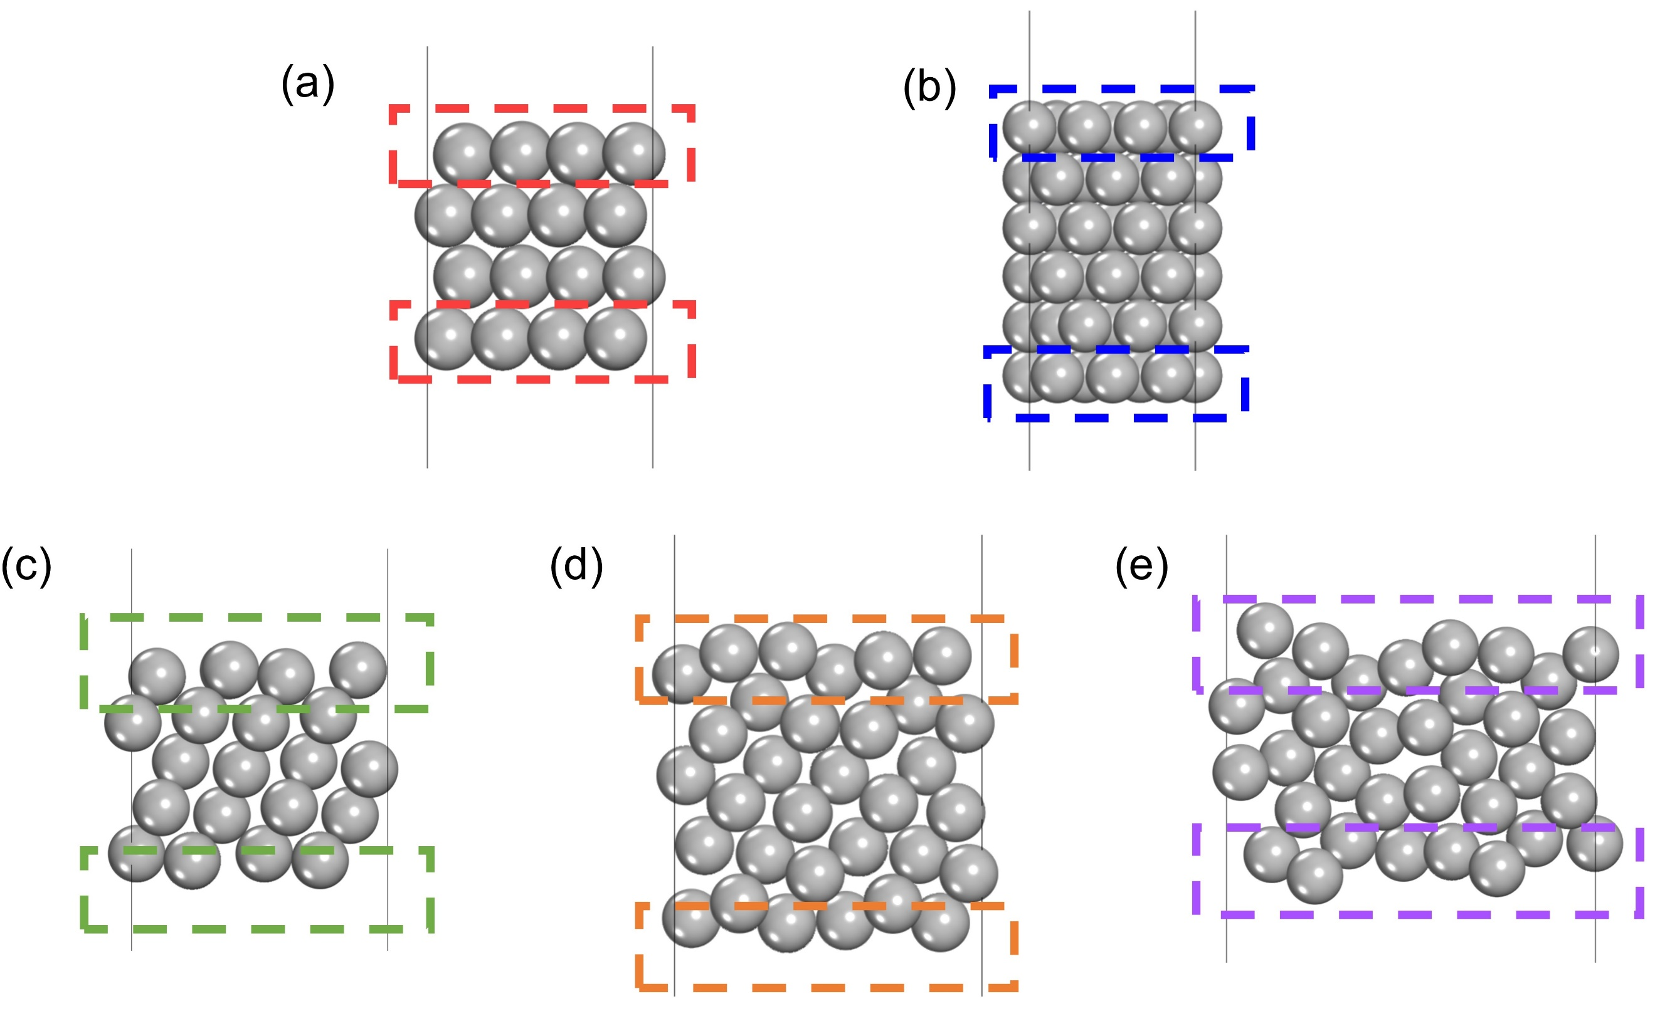
Fig. S1 The side views of the slab models. a Zn (002) surface, b Zn (100) surface, c Zn (101) surface, d Zn (102) surface, e Zn (103) surface.

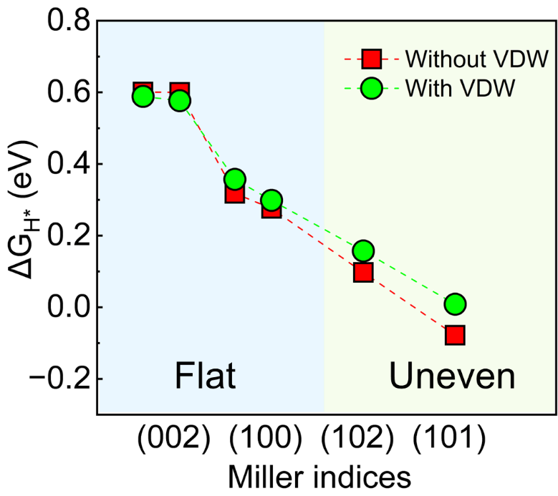
Fig. S2 The $∆G_{H^{*}}$ obtained after considering Van der Waals (VDW) interactions.
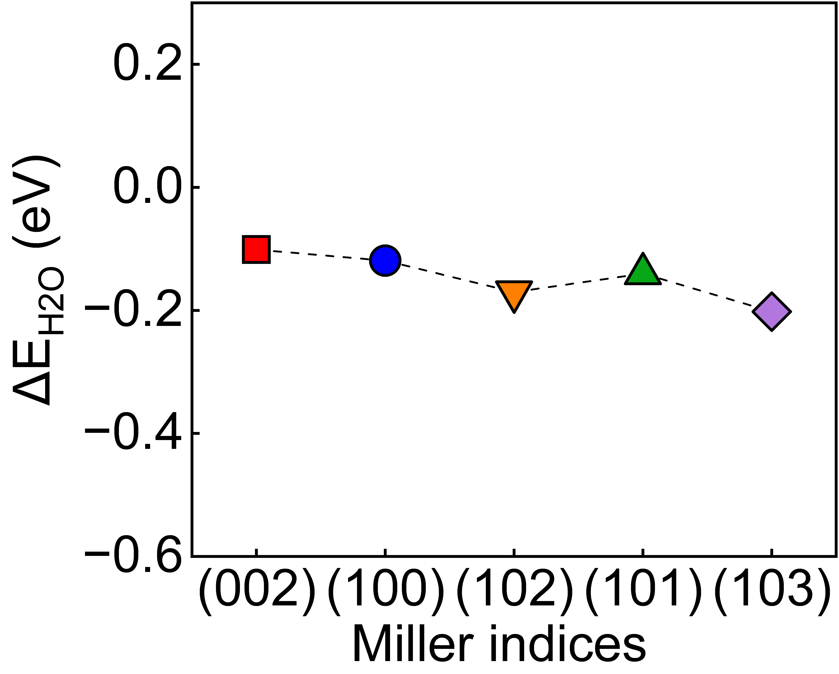
Fig. S3 The comparative water adsorption energy on several crystal surface of Zn anode.

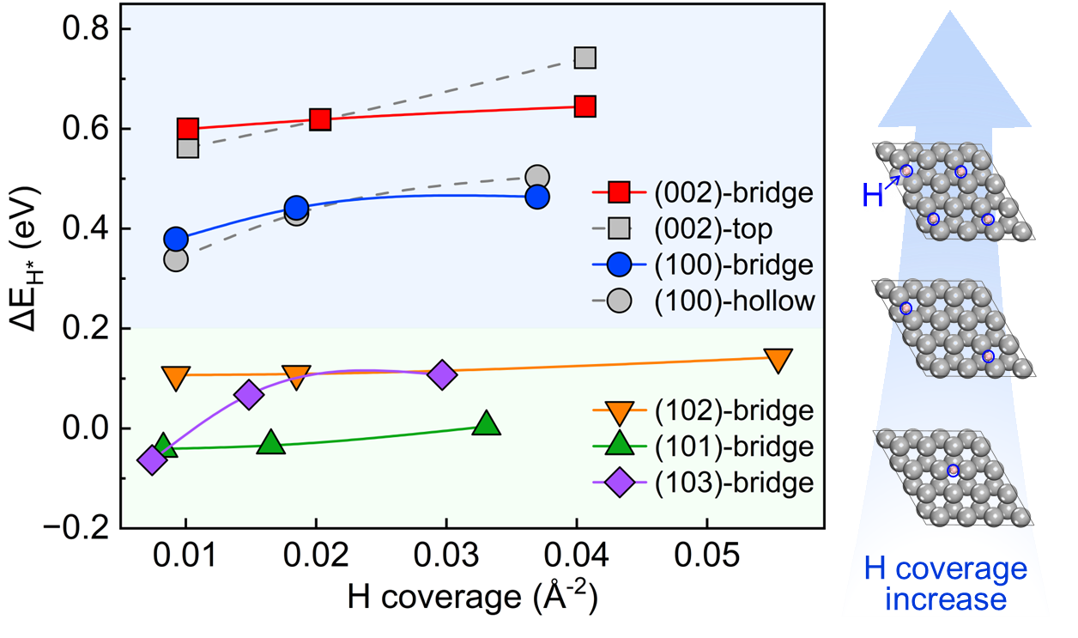
Fig. S4 Hydrogen adsorption energy ($∆E_{H^{*}}$) at several crystal surfaces of the zinc anode as a function of different hydrogen coverage. The H coverage indicates the number of hydrogens absorbed per unit area.
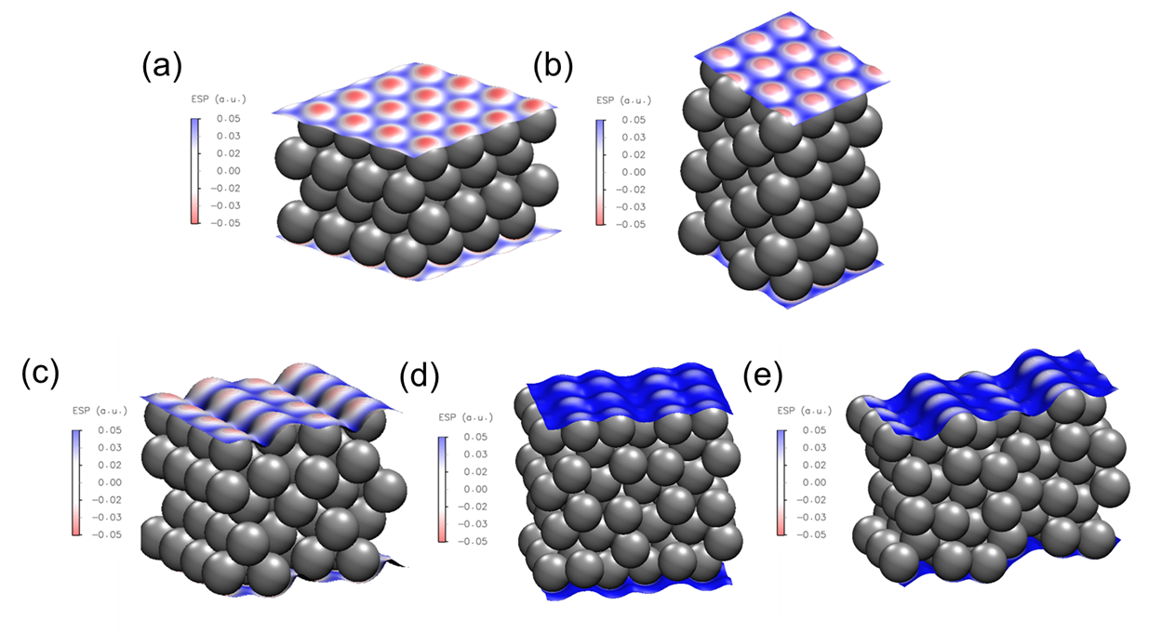
Fig. S5 The electrostatic potential at several crystal surface of Zn anode. a Zn (002) surface, b Zn (100) surface, c Zn (101) surface, d Zn (102) surface, e Zn (103) surface.

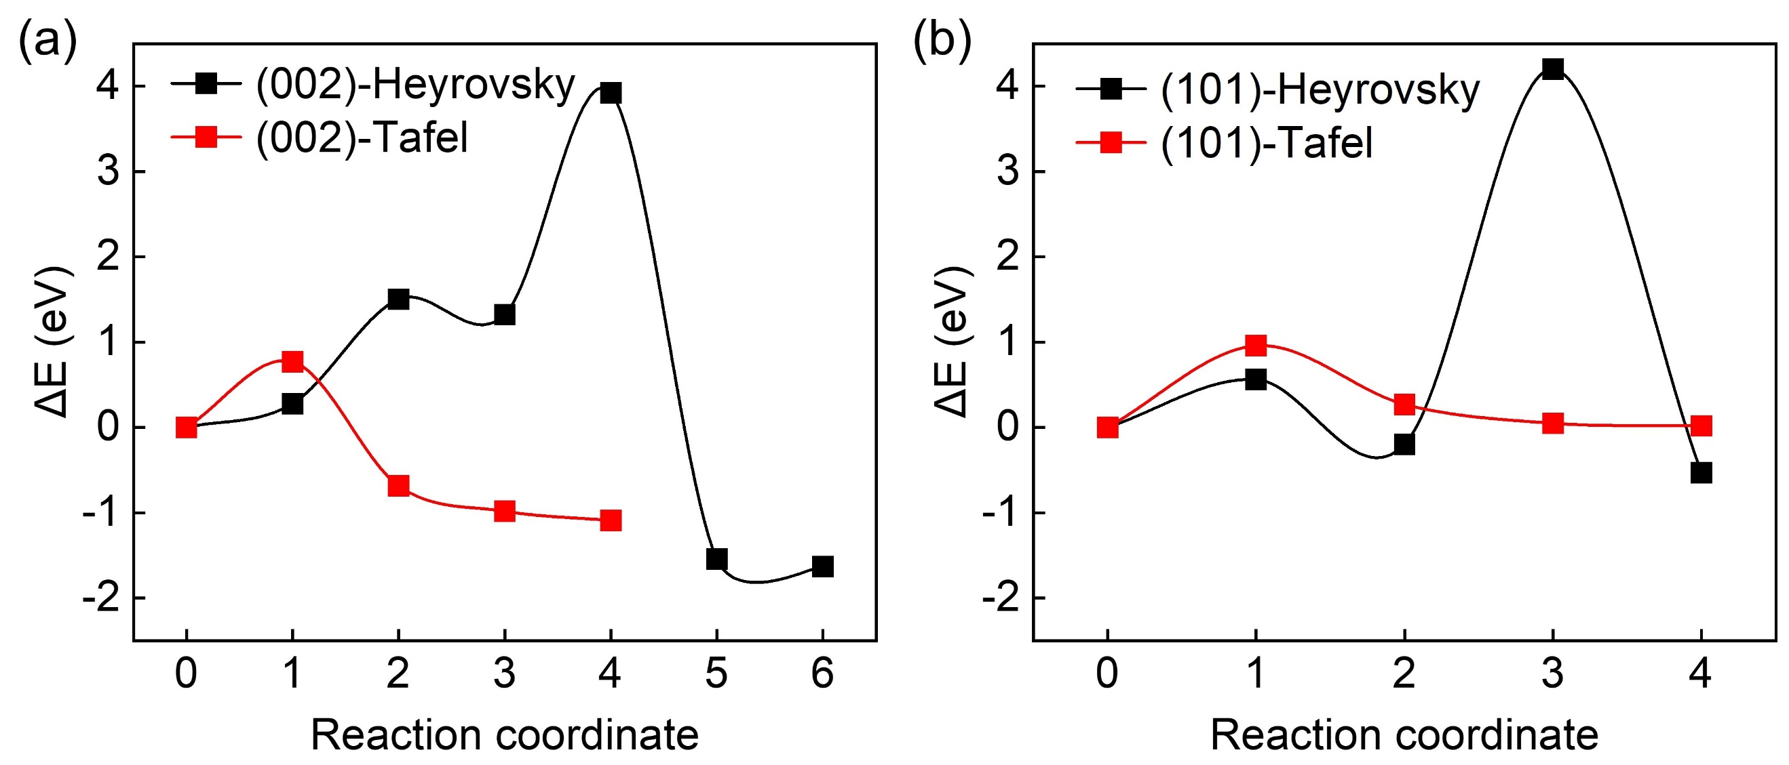
Fig. S6 The energy barriers and reaction pathways of Heryrovsky step and Tafel step on a flat crystal surface (002) and b uneven crystal surface (101) of Zn anode.

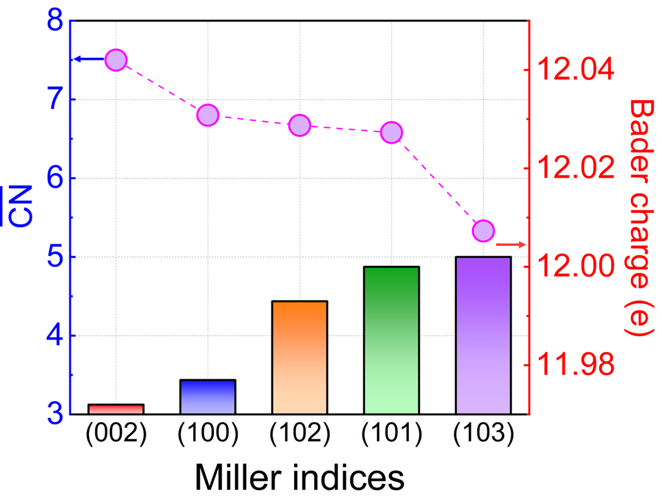
Fig. S7 The Bader charge of surface Zn, and correlation between the Bader charge and generalized coordination number $\overline{CN}$.
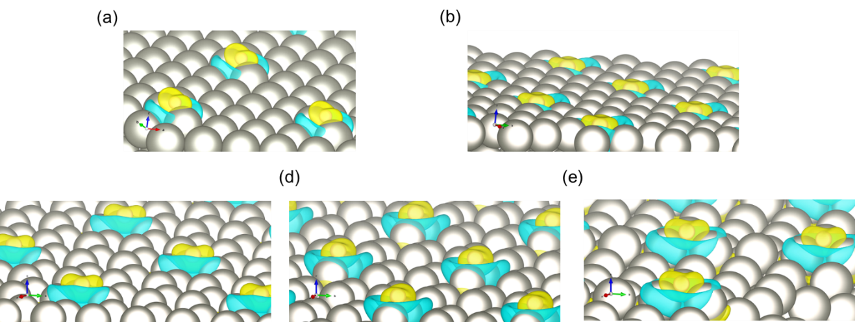
Fig. S8 The differential charge density induced by H adsorption for a Zn (002), b Zn (100), c Zn (101), d Zn (102), e Zn (103) surface models. The isosurfaces are all set to 0.001 e/Bohr³. The yellow and blue isosurfaces indicate loss and gain electrons, respectively.

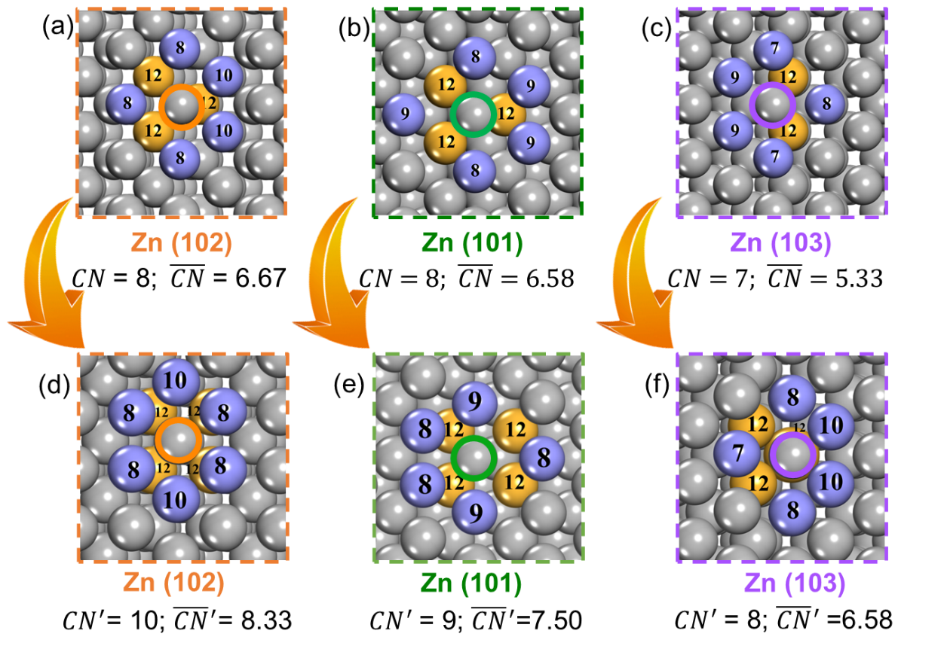
Fig. S9 The schematic diagram of the $\overline{CN}$of Zn atom with lowest $∆G_{H^{*}}$ at a Zn (102), b Zn (101), and c Zn (103) surface. The schematic diagram of the${ \overline{CN}}^{'}$of Zn atom with higher $∆G_{H^{*}}$ at d Zn (102), e Zn (101), and f Zn (103) surface.

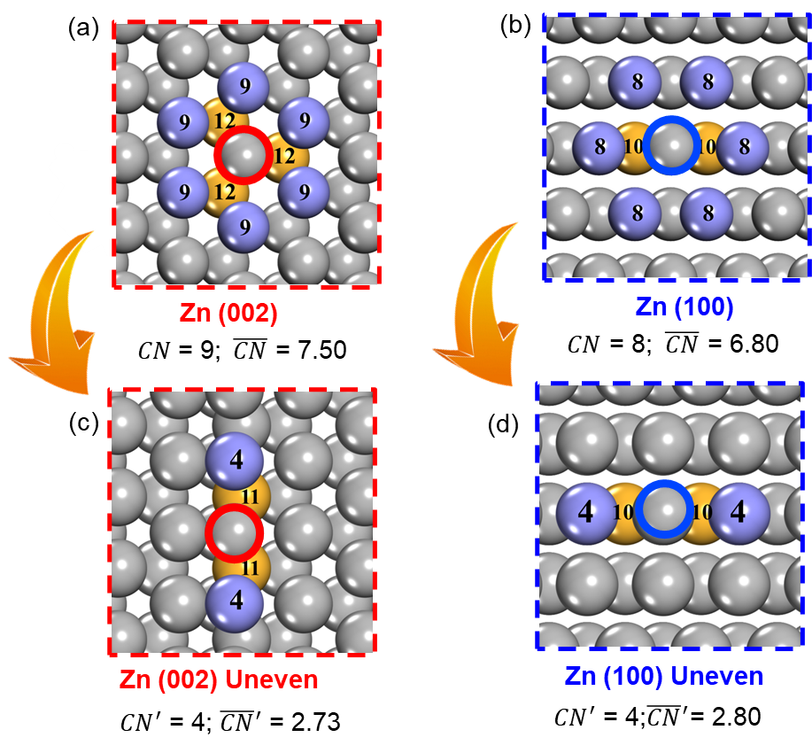
Fig. S10 The schematic diagram of the $\overline{CN}$of Zn atom at a Zn (002) and b Zn (100) surface. The schematic diagram of ${\overline{CN}}^{'}$of Zn atom at c uneven Zn (002) and d uneven Zn (100) surface.
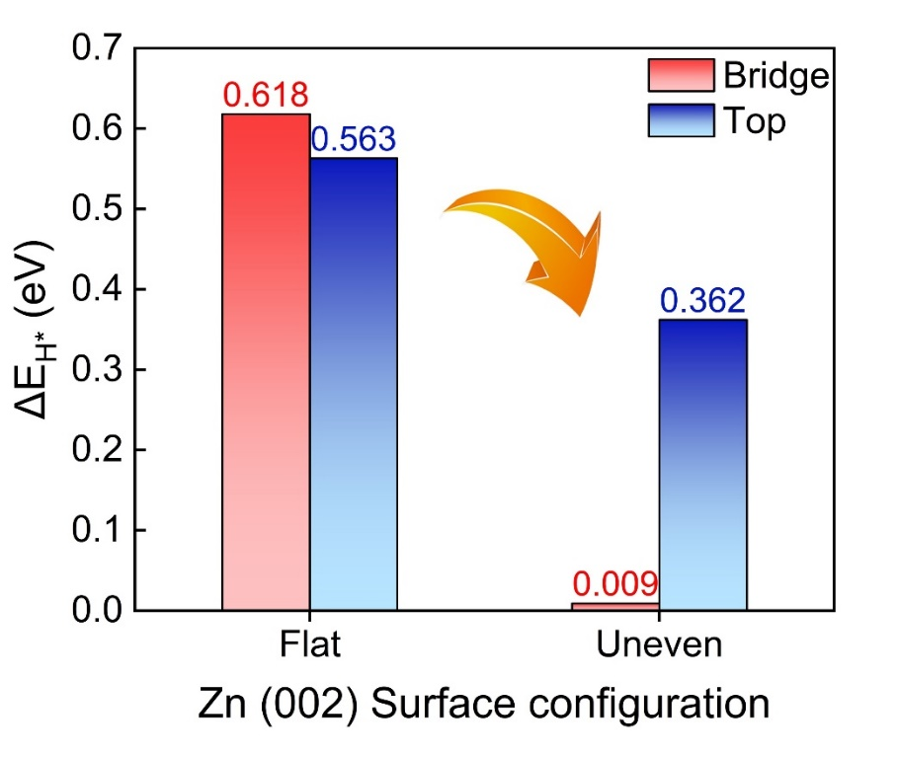
Fig. S11 The adsorption energy of H on flat and uneven Zn (002) surface.

Supplementary Tables
Table S1. The computational details about k-points densities applied for Brillouin zone integration and the information of slab models.
Miller indices | Lattice parameters | Layer number | Atom number | K-Points | k-points densities (/Å⁻¹)
(0 0 2) | a = b = 10.66 Å  c = 39.78 Å  α = β = 90.00°  γ =120.00° | 4 | 64 | 3 3 1 | 32 32 40
(1 0 0) | a = 8.01 Å  b = 9.79 Å  c = 48.53 Å  α=β=γ= 90.00° | 6 | 72 | 3 3 1 | 24 29 49
(1 0 1) | a = 11.87 Å  b = 10.44 Å  c = 37.00 Å  α = β = 90.00°  γ =102.70° | 5 | 80 | 3 3 1 | 36 31 37
(1 0 2) | a = 13.53 Å  b = 7.99 Å  c = 29.69 Å  α = β =γ= 90.00° | 6 | 96 | 3 4 1 | 41 32 30
(1 0 3) | a = 17.11 Å  b = 7.98 Å  c = 26.71 Å  α = β = 90.00°  γ =98.94° | 5 | 102 | 1 3 1 | 17 24 27

Table S2. The $∆G_{H^{*}}$ values and the corresponding structures for H adsorbed at different sites of Zn (101) surface.
Surface structures | Adsorption site | $∆G_{H^{*}}$ (eV)
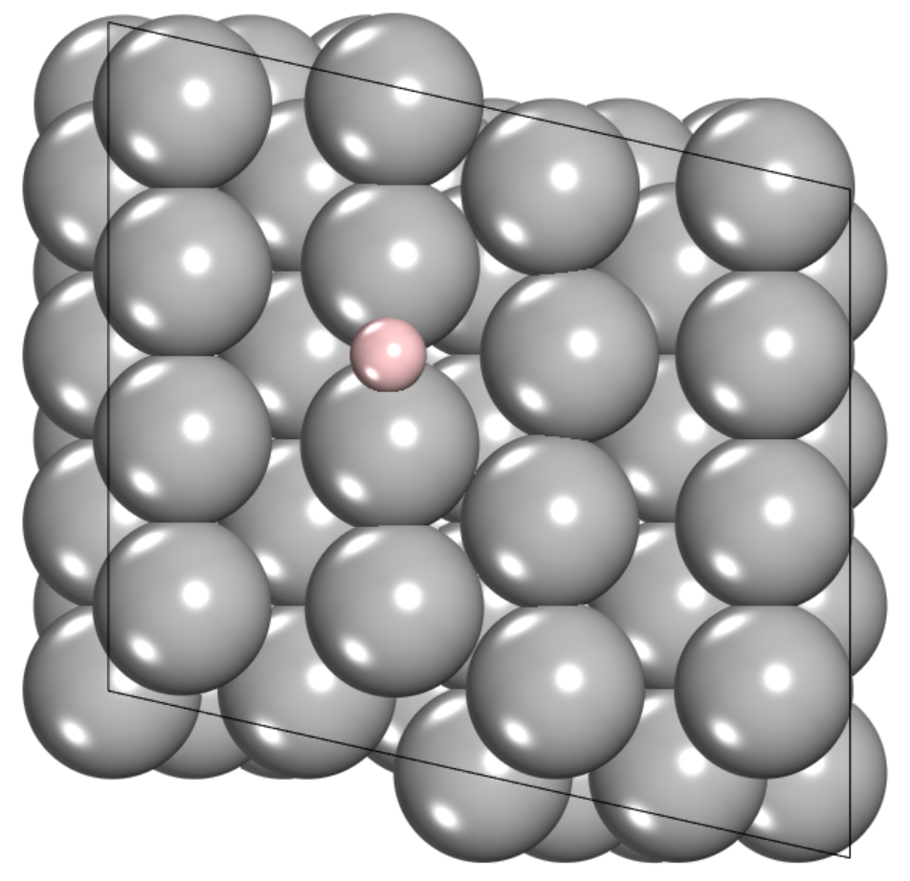 | Bridge | 0.023
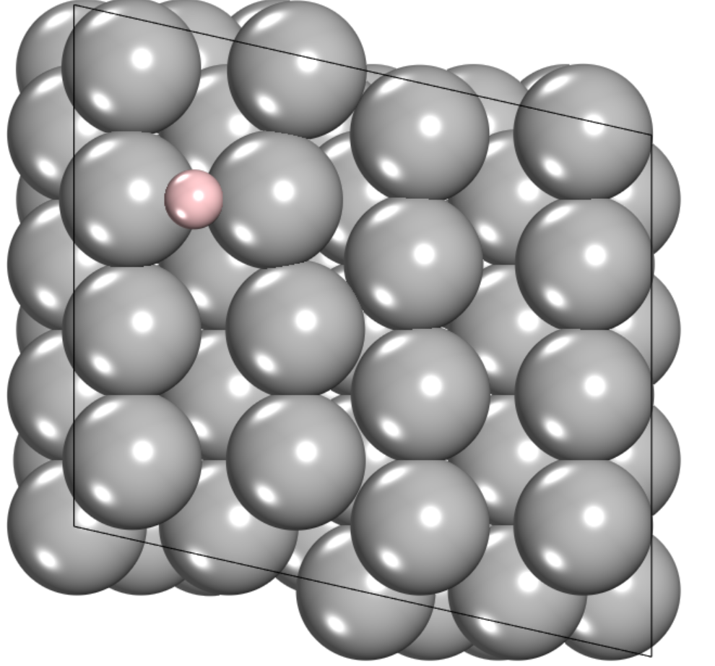 | Bridge | 0.363
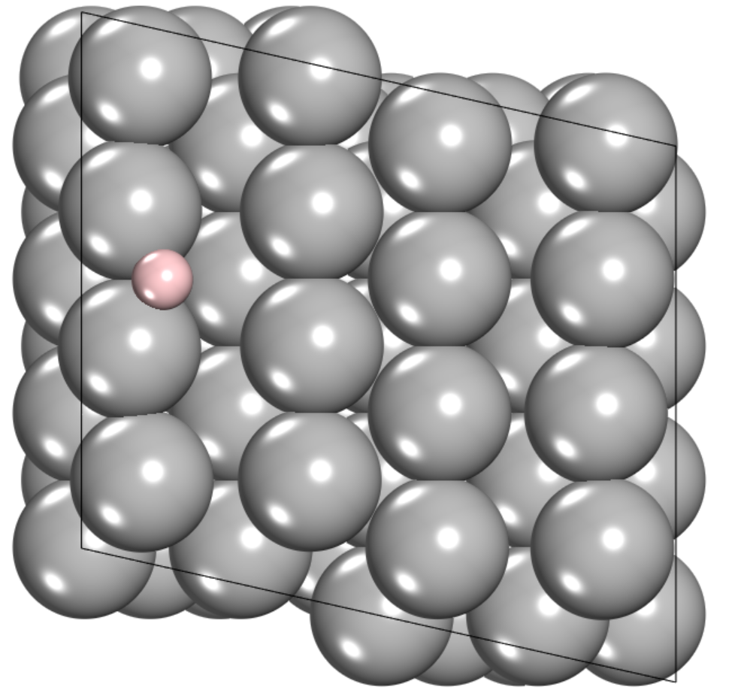 | Bridge | 0.250
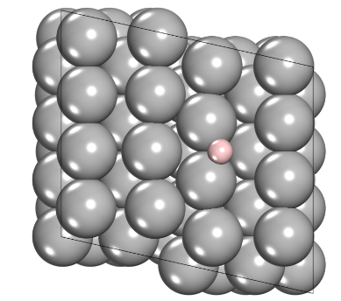 | Bridge | 0.242

Table S3. The $∆G_{H^{*}}$ values and the corresponding structures for H adsorbed at different sites of Zn (102) surface.
Surface structures | Adsorption site | $∆G_{H^{*}}$ (eV)
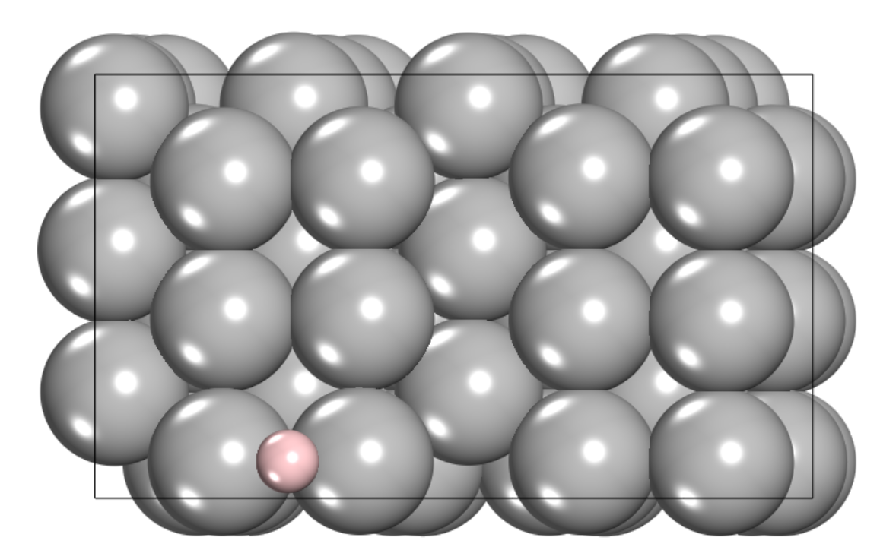 | Bridge | 0.174
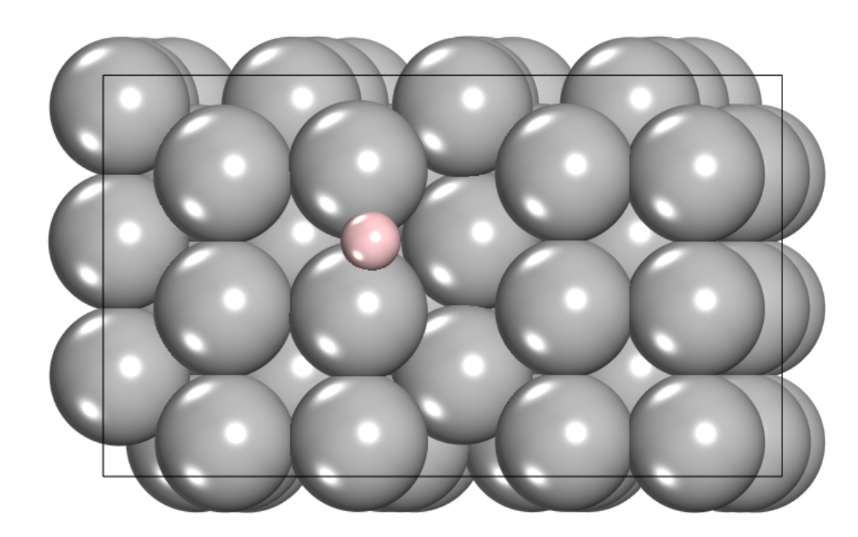 | Bridge | 0.334
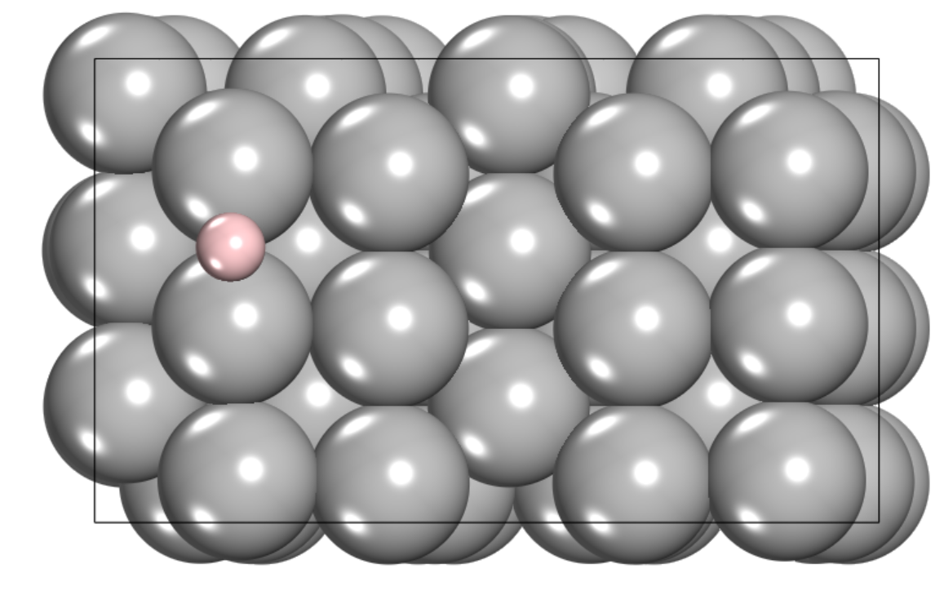 | Bridge | 0.277
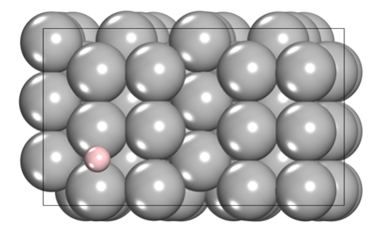 | Bridge | 0.285
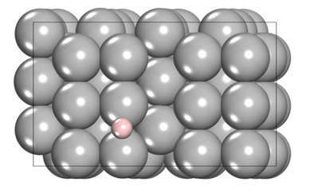 | Bridge | 0.328

Table S4. The $∆G_{H^{*}}$ values and the corresponding structures for H adsorbed at different sites of Zn (103) surface.
Surface structures | Adsorption site | $∆G_{H^{*}}$ (eV)
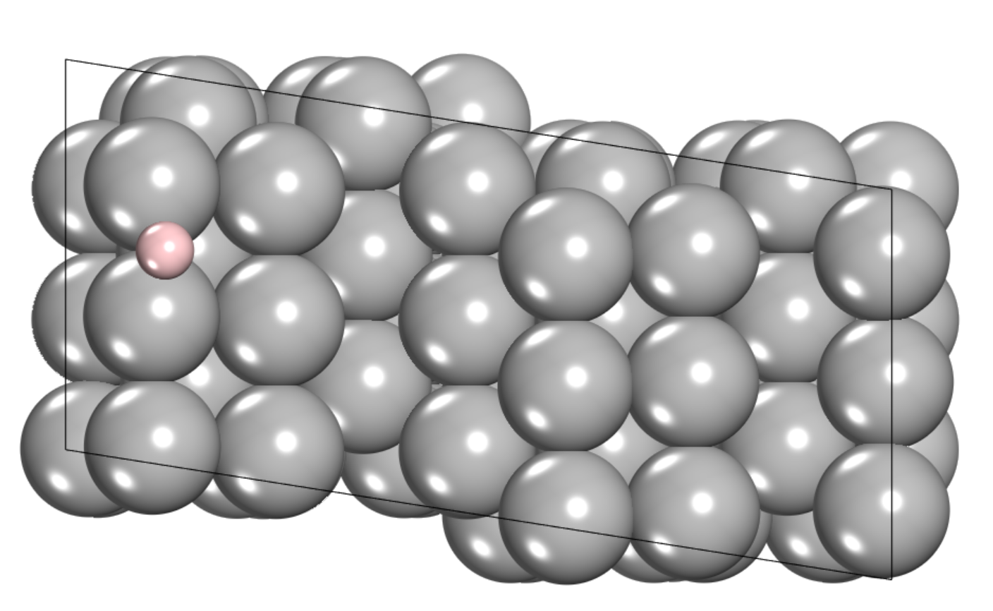 | Bridge | -0.054
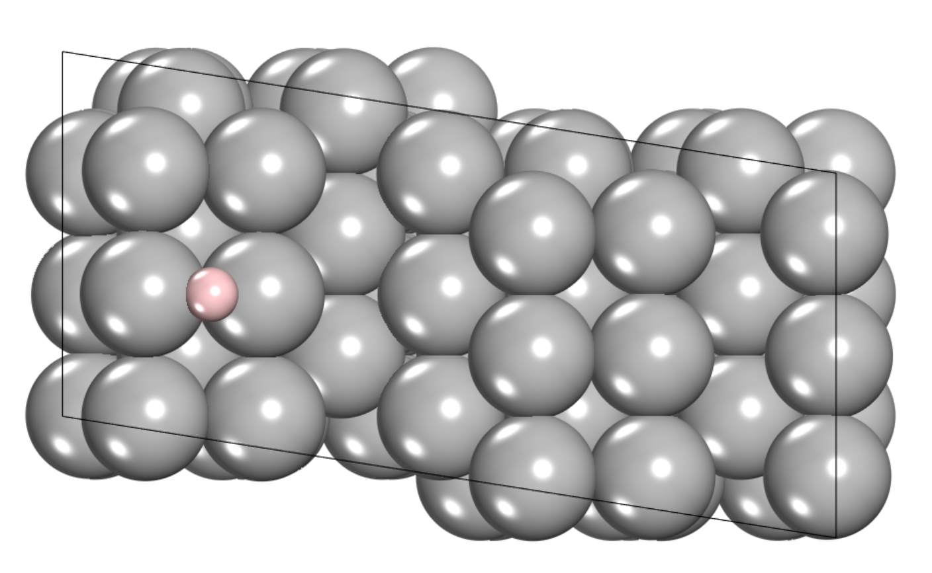 | Bridge | 0.058
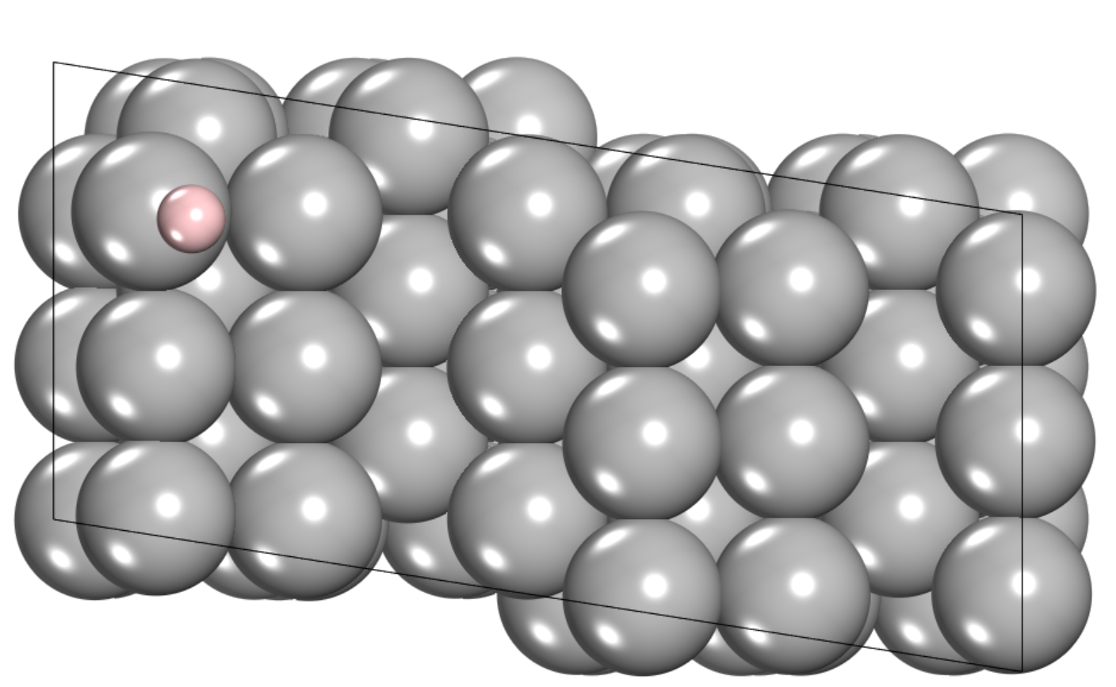 | Top | 0.199
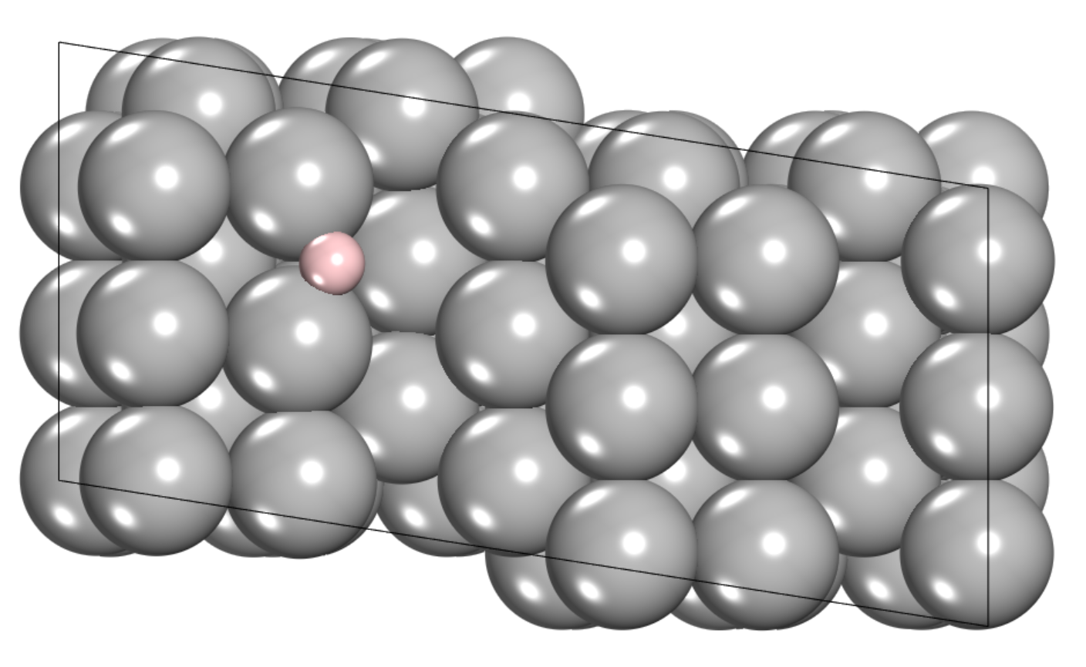 | Bridge | 0.340

Table S5. The $∆G_{H^{*}}$ values and the corresponding structures for H adsorbed at different sites of Zn (002) surface.
Surface structures | Adsorption site | $∆G_{H^{*}}$ (eV)
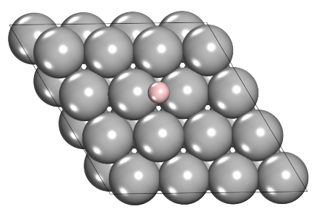 | Bridge | 0.589
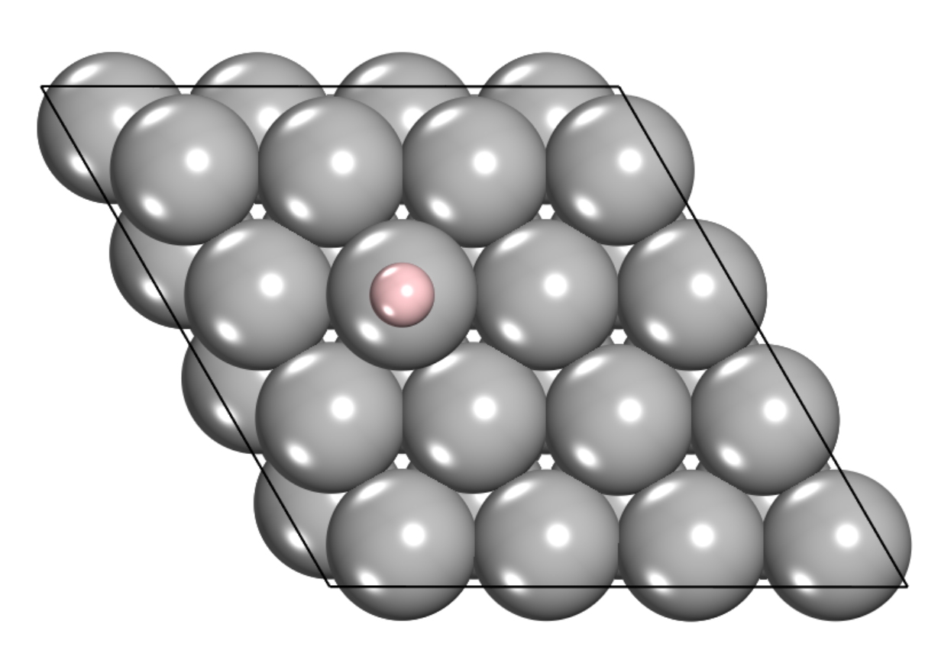 | Top | 0.577
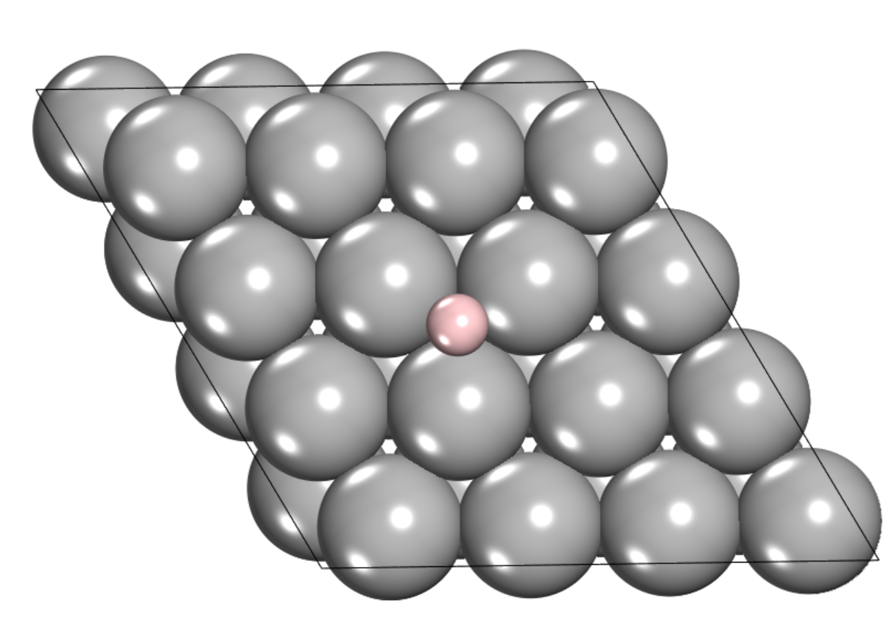 | Hollow-fcc | 0.647
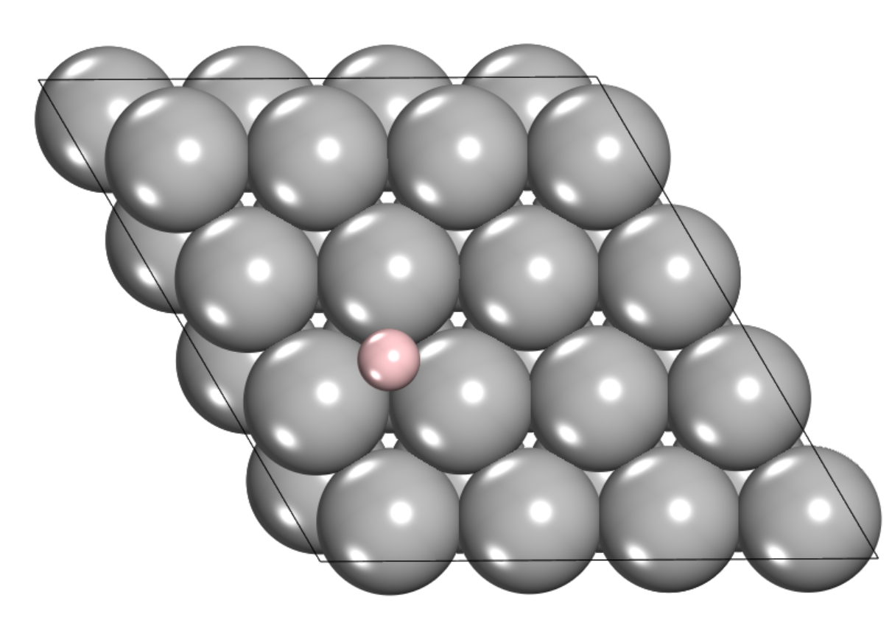 | Hollow-hcp | 0.630

Table S6. The $∆G_{H^{*}}$ values and the corresponding structures for H adsorbed at different sites of Zn (100) surface.
Surface structures | Adsorption site | $∆G_{H^{*}}$ (eV)
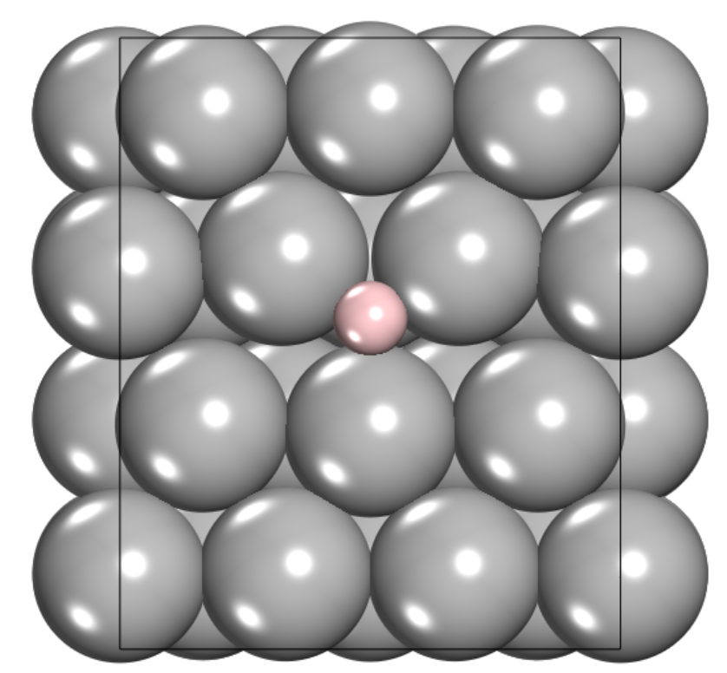 | Hollow | 0.290
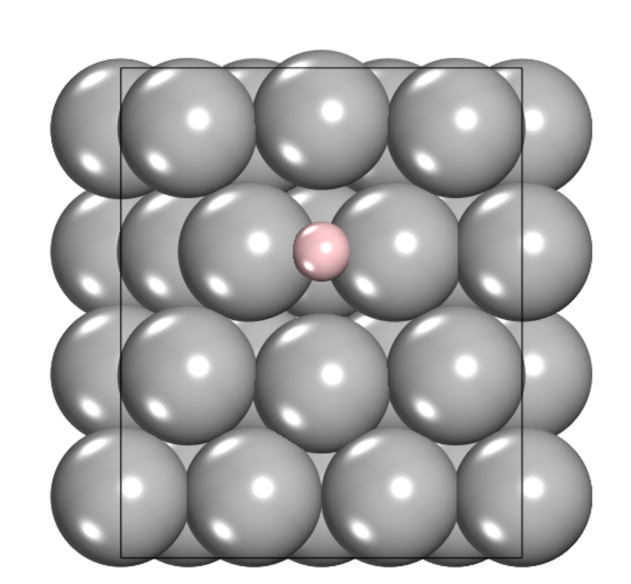 | Bridge | 0.392
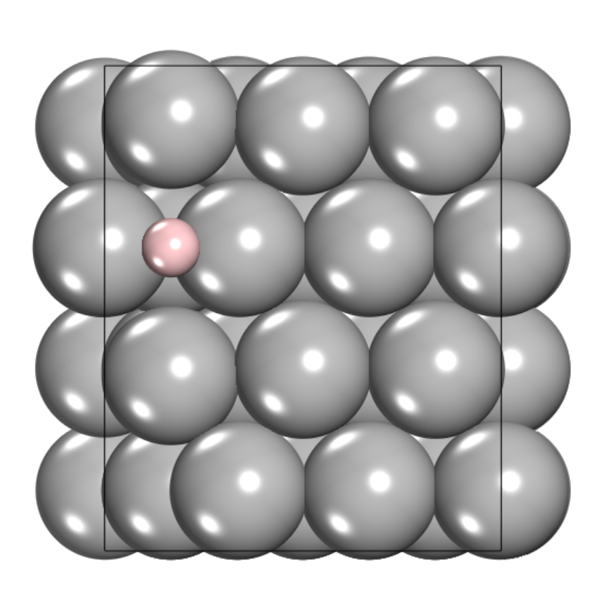 | Bridge | 0.458
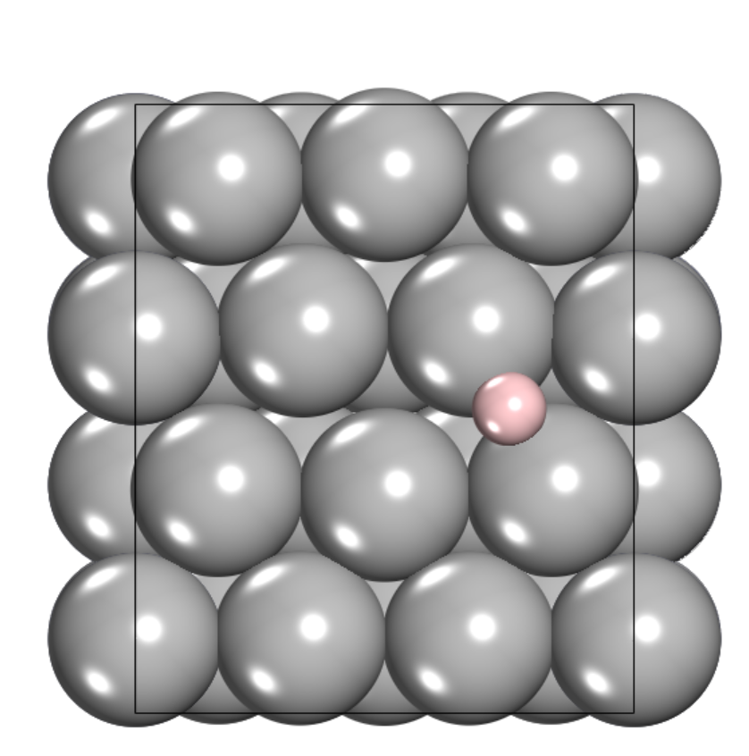 | Bridge | 0.357
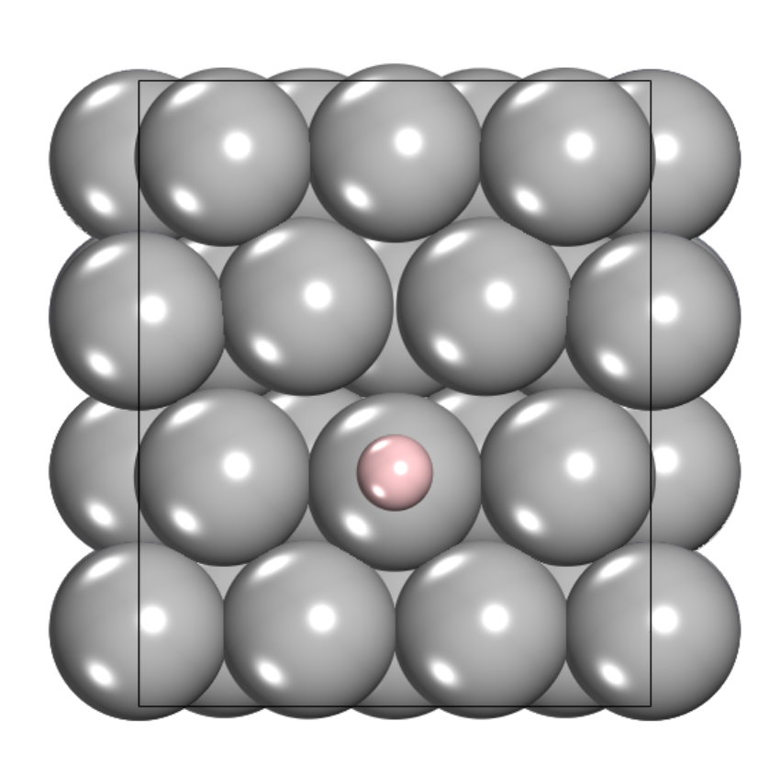 | Top | 0.652

Table S7. Details of Gibbs free energy correction for H adsorbed on (002) and (100) surface with different H coverages. n represent the number of adsorbed H atoms. ${ZPE}_{H^{*}}$ and ${TS}_{H^{*}}$ for n > 1 are the average ${ZPE}_{H^{*}}$ and ${TS}_{H^{*}}$ of n H* respectively.
Miller indices | Adsorption site | n | H coverage ($Å^{-2}$) | $$∆E_{H^{*}}$$  (eV) | $${ZPE}_{H^{*}}$$  (eV) | $$TS_{H^{*}}$$  (eV) | $${\frac{1}{2}ZPE}_{H_{2}}$$  (eV) | $${\frac{1}{2}TS}_{H_{2}}$$  (eV) | $$∆G_{H^{*}}$$  $$(eV)$$
(0 0 2) | top | 1 | 0.010 | 0.563 | 0.105 | 0.000 | 0.140 | 0.049 | 0.577
(0 0 2) | top | 2 | 0.020 | 0.617 | 0.073 | 0.018 | 0.140 | 0.049 | 0.581
(0 0 2) | top | 4 | 0.041 | 0.742 | 0.133 | 0.052 | 0.140 | 0.049 | 0.731
(0 0 2) | bridge | 1 | 0.010 | 0.600 | 0.093 | 0.013 | 0.140 | 0.049 | 0.589
(0 0 2) | bridge | 2 | 0.020 | 0.619 | 0.071 | 0.008 | 0.140 | 0.049 | 0.590
(0 0 2) | bridge | 4 | 0.041 | 0.645 | 0.045 | 0.025 | 0.140 | 0.049 | 0.574
(1 0 0) | bridge | 1 | 0.009 | 0.379 | 0.082 | 0.012 | 0.140 | 0.049 | 0.357
(1 0 0) | bridge | 2 | 0.018 | 0.442 | 0.065 | 0.064 | 0.140 | 0.049 | 0.351
(1 0 0) | bridge | 4 | 0.037 | 0.464 | 0.150 | 0.068 | 0.140 | 0.049 | 0.505
(1 0 0) | hollow | 1 | 0.009 | 0.339 | 0.066 | 0.015 | 0.140 | 0.049 | 0.298
(1 0 0) | hollow | 2 | 0.018 | 0.430 | 0.137 | 0.009 | 0.140 | 0.049 | 0.467
(1 0 0) | hollow | 4 | 0.037 | 0.503 | 0.134 | 0.009 | 0.140 | 0.049 | 0.537

Table S8. Details of Gibbs free energy correction for H adsorbed on (101), (102), and (103) surface with different H coverages. n represent the number of adsorbed H atoms. ${ZPE}_{H^{*}}$ and ${TS}_{H^{*}}$ for n > 1 are the average ${ZPE}_{H^{*}}$ and ${TS}_{H^{*}}$ of n H* respectively.
Miller indices | Adsorption site | n | H coverage ($Å^{-2}$) | $$∆E_{H^{*}}$$  (eV) | $${ZPE}_{H^{*}}$$  (eV) | $$TS_{H^{*}}$$  (eV) | $${\frac{1}{2}ZPE}_{H_{2}}$$  (eV) | $${\frac{1}{2}TS}_{H_{2}}$$  (eV) | $$∆G_{H^{*}}$$  $$(eV)$$
(1 0 1) | bridge | 1 | 0.008 | -0.041 | 0.164 | 0.010 | 0.140 | 0.049 | 0.023
(1 0 1) | bridge | 2 | 0.017 | -0.034 | 0.165 | 0.014 | 0.140 | 0.049 | 0.026
(1 0 1) | bridge | 4 | 0.033 | 0.004 | 0.167 | 0.015 | 0.140 | 0.049 | 0.065
(1 0 2) | bridge | 1 | 0.009 | 0.107 | 0.168 | 0.011 | 0.140 | 0.049 | 0.174
(1 0 2) | bridge | 2 | 0.018 | 0.109 | 0.173 | 0.010 | 0.140 | 0.049 | 0.181
(1 0 2) | bridge | 6 | 0.055 | 0.142 | 0.261 | 0.013 | 0.140 | 0.049 | 0.217
(1 0 3) | bridge | 1 | 0.007 | -0.101 | 0.152 | 0.013 | 0.140 | 0.049 | -0.054
(1 0 3) | bridge | 2 | 0.015 | -0.003 | 0.151 | 0.014 | 0.140 | 0.049 | 0.043
(1 0 3) | bridge | 4 | 0.030 | 0.047 | 0.155 | 0.015 | 0.140 | 0.049 | 0.096

Table S9. The Bader charge of surface Zn near the adsorption sites with the lowest Gibbs free energy.
Miller indices | Bader charge of surface Zn (e) | Net charge of surface Zn (e)
(0 0 2) | 11.972 | -0.028
(1 0 0) | 11.977 | -0.023
(1 0 1) | 12.000 | 0.000
(1 0 2) | 11.993 | -0.007
(1 0 3) | 12.002 | 0.002

