Supporting Information for
Enhancing the Performance of Perovskite Light-Emitting Diodes via Synergistic Effect of Defect Passivation and Dielectric Screening
Xuanchi Yu^{1, 2}, Jia Guo^{1,} *, Yulin Mao¹, Chengwei Shan², Fengshou Tian², Bingheng Meng², Zhaojin Wang², Tianqi Zhang¹, Aung Ko Ko KYAW², Shuming Chen², Xiaowei Sun², Kai Wang², Rui Chen^{2,} * and Guichuan Xing^{1,} *
¹ Institute of Applied Physics and Materials Engineering, University of Macau, Avenida da Universidade, Taipa, Macao 999078, P. R. China
² Department of Electrical and Electronic Engineering, Southern University of Science and Technology, Shenzhen 518055, P. R. China
* Corresponding authors. E-mail: gcxing@um.edu.mo (Guichuan Xing); chenr@sustech.edu.cn (Rui Chen); jiaguo@um.edu.mo (Jia Guo)
Supplementary Figures and Tables

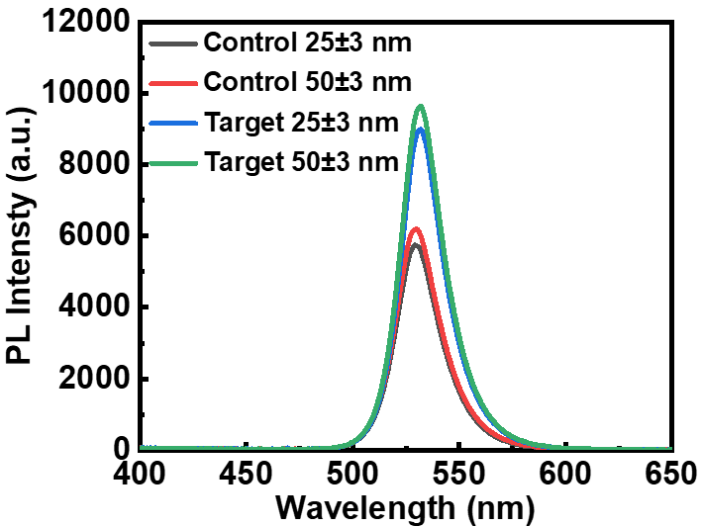

Fig. S1 PL spectra of control and target perovskite films with different thickness
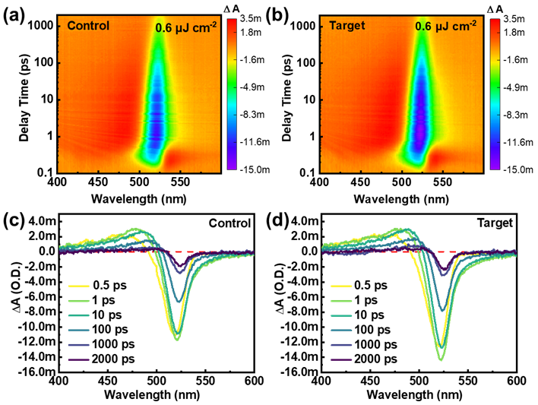

Fig. S2 TA measurements for control and target perovskite films following excitation at 360 nm. Pseudo color TA spectra of the a control and b target films. TA spectra at selected probe delay times for the c control and d target films

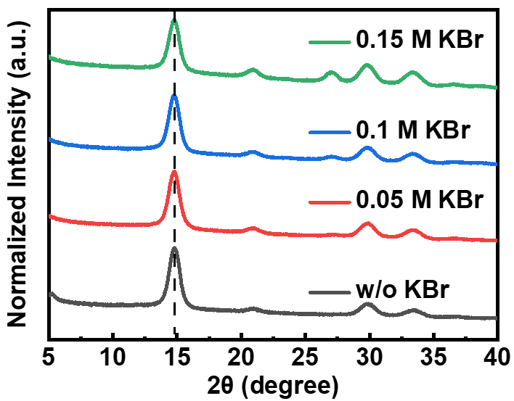
Fig. S3 XRD patterns of quasi-2D perovskite films without and with different KBr concentration

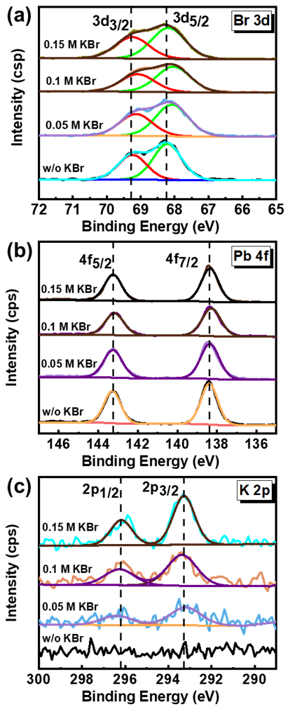
Fig. S4 XPS spectra of a K 2p signals, b Pb 4f signals, c Br 3d signals and d N 1s signals of perovskite films without and with different KBr concentration

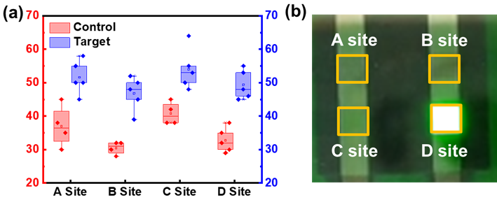

Fig. S5 a Average thickness of the control and target perovskite thin films at four different sites. b The distribution of four sites in the actual film

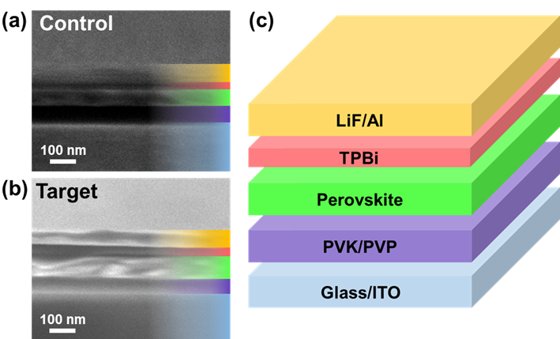

Fig. S6 Cross-sectional SEM images of a control and b target PeLEDs. c Device structure of fabricated PeLEDs

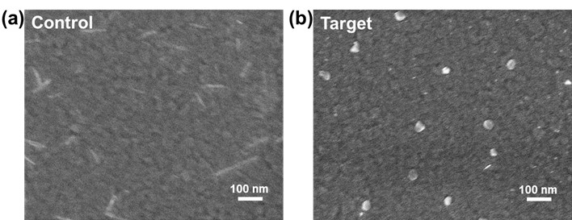

Fig. S7 SEM images of a control and b target perovskite films

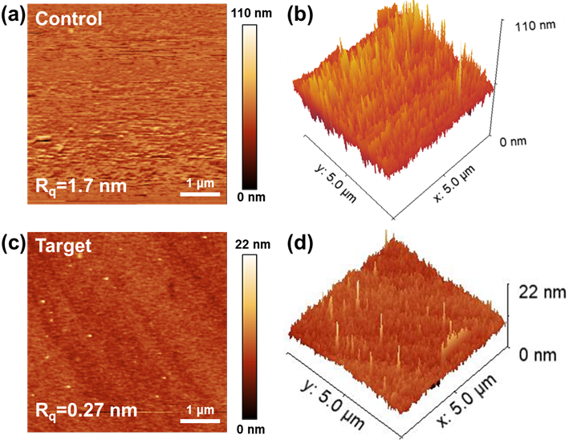
Fig. S8 AFM a 2D and b 3D images of control perovskite films. AFM c 2D and d 3D images of target perovskite films

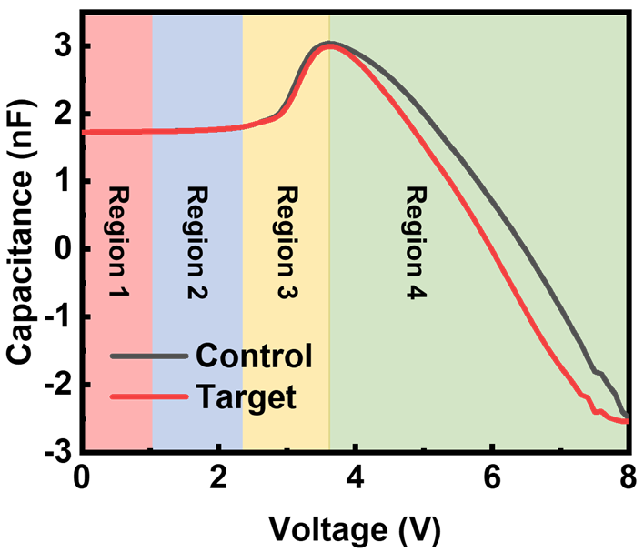
Fig. S9 Capacitance-Voltage (C–V) curve of control and target PeLEDs

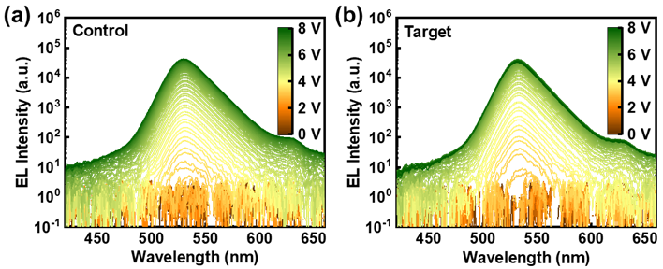
Fig. S10 EL spectra of a control and b target PeLEDs at 0 to 8 V bias with 0.1 V interval
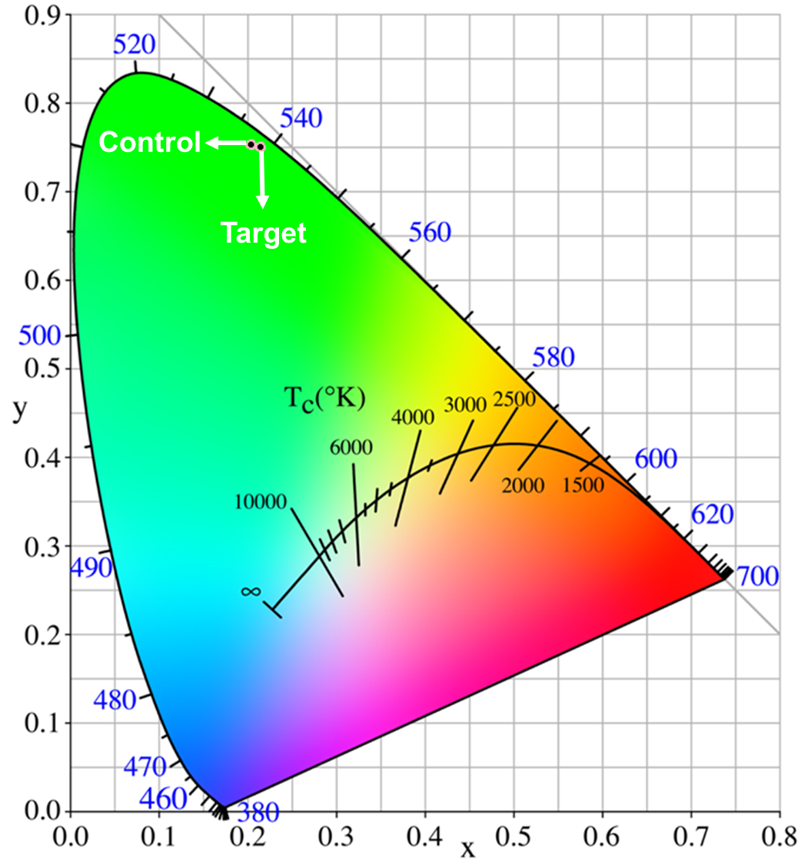
Fig. S11 CIE coordinate of control and target PeLEDs
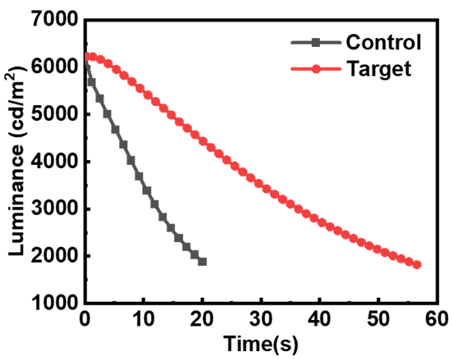
Fig. S12 Operational lifetime tested at a constant current density of 1.6 mA cm^{–2} for control and 1.3 mA cm^{–2} for target PeLEDs
Table S1 Lifetimes extracted from the TRPL decays of the control and target films, excited by a 360 nm laser
 | Control | Target
A₁ | 0.42 ± 0.02 | 0.37 ± 0.02
τ₁ (ns) | 9.33 ± 0.69 | 9.19 ± 0.87
A₂ | 0.56 ± 0.02 | 0.63 ± 0.02
τ₂ (ns) | 58.95 ± 2.18 | 67.45 ± 2.63
τ_{avg} (ns) | 53.69 | 63.10

Table S2 XPS fitting results of perovskite films without and with different KBr concentration
 | C | N | Pb | Br | K | Atomic ratio (C:N:Pb:Br:K)
w/o KBr | 34.71 | 15.65 | 9.4 | 40.24 | 0 | 3.7: 1.7: 1: 4.3: 0
0.05 M KBr | 32.44 | 14.16 | 8.99 | 40.48 | 3.92 | 3.6: 1.6: 1: 4.5: 0.4
0.1 M KBr | 38.78 | 12.02 | 7.39 | 35.17 | 6.64 | 5.2: 1.6: 1: 4.8: 0.9
0.15 M KBr | 34.31 | 11.64 | 7.58 | 39.29 | 7.18 | 4.5: 1.5: 1: 5.18: 0.95

Table S3 PLQY, PL average lifetimes (τ_{avg}), radiative decay rates (k_{r}), and nonradiative recombination rates (k_{nr}) of control and target perovskite films
 | Control | Target
PLQY (%) | 66.5 | 89.5
τ_{avg} (ns) | 53.69 | 63.10
k_{r} (10⁷ s⁻¹) | 1.24 | 1.42
k_{nr} (10⁷ s⁻¹) | 0.624 | 0.166

Table S4 Performance metrics of the state-of-the-art green PeLEDs
Perovskite | EQE  (%) | Luminance  (cd/m²) | CE  (cd/A) | V_{on}  (V) | References
CsPbBr₃:PEABr = 1:0.4 | 32.1 | 1.1 × 10⁴ | 111.7 | 2.5 | Adv. Mater. 2024, 2400421
PEA₂(FAPbBr₃)₂PbBr₄ | 30.84 | 3.9× 10⁴ | 115.32 | ~3 | Adv. Mater. 2023, 35, 2302283
PEA₂(FAPbBr₃)₂PbBr₄ | 20.82 | ~1 × 10⁴ | ~82 | ~2.8 | Nano-Micro Lett. 2023, 15, 119
PEA₂FA_{n-1}Pb_{n}Br_{3n+1}  (n = 5) | 21.2 | > 6.1 × 10⁴ | - | ~3 | Adv. Funct. Mater. 2021, 31, 2103890
PEA₂FA_{n-1}Pb_{n}Br_{3n+1}  (n = 5) | 22.2 | 5.4 × 10⁴ | - | 3 | Light Sci Appl. 2022, 11, 69
PEA₂Cs_{n-1}Pb_{n}Br_{3n+1} | 21.0 | 4.8 × 10⁴ | - | 2.9 | J. Phys. Chem. C. 2023, 127, 19, 9388–9396
PEA₂(FAPbBr₃)₂PbBr₄ | 25.9 | 2.9 × 10⁴ | 108.1 | 2.9 | Nano Lett. 2023, 23, 23, 11082–11090
CsPbBr₃:PEABr = 1:0.4 | 19.3 | 1.2 × 10⁴ | 61.7 | 2.6 | Adv. Optical Mater. 2022, 10, 2200276
PEA₂FA_{n-1}Pb_{n}Br_{3n+1}  (n = 5) | 20.83 | 5.9 × 10⁴ | 90.98 | < 3 | Our work

