Supporting Information for
Boosted Lithium-Ion Transport Kinetics in n-Type Siloxene Anodes Enabled by Selective Nucleophilic Substitution of Phosphorus
Se In Kim¹, Woong-Ju Kim¹, Jin Gu Kang^{2,} *, and Dong-Wan Kim^{1,} *
¹School of Civil, Environmental and Architectural Engineering, Korea University, Seoul 02841, South Korea
²Nanophotonics Research Center, Korea Institute of Science and Technology, Seoul, 02792, South Korea
*Corresponding authors. E-mail: dwkim1@korea.ac.kr (Dong-Wan Kim); lucid1@kist.re.kr (Jin Gu Kang)

Supplementary Note S1
Using the elemental analysis results obtained via ICP-OES, we determined the doping concentrations of the doped SX samples. The number density of the SX molecules (N_{SX}) is:
(S1)
where N_{A} is Avogadro’s number (6.02×10²³ mol⁻¹), ρ_{SX} is the density of SX (1.54 g cm⁻³) [S1–S3], and M_{W} is the molecular weight of SX (222 g mol⁻¹). Thus, the doping concentration (N_{D}, in atoms cm⁻³) can be calculated by:
(S2)
where a factor of 6 is the number of Si sites in one formula unit of SX (i.e., Si₆O₃H₆), and x_{Si} and x_{P} are the measured atomic percentages of Si and P, respectively.
Supplementary Figures and Tables
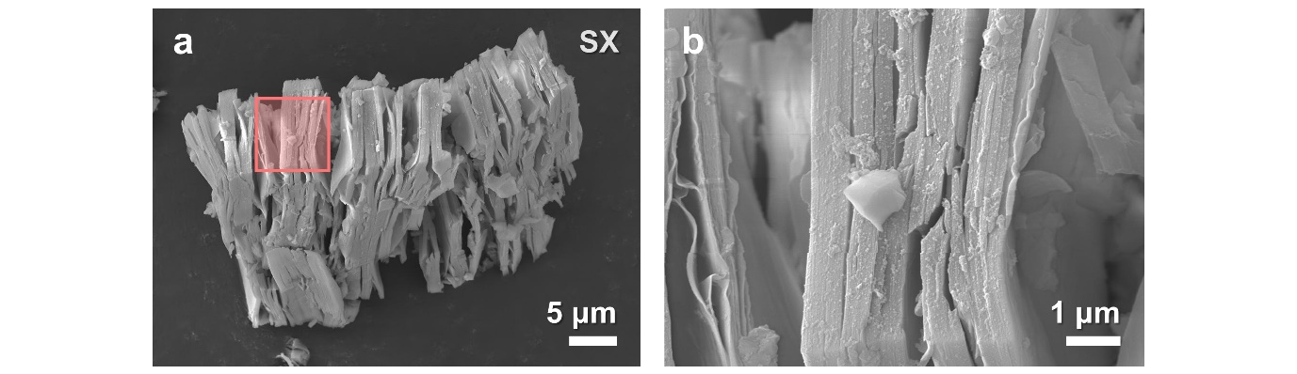
Fig. S1 a Low- and b high-magnification SEM images of SX. b Magnified image of the square region in a
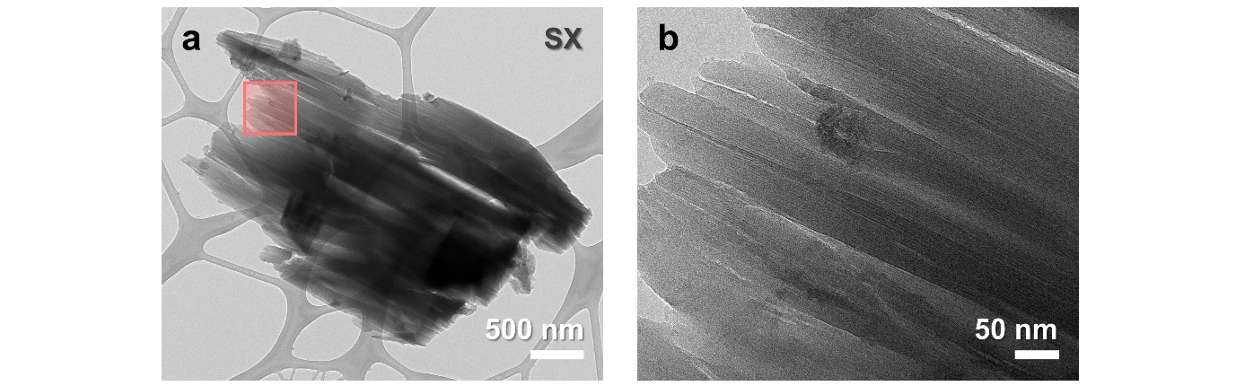
Fig. S2 a Low- and b high-magnification TEM images of SX. b Magnified image of the square region in a
Fig. S3 EDX elemental mapping of Si, O, and P in SX
Fig. S4 Survey XPS spectra of a SX and b n-SX
Fig. S5 Full-range FTIR transmittance spectra of SX, n-SX, and H-SX. Peaks are indexed with their corresponding vibrational modes on the image top

Fig. S6 CV curves of H-SX/A (left panel) and n-SX/V (right) at a scan rate of 0.1 mV s⁻¹ during first, 5th, 15th, and 50th cycles

Fig. S7 Plots of (dE/dQ)⁻¹ vs. E for a SX/A and b n-SX/A in the 0.01- 0.6 V range, acquired from their galvanostatic voltage curves at 200 mA g⁻¹

Fig. S8 C.E. of SX/A, H-SX/A, and n-SX/V at 200 mA g⁻¹
Fig. S9 Nyquist plots of SX/A at its a lithiated and b delithiated state during first, 10th, 20th, 50th, and 100th cycles. Open circles and solid lines denote the measured data and fitted results, respectively
Fig. S10. Plots of Z’ vs. ω^{−1/2} for a,b n-SX/A and c,d SX/A at their lithiated a,c and delithiated b,d states over a series of cycles (first, 10th, 20th, 50th, and 100th). Measured data were fitted with linear-regression to extract the Li diffusion coefficients
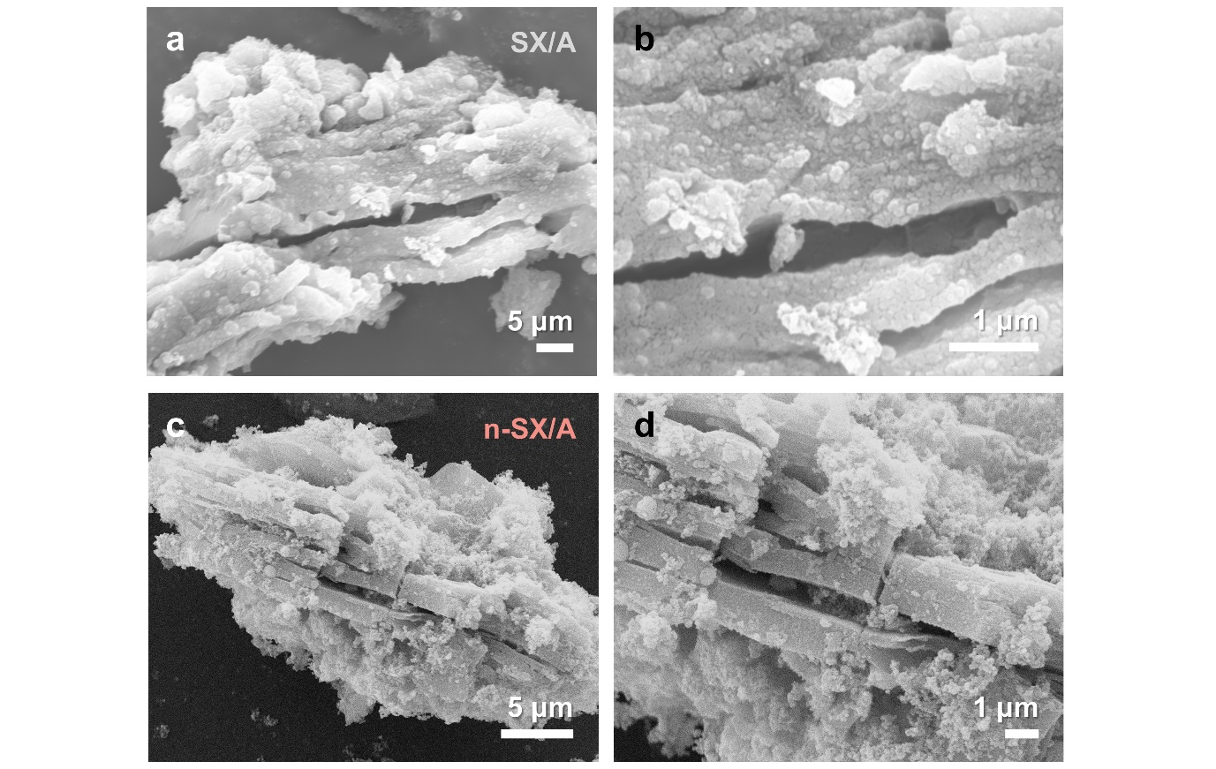
Fig. S11 Post-cycling a low- and b high-magnification SEM images of SX/A and c low- and d high-magnification SEM images of n-SX/A (after 100 cycles)
Fig. S12 High-resolution XPS Si 2p spectra of a SX/A and b n-SX/A after 100 cycles
Table S1 ICP-OES elemental analysis results and doping concentrations
Electrode | Doping process condition |  | Content (at%) |  | Doping  concentration (atoms cm⁻³)
Electrode | SX:NaH₂PO₂ | Ar flow rate (sccm) | Si | P | Doping  concentration (atoms cm⁻³)
SX | N.A. | N.A. | 49.6±0.001 | 0 | 0
n-SX | 1:2 | 100 | 51.7±0.003 | 0.05±0.02 | 2.4×10¹⁹
n-SX-101 | 1:10 | 100 | 56.0±0.02 | 0.08±0.04 | 3.6×10¹⁹
n-SX-102 | 1:10 | 200 | 55.4±0.005 | 0.15±0.004 | 6.7×10¹⁹
n-SX-103 | 1:10 | 300 | 49.4±0.001 | 0.16±0.02 | 8.1×10¹⁹
Table S2 Key electrochemical properties of the electrodes at 2000 mA g⁻¹
Electrodes | Activation  cycle | Post-activation  capacity (mAh g⁻¹) | Capacity  retention (%)
n-SX | 60 | 552 | 44
n-SX-101 | 25 | 621 | 39
n-SX-102 | 25 | 594 | 73
n-SX-103 | 15 | 756 | 56
1n3S | 60 | 329 | 67
1n1S | 30 | 315 | 56
3n1S | 14 | 413 | 45
SX | 230 | 153 | 90
Table S3 Performance summary of siloxene-based electrodes for lithium ion batteries
Material | Engineering |  | CD  (mA g⁻¹) | Capacity  (mAh g⁻¹) | Cycle  number | Retention  (%) | Refs.
Material | Intrinsic | External
n-SX-102 | Doping | N.A. | 2000 | 594 | 500 | 73 | This work
SX/SiO_{x} | Oxidization | N.A. | 750 | ~700 | 300 | 98.6 | [S2]
SX/SiO_{x} | Oxidization | N.A. | 1000 | 506 | 800 | ~99 | [S4]
SX | Oxidization | N.A. | 1000 | 750 | 200 | 77 | [S3]
SX | N.A. | Binder  selection | 1000 | 231 | 1400 | 55 | [S5]
rGO-SX | N.A. | Aerogel-mediated | 1000 | 243 | 1000 | 99.5 | [S6]
COF-SX | N.A. | Surface  modification | 2000 | 584 | 1000 | ~99 | [S7]
G-SX | N.A. | Surface modification | 4100 | 1040 | 1000 | 70 | [S8]
LM-SX | N.A. | Matrix-embedded | 2000 | 847 | 300 | ~99 | [S9]
Li-SX | N.A. | Prelithiated | 5000 | ~680 | 724 | 80 | [S10]
SX | N.A. | N.A. | 193 | 1845 | 58 | 79 | [S11]
rGO: reduced graphene oxide; COF: covalent organic framework; G: graphene; LM: liquid metal

Supplementary References
- S. Yamanaka, H. Matsu-ura, M. Ishikawa, New deintercalation reaction of calcium from calcium disilicide. Synthesis of layered polysilane. Mater. Res. Bull. 31, 307-316 (1996). https://doi.org/10.1016/0025-5408(95)00195-6
- R. Fu, Y. Li, Y. Wu, C. Shen, C. Fan et al., Controlling siloxene oxidization to tailor SiO_{x} anodes for high performance lithium ion batteries. J. Power Sources. 432, 65-72 (2019). https://doi.org/10.1016/j.jpowsour.2019.05.071
- D. J. Arnot, W. Li, D. C. Bock, C. A. Stackhouse, X. Tong et al., Low-oxidized siloxene nanosheets with high capacity, capacity retention, and rate capability in lithium-based batteries. Adv. Mater. Interfaces 9, 2102238 (2022). https://doi.org/10.1002/admi.202102238
- Y. Ren, X. Yin, L. Xiang, R. Xiao, H. Huo et al., Layer stacked SiO_{x} microparticle with disconnected interstices enables stable interphase and particle integrity for lithium-ion batteries. J. Energy Chem. 86, 300-307 (2023). https://doi.org/10.1016/j.jechem.2023.07.023
- S. I. Kim, W.-J. Kim, J. G. Kang, D.-W. Kim, Intermolecular interaction engineering to enhance lithium-ion storage in two-dimensional oxidized silicon nanosheet anodes. Chem. Eng. J. 467, 143364 (2023). https://doi.org/10.1016/j.cej.2023.143364
- S. A. Alomari, D. P. Dubal, J. MacLeod, N. Motta, Three-dimensional nitrogen-doped rGO-siloxene nanocomposite anode for Li-ion storage. Appl. Surf. Sci. 624, 157099 (2023). https://doi.org/10.1016/j.apsusc.2023.157099
- Y. Zhang, Y. Wu, Y. An, C. Wei, L. Tan et al., Ultrastable and high-rate 2D siloxene anode enabled by covalent organic framework engineering for advanced lithium-ion batteries. Small Methods. 6, 2200306 (2022). https://doi.org/10.1002/smtd.202200306
- K. T. Kumar, M. J. Kumar Reddy, G. S. Sundari, S. Raghu, R. A. Kalaivani et al., Synthesis of graphene-siloxene nanosheet based layered composite materials by tuning its interface chemistry: an efficient anode with overwhelming electrochemical performances for lithium-ion batteries. J. Power Sources. 450, 227618 (2020). https://doi.org/10.1016/j.jpowsour.2019.227618
- Y. Zhang, L. Tan, Y. Wu, Y. An, Y. Liu et al., Self-healing and ultrastable anode based on room temperature liquid metal reinforced two-dimensional siloxene for high-performance lithium-ion batteries. Appl. Mater. Today 26, 101300 (2022). https://doi.org/10.1016/j.apmt.2021.101300
- H. Shen, Y. An, Q. Man, J. Wang, C. Liu et al., Controlled prelithiation of siloxene nanosheet anodes enables high performance 5 V-class lithium-ion batteries. Chem. Eng. J. 454, 140136 (2023). https://doi.org/10.1016/j.cej.2022.140136
- L. C. Loaiza, L. Monconduit, V. Seznec, Siloxene: a potential layered silicon intercalation anode for Na, Li and K ion batteries. J. Power Sources 417, 99-107 (2019). https://doi.org/10.1016/j.jpowsour.2019.02.030

