Supporting Information for
Polymer Fiber Rigid Network with High Glass Transition Temperature Reinforces Stability of Organic Photovoltaics
Qiao Zhou¹, Cenqi Yan^{1,} *, Hongxiang Li¹, Zhendong Zhu¹, Yujie Gao¹, Jie Xiong¹, Hua Tang², Can Zhu³, Hailin Yu¹, Sandra P Gonzalez Lopez², Jiayu Wang¹, Meng Qin¹, Jianshu Li¹, Longbo Luo^{1,} *, Xiangyang Liu¹, Jiaqiang Qin¹, Shirong Lu⁴, Lei Meng³, Frédéric Laquai², Yongfang Li³, Pei Cheng^{1,} *
¹ College of Polymer Science and Engineering, State Key Laboratory of Polymer Materials Engineering, Sichuan University, Chengdu, 610065, P. R. China
² KAUST Solar Center, Physical Sciences and Engineering Division, King Abdullah University of Science and Technology (KAUST), Thuwal, Kingdom of Saudi Arabia
³ Beijing National Laboratory for Molecular Sciences, CAS Key Laboratory of Organic Solids, Institute of Chemistry, Chinese Academy of Sciences, Beijing, 100190, P. R. China
⁴ Department of Material Science and Technology, Taizhou University, Taizhou, 318000, P. R. China
*Corresponding authors. E-mail: yancenqi@scu.edu.cn (Cenqi Yan); luolongbo@scu.edu.cn (Longbo Luo); chengpei@scu.edu.cn (Pei Cheng)
Supplementary Figures and Tables
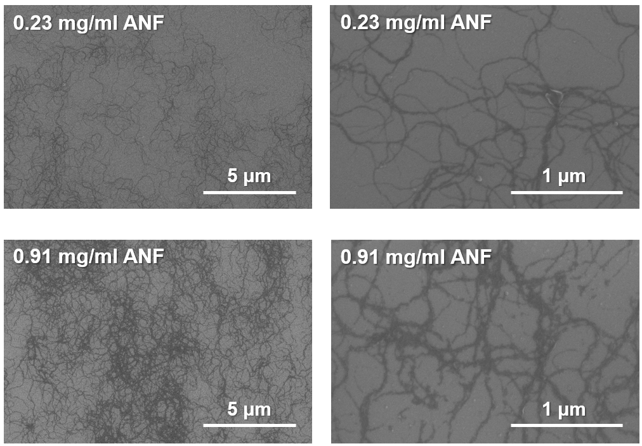
Fig. S1 SEM images of ANF films with different dispersion concentrations
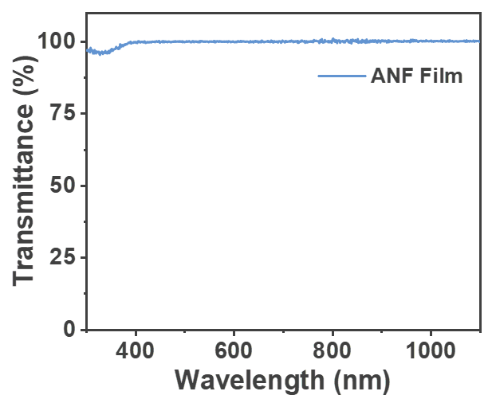
Fig. S2 Transmittance of ANF film
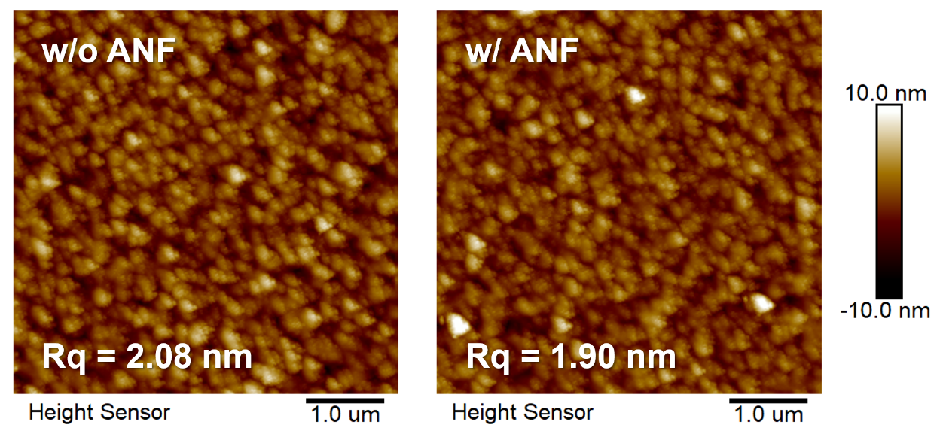
Fig. S3 AFM images of active layers with and without ANF
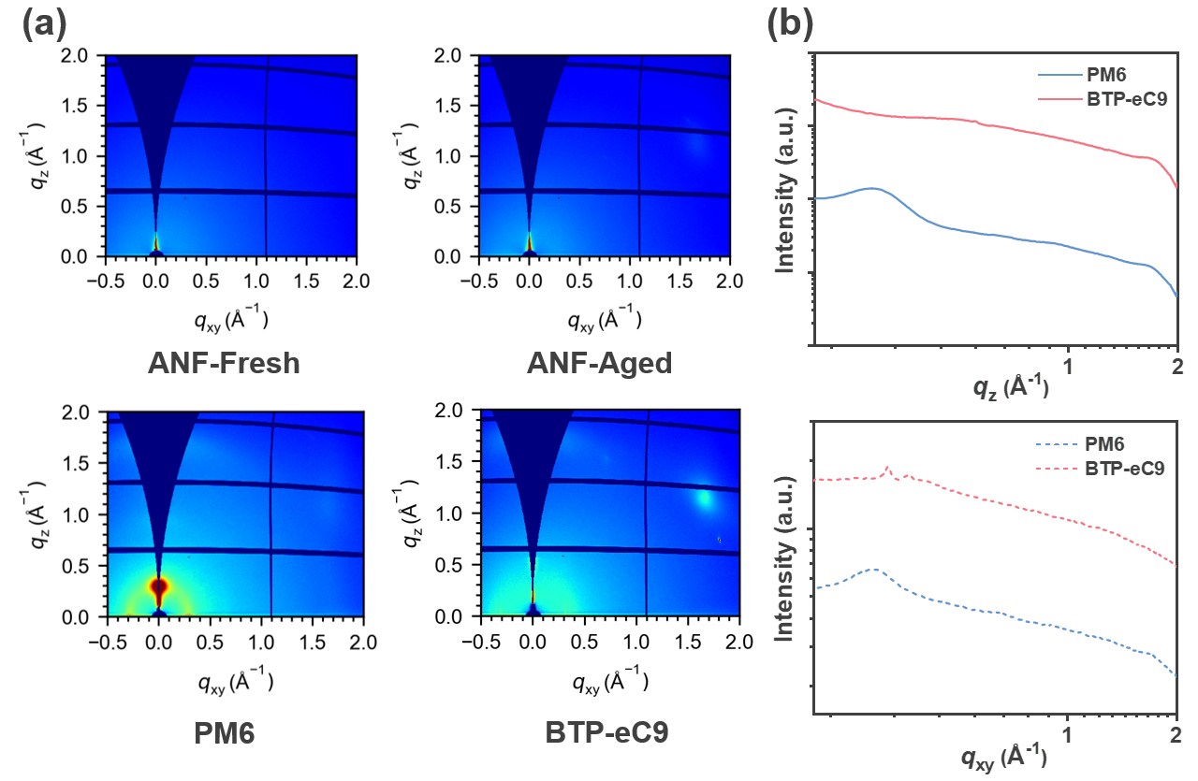
Fig. S4 a 2D and b 1D GIWAXS diffraction patterns of neat PM6, BTP-eC9, ANF-fresh and ANF-aged films
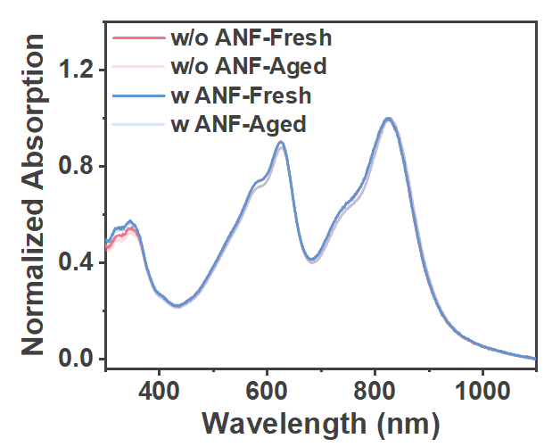
Fig. S5 Normalized absorption spectra of PM6:BTP-eC9 blend films without and with ANF before and after heating at 130 °C for 3 h
Table S1 Photovoltaic parameters decay of PM6: BTP-eC9-based OPVs with ANF of different dispersion concentrations heated at 130 °C for 0, 10, 20, 30, 60, 120, and 180 min
ANF dispersion concentration (mg mL⁻¹) | heating time (min) | remaining V_{OC} ratio ^{a)} | remaining  J_{SC} ratio ^{a)} | remaining  FF ratio ^{a)} | remaining  PCE ratio ^{a)}
0 | 0 | 1.00 | 1.00 | 1.00 | 1.00
0 | 10 | 0.957 | 1.01 | 0.945 | 0.907
0 | 20 | 0.943 | 1.02 | 0.941 | 0.899
0 | 30 | 0.940 | 1.02 | 0.939 | 0.897
0 | 60 | 0.921 | 1.02 | 0.923 | 0.865
0 | 120 | 0.903 | 1.02 | 0.912 | 0.837
0 | 180 | 0.894 | 1.01 | 0.909 | 0.820
0.23 | 0 | 1.00 | 1.00 | 1.00 | 1.00
0.23 | 10 | 0.985 | 1.01 | 0.963 | 0.954
0.23 | 20 | 0.981 | 1.02 | 0.975 | 0.971
0.23 | 30 | 0.978 | 1.02 | 0.972 | 0.970
0.23 | 60 | 0.974 | 1.03 | 0.971 | 0.971
0.23 | 120 | 0.965 | 1.03 | 0.964 | 0.951
0.23 | 180 | 0.962 | 1.02 | 0.959 | 0.938
0.46 | 0 | 1.00 | 1.00 | 1.00 | 1.00
0.46 | 10 | 0.987 | 1.00 | 0.968 | 0.955
0.46 | 20 | 0.982 | 1.01 | 0.975 | 0.965
0.46 | 30 | 0.979 | 1.01 | 0.977 | 0.966
0.46 | 60 | 0.975 | 1.02 | 0.974 | 0.960
0.46 | 120 | 0.970 | 1.01 | 0.970 | 0.946
0.46 | 180 | 0.967 | 1.00 | 0.964 | 0.933
0.91 | 0 | 1.00 | 1.00 | 1.00 | 1.00
0.91 | 10 | 0.989 | 1.00 | 0.970 | 0.959
0.91 | 20 | 0.982 | 1.01 | 0.972 | 0.960
0.91 | 30 | 0.979 | 1.01 | 0.973 | 0.960
0.91 | 60 | 0.976 | 1.01 | 0.969 | 0.951
0.91 | 120 | 0.972 | 1.01 | 0.968 | 0.945
0.91 | 180 | 0.970 | 1.00 | 0.962 | 0.931
^{a)} Average value of eight independent devices
Table S2 Average and best device data based on PM6: L8-BO, PM6: PC₇₁BM, and PTB7-Th: IEICO-4F blend films without and with ANF before and after heating at 130 °C for 180 min
active layer | ANF | heating time (min) | V_{OC} (V) | J_{SC}  (mA cm⁻²) | FF (%) | PCE (%)
 |  |  |  |  |  | best | average ^{a)}
PM6:L8-BO | w/o | 0 | 0.878 | 24.6 | 76.4 | 16.5 | 16.1
PM6:L8-BO | w/o | 180 | 0.790 | 24.8 | 65.3 | 12.8 | 13.0
PM6:L8-BO | w | 0 | 0.875 | 24.9 | 74.4 | 16.2 | 16.0
PM6:L8-BO | w | 180 | 0.843 | 25.2 | 68.9 | 14.6 | 14.5
PM6:PC₇₁BM | w/o | 0 | 0.872 | 12.9 | 61.8 | 6.93 | 6.55
PM6:PC₇₁BM | w/o | 180 | 0.816 | 11.7 | 57.3 | 5.46 | 5.05
PM6:PC₇₁BM | w | 0 | 0.861 | 12.8 | 54.6 | 6.01 | 5.55
PM6:PC₇₁BM | w | 180 | 0.826 | 11.8 | 52.7 | 5.15 | 5.03
PTB7-Th:IEICO-4F | w/o | 0 | 0.725 | 24.3 | 58.8 | 10.3 | 9.87
PTB7-Th:IEICO-4F | w/o | 180 | 0.588 | 23.6 | 48.4 | 6.71 | 6.87
PTB7-Th:IEICO-4F | w | 0 | 0.727 | 23.9 | 57.8 | 10.1 | 9.65
PTB7-Th:IEICO-4F | w | 180 | 0.712 | 24.0 | 52.6 | 9.01 | 8.65
^{a)} Average value of eight independent devices

