Supporting Information for
An Artificial Intelligence-Assisted Flexible and Wearable Mechanoluminescent Strain Sensor System
Yan Dong^{1,} *, Wenzheng An¹, Zihu Wang¹ and Dongzhi Zhang^{1,}*
¹College of Control Science and Engineering, China University of Petroleum (East China), Qingdao 266580, P. R. China
*Corresponding authors. E-mail: dzzhang@upc.edu.cn (Dongzhi Zhang); yandong@upc.edu.cn (Yan Dong)
Supplementary Figures
Fig. S1 Schematic illustration of the preparation process of SFLC film
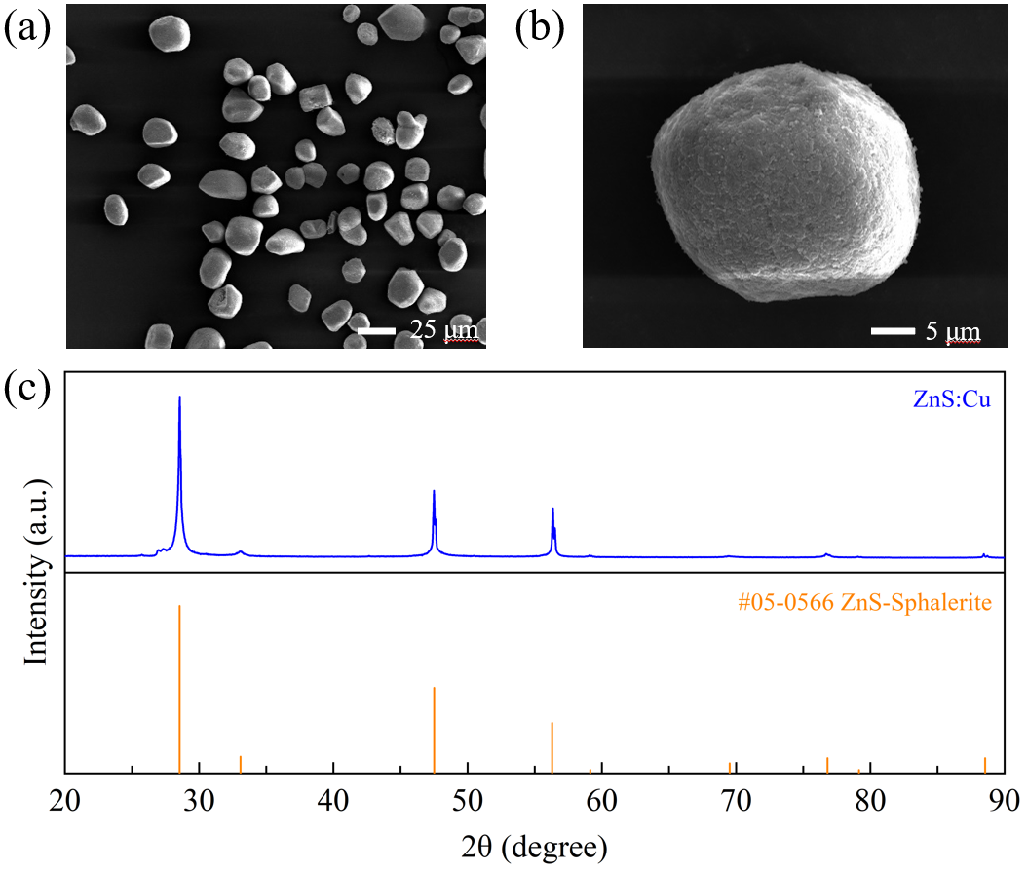
Fig. S2 (a) and (b) SEM image of the ZnS:Cu fluorescent particles for the fabrication of the SFLC film. (c) XRD of the ZnS:Cu fluorescent particles
Fig. S3 (a) Schematic illustration of the ZnS:Cu-SG/PDMS film stripping test. (b) Stripping force vs displacement curve of the ZnS:Cu-SG/PDMS film

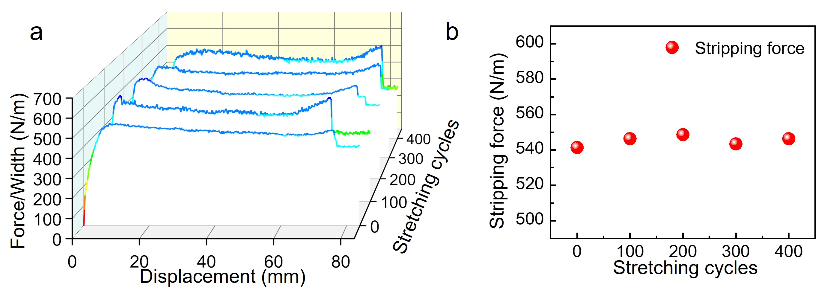
Fig. S4 (a) Stripping force vs displacement curves of the SFLC film after different stretching cycles. (b) Stripping force at the beginning of detachment of PDMS layer and the SG layer of the SFLC film

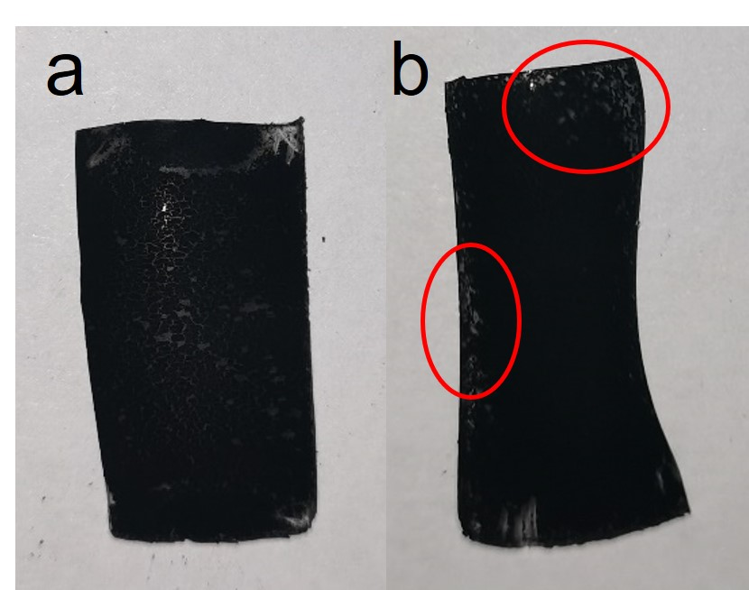
Fig. S5 Photos of SFLC film fabricated by different methods (a) drop-casting method (b) brush-casting method, the CNTs film in the red circles is not uniform
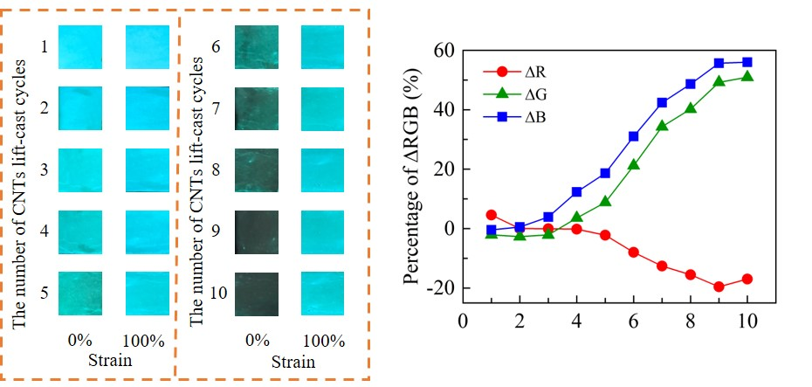
Fig. S6 Effects of number of lift-cast cycles of the top CNTs layers on the strain sensing performance of the SFLC film
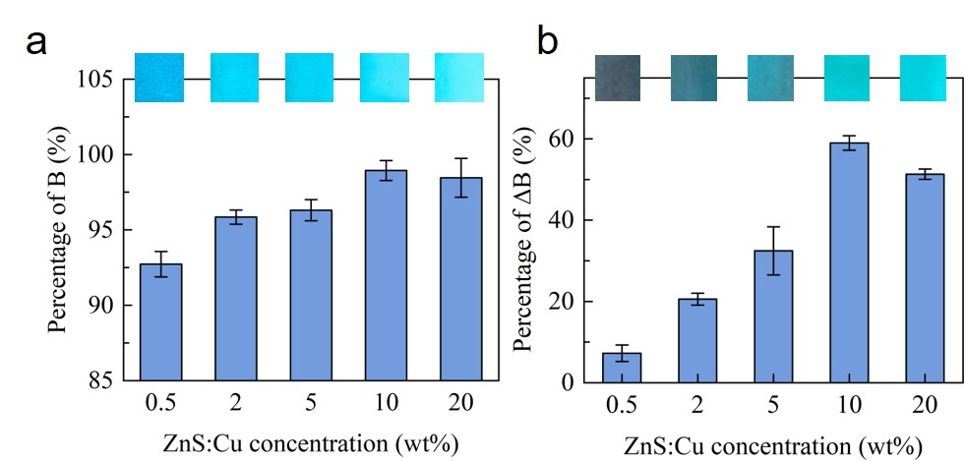
Fig. S7 Effects of ZnS:Cu concentration in the SG layer on the performance of the SFLC film. (n = 5, mean ± s.d.)\

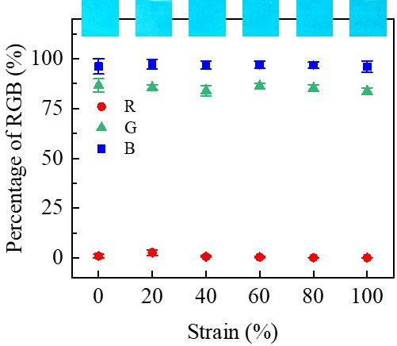
Fig. S8 Effects of PDMS layer deformation on the detected fluorescent intensity

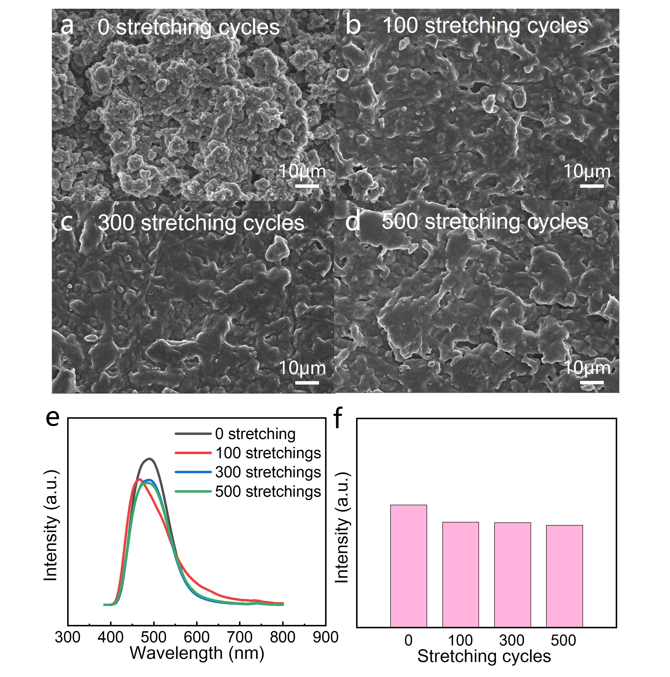
Fig. S9 SEM images showing the surface morphology of the top CNTs shielding layer after (a) 0, (b) 100, (c) 300, and (d) 500 stretching cycles. (e) PL spectrum and (f) comparison of the peak intensity of the PL spectrum of the SFLC film under the same strain after different stretching cycles
Table S1 List of features for the color data for neural network training and strain prediction
No. | Feature | Description | No. | Feature | Description
1 | R_{m} | Mean value of R channel | 13 | V_{m} | Mean value of V channel
2 | G_{m} | Mean value of G channel | 14 | X_{m} | Mean value of X channel
3 | B_{m} | Mean value of B channel | 15 | Y_{m} | Mean value of Y channel
4 | R_{m}/RGB_{n} | Ratio of R_{m} and RGB_{n} | 16 | Z_{m} | Mean value of Z channel
5 | G_{m}/RGB_{n} | Ratio of G_{m} and RGB_{n} | 17 | L_{m} | Mean value of L channel
6 | B_{m}/RGB_{n} | Ratio of B_{m} and RGB_{n} | 18 | a_{m} | Mean value of a channel
7 | RGB_{n} | Sum of R_{m}, G_{m}, B_{m} | 19 | b_{m} | Mean value of b channel
8 | Intensity  (unweighted) | Grey scale formula result  0.299*R_{m}+0.587* G_{m}+0.114* B_{m} | 20 | HSV_{n} | Sum of H_{m}, S_{m}, V_{m}
9 | Cb_{m} | Mean value of C_{b} channel  -0.172*R_{m}-0.339* G_{m}+0.511* B_{m}+128 | 21 | XYZ_{n} | Sum of X_{m}, Y_{m}, Z_{m}
10 | Cr_{m} | Mean value of C_{r} channel  0.511*R_{m}-0.428* G_{m}-0.083* B_{m}+128 | 22 | Lab | Sum of L_{m}, a_{m}, b_{m}
11 | H_{m} | Mean value of H channel | 23 | Strain | Strain of the sensor
12 | S_{m} | Mean value of S channel | 24 | CT | Color temperature
Table S2 Parameters of 1D-CNN-GRU model for strain prediction
Layer | Name | Input  shape | Number of neurons | Convolution kernel | Step size | Return sequences | Activation function | Output shape
1 | InputLayer | 24×1 | － | － | － | － | － | 24×1
2 | Conv1D | 24×1 | 32 | (1,1) | 1 | － | Relu | 24×32
3 | MaxPooling1D | 24×32 | － | － | 1 | － | － | 24×32
4 | Conv1D | 24×32 | 64 | (1,1) | 1 | － | Relu | 24×64
5 | Conv1D | 24×32 | 64 | (1,1) | 1 | － | Relu | 24×64
6 | MaxPooling1D | 24×64 | － | － | 1 | － | － | 24×64
7 | Conv1D | 24×64 | 128 | (1,1) | 1 | － | Relu | 24×128
8 | Conv1D | 24×64 | 128 | (1,1) | 1 | － | Relu | 24×128
9 | MaxPooling1D | 24×128 | － | － | 1 | － | － | 24×128
10 | GRU | 24×128 | 64 | (1,1) | － | True | Linear | 24×64
11 | GRU | 24×64 | 64 | (1,1) | － | False | Linear | 64
12 | Dense | 64 | 1 | － | － | － | Linear | 1
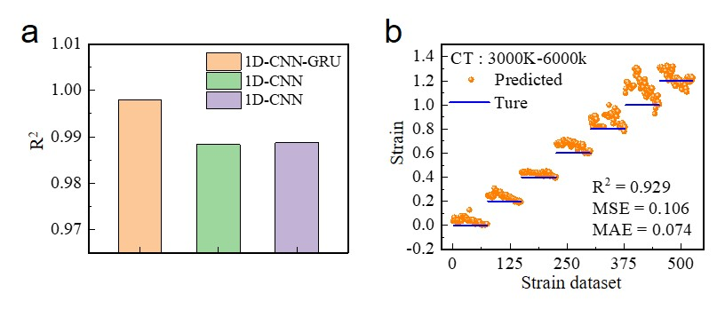
Fig. S10 (a) Comparison of the coefﬁcient of determination (R²) of the output results of the three neural network models. (b) Comparison of the predicted strains (yellow dots) obtained under different color temperature with the true strain values (blue line) without color temperature auto-correction
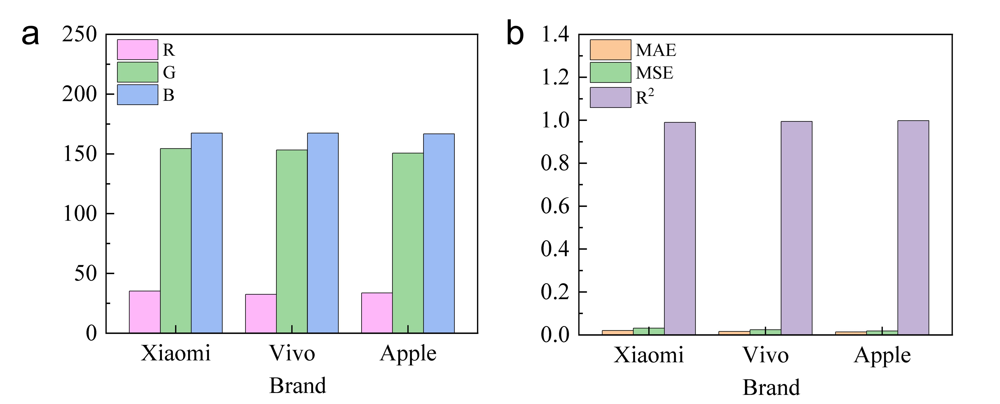
Fig. S11 (a) RGB values extracted from phots of the same SFLC film taken by smartphones of different brands. (b) RMSE, MAE, and R² values obtained using photos taken by smartphones of different brands
Table S3 RMSE, MAE, and R2 values obtained using photos taken by smartphones of different brands
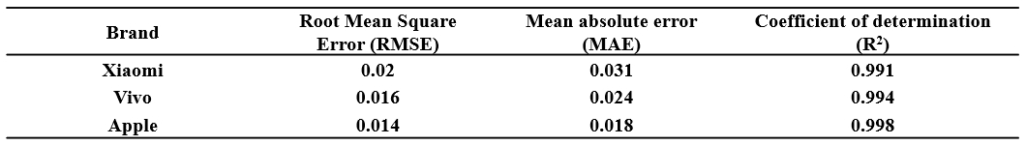

Table S4 Effects of repetitive bending on the strain prediction performance of the sensor system
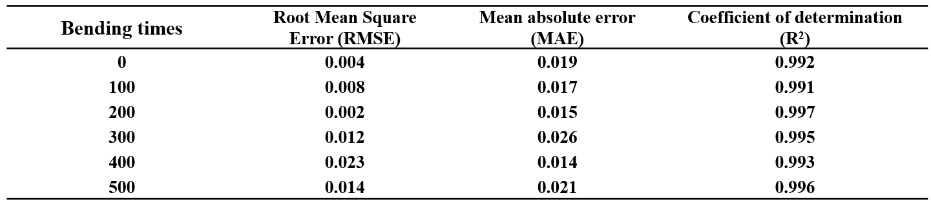

Table S5 Effects of repetitive twisting on the strain prediction performance of the sensor system
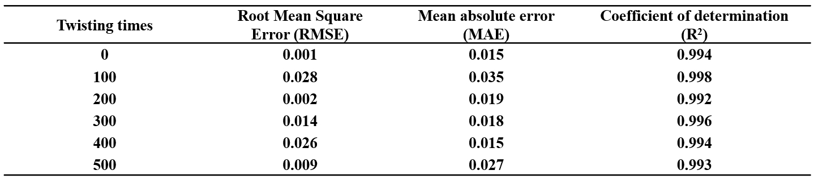

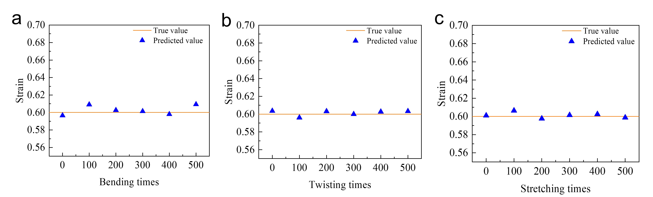

Fig. S12 The strain prediction results of repetitive testing of the sensor film after multiple times of (a) bending, (b) twisting, and (c) stretching

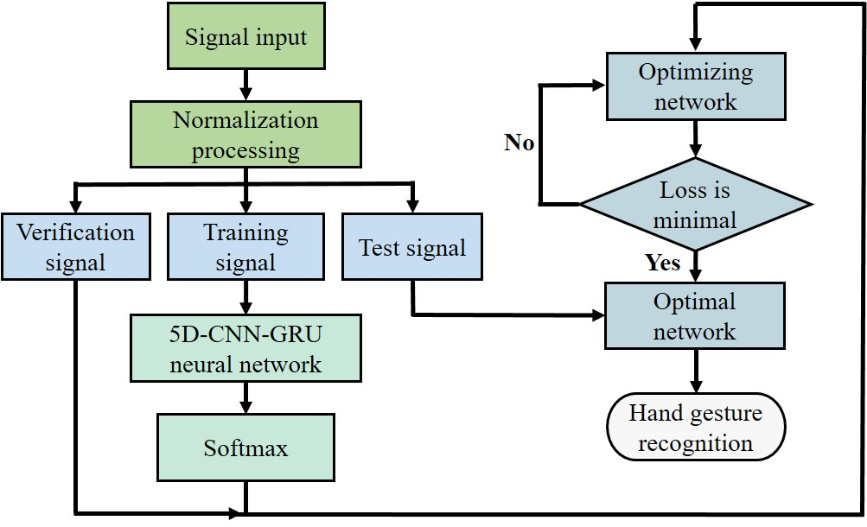
Fig. S13 Algorithm flow chart showing the training and optimization process of the 5D-CNN-GRU neural network for hand gesture recognition

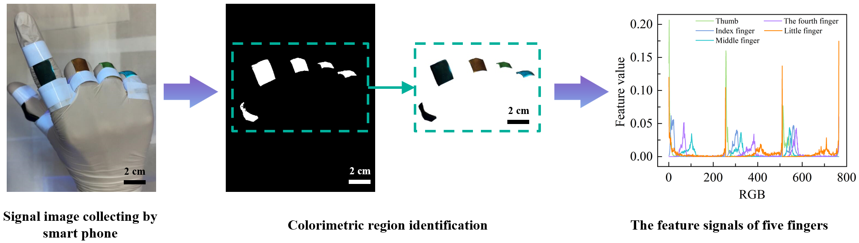
Fig. S14 Process of the color data extraction and conversion to RGB distribution from the image of a human hand wearing the smart glove

Table S6 Parameters of 5D-CNN-GRU model for hand gesture recognition
Layer | Name |  | Input  shape | Number of neurons | Return sequences | Activation function | Output shape
1 | Input | Chanel 1 | 765×1 | － | － | － | 765×1
1 | Input | Chanel 2 | 765×1 | － | － | － | 765×1
1 | Input | Chanel 3 | 765×1 | － | － | － | 765×1
1 | Input | Chanel 4 | 765×1 | － | － | － | 765×1
1 | Input | Chanel 5 | 765×1 | － | － | － | 765×1
2 | Function model |  | 765×1 | － | － | － | 753×64
2 |  |  | 765×1 | － | － | － | 753×64
2 |  |  | 765×1 | － | － | － | 753×64
2 |  |  | 765×1 | － | － | － | 753×64
2 |  |  | 765×1 | － | － | － | 753×64
3 | Concatenate |  | 753×64 | － | － | － | 753×320
3 |  |  | 753×64
3 |  |  | 753×64
3 |  |  | 753×64
3 |  |  | 753×64
4 | GRU |  | 753×320 | 64 | True | Linear | 753×64
5 | GRU |  | 753×64 | 32 | False | Linear | 32
6 | Dense |  | 32 | 1 | － | Softmax | 11
Table S7 The network parameters of 5D-CNN-GRU Functional model
Layer | Name | Input  shape | Number of neurons | Convolution kernel | Step size | Activation function | Output shape
1 | InputLayer | 765×1 | － | － | － | － | 765×1
2 | Conv1D | 765×1 | 16 | (4,1) | 1 | Relu | 762×16
3 | Conv1D | 762×16 | 16 | (4,1) | 1 | Relu | 759×16
4 | MaxPooling1D | 759×16 | － | － | 1 | － | 759×16
5 | Conv1D | 759×16 | 64 | (4,1) | 1 | Relu | 756×64
6 | Conv1D | 756×64 | 64 | (4,1) | 1 | Relu | 753×64
7 | MaxPooling1D | 753×64 | － | － | 1 | － | 753×64

