Supporting Information for
Scalable Fabrication of Methylammonium-Free Wide-Bandgap Perovskite Solar Cells by Blade Coating in Ambient Air
Jianbo Liu¹, Meng Zhang^{2,} *, Xiaoran Sun¹, Linhu Xiang¹, Xiangyu Yang¹, Xin Hu³, Zhicheng Wang¹, Tian Hou¹, Jinzhao Qin³, Yuelong Huang^{1, 3,} *, Mojtaba Abdi-Jalebi^{4,} *, and Xiaojing Hao^{2,} *
¹ School of New Energy and Materials, Southwest Petroleum University, Chengdu 610500, P. R. China
² The Australian Centre for Advanced Photovoltaics, School of Photovoltaic and Renewable Energy Engineering, University of New South Wales, Sydney, New South Wales 2052, Australia
³ Huzhou Phoenixolar Co., Ltd., Huzhou 313000, P. R. China
⁴ Institute for Materials Discovery, University College London, Malet Place, London WC1E 7JE, UK

*Corresponding authors. E-mail: meng.zhang@unsw.edu.au (Meng Zhang); hyl@phoenixolar.com (Yuelong Huang); m.jalebi@ucl.ac.uk (Mojtaba Abdi-Jalebi); xj.hao@unsw.edu.au (Xiaojing Hao)

S1 Supplementary Figures and Tables
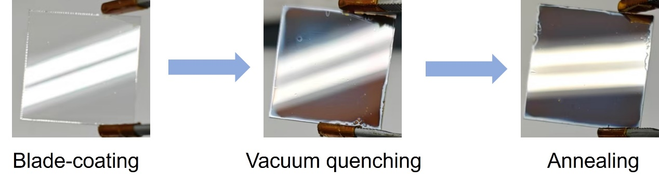
Fig. S1 Photos of blade-coated WBG perovskite films at different stage
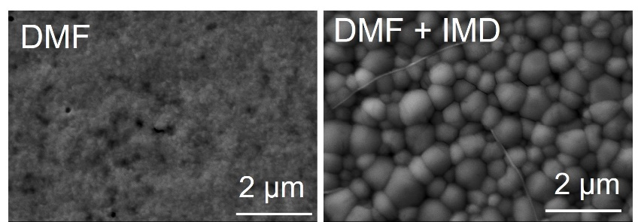
Fig. S2 SEM images of blade-coated WBG perovskite films fabricated using DMF and DMF + IMD solvent systems

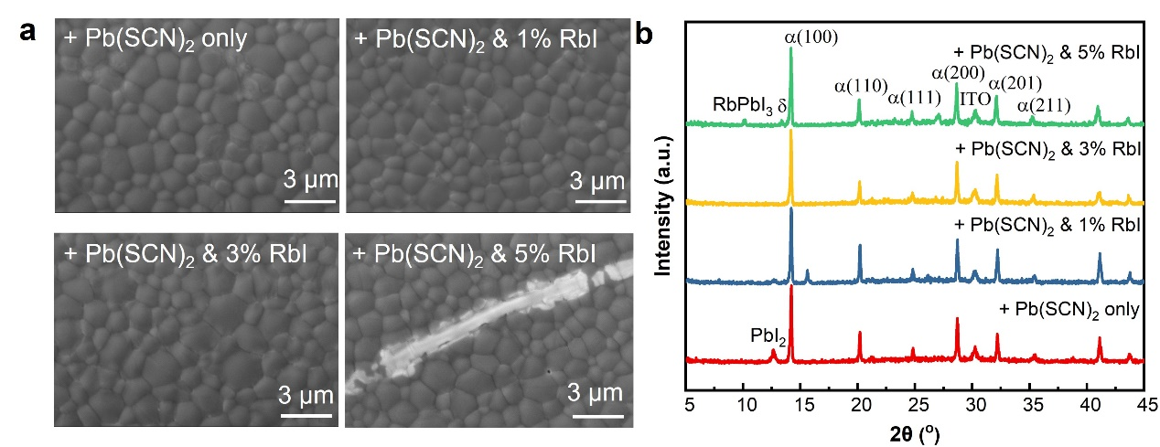
Fig. S3 a SEM images and b XRD patterns of perovskite films with varying RbI concentrations

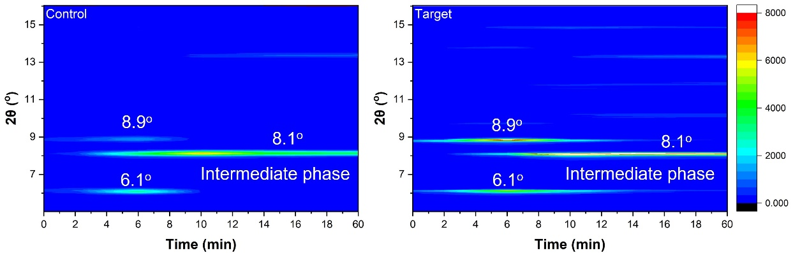
Fig. S4 Time-resolved XRD analysis of phase evolution in control and target perovskite films during ambient drying

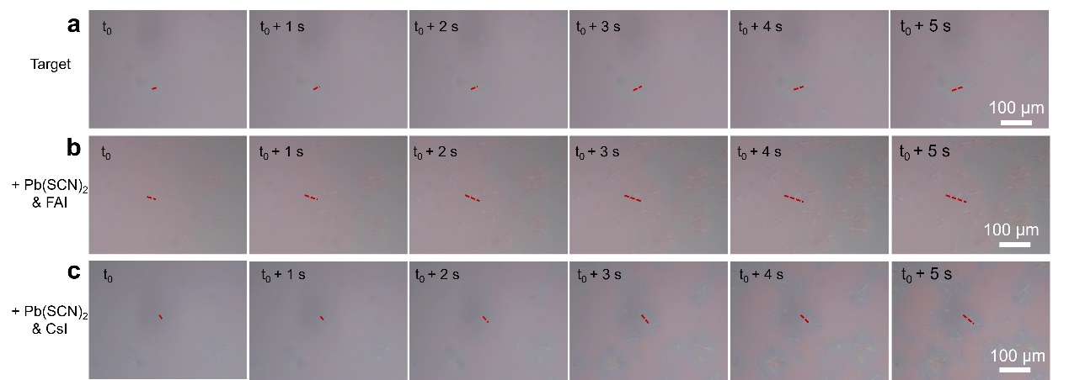
Fig. S5 The dendrite growth during natural drying of WBG precursor films with a RbI, b FAI, and c CsI

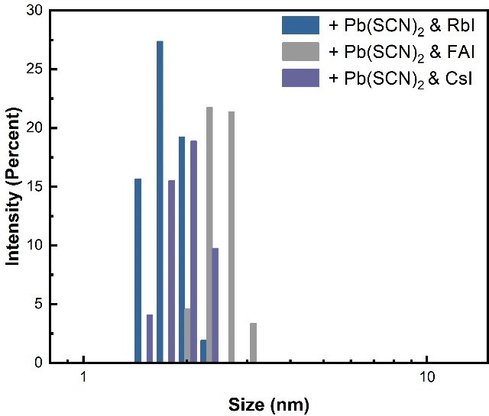
Fig. S6 Dynamic light scattering (DLS) size distributions of perovskite precursor solutions with RbI, FAI, and CsI (test concentration: 1.5 M)
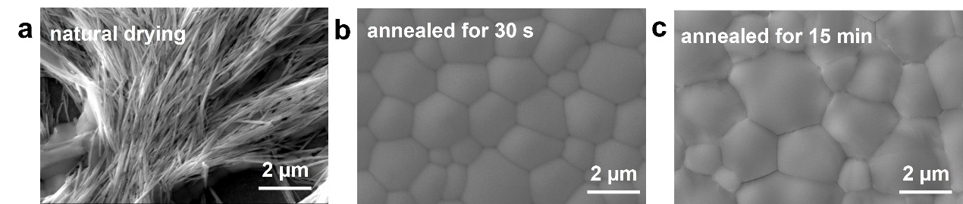
Fig. S7 SEM images of target films under different conditions: a natural drying, b annealed for 30 s, and c annealed for 15 min
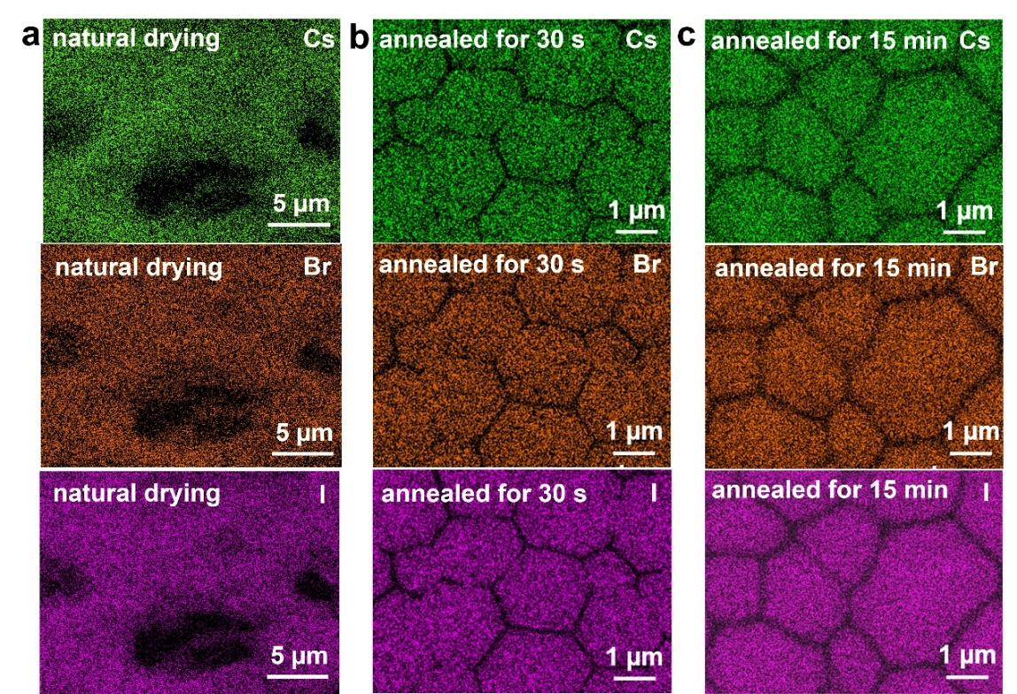
Fig. S8 EDS mapping of target films of Cs, Br, and I elements under different conditions: a natural drying, b annealed for 30 s, and c annealed for 15 min
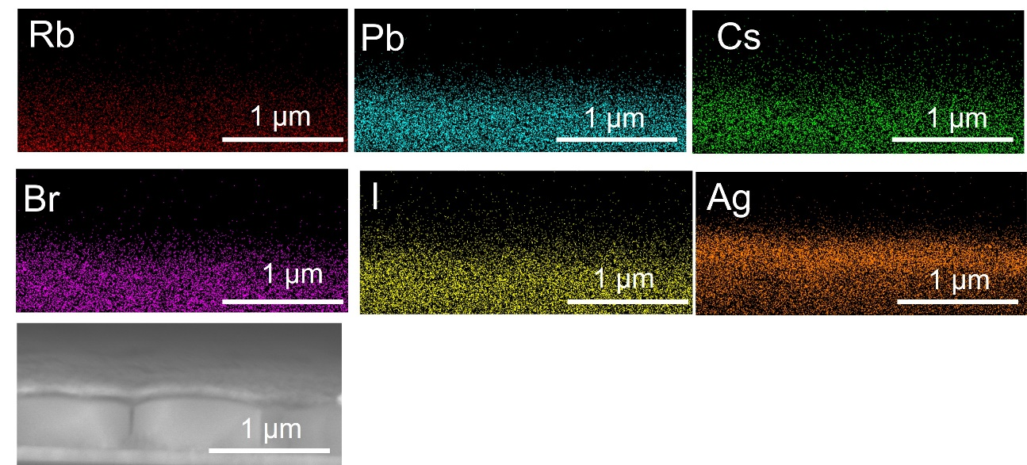
Fig. S9 Cross-sectional EDS elemental mapping of the target perovskite film

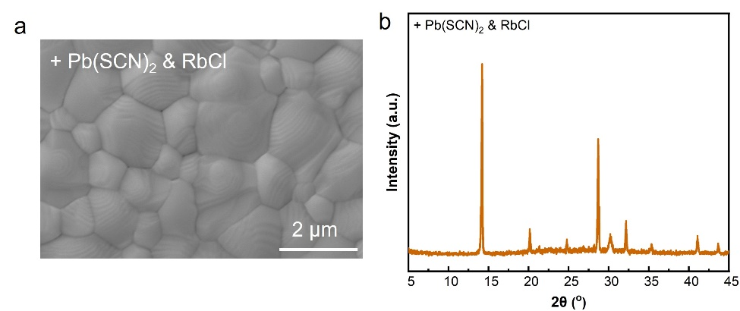
Fig. S10 a SEM image and b XRD pattern of perovskite film with 3% RbCl

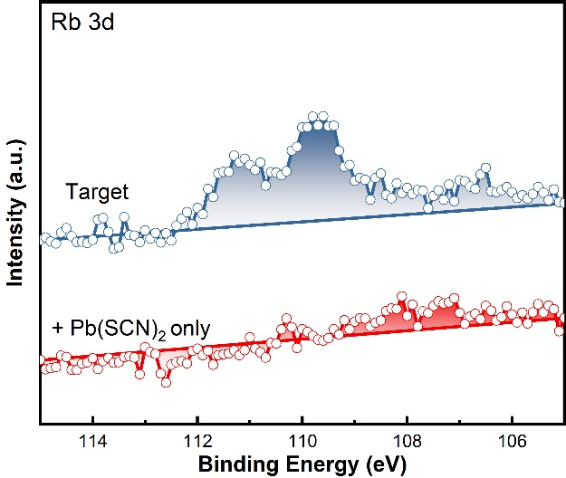
Fig. S11 XPS spectra of the Rb 3d regions
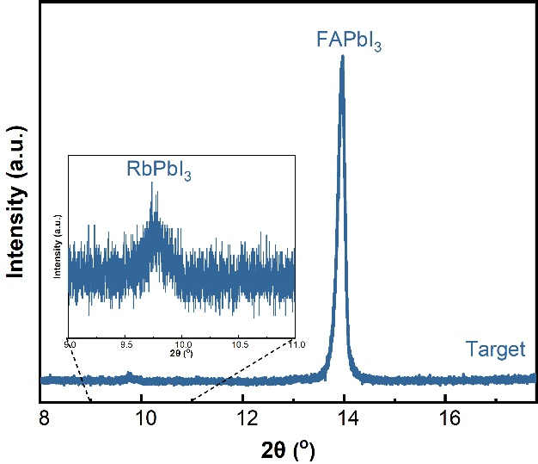
Fig. S12 XRD pattern of target perovskite film
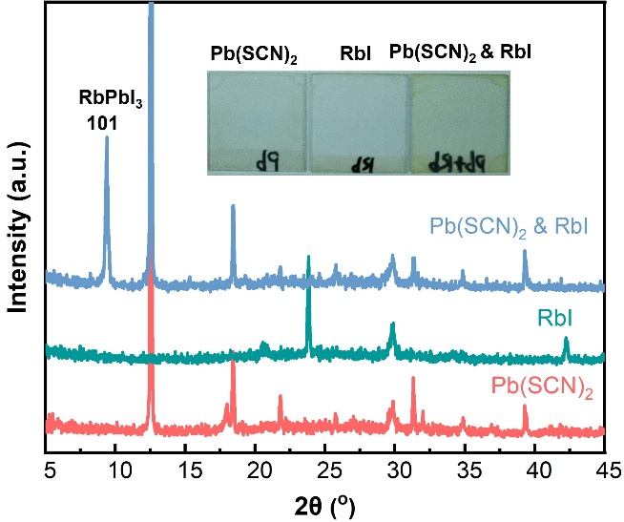
Fig. S13 XRD patterns of Pb(SCN)₂, RbI, and a mixture of Pb(SCN)₂ and RbI (the inserted images are photos of the three films)
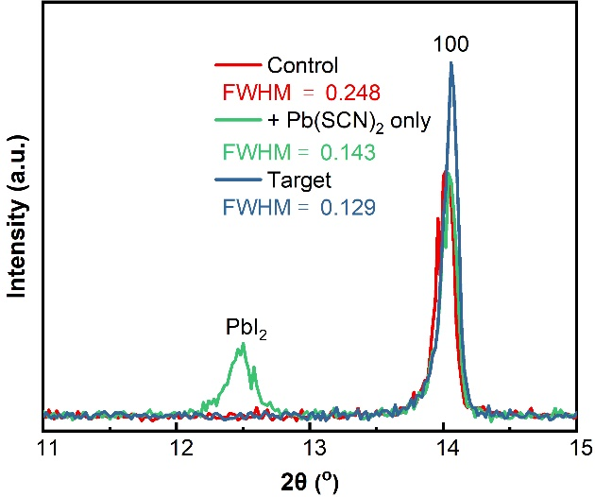
Fig. S14 XRD patterns and FWHM of perovskite films
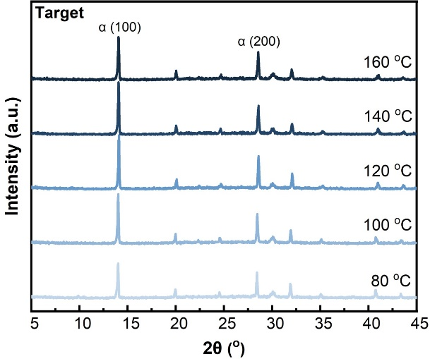
Fig. S15 XRD patterns of the as-deposited perovskite precursor films before annealing
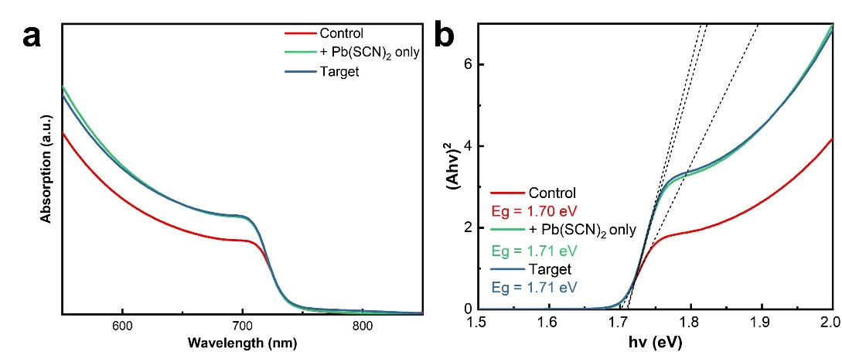
Fig. S16 a UV-vis absorption spectra and b Tauc plot of the FA_{0.8}Cs_{0.2}Pb(I_{0.75}Br_{0.25})₃ perovskite films
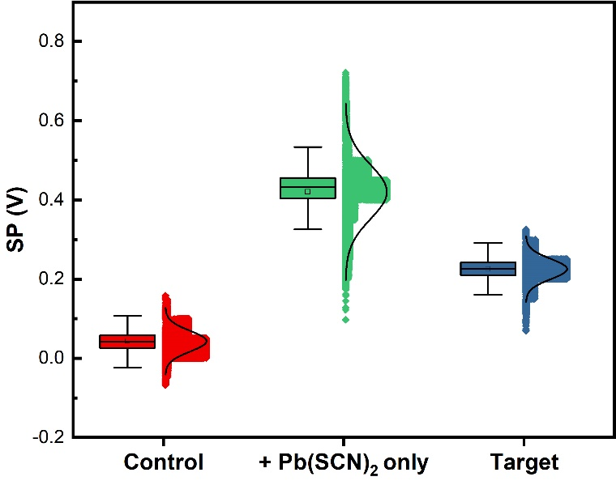
Fig. S17 The surface potential (SP) statistics values from KPFM measurements for the control, Pb(SCN)₂ only, and target films
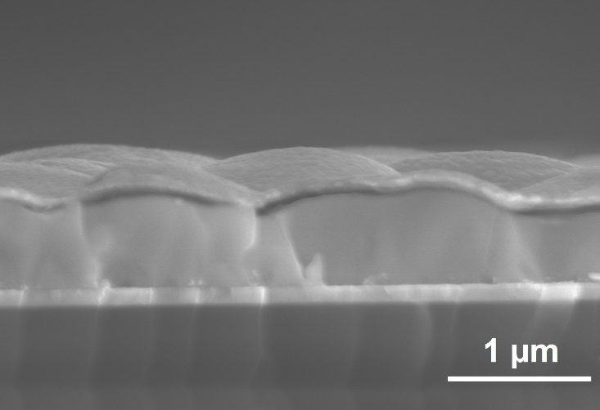
Fig. S18 Cross-sectional SEM image of the target device

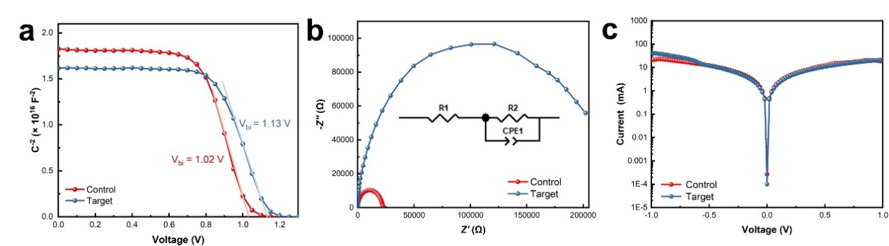
Fig. S19 a Mott-Schottky plots of the control and target devices; b Electrochemical impedance spectroscopy (EIS) spectrum of the control and target devices; c Dark J-V curves of the control and target devices

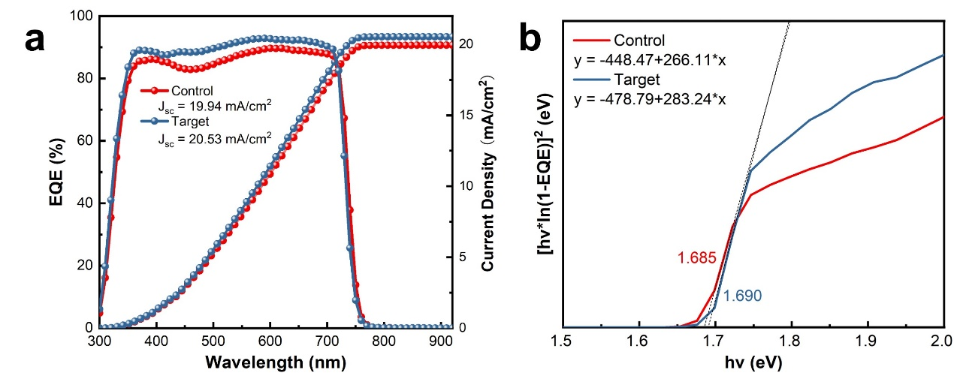
Fig. S20 a EQE spectra of control and target devices and b Bandgap values of control and target perovskite films, determined from EQE spectra
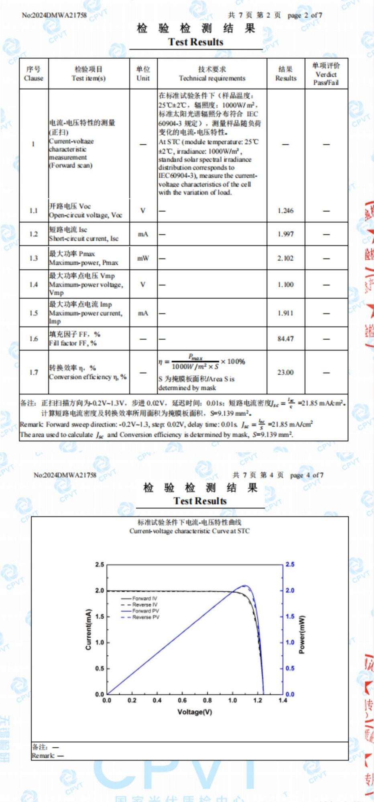
Fig. S21 Certification report for small area WBG PSCs
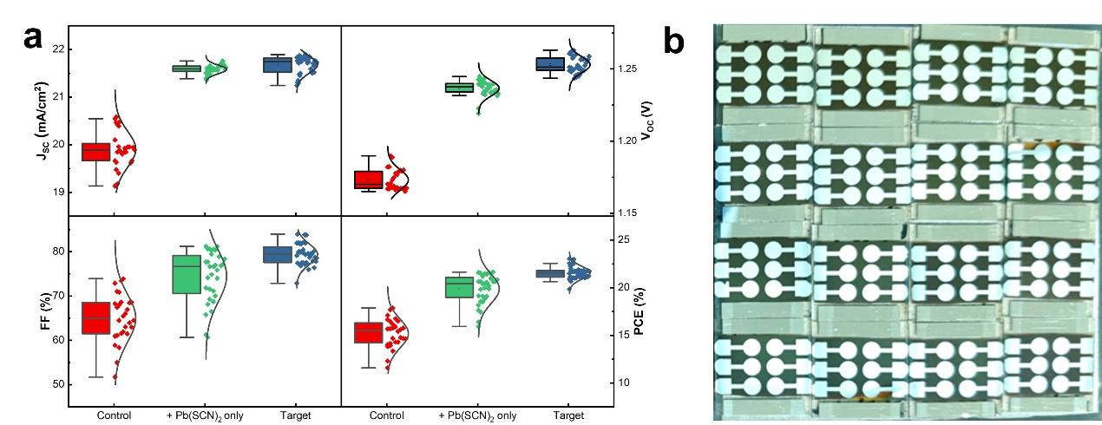
Fig. S22 a Distribution of PV parameters for the control, Pb(SCN)₂ only, and target devices. b Photos of the devices

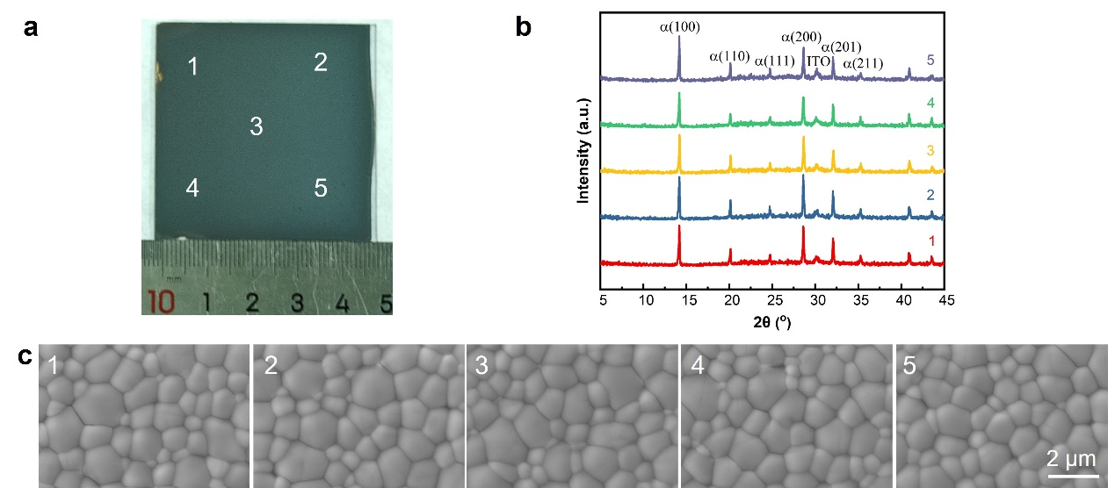
Fig. S23 a Photograph of a 5×5 cm² target film prepared by blade-coating. b XRD patterns and c SEM images collected at 5 different spots on the film
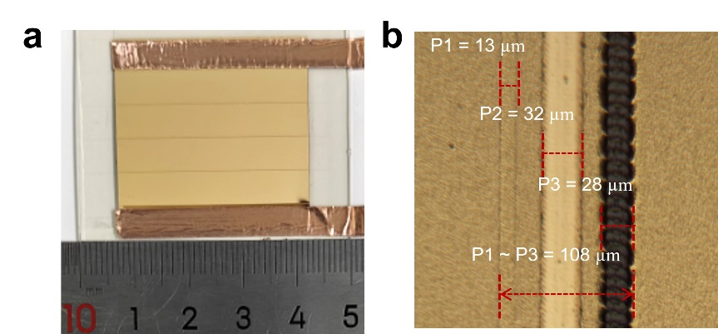
Fig. S24 a Photos of the mini-module. b The optical image of the P1-P2-P3 patterning of the mini-module
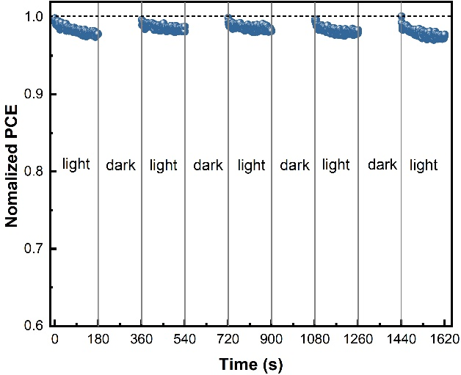
Fig. S25 MPPT of the mini-module under multiple light/dark cycles

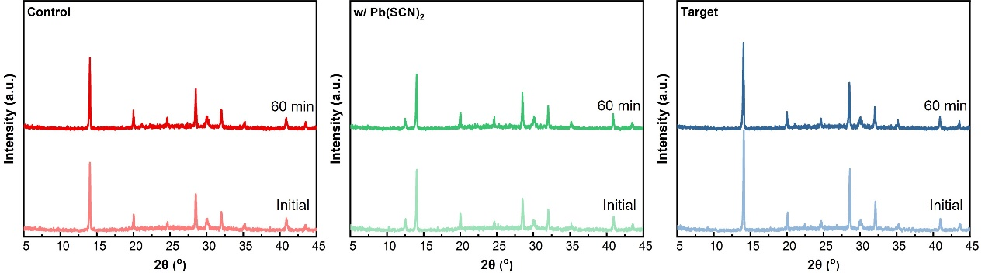
Fig. S26 XRD patterns of FA_{0.8}Cs_{0.2}Pb(I_{0.75}Br_{0.25})₃ perovskite films before and after heating at 65 ºC for 60 minutes under one-sun irradiation

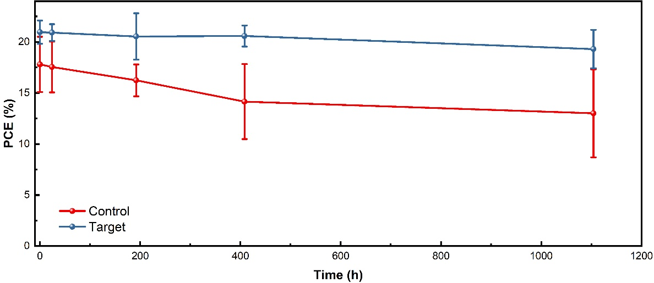
Fig. S27 The storage stability of the control and target devices in air (at 25 °C with a relative humidity of 30 ± 10%)

Table S1 Blade-coated champion single-junction WBG devices
Bandgap (eV) | Component | Voc  (V) | Jsc  (mA/cm²) | FF  (%) | PCE  (%) | Area  (cm²) | Years
1.65 | Cs_{0.1}MA_{0.9}Pb(I_{0.9}Br_{0.1})₃ | 1.167 | 21 | 82 | 20.1 | 0.06 | 2020 [S1]
1.65 | Cs_{0.1}FA_{0.2}MA_{0.7}Pb(I_{0.85}Br_{0.15})₃ | 1.23 | 21.2 | 83.8 | 21.9 | 0.06 | 2022 [S2]
1.61 | FA_{0.75}Cs_{0.25}PbI_{2.7}Br_{0.3} | 1.14 | 23.4 | 75.6 | 20.2 | 0.1 | 2022 [S3]
1.65 | Cs_{0.17}FA_{0.83}Pb(I_{0.8}Br_{0.2})₃ | 1.24 | 20.80 | 79.5 | 20.56 | 0.094 | 2022 [S4]
1.65 | Cs_{0.17}FA_{0.83}Pb(I_{0.8}Br_{0.2})₃ | 1.21 | 20.55 | 74.0 | 18.4 | 1.00 | 2022 [S4]
1.71 | FA_{0.9}Cs_{0.1}Pb(I_{0.7}Br_{0.3})₃ | 1.27 | 20.32 | 81.22 | 20.84 | 0.09 | 2022 [S5]
1.68 | (FA_{0.65}MA_{0.2}Cs_{0.15})Pb(I_{0.8}Br_{0.2})₃ | 1.16 | 20.94 | 81.8 | 19.92 | 0.07 | 2023 [S6]
1.68 | Cs_{0.22}(FA_{0.8}MA_{0.2})_{0.78}Pb(I_{0.83}Br_{0.14}Cl_{0.03})₃ | 1.21 | 21.3 | 79.6 | 20.9 | 0.1 | 2024 [S7]
1.67 | FA_{0.7}Cs_{0.25}MA_{0.05}Pb(I_{0.8}Br_{0.2})₃ | 1.25 | 21.05 | 84.34 | 22.06 | 0.07 | 2024 [S8]
1.67 | FA_{0.7}Cs_{0.25}MA_{0.05}Pb(I_{0.8}Br_{0.2})₃ | 1.26 | 20.15 | 76.98 | 19.63 | 1.02 | 2024 [S8]
1.67 | Cs_{0.22}FA_{0.63}MA_{0.15}PbI_{0.83}Br_{0.14}Cl_{0.03} | 1.23 | 21.4 | 85.0 | 22.4 | 0.057 | 2024 [S9]
1.67 | Cs_{0.22}FA_{0.63}MA_{0.15}PbI_{0.83}Br_{0.14}Cl_{0.03} | 4.78 | 20.8 | 79 | 19.6 | 9.8 | 2024 [S9]
1.66 | (Cs_{0.22}FA_{0.63}MA_{0.15})Pb(I_{0.83}Br_{0.14}Cl_{0.03})₃ | 1.24 | 23.1 | 82.9 | 22.6 | 0.1 | 2024 [S10]
1.68 | Cs_{0.25}FA_{0.75}Pb(I_{0.8}Br_{0.2})₃ | 1.20 | 20.72 | 85.37 | 21.31 |  | 2024 [S11]
1.68 | Cs_{0.05}FA_{0.80}MA_{0.15}PbI_{2.25}Br_{0.75} | 1.24 | 20.6 | 84 | 21.5 | 1.05 | 2024 [S12]
1.69 | FA_{0.8}Cs_{0.2}PbI_{2.25}Br_{0.75} | 1.26 | 21.75 | 83.94 | 23.0 | 0.093 | Our work,  2025
1.69 | FA_{0.8}Cs_{0.2}PbI_{2.25}Br_{0.75} | 6.34 | 4.16 | 76.47 | 20.2 | 10.5 | Our work,  2025
Supplementary References
- B. Chen, Z.J. Yu, S. Manzoor, S. Wang, W. Weigand et al., Blade-coated perovskites on textured silicon for 26%-efficient monolithic perovskite/silicon tandem solar cells. Joule 4(4), 850–864 (2020). https://doi.org/10.1016/j.joule.2020.01.008
- G. Yang, Z. Ni, Z.J. Yu, B.W. Larson, Z. Yu et al., Defect engineering in wide-bandgap perovskites for efficient perovskite–silicon tandem solar cells. Nat. Photonics 16(8), 588–594 (2022). https://doi.org/10.1038/s41566-022-01033-8
- Y. Zheng, X. Xu, S. Liu, G. Xu, Z. Bi et al., Blade coating high-quality formamidinium–cesium lead halide perovskites with green solvent for efficient and stable solar cells. Sol. RRL 6(12), 2200737 (2022). https://doi.org/10.1002/solr.202200737
- G.S. Jang, Y. Kim, Y.Y. Kim, J.J. Yoo, G. Kim et al., Ambient air-processed wide-bandgap perovskite solar cells with well-controlled film morphology for four-terminal tandem application. Sol. RRL 6(8), 2200252 (2022). https://doi.org/10.1002/solr.202200252
- X. Zhou, H. Lai, T. Huang, C. Chen, Z. Xu et al., Suppressing nonradiative losses in wide-band-gap perovskites affords efficient and printable all-perovskite tandem solar cells with a metal-free charge recombination layer. ACS Energy Lett. 8(1), 502–512 (2023). https://doi.org/10.1021/acsenergylett.2c02156
- Z. Zhang, J. Shang, H. Ge, Y. Zhang, Q. Chen et al., Suppressing halide phase segregation in wide-bandgap perovskite film by co-doping strategy for high-performance and stable perovskite solar cells. Mater. Today Phys. 37, 101187 (2023). https://doi.org/10.1016/j.mtphys.2023.101187
- A.S. Subbiah, L.V. Torres Merino, A.R. Pininti, V. Hnapovskyi, S. Mannar et al., Enhancing the performance of blade-coated perovskite/silicon tandems via molecular doping and interfacial energy alignment. ACS Energy Lett. 9(2), 727–731 (2024). https://doi.org/10.1021/acsenergylett.4c00070
- P. Jia, G. Chen, G. Li, J. Liang, H. Guan et al., Intermediate phase suppression with long chain diammonium alkane for high performance wide-bandgap and tandem perovskite solar cells. Adv. Mater. 36(25), 2400105 (2024). https://doi.org/10.1002/adma.202400105
- A.R. Pininti, A.S. Subbiah, C. Deger, I. Yavuz, A. Prasetio et al., Resolving scaling issues in self-assembled monolayer-based perovskite solar modules via additive engineering. Adv. Energy Mater. 15(7), 2403530 (2025). https://doi.org/10.1002/aenm.202403530
- A.S. Subbiah, S. Mannar, V. Hnapovskyi, A.R. Pininti, B. Vishal et al., Efficient blade-coated perovskite/silicon tandems via interface engineering. Joule 9(1), 101767 (2025). https://doi.org/10.1016/j.joule.2024.09.014
- X. Ge, Z. Huang, B. Shi, P. Wang, Z. Liu et al., Crystallization control of blade-coated wide bandgap FACs-based perovskite. Adv. Funct. Mater. 35(12), 2417493 (2025). https://doi.org/10.1002/adfm.202417493
- C. Duan, H. Gao, K. Xiao, V. Yeddu, B. Wang et al., Scalable fabrication of wide-bandgap perovskites using green solvents for tandem solar cells. Nat. Energy 10(3), 318–328 (2024). https://doi.org/10.1038/s41560-024-01672-x

