Supporting Information for
Multifunctional MXene for Thermal Management in Perovskite Solar Cells
Zhongquan Wan^{1,2}*, Runmin Wei², Yuanxi Wang¹, Huaibiao Zeng², Haomiao Yin¹, Muhammad Azam¹, Junsheng Luo¹*, Chunyang Jia¹*
¹National Key Laboratory of Electronic Films and Integrated Devices, School of Integrated Circuit Science and Engineering, University of Electronic Science and Technology of China, 611731 Chengdu, P. R. China
²Shenzhen Institute for Advanced Study, University of Electronic Science and Technology of China, 518110 Shenzhen, P. R. China
*Corresponding authors. E-mail: zqwan@uestc.edu.cn (Zhongquan Wan); luojs@uestc.edu.cn (Junsheng Luo); cyjia@uestc.edu.cn (Chunyang Jia)

Supplementary Figures and Tables
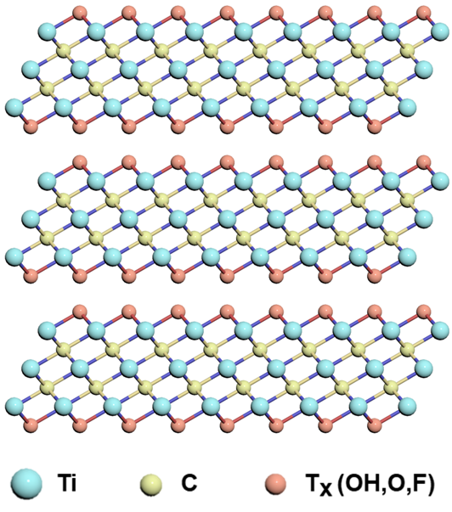
Fig. S1 Schematic diagram of the multilayer Ti₃C₂T_{X}
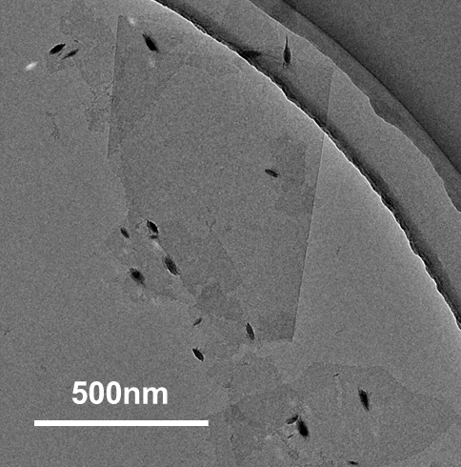
Fig. S2 TEM image of single layer or few layer Ti₃C₂T_{X} nanosheets

Fig. S3 XPS survey spectra of the Ti₃C₂T_{X}

Fig. S4 High-resolution XPS spectra of Ti 2p and C 1s for Ti₃C₂T_{X}
Fig. S5 Schematic diagram of films cooling test process: Transfer from 85 ℃ hot plate to room temperature cooling platform

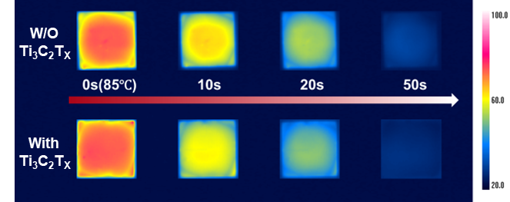
Fig. S6 Infrared thermal images of ITO/perovskite and ITO/ Ti₃C₂T_{X}-modified perovskite films under a cooling test

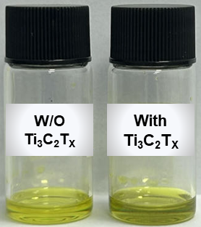
Fig. S7 Comparison image of perovskite precursor solution without and with Ti₃C₂T_{X}
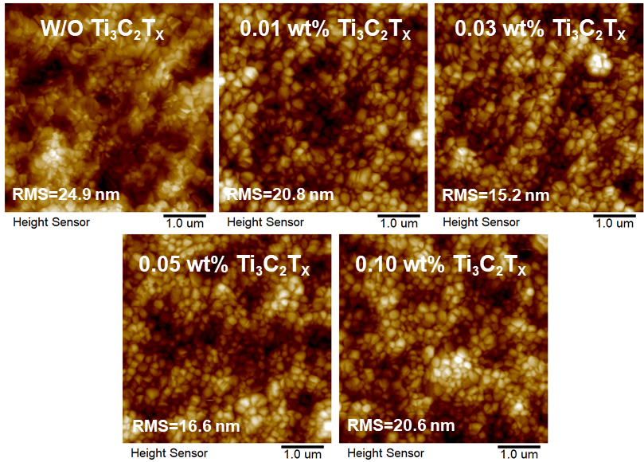
Fig. S8 AFM images of perovskite films without and with 0.01 wt%, 0.03 wt%, 0.05 wt%, 0.10 wt% Ti₃C₂T_{X}
Fig. S9 EDS spectra of 0.03 wt% Ti₃C₂T_{X}-modified perovskite film
Fig. S10 I–V curves (log–log plots) of the pure perovskite device with the structure of ITO/PVK/Au and ITO/PVK-0.03 wt% Ti₃C₂T_{X}/Au
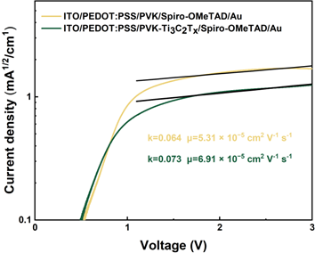
Fig. S11 J–V curves (log–log plots) of the pure hole device with the structure of ITO/PEDOT:PSS/PVK-Ti₃C₂T_{X}/Spiro-OMeTAD/Au
Fig. S12 Nyquist plots of the PSCs with and without Ti₃C₂T_{X} under dark condition
Equation S1 Carrier mobility calculation formula
$$J=\frac{9{ε_{0}ε}_{r}μ{V_{eff}}^{2}}{8L^{3}}$$
J is the measured current density, V_{eff} is the effective voltage defined as the difference between the applied voltage (V_{app}) and the built-in voltage (V_{bi}), L is the film thickness,$\text{ε}$₀ is the vacuum permittivity, $\text{ε}$_{r} is the relative dielectric constant, and μ is the carrier mobility.

Table S1 Comparison of thermal conductivities of various thermally conductive materials
Thermally conductive materials | Thermal conductivity
h-BN | 51.1 W m⁻¹ K⁻¹
Al₂O₃ | ~20-30 W m⁻¹ K⁻¹
SiO₂ | ~5 W m⁻¹ K⁻¹
Zeolite | 1 W m⁻¹ K⁻¹
Ti₃C₂T_{X} | 55.8 W m⁻¹ K⁻¹
Table S2 Input parameters for the simulation of PSC
Input parameter | ITO | SnO₂ | Perovskite | Spiro-OMeTAD | Au
Thickness (nm) | 100 | 50 | 500 | 350 | 50
K (W·m⁻¹·k⁻¹) | 10 | 5 | 0.413 | 0.49 | 318
h (W·m⁻²·k⁻¹) | 3.1×10⁸ | - | - | - | 9.6×10⁹
ρ (kg·m⁻³) | 7120 | 6950 | 4000 | 4128 | 19300
C_{p} (J·kg⁻¹·K⁻¹) | 345 | 350 | 258 | 262 | 128
Table S3 The fitting parameters of TRPL
Simple | A₁ | τ₁ (ns) | A₂ | τ₂ (ns) | τ_{ave} (ns)
PVK | 0.943 | 7.628 | 0.344 | 868.744 | 848.50
0.03wt% Ti₃C₂T_{X}-modified PVK | 0.824 | 9.276 | 0.369 | 931.975 | 911.91
Table S4 The photovoltaic parameters of the PSCs
PSC | V_{oc} (V) | J_{sc} (mA/cm²) | FF (%) | PCE (%)
PVK | 1.145 | 25.18 | 82.2 | 23.70
0.01wt% Ti₃C₂T_{X}-modified PVK | 1.151 | 25.22 | 81.6 | 23.69
0.03wt% Ti₃C₂T_{X}-modified PVK | 1.177 | 25.29 | 84.4 | 25.13
0.05wt% Ti₃C₂T_{X}-modified PVK | 1.167 | 25.28 | 82.4 | 24.30
0.10wt% Ti₃C₂T_{X}-modified PVK | 1.157 | 25.24 | 80.9 | 23.62

Table S5 Literature survey of the works on the thermal stability (85 ℃) of unencapsulated PSCs based on other thermal management strategies
Year | Strategy | Champion PCE (%) | Aging time (h) | PCE/PCE⁰ (%) | Refs.
2020 | Enhancing the thermal conductivity of Spiro with Al₂O₃ | 21.20 | 720 | 60 | [S1]
2021 | Enhancing the thermal conductivity of Spiro with SiO₂ | 22.29 | 1468 | 67 | [S2]
2021 | Enhancing the thermal conductivity of PCBM with PS | 18.34 | 100 | 64 | [S3]
2023 | Enhancing the thermal conductivity of Spiro with zeolite | 23.42 | 720 | 61 | [S4]
2023 | Enhancing the thermal conductivity of PVK with h-BN | 19.8 | 300 | 85 | [S5]
2025 | Enhancing the thermal conductivity of PVK with Ti₃C₂T_{X} | 25.13 | 1000 | 86 | This work
Table S6 Literature survey of the works on the thermal stability (85 ℃) of unencapsulated PSCs based on PVK/Spiro-OMeTAD
Device’s structure | Aging time (h) | PCE/PCE⁰ (%) | Refs.
ITO/SnO₂/PCBM/PVK/Spiro-OMeTAD/Au | 1000 | 85.0 | [S6]
FTO/SnO₂/PVK/Spiro-OMeTAD/Au | 27 | 85.0 | [S7]
FTO/SnO₂/PVK/Spiro-OMeTAD/Au | 100 | 90 | [S8]
ITO/SnO₂/PVK/Spiro-OMeTAD/Au | 450 | 92.0 | [S9]
FTO/bl-TiO₂/mp-TO₂/PVK/Spiro-OMeTAD/Au | 245 | 0 | [S10]
FTO/c-TiO₂/mp-TO₂/PVK/Spiro-OMeTAD/Au | 100 | 80.0 | [S11]
ITO/SnO₂/MoO₃/PVK/Spiro-OMeTAD/Au | 558 | 90.0 | [S12]
ITO/SnO₂/TMPU/PVK/TMFS/Spiro-OMeTAD/Au | 500 | 94.2 | [S13]
ITO/SnO₂/MgAc₂/PVK/Spiro-OMeTAD/Au | 1250 | 80.0 | [S14]
FTO/TiO₂/SnO₂/PVK/Spiro-OMeTAD/Au | 200 | 60.0 | [S15]
FTO/SnO₂/PVK/Spiro-OMeTAD/Au | 310 | 85.0 | [S16]
FTO/SnO₂/PVK/Spiro-OMeTAD/Au | 500 | 92.4 | [S17]
FTO/SnO₂/PVK/Spiro-OMeTAD/Au | 140 | 70.0 | [S18]
ITO/SnO₂/PVK-Ti₃C₂T_{X}/Spiro-OMeTAD/Au | 1000 | 86.0 | This work
Supplementary References
- K. Choi, J. Lee, H. Choi, G.-W. Kim, H.I. Kim et al., Heat dissipation effects on the stability of planar perovskite solar cells. Energy Environ. Sci. 13(12), 5059–5067 (2020). https://doi.org/10.1039/D0EE02859B
- F. Pei, N. Li, Y. Chen, X. Niu, Y. Zhang et al., Thermal management enables more efficient and stable perovskite solar cells. ACS Energy Lett. 6(9), 3029–3036 (2021). https://doi.org/10.1021/acsenergylett.1c00999
- Z. Zhang, Y. Tang, Y. Wang, Z. Zeng, R. Shi et al., Heat transfer enhancement of n-type organic semiconductors by an insulator blend approach. ACS Appl. Mater. Interfaces 14(26), 30174–30181 (2022). https://doi.org/10.1021/acsami.2c05503
- W. Wang, J. Zhang, K. Lin, J. Wang, B. Hu et al., Heat diffusion optimization in high performance perovskite solar cells integrated with zeolite. J. Energy Chem. 86, 308–317 (2023). https://doi.org/10.1016/j.jechem.2023.07.001
- Y. Yin, Y. Zhou, S. Fu, X. Zuo, Y.-C. Lin et al., Enhancing crystallization in hybrid perovskite solar cells using thermally conductive 2D boron nitride nanosheet additive. Small 19(15), e2207092 (2023). https://doi.org/10.1002/smll.202207092
- W. Song, L. Rakocevic, R. Thiruvallur Eachambadi, W. Qiu, J.P. Bastos et al., Improving the morphology stability of spiro-OMeTAD films for enhanced thermal stability of perovskite solar cells. ACS Appl. Mater. Interfaces 13(37), 44294–44301 (2021). https://doi.org/10.1021/acsami.1c11227
- W. Zhang, L. He, D. Tang, X. Li, Surfactant sodium dodecyl benzene sulfonate improves the efficiency and stability of air-processed perovskite solar cells with negligible hysteresis. Sol. RRL 4(11), 2000376 (2020). https://doi.org/10.1002/solr.202000376
- M. Chen, P. Li, C. Liang, H. Gu, W. Tong et al., Enhanced efficiency and stability of perovskite solar cells by 2D perovskite vapor-assisted interface optimization. J. Energy Chem. 45, 103–109 (2020). https://doi.org/10.1016/j.jechem.2019.10.006
- S. Tan, I. Yavuz, N. De Marco, T. Huang, S.J. Lee et al., Steric impediment of ion migration contributes to improved operational stability of perovskite solar cells. Adv. Mater. 32(11), e1906995 (2020). https://doi.org/10.1002/adma.201906995
- H. Zheng, G. Liu, C. Zhang, L. Zhu, A. Alsaedi et al., The influence of perovskite layer and hole transport material on the temperature stability about perovskite solar cells. Sol. Energy 159, 914–919 (2018). https://doi.org/10.1016/j.solener.2017.09.039
- K.-M. Lee, S.Y. Abate, J.H. Yang, W.-H. Chiu, S. Ahn et al., Facile synthesis of spiro-core-based hole-transporting material for high-performance and stable perovskite solar cells. Chem. Eng. J. 454, 139926 (2023). https://doi.org/10.1016/j.cej.2022.139926
- C. Liang, H. Gu, Y. Xia, Z. Wang, X. Liu et al., Two-dimensional Ruddlesden–Popper layered perovskite solar cells based on phase-pure thin films. Nat. Energy 6(1), 38–45 (2021). https://doi.org/10.1038/s41560-020-00721-5
- Z. Yi, X. Li, B. Xiao, Q. Jiang, Y. Luo et al., Dual-interface engineering induced by silane coupling agents with different functional groups constructing high-performance flexible perovskite solar cells. Chem. Eng. J. 469, 143790 (2023). https://doi.org/10.1016/j.cej.2023.143790
- M. Guli, Y. Zhang, R. Li, W. He, C. Lan et al., MgAc₂-modified SnO₂ electron transport layer for highly efficient and thermal stable perovskite solar cells. Nano Lett. 24(45), 14183–14190 (2024). https://doi.org/10.1021/acs.nanolett.4c02824
- Yukta, R.D. Chavan, A. Mahapatra, D. Prochowicz, P. Yadav et al., Improved efficiency and stability in 1, 5-diaminonaphthalene iodide-passivated 2D/3D perovskite solar cells. ACS Appl. Mater. Interfaces 15(46), 53351–53361 (2023). https://doi.org/10.1021/acsami.3c09887
- C. Shi, J. Li, S. Xiao, Z. Wang, W. Xiang et al., Alcohol-dispersed polymer complex as an effective and durable interface modifier for n-i-p perovskite solar cells. J. Energy Chem. 93, 243–252 (2024). https://doi.org/10.1016/j.jechem.2024.01.075
- Y.S. Shin, J. Lee, D.G. Lee, J.W. Song, J. Seo et al., Damp-heat stable and efficient perovskite solar cells and mini-modules with a tBP-free hole-transporting layer. Energy Environ. Sci. 18(7), 3269–3277 (2025). https://doi.org/10.1039/D4EE05699J
- K. Choi, J. Lee, H.I. Kim, C.W. Park, G.-W. Kim et al., Thermally stable, planar hybrid perovskite solar cells with high efficiency. Energy Environ. Sci. 11(11), 3238–3247 (2018). https://doi.org/10.1039/c8ee02242a

