Supporting Information for
Ultrathin Gallium Nitride Quantum-Disk-In-Nanowire-Enabled Reconfigurable Bioinspired Sensor for High-Accuracy Human Action Recognition
Zhixiang Gao^{1,#}, Xin Ju^{2,#}, Huabin Yu^{1,#}, Wei Chen¹, Xin Liu¹, Yuanmin Luo¹, Yang Kang¹, Dongyang Luo¹, JiKai Yao¹, Wengang Gu¹, Muhammad Hunain Memon¹, Yong Yan¹*, Haiding Sun¹*
¹ iGaN Laboratory, School of Microelectronics, University of Science and Technology of China, Hefei 230029, P. R. China
² Institute of Materials Research and Engineering, 2 Fusionopolis Way, #08-03Agency for Science Technology and Research Singapore 138634, Singapore
# Zhixiang Gao, Xin Ju, and Huabin Yu contributed equally to this work.
*Corresponding authors. E-mail: yanyong365@ustc.edu.cn (Yong Yan), haiding@ustc.edu.cn (Haiding Sun)
Supplementary Figures
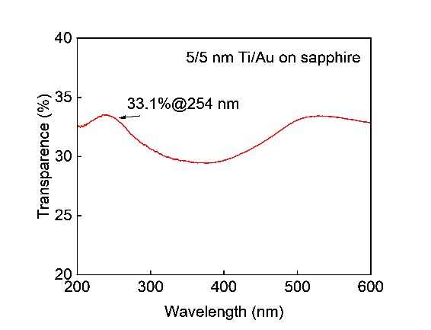
Fig. S1 Wavelength-dependent transmittance curve of 5/5 nm Ti/Au on a sapphire substrate

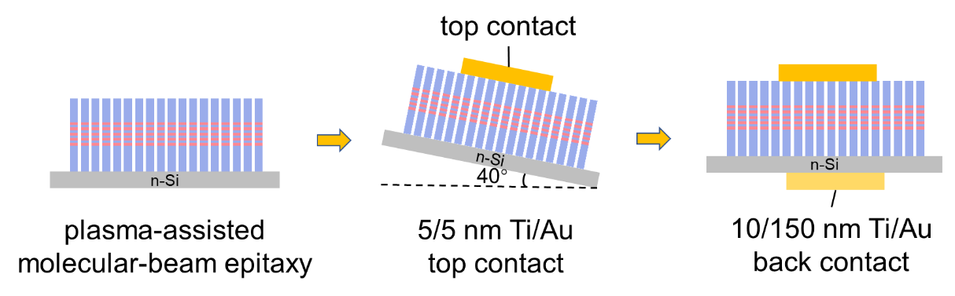
Fig. S2 Fabrication process of the proposed nanowire optoelectronic device
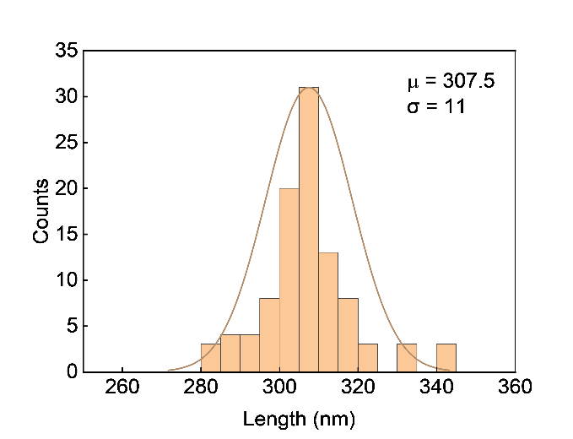
Fig. S3 Statistics of length from 100 nanowires. The average length of the grown nanowire is ~300 nm with μ = 307.5 nm, σ = 11 nm, showing good uniformity

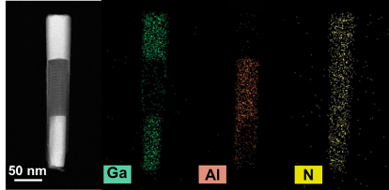
Fig. S4 Energy-dispersive spectroscopy (EDS) element mapping of the nanowire

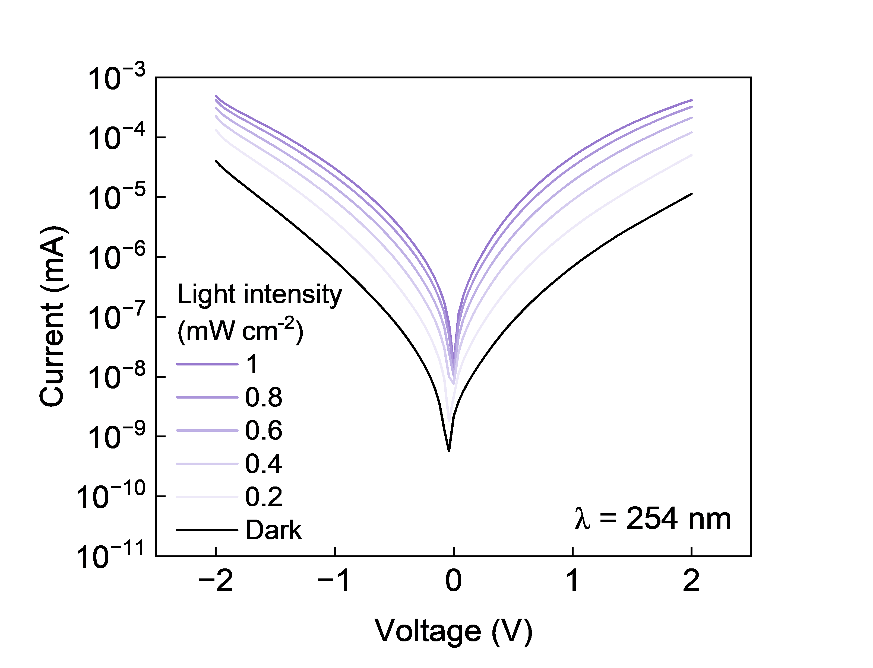
Fig. S5 Current-voltage characteristics of a representative device under different light intensities

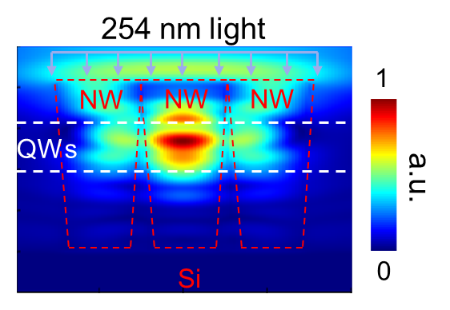
Fig. S6 Cross-sectional optical field distribution of NWs array on Si substrate, illuminated by 254 nm light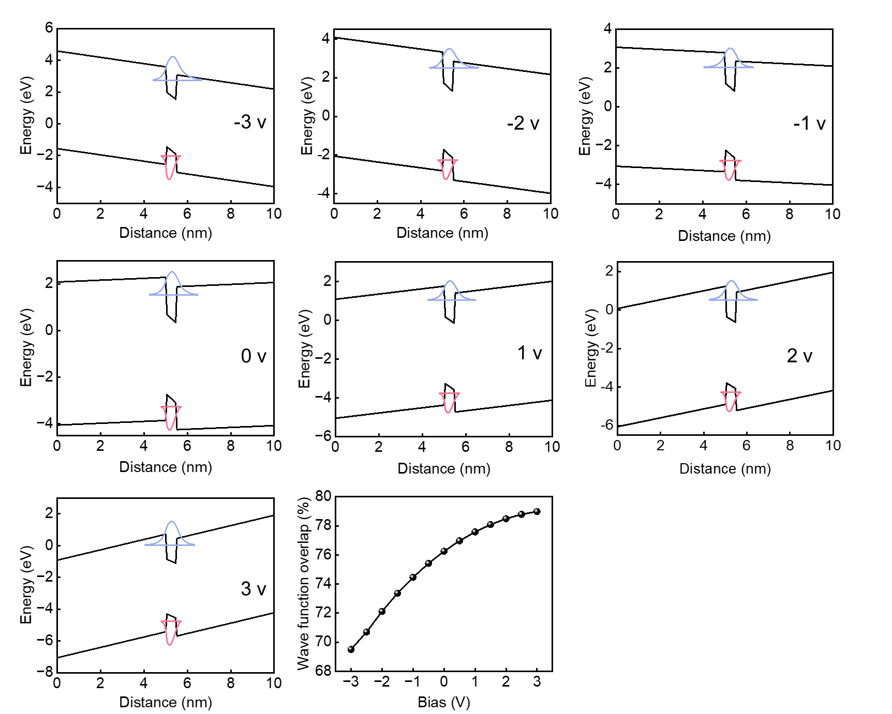
Fig. S7 Band structure and wavefunction overlap under different bias conditions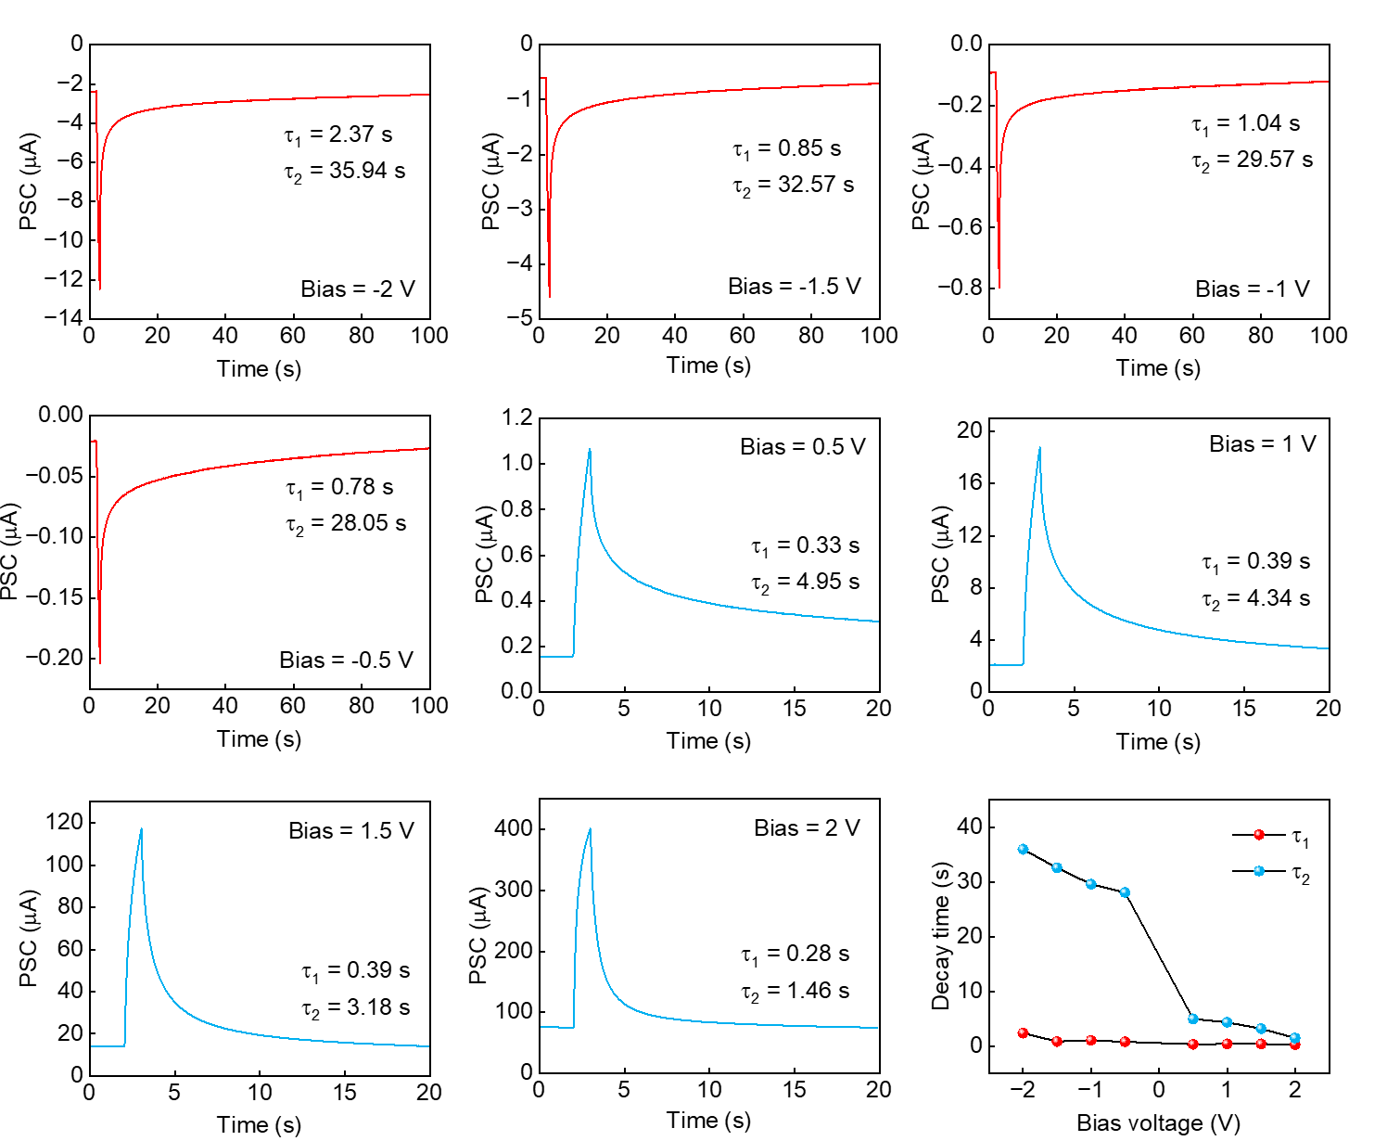
Fig. S8 PPC characteristics extracted under reverse and forward bias with the same illumination conditions, showing an obvious difference in the fitting parameter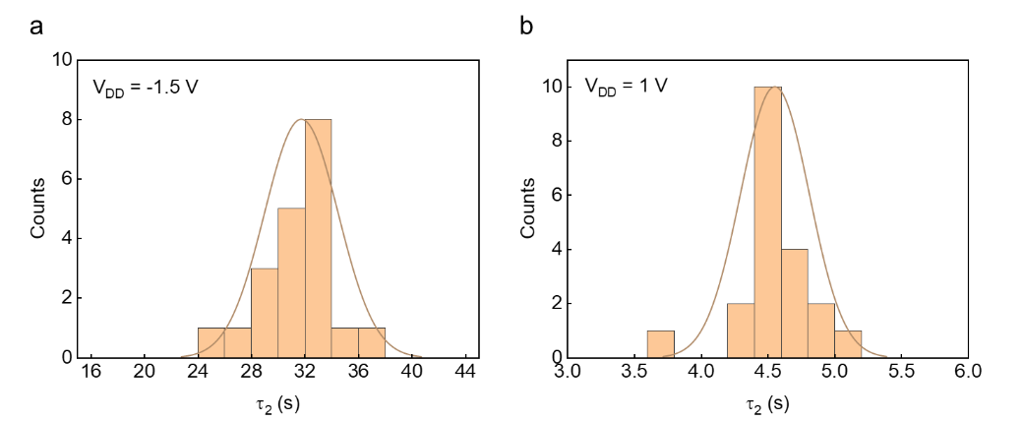
Fig. S9 Statistic data of the PPC fitting parameter τ₂ under (a) negative and (b) positive voltage bias from stochastically selected 20 QD-NW devices
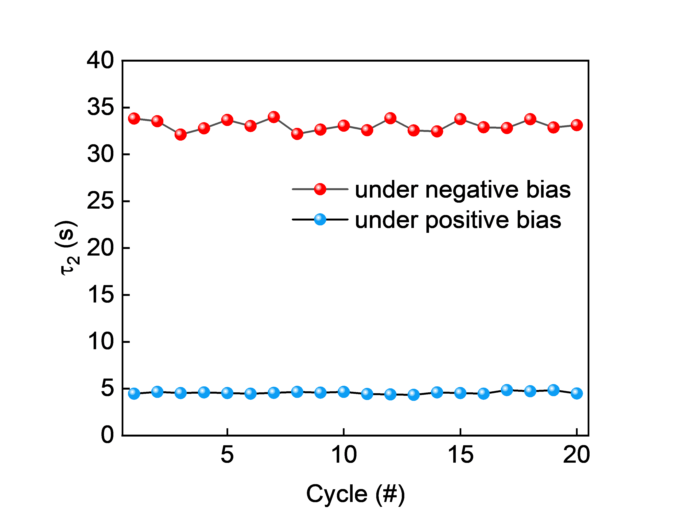
Fig. S10 Statistic data of the PPC fitting parameter τ₂ under negative and positive voltage bias sampled by 20 cycles from a representative device
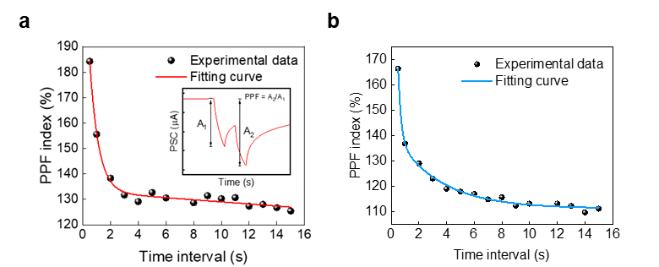
Fig. S11 Modulation ratio of PPF index as a function of interval time (Δt). (a) PPF index extracted under negative bias. The inset plots the time-resolved post-synaptic current of device at two successive light pulses. (b) PPF index extracted under positive bias
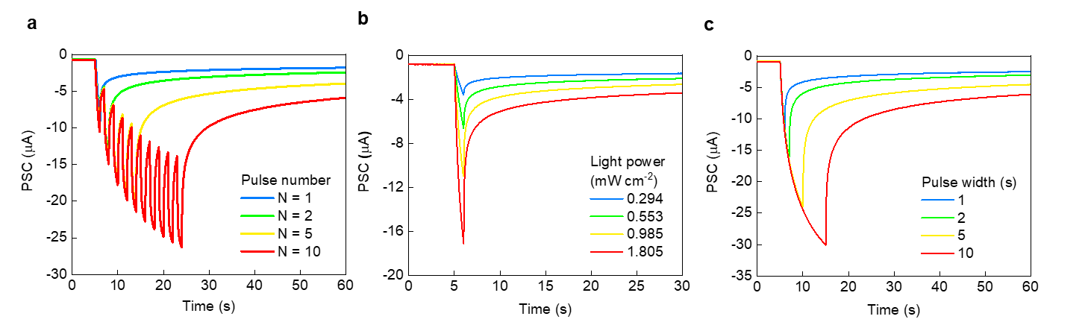
Fig. S12 Synaptic plasticity transition under long-term mode. (a) Pulse number dependent transition between short-term plasticity and long-term plasticity. (b) Emulation of STP and LTP behavior by light intensity-varied photonic stimuli. (c) Synaptic plasticity transition triggered by presynaptic pulses with different pulse durations
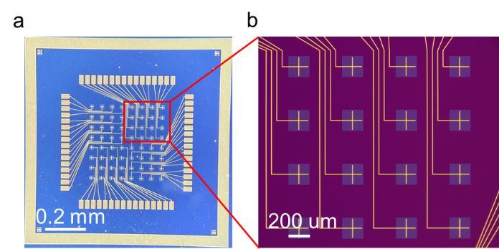
Fig. S13 (a) Optical image of the 8×8 nanowire array. (b) Partial enlarged detail of the array
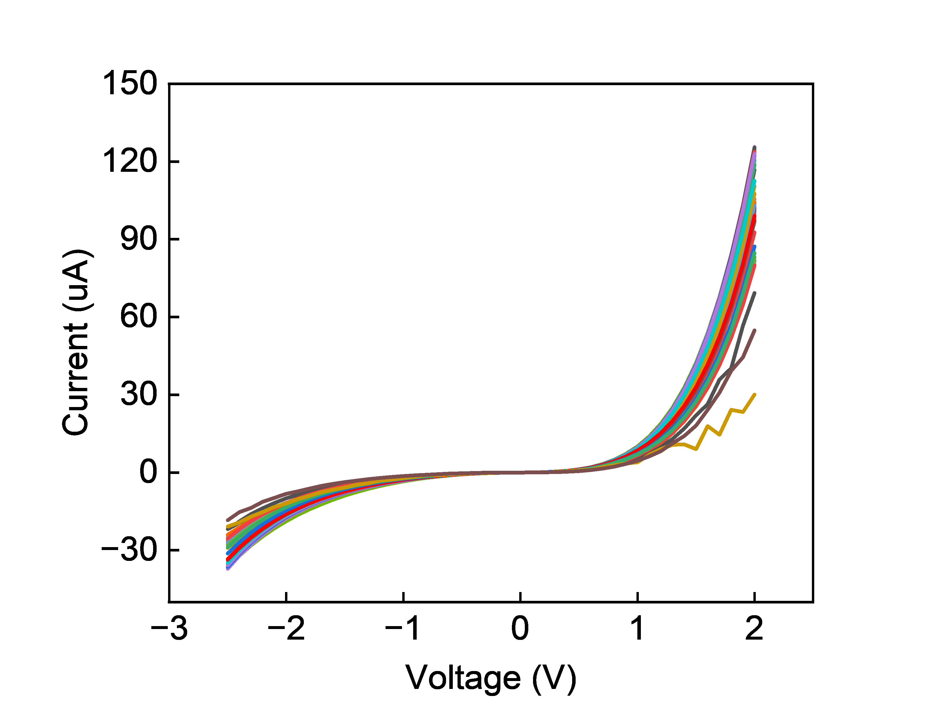
Fig. S14 Device-to-device variation of the sensor array

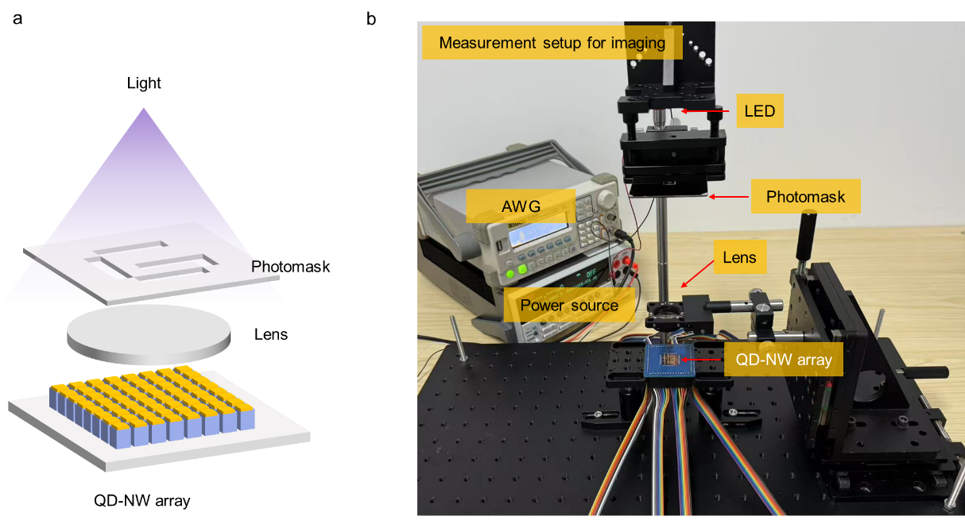
Fig. S15 “G” shaped photomask with 17 pixels for imaging sensing

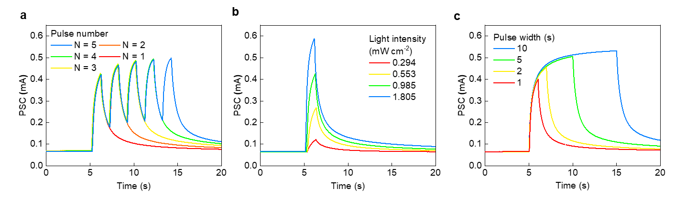
Fig. S16 Synaptic plasticity transition under short-term mode. Transition between STP and LTP by adjusting the (a) pulse number; (b) light intensity; (c) pulse duration
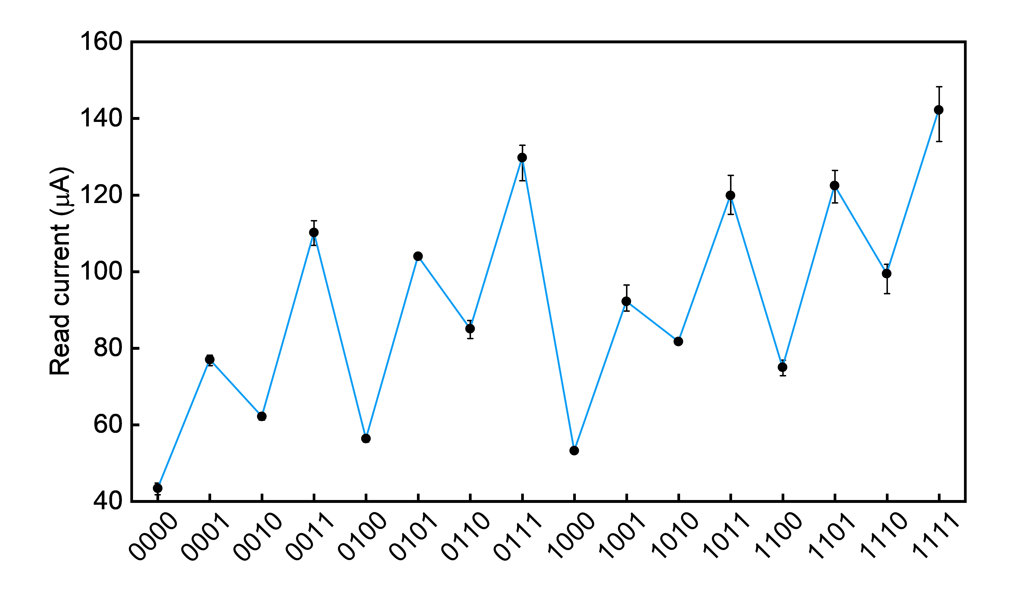
Fig. S17 Reliability and repeatability of the QD-NWs device for reservoir computing, each input contains 5 cycles
Fig. S18 Statistical data of four representative 4-bits inputs from 20 stochastically selected QD-NW devices under 1 mW cm⁻² light condition
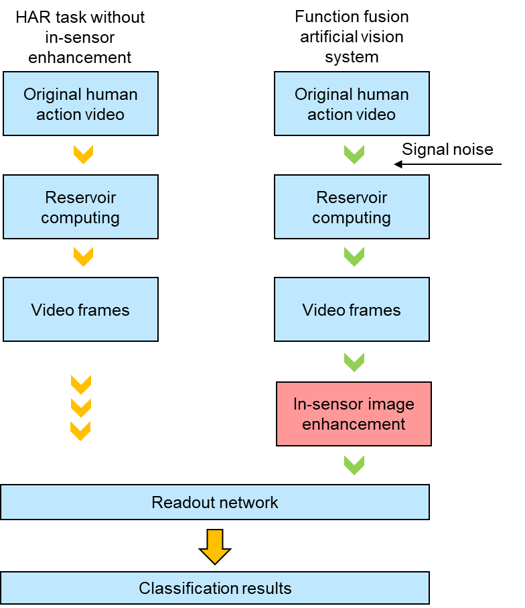
Fig. S19 Flowchart of the two functions fusion. Flow 1 demonstrates the classification results with raw inputs. While flow 2 presents a preferable result with a pre-processing unit followed by RC

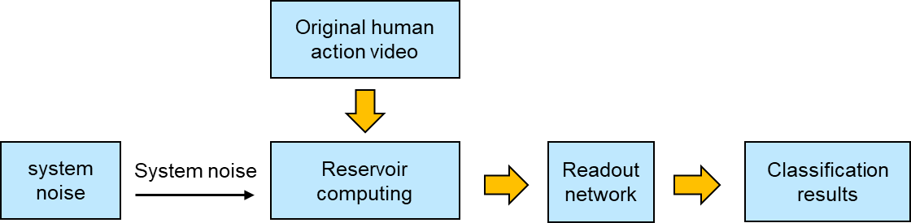
Fig. S20 Flowchart of the robustness verification. To verify the robustness of the RC system, different levels of device noise are applied to the NW reservoir outputs to mimic the application of non-ideal factors on the hardware

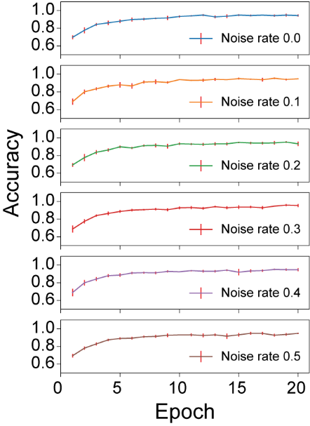
Fig. S21 Comparison of validation accuracy versus training epoch for noise rates of 0.0 to 0.5 (cov), respectively

