Supporting Information for
Ultrafast Laser Shock Straining in Chiral Chain 2D Materials: Mold-Topology-Controlled Anisotropic Deformation
Xingtao Liu^{1,4 †}, Danilo de Camargo Branco^{2†}, Licong An^{3,4}, Mingyi Wang^{1,4}, Haoqing Jiang¹, Ruoxing Wang^{1,4}, Wenzhuo Wu^{1,4}* and Gary J. Cheng^{1,3,4}*
¹ School of Industrial Engineering, Purdue University, West Lafayette, IN 47906
² School of Aeronautics and Astronautics, Purdue University, West Lafayette, IN 47906
³ School of Materials Engineering, Purdue University, West Lafayette, IN 47906
⁴ Birck Nanotechnology Center, Purdue University, West Lafayette, IN 47906
† Xingtao Liu and Danilo de Camargo Branco contributed equally to this work.
*Corresponding authors. E-mail: wu966@purdue.edu (Wenzhuo Wu); gjcheng@purdue.edu (Gary J. Cheng)
Supplementary Figures and Tables
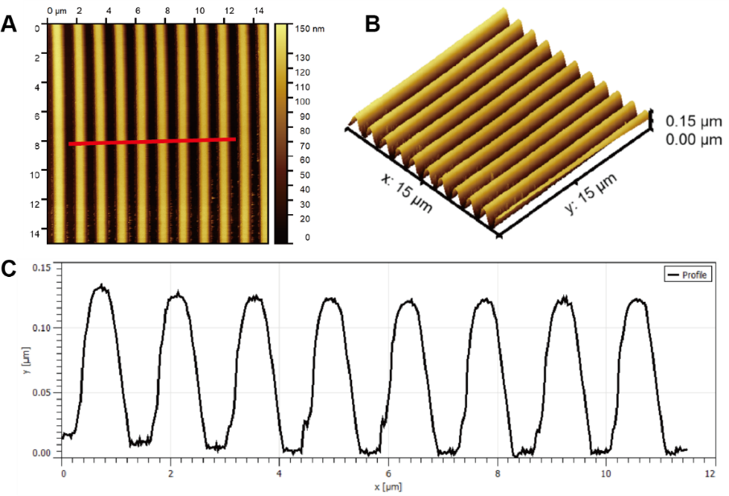
Fig. S1 (A) AFM analysis of the CD molds; (B) 3D topography of the CD trenches in (A); (C) the height measurement of the red line in (A)

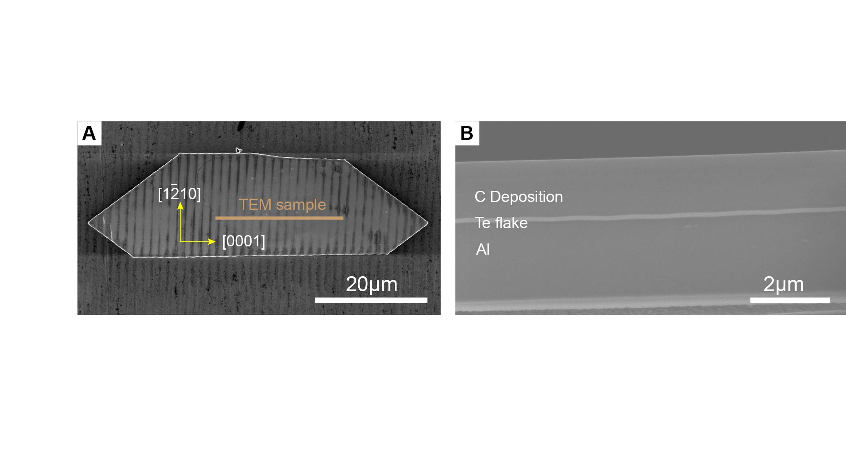
Fig. S2 (A) SEM image showing the pattern on 2D Te and demonstrating the area of TEM sample. (B) FIB cross section imaging showing the morphology of the strained 2D Te on CD trenches that are perpendicular to the Te chains
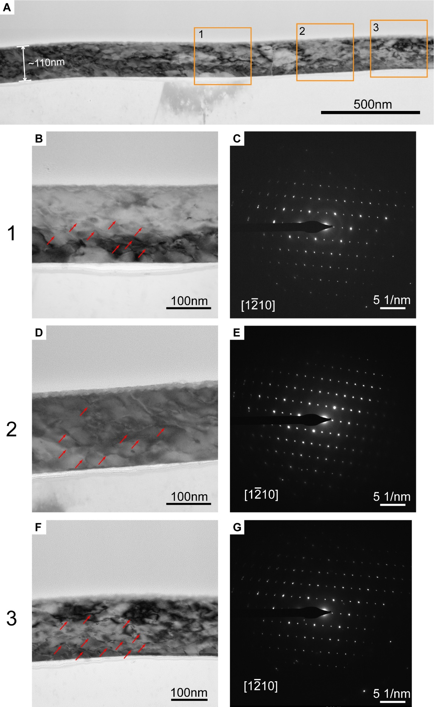
Fig. S3 TEM analysis of the strained Te flake from CD mold, the strain field is perpendicular to [0001] direction. (A) Bright field TEM image of the strained Te (B, D and F) magnified images of the areas in (A). (C, E and G) corresponding SAD patterns of (B, D and F)
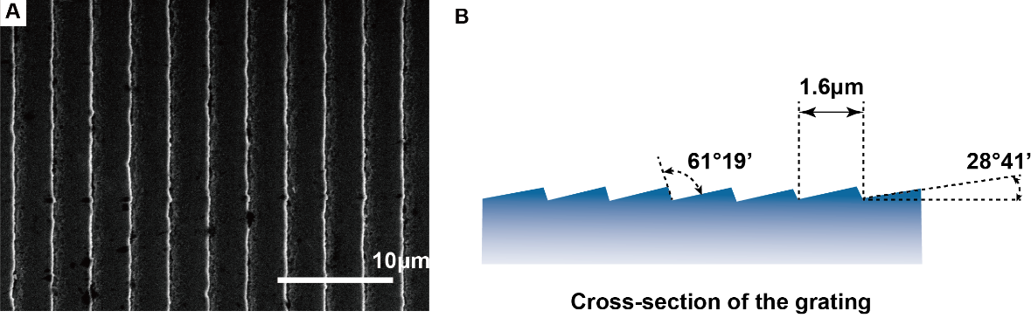
Fig. S4 (A) SEM image of the grating; (B) the schematic showing the blaze wavelength and blaze angle of the grating

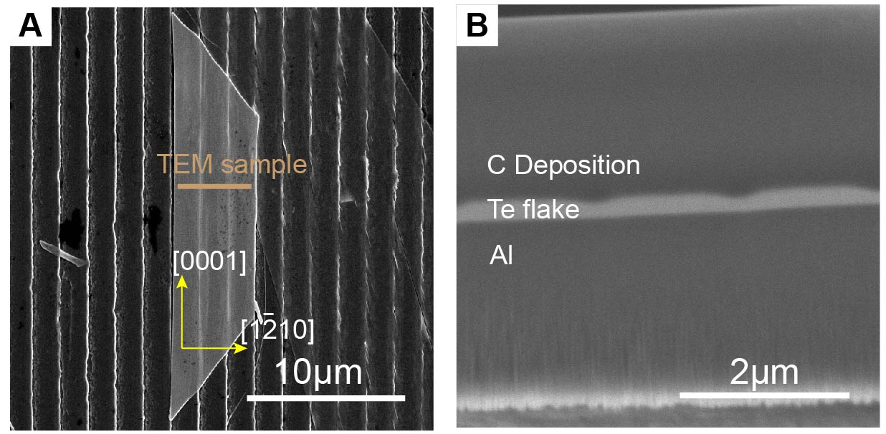
Fig. S5 (A) SEM image showing the pattern on 2D Te and demonstrating the area of TEM sample. (B) FIB cross section imaging showing the morphology of the strained 2D Te on grating mold on which the sharp edges are parallel to Te chains
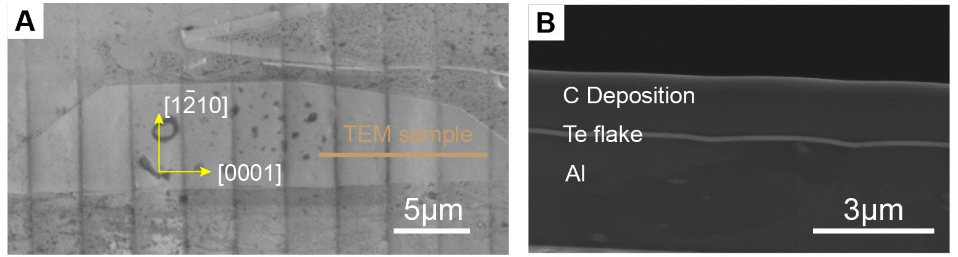

Fig. S6 (A) SEM image showing the pattern on 2D Te and demonstrating the area of TEM sample. (B) FIB cross section imaging showing the morphology of the strained 2D Te on grating mold on which the sharp edges are perpendicular to Te chains
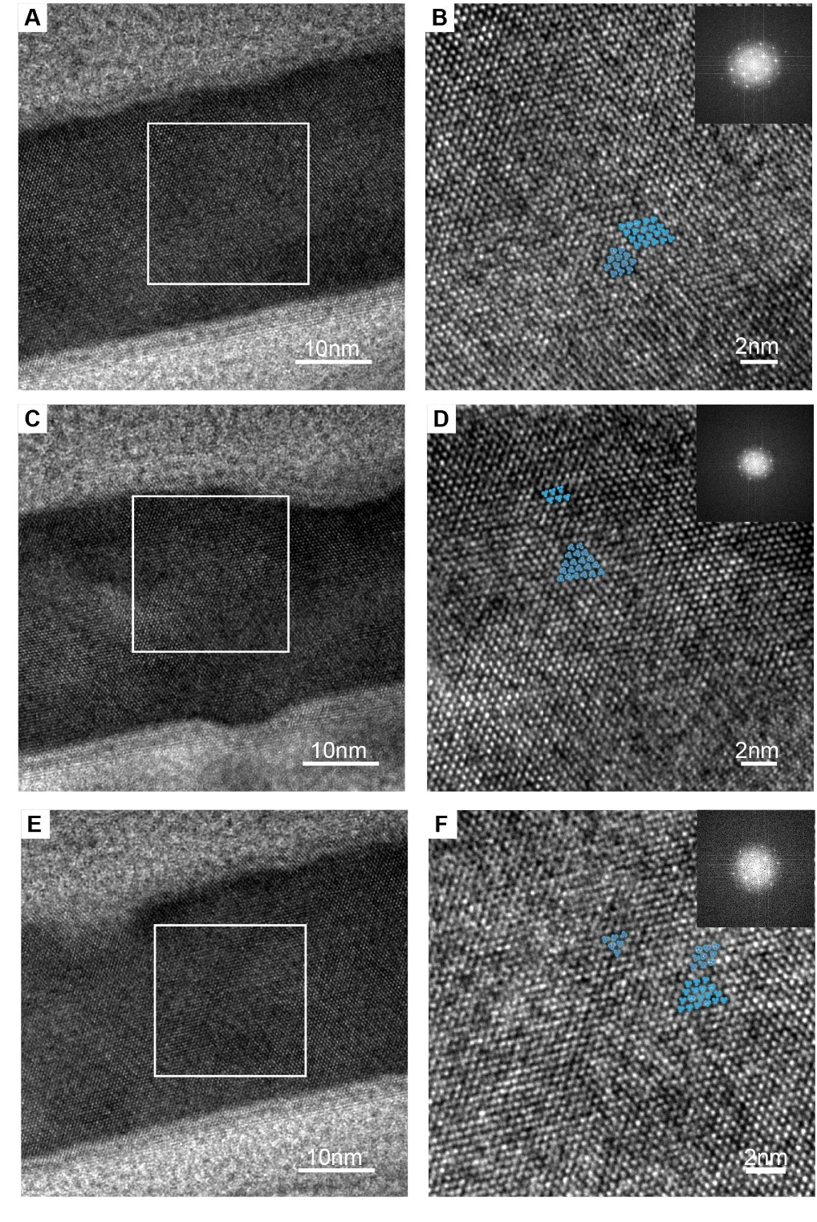
Fig. S7 HRTEM images of the strained Te (A-B) HRTEM images and the magnified images of the area 1 in 1H (C-D) HRTEM images and the magnified images of the area 2 in Fig. 1H (E-F) HRTEM images and the magnified images of the area 3 in Fig. 1H. The image in top right corner of B, D and F are the corresponding FFT images

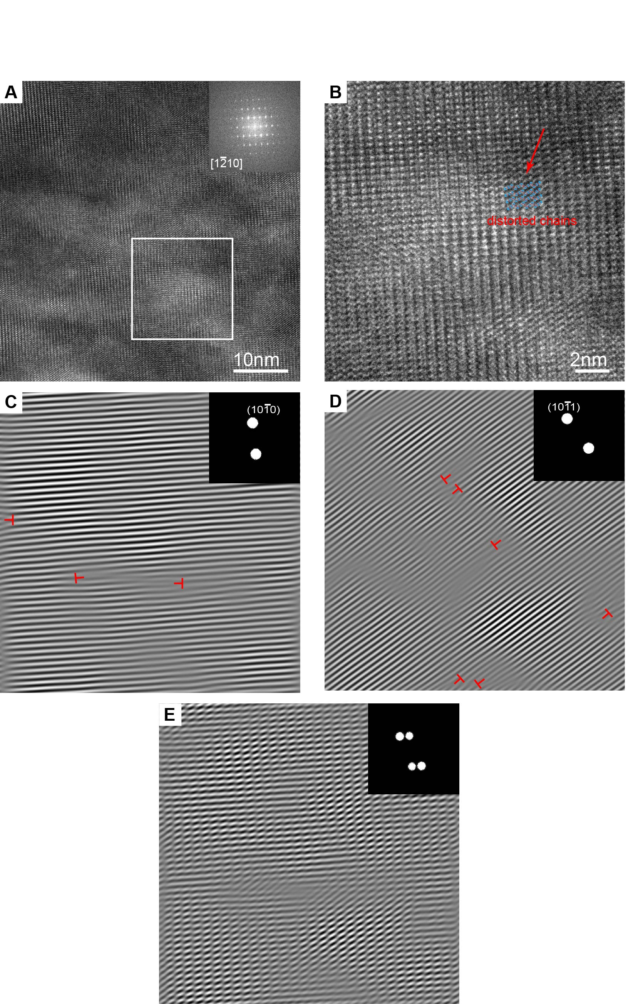
Fig. S8 HRTEM analysis of the symmetrical strained Te flake on CD mold when the trenches are perpendicular to Te chains (A) HRTEM image, the FFT in the image is the FFT of the white square area. (B) The magnified image of the white square area in A; (C-E) The IFFT images of the masked areas in the FFT patterns
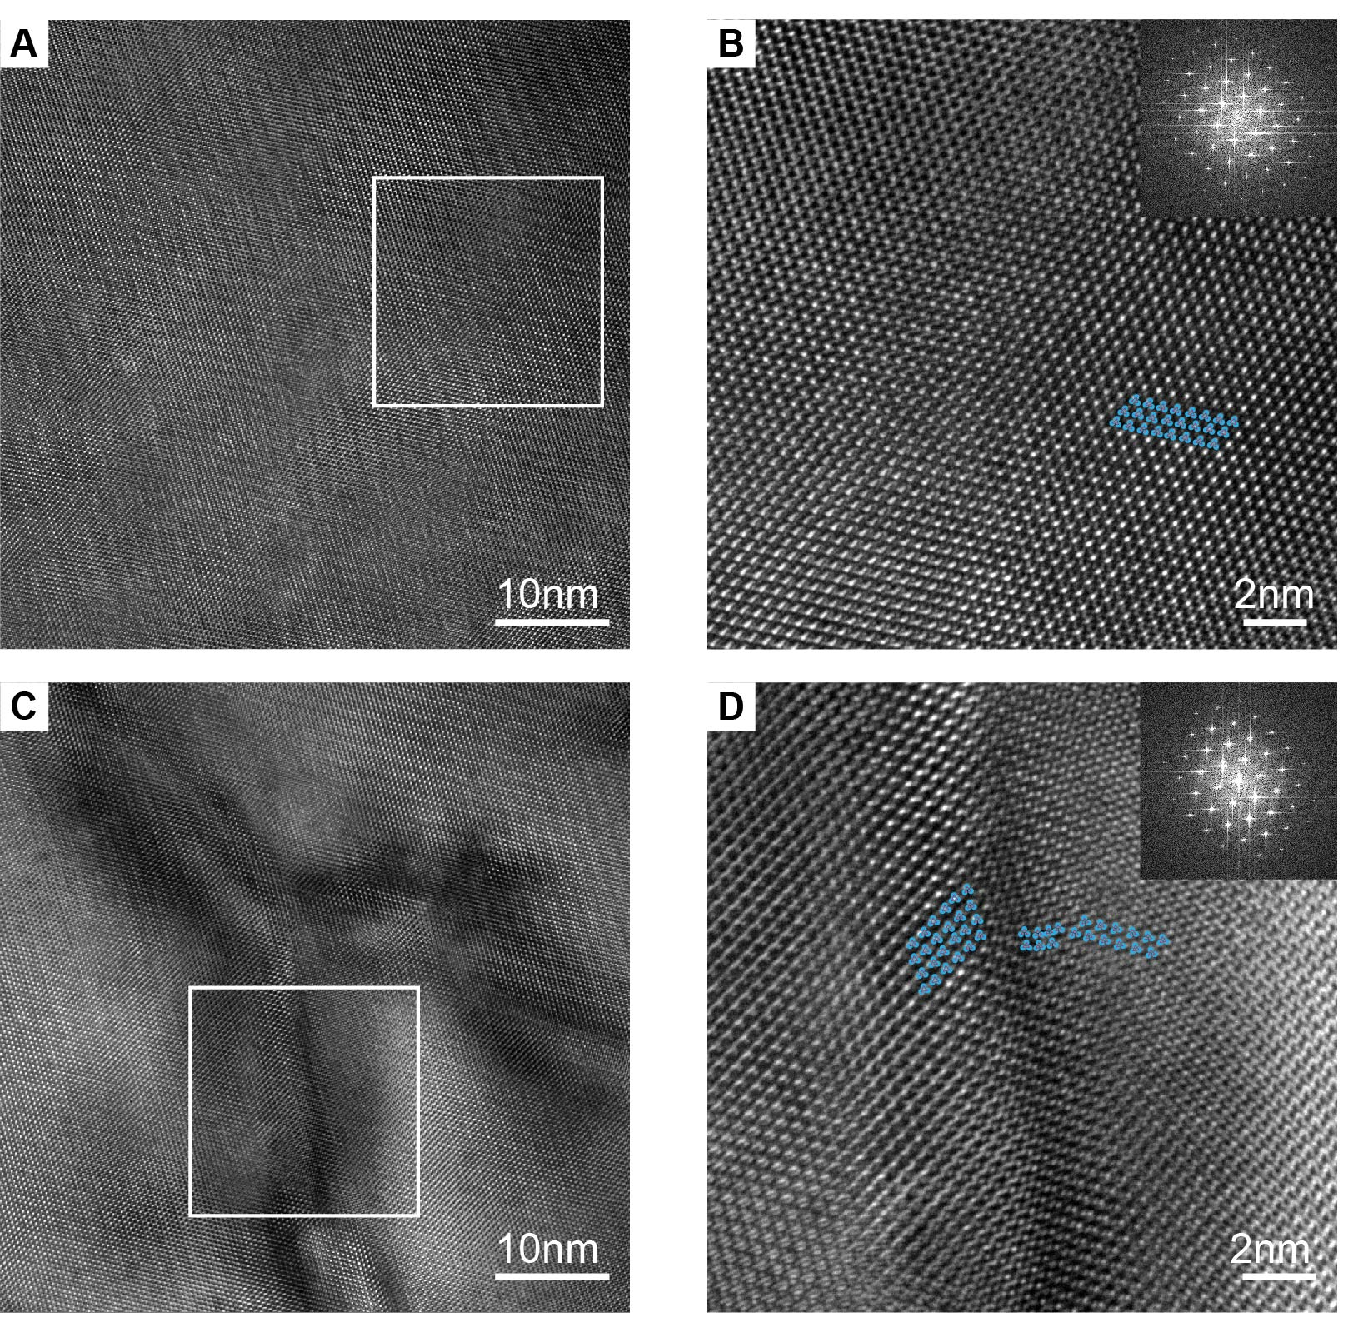
Fig. S9 HRTEM analysis of the is asymmetrically strained Te flake on blazed grating mold, the grating edges are parallel to the [0001] direction. (A) HRTEM image of the flat area of Te flake (B) The magnified image of the white square area in (A) and corresponding FFT pattern (C) HRTEM image of the severely deformed area on Te flake (D) The magnified image of the white square area in (C) and corresponding FFT pattern
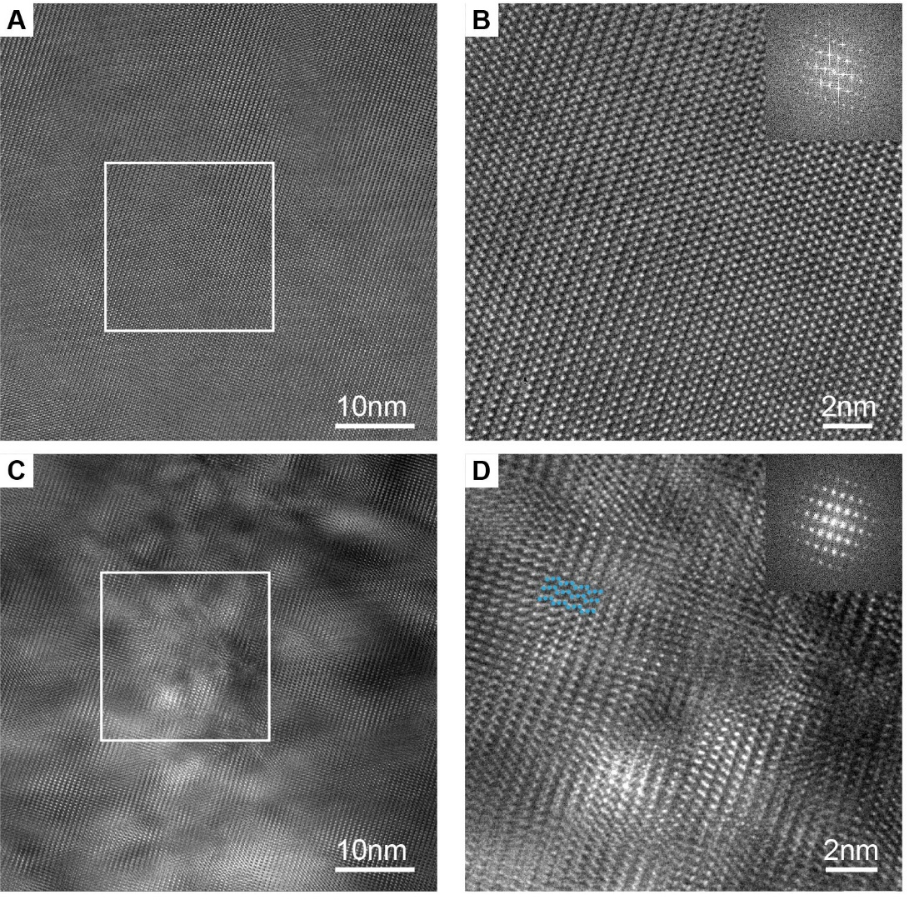
Fig. S10 HRTEM analysis of the is asymmetrically strained Te flake on blazed grating mold, the grating edges are perpendicular to the [0001] direction. (A) HRTEM image of the flat area of Te flake (B) The magnified image of the white square area in (A) and corresponding FFT pattern (C) HRTEM image of the severely deformed area on Te flake (D) The magnified image of the white square area in (C) and corresponding FFT pattern

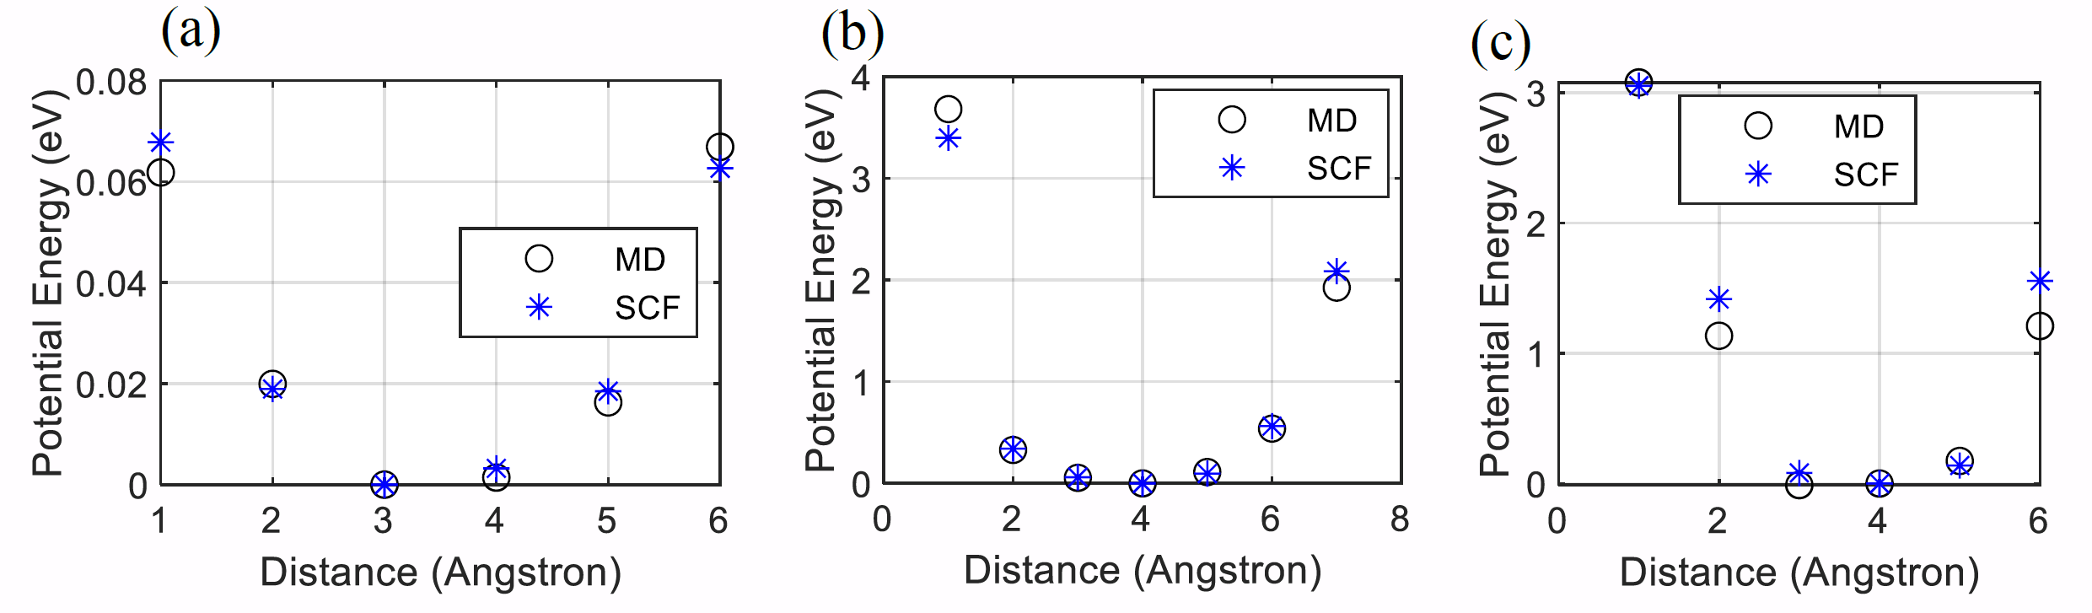
Fig. S11 (a) Intrachain interactions. (b) Interchain interactions. (c) Te chain and 𝑆𝑖𝑂2 substrate interactions

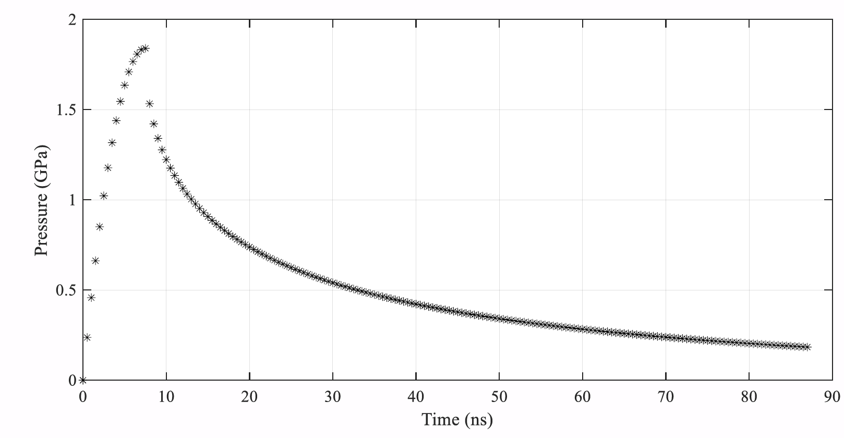
Fig. S12 Shock pressure time history

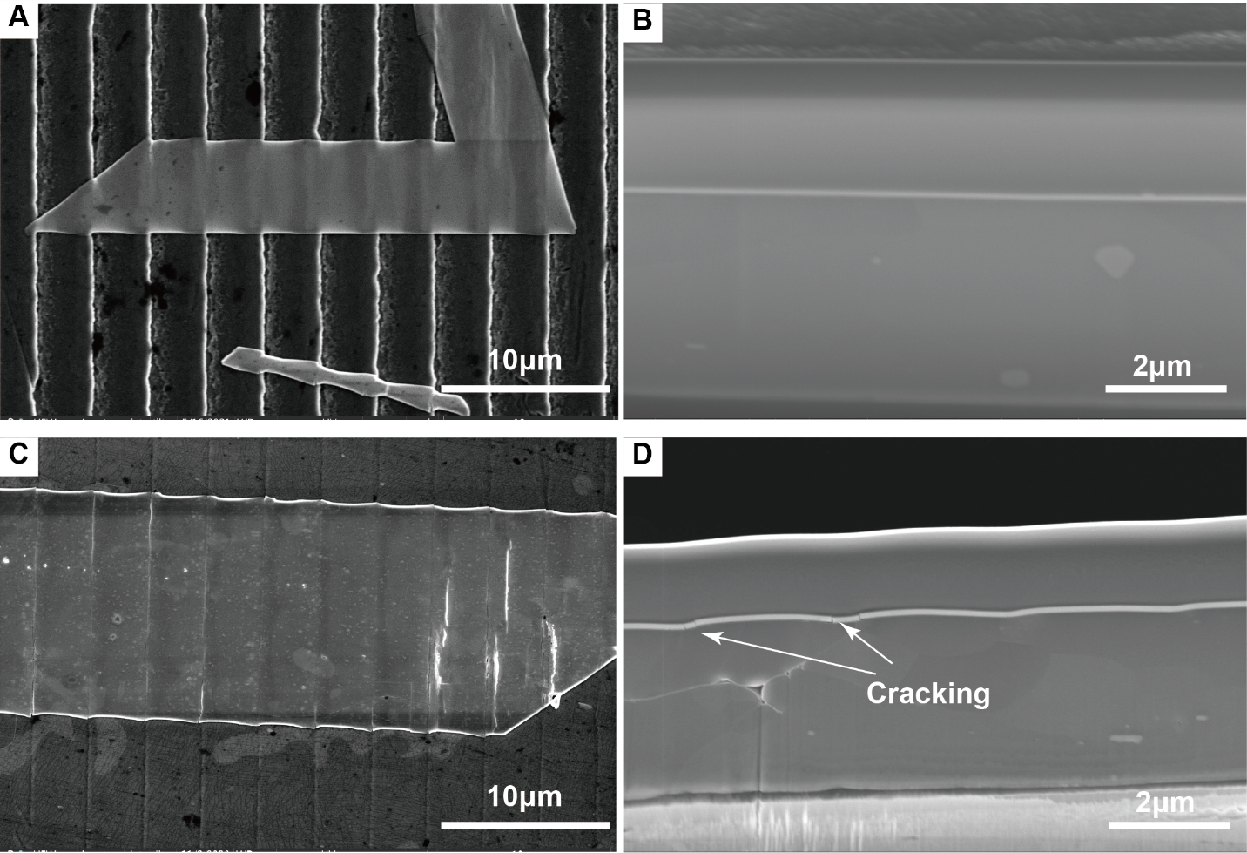
Fig. S13 SEM and FIB cross section images of the Te flakes on blazed grating with different laser power density. (A-B) 0.1GW/cm² (C-D) 1.12GW/cm²

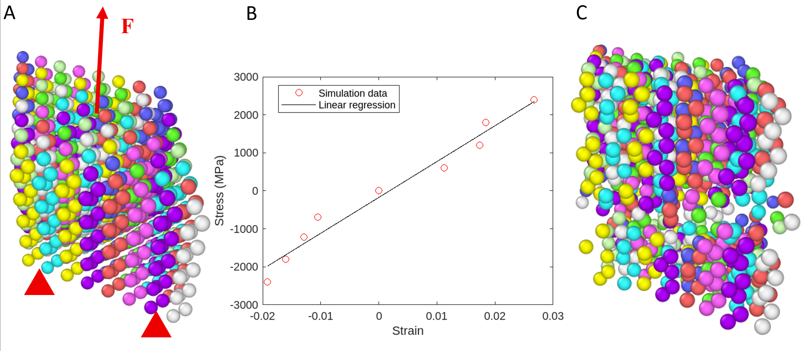
Fig. S14 (A) Longitudinal loading setup for the first loading case where the top atoms are loaded on their longitudinal direction, and the bottom atoms are fixed in place; (B) stress-strain response for the compressive-to-tensile longitudinal loading; (C) chains breakage at a longitudinal tensile loading above the maximum load on the above stress-strain graph

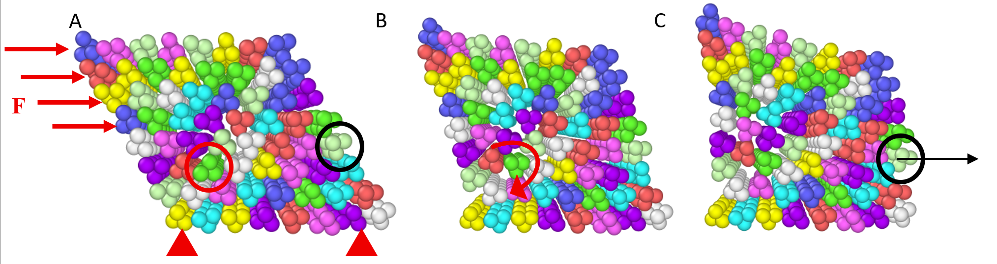
Fig. S15 (A) Transversal loading setup for the second loading case where the top atoms are loaded on the chains transversal direction in shear, and the bottom atoms are fixed in place; (B) chains twisting mechanism at the imminence of chains gliding. C chains gliding along the gliding plane (0 1 0). The red circle highlights the Te chain where twisting can be observed through shear loading. The black circle and the black arrow highlight the Te chain where chain gliding is observed as well as the gliding direction.
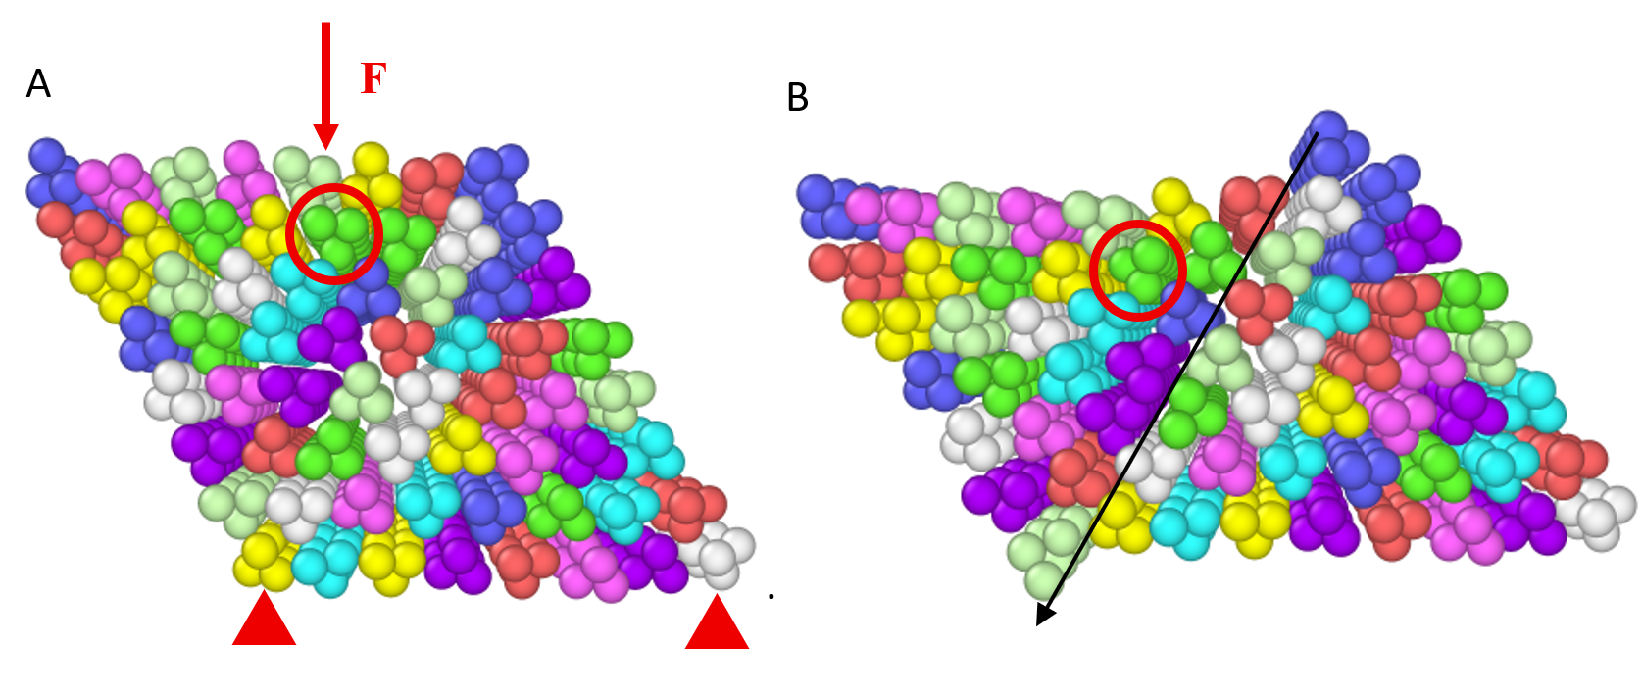
Fig. 16 (A) Transversal loading setup for the third loading case where the top atoms are loaded on the chains transversal direction in compression, and the bottom atoms are fixed in place; (B) chains twisting and gliding mechanisms for the third loading cas
Table S1 Interatomic interactions models and coefficients used in the MD simulations
System configuration | Interaction type | Interaction model | Coefficient | Value | Unit
Intrachain interactions | 2-body | Lennard-Jones | 𝜎_{𝑇𝑒/𝑇𝑒} | 2.4823 | Å
Intrachain interactions | 2-body | Lennard-Jones | 𝜀_{𝑇𝑒/𝑇𝑒} | 2.6 | eV
Intrachain interactions | 3-body | Harmonic angular | 𝐶_{𝛼} | 16.0 | eV
Intrachain interactions | 3-body | Harmonic angular | 𝜃₀ | 98.437 | degrees
Intrachain interactions | 4-body | Harmonic dihedral | 𝐶_{𝐷1} | 0.6 | eV
Intrachain interactions | 4-body | Harmonic dihedral | 𝐶_{𝐷2} | 19 | ---
Interchain interactions | 2-body | Lennard-Jones | 𝜎_{𝑇e1/𝑇𝑒2} | 3.36 | Å
Interchain interactions | 2-body | Lennard-Jones | 𝜀_{𝑇𝑒1/𝑇𝑒2} | 0.04 | eV
Chain-substrate interaction | 2-body | Lennard-Jones | 𝜎_{𝑇𝑒/Si} | 3.0 | Å
Chain-substrate interaction | 2-body | Lennard-Jones | 𝜀_{𝑇𝑒/Si} | 0.5 | eV
Chain-substrate interaction | 2-body | Lennard-Jones | 𝜎_{𝑇𝑒/O} | 2.0 | Å
Chain-substrate interaction | 2-body | Lennard-Jones | 𝜀_{𝑇𝑒/O} | 0.05 | eV

