Supporting Information for
Heteroatom-Coordinated Fe-N₄ Catalysts for Enhanced Oxygen Reduction in Alkaline Seawater Zinc-Air Batteries
Wenhan Fang^{3,4}, Kailong Xu^{1,2}, Xinlei Wang^{1,2}, Yuanhang Zhu⁵, Xiuting Li⁵, Hui Liu^{1,2}, Danlei Li^{3, 4*}, Jun Wu^{1, 2*}
¹Department of School of Metallurgy and Environment, Central South University, Changsha 410083, P. R. China
²State Key Laboratory of Advanced Metallurgy for Non-ferrous Metals, Changsha 410083, P. R. China
³Department of Chemistry and Materials Science, School of Science, Xi’an Jiaotong-Liverpool University, Suzhou 215123, P. R. China
⁴Department of Chemistry, University of Liverpool L69 7ZD, the United Kingdom
⁵Institute for Advanced Study, Shenzhen University, Shenzhen 518060, P. R. China
*Corresponding authors. E-mail: danlei.li@xjtlu.edu.cn (Danlei Li); wujun@csu.edu.cn (Jun Wu)
Supplementary Figures
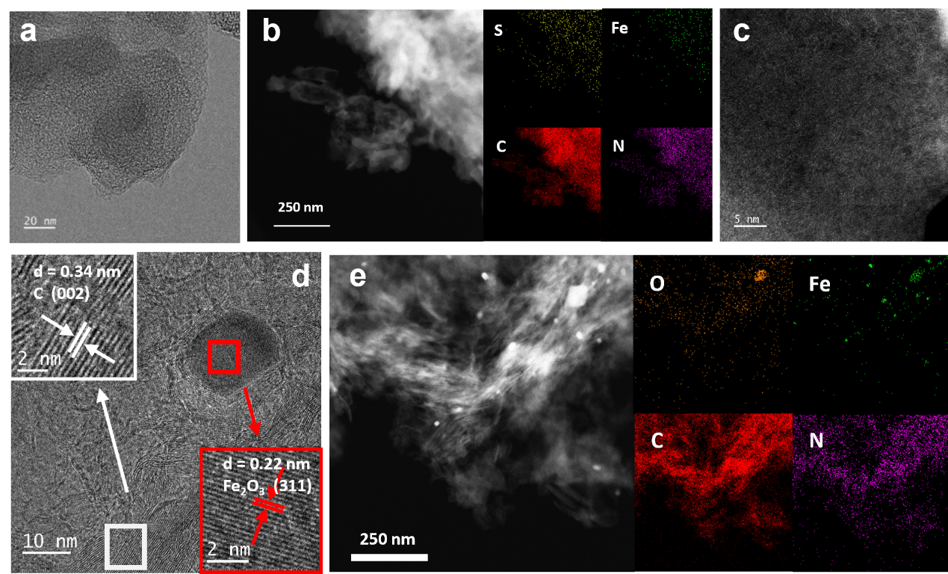
Fig. S1 HRTEM pattern of a) S-Fe-N₄, d) Fe-N₄. STEM-EDS mapping of b) S-Fe-N₄, e) Fe-N₄. c) HAADF-STEM image of S-Fe-N₄
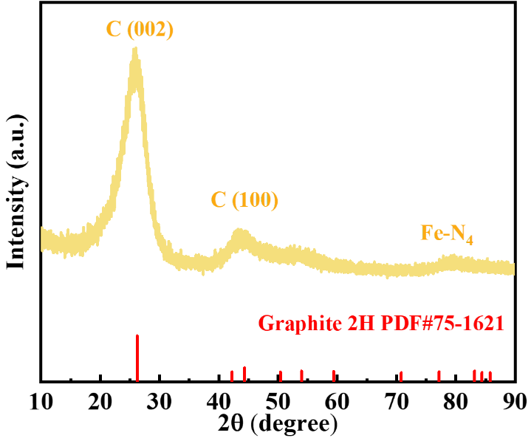
Fig. S2 XRD pattern of Fe-N₄

Fig. S3 Pore volume increment curves of Cl-Fe-N₄ and S-Fe-N₄

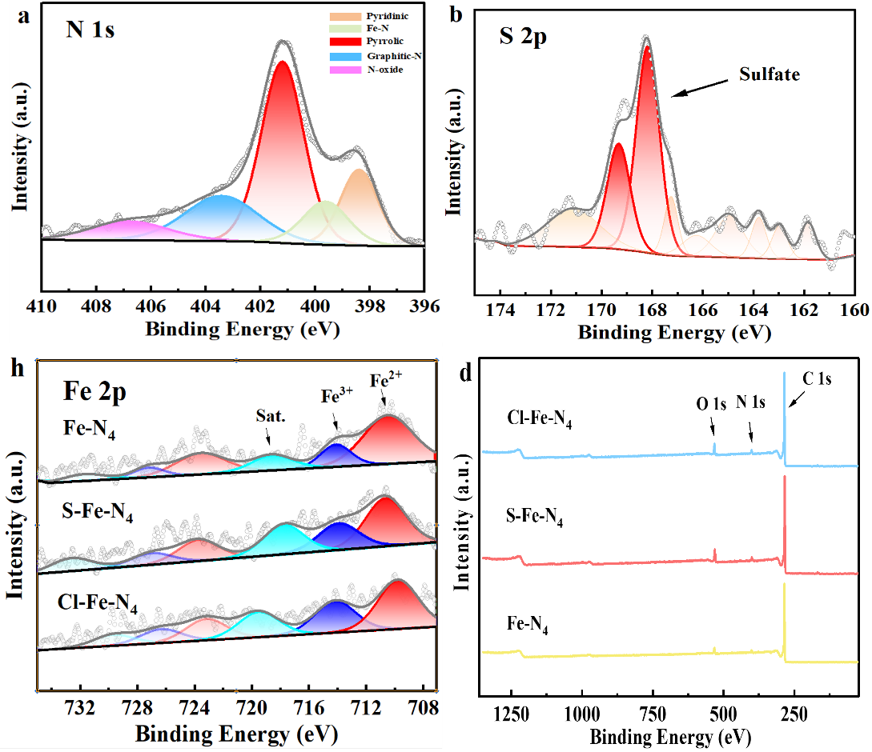
Fig. S4 Deconvoluted high-resolution XPS spectra of a) N 1s, b) S 2p for Fe-N₄. c) Fe 2p for Cl-Fe-N₄, S-Fe-N₄, and Fe-N₄. d) XPS survey spectrum of Cl-Fe-N₄, S-Fe-N₄ and Fe-N₄
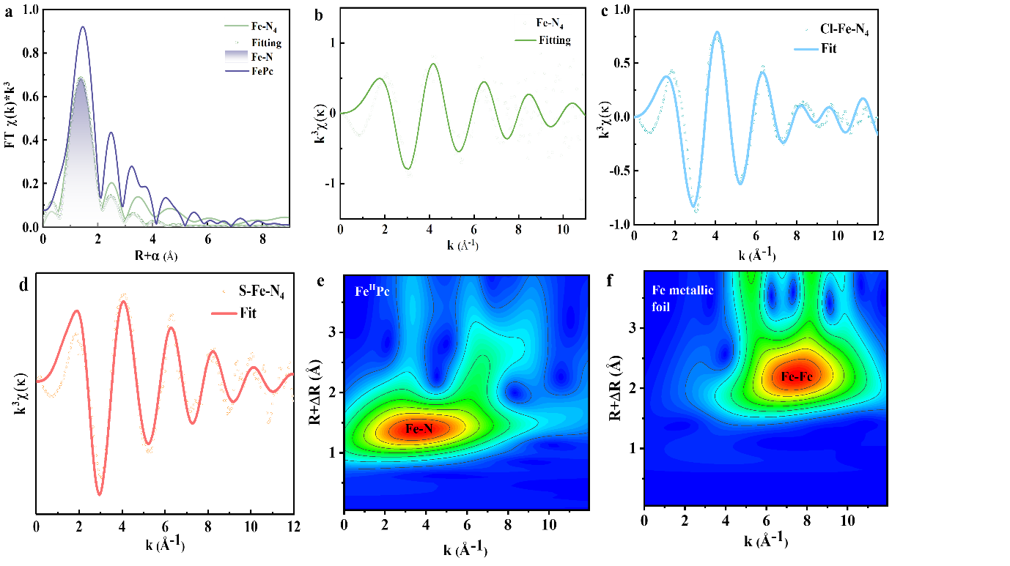
Fig. S5 k³-weighted Fe k-edge EXAFS fitting curves of a) Fe-N₄ and reference samples in k space. EXAFS fitting curve of b) Fe-N₄, c) Cl-Fe-N₄ and d) S-Fe-N₄ in R space. Wavelet transform EXAFS analysis of the Fe k-edge for e) Fe metallic foil and f) FeᴵᴵPc

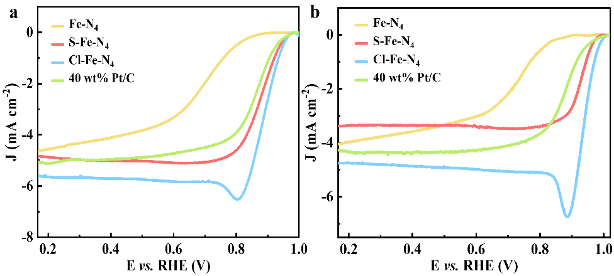
Fig. S6 LSV polarization curves of Cl-Fe-N₄, S-Fe-N₄, Fe-N₄ and Pt/C using RDE at 1600 rpm in a) 0.1 M KOH, b) 0.1 M KOH with 0.5 M KCl. Catalyst loading: 0.75 mg cm⁻²

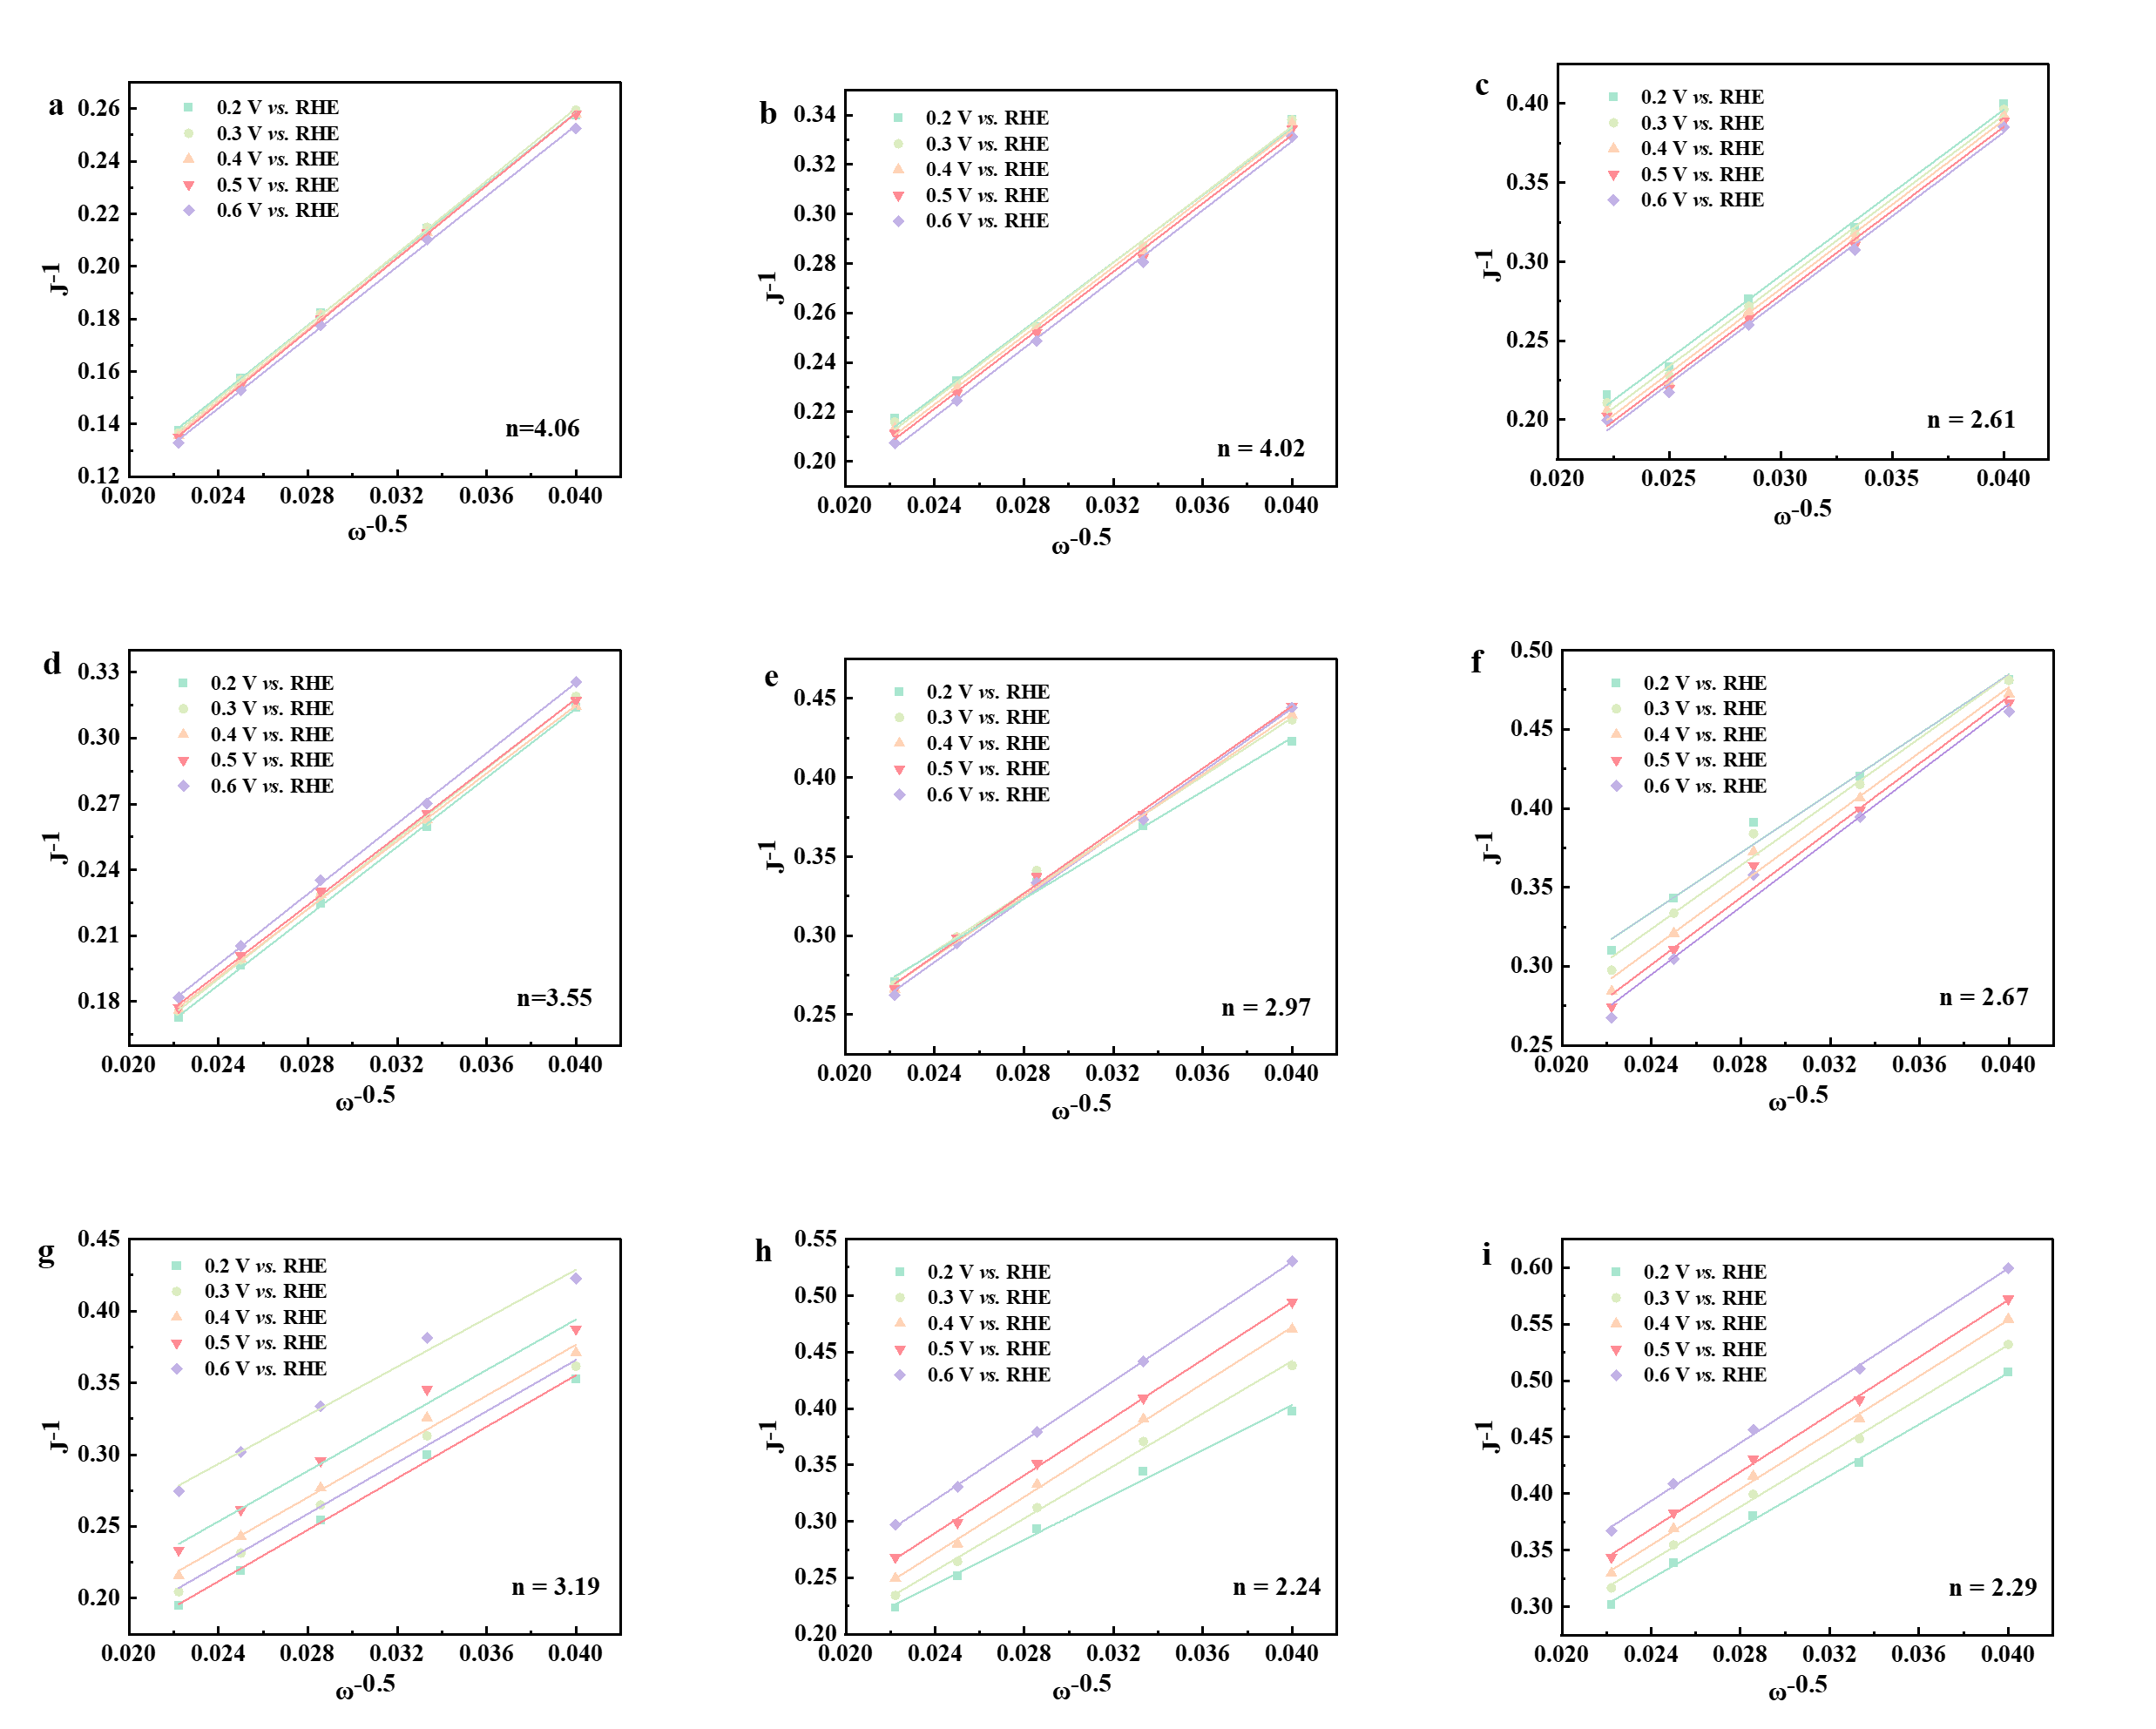
Fig. S7 K-L plots at different rotating speeds in a) 0.1 M KOH, b) 0.1 M KOH with 0.5 M KCl and c) alkaline synthetic seawater (pH = 13) of Cl-Fe-N₄; in d) 0.1 M KOH, e) 0.1 M KOH with 0.5 M KCl and f) alkaline synthetic seawater of S-Fe-N₄; g) 0.1 M KOH, h) 0.1 M KOH with 0.5 M KCl and i) alkaline synthetic seawater of Fe-N₄

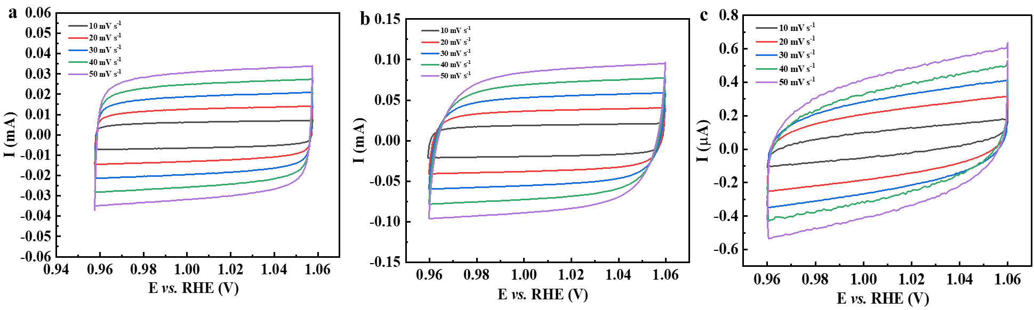
Fig. S8 CV curves of a) Cl-Fe-N₄, b) S-Fe-N₄, c) Fe-N₄ in alkaline synthetic seawater. Catalyst loading: 0.1 mg cm⁻²

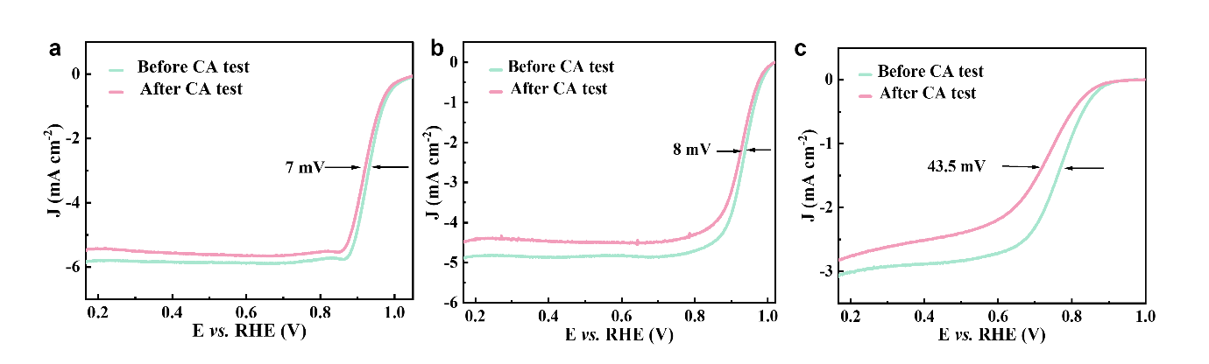
Fig. S9 LSV polarization curves before and after CA test of a) Cl-Fe-N₄, b) S-Fe-N₄, c) Fe-N₄ using RDE at 1600 rpm in alkaline synthetic seawater (pH=13) with a scan rate of 10 mV s⁻¹. Catalyst loading: 0.75 mg cm⁻².

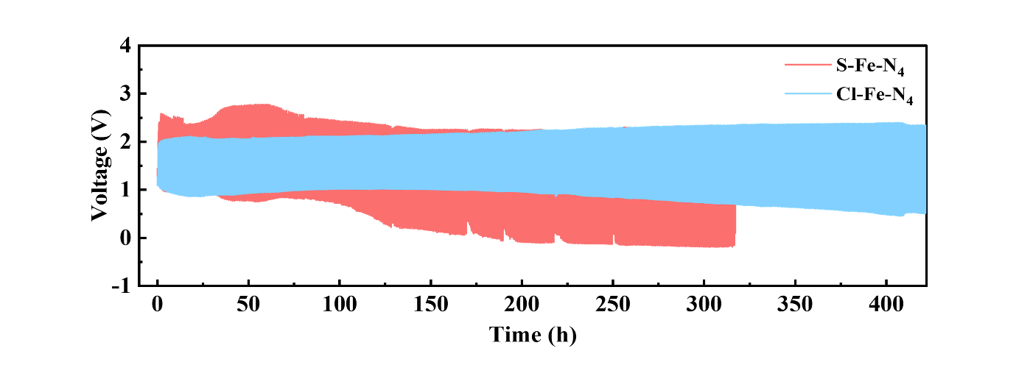
Fig. S10 The long cycling curves of Cl-Fe-N₄ and S-Fe-N₄ at 10 mA cm⁻² in alkaline synthetic seawater
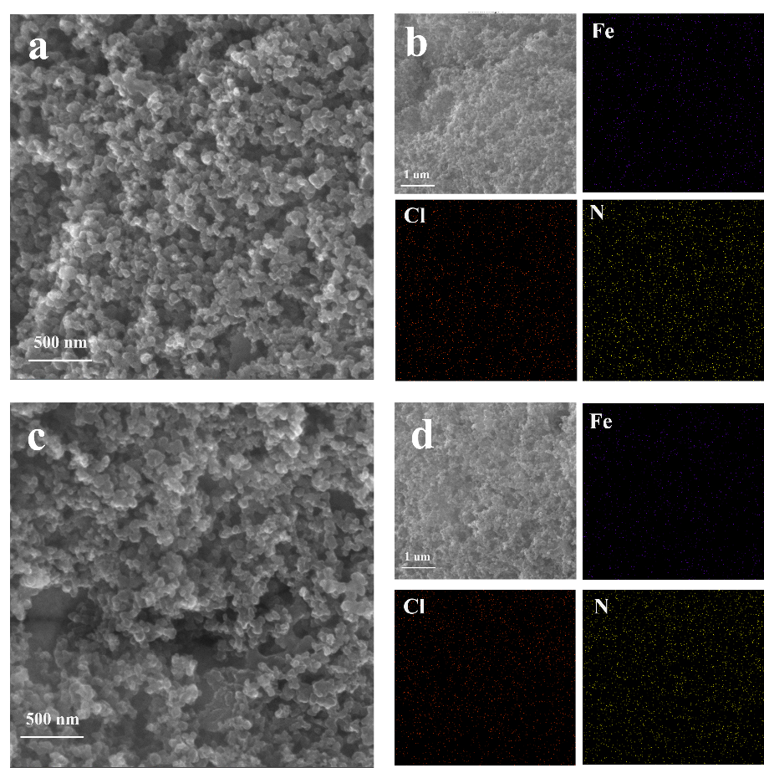
Fig. S11 a) SEM pattern and b) EDS mapping before the zinc-air battery test, and c) SEM pattern and d) EDS mapping after the test of Cl-Fe-N₄

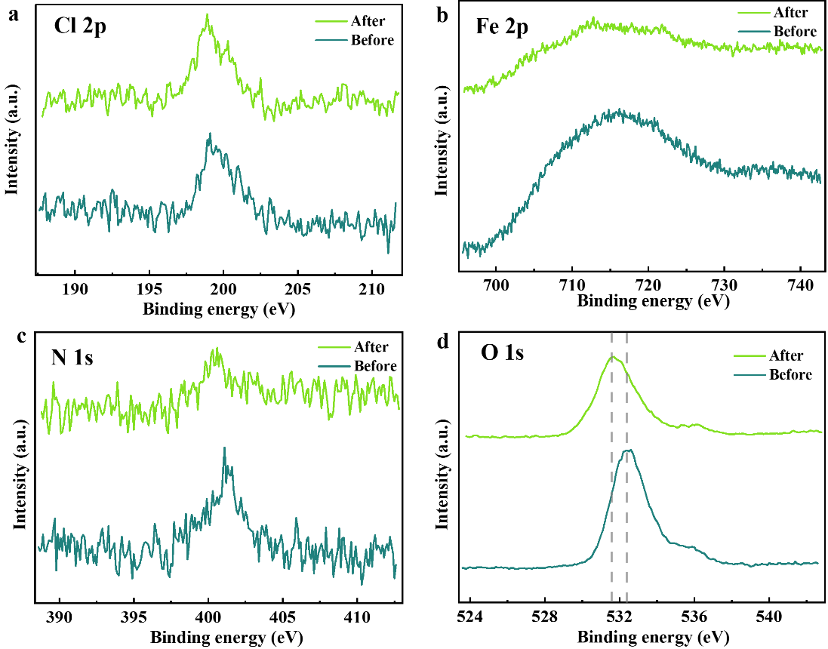
Fig. S12 Deconvoluted high-resolution XPS spectra of a) Cl 2p, b) Fe 2p, c) N 1s and d) O 1s for Cl-Fe-N₄ before and after the zinc-air battery test

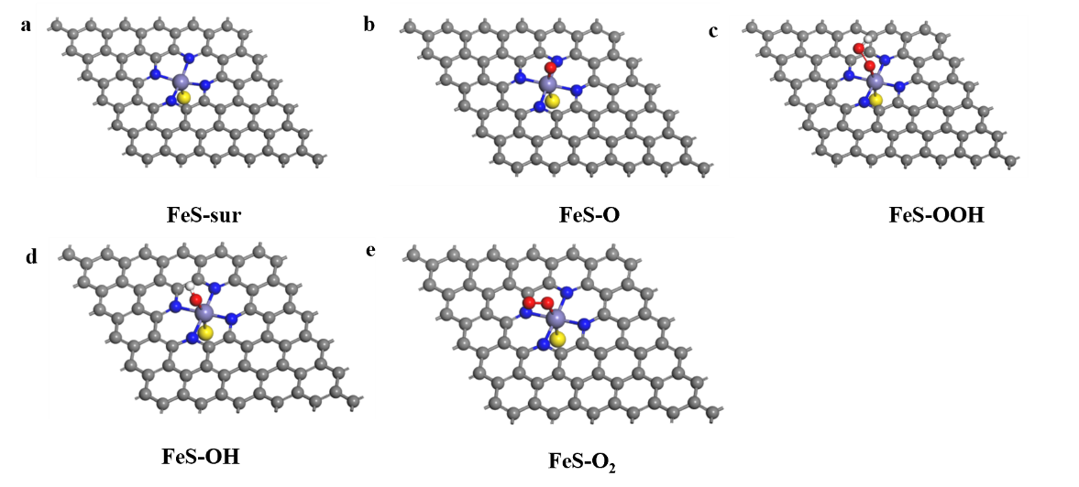
Fig. S13 Theoretical structures of the surface of a) unoccupied Fe-N₄ single atom site, Fe-N₄ single atom site adsorbed by b) -O, c) -OOH, d) -OH, e) -O₂

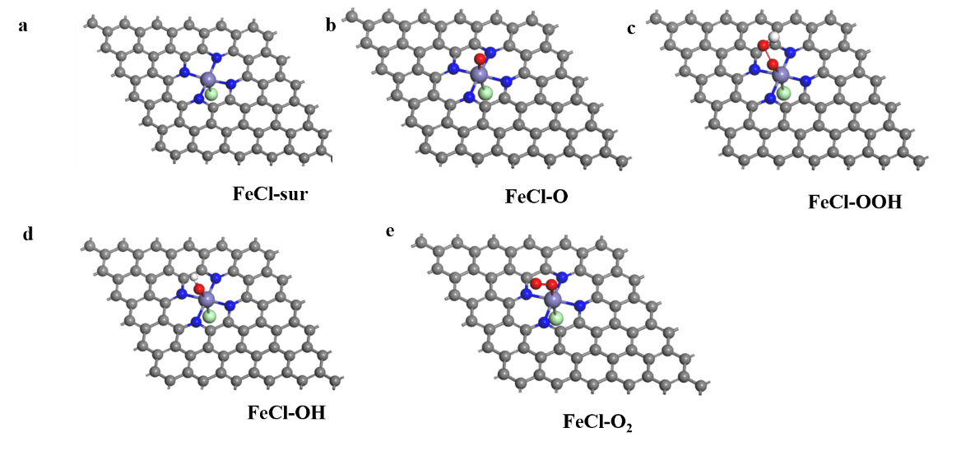
Fig. S14 Theoretical structures of the surface of a) unoccupied S-Fe-N₄ single atom site, S-Fe-N₄ single atom site adsorbed by b) -O, c) -OOH, d) -OH, e) -O₂

Fig. S15 Theoretical structures of the surface of a) unoccupied Cl-Fe-N₄ single atom site, Cl-Fe-N₄ single atom site adsorbed by b) -O, c) -OOH, d) -OH, e) -O₂

Fig. S16 The Bader charge of Fe-N₄. Purple ball: Fe; Green ball: Cl; Yellow ball: S; Grey ball: C; Blue ball: N; Red ball: O; White ball: H

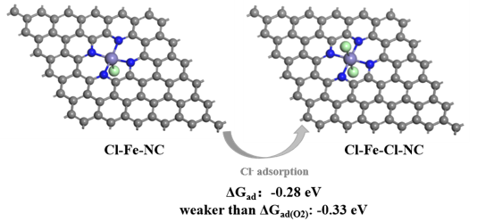
Fig. S17 Adsorption Energy and Configuration of Cl⁻ on Cl-Fe-NC
Supplementary Tables
Table S1 Atomic ratios in different samples based on XPS analysis
 | C | N | O | S | Cl | Fe
Cl-Fe-N₄ | 88.62 % | 4.73 % | 6.00 % | 0.36 % | 0.34 % | 0.13 %
S-Fe-N₄ | 88.21 % | 4.21 % | 6.90 % | 0.81 % | \ | 0.11 %
Fe-N₄ | 92.15 % | 3.55 % | 4.14 % | 0.08 % | \ | 0.10 %

Table S2 N species ratios in different samples based on XPS analysis
 | pyrrolic | pyridinic | Fe-N | N-oxide | graphitic-N
Cl-Fe-N₄ | 51.59 % | 23.49 % | 0.34 % | 7.55 % | 17.03 %
S-Fe-N₄ | 53.92 % | 15.72 % | 5.88 % | 7.3 % | 17.18 %
Fe-N₄ | 44.49 % | 16.25 % | 11.54 % | 8.54 % | 19.18 %

Table S3 Curve fitting parameters of Fe K-edge EXAFS
Sampleª | Path | N^{b} | R(Å) ^{c} | σ²(10⁻³Å²) ^{d} | ΔE₀(eV) | R-factor
S-Fe-N₄ | Fe-N | 4.40 | 2.02 | 7.18 | -0.56 | 0.016
S-Fe-N₄ | Fe-S | 0.90 | 2.67 | 30.05 | -0.56 | 0.016
Cl-Fe-N₄ | Fe-N | 4.04 | 1.91 | 6.34 | -9.92 | 0.009
Cl-Fe-N₄ | Fe-Cl | 0.78 | 2.17 | 0.04 | -9.92 | 0.009
Fe-N₄ | Fe-N | 4.0 | 1.96 | 5.64 | -4.49 | 0.014
ªS₀²was fixed as 1.0. Data ranges: 3.0 < k ≤ 8.0 Å⁻¹,1.0 ≤ R < 3.0 Å.
^{b}N is the coordination number.
^{c}R is the distance between absorber and backscatter atoms. ^{d}σ²is the Debye-Waller factor. R-factor is residual factor.

Table S4 Atomic ratios of Cl-Fe-N₄ before and after zinc-air battery test based on XPS analysis
 | C | N | O | Fe | Cl
Before the test | 75.69% | 4.11% | 19.46% | 0.15% | 0.59%
After the test | 67.31% | 3.07% | 28.45% | 0.09% | 1.08%

