Supporting Information for
Self-Assembled Ordered Nanostructure of Zwitterionic Co-Solutes Induces Localized High-Concentration Electrolytes for Ultrastable and Efficient Zinc Metal Anodes
Shengyang Huang¹, Zuyang Hu^{1, 2}, Xin Wang Mo¹, Yeonju Park^{3, 4}, Jun Su Kim¹, Gun Jang¹, Dong Hyun Min¹, Hao Fu¹, Peixun Xiong¹, Zhipeng Wen², Young Mee Jung^{3, 4}, Jaeyun Kim¹, Hyunjoo Lee⁵, Chihyun Hwang⁶, Youngkwon Kim^{6,} *, Cheng Chao Li^{2,} *, Qingyun Dou^{1, 7,} * and Ho Seok Park^{1, 8,} *
¹ School of Chemical Engineering, Sungkyunkwan University (SKKU), 2066 Seobu-ro, Jangan-gu, Suwon 16419, Republic of Korea
² Guangdong Provincial Key Laboratory of Plant Resources Biorefinery, School of Chemical Engineering and Light Industry, Guangdong University of Technology, Guangzhou 510006, P. R. China
³ Department of Chemistry, Institute for Molecular Science and Fusion Technology, Kangwon National University, Chuncheon 24341, Republic of Korea
⁴ Kangwon Radiation Convergence Research Support Center, Kangwon National University, Chuncheon 24341, Republic of Korea
⁵ Clean Energy Center, Institute of Science and Technology (KIST), 5, Hwarang-ro 14-gil, Seongbuk-gu, Seoul 02792, Republic of Korea
⁶ Advanced Batteries Research Center, Korea Electronics Technology Institute (KETI), 25, Saenari-ro, Seongnam 13509, Republic of Korea
⁷ Department of Materials Science and Engineering, Sun Yat-Sen University, Guangzhou 510275, P. R. China
⁸ SKKU Institute of Energy Science and Technology (SIEST), Sungkyunkwan University, 2066, Seoburo, Jangan-gu, Suwon 440-746, Republic of Korea
*Corresponding authors. E-mail: douqy3@mail.sysu.edu.cn (Qingyun Dou), ykkim96@keti.re.kr (Youngkwon Kim), licc@gdut.edu.cn (Cheng Chao Li), phs0727@skku.edu (Ho Seok Park)
S1 Experimental Section
S1.1 Electrolyte preparation
The blank electrolyte of 2 molal (mol kg⁻¹) Zn(OTf)₂ was formulated by dissolving zinc (II) trifluoromethanesulfonate (TCI, >98%) in deionized water. For the cell electrolyte preparation, varying concentrations of 3-(decyldimethylammonio)propanesulfonate inner salt (C₁₀, Sigma-Aldrich, ≥98%), dimethylethylammoniumpropane sulfonate (C₂, Sigma-Aldrich, ≥97%), 3-(N,N-dimethyloctylammonio)propanesulfonate inner salt (C₈, Sigma-Aldrich, ≥98%), N-dodecyl-N,N-dimethyl-3-ammonio-1-propanesulfonate (C₁₂, Sigma-Aldrich, >99%), 3-(N,N-dimethylmyristylammonio)propanesulfonate (C₁₄, Sigma-Aldrich, ≥99%) and 3-(N,N-dimethylpalmitylammonio)propanesulfonate (C₁₆, Sigma-Aldrich, ≥98%) were separately introduced into the blank electrolyte. The optimized concentration of co-solute is 1 molal.
S1.2 Cathodes preparation
The cathodes were prepared by blending 70 wt% of active materials, 20 wt% Ketjen Black (KB, Lion Specialty Chemicals Co., Ltd.), and 10 wt% polyvinylidene fluoride (PVDF, Sigma-Aldrich, average Mw ~180000) in 1-methyl-2-pyrrolidone (NMP, DAEJUNG). The resulting slurry was cast onto a titanium foil (MA-EN-CU-001001, Canrd Technology Co. Ltd.) and dried at 80 °C overnight, yielding a VO₂/CNT loading of 4 mg cm⁻² on each cathode. The high mass loading (20 mg cm⁻²) and ultrahigh mass loading (50 mg cm⁻²) free-standing cathodes were obtained by casting the slurry onto glass plates and then drying them.
S1.3 Material characterizations
For the electrolyte characterization, Fourier-transform infrared (FT-IR) spectra were recorded using two FT-IR 4700s (JASCO) employing attenuated total reflection (ATR) techniques. Raman spectra were collected with a Confocal Raman Spectrometer (NT-MDT) operating at a wavelength of 532 nm. SERS spectra were obtained with a LabRAM HR Evolution confocal Raman microscope (Horiba-Jobin-Yvon) equipped with an air-cooled, frequency-doubled Nd:YAG laser at an excitation wavelength of 532 nm. Samples for nuclear magnetic resonance (NMR) analysis were prepared by mixing electrolytes in deuterium oxide (D₂O). The NMR spectra were recorded on a 700 MHz spectrometer (AVANCE Ⅲ 700, Bruker). For SAXS, the scattered intensity was recorded using a Mar165 CCD detector with 2048 × 2048 pixels and a pixel size of 79 μm. The distance between the sample and the detector was 1600 mm. The active area is Φ165 mm. UV-vis absorption spectra were obtained by a MULTISKAN GO (Thermo SCIENTIFIC). DLS spectra were collected using a Zetasizer Nano ZS90 (Malvern Panalytical). To assess the ionic conductivities of the electrolytes, a real-time conductivity (SevenMulti, Mettler-Toledo) was utilized. Contact angle measurements were conducted using a contact angle goniometer (SmartDrop_Plus, FEMTOBIOMED). Digital images captured on an Honor 10 (Huawei). The electron backscatter diffractions of the Zn anodes were obtained from a JSM-IT800 (JEOL). The morphologies of the Zn anodes were analyzed using scanning electron microscopy (SEM, JSM-7000F, JEOL). A 3D laser confocal scanning microscope (3D LCSM, OLS5100, Olympus) was employed for three-dimensional imaging and reconstruction of post-cycled Zn samples. X-ray diffraction (XRD) patterns were recorded with an X-ray diffractometer (PANalytical, Almelo) using Cu Kα radiation (λ = 0.154 nm). X-ray photoelectron spectroscopy (XPS, ESCALAB 250, Thermo-Scientific) was used for characterizing the surface components of the electrodes, with in-depth XPS spectra obtained through argon ion sputtering for varying durations (0 s, 300 s, 600 s, and 900 s). The binding energies in the XPS spectra were referenced against the adventitious C 1s peak at 284.6 eV. Time-of-flight secondary ion mass spectrometry (ToF-SIMS) measurements were conducted using a TOF-SIMS-5 (ION-TOF), with sputtering performed using a 1 keV O₂ beam over a 150×150 µm² area, while analysis was restricted to a 40×40 μm² area using a pulsed 25 keV Bi⁺ primary beam.
S1.4 Electrochemical measurements
The electrochemical performances of all kinds of cells were evaluated using the WonATech WBCS3100L Battery Testing System, Maccor Series 4000 Battery Testing System and NEWARE Battery Testing System (CT-4008Tn-5V6A-S1). A comprehensive analysis of the cells' electrochemical properties, including cyclic voltammetry (CV), electrochemical impedance spectroscopy (EIS), linear sweep voltammetry (LSV), and chronoamperometry (CA), was carried out using a BioLogic VMP3 Multichannel Potentiostat. EIS measurements were performed over a wide frequency range of 10 Hz to 100 kHz to gain in-depth insights into the cell dynamics. The HER was assessed via LSV in electrolytes using NaOTf salt, using a sweep rate of 5 mV s⁻¹. Chronoamperometry was employed to capture diffusion profiles under 150 mV. Corrosion behavior was examined in the three-electrode system with Tafel analysis. Zn foils were utilized as both the working and counter electrodes, while an Ag/AgCl electrode served as the reference.
The transference number of Zn²⁺ (t_{Zn}) was obtained from the Zn||Zn symmetric cells. The procedure of CA was employed under 10 mV for 1200 s. The t_{Zn} value was calculated using Eq. 1:
$t_{Zn}= \frac{I_{s}\left(ΔV-I_{0}R_{0}\right)}{I_{0}\left(ΔV-I_{s}R_{s}\right)}$ (S1)
where I₀ and Is are the initial and steady-state currents, respectively. ΔV represents the applied potential. R₀ and Rs donate the initial and steady-state electrode resistances, respectively.
S1.5 Calculation methods
Density functional theory (DFT) calculations were conducted using the Gaussian (G09) program [S1]. The Becke’s three-parameter hybrid method with the Lee-Yang-Parr correlation functional (B3LYP) was employed [S2, S3]. Structural optimizations were conducted at the 6-311++G(d,p) level [S4], and single-point energy calculations were carried out using the def2-TZVP basis set [S5, S6]. Grimme’s dispersion correction with Becke-Johnson damping [DFT-D3(BJ)] [S7-S9] was applied throughout the calculations. Solvation effects were considered using the SMD universal solvation model [S10]. Frequency analyses were performed to confirm that all optimized ion-solvent complexes correspond to true minima on the potential energy surface. Electrostatic potential (ESP) analyses were conducted using Multiwfn [S11, S12] and visualized with VMD [S13] software. The binding energy (E_{b}) between molecule/ion A and molecule/ion B was calculated according to Eq. 2:
$E_{b}= E_{complex}-E_{A}-E_{B}$ (S2)
Adsorption energy calculations were performed using the projector augmented wave (PAW) method as implemented in the Vienna Ab Initio Simulation Package (VASP) [S13]. The generalized gradient approximation (GGA) with the Perdew-Burke-Ernzerhof (PBE) functional was adopted to describe the exchange-correlation energy [S14, S15]. A plane-wave cutoff energy of 500 eV and a Γ-centered 3×3×1 k-point mesh were used in all calculations. Structural optimizations were carried out until the residual forces on all atoms were less than 0.03 eV Å⁻¹, and the total energy convergence criterion was set to 1×10⁻⁵ eV. The adsorption energy (E_{a}) between the Zn slab and the adsorbate was calculated using Eq. 3:
$E_{a}= E_{system}-E_{slab}-E_{Adsorbate}$ (S3)
Molecular dynamics (MD) were performed using the Large-scale Atomic/Molecular Massively Parallel Simulator (LAMMPS) based on the Optimized Potentials for Liquid Simulations All-Atom (OPLS-AA) force field [S16-S18]. The force field parameters for organic solvents were generated using the LigParGen web server, while the restrained electrostatic potential (RESP) atomic charges were derived from electrostatic potential (ESP) fitting using Multiwfn [S11, S12]. Initial atomic configurations were constructed using the Packmol package [S19, S20], and all final model boxes and solvation structures were visualized with VMD [S13]. Periodic boundary conditions were applied in all three dimensions. A cutoff distance of 10 Å was set for both van der Waals interactions and the particle-particle particle-mesh (PPPM) method for long-range Coulombic interactions. The time step was set to 1 fs. All electrolyte models were first equilibrated in the NVT ensemble using the Nosé-Hoover thermostat at 298 K for 5 ns [S21, S22]. Subsequently, a 20 ns NPT ensemble simulation was performed under a Nosé–Hoover thermostat and barostat to fully equilibrate the system at 298 K and 1 atm. A 15 ns production run was finally conducted under NPT conditions at 298 K and 1 atm, during which data for radial distribution function (RDF) and solvent shell analyses were collected.

S2 Results and Discussion

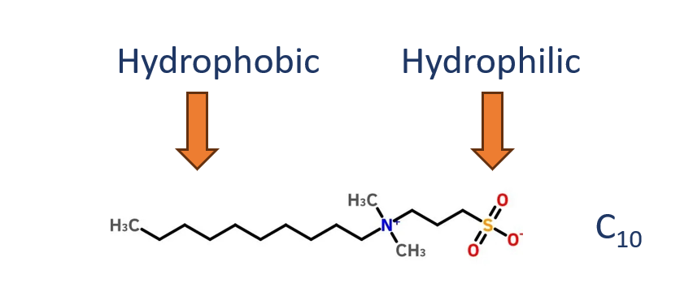
Fig. S1 The amphiphilic characteristics of C₁₀

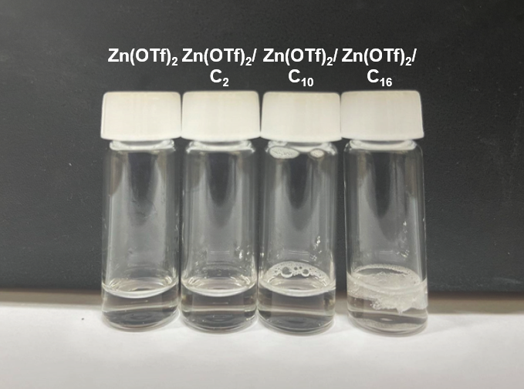

Fig. S2 Digital images of different electrolytes

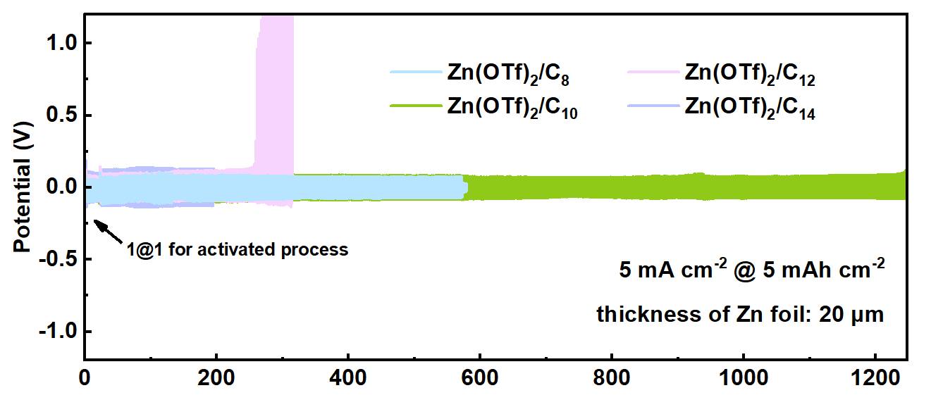

Fig. S3 Cycling performances of Zn||Zn symmetric cells with C₈, C₁₀, C₁₂, and C₁₄ at 5 mA cm⁻² for 5 mAh cm⁻²

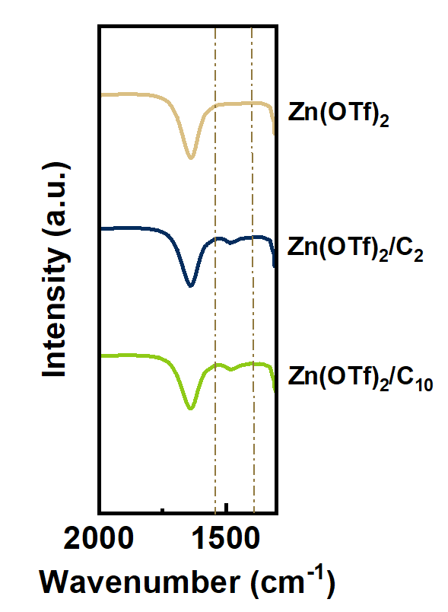
Fig. S4 FT-IR spectra of different electrolytes at the range of 2000-1300 cm⁻¹

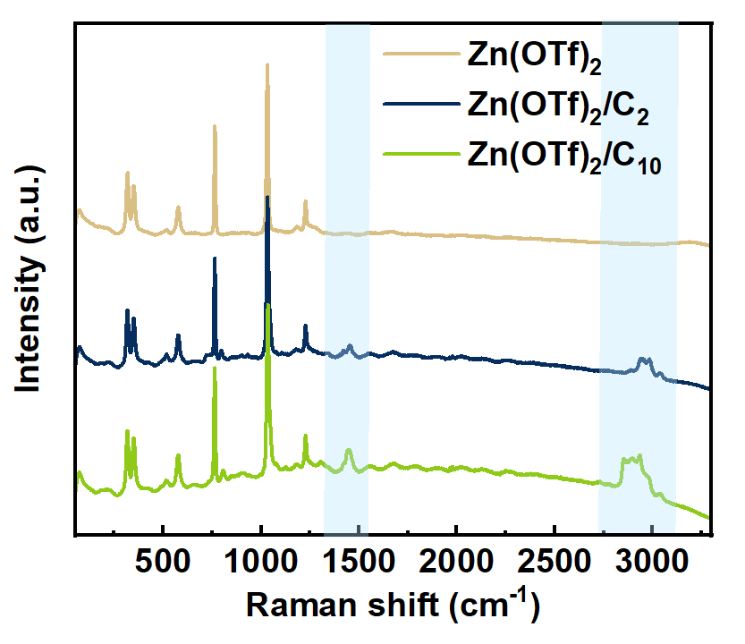
Fig. S5 Raman spectra of different electrolytes

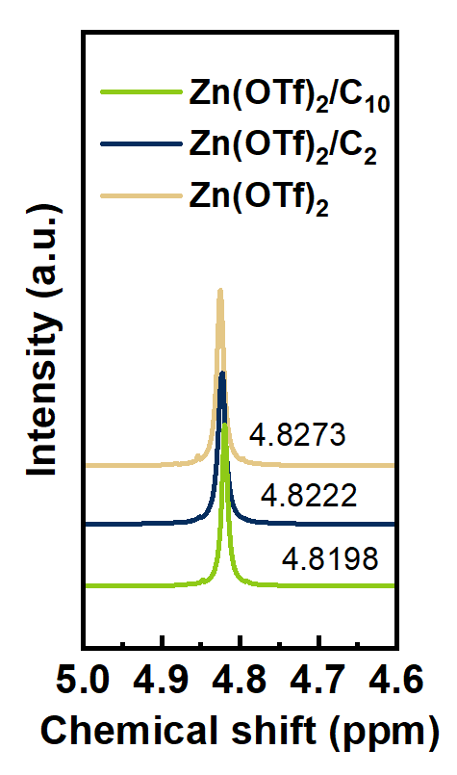
Fig. S6 ¹H NMR spectra of different electrolytes at the range of 5.0-4.6 ppm

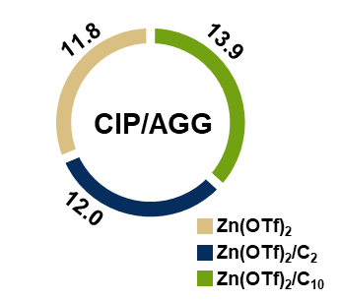
Fig. S7 The ratios of CIP/AGG in all solvation structures in different electrolytes from MD simulations

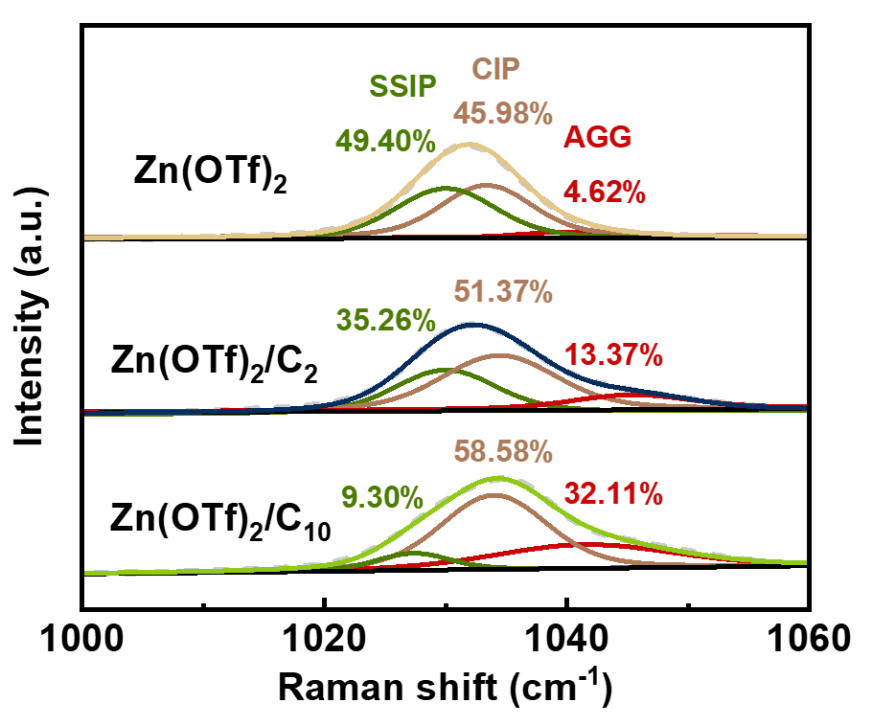
Fig. S8 Raman spectra for SSIP/CIP

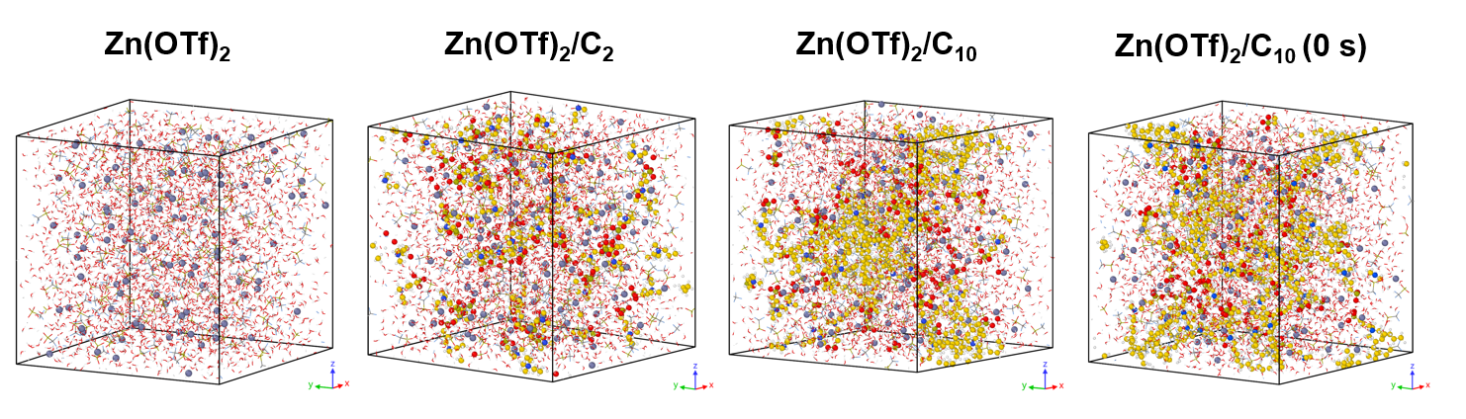
Fig. S9 Snapshots of different electrolytes after 15 ns, and Zn(OTf)₂/C₁₀ at 0 s (3D images)
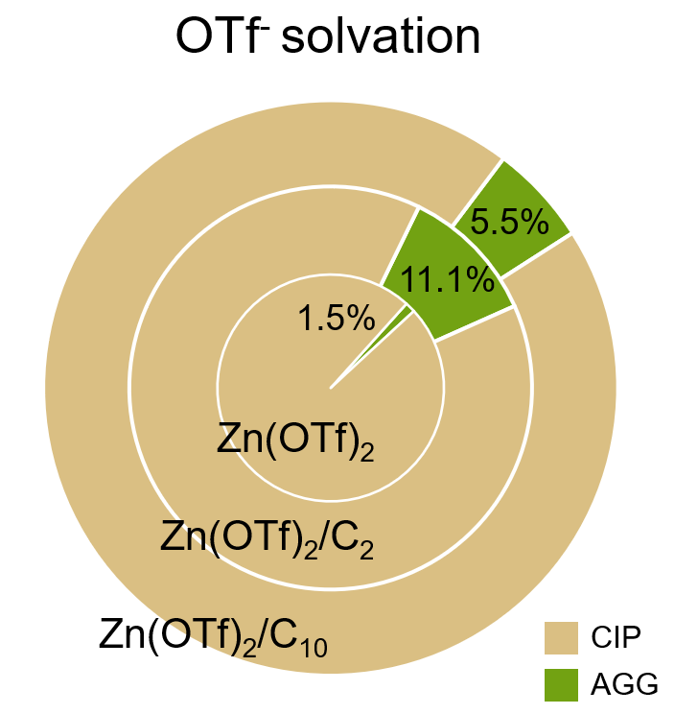
Fig. S10 Statistical analysis of the proportion of AGG in CIP/AGG configurations
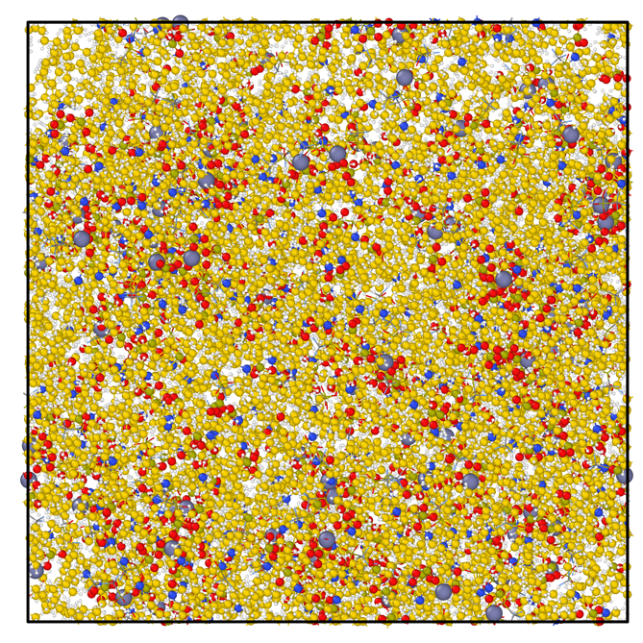
Fig. S11 Snapshots of MD simulation about a water-free, high-C₁₀-concentration system

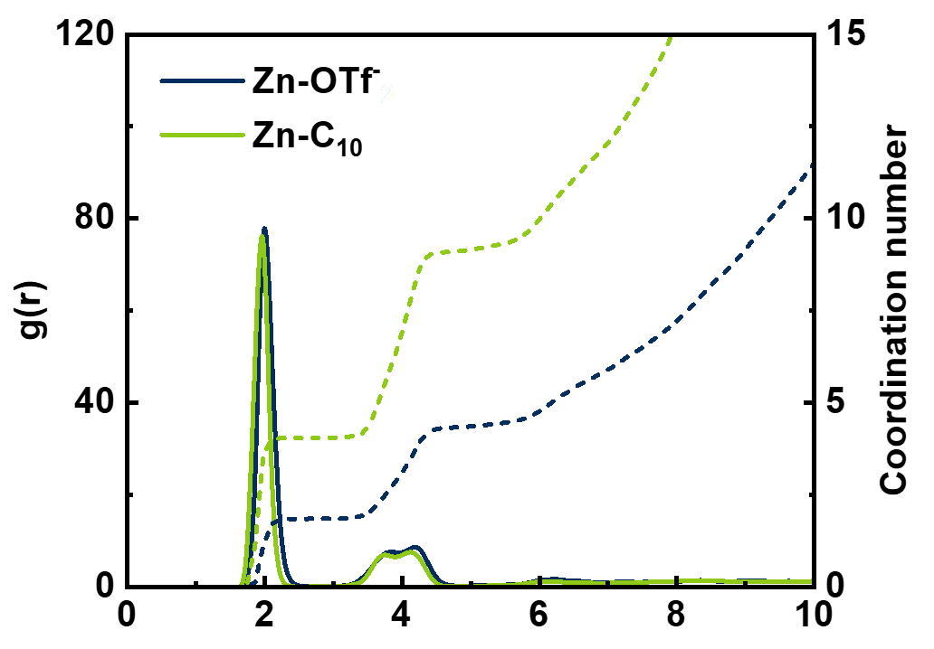
Fig. S12 Radial distribution functions and corresponding coordination numbers of Zn²⁺–O in the water-free, high-C₁₀-concentration system

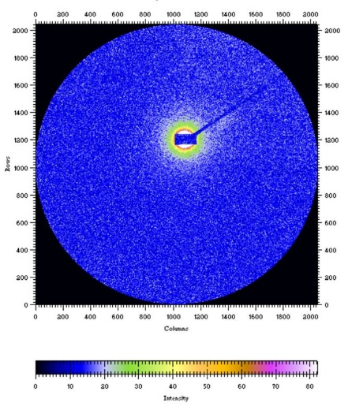
Fig. S13 Two-dimensional SAXS image of Zn(OTf)₂
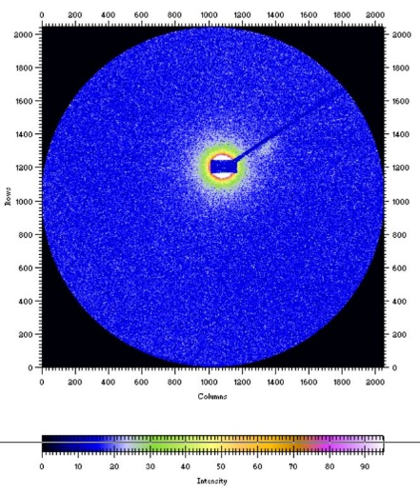
Fig. S14 Two-dimensional SAXS image of Zn(OTf)₂/C₂

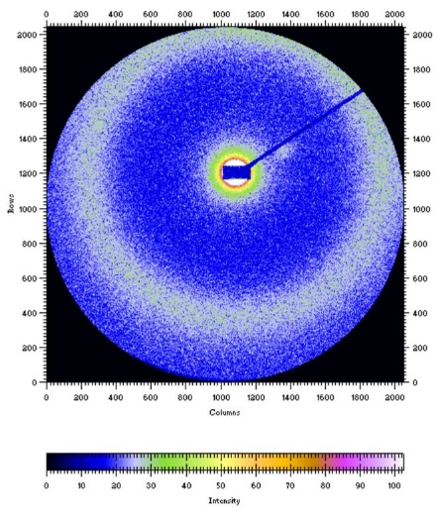
Fig. S15 Two-dimensional SAXS image of Zn(OTf)₂/C₁₀

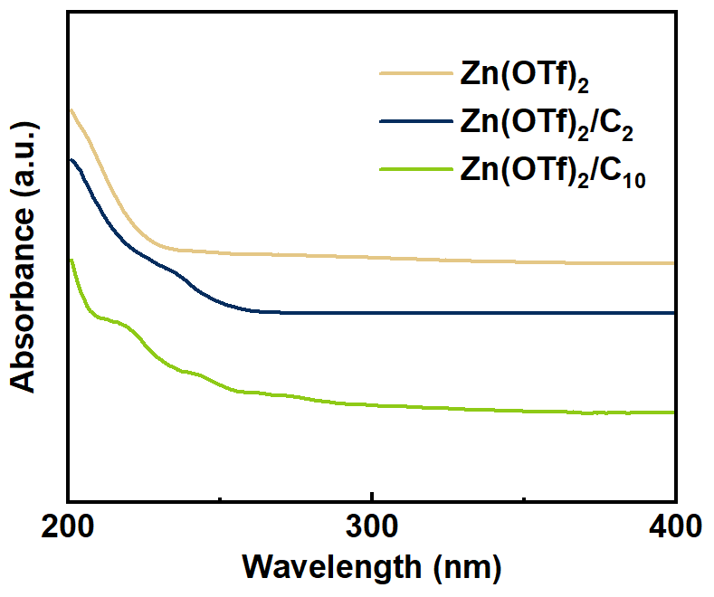
Fig. S16 UV-vis spectra of different electrolytes

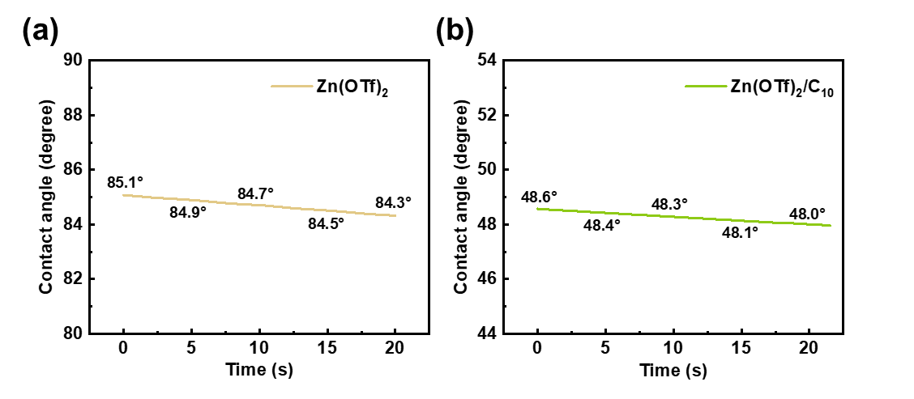
Fig. S17 In-situ contact angle test of (a) Zn(OTf)₂, and (b) Zn(OTf)₂/C₁₀

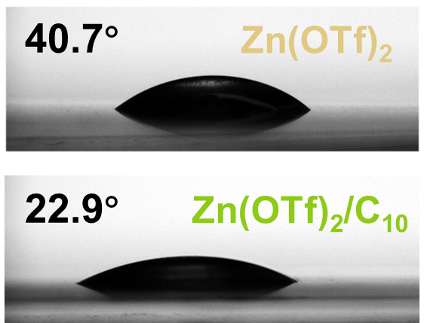
Fig. S18 Contact angles of de-ionized water on Zn foil after immersion in different electrolytes

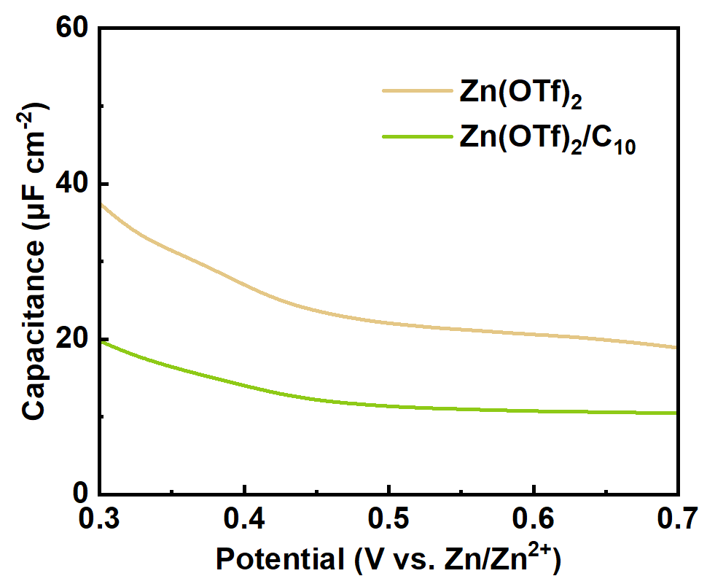
Fig. S19 Capacitance-potential profiles of different electrolytes

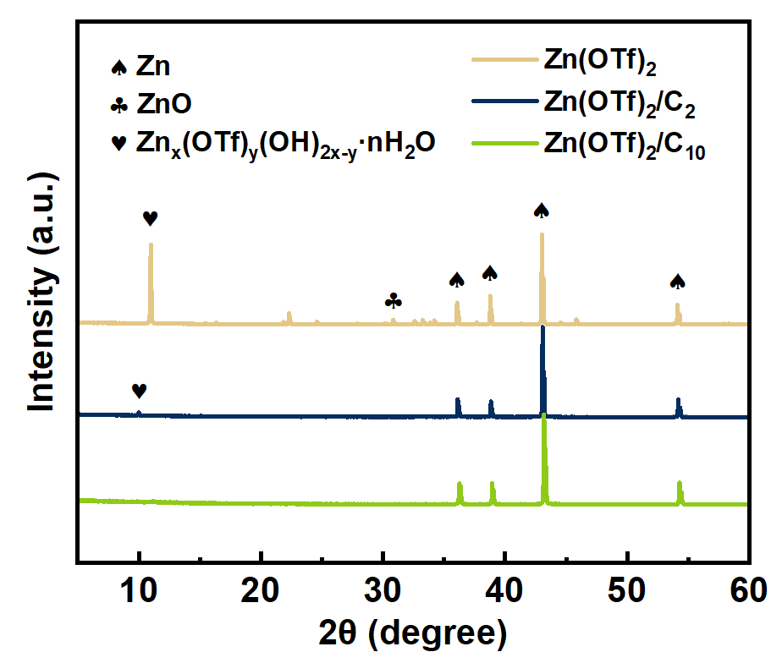
Fig. S20 XRD images of Zn after immersing for 7 days in different electrolytes
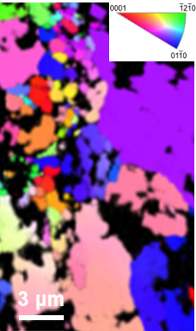
Fig. S21 EBSD orientation map of Zn after plating/stripping for 20 times in Zn(OTf)₂

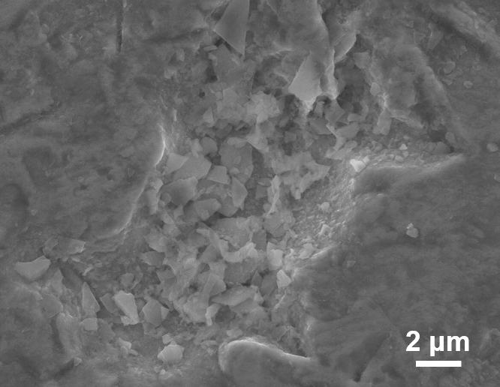
Fig. S22 SEM image of Zn foil after immersing for 7 days in Zn(OTf)₂

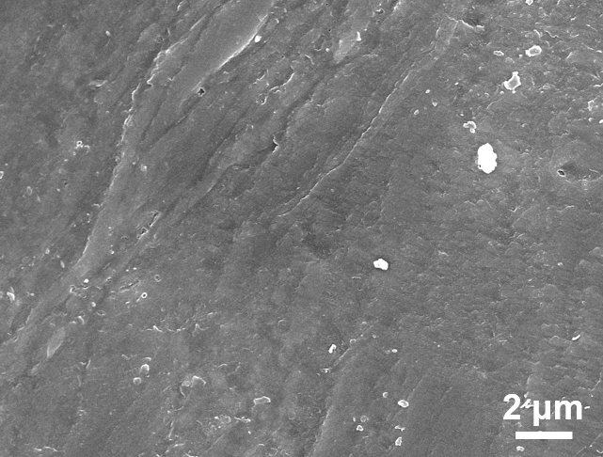
Fig. S23 SEM image of Zn foil after immersing for 7 days in Zn(OTf)₂/C₁₀

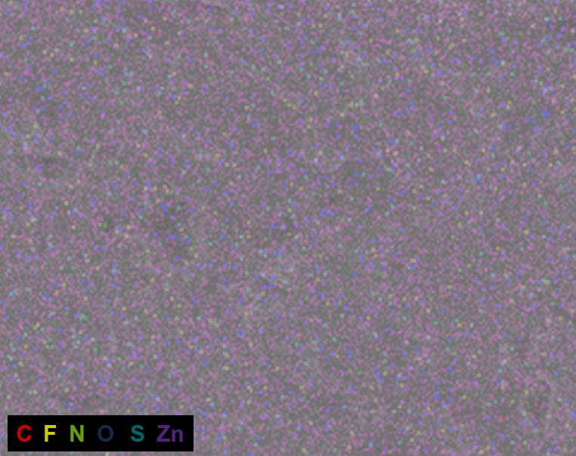
Fig. S24 EDX mapping of Zn foil after immersing for 7 days in Zn(OTf)₂/C₁₀
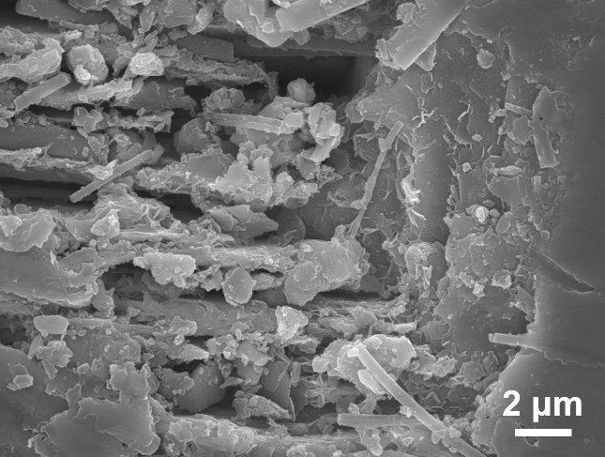
Fig. S25 SEM image of Zn after plating/stripping for 20 times in Zn(OTf)₂

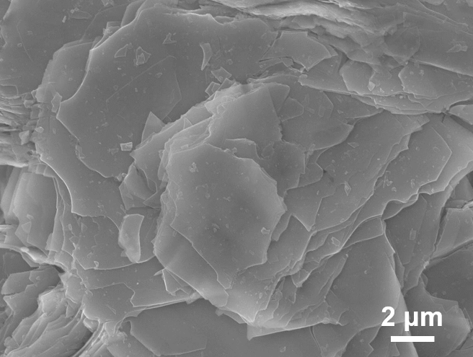
Fig. S26 SEM image of Zn foil after immersing for 7 days in Zn(OTf)₂/C₂

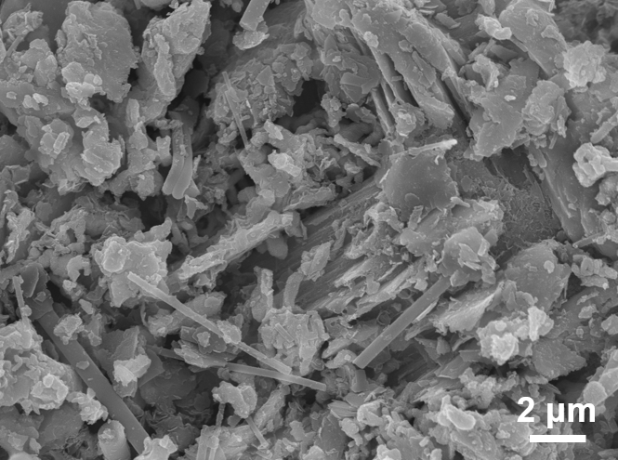
Fig. S27 SEM image of Zn after plating/stripping for 20 times in Zn(OTf)₂/C₂

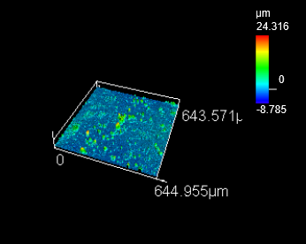
Fig. S28 LSCM image of Zn after plating/stripping for 20 times in Zn(OTf)₂
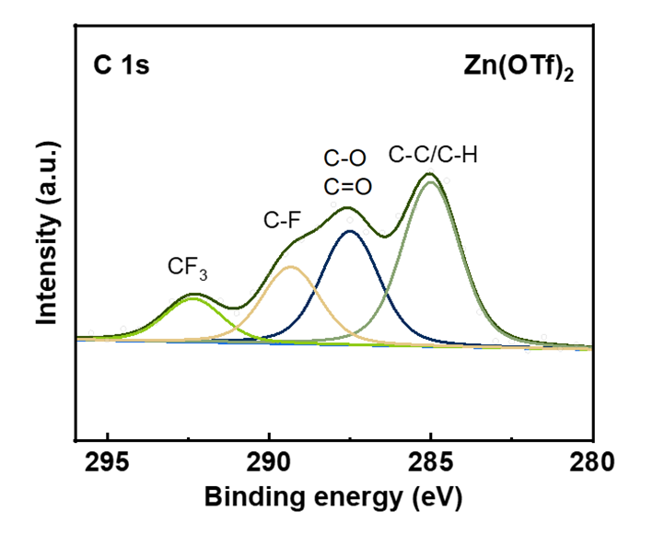
Fig. S29 XPS C 1s spectra of Zn after plating/stripping for 20 times in Zn(OTf)₂

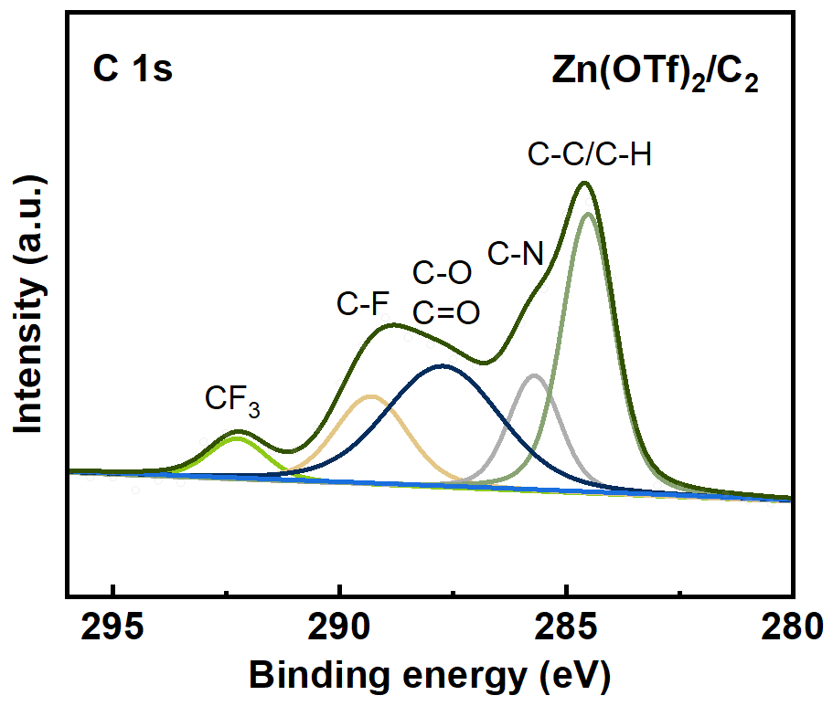
Fig. S30 XPS C 1s spectra of Zn after plating/stripping for 20 times in Zn(OTf)₂/C₂

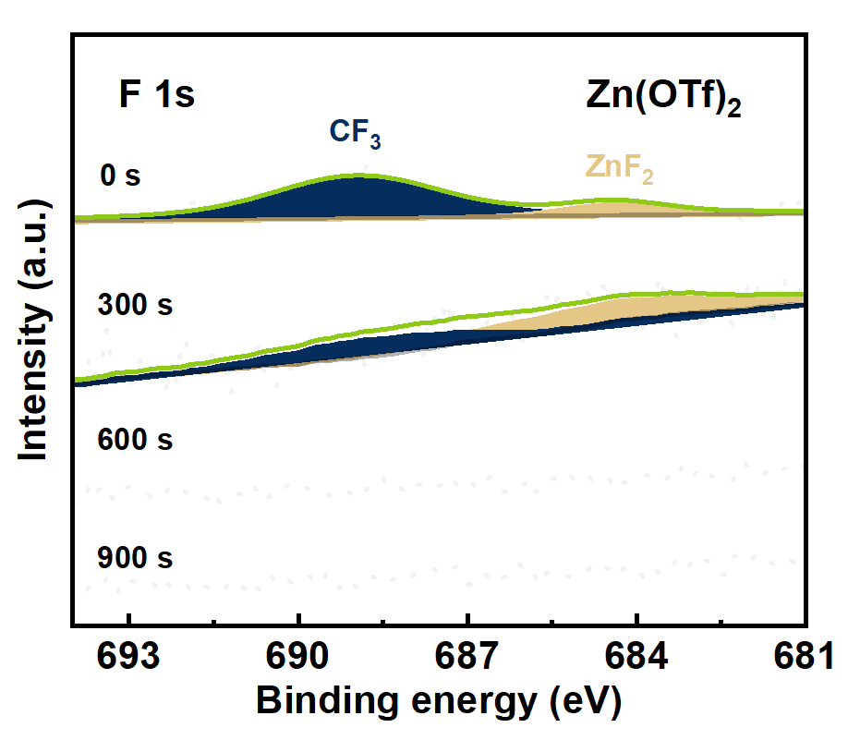
Fig. S31 In-depth XPS F 1s spectra of Zn after plating/stripping for 20 times in Zn(OTf)₂

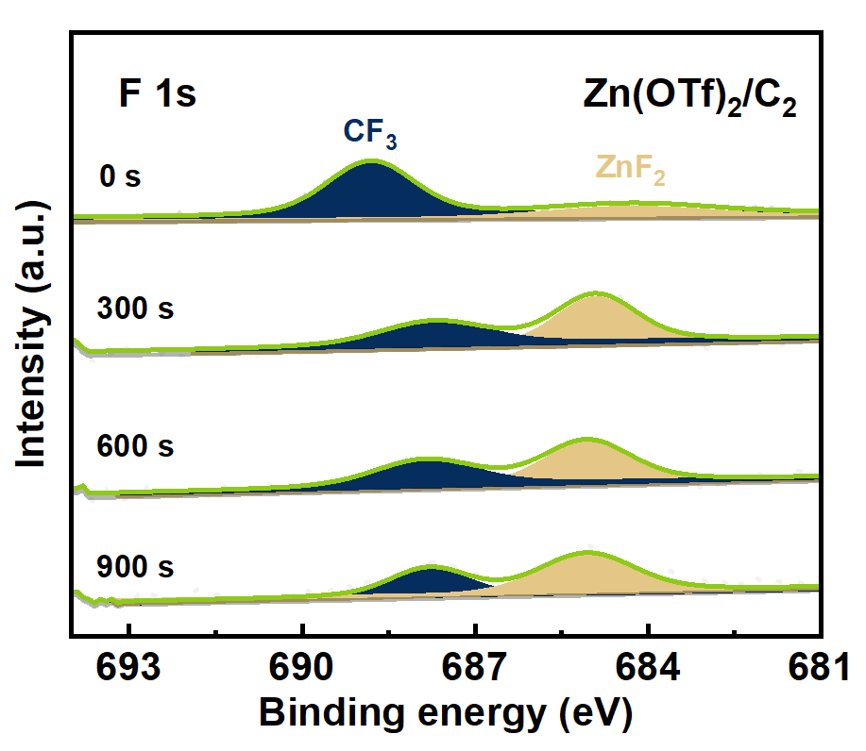
Fig. S32 In-depth XPS F 1s spectra of Zn after plating/stripping for 20 times in Zn(OTf)₂/C₂
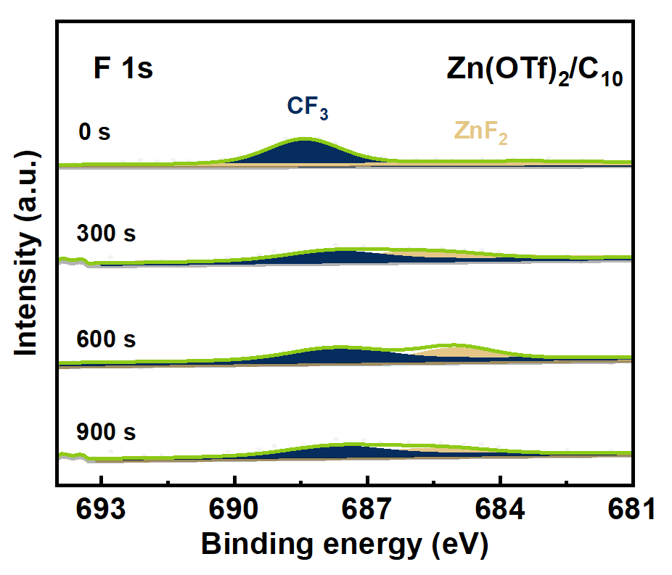
Fig. S33 In-depth XPS F 1s spectra of Zn after plating/stripping for 20 times in Zn(OTf)₂/C₁₀

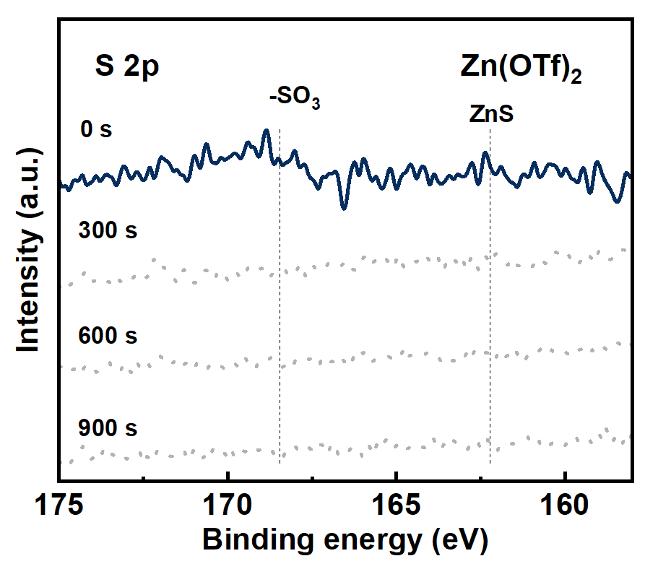
Fig. S34 In-depth XPS S 2p spectra of Zn after plating/stripping for 20 times in Zn(OTf)₂

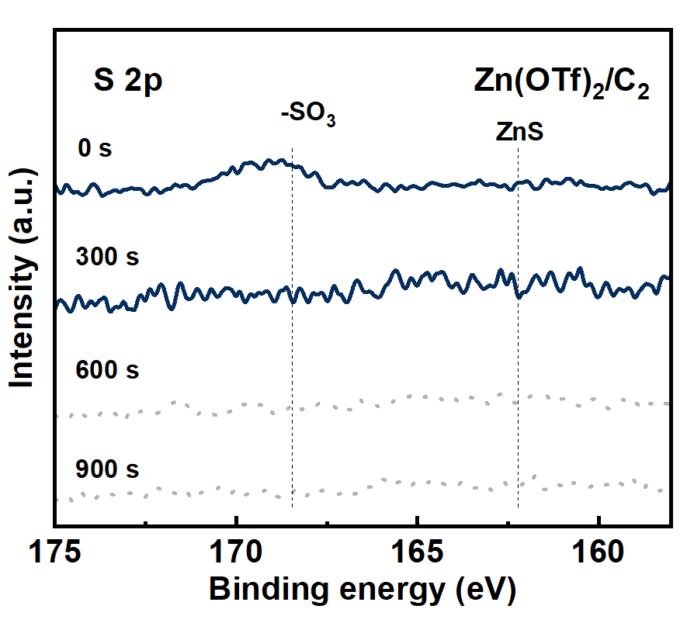
Fig. S35 In-depth XPS S 2p spectra of Zn after plating/stripping for 20 times in Zn(OTf)₂/C₂

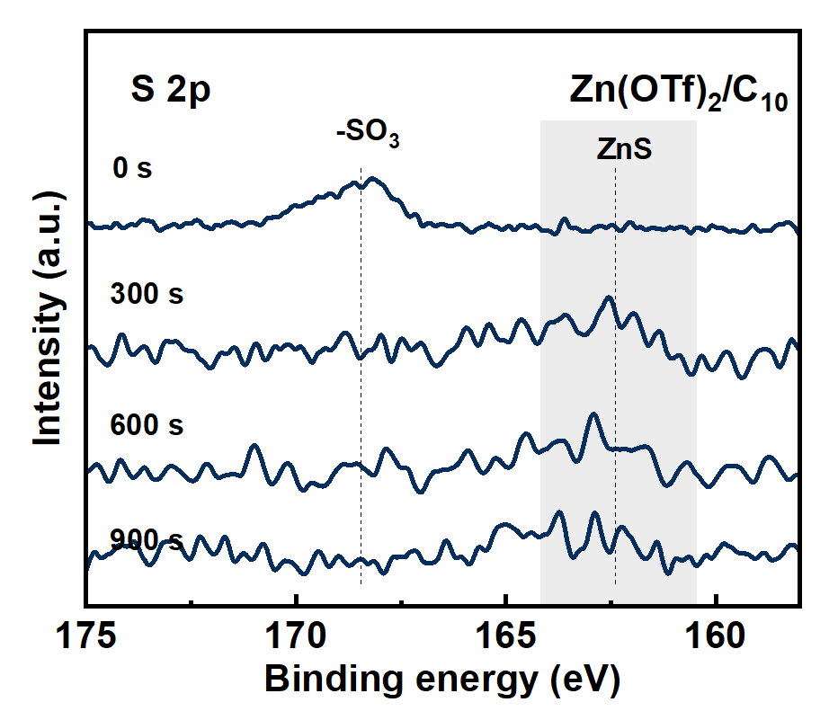
Fig. S36 In-depth XPS S 2p spectra of Zn after plating/stripping for 20 times in Zn(OTf)₂/C₁₀
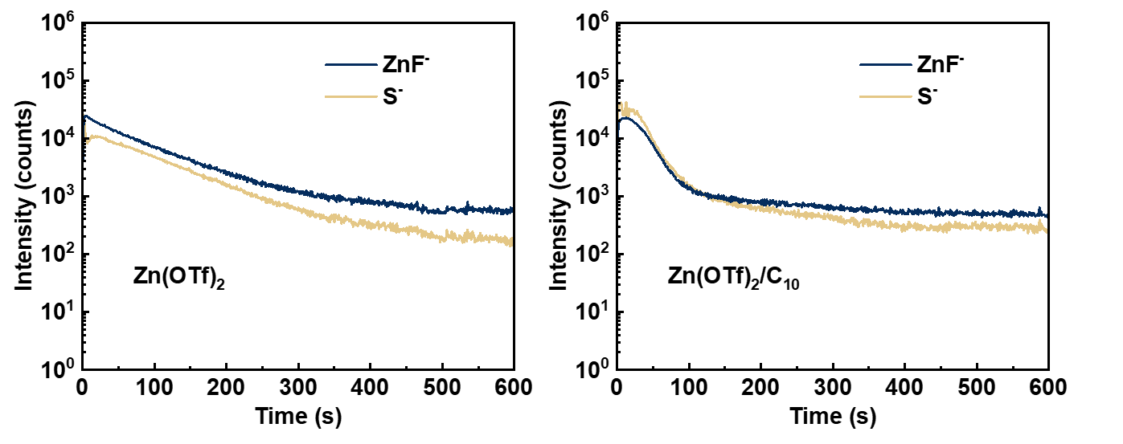
Fig. S37 2D ToF-SIMS spectra of Zn after plating/stripping for 20 times in Zn(OTf)₂ and Zn(OTf)₂/C₁₀

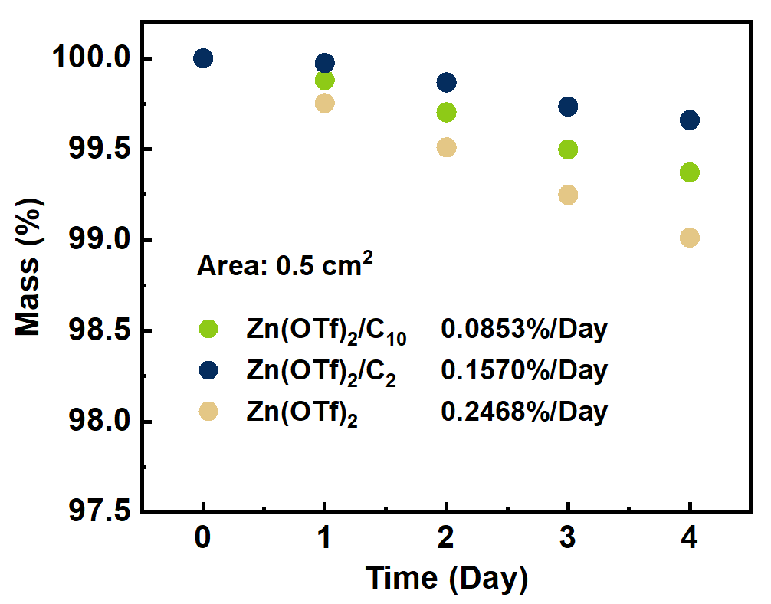
Fig. S38 Mass change of Zn immersed in different electrolytes

To prevent the influence of basic byproducts, the samples were rinsed with 5% citric acid for 5 min before each mass measurement. The Zn(OTf)₂/C₁₀ shows the lowest mass change (0.0853%/Day) compared to The Zn(OTf)₂ (0.2468%/Day) and Zn(OTf)₂/C₂ (0.1570%/Day), further confirming the corrosion-inhibiting effect of C₁₀.

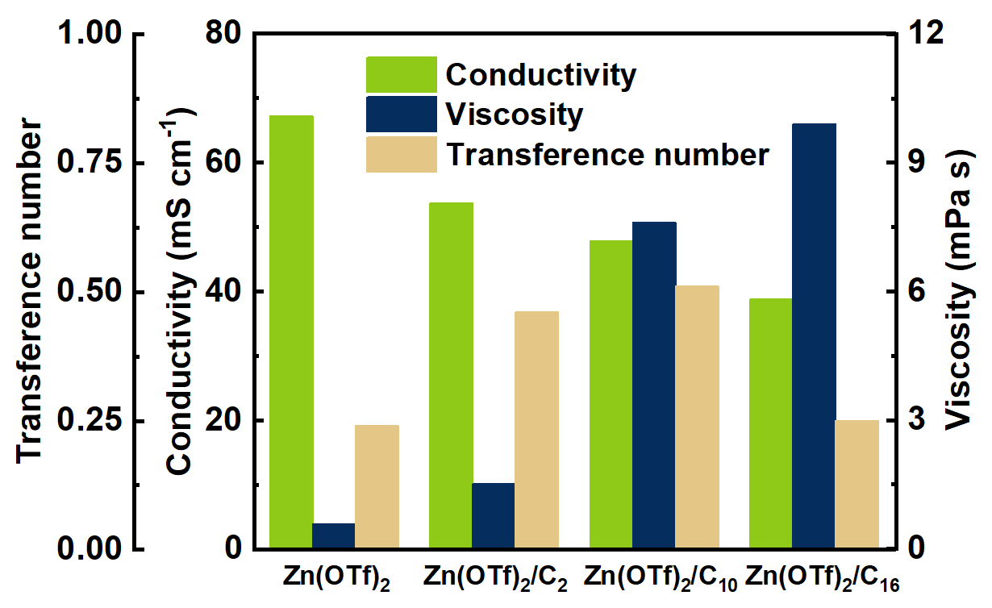
Fig. S39 Conductivity, viscosity, and transference number of different electrolytes. Zn(OTf)₂/C₁₆ was tested under 40 °C
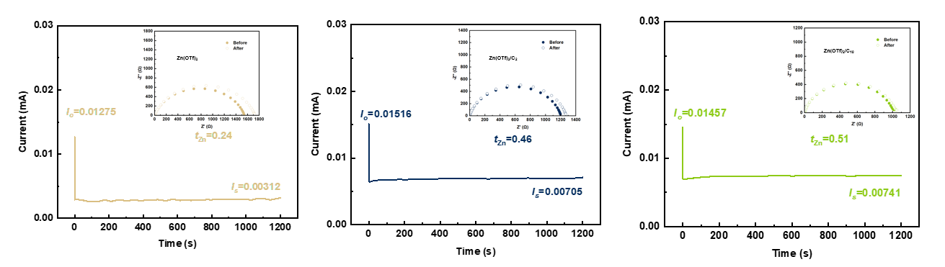
Fig. S40 Transference number of different electrolytes
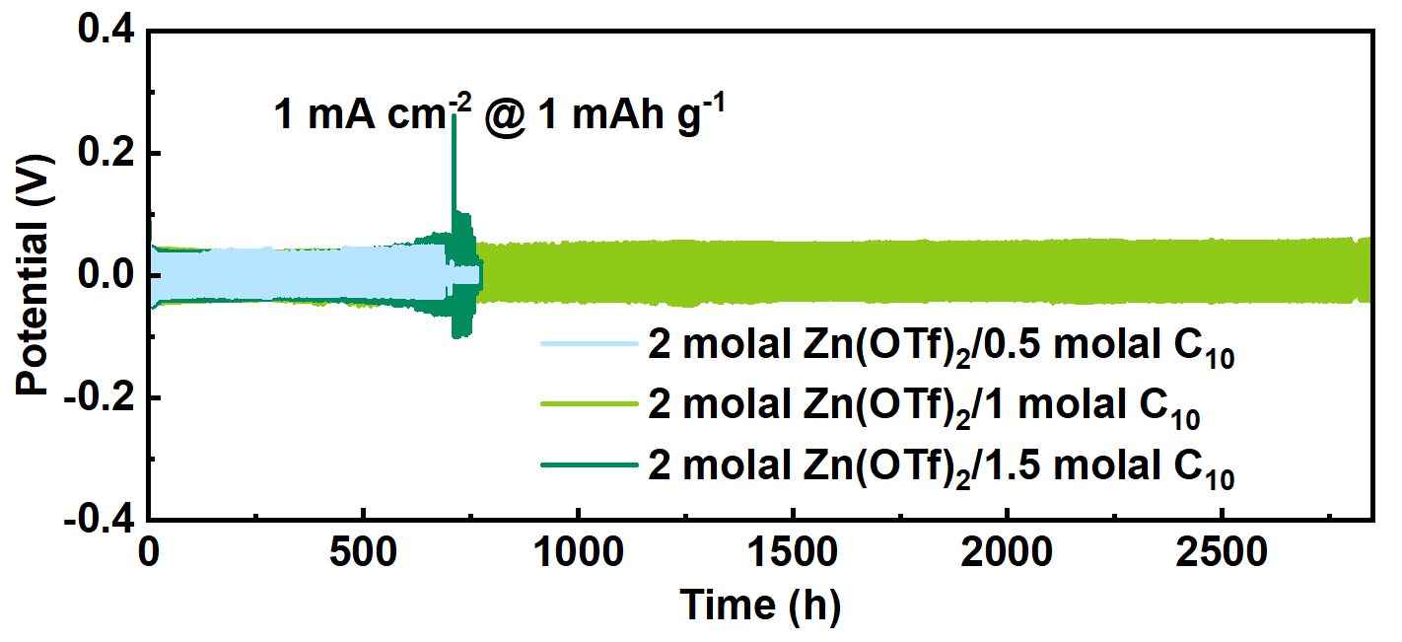
Fig. S41 Cycling performances of Zn||Zn symmetric cells with different concentrations of C₁₀ at 1 mA cm⁻² for 1 mAh cm⁻²

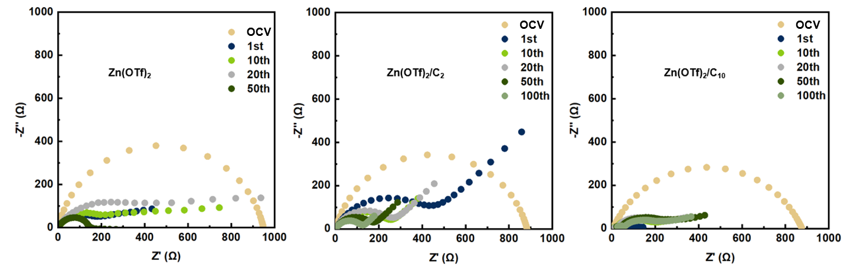
Fig. S42 In-situ EIS spectra of Zn||Zn in different electrolytes

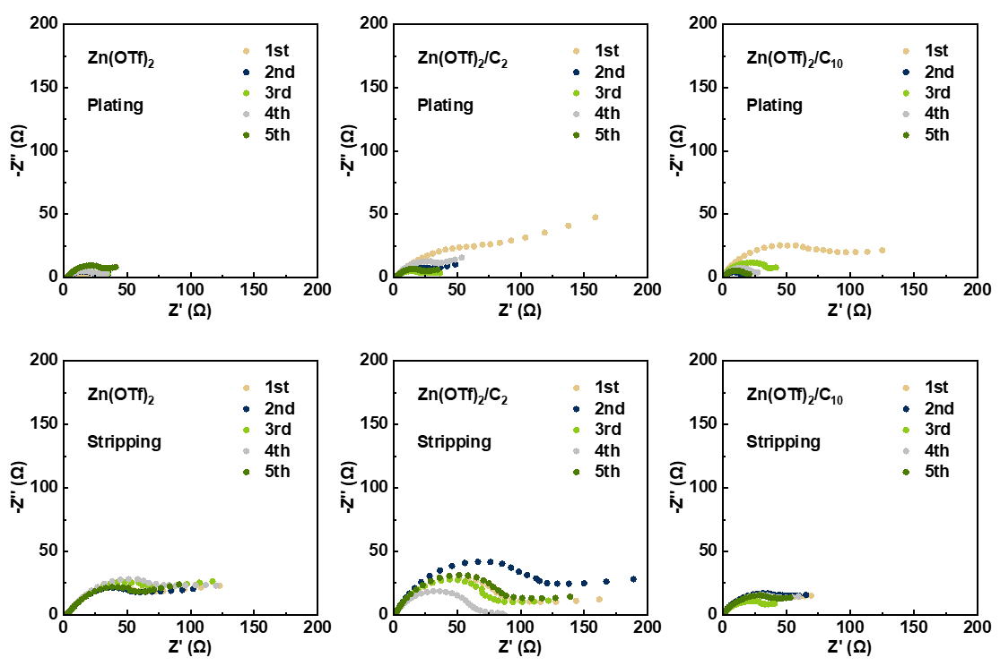
Fig. S43 In-situ EIS results of the symmetric cells at the start/end of plating/stripping for the first five cycles
During the first plating process, both C₂ and C₁₀ exhibited a slight increase in R_{ct} along with a pronounced low-frequency diffusion feature, indicating that these additives promote the formation of an ordered interfacial structure during the nucleation/growth stage. After interfacial activation, however, a substantial decrease in R_{ct} was observed. Notably, the R_{ct} of C₁₀ dropped below that of the blank electrolyte, demonstrating its superior capability to establish a more favorable interfacial environment for Zn²⁺ deposition. More importantly, the stripping behavior shows a clear divergence between the additives. After stripping, the R_{ct} of C₂ remains comparable to or slightly higher than that of the blank electrolyte, indicating only limited improvements in reversibility and suppression of dead Zn. In contrast, C₁₀ yields a markedly lower R_{ct} after stripping, demonstrating that it effectively preserves interfacial contact during Zn removal. This advantage can be attributed to its self-assembly at the electrode surface, which promotes uniform deposition morphology, minimizes dead Zn formation, and stabilizes a conductive, low-resistance interphase in the LHCE system. Together, these results highlight that C₁₀ not only facilitates Zn²⁺ deposition but also greatly enhances the reversibility of Zn²⁺ stripping.
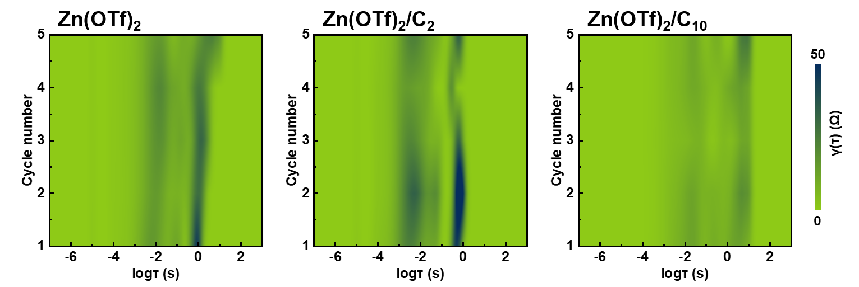
Fig. S44 In-situ DRT results of the symmetric cells for the first five cycles
For C₁₀, both the charge-transfer resistance (R_{ct}) and diffusion-related impedance are significantly reduced, reflecting a highly conductive and uniform interface. The diffusion relaxation peak shifts to longer time scales (log τ ≈ 0–1 s), indicating that Zn²⁺ transport occurs through a more ordered and stabilized interfacial layer. This behavior can be attributed to the self-assembled ion channels formed by C₁₀ at the electrode surface, as well as the favorable formation of a stable, uniform, and highly ion-conductive SEI in the LHCE environment. Together, these effects facilitate smooth ion migration while maintaining interfacial integrity, promoting uniform Zn deposition and reversible stripping.
In contrast, C₂ exhibits increased R_{ct} and enhanced diffusion impedance, with the diffusion peak remaining near log τ ≈ 0 s. This suggests that C₂ lacks self-assembly and the advantageous LHCE properties, resulting in a less organized interface and hindered Zn²⁺ transport. Therefore, these results are fully consistent with the theoretical framework proposed in our manuscript.
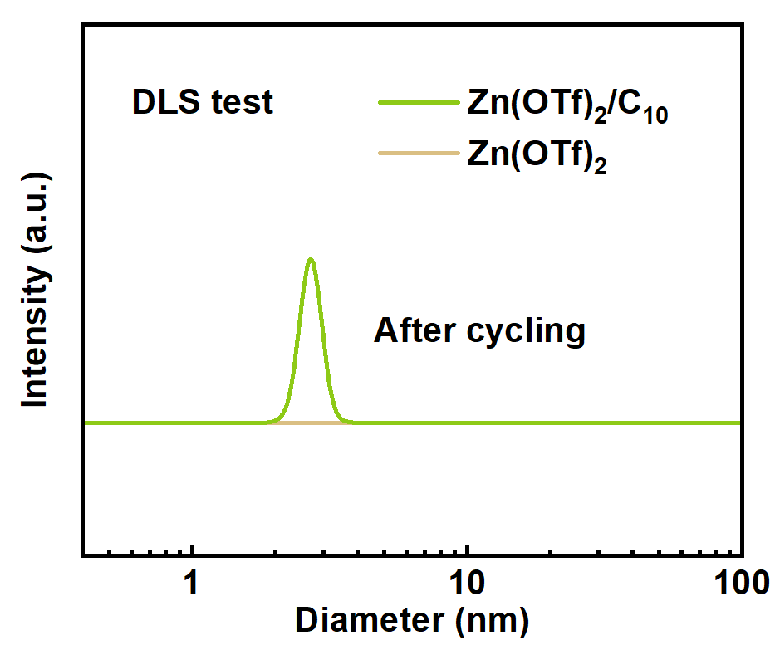
Fig. S45 DLS spectra of different electrolytes after cycling
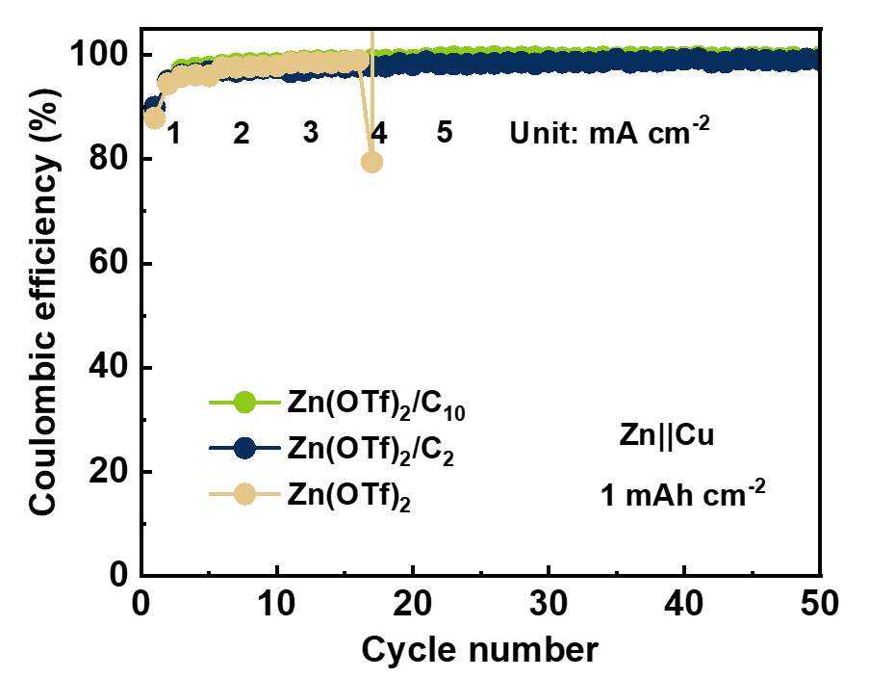
Fig. S46 CEs of Zn||Cu asymmetric cells in different electrolytes

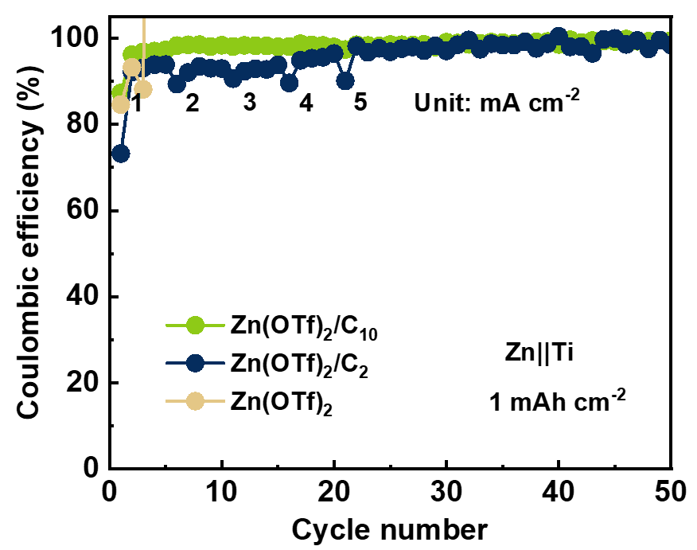
Fig. S47 CEs of Zn||Ti asymmetric cells in different electrolytes

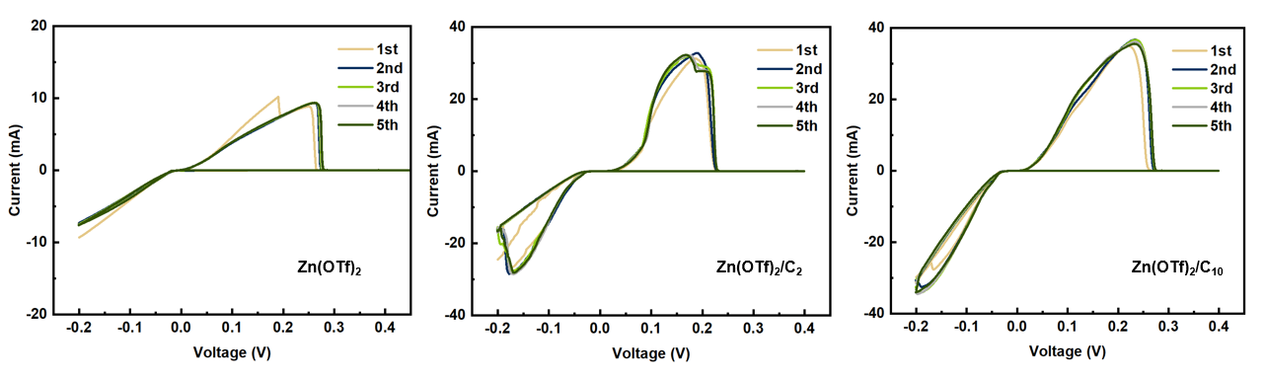
Fig. S48 CV curves of Zn||Cu in different electrolytes
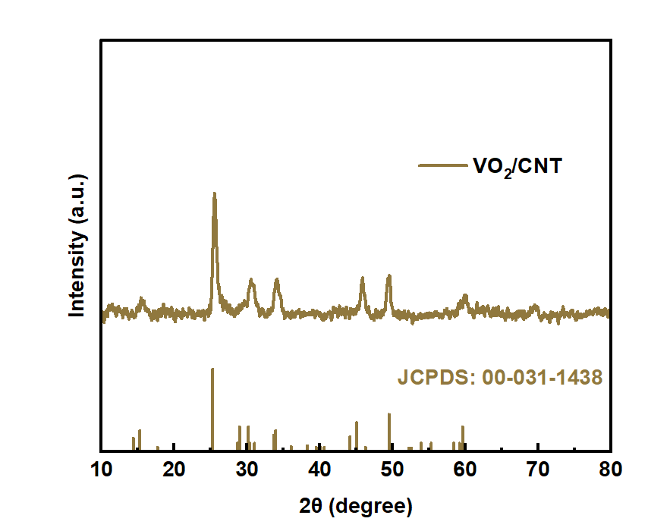
Fig. S49 XRD spectra of VO₂/CNT

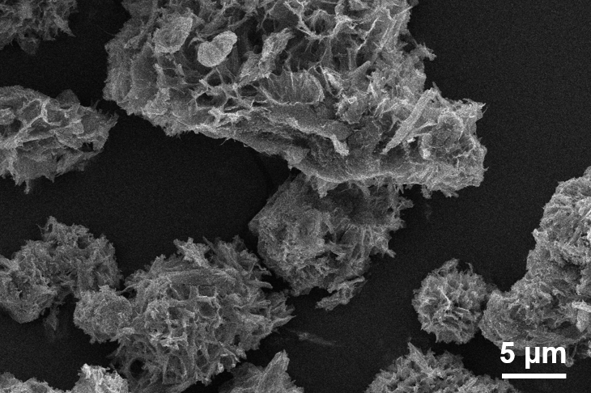

Fig. S50 SEM image of VO₂/CNT
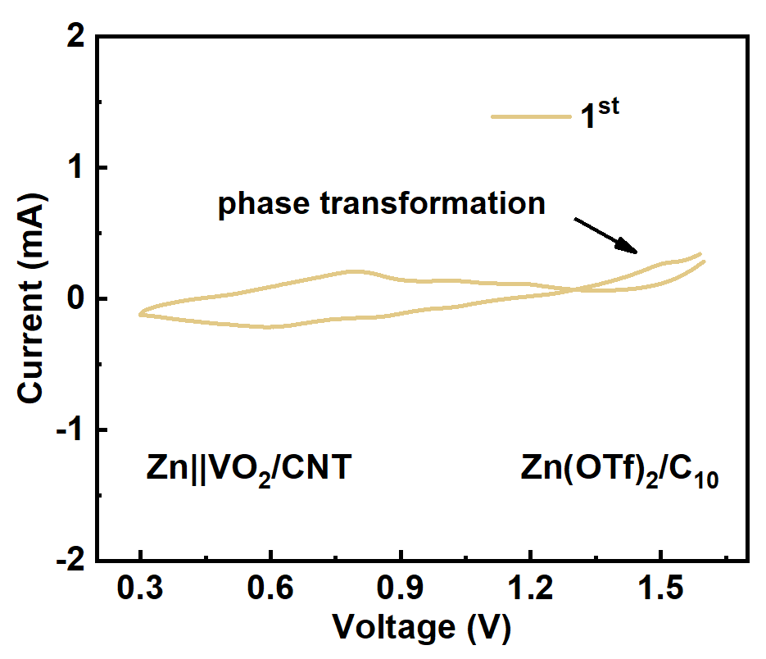
Fig. S51 The 1st CV curve of Zn||VO₂/CNT using Zn(OTf)₂/C₁₀

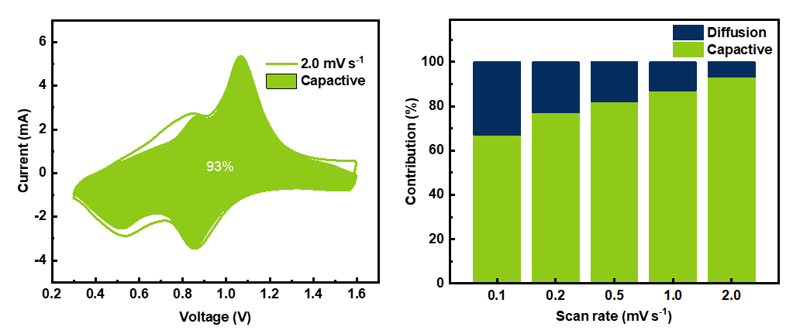
Fig. S52 Capacitive contribution of Zn||VO₂/CNT using Zn(OTf)₂/C₁₀
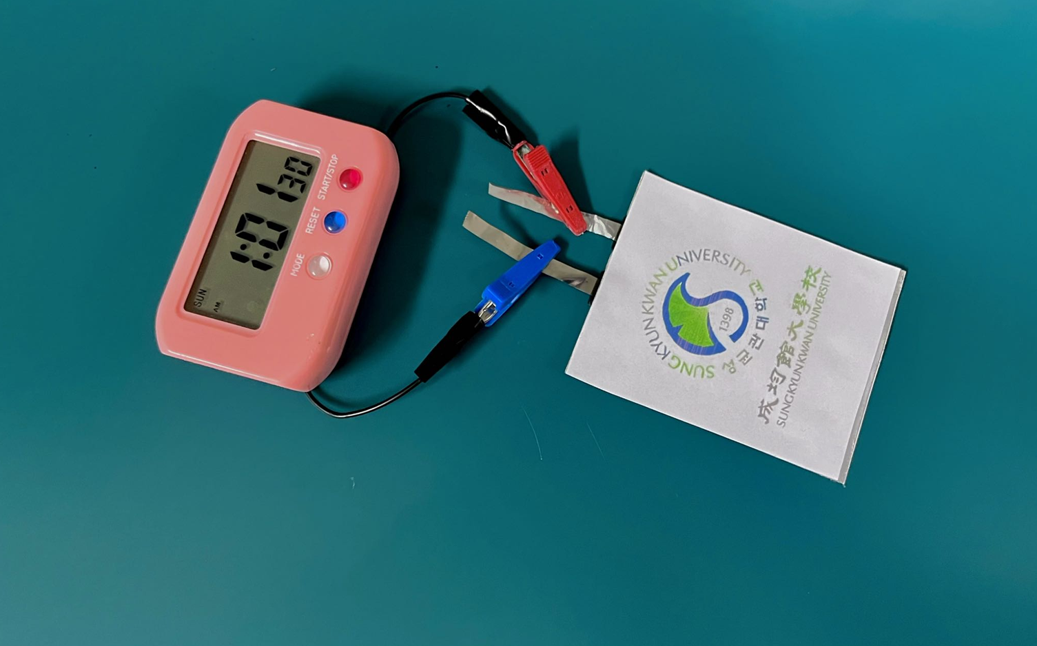
Fig. S53 Practical application of Zn||VO₂/CNT pouch cell with Zn(OTf)₂/C₁₀ electrolyte in powering an electronic alarm clock
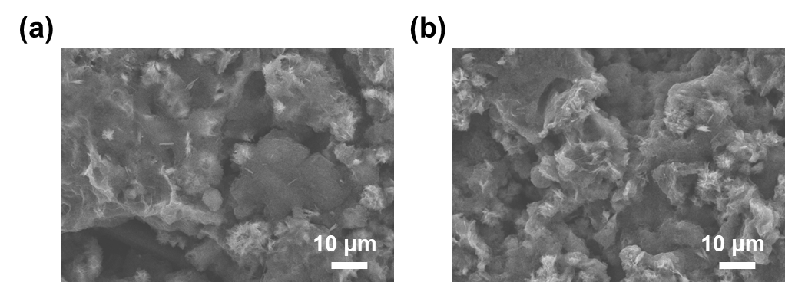
Fig. S54 SEM image of VO₂/CNT cathodes with Zn(OTf)₂ after cycling
Fig. S55 SEM image of VO₂/CNT cathodes with Zn(OTf)₂/C₁₀ after cycling

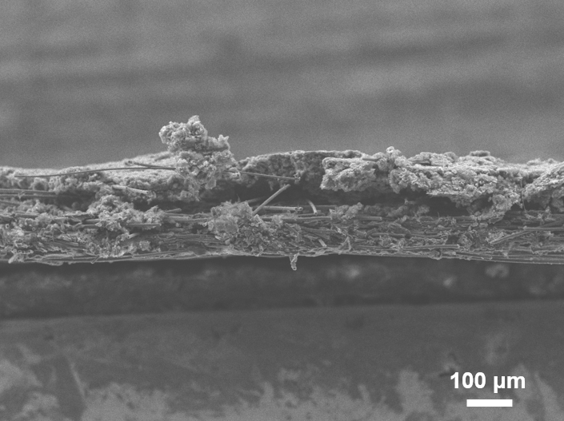
Fig. S56 Cross-section SEM image of cathodes with Zn(OTf)₂ after cycling
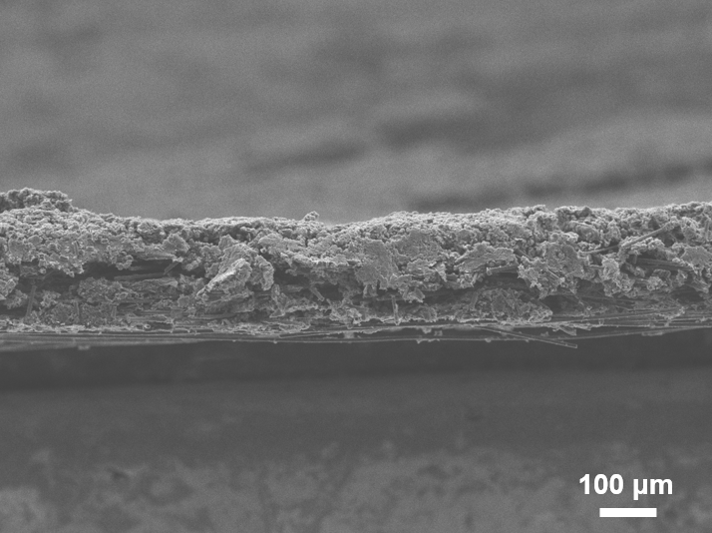
Fig. S57 Cross-section SEM image of cathodes with Zn(OTf)₂/C₁₀ after cycling

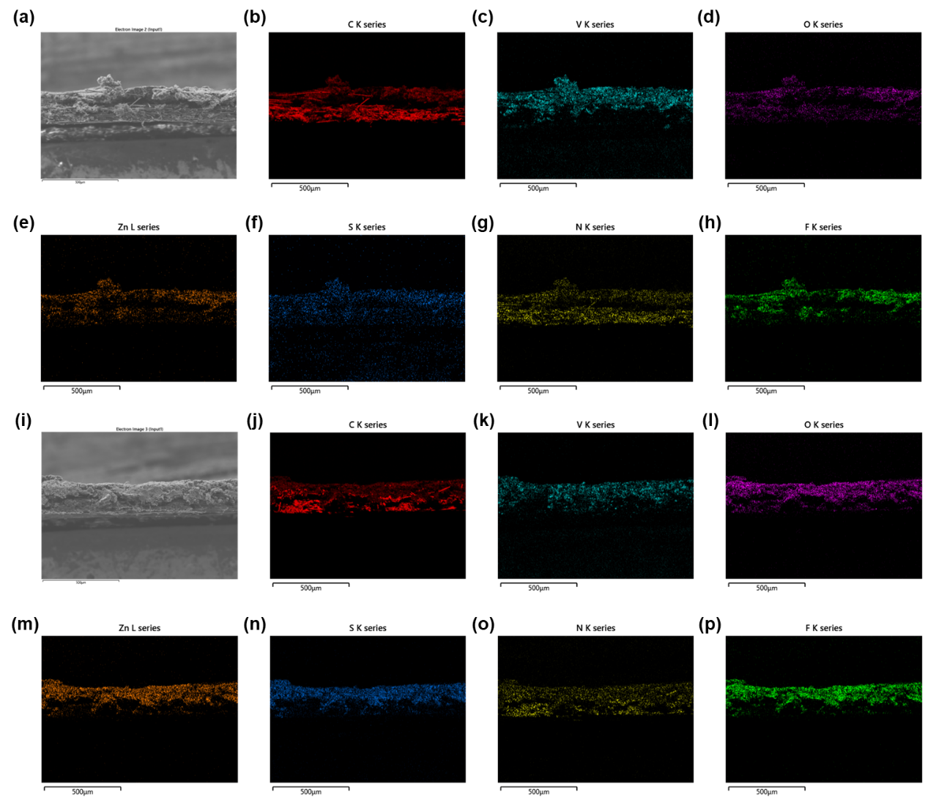
Fig. S58 Corresponding EDX mapping images of cross-section SEM images of cathodes with (a-h) Zn(OTf)₂, and (i-p) Zn(OTf)₂/C₁₀ after cycling
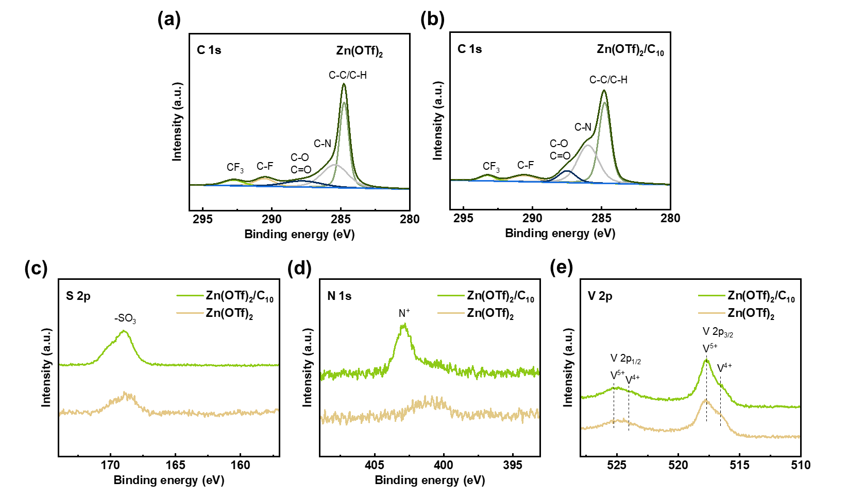
Fig. S59 XPS C 1s spectra of cathodes with (a) Zn(OTf)₂, and (b) Zn(OTf)₂/C₁₀ after cycling. (c-e) XPS S 2p, N 1s, and V 2p spectra of cathodes with different electrolytes after cycling

Table S1 Key parameters related to SAXS of different electrolytes
Electrolyte | R_{g} (nm) in Guinier plots | r_{max} (nm) in PDDF plots
Zn(OTf)₂ | 9.902 | 26.540
Zn(OTf)₂/C₂ | 10.051 | 24.630
Zn(OTf)₂/C₁₀ | 23.541 | 54.813

Table S2 Comparison of the relative contributions of different species
 | CF₃ | C-F | C-O | C-N | C-C/C-H
Zn(OTf)₂ | 10.88% | 19.37% | 28.63% | 0% | 41.12%
Zn(OTf)₂/C₂ | 5.44% | 14.78% | 32.04% | 13.76% | 33.98%
Zn(OTf)₂/C₁₀ | 4.99% | 4.75% | 5.54% | 34.75% | 49.97%

From the results in the table, it can be observed that the adsorption of the zwitterion introduces a distinct C–N peak at the Zn interface. In particular, C₁₀ exhibits a higher proportion of C–N due to its self-assembly effect and stronger binding affinity with Zn. In contrast, in the blank electrolyte, where no zwitterion adsorption occurs, the interfacial signal is dominated by peaks associated with OTf⁻ species. This indirectly highlights the fundamentally different interfacial chemistries induced by zwitterions compared with those in conventional diluent-based systems.

Table S3 Comparison of the recently reported cycling performance of Zn||Zn cells under 5 mA cm⁻² and 5 mAh cm⁻²
No. | Strategy | Thickness of Zn (μm) | DOD (%) | Time (h) | Refs.
1 | HA polymer additive | 100 | 8.5 | 800 | [S23]
2 | Nb₂O₅ coating | 100 | 8.5 | 220 | [S24]
3 | Serine additive | 50 | 17.1 | 800 | [S25]
4 | β-CD additive | 100 | 8.5 | 350 | [S26]
5 | UIO-66-SO₃H coating | 50 | 17.1 | 700 | [S27]
6 | PSN coating | 30 | 28.5 | 400 | [S28]
7 | Veratraldehyde additive | / | / | 800 | [S29]
8 | Glucose additive | 100 | 8.5 | 270 | [S30]
9 | Zn-Sn alloy anode | 24 | 35.6 | 240 | [S31]
★ | C₁₀ co-solute | 20 | 42.7 | 1240 | This work

Table S4 Comparison of cycling performances with recently reported high-loading V-based ZMBs
Strategy | Areal current density  (mA cm⁻²) | Mass loading  (mg cm⁻²) | Areal capacity  (mAh cm⁻²) | Refs.
DMAC+TMP  co-solvent | 3.3 | 6.6 | 0.8 | [S32]
BE+SIA | 0.46 | 9.2 | 1.8 | [S33]
3D printed graphene | 4 | 11.4 | 2 | [S34]
PACMO/PEO coating | 17 | 17 | 2.33 | [S35]
N, S co-doped CDs | 11.52 | 11.52 | 2 | [S36]
Mn_{2.5}V₁₀O₂₄∙5.9H₂O | 6.15 | 12.3 | 3 | [S37]
H-SU additive | 12 | 60 | 4.2 | [S38]
C₁₀ co-solute | 10 | 20 | 3.28 | This work
C₁₀ co-solute | 5 | 50 | 8.10 | This work

Table S5 Comparison of cycling performances with recently reported high-loading ZMBs except V-based
Cathode | Areal current density  (mA cm⁻²) | Mass loading  (mg cm⁻²) | Areal capacity  (mAh cm⁻²) | Refs.
3DP MnO₂ | 0.1 | 28.4 | 8.04 | [S39]
MNSMO@CC | ~0.7 | ~7 | 0.64 | [S40]
PANI | 1.578 | 15.78 | 1.25 | [S41]
cCNF/AC@I₂ | 28.2 | 14.1 | 2.6 | [S42]
NMO/VTCNTs | 1 | 5 | 1.65 | [S43]
MnVO | 10 | 20 | 3.28 | This work
MnVO | 5 | 50 | 8.10 | This work

Table S6 Comparison of representative zwitterions/micelles works in ZMBs
 | Materials  Types | Full cells  Performances
Our work | C₁₀  Zwitterion | Zn||VO₂/CNT  8.10 mAh cm⁻² after 150 cycles
Energy Environ. Sci. 16, 2684-2695 (2023) | L-carnitine  Zwitterion | Zn||V₂O₅  ~0.12 mAh cm⁻² after 3500 cycles
Nano-Micro Lett. 17, 314 (2025) | MPC  Zwitterion | Zn||V₂O₅  1 mAh cm⁻² after 300 cycles
ACS Nano 19, 32943-32955  (2025) | BES  Zwitterion | Zn||ZnVO  ~0.4 mAh cm⁻² after 2700 cycles
Adv. Funct. Mat. 34, 2401889 (2024) | ggg  Zwitterion | Zn||MnO₂  ~0.12 mAh cm⁻² after 900 cycles
Energy Storage Mater. 64, 103059 (2024) | TMB  Zwitterion | Zn||V₂O₅  ~0.5 mAh cm⁻² after 1000 cycles
Nano Energy 142, 111178 (2025) | NDSB  Zwitterion | Zn||AlVO  ~0.27 mAh cm⁻² after 1000 cycles
Adv. Funct. Mat. 35, 2417695 (2024) | POPSO-Na  Micelle | Only ZIC
Chem. Eng. J. 503, 158436 (2025) | SDBS  Micelle | Zn||NH₄VO  ~0.3 mAh cm⁻² after 500 cycles
Adv. Energy Mat. 12, 2103557 (2022) | TMBAC  Micelle | Zn||VO₂  ~0.7 mAh cm⁻² after 100 cycles

To clarify and highlight the key innovations of our study, we summarize them as follows:
1. First demonstration of LHCEs formed by zwitterions
Although several studies have previously reported the use of zwitterions, our work is the first to reveal that zwitterions can induce the formation of localized high-concentration electrolytes (LHCEs), which fundamentally differs from their conventional roles. Importantly, this is the first demonstration of LHCEs induced by zwitterions, which is fundamentally different from the conventional diluent-induced LHCEs.
Importantly, the formation of LHCEs induced by the zwitterionic C₁₀ enables the formation of a stable and robust hybrid ZnS/ZnF₂ SEI, which in turn allows us to demonstrate practical full cell performance (8.10 mAh cm⁻² after 150 cycles with a cathode mass loading of 50 mg cm⁻²).
2. First rigorous evidence of aggregate formation by zwitterions
To the best of our knowledge, there have been virtually no prior reports demonstrating that zwitterions can self-assemble into aggregates. In earlier studies involving micelle-type additives, the authors typically relied on schematic illustrations after observing aggregation, and merely suggested a spherical micelle structure without providing scientific proof. Such an approach is not sufficiently rigorous.
3. Comprehensive structural verification of spherical aggregates
For the first time, we introduced Guinier, pair distance distribution function (PDDF), and Porod analyses into the field of Zn metal batteries electrolytes, and, in conjunction with complementary spectroscopic characterizations and DFT/MD, we conclusively validated the presence of spherical aggregates.

Table S7 Comparison of representative diluent-based works in ZMBs and our work
 | Materials  Type | Symmetric cells  Performances | Full cells  Performances
Our work | C₁₀  Zwitterion | 5 mA cm⁻², 5 mAh cm⁻²  > 1200 h (DOD = 42.7%) | Zn||VO₂/CNT (50 mg cm⁻²)  8.10 mAh cm⁻² after 150 cycles
Angew. Chem. Int. Ed. Early View, e202511410 (2025) | TPP  Diluent | 5 mA cm⁻², 5 mAh cm⁻²  > 1150 h (DOD = 17.1%) | Zn||NaVO (2-5 mg cm⁻²)  >0.5 mAh cm⁻² after 2000 cycles
J. Mater. Chem. A 9, 22347-22352 (2021) | 1,4-dioxane  Diluent | 0.5 mA cm⁻², 0.5 mAh cm⁻²  400 h (DOD = 4.3%) | Zn||V₂O₅ (2±0.5 mg cm⁻²)  >0.09 mAh cm⁻² after 100 cycles
Angew. Chem. Int. Ed. 64, e202501183 (2025) | 1,4-dioxane  /emim+  Diluent | 1.17 mA cm⁻², 1.17 mAh cm⁻²  1200 h (DOD = 20%) | Zn||MnVO (10 mg cm⁻²)  3.3 mAh cm⁻² after 300 cycles
Adv. Funct. Mat. Early View, e15837 (2025) | APT  Diluent | 2 mA cm⁻², 2 mAh cm⁻²  1300 h (DOD = 3.4%) | Zn||NVO (2 mg cm⁻²)  ~0.6 mAh cm⁻² after 3300 cycles
Angew. Chem. Int. Ed. 62, e202315834 (2023) | THF  Diluent | 0.25 mA cm⁻², 0.25 mAh cm⁻²  2000 h (no thickness data) | Zn||PANI (1 mg cm⁻²)  0.1 mAh cm⁻² after 500 cycles

In conventional diluent-type LHCEs, the localized solvation structure mainly arises from the dilution effect, where non-coordinating solvents weaken the Zn²⁺–H₂O interaction and promote the formation of anion-rich solvation shells. However, such systems typically require a large fraction of inert diluents, which inevitably reduces ionic conductivity and limits practical applicability.
In contrast, our C₁₀-based system achieves localized high concentration through self-assembled zwitterionic aggregates, which promote the formation of CIP/AGG via zwitterionic effects. This design does not rely on diluents, thereby avoiding the trade-off between solvation modulation and conductivity. Moreover, the amphiphilic nature of C₁₀ further induces vertical self-assembly at the interface, forming ordered ionic channels that enable pre-accumulation of Zn²⁺ near the electrode surface and subsequent uniform deposition—an interfacial regulation mechanism absent in conventional LHCEs.
These mechanistic distinctions collectively demonstrate that our approach not only reproduces the solvation advantages of diluent-type LHCEs, achieving more uniform and stable SEI formation, but also adds a unique self-assembly–driven interfacial regulation, broadening the conceptual framework for LHCE design and enhancing practical electrochemical performance.
Table S8 EDX elemental analysis results of Zn(OTf)₂, and Zn(OTf)₂/C₁₀
Zn(OTf)₂/ Zn(OTf)₂/C₁₀ | Line | wt% | wt% sigma | atomic%
C | K series | 66.54/58.13 | 0.45/0.31 | 79.55/71.90
N | K series | 2.77/3.38 | 0.59/0.45 | 2.84/3.59
O | K series | 10.41/13.78 | 0.22/0.18 | 9.35/12.80
F | K series | 5.46/8.69 | 0.10/0.10 | 4.13/6.79
S | K series | 0.39/3.05 | 0.02/0.03 | 0.17/1.41
V | K series | 12.83/8.79 | 0.12/0.08 | 3.62/2.56
Zn | L series | 1.60/4.17 | 0.05/0.06 | 0.35/0.95

Supplementary References
[S1] M. J. Frisch, G. W. Trucks, H. B. Schlegel, et al. Gaussian 09 Revision E.01, Gaussian Inc., Wallingford CT, 2009.
[S2] P.J. Stephens, F.J. Devlin, C.F. Chabalowski, M.J. Frisch, Ab initio calculation of vibrational absorption and circular dichroism spectra using density functional force fields. J. Phys. Chem. 98(45), 11623–11627 (1994). https://doi.org/10.1021/j100096a001
[S3] A.D. Becke, Density-functional thermochemistry. III. The role of exact exchange. J. Chem. Phys. 98(7), 5648–5652 (1993). https://doi.org/10.1063/1.464913
[S4] R. Krishnan, J.S. Binkley, R. Seeger, J.A. Pople, Self-consistent molecular orbital methods. XX. A basis set for correlated wave functions. J. Chem. Phys. 72(1), 650–654 (1980). https://doi.org/10.1063/1.438955
[S5] A. Schäfer, H. Horn, R. Ahlrichs, Fully optimized contracted Gaussian basis sets for atoms Li to Kr. J. Chem. Phys. 97(4), 2571–2577 (1992). https://doi.org/10.1063/1.463096
[S6] A. Schäfer, C. Huber, R. Ahlrichs, Fully optimized contracted Gaussian basis sets of triple Zeta Valence quality for atoms Li to Kr. J. Chem. Phys. 100(8), 5829–5835 (1994). https://doi.org/10.1063/1.467146
[S7] S. Grimme, J. Antony, S. Ehrlich, H. Krieg, A consistent and accurate ab initio parametrization of density functional dispersion correction (DFT-D) for the 94 elements H-Pu. J. Chem. Phys. 132(15), 154104 (2010). https://doi.org/10.1063/1.3382344
[S8] S. Grimme, S. Ehrlich, L. Goerigk, Effect of the damping function in dispersion corrected density functional theory. J. Comput. Chem. 32(7), 1456–1465 (2011). https://doi.org/10.1002/jcc.21759
[S9] B.P. Pritchard, D. Altarawy, B. Didier, T.D. Gibson, T.L. Windus, New basis set exchange: an open, up-to-date resource for the molecular sciences community. J. Chem. Inf. Model. 59(11), 4814–4820 (2019). https://doi.org/10.1021/acs.jcim.9b00725
[S10] A.V. Marenich, C.J. Cramer, D.G. Truhlar, Universal solvation model based on solute electron density and on a continuum model of the solvent defined by the bulk dielectric constant and atomic surface tensions. J. Phys. Chem. B 113(18), 6378–6396 (2009). https://doi.org/10.1021/jp810292n
[S11] T. Lu, F. Chen, Multiwfn: a multifunctional wavefunction analyzer. J. Comput. Chem. 33(5), 580–592 (2012). https://doi.org/10.1002/jcc.22885
[S12] T. Lu. A comprehensive electron wavefunction analysis toolbox for chemists, Multiwfn. J. Chem. Phys. 161, 082503 (2024). https://doi.org/10.1063/5.0216272
[S13] G. Kresse, J. Furthmüller, Efficient iterative schemes for ab initio total-energy calculations using a plane-wave basis set. Phys. Rev. B 54(16), 11169–11186 (1996). https://doi.org/10.1103/physrevb.54.11169
[S14] J.P. Perdew, K. Burke, M. Ernzerhof, Generalized gradient approximation made simple. Phys. Rev. Lett. 77(18), 3865–3868 (1996). https://doi.org/10.1103/physrevlett.77.3865
[S15] P.E. Blöchl, Projector augmented-wave method. Phys. Rev. B 50(24), 17953–17979 (1994). https://doi.org/10.1103/physrevb.50.17953
[S16] S. Plimpton, Fast parallel algorithms for short-range molecular dynamics. J. Comput. Phys. 117(1), 1–19 (1995). https://doi.org/10.1006/jcph.1995.1039
[S17] W.L. Jorgensen, D.S. Maxwell, J. Tirado-Rives, Development and testing of the OPLS all-atom force field on conformational energetics and properties of organic liquids. J. Am. Chem. Soc. 118(45), 11225–11236 (1996). https://doi.org/10.1021/ja9621760
[S18] G.A. Kaminski, R.A. Friesner, J.T.-Rives, W.L. Jorgensen, Evaluation and Parameterization of a Generalized Amber Force Field. J. Phys. Chem. B 105, 6474–6487 (2001). https://doi.org/10.1021/jp003919d
[S19] L. Martínez, R. Andrade, E.G. Birgin, J.M. Martínez, PACKMOL: a package for building initial configurations for molecular dynamics simulations. J. Comput. Chem. 30(13), 2157–2164 (2009). https://doi.org/10.1002/jcc.21224
[S20] J.M. Martínez, L. Martínez, Packing optimization for automated generation of complex system's initial configurations for molecular dynamics and docking. J. Comput. Chem. 24(7), 819–825 (2003). https://doi.org/10.1002/jcc.10216
[S21] W. Humphrey, A. Dalke, K. Schulten, VMD: Visual molecular dynamics. J. Mol. Graph. 14(1), 33–38 (1996). https://doi.org/10.1016/0263-7855(96)00018-5
[S22] S. Nosé, A unified formulation of the constant temperature molecular dynamics methods. J. Chem. Phys. 81(1), 511–519 (1984). https://doi.org/10.1063/1.447334

[S23] M.J. Qiu, P. Sun, W.J. Mai, G.F. Cui, Chaotropic polymer additive with ion transport tunnel enable dendrite-free zinc battery. ACS Appl. Mater. Interfaces 14, 40951–40958 (2022). https://doi.org/10.1021/acsami.2c10517
[S24] S.J. So, Y.N. Ahn, J.W. Ko, I. Kim, J. Hur, Uniform and oriented zinc deposition induced by artificial Nb₂O₅ Layer for highly reversible Zn anode in aqueous zinc ion batteries. Energy Storage Mater. 52, 40–51 (2022). https://doi.org/10.1016/j.ensm.2022.07.036
[S25] Y.F. Wang, L. Mo, X.X. Zhang, Y.K. Ren, T.T. Wei et al., Facet-termination promoted uniform Zn (100) deposition for high-stable zinc-ion batteries. Adv. Energy Mater. 13, 2202875 (2023). https://doi.org/10.1002/aenm.202301517
[S26] M.J. Qiu, P. Sun, Y. Wang, L. Ma, C.Y. Zhi et al., Inside cover: anion-trap engineering toward remarkable crystallographic reorientation and efficient cation migration of Zn ion batteries. Angew. Chem. Int. Ed. 61, e202206015 (2022). https://doi.org/10.1002/anie.202214654
[S27] H. F. Fan, M. Li, E. D. Wang, Anion-functionalized interfacial layer for stable Zn metal anodes. Nano Energy 103, 107751 (2022). https://doi.org/10.1016/j.nanoen.2022.107751
[S28] S. Zhou, Y.P. Wang, H.T. Lu, Y.F. Zhang, C.Y. Fu et al., Anti-corrosive and zn-ion-regulating composite interlayer enabling long-life Zn metal anodes. Adv. Funct. Mater. 31, 2101234 (2021). https://doi.org/10.1002/adfm.202104361
[S29] M.J. Qiu, L. Ma, P. Sun, Z.L. Wang, G.F. Cui, W.J. Mai, Manipulating interfacial stability via absorption-competition mechanism for long-lifespan Zn anode. Nano-Micro Lett. 14, 103 (2022). https://doi.org/10.1007/s40820-021-00777-2
[S30] P. Sun, L. Ma, W.H. Zhou, M.J. Qiu, Z.L. Wang et al., Simultaneous regulation on solvation shell and electrode interface for dendrite-free zn ion batteries achieved by a low-cost glucose additive. Angew. Chem. Int. Ed. 60, 18247–18255 (2021). https://doi.org/10.1002/anie.202105756
[S31] L.Y. Wang, W.W. Huang, W.B. Guo, Z.H. Guo, C.Y. Chang et al., Sn Alloying to inhibit hydrogen evolution of Zn metal anode in rechargeable aqueous batteries. Adv. Funct. Mater. 32, 2104567 (2022). https://doi.org/10.1002/adfm.202108533
[S32] Y.Y. Wang, Z.J. Wang, W.K. Pang, W. Lie, J.A. Yuwono et al., Solvent control of water O−H bonds for highly reversible zinc ion batteries. Nat. Commun. 14, 1234 (2023). https://doi.org/10.1038/s41467-023-38384-x
[S33] K.Q. Feng, B.C. Chen, B.J. Xi, C.X. Tian, B.Y. Sang et al., Antioxidant interfaces enabled by self-deoxidizing and self-dehydrogenating redox couple for reversible zinc metal batteries. Adv. Energy Mater. 14, 2300678 (2024). https://doi.org/10.1002/aenm.202401053
[S34] B.K. Wu, B.B. Guo, Y.Z. Chen, Y.B. Mu, H.Q. Qu et al., High zinc utilization aqueous zinc ion batteries enabled by 3d printed graphene arrays. Energy Storage Mater. 54, 75–84 (2023). https://doi.org/10.1016/j.ensm.2022.10.017
[S35] J. Feng, X.Y. Li, Y.X. Ouyang, H.Y. Zhao, N. Li et al., Regulating Zn²⁺ migration-diffusion behavior by spontaneous cascade optimization strategy for long-life and low N/P ratio zinc ion batteries. Angew. Chem. Int. Ed. 63, e202310015 (2024). https://doi.org/10.1002/anie.202407194
[S36] Z. Xu, H. Li, Y.P. Liu, K.X. Wang, H.B. Wang et al., Durable modulation of Zn(002) plane deposition via reproducible zincophilic carbon quantum dots towards low N/P ratio zinc-ion batteries. Mater. Horiz. 10, 3680–3693 (2023). https://doi.org/10.1039/D3MH00261F
[S37] L. Yang, Y.J. Zhu, F.L. Zeng, L.Y. Dong, J.C. Tao et al., Synchronously promoting the electron and ion transport in high-loading Mn_{2.5}V₁₀O_{24∙5}.9H₂O cathodes for practical aqueous zinc-ion batteries. Energy Storage Mater. 65, 103162 (2024). https://doi.org/10.1016/j.fueleneab.2023.12.004
[S38] S.Y. Huang, P. Zhang, J. Lu, J.S. Kim, D.H. Min et al., Molecularly engineered multifunctional imide derivatives for practical Zn metal full cells. Energy Environ. Sci. 17, 7870–7881 (2024). https://doi.org/10.1039/D4EE02867H
[S39] H. Yang, Y. Wan, K. Sun, M.D. Zhang, C.Z. Wang et al., Reconciling Mass Loading and Gravimetric Performance of MnO₂ Cathodes by 3D-Printed Carbon Structures for Zinc-Ion Batteries. Adv. Funct. Mater. 33, 2401234 (2023). https://doi.org/10.1002/adfm.202215076
[S40] W.J. Zheng, Z.B. Cui, C. Liu, L.B. Yuan, S.S. Li et al., Tailoring hierarchical MnO₂ nanostructures on self-supporting cathodes for high-mass-loading zinc-ion batteries. Chem. Sci. 15, 20303–20314 (2024). https://doi.org/10.1039/D4SC06182A
[S41] R.F. Yu, Y.F. Xu, X.X. Liu, G.X. Zhang, H.P. Du et al., Screen-printed high loading flexible Zn-PANI battery. Chem. Eng. J. 497, 154788 (2024). https://doi.org/10.1016/j.cej.2024.154788
[S42] Z. L. Li, W. W. Cao, T. Hu, Y. C. Hu, R. Zhang et al., Deploying cationic cellulose nanofiber confinement to enable high iodine loadings towards high energy and high-temperature Zn-I₂ battery. Angew. Chem. Int. Ed. 136, e202317652 (2024). https://doi.org/10.1002/anie.202482011
[S43] X. Gao, C. Y. Zhang, Y. H. Dai, S. Y. Zhao, X. Y. Hu et al., Three-dimensional manganese oxide@carbon networks as free-standing, high-loading cathodes for high-performance zinc-ion batteries. Small Struct. 4, 2300456 (2023). https://doi.org/10.1002/sstr.202200316

