Supporting Information for
W/V Dual-Atom Doping MoS₂ Mediated Phase Transition for Efficient Polysulfide Adsorption/Conversion Kinetics in Lithium−Sulfur Battery
Zhe Cui¹⁺, Ping Feng^{2,} *⁺, Gang Zhong¹, Qingdong Ou^{1, 3,} *, Mingkai Liu^{4,} *
¹ Macao Institute of Materials Science and Engineering (MIMSE), Faculty of Innovation Engineering, Macau University of Science and Technology, Taipa, Macao, P. R. China
² Institute for Technical Chemistry and Environmental Chemistry, Friedrich-Schiller-Universität Jena, Jena 07743, Germany
³ Macau University of Science and Technology Zhuhai MUST Science and Technology Research Institute, Zhuhai 519031, P. R. China
⁴ School of Chemistry & Chemical Engineering, Anhui University of Technology, Ma’anshan, Anhui 243002, P. R. China
⁺ Zhe Cui and Ping Fengcontributed equally to this work.
*Corresponding authors. E-mail: ping.feng@uni-jena.de (Ping Feng); qdou@must.edu.mo (Qingdong Ou); liumingkai@ahut.edu.cn (Mingkai Liu)
S1 Experimental Section
S1.1 Synthesis of the carbon nanofibers
Carbon nanofibers (CNFs) were obtained by an electrospinning process. The mixture solution was prepared by adding 1.0 g Polyacrylonitrile (PAN) (Macklin, Mw = 150 000) into 8 mL dimethylformamide (Sinopharm Chemical Reagent) and stirred for 12 h. The distance between the needle and collector was 15 cm and the electrospun process was conducted by a constant flow of 2 ml h⁻¹ under the voltage of 12 kV. Subsequently, the collected polymer fibers were peroxided in air at 250 °C for 2 h. Then, the sample was heated to 800 °C with a ramp of 5 °C min⁻¹ under a flowing Ar atmosphere and maintained for 2 h to prepare CNFs.
S1.2 Synthesis of CMWVS
CMWVS composites were synthesized via a hydrothermal reaction. Specifically, 0.5 mmol of sodium molybdate dihydrate (Na₂MoO₄·2H₂O), 0.5 mmol of sodium tungstate dihydrate (Na₂WO₄·2H₂O), 0.2 mmol of sodium metavanadate dihydrate (Na₃VO₄·2H₂O), 1 mmol of oxalic acid dihydrate (C₂H₂O₄·2H₂O), and 5 mmol of thiourea were dissolved in 35 mL of deionized water under continuous stirring to form a homogeneous solution. The resulting solution was transferred into a reactor, where a 50 mg CNFs membrane was added. After sealing, the reactor was heated to 200 °C and maintained at this temperature for 24 hours. Upon completion, the system was allowed to cool naturally to room temperature. The nanofiber membrane was then rinsed thoroughly with deionized water and ethanol several times and dried in a vacuum oven at 60 °C for 12 hours to obtain the CMWVS composite. For comparison, CMS composites were prepared following the same procedure, except that Na₂WO₄·2H₂O and Na₃VO₄·2H₂O were omitted.
S1.3 Preparation of the cathode
The CMWVS and sulfur powder were mixed in a weight ratio of 2:8. The mixture was sealed in an autoclave under argon and heated at 155 °C for 12 h. Then, the electrode was prepared by casting the slurry of CMWVS/S, conductive carbon, and polyvinylidene difluoride (PVDF) (7:2:1 in weight ratio) on carbon-coated Al by the doctor blade technique. After drying at 50 °C under vacuum overnight, the electrode was cut into wafers with a diameter of 12.7 mm. The areal sulfur loading of the electrode is around ∼2 mg cm⁻². The CMS/S and CNFs/S electrode was prepared using the same method.
S1.4 Electrochemical measurements
CR2032 coin cells were assembled with the cathode, the Li foil as the anode, and a piece of Celgard 2700 membrane as the separator in an Ar-filled glove box (UNIlab plus, M. BRAUN) with H₂O content < 0.5 ppm and O₂ content < 0.5 ppm. 1.0 M Lithium bis(trifluormethylsulfonyl)amid in a 1:1 volume ratio of 1,3-dioxolane (DOL) / 1,2-dimethoxyethane (DME) with 2.0 wt % of LiNO₃ was used as the electrolyte. The cathode and the anode side were supplemented with 15.0 μL electrolyte, respectively. The electrolyte/sulfur ratio was maintained at ~15 μL mg⁻¹. Before the electrochemical testing, all the cells were aged at room temperature under open circuit potential for 12.0 h to let the electrolyte wet the electrode. In this work, the current density of 1.0 C equals 1,675.0 mA g⁻¹. The specific capacity is calculated based on the mass of sulfur. The galvanostatic charge and discharge were conducted on a LAND battery tester (CT2001A) at room temperature. The CV curves of the assembled coin cells were measured with an Autolab electrochemical workstation (PGSTAT302N potentiostat).
S2 Adsorption Tests of LiPSs
A Li₂S₆ solution was prepared by dissolving the appropriate amounts of sulfur and Li₂S powder in a DOL/DME solution (1:1 by volume). The solution was then stirred at 80 °C for 48 hours inside a glove box to ensure complete reaction. After that, the host materials with the same mass were separately added to 2.0 mM Li₂S₆ solution (5.0 mL). The Li₂S₈ solution (1.0 M) was first diluted to 2.0 mM for further use. After that, the powder of CMWVS, CMS, and CNF particles with the same mass (20.0 mg) were added to 2.0 mM Li₂S₆ solution (4.0 mL), respectively. After aging for 3.0 hours inside the glove box, the supernatant liquid was sealed in cylinder quartz for the UV-vis absorption spectroscopy test.
S3 Kinetics of Li₂S Precipitation on the Host Materials
The Li₂S₈ catholyte was prepared by the chemical reaction between sulfur and lithium sulfide (Li₂S + 7S → Li₂S₈). In a typical process, 4.48 g sulfur and 0.92 g Li₂S were dissolved in 20.0 mL DOL/DME solution (V_{DOL}: V_{DME} = 1: 1) with 2.0 wt % LiNO₃ additives in a 50.0 mL bottle and kept stirring overnight in an Ar-filled glove box. Then this suspension was heated at 80 °C in a vacuum oven inside the glove box for one day to yield the Li₂S₈ catholyte (1.0 M) with red-brown color. For the Li₂S precipitation test, the electrode was prepared by casting the slurry of CMWVS (CMS, or CNF), conductive carbon, and PVDF (7:2:1 in weight ratio) on carbon paper by the doctor blade technique. After drying at 50 °C under vacuum overnight, the electrode was cut into wafers with a diameter of 12.7 mm. The coin cell was assembled with the CMWVS (CMS, or CNF) as the cathode, respectively, lithium as the anode, and a Celgard 2700 membrane serving as the separator. The loading of Li₂S₈ catholyte for the Li₂S precipitation test is 1.0 mg cm⁻². The cathode and the anode sides were supplemented with 15.0 μL electrolytes, respectively. All the assembled coin cells were aged at room temperature for 12.0 h. After that, the cell was first discharged galvanostatically at 0.1 C to 2.12 V and then discharged potentiostatically at 2.05 V for Li₂S nucleation and growth. The current vs. time curve was collected for the kinetic analysis. For the symmetrical cell, two identical electrodes (CMWVS, CMS, CNF) were assembled into a CR2032 coin cell with a Celgard 2700 membrane serving as the separator. 1.0 M Li₂S₈ catholyte (5.0 μL) was loaded to the host electrodes as the sulfur source. The cathode and the anode sides were supplemented with 15.0 μL electrolytes, respectively. CV measurements of the symmetric cell were performed at a scan rate of 10.0 mV s⁻¹ within the potential range from -0.8 to 0.8 V.
S4 Characterization
The morphology of the obtained samples was investigated by a LEO 1530 field emission SEM and a JEOL-2100 TEM (JEOL, GmbH, Eching, Germany) at 200 kV. XRD Patterns were collected in Bragg-Brentano geometry on a Bruker D8 Advance diffractometer with Cu Kα radiation using a zero-background holder and a step size of 0.03 °/step and a measuring time of 1 s/step. The chemical states of the elements in the samples were characterized using X-ray photoelectron spectroscopy (XPS) with an ESCA-Lab-220i-XL X-ray Photoelectron Spectrometer (Thermo Fisher Scientific) with Al Kα sources (hν = 1,486.6 eV). HAADF-STEM images and EDS elemental mapping were carried out on a JEOL ARM-200F field-emission transmission electron microscope operating at an accelerating voltage of 200 kV using Cu-based TEM grids. XANES data were collected at the BL14B2 beamline at the SPring-8 (Japan Synchrotron Radiation Research Institute, Hyogo, Japan) in transmission mode in air at room temperature Powder samples were mixed with an appropriate amount of boron nitride and pressed into pellets. The data in the XANES region of the absorption coefficient were examined by applying the same procedure for pre-edge line fitting, post edge curve fitting, and edge-step normalization to all data. XANES and EXAFS data processing and analysis were performed using the IFEFFIT package [S1]. EXAFS data modeling and analysis were performed using standard procedures. The passive electron reduction factors were obtained to be 0.78 (0.82, 0.81) from the fit to the Mo (V, W) foil data. They were subsequently fixed to be 0.78 (0.82, 0.81) for Mo (V, W) absorption edge data analyze, in the analysis of sample. For Mo edge, the fitting k range is 3−15 Å⁻¹ and the fitting R range is 1−3.5 Å. For V-K edge, the fitting k range is 3−15 Å⁻¹ and the fitting R range is 1−2.5 Å. For W edge, the fitting k range is 3−16 Å⁻¹ and the fitting R range is 1−3 Å. The elemental composition of the samples was analyzed using inductively coupled plasma atomic emission spectroscopy (ICP-AES, Leeman Laboratories Prodigy). Brunauer–Emmett–Teller measurements were used to measure the N₂ adsorption–desorption performance with an automatic specific surface area and porosity analyzer (ASAP-2010).
S5 DFT Calculation
The density functional theory (DFT) calculations were performed using the Vienna Ab initio Simulation Package (VASP) [S2, S3], with the generalized gradient approximation (GGA) Perdew–Burke–Ernzerhof (PBE) functional [S4] to describe electron exchange and correlation. The projector-augmented plane wave (PAW) [S5, S6] potentials were used to describe the core-valence electron interaction and take valence electrons into account using a plane wave basis set with a kinetic energy cutoff of 500 eV. Partial occupancies of the Kohn−Sham orbitals were allowed using the Gaussian smearing method and a width of 0.05 eV. The electronic energy was considered self-consistent when the energy change was smaller than 10⁻⁵ eV. A geometry optimization was considered convergent when the force change was smaller than 0.02 eV/Å. A k-points sampling of 2 × 2 × 1 with Monkhorst-Pack [S7] scheme was used in all calculations and all calculations were considered the spin polarization effect.
S6 Supplementary Figures and Tables
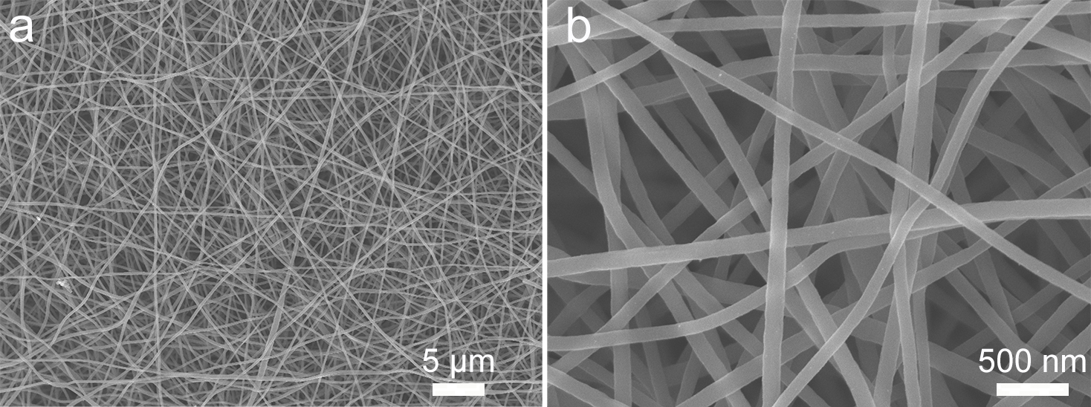
Fig. S1 SEM images of the CNF samples
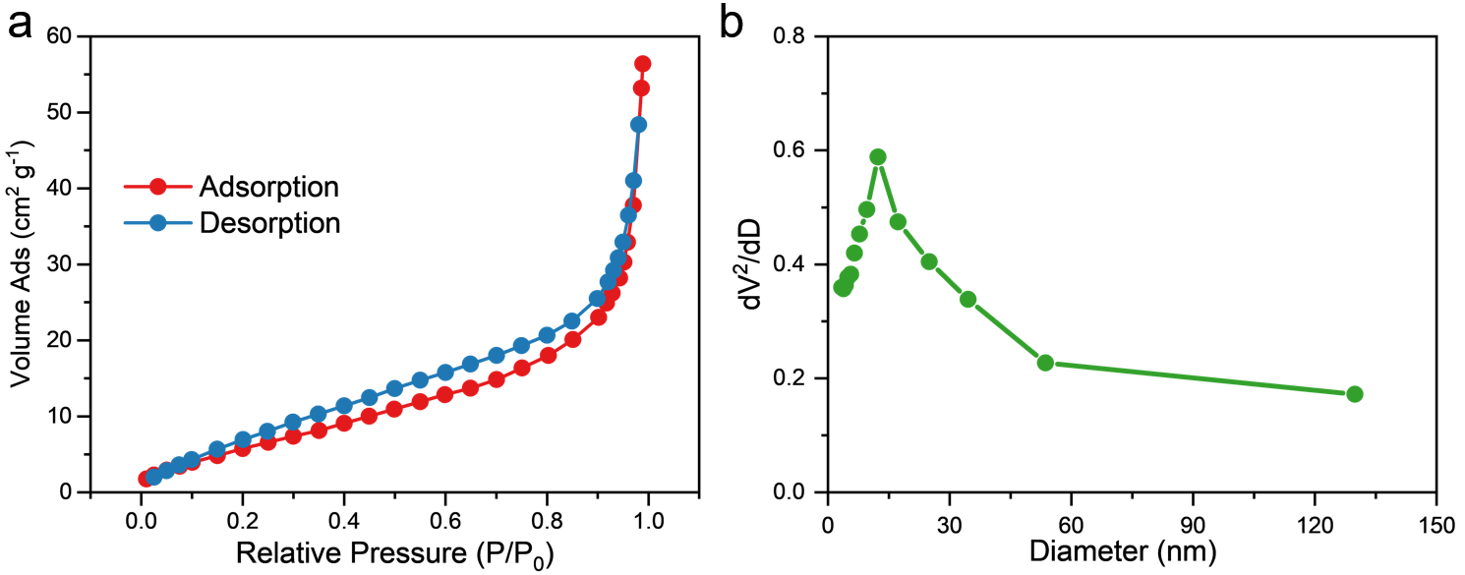
Fig. S2 N₂ adsorption-desorption isotherms of CMWVS (a) and corresponding pore size distribution (b)
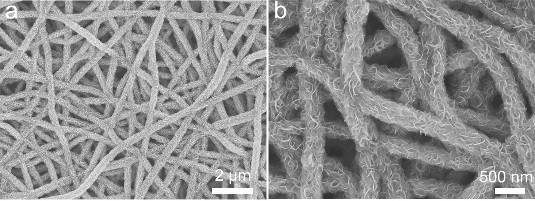
Fig. S3 SEM images of the CMS sample
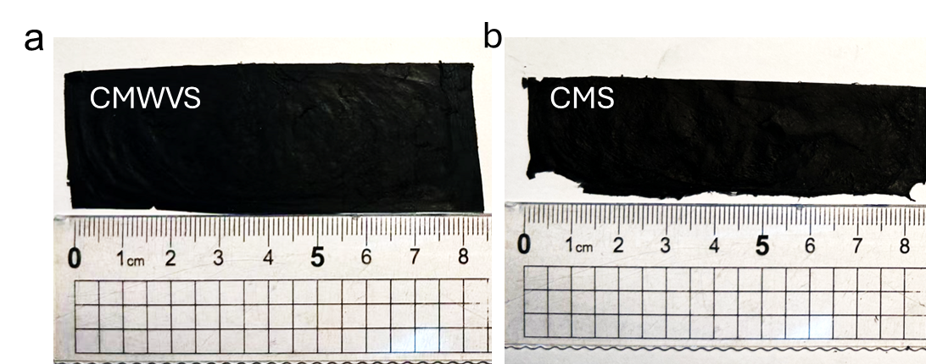
Fig. S4 The optical photograph of CMWVS (a) and CMS (b)
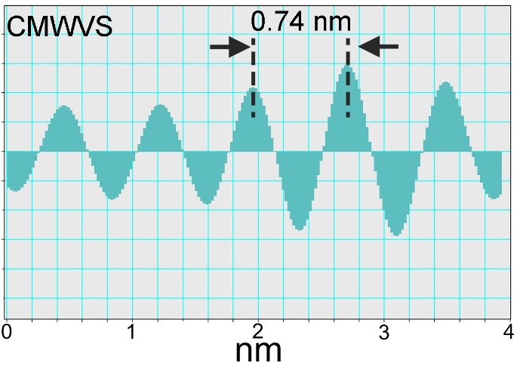
Fig. S5 The inverse FFT image’s line profile of the HRTEM image in Fig. 1e
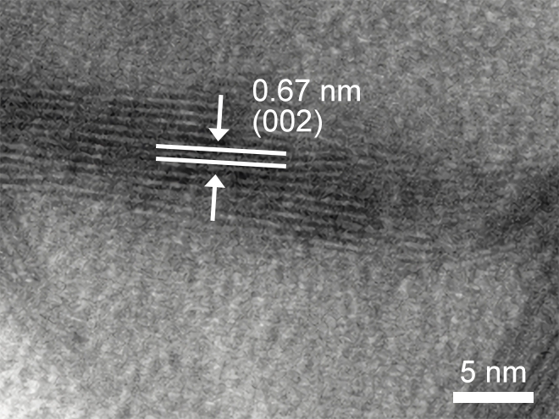
Fig. S6 HRTEM image of the CMS sample
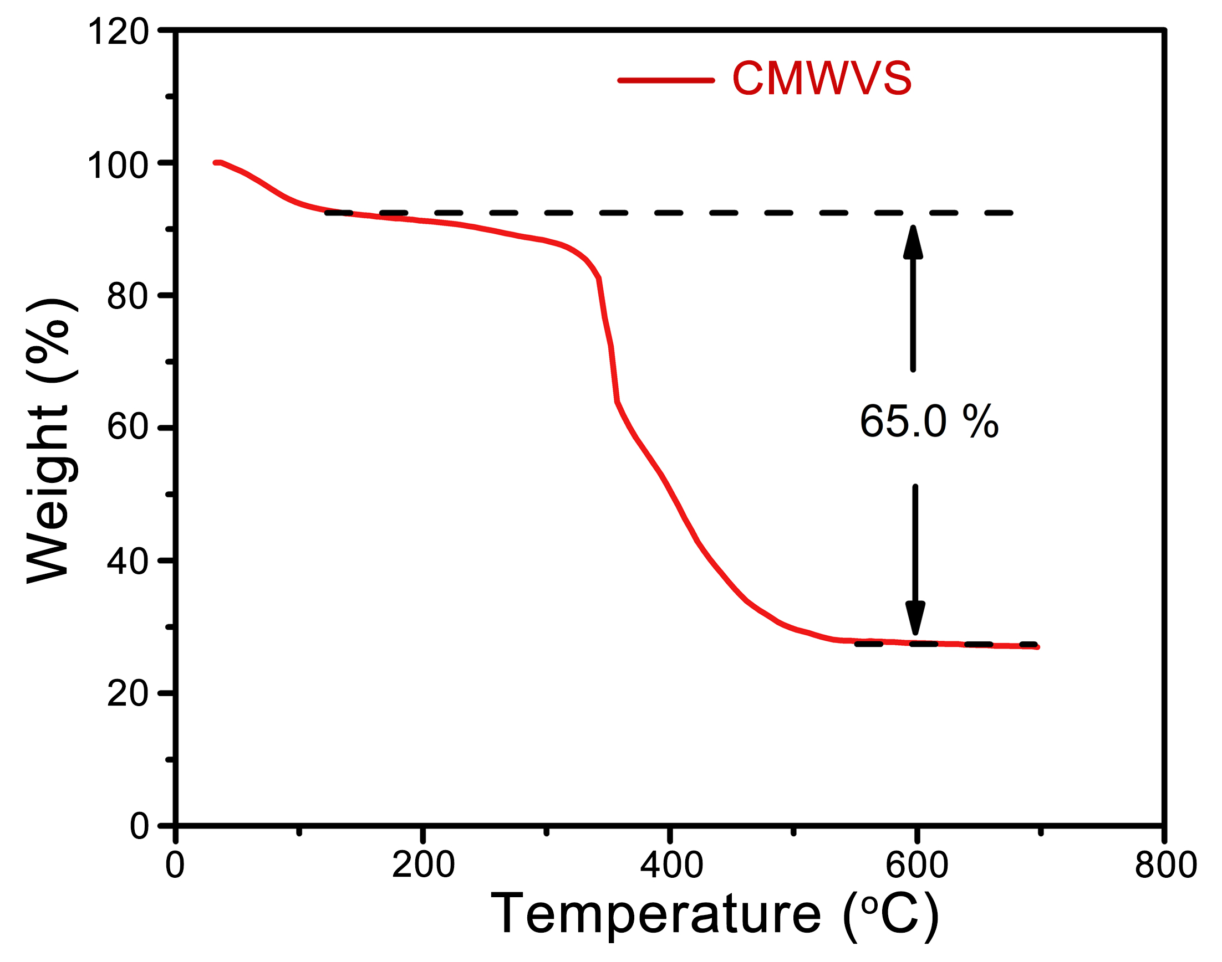
Fig. S7 TGA curve of the CMWVS sample under a heating rate of 10 °C min⁻¹ in air
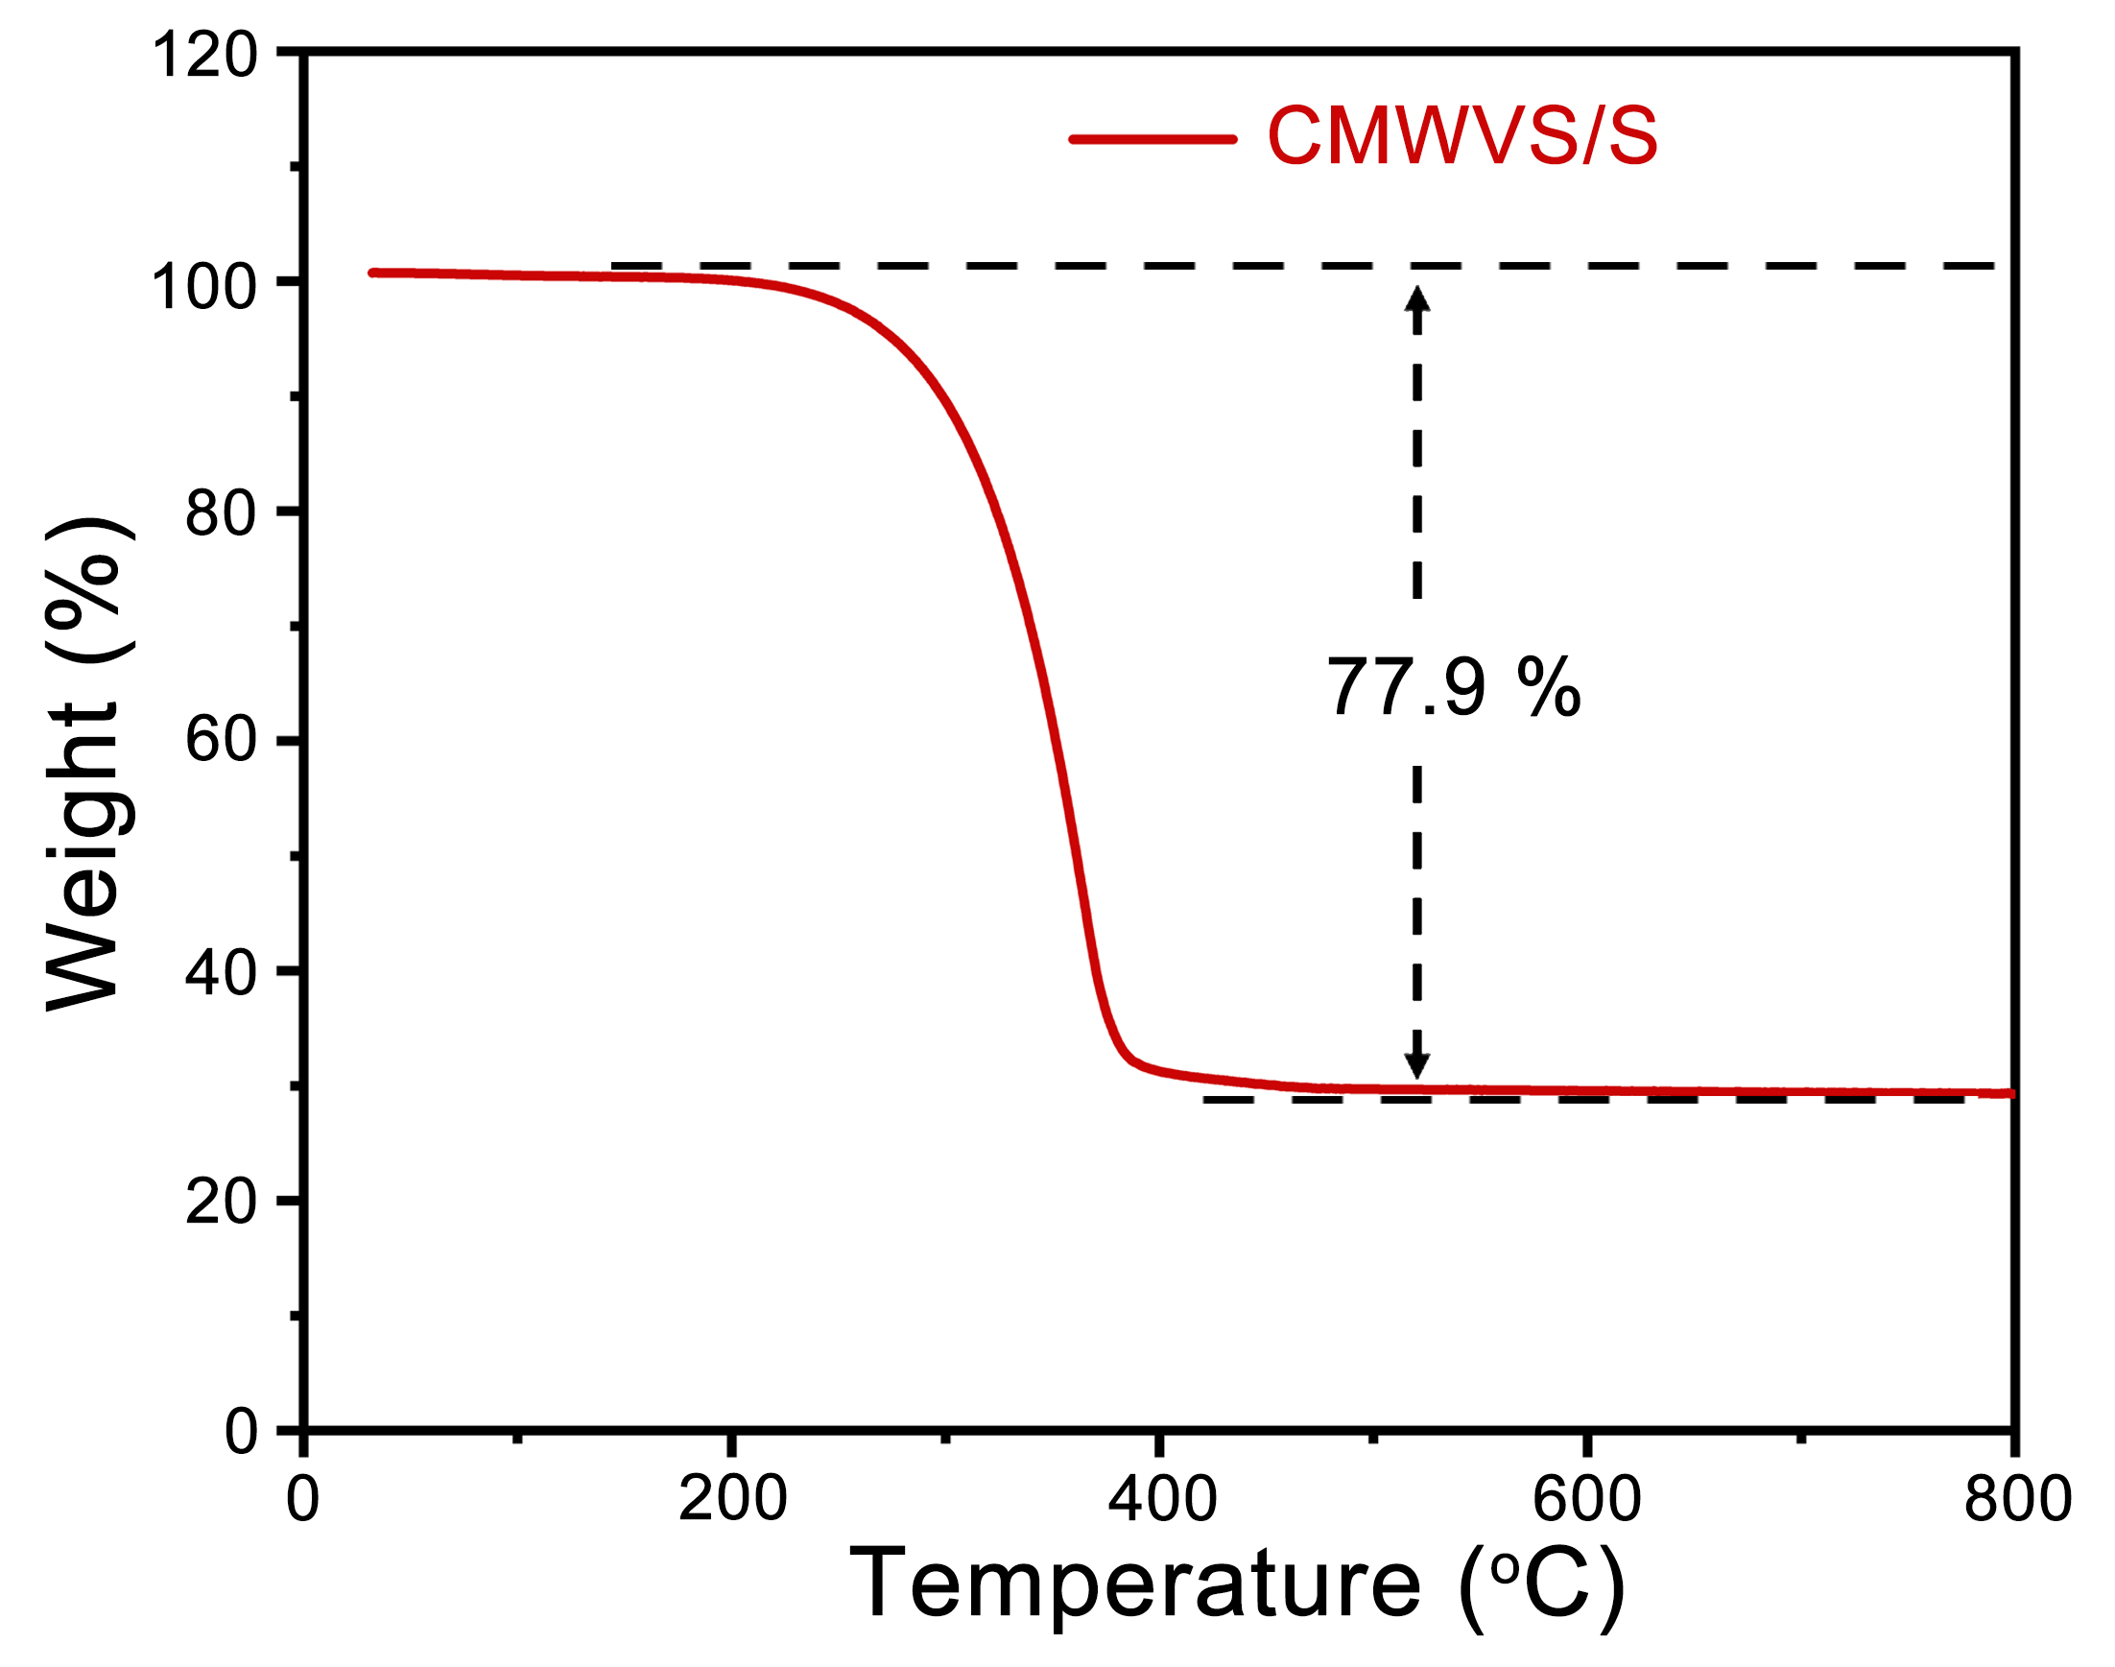
Fig. S8 TGA curve of the CMWVS/S sample under a heating rate of 10 °C min⁻¹ in nitrogen

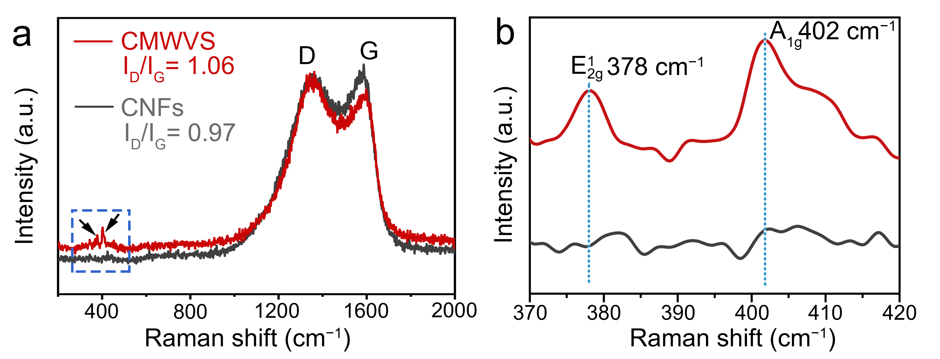
Fig. S9 Raman spectra of CMWVS and CNFs samples

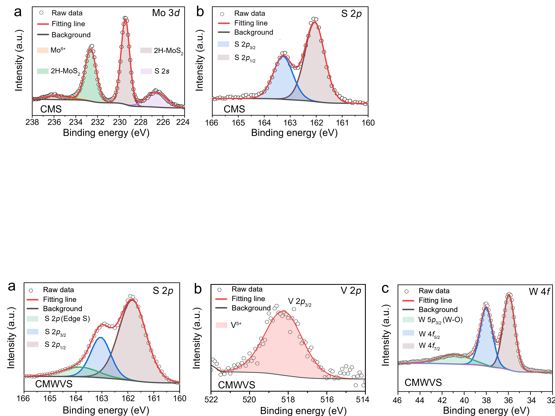
Fig. S10 High-solution XPS spectra of (a) Mo 3d and (b) S 2p in CMS sample

Fig. S11 High-resolution XPS spectra of (a) S 2p, (b) V 2p, and (c) W 4f in the CMWVS sample

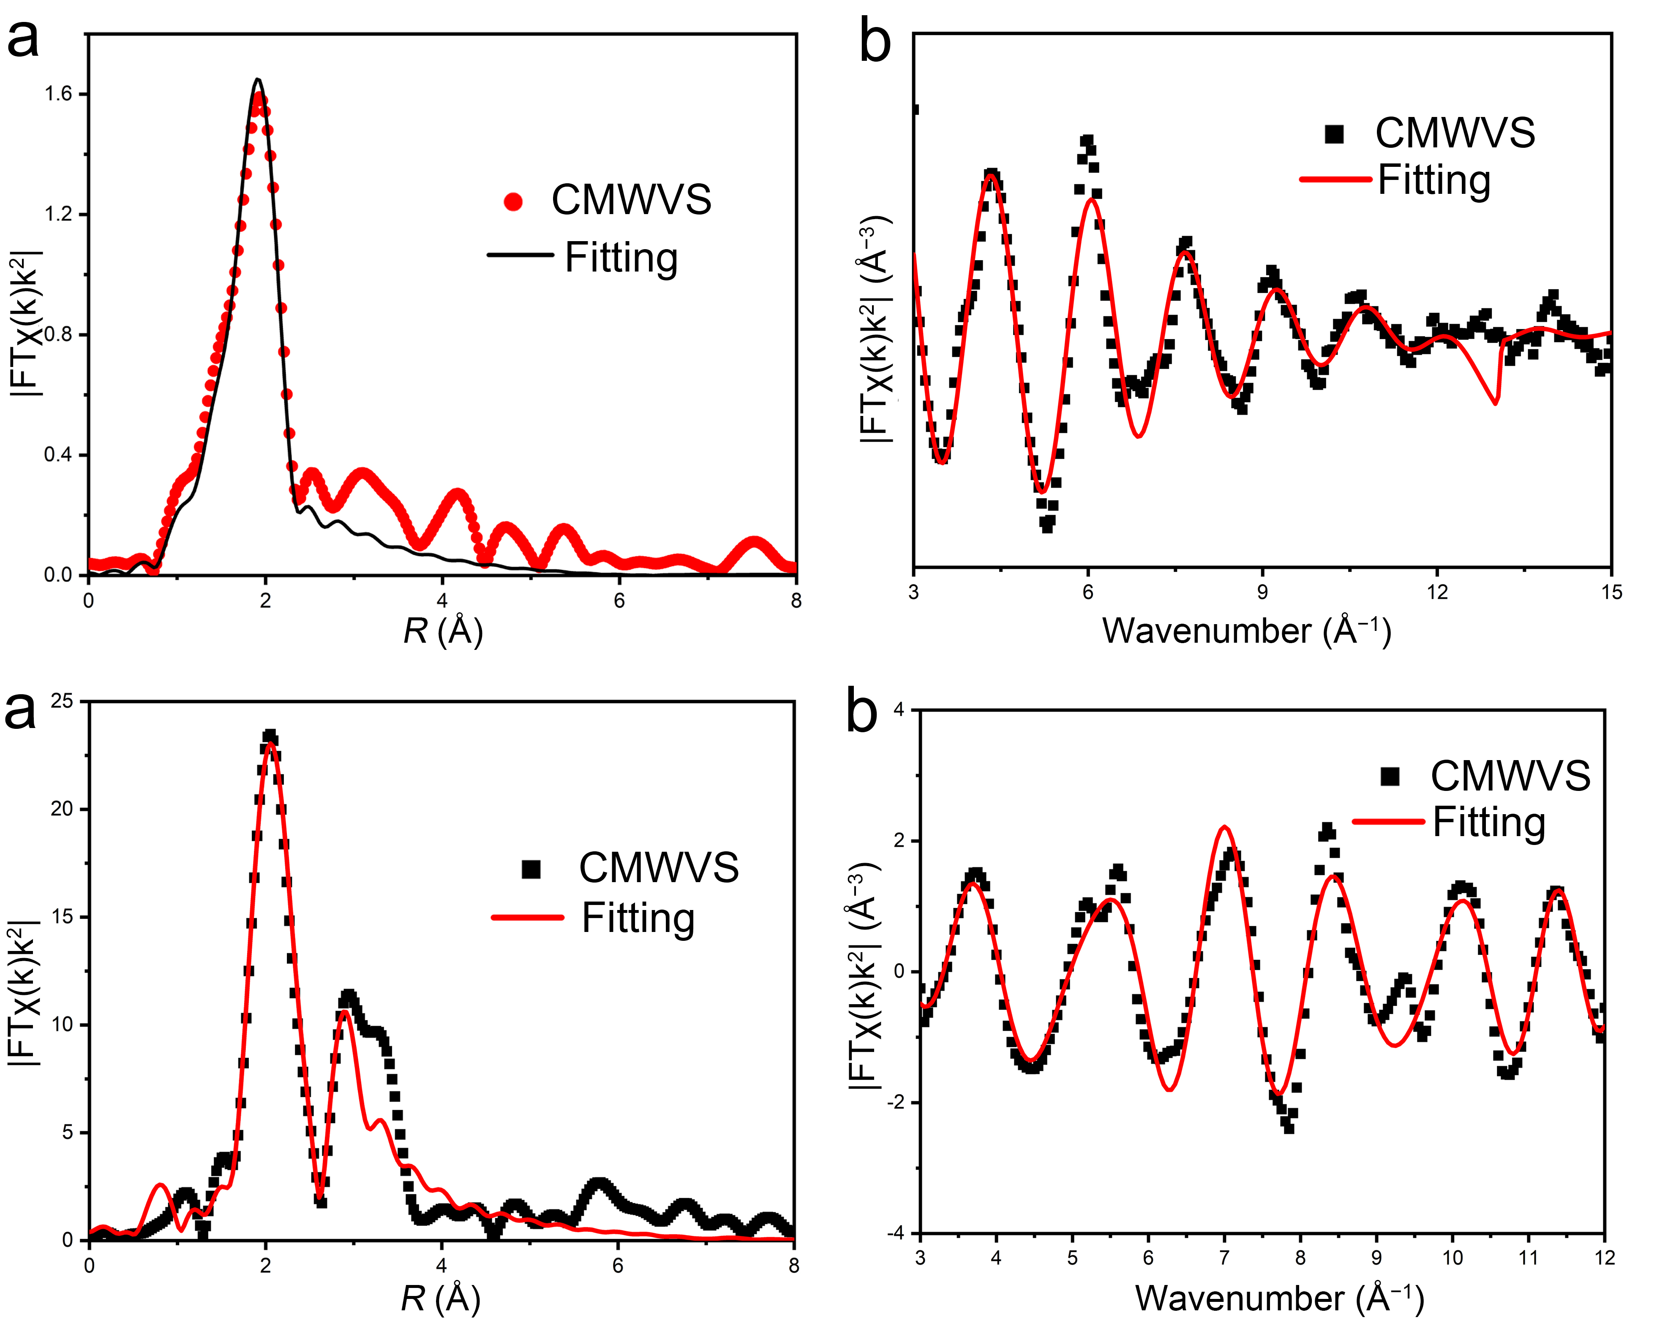
Fig. S12 (a) Fourier-transformed EXAFS spectra of CMWVS at the V K-edge, showing the magnitude of the radial distribution function (red dots) and the corresponding fitting curve (black line). (b) Corresponding k-space fitting curve (red line) and experimental data (black squares) of CMWVS at the V K-edge. The excellent agreement between the experimental data and fitting results confirms the reliability of the local structural model

Fig. S13 (a) Fourier-transformed EXAFS spectra of CMWVS at the W K-edge, showing the magnitude of the radial structure function (black squares) and the corresponding fitting curve (red line). (b) Corresponding k-space EXAFS fitting of CMWVS at the W K-edge, with experimental data (black squares) and the fitted curve (red line). The close agreement between the fitting and experimental data confirms the validity of the local coordination environment model for W in CMWVS

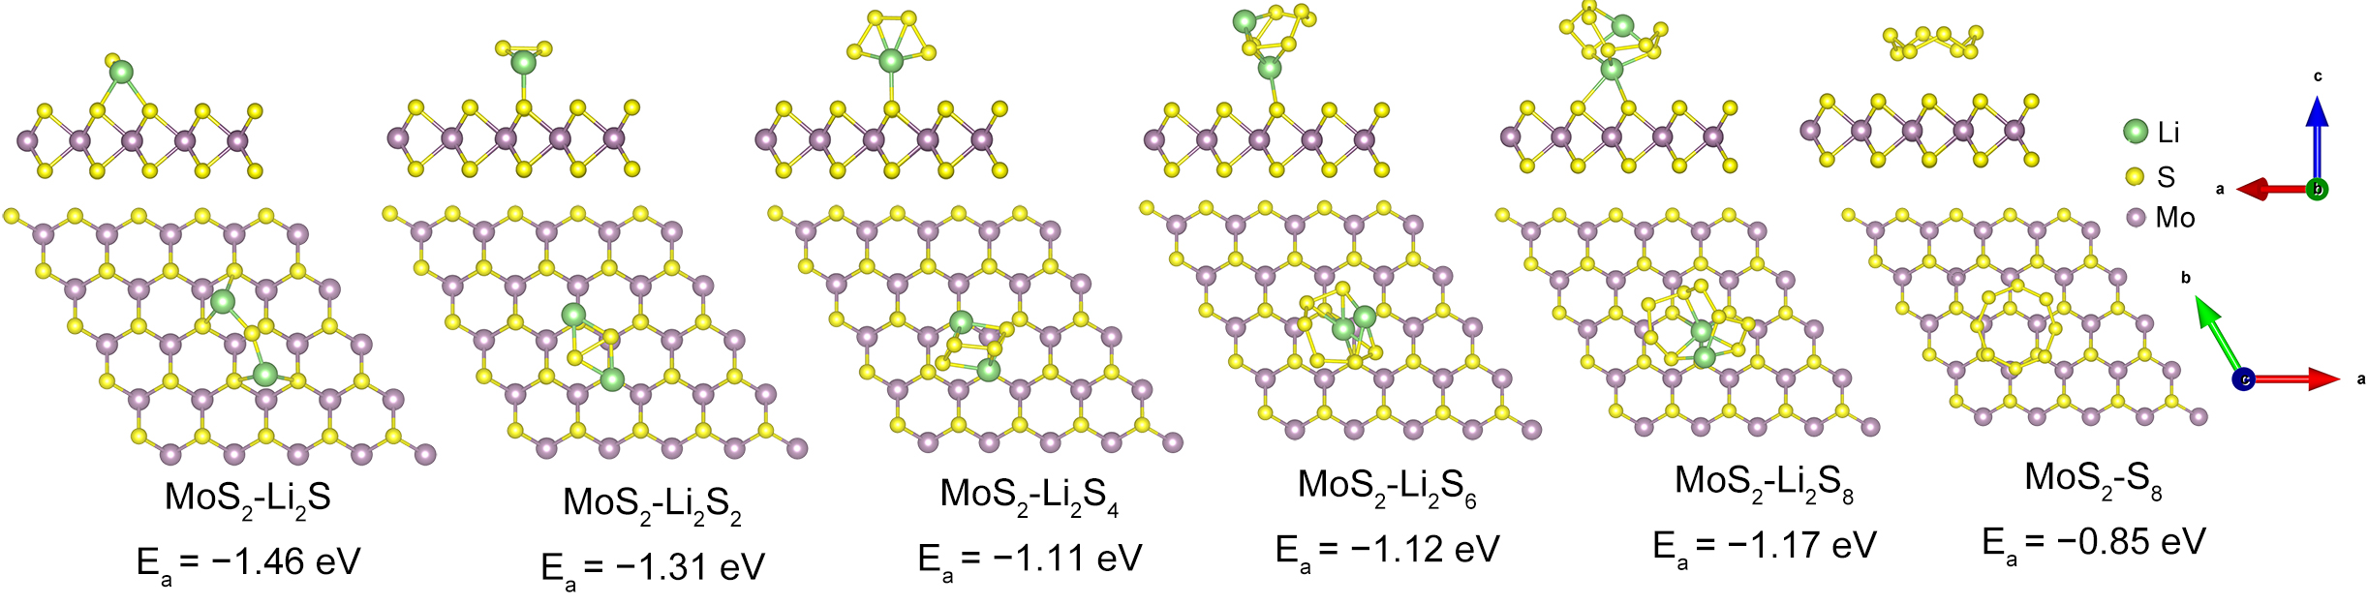
Fig. S14 The optimized adsorption models for MoS₂ with S₈ and Li₂S_{x} (n=1, 2, 4, 6, 8)

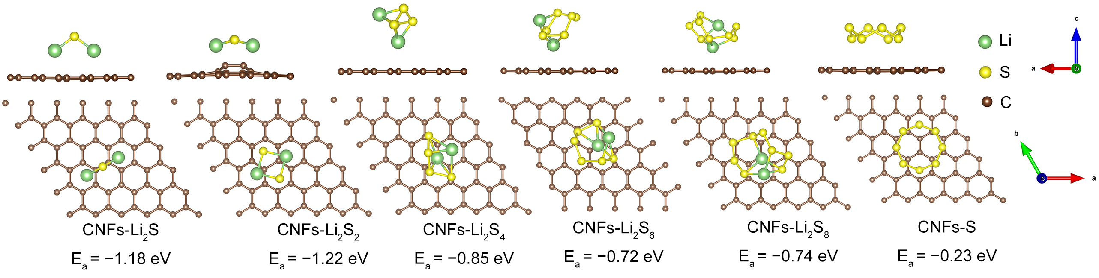
Fig. S15 The optimized adsorption models for carbon with S₈ and Li₂S_{x} (n=1, 2, 4, 6, 8)
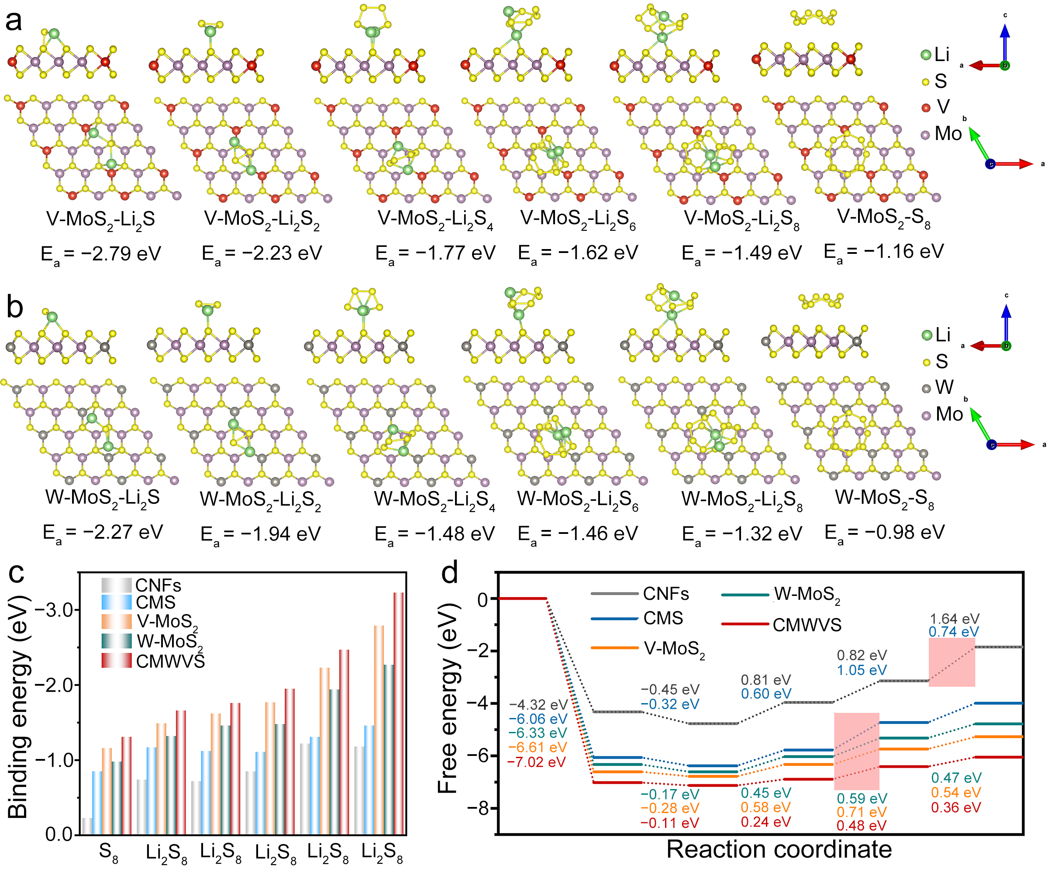
Fig. S16 (a) The optimized adsorption models for V-MoS₂ with S₈ and Li₂S_{x} (n=1, 2, 4, 6, 8). (b) The optimized adsorption models for W-MoS₂ with S₈ and Li₂S_{x} (n = 1, 2, 4, 6, 8). (c) Calculated binding energies of sulfur species (S₈ to Li₂S) on the CMWVS, V-MoS₂, W-MoS₂, CMS, and CNFs surface. (d) Gibbs free energy profiles for the stepwise reduction of S₈ to Li₂S on CMWVS, V-MoS₂, W-MoS₂, CMS, and CNFs

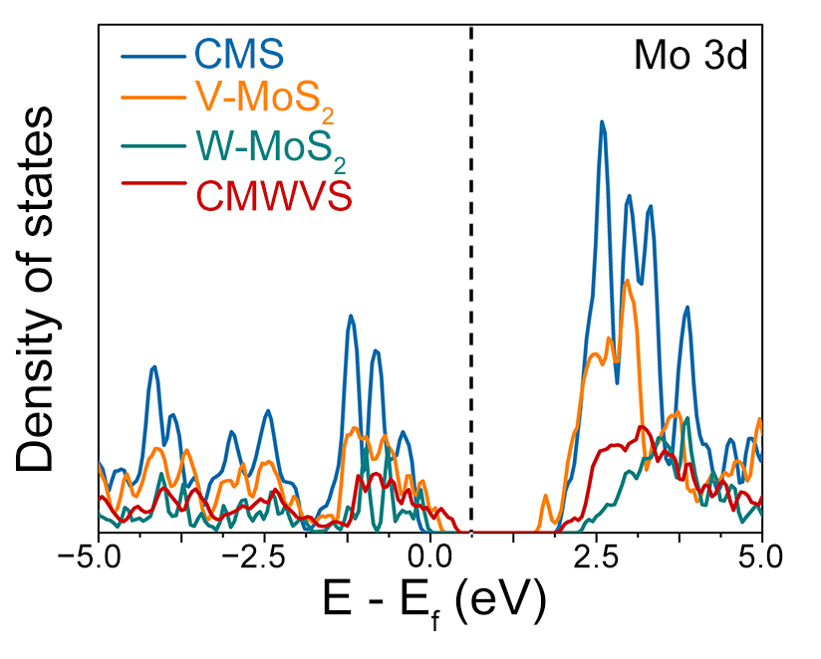
Fig. S17 Partial density of states of Mo 3d orbitals in CMS, V-MoS₂, W-MoS₂, and CMWVS, showing shifts in the d-band center
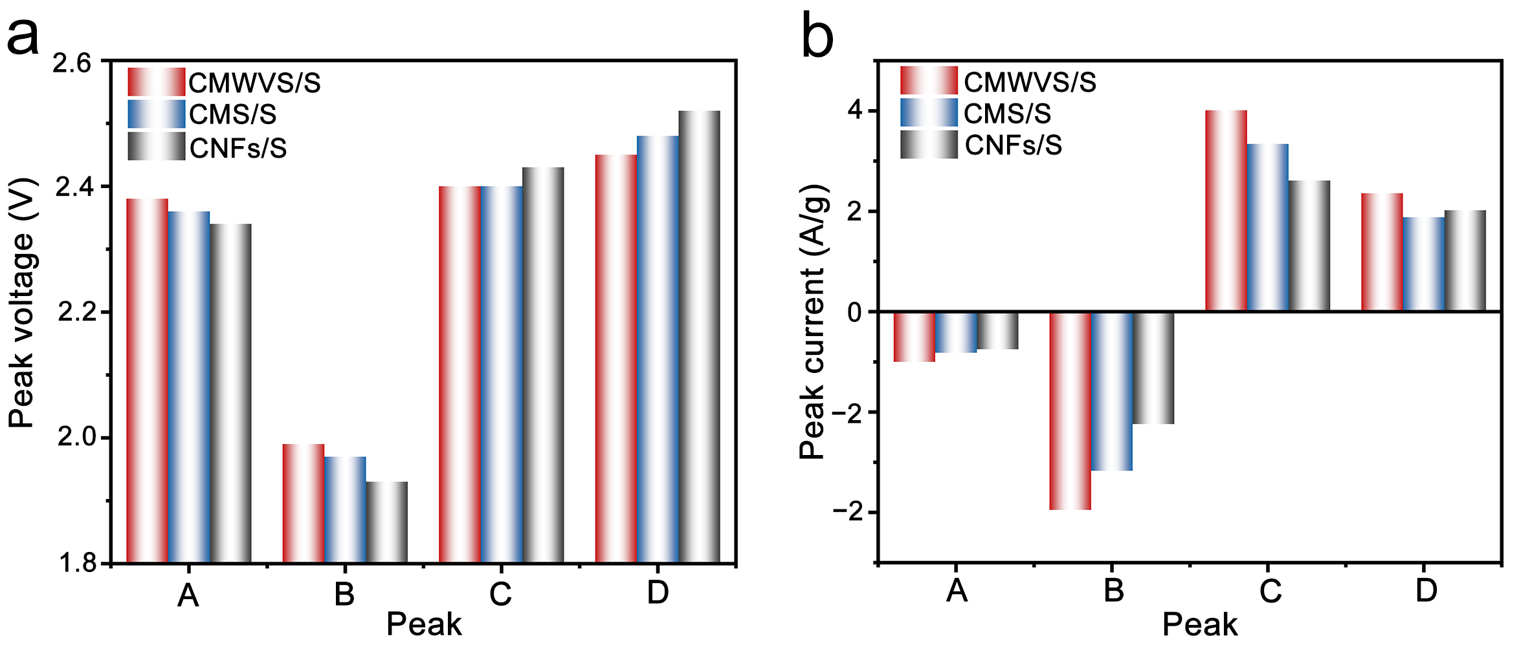
Fig. S18 Comparison of peak voltages and peak currents from the CV results of CMWVS/S, CMS/S, and CNFs/S electrodes

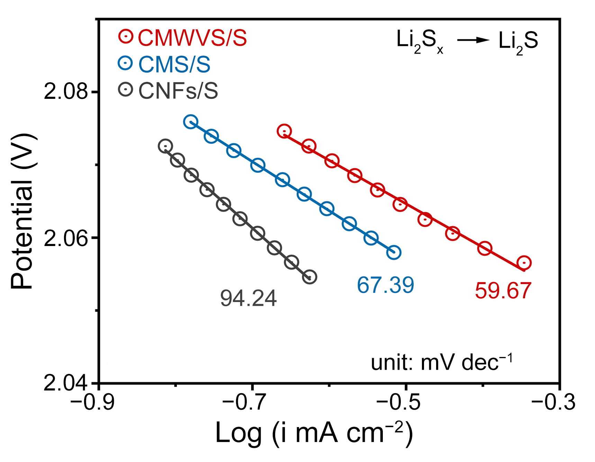
Fig. S19 Tafel plots derived from the CV curves at the reduction stage of Li₂S_{x} to Li₂S

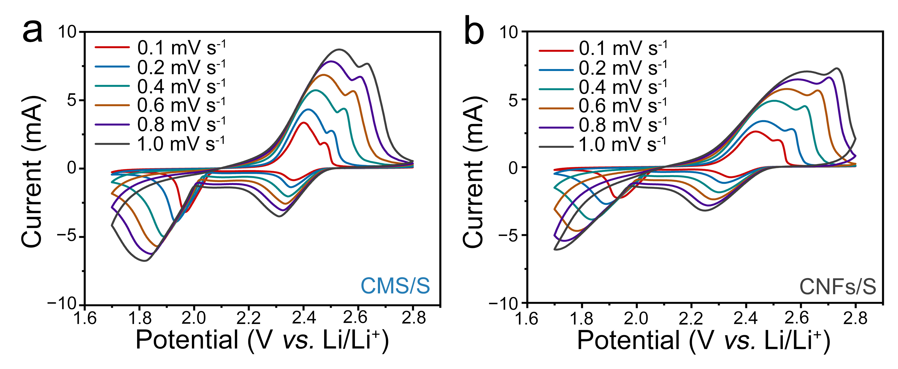
Fig. S20 CV curves of Li−S batteries with CMS/S and CNFs/S electrodes at scan rates from 0.1 to 10 mV s⁻¹

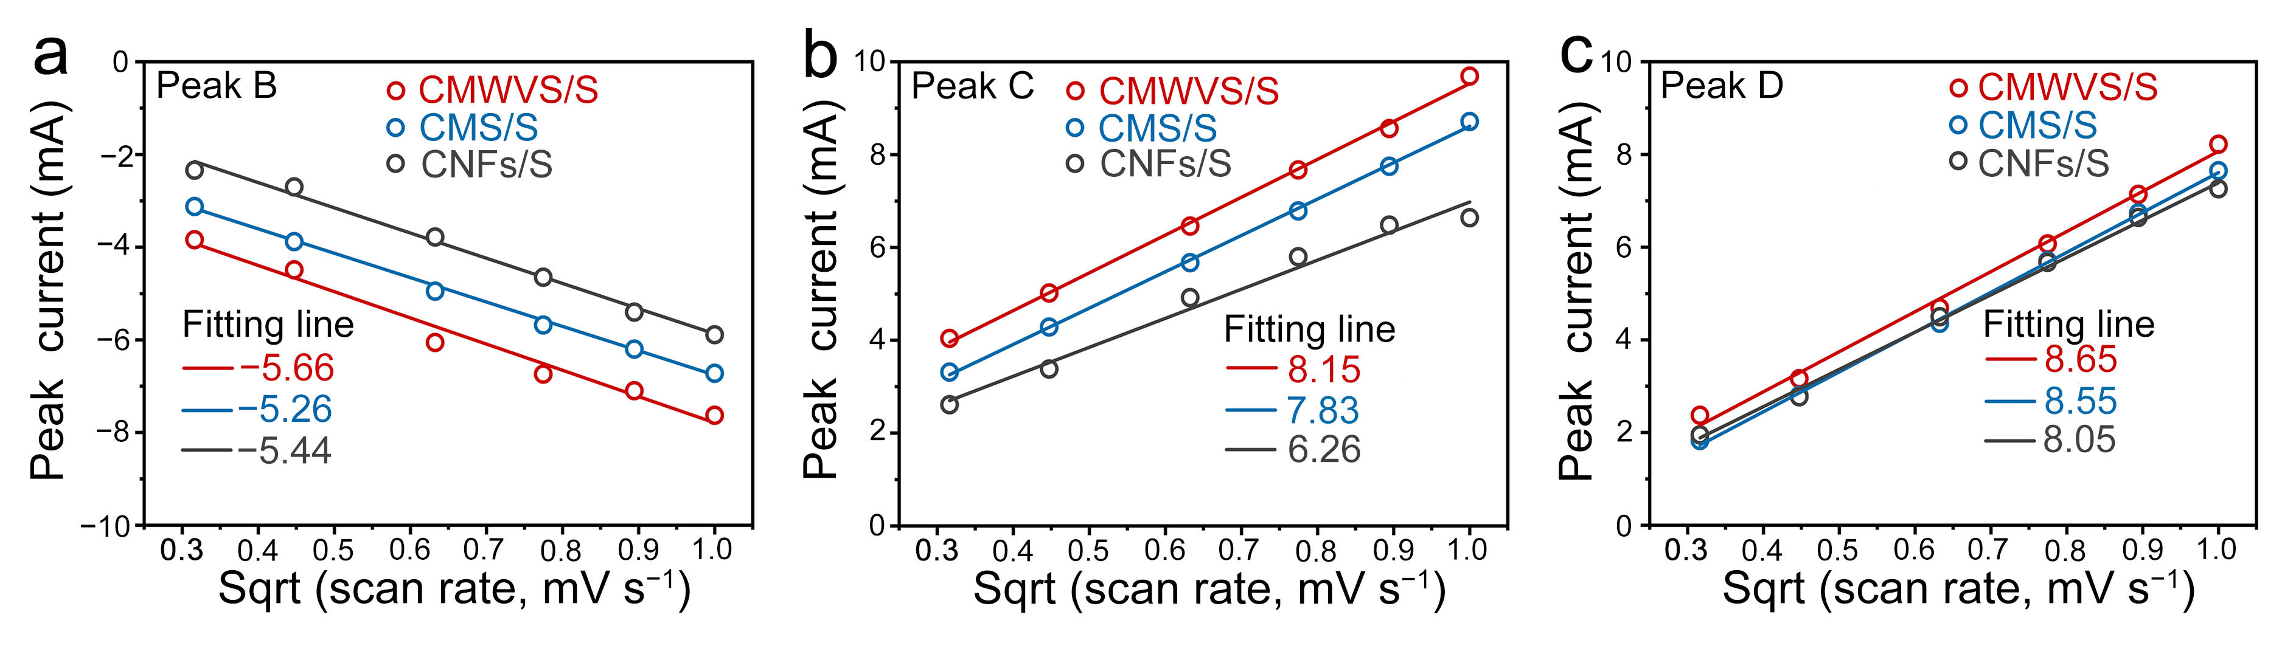
Fig. S21 Linear fitting of current responses of reduction (a) peak B, (b) peak C, and (c) peak D, and the square root of sweep rates for CMWVS/S, CMS/S, and CNFs/S electrodes

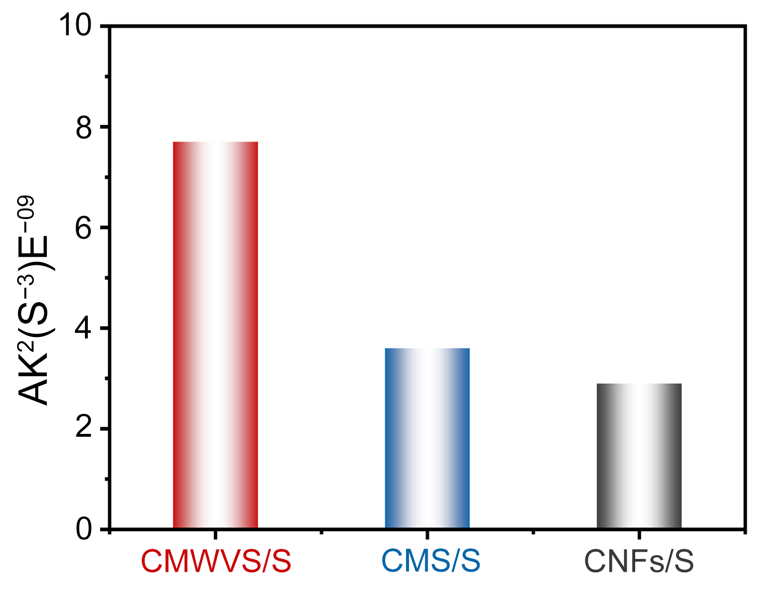
Fig. S22 Li₂S nucleation and growth rate value of CMWVS, CMS and CNFs-based electrodes

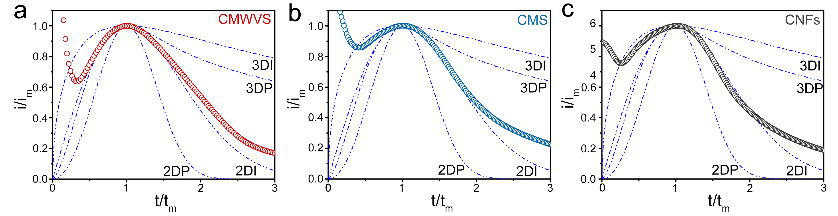
Fig. S23 Dimensionless transient (symbols), I_{m} (peak current), and t_{m} (time to reach peak current). Corresponding dimensionless transients of (a) CMWVS, (b) CMS and (c) CNFs

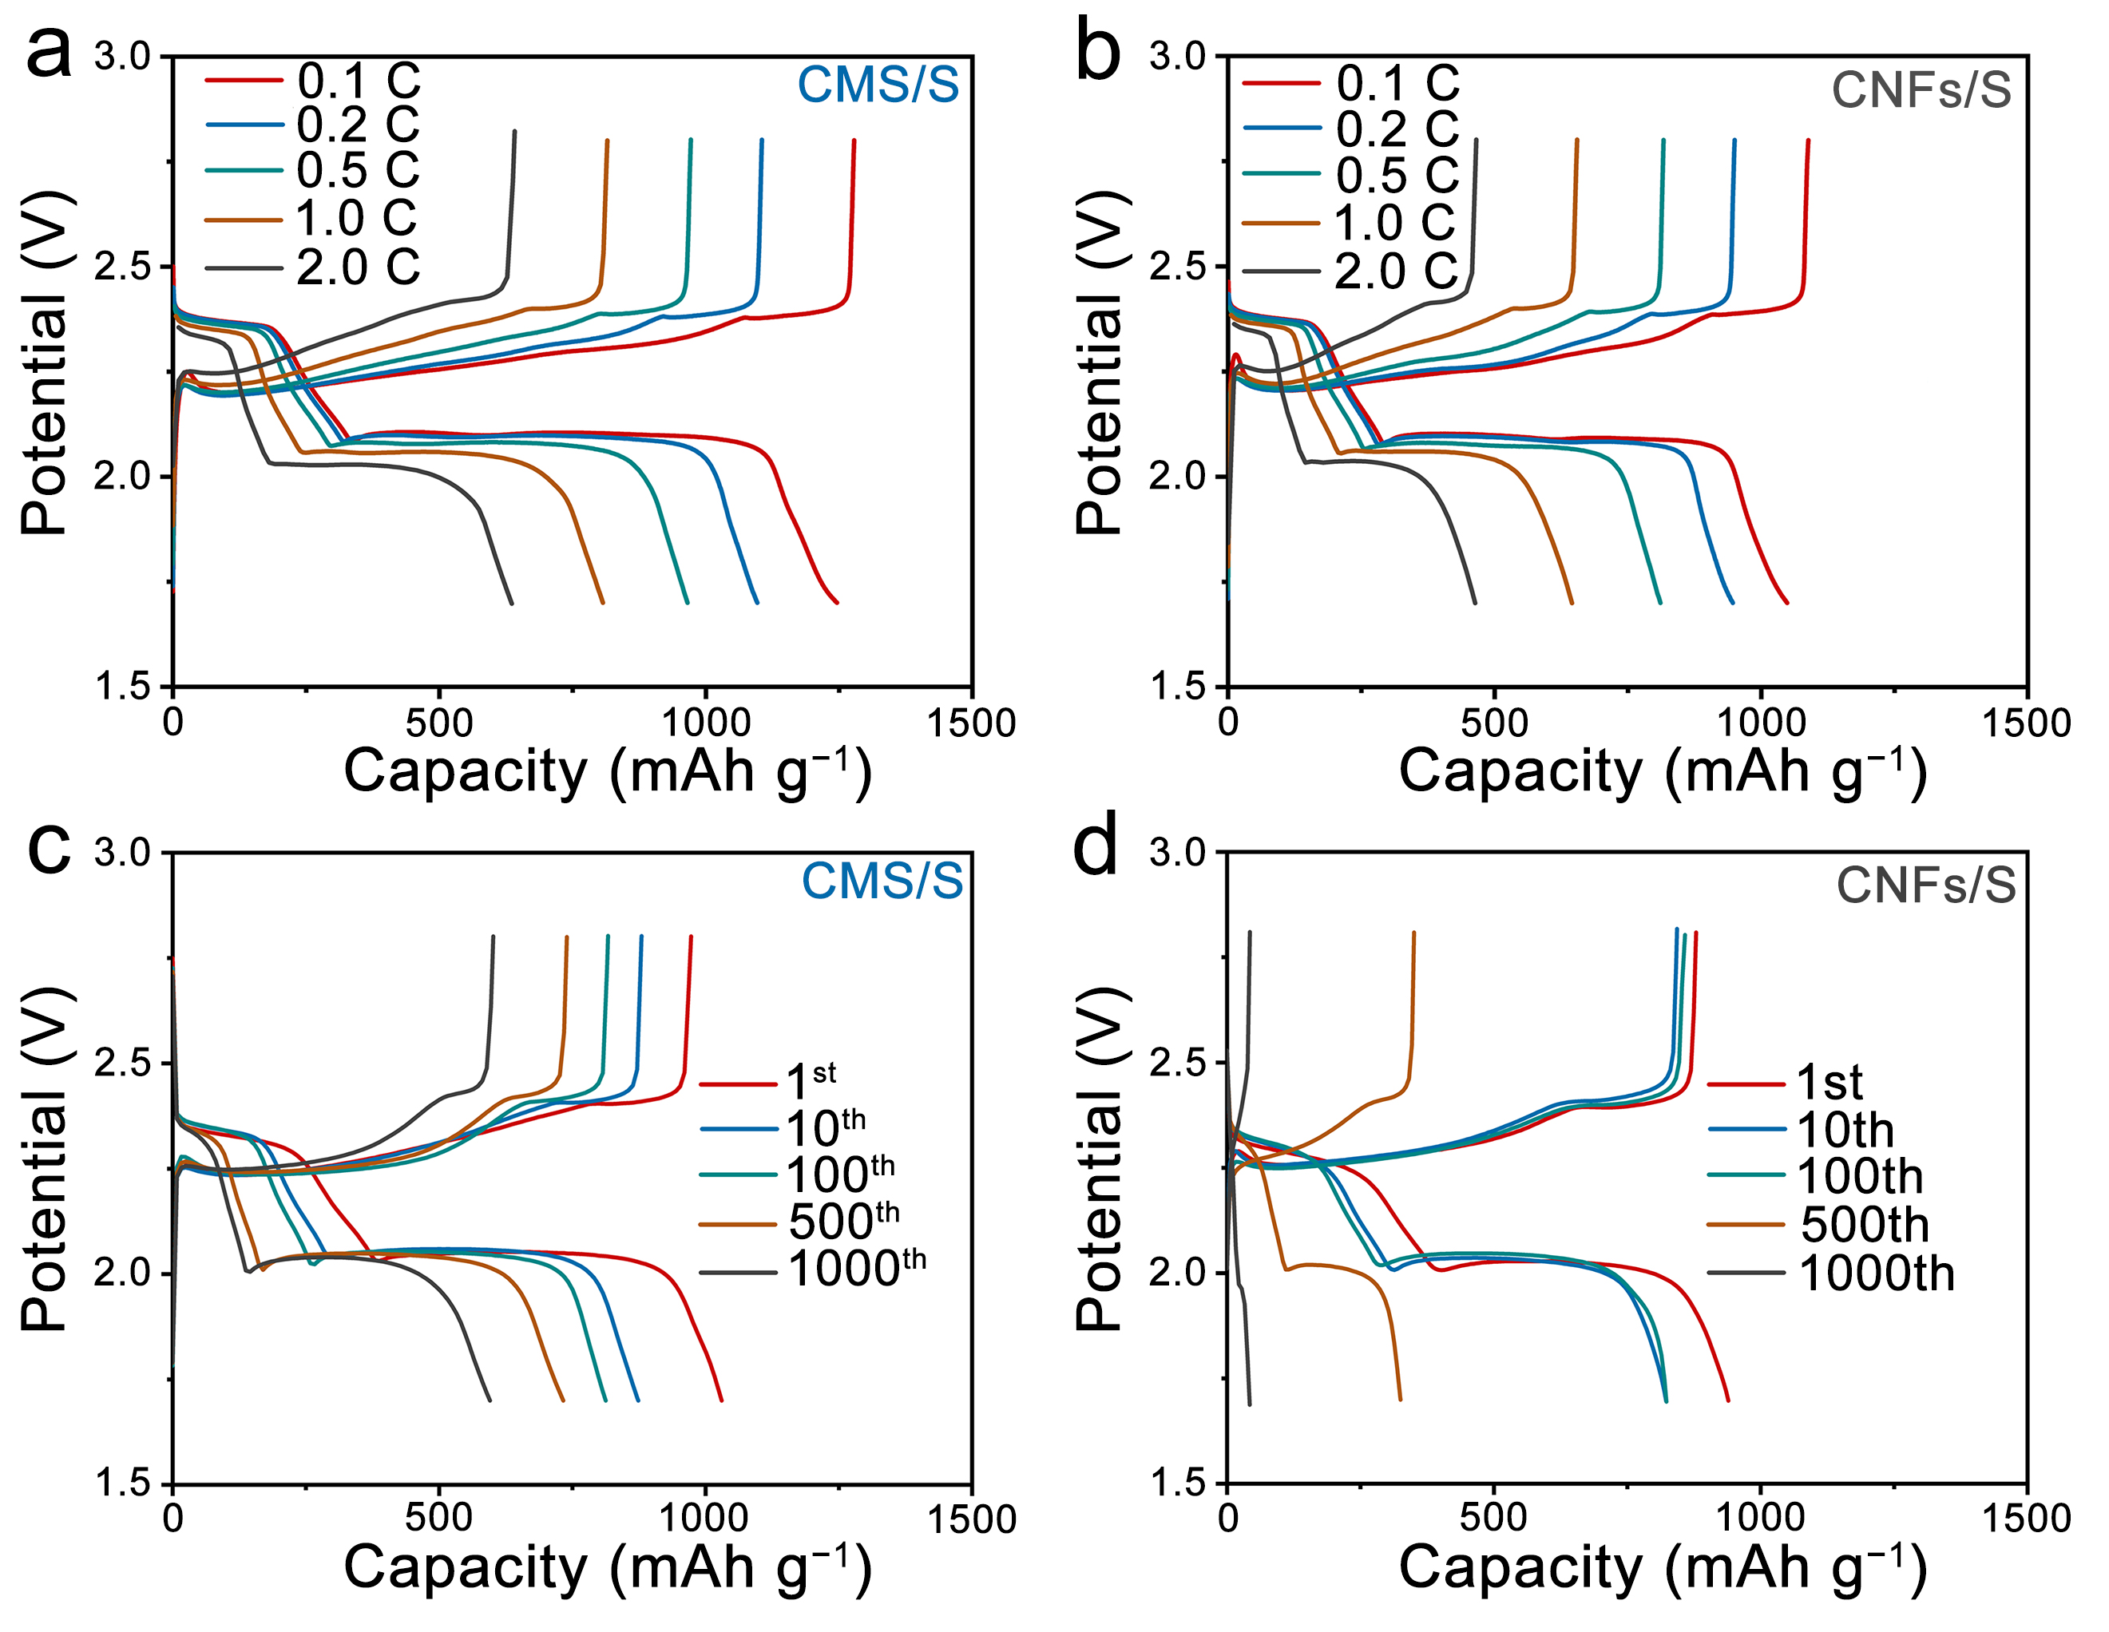
Fig. S24 GCD profile under different current rates of (a) CMS/S and (b) CNFs/S. GCD profile under different cycles of (c) CMS/S and (d) CNFs/S at 1.0 C
Fig. S25 Long cyclic performance of the CMWVS/S electrode at 1.0 C
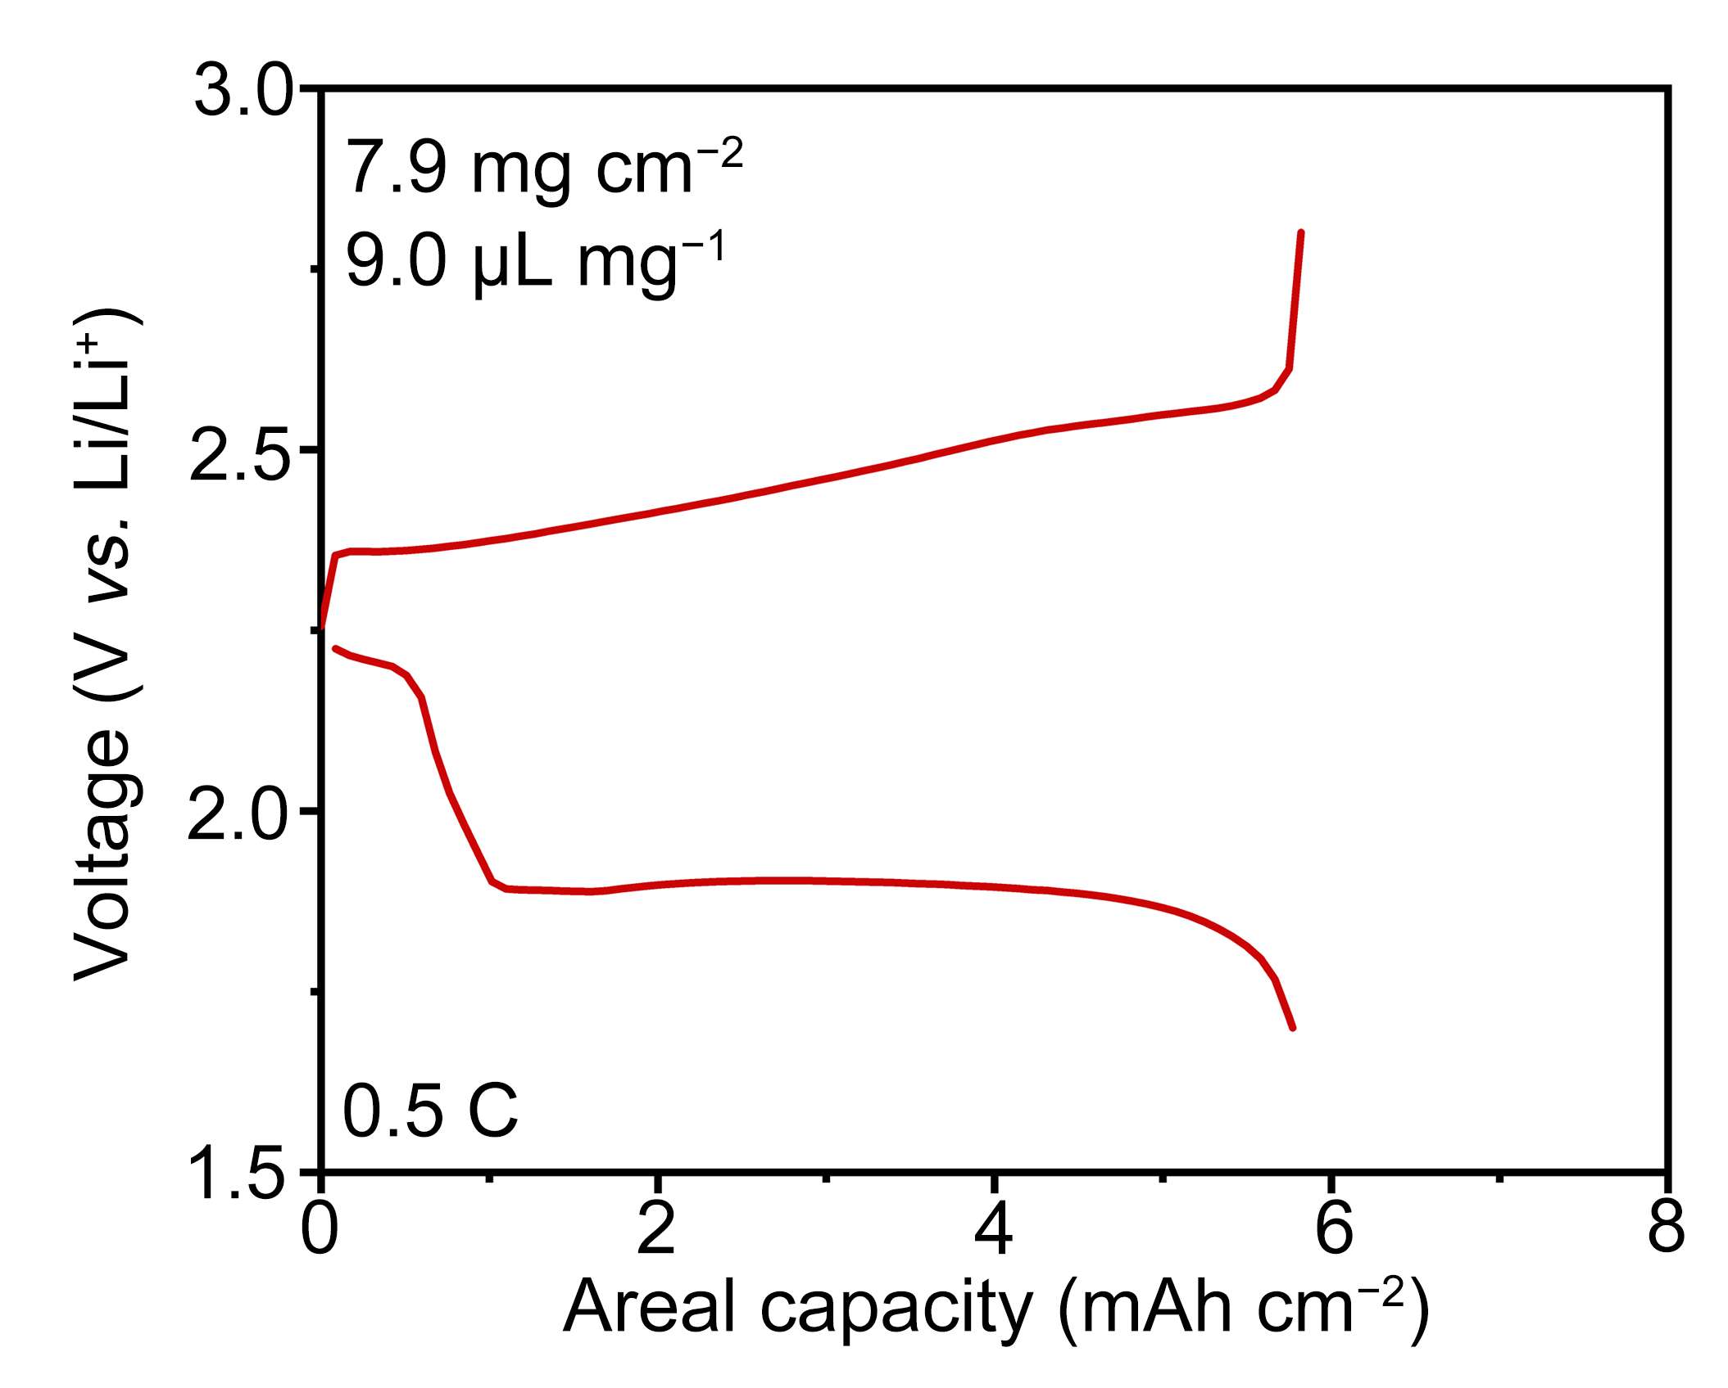
Fig. S26 GCD curves of high-loading Li−S cell based on CMWVS/S cathode under a high sulfur loading of 7.9 mg cm⁻² and a lean electrolyte condition with an E/S ratio of 9.0 μL mg⁻¹
Fig. S27 Cycling performance of high-loading Li−S cell based on CMWVS/S cathode under a high sulfur loading of 10.3 mg cm⁻² and a lean electrolyte condition with an E/S ratio of 5.0 μL mg⁻¹
Table S1 The content of W, V, and Mo in CMWVS
Elements content (ppm) | W | V | Mo
1st | 0.8079 | 0.2032 | 32.8537
2nd | 0.7741 | 0.2125 | 30.9018
3rd | 0.8284 | 0.1815 | 31.6787
4th | 0.7698 | 0.2377 | 32.0601
5th | 0.8058 | 0.1776 | 31.9225
Average value  (Keeping one decimal) | 0.80 | 0.20 | 31.9
Table S2 EXAFS fitting parameters at the V K-edge for various samples
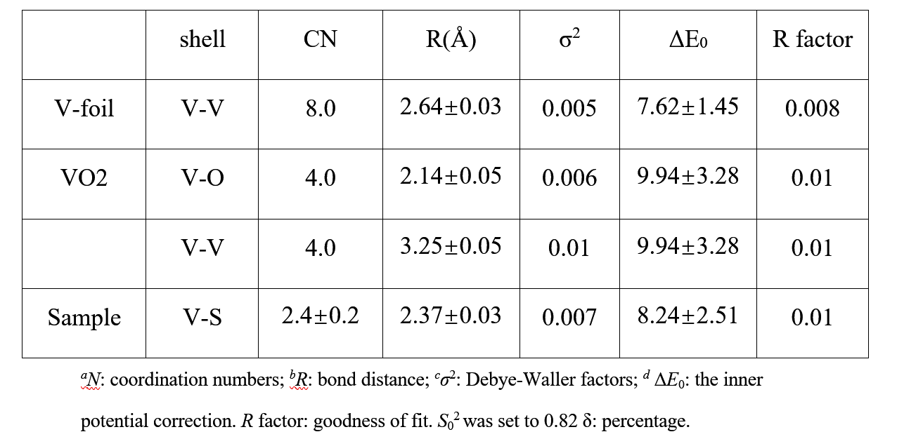

Table S3 EXAFS fitting parameters at the W K-edge for various samples
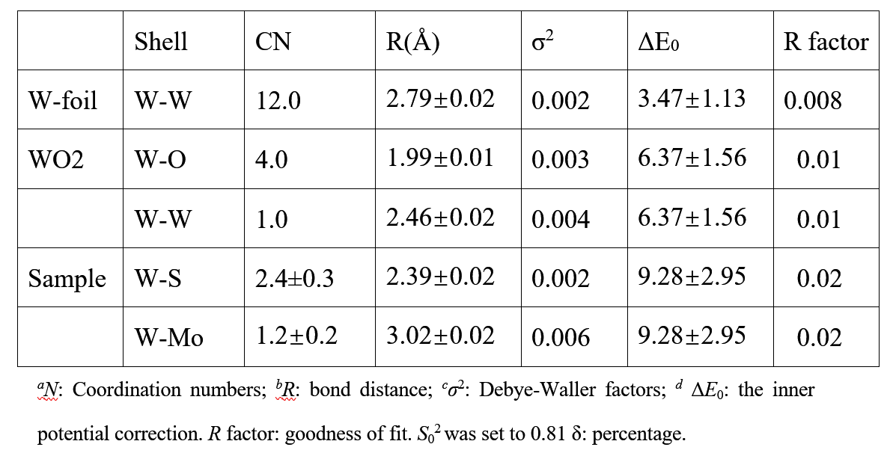
Table S4 Detailed parameters and calculated Li diffusion coefficient ($D_{{Li}^{+}}$) values at different redox peak positions for different electrodes. The number of reactive electrons n was determined based on the electrochemical reaction mechanism of sulfur cathodes, where the typical two-electron transfer process (S + 2e⁻ + 2Li⁺ → Li₂S) was considered. Accordingly, n was set to 2. The value of C_{Li} was obtained from the molar concentration of Li⁺ in the electrolyte
Cathodes | Peak | n | A / cm⁻² | $C_{{Li}^{+}}$ / mol cm⁻³ | Slope, Ip / v^{0.5} | $D_{{Li}^{+}}$ / cm² s⁻¹
CMWVS | A | 2 | 1.27 | 0.0012 | 0.124 | 1.1 × 10⁻⁸
CMWVS | B | 2 | 1.27 | 0.0012 | 0.179 | 2.4 × 10⁻⁸
CMWVS | C | 2 | 1.27 | 0.0012 | 0.258 | 4.9× 10⁻⁸
CMWVS | D | 2 | 1.27 | 0.0012 | 0.274 | 5.6× 10⁻⁸
CMS | A | 2 | 1.27 | 0.0012 | 0.122 | 1.1 × 10⁻⁸
CMS | B | 2 | 1.27 | 0.0012 | 0.166 | 2.0 × 10⁻⁸
CMS | C | 2 | 1.27 | 0.0012 | 0.248 | 4.6 × 10⁻⁸
CMS | D | 2 | 1.27 | 0.0012 | 0.271 | 5.5 × 10⁻⁸
CNFs | A | 2 | 1.27 | 0.0012 | 0.118 | 1.0 × 10⁻⁸
CNFs | B | 2 | 1.27 | 0.0012 | 0.172 | 2.2 × 10⁻⁸
CNFs | C | 2 | 1.27 | 0.0012 | 0.198 | 2.9× 10⁻⁸
CNFs | D | 2 | 1.27 | 0.0012 | 0.255 | 4.8 × 10⁻⁸

Table S5 Comparison of the electrochemical performance of different electrodes in Li−S batteries
Host materials | Sulfur loading (mg cm⁻²) | Current density (C) | Initial capacity (mAh g⁻¹) | Final capacity (mAh g⁻¹) | Coulombic efficiency (%) | Cycle number | Refs
CMWVS | 2 | 1 | 1235.7 | 816.3 | 99.5 | 1000 | This work
CoSe₂@CNF/CNT | 1.15 | 1 | 1098.8 | 766.4 | 98.8 | 500 | [S8]
NiCoP@CC | / | 1 | 739.4 | 420 | / | 900 | [S9]
Ag/C@CNF | 2 | 5 | 650 | 520 | / | 1000 | [S10]
FeSa-NC@CBC | 2.5 | 1 | 1006.2 | 799.8 | 98.7 | 500 | [S11]
CFP-VN/S | 2.3 | 1 | 806 | 596 | 99.0 | 300 | [S12]
HP-N-CNF | 4.8 | 0.3 | 871 | 565 | 89 | 100 | [S13]
P-N-CNF@NCO/HNC | 3.6 | 0.1 | 268 | 418 | 94 | 400 | [S14]
Supplementary References
- B. Ravel, M. Newville, ATHENA, ARTEMIS, HEPHAESTUS: data analysis for X-ray absorption spectroscopy using IFEFFIT. J. Synchrotron Rad. 12, 537–541 (2005) https://doi:10.1107/S0909049505012719
- G. Kresse, J. Furthmüller, Efficiency of Ab-Initio Total Energy Calculations for Metals and Semiconductors Using a Plane-Wave Basis Set. Comput. Mater. Sci. 6, 15−50 (1996). https://doi.org/10.1016/0927-0256(96)00008-0
- G. Kresse, J. Furthmüller, Efficient Iterative Schemes for Ab Initio Total-Energy Calculations Using a Plane-Wave Basis Set. Phys. Rev. B 54, 11169−11186 (1996). https://doi.org/10.1103/PhysRevB.54.11169
- J. P. Perdew, K. Burke, M. Ernzerhof, Generalized Gradient Approximation Made Simple. Phys. Rev. Lett. 77, 3865−3868 (1996). https://doi.org/10.1103/PhysRevLett.77.3865
- G. Kresse, D. Joubert, From Ultrasoft Pseudopotentials to the Projector Augmented-Wave Method. Phys. Rev. B 59, 1758-1775 (1999). https://doi.org/10.1103/PhysRevB.59.1758
- P.E. Blöchl, Projector Augmented-Wave Method. Phys. Rev. B 50, 17953−17979 (1994). https://doi.org/10.1103/PhysRevB.50.17953
- H.J. Monkhorst, J.D. Pack, on special points for brillouin zone integrations. Phys. Rev. B, 13 5188-5192(1976). https://doi.org/10.1103/PhysRevB.13.5188
- J. Ao, Y. Xie, Y. Lai, M. Yang, J. Xu et al., CoSe₂ nanoparticles‑decorated carbon nanofibers as a hierarchical self‑supported sulfur host for high‑energy lithium‑sulfur batteries. Sci. China Mater. 66, 3075−3083 (2023). https://doi.org/10.1007/s40843-022-2462-x
- Z. Yang, W. Lu, C. Sun, M. Yap, N. Chen et al., Bifunctional NiCoP nanofiber arrayed on carbon cloth for fast polysulfide conversion and uniform lithium deposition in lithium sulfur batteries. J. Colloid Interface Sci. 685, 235−243 (2025). https://doi.org/10.1016/j.jcis.2025.01.095
- C. Zhou, H. Wang, Q. Li, F. Wu, S. Cao et al., An Ag/C core−shell composite functionalized carbon nanofiber film as freestanding bifunctional host for advanced lithium−sulfur batteries. Adv. Fiber Mater. 6, 181−194 (2023). https://doi.org/10.1007/s42765-023-00341-0
- X. Lin, W. Li, V. Nguyen, S. Wang, S. Yang et al., Fe‑single‑atom catalyst nanocages linked by bacterial cellulose‑derived carbon nanofiber aerogel for Li‑S batteries. Chem. Eng. J. 477, 146977 (2023). https://doi.org/10.1016/j.cej.2023.146977
- K. Kong, Z. Cheng, X. Meng, F. Cui, J . Huang et al., Vanadium nitride nanowires array on carbon nanofiber paper for regulating polysulfides toward stable freestanding sulfur cathode. Small 21(18), 2412586 (2025). https://doi.org/10.1002/smll.202412586
- R. Saroha, J. S. Cho, Nanofibers comprising interconnected chain‑like hollow N‑doped C nanocages as 3D free‑standing cathodes for Li−S batteries with super‑high sulfur content and lean electrolyte/sulfur ratio. Small Methods 6(5), 2200049 (2022). https://doi.org/10.1002/smtd.202200049
- R. Saroha, Y. H. Seon, B. Jin, Y. C. Kang, D.-W. Kang et al., Self‑supported hierarchically porous 3D carbon nanofiber network comprising Ni/Co/NiCo₂O₄ nanocrystals and hollow N‑doped C nanocages as sulfur host for highly reversible Li−S batteries. Chem. Eng. J. 446, 137141 (2022). https://doi.org/10.1016/j.cej.2022.137141

