Supporting Information for
Magnetic-Dielectric Synergy in One-Dimensional Metal Heterostructures for Enhanced Low-Frequency Microwave Absorption
Feiyue Hu^{1#}, Peigen Zhang^{1#}*, Pei Ding¹, Shuo Zhang¹, Bingbing Fan^{2, 3}, Ali Saffar Shamshirgar⁴, Wei Zheng¹, Wenwen Sun¹, Longzhu Cai⁵, Haijiao Xie⁶, Qiyue Shao¹, Johanna Rosen⁴*, and ZhengMing Sun¹*
¹ State Key Laboratory of Engineering Materials for Major Infrastructure, School of Materials Science and Engineering, Southeast University, Nanjing 211189, P. R. China
² School of Materials Science and Engineering, Zhengzhou University, Zhengzhou 450001, P. R. China
³ Department of Engineering, Faculty of Environment, Science and Economy, University of Exeter, Exeter EX4 4QF, United Kingdom
⁴ Materials Design Division, Department of Physics, Chemistry and Biology (IFM), Linköping University, SE-581 83, Linköping, Sweden
⁵ State Key Laboratory of Millimeter Waves, School of Information Science and Engineering, Southeast University, Nanjing 210096, P. R. China
⁶ Hangzhou Yanqu Information Technology Co., Ltd, Hangzhou 310003, P. R. China
# Feiyue Hu and Peigen Zhang contribute equally to this paper.
* Corresponding authors. E-mail: zhpeigen@seu.edu.cn (Peigen Zhang), johanna.rosen@liu.se (Johanna Rosen) and zmsun@seu.edu.cn (ZhengMing Sun)

S1 RCS simulation
CST Studio Suite 2020 was employed to simulate the radar cross section (RCS) of the microwave absorber, considering the realistic far-field response of the MA materials. A widely adopted metal-back configuration was used, consisting of a dual-layer square specimen (20 × 20 cm²). The top layer, 2.44 mm thick, served as the absorbing layer, while the bottom layer was a 1.0 mm perfect electric conductor (PEC). The sample/PEC bilayer was positioned on the X–O–Y plane, with linearly polarized plane waves incident along the +Z to -Z direction and the electric field polarized along the X-axis. Open boundary conditions were applied in all directions, and the field monitor frequency was set to 6.6 GHz. In addition, to further confirm the broadband absorption characteristics of the CNS samples, low-frequency RCS signals at 2.5, 3.5, 5.0, and 8.0 GHz were also simulated. The scattering directions were defined conventionally in spherical coordinates using θ (theta) and φ (phi). The RCS values can be described as follows:
δ (dB m²) = 10 lg((4πS/λ²)|E_{s}/E_{i}|)² (S1)
Herein, S, λ, E_{s} and E_{i} symbolize the area of the target object simulation model, the wavelength of EMW, the electric field intensity of the scattered wave and the incident wave, respectively.

S2 Calculation details
Slab model of Co(111) 2×6×1 supercell with four stoichiometric layers was built based on Face Center Cubic (FCC) Co bulk structure. Slab model of Ni(111) 2×6×1 supercell with four stoichiometric layers was built based on FCC Ni bulk structure. Slab model of CoNi(111) with four stoichiometric layers was built based on Co(111) 2×6×1 supercell. Slab model of Sn(100) 2×4×1 supercell with two stoichiometric layers was built based on Sn bulk structure. Slab model of SnO₂(110) 4×2×1 supercell with three stoichiometric layers was built based on rutile SnO₂ bulk structure. Slab model of SnO₂(110)/Co(111) was built based on SnO₂(110) 1×1×2 supercell and Co(111) 2×6×1 supercell. Slab model of SnO₂(110)/Ni(111) was built based on SnO₂(110) 1×1×2 supercell and Ni(111) 2×6×1 supercell. Slab model of SnO₂(110)/CoNi(111) was built based on SnO₂(110) 1×1×2 supercell and CoNi(111). Slab model of Sn(100)/SnO₂(110) was built based on Sn(100) 2×4×1 supercell and SnO₂(110) 4×2×1 supercell. In slab model, thickness along c direction was set at 40Å to avoid weak interactions between images.
In DFT calculations, structural optimizations were performed by Vienna Ab-initio Simulation Package (VASP) with the projector augmented wave (PAW) method. The exchange-functional was treated using the Perdew-Burke-Ernzerhof (PBE) functional, in combination with the DFT-D3 correction. Cut-off energy of the plane-wave basis was set as 450 eV. For optimization of lattice size of Co(111), Ni(111), CoNi(111), Co(111)/SnO₂(110), Ni(111)/SnO₂(110) and CoNi(111)/SnO₂(110), the Brillouin Zone integration was performed with a Monkhorst k-point sampling of 2×1×1. For optimization of lattice size of Sn(100), SnO₂(110) and SnO₂(110)/Sn(100), the Brillouin Zone integration was performed with a k-point sampling of 2×2×1. The self-consistent calculations applied a convergence energy threshold of 10⁻⁵ eV. The equilibrium geometries were optimized with maximum stress on each atom within 0.02 eV Å⁻¹. Spin polarization method was used to describe magnetism of slab models. Isosurface level of charge density difference was set at 0.02 e Å⁻³. Work functions of slab models were calculated by GGA-PBE functional, and then treated by vaspkit interface.

S3 Supplementary Figures and Tables
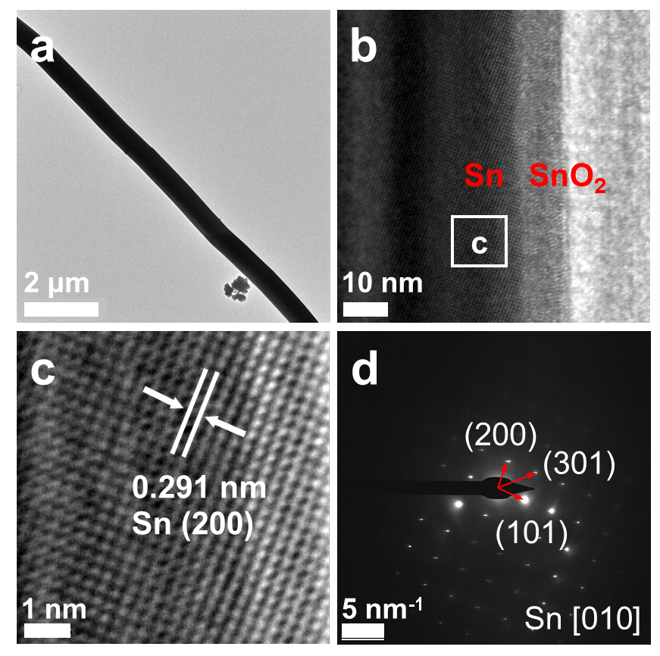
Fig. S1 a TEM image, b, c HRTEM image and d SAED pattern of Sn whisker
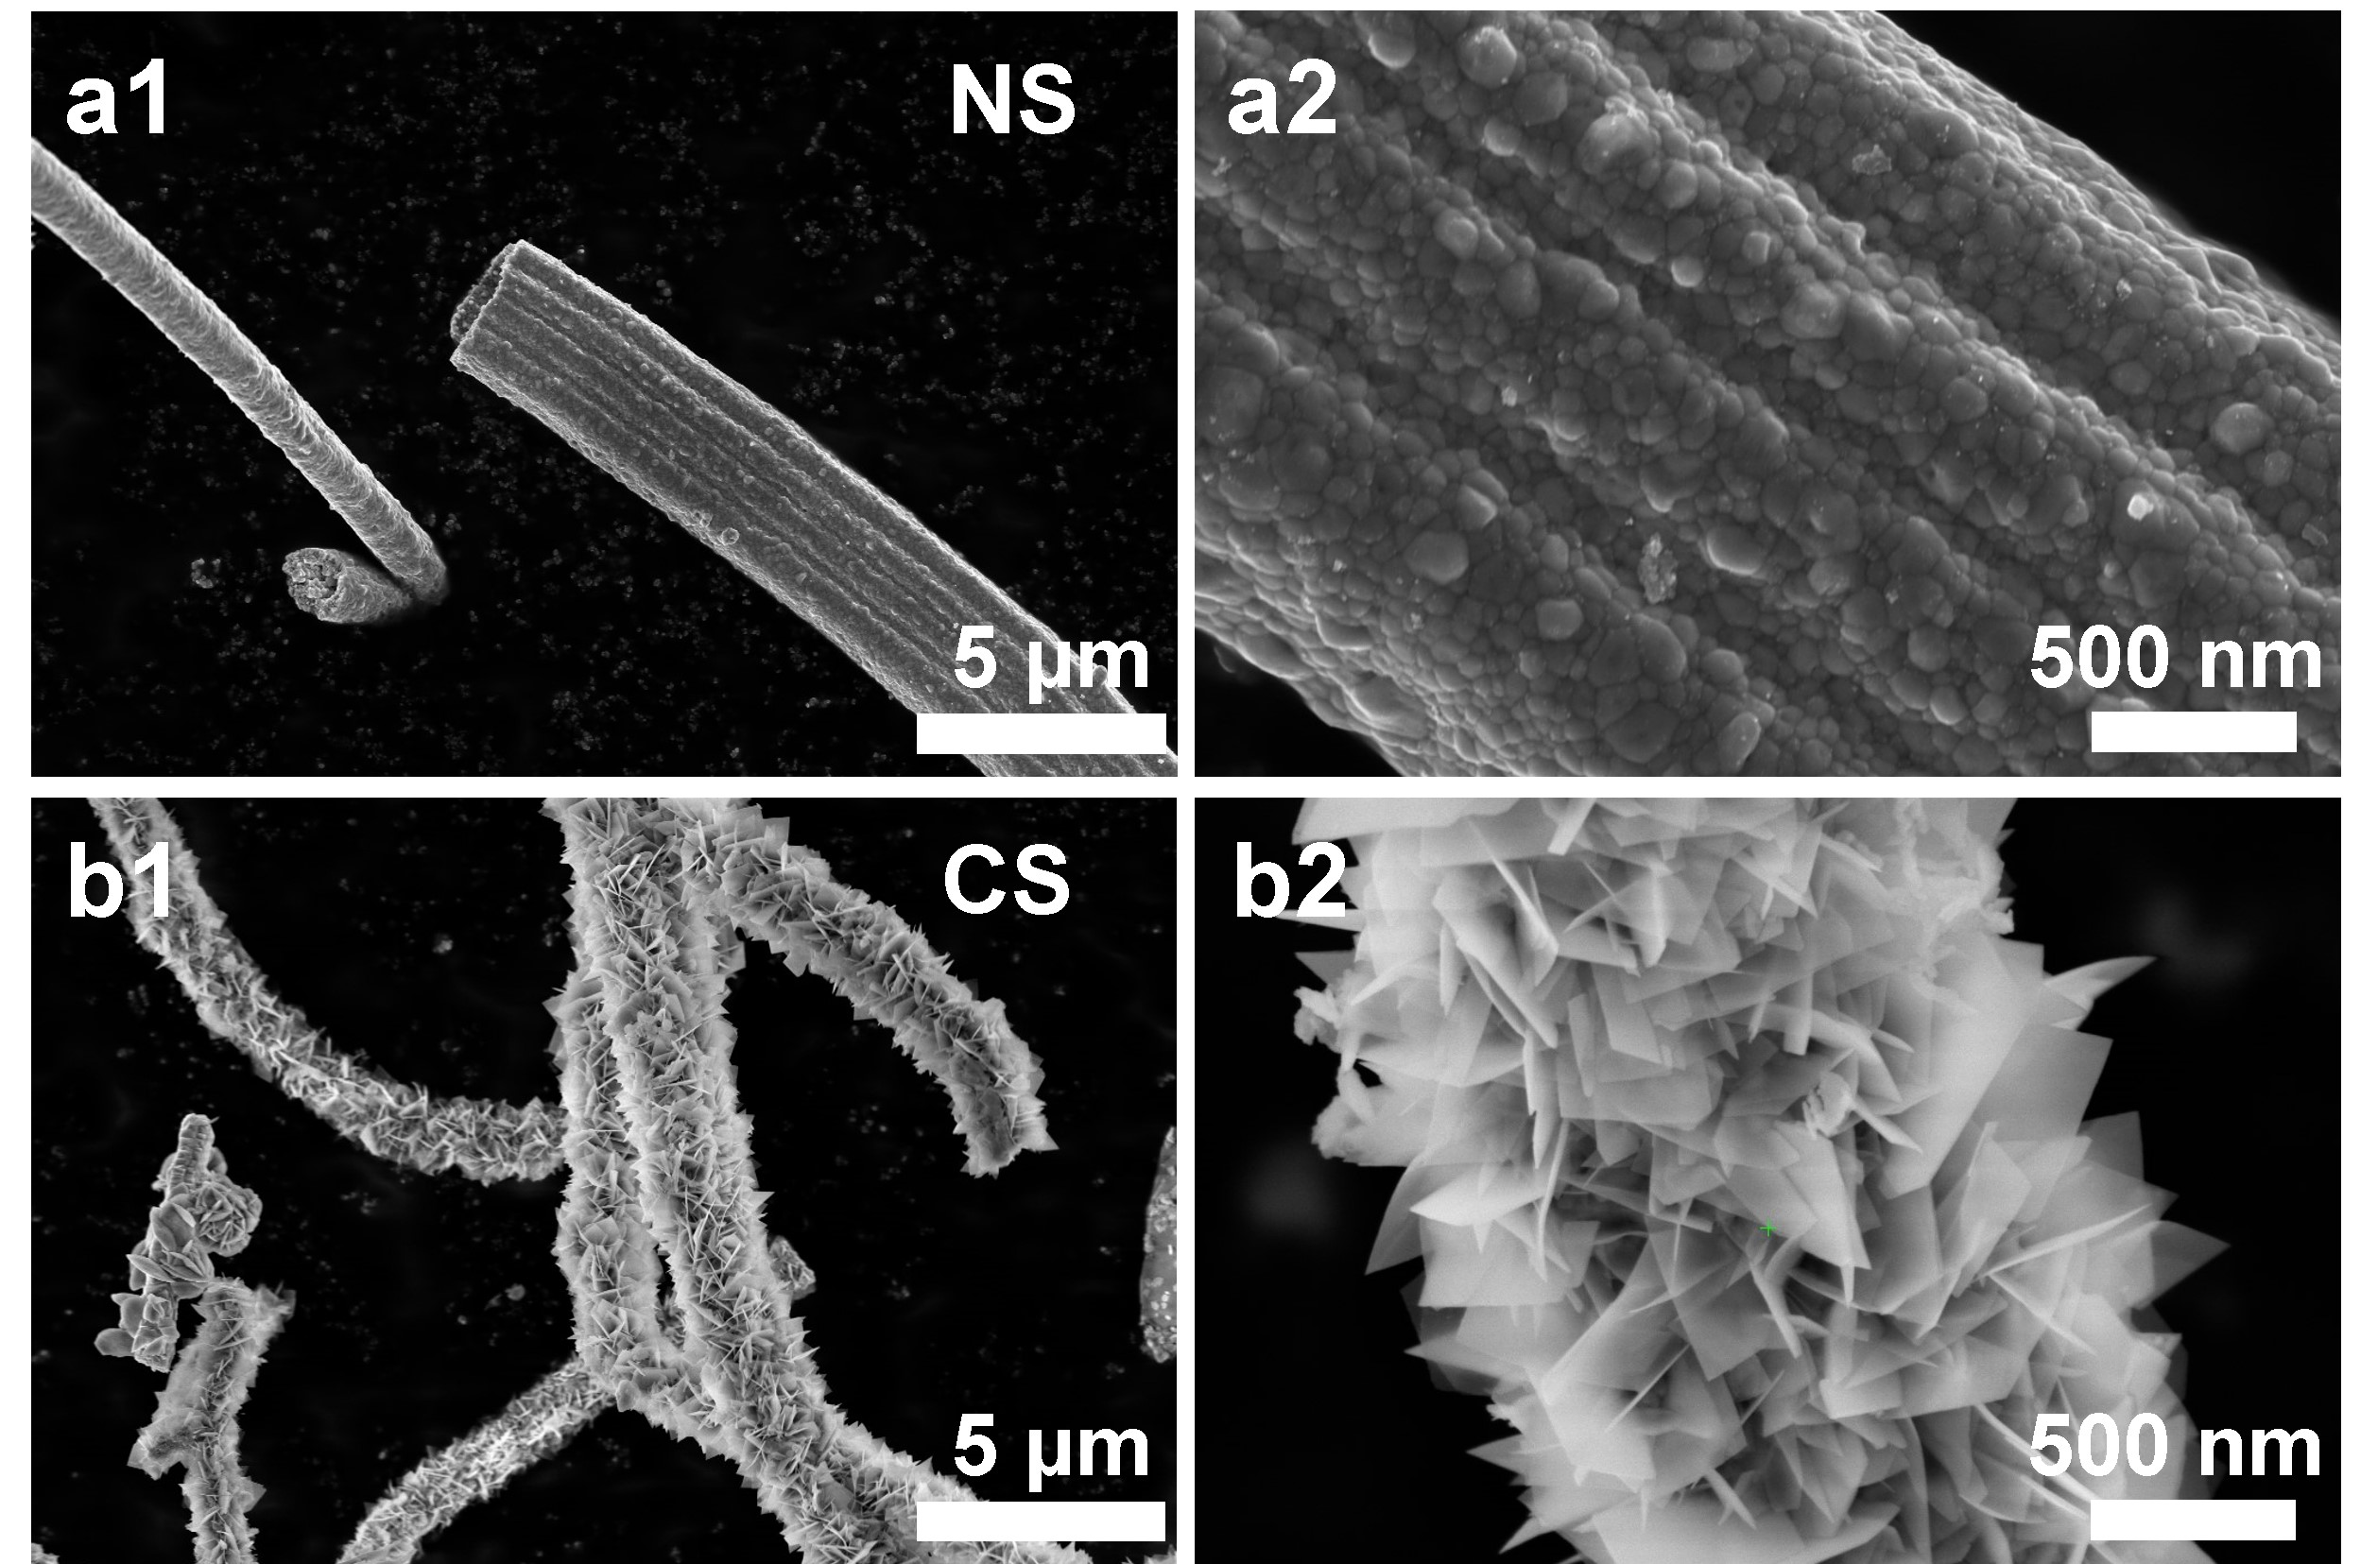
Fig. S2 SEM images of a NS and b CS
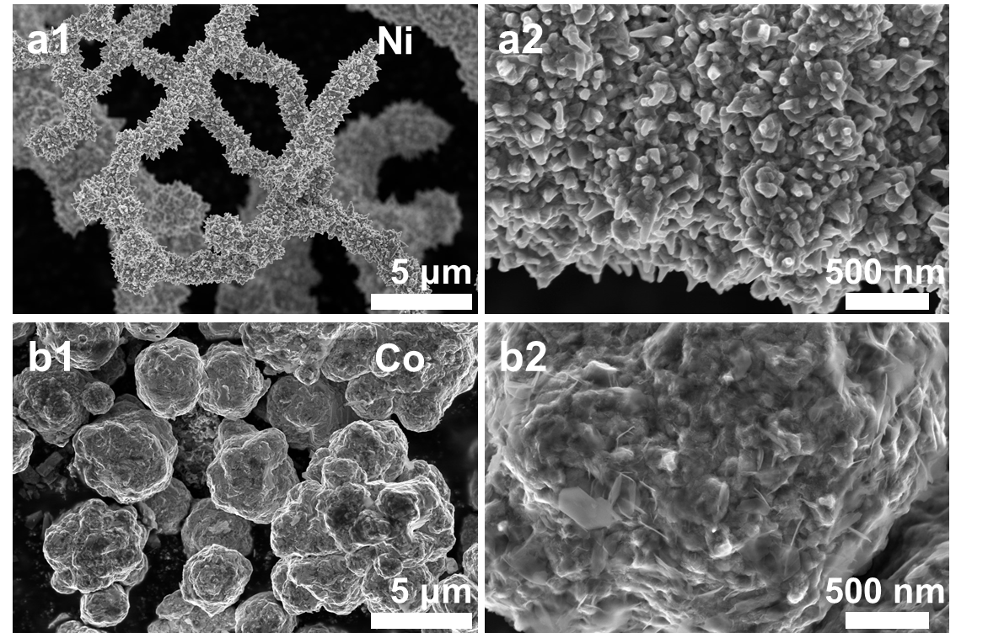
Fig. S3 SEM images of a Ni and b Co

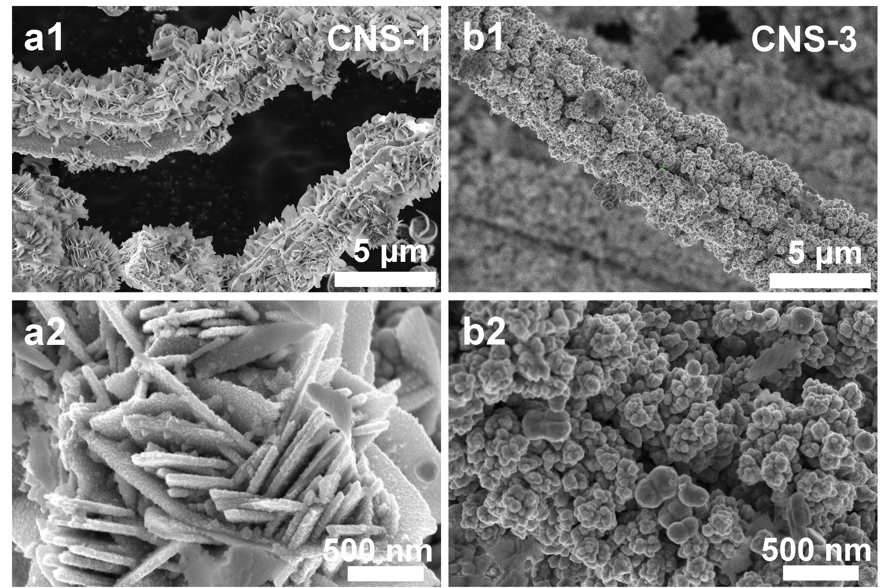
Fig. S4 SEM images of a CNS-1, and b CNS-3
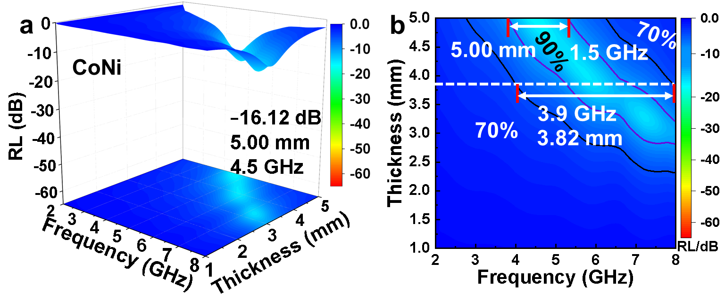
Fig. S5 a The RL value and b EAB of Sn whisker at low-frequency
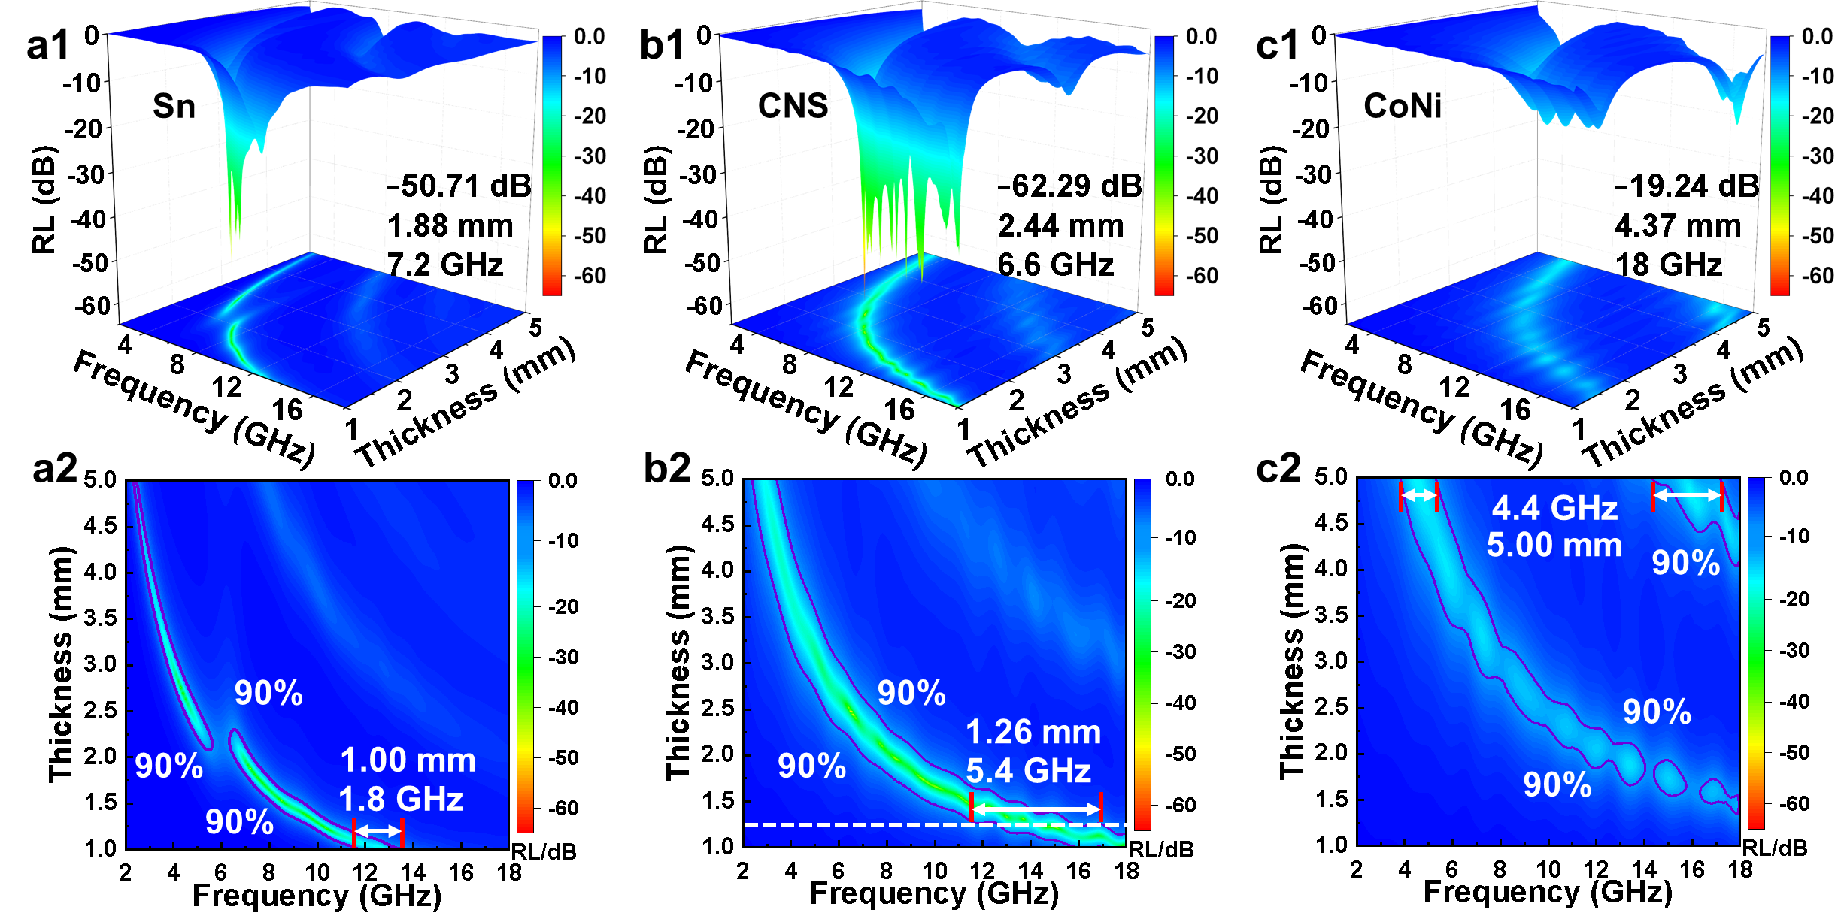
Fig. S6 The RL value and EAB of a Sn whisker, b CNS and c CoNi at 2-18 GHz
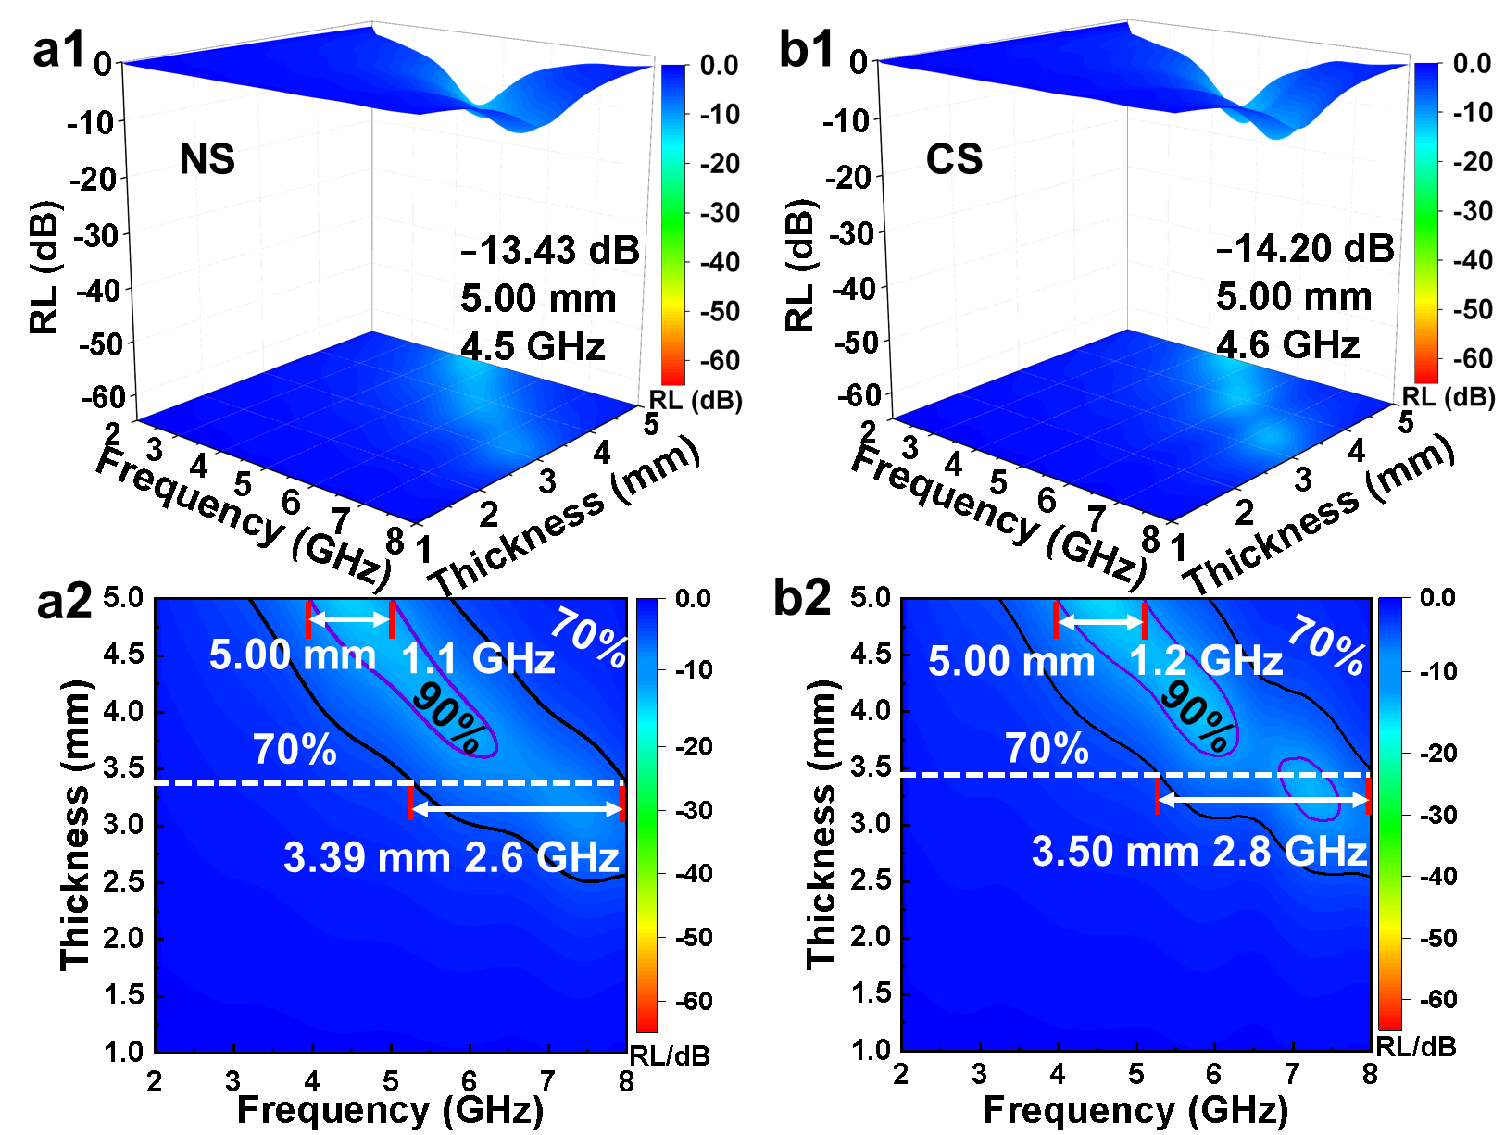
Fig. S7 The RL value and EAB of a NS and b CS at low-frequency
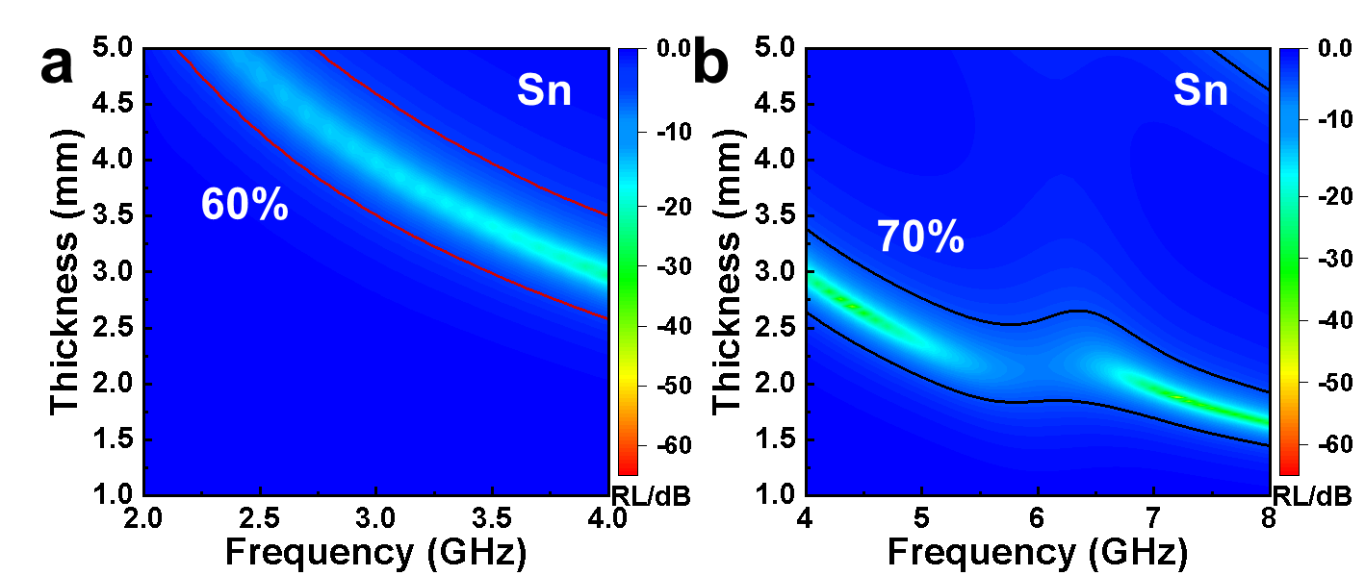
Fig. S8 The EAB of Sn whisker at a S band (EAB-60) and b C band (EAB-70)

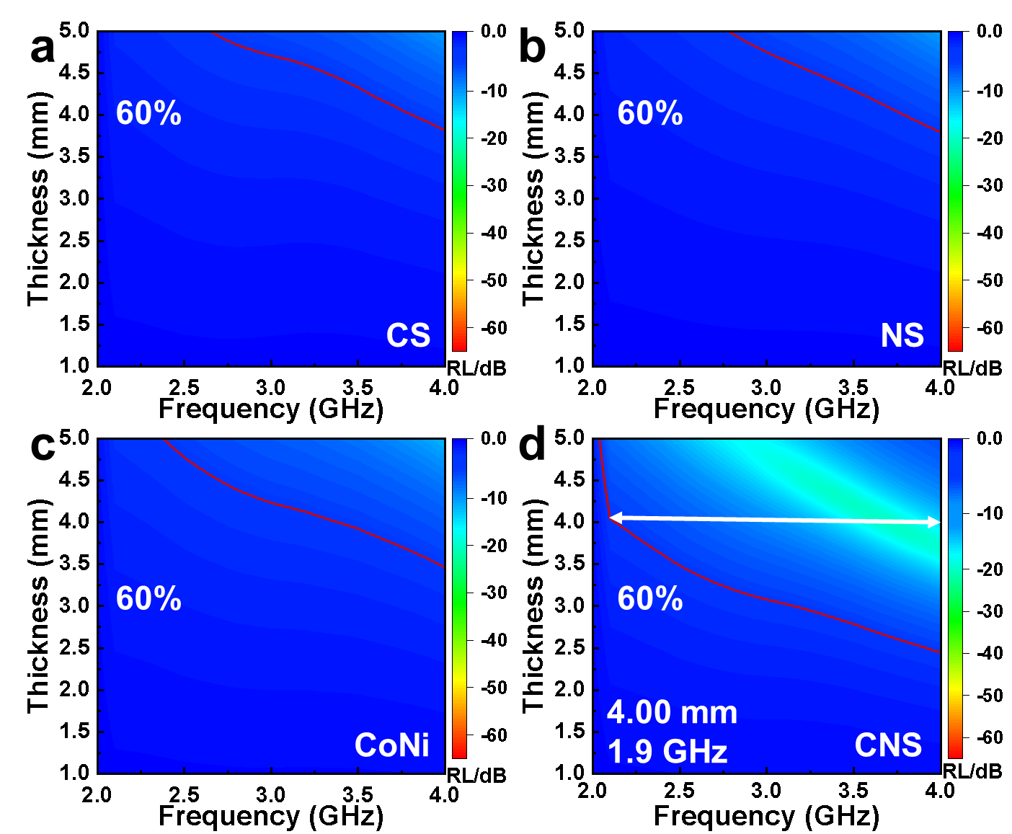
Fig. S9 The EAB-60 of a CS, b NS, c CoNi, and d CNS at S band
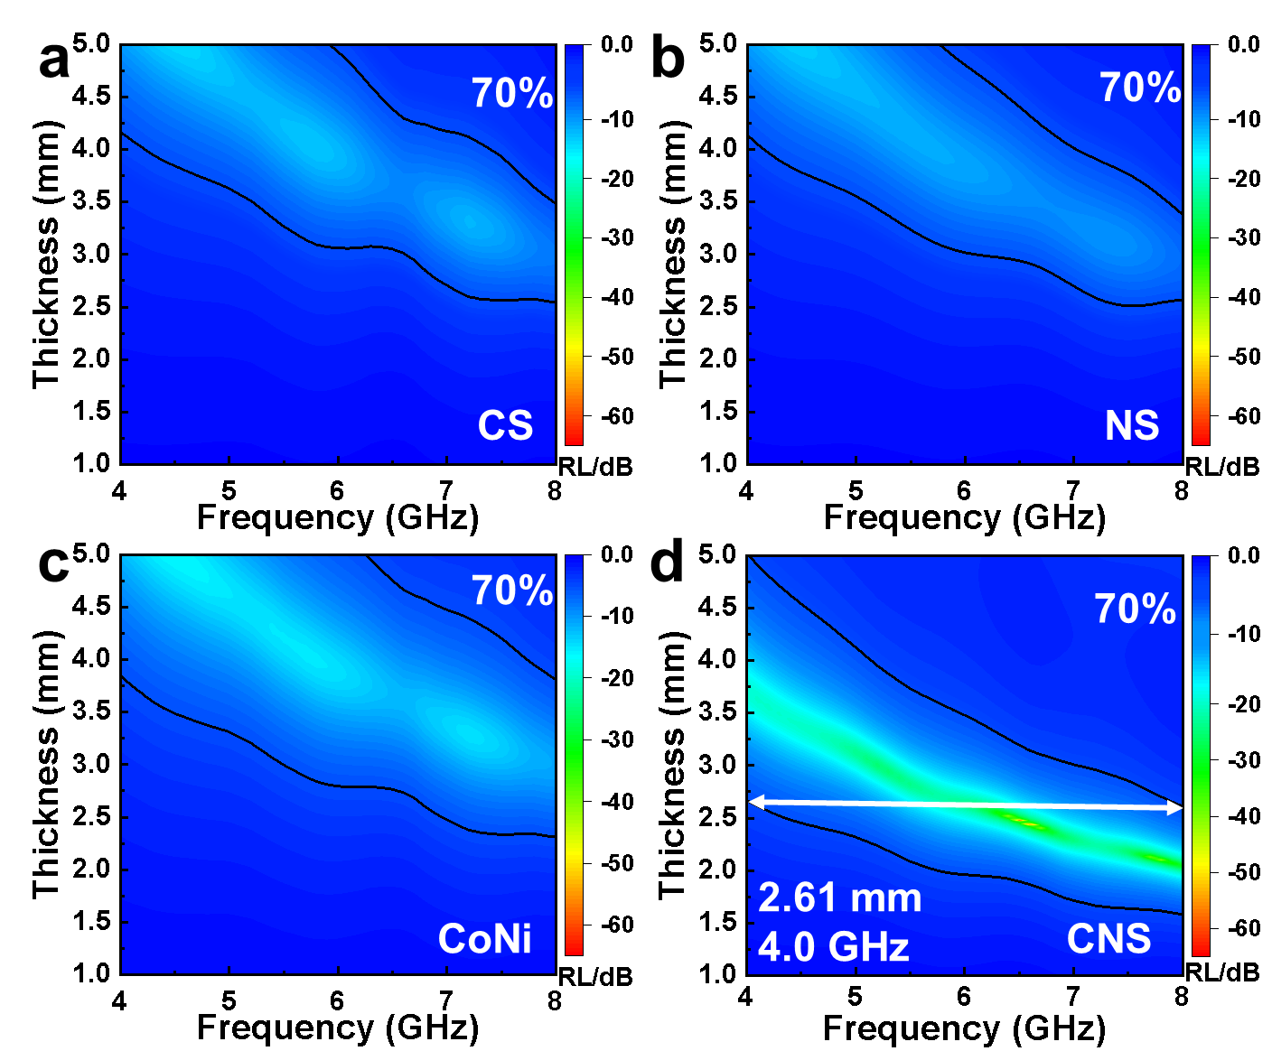
Fig. S10 The EAB-70 of a CS, b NS, c CoNi, and d CNS at C band
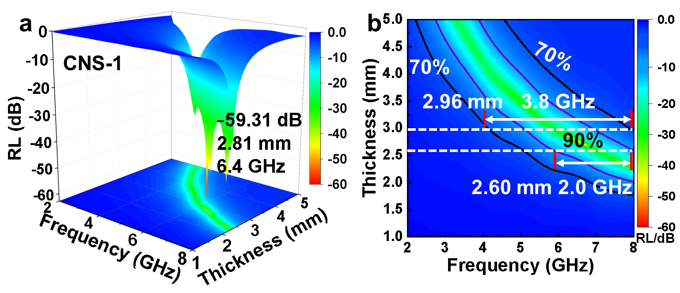
Fig. S11. a The RL value and b EAB of CNS-1 at low-frequency.
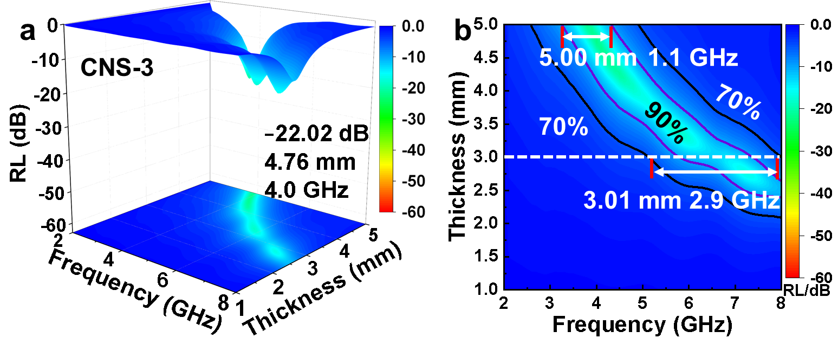
Fig. S12 a The RL value and b EAB of CNS-3 at low-frequency
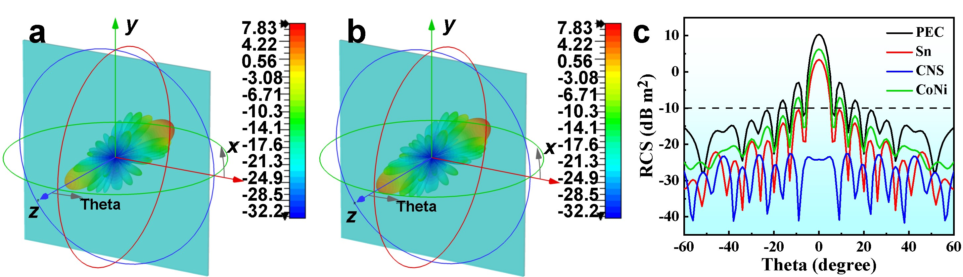
Fig. S13 PEC plate covered with a Sn and b CoNi at 6.6 GHz. c 2D RCS plots of PEC Plate and sample-coated PEC plates at 6.6 GHz

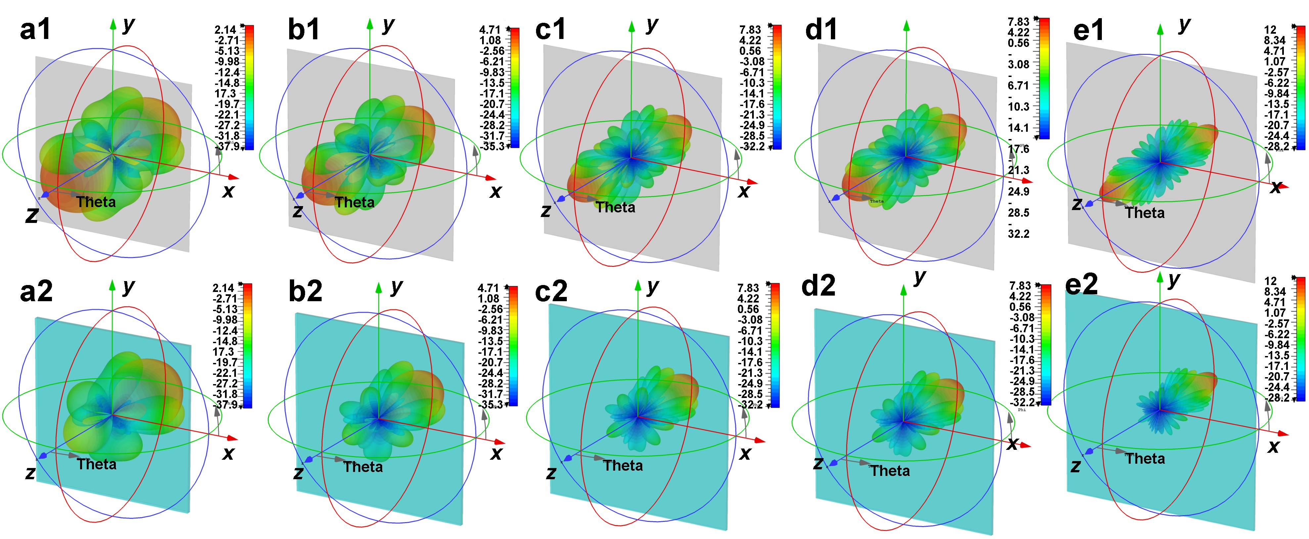
Fig. S14 3D RCS plots of PEC and CNS-coated PEC plates at different low frequency points for a 2.5 GHz, b 3.5 GHz, c 5 GHz, d 6.6 GHz, and e 8 GHz, respectively

Fig. S15 Work functions for Co, Ni, CoNi, SnO₂, and Sn
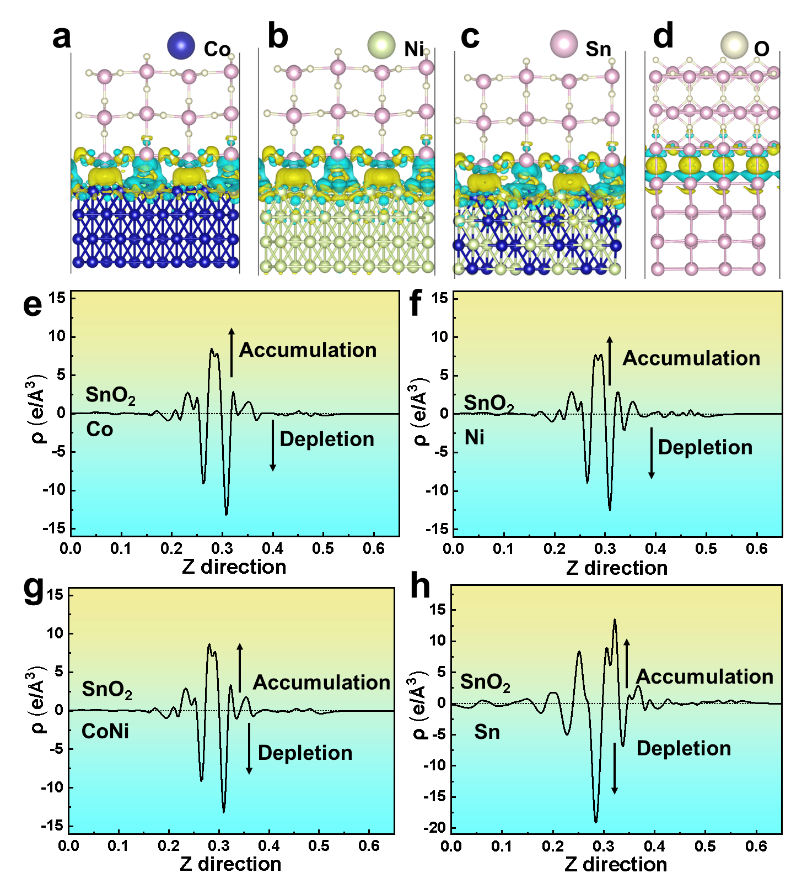
Fig. S16 The DFT calculated electron density distribution of a,e Co/SnO₂ interface, b,f Ni/SnO₂ interface, c,g CoNi/SnO₂ interface, and d,h Sn/SnO₂ interface (the cyan and yellow regions refer to electron depletion and accumulation, respectively)

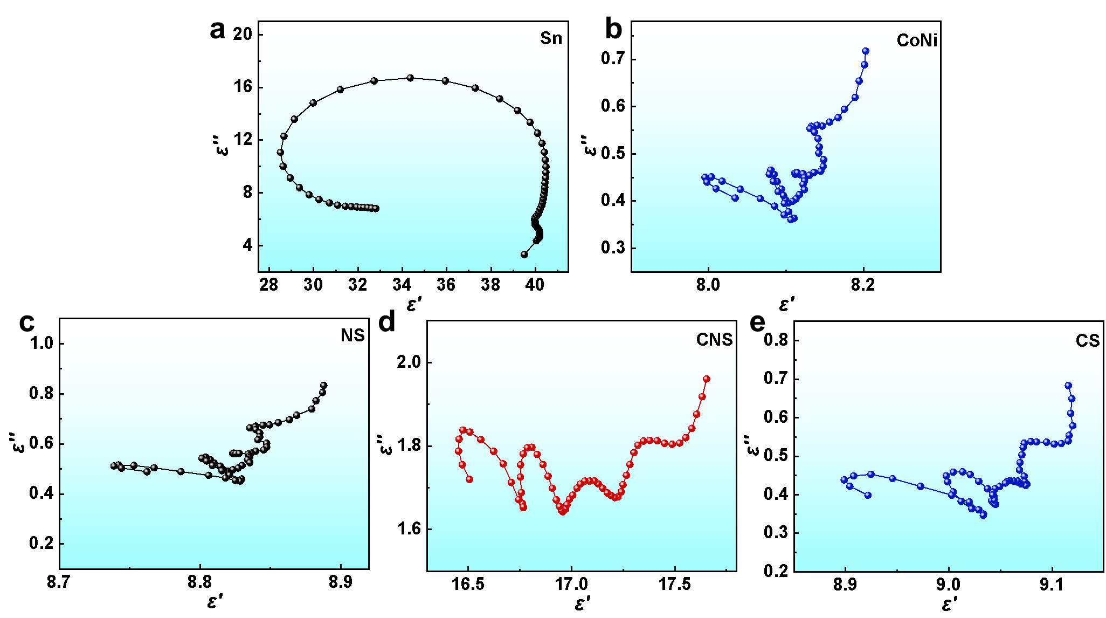
Fig. S17 Cole-Cole semicircles of a Sn, b CoNi, c NS, d CNS, and e CS at low frequency
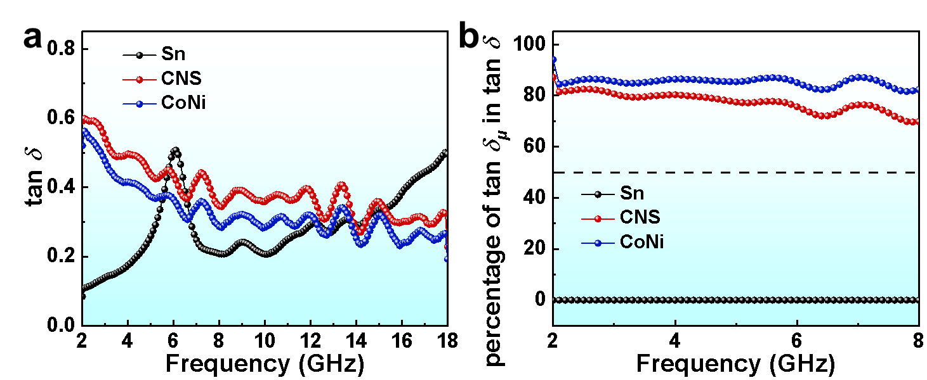
Fig. S18 a the total loss tangent (tan δ) and b the percentage contribution of the magnetic loss tangent (tan δ_{μ}) to tan δ for the samples

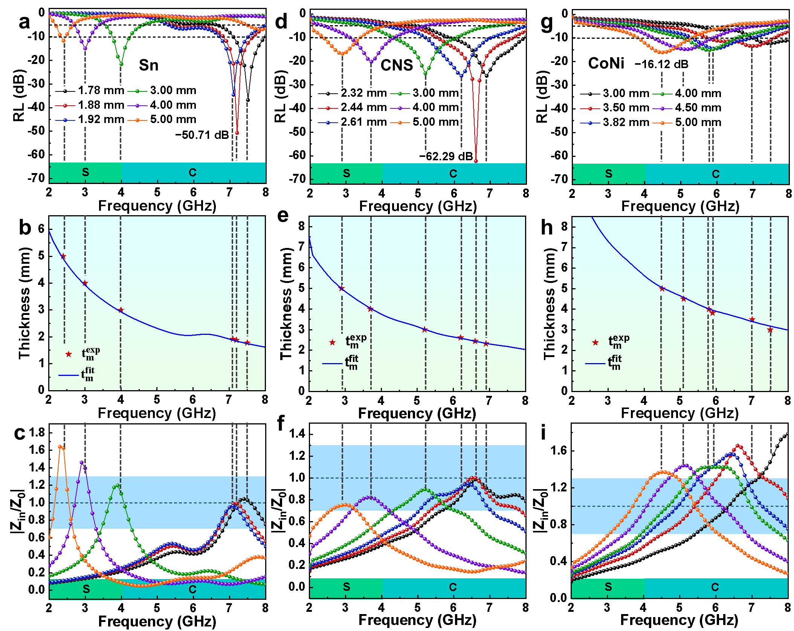
Fig. S19 2D plots of a,d,g RL, b,e,h RL peak frequency corresponds to the experimental value of thickness and the simulated thickness value of the quarter-wavelength model, and c,f,i Impedance matching rate (|Z_{in}/Z₀|) of Sn whisker, CNS, and CoNi, respectively
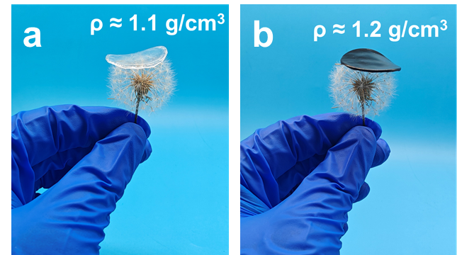
Fig. S20 Demonstration of low density of a TPU and b CNS/TPU-2 film

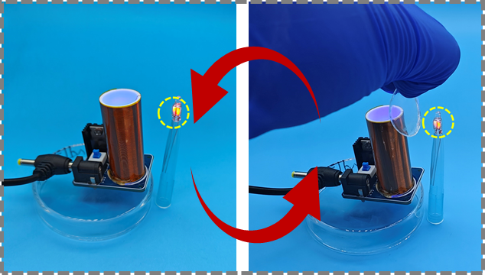
Fig. S21 Demonstration of the electromagnetic protection (i.e., shielding of electromagnetic signals from the Tesla coil to shut off a light bulb) of the pure TPU film

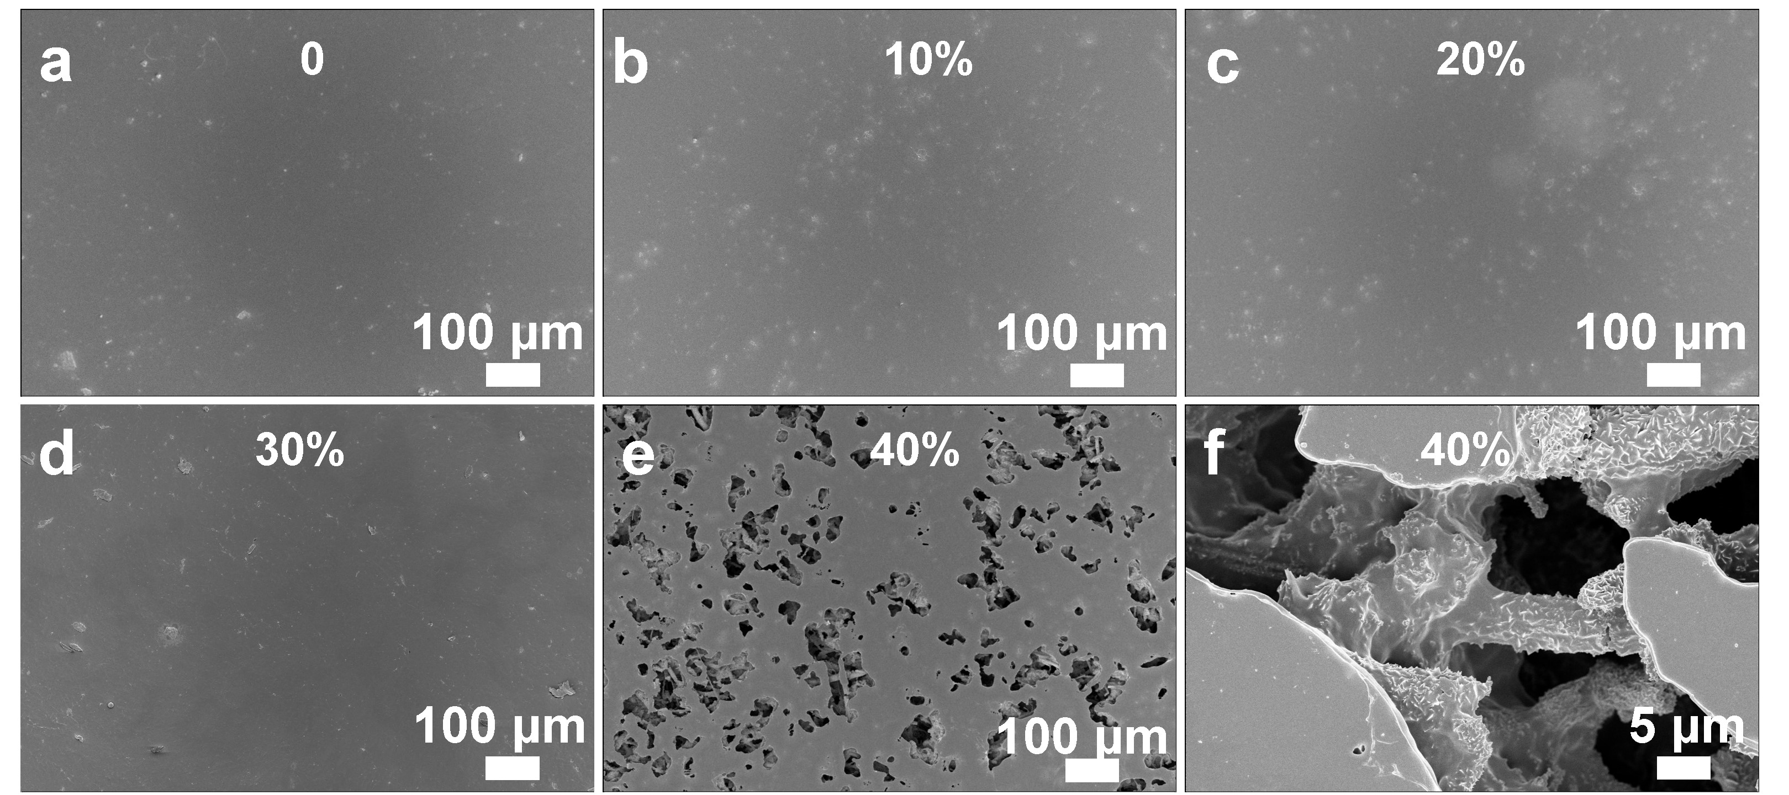
Fig. S22 SEM images of the surface of TPU films with different filling amount (wt.%) of CNS: a 0, b 10%, c 20%, d 30%, and e,f 40%
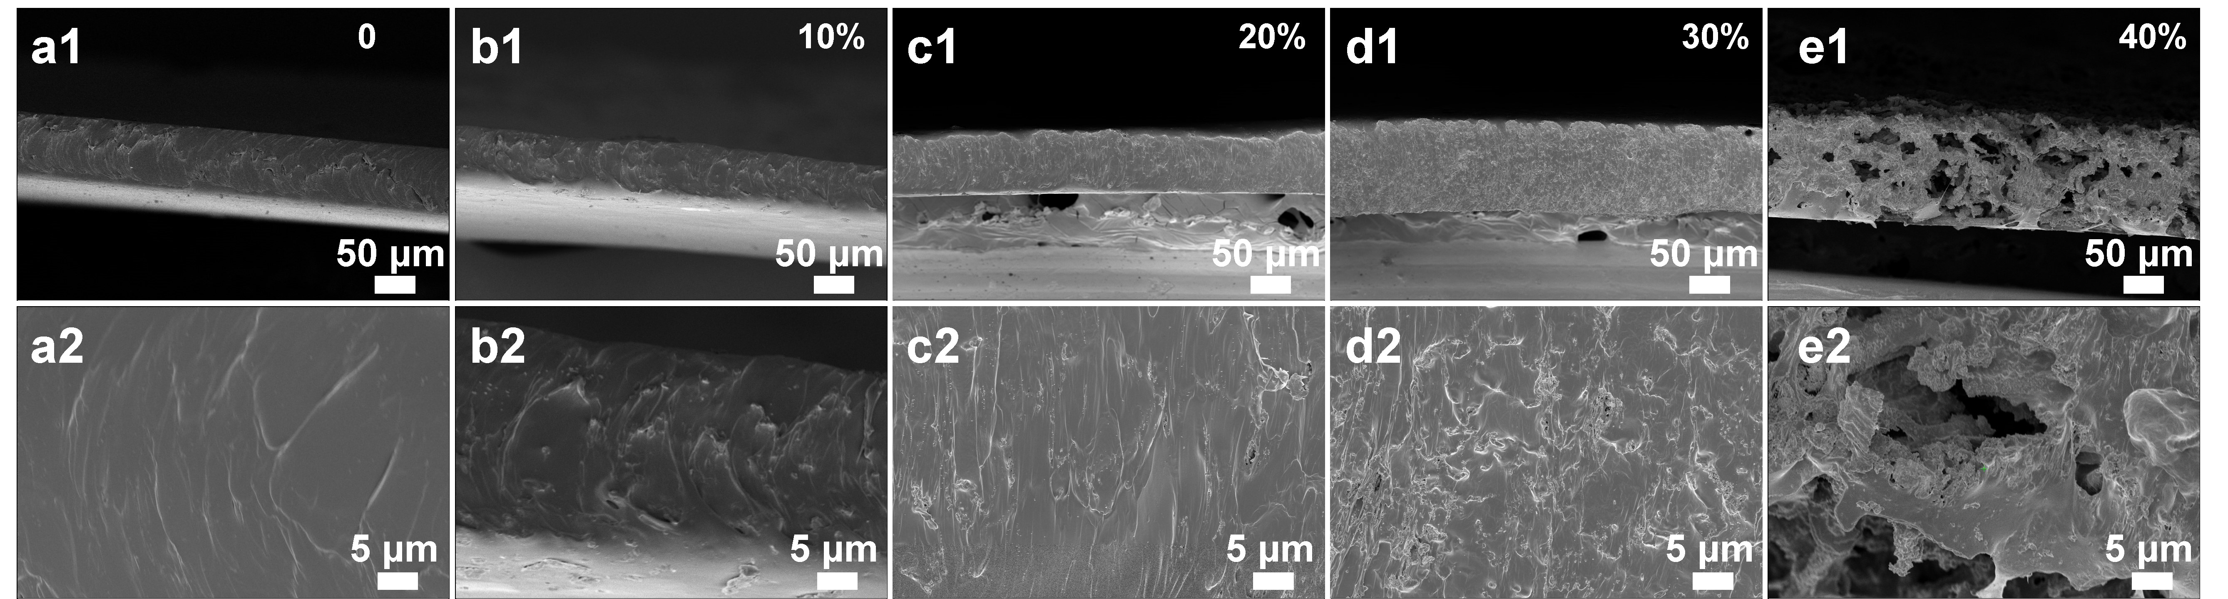
Fig. S23 SEM images of the cross-section of TPU films with different filling amount (wt.%) of CNS: a 0, b 10%, c 20%, d 30%, and e 40%
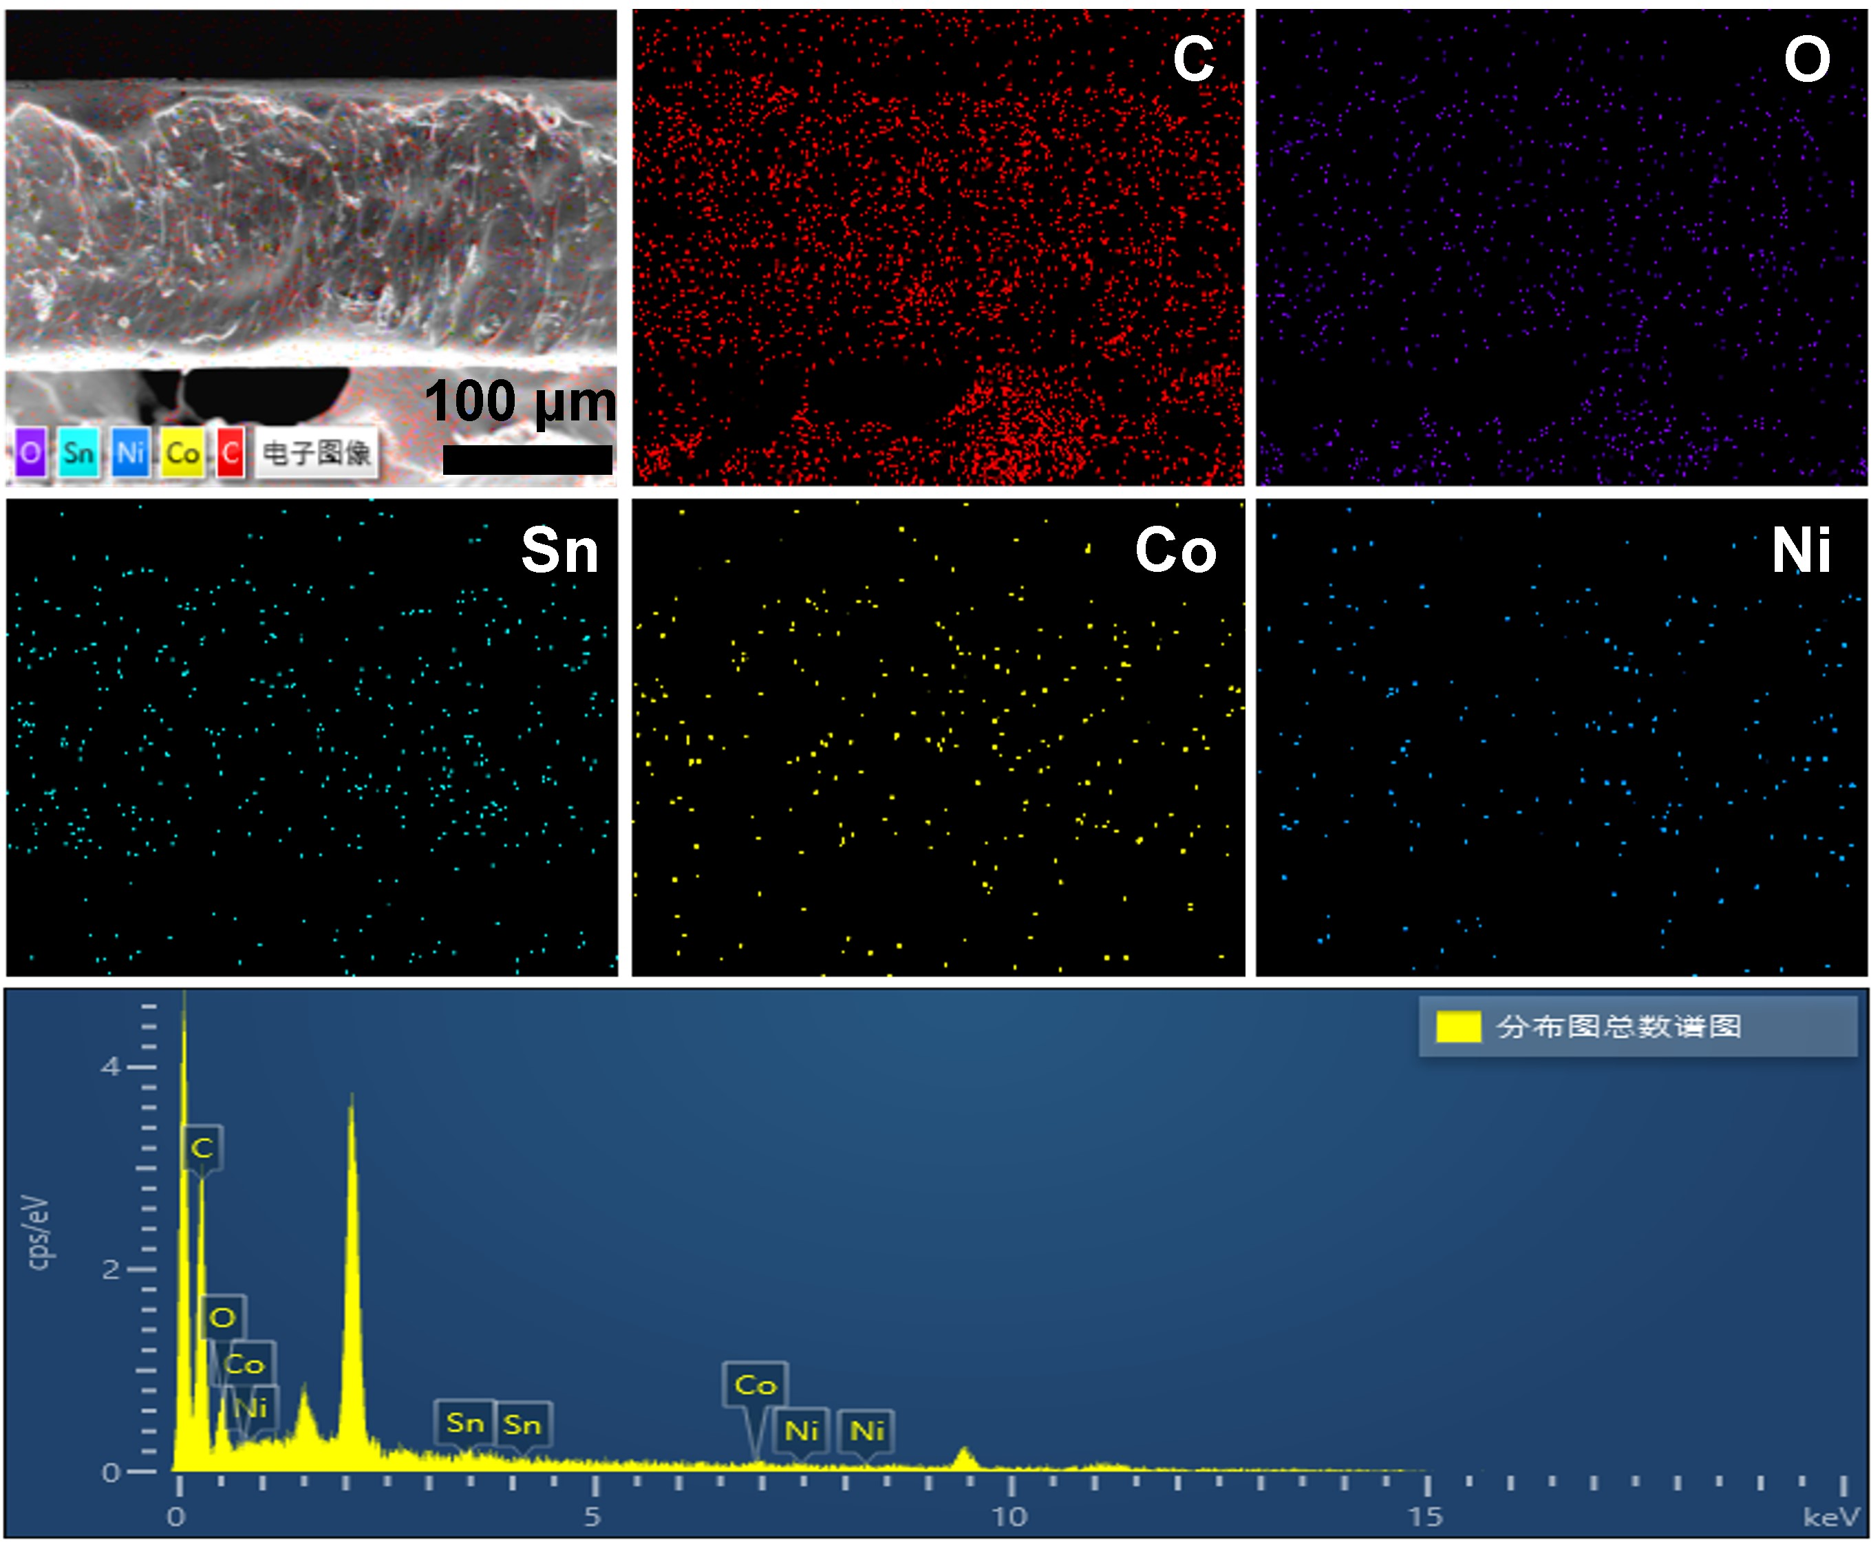
Fig. S24 EDS mapping of the cross-section of CNS/TPU-2 film
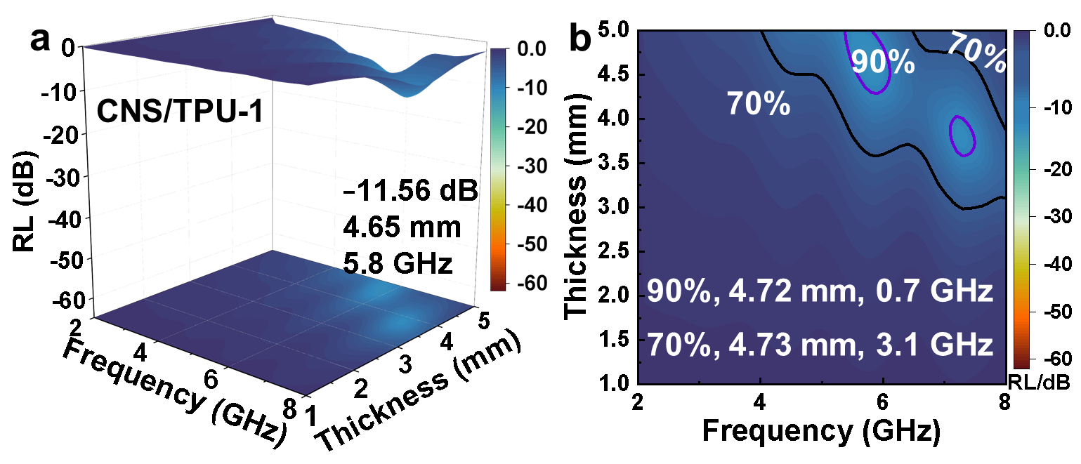
Fig. S25 a The RL value and b EAB of CNS/TPU-1 film at low-frequency
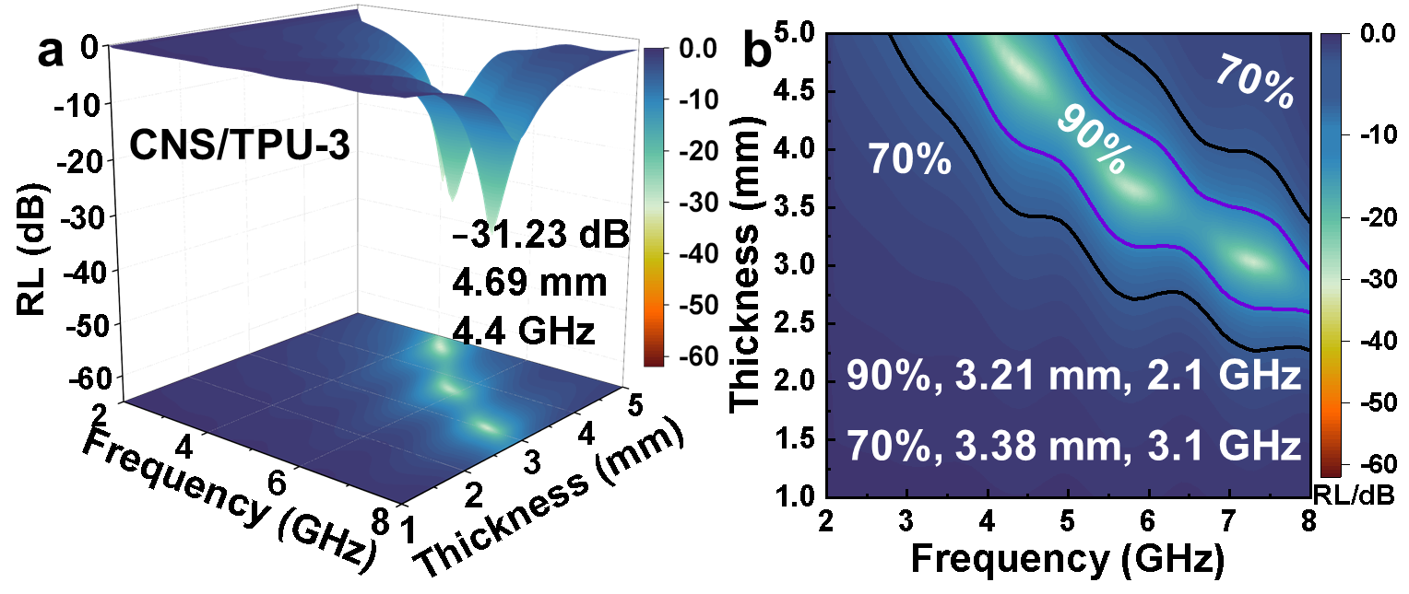
Fig. S26 a The RL value and b EAB of CNS/TPU-3 film at low-frequency

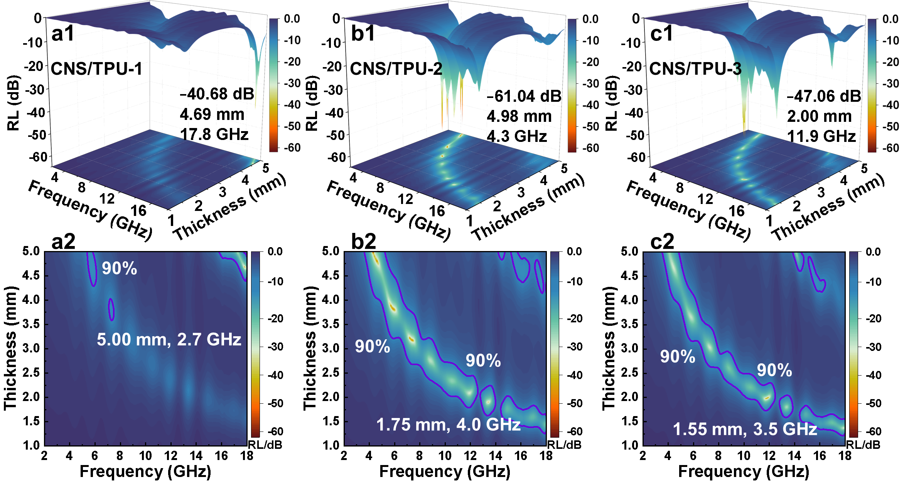
Fig. S27 The RL value and EAB of a CNS/TPU-1, b CNS/TPU-2 and c CNS/TPU-3 at 2-18 GHz
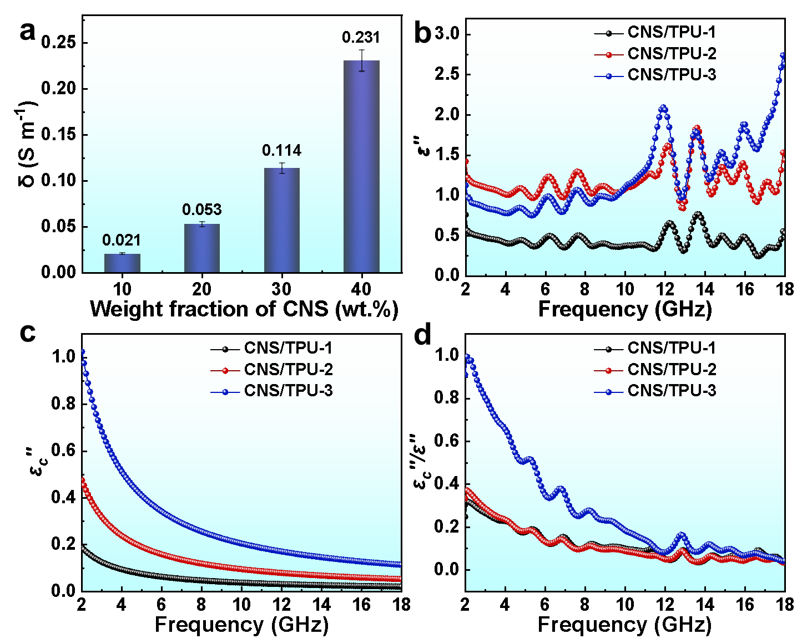
Fig. S28 a DC electrical conductivity of composite films as a function of CNS loading. b Imaginary part of the complex permittivity (ε''), c Conductive-loss component (ε_{c}'') extracted from the dielectric response, and d Percentage contribution of conductive loss to the total dielectric loss (ε_{c}''/ε'') for CNS/TPU film samples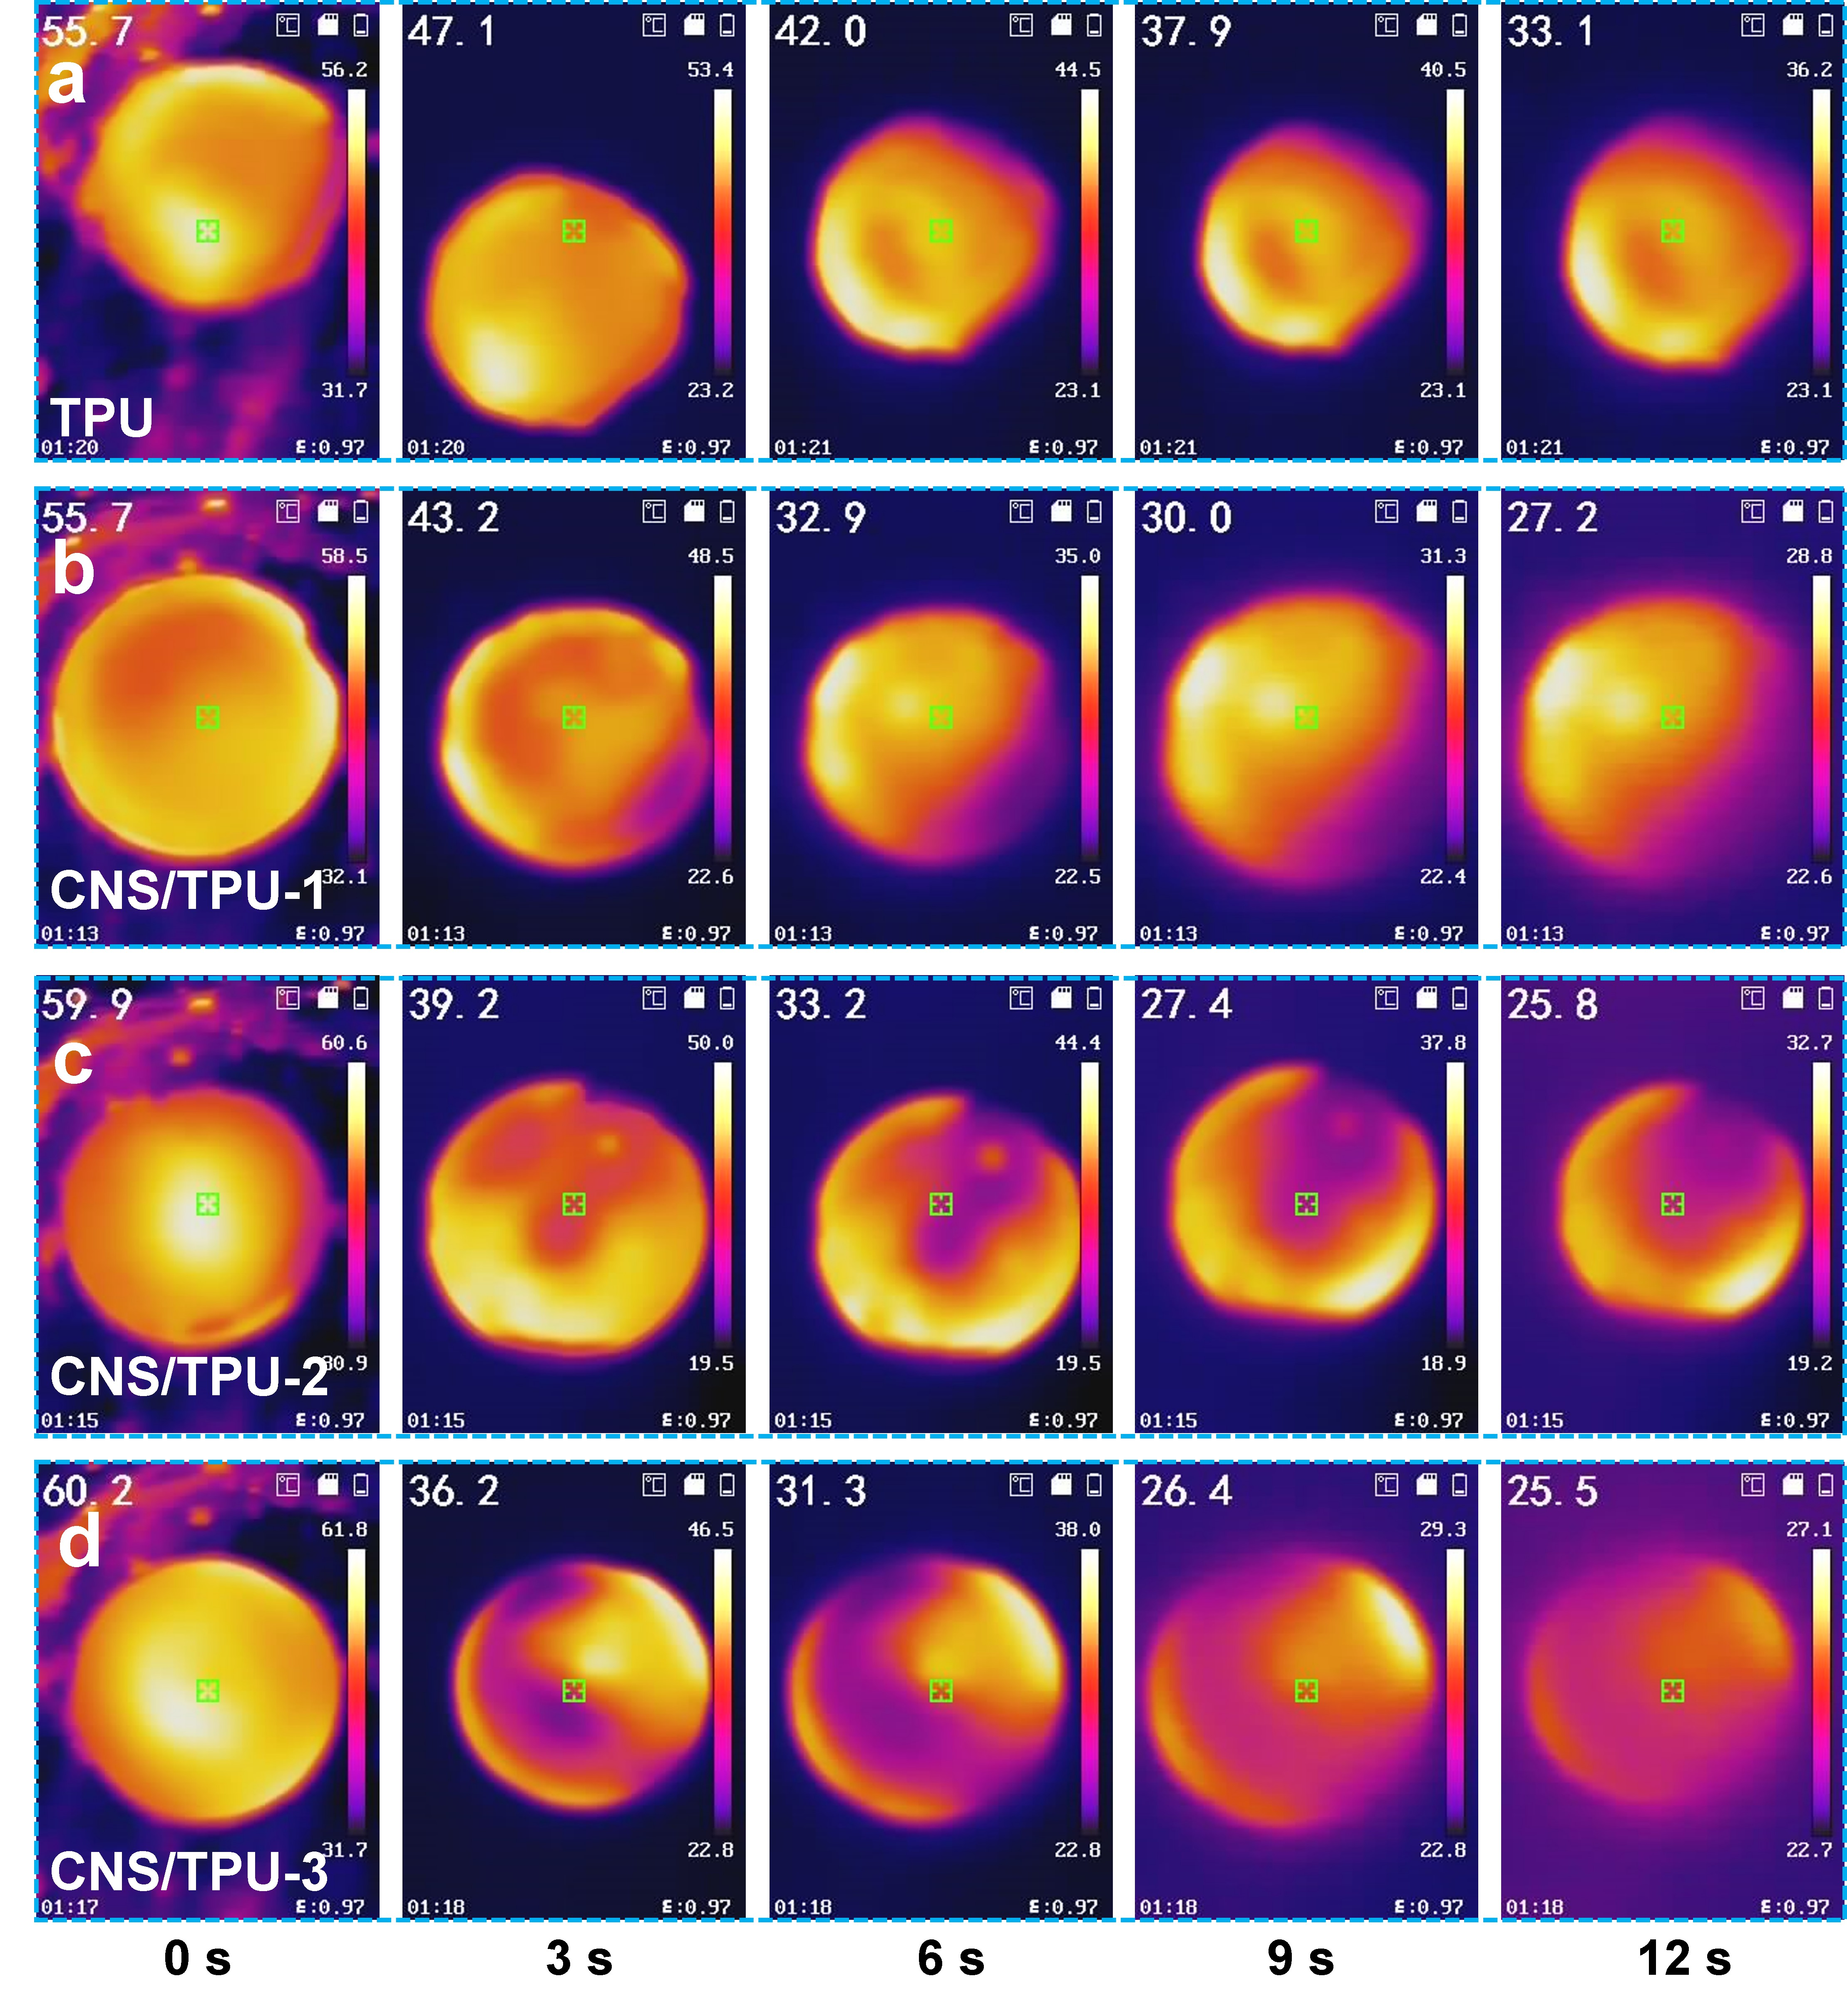
Fig. S29 Infrared thermal images of TPU films with different CNS fillings dissipating over time at room temperature after leaving a 60 °C hot plate
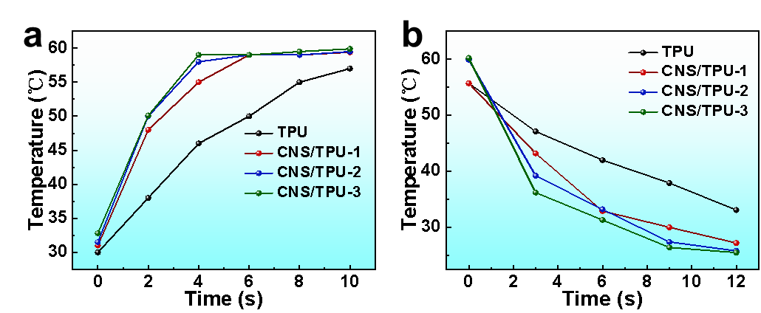
Fig. S30 a Heating temperature-time curves and b Cooling temperature-time curves of TPU films with different CNS fillings
Table S1 Low-frequency microwave absorption properties of absorbers
Materials | RL_{min} (dB) | |RL_{min}|/d (dB/mm) | EAB (GHz) | EAB/d (GHz/mm) | Refs.
NiFe₂O₄ @BiFeO₃@PPy | -65.30 | 14.74 | 2.32 | 0.52 | [S1]
FeCo | -42.1 | 19.14 | 1.6 | 0.73 | [S2]
CoNi@BN/PDMS | -49.9 | 11.34 | 2.40 | 0.16 | [S3]
Fe₆W₆C-FeWO₄@C | -36.5 | 8.11 | 2.6 | 0.79 | [S4]
FeCo@C | -35.90 | 8.98 | 2.58 | 0.65 | [S5]
CoNi/PDMS | -56.7 | 13.83 | 1.04 | 0.25 | [S6]
3D MXene/CNF | -47.9 | 5.64 | 1.2 | 0.14 | [S7]
CNS | -62.29 | 25.53 | 2.2 | 0.95 | This work
CNS/TPU-2 | -61.04 | 12.26 | 2.5 | 0.75 | This work
Table S2 M_{s} and H_{c} of samples
Materials | CS | NS | CoNi | CNS
Ms (emu/g) | 43.81 | 30.19 | 108.53 | 44.64
Hc (oe) | 135.89 | 116.57 | 99.73 | 160.27
Table S3 |K₁| of samples
Materials | CS | NS | CNS
|K₁| (J/kg) | 0.298 | 0.176 | 0.358

Supplementary References
- B. Cai, L. Zhou, P.-Y. Zhao, H.-L. Peng, Z.-L. Hou et al., Interface-induced dual-pinning mechanism enhances low-frequency electromagnetic wave loss. Nat Commun. 15, 3299 (2024). https://doi.org/10.1038/s41467-024-47537-5
- G. Chen, R. Zhang, M. Yuan, S. Xue, Y. Liu et al., Visualizing nanoscale interlayer magnetic interactions and unconventional low‐frequency behaviors in ferromagnetic multi‐shelled structures. Adv. Mater. 36, 2313411 (2024). https://doi.org/10.1002/adma.202313411
- M. He, X. Zhong, X. Lu, J. Hu, K. Ruan et al., Excellent low-frequency microwave absorption and high thermal conductivity in polydimethylsiloxane composites endowed by hydrangea-like coni@bn heterostructure fillers. Adv. Mater. 36, 2410186 (2024). https://doi.org/10.1002/adma.202410186
- L. Rao, M. Huang, X. Wang, Y. Qian, Z. Yan et al., Atomic infusion induced reconstruction enhances multifunctional thermally conductive films for robust low-frequency electromagnetic absorption. Angew. Chem. Int. Ed. 64, e202418338 (2025). https://doi.org/10.1002/anie.202418338
- L. Rao, L. Wang, C. Yang, R. Zhang, J. Zhang et al., Confined diffusion strategy for customizing magnetic coupling spaces to enhance low‐frequency electromagnetic wave absorption. Adv. Funct. Mater. 33, 2213258 (2023). https://doi.org/10.1002/adfm.202213258
- M. He, J. Hu, H. Yan, X. Zhong, Y. Zhang et al., Shape anisotropic chain‐like coni/polydimethylsiloxane composite films with excellent low‐frequency microwave absorption and high thermal conductivity. Adv Funct Mater. 2316691 (2024). https://doi.org/10.1002/adfm.202316691
- B. Shan, Y. Wang, X. Ji, Y. Huang, Enhancing low-frequency microwave absorption through structural polarization modulation of mxenes. Nano-Micro Lett. 16, 212 (2024). https://doi.org/10.1007/s40820-024-01437-x

