Supporting Information for
Sandwich-Architected Hybrid Organic Crystals with Humidity-Temperature Sensing and Cryogenic Photothermal Actuation
Linfeng Lan^{1,2}, Lijie Wang^{1*}, Chenguang Wang¹, Hongyu Zhang^{2*}
¹ State Key Laboratory of Integrated Optoelectronics, College of Electronic Science and Engineering, Jilin University, Qianjin Street, Changchun 130012, P. R. China
² State Key Laboratory of Supramolecular Structure and Materials, College of Chemistry, Jilin University, Qianjin Street, Changchun 130012, P. R. China
*Corresponding authors. E-mail: wang_lij@jlu.edu.cn (Lijie Wang); hongyuzhang@jlu.edu.cn (Hongyu Zhang)
S1 Supplementary Scheme and Figures

Scheme S1 Molecular formulas for compounds 1–4

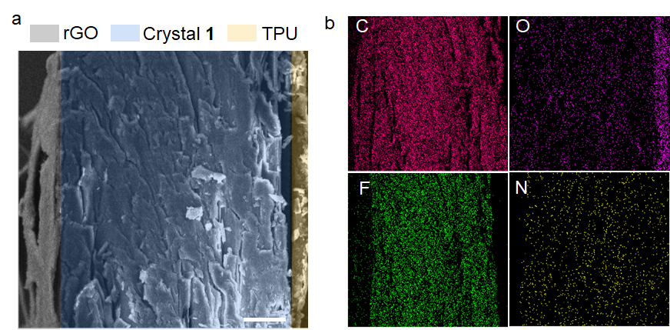
Fig. S1 Scanning electron microscopy (SEM) images (a) and Energy-dispersive X-ray spectroscopy (EDX) elemental maps (b) of the GT1 showing the spatial distribution of the constituent elements. The scale bar is 20 μm

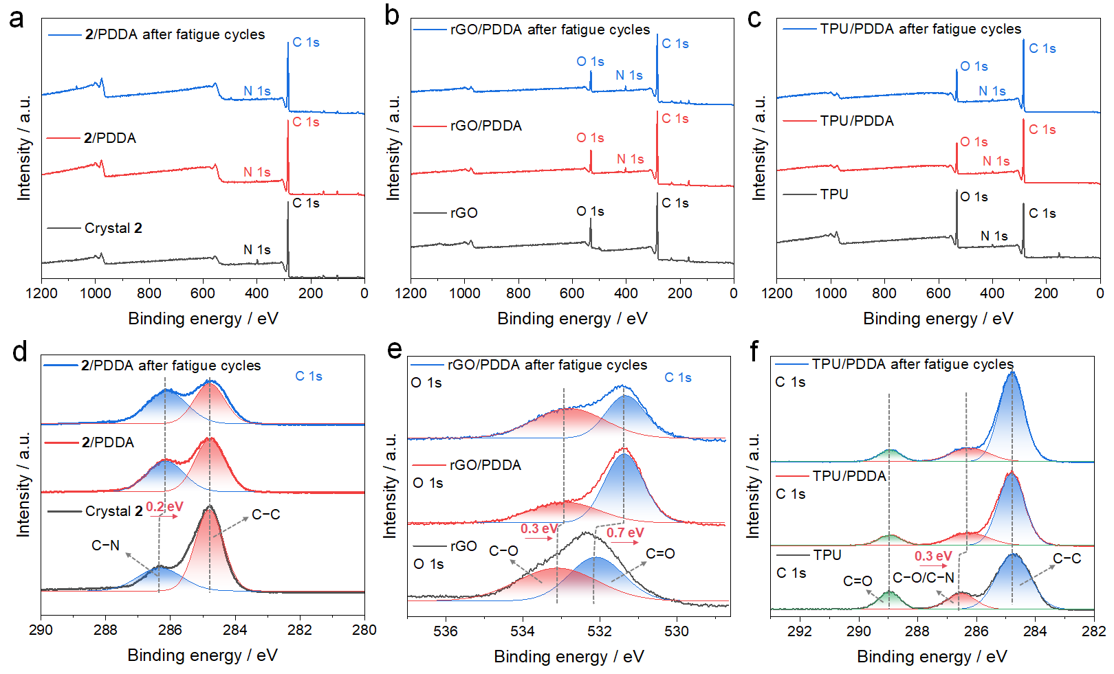
Fig. S2 (a, d) Wide-scan and C 1s XPS spectra of crystal 2, 2/PDDA, and 2/PDDA after the fatigue cycles. (b, e) Wide-scan and O 1s XPS spectra of rGO, rGO/PDDA, and rGO/PDDA after the fatigue cycles. (c, f) Wide-scan and C 1s XPS spectra of TPU, TPU/PDDA, and TPU/PDDA after the fatigue cycle. The fatigue cycles refer to repeated operation of the samples under alternating conditions of high/low humidity (20–90% RH), high/low temperature (–150 to 150°C), and repeated infrared irradiation

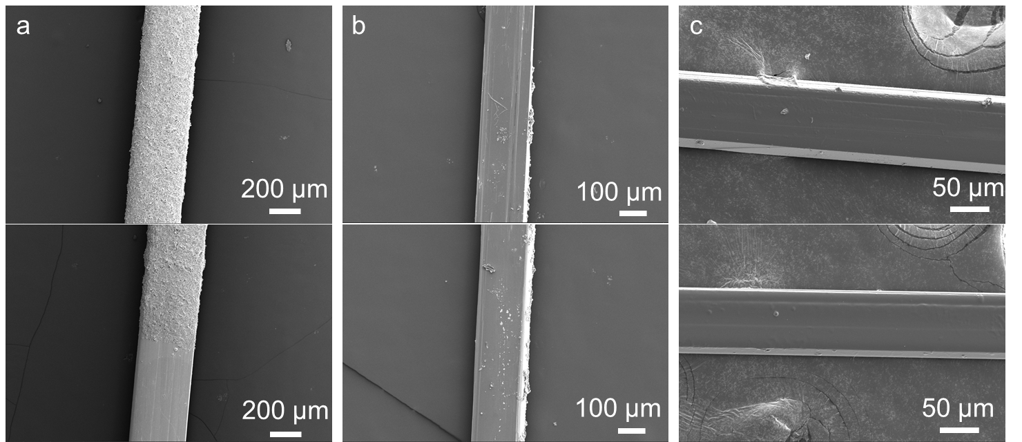
Fig. S3 SEM images of hybrid crystals GT1 and GT2: (a) Surface morphology of the rGO-modified side and junction region, showing uniform coating and roughness distribution. (b) Backside of the rGO-modified crystal, showing its original morphology without surface coating. (c) Surface morphology of the TPU-modified side, illustrating the smooth and continuous coating

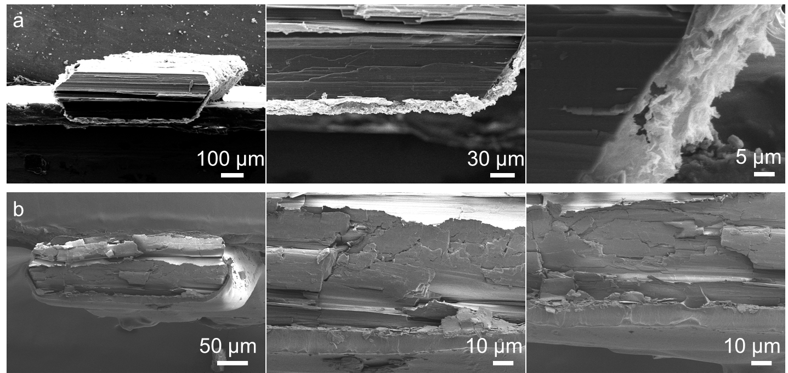
Fig. S4 High-magnification SEM images of the hybrid crystal cross-sections: (a) Morphology and thickness of the rGO layer, showing its uniform coating and layered structure. (b) Morphology and thickness of the TPU layer, illustrating the smooth surface and compact adhesion to the crystal substrate
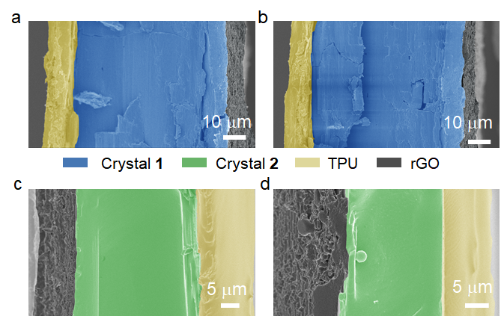
Fig. S5 Cross-sectional SEM images of the hybrid crystals: (a, c) GT1 (a) and GT2 (c), showing the distinct sandwich-like multilayer structure; (b, d) GT1 (b) and GT2 (d) after cycles of high/low humidity (20% to 90% RH), high/low temperature (–150 to 150 °C), and repeated infrared irradiation, demonstrating the structural stability of the multilayer structure
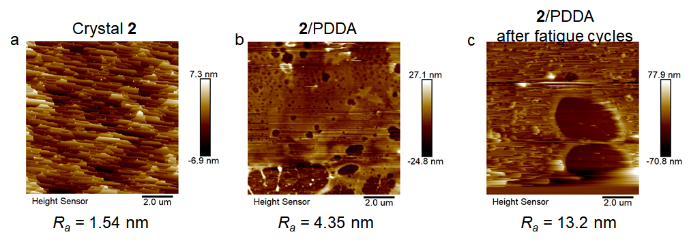
Fig. S6 (a, b) AFM images of the surface morphology of crystal 2 and 2/PDDA, showing the crystal surface and the deposited PDDA layer. (c) AFM image of 2/PDDA after cycles of high/low humidity (20% to 90% RH), high/low temperature (–150 to 150°C), and repeated infrared irradiation
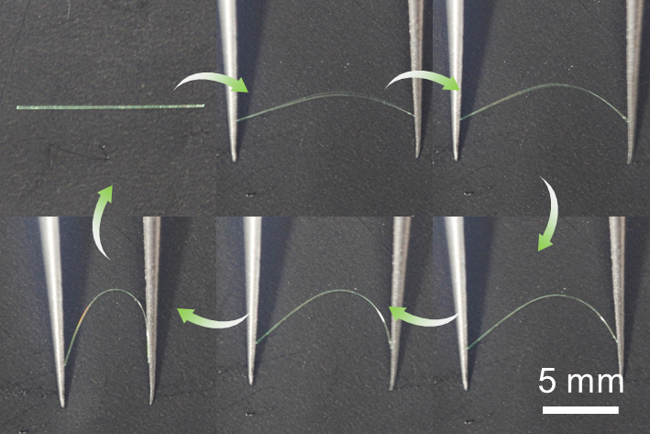
Fig. S7 Reversible elastic bending process of the pristine crystal 2

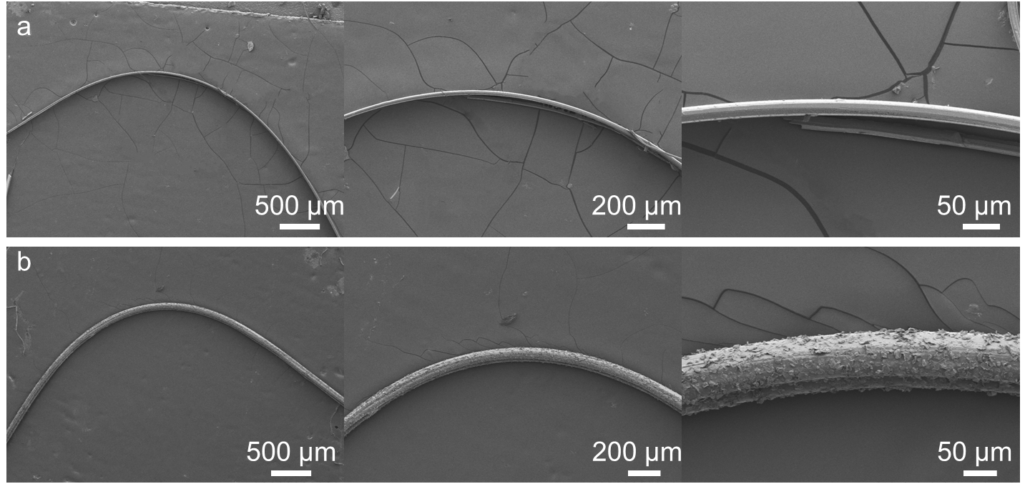
Fig. S8 (a, b) SEM images of the pristine crystal 2 (a) and hybrid crystal GT2 (b) under bending deformation showing intact structure under external forces

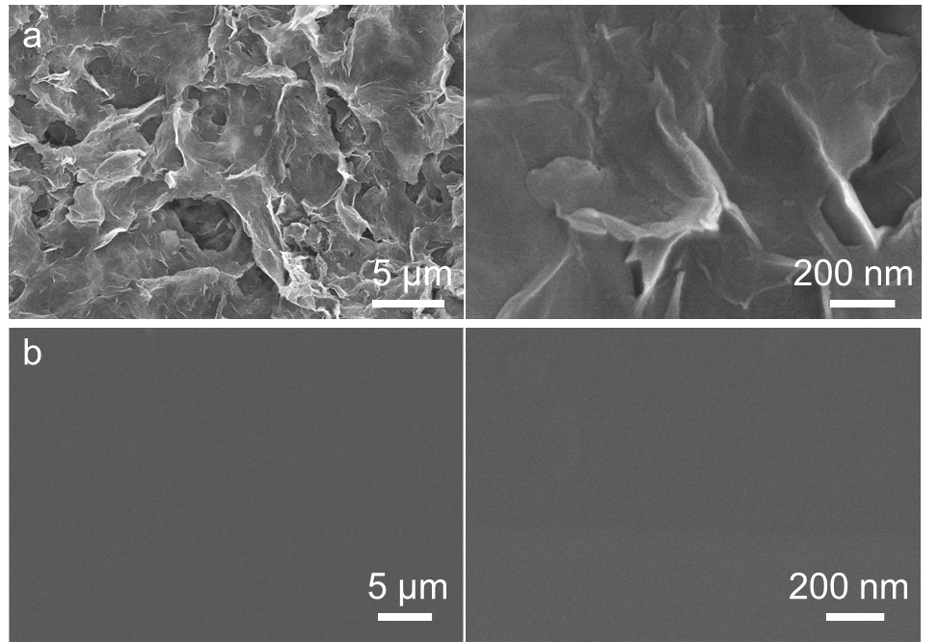
Fig. S9 High-magnification field-emission scanning electron microscopy (FE-SEM) images of hybrid crystal GT2 surfaces after 1000 cycles of repeated bending: (a) Surface morphology of the rGO layer, showing visible wrinkles and structural integrity. (b) Surface morphology of the TPU layer, exhibiting smooth and undamaged surface characteristics

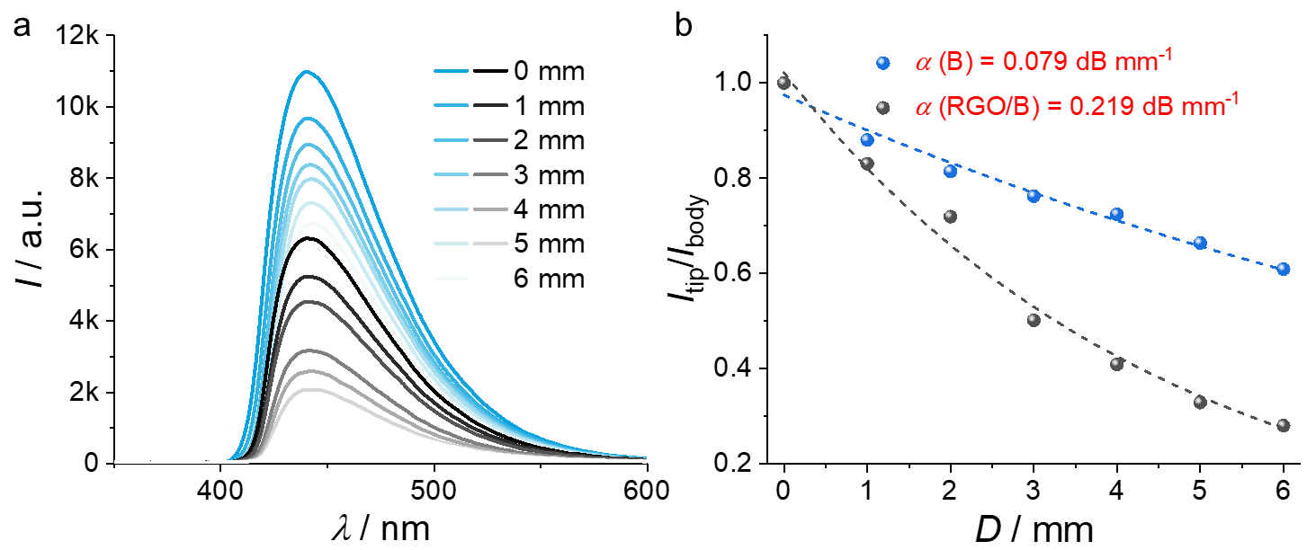
Fig. S10 The optical waveguides properties of a crystal GT1: (a) Fluorescence spectra collected at one tip of GT1 with different distances between the tip and the excitation site of the laser. (b) The I_{tip}/I_{body} decays of GT1. The optical loss coefficients (α) are determined by a single-exponential fitting of the function. I_{tip}/I_{body} = Aexp(–αD), in which I_{tip} and I_{body} are the fluorescence intensities of out-coupled and incidence light respectively, A is the optical loss coefficient and D is the distance between the excited site and the tip of crystals for collecting emission

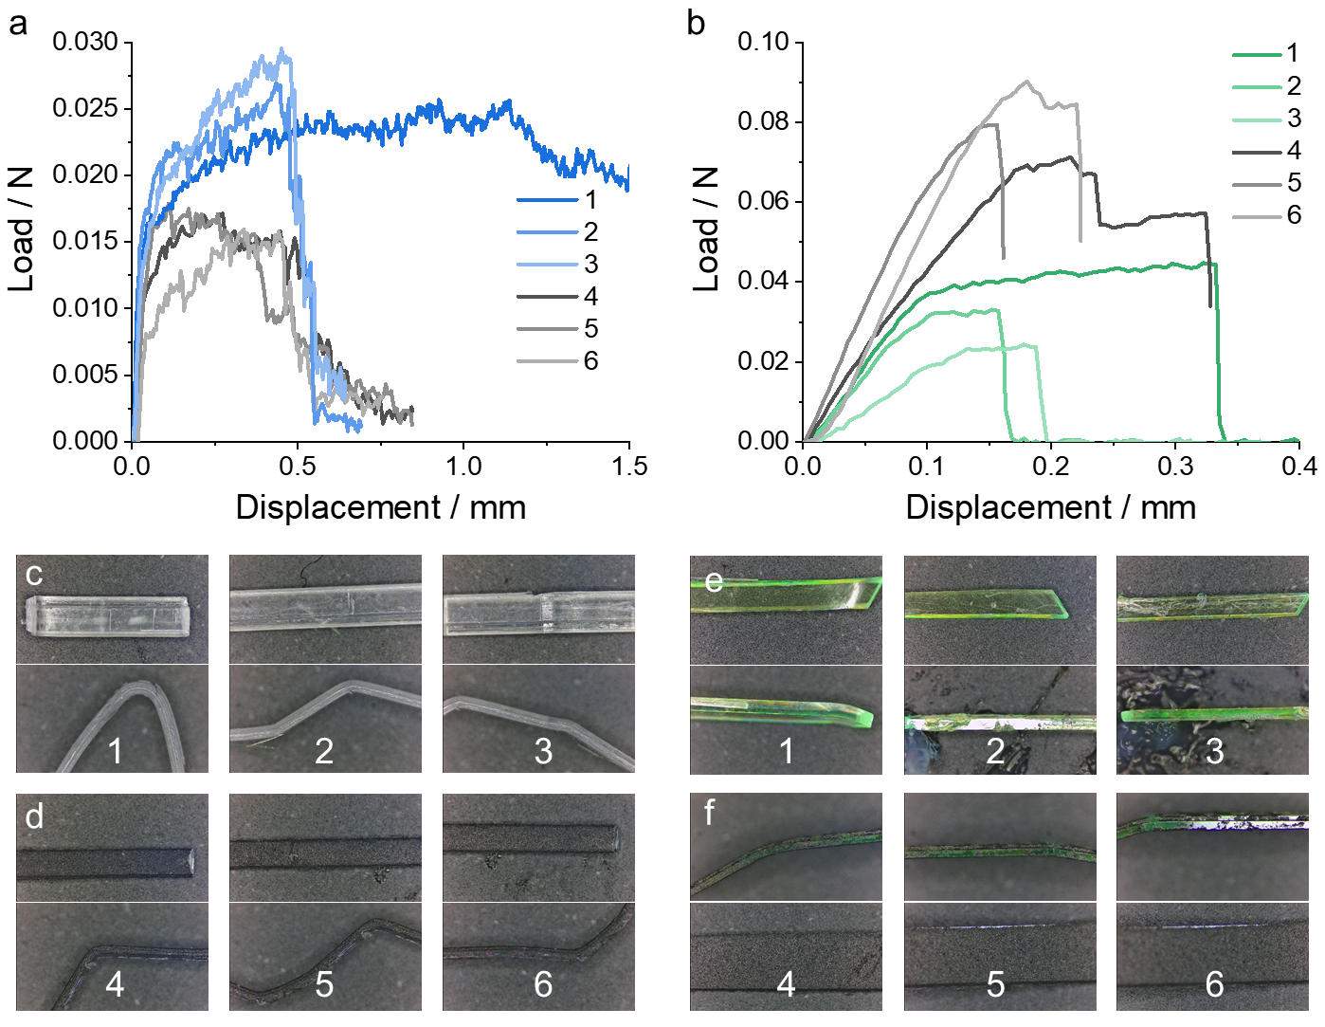
Fig. S11 (a, b) Load–displacement curves obtained from the three-point bending test of crystals 1 and GT1 (a), 2 and GT2 (b). (c–f) Optical microscopy images for measuring the width and thickness of samples 1 (c), GT1 (d), 2 (e), and GT2 (f). The corresponding values of width and thickness are summarized in Table S1.

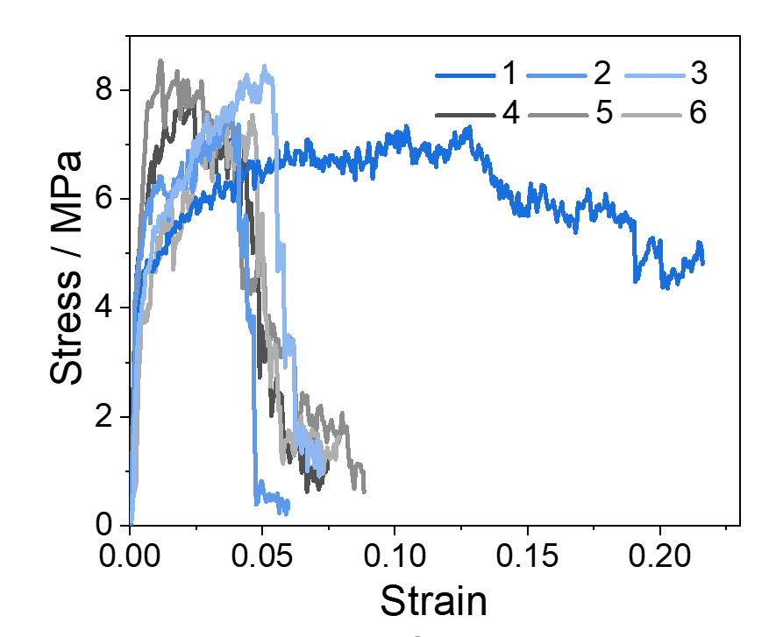
Fig. S12 Stress–strain curves obtained from the three-point bending tests of crystals 1 (Samples 1–3) and GT1 (Samples 4–6)

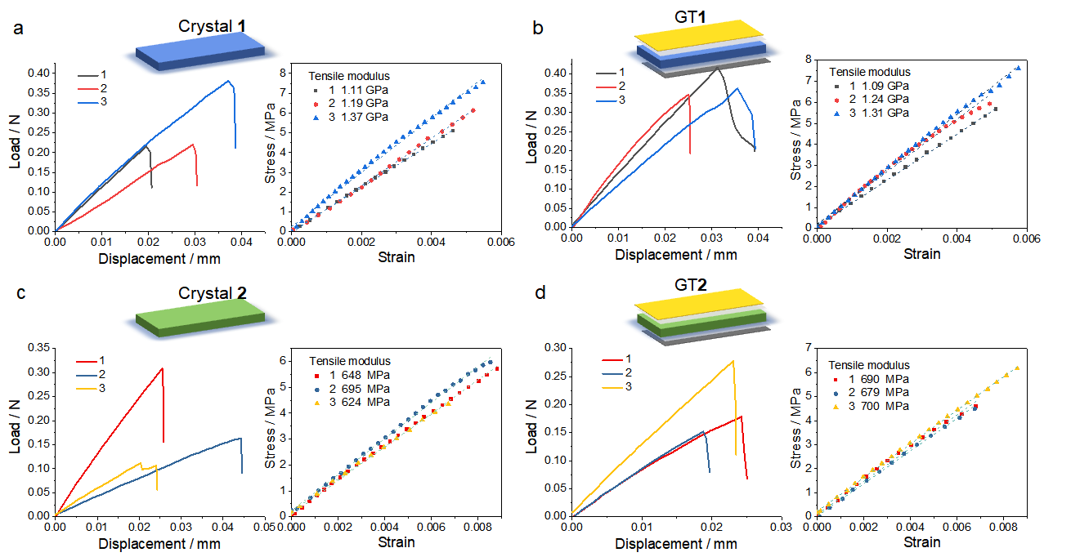
Fig. S13 Displacement–load curves and corresponding stress–strain curves of pristine crystal 1 (a), GT1 (b), pristine crystal 2 (c), and GT2 (d) under tensile testing. Three independent specimens were tested for each sample

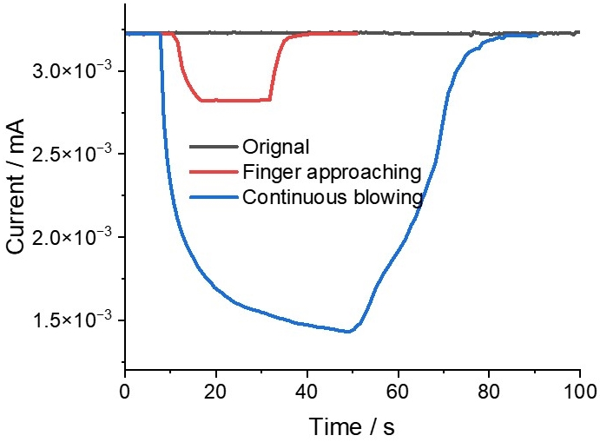
Fig. S14 Current variation over time for GT2 under initial conditions, finger proximity, and blowing conditions, corresponding to Fig. 2k
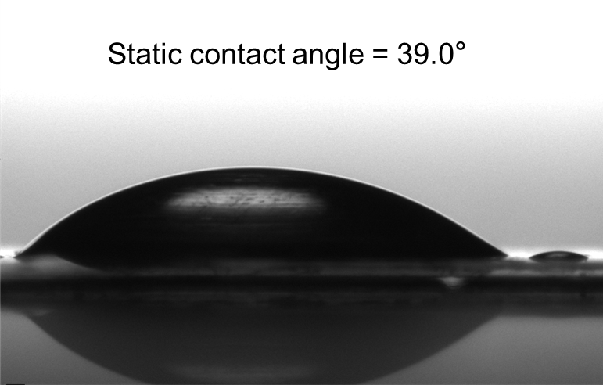
Fig. S15 Surface tension of water drops on the rGO layer of GT2

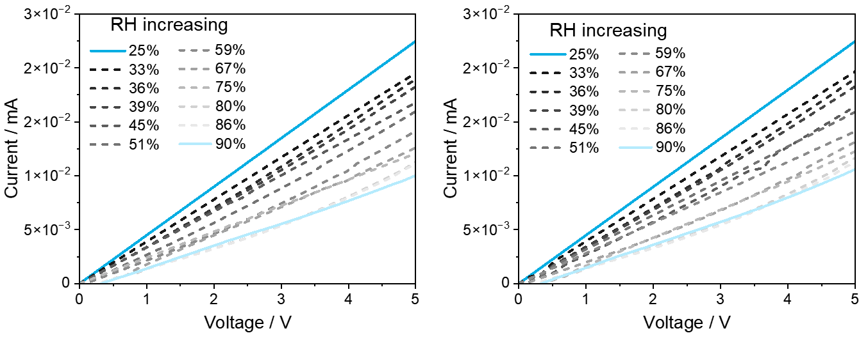
Fig. S16 The second (left) and third (right) tests demonstrate the electrical response of GT2 to varying relative humidity (RH) levels at 25°C

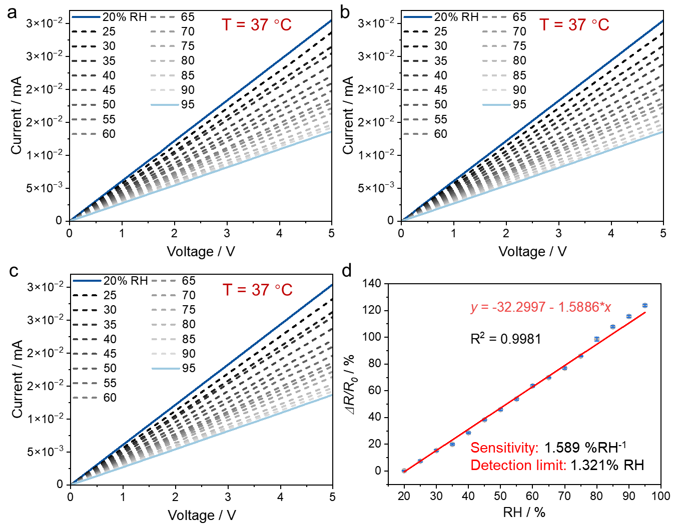
Fig. S17 (a–c) The current-voltage (I-V) curves of GT2 under different relative humidity (RH) conditions at 37°C, measured repeatedly over three cycles to confirm reproducibility. (d) The corresponding linear correlation between normalized resistance change (ΔR/R₀) and RH

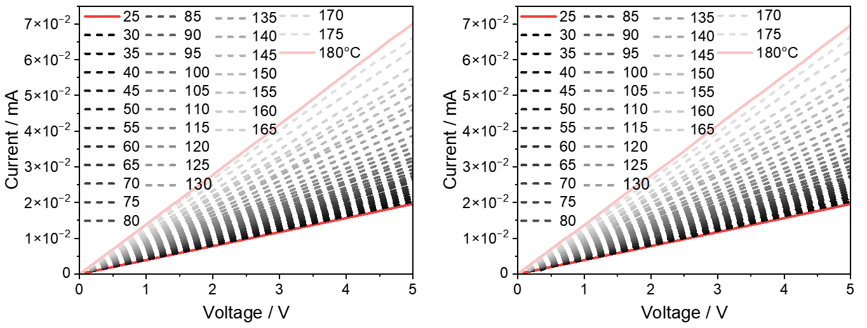
Fig. S18 The second (left) and third (right) tests demonstrate the electrical response of GT2 to varying temperature levels at 30% RH

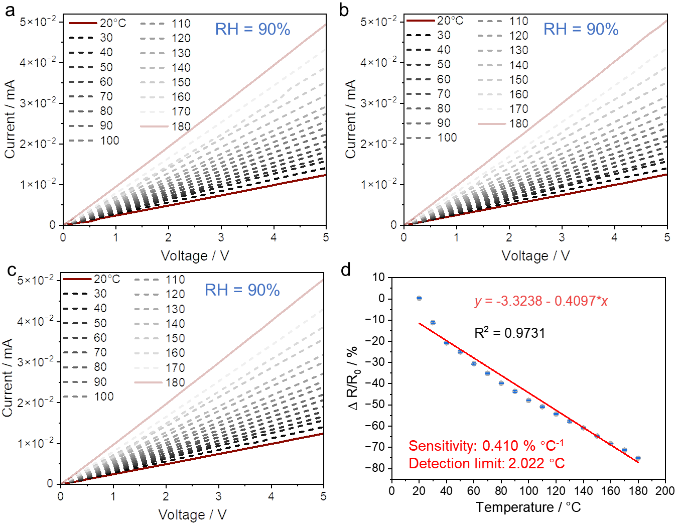
Fig. S19 (a–c) The I-V curves of GT2 under different temperature conditions at 90% RH, measured repeatedly over three cycles to confirm reproducibility. (d) The corresponding linear correlation between normalized resistance change (ΔR/R₀) and temperature
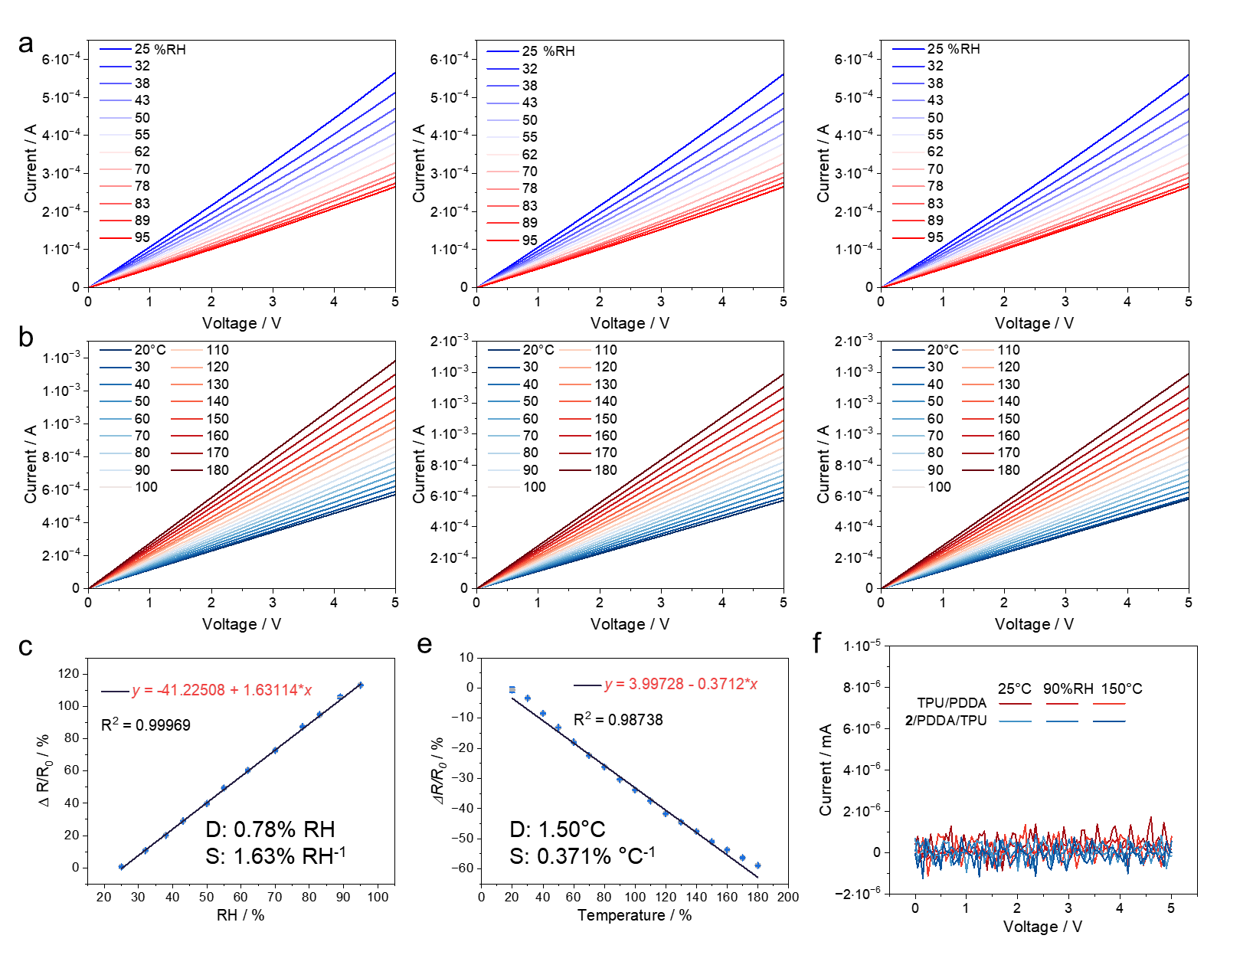
Fig. S20 (a) The I-V curves of rGO under different relative humidity conditions at 25°C, measured repeatedly over three cycles. (b) The I-V curves of rGO under different temperature conditions at 30% RH, measured repeatedly over three cycles. (c) The corresponding linear correlation between normalized resistance change (ΔR/R₀) and relative humidity. (e) The corresponding linear correlation between normalized resistance change (ΔR/R₀) and temperature. (f) The I-V curves of TPU/PDDA and 2/PDDA/TPU under different conditions

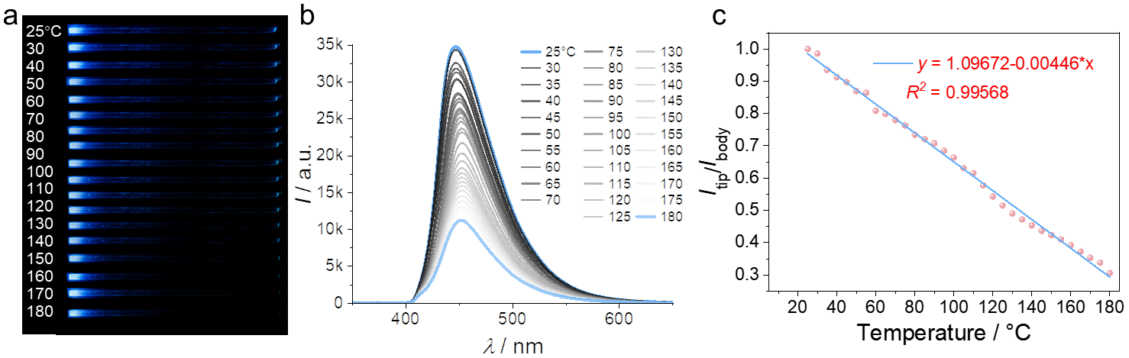
Fig. S21 (a) Fluorescent images of GT1 showing optical waveguides at temperatures ranging from 25°C to 180°C. (b) Emission spectra collected at the crystal tip under varying temperatures. (c) Linear correlation between the ratio of I_{tip}/I_{body} and temperature, demonstrating the temperature-dependent attenuation of optical signals

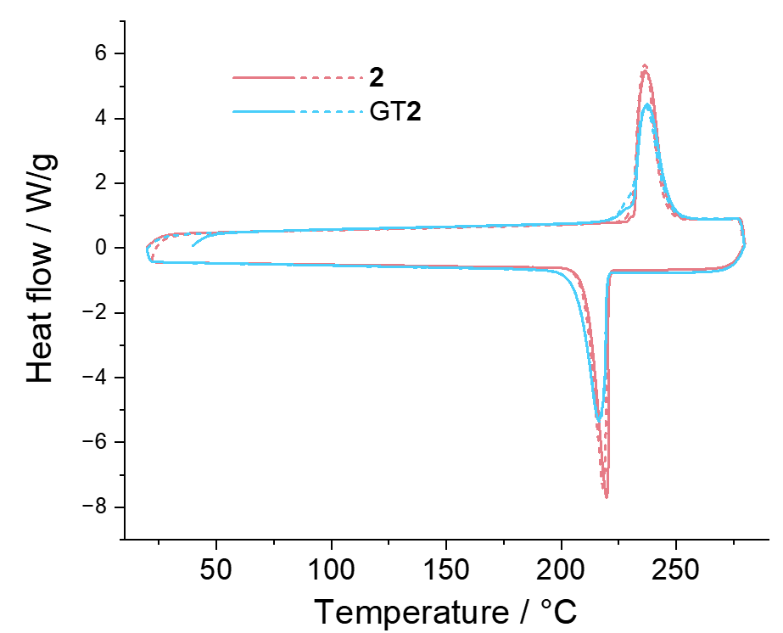
Fig. S22 Differential scanning calorimetry (DSC) curves of crystals 2 and GT2. The DSC curves

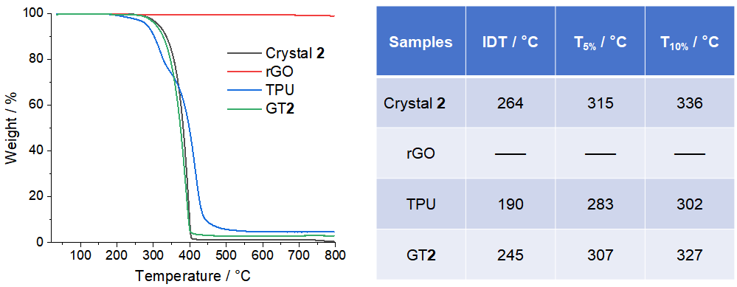
Fig. S23 TGA curves of crystal 2, rGO, TPU, and GT2, and summary table of thermal parameters, including Initial decomposition temperature (IDT), decomposition temperature at 5% weight loss (T), and decomposition temperature at 10% weight loss (T_{10%})

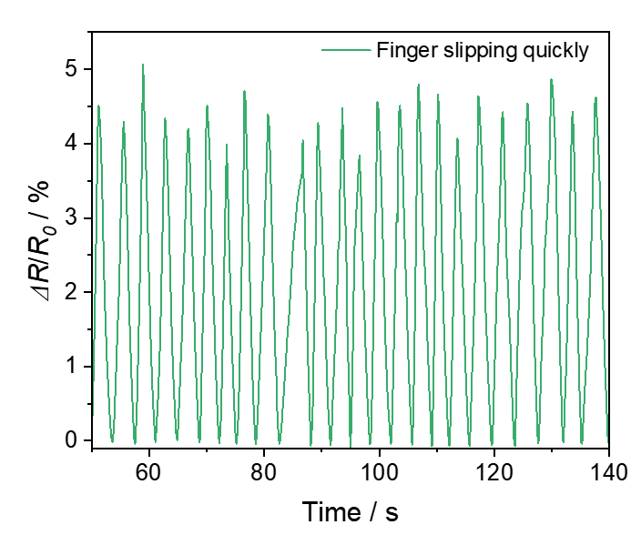
Fig. S24 Monitoring water evaporation from finger recorded by GT2. A Finger quickly and repeatedly passing over GT2 at approximately 2 mm height

Fig. S25 Humidity sensing performance of GT2 after 25 days of storage at 90% RH followed by drying at 60°C for 2 h. Top: detected breathing signals. Bottom: local fingertip moisture changes monitored by GT2, with the fingertip repeatedly approaching and moving away from the sensor (~4 mm distance)

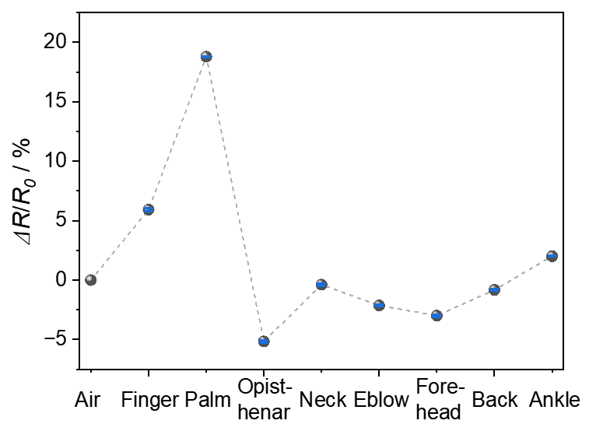
Fig. S26 Normalized resistance change of different parts of the human body recorded by GT2
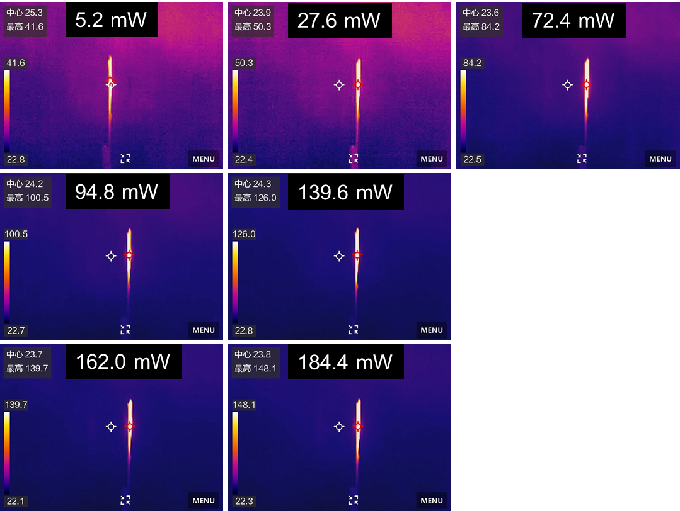
Fig. S27 Infrared thermal imaging of GT2 under varying infrared (808 nm) power intensities. Thermal images show the temperature distribution of GT2 as the infrared power increases from 5.2 to 184.4 mW. The red circle indicates the maximum temperature reached on the crystal surface

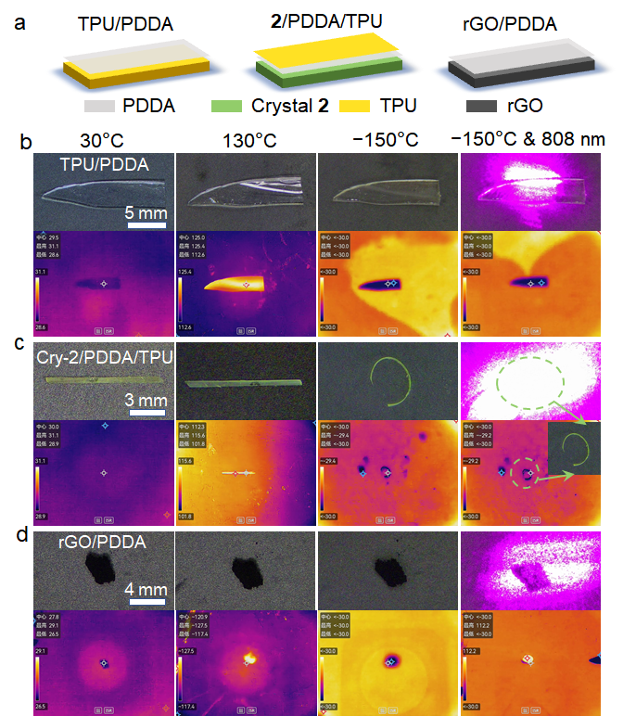
Fig. S28 (a) Schematic illustration of the sample configurations: TPU/PDDA, 2/PDDA/TPU, and rGO/PDDA. (b–d) Optical images (top) and infrared thermal images (bottom) of the samples TPU/PDDA (b), 2/PDDA/TPU (c), and rGO/PDDA (d) under different temperatures and under low-temperature infrared irradiation

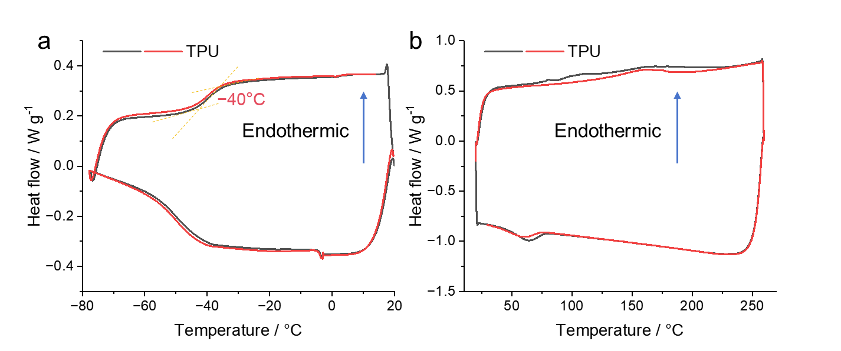
Fig. S29 DSC curves of TPU in the ranges of 20 to −80°C and 20 to 260°C

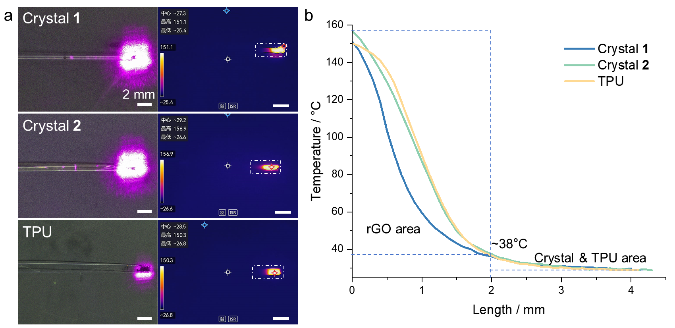
Fig. S30 (a) Comparison of the thermal conductivity of Crystal 1, Crystal 2, and TPU. A ~2 mm area of rGO was attached to one end of each sample, and the region was irradiated with infrared light to raise its central temperature above 150°C. (b) The corresponding temperature distribution profiles along the white dashed box in panel (a)
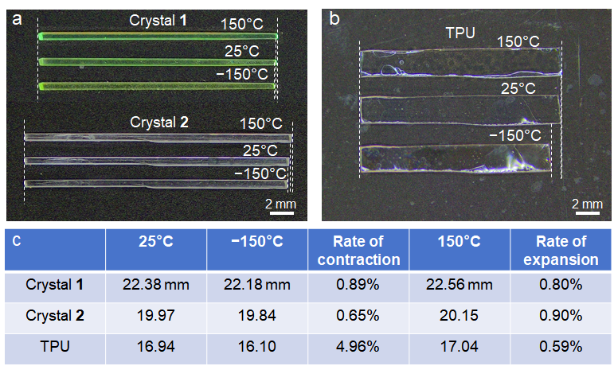
Fig. S31 (a, b) Optical photographs of crystal 1 and 2 (a) and TPU film (b) at 25°C, 150°C and −150°C. (c) Corresponding length measurements with calculated contraction ratios (low temperature) and expansion ratios (high temperature)

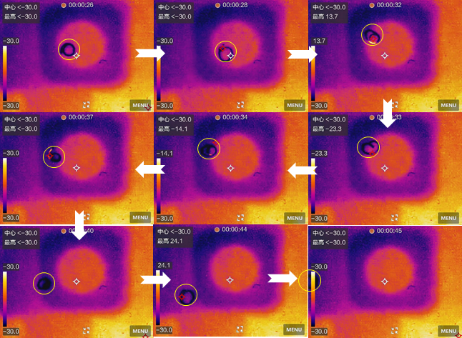
Fig. S32 The motion and temperature changes of the crystal driven by infrared irradiation at low temperatures were captured using an infrared camera. The crystal is highlighted within the yellow circle. The actual environmental temperature is −150°C, while the infrared camera's detection limit is −30°C
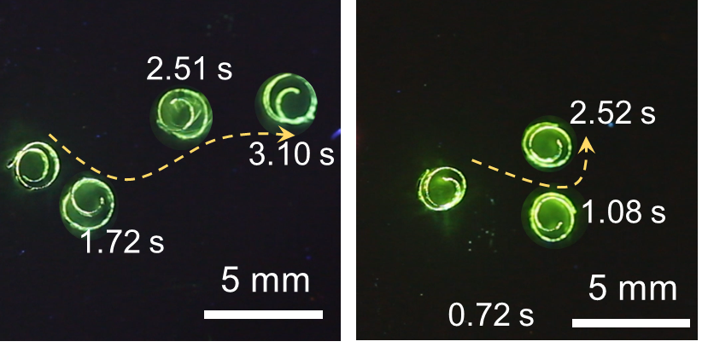
Fig. S33 Fluorescent images showing the time and distance of curled GT2 crystals at −150°C as it jumps under infrared driving. The dotted yellow lines represent the motion trajectory of the crystal
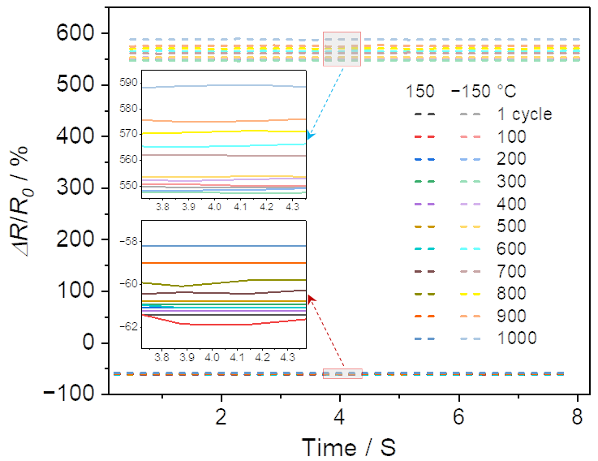
Fig. S34 Fatigue resistance of GT2 under thermal cycling. The ΔR/R₀ of GT2 over 1000 cycles between 150°C and −150°C demonstrates its excellent thermal stability and durability. Insets show magnified views at specific cycles
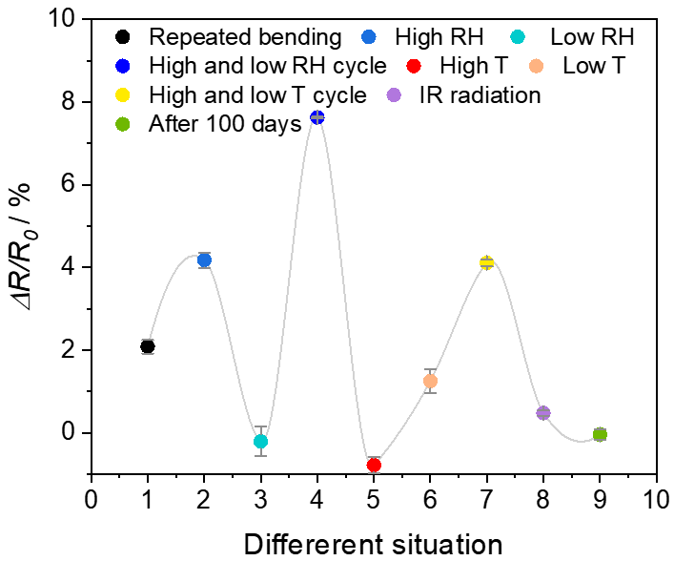
Fig. S35 Normalized resistance changes of the GT2 under different conditions

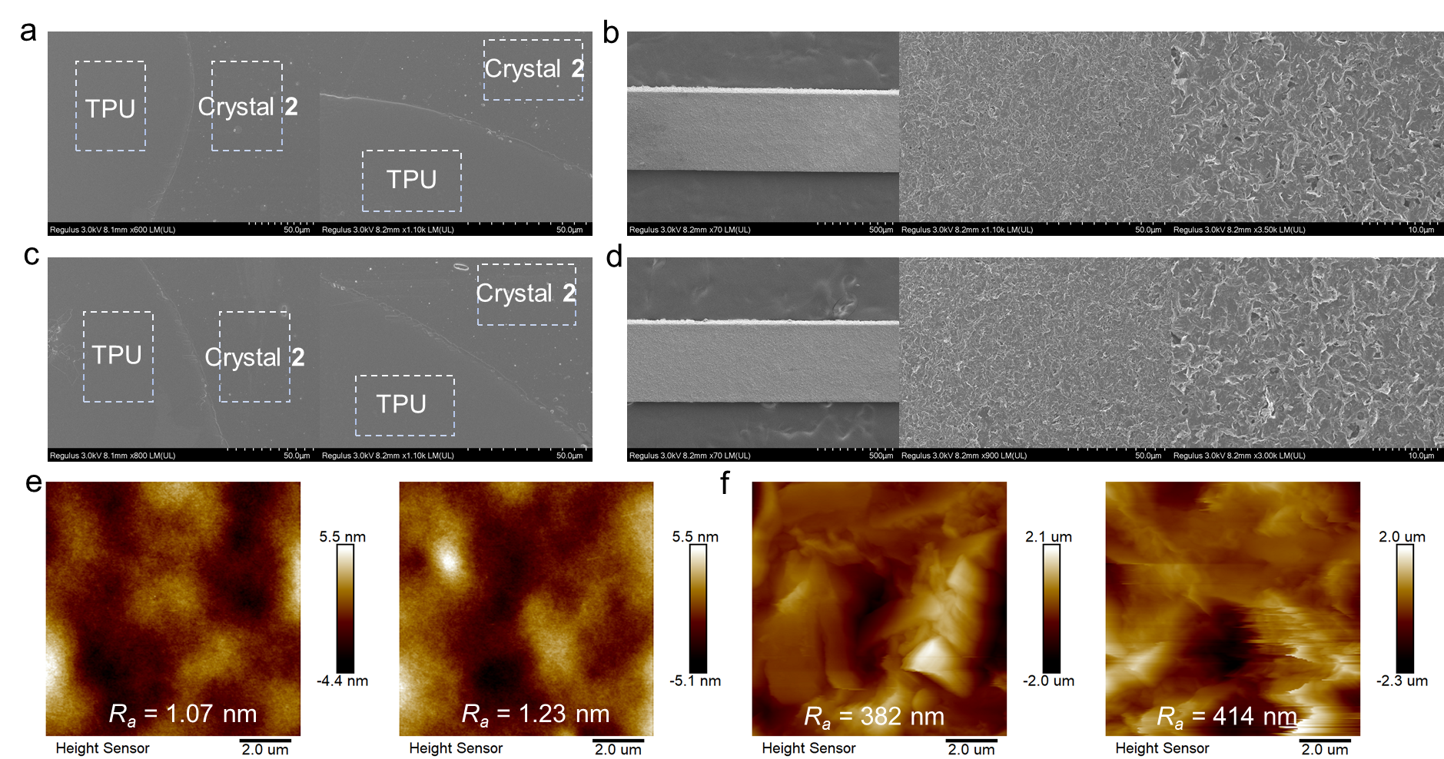
Fig. S36 (a, b) Initial GT2 showing the TPU and crystal surfaces (a) as well as the layered rGO structure (b). (c, d) GT2 after cycles of high/low humidity (20%–90% RH), high/low temperature (−150 to 150°C), and repeated infrared irradiation, showing the TPU and crystal surfaces (c) together with the rGO layered structure (d). (e) AFM images of the TPU layer in GT2 before (left) and after fatigue cycling (right). (f) AFM images of the rGO layer in GT2 before (left) and after fatigue cycling (right).

Table S1 Dimensions, plastic yield strength, and elastic modulus of crystals 1 and 2, as well as hybrid crystals GT1 and GT2 in three-point bending tests
Crystals | Sample number | Width / μm | Thickness / μm | Yield strength / Mpa | Elastic moduli / Gpa
1 | 1 | 354.97 | 163.74 | 7.34 | 1.97
1 | 2 | 347.94 | 149.86 | 7.71 | 1.94
1 | 3 | 272.57 | 138.64 | 8.44 | 1.82
GT1 | 4 | 774.89 | 146.72 | 7.82 | 1.53
GT1 | 5 | 775.22 | 152.79 | 8.54 | 1.66
GT1 | 6 | 773.94 | 152.41 | 7.63 | 1.43
2 | 1 | 550.68 | 169.30 | 21.09 | 1.74
2 | 2 | 551.06 | 169.39 | 19.02 | 1.93
2 | 3 | 551.06 | 169.99 | 21.08 | 1.88
GT2 | 4 | 390.28 | 158.90 | 19.42 | 1.11
GT2 | 5 | 382.53 | 156.89 | 19.68 | 1.40
GT2 | 6 | 382.53 | 157.45 | 22.68 | 1.53
Table S2 Dimensions, breaking strength, and tensile modulus of crystals 1 and 2, as well as hybrid crystals GT1 and GT2 in tensile tests
Crystals | Sample number | Length / mm | Width / μm | Thickness / μm | Yield strength / Mpa | Elastic modulus / Gpa
1 | 1 | 4.22 | 521 | 81 | 5.10 | 1.11
1 | 2 | 5.68 | 427 | 84 | 6.13 | 1.19
1 | 3 | 6.77 | 496 | 102 | 7.54 | 1.37
GT1 | 4 | 8.1 | 608 | 150 | 5.67 | 1.09
GT1 | 5 | 5.07 | 384 | 152 | 5.97 | 1.24
GT1 | 6 | 6.17 | 496 | 96 | 7.61 | 1.31
2 | 1 | 2.89 | 426 | 117 | 5.70 | 0.645
2 | 2 | 5.19 | 263 | 104 | 5.96 | 0.695
2 | 3 | 3.02 | 272 | 94 | 4.36 | 0.624
GT2 | 4 | 3.56 | 319 | 122 | 4.59 | 0.690
GT2 | 5 | 2.78 | 282 | 120 | 4.49 | 0.679
GT2 | 6 | 2.69 | 257 | 175 | 6.17 | 0.700

Table S3 Comparison of the performance of our hybrid crystal-based flexible sensor with recently reported flexible sensors. The comparison parameters include operating humidity range (RH / %), operating temperature range (T / °C), sensitivity （S） and detection limit (MDL). “―” indicates no data available
Sensor system | Humidity sensing |  |  | Temperature sensing
Parameters | RH / % | S / % RH^{–1} | MDL / % RH | T / °C | S / % °C^{–1} | MDL / °C | Refs.
This work (hybrid crystal) | 25–90 | 1.65 | 0.54 | 25–180 | 0.46 | 1.77
AgNPs/CA/PVA | 50–90 | ― | ― | 30–45 | 0.043 | ― | [S1]
Dual-modal sensors | 20–90 | ― | ― | 25–45 | 1.66 | ― | [S2]
FET-based thermistor | ― | ― | ― | 30–80 | 1.34 | 0.2 | [S3]
RF/PAA DN gel | 70–90 | 0.311 | ― | −20–90 | 8.65 | ― | [S4]
PVA/CA/AgNPs sensor | 30–90 | ― | ― | 30–40 | 0.076 | ― | [S5]
Biomimetic electronic skins | 33–98 | ― | ― | 25–50 | 1.74 | ― | [S6]
PVA-CNF organohydrogel. | 22–98 | ― | ― | 21.5–48.6 | 9.38 | ― | [S7]
PPy/PU-CNT nano-architectures | 20–80 | 3.71 | ― | 20–50 | 0.77 | ― | [S8]
Self-powered multimodal sensor | 40–90 | ― | ― | 25-40 | 0.055 | ― | [S9]
Table S4. Comparison of cryogenic actuation performance of our hybrid crystals with representative flexible actuators
Actuator system | Actuation mode | Operating temperature | Motion Type | Unique advantage | Refs.
This work  (hybrid crystal) | Infrared radiation | −150°C | Crawl, walk, jump | Fast and controllable movement
IS-P³//1–3 | Temperature switching | −125°C | Bending,  grasping | Sensitive response (1867°/s) | [S10]
Magnetic flexible metastructures | Magnetic control | −196°C | Crawling, grasping | Complex deformation | [S11]
LCEs | Temperature switching | −18°C | Slight bending | Simple fabrication | [S12]
S2 Legends for the Supplementary Movies
Movie S1 Infrared thermographic imaging of infrared-driven heating and natural cooling of the hybrid crystal GT2. The movie captures the temperature evolution of GT2 under four different infrared power levels, showing rapid heating to peak temperatures followed by natural cooling after the infrared source is turned off.

Movie S2 Low-temperature-driven response of GT2. The movie shows the crystal curling into a spring-like shape when placed near liquid nitrogen and returning to its original straight form upon exposure to room temperature, demonstrating its reversible low-temperature actuation.
Movie S3 Infrared thermographic imaging of shape transformation and localized temperature changes of the curled crystal at low temperatures. At low temperatures, the crystal curls into a helical shape, and upon infrared irradiation at a specific site, localized heating induces partial straightening, triggering significant shape transformation and motion. This reversible process demonstrates the crystal's photothermal responsiveness.
Movie S4 Infrared-driven inching and helical motions of bent GT3 and curled GT2 crystals at low temperatures.
Movie S5 Infrared-driven jumping and obstacle-crossing motion of GT2 at low temperatures.
Movie S6 Infrared-driven walking motion of GT4 with paper feet at low temperatures, demonstrating controlled directional movement upon periodic infrared irradiation.
Supplementary References
- L. Chen, Y. Xu, Y. Liu, J. Wang, J. Chen et al., Flexible and transparent electronic skin sensor with sensing capabilities for pressure, temperature, and humidity. ACS Appl. Mater. Interfaces 15, 24923–24932 (2023). https://doi.org/10.1021/acsami.3c03829
- W. Shi, X. Yang, L. Lei, J. Lin, Q. Liang et al., Human respiration monitoring using humidity and temperature dual-modal sensors for temperature-insensitive humidity sensing and synchronous temperature sensing. Sens. Actuators A Phys. 395, 117008 (2025). https://doi.org/10.1016/j.sna.2025.117008
- T.Q. Trung, S. Ramasundaram, B.U. Hwang, N.E. Lee, An all-elastomeric transparent and stretchable temperature sensor for body-attachable wearable electronics, Adv. Mater. 28, 502–509 (2016). https://doi.org/10.1002/adma.201504441
- Q. Quan, C. Fan, N. Pan, M. Zhu, T. Zhang et al., Tough and stretchable phenolic-reinforced double network deep eutectic solvent gels for multifunctional sensors with environmental adaptability. Adv. Funct. Mater. 33, 2303381 (2023). https://doi.org/10.1002/adfm.202303381
- L. Chen, X. Chang, H. Wang, J. Chen, Y. Zhu. Stretchable and transparent multimodal electronic-skin sensors in detecting strain, temperature, and humidity, Nano Energy 96, 107077 (2022). https://doi.org/10.1016/j.nanoen.2022.107077
- W. Wang, D. Yao, H. Wang, Q. Ding, Y. Luo et al., A breathable, stretchable, and self-calibrated multimodal electronic skin based on hydrogel microstructures for wireless wearables. Adv. Funct. Mater. 34, 2316339 (2024). https://doi.org/10.1002/adfm.202316339
- J. Li, H. Wang, Y. Luo, Z. Zhou, H. Zhang, Design of AI-enhanced and hardware-supported multimodal e-skin for environmental object recognition and wireless toxic gas alarm. Nano-Micro Lett. 16, 256 (2024). https://doi.org/10.1007/s40820-024-01466-6
- Y. He, S. Xiao, Q. Wang, C. Guo, D. Luo et al., An in-situ multiresponsive flexible sensor utilizing electrochemical impedance spectroscopy for the precise and simultaneous detection of pressure, temperature, and humidity. Chem. Engin. J. 521, 166956 (2025). https://doi.org/10.1016/j.cej.2025.166956
- L. Ye, Z. Tang, J. Feng, Y.-P. Jiang, X.-G. Tang et al., A flexible self-powered multimodal sensor with low-coupling temperature, pressure and humidity detection for physiological monitoring and human-robot collaboration. Chem. Eng. J. 519, 164866 (2025). https://doi.org/10.1016/j.cej.2025.164866
- L. Lan, L. Li, Q. Di, X. Yang, X. Liu et al., Organic single-crystal actuators and waveguides that operate at low temperatures. Adv. Mater. 34, 2200471 (2022). https://doi.org/10.1002/adma.202200471
- W. Han, W. Gao, X. Wang. Magnetic flexible metastructures: developing smart shape-morphing capabilities at extremely low temperatures. Compos. Sci. Technol. 269, 111242 (2025). https://doi.org/10.1016/j.compscitech.2025.111242
- Y. Chen, X. Li, J. Wang, D. Zhou, L. Yao et al., Ultra-low temperature-responsive liquid crystal elastomers with tunable drive temperature range. Polymer 294, 126726 (2024). https://doi.org/10.1016/j.polymer.2024.126726

