Supporting Information for
Strong and Tough MXene Induced Bacterial Cellulose Macrofibers for AIoT Textile Electronics
Yi Hao^{1, 2, 3}, Zixuan Zhang^{2, 3}, Yajun Chen⁴, Song Wang⁵, Yingjia Tong⁶, Pengfei Lv^{1, 7,} *, Qufu Wei^{1,} * and Chengkuo Lee^{2, 3,} *
¹ Key Laboratory of Special Protective Textiles, Ministry of Education, College of Textile Science and Engineering, Jiangnan University, Wuxi 214122, P. R. China
² Department of Electrical and Computer Engineering, National University of Singapore, Singapore 117583, Singapore
³ Center for Intelligent Sensors and MEMS (CISM), National University of Singapore, Singapore 117583, Singapore
⁴ Suzhou Institute of Trade & Commerce, Suzhou 215009, P. R. China
⁵ State Key Laboratory for Mechanical Manufacturing Systems Engineering, Xi’an Jiaotong University, Xi’an 710049, P. R. China
⁶ School of Life Sciences and Health Engineering, Jiangnan University, Wuxi 214122, P. R. China
⁷ Laboratory of Flexible Electronics Technology, Tsinghua University, Beijing 10084, P. R. China
*Corresponding authors. E-mail: pengfeilv@jiangnan.edu.cn (Pengfei Lv); qfwei@jiangnan.edu.cn (Qufu Wei); elelc@nus.edu.sg (Chengkuo Lee)
Supplementary Figures and Tables
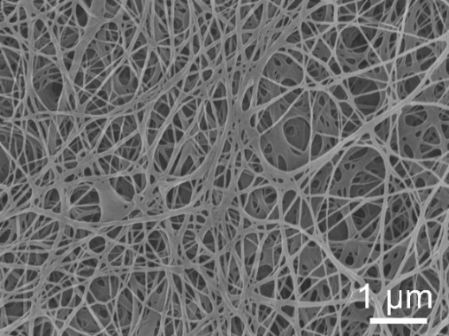
Fig. S1 The surface morphology SEM image of BC micro-nanofiber membrane

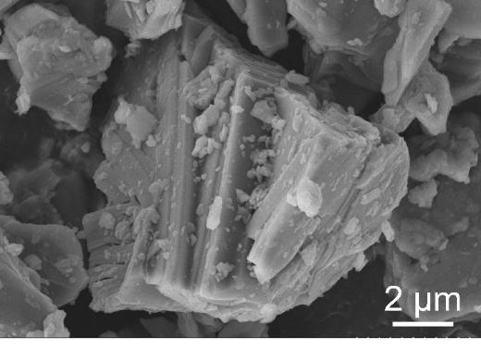
Fig. S2 SEM image of bulk Ti₃AlC₂ MAX. A typical accordion-like structure can be clearly seen

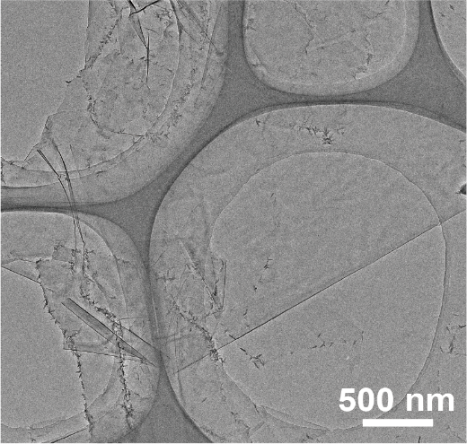
Fig. S3 TEM image of exfoliated Ti₃C₂T_{x} MXene nanosheets

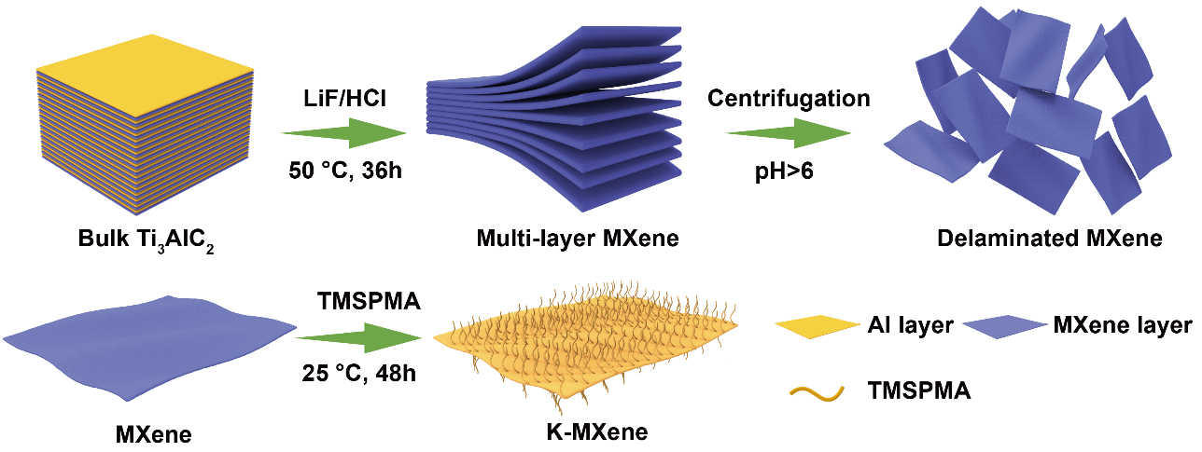
Fig. S4 Schematic process of MXene nanosheets and surface-functionalized K-MXene single layers
Typically, 1.0 g Ti₃AlC₂ powder was slowly added to an etching solution consisting of 1.6 g of LiF and 20 mL of 9M HCl. After etching at 50 ℃ for 30 h, the mixture was washed with deionized water and repeatedly centrifuged at 3500 rpm for 10 min until the pH of the supernatant was approximately 6. Subsequently, anhydrous ethanol was added to the precipitate, and the mixture was ultrasonicated for 1 h to delaminate the Ti₃C₂T_{x} nanosheets. Finally, the delaminated single-layer Ti₃C₂T_{x} nanosheets were collected by centrifuging at 3500 rpm for 3 min several times, yielding a dark green dispersion of Ti₃C₂T_{x} MXene nanosheets. As a result, the final sediments were redispersed in DI water, resulting a 10 mg mL⁻¹ concentration solution.

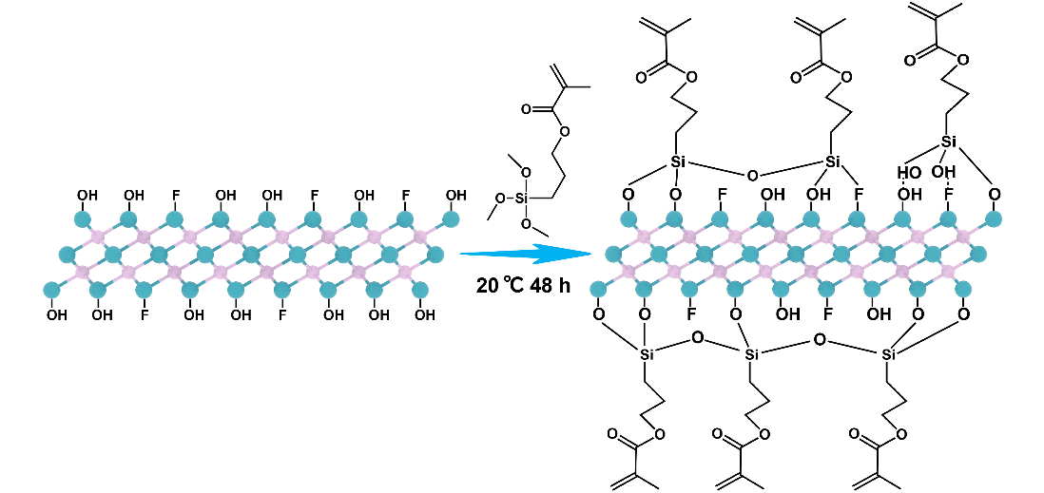
Fig. S5 Schematic diagram of the surface functionalization of MXene nanosheets by the introduction of KH570
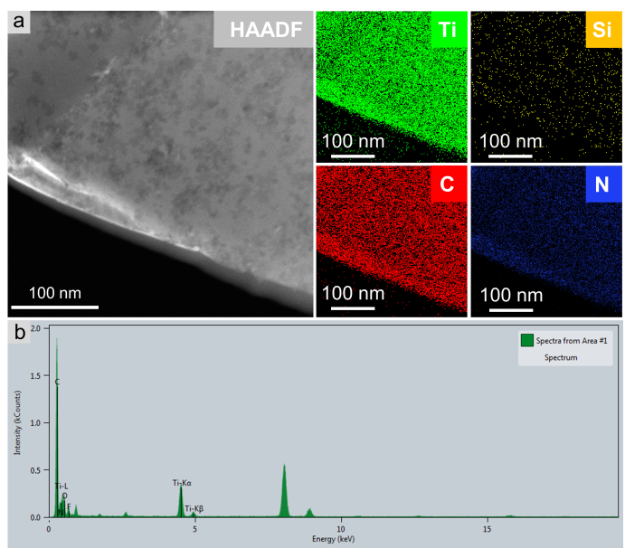
Fig. S6 HAADF-STEM-EDS elemental maps of the K-MXene and the corresponding images of Ti, Si, C and N, respectively

Fig. S7 XPS spectra of MXene and K-MXene films. X-ray photoelectron spectroscopy (XPS) reveals the appearance of new silicon peak in KH570, originating from the KH570 modifier

Fig. S8 a Particle size distribution of MXene nanosheets and b K-MXene nanosheets dispersed in deionized water; c Zeta potential of MXene nanosheets and K-MXene nanosheets in deionized water

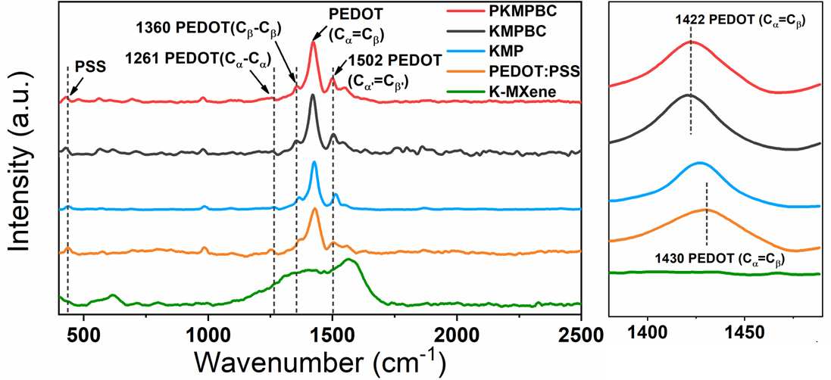
Fig. S9 Raman spectra of K-MXene, PEDOT:PSS, KMP conductive ink, KMPBC and PKMPBC macrofibers

Fig. S10 a Particle size distribution of PEDOT:PSS dispersion and b K-MXene/PEDOT:PSS ink dispersed in deionized water; c Zeta potential of PEDOT:PSS and K-MXene/PEDOT:PSS ink dispersed in deionized water

Fig. S11 FTIR spectra of K-MXene, PEDOT:PSS, and KMP conductive ink. The KMP conductive ink clearly showed the C=C bond on the PSS benzene ring at 1525 cm⁻¹, and the SO₃⁻ bond of the PSS benzene ring at 1174 cm⁻¹ and 1039 cm⁻¹, respectively. In addition, the Ti-O bonds representing the MXene nanosheets were also detected at 557 cm⁻¹
Fig. S12 Thermogravimetric analysis (TGA) curves of MXene, BC macrofiber, KMBC macrofiber, KMPBC macrofiber and PKMPBC macrofiber
As shown in Fig. S12, the TGA curve of MXene nanosheet illustrates no obvious weight loss through entire temperature range with the residual weight maintaining a stable value of 89.5% at 800 °C. The weight of BC macrofibers reduced significantly at 290.6 °C, and the remaining weight is 19.8% at 800 °C. As a result, the thermal weight loss ratio of PKM₇P₃BC macrofibers is 46.8%.
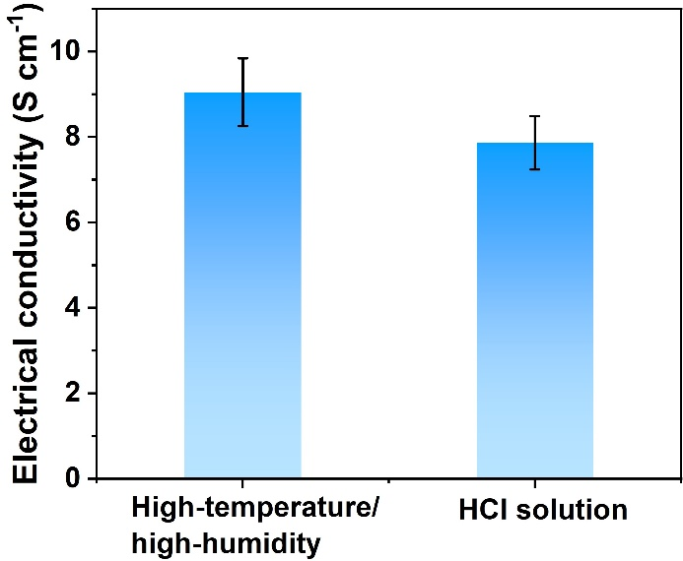
Fig. S13 Electrical conductivity of PKMPBC in high-temperature/high-humidity (40±2 °C, 90%±3%) and 10% (w/w) HCl solution, respectively

Fig. S14 Contact angle images of PKMPBC fabric with water, HCl solution, NaOH solution, NaCl solution, PBS buffer solution and sweat, respectively

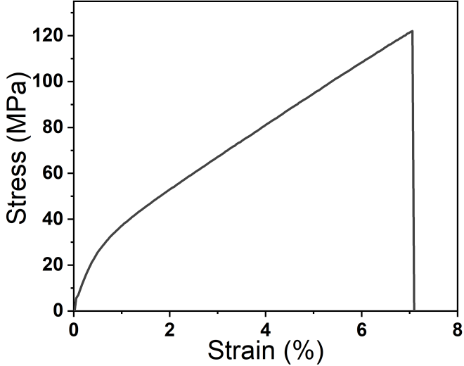
Fig. S15 Stress-strain curve of undrawn BC macrofibers

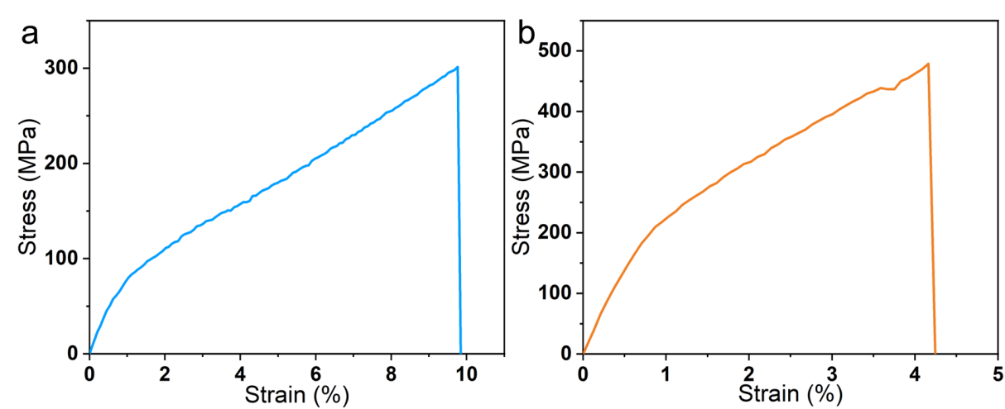
Fig. S16 Stress-strain curve of PKMPBC macrofibers under (a) high temperature and high humidity (40±2 °C, 90%±3%) and (b) 10% (w/w) HCl solution

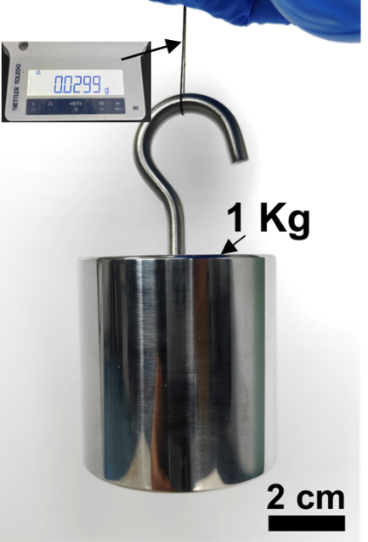
Fig. S17 A PKM₇P₃BC macrofiber of 29.9 mg can lift up a weight of 1 kg which is more than 30000 times heavier than the macrofiber
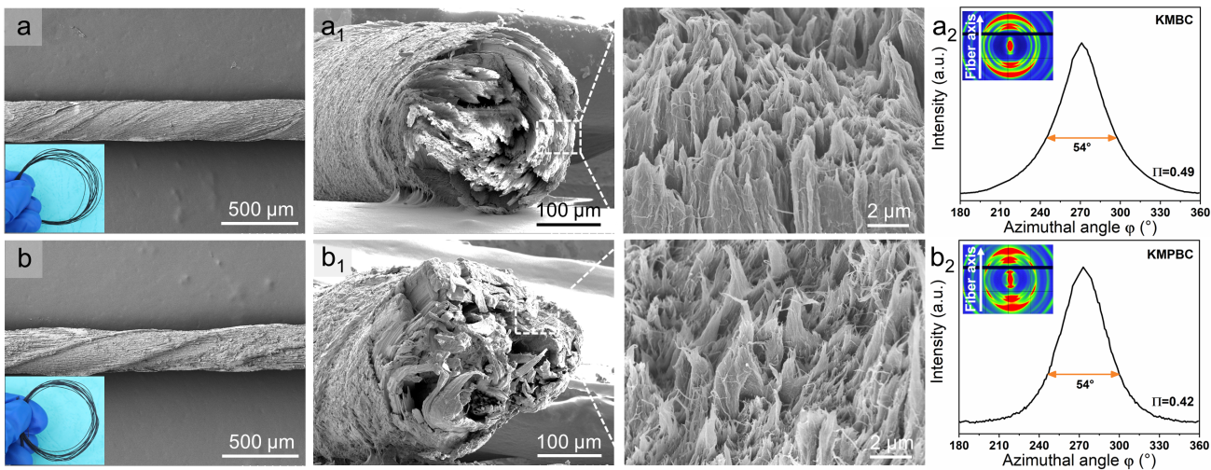
Fig. S18 a, b SEM images, a₁, b₁ Cross-sectional and enlarged SEM images of KMBC and KMPBC macrofibers, and a₂, b₂ 2D WAXS images with corresponding fwhm curves
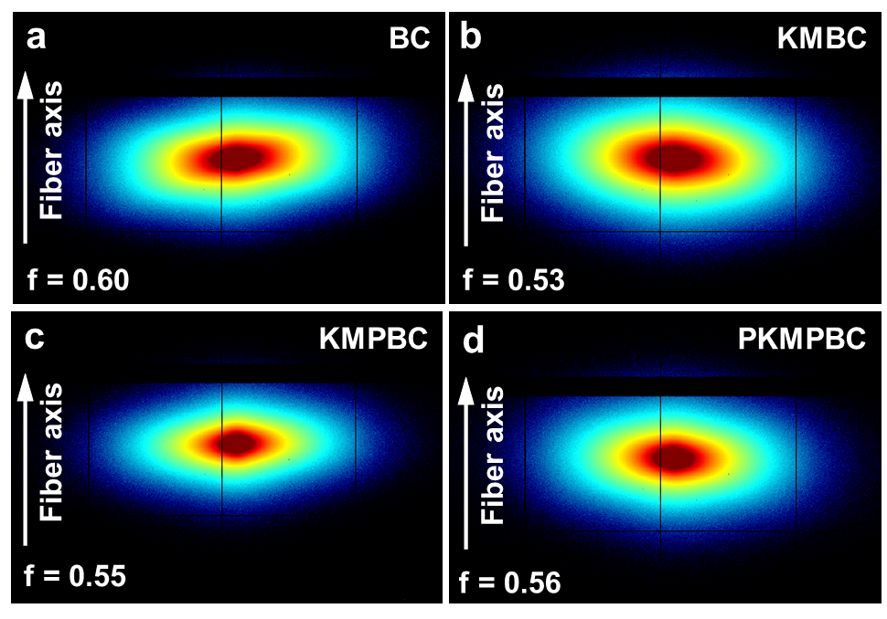
Fig. S19 The 2D SAXS images of a BC, b KMBC c KMPBC and d PKMPBC fibers
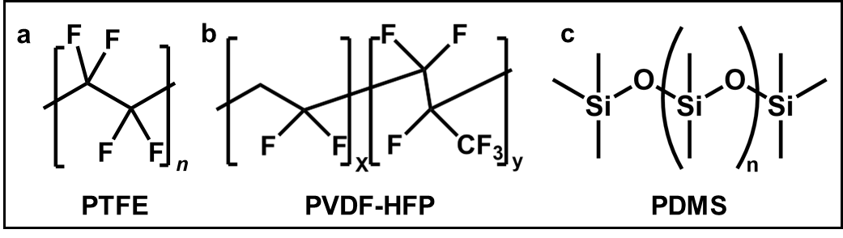
Fig. S20 The detailed molecular structure of a PTFE, b PVDF-HFP and c PDMS, respectively
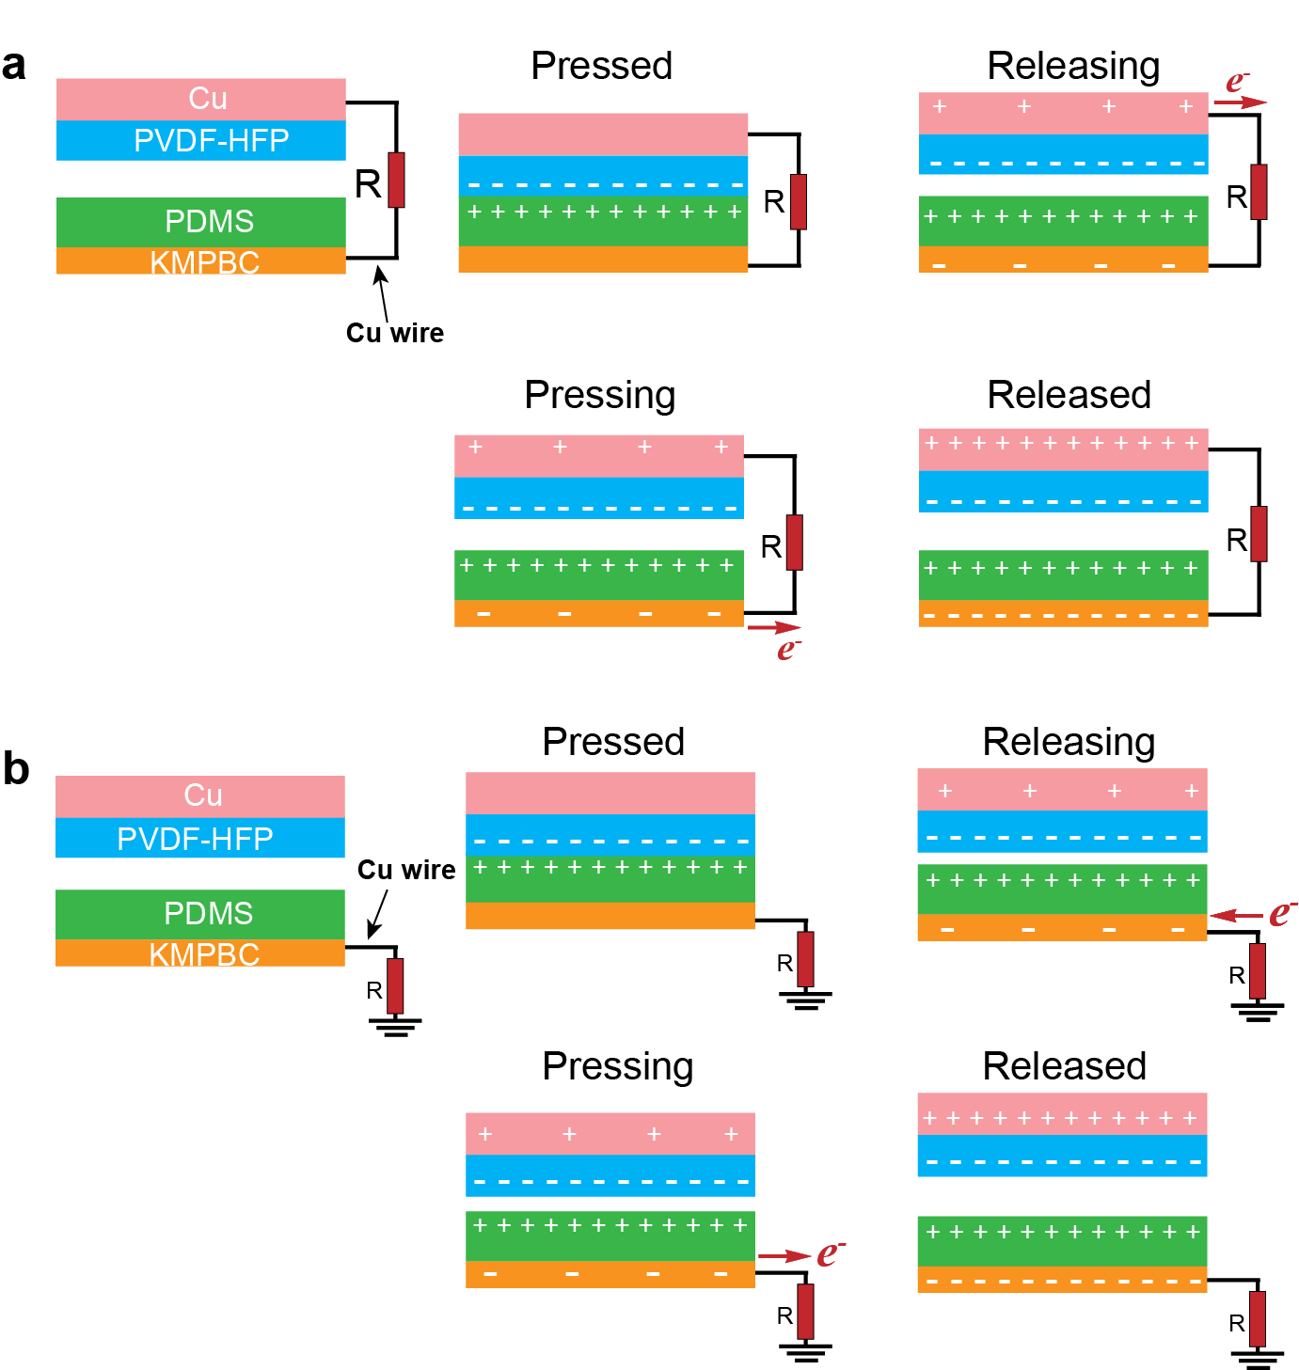
Fig. S21 Working principle of PKT-TENG in a double-electrode mode, b single-electrode mode
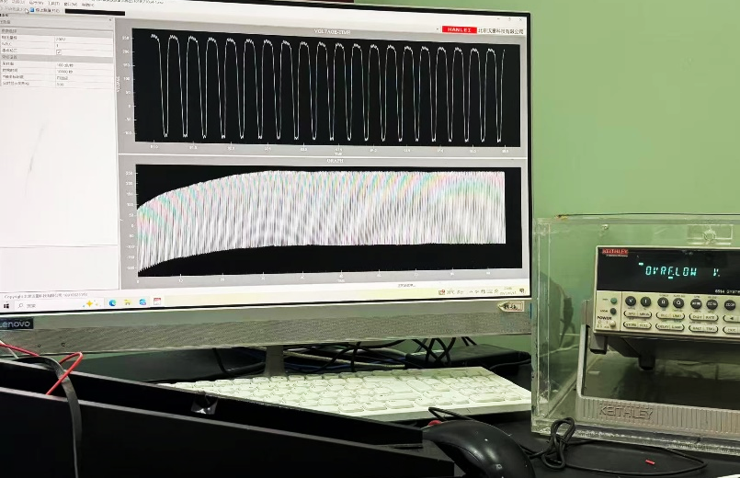
Fig. S22 The output voltage testing photograph of PKT-TENG at a working frequency of 4 Hz

Fig. S23 Relationship between the output voltage and current of PKMPBC fabric-based TENG when connected to different external resistances ranging from 0.1 MΩ to 1000 MΩ

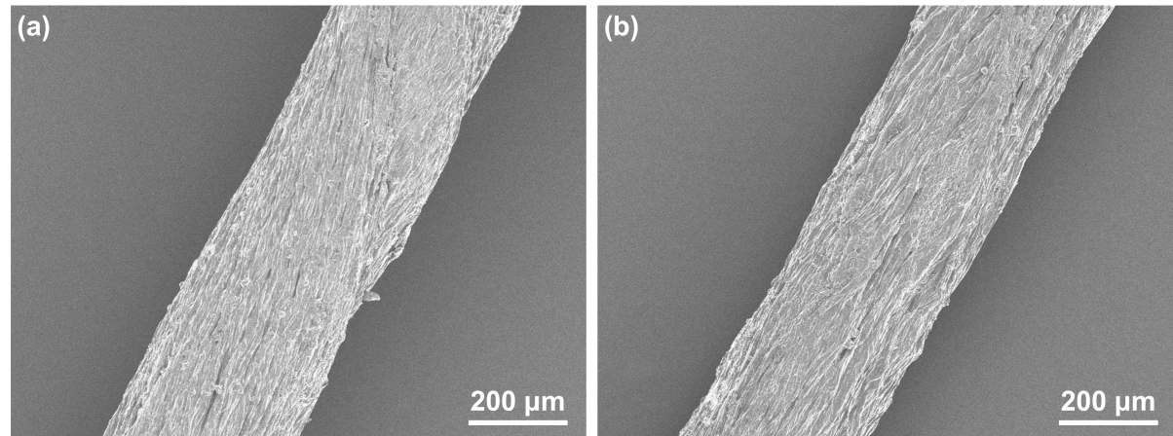
Fig. S24 The variation in the SEM surface morphology of the PKMPBC macrofiber (a) before and (b) after 2700 contact-separation cycles

Fig. S25 Output voltage of PF-TENG before and after water injection on the friction surface

Fig. S26 Charging curves of PKM₇P₃BC textile-based TENG for commercial capacitors at different operating frequencies (0.5 Hz-3.0Hz)

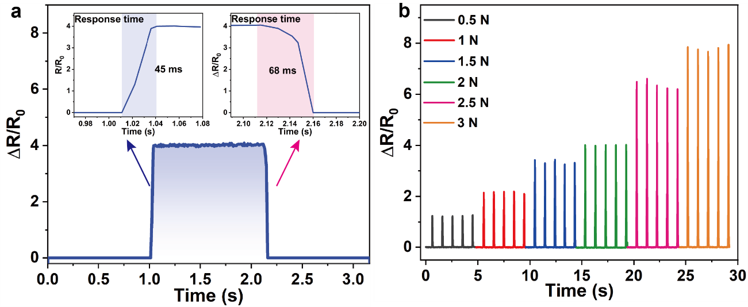
Fig. S27 a The response and recovery time of the PKMPBC textile-based sensor under finger pressure. b Cyclic relative resistant change of the PKMPBC textile-based sensor at diverse loads from 0.5 N to 3 N
The operational performance of the PKMPBC textile-based sensor was evaluated under ambient conditions (20±3°C, 40%±2%). When a forefinger touched the surface of PKMPBC textile-based sensor, an ultrafast response in resistance variation was observed within 45 ms. Subsequently, upon removal of the finger, the resistance returned to its initial level within 68 ms without any baseline drift (Fig. S27a). Fig. 27b exhibits the relative resistance changes of the PKMPBC textile-based sensor under cyclic loads in the range of 0.5-3 N. The signal peak of the relative resistant changes can clearly distinguish pressures of different amplitudes and present the repeatability of the relative resistant changes at the identical load. These illustrate that the PKMPBC textile-based sensor possesses reliable monitoring and a stable sensing response for full-range monitoring induced by the environment stimuli.
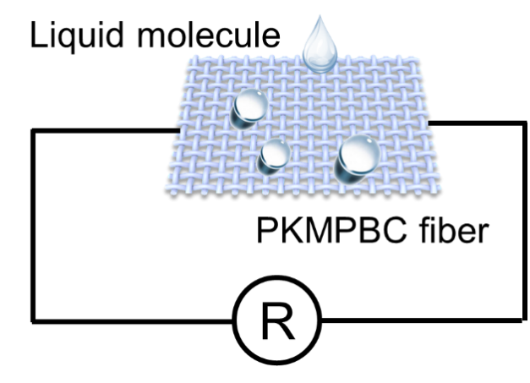
Fig. S28 Schematic diagram of liquid molecule recognition sensing system circuit (3 cm×2.5 cm)

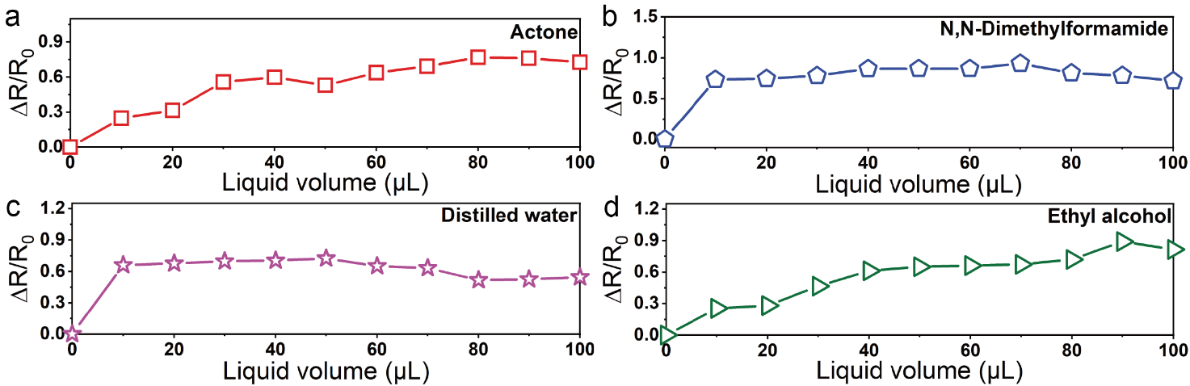
Fig. S29 Resistance changes in the recognition system at different liquid volume (0-100 μL)

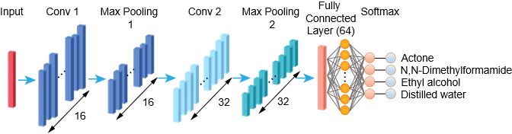
Fig. S30 Snapshots of the real classification system and process
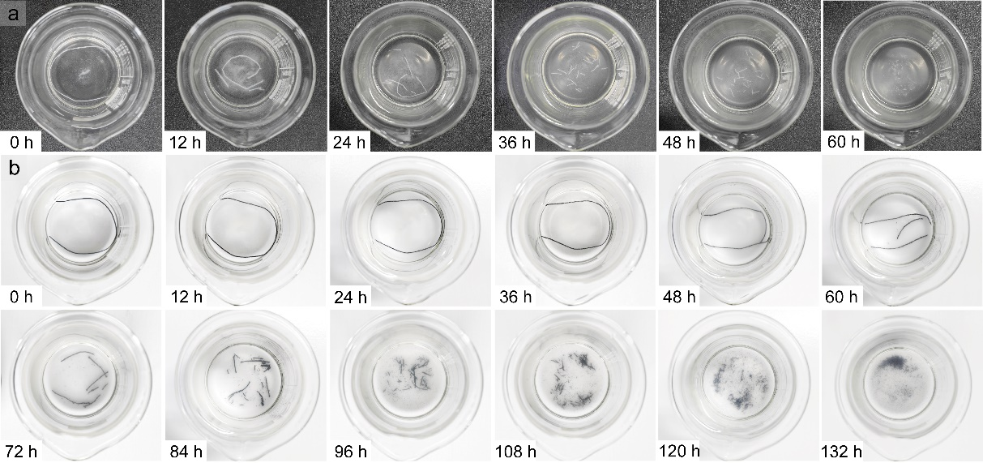
Fig. S31 Optical photographs of (a) BC and (b) PKPMBC macrofibers in the degradation experiment with the cellulase solution
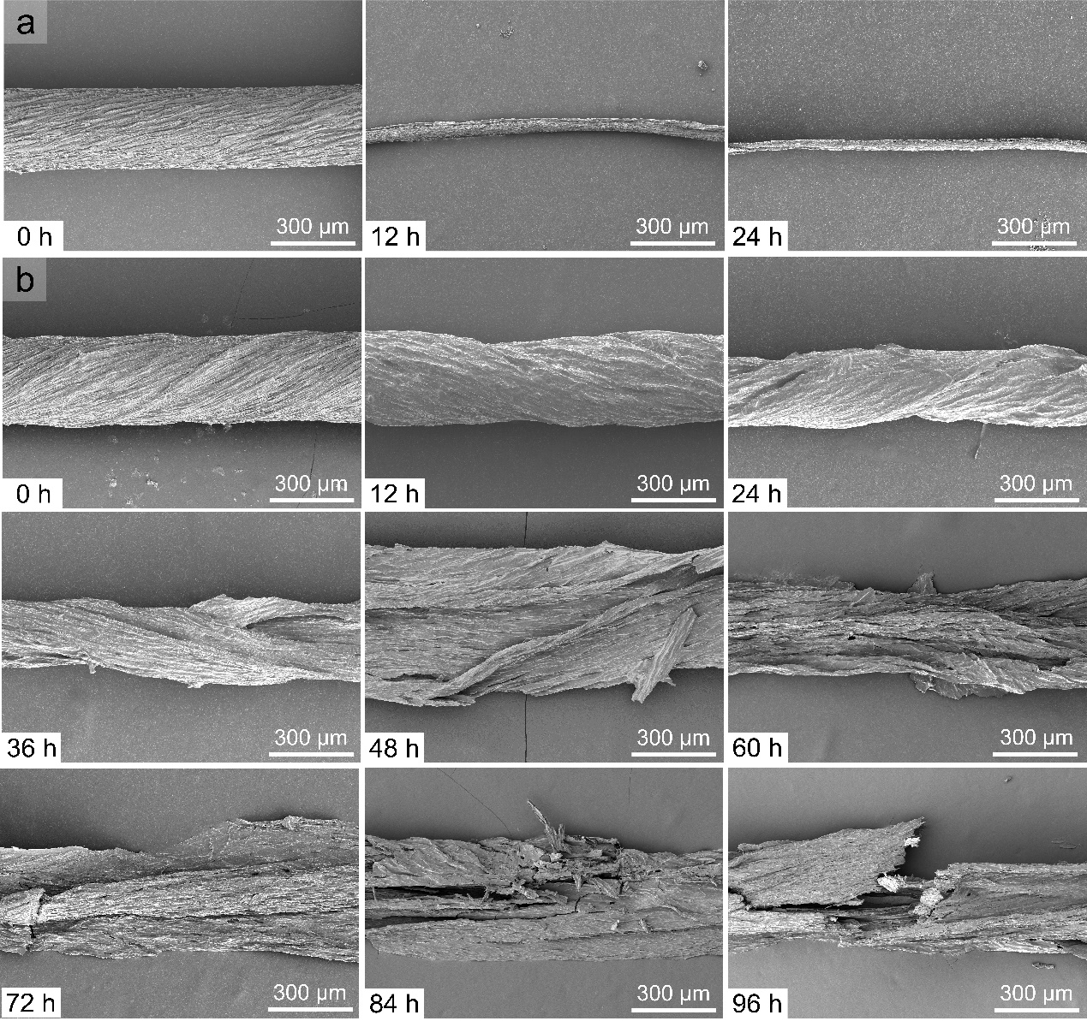
Fig. S32 SEM images of (a) BC and (b) PKMPBC macrofibers in the degradation experiment with cellulase solution
Fig. S33 The weight loss of the BC and PKMPBC macrofibers during degradation
The real-time images of the degradation process of BC and PKM₇P₃BC macrofibers every 12 hours are recorded in Fig. S31, it can be seen that the BC and PKM₇P₃BC macrofibers gradually degrade in cellulase solution. The SEM images of the degradation process of BC macrofibers in 24 h (Fig. S32) indicates that the diameter of BC macrofiber gradually decreases. During this process, the macrofibers simultaneously fragmenting until completely degradation. It can be clearly observed that the degradation process of PKM₇P₃BC macrofiber is slower than that of BC macrofiber because of the K-MXene/PEDOT:PSS ink and PDMS hydrophobic shell coating. Specifically, the PKM₇P₃BC macrofiber slowly break into several short fiber bundles within 60 h, and the internal BC nanofibers inside of macrofibers are gradually degraded. Then, K-MXene/PEDOT:PSS conductive aggregates begin to disintegrate in the cellulase solution until complete degradation within 132 h accompanied by black residues of K-MXene and PEDOT:PSS. Furthermore, the weight change of the macrofibers during degradation is also recorded, as shown in Fig. S33. During the degradation process, the mass of BC macrofibers decreases by 82% within 12 h and by 96% within 24 h. The degradation rate of BC macrofibers slows down as it approached complete degradation from 12 h to 24 h, whereas the PKM₇P₃BC macrofibers maintains a stable degradation rate. The mass of PKM₇P₃BC macrofibers decreases by approximately 50% within 36 h and by 60% within 60 h. The mass changes of BC and PKM₇P₃BC macrofibers in weight loss curve shows the same trend as the optical and SEM images.

Table S1 The comparison of different properties among different fibers
Fiber | Mechanical strength (MPa) | Conductivity (S cm⁻¹) | Strain (%) | Young's modulus (GPa) | Output  voltage | Applications | Refs.
MWCNTs/ CSF | 0.4 | 1 | 1378 | 0.49 GPa | / | Strain sensor | [S1]
MXene/CNT (95wt% MXene) | 38.4 | 2.7 | 4.7 | / | / | Piezoresistive sensor | [S2]
ANFs/MXene (2:1) | 20 | 0.171 | 2.8 | 0.395 GPa | / | Resistance sensor | [S3]
ANFs/MXene (1:1) | 20 | 0.117 | 6.8 | 0.75 GPa | / | Resistance sensor | [S3]
ANFs/MXene (1:2) | 13 | 0.05 | 7.5 | 1.74 GPa | / | Resistance sensor | [S3]
MXene | 8 | 10 | 0.46 | 20.30 GPa | 160 mV | Strain sensor | [S4]
MXene/TPU | 3.76 | 4.32 | 675 | 0.76 GPa | 20.1 V | TENG & biomechanical sensor | [S5]
MWCNTs/cellulose | 449 | 5.32 | 3 |  | 170 V | TENG | [S6]
MWCNTs/aramid fiber | 47.2 | 82 | 9.6 | / | / | Electric heater | [S7]
MXene/bacterial cellulose paper | 109.6 | 50.2 | 11.2 | 2.4 GPa | / | Electromagnetic shielding | [S8]
d-Ti₃C₂T_{X}/CNFs | 135.4 | 7.39 | 16.7 | 3.8 GPa | / | Electromagnetic shielding | [S9]
MXene/rGO (88 wt% MXene) | 132.5 | 72.3 | 2.9 | / | / | Supercapacitors | [S10]
MXene/GO/cellulose fiber | 162.5 | 368.2 | 6.7 | 9.0 GPa | / | Electromagnetic shielding | [S11]
MXene/PEDOT:PSS | 58.7 | 1489 | 2 | 7.5 GPa | / | Supercapacitors | [S12]
PKMPBC macrofiber | 434 | 10.1 | 4.1 | 25.9 GPa | 272.5 V | TENG & biomechanical sensor | This work

Table S2 The combination properties comparison with other similar materials
Fiber | Response/  recovery time | Filler contents | Conductivity | Permeability | Stability | Refs.
Kevlar/  MXene | 90 ms/110 ms | 1 wt% | 0.17 S m⁻¹ | / | / | [S13]
CNT/MXene/TPU | 89 ms | 4 wt% (CNT); 1 wt% (MXene) | 13.1 S cm⁻¹ | / | 1000 | [S14]
CB/MXene/  plant fiber@PDMS | 40 ms/100 ms | 30 wt% | ≈ 2kΩ | / | 5000 | [S15]
MXene/GO-AgNWs | 69 ms/71 ms | MXene: 10 mg mL⁻¹ |  | 800±50 mm/s | 1000 | [S16]
MXene  /PVA | / | MXene: 40 wt% | 0.28 S cm⁻¹ | / | / | [S17]
PKMPBC macrofiber | 45 ms/68 ms | MXene: 20 mg mL⁻¹ | 10.05 S cm⁻¹ | / | 2700 | This work

Table S3 The parameters for constructing Convolution Netural Network (CNN)
Layer Type | Parameters | Output Shape
Input | Length = 4000, Channels = 1 | [4000, 1]
1D Convolution + BN + ReLU | Kernel Size = 5, Filters = 16 | [4000, 16]
MaxPooling1D | Pool Size = 2, Stride = 2 | [2000, 16]
1D Convolution + BN + ReLU | Kernel Size = 5, Filters = 32 | [2000, 32]
MaxPooling1D | Pool Size = 2, Stride = 2 | [1000, 32]
Global Average Pooling 1D | - | -
Fully Connected (Dense) | Units = 64 | [64]
ReLU Activation | - | -
Fully Connected (Dense) | Units = 4 (number of classes) | [4]
Softmax | - | [4]
Classification Layer | Cross-entropy loss | [4]
Supplementary Movies
Movie S1 The flexibility of PKT-TENG
Movie S2 Output performance of PKF-TENG under pouring liquids
Movie S3 Detecting motion signals after pouring water
Supplementary References
- Z. Tang, S. Jia, F. Wang, C. Bian, Y. Chen et al., Highly stretchable core-sheath fibers via wet-spinning for wearable strain sensors. ACS Appl. Mater. Interfaces 10(7), 6624–6635 (2018). https://doi.org/10.1021/acsami.7b18677
- Y. Ma, N. Liu, L. Li, X. Hu, Z. Zou et al., A highly flexible and sensitive piezoresistive sensor based on MXene with greatly changed interlayer distances. Nat. Commun. 8(1), 1207 (2017). https://doi.org/10.1038/s41467-017-01136-9
- B. Cheng, P. Wu, Scalable fabrication of kevlar/Ti₃C₂T_{x} MXene intelligent wearable fabrics with multiple sensory capabilities. ACS Nano 15(5), 8676–8685 (2021). https://doi.org/10.1021/acsnano.1c00749
- S. Seyedin, S. Uzun, A. Levitt, B. Anasori, G. Dion et al., MXene composite and coaxial fibers with high stretchability and conductivity for wearable strain sensing textiles. Adv. Funct. Mater. 30(12), 1910504 (2020). https://doi.org/10.1002/adfm.201910504
- Y. Hao, Y. Zhang, A. Mensah, S. Liao, P. Lv et al., Scalable, ultra-high stretchable and conductive fiber triboelectric nanogenerator for biomechanical sensing. Nano Energy 109, 108291 (2023). https://doi.org/10.1016/j.nanoen.2023.108291
- S. Hu, J. Han, Z. Shi, K. Chen, N. Xu et al., Biodegradable, super-strong, and conductive cellulose macrofibers for fabric-based triboelectric nanogenerator. Nanomicro Lett. 14(1), 115 (2022). https://doi.org/10.1007/s40820-022-00858-w
- B. Yang, X. Ding, M. Zhang, L. Wang, Scalable electric heating paper based on CNT/Aramid fiber with superior mechanical and electric heating properties. Compos. Part B Eng. 224, 109242 (2021). https://doi.org/10.1016/j.compositesb.2021.109242
- H. Liu, Z. Cui, L. Luo, Q. Liao, R. Xiong et al., Facile fabrication of flexible and ultrathin self-assembled Ti₃C₂T/bacterial cellulose composite films with multifunctional electromagnetic shielding and photothermal conversion performances. Chem. Eng. J. 454, 140288 (2023). https://doi.org/10.1016/j.cej.2022.140288
- W.-T. Cao, F.-F. Chen, Y.-J. Zhu, Y.-G. Zhang, Y.-Y. Jiang et al., Binary strengthening and toughening of MXene/cellulose nanofiber composite paper with nacre-inspired structure and superior electromagnetic interference shielding properties. ACS Nano 12(5), 4583–4593 (2018). https://doi.org/10.1021/acsnano.8b00997
- S. Seyedin, E.R.S. Yanza, J. Razal, Knittable energy storing fiber with high volumetric performance made from predominantly MXene nanosheets. J. Mater. Chem. A 5(46), 24076–24082 (2017). https://doi.org/10.1039/c7ta08355f
- L.-X. Liu, W. Chen, H.-B. Zhang, Y. Zhang, P. Tang et al., Tough and electrically conductive Ti₃C₂T_{x} MXene–based core–shell fibers for high–performance electromagnetic interference shielding and heating application. Chem. Eng. J. 430, 133074 (2022). https://doi.org/10.1016/j.cej.2021.133074
- J. Zhang, S. Seyedin, S. Qin, Z. Wang, S. Moradi et al., Highly conductive Ti₃C₂T_{x} MXene hybrid fibers for flexible and elastic fiber-shaped supercapacitors. Small 15(8), 1804732 (2019). https://doi.org/10.1002/smll.201804732
- B. Cheng, P. Wu, Scalable fabrication of kevlar/Ti₃C₂T_{x} MXene intelligent wearable fabrics with multiple sensory capabilities. ACS Nano 15(5), 8676–8685 (2021). https://doi.org/10.1021/acsnano.1c00749
- L. Lan, C. Jiang, Y. Yao, J. Ping, Y. Ying, A stretchable and conductive fiber for multifunctional sensing and energy harvesting. Nano Energy 84, 105954 (2021). https://doi.org/10.1016/j.nanoen.2021.105954
- T. Chen, Z. Liu, G. Zhao, Z. Qin, P. Zheng et al., Piezoresistive sensor containing lamellar MXene-plant fiber sponge obtained with aqueous MXene ink. ACS Appl. Mater. Interfaces 14(45), 51361–51372 (2022). https://doi.org/10.1021/acsami.2c15922
- Z.M. Abay, Y. Wei, Z. Tang, Y. Liu, K. Chen et al., Versatile MXene/(GO-AgNWs) electronic textile enabled by mixed-scale assembly strategy. Nano Energy 139, 110963 (2025). https://doi.org/10.1016/j.nanoen.2025.110963
- M. Wei, N. Wu, B. Li, J. Liu, F. Pan et al., From MXene to multimodal-responsive smart, durable electromagnetic interference shielding textiles. Adv. Funct. Mater. 35(28), 2424312 (2025). https://doi.org/10.1002/adfm.202424312

