Supplementary Information for
High Durability Sliding TENG with Enhanced Output Achieved by Capturing Multiple Region Charges for Harvesting Wind Energy
Wencong He^{1, *}, Yunchuan Liu¹, Junhao Jin¹, Jiahao Cai¹, Buyong Wan¹, Jie Chen¹, Xiaohong Yang^{1, *} and Chenguo Hu^{2, *}
¹ College of Physics and Electronic Engineering, Chongqing Normal University, Chongqing 401331, P. R. China
² School of Physics, Chongqing Key Laboratory of Soft Condensed Matter Physics and Smart Materials, Chongqing University, Chongqing 400044, P. R. China
* Corresponding authors. E-mail: hewc@cqnu.edu.cn (Wencong He); xiaohongyang@cqnu.edu.cn (Xiaohong Yang); hucg@cqu.edu.cn (Chenguo Hu)
Supplementary Figures

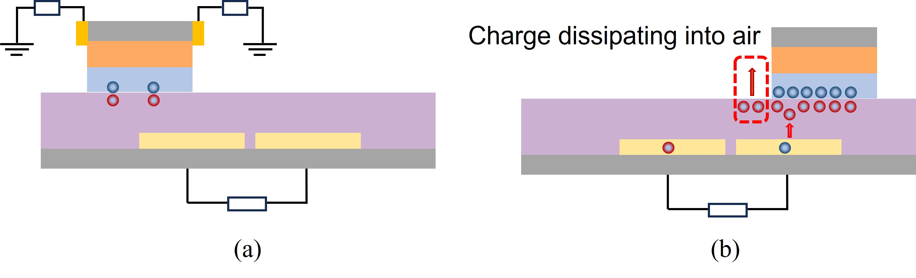

Fig. S1 Charge Dissipation Principle of TENG. a Initial work phase of TENG. b TENG charge dissipation operation without side electrodes
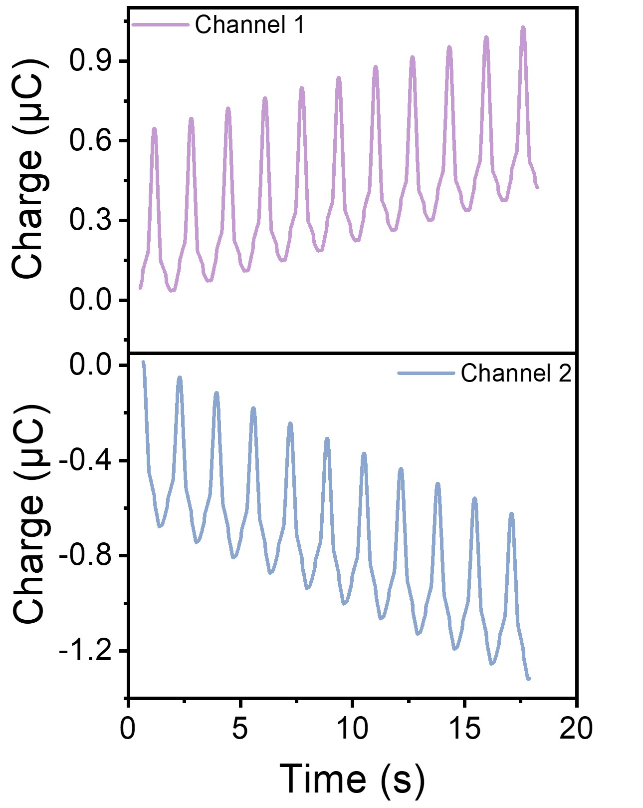

Fig. S2 Dual channel transfer charge of DC TENG

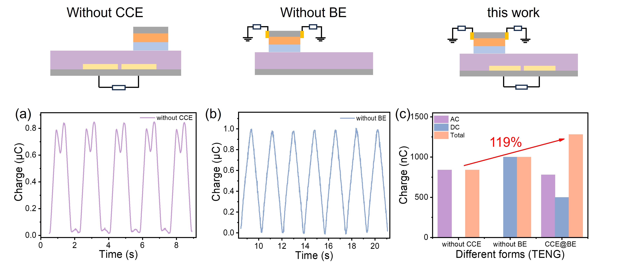

Fig. S3 Charge transfer in different types of TENGs. a Charge transfer without a collection electrode on the slider. b Charge transfer without a bottom electrode on the stator. c Comparison of charge transfer with both a collection electrode and a bottom electrode

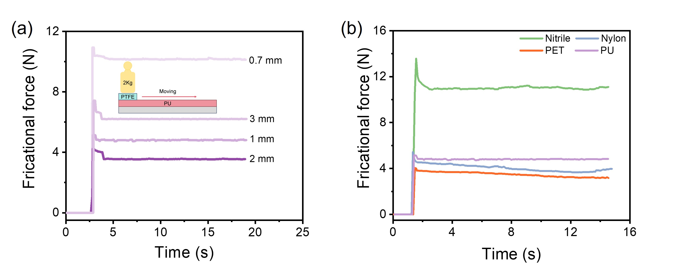

Fig. S4 The friction coefficient of the materials. a The friction coefficients of different PUs. b The friction coefficients of different stator dielectric materials
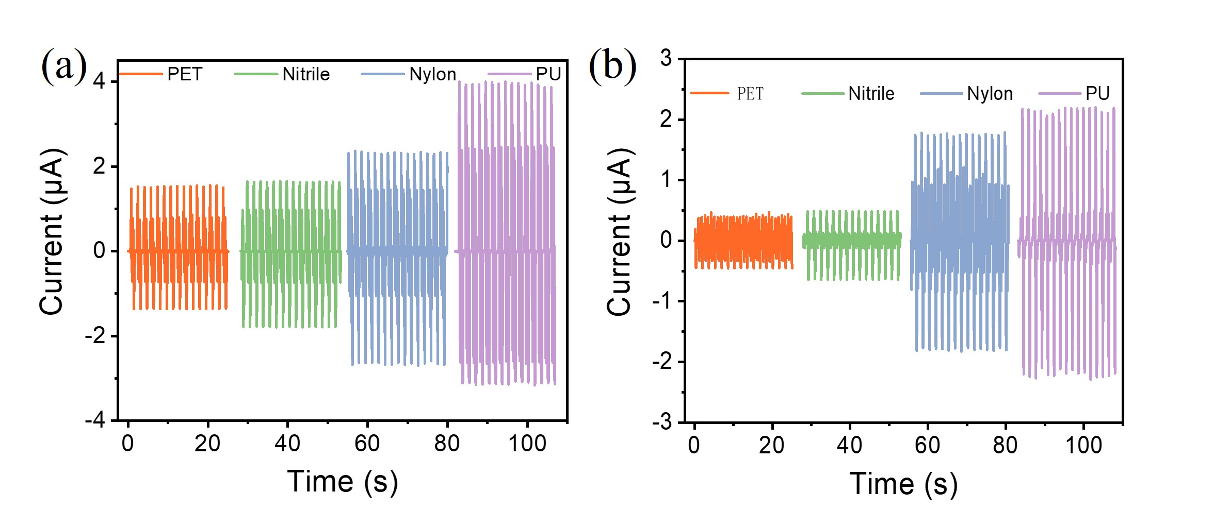

Fig. S5 Current output for different dielectric materials of stator. a AC currents of different positive dielectric materials. b DC currents of different positive dielectric materials

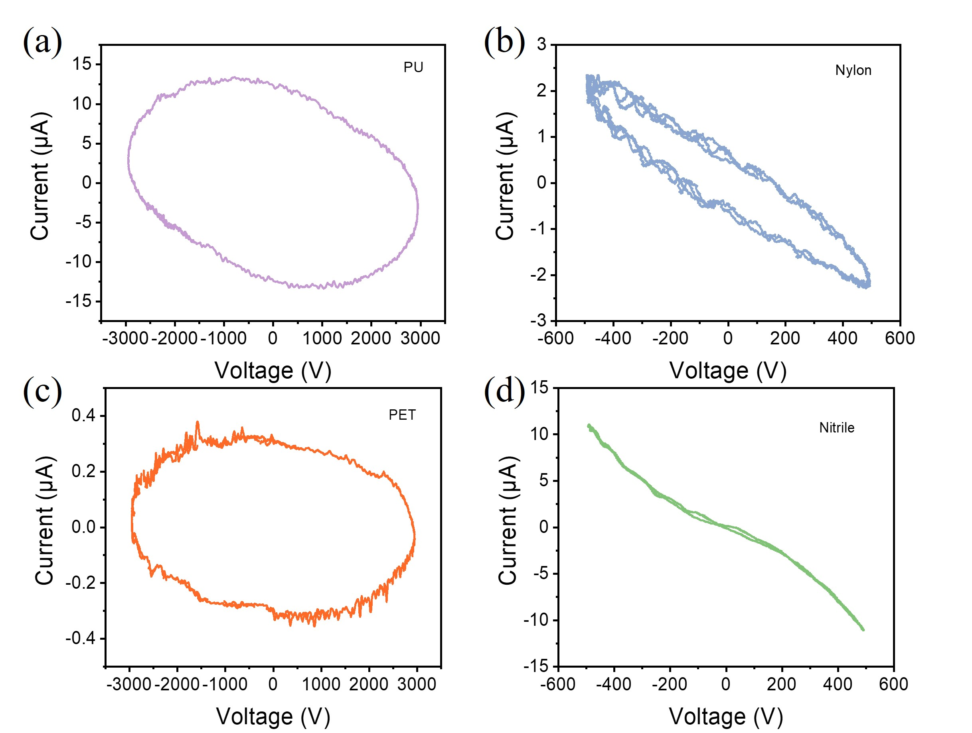

Fig. S6 I-V curves of different positive materials

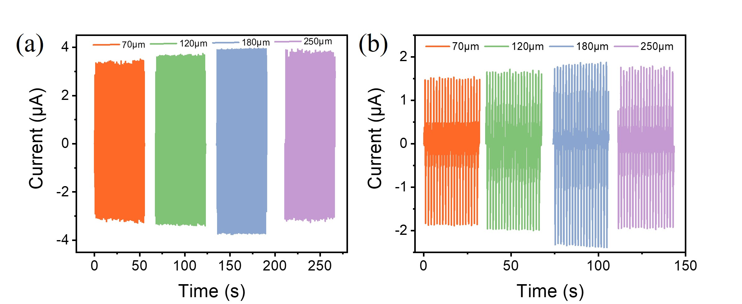

Fig. S7 Current output for different thicknesses of PTFE. a AC current output for PTFE of different thicknesses. d DC current output for PTFE of different thicknesses
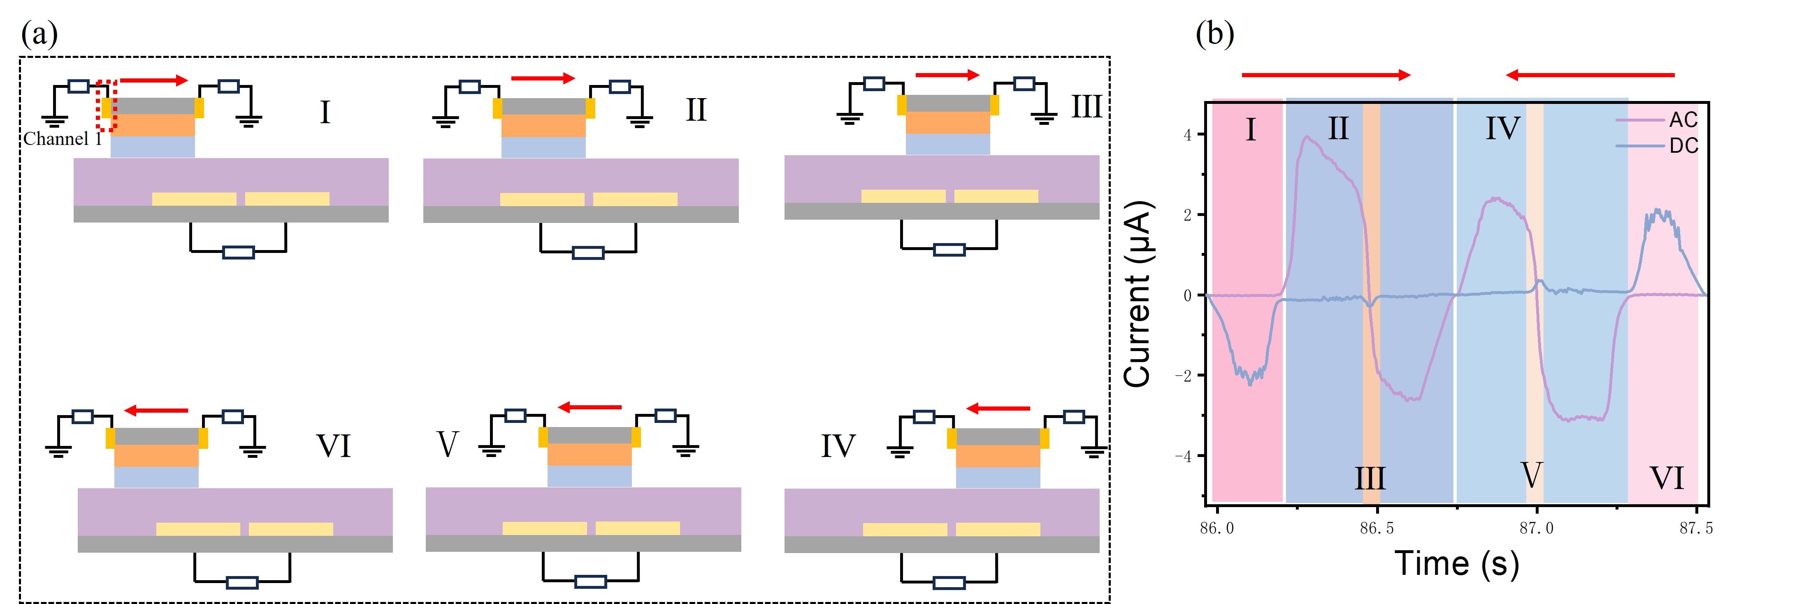

Fig. S8 Current output characteristics. a Different stages of work. b AC and DC short-circuit current output generated by the Channel 1 electrode and the bottom electrode of the slider at different positions

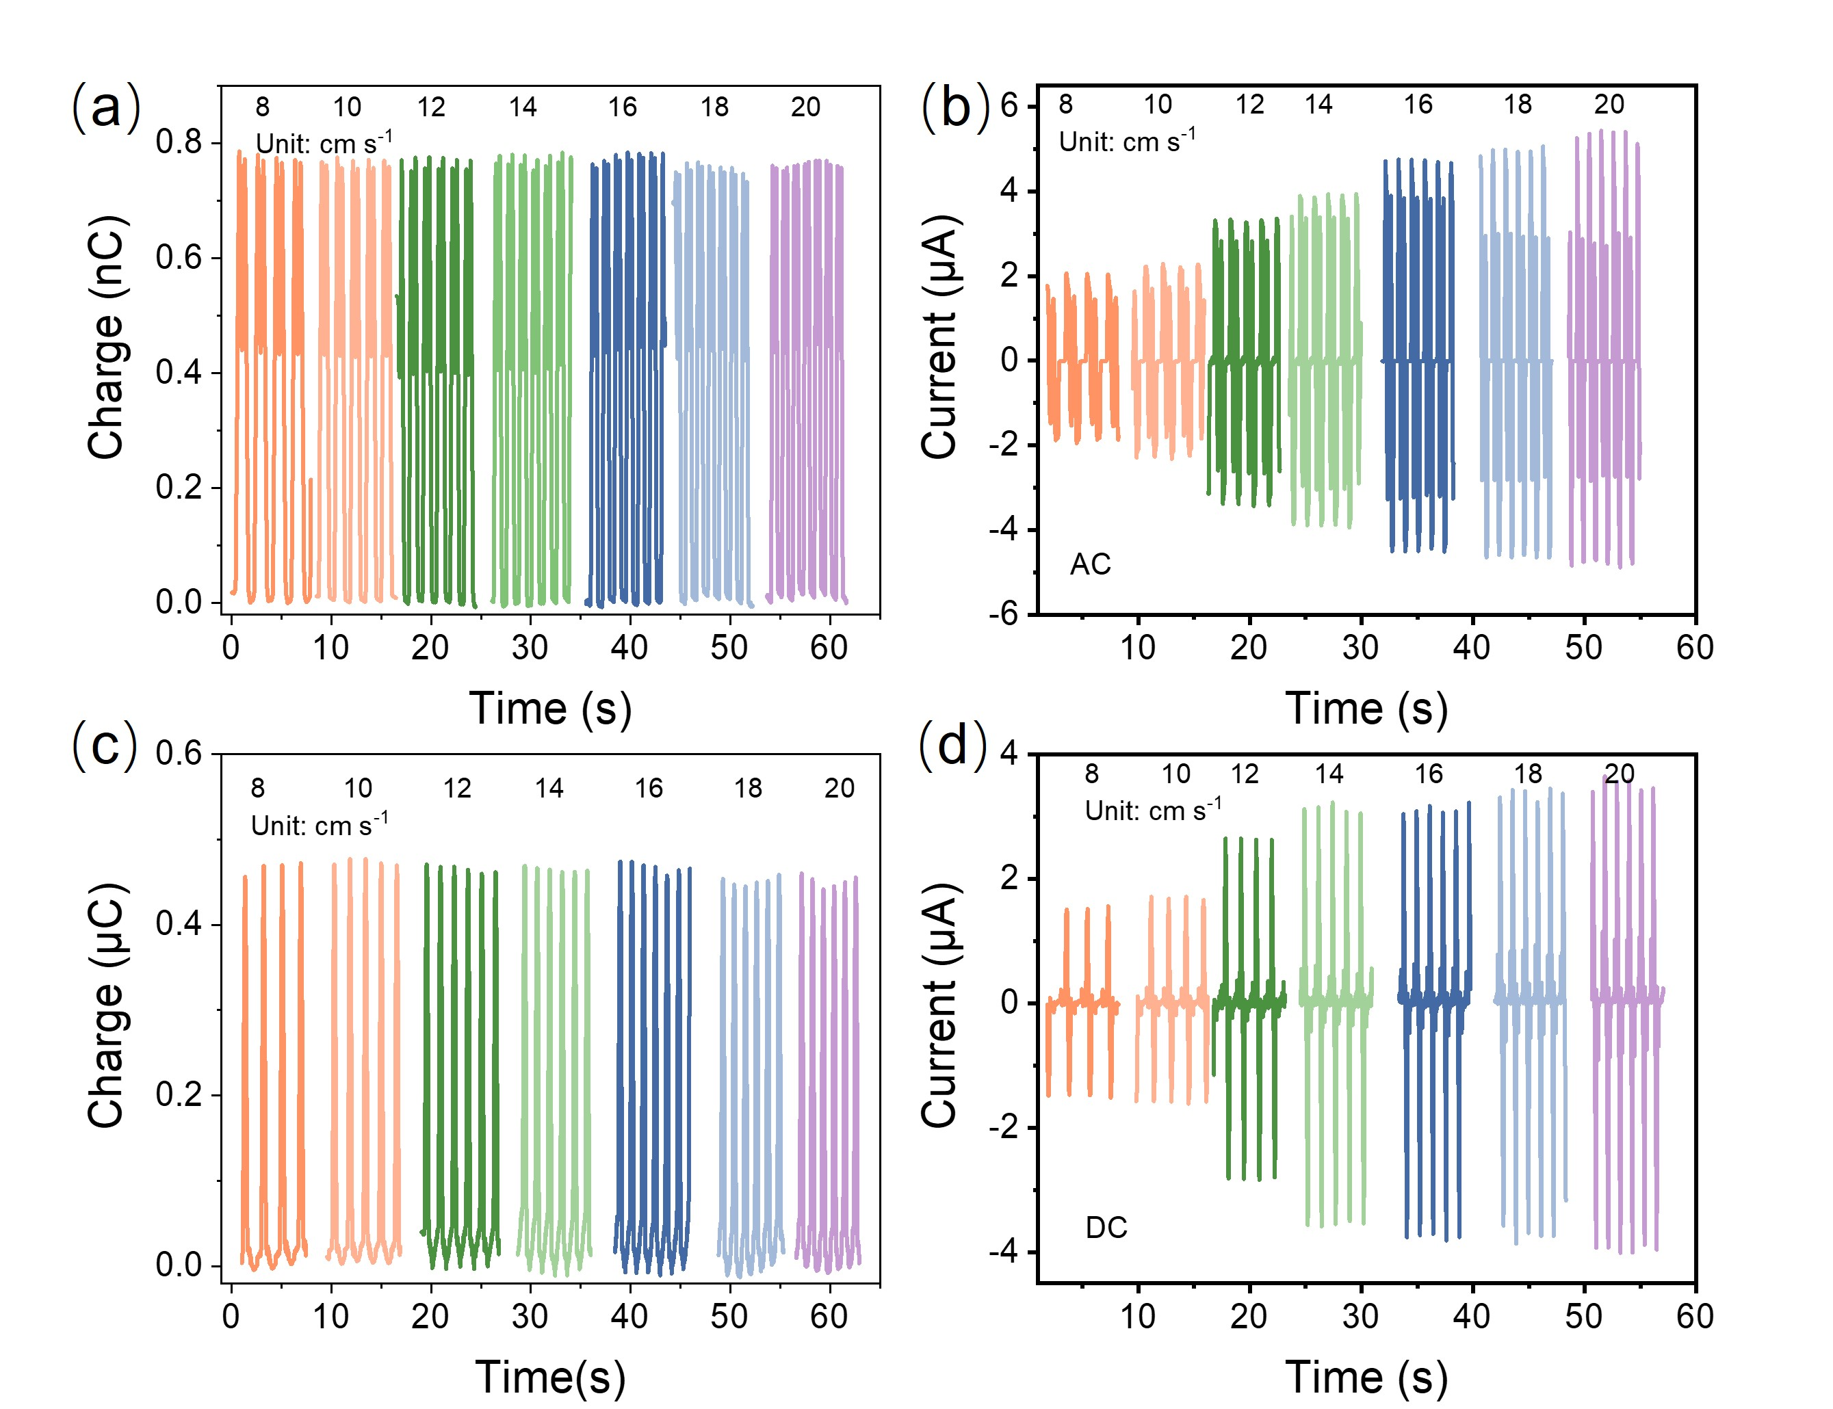

Fig. S9 The short-circuit current and the transferred charge of the sliding-type TENG under different speeds. a, b Transfer charge and short-circuit currents in AC. c, d Transfer charge and short-circuit currents in DC

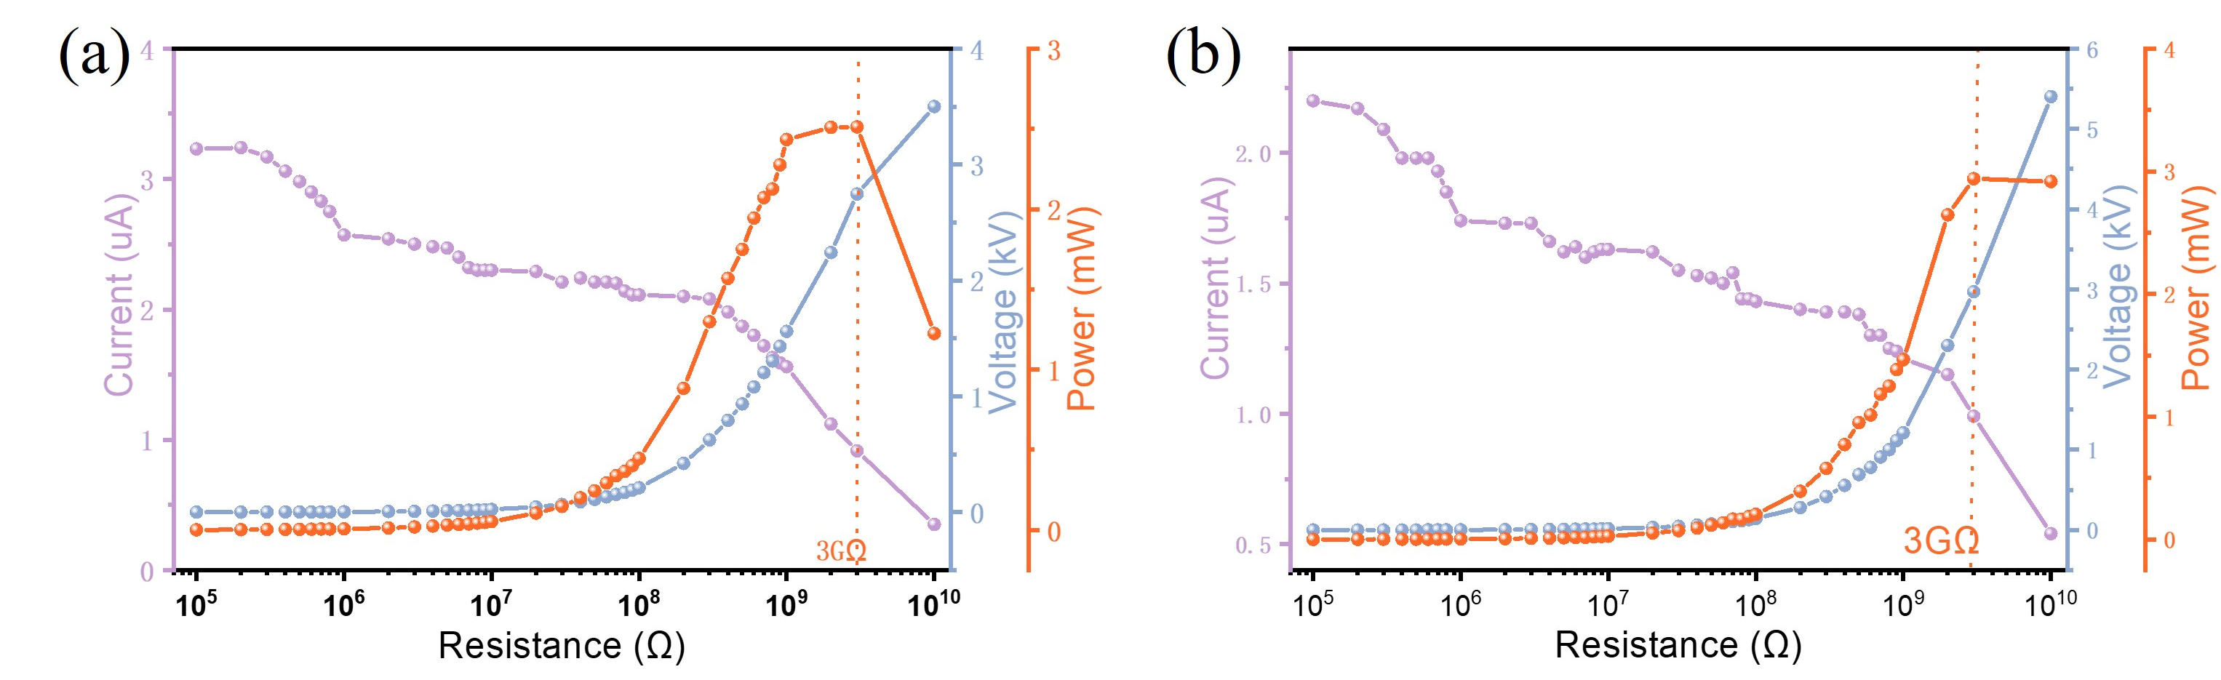Fig. S10 The short-circuit current and voltage of the sliding-type TENG under different resistances

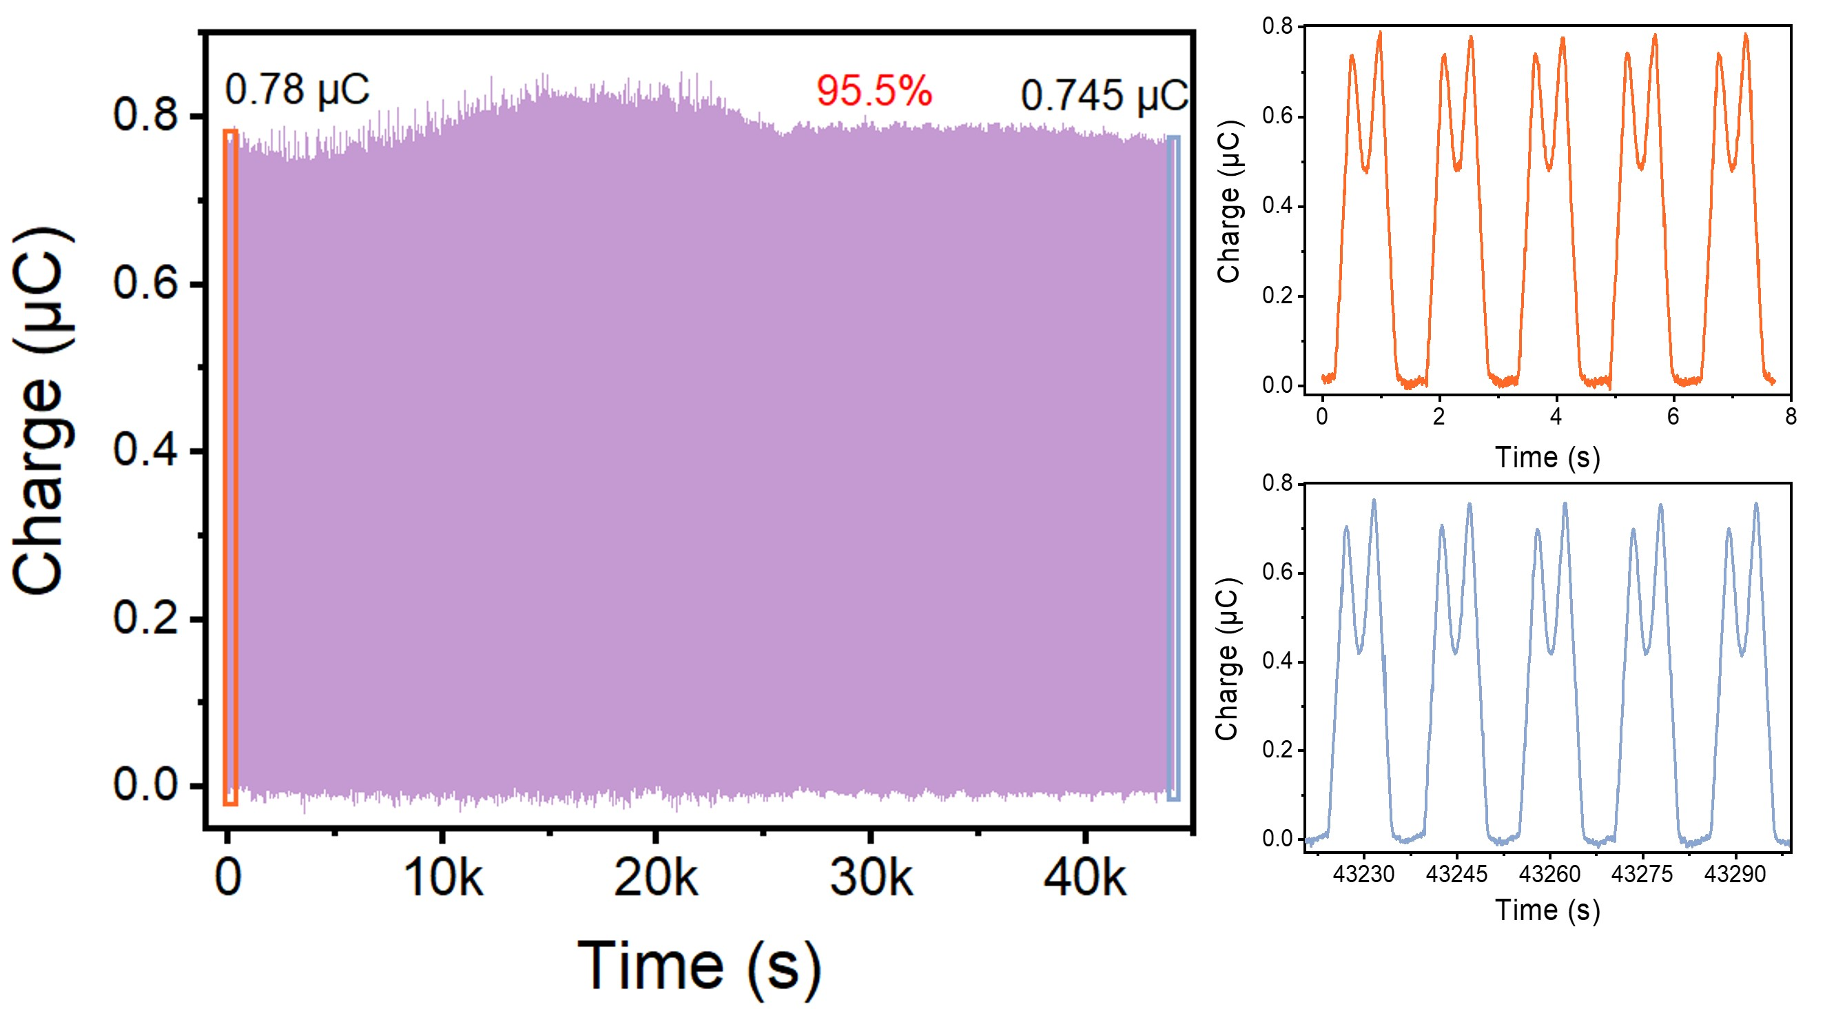

Fig. S11 Durability test of the sliding-type DDO-TENG, charge transfer from the beginning to after 12 hours

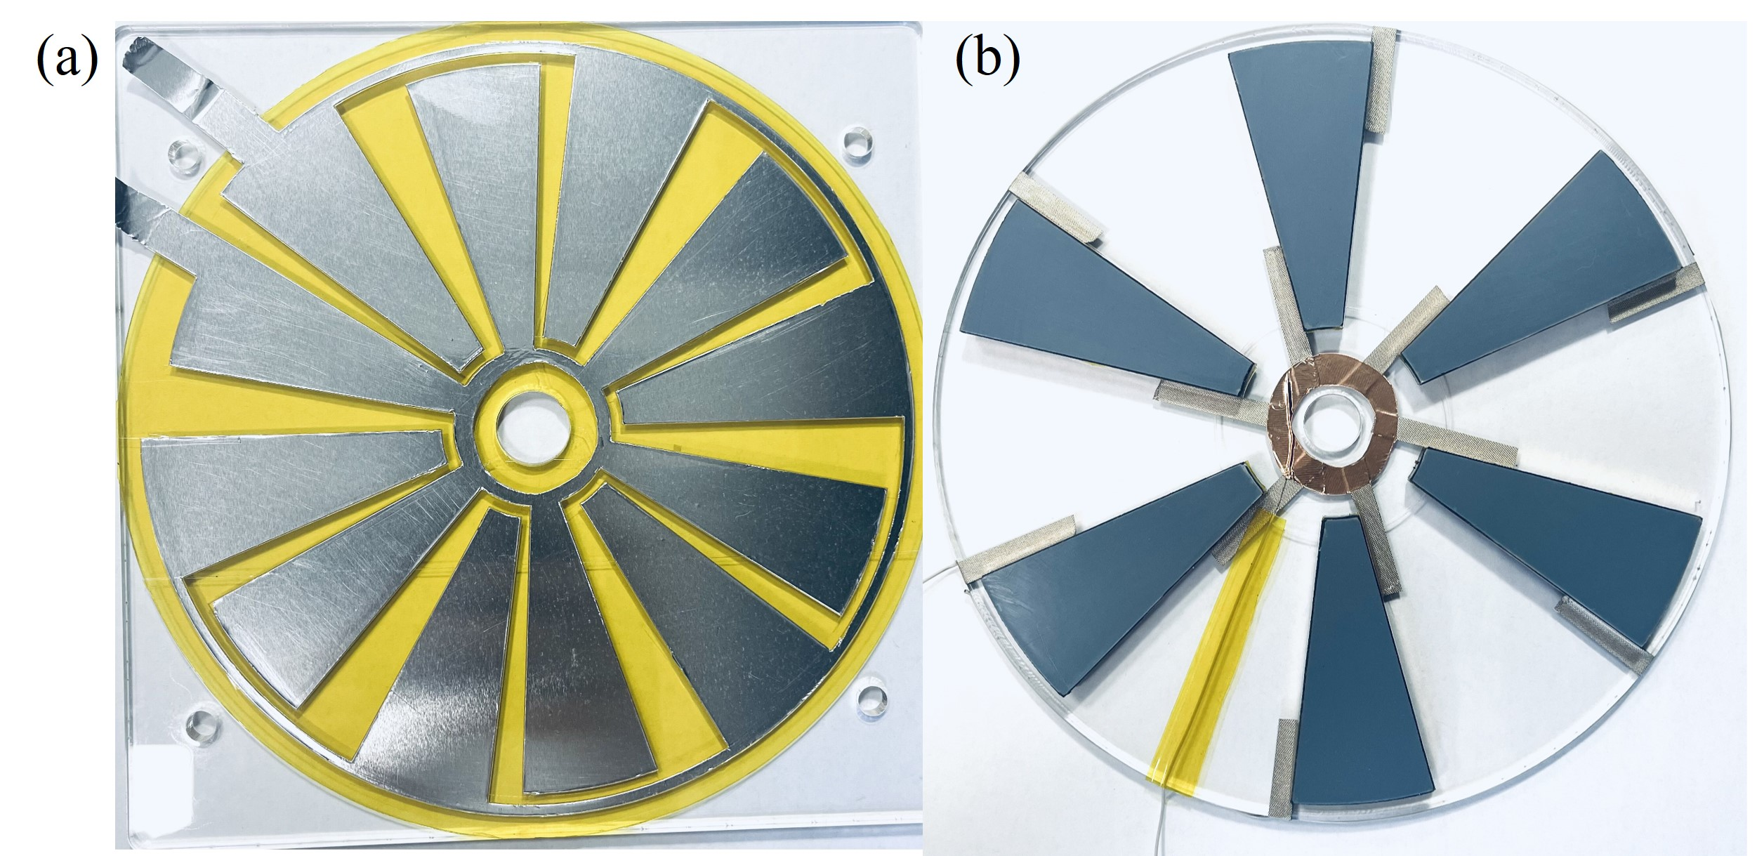
Fig. S12 Optical photos of the rotating type DDO-TENG. a Schematic diagram of the stator. b Schematic diagram of the rotor
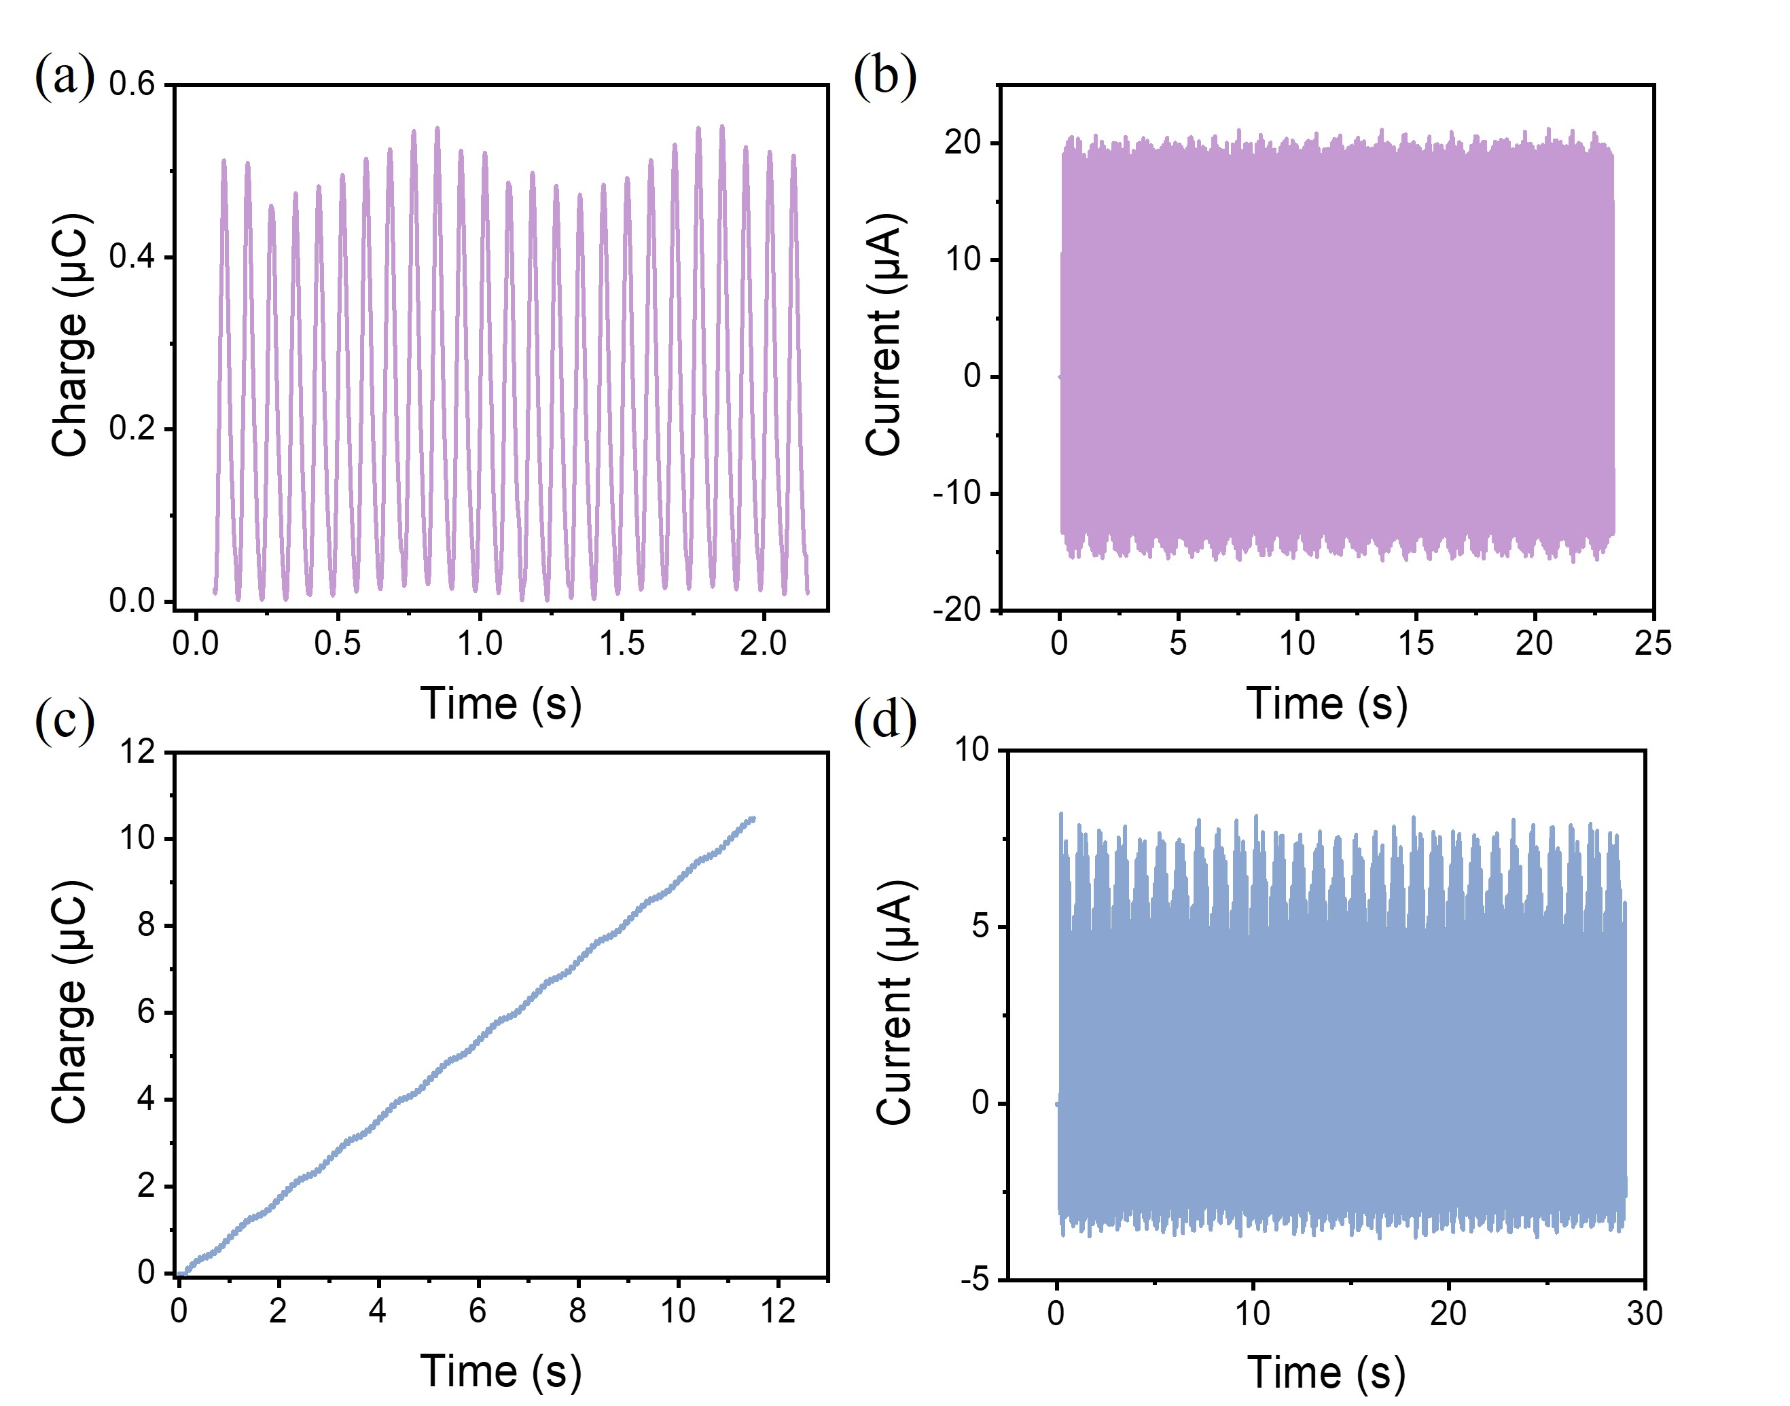

Fig. S13 Output performance of the rotary DDO-TENG with 12 pairs of electrodes. a Charge transfer of the bottom electrode. b Current output of the bottom electrode. c Charge transfer of the rotor electrode. d Current output of the rotor electrode

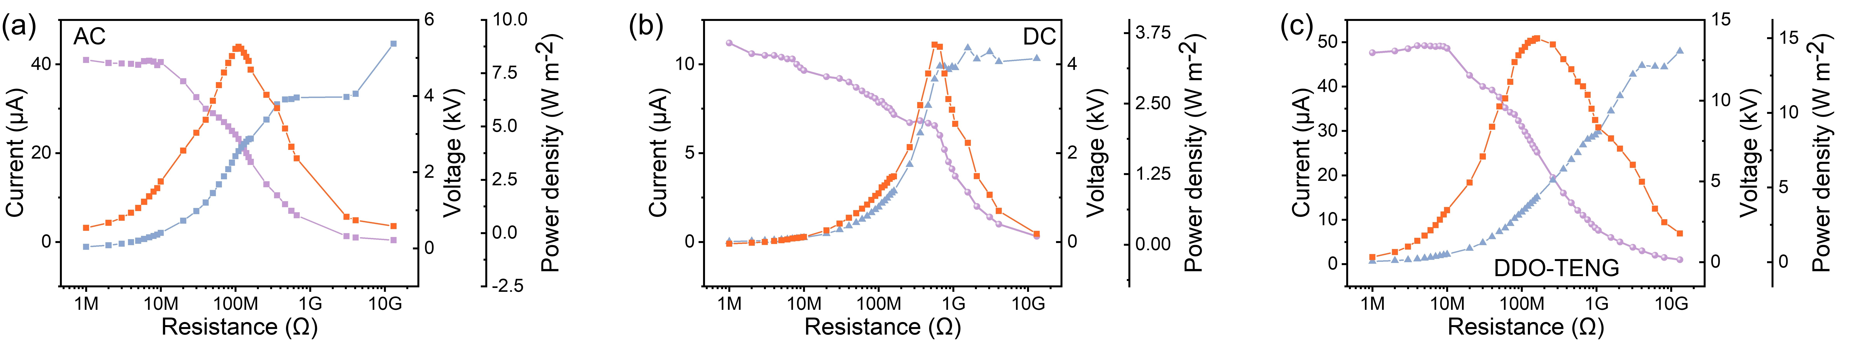

Fig. S14 The short-circuit current and voltage of the rotary DDO-TENG under different resistances
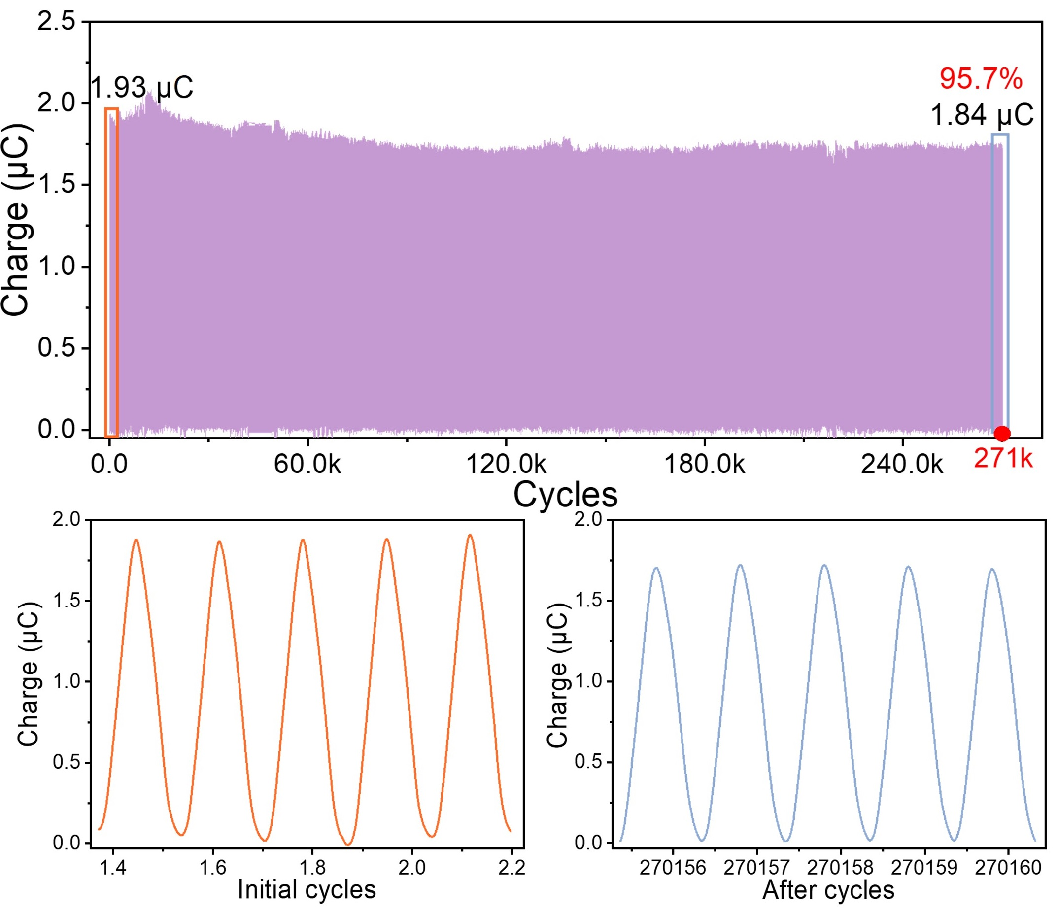

Fig. S15 The specific transferred charges at the initial stage and after cycling

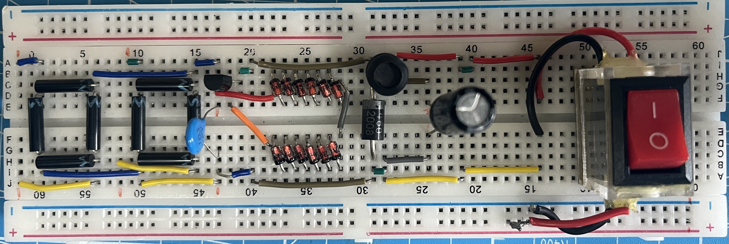

Fig. S16 Optical picture of the power management circuit

