Supporting Information for
Modulation of Trichromatic Emission Centers in Organic–Inorganic Hybrids for Optoelectronic Applications
Weidong Cai¹, Chongyuan Li¹, Qiang Guo¹, Fuxiang Ji², Muyi Zhang³, Yiqiang Zhan¹*
¹College of Future Information Technology, Fudan University, Shanghai 200438, P. R. China
²Institute of Computational Physics, Zurich University of Applied Sciences, Technikumstrasse 71, Winterthur 8400, Switzerland
³Department of Physics, Chemistry, and Biology (IFM), Linköping University, Linköping SE-58183, Sweden
*Corresponding author. E-mail: yqzhan@fudan.edu.cn (Yiqiang Zhan)
Supplementary Figures and Tables
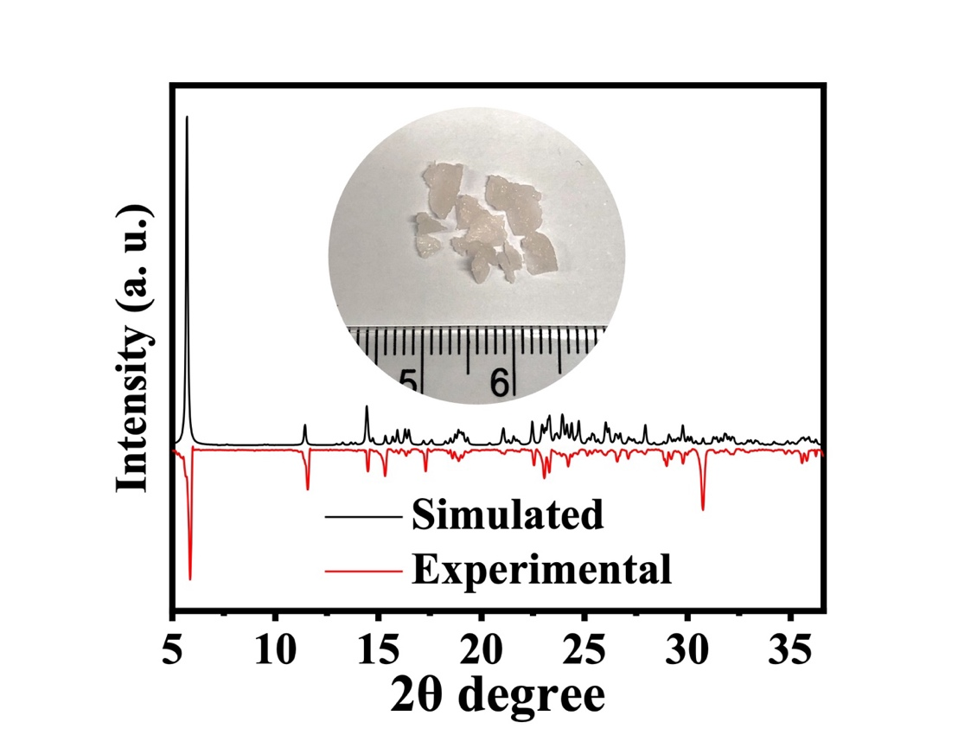
Fig. S1 Experimental and simulated XRD patterns with inserted optical photo of (NEA)₂MnBr₄ crystal

Fig. S2 PL decay curves of the (NEA)₂MnBr₄ at the emission wavelengths of 425 nm and 660 nm
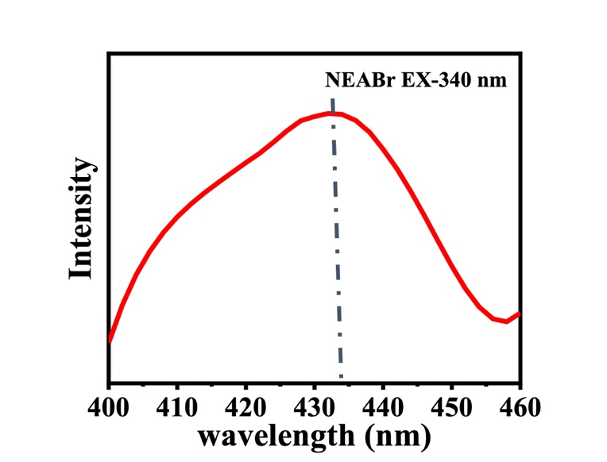
Fig. S3 PL spectra of precursor NEABr under excitation wavelength of 340 nm
Fig. S4 Photoluminescence excitation (PLE) pattern of precursor NEABr film at emission peak 435 nm and (NEA)₂MnBr₄ film at emission peak 425 nm and 660 nm
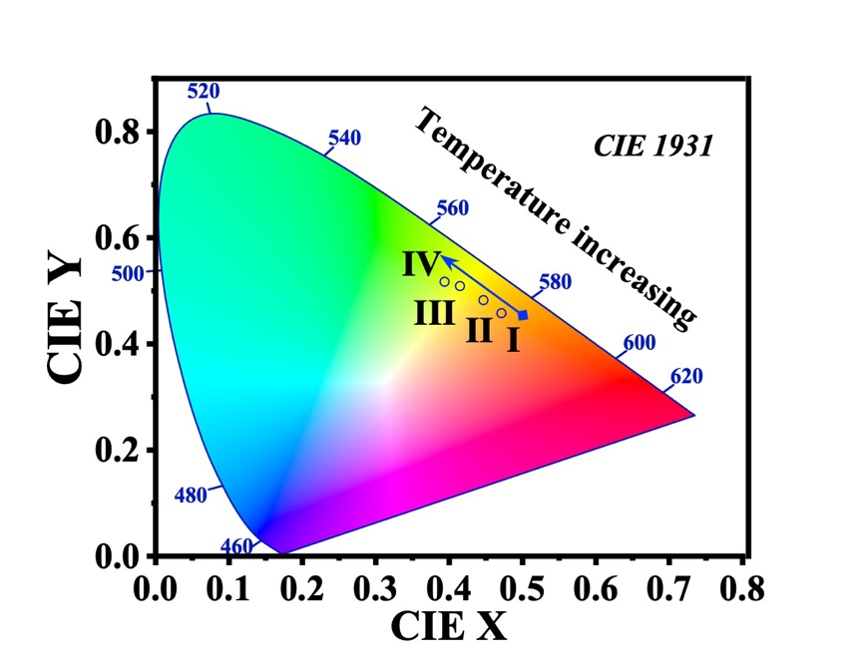
Fig. S5 CIE coordinates of (NEA)₂MnBr₄ film under different temperatures
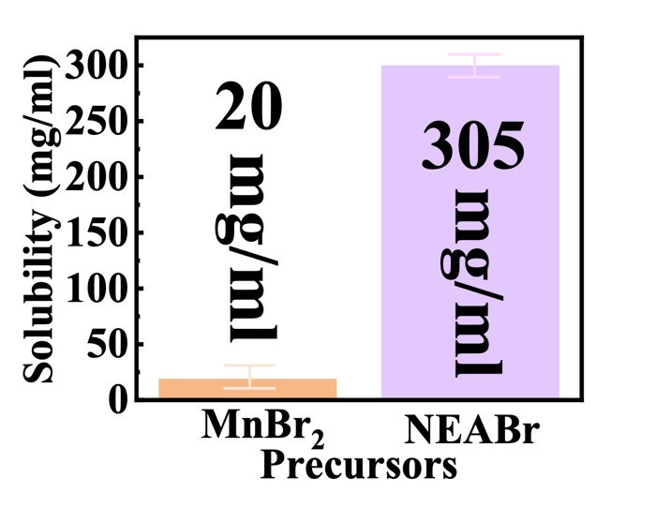
Fig. S6 Solubility bar graph of precursors NEABr and MnBr₂

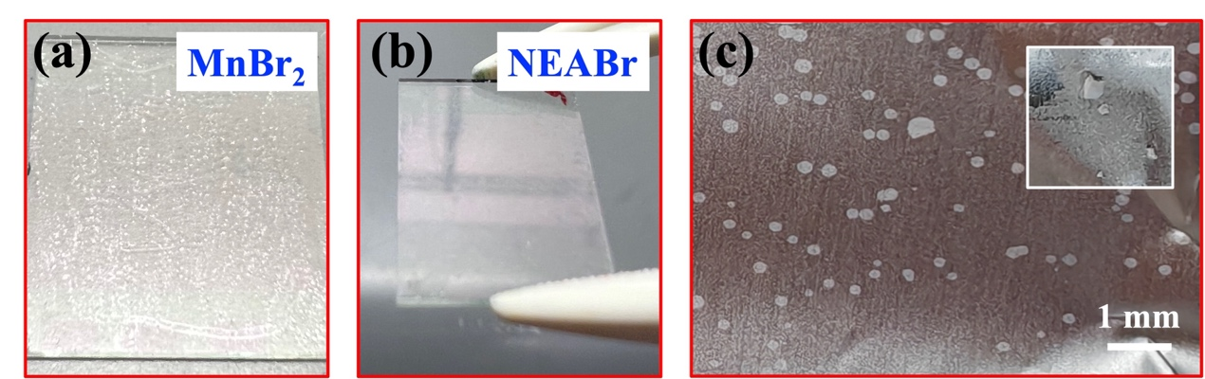
Fig. S7 The spin-coated film of precursors (a) MnBr₂ and (b) NEABr (c) MnBr₂ particles on the tin foil inside the spin coater

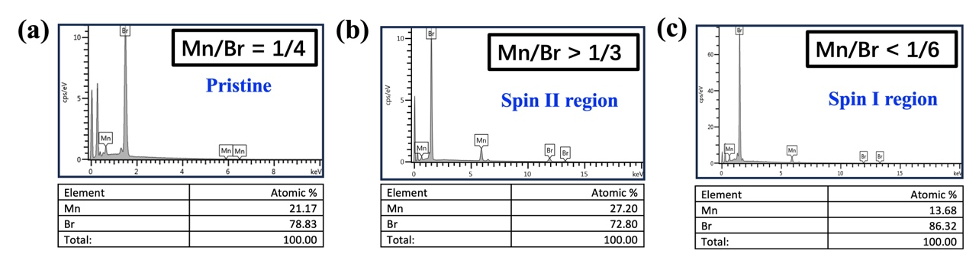
Fig. S8 Energy dispersive X-ray spectroscopy (EDS) results of (a) pristine crystal (NEA)₂MnBr₄, (b) spin-coated films in region II and (c) spin-coated films in region I
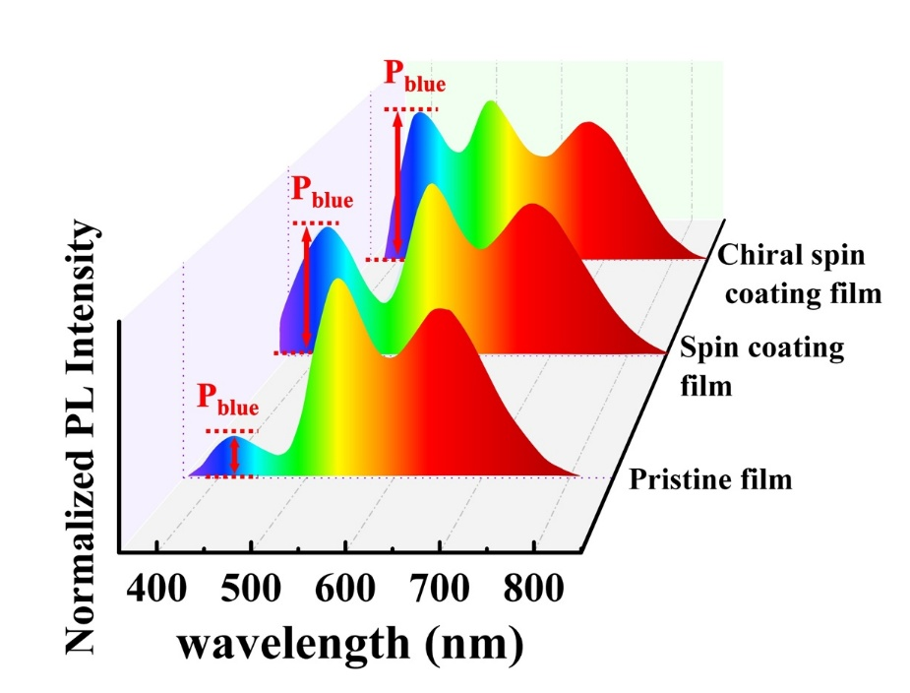
Fig. S9 PL spectra of pristine film, spin coating film and chiral spin coating film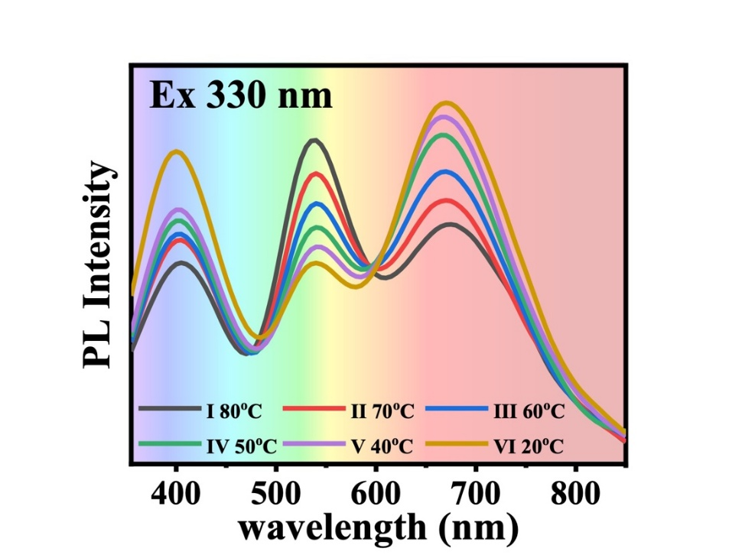
Fig. S10 PL spectrum of (NEA)₂MnBr₄ film under different temperatures
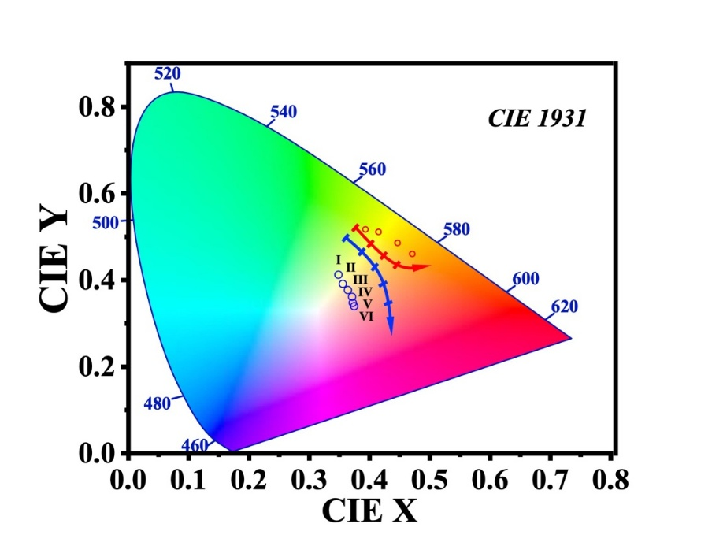
Fig. S11 Corresponding CIE coordinates of spin coating film and drop casting film under different temperatures
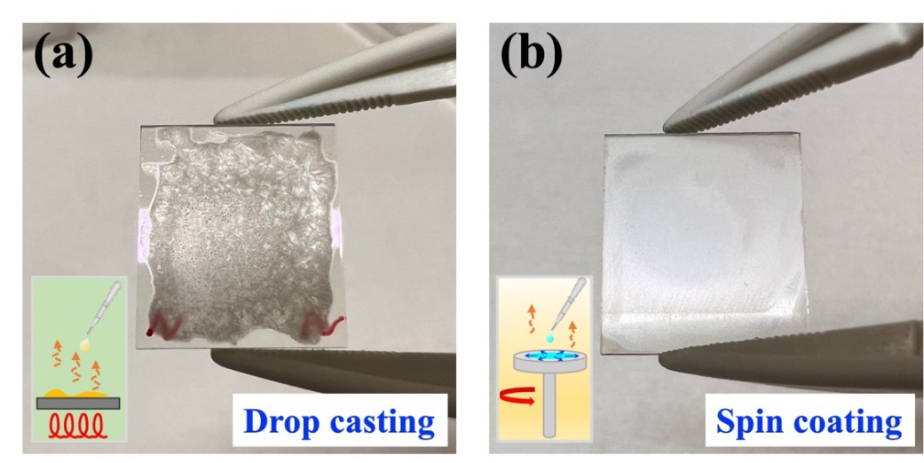
Fig. S12 The (NEA)₂MnBr₄ film is obtained by (a) the drop casting method and (b) the spin coating method
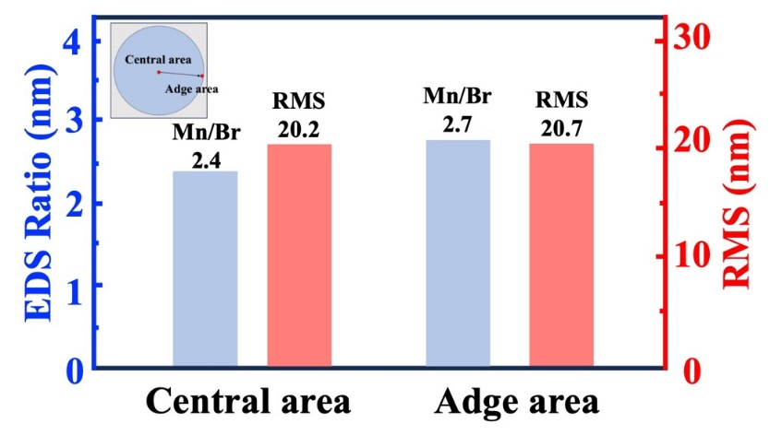
Fig. S13 Statistical histogram of film component ratio (EDS) and roughness (AFM) in the center and edge areas of the spin-coated film
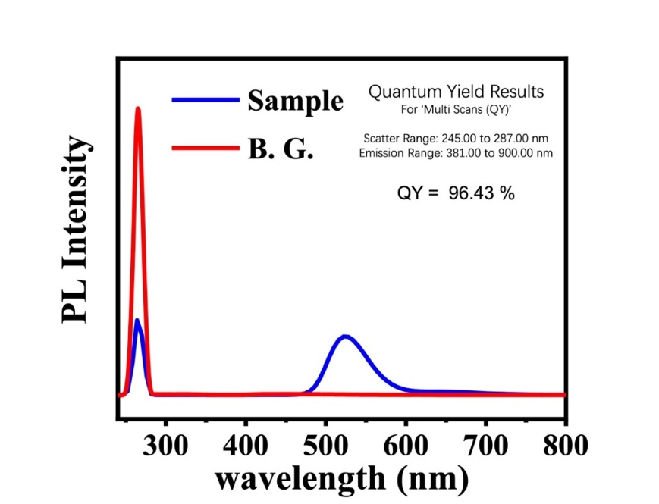
Fig. S14 The PLQY of (NEA)₂MnBr₄ film
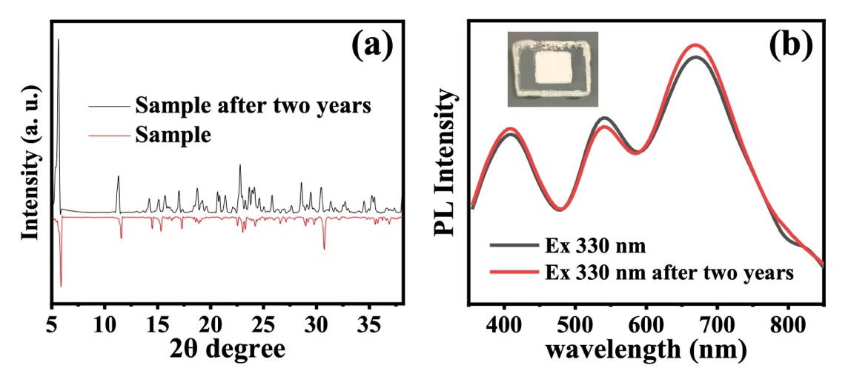
Fig. S15 XRD and PL Stability measurements of (NEA)₂MnBr₄ after sample with encapsulation is placed in air after two years
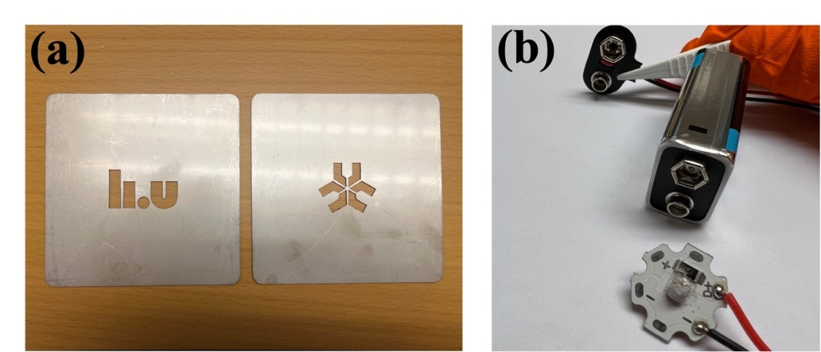
Fig. S16 (a) Templates for spray-painting the university logo. (b) We collect powder after spin coating on substrate, then cover them inside the protective glass of LED chips to light up the LED
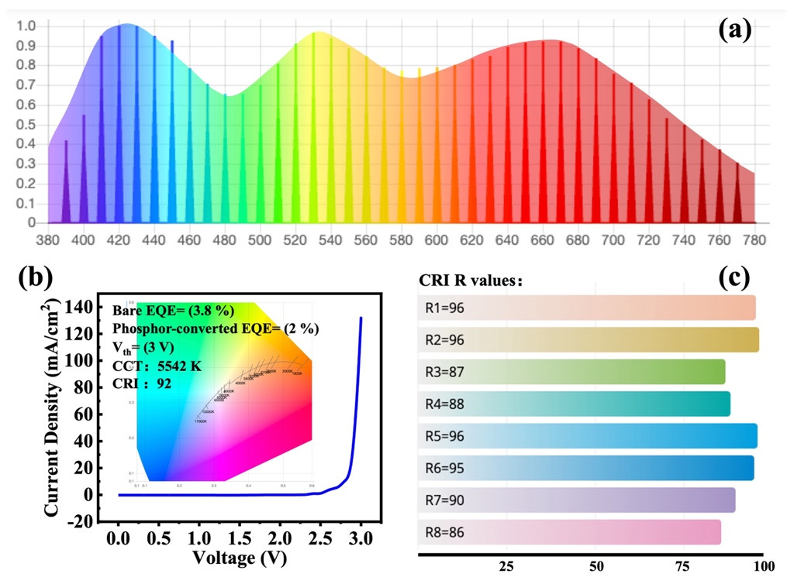
Fig. S17 (a) Emission spectrum of white LED. (b) J–V curve of the fabricated photoluminescent excitation device, the inserted image is the CCT (Correlated Color Temperature) coordinates. (c) R1–R8 values of the device’s white-light emission with CRI90 (Color Rendering Index) in the wavelength range of 380–780 nm
Fig. S18 Radioluminescence (RL) spectrum of (NEA)₂MnBr₄ film

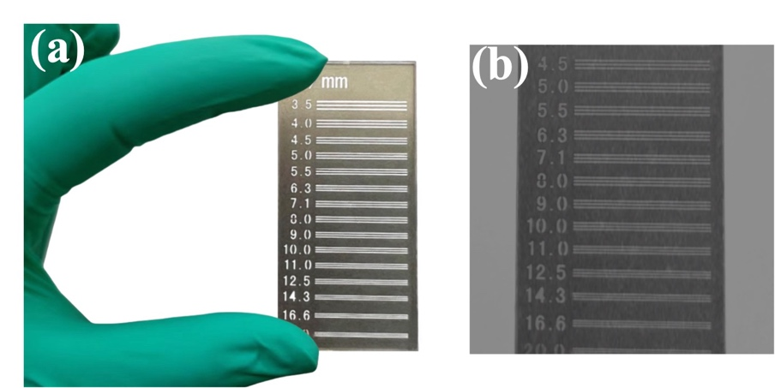
Fig. S19 X-ray image of the standard X-ray resolution pattern plate with scintillator and its bright-field image
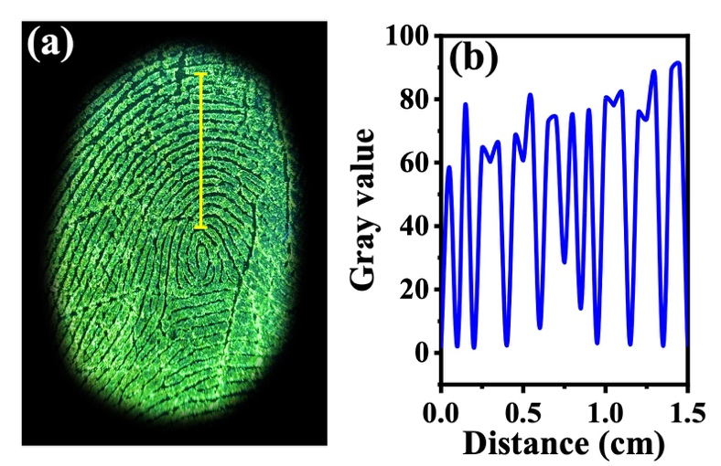
Fig. S20 The LFP grayscale distribution map was obtained along the direction indicated by the yellow straight line of the stained LFP

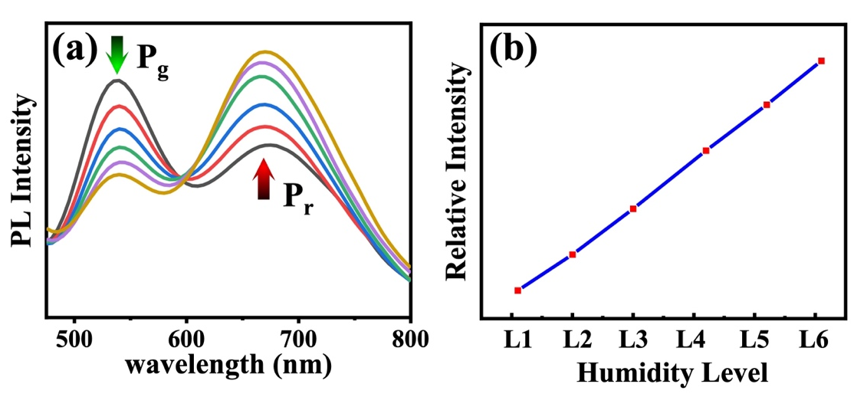
Fig. S21 (a) Humidity-dependent PL spectra. (b) The linear relationship between the P value (P=P_{r}/P_{g}) and the humidity level

Table S1 Crystallographic data of (NEA)₂MnBr₄
Empirical formula | C₂₄H₂₈Br₄MnN₂
Formula weight | 719.06
Temperature/K | 150.0
Crystal system | triclinic
Space group | P₁
a/Å | 7.5935(3)
b/Å | 11.6164(4)
c/Å | 15.4735(6)
α/° | 90.849(2)
β/° | 90.779(2)
γ/° | 96.480(2)
Volume/Å³ | 1355.87(9)
Z | 2
ρ_{calc} g/cm³ | 1.761
μ/mm⁻¹ | 6.395
F(000) | 702.0
Data collection range/° | 4.368 to 52.862
Index ranges | -9 ≤ h ≤ 9, -14 ≤ k ≤ 14, -19 ≤ l ≤ 19
Goodness-of-fit on F² | 0.941
Final R indexes [I>=2σ (I)] | R₁ = 0.0329, wR₂ = 0.0666
Final R indexes [all data] | R₁ = 0.0443, wR₂ = 0.0714
CCDC no. | 2300440


