Supporting Information for
FeOOH Cocatalysts with Gradient Oxygen Vacancy Distribution Enabling Efficient and Stable BiVO₄ Photoanodes
Shiyuan Wang¹, Mengjia Jiao¹, Qian Ye¹, Jie Jian¹*, Fan li², Guirong Su³, Lu Zhang⁴, Ziying Zhang⁵, Zelin Ma¹, Jiulong Wang¹, Yazhou Shuang¹, Fang Wang¹, Yalong Song¹, Lichao Jia⁴ and Hongqiang Wang¹*
¹ State Key Laboratory of Solidification Processing, Center for Nano Energy Materials, School of Materials Science and Engineering, Northwestern Polytechnical University and Shaanxi Joint Laboratory of Graphene (NPU), Shaanxi Laboratory for Advanced Materials, Xi'an 710072, P. R. China
² School of Physics and Information Technology, Shaanxi Normal University, Xi'an 710119, P. R. China
³ College of Materials Science and Engineering, Hohai University, Changzhou 213200, P. R. China
⁴ School of Materials Science and Engineering, Shaanxi Normal University, Xi’an 710119, P. R. China
⁵ International Research Center for Renewable Energy, Xi’an Jiaotong University, Xi'an 710049, P. R. China
*Corresponding authors. E-mail: jianjie112@nwpu.edu.cn (Jie Jian); hongqiang.wang@nwpu.edu.cn (Hongqiang Wang)
S1 Experimental Section
Materials. Dimethyl sulfoxide (DMSO) was obtained from Sigma-Aldrich. Bismuth nitrate pentahydrate (Bi(NO₃)₃·5H₂O, >98%), Sodium sulfite (Na₂SO₃, >97%), p-benzoquinone (C₆H₄O₂, >99%) and Potassium hydroxide (KOH, >85%) were obtained from Sinopharm Chemical Reagent Co., Ltd.. Iron chloride hexahydrate (FeCl₃·6H₂O, >99%) was purchased from Macklin Inc.. Vanadium acetylacetone oxygen (VO(acac)₂, >99%) was purchased from Acros Organics and Fisher Scientific. Fluorine-doped tin oxide (FTO) substrates (~ 30 Ω) was obtained from Pilkington. Deionized water with a resistance of 18.2 MΩ·cm was produced by a Water Purification System (Merck Millipore, Direct-Q5 UV). All materials were used as received.
Preparation of the BVO films. The BiVO₄ (BVO) photoanodes were fabricated by the electrochemical deposition reported elsewhere¹. Briefly, 46 mM p-benzoquinone (C₆H₄O₂) was dissolved in ethanol and sonicated for 10 minutes to obtain a yellow green transparent clear solution, denoted as solution A. 20 mM Bi(NO₃)₃·5H₂O and 400 mM KI were dissolved in DI water, followed by adding 38 mM nitric acid to adjust the pH to 4.7, and the obtained orange transparent clear solution was denoted as solution B. Then, solution A was slowly added to solution B to obtain a bright red transparent and clear solution. Next, a three electrodes deposition system was used for electrochemical deposition. The working electrode is FTO glass treated by UV for 15 min, the counter electrode is Pt sheet, and the reference electrode is Ag/AgCl. The voltage was set to -0.1 V and the deposition time is controlled to be 600 s to obtain BiOI film. Then, 0.2 M VO(acac)₂ was dissolved in DMSO and sonicated for 5 minutes to fully dissolve. The 250 µL of above solution was dripped onto the surface of the BiOI film, and subsequently putted on a hot bench of 120 °C for 15 minutes. Then, the obtained thin film was annealed at 450 °C for 2 hours with a heating rate of 2 °C /min. After natural cooling, the film was then soaked in a 1.0 M NaOH solution for 20 minutes to remove excess V₂O₅ on the surface. Finally, the film was rinsed with DI water and dried with N₂.
Preparation of the BVO/FeOOH film. The BVO photoanode was placed in a 10 ml 0.01 M FeCl₃ H₂O-dimethyl sulfoxide (DMSO) mixed solution with the H₂O-DMSO ratios stetted as 3/1 for 10 h at 50 °C to obtain BVO/FeOOH with different phase film. Then, the films were washed with DI water and dried with nitrogen.
Preparation of the BVO/FeOOH-GO_{V} film. The as prepared BVO/FeOOH photoanodes were immersed in the 1M KPi buffer solution with 0.1M Na₂SO₃ for different times under illumination by A Xe 500 W lamp (AM 1.5G).
Material Characterization. The morphologies of all films were evaluated through a field emission scanning electron microscopy (FESEM, FEI Nova Nano SEM 450). X-ray diffraction (XRD) spectra were used to characterize the crystal structure of all films by a D8 ADVANCE (Bruker). The Raman spectra of all films were identified using a Renishaw in Via Raman microscope with a 532 nm laser. Ultraviolet–visible (UV–vis) spectra of all films were performed to measure the absorbance of all samples by a Perkin-Elmer Lambda 35 UV-vis-NIR spectrophotometer. Transmission electron microscopy (TEM) and high-resolution transmission electron microscopy (HRTEM) were performed through a FEI Talos F200X microscope. The FTIR spectra (4000 to 500 cm-1) were recorded on a Jasco FT/IR-6100 FTIR. Scanning transmission electron microscopy coupled with electron energy-loss spectroscopy (STEM-EELS) were recorded on a FEI Themis Z. X-ray photoelectron spectroscopy (XPS) was recorded on a ULVAC-PHI (PHI 5000 VersaProbe III) XPS system, the depth of each sputtering process was controlled by time (etch rate ~ 0.1 nm/s), and all peak were calibrated by the C 1 s peak (284.8 eV) as a reference. The photoluminescence (PL) spectra were carried out using a PL spectrometer (FLS 980, Edinburgh) with excitation laser of 310 nm. (TAS) measurements of all films were performed with a commercial TA system (Time-Tech Spectra, LLC). Electron paramagnetic resonance (EPR) measurements were conducted on Bruker EMXPLUS operating at room temperature. The intensity modulated photocurrent spectroscopy (IMPS) of all films was recorded on a Modulab Solartron Analytical potentiostat, model 2200 A. A cold white LED that drove illumination of 455 nm was adopted as light source in 1.0 M potassium phosphate buffer solution at 1.23 V_{RHE}. The light intensity was adjusted to 68.93 mW cm⁻², and it was modulated by 10% in the range of 100 kHz to 0.1 Hz.
Photoelectrochemical characterization. The photoelectrochemical measurements were carried out at room temperature by a three-electrode test system and an electrochemical workstation (CHI660E). In the three-electrode test system, all the above MBVO photoanodes in this work were used as working electrodes, and the exposed irradiation area for PEC measurements was fixed as 0.25 cm², while Ag/AgCl electrode and Pt electrode were used as reference and counter electrodes, respectively. 1.0 M potassium phosphate buffer with and without 0.1 M Na₂SO₃ aqueous solution (pH=7) were adopted as the electrolyte, respectively. A Xe 500 W lamp (CEL-S500, CEAULIGHT) adjusted to 100 mW cm⁻² via an AM 1.5G filter was used as the light source. Photocurrent vs voltage (I-V) curves were recorded by scanning rate of 10 mV s⁻¹ with the potential range from -0.6 to 0.8 V vs. Ag/AgCl. The cyclic voltammetry (CV) measurements were carried out at 1.23 V_{RHE}, and the scan rate was 0.02 to 0.1 mV s⁻¹. Electrochemical impedance spectroscopy (EIS) spectra were collected by frequency from 10 Hz to 10⁶ Hz at 1.23 V_{RHE}. Mott-Schottky (MS) spectra were characterized with the potential range from -0.6 to 0.6 V vs. Ag/AgCl. The incident-photon-to-current conversion efficiency (IPCE) was measured using the same three-electrode cell described above at 1.23 V_{RHE} under monochromatic irradiation from a Xe lamp equipped with bandpass filters. Open circuit potentials (OCP) of the photoanodes were measured in 1.0 M potassium phosphate buffer (pH=7).
Calculations. All reversible hydrogen electrode (RHE) in this work were converted using the Nernst equation¹:
V_{RHE} = V_{Ag/AgCl} + 0.0591×pH + 0.197 (V) | (S1)
where V_{RHE} refers to the potential versus RHE. V_{Ag/AgCl} is the potential versus Ag/AgCl.
IPCE, the absorbed photon-to-current conversion efficiency (APCE) and the applied bias photon-to-current efficiency (ABPE) values can be calculated using the following equations, resepectivly²:
IPCE (%) = (J×1240) / (λ×P_{light})×100% | (S2)
APCE (%) = IPCE (%) / LHE×100% | (S3)
ABPE (%) = J×(1.23-V_{app})/P_{light} ×100% | (S4)
where J is the photocurrent density of MBVO films (mA cm⁻²), λ is the incident light wavelength (nm), and P_{light} represents the power density of incident light. V_{app} is the applied external potential.
The carrier density (Nd) can be calculated according to the MS spectra by the following equation³:
Nd = (2/eε₀ε)×(d(1/C²) / dVs)⁻¹ | (S5)
where e, ε₀, ε, C and Vs is the electronic charge (1.602 × 10⁻¹⁹ C), vacuum permittivity (8.854 × 10⁻¹² F m⁻¹), relative permittivity (68 F m⁻¹ for BiVO₄), the space charge capacitance (F cm⁻², obtained from MS curves) and the applied potential (V), respectively⁴.
η_{inj} =J (H₂O) / J (Na₂SO₃) | (S6)
where J (H₂O) is the photocurrent density measured in 1M potassium phosphate buffer and J (Na₂SO₃) is the photocurrent density measured in 1M potassium phosphate buffer with 0.1M Na₂SO₃ (pH = 7).
The τ_{n} is calculated by the equation as follows:
τ_{n} = -K_{B}T /e(dOCP/dt) | (S7)
Where the τ_{n}, K_{B}, T, e, and dOCP/dt are the carrier transfer lifetime, Boltzmann's constant, temperature, charge of single electron, and derivative of the OCP transient decay, respectively.
The charge transport time (τ_{d}) can be gained from using the following equation⁵:
τ_{d} =(2πf_{IMPS})⁻¹ | (S8)
Where f_{IMPS} is the frequency at the minimum imaginary component in the IMPS spectra.
According to the low frequency intercept of the IMPS plots, the represents k_{trans}/(k_{trans}+k_{rec}), the charge transfer efficiencies (K_{trans}/(K_{rec} + K_{trans})) can be obtained.
The (K_{tran} + K_{rec}) can be calculated using the following equation⁵:
(2πf_{max})⁻¹ = K_{tran} + K_{rec} | (S9)
Theoretical calculations. Density functional theory (DFT) as implemented in the Vienna Ab-initio Simulation Package (VASP) ⁶ was employed to the optimize geometry structures. The (010) surface of FeOOH (Orthorhombic, Pbnm No. 62) was modelled with 15 Å vacuum. The supercell had a volume of 3035.917380 Å³, with lattice parameters: a = 9.0534 Å, b = 13.7937 Å, and c = 24.3107 Å. The projected augmented wave (PAW) potentials were used to describe the ionic cores and account for the valence electrons using a plane wave basis set with a kinetic energy cutoff of 450 eV. The electronic energy was considered self-consistent when the energy change was smaller than 10⁻⁵ eV. Geometry optimization was considered convergent when the force change was smaller than 0.04 eV/Å. The van der Waals interactions were considered using the method of the Grimme (DFT+D3) ⁷. The Brillouin-zone integration was sampled with a Monkhorst-Pack mesh of 2×2×1 during the structural relaxation calculations.
The Gibbs free energy of an adsorbate on the surface was calculated using the following equation:
G = E + ZPE − TS | (S10)
where E is the total energy, ZPE is the zero-point energy, T is 298.15 K, and S is the entropy.
The OER process was modeled as follows:
*+ H₂O→ OH* + H⁺ +e– | (S11)
OH*→ O* + H⁺ + e– | (S12)
O* +H₂O → OOH* + H⁺ + e– | (S13)
OOH* → O₂ + H⁺ + e– | (S14)
where the * represents the adsorption sites of the surface, and OH*, O*, and OOH* represent the corresponding adsorption intermediates, respectively.

S2 Supplementary Figures and Tables
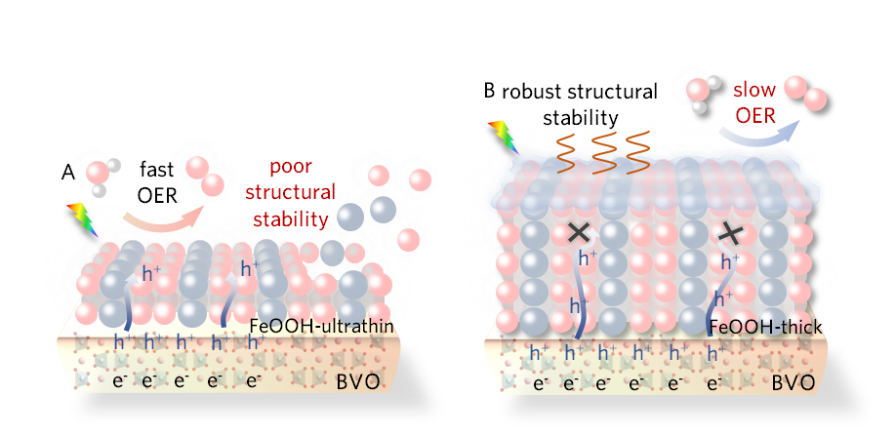

Fig. S1 Illustration of (A) the fast OER and poor structural stability of ultrathin FeOOH layer and (B) the slow OER and robust structural stability of thick FeOOH layer decorated on BVO photoanodes

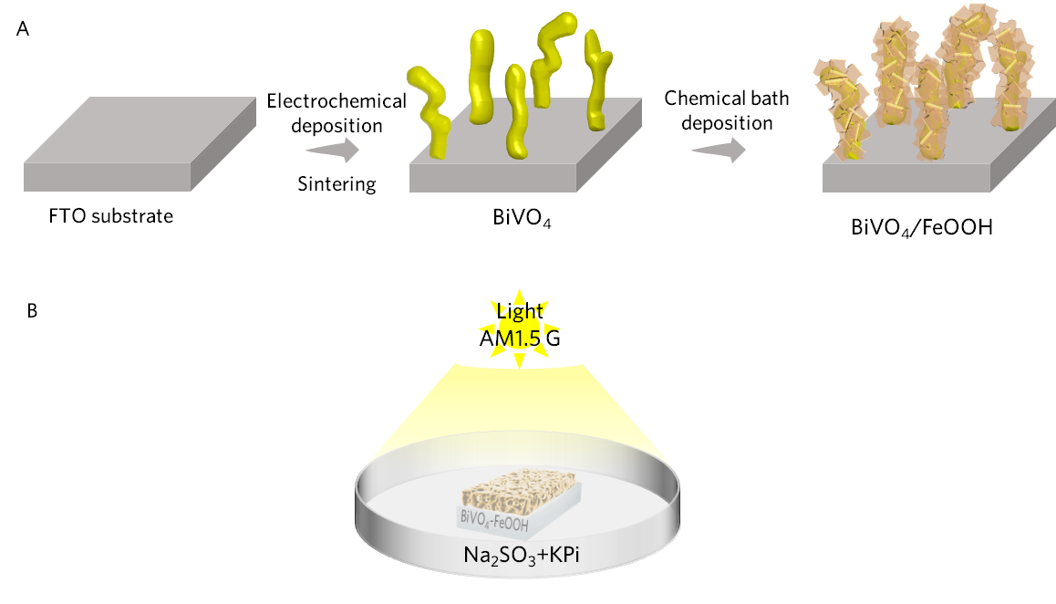
Fig. S2 (A) The fabrication process of BVO/FeOOH films, (B) PE process for BVO/FeOOH film

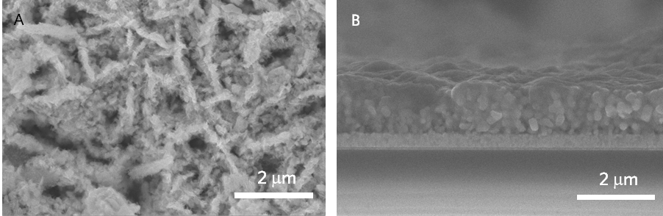
Fig. S3 (A) SEM image and (B) cross cross-section SEM image of BVO/FeOOH photoanodes

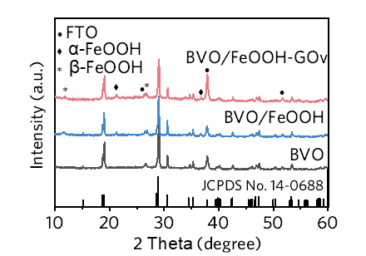
Fig. S4 XRD patterns of BVO, BVO/FeOOH and BVO/FeOOH-GO_{V} films

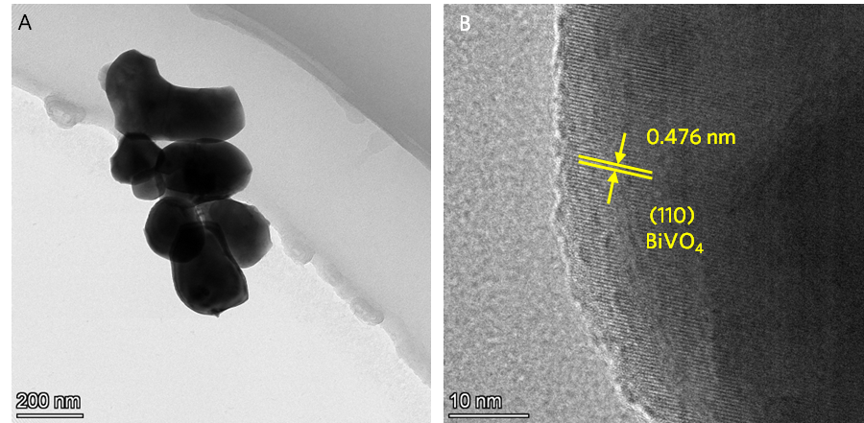
Fig. S5 (A) TEM image and (B) HRTEM image of BVO film

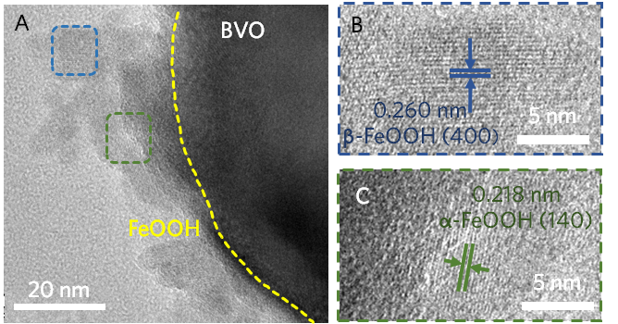
Fig. S6 (A) HRTEM image of BVO/FeOOH photoanode. (B) HRTEM image of area labeled in bule in (A). (C) HRTEM image of area labeled in green in (A)

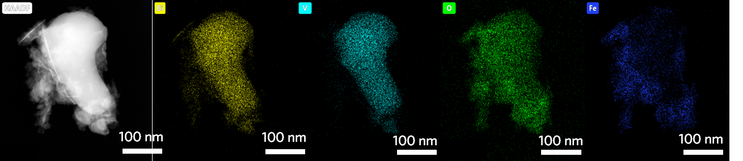
Fig. S7 TEM-EDS analysis of BVO/FeOOH-GO_{V} film

Fig. S8 UV-vis absorption spectra of the bare BVO, BVO/FeOOH and BVO/FeOOH-GO_{V} films (insert: Tauc plots derived from UV-vis absorption spectra)

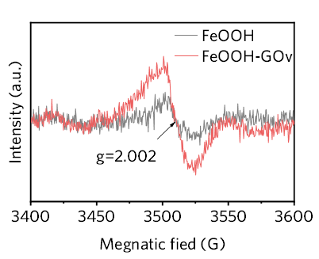
Fig. S9 EPR spectra of FeOOH and FeOOH-GO_{V}

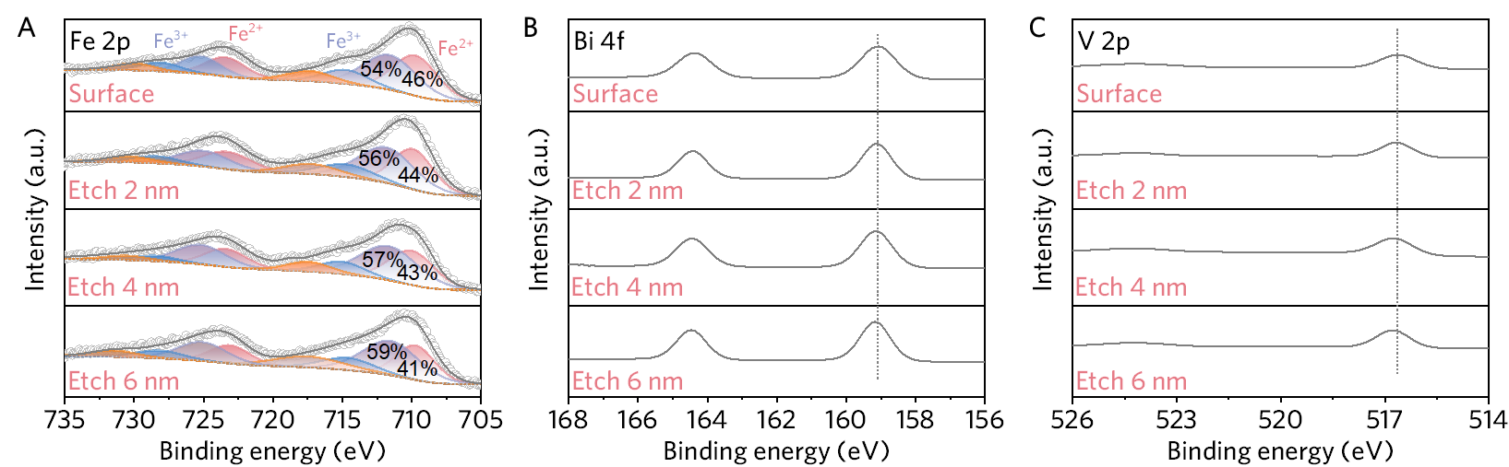
Fig. S10 Depth profiles of (A) Fe 2p, (B) Bi 4f and (C) V 2p for BVO/FeOOH-GO_{V} film

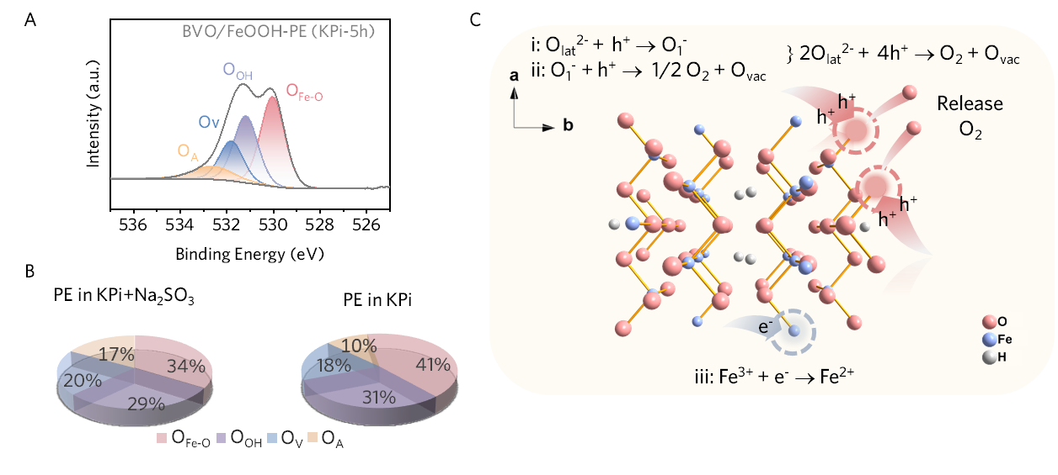
Fig. S11 (A) XPS of O 1s of BVO/FeOOH film photoetched in KPi without 0.1M Na₂SO₃. (B) The Pie chart of O_{L}, O_{V} and O_{A} derived from the O 1s of BVO/FeOOH-GO_{V} film photoetched in KPi with and without 0.1M Na₂SO₃. (C) The illustration of the generation of O_{V} in FeOOH during the photoetch treatment process in KPi
Discussion S1: The XPS quantification reveals that there is a large amount of Ov in BVO/FeOOH-PE (KPi+SO₃²⁻) photoanode, while less O_{V} in BVO/FeOOH-PE (KPi) photoanode. This disparity fundamentally excludes that the presence of O_{V} is due to the Fe³⁺ reduction (Fe³⁺ → Fe²⁺), as such a Fe³⁺ reduction-mediated process would yield a comparable O_{V} concentration in BVO/FeOOH photoanodes regardless of sulfite presence. The similar photoreduction has been reported for other semiconductors [S8, S9]. Their results reveal that the holes can actively oxidize O_{lat}²⁻ and release O₂, which results in the generation of O_{V}.
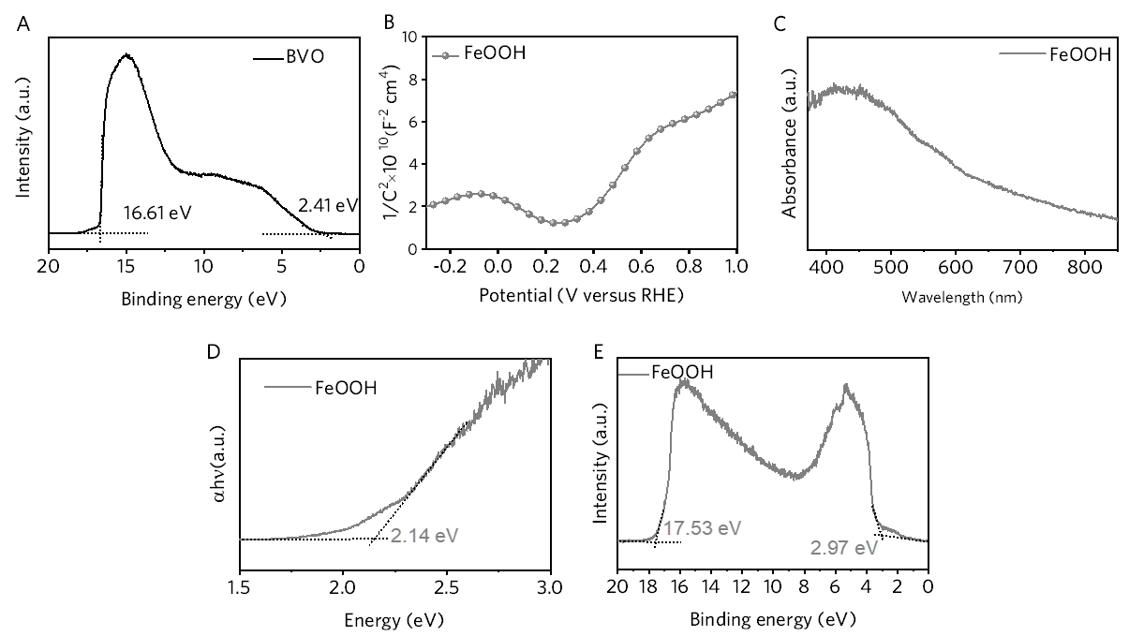
Fig. S12 (A) UPS of BVO photoanode, (B) M-S plot, (C) UV-vis absorption spectroscopy, (D) Tauc plots derived from UV-vis absorption spectroscopy, (E) UPS of FeOOH
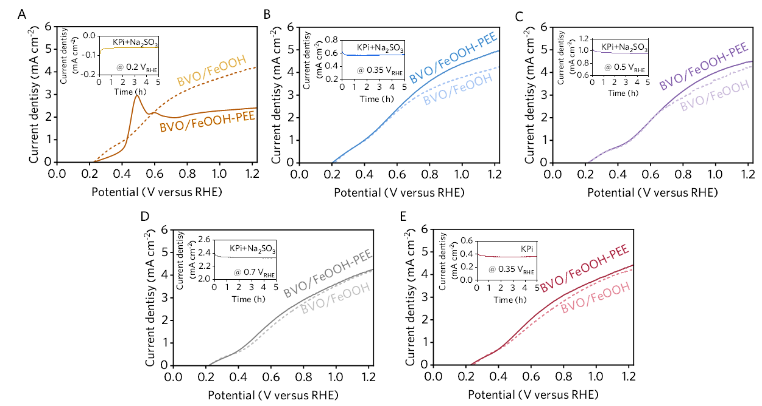
Fig. S13 J-V curves for BVO/FeOOH films before (dash line) and after (solid line) photoelectric etching (PEE) treatment at (A) 0.2 V_{RHE} in 1 M KPi buffer with 0.1M Na₂SO₃, (B) 0.35 V_{RHE} in 1 M KPi buffer with 0.1M Na₂SO₃, (C) 0.5 V_{RHE} in 1 M KPi buffer with 0.1M Na₂SO₃, (D) 0.7 V_{RHE} in 1 M KPi buffer with 0.1M Na₂SO₃ and (E) 0.35 V_{RHE} in 1 M KPi buffer under AM 1.5G illumination (each insertion graph is the I-T curve corresponding to the potentiostatic PEE).
Discussion S2: Based on the flat band potential of the BVO/FeOOH photoanode, we selected four applied biases: 0.2 V_{RHE}, 0.35 V_{RHE}, 0.5 V_{RHE} and 0.7 V_{RHE}, respectively. At 0.2 V_{RHE} (below the flat band potential), BVO/FeOOH photoanode exhibits a reduction current. After 5 hours, this condition leads to BVO/FeOOH photoanode failure due to cathodic corrosion (Fig. S11A). Therefore, the applied bias was set to be higher than the flat band potential, while remaining sufficiently low to avoid significant electrochemical oxidation or dissolution of BVO or FeOOH.

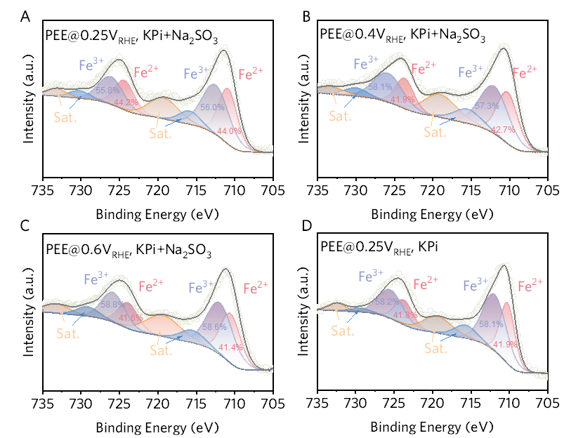
Fig. S14 XPS of Fe 2p peaks of photoelectric etched BVO/FeOOH at (A) 0.35 V_{RHE} in 1.0 M KPi buffer with 0.1M Na₂SO₃, (B) 0.5 V_{RHE} in 1 M KPi buffer with 0.1M Na₂SO₃, (C) 0.7 V_{RHE} in 1 M KPi buffer with 0.1M Na₂SO₃ and (D) 0.35 V_{RHE} in 1 M KPi buffer under AM 1.5G illumination
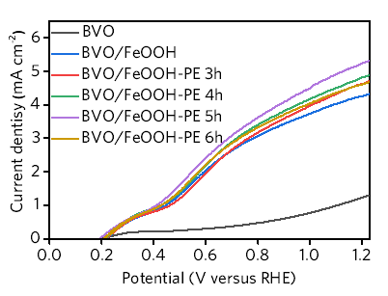
Fig. S15 J-V curves for BVO/FeOOH films photoetched with different time

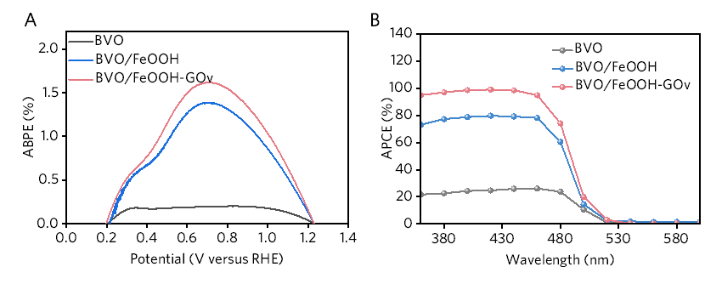
Fig. S16 (A) ABPE and (B) APCE for BVO, BVO/FeOOH and BVO/FeOOH-GO_{V} films

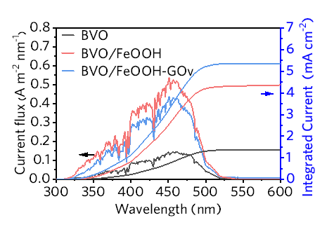
Fig. S17 The current flux by integrating IPCE over the photon flux of AM 1.5G and the corresponding integrated current density of BVO, BVO/FeOOH and BVO/FeOOH-GO_{V} photoelectrodes at the potential of 1.23 V_{RHE}

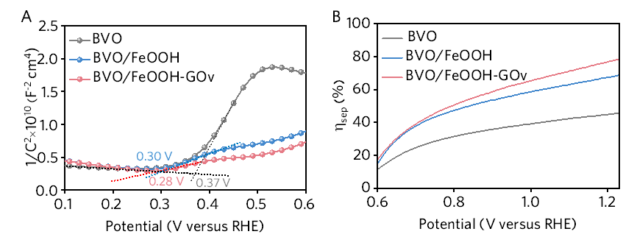
Fig. S18 (A) M-S plots and (B) Charge separation efficiencies of BVO, BVO/FeOOH and BVO/FeOOH-GO_{V} films

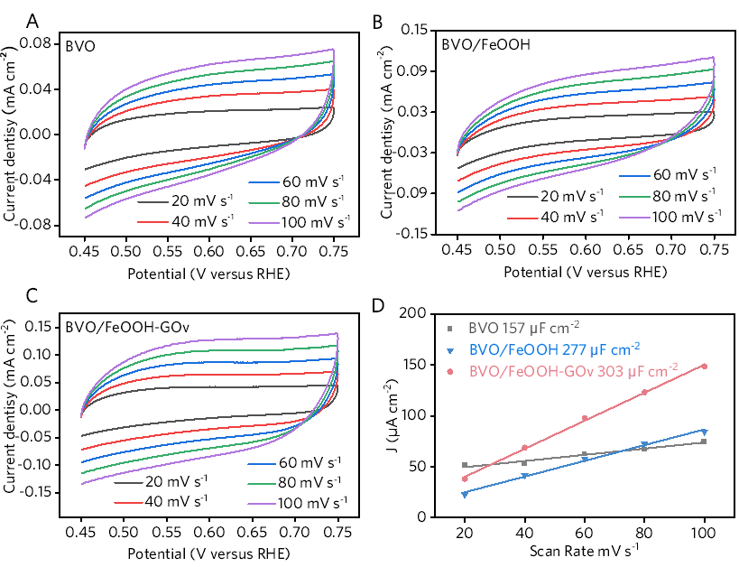
Fig. S19 Cyclic voltammetry curves of (A) BVO, (B) BVO/FeOOH and (C) BVO/FeOOH-GO_{V} films. (D) the Δcurrent density-scan rate curves of BVO, BVO/FeOOH and BVO/FeOOH-GO_{V} films

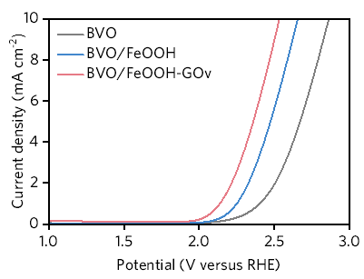
Fig. S20 J-V curves of BVO, BVO/FeOOH and BVO/FeOOH-GO_{V} films in dark

Fig. S21 Chronoamperometry curve of BVO, BVO/FeOOH and BVO/FeOOH-GO_{V} films under chopped illumination
Discussion S3: Defect states predominantly govern charge carrier recombination kinetics and transport dynamics, with their most pronounced influence manifested in the photocurrent decay profile following illumination cessation (turn-off transient). BVO exhibits rapid photocurrent decay (~2.31 s) post-illumination cessation, characteristic of defect states acting as recombination centers. FeOOH deposition markedly slows decay kinetics (~6.01 s), confirming suppressed surface recombination and optimized interfacial charge transfer between BVO and FeOOH. BVO/FeOOH-GO_{V} demonstrates the slowest decay (~7.05 s, a little longer than BVO/FeOOH), exceeding both BVO and BVO/FeOOH, attributable to its GO_{V} architecture. This engineered GOv distribution enhances charge extraction while avoiding deep-level defects within FeOOH that form under random/high-concentration O_{V} conditions.
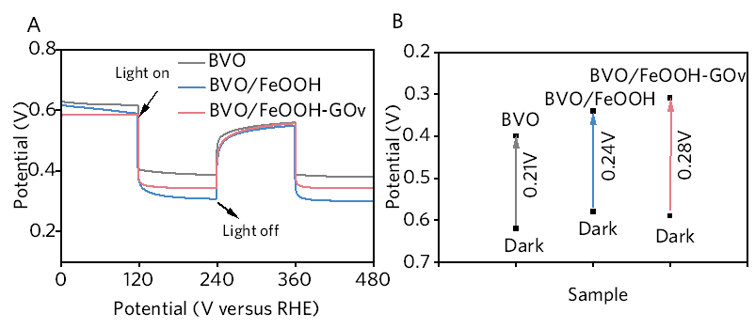
Fig. S22 (A) Photovoltage response and (B) photovoltage of BVO, BVO/FeOOH and BVO/FeOOH-GO_{V} films

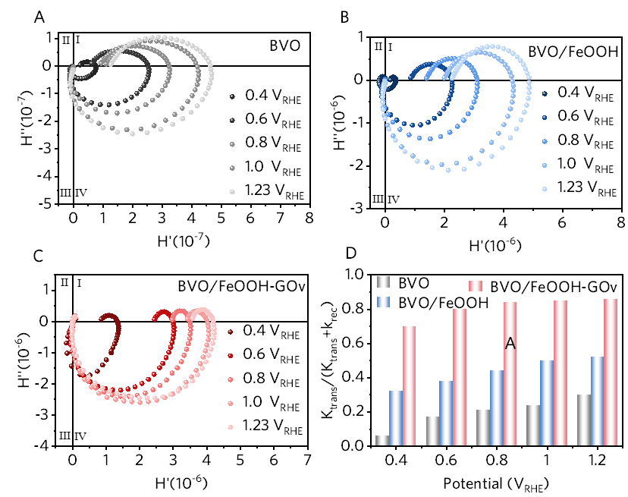
Fig. S23 IMPS plots of (A) BVO, (B) BVO/FeOOH and (C) BVO/FeOOH-GO_{V} films measured at applied bias potentials ranging from 0.4 V_{RHE} to 1.23 V_{RHE}, (D) the charge transfer efficiencies (K_{trans}/(K_{rec} + K_{trans})) derived from the IMPS plots of BVO, BVO/FeOOH and BVO/FeOOH-GO_{V} films
Discussion S4 The high k_{rec}​ value of BVO photoanode shown in Fig. 3F at low bias potential can be attributed to three main factors. First, the weaker built-in electric field at a lower bias potential may lead to vigorous recombination of photogenerated electrons and holes in the BVO bulk. Second, the unsaturated surface states of the BVO films can trap charge carriers at low bias potentials, significantly increasing surface recombination. Third, the slower water oxidation reaction rate at low bias potentials can result in the accumulation of photogenerated holes, further exacerbating recombination. However, as the applied bias potential increases, the enhanced electric field strength, saturation of surface states, and accelerated reaction kinetics collectively suppress recombination, leading to a decreased and almost constant recombination constant.
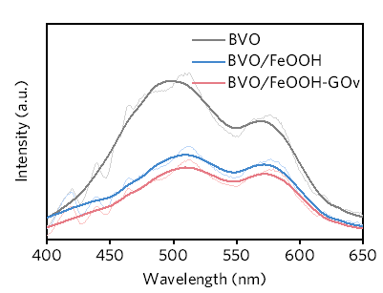
Fig. S24 PL spectra of BVO, BVO/FeOOH and BVO/FeOOH-GO_{V} films
Discussion S5: There are two peaks could be clearly identified. The peak at 500 nm is assigned to inter-band radiative recombination of holes of BVO¹⁰, and the peak at 570 nm is attributed to the near-band-edge emission of BVO¹¹. The strong PL peak of BVO indicates a relatively high electron-hole recombination ratio. Evidently, the PL peak intensities of BVO/FeOOH-GO_{V} film have been reduced, providing strong evidence that the FeOOH-GO_{V} inhibits carrier recombination of BVO surface most effectively.

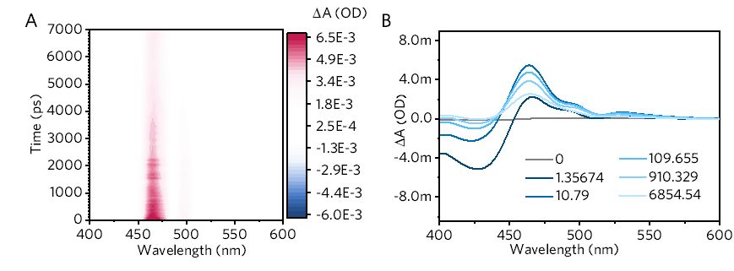
Fig. S25 (A) TAS spectra and (B) TAS at selected delay times of BVO film
Discussion S6: The bare BVO principally presents two characteristic bands, a ground state bleaching (~430 nm, GSB) peak, attributed to the depopulation of the ground state due to band gap transition, which is correlated to the VB free hole dynamics, and an absorption peak (~470 nm, HA) corresponding to the absorption of photogenerated holes [S12, S13].

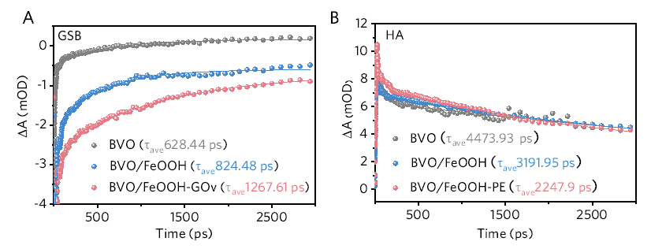
Fig. S26 (A) GSB and (B) HA signals at selected delay times for BVO, BVO/FeOOH and BVO/FeOOH-GO_{V} films
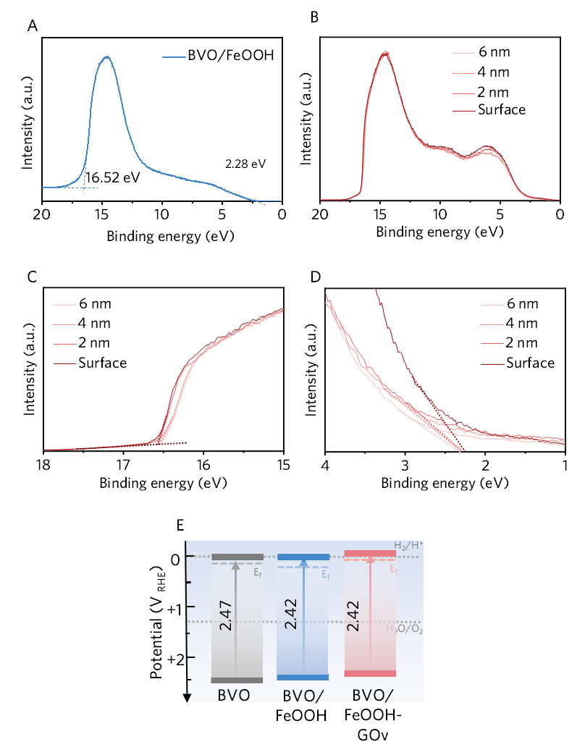
Fig. S27 (A) UPS of BVO/FeOOH film. (B-D) UPS of BVO/FeOOH-GO_{V} film with different etching depth. (E) Band structure of different films

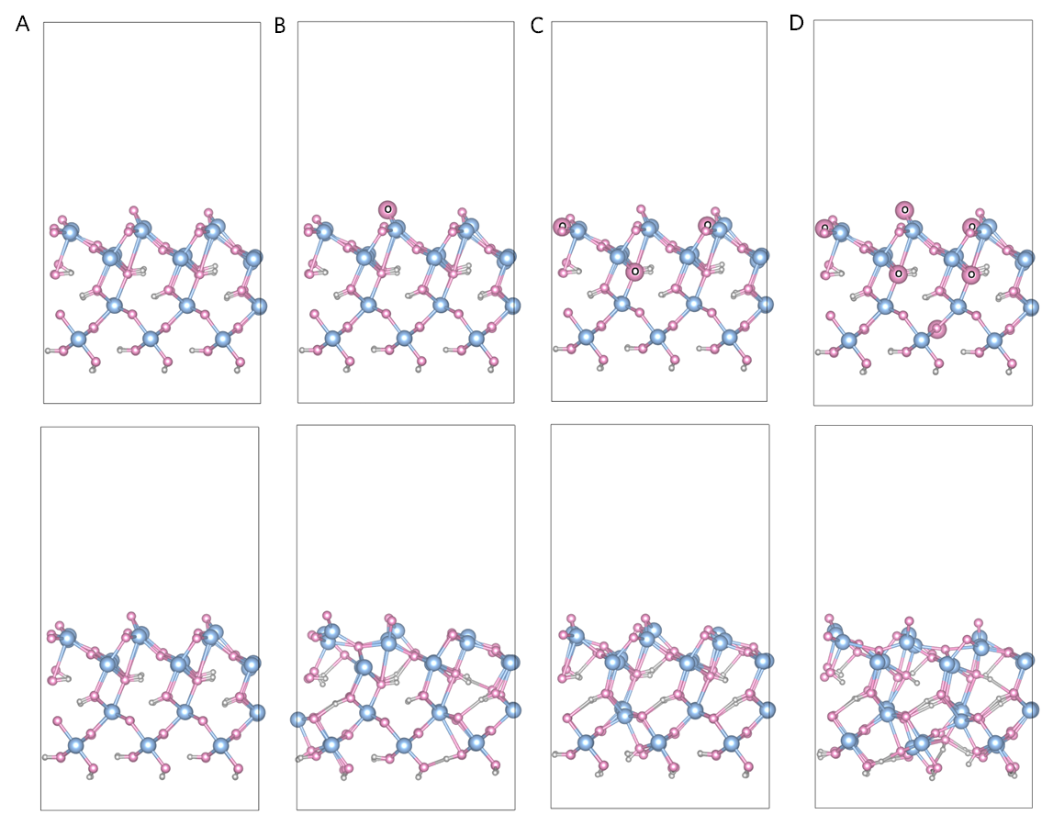
Fig. S28 The standard orientation of the (A) FeOOH, (B) FeOOH-GO_{V1}, (C) FeOOH-GO_{V2} and (D) FeOOH-GO_{V} models (first row: initial models; second row: optimized models; bule balls: Fe atoms; pink balls: O atoms; gray balls: H atoms; the larger O atoms marked in the initial models were the deducted O atoms)
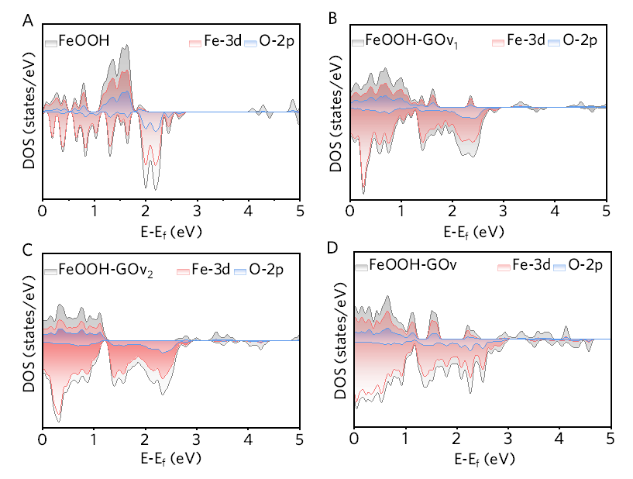
Fig. S29 Enlarged calculated TDOS (gray), Fe-3d (red) and O-2p (bule) PDOS of (A) FeOOH, (B) FeOOH-GO_{V1}, (C) FeOOH-GO_{V2} and (D) FeOOH-GO_{V}, where the Fermi energy level is set to 0
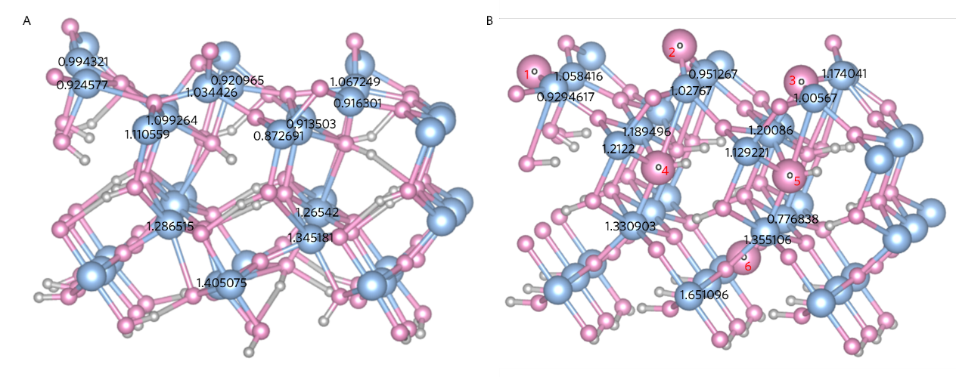
Fig. S30 The Bader charge of Fe atoms nearest to the oxygen vacancies for (A) FeOOH-GO_{V} and (B) FeOOH model
Table S1 Recorded values for photocurrent densities and stability from representative FeOOH cocatalysts modified BiVO₄ films
Sample | Current density | Stability | Measured at V_{RHE} | Buffer solution | References
BVO/Ni:FeOOH | 4.15 | 5 h | 1.23 | 1 M KBi (PH~9) | [S14]
B-BVO/β-FeOOH | 4.96 | 20 h | 1.23 | 1 M KBi (PH~9) | [S15]
BVO /FeOOH(amorphous) | 3.33 | 3h | 1.23 | 0.1 M KHCO₃ solution (pH 9) | [S16]
BVO/β-FeOOH | 4.3 | 2 h | 1.23 | 0.2M Na₂SO₄ | [S17]
BVO/β-FeOOH | 4.5 | - | 1.23 | 0.2 M Na₂SO₄ | [S17]
BVO/β-FeOOH | 5.2 | - | 1.23 | 0.2 M Na₂SO₄ | [S17]
BVO/FeOOH/CQDs | 2.53 | 2 h | 1.23 | 0.2 M Na₂SO₄ containing 0.5 M Na₂SO₃ | [S18]
Ni:FeOOH-coated WO₃/BiVO₄ | 4.5 | 3h  (0.8 V_{RHE}) | 1.23 | 0.5 M potassium phosphate buffer solution (pH = 7) | [S19]
FeOOH/Mo:BiVO₄ | 3.5 | 6h | 1.23 | 1M phosphate buffer at pH 6.8 | [S20]
FeOOH/Au/BiVO₄ | 4.64 | 2.2h | 1.23 | aqueous solution of 0.1 M Na2SO4 (pH =7) | [S11]
FeOOH/In-BiVO₄(L) | 5.02 | 8h (0.8V_{RHE}) | 1.23 | 0.5 M KBi (pH = 9.5) | [S21]
BiVO₄/S-FeOOH | 3.58 | 2h | 1.23 | 0.5 M Na₂SO₄ solution | [S22]
Vo-BiVO₄/FeOOH | 4.71 | 11 h | 1.23 | 0.5 M borate buffer (pH = 9.5) | [S23]
F:FeOOH/BiVO₄ | 2.7 | 3 h | 1.23 | 0.5 M Na2SO4 solution (pH = 7.35) | [S24]
FeOOH/Ti:BiVO₄ | 3.99 | 2 h | 1.23 | 0.2 M Na₂SO₄ | [S25]
Ni:FeOOH/BiVO₄ | 4.21 | 12 h | 1.23 | 0.2 M  Na₂SO₄ | [S26]
FeOOH@1T-MoS2@BiVO₄ | 4.02 | 8 h | 1.23 | 0.1 M potassium phosphate (KH₂PO₄) buffer solution | [S27]
α-FeOOH(P-II)/BiVO₄ | 2.64 | 20 h | 1.23 | 0.2 M Na₂SO₄ (pH = 7) | [S28]
BiVO₄@Ni:FeOOH | 2.86 | 2h | 1.23 | 0.5M Na₂SO₄ electrolyte solution (pH 6.8) | [S29]
BVO/FeOOH-GO_{V} | 5.37 | 160h | 1.23 | 1 M KPi | This work
Table S2 XPS deconvolution results of O1s spectrum of the pristine BVO, BVO/FeOOH and BVO/FeOOH-GO_{V} photoanodes
Sample | O_{Fe-O} (%)  529.90 eV | O_{OH} (%)  531.08 eV | O_{V} (%)  531.76 eV | O_{A} (%)  532.57 eV
BVO | 78.30 | - | 17.13 | 4.57
BVO/FeOOH | 36.12 | 34.07 | 15.54 | 14.47
BVO/FeOOH-GO_{V} | 33.84 | 29.25 | 19.99 | 16.92
Table S3 XPS deconvolution results of Fe 2p spectrum of the BVO/FeOOH and BVO/FeOOH-GO_{V} photoanodes
Sample | Fe²⁺ (%)  2p 3/2 | Fe³⁺ (%)  2p 3/2 | Fe²⁺ (%)  2p 1/2 | Fe³⁺ (%)  2p 1/2
BVO/FeOOH | 41.3 | 58.7 | 41.5 | 58.5
BVO/FeOOH-GO_{V} | 46.3 | 53.7 | 45.9 | 54.1

Table S4 Depth profile deconvolution results of O1s spectrum of the pristine BVO, BVO/FeOOH and BVO/FeOOH-GO_{V} photoanodes
Etch depth | O_{Fe-O} (%)  529.90 eV | O_{OH} (%) 531.08 eV | O_{V} (%)  531.76 eV | O_{A} (%)  532.57 eV
Surface | 33.84 | 29.25 | 19.99 | 16.92
2 nm | 37.20 | 29.09 | 18.20 | 15.51
4 nm | 37.82 | 31.31 | 16.77 | 14.10
6 nm | 38.75 | 31.22 | 15.59 | 14.44

Table S5 Band gap (E_{g}), VBM (VB) and CBM (CB) positions of BVO and FeOOH
Sample | E_{g} | VB (V_{RHE}) | CB (V_{RHE})
FeOOH | 2.14 | 2.15 | 0.01
BVO | 2.47 | 2.51 | 0.04
Table S6 Series resistance (Rs) and charge transfer resistance (Rct) of the pristine BVO, BVO/FeOOH and BVO/FeOOH-GO_{V} photoanodes
Sample | R_{s} (ohm) | R_{ct} (ohm)
BVO | 52 | 6645
BVO/FeOOH | 55 | 1054
BVO/FeOOH-GOv | 53 | 826
Table S7 Flat band potential (E_{fb}) and carrier density (N_{A}) of the pristine BVO, BVO/FeOOH and BVO/FeOOH-GO_{V} photoanodes
Sample | φ_{fb} (V_{RHE}) | N_{A} (cm⁻³)
BVO | 0.37 | 2.02×10¹⁸
BVO/FeOOH | 0.30 | 5.78×10¹⁸
BVO/FeOOH-GO_{V} | 0.29 | 8.60×10¹⁸
Table S8 Comparison of PEC performance at 1.23 V_{RHE} of BVO/FeOOH photoanode in this work with other reprehensive reports on FeOOH-based photoanodes modified by O_{V}
Sample | Current density | Stability | Buffer solution | References
BVO/Ni:FeOOH  (doping) | 4.15 | 5 h | 1 M KBi (PH~9) | [S14]
B-BVO/β-FeOOH  (crystallization) | 4.96 | 20 h | 1 M KBi (PH~9) | [S15]
BVO/citrate/FeOOH  (bridging agent) | 3.33 | 3h | 0.1 M KHCO₃ solution (pH 9) | [S16]
BVO/β-FeOOH  (crystallization) | 4.3 | 2 h | 0.2M Na₂SO₄ | [S17]
BVO/β-FeOOH  (NaBH₄ reduction) | 4.5 | - | 0.2 M Na₂SO₄ | [S17]
BVO/β-FeOOH  (Ar-plasma treatment) | 5.2 | - | 0.2 M Na₂SO₄ | [S17]
BVO/FeOOH/CQDs  (Heterogeneous engineering) | 2.53 | 2 h | 0.2 M Na₂SO₄ containing 0.5 M Na₂SO₃ | [S18]
BVO/FeOOH-GOv  (Photoetching) | 5.37 | 160h | 1 M KPi | This work
Table S9 The fit results for the decays at ~443 nm calculated with three exponential decay model of the pristine BVO, BVO/FeOOH and BVO/FeOOH-GO_{V} photoanodes
Sample | A₁ | τ₁ | A₂ | τ₂ | A₃ | τ₃ | τ_{av}
BVO | 0.03 | 2.94 | 0.01 | 21.37 | 5.87 | 628.53 | 628.44
BVO/FeOOH | 0.01 | 69.28 | 7.96 | 440.32 | 6.73 | 1020.61 | 824.48
BVO/FeOOH-GO_{V} | 0.01 | 82.49 | 9.31 | 1267.37 | 9.55 | 1267.94 | 1267.61
Table S10 The fit results for the decays ~470 nm calculated with three exponential decay model of the pristine BVO, BVO/FeOOH and BVO/FeOOH-GO_{V} photoanodes
Sample | A₁ | τ₁ | A₂ | τ₂ | A₃ | τ₃ | τ_{av}
BVO | 0.49 | 4.16 | 0.41 | 4518.57 | 0.16 | 105.28 | 4473.93
BVO/FeOOH | 0.22 | 47.03 | 0.21 | 3214.62 | 0.21 | 3217.47 | 3191.95
BVO/FeOOH-GO_{V} | 0.39 | 4.54 | 0.09 | 98.444 | 0.42 | 2272.02 | 2247.90
Table S11 The fit results for the decays at ~510 nm calculated with three exponential decay model of BVO/FeOOH-GO_{V} and BVO/FeOOH films
Sample | A₁ | τ₁ | A₂ | τ₂ | A₃ | τ₃ | τ_{av}
BVO/FeOOH | 0.15 | 58.24 | 0.19 | 5962.54 | 0.2 | 5975.83 |  | 5947.26
BVO/FeOOH-GO_{V} | 0.18 | 46.6 | 0.25 | 9167.21 | 0.25 | 9160.07 |  | 9146.98
Table S12 VBM (VB) and Fermi levels (E_{f}) of BVO/FeOOH-GO_{V} films
Sample | Etching depth | VB (V_{RHE}) | E_{f} (V_{RHE}) | CB (V_{RHE})
BVO/FeOOH-GO_{V} | 6 nm | 2.48 | 0.20 | 0.06
BVO/FeOOH-GO_{V} | 4 nm | 2.46 | 0.13 | 0.04
BVO/FeOOH-GO_{V} | 2 nm | 2.43 | 0.11 | 0.01
BVO/FeOOH-GO_{V} | Surface (0 nm) | 2.42 | 0.08 | 0
BVO/FeOOH | - | 2.47 | 0.19 | 0.05
BVO | - | 2.51 | 0.1 | 0.04

Table S13 Bandgap (E_{g}) and positions (distance from the vacuum level) of VBM (VB) and CBM (CB) of FeOOH, FeOOH-GO_{V1}, FeOOH-GO_{V2} and FeOOH-GO_{V} determined by DFT analysis (E_{f} as 0 eV)
Sample | Etching depth | VB (V_{RHE}) | E_{g} (V_{RHE}) | CB (V_{RHE})
FeOOH-Bulk | 6 nm | 2.80 | 1.96 | 3.96
FeOOH-GO_{V1} | 4 nm | 3.85 | 0.40 | 4.25
FeOOH-GO_{V2} | 2 nm | 4.48 | 0.37 | 4.85
FeOOH-GO_{V} | Surface  (0 nm) | 4.68 | 0.37 | 5.05
Table S14 The average Bader charge of Fe atoms nearest to the oxygen vacancies for FeOOH-GO_{V} and FeOOH model
FeOOH-GO_{V} |  |  |  | FeOOH
position | average charge (|e|) | layer | average charge (|e|) | position | average charge (|e|) | layer | average charge (|e|)
O1 | 0.959449 | First | 0.9676095 | O1 | 0.993938 | First | 1.0244205
O2 | 0.977695 | First | 0.9676095 | O2 | 0.989468 | First | 1.0244205
O3 | 0.965684 | First | 0.9676095 | O3 | 1.089855 | First | 1.0244205
O4 | 1.165446 | Second | 1.132322 | O4 | 1.244192 | Second | 1.179848
O5 | 1.099198 | Second | 1.132322 | O5 | 1.115506 | Second | 1.179848
O6 | 1.338558 | Third | 1.338558 | O6 | 1.261012 | Third | 1.261012
Noting: The positions of oxygen vacancies are labeled as O1, O2…, etc.
Supplementary References
- T. W. Kim,K.-S. Choi, Nanoporous BiVO₄ Photoanodes with Dual-Layer Oxygen Evolution Catalysts for Solar Water Splitting. Science 343(6174), 990-994 (2014). http://doi.org/10.1126/science.1246913
- X. Zhang, P. Zhai, Y. Zhang, Y. Wu, C. Wang, et al., Engineering Single-Atomic Ni-N₄-O Sites on Semiconductor Photoanodes for High-Performance Photoelectrochemical Water Splitting. J. Am. Chem. Soc. 143(49), 20657-20669 (2021). http://doi.org/10.1021/jacs.1c07391
- J. Jian, Y. Xu, X. Yang, W. Liu, M. Fu, et al., Embedding laser generated nanocrystals in BiVO₄ photoanode for efficient photoelectrochemical water splitting. Nat. Commun. 10(1), 2609 (2019). http://doi.org/10.1038/s41467-019-10543-z
- Y. Ma, S. R. Pendlebury, A. Reynal, F. Le Formal,J. R. Durrant, Dynamics of photogenerated holes in undoped BiVO₄ photoanodes for solar water oxidation. Chem Sci 5(8), 2964-2973 (2014). http://doi.org/10.1039/c4sc00469h
- C. Zachaus, F. F. Abdi, L. M. Peter,R. van de Krol, Photocurrent of BiVO₄ is limited by surface recombination, not surface catalysis. Chem Sci 8(5), 3712-3719 (2017). http://doi.org/10.1039/c7sc00363c
- J. F. G. Kresse, Efficiency of ab-initio total energy calculations for metals and semiconductors using a plane-wave basis set. Comput. Mater. 6, 15-50 (1996).
- J. A. Stefan Grimme, Stephan Ehrlich, Helge Krieg, A consistent and accurate ab initio parametrization of density functional dispersion correction (DFT-D) for the 94 elements H-Pu. J. chem. phys. 132, 154104 (2010). http://doi.org/10.1063/1.3382344兴
- S. Feng, T. Wang, B. Liu, C. Hu, L. Li, et al., Enriched surface oxygen vacancies of photoanodes by photoetching with enhanced charge eeparation. Angew. Chem. Int. Ed. 59(5), 2044-2048 (2020). http://doi.org/10.1002/anie.201913295
- A. N. Ren-De Sun, A. Fujishima, T. Watanabe, K. Hashimoto, Photoinduced Surface Wettability Conversion of ZnO and TiO₂ Thin Films. J. Phys. Chem. B 105, 1984-1990 (2001). https://doi.org/10.1021/jp002525j
- B. Zhang, S. Yu, Y. Dai, X. Huang, L. Chou, et al., Nitrogen-incorporation activates NiFeO_{x} catalysts for efficiently boosting oxygen evolution activity and stability of BiVO₄ photoanodes. Nat. Commun. 12(1), 6969 (2021). http://doi.org/10.1038/s41467-021-27299-0
- H. Geng, P. Ying, Y. Zhao,X. Gu, Cactus shaped FeOOH/Au/BiVO₄ photoanodes for efficient photoelectrochemical water splitting. Int. J. Hydrogen Energy 46(71), 35280-35289 (2021). http://doi.org/10.1016/j.ijhydene.2021.08.067
- A. Kahraman, M. B. Vishlaghi, I. Baylam, A. Sennaroglu, S. Kaya, Roles of Charge Carriers in the Excited State Dynamics of BiVO₄ Photoanodes. J. Phys. Chem. C 123(47), 28576-28583 (2019). http://doi.org/10.1021/acs.jpcc.9b07391
- J. Ravensbergen, F. F. Abdi, J. H. van Santen, R. N. Frese, B. Dam, et al., Unraveling the Carrier Dynamics of BiVO₄: A Femtosecond to Microsecond Transient Absorption Study. J. Phys. Chem. C 118(48), 27793-27800 (2014). http://doi.org/10.1021/jp509930s
- M. A. Gaikwad, U. V. Ghorpade, U. P. Suryawanshi, P. V. Kumar, S. Jang, et al., Rapid Synthesis of Ultrathin Ni:FeOOH with In Situ-Induced Oxygen Vacancies for Enhanced Water Oxidation Activity and Stability of BiVO₄ Photoanodes. ACS Appl. Mater. Interfaces 15(17), 21123-21133 (2023). http://doi.org/10.1021/acsami.3c01877
- Z. Kang, X. Lv, Z. Sun, S. Wang, Y.-Z. Zheng, et al., Borate and iron hydroxide co-modified BiVO₄ photoanodes for high-performance photoelectrochemical water oxidation. Chem. Eng. J. 421(129819 (2021). http://doi.org/10.1016/j.cej.2021.129819
- X. Xiong, C. Zhang, X. Zhang, L. Fan, L. Zhou, et al., Uniformly citrate-assisted deposition of small-sized FeOOH on BiVO₄ photoanode for efficient solar water oxidation. Electrochim. Acta 389(138795 (2021). http://doi.org/10.1016/j.electacta.2021.138795
- B. Zhang, L. Wang, Y. Zhang, Y. Ding,Y. Bi, Ultrathin FeOOH Nanolayers with Abundant Oxygen Vacancies on BiVO₄ Photoanodes for Efficient Water Oxidation. Angew. Chem. Int. Ed. 57(8), 2248-2252 (2018). http://doi.org/10.1002/anie.201712499
- T. Zhou, S. Chen, J. Wang, Y. Zhang, J. Li, et al., Dramatically enhanced solar-driven water splitting of BiVO₄ photoanode via strengthening hole transfer and light harvesting by co-modification of CQDs and ultrathin β-FeOOH layers. Chem. Eng. J. 403, 126350 (2021). http://doi.org/10.1016/j.cej.2020.126350
- L. Cai, J. Zhao, H. Li, J. Park, I. S. Cho, et al., One-Step Hydrothermal Deposition of Ni:FeOOH onto Photoanodes for Enhanced Water Oxidation. ACS Energy Lett. 1(3), 624-632 (2016). http://doi.org/10.1021/acsenergylett.6b00303
- L. Chen, F. M. Toma, J. K. Cooper, A. Lyon, Y. Lin, et al., Mo-Doped BiVO₄ Photoanodes Synthesized by Reactive Sputtering. ChemSusChem 8(6), 1066-1071 (2015). http://doi.org/10.1002/cssc.201402984
- Y. Guo, Y. Wu, Z. Wang, D. Dai, X. Liu, et al., Multi-strategy preparation of BiVO₄ photoanode with abundant oxygen vacancies for efficient water oxidation. Appl. Surf. Sci. 614(156164 (2023). http://doi.org/10.1016/j.apsusc.2022.156164
- Y. He, R. Zhang, Z. Wang, H. Ye, H. Zhao, et al., Unveiling the Influence of Sulfur Doping on Photoelectrochemical Performance in BiVO₄/FeOOH Heterostructures. Anal. Chem. 96(1), 110-116 (2023). http://doi.org/10.1021/acs.analchem.3c03287
- X. Lu, K.-h. Ye, S. Zhang, J. Zhang, J. Yang, et al., Amorphous type FeOOH modified defective BiVO₄ photoanodes for photoelectrochemical water oxidation. Chem. Eng. J. 428, 131027 (2022). http://doi.org/10.1016/j.cej.2021.131027
- H. She, P. Yue, J. Huang, L. Wang,Q. Wang, One-step hydrothermal deposition of F:FeOOH onto BiVO₄ photoanode for enhanced water oxidation. Chem. Eng. J. 392, 123703 (2020). http://doi.org/10.1016/j.cej.2019.123703
- J. Wang, J. Bai, Y. Zhang, L. Li, C. Zhou, et al., Unconventional Substitution for BiVO₄ to Enhance Photoelectrocatalytic Performance by Accelerating Polaron Hopping. ACS Appl. Mater. Interfaces 15(11), 14359-14368 (2023). http://doi.org/10.1021/acsami.2c23169
- J. Wang, Y. Zhang, J. Bai, J. Li, C. Zhou, et al., Ni doped amorphous FeOOH layer as ultrafast hole transfer channel for enhanced PEC performance of BiVO₄. J. Colloid Interface Sci. 644, 509-518 (2023). http://doi.org/10.1016/j.jcis.2023.03.162
- L. Yu, K. Xue, H. Luo, C. Liu, H. Liu, et al., Phase engineering of 1 T-MoS₂ on BiVO₄ photoanode with p-n Junctions: Establishing high speed charges transport channels for efficient photoelectrochemical water splitting. Chem. Eng. J. 472, 144965 (2023). http://doi.org/10.1016/j.cej.2023.144965
- W. Zhang, J. Ma, L. Xiong, H.-Y. Jiang,J. Tang, Well-Crystallized α-FeOOH Cocatalysts Modified BiVO₄ Photoanodes for Efficient and Stable Photoelectrochemical Water Splitting. ACS Appl. Energy Mater. 3(6), 5927-5936 (2020). http://doi.org/10.1021/acsaem.0c00834
- X. Zhang, H. Li, W. Kong, H. Liu, H. Fan, et al., Reducing the surface recombination during light-driven water oxidation by core-shell BiVO₄@Ni:FeOOH. Electrochim. Acta 300, 77-84 (2019). http://doi.org/10.1016/j.electacta.2019.01.073

