Supporting Information for
Photocatalytic H₂O₂ Production over Ultrathin Layered Double Hydroxide with 3.92% Solar-to-H₂O₂ Efficiency
Yamin Xi¹ , Zechun Lu³ , Tong Bao¹ , Yingying Zou¹ , Chaoqi Zhang¹ , Chunhong Xia¹ , Guangfeng Wei^{3*} , Chengzhong Yu^{1,2,4*} , and Chao Liu^{1,2,5*}
¹ School of Chemistry and Molecular Engineering, East China Normal University, Shanghai 200241, P. R. China
² State Key Laboratory of Petroleum Molecular and Process Engineering, SKLPMPE, East China Normal University, Shanghai 200241, P. R. China
³ Shanghai Key Laboratory of Chemical Assessment and Sustainability, School of Chemical, Science and Engineering, Tongji University, Shanghai, 200092, P. R. China
⁴ Australian Institute for Bioengineering and Nanotechnology, The University of Queensland, Brisbane, QLD 4072, Australia
⁵ Shanghai Frontiers Science Center of Molecule Intelligent Syntheses, School of Chemistry and Molecular Engineering, East China Normal University, Shanghai 200241, P. R. China
*Corresponding authors. E-mail: weigf@tongji.edu.cn (Guangfeng Wei); czyu@chem.ecnu.edu.cn or c.yu@uq.edu.au (Chengzhong Yu); cliu@chem.ecnu.edu.cn (Chao Liu)
S1 Characterization
Transmission electron microscopy (TEM) and high-resolution transmission electron microscopy (HRTEM) images were collected on a JEM-2100 F (JEOL, Japan) with an acceleration voltage of 200 kV. The element analysis was conducted on a field-emission scanning electron microscope (FIB, Helios G4 UX, FEI Inc. USA) equipped with an X-ray energy dispersive spectrometer (EDS: X-Max 150T, Oxford, UK). X-ray photoelectron spectroscopy (XPS) measurement was carried out on a Thermo ESCALAB 250 using an Al Kα radiation and C 1s (284.8 eV) as a reference to correct the binding energy (the resolution is 0.1 eV). XRD patterns were recorded using a Bruker D8 advanced X-ray diffractometer with Cu Kα radiation (λ = 0.154 nm). UV/vis diffuse reflectance spectra were collected on a Lambda950 spectrophotometer. BaSO₄ was used as the reflectance standard. Room temperature photoluminescence (PL) spectra were recorded on an Edinburgh FS5 spectrofluorometer in the range of 390 − 600 nm. Time-resolved photoluminescence (TRPL) spectra were taken on a FSL980 transient fluorescence spectrometer. Electron spin resonance (ESR) spectra were recorded on a Bruker A300 ESR spectrometer. Thermogravimetric analysis (TGA) was conducted on a Mettler-Toledo TGA/SDTA851e equipment. Chemical analyses for C, H, N, and O elements were conducted on an ELEMENTAR Vario micro (Germany) element analyzer. The Ni and Cr contents in the samples were determined by inductively coupled plasma atomic emission spectrometry (ICP-AES), carried on an Optima 7000DV spectrometer.
S2 Photocatalytic measurements
In a typical reaction setup, 10 mg of photocatalysts were dispersed in the mixture solution of H₂O (20 mL) and BA (4 mL). The resultant mixture was sonicated and bubbled with oxygen for 30 min in the dark. Subsequently, the photoreaction was initiated by irradiation of a 300 W xenon lamp (PLS-SXE300D/300DUV, Perfect Light). After photocatalytic reactions, the supernatant was isolated by centrifugation, then filtrated with a millipore filter (0.45 µm) to remove the photocatalyst. The H₂O₂ concentration was determined by iodometry. Typically, 50 μL of treated reaction solution was added to 1 mL of mixture solution of 0.05 M C₈H₅KO₄ and 0.2 M KI. Under acidic condition, the H₂O₂ molecules will react with I⁻ to generate I₃⁻. After reaction for 30 min, the amount of I₃⁻ was measured by a UV spectrophotometer at 350 nm, which was further used to quantify the generated H₂O₂. The concentration of benzaldehyde generated in the reaction was determined by high-performance liquid chromatography (HPLC) (LC20AD, Shimadzu, Japan) using a UV-vis detector (SPD-20A, Shimadzu, Japan) and a 5 μm C18 column. 100 μL of the reaction solution was injected, and the mobile phase, comprising a methanol-phosphoric acid aqueous solution (3:7, v/v), was delivered at a flow rate of 1 mL/min. The detection wavelength was set as 254 nm.
S3 H₂O₂ quantification by ferrous ion oxidation xylenol orange colorimetry method
The H₂O₂ concentration was further determined using a ferrous ion oxidation xylenol orange colorimetry method. Typically, a ferrous ion oxidation xylenol orange (FOX) solution was prepared by dissolving Fe(NH₄)₂(SO₄)₂·6H₂O (19.61 mg), D-sorbitol (3.644 mg), and xylenol orange (XO) (14.333 mg) in deionized water (200 mL) added with ethanol (2 mL) and H₂SO₄ (98%, 272 μL). Subsequently, 50 μL of the obtained H₂O₂ solution (diluted if needed) was mixed with the pre prepared FOX solution. The concentration of H₂O₂ was quantified by monitoring the characteristic absorption peak at 560 nm via UV-Vis spectroscopy according to the calibration curve (Fig. S11).
S4 Apparent quantum yield (AQY) and solar-to-chemical conversion (SCC) efficiency
Apparent quantum efficiency (AQY) was measured by illuminating the suspension of NiCrOOH-NO₃ with monochromated light (λ = 365, 400, 420, 500, 550, 600, and 650 nm). The photocatalytic reactions were carried out in a circular quartz reactor with an inner diameter of 4 cm. The light source illuminated the reactor from the top. The optical path length through the reaction suspension (24 mL) was 1 cm. The full-width at half-maximum of each bandpass filter was approximately ±15 nm. In addition, an optical power meter (PL-MW2000, Beijing Perfectlight Technology) was utilized to detect the light intensity. AQY for H₂O₂ production was calculated using the following equation:
AQY (H₂O₂) = ([the number of evolved H₂O₂ molecules × 2]) / (photon number) × 100
AQY (%)=N_{electron}/N_{photon} = 2N(H₂O₂)/[(I×A×t)/(E_{photon}×N_{A})],
where N(H₂O₂) represents the amount of H₂O₂; I is the incident light intensity; A is the illumination area (3.14 cm²); t is the illumination time; N_{A} is Avogadro’s constant. Besides, E_{photon} refers to the average single photon energy, which is calculated using the equation [S1, S2]:
E_{photon} = hc/λ,
where h is the Planck constant, c is the speed of light, and λ is the wavelength.
The absorbed-photon-to-chemical efficiency (APCE) was calculated to evaluate the intrinsic efficiency by using the following equation [S3]:
APCE (%) = AQY (%) / A,
where AQY is calculated via incident photons and H₂O₂ yield, and A is the absorption of photocatalyst solution.

To determine the SCC efficiency, 0.6 g/L of catalyst was dispersed in water and BA solution (volume ratio of 5/1) with O₂ bubbling at 333 K (Fig. S15). An AM1.5G solar simulator was used as light source. The photocatalytic reaction was conducted for 1 h under stirring. To investigate the effects of optical depth, reaction solutions with various total volumes from 60 to 150 mL were used with the stirring rate settled as 800 rpm. Besides, the effect of stirring rate was also explored by using different stirring rates from 0 to 800 rpm in 120 mL reaction solution (Figs. S16, S17). The SCC efficiency was determined using:
The free energy for H₂O₂ formation is 117 kJ mol^{–1}, the irradiance of the AM1.5 global spectrum (300-2500 nm) is 1000 W m^{–2} and the irradiated area is 3.14 × 10^{–4} m², giving a total input energy of 0.314 W.
S5 Isotope labelling experiments
5 mg of catalysts and 1 mL of H₂O were put in a sealed quartz vial (5 mL), followed by ultrasonication for 5 min. Pure Ar was bubbled into the resultant suspension for 30 min in the dark. Then, 5 mL of ¹⁸O₂ was injected and the reactor was irradiated with a 300 W xenon lamp for 5 h. After removing the remaining ¹⁸O₂ gas, excessive MnO₂ aqueous solution (Ar saturation) was added into the reactor to convert H₂O₂ into O₂, and the gas products were eventually analyzed by gas chromatography-mass spectrometry (GCMS-QP2010 SE, SHIMADZU).
S6 Photoelectrochemical test
Photoelectrochemical measurements were performed on a Chenhua CHI 760E electrochemical workstation by a standard three-electrode cell system in 0.1 M Na₂SO₄ electrolyte. The Pt wire, Ag/AgCl, and photocatalyst modified indium-doped tin oxide (ITO) were used as counter, reference and working electrodes, respectively. The working electrode was prepared as follows: 10 mg of catalysts was first mixed with 30 µL of 10% Nafion solution to make a slurry. Afterward, the slurry was pipetted onto a piece of ITO glass (effective area: 1 cm²), and then dried at 55 °C overnight. The photocurrent was recorded under simulated sunlight using a 300 W xenon lamp as light source. Electrochemical impedance spectroscopy (EIS) curves were obtained in a frequency range from 0.01 Hz to 1000 kHz under irradiation. The transient open-circuit voltage decay (OCVD) measurements were taken for a total of 800 s, and the visible light was switched on and off after 100 and 400 s from the start, respectively. The average lifetimes of the photogenerated carriers (τ_{n}) were then estimated from the open-circuit voltage (V_{oc}) decay according to the following Equation:
where τ_{n} represents the average lifetime, V_{oc} is open-circuit voltage, k_{B} is the Boltzmann constant, T is the temperature (in Kelvin), and q is the unsigned charge of an electron.

S7 Computational methods
Spin-polarized density functional theory (DFT) calculations were performed using LASP (www.lasphub.com) program [S4] contained VASP 6.2.1 packages [S5] with projected augmented wave (PAW) pseudo-potentials [S6, S7]. The exchange-correlation energy was treated based on the generalized gradient approximation (GGA) by using Perdew Burke–Ernzerhof (PBE) functional [S8]. The DFT+U method was used to describe the Cr and Ni 3d electrons following previous studies [S9-S11]. The U_{eff} values of Cr 3d and Ni 3d are 3.2 and 3.8 eV, respectively. The plane-wave cutoff energy was set as 450 eV. The DFT-D3(BJ) method of Grimme [S12, S13] was employed to describe long range VDW interactions. The Monkhorst–Pack scheme with a k-point separation length of 0.05 Å⁻¹ was utilized for sampling the first Brillion zone [14]. To correct the zero-point energy for reaction profiles, the vibrational frequency calculations were performed via the finite-difference approach. The solvation effects were considered by VASPsol package [S15, S16]. All atoms were fully relaxed in the calculations. The Quasi-Newton l-BFGS method was used for geometry relaxation until the maximal force on each degree of freedom less than 0.05 eV/Å. To derive the free energy reaction profiles, we followed the same approach as our previous work [S17]. The standard thermodynamic data [S18] was utilized to acquire the temperature and pressure contributions. In this work, the structure model was obtained via optimizing the experimental crystal structures. For example, the optimized lattice parameters of NiCrOOH-NO₃ are 9.20 Å × 5.33 Å × 9.33 Å with α=88.3°, β=96.8°, γ=90.5°, and 9.22 Å × 5.29 Å × 8.79 Å with α=93.2°, β=77.3°, γ=89.9°, respectively. The optimized lattice parameters of NiCrOOH-Cl are 5.41 Å × 5.56 Å × 8.04 Å with α=103.9°, β=96.7°, γ=60.9°.

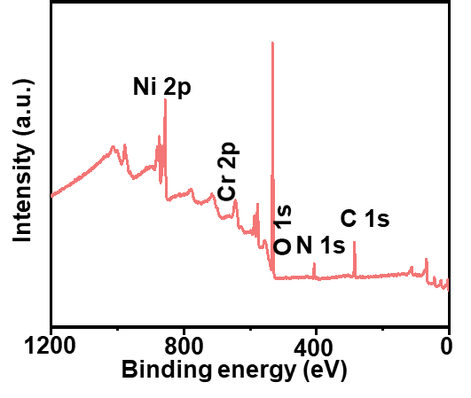
Fig. S1 XPS survey spectrum of NiCrOOH-NO₃

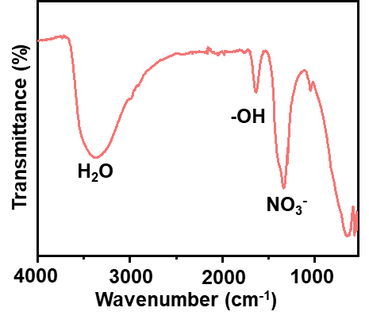
Fig. S2 FTIR spectrum of NiCrOOH-NO₃

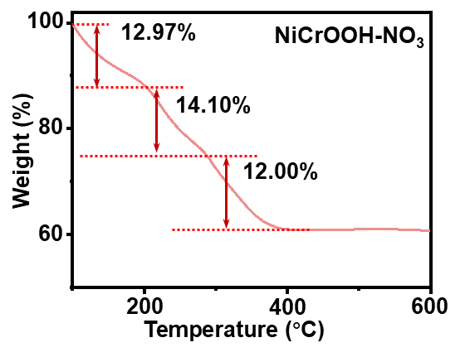
Fig. S3 TGA curve of NiCrOOH-NO₃

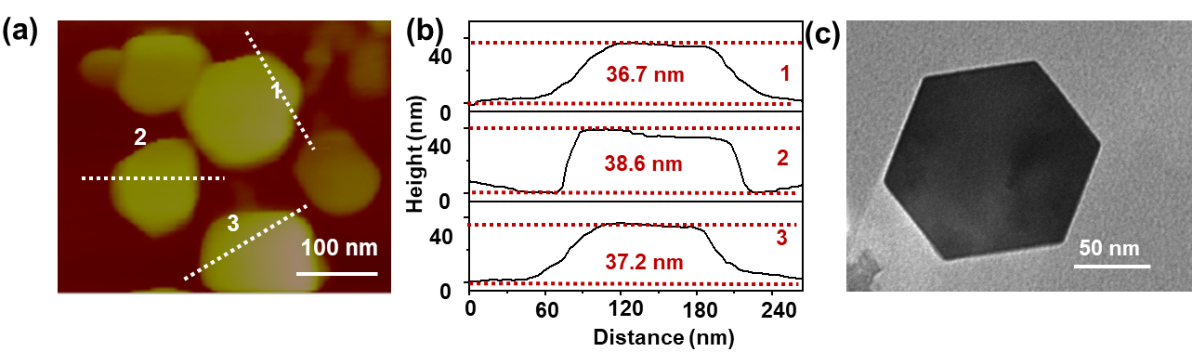
Fig. S4 (a) AFM image and (b) height profiles of NiCrOOH-NO₃-T nanosheets, (c) TEM image

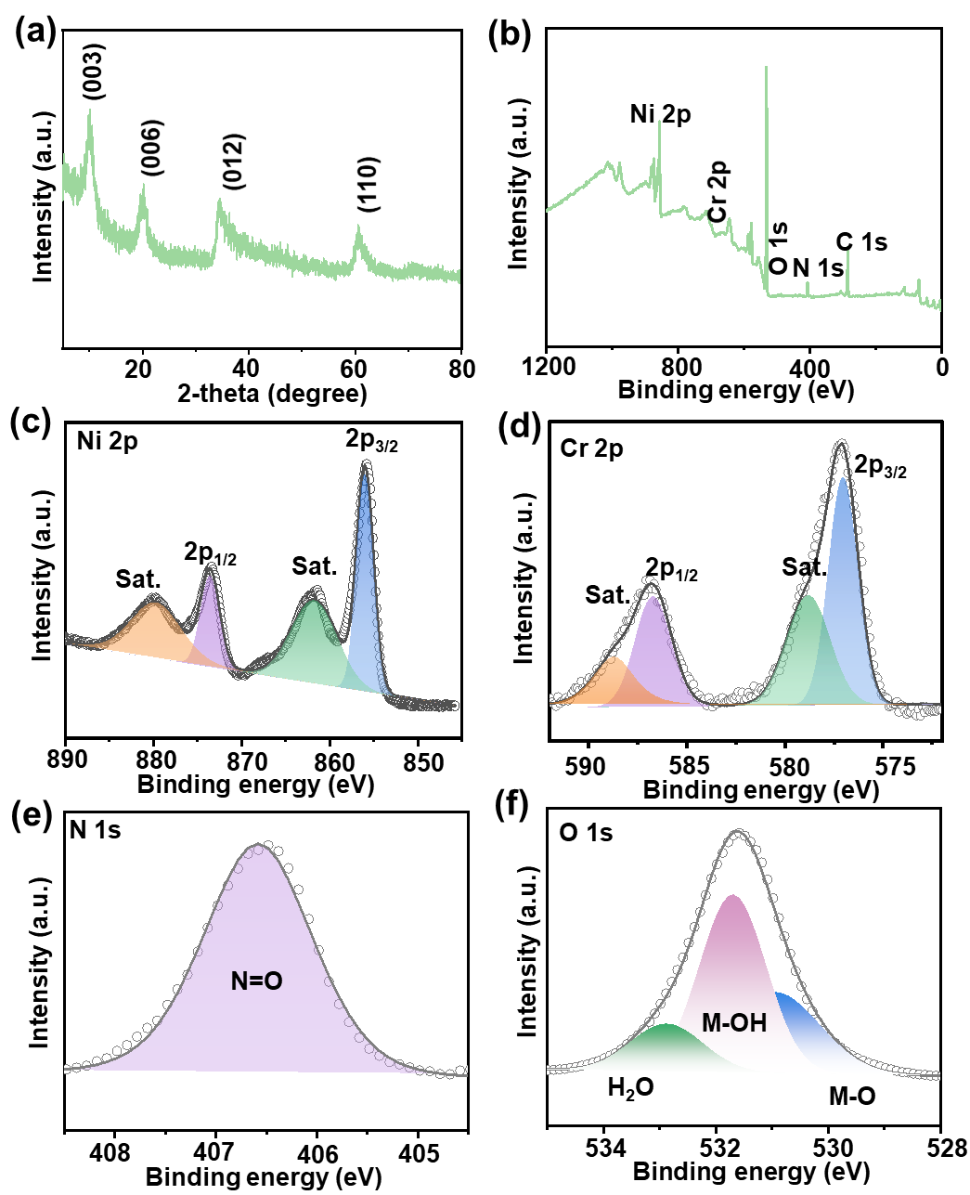
Fig. S5 (a) XRD pattern, (b) XPS survey spectrum, high-resolution XPS spectra of (c) Ni 2p, (d) Cr 2p, (e) N 1s, (f) O 1s of NiCrOOH-NO₃-T

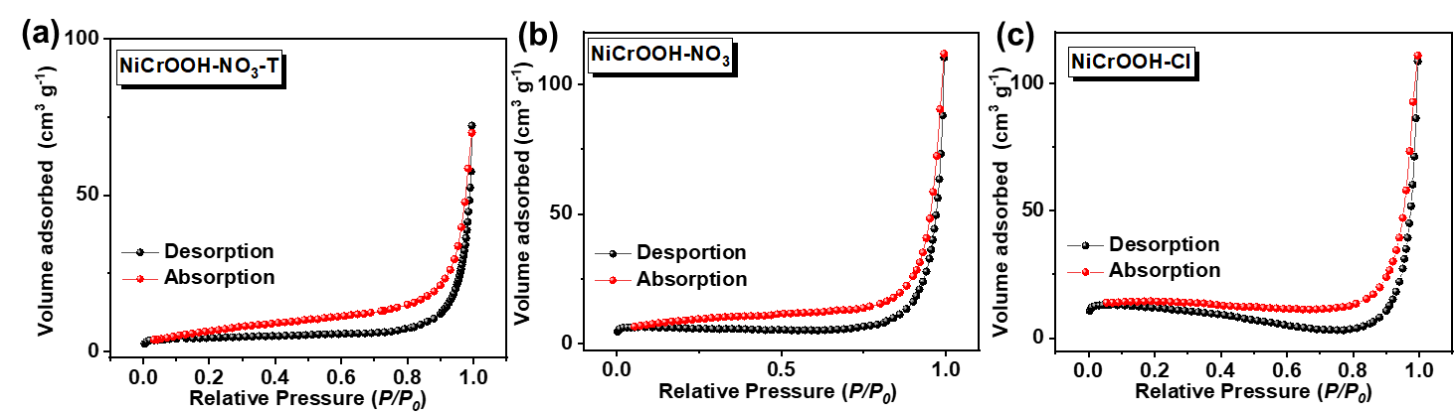
Fig. S6 Nitrogen adsorption-desorption isotherms of NiCrOOH-NO₃-T, NiCrOOH-NO₃ and NiCrOOH-Cl

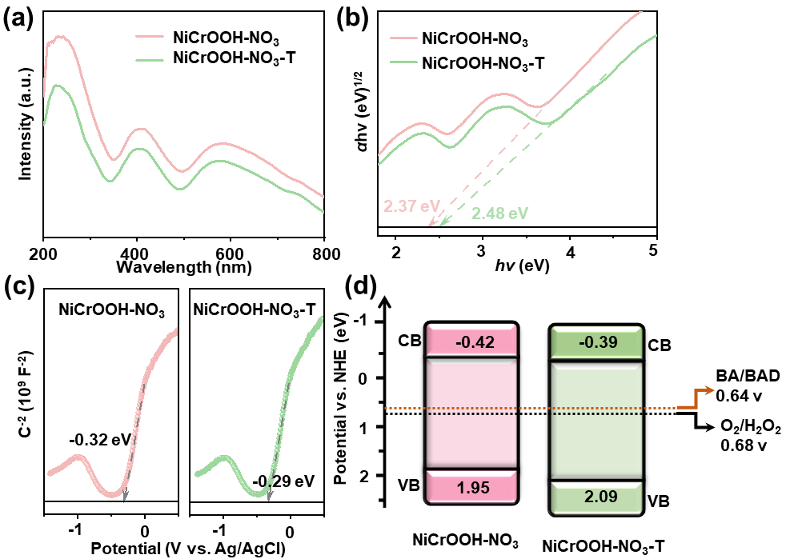
Fig. S7 (a) UV–vis DRS profiles of NiCrOOH-NO₃ and NiCrOOH-NO₃-T, (b) Tauc plots and (c) Mott-Schottky plots, and (d) band structures of NiCrOOH-NO₃ and NiCrOOH-NO₃-T

Fig. S8 Light irradiation spectrum of the xenon lamp (320 nm < λ < 780 nm)

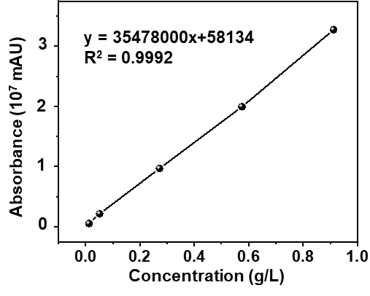
Fig. S9 Standard curve between concentration and absorbance of benzaldehyde

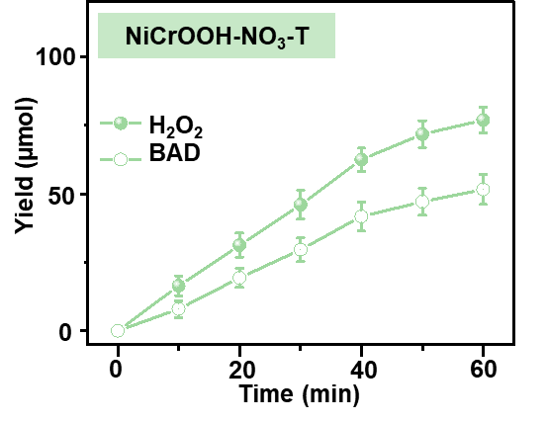
Fig. S10 Time course of H₂O₂ and BAD contents during the photocatalytic reaction over NiCrOOH-NO₃-T

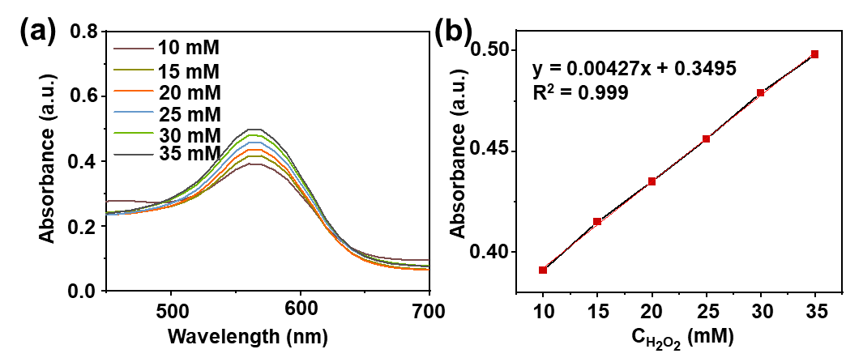
Fig. S11 (a) UV-vis absorption spectra and (b) corresponding standard curve for H₂O₂ quantification by ferrous ion oxidation xylenol orange colorimetry

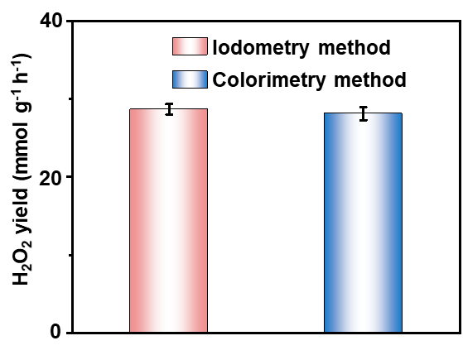
Fig. S12 H₂O₂ yield rates determined by iodometry and colorimetry method

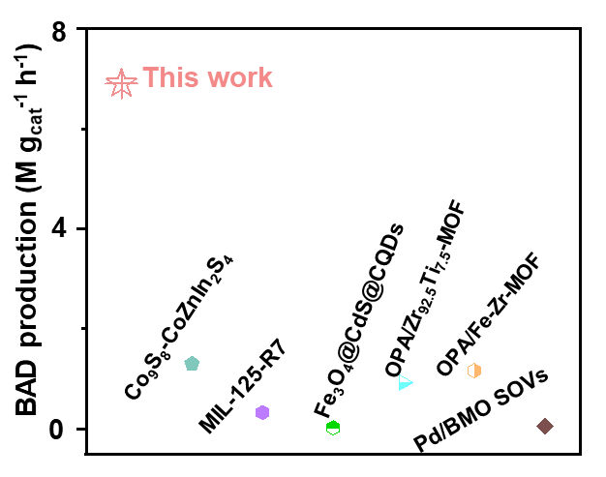
Fig. S13 Comparison of BAD production with recently reported photocatalysts

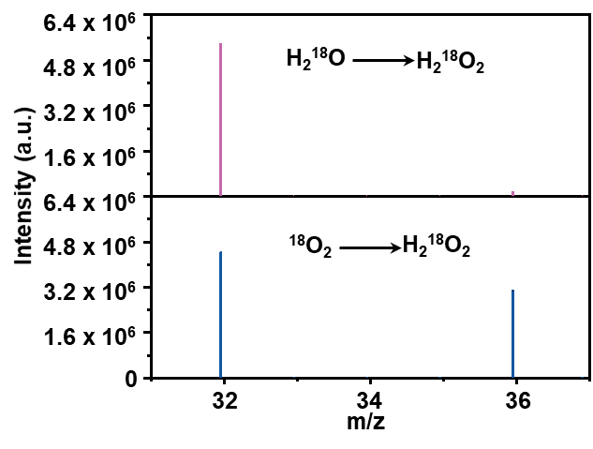
Fig. S14 GC-MS spectra of O₂ products generated from H₂O₂ decomposition in the isotope labelling experiment

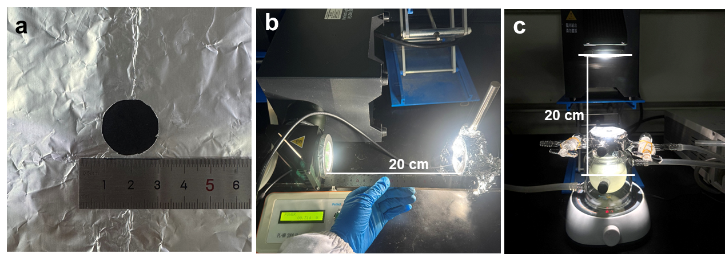
Fig. S15 Image of (a) a circular hole with a radius of 1 cm in the aluminum foil sheet, (b) light intensity measurement via the Si photodiode, (c) reaction system for measuring SCC efficiency of NiCrOOH-NO₃

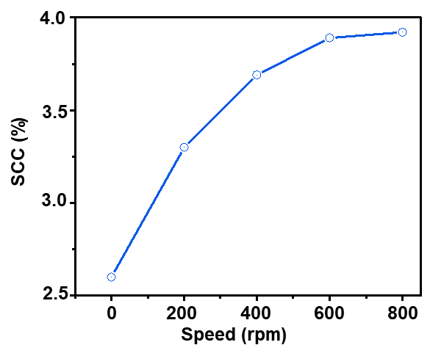
Fig. S16 SCC efficiency at different rotational speeds

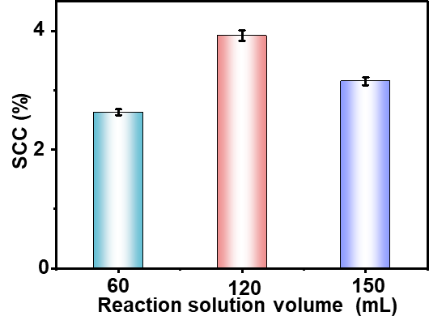
Fig. S17 SCC efficiency of NiCrOOH-NO₃ with different volumes of reaction solution

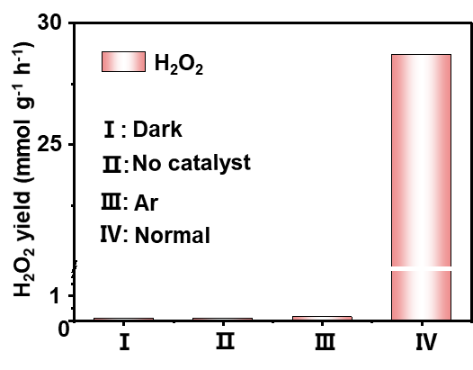
Fig. S18 Photocatalytic H₂O₂ production over NiCrOOH-NO₃ under different conditions

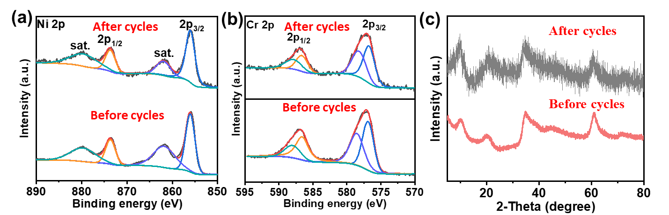
Fig. S19 (a) Ni 2p, (b) Cr 2p XPS spectra and (c) XRD pattern of NiCrOOH-NO₃ after cycling test
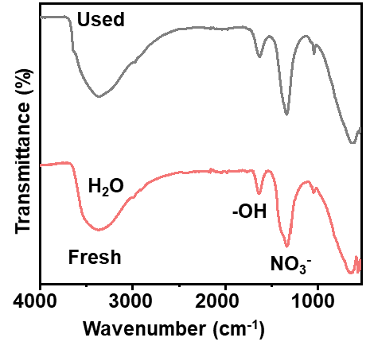
Fig. S20 FTIR spectra of NiCrOOH-NO₃ before and after cycling test

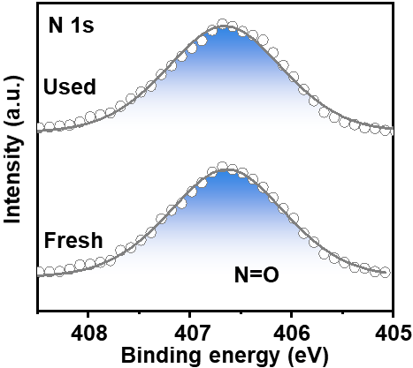
Fig. S21 N 1s XPS spectra of NiCrOOH-NO₃ before and after cycling test

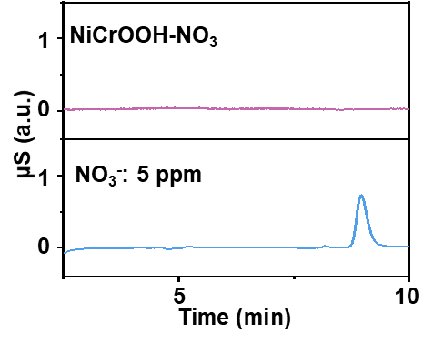
Fig. S22 Ion chromatogram spectra of post-reaction supernatant and 5 ppm NO₃⁻ solution

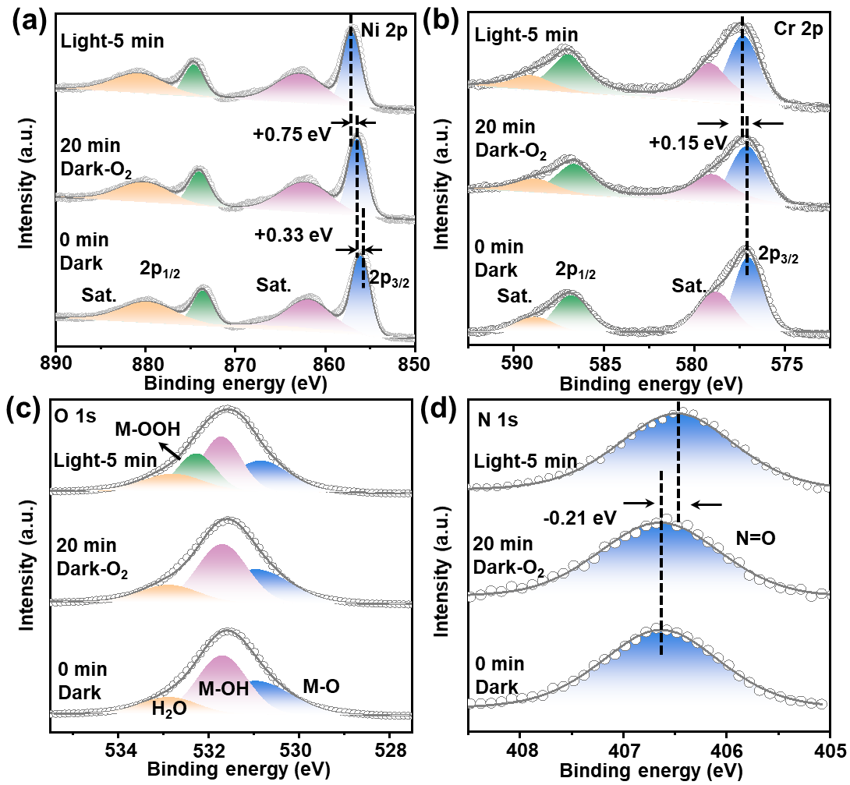
Fig. S23 ISIXPS spectra of (a) Ni 2p, (b) Cr 2p, (c) O 1s and (d) N 1s of NiCrOOH-NO₃

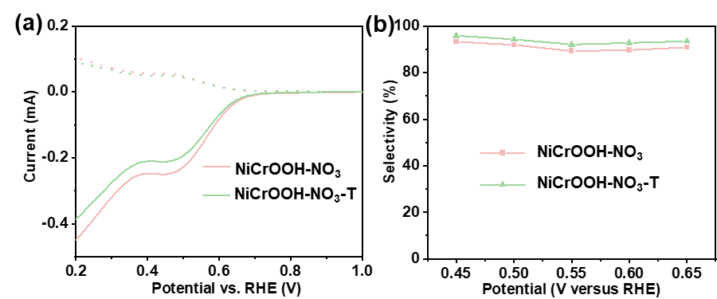
Fig. S24 (a) LSV polarization curves and (b) H₂O₂ selectivities of NiCrOOH-NO₃ and NiCrOOH-NO₃-T

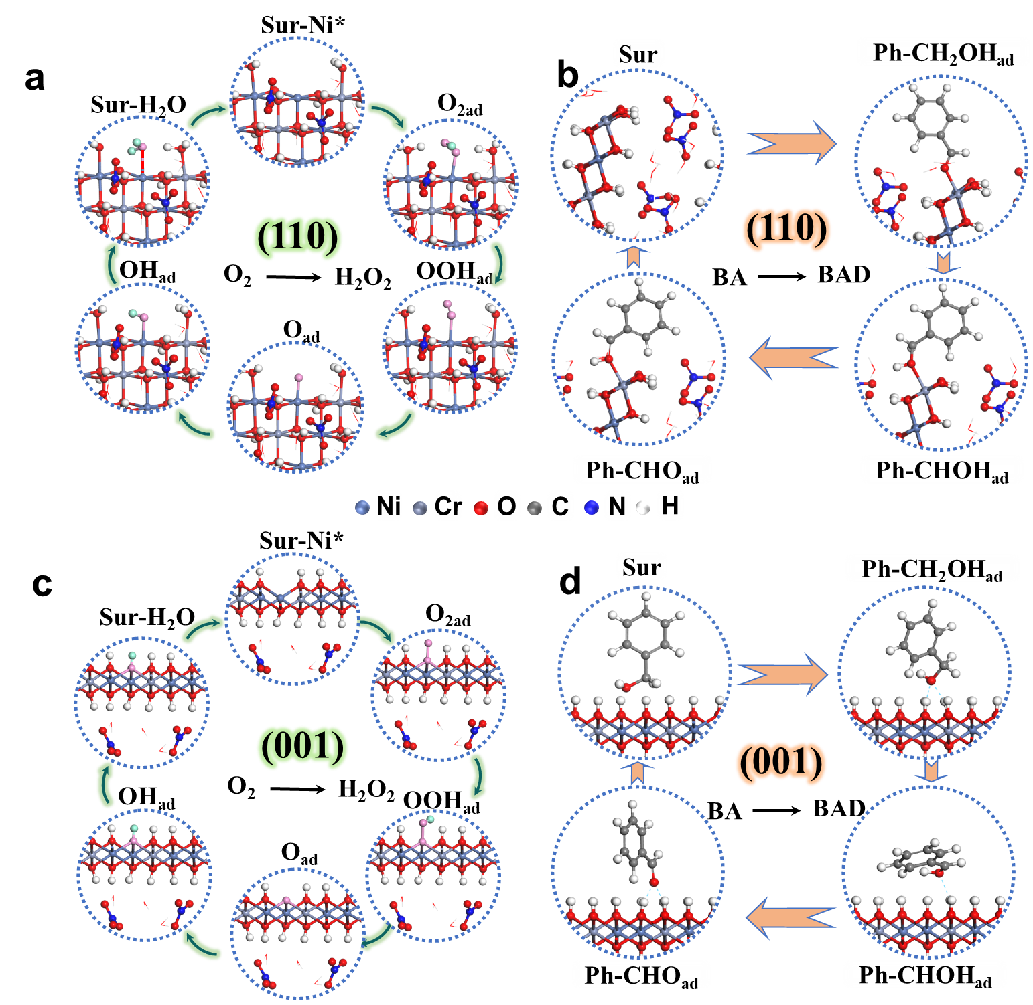
Fig. S25 Optimized structures of the reaction intermediates on (a, b) (110) and (c, d) (001) planes over NiCrOOH-NO₃

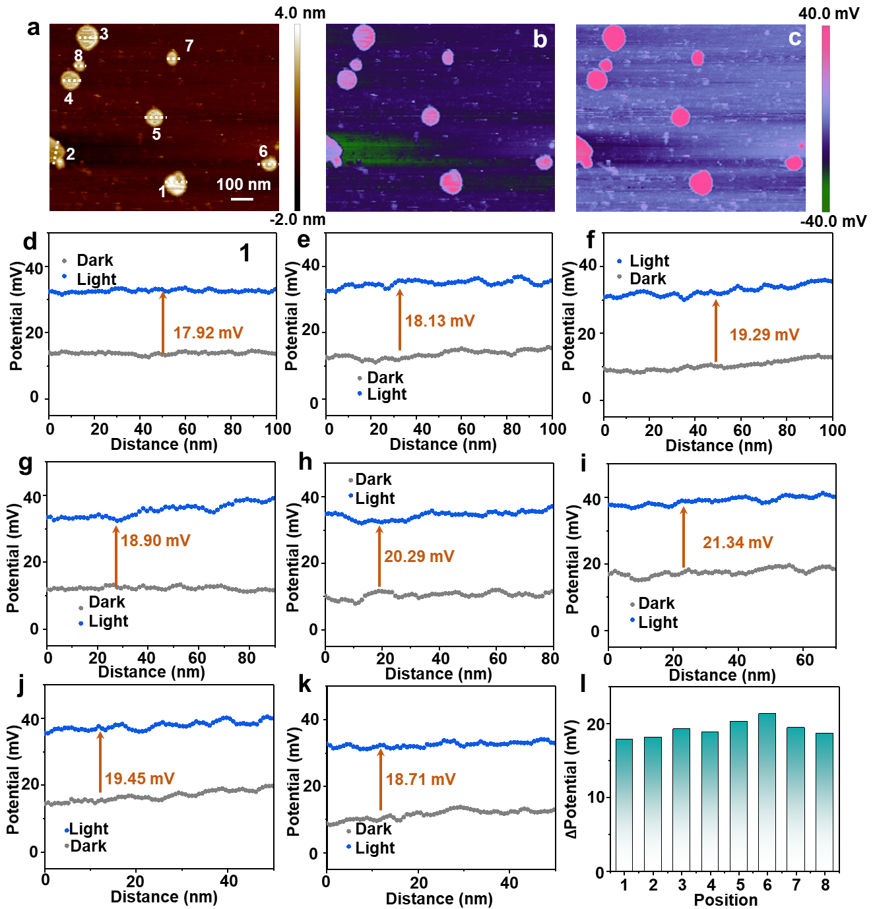
Fig. S26 (a) Atomic force microscopy image of NiCrOOH-NO₃, corresponding KPFM images (b) in darkness and (c) under illumination, (d-k) line scanning surface potential profiles along the white dashed lines, (i) statistical potential difference of NiCrOOH-NO₃ under illumination versus dark conditions
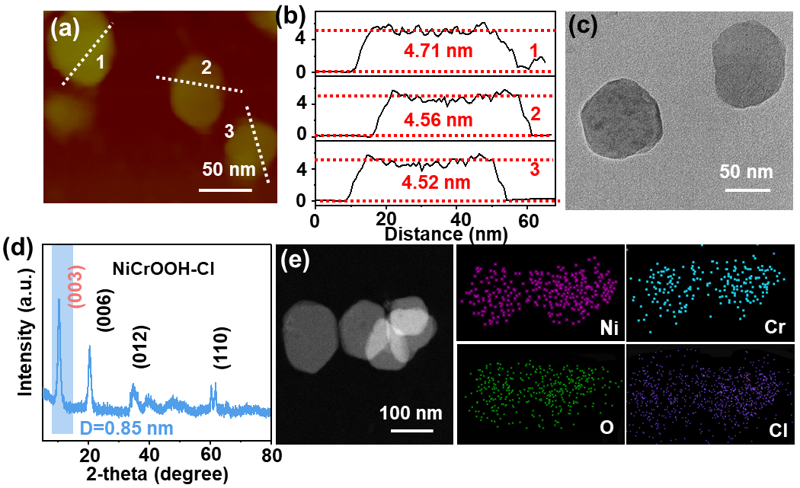
Fig. S27 (a) AFM image and (b) height profiles of NiCrOOH-Cl nanosheets, (c) TEM, (d) XRD pattern, (e) High-angle annular dark-field scanning TEM image and EDS element maps for Ni, Cr, O and Cl of NiCrOOH-NO₃-Cl
The TEM image shows that NiCrOOH-Cl has also a hexagonal plate morphology with a thickness of ~ 4.6 nm (Fig. S12a-c), close to that of NiCrOOH-NO₃. The (003) crystal plane diffraction peak for NiCrOOH-Cl is observed at 10.28°, which corresponds to a d₀₀₃-spacing of 0.87 nm (Fig. S12d). The HAADF and EDX elemental mapping images present the uniform distribution of Ni, Cr, Cl and O elements (Fig. S12e).

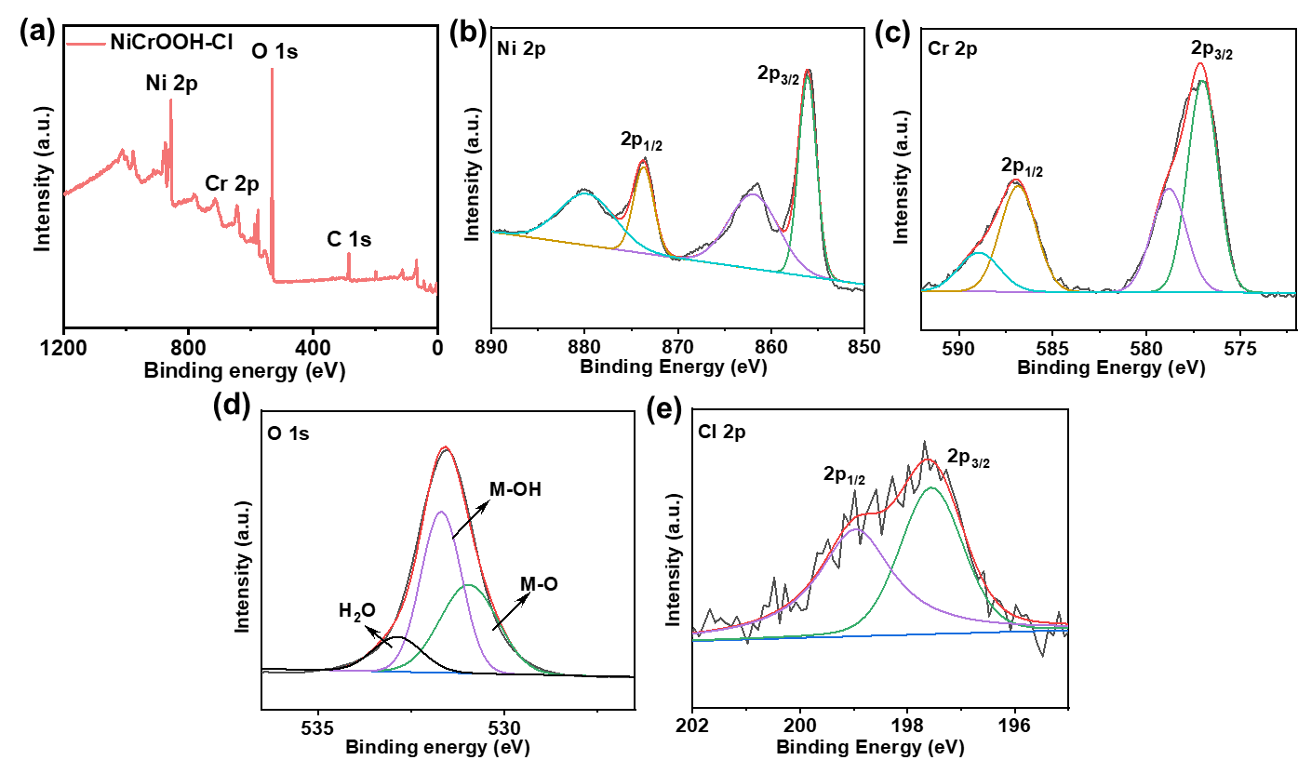
Fig. S28 (a) XPS survey spectra of NiCrOOH-Cl, XPS spectra of (b) Ni 2p, (c) Cr 2p, (d) O 1s and (e) Cl 2p of NiCrOOH-Cl
The XPS survey spectra (Fig. S13a) also demonstrate the coexistence of Ni, Cr, Cl and O elements. The Ni 2p and Cr 2p peaks indicate the existence of Ni²⁺ and Cr³⁺ in NiCrOOH-Cl. Fig. S13d displays the O 2p spectrum, where two peaks are close to NiCrOOH-NO₃. In addition, two peaks at 197.55 eV and 198.98 eV are found in the Cl 2p XPS spectra (Fig. S13e), suggesting the successful intercalation of Cl⁻ in NiCrOOH-Cl.

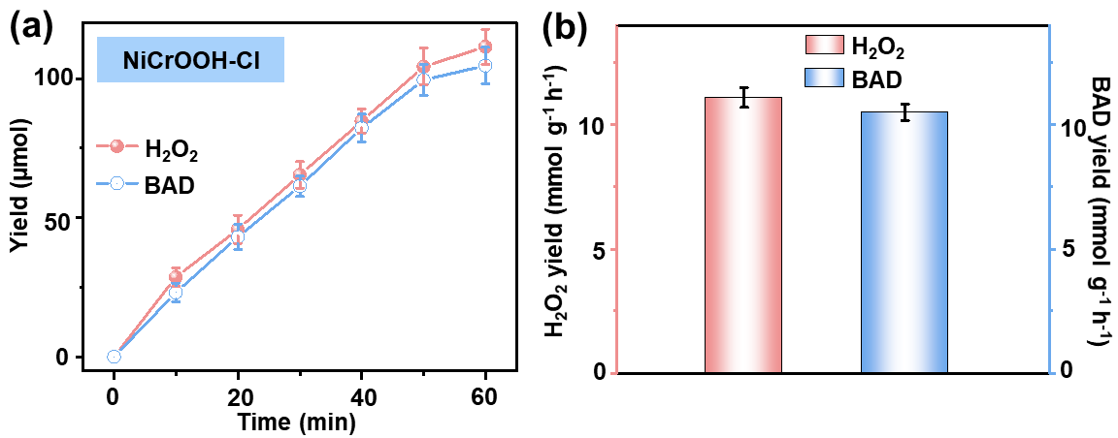
Fig. S29 (a) Time course of H₂O₂ and BAD contents during the photocatalytic reaction over NiCrOOH-Cl, (b) H₂O₂ and BAD yield rates of NiCrOOH-Cl

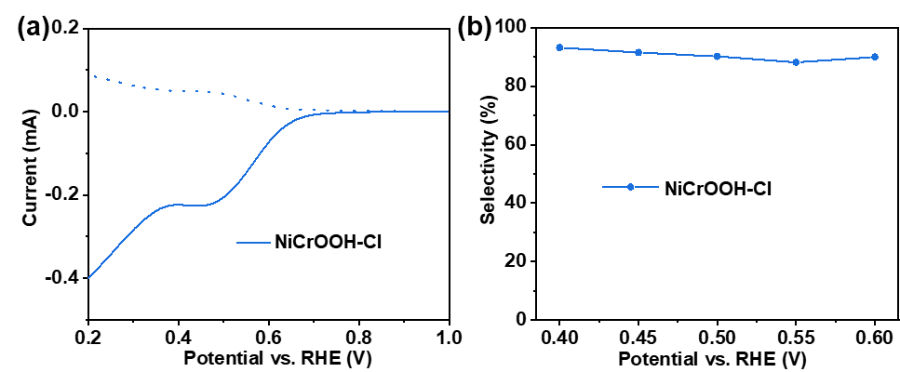
Fig. S30 (a) LSV polarization curve and (b) H₂O₂ selectivity of NiCrOOH-Cl

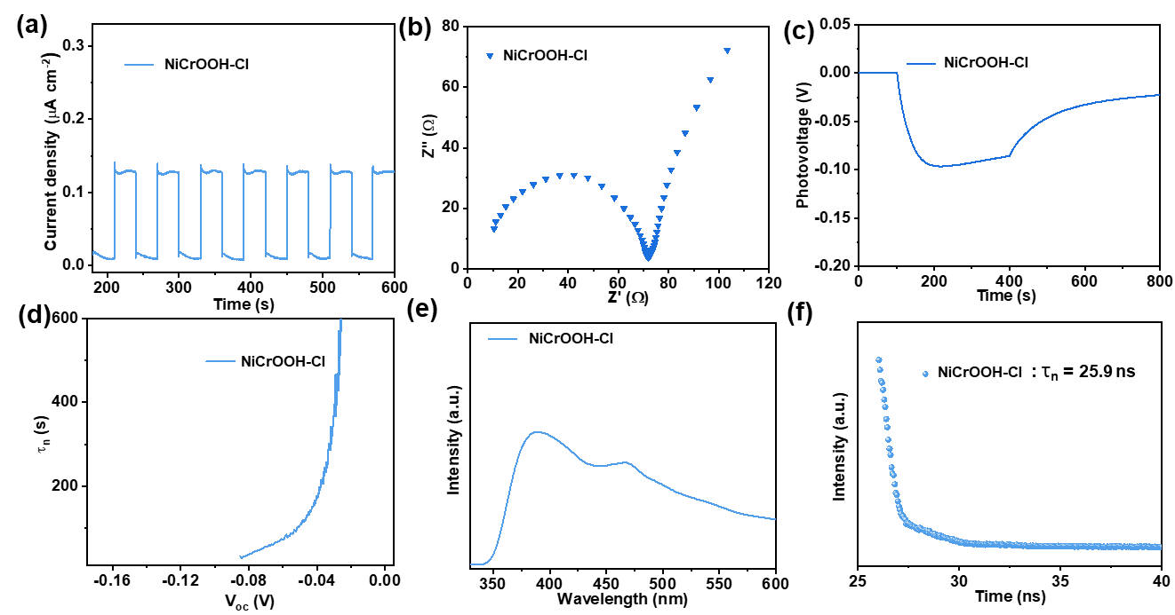
Fig. S31 (a) transient photocurrent response, (b) EIS curve, (c) transient OCVD curve, (d) average electron lifetimes (τ_{n}), (e) PL spectrum and (f) TRPL spectrum of NiCrOOH-Cl

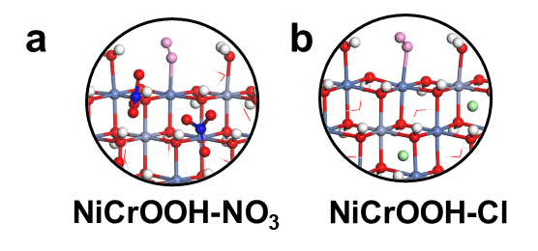
Fig. S32 Adsorption configurations of O₂ on NiCrOOH-NO₃ and NiCrOOH-Cl
Table S1 Atomic percentage of XPS for NiCrOOH-NO₃ before and after photocatalytic reaction
Sample |  | N(%) | O(%) | Ni(%) | Cr(%) | Ni/Cr/N/O ratio from XPS
Fresh |  | 4.90%±0.98 | 56.55%  ±1.23 | 9.85%  ±1.08 | 4.89%  ±1.19 | Ni_{2.00}Cr_{0.99}N_{0.99}O_{11.48}
Used |  | 4.86%  ±1.30 | 56.28%  ±1.27 | 9.81%  ±1.08 | 4.87%  ±1.26 | Ni_{2.00}Cr_{0.99}N_{0.98}O_{11.47}
Table S2 EA and ICP-AES results of NiCrOOH-NO₃
Sample | H(%) | N(%) | O(%) | Ni(%) | Cr(%) | Ni/Cr/H/N/O ratio from EA and ICP-AES
NiCrOOH-NO₃ | 3.04%  ±1.09 | 3.68% ±1.37 | 48.60%  ±1.53 | 31.08%  ±1.21 | 13.60%  ±1.33 | Ni_{2.00}Cr_{0.99}N_{0.98}O_{11.47}H_{11.48}

Table S3 BET specific surface areas (S) of NiCrOOH-NO₃-T, NiCrOOH-NO₃ and NiCrOOH-Cl
Samples | S (m²·g⁻¹)
NiCrOOH-NO₃-T | 60.2
NiCrOOH-NO₃ | 93.1
NiCrOOH-Cl | 92.3
Table S4 Calculated AQY and APCE value of NiCrOOH-NO₃ under different-wavelength irradiation
Wavelength (nm) | Light power (mW) | Photon flux (µmol m⁻² s⁻¹) | H₂O₂ production (µmol) | Absorptance (A) | AQY  (%) | APCE (%)
350 | 13 | 126.24 | 22 | 0.53 | 30.84 | 58.19
400 | 15 | 159.63 | 30.4 | 0.49 | 33.70 | 68.78
450 | 18 | 215.49 | 26.07 | 0.43 | 21.41 | 49.79
500 | 20 | 266.04 | 25.43 | 0.33 | 16.92 | 51.27
550 | 23 | 336.54 | 20.93 | 0.44 | 11.00 | 25.00
600 | 16 | 255.40 | 10.58 | 0.36 | 7.33 | 20.36
650 | 13 | 224.80 | 5.87 | 0.31 | 4.62 | 14.90
Table S5 Comparison H₂O₂ production rate of NiCrOOH-NO₃ with recently reported photocatalysts
Photocatalyst | Light source | Reaction conditionsª |  | Activity  (mmol g_{cat}⁻¹ h⁻¹) |  | AQY |  | Refs.
NiCrOOH-NO₃ | 300 W Xe lamp  320 < λ < 780 nm | H₂O/BA |  | 28.7 |  | 33.7 |  | This work
QP-HPTP-COF | 300 W Xe lamp  λ > 420 nm | H₂O |  | 4.4 |  | - | [1]
RS | 300 W Xe lamp  λ > 420 nm | H₂O |  | 1.5 |  | 13.1 | [10]
rGO@MRF | 300 W Xe lamp  λ ≥ 420 nm | H₂O |  | 0.9 |  | - | [43]
TAPT–FTPB COF | 300 W Xe lamp  AM1.5G | H₂O |  | 3.8 |  | - | [40]
RF-DHAQ | 300 W Xe lamp  λ > 420 nm | H₂O |  | 1.8 |  | - | [48]
SA-TCPP | 300 W Xe lamp  λ > 420 nm | H₂O |  | 1.8 |  | 14.9 | [47]
Mo:BiVO₄ | 300 W Xe lamp  AM 1.5G | H₂O |  | 0.1 |  | 1.2 | [39]
APFac | 300 W Xe lamp  λ > 420 nm | H₂O |  | 4.5 |  | - | [45]
COF-TfpBpy | 300 W Xe lamp | H₂O |  | 0.7 |  | 13.6 | [37]
PI-BD-TPB | 300 W Xe lamp | H₂O |  | 3.8 |  | 14.3 | [35]
CoO_{x}-BCN-FeOOH | 300 W Xe lamp  λ > 420 nm | H₂O |  | 0.3 |  | 8.4 | [38]
Co-N@G | AM 1.5G | H₂O |  | 16.6 |  | 9.1 | [44]
Kf-AQ | λ > 400 nm | H₂O |  | 4.8 |  | 15.8 | [46]
Sb-SAPC | 300 W Xe lamp  λ > 420 nm | H₂O |  | 0.1 |  | 17.6 | [42]
SA-NDI | 300 W Xe lamp  AM1.5G | H₂O/MeOH |  | 1.2 |  | 17.2 | [36]
RF523 | λ > 420 nm | H₂O/BA |  | 0.1 |  | 7.8 | [41]
Pd/BMO-SOVs | blue LED | H₂O/BA |  | 0.01 |  | - | [56]
sonoCOF-F2 | 300 W Xe lamp  AM1.0G | H₂O/BA |  | 0.7 |  | 4.8 | [57]
MIL-125-NH₂-R7 | 300 W Xe lamp  λ > 420 nm | H₂O/BA |  | 0.3 |  | - | [53]
Bi₂MoO₆-H₂ | Xe lamp | H₂O/BA |  | 0.1 |  | - | [49]
OPA/Zr_{92.5}Ti_{7.5}-MOF | 300 W Xe lamp  λ > 420 nm | H₂O/BA |  | 13.6 |  | - | [50]
OPA/Fe-Zr-MOF | 500 W Xe lamp  λ > 420 nm | H₂O/BA |  | 18.3 |  |  | [51]
TpAzo-CPd | 300 W Xe lamp  λ > 420 nm | H₂O/BA |  | 0.7 |  | - | [55]
PMCR-1 | 300 W Xe lamp  λ > 420 nm |  | H₂O/BA | 5.5 |  | 14 | [42]
Al−TCPP | 300 W Xe lamp  AM 1.5G |  | H₂O/BA | 6.4 |  | 12.1 | [58]
EBA-COF | 50 W LED lamp λ > 420 nm |  | H₂O/ETOH |  | 1.8 | - | [59]
Tp-BTz COF | 300 W Xe lamp |  | H₂O/BA |  | 100.9 | 18.0 | [60]
TpPm | 300W Xe lamp  λ > 420 nm |  | H₂O/BA |  | 17.0 | 22.7 | [61]
Table S6 Summary of reported SCC efficiencies for photocatalytic H₂O₂ production
Samples | Mass(mg) | Volume (mL) |  |  | Temperature (°C) | Irradiance (mW cm⁻²) | Area (cm²) | Total input energy (W) |  |  | H₂O₂ formed (µmol) |  | SCC |  | Refs
NiCrOOH-NO₃ | 100 |  | 100 |  | 50 | 100 | 3.14 | 0.314 | 378.84 |  |  |  | 3.92 | This work
QP-HPTP-COF | 800 |  | 135 |  | - | 100 | 4 | 0.4 | 173.54 |  |  |  | 1.41 | [1]
RS | 500 |  | 100 |  | 50 | 100 | 4 | 0.400 | 172.30 |  |  |  | 1.40 | [10]
rGO@  MRF | 400 |  | 150 |  | 50 | 100 | 6.25 | 0.625 | 236.50 |  |  |  | 1.23 | [43]
TAPT–FTPB COF | - |  | - | - |  | 100 | 1 | 0.100 | 37.54 |  |  |  | 1.22 | [40]
RF-DHAQ | 400 |  | 150 | 50 |  | 100 | 4 | 0.400 | 147.69 |  |  |  | 1.20 | [48]
SA-TCPP | - |  | - | 80 |  | 100 | 1.09 | 0.109 |  | 36.89 |  | 1.1 |  | [47]
SA-NDI | 150 |  | 40 | 60 |  | 100 | 3.14 | 0.314 | 99.51 |  |  |  | 1.03 | [36]
COF-TfpBpy | 600 |  | 400 | 60 |  | 40.8 | 16 | 0.653 | 531.70 |  |  |  | 1.08 | [37]
PI-BD-TPB | 80 |  | 60 | 50 |  | 100 | 0.79 | 0.0785 | 74.07 |  |  |  | 0.92 | [35]
CoO_{x}-BCN-FeOOH | - |  | - | - |  | 100 | 4 | 0.4 | 92.31 |  |  |  | 0.75 | [38]
Co-N@G | 200 |  | - | - |  | 100 | - | - | 707.80 |  |  |  | 0.72 | [44]
Kf-AQ | 5 |  | 30 | -- |  | 98.4 | 0.37 | 0.037 | 7.97 |  |  |  | 0.7 | [46]
Sb-SAPC | 500 |  | 100 | - |  | 100 | 1 | 0.1 |  | 18.77 |  | 0.61 |  | [42]
APFac | 400 |  | 150 | 50 |  | 100 | 4 | 0.400 |  | 66.46 |  | 0.54 |  | [45]
RF523 | 250 |  | 50 | 60 |  | 100 | 3.14 | 0.314 |  | 48.31 |  | 0.5 |  | [41]
Mo:  BiVO₄ | - |  | 12 | - |  | 100 | 1.91 | 0.191 |  | 17.04 |  | 0.29 |  | [39]
Tp-BTz COF | 5 |  | 20 | 25 |  | 100 | 12.6 | 1.26 |  | 569.91 |  | 1.47 |  | [60]
TpPm | 150 |  | 50 | - |  | 100 | 12.56 | 1.26 |  | 356.68 |  | 1.84 |  | [61]
Table S7 ICP-AES results of the reaction solution after photocatalytic test
Sample | Ni (mg/L) | Cr (mg/L)
Reaction solution  after test | 0.010 | 0.012
Supplementary References
- T. Takata, J. Jiang, Y. Sakata, M. Nakabayashi, N. Shibata et al., Photocatalytic water splitting with a quantum efficiency of almost unity. Nature 581(7809), 411–414 (2020). https://doi.org/10.1038/s41586-020-2278-9
- J. Meng, Y. Duan, S. Jing, J. Ma, K. Wang et al., Facet junction of BiOBr nanosheets boosting spatial charge separation for CO₂ photoreduction. Nano Energy 92, 106671 (2022). https://doi.org/10.1016/j.nanoen.2021.106671
- Y. Zhang, Y. Li, X. Xin, Y. Wang, P. Guo et al., Internal quantum efficiency higher than 100% achieved by combining doping and quantum effects for photocatalytic overall water splitting. Nat. Energy 8(5), 504–514 (2023). https://doi.org/10.1038/s41560-023-01242-7
- S.-D. Huang, C. Shang, P.-L. Kang, X.-J. Zhang, Z.-P. Liu, LASP: Fast global potential energy surface exploration. Wires Comput. Mol. Sci. 9(6), e1415 (2019). https://doi.org/10.1002/wcms.1415
- G. Kresse, J. Furthmüller, Efficiency of ab-initio total energy calculations for metals and semiconductors using a plane-wave basis set. Comput. Mater. Sci. 6(1), 15–50 (1996). https://doi.org/10.1016/0927-0256(96)00008-0
- P.E. Blöchl, Projector augmented-wave method. Phys. Rev. B 50(24), 17953–17979 (1994). https://doi.org/10.1103/physrevb.50.17953
- G. Kresse, D. Joubert, From ultrasoft pseudopotentials to the projector augmented-wave method. Phys. Rev. B 59(3), 1758–1775 (1999). https://doi.org/10.1103/physrevb.59.1758
- J.P. Perdew, K. Burke, M. Ernzerhof, Generalized gradient approximation made simple. Phys. Rev. Lett. 77(18), 3865–3868 (1996). https://doi.org/10.1103/physrevlett.77.3865
- S.L. Dudarev, G.A. Botton, S.Y. Savrasov, C.J. Humphreys, A.P. Sutton, Electron-energy-loss spectra and the structural stability of nickel oxide: An LSDA+U study. Phys. Rev. B 57(3), 1505–1509 (1998). https://doi.org/10.1103/physrevb.57.1505
- N.J. Mosey, P. Liao, E.A. Carter, Rotationally invariant ab initio evaluation of Coulomb and exchange parameters for DFT+U calculations. J. Chem. Phys. 129, 014103 (2008). https://doi.org/10.1063/1.2943142
- P. Liao, J.A. Keith, E.A. Carter, Water oxidation on pure and doped hematite (0001) surfaces: prediction of co and Ni as effective dopants for electrocatalysis. J. Am. Chem. Soc. 134(32), 13296–13309 (2012). https://doi.org/10.1021/ja301567f
- S. Grimme, J. Antony, S. Ehrlich, H. Krieg, A consistent and accurate ab initio parametrization of density functional dispersion correction (DFT-D) for the 94 elements H-Pu. J. Chem. Phys. 132(15), 154104 (2010). https://doi.org/10.1063/1.3382344
- S. Grimme, S. Ehrlich, L. Goerigk, Effect of the damping function in dispersion corrected density functional theory. J. Comput. Chem. 32(7), 1456–1465 (2011). https://doi.org/10.1002/jcc.21759
- H.J. Monkhorst, J.D. Pack, Special points for Brillouin-zone integrations. Phys. Rev. B 13(12), 5188–5192 (1976). https://doi.org/10.1103/physrevb.13.5188
- K. Mathew, R. Sundararaman, K. Letchworth-Weaver, T.A. Arias, R.G. Hennig, Implicit solvation model for density-functional study of nanocrystal surfaces and reaction pathways. J. Chem. Phys. 140(8), 084106 (2014). https://doi.org/10.1063/1.4865107
- K. Mathew, V.S. Chaitanya Kolluru, S. Mula, S.N. Steinmann, R.G. Hennig, Implicit self-consistent electrolyte model in plane-wave density-functional theory. J. Chem. Phys. 151(23), 234101 (2019). https://doi.org/10.1063/1.5132354
- G.-F. Wei, C. Shang, Z.-P. Liu, Confined platinum nanoparticle in carbon nanotube: structure and oxidation. Phys. Chem. Chem. Phys. 17(3), 2078–2087 (2015). https://doi.org/10.1039/c4cp04145c
- 18 CRC Handbook of Chemistry and Physics; 84th ed.; Lide, D. R., Ed.; CRC Press: Boca Raton, FL, 2003−2004.

