Supporting Information for
Uniform Fast-Kinetic Anode/Cathode Electrolyte Interphases Enable High Performance 3C Li-Metal Batteries with >99.9% Coulombic Efficiencies
Qingyang Cao¹, Danchen Fu¹, Xuedong He¹, Yaohua Huang¹, Ningning Yao¹, Chunyu Song¹, Huawei Song¹* and Chengxin Wang¹*
¹State Key Laboratory of Optoelectronic Materials and Technologies, School of Materials Science and Engineering, Sun Yat-Sen (Zhongshan) University, Guangzhou 510275, People’s Republic of China
*Corresponding authors. E-mail: songhw5@mail.sysu.edu.cn (Huawei Song); wchengx@mail.sysu.edu.cn (Chengxin Wang)
Supplementary Figures and Tables
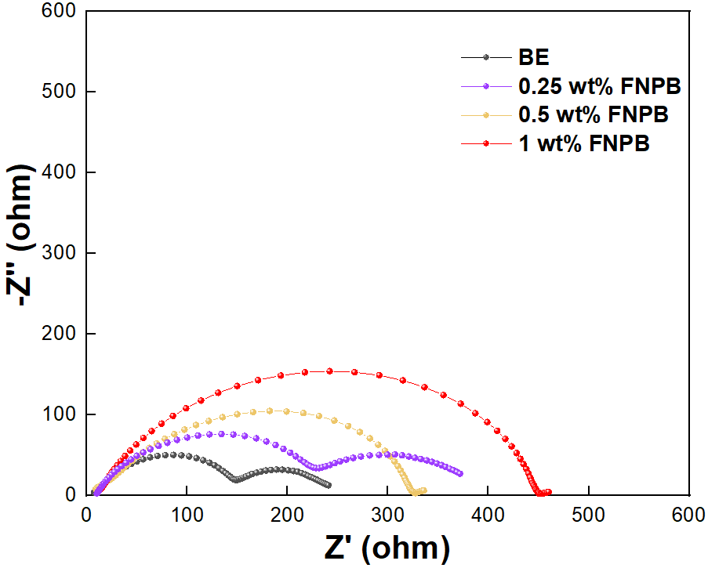
Fig. S1 EIS plots of pristine Li-metal symmetric cells with electrolytes containing different amounts of FNPB
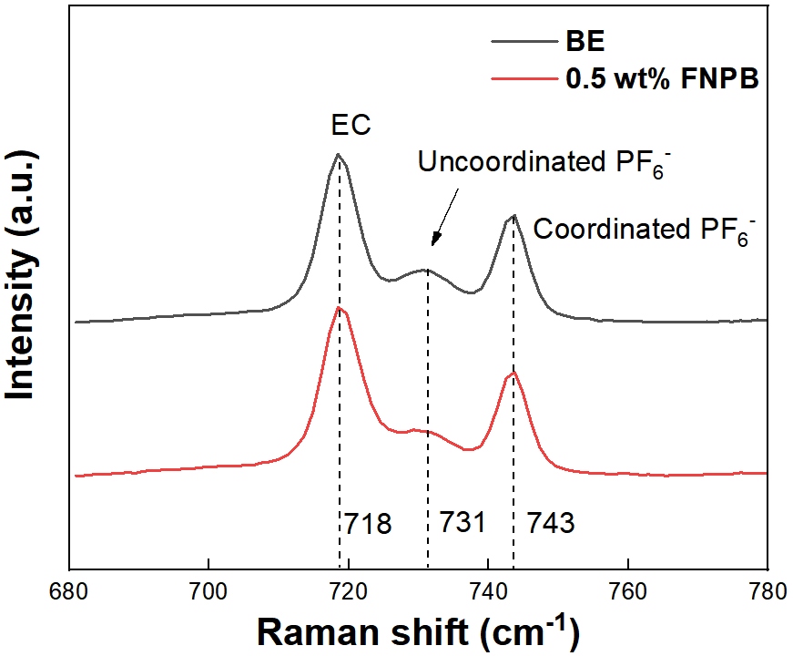

Fig. S2 Local anion signals in Raman spectra of electrolyte with/without FNPB

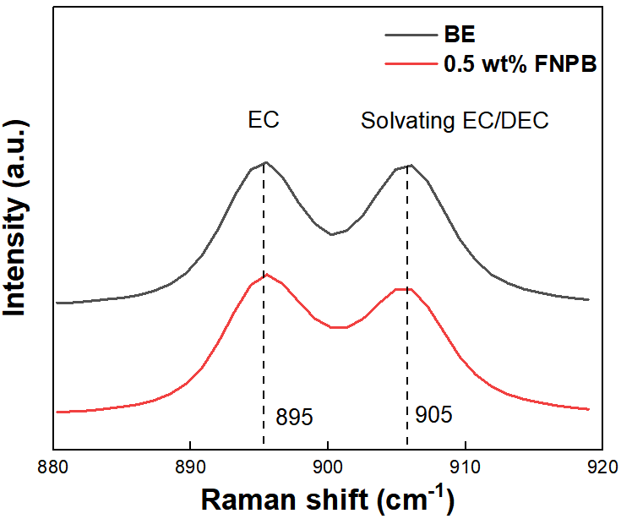

Fig. S3 Local cation signals in Raman spectra of electrolyte with/without FNPB

Fig. S4 The Binding Energies of Li metal with FNPB, EC and DEC

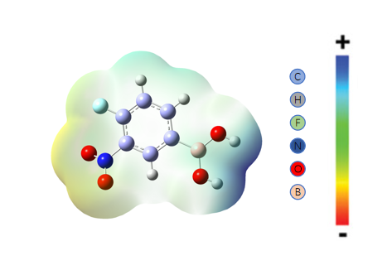
Fig. S5 Electrostatic potential surface, with yellow and blue areas representing negative and positive charges, respectively

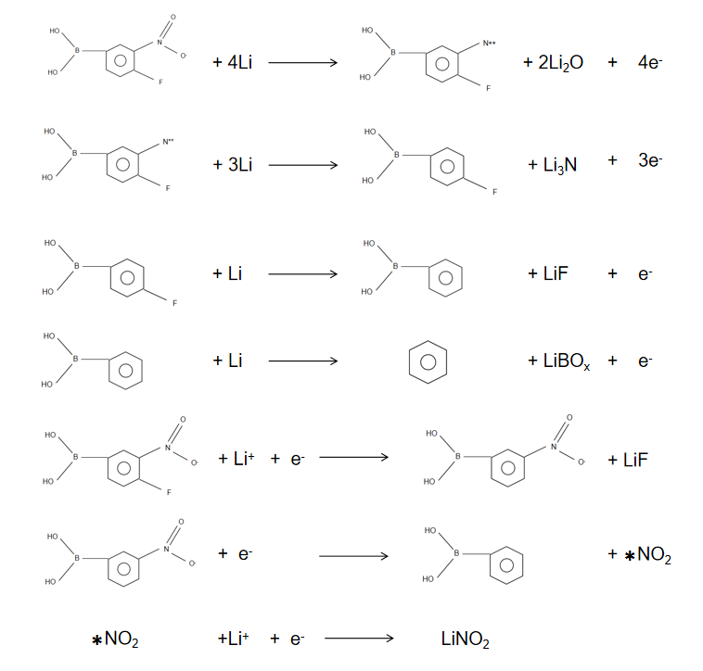
Fig. S6 One possible reaction pathway between FNPB and Li metal and LiFePO₄
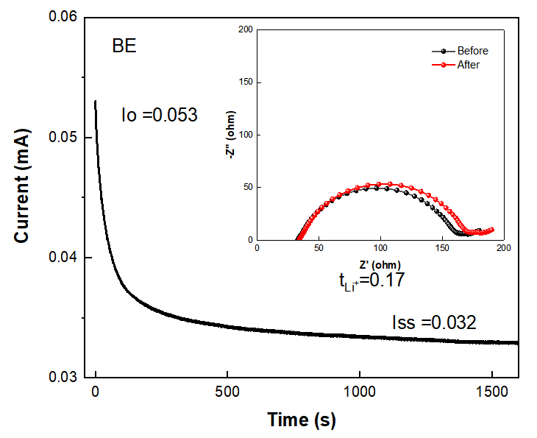
Fig. S7 Current-time plots of Li-metal symmetric cells with BE after polarization at a constant potential of 10 mV for 1600 s. The inset plots are the impedance spectra before and after the polarization
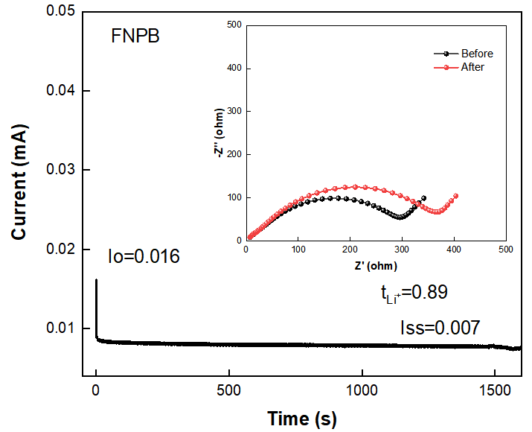
Fig. S8 Current-time plots of Li-metal symmetric cells with electrolyte containing FNPB additive after polarization at a constant potential of 10 mV for 1600 s. The inset plots are the impedance spectra before and after the polarization

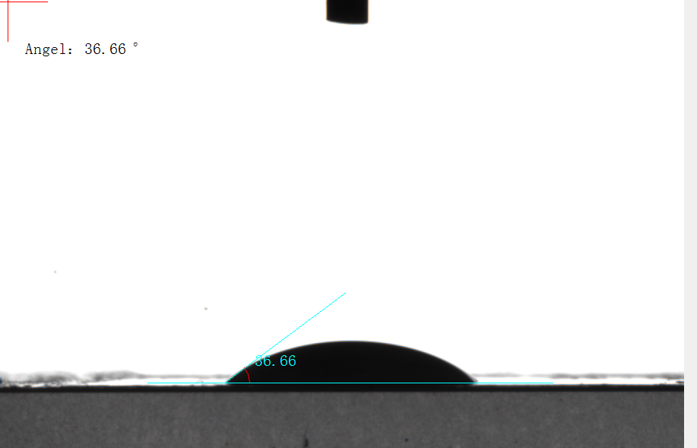

Fig. S9 Contact angle measurement of BE

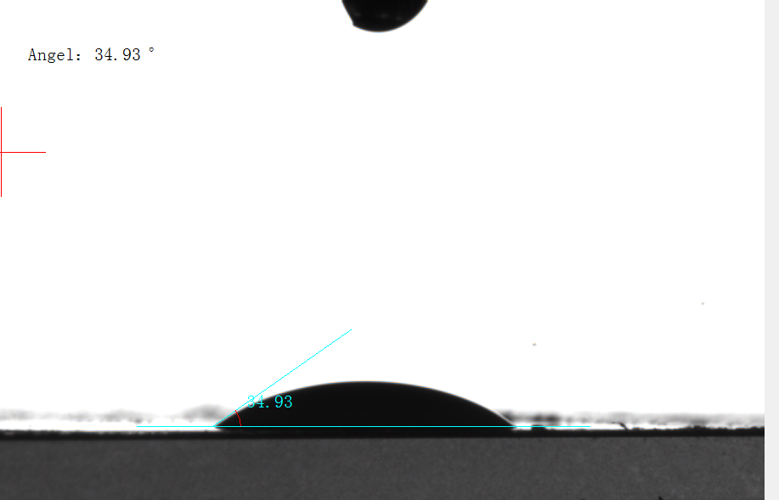
Fig. S10 Contact angle measurement of electrolyte after adding FNPB
Fig. S11 Chronoamperoetry test of Li||Li cells in BE and FNPB electrolyte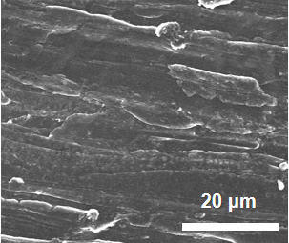

Fig. S12 SEM image of the pristine Li-metal electrode

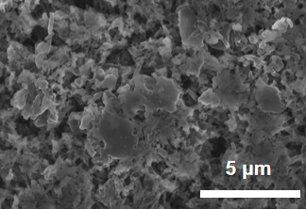

Fig. S13 SEM images of Li-metal electrodes plating/stripping in BE at 1 mA cm⁻² for 50 cycles

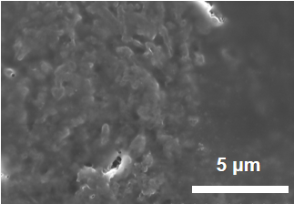

Fig. S14 SEM images of Li-metal electrodes plating/stripping in FNPB at 1 mA cm⁻² for 50 cycles
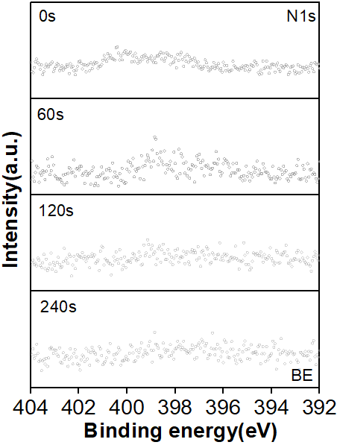
Fig. S15 N 1s XPS depth profiles of the Li-metal electrode cycled in BE after 50 cycles
Fig. S16 Li 1s XPS depth profiles of the Li-metal electrode cycled in BE after 50 cycles

Fig. S17 Li 1s XPS depth profiles of the Li-metal electrode cycled in FNPB after 50 cycles

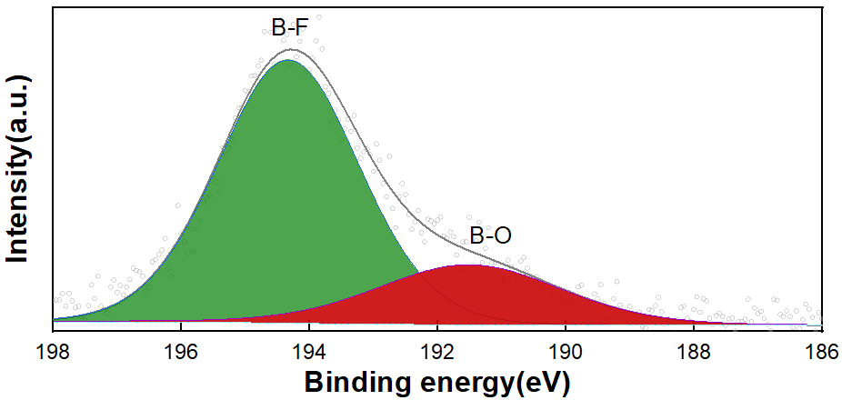Fig. S18 B 1s XPS spectrum of the Li-metal electrode cycled in FNPB after 50 cycles

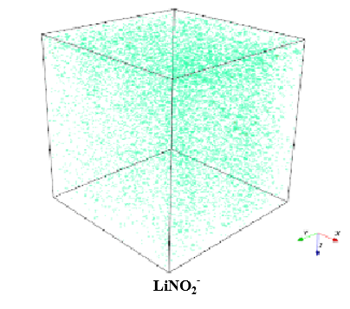
Fig. S19 TOF-SIMS 3D render overlay images of LiNO₂⁻ signals for the Li metal electrode cycled in FNPB after 50 cycles
Table S1 Performance comparison of Li-metal batteries with different electrolyte additives
Electrolyte composition | Positive electrode | Voltages  (V) | Performance | CE | References
1 M LiPF₆ in  EC/DEC (TDFA),100 μL | LFP (3 mg cm⁻) | 2.5-4.2 | 300 cycle (89.4%), 1C | / | [S1]
2M LiFSI in DOL with 3vol% TEB | LFP (2.64 mg cm⁻²) | 2.5-3.8 | 500 cycle (80.0%), C/2 | 0.5mA  98.49% | [S2]
1 M LiTFSI+0.04 M CH₃OK  +2%LiNO₃ in DME/DOL | LFP (10.5 mg cm⁻²) | 2.5-3.8 | 350 cycle (91.5%), C/2 | / | [S3]
1 M LiTFSI/DOL-DME (1:1 vol%) with 1 wt% LiNO₃(4% 2,2,2-TFTF) | LFP (1.8 mg cm⁻²) | 2.4-4.2 | 500 cycle (86.0%), | / | [S4]
1 M LiPF₆ in EC/DMC (1:1 vol%) with 1% LiNO₃ +0.5% HFT | LFP (3 mg cm⁻²) | 2.5-4.2 | 500cycle (<80.0%),2C | 1mA  97.1% | [S5]
0.6M LiFSI+0.4M LiBOB  in EC/EMC(3:7)(B-FC) | NMC622(1.4 mAh cm⁻²) | 3.0-4.5 | 300 cycle (73.1%), C/2 | / | [S6]
1 M LiPF₆ in DEC : EC : EMC (2:3:5 vol%) with 1wt% LiDFP +0.3wt% LiNO₃ | LFP (1.25 mAh cm⁻²) | 2.2-4.1 | 350 cycle (88.0%),1C | 1mA  98.2% | [S7]
1 M LiPF₆ in EC/DEC (FNPB),30 μL | LFP (4 mg cm⁻²) | 2.5-4.0 | 500 cycle (99.9%), 3C | 1mA  98.2% | This work

Supplementary References
- E. Park, Y.-H. Lee, S.-H. Huh, J. Huh, Y.-E. Sung et al., Bifunctional trimethylsilyl-modified fluorinated ester additive for LiF-rich solid electrolyte interphase in lithium metal batteries. Energy Storage Mater. 78, 104271 (2025). https://doi.org/10.1016/j.ensm.2025.104271
- Y. Guo, Y. Huang, H. Hu, Y. Chen, X. Cai et al., Anion-anchoring enabling fast Li+ transport within wide temperature. Nano Energy 147, 111568 (2026). https://doi.org/10.1016/j.nanoen.2025.111568
- J. Yang, M. Li, Z. Sun, X. Lian, Y. Wang et al., Prolonging the cycling lifetime of lithium metal batteries with a monolithic and inorganic-rich solid electrolyte interphase. Energy Environ. Sci. 16(9), 3837–3846 (2023). https://doi.org/10.1039/d3ee00161j
- S. Yang, M. Hao, Z. Wang, Z. Xie, Z. Cai et al., 2, 2, 2-Trifluoroethyl trifluoroacetate as effective electrolyte additive for uniform Li deposition in lithium metal batteries. Chem. Eng. J. 435, 134897 (2022). https://doi.org/10.1016/j.cej.2022.134897
- J. Jiang, M. Li, X. Liu, J. Yi, Y. Jiang et al., Multifunctional additives to realize dendrite-free lithium deposition in carbonate electrolytes toward low-temperature Li metal batteries. Adv. Energy Mater. 14(27), 2400365 (2024). https://doi.org/10.1002/aenm.202400365
- J. Han, C. Park, D. Jin, S. Kim, C.B. Dzakpasu et al., A bis(2-fluoroethyl) carbonate as a new electrolyte additive for enhancing the long-term cycle performance of Li-metal batteries. J. Electrochem. Soc. 170(2), 020529 (2023). https://doi.org/10.1149/1945-7111/acbca1
- M. Li, C. Chen, H. Luo, Q. Xu, K. Yan et al., Constructing an inorganic-rich solid electrolyte interphase by adjusting electrolyte additives for stable Li metal anodes. J. Mater. Chem. A 12(17), 10072–10080 (2024). https://doi.org/10.1039/d3ta07655e

