Supporting Information for
Air-Breakdown Triboelectric Nanogenerator Inspired by Transistor Architecture for Low-Force Human-Machine Interfaces
Karthikeyan Munirathinam¹, Longlong Li¹, Arunkumar Shanmugasundaram¹, Jongsung Park⁴, and Dong-Weon Lee^{1, 2, 3} *
¹MEMS and Nanotechnology Laboratory, School of Mechanical System Engineering, Chonnam National University, Gwangju, 61186, Republic of Korea
² Advanced Medical Device Research Center for Cardiovascular Disease, Chonnam National University, Gwangju, 61186, Republic of Korea
³ Center for Next-generation Research and Development, Chonnam National University, Gwangju, 61186, Republic of Korea
⁴ Department of Precision Mechanical Engineering, Kyungpook National University, Sangju, 37224, Republic of Korea
*Corresponding author. E-mail: mems@jnu.ac.kr (Dong-Weon Lee)

Supplementary Figures and Tables

Fig. S1 COMSOL simulation results for the electric field distribution between the human finger and the base of AB-TENG kept at different distances

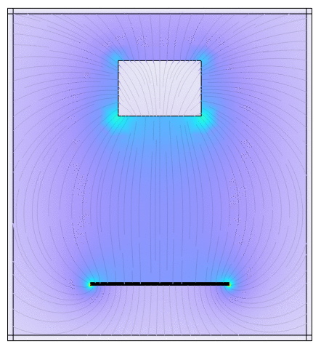
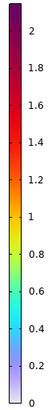
(a)

(b)
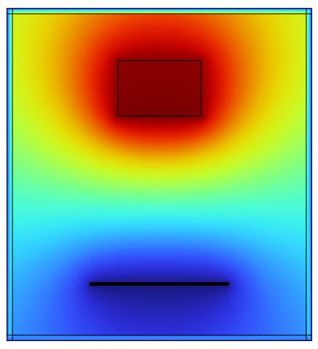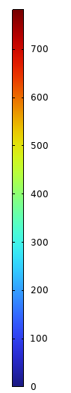

Fig. S2 COMSOL simulation results (movie) for the (a) electric field, and (b) potential distribution during the motion of a human finger towards the AB-TENG

Fig. S3 Air breakdown induced charge flow mechanism of AB-TENG in indirect mode. (i-iv) Alternating charge flow due to the electrostatic induction process between emitter and collector during the contact and separation of the human finger

Fig. S4 Influence of charge inducing layer on the induction process of AB-TENG in indirect mode. Output voltage produced by the AB-TENG by using (a) negative and, (b) positive triboelectric materials as charge inducing layers

Fig. S5 Influence of the thickness of the charge-inducing layer on the induction process of AB-TENG in indirect mode. (a-f) Output voltage produced by the AB-TENG by using PTFE with different thicknesses from 25-150 µm
c
Fig. S6 Air breakdown induced electrons flow mechanism of AB-TENG in direct mode. (i-iv) Alternating electron flow process between emitter and collector during the contact and separation of the human finger

Fig. S7 (a) Electrical output measured by four AB-TENGs (samples 1, 2, 3, and 4) having similar dimensions and working conditions. (b) Electrical output produced by AB-TENG with four different individuals (A, B, C, and D) under a maximum contact force of 24 N

Fig. S8 (a) Peak power produced by AB-TENG at various load resistances. (b) Influence of charge inducing layer on AB-TENG performance

Fig. S9 Investigation of AB-TENG at a low load resistance. Output voltage produced by AB-TENG at (a, b) 50 Ω resistance and peak time duration, (c, d) 5 kΩ resistance and peak time duration, (e, f) 500 kΩ resistance and peak time duration
Fig. S10 (a) RMS voltage and current produced by AB-TENG at various load resistances. (b) Average power produced by AB-TENG

Fig. S11 Influence of potential difference on the performance of the AB-TENG. (a) Influence of materials' electron affinities on the output voltage of AB-TENG with copper and aluminum as a base electrode material. (b, c) The impact of two individuals (A, B), connected in series as the charge generators, on the output of AB-TENG

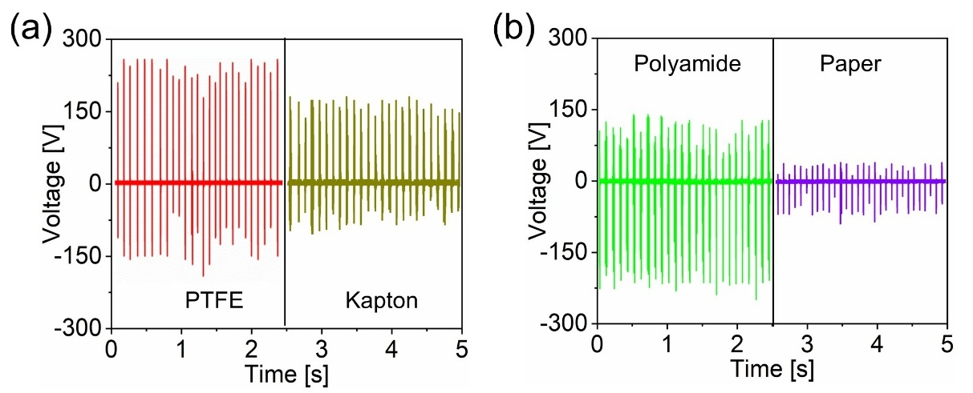
Fig. S12 Influence of charge-inducing layer on the induction process of AB-TENG in direct mode. Output voltage produced by the AB-TENG by using (a) negative and (b) positive triboelectric materials as charge-inducing layers

Fig. S13 (a) Schematic and the device image of a conventional tactile TENG fabricated in single electrode mode. (b) Comparison of the output voltage produced by AB-TENG and the conventional TENG
Fig. S14 Load resistance test (a) Conventional TENG output voltage and current trend against the load resistance. (b) Peak power produced by conventional TENG. (c) AB-TENG output voltage and current trend against the load resistance. (d) Peak power produced by AB-TENG

Fig. S15 Electrical circuit used by conventional TENG and the AB-TENG for powering a red LED (1.8 V threshold voltage) through the parallel connection of 800 Ω load resistance
Fig. S16 (a) Comparison of a 0.1µF capacitor voltage charged by using indirect AB-TENG and the conventional TENG. (b) Comparison of AB-TENG power density with the reported tactile TENGs
Table S1 Comparison of AB-TENG with the reported breakdown TENGs
S. No | Strategy/ Design | Mechanism/Key Innovation | Voltage (V)/ Current(µA) | Power (mW)/Power density (Wm⁻²) | Reference
1 | Ion-enhanced Field emission TENG | Field emission due to the triboelectric effect | 500/  250 (mA) | 3.9/NA | Chung et al. [49]
2 | DC-TENG | Triboelectric effect and electrostatic breakdown | 110/15 | 10/NA | Liu et al. [48]
3 | DC-TENG | Triboelectric effect and electrostatic breakdown | 1200/37 | 10/NA | Luo et al. [47]
4 | DLSS-TENG | Triboelectric effect-based controlled field emission | 100/56 | NA/NA | Chung et al. [63]
5 | AB-TENG | Electrostatic discharge of skin electrons | 290/210 | 22/NA | This work

Fig. S17 Images of the demonstrations conducted to study the influence of airgap distance and contact force on the AB-TENG. a) Investigation of air breakdown without using air cavity layers (powering LED). Air breakdown test with a PLA-based air cavity layer. b) Image of the fabricated AB-TENG with 1.5 cm x 1.5 cm. Air cavity layer (1.6 cm x 1.6 cm) placed above the AB-TENG. c) Air cavity layers made with different thicknesses. d) Image of the experimental setup used to measure the contact force

Fig. S18 Circuit diagram for glowing LED with different contact forces

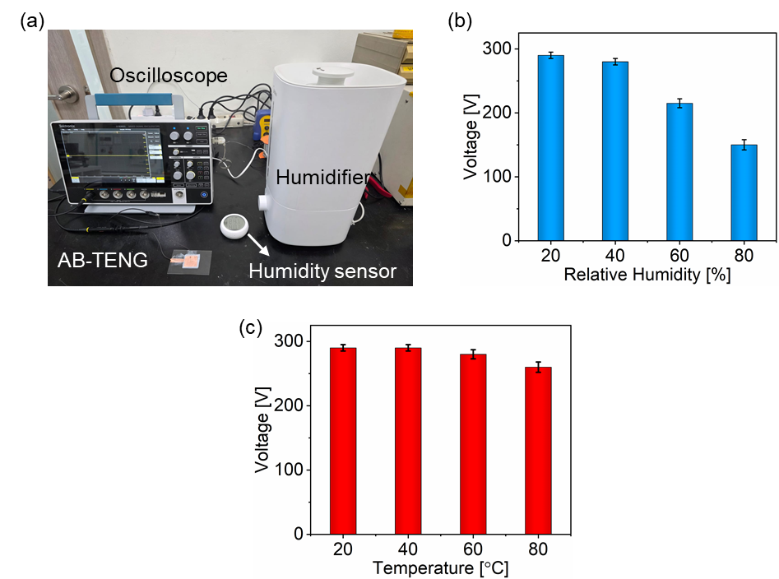
Fig. S19 (a) Humidity experimental setup. (b) Output voltage variation with respect to relative humidity. (c) Performance of AB-TENG under different temperatures

Fig. S20 Block diagram for the development of an IR remote control using direct AB-TENG

Fig. S21 (a-d) Electrical circuit connection during the operation of individual AB-TENGs (TI, T2, T3, and T4)
Fig. S22 Images of the AB-TENG-based self-powered keyboard with 30 characters. a) Keyboard front view. b) Keyboard back view.
Fig. S23. Block diagram for the development of the self-powered keyboard using AB-TENG in (a) wired, and (b) wireless mode

