Supporting Informaiton for
High Performance Differential Imaging via Reconfigurable Black Phosphorus p-n Homojunction Optoelectronics
Rui Hao^{1, 2}, Lili Luo¹, Lu Yang¹, Xue Yang², Fengsong Gao¹, Meijie Zhu², Yingtao Li^{1,} *, Qingliang Feng^{2,} *, Zemin Zhang¹*
¹ School of Physical Science and Technology, Lanzhou University, Lanzhou 730000, P. R. China
² School of Chemistry and Chemical Engineering, Northwestern Polytechnical University, Xi’an 710072, P. R. China
*Corresponding authors. E-mail: ytli@lzu.edu.cn (Yingtao Li); fengql@nwpu.edu.cn (Qingliang Feng); zhangzemin@lzu.edu.cn (Zemin Zhang)
Supplementary Figures and Tables
Fig. S1 Schematic diagram of electrochemical exfoliation of BP (a) exfoliation BP nanosheets dispersed on the substrate (b)

Fig. S2 The XRD pattern of BFO films

Fig. S3 Schematic illustrations of polarization programming and characterization configurations. (a) Ferroelectric domain writing using a conductive AFM tip with the bottom LSMO electrode grounded. (b) PFM and KPFM measurements performed after removal of the DC writing bias, ensuring that the measured CPD reflects remanent polarization-induced surface potential. (c) Polarization programming via lithographically defined electrodes prior to device measurements. (d) Electrical and optoelectronic characterization of the programmed pn/np configurations without any external writing field

Fig. S4 The Raman spectra of BFO films (a) and BFO/BP (b)

Fig. S5 Output characteristics of the BP transistor device on BFO substrate

Fig. S6 Repeatable I-t characteristics of the BP/BFO device under illumination at different wavelengths: 365 nm (a), 808 nm (b), 1550 nm

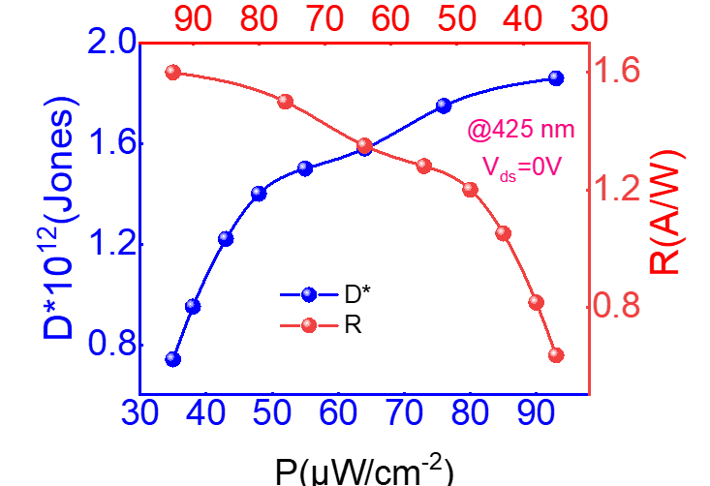
Fig. S7 Power-dependent R and D* as functions of incident laser power density at 425 nm at 0 V bias
Fig. S8 Photocurrent It curves under different p-n and n-p configurations

In this study, the carrier distribution of channeled BP nanosheets is statistically modeled using the Fermi-Dirac distribution, and the energy band structure of the material obtained by combining Poisson's equation, the current continuity equation, and the drift-diffusion model.Various physical effects are considered and the concentration distributions of electrons and holes are analyzed when different gate voltages are applied to different regions on the left and right, in order to determine the effect of voltage on the channel .The resulting TCAD simulation model matches the actual experimental junction.Some key models are briefly described below.
SRH Model:
SRH recombination refers to the recombination caused by the presence of localized energy levels or defects in semiconductors. The specific form of the SRH model is as follows:
$R_{SRH}=\frac{n_{0}p_{0}-n_{i}^{2}}{τ_{n}\left(n_{0}+n_{1}\right)+τ_{0}(p_{0}+p_{1})}$ (S1)
In the equation, R_{SRH} represents the recombination rate per unit volume, n₀​ and p₀ denote the electron and hole concentrations due to impurity defects, n_{1​} and p₁ represent the intrinsic electron and hole concentrations of the semiconductor, n_{i} is the intrinsic carrier concentration of the semiconductor, and τ_{n} and τ_{p} are the lifetimes of electrons and holes, respectively.
Carrier mobility dependency model
The carrier mobility has a significant impact on the response speed of the photodetector. Due to the coexistence of multiple scattering mechanisms, the carrier mobility varies with doping concentration and electric field strength at room temperature. We use the built-in TCL language interpreter in Sentauras Sdevice to embed the corresponding model to account for this effect. For specific doping concentrations and electric field strengths, the corresponding carrier mobility can be calculated using the following formula:
$μ_{h_{0}}\left(N_{imp}\right)=μ_{min}+\frac{μ_{max}-μ_{min}}{1+{(\frac{N_{imp}}{N_{μ}})}^{α}}$ (S2)
$μ_{h}\left(E,N_{imp}\right)=μ_{h_{0}}(N_{imp}){\left(\frac{1}{1+(\frac{μ_{h_{0}}E_{f}}{ν_{sat}})^{β_{sat}}}\right)}^{1/β_{sat}}$ (S3)
Where $μ_{h_{0}}$ and μ_{h} are the hole mobility without electric field or with electric field, N_{imp} is the doping concentration, E_{f} is the electric field, ν_{sat} is the saturation velocity for the hole, and a, μ_{max}, μ_{min}, N_{m}, β_{sat} are the fitting parameters.
FE Polarization model:
The ferroelectric (FE) model describes the relationship between polarization and electric field in ferroelectric materials based on the Ginzburg–Landau–Khalatnikov (GLK) formalism. It characterizes the evolution of spontaneous polarization under an external electric field through minimization of the system’s free energy. The general form of the FE model is expressed as:
$ρ\frac{dP_{i}}{dt}+∇_{P_{i}}F=0$ (S4)
where P represents the polarization vector, ρ is a material-dependent kinetic coefficient, and F(P) denotes the free energy function expanded as a power series of P:
$F=\int_{Ω}{α_{i}P_{i}^{2}}+β_{i}P_{i}^{4}+γ_{i}p_{i}^{6}-g_{ij}\frac{∂P_{i}}{∂x_{j}}-E_{i}P_{i}+ε_{0}E_{i}E_{i}dΩ$ (S5)
Here, α, β, and γ are material-specific parameters, and E is the applied electric field. The presence of multiple energy minima in F(P) leads to polarization switching between different states, resulting in ferroelectric hysteresis and remanent polarization. This behavior provides the physical foundation for nonvolatile electric-field control and underlies the operation of ferroelectric field-effect and negative-capacitance devices.
In summary, Table S1 summarizes the main material parameters used in the aforementioned models.
Table S1 Parameters adopted in TCAD simulation
Parameter | BP | BFO
Bandgap（eV） | 0.3 | 2.8
Electron affinity（eV） | 4.0 | 4.0
Relative permittivity | 8.4 | 85
Shockley-Read-Hall
τ_{n0} | 1.0×10⁻⁸ | 1.0×10⁻⁹
τ_{p0} | 1.0×10⁻⁹ | 1.0×10⁻¹⁰
Mobility
μ_{n}（cm²·V⁻¹·s⁻¹） | 1000 | 50
μ_{p}（cm²·V⁻¹·s⁻¹） | 800 | 20
Vsn（cm·s⁻¹） | 1×10¹⁷ | 1×10¹⁸
Vsp（cm·s⁻¹） | 5×10⁵ | \
FE Polarization
Alpha | 0.0 | -2.5e+10
Beta | 0.0 | 1.8e+20
Gamma | 0.0 | 0.0
G | 0.0 | 2.0e-03
Rho | 0.0 | 1.0e+06

Table S2 Benchmark comparison of self-powered photodetectors
Device structure | 𝜆(nm) | R(A/W) | D (Jones*10¹⁰) | Pin(μW/cm⁻²) | τ_{d}(ms)
This work | 425 | 1.6 | 12 | 93 | 600
WS₂ | 530 | 0.471 | - | 12300 | 4.4
WSe₂ | 450 | 0.36 | - | 6000 | 0.61
SnO₂ | 290 | 0.00155 | 9.8 | 18 | 0.64
WSe₂- WSe₂ | 532 | 0.0112 | 4.40 | 500 | 0.18
InSe | 520 | 0.103 | 1.83 | 54.4 | 0.103
1D Te/2D MoSe₂ | 514 | 0.328 | 0.82 | 39000 | 0.328
MoTe₂ | 637 | 0.016 | 10 | 1.13 | 0.016
Supplementaty References
- J. Park, Y. You, D. Lee, J. Kim, Self-powered high-performance WS₂ photodetector via a monolithic p-i-n homojunction. Nano Lett. 25(37), 13780–13786 (2025). https://doi.org/10.1021/acs.nanolett.5c03066
- J. Weng, Z. Zhang, T. He, L. Zhang, Y. Zhou et al., WSe₂ pn homojunction photodetector engineered by in situ ferroelectric doping. Adv. Funct. Mater. 35(43), 2506469 (2025). https://doi.org/10.1002/adfm.202506469
- B. Liu, M. Li, W. Fu, P. Ye, W. E et al., High-performance self-driven ultraviolet photodetector based on SnO₂ p-n homojunction. Opt. Mater. 129, 112571 (2022). https://doi.org/10.1016/j.optmat.2022.112571
- C. Tan, H. Wang, X. Zhu, W. Gao, H. Li et al., A self-powered photovoltaic photodetector based on a lateral WSe₂–WSe₂ homojunction. ACS Appl. Mater. Interfaces 12(40), 44934–44942 (2020). https://doi.org/10.1021/acsami.0c11456
- J. Chen, Z. Zhang, J. Feng, X. Xie, A. Jian et al., 2D InSe self-powered Schottky photodetector with the same metal in asymmetric contacts. Adv. Mater. Interfaces 9(35), 2200075 (2022). https://doi.org/10.1002/admi.202200075
- J. You, Z. Jin, Y. Li, T. Kang, K. Zhang et al., Epitaxial growth of 1D Te/2D MoSe₂ mixed-dimensional heterostructures for high-efficient self-powered photodetector. Adv. Funct. Mater. 34(10), 2311134 (2024). https://doi.org/10.1002/adfm.202311134
- K. Shao, H. Nan, R. Qi, C. Jiang, H. Wang et al., Self-powered MoTe₂ homojunction photodetector with ultrafast response via h-BN encapsulation and doping regulation. J. Mater. Chem. C 13(36), 18972–18980 (2025). https://doi.org/10.1039/D5TC02340H

