Supporting Information for
Graphene-Skinned Fiber with Fine Tunable Electrical Resistance via Radical and Substrate Engineering for Electromagnetic-Thermal Fabric
Jie Liang¹, Zhaochen Li¹, Fang Ye¹*, Yuchen Cao¹, Yi An¹, Xiaomeng Fan¹*, Qiang Song¹*
¹ Science and Technology on Thermostructural Composite Materials Laboratory, Northwestern Polytechnical University, Xi’an 710072, People’s Republic of China
*Corresponding authors. E-mail: yefang511@nwpu.edu.cn (Fang Ye); fanxiaomeng@nwpu.edu.cn (Xiaomeng Fan); songqiang511@nwpu.edu.cn (Qiang Song)
Supplementary Figures
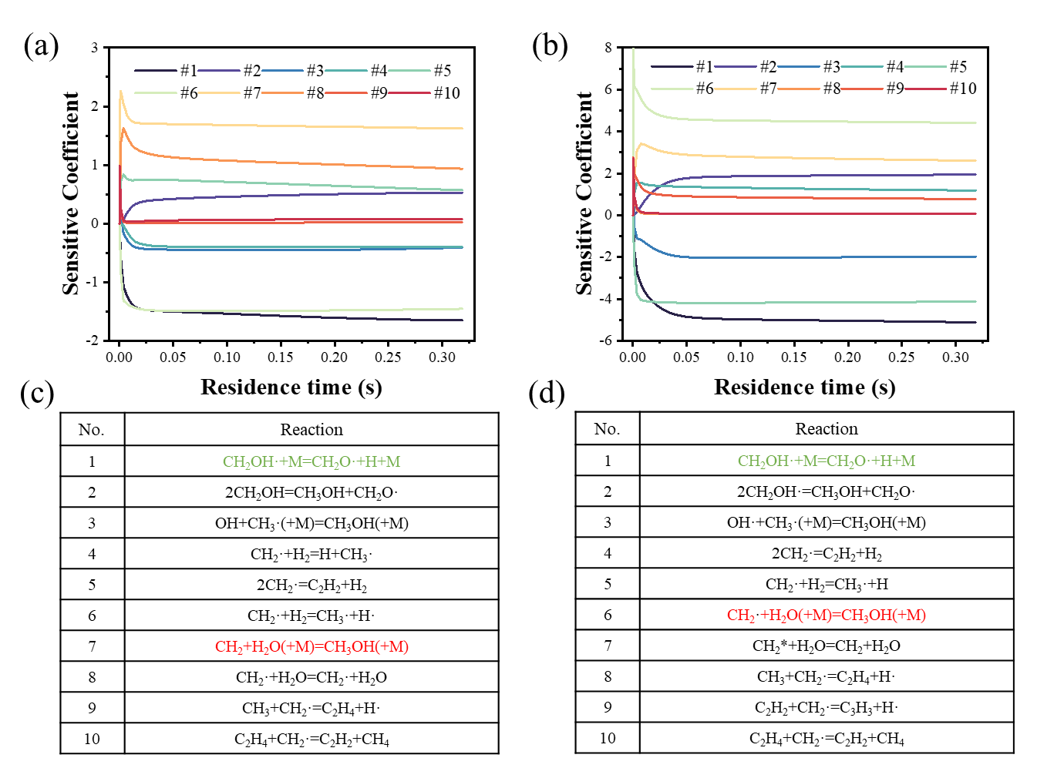
Fig. S1 Sensitivity analysis of (a) C₂H₂, (b) C₆H₆, the top 10 elementary reactions affecting the sensitivity of the (c) C₂H₂, (d) C₆H₆

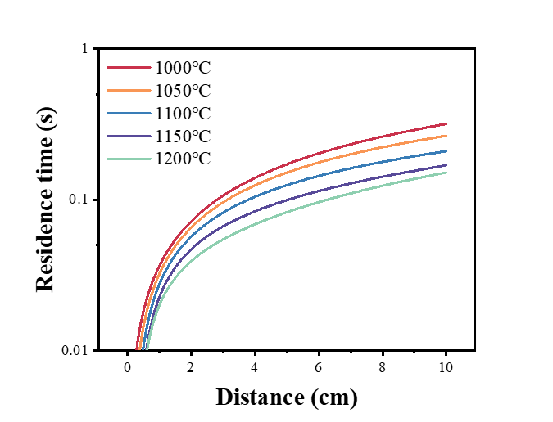
Fig. S2 Residence time at different temperatures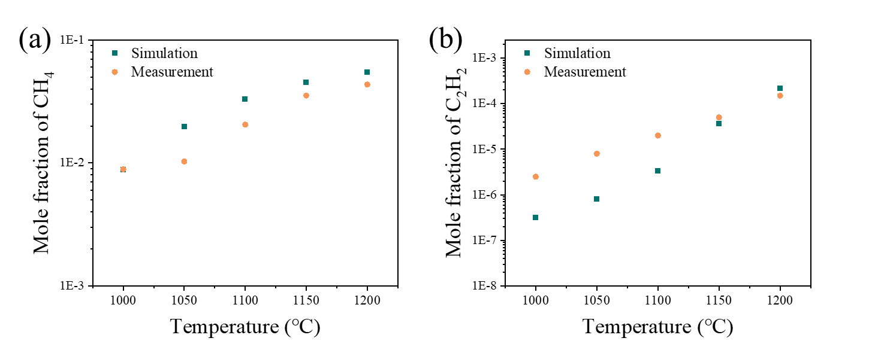
Fig. S3 Variation of molar fraction of different gases with deposition temperature: (a) CH₄, (b) C₂H₂

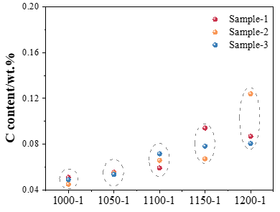
Fig. S4 Carbon content in Graphene based SiO₂ fiber cloth at different deposition temperatures

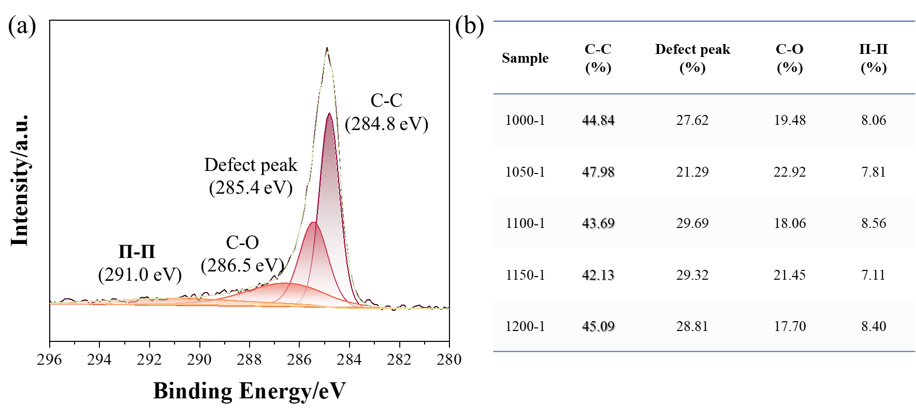
Fig. S5 C 1s peak results of graphene at different deposition temperature: (a) spectrum, (b) bonding proportion

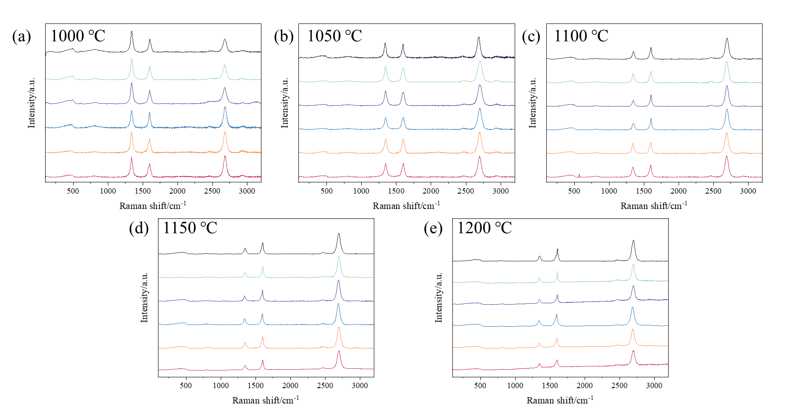
Fig. S6 Raman spectra from different regions of the samples: (a) 1000-1, (b) 1050-1, (c) 1100-1, (d) 1150-1, (e) 1200-1

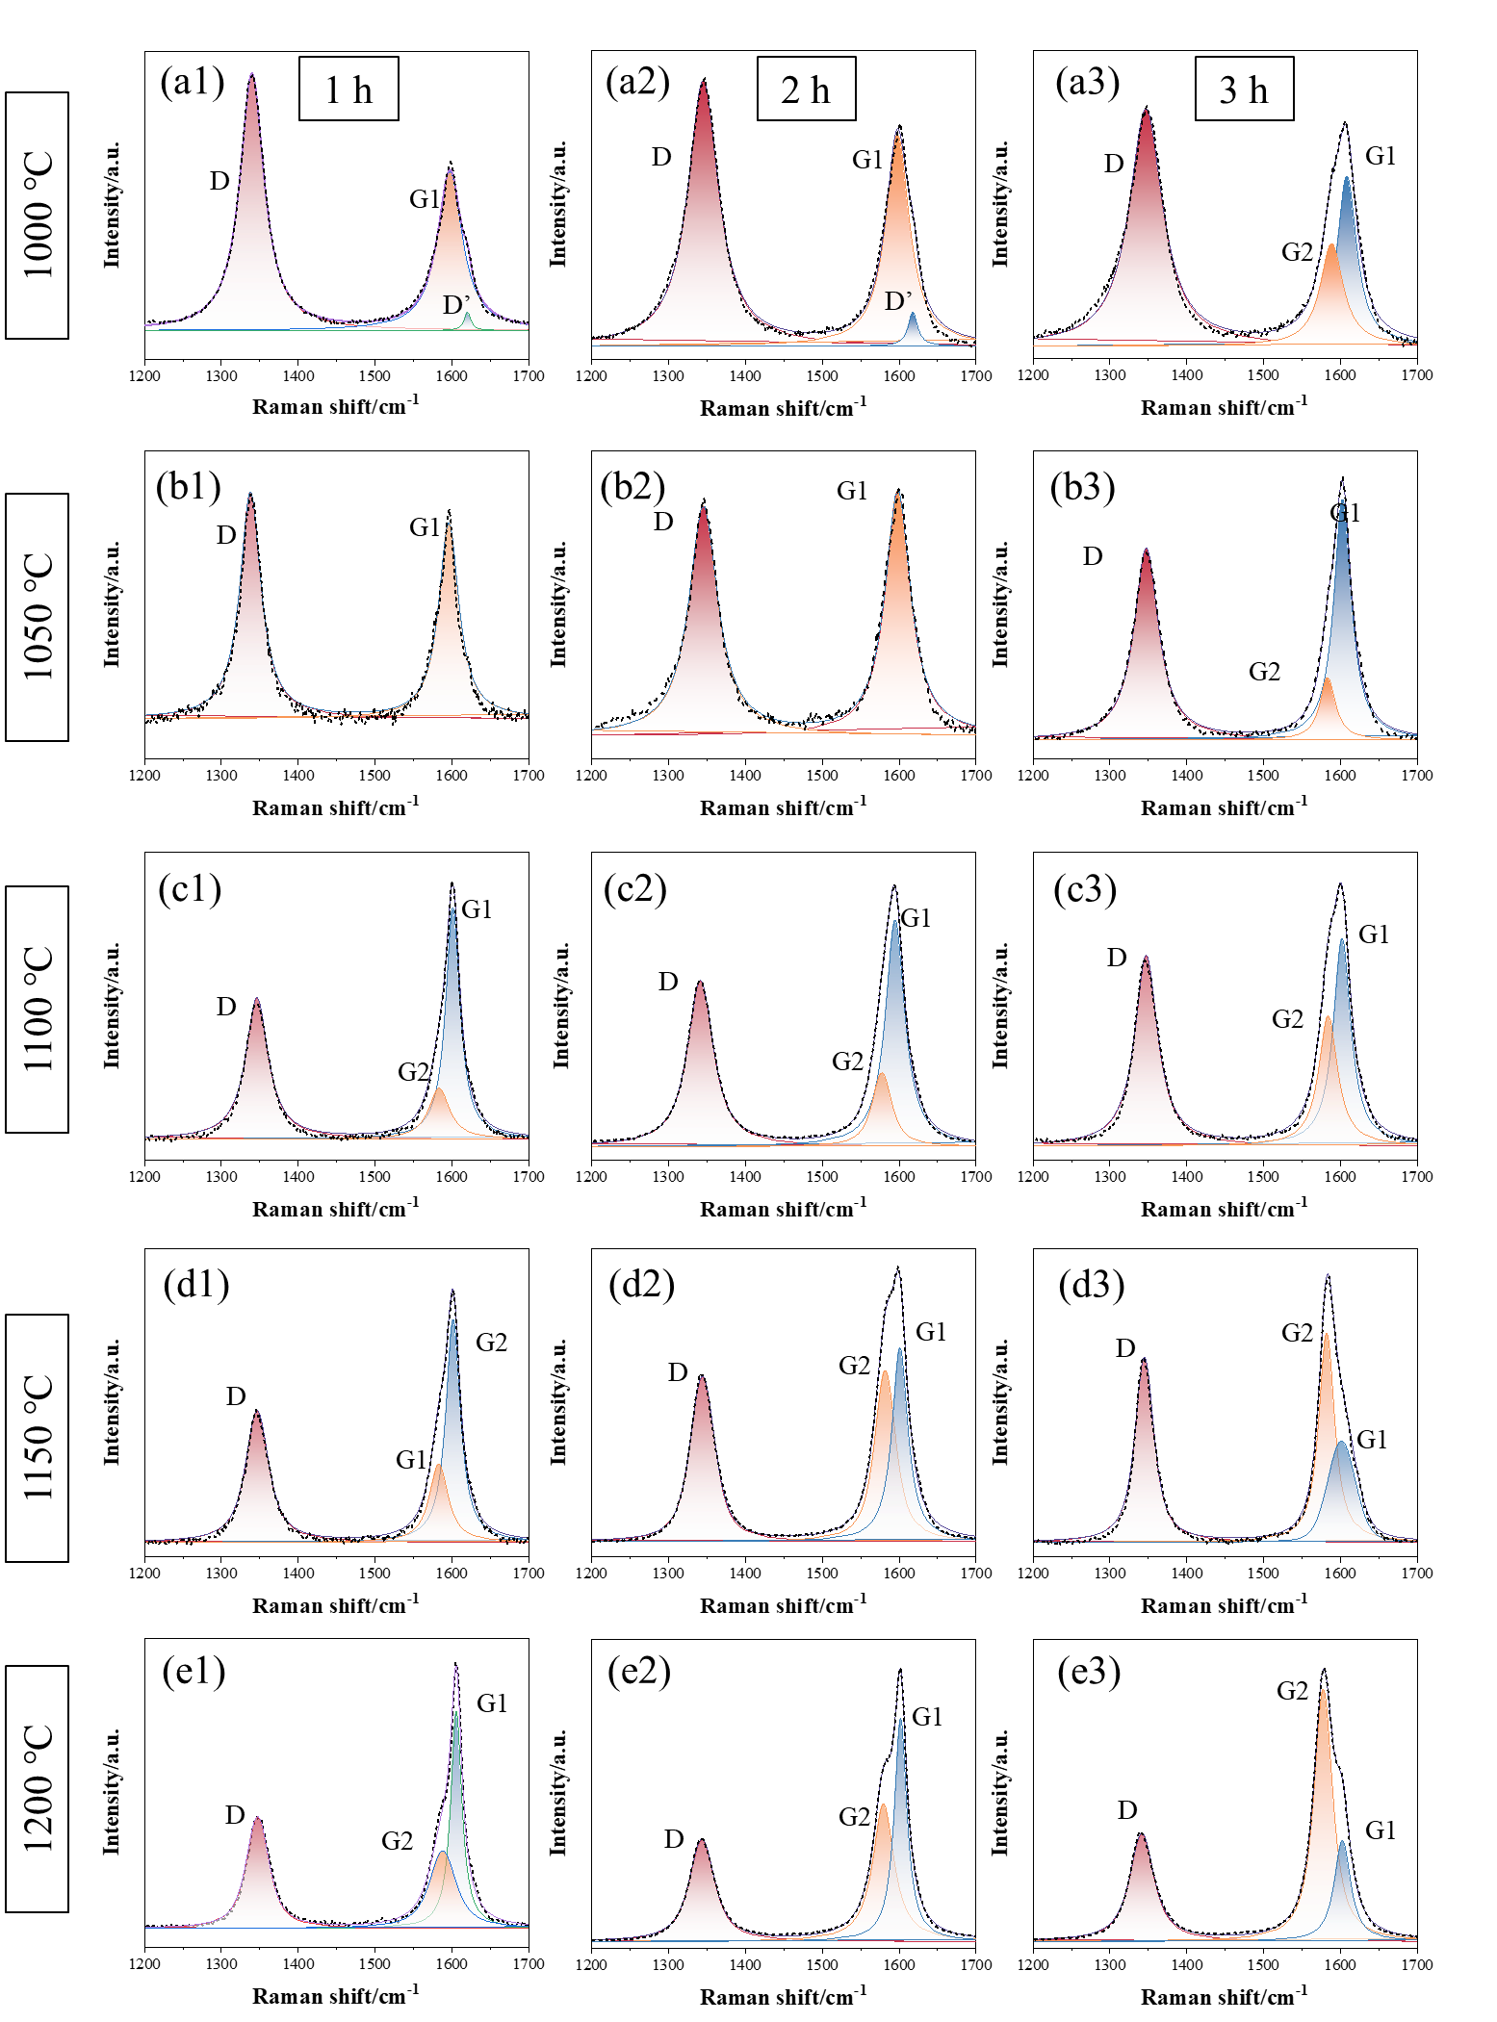
Fig. S7 Raman spectra fitting results of graphene at different deposition times: (a1) 1000-1, (a2) 1000-2, (a3) T1000-3, (b1) 1050-1, (b2) 1050-2, (b3) 1050-3, (c1) 1100-1, (c2) 1100-2, (c3) 1100-3, (d1) 1150-1, (d2) 1150-2, (d3) 1150-3, (e1) 1200-1, (e2) 1200-2, (e3) 1200-3
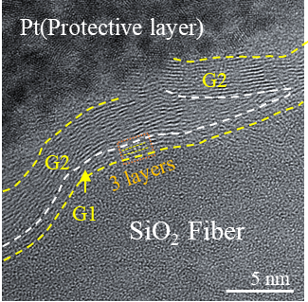
Fig. S8 Cross-sectional microstructure of Gr-skinned SiO₂ fiber
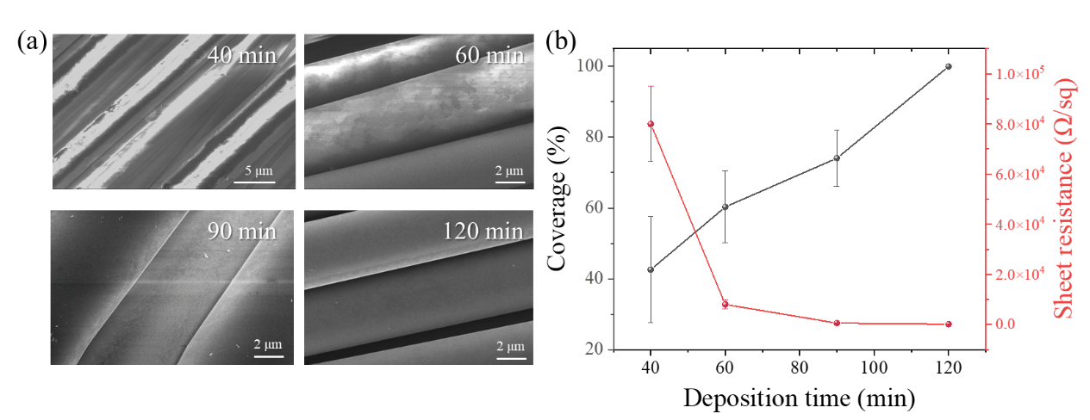
- Fig. S9 (a) Micro-morphology and (b) coverage and sheet resistance at different deposition temperatures at 1000 ℃

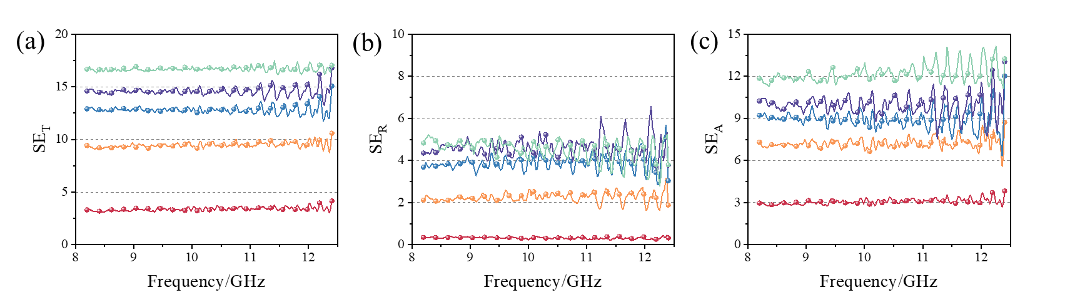
Fig. S10 Electromagnetic wave response characteristics of graphene based SiO₂ fiber cloth at different deposition temperatures: (a) total shielding effectiveness, (b) reflection shielding effectiveness, (c) absorption shielding effectiveness

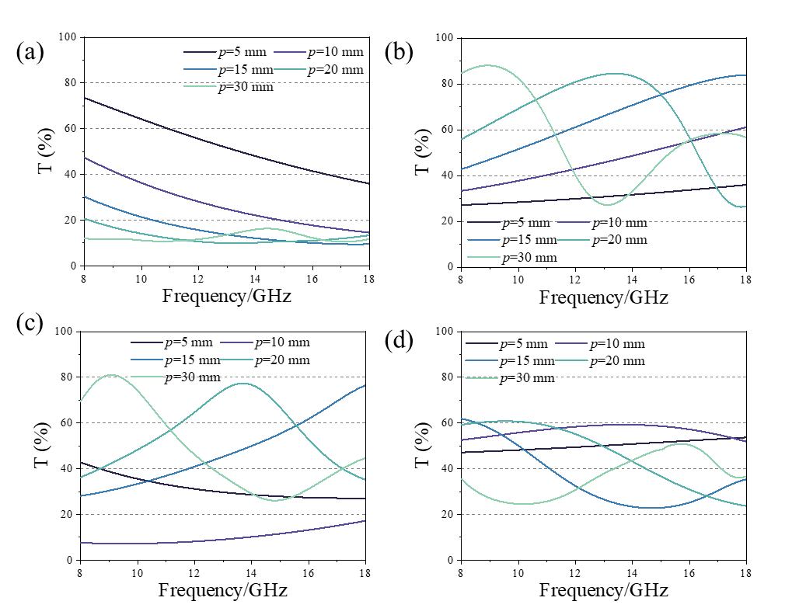
Fig. S11 Transmittance under different structural parameters: (a) Band-stop type, (b) Band-pass type, (c) High-pass type, (d) Low-pass type

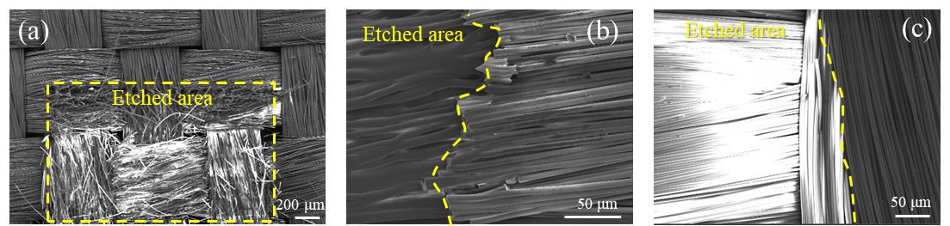
Fig. S12 Etching phenomena under different laser parameters: (a) fiber damage, (b) fiber melting, (c) fiber remains intact

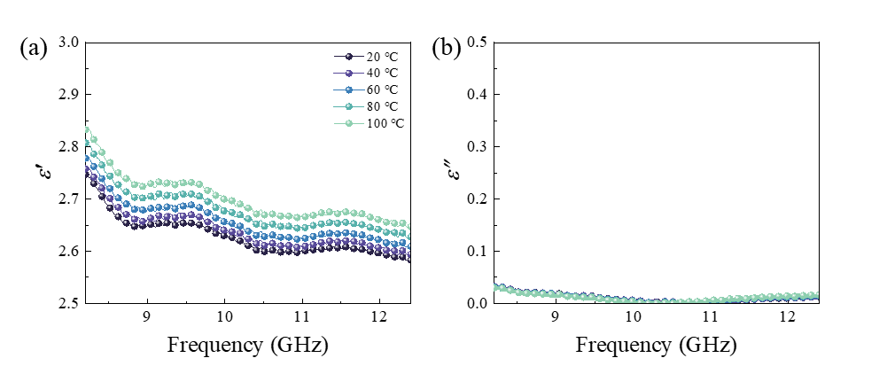
Fig. S13 Dielectric constant of acrylic at different temperatures, (a) ε׳, (b) ε״

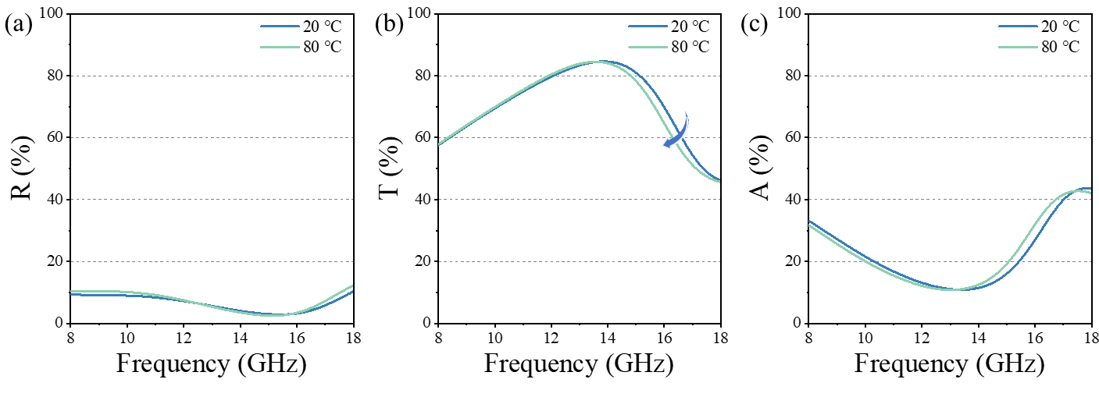
Fig. S14 Simulated (a) Reflectance, (b) Transmittance, (c) Absorptance at 20 ℃ and 80 ℃

