Supporting Information for
Eco-Friendly, Multi-Mode Processable Highly Moldable Wood Enabled by the Reconstruction of Hydrogen-Bonding Domain
Rui Yang^{1,} *, Linghui Qi¹, Xiaoli Wu², Zhipeng Liu¹, Huiyang Bian³, Changlei Xia¹, Changtong Mei¹, Shuaicheng Jiang^{4,} *, Meng Yao^{5,} *, Jianzhang Li^{4,} *
¹ Jiangsu Co-Innovation Center of Efficient Processing and Utilization of Forest Resources, International Innovation Center for Forest Chemicals and Materials, College of Materials Science and Engineering, Nanjing Forestry University, Nanjing 210037, P. R. China
² School of Mechanical and Electronic Engineering, Nanjing Forestry University, Nanjing 210037, P. R. China
³ Jiangsu Provincial Key Lab of Sustainable Pulp and Paper Technology and Biomass Materials, Nanjing Forestry University, Nanjing 210037, P. R. China
⁴ State Key Laboratory of Efficient Production of Forest Resources & MOE Key Laboratory of Wood Material Science and Application, Beijing Forestry University, Beijing 100091, P. R. China
⁵ College of Materials Science and Engineering, Sichuan University, Chengdu 610065, P. R. China
*Corresponding authors. E-mail: yangrui@njfu.edu.cn (Rui Yang); jiangsc@bjfu.edu.cn (Shuaicheng Jiang); yaomeng@scu.edu.cn (Meng Yao); lijzh@bjfu.edu.cn (Jianzhang Li)
Supplementary Figures and Tables
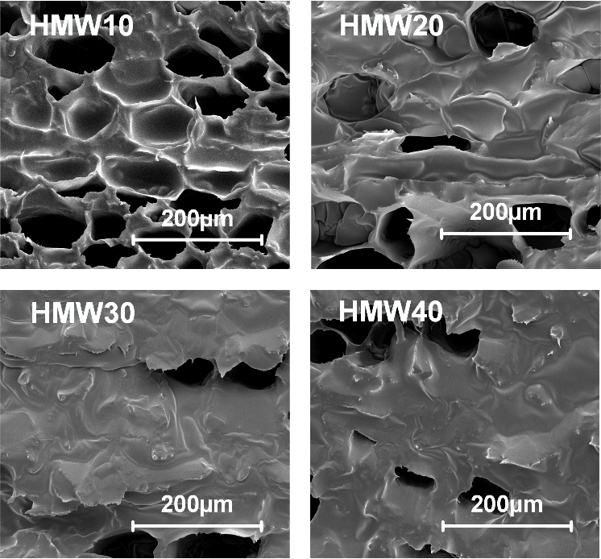
Fig. 1 The SEM picture of HMW10, HMW20, HMW30 and HMW40
Fig. 2 The compression principle of HMW

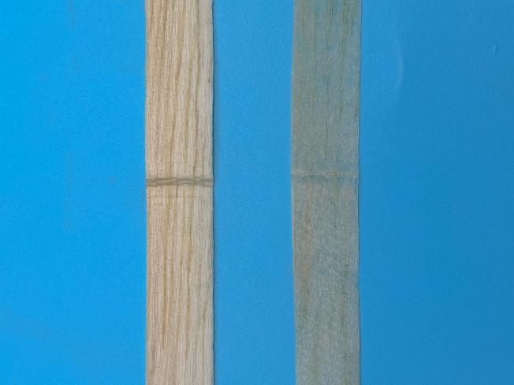
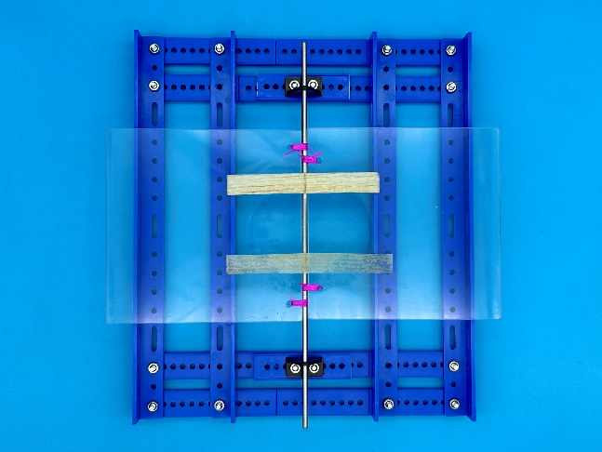
Fig. 3 a - b, SEM image of HMW10. c - d, SEM image of HMW20; e - f, SEM image of HMW30; g - h, SEM image of HMW40
DW
HMW

Fig. 4 Repeated folding test equipment and photos of samples after 2000 folds

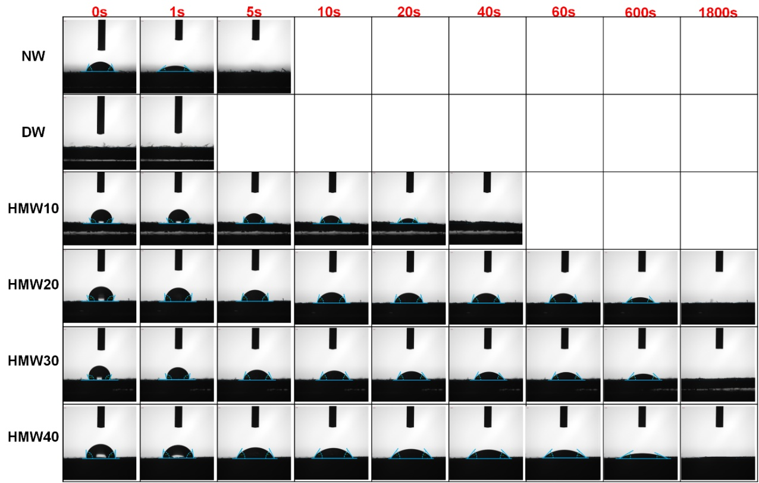
Fig. 5 Water contact angle of NW, MW, HMW10, HMW20, HMW30, HMW40
Fig. 6 Water absorption effect of DW and HMW
Fig. 7 The acid and alkali resistance test of HMW
Fig. 8 STL of honeycomb thin-film acoustic structures and EVA
Fig. 9 The simulation curve and the actual measured curve of sound insulation test
Fig. 10 Vibration pattern of single layer structure and triple layer structure
Fig. 11 The mass increasing rate of HMW10, HMW20, HMW30 and HMW40
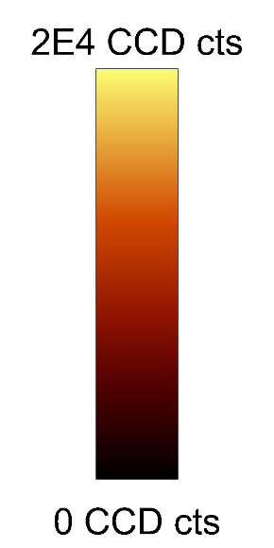
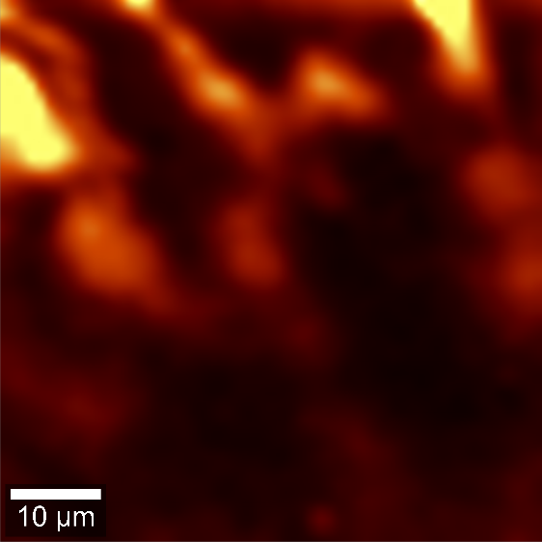
Fig. 12 Raman imaging of HMW

Fig. 13 Schematic diagram of impedance tube
DW
Fig. 14 The MSD simulation curve of DW and HMW
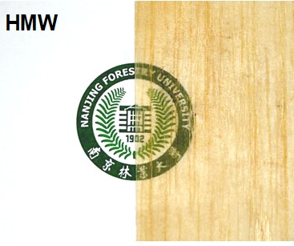

Fig. 15 The semi-transparent effect of HMW
Fig. 16 The composition content of NW and DW
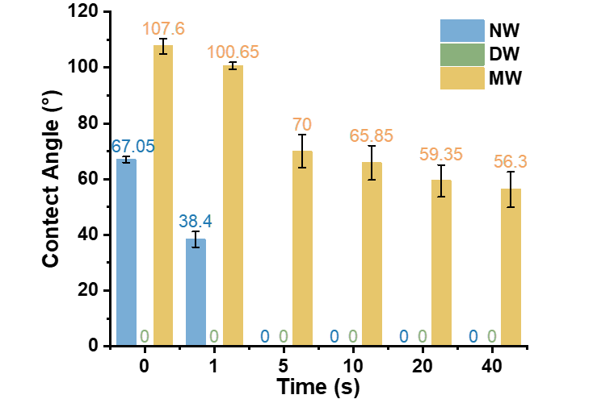
Fig. 17 Water contact angles of NW, DW and HMW
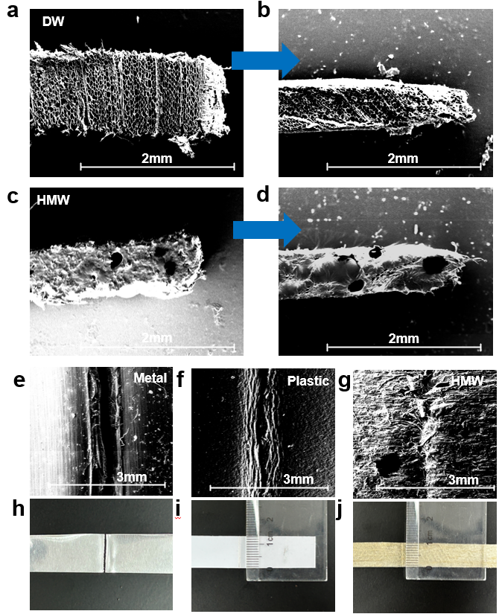
Fig. 18 SEM images of the changes in HMW compression molding. a and b The pore changes of AESO without filling. c and d The pore changes during the shaping of HMW. e - g SEM images of creases after 50 folds for metal, plastic and HMW. h - j Photographs of creases after 50 folds for metal, plastic and HMW

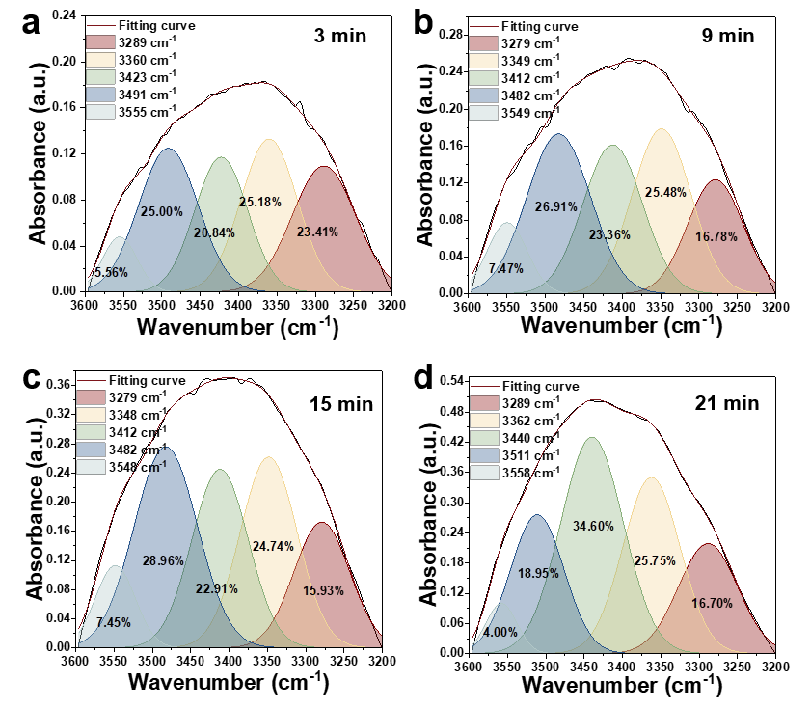
Fig. 19 Peak deconvolution and fitting of HMW. a - d The hydrogen bond data of f-HMW after drying at 60 °C for 3, 9, 15 and 21 minutes were respectively presented
Fig. 20 The influence of folding times on the tensile strength of materials
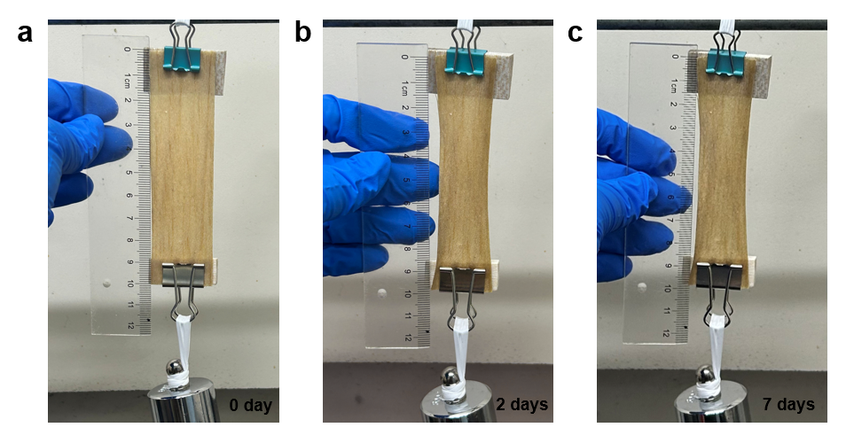
Fig. 21 The tensile condition of HMW under long-term loading
Fig. 22 The pore area distribution of NW and DW

Movie S1 The plastic ability comparison of conventional DW (above) and HMW (below).
Movie S2 The compression process of re-entrant hexagonal honeycomb structure.

Table S1 Bond Energies and Bond Lengths of OW Samples Before and After Treatment
 | [O(6)H…O(3’)] |  |  | [O(3)H…O(5)] |  |  | [O(2)H…O(6)] |  |  | O…H(2) |  |  | O…H(6)
 | BP | E_{H}(kJ/mol) | R (Å) | BP | E_{H}(kJ/mol) | R (Å) | BP | E_{H}(kJ/mol) | R (Å) | BP | E_{H}(kJ/mol) | R (Å) | BP | E_{H}(kJ/mol) | R (Å)
3 Min | 3288.74 | 25.98 | 2.77 | 3360.21 | 20.84 | 2.79 | 3422.62 | 16.35 | 2.80 | 3491.50 | 11.40 | 2.82 | 3554.83 | 6.84 | 2.83
9 Min | 3278.75 | 26.70 | 2.77 | 3348.68 | 21.67 | 2.78 | 3412.11 | 17.11 | 2.80 | 3482.45 | 12.05 | 2.81 | 3549.41 | 7.23 | 2.83
15 Min | 3279.19 | 26.67 | 2.77 | 3348.40 | 21.69 | 2.78 | 3411.81 | 17.13 | 2.80 | 3482.46 | 12.05 | 2.81 | 3548.22 | 7.32 | 2.83
21 Min | 3288.64 | 25.99 | 2.77 | 3362.34 | 20.69 | 2.79 | 3439.76 | 15.12 | 2.80 | 3511.06 | 9.99 | 2.82 | 3557.70 | 6.64 | 2.83
Table S2 Deconvolution Results of the 3600-3200 cm⁻¹ Band of OW Samples Before and After Treatment
 | [O(6)H…O(3’)] |  | [O(3)H…O(5)] |  | [O(2)H…O(6)] |  | O…H(2) |  | O…H(6) |  | R²
 | FPAC | AR | FPAC | AR | FPAC | AR | FPAC | AR | FPAC | AR | R²
3 Min | 3288.74 | 23.41 | 3360.21 | 25.18 | 3422.62 | 20.84 | 3491.50 | 25.00 | 3554.83 | 5.56 | >0.99
9 Min | 3278.75 | 16.78 | 3348.68 | 25.48 | 3412.11 | 23.36 | 3482.45 | 26.91 | 3549.41 | 7.47 | >0.99
15 Min | 3279.19 | 15.93 | 3348.40 | 24.74 | 3411.81 | 22.91 | 3482.46 | 28.96 | 3548.22 | 7.45 | >0.99
21 Min | 3288.64 | 16.70 | 3362.34 | 25.75 | 3439.76 | 34.60 | 3511.06 | 18.95 | 3557.70 | 4.00 | >0.99

