Supporting Information for
Low-Temperature CH₄ Reforming and Water Splitting with Activated NiO/CeO₂ as Oxygen Carrier
Chunli Han¹*, Akira Yoko^{1,2}*, Yi-Ping Chang³, Manuel Harder³, Kakeru Ninomiya², Maiko Nishibori², Zhong Yin², Ardiansyah Taufik¹, Satoshi Ohara⁴, and Tadafumi Adschiri^{1,4}*
¹ World Premier International Research Center Initiative-Advanced Institute for Materials Research (WPI-AIMR), Tohoku University, Sendai, 980-8577, Japan
² International Center for Synchrotron Radiation Innovation Smart, Tohoku University, Sendai, 980-8572, Japan
³ European XFEL GmbH, Holzkoppel 4, 22869 Schenefeld, Germany
⁴ New Industry Creation Hatchery Center, Tohoku University, Sendai, 980-8579, Japan
* Corresponding authors. E-mail: han_chunli@126.com (Chunli Han); akira.yoko.c7@tohoku.ac.jp (Akira Yoko); tadafumi.ajiri.b1@tohoku.ac.jp (Tadafumi Adschiri)
Supplementary Figures and Tables
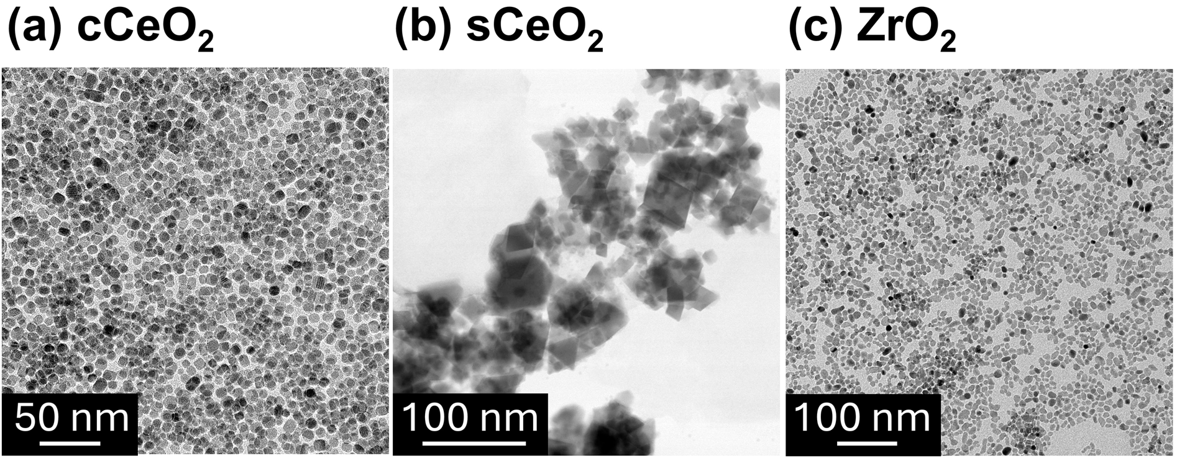
Fig. S1 TEM images of (a) cubic CeO₂, (b) commercial CeO₂, and (c) ZrO₂ nanoparticles

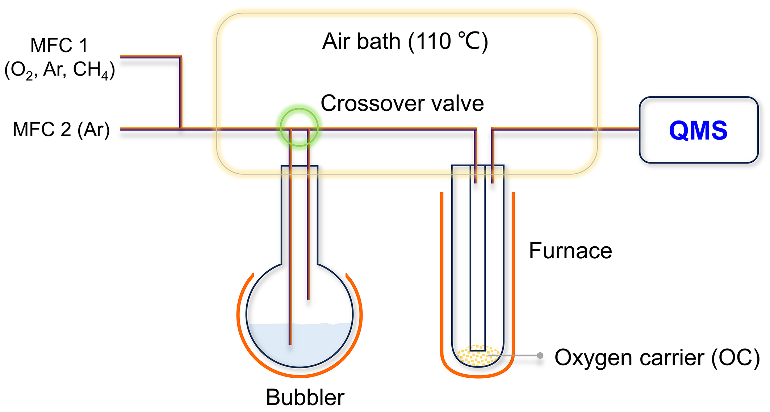
Fig. S2 Schematic diagram of the continuous-flow fixed-bed catalyst analyzer

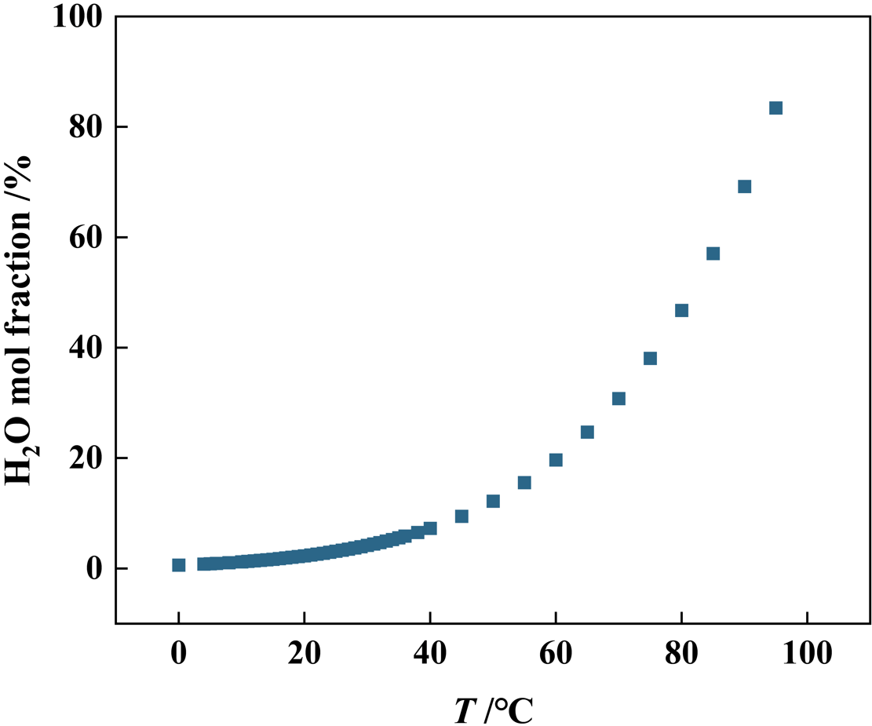
Fig. S3 Saturated vapor pressure curve of H₂O [S1]
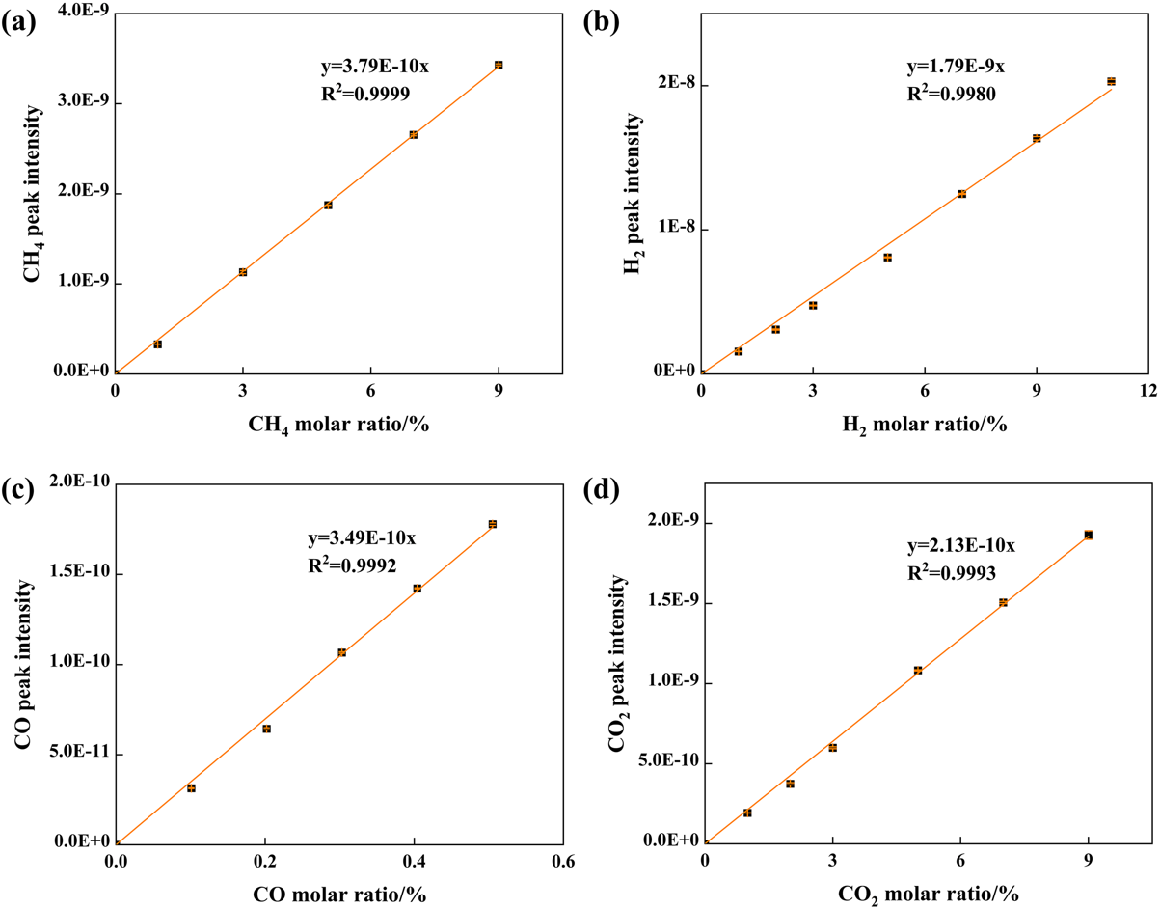
Fig. S4 Calibration curves of mass spectra for CH₄ (m/z=15), H₂ (m/z=2), CO (m/z=28), and CO₂ (m/z=44)

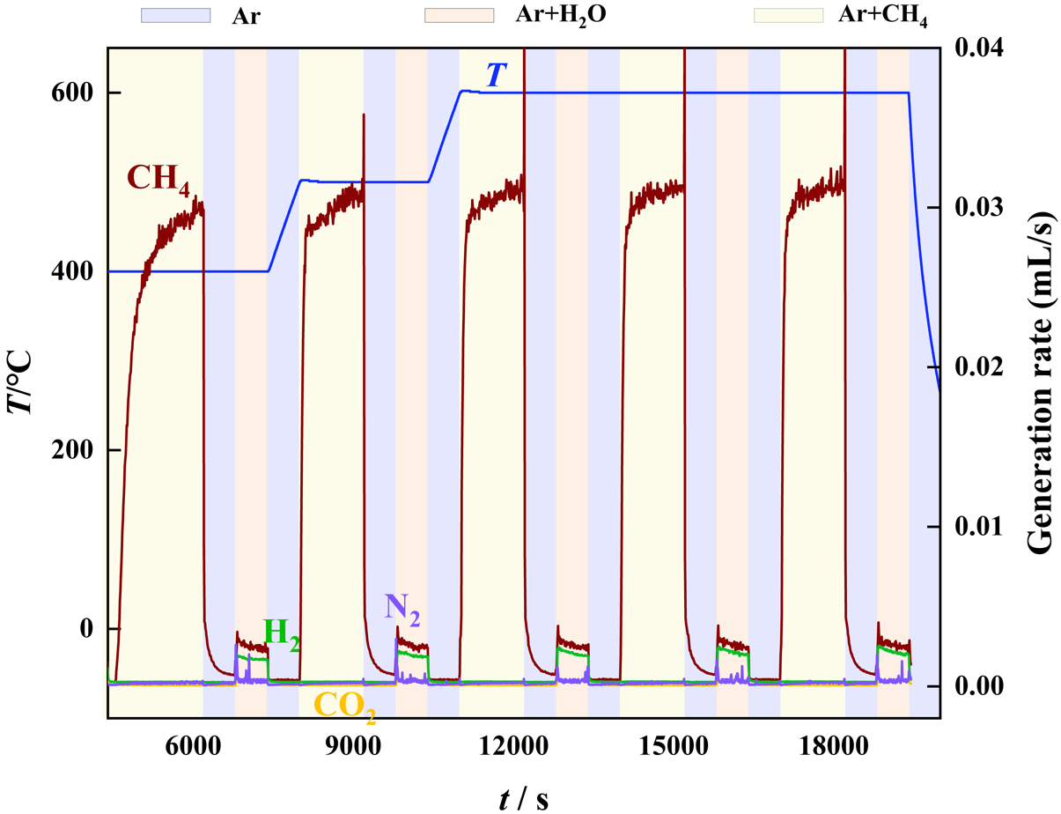
Fig. S5 Mass spectrometry background curves obtained under the same temperature program as the CL POM-WS cycles, without loading oxygen carriers
During the WS step (Ar+H₂O), the introduction of steam caused some impurity peaks (purple sharp peaks, m/z = 28), which were attributed to N₂ introduced from the steam bubbler. The areas of these impurity peak in the background curves closely matched those observed in the actual CL POM-WS measurements. Therefore, we assigned these intermittent sharp peaks to N₂ contamination originating from the steam bubbler.

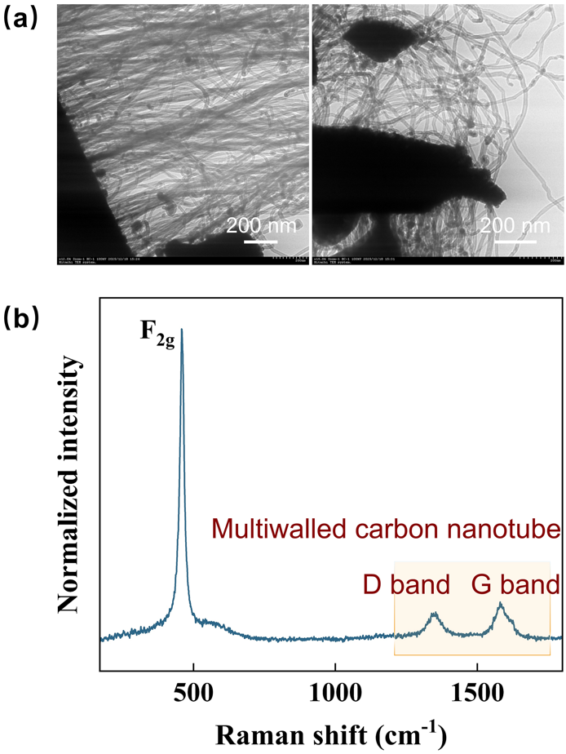
Fig. S6 (a) TEM images, and (b) Raman spectrum of the 6.5NiO/cCeO₂ OC after reaction with CH₄ at 600 °C

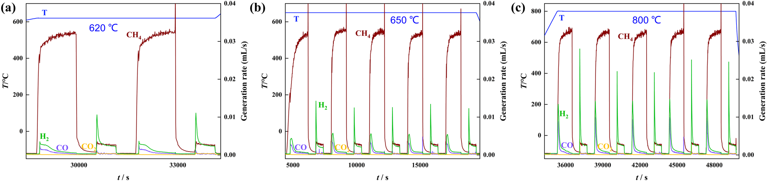
Fig. S7 Reaction performance of the activated 2.1NiO/cCeO₂ OC. (a) 620 °C, (b) 650 °C, (c) 800 °C

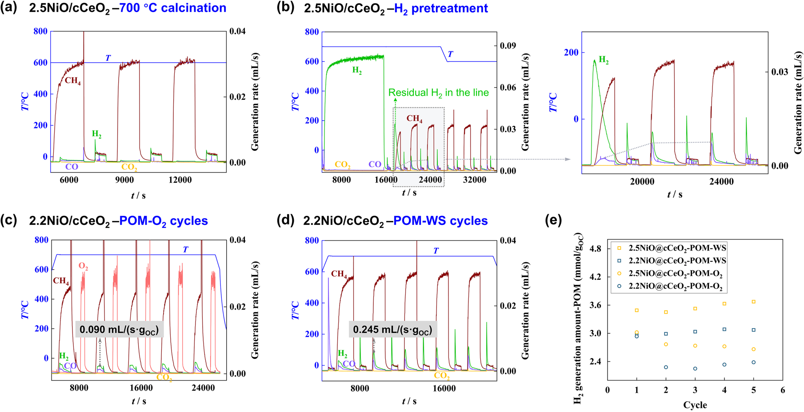
Fig. S8 Investigation of the activation inducing factors: (a) Reaction performance of a control sample (2.5NiO/cCeO₂-700) at 600 °C, prepared by calcination at 700 °C for 4h, (b) CH₄ substituted by H₂ during the reduction step, (c) steam substituted by O₂ during the reoxidation step, (d) OC reaction performance at 700 °C during POM-WS cycles, (e) Comparison of H₂ generation amounts in the POM step using steam and O₂ for reoxidation
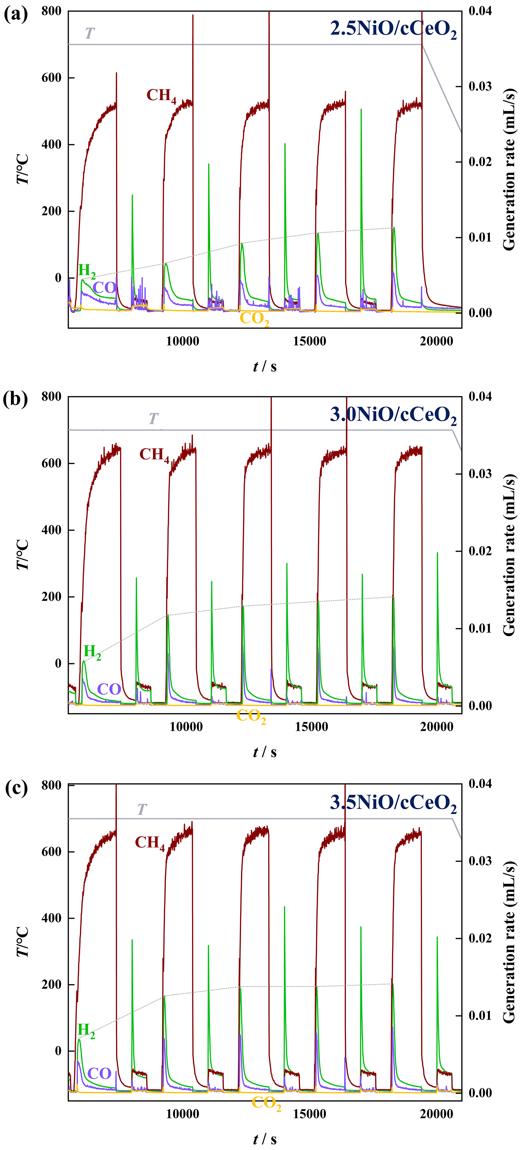
Fig. S9 Five-cycle CL POM-WS activation processes of NiO/cCeO₂ OCs with varying Ni loading amounts
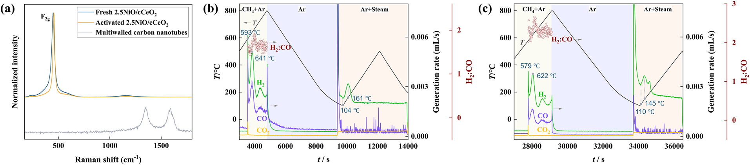
Fig. S10 (a) Raman spectra of 2.5NiO/cCeO₂ OC before and after activation. The F_{2g} mode could be attributed to the fluorite cubic structure of CeO₂.[2] During activation, there was no carbon deposition. (b, c) CH₄/H₂O(g)-TPR curves of the activated 2.5NiO/cCeO₂ OC with and without atmospheric exposure

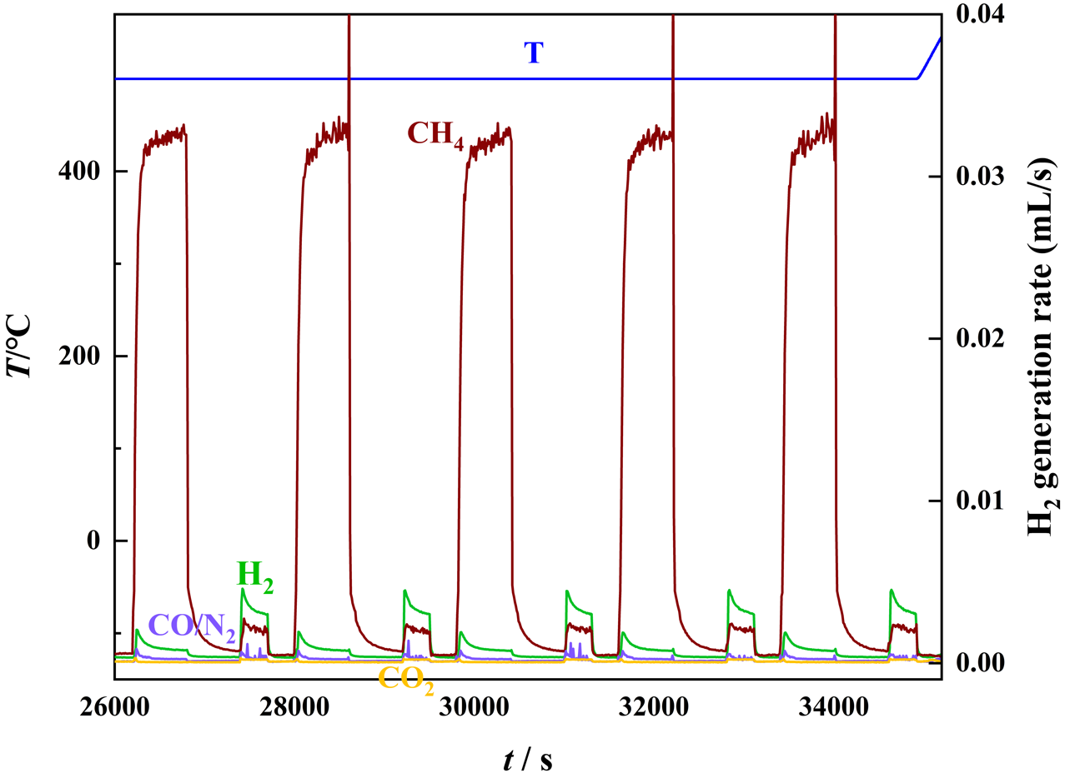
Fig. S11 Reaction performance of the activated 2.5NiO/cCeO₂ OC at 500 °C
Table S1 Reaction stability of the activated 2.5NiO/cCeO₂ OC at 500 °C
 | POM |  |  |  | WS
 | H₂-POM umol/g_{OC} | CO selectivity/% | H₂:CO | H₂-WS umol/g_{OC} |  | H₂ purity/%
cycle-1 | 292.2 | 94.8 | 2.8 | 97.1 |  | 98.9
cycle-2 | 274.4 | 95.0 | 2.9 | 96.4 |  | 99.3
cycle-3 | 274.8 | 94.7 | 2.9 | 97.1 |  | 99.4
cycle-4 | 274.0 | 95.3 | 2.8 | 104.2 |  | 99.5
cycle-5 | 273.7 | 95.5 | 2.8 | 111.2 |  | 99.7
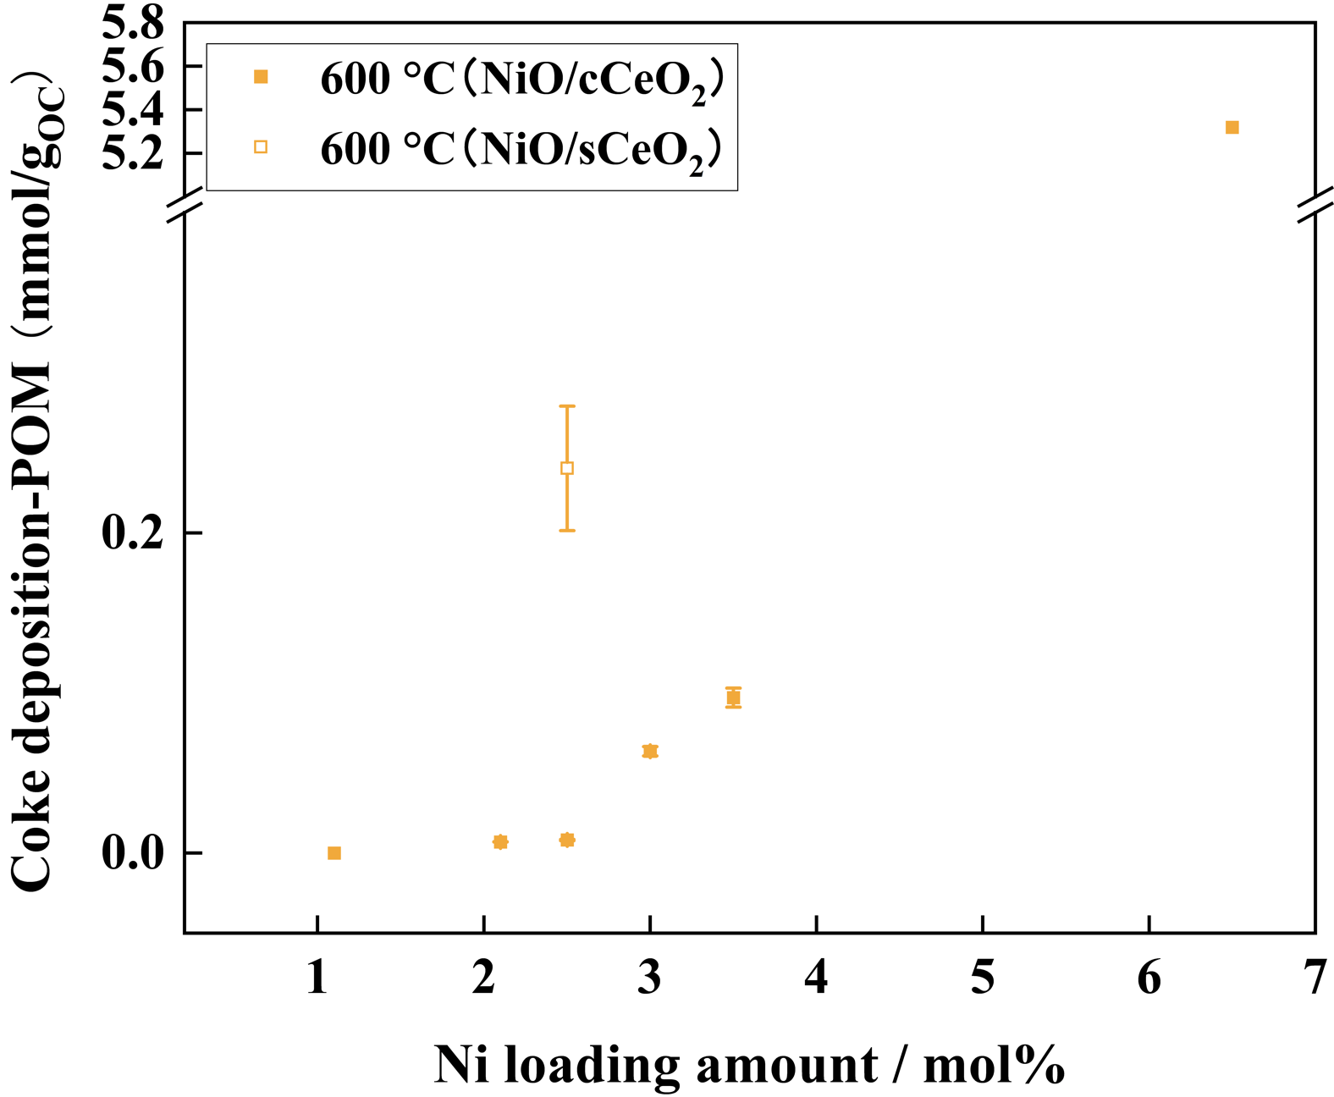
Fig. S12 Coke deposition amounts during the POM step with varying Ni loading amounts
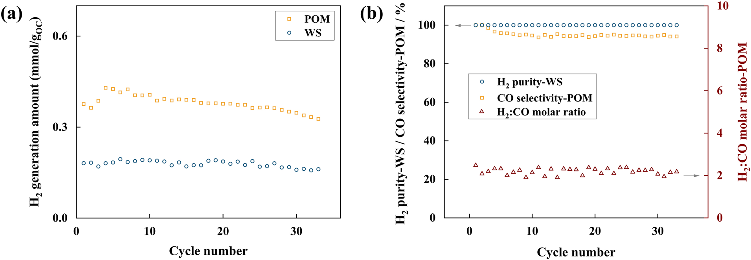
Fig. S13 Long-term stability evaluation of 2.5NiO/cCeO₂ OC at 550 °C. (a) H₂ generation amounts in the POM and WS steps over 33 cycles (POM: 10 min, WS: 5 min). (b) CO selectivity, H₂:CO molar ratio in the POM step, and H₂ purity in the WS step over 33 cycles
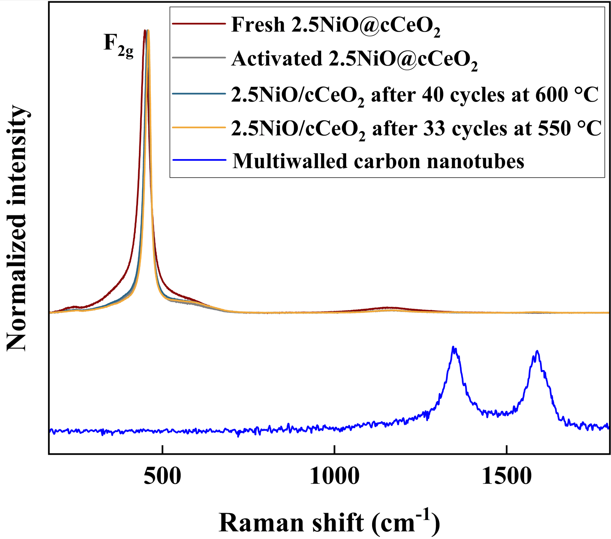
Fig. S14 Raman spectra of 2.5NiO/cCeO₂ OC after long-term test at 600 °C and 550 °C

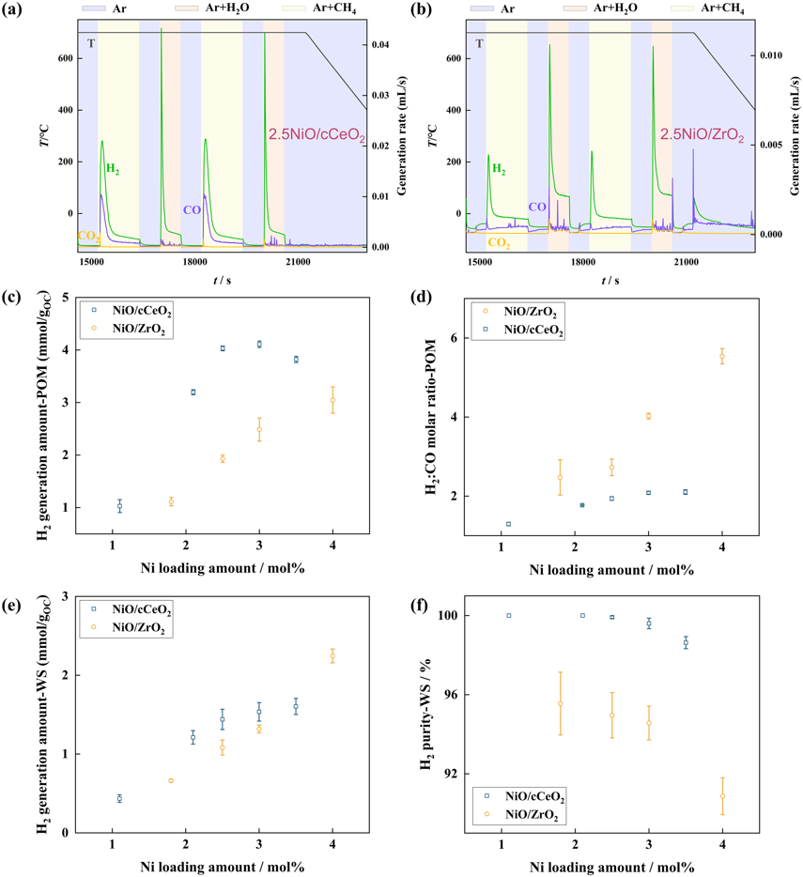
Fig. S15 Effects of the support nanoparticles on the OC performance. (a, b) Reaction performances of 2.5NiO/cCeO₂ OC and 2.5NiO/ZrO₂ OC at 700 °C, (c, d) H₂ generation amount and H₂:CO molar ratio in the POM step, and (e, f) H₂ generation amount and H₂ purity in the WS step with NiO/cCeO₂ and NiO/ZrO₂ as OC at 700 °C
Table S2 Comparison of the reaction performance of 2.5NiO/cCeO₂ OC with several representative OCs for the CL methane reforming
Oxygen carrier | T  /°C | POM |  |  | WS |  | Refs.
Oxygen carrier | T  /°C | Syngas  mmol/g_{OC} | H₂:CO | CO selectivity/% | H₂  mmol/g_{OC} | H₂ purity/% | Refs.
2.5NiO/cCeO₂  (POM: 20 min,  WS: 10 min) ª | 600 | 3.6 | 1.9 | 98.7 | 1.0 | 99.1 | This work
2.5NiO/cCeO₂  (POM: 20 min,  WS: 10 min) ª | 700 | 6.0 | 1.9 | 98.8 | 1.4 | 99.9 | This work
2.5NiO/cCeO₂  (POM: 20 min,  WS: 10 min) ª | 800 | 7.8 | 1.9 | 99.4 | 1.9 | 97.0 | This work
Ni-MoC_{x}O_{y} | 500 | — | 2.0 | 99 | — | — | Chem, 2023 [S3]
Ni-MoC_{x}O_{y} | 800 | — | 4.9 | 44 | — | — | Chem, 2023 [S3]
Ni/rABO₃ | 570 | — | 2.0 | 80 | — | — | Angew. Chem. Int. Ed., 2020 [S4]
0.5 wt% Rh-LaCeO_{4−x} | 650 | 0.5 | — | 90 | — | — | Adv. Energy. Mater., 2019 [S5]
Ni_{1.5}Mg_{1.5}Al-MMO | 700 | 5.8 | 2.3-2.4 | 90-96 | — | — | J. Catalysis, 2026 [S6]
LaFe_{0.5}Ni_{0.5}O₃ | 700 | 6.7 | ~3.6 | 50.0 | — | — | ACS Catalysis, 2024 [S7]
LaCo_{0.6}Fe_{0.4}O₃ | 700 | 3.3 | 1.8 | 92.0 | 2.2 | 99.3 | Energ. Conv. Manage., 2020 [S8]
10%CeO₂/3DOM LaFeO₃ | 800 | 9.9 | 2.0 | 90.0 | 3.4 | ~100 | Appl. Catal. B-Environ. Energy, 2017 [S9]
0.5LaMn_{0.8}Al_{0.2}O_{3+δ}/  LaMn_{0.7}Co_{0.3}O_{3+δ} | 850 | 2.4 | 2.0 | 83.6 | 1.1 | ~100 | Fuel, 2025 [S10]
Ca₂Fe_{1.4}Al_{0.6}O₅ | 850 | 6.9 | 2.0 | 95.5 | 3.16 | 95.4 | Appl. Surf. Sci., 2025 [S11]
La_{0.6}Ce_{0.4}Mn_{0.7}Ni_{0.3}O₃ | 850 | 4.5 | 2.0 | 60.0 | 2.9 | ~100 | Fuel, 2024 [S12]
LaFeO₃ | 900 | 4.6 | 2.0 | 97.0 | — | — | Nature Communications, 2024 [S13]
^{a.} The values were summarized based on Fig. 4a-d.

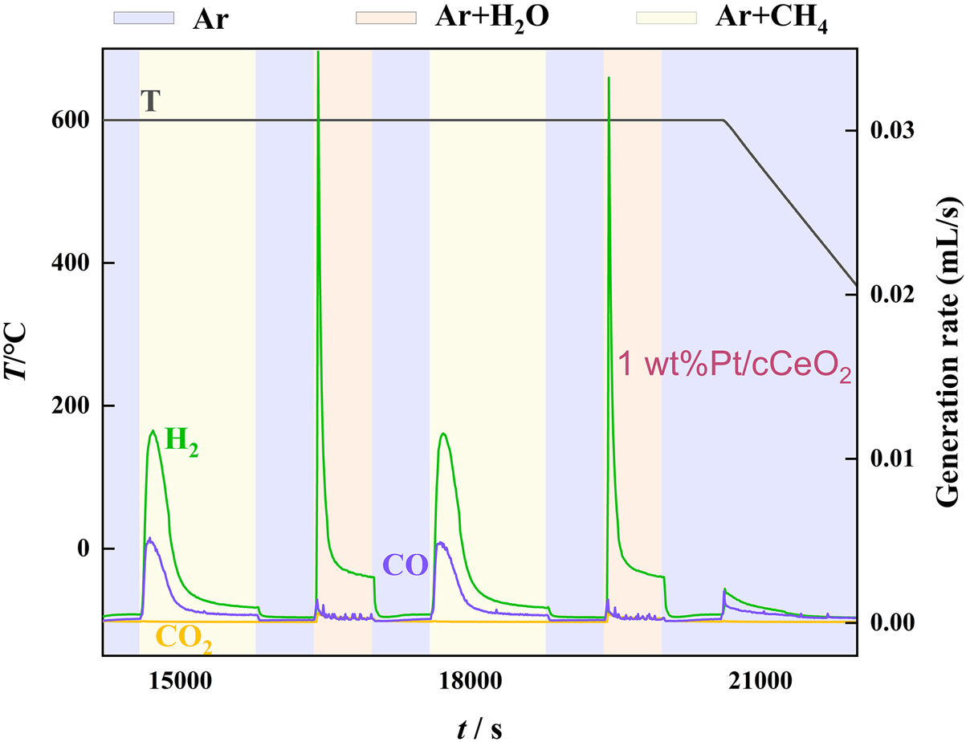
Fig. S16 Gas generation rate curves using 1 wt%Pt/cCeO₂ as OC
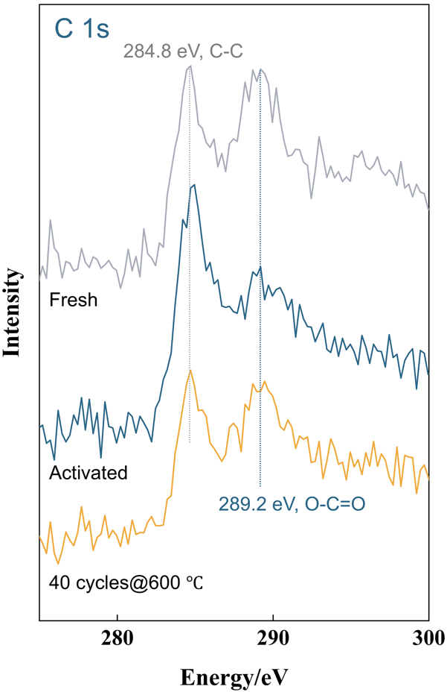
Fig. S17 C 1s XPS spectra of the fresh, activated, and long-term used 2.5NiO/cCeO₂ OCs
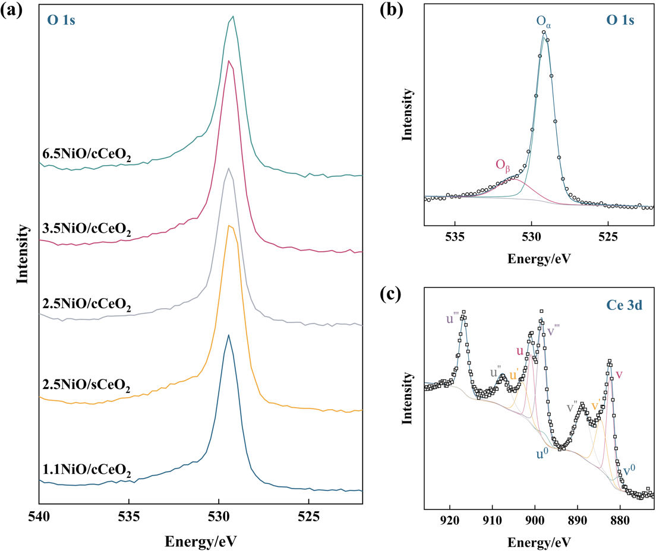
Fig. S18 (a) O 1s XPS spectra of the activated OCs with varying Ni loading amounts. (b) Fitting of O 1s XPS spectrum. O_{α} and O_{β} at 529.1 eV and 531.2 eV represent the CeO₂ lattice oxygen and non-lattice oxygen (defective oxygen species, surface hydroxyls, adsorbed oxygen), respectively [S14-S16]. (c) Fitting of Ce 3d XPS spectrum. v⁰, u⁰, v′, and u′ represent Ce³⁺, and other peaks represent Ce⁴⁺ [S17]
Fig. S19 H₂-TPR profiles of the activated 2.5NiO/cCeO₂ and 2.5NiO/sCeO₂ OCs

Supplementary References
- N. I. o. S. a. Technology, NIST Chemistry WebBook. 69 (2023).
- C. Andriopoulou, A. Trimpalis, K.C. Petallidou, A. Sgoura, A.M. Efstathiou et al., Structural and redox properties of Ce_{1–x}Zr_{x}O_{2–δ} and Ce_{0.8}Zr_{0.15}RE_{0.05}O_{2–δ}(RE: La, Nd, Pr, Y) solids studied by high temperaturein SituRaman spectroscopy. J. Phys. Chem. C 121(14), 7931–7943 (2017). https://doi.org/10.1021/acs.jpcc.7b00515
- X. Zhang, Y. Xu, Y. Liu, L. Niu, Y. Diao et al., A novel Ni–MoCxOy interfacial catalyst for syngas production via the chemical looping dry reforming of methane. Chem 9(1), 102–116 (2023). https://doi.org/10.1016/j.chempr.2022.09.007
- K. Kousi, D. Neagu, L. Bekris, E.I. Papaioannou, I.S. Metcalfe, Endogenous nanoparticles strain perovskite host lattice providing oxygen capacity and driving oxygen exchange and CH₄ conversion to syngas. Angew. Chem. Int. Ed. 59(6), 2510–2519 (2020). https://doi.org/10.1002/anie.201915140
- V.P. Haribal, X. Wang, R. Dudek, C. Paulus, B. Turk et al., Modified ceria for “low-temperature” CO₂ utilization: a chemical looping route to exploit industrial waste heat. Adv. Energy Mater. 9(41), 1901963 (2019). https://doi.org/10.1002/aenm.201901963
- J. Yuan, J. Cai, H. Zhao, H. Wang, K. Li, Selectivity control of NiO-based oxygen carriers for chemical looping methane anaerobic oxidation to syngas. J. Catal. 453, 116527 (2026). https://doi.org/10.1016/j.jcat.2025.116527
- R. Zhang, G. Liu, C. Huo, J. Liu, B. Zhang et al., Tailoring catalytic and oxygen release capability in LaFe_{1–x}Ni_{x}O₃ to intensify chemical looping reactions at medium temperatures. ACS Catal. 14(10), 7771–7787 (2024). https://doi.org/10.1021/acscatal.4c01386
- M. Lee, H.S. Lim, Y. Kim, J.W. Lee, Enhancement of highly-concentrated hydrogen productivity in chemical looping steam methane reforming using Fe-substituted LaCoO₃. Energy Convers. Manag. 207, 112507 (2020). https://doi.org/10.1016/j.enconman.2020.112507
- Y. Zheng, K. Li, H. Wang, D. Tian, Y. Wang et al., Designed oxygen carriers from macroporous LaFeO₃ supported CeO₂ for chemical-looping reforming of methane. Appl. Catal. B Environ. 202, 51–63 (2017). https://doi.org/10.1016/j.apcatb.2016.08.024
- X. Yin, Y. Sang, S. Wang, L. Shen, Regulation of oxidation state of LaMn_{0.8}Al_{0.2}O_{3+δ}/LaMn_{0.7}Co_{0.3}O_{3+δ} oxygen carriers for chemical looping steam methane reforming. Fuel 397, 135479 (2025). https://doi.org/10.1016/j.fuel.2025.135479
- Y. Zou, H. Liu, J. Liu, C. Wu, R. Li et al., Heterocoordination-driven regulation of Ca₂Fe₂O₅ lattice oxygen for high selectivity syngas and hydrogen production via chemical looping. Appl. Surf. Sci. 703, 163411 (2025). https://doi.org/10.1016/j.apsusc.2025.163411
- J. Ji, L. Shen, Enhanced co-production of high-quality syngas and highly-concentrated hydrogen via chemical looping steam methane reforming over Ni-substituted La_{0.6}Ce_{0.4}MnO3 oxygen carriers. Fuel 368, 131588 (2024). https://doi.org/10.1016/j.fuel.2024.131588
- J. He, T. Wang, X. Bi, Y. Tian, C. Huang et al., Subsurface A-site vacancy activates lattice oxygen in perovskite ferrites for methane anaerobic oxidation to syngas. Nat. Commun. 15(1), 5422 (2024). https://doi.org/10.1038/s41467-024-49776-y
- J. Li, Z. Liu, D.A. Cullen, W. Hu, J. Huang et al., Distribution and valence state of Ru species on CeO₂ supports: support shape effect and its influence on CO oxidation. ACS Catal. 9(12), 11088–11103 (2019). https://doi.org/10.1021/acscatal.9b03113
- H. Idriss, On the wrong assignment of the XPS O1s signal at 531–532 eV attributed to oxygen vacancies in photo- and electro-catalysts for water splitting and other materials applications. Surf. Sci. 712, 121894 (2021). https://doi.org/10.1016/j.susc.2021.121894
- D.J. Morgan, Photoelectron spectroscopy of ceria: Reduction, quantification and the myth of the vacancy peak in XPS analysis. Surf. Interface Anal. 55(11), 845–850 (2023). https://doi.org/10.1002/sia.7254
- Y. Zhu, G. Seong, T. Noguchi, A. Yoko, T. Tomai et al., Highly Cr-substituted CeO₂ nanoparticles synthesized using a non-equilibrium supercritical hydrothermal process: high oxygen storage capacity materials designed for a low-temperature bitumen upgrading process. ACS Appl. Energy Mater. 3(5), 4305–4319 (2020). https://doi.org/10.1021/acsaem.0c00026

