Supporting Information for
Ligand-Wise Stripping Dictates Metal Ensemble Catalysts for Selective Oxidation of Biomass-Derived 5-Hydroxymethylfurfural
Junkai Li¹, Guanhua Wang^{1,*}, Yunxiang Wu¹, Chuqiao Song², Tairan Pang¹, Zechao Zhuang³, Jiarui Yang³, Wenjie Sui^{4,*}, Lili Lin^{2,*}, Dingsheng Wang³, Ligang Wang^{5,*} and Chuanling Si^{1,*}
¹ State Key Laboratory of Bio-based Fiber Materials, Tianjin Key Laboratory of Pulp and Paper, College of Light Industry Science and Technology, Tianjin University of Science and Technology, Tianjin 300457, P. R. China
² Institute of Industrial Catalysis, State Key Laboratory of Green Chemistry Synthesis Technology, College of Chemical Engineering, Zhejiang University of Technology, Hangzhou 310014, P. R. China
³ Department of Chemistry, Tsinghua University, Beijing 100084, P. R. China
⁴ State Key Laboratory of Food Nutrition and Safety, College of Food Science and Engineering, Tianjin University of Science and Technology, Tianjin 300457, P. R. China
⁵ Institute of Molecular Plus, Tianjin University, Tianjin 300072, P. R. China
*Corresponding authors. E-mail: ghwang@tust.edu.cn (Guanhua Wang); wjsui@tust.edu.cn (Wenjie Sui ); linll@zjut.edu.cn (Lili Lin); lgwang_246@tju.edu.cn (Ligang Wang); sichli@tust.edu.cn (Chuanling Si)
S1 Materials
Enzymatic hydrolysis lignin (EHL) utilized for catalyst manufacture was extracted from the enzymatic hydrolysis residue of steam-exploded maize stalk, asper our previous study. 5-Hydroxymethylfurfural (HMF, C₆H₆O₃), 5-hydroxymethyl-2-furancarboxylic acid (HMFCA, C₆H₆O₄), 2,5-furandicarboxylicacid (FDCA, C₆H₄O₅), furan-2,5-dicarbaldehyde (DFF, C₆H₄O₃), 5-formyl-2-furoic acid (FFCA, C₆H₄O₄), 2-furaldehyde, (C₅H₄O₂), 2-furoic acid, (C₅H₄O₃), anhydrous zinc chloride (ZnCl₂), cobalt chloride hexahydrate (CoCl₂·6H₂O), melamine (C₃H₆N₆), sodium carbonate (Na₂CO₃), and sodium hydroxide (NaOH) were used.

S2 Characterization
TEM images were obtained by JEOL JEM-2100 with an acceleration voltage of 200 kV. High angle annular darkfield scanning transmission electron microscopy (HAADF-STEM) images were acquired on Titan cubed 60-300 (FEI, USA) equipped with a probe spherical aberration corrector. The X-ray absorption fine structure (XAFS) spectrum was composed of two distinct components, namely the X-ray absorption near-edge structure (XANES) and the extended X-ray absorption fine structure (EXAFS). XAFS measurements were taken at the 14B2 beam line of Spring-8, Japan’s synchrotron Radiation Facility. The XANES and EXAFS data were processed and analyzed using the ICOFFIT package. X-ray diffraction (XRD) determination of the catalysts was carried out using Rigaku Ru-200b X-ray diffractometer with monochromatic Cu Kα radiation in the scanning range of 5º-90º. X-ray photoelectron spectroscopy (XPS) was collected by PHI 5000C ESCA spectrometer with Mg Kα radiation (hν 1253.6 eV), and the binding energy was corrected by C 1s value of 284.6 eV. Inductively coupled plasma mass spectrometry (ICP-MS, Thermo Scientific ICAPQ) was employed for quantitative determination of Ni content, and the catalyst was digested using HNO₃ prior to testing. Fourier transform infrared (FT-IR) measurements were made using a Nicolet Nexus spectrometer.
S3 Metal-free nitrogen-doped lignin-derived carbon-based catalyst (NC) preparation
EHL (0.6 g) and melamine (9 g) were uniformly ground, the resultant solid sample was heated in a tube furnace under a nitrogen atmosphere at 550 ºC and 900 ºC for 1 h respectively. After the completion of pyrolysis, no further treatment was necessary, and subsequent experiments were carried out directly.
S4 Oxidize gram-scale HMF over the Co catalysts
The catalytic oxidation of HMF was performed in a 300 mL stainless steel reactor containing 10 g/L HMF, 1mol/L Na₂CO₃, 3.5 g Co-N₂/Co₄ catalysts, and 150 mL deionized water. The reaction conditions were 5 bar O₂, 5 h and 55 ºC.
S5 Oxidize high-concentration (10 wt%) HMF over the Co catalysts
The catalytic oxidation of HMF was performed in a 300 mL stainless steel reactor containing 10 wt.% HMF, 0.1mol/L Na₂CO₃, Co-N₂/Co₄ catalysts (HMF/Co molar ratio = 65.6), and 150 mL deionized water. The reaction conditions were 10 bar O₂, 12 h and 120 ºC.
S6 Oxidize furfuryl alcohol to furoic acid over the Co catalysts
The catalytic oxidation of HMF was performed in a 50 mL stainless steel reactor containing 0.2 mmol furfuryl alcohol, 1M Na₂CO₃, 50 mg Co catalysts, and 20 mL deionized water. The reaction conditions were 3 bar O₂, 5 h and 65 ºC. After the reaction, the contents of furfural and its furoic acid in the samples were analyzed by HPLC using Aminex®HPX-87H column (300 mm×7.8 mm) and sulfuric acid solution (5mM) as mobile phase. The contents of furfuryl alcohol in the samples were analyzed by HPLC using C18 column (250 mm×4.6 mm).
S7 Oxidize vanillin alcohol to vanillin over the Co catalysts
The catalytic oxidation of HMF was performed in a 50 mL stainless steel reactor containing 0.1 g vanillin alcohol, 0.2g NaOH, 50 mg Co catalysts, and 20 mL deionized water. The reaction conditions were 5 bar O₂, 1 h and 100 ºC. The contents of vanillin alcohol and vanillin in the samples were analyzed by HPLC using C18 column (250 mm×4.6 mm).

S8 Life Cycle Assessment (LCA) analysis
Analysis is conducted in open LCA 2.0, utilizing its database to identify key environmental impact factors. Employing a “cradle-to-gate” system boundary with 1 kg of FDCA production as the functional unit, the analysis utilized OpenLCA software for modeling. Life Cycle Impact Assessment combines results from the life cycle inventory using the ecoinvent-ReCiPe 2016 v1.03 method, which assesses environmental impact.
S9 Density functional theory (DFT) calculation
All the DFT calculations were conducted based on the Vienna Ab initio Simulation Package (VASP) [S1, S2]. The exchange-correlation potential was described by the Perdew-Burke-Ernzerhof (PBE) generalized gradient approach (GGA) [S3]. The electron-ion interactions were accounted by the projector augmented wave (PAW). All DFT calculations were performed with a cut-off energy of 400 eV, and the Brillouin zone was sampled using a 3×3×1 k-point grid. The energy and force convergence criteria of the self-consistent iteration were set to 10⁻⁵ eV and 0.02 eV Å-1, respectively. DFT-D3 method was used to describe van der Waals interactions [S4].
The Gibbs free energy changes (ΔG) of the reaction are calculated using the following formula:
∆G = ∆E + ∆ZPE - T∆S
where ΔE is the electronic energy difference directly obtained from DFT calculations, ΔZPE is the zero-point energy difference, T is the room temperature (298.15 K) and ΔS is the entropy change.
The adsorption energies (Eads) of a molecule are calculated by
E_{ads} = E*_{A}–E_{A} –E_{Sub}
where E_{A} and E*_{A} represent the energies before and after the adsorption of a molecule on the substrate, respectively. E_{sub} is the energy of clean surface.

Supplementary Figures and Tables
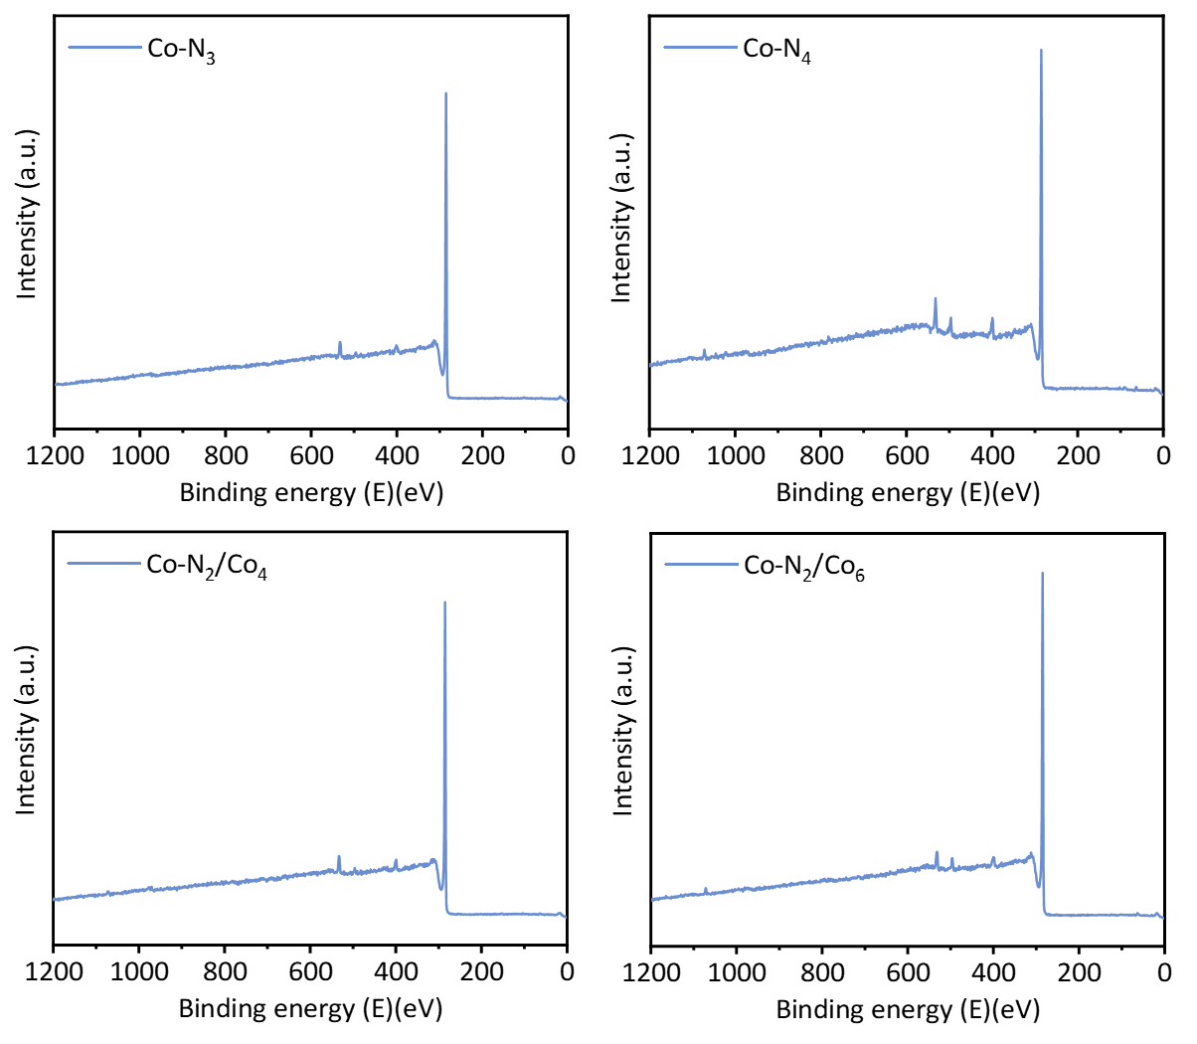
Fig. S1 XPS spectra of Co catalysts

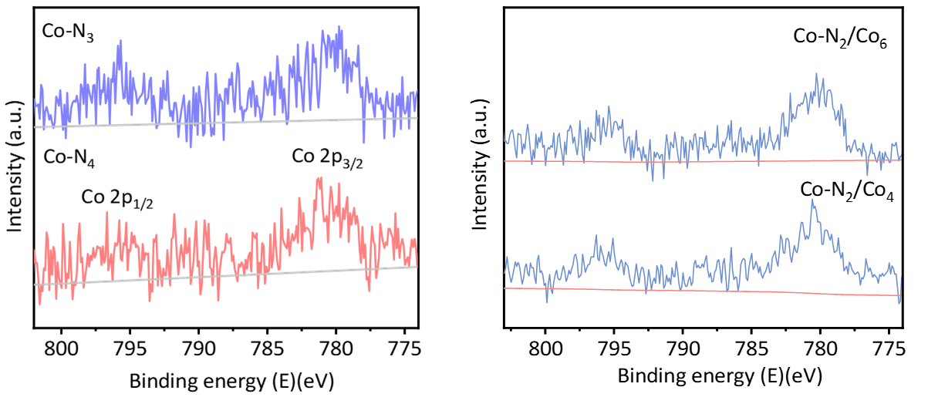
Fig. S2 Co 2p XPS spectra of Co catalysts
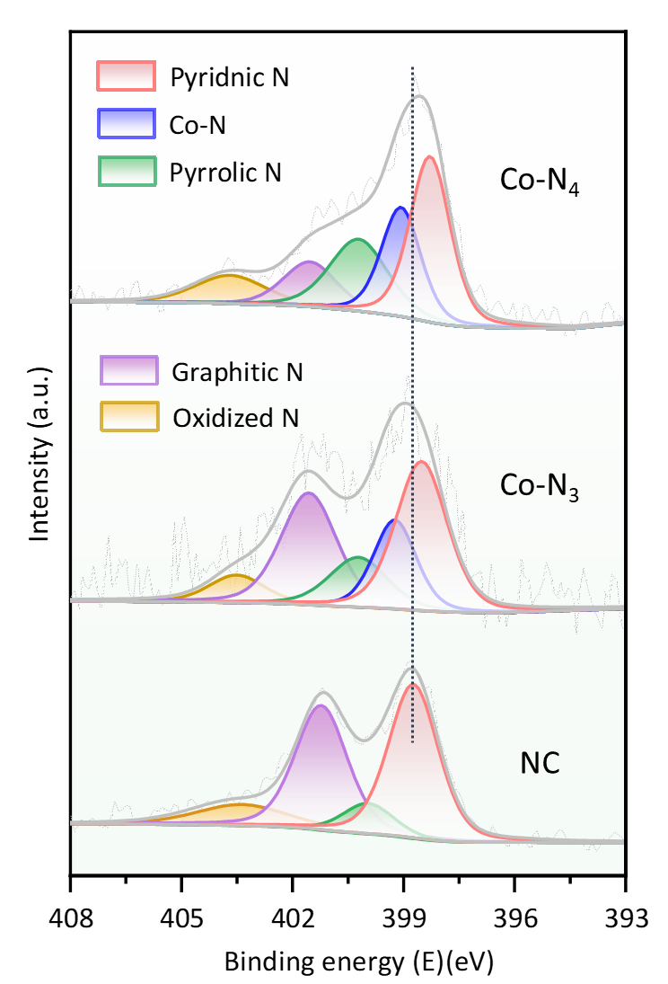
Fig. S3 N 1s XPS spectra of Co catalysts and NC catalysts

Fig. S4 XANES and EXAFS spectra of the Co samples
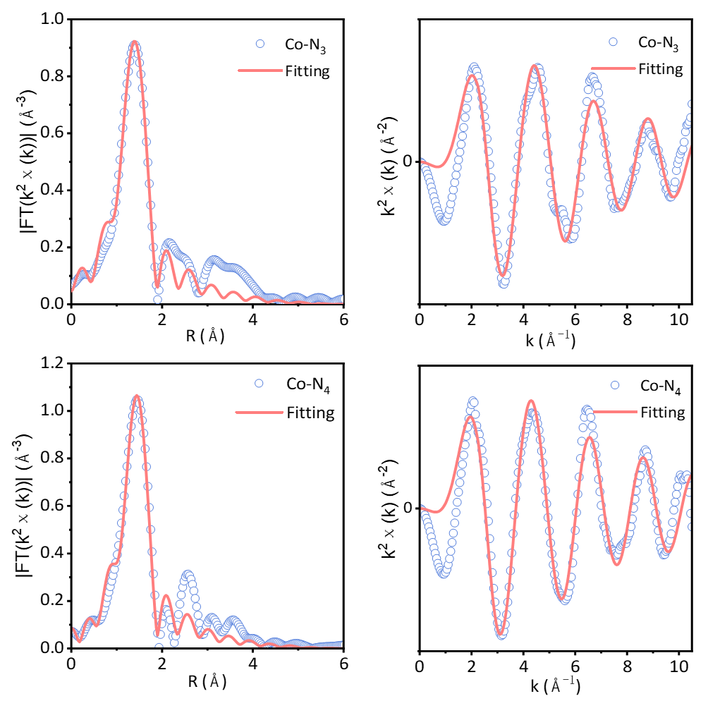
Fig. S5 EXAFS fitting curves of Co-N₃ SACs and Co-N₄ SACs at R space and K space
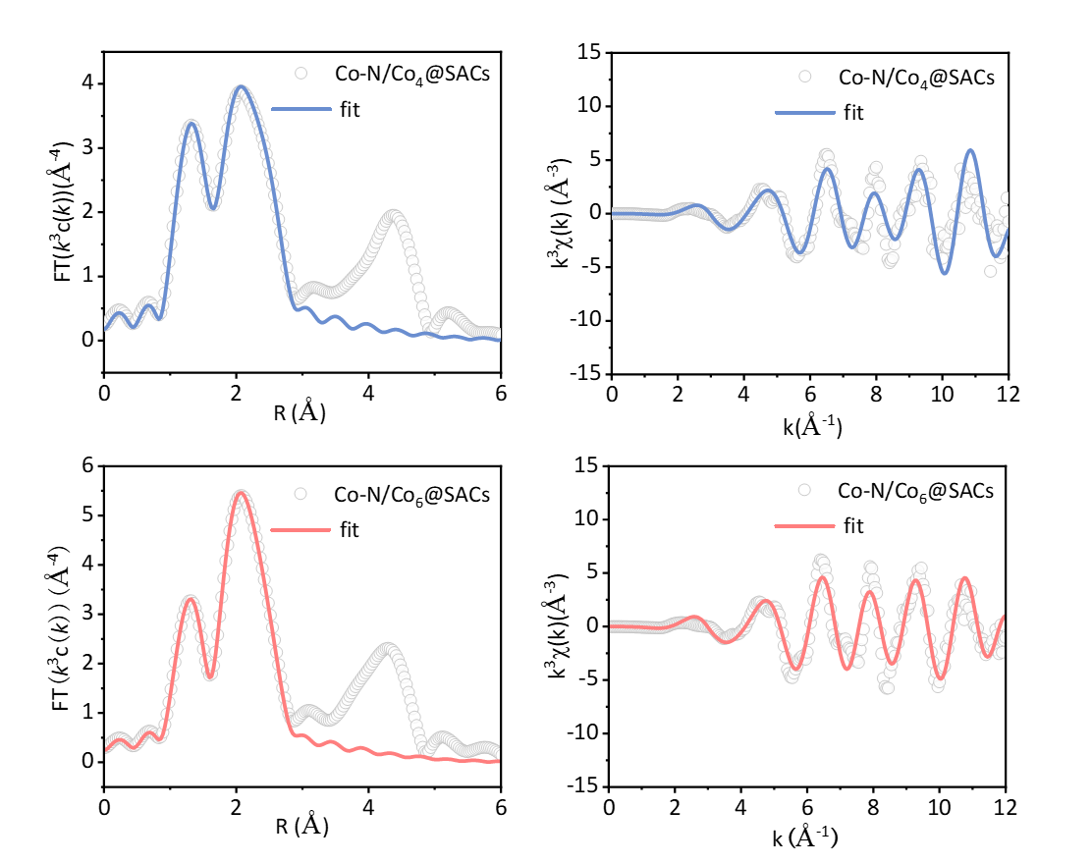
Fig. S6 EXAFS fitting curves of Co-N₂/Co₄ SACs and Co-N₂/Co₆ SACs at R space and K space
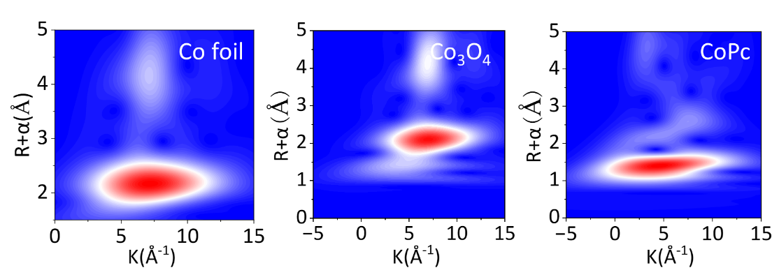
Fig. S7 WT-EXAFS of Co samples 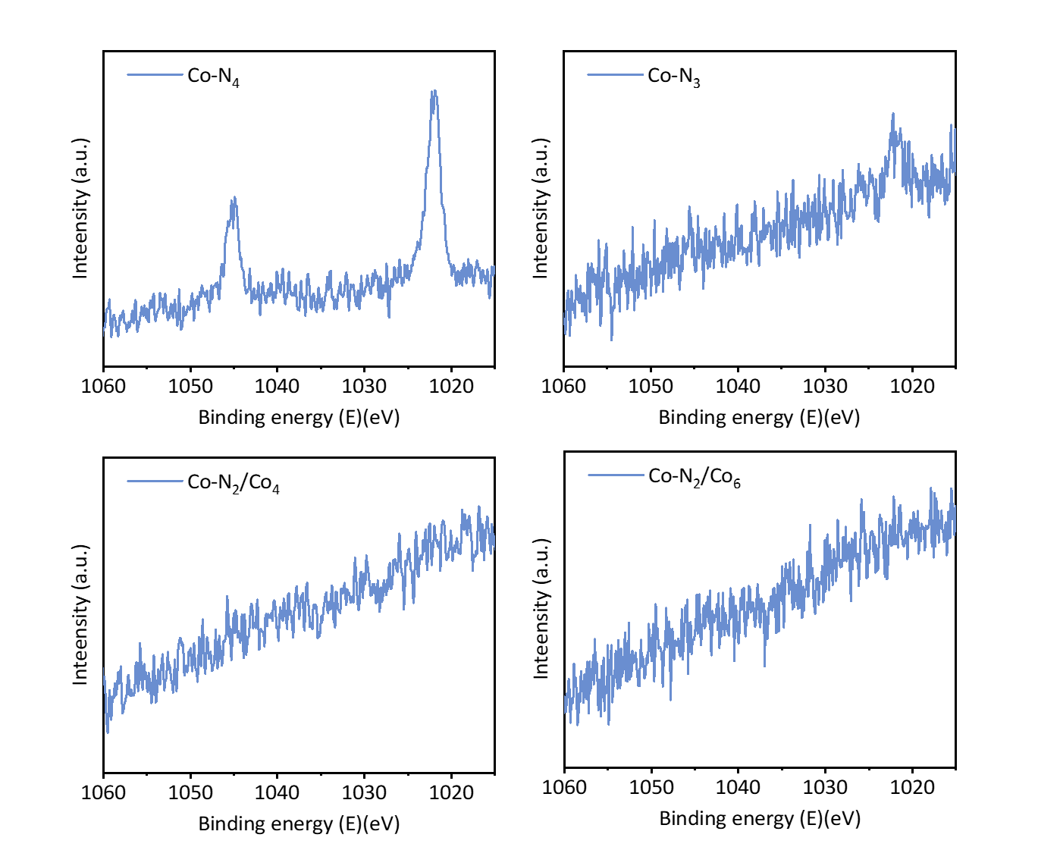
Fig. S8 Zn 2p XPS spectra of Co catalysts
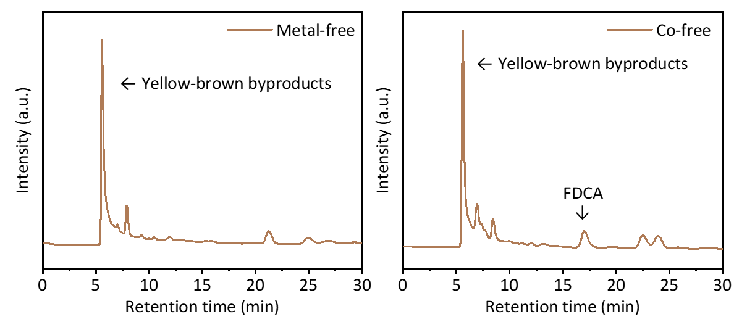
Fig. S9 HPLC chromatograms of catalytic products
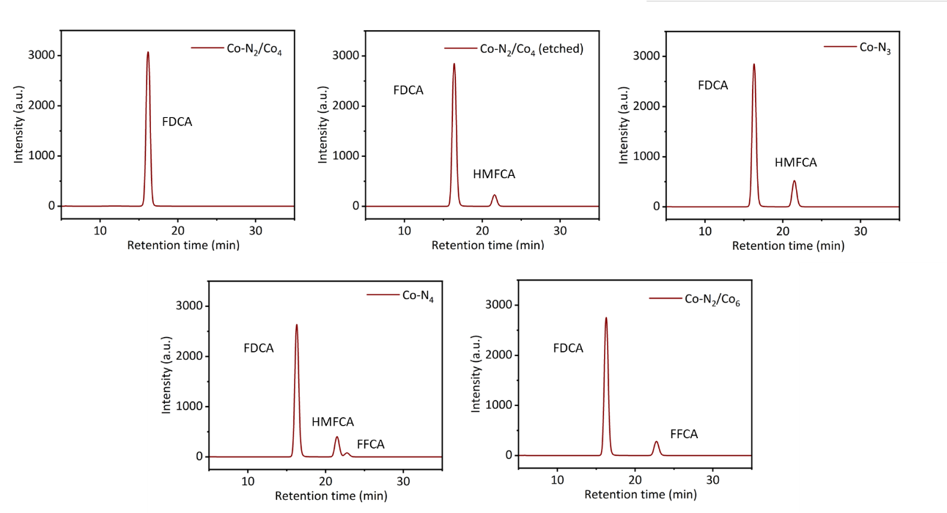
Fig. S10 HPLC chromatograms of HMF to FDCA

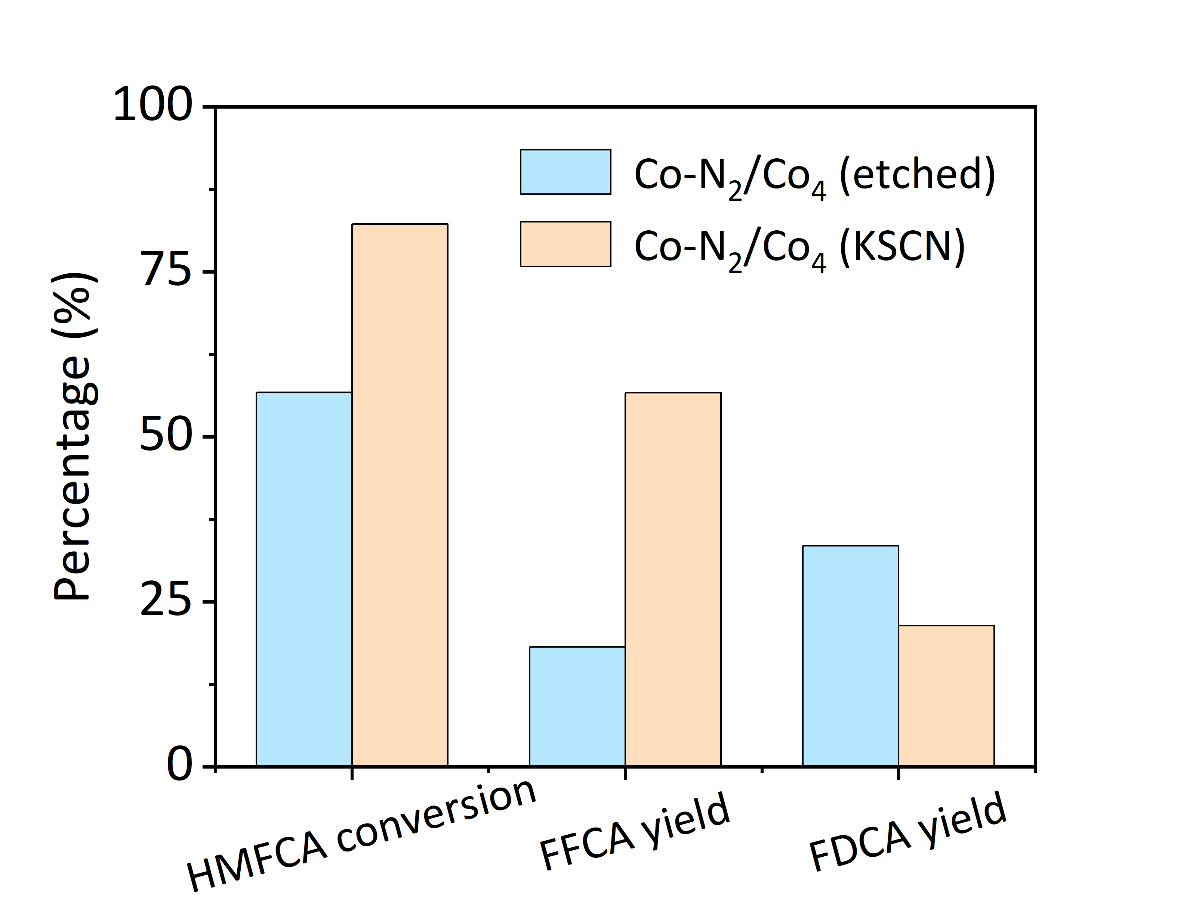
Fig. S11 Catalytic performance of Co-N₂/Co₄ (etched) and Co-N₂/Co₄ (KSCN) catalysts for HMFCA to FDCA. Reaction conditions: 5 bar O₂, 5 h and 55 ºC
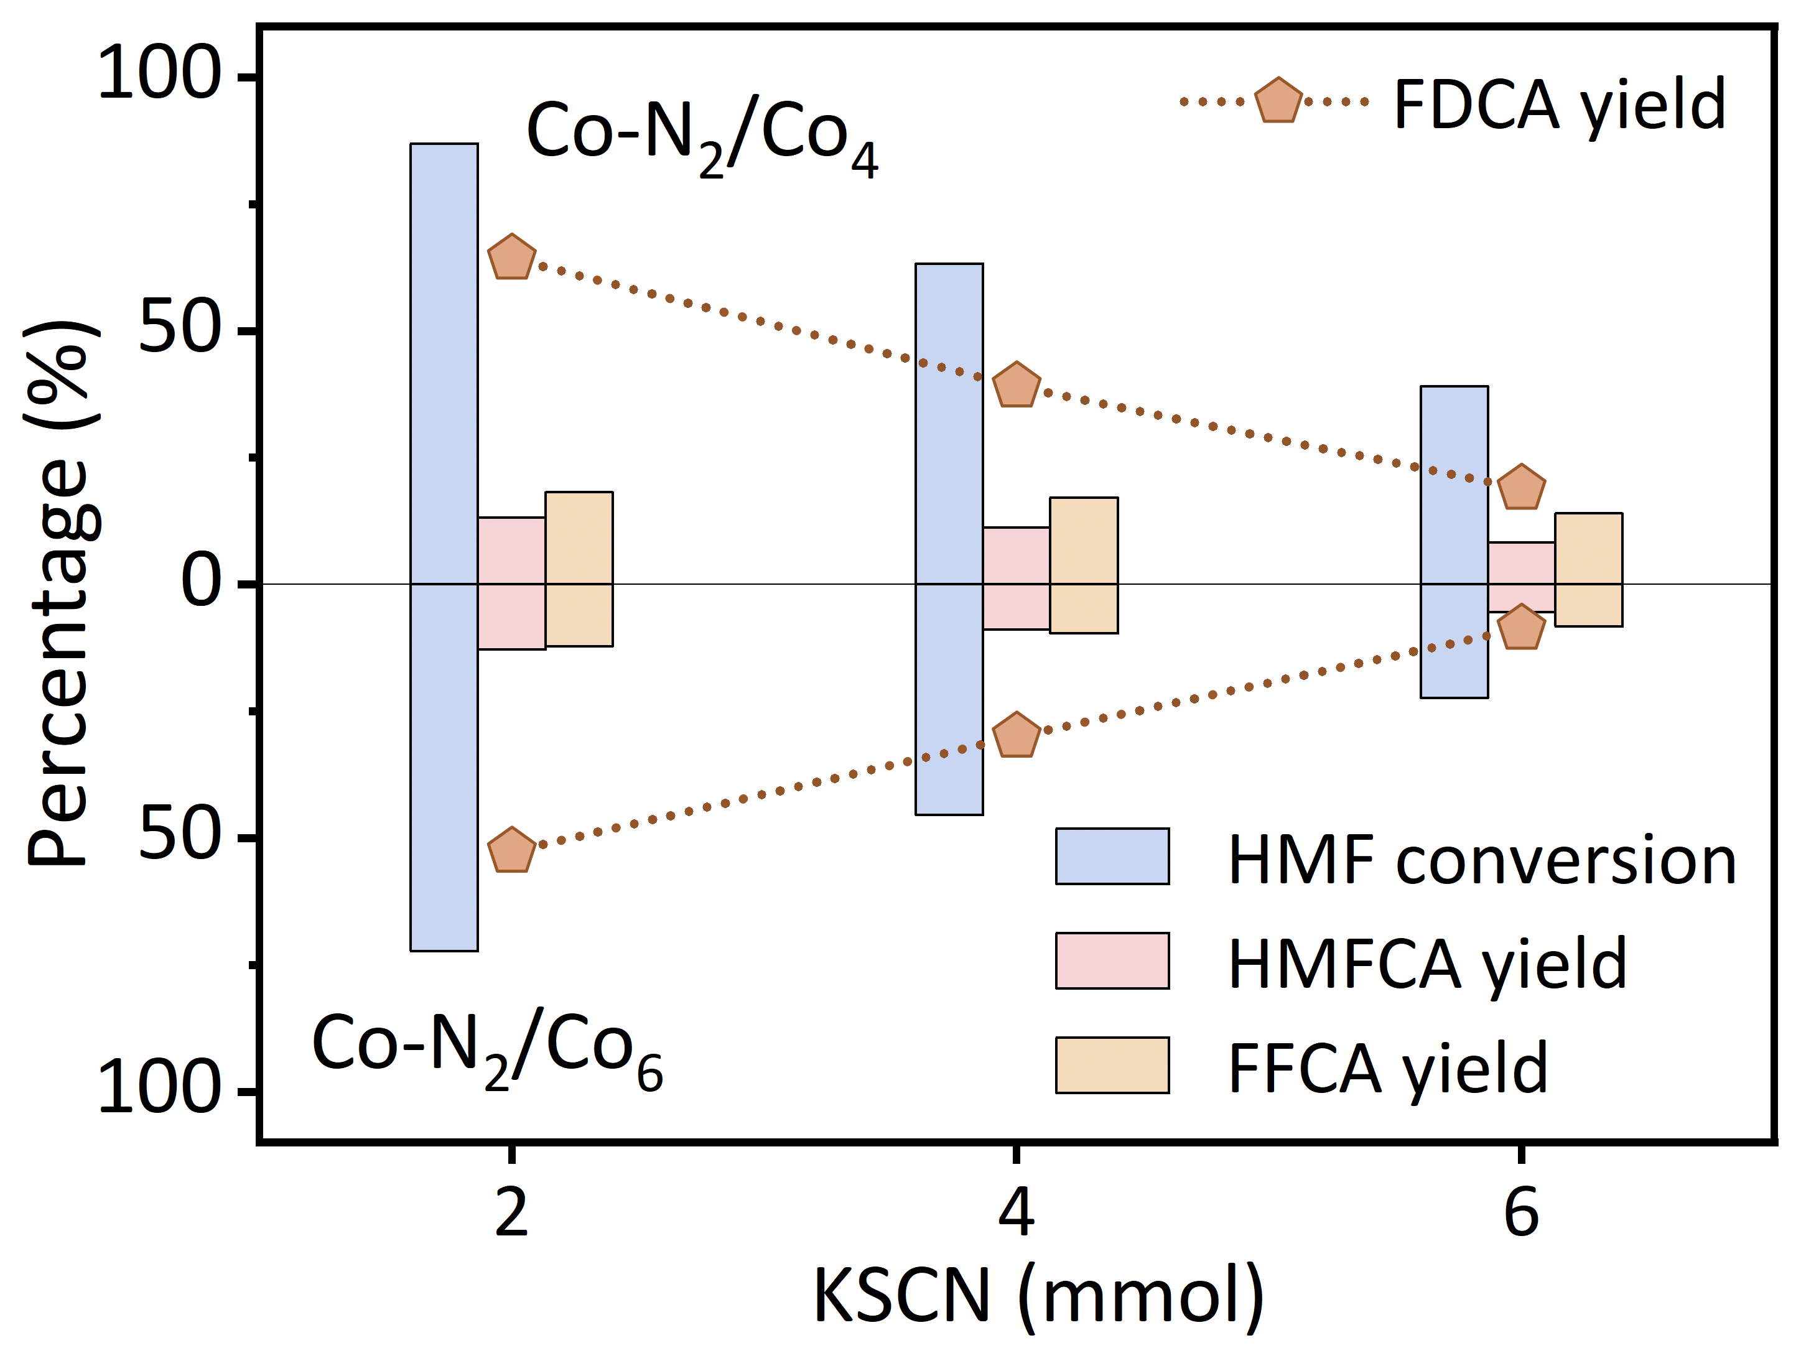
Fig. S12 The catalytic effect of the Co cluster was verified by poisoning the Co-N₂ sites with KSCN
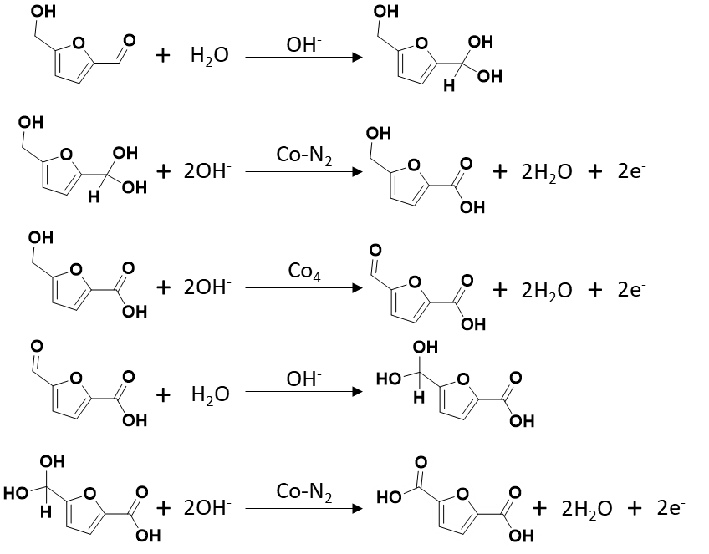
Fig. S13 Overall mechanism of HMF oxidation to FDCA over the Co-N₂/Co₄ SACs
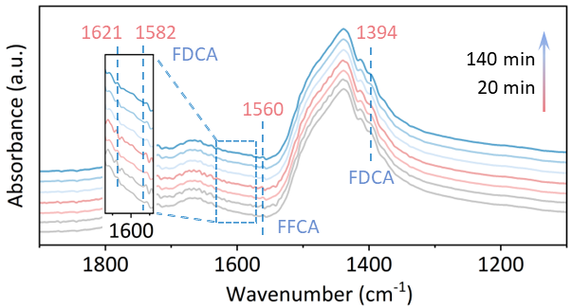
Fig. S14 FTIR spectra were collected during HMF oxidation on Co single-atom catalyst

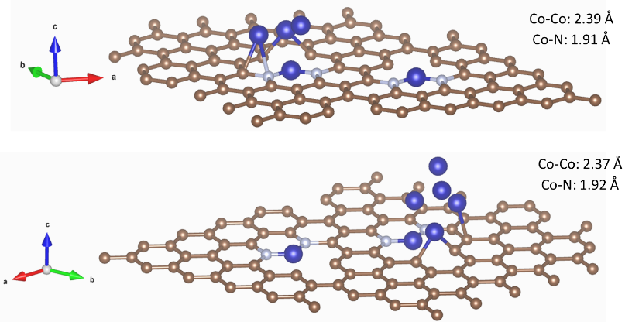
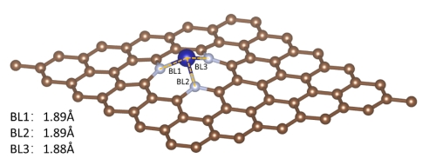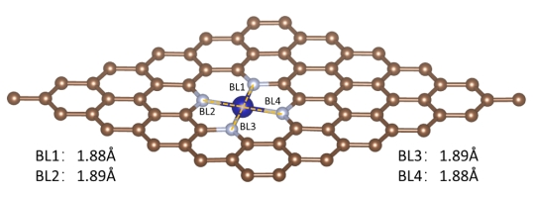
Fig. S15 The bond length of different bonds in catalyst model
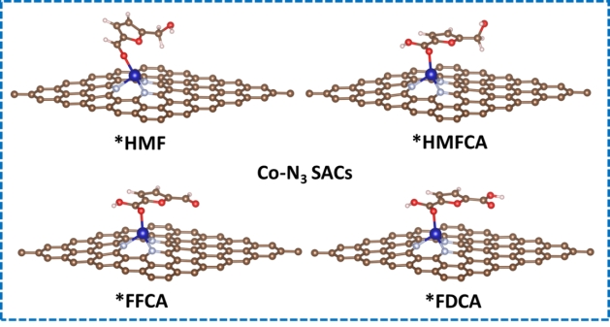
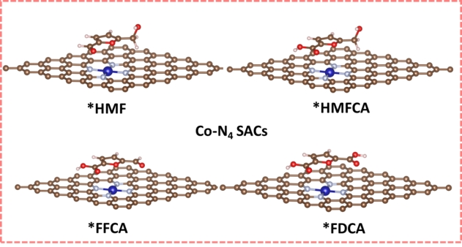
Fig. S16 HMF dehydrogenation/oxygenation process over the Co-N₃ SACs and Co-N₄ SACs
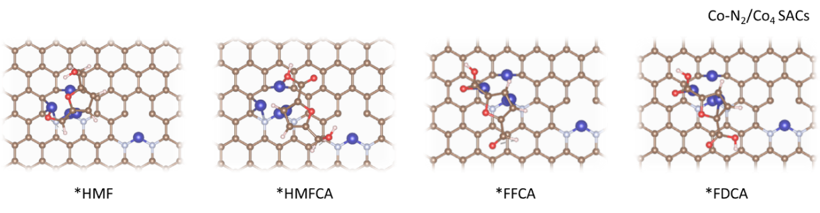
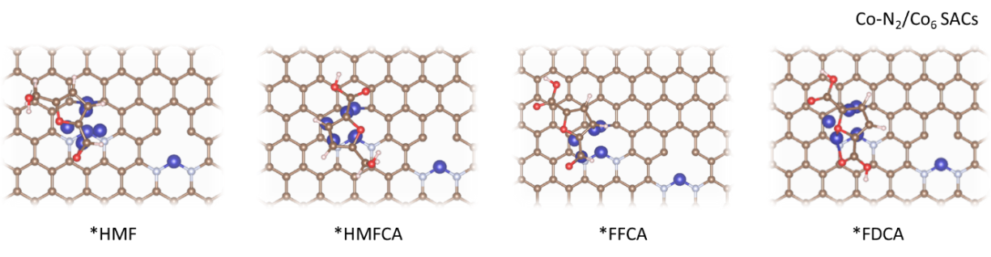
Fig. S17 HMF dehydrogenation/oxygenation process over the Co-N₂/Co₄ SACs and Co-N₂/Co₆ SACs
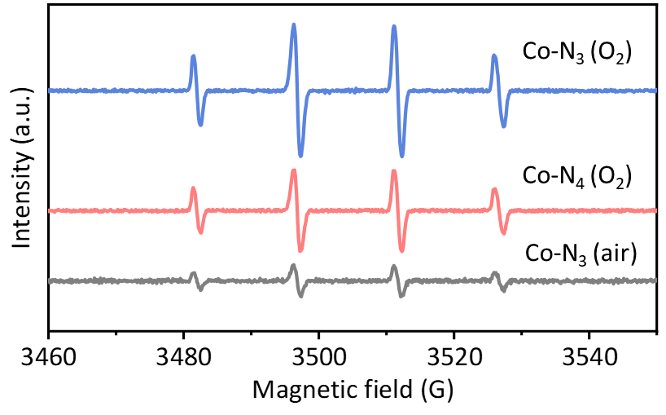
Fig. S18 EPR spectra of the Co catalysts under different conditions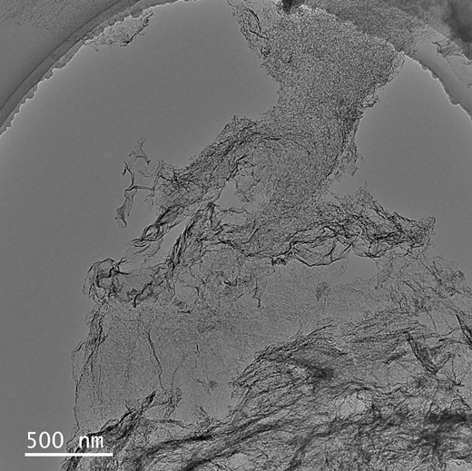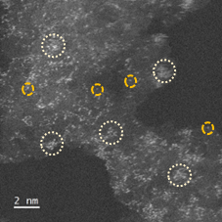
Fig. S19 HAADF-STEM and TEM images of used Co-N₂/Co₄ SACs after six cycles
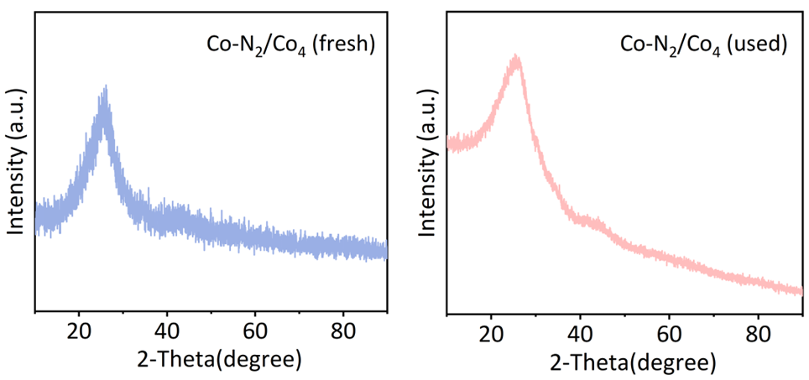
Fig. S20 XRD spectra of fresh and used Co-N₂/Co₄ SACs

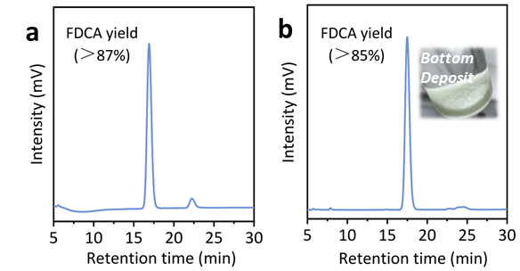
Fig. S21 (a, b) HPLC chromatogram of HMF gram-scale experiment and 10 wt.% HMF concentration experiment
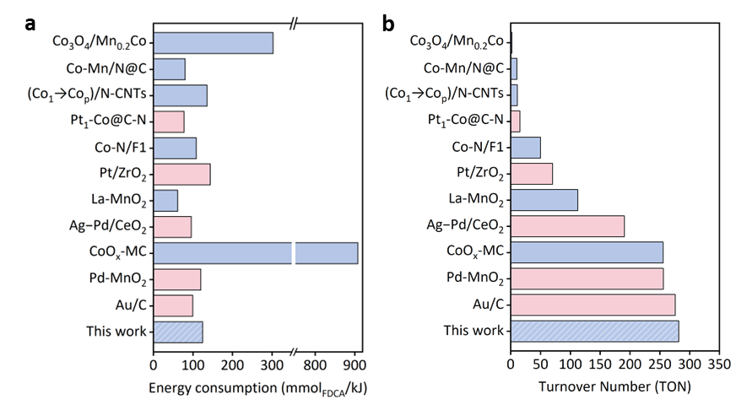
Fig. S22 (a, b) Comparison of energy consumption and TON values between this work and literature data
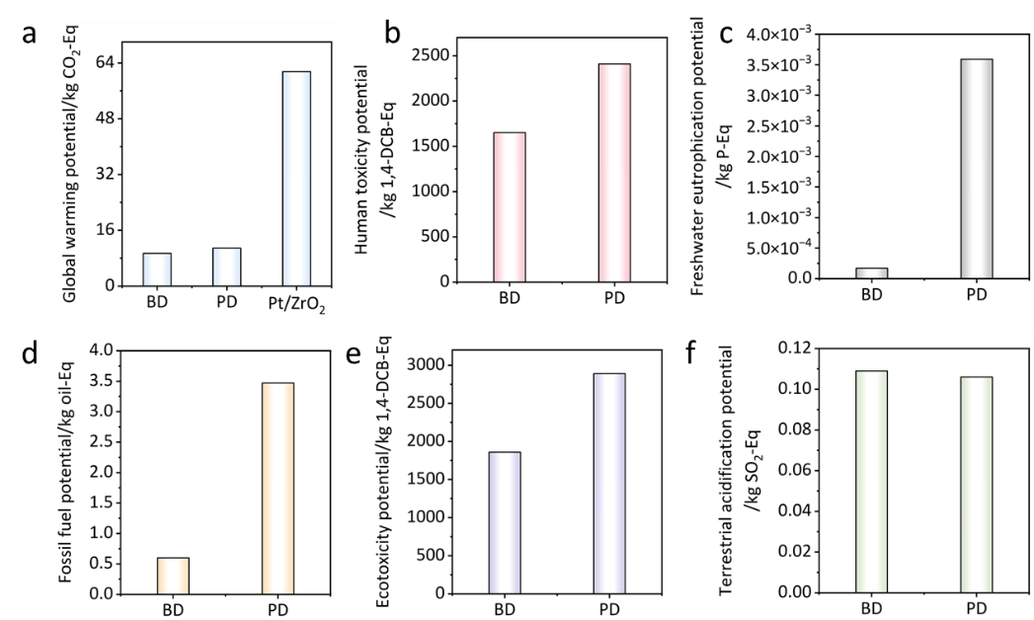
Fig. S23 (a-f) Life cycle assessment indicators for biomass-based FDCA (BD) and petroleum-based terephthalic acid (PD) [S5-S7]
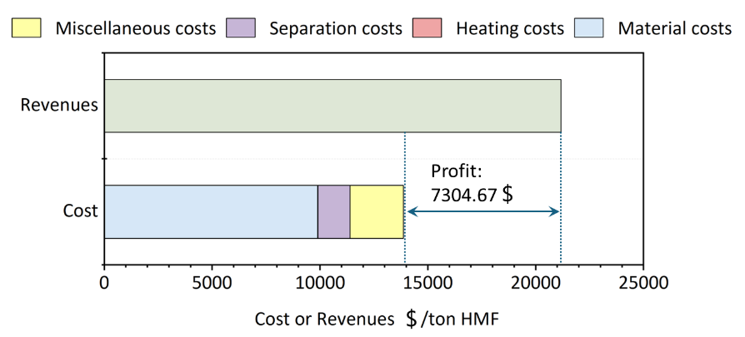
Fig. S24 TEA analysis
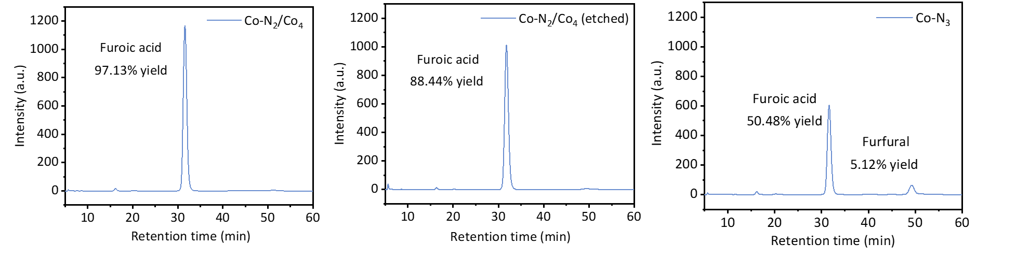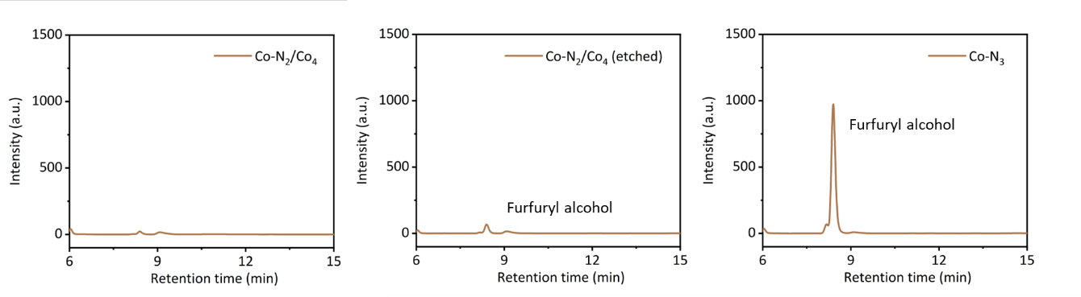
Fig. S25 HPLC chromatograms of furfuryl alcohol to furoic acid
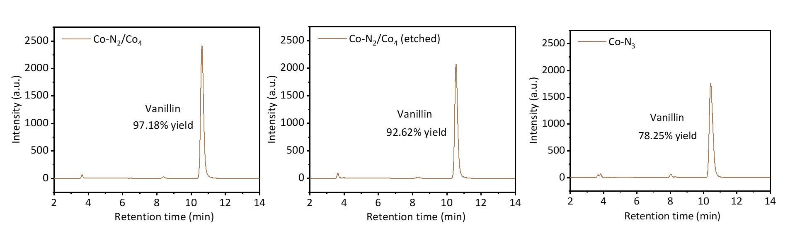
Fig. S26 HPLC chromatograms of vanillin alcohol to vanillin
Table S1 Zn and Co contents in the Co catalysts
Catalysts | Co content | Zn content
Co-N₄ SACs | 0.88wt.% | 0.36 wt.%
Co-N₃ SACs | 1.13 wt.% | 0.11 wt.%
Co-N₂/Co₄ SACs | 1.33 wt.% | /
Co-N₂/Co₆ SACs | 1.51 wt.% | /
Table S2 The atomic proportions of XPS Co and C-N wt.% in the Co catalyst
Sample | Co-N atomic proportions | Co atomic proportions (wt.%)
Co-N₄ | 1.21 | 0.34
Co-N₃ | 0.46 | 0.16
Co-N₂/Co₄ (etched) | 0.32 | 0.13
Table S3 Structural parameters of different samples extracted from the EXAFS fitting
 | shell | CN | R(Å) | σ²(10⁻³Å²) | ΔE₀ (eV) | R factor
Co-N₃ | Co-N | 3.2±0.2 | 1.90±0.01 | 4.1±0.4 | -2.1±0.3 | 0.012
Co-N₄ | Co-N | 3.8±0.4 | 1.92±0.01 | 7.2±1.0 | -4.7±0.4 | 0.014
Data ranges: 3.0 ≤ k ≤ 10.0 Å⁻¹, 1.0 ≤ R ≤ 2.5 Å. R: bond distance; σ²: Debye-Waller factors; R factor: goodness of fit. S₀² is the amplitude reduction factor (S₀² =0.75 was obtained by Co foil fitting and applied for the other samples fitting).
Table S4 Structural parameters of different samples extracted from the EXAFS fitting
 | S₀² | Shell | CN* | R(Å) | σ² (10⁻³ Å²) | ΔE₀ | R factor
Co foil | 0.75 | Co-Co | 12 | 2.49±0.01 | 6.3±0.1 | 7.51±0.37 | 0.0019
Co-N₂/Co₄ | 0.75 | Co-N | 2.4±0.1 | 1.92±0.01 | 13.5±1.7 | -1.26±0.61 | 0.0021
 |  | Co-Co | 4.1±0.1 | 2.40±0.01 | 13.2±0.6
Co-N₂/Co₆ | 0.75 | Co-N | 1.7±0.1 | 1.93±0.01 | 13.5±4.1 | -5.16±0.94 | 0.0017
 |  | Co-Co | 6.0±0.1 | 2.39±0.01 | 15.4±0.8
CN: coordination numbers; R: bond distance; σ²: Debye-Waller factors; ΔE₀: the inner potential correction. R factor: goodness of fit.
Table S5 The catalytic effect of the Co cluster was verified by poisoning the Co-N₂ sites with KSCN
Co₄ site | HMF conversion | HMFCA yield | FFCA yield | FDCA yield
2 mmol (KSCN) | 86.86% | 13.18% | 18.15% | 58.44%
4 mmol (KSCN) | 63.22% | 11.17% | 17.12% | 35.53%
6 mmol (KSCN) | 39.03% | 8.28% | 13.97% | 17.16%
Co₆ site | HMF conversion | HMFCA yield | FFCA yield | FDCA yield
2 mmol (KSCN) | 72.27% | 12.86% | 12.21% | 47.88%
4 mmol (KSCN) | 45.41% | 8.94% | 9.66% | 27.26%
6 mmol (KSCN) | 22.36% | 5.53% | 8.27% | 7.93%
Table S6 Catalytic performance of the three catalysts
Catalysts | Conv. HMF% | Activity (μmol/g/min)
Co-N₂/Co₄ | 8.83 | 117.73
Co-N₂/Co₄ (etched) | 5.86 | 78.13
Co-N₂/Co₄ (KSCN) | 2.83 | 37.73
Catalysts | Conv. HMFCA% | Activity (μmol/g/min)
Co-N₂/Co₄ | 9.89 | 131.87
Co-N₂/Co₄ (etched) | 1.95 | 26
Co-N₂/Co₄ (KSCN) | 5.87 | 78.26
Catalysts | Conv. FFCA% | Activity (μmol/g/min)
Co-N₂/Co₄ | 7.97 | 102.27
Co-N₂/Co₄ (etched) | 6.41 | 85.47
Co-N₂/Co₄ (KSCN) | 3.18 | 42.4
Table S7 The reaction results of the Co catalyst at 55 ºC, 5bar O₂ and 5 h
Samples | HMF conversion | HMFCA yield | FFCA yield | FDCA yield
Co-N₂/Co₄ | 99.87% | 0.95% | 0.16% | 98.76%
Co-N₂/Co₄ (etched) | 99.58% | 10.62% | 0.21% | 88.42%
Co-N₃ | 99.28% | 13.22% | 1.25% | 86.48%
Co-N₄ | 99.57% | 18.69% | 6.83% | 74.73%
Table S8 The reaction results of the Co catalyst at 55 ºC and 5 h
Samples | Oxygen pressure | HMF conversion (%) | HMFCA yield (%) | FFCA yield (%) | FDCA yield (%)
Co-N₂/Co₄ | 1 bar | 99.47 | 10.04 | 15.72 | 74.24
Co-N₂/Co₄ | 2 bar | 99.68 | 13.76 | 10.55 | 75.66
Co-N₂/Co₄ | 3 bar | 99.64 | 9.46 | 13.52 | 77.02
Co-N₂/Co₄ | 4 bar | 99.86 | 10.11 | 0.75 | 89.06
Co-N₂/Co₄ | 5 bar | 99.87 | 0.95 | 0.16 | 98.76
Co-N₂/Co₄ (etched) | 1 bar | 99.02 | 16.97 | 12.94 | 69.09
Co-N₂/Co₄ (etched) | 2 bar | 99.31 | 18.22 | 8.07 | 71.71
Co-N₂/Co₄ (etched) | 3 bar | 99.54 | 11.33 | 15.04 | 74.35
Co-N₂/Co₄ (etched) | 4 bar | 99.62 | 14.19 | 3.65 | 81.78
Co-N₂/Co₄ (etched) | 5 bar | 99.58 | 10.62 | 0.21 | 88.42
Co-N₃ | 1 bar | 99.08 | 16.58 | 15.72 | 66.80
Co-N₃ | 2 bar | 99.62 | 12.33 | 13.43 | 73.86
Co-N₃ | 3 bar | 99.68 | 10.86 | 10.95 | 77.87
Co-N₃ | 4 bar | 99.73 | 12.42 | 3.58 | 84.00
Co-N₃ | 5 bar | 99.28 | 13.22 | 1.25 | 86.48
Table S9 The Co content in the catalysts after first-run catalysis
Catalysts | Co content in fresh  catalysts (%) | Co content in regenerated  catalysts (%)
Co-N₂/Co₄ SACs | 1.33 wt.% | 1.25 wt.%
Table S10 Statistical data on catalysts for HMF oxidation reactions [S8-S24]
Catalyst | Reaction conditions |  |  | HMF conversion (%) | FDCA yield (%)
Catalyst | T(ºC) | O₂(bar) | t(h) | HMF conversion (%) | FDCA yield (%)
Noble metal-based catalysts
Au/TiO₂ | 80 | 25 | 8 | ＞97 | 87
Au/Ni_{x}Co₁O_{y} | 120 | 5 | 8 | 100 | ＞99
Pd/MnO₂ | 80 | 1 | 4 | ＞99.9 | 88.1
Au₁-Pd₁/ZOC | 80 | 3 | 6 | ＞99.9 | 99.9
Pt₁-Co@C-N | 100 | 5 | 4 | ＞99 | 99.6
RuO_{x}/MnO_{x} | 120 | 10 | 6 | / | 86.56
Pt-Au alloy catalyst | 95 | 10 | 3 | ＞99 | 99
Pt/MnPO | 110 | 10 | 24 | 100 | 98
Ag_{1.5}Pd_{1.5}/CeO₂ | 20 | 1 | 4 | 100 | 93
Au/C | 70 | 10 | 4 | ＞99 | ＞85
Pt/γ-Al₂O₃ | 100 | 10 | 24 | 100 | 96
Pt/ZrO₂ | 100 | 4 | 12 | 100 | 97
Non-noble metal-based catalysts
Co/Mn/Br catalysts | 130 | 10 | / | / | 75.8
La-MnO₂ | 140 | 5 | 4 | 96.3 | 95.4
Co₃O₄/Mn_{x}Co | 140 | 1 | 24 | ＞99 | 99
a-Co/Cu-NC | 90 | 1 | 8 | ＞99 | 98
CoO_{x}-MC | 80 | 5 | 30 | ＞99 | 95.3
(Co₁→Co_{p})/N-CNTs | 100 | 1 | 8 | 100 | 96
Co-N₂/Co₄ SACs | 55 | 5 | 5 | ＞99 | 98.76
T=temperature, t=reaction time.

Table S11 Raw materials required to produce 1kg FDCA
Raw material | Quantity
HMF | 1.03 kg
Na₂CO₃ | 0.1 kg
O₂ | 0.15 kg
CoCl₂·6H₂O | 6.45×10⁻⁵kg
ZnCl₂ | 3.69×10⁻⁴kg
Lignin | 0.02 kg
NaOH | 0.003 kg
Melamine | 0.18 kg
Electricity | 21.8 kWh
Table S12 Furfuryl alcohol and vanillin alcohol are oxidized to furoic acid and vanillin
 | Furoic acid yield (%) |  | Furfural yield (%) |  | Furfuryl alcohol conversion (%)
Co-N₂/Co₄ | 97.13 |  | 0.49 |  | 99.62
Co-N₂/Co₄ (etched) | 88.44 |  | 0.57 |  | 91.01
Co-N₃ | 50.48 |  | 5.12 |  | 57.60
 |  | Vanillin alcohol conversion (%) |  | Vanillin yield (%)
Co-N₂/Co₄ |  | ＞99 |  | 97.18
Co-N₂/Co₄ (etched) |  | ＞98 |  | 92.62
Co-N₃ |  | ＞99 |  | 78.25
Supplementary Note S1
A simplified techno-economic analysis (TEA) was conducted to evaluate the feasibility of the HMF oxidation process.
1. Material costs
Material costs: 1 ton HMF (9850 $/t), 9 ton water (0.7 $/t) and 0.11 ton Na₂CO₃ (300 $/t). Therefore, the capital costs component can be calculated as:
Material cost = 9889.3 $
2. Heating costs:
The heating cost mainly consists of heating energy consumption and heat loss energy consumption.
Heating energy consumption formula:
Q_{heating} = m × c × ΔT=9×10⁶×4.184×95=3.58×10⁶kJ
Specific heat capacity of water: c = 4.184 J/g·°C (standard value).
Energy Consumption for Heat Loss to Maintain Temperature:
Formula:
Q_{loss}=P_{loss} × t=(U × ΔT) × t=0.03×95×43200=123.12kJ
Typical range of the heat loss coefficient U for insulation of a reactor: U≈0.02~0.05 W/°C. Here, an intermediate value is taken: U=0.03 W/°C
Q_{total}=Q_{heating}+Q_{loss}≈3.58×10⁶kJ
The energy input of 3.58×10⁶ kJ required for the reactor operation corresponds to a coal cost of approximately 18.3 $.
Heating costs=18.3 $
3. Separation costs:
The separation process, comprising acidification-induced precipitation, solid-liquid separation, washing, and drying, generates dominant costs from material consumption, energy input, and wastewater pretreatment. These combined operational expenditures account for approximately 15% of the raw material cost.
Separation costs=1483.4 $
4. Miscellaneous costs:
In the HMF oxidation process, miscellaneous costs including capital costs, maintenance costs and operating costs account for approximately 25% of the raw material costs
Miscellaneous cost = 2472.33 $
5. Total plant gate levelized cost:
Finally, the total cost can now be calculated by adding up all 4 components:
Toal cost = 9889.3 $ + 18.3 $ + 1483.4 $ +2472.33 $ = 13863.33 $
Product value:
After catalysis, 1 ton of HMF feedstock finally gave 1.08 ton FDCA (19600 $/t).
Product value = 21168 $
Potential profit:
Therefore, the total income of catalysis per ton of HMF can be calculated as follows:
Toal profit = Product value – Toal cost = 21168 – 13863.33 = 7304.67 $
Supplementary References
- G. Kresse, J. Hafner, Ab initiomolecular dynamics for liquid metals. Phys. Rev. B 47(1), 558–561 (1993). https://doi.org/10.1103/physrevb.47.558
- G. Kresse, J. Hafner, Ab initio molecular-dynamics simulation of the liquid-metal-amorphous-semiconductor transition in germanium. Phys. Rev. B 49(20), 14251–14269 (1994). https://doi.org/10.1103/physrevb.49.14251
- J.P. Perdew, K. Burke, M. Ernzerhof, Generalized gradient approximation made simple. Phys. Rev. Lett. 77(18), 3865–3868 (1996). https://doi.org/10.1103/physrevlett.77.3865
- S. Grimme, J. Antony, S. Ehrlich, H. Krieg, A consistent and accurate ab initio parametrization of density functional dispersion correction (DFT-D) for the 94 elements H-Pu. J. Chem. Phys. 132(15), 154104 (2010). https://doi.org/10.1063/1.3382344
- M.G. Davidson, S. Elgie, S. Parsons, T.J. Young, Production of HMF, FDCA and their derived products: a review of life cycle assessment (LCA) and techno-economic analysis (TEA) studies. Green Chem. 23(9), 3154–3171 (2021). https://doi.org/10.1039/d1gc00721a
- K. Wiranarongkorn, K. Im-Orb, D. Saebea, Y. Patcharavorachot, A. Arpornwichanop, Energy analysis and life cycle assessment of furfural and 5-hydroxymethylfurfural integrated biorefinery processes with heat pump-assisted reactive distillation. Energy 319, 134720 (2025). https://doi.org/10.1016/j.energy.2025.134720
- Y. Lei, G. Zhu, X. Liu, X. Wu, B. Fu et al., Comparative assessment of 5-hydroxymethylfurfural Production: Economic viability and environmental performance of five conceptual bioprocesses. Biomass Bioenergy 201, 108118 (2025). https://doi.org/10.1016/j.biombioe.2025.108118
- H. Ban, Y. Zhang, S. Chen, Y. Cheng, T. Pan et al., Production of 2, 5-furandicarboxylic acid by optimization of oxidation of 5-methyl furfural over homogeneous Co/Mn/Br catalysts. ACS Sustainable Chem. Eng. 8(21), 8011–8023 (2020). https://doi.org/10.1021/acssuschemeng.0c02574
- H. Chen, J. Shen, K. Chen, Y. Qin, X. Lu et al., Atomic layer deposition of Pt nanoparticles on low surface area zirconium oxide for the efficient base-free oxidation of 5-hydroxymethylfurfural to 2, 5-furandicarboxylic acid. Appl. Catal. A Gen. 555, 98–107 (2018). https://doi.org/10.1016/j.apcata.2018.01.023
- T. Gao, Y. Yin, G. Zhu, Q. Cao, W. Fang, Co₃O₄ NPs decorated Mn-Co-O solid solution as highly selective catalyst for aerobic base-free oxidation of 5-HMF to 2, 5-FDCA in water. Catal. Today 355, 252–262 (2020). https://doi.org/10.1016/j.cattod.2019.03.065
- Z. Gui, W. Cao, S. Saravanamurugan, A. Riisager, L. Chen et al., Efficient aerobic oxidation of 5-hydroxymethylfurfural in aqueous media with Au–Pd supported on zinc hydroxycarbonate. ChemCatChem 8(23), 3636–3643 (2016). https://doi.org/10.1002/cctc.201600852
- Q. Hou, T. Gao, H. Zhang, Q. Tang, W. Fang, Pt nanoparticles in cooperation with Mn-P composite drive base-free selective oxidation of 5-hydroxymethylfurfural. Catal. Today 443, 114990 (2025). https://doi.org/10.1016/j.cattod.2024.114990
- Y. Jin, S. Sarina, H. Liu, W. Martens, E.R. Waclawik et al., Aerobic oxidation of 5-hydroxymethyl-furfural to 2, 5-furandicarboxylic acid at 20 °C by optimizing adsorption on AgPd alloy nanoparticle catalysts. ACS Catal. 12(18), 11226–11238 (2022). https://doi.org/10.1021/acscatal.2c03457
- T. Jing, S. Yang, T. Li, Y. Wan, H. Jia et al., Atomic Co/Cu dual-metal for rapid conversion of 5-hydroxymethylfurfural under ambient pressure. Adv. Funct. Mater. 34(44), 2407335 (2024). https://doi.org/10.1002/adfm.202407335
- X. Liao, J. Hou, Y. Wang, H. Zhang, Y. Sun et al., An active, selective, and stable manganese oxide-supported atomic Pd catalyst for aerobic oxidation of 5-hydroxymethylfurfural. Green Chem. 21(15), 4194–4203 (2019). https://doi.org/10.1039/C9GC01674K
- X. Liu, M. Zhang, Z. Li, CoOx-MC (MC = mesoporous carbon) for highly efficient oxidation of 5-hydroxymethylfurfural (5-HMF) to 2, 5-furandicarboxylic acid (FDCA). ACS Sustainable Chem. Eng. 8(12), 4801–4808 (2020). https://doi.org/10.1021/acssuschemeng.9b07443
- C. Megías-Sayago, A. Lolli, D. Bonincontro, A. Penkova, S. Albonetti et al., Effect of gold particles size over Au/C catalyst selectivity in HMF oxidation reaction. ChemCatChem 12(4), 1177–1183 (2020). https://doi.org/10.1002/cctc.201901742
- P. Rapado, C. Lois, M. Cano, L. Faba, S. Ordóñez, Biomass to plastics: From HMF to fructose for the synthesis of 2, 5-furandicarboxylic acid over Au/TiO₂. Catal. Today 445, 115036 (2025). https://doi.org/10.1016/j.cattod.2024.115036
- R. Sahu, P.L. Dhepe, Synthesis of 2, 5-furandicarboxylic acid by the aerobic oxidation of 5-hydroxymethyl furfural over supported metal catalysts. React. Kinet. Mech. Catal. 112(1), 173–187 (2014). https://doi.org/10.1007/s11144-014-0689-z
- S. Yang, C. Wu, J. Wang, H. Shen, K. Zhu et al., Metal single-atom and nanoparticle double-active-site relay catalysts: design, preparation, and application to the oxidation of 5-hydroxymethylfurfural. ACS Catal. 12(2), 971–981 (2022). https://doi.org/10.1021/acscatal.1c05236
- L. Yu, H. Chen, Z. Wen, M. Jin, X. Ma et al., Efficient aerobic oxidation of 5-hydroxymethylfurfural to 2, 5-furandicarboxylic acid over a nanofiber globule La-MnO₂ catalyst. Ind. Eng. Chem. Res. 60(4), 1624–1632 (2021). https://doi.org/10.1021/acs.iecr.0c05561
- H. Zhang, Y. Wang, Q. Zhang, B. Gu, Q. Tang et al., Synergy in magnetic Ni_{x}Co₁O_{y} oxides enables base-free selective oxidation of 5-hydroxymethylfurfural on loaded Au nanoparticles. J. Energy Chem. 78, 526–536 (2023). https://doi.org/10.1016/j.jechem.2022.11.057
- X. Zhong, P. Yuan, Y. Wei, D. Liu, D. Losic et al., Coupling natural halloysite nanotubes and bimetallic Pt–Au alloy nanoparticles for highly efficient and selective oxidation of 5-hydroxymethylfurfural to 2, 5-furandicarboxylic acid. ACS Appl. Mater. Interfaces 14(3), 3949–3960 (2022). https://doi.org/10.1021/acsami.1c18788
- W. Zhu, Y. Meng, C. Yang, J. Zhao, H. Wang et al., Effect of coordination environment surrounding a single Pt site on the liquid-phase aerobic oxidation of 5-hydroxymethylfurfural. ACS Appl. Mater. Interfaces 13(41), 48582–48594 (2021). https://doi.org/10.1021/acsami.1c12329

