Supporting Information for
Phage-Inspired Artificial Peroxidases with Robust Sub-nanometer Cluster Sites for Efficient Oral Biofilm Elimination and Dental Caries Prevention

Huang Zhu^{1,2,3,#}, Ting Wang^{2,#}, Shihuan Gao², Wei Geng², Tian Ma², Liang Cheng⁴, Xianglong Han¹, Jiuhong Deng^{1,}*, Shanshan Gao^{1,}*, and Chong Cheng^{1,2,5,}*

¹ State Key Laboratory of Oral Diseases, National Clinical Research Center for Oral Diseases, West China Hospital of Stomatology, Sichuan University, Chengdu, 610041, PR China
² College of Polymer Science and Engineering, State Key Laboratory of Advanced Polymer Materials, Sichuan University, Chengdu, 610065, PR China
³ School of Preclinical Medicine, Chengdu University, Chengdu, 610106, PR China
⁴ Department of Materials Science and Engineering, The Macau University of Science and Technology, Taipa, Macau, 999078, PR China
⁵ Institute of Chemistry and Biochemistry, Free University of Berlin, Berlin, 14195, Germany
# These authors contributed equally to this work.
* Corresponding authors. E-mail: jiuhongdeng@163.com (J.H. Deng); christina12357@163.com (S.S. Gao); chong.cheng@scu.edu.cn (C. Cheng)

S1 Experimental Section
S1.1 Synthesis of spiky TiO₂ (S-TiO₂)
In a typical experiment for the fabrication of S-TiO₂, 0.35 g of K₂TiO(C₂O₄)₂ and 1 g of urea were added to a mixture of 10 mL of deionized water and 30 mL of diethylene glycol. Following thorough stirring until a uniform mixture was achieved, the solution was placed into a Teflon-lined stainless steel autoclave and heated to 180 °C for 1 hour. After the reaction, the autoclave was allowed to cool to room temperature. The resulting products were then washed with deionized water and ethanol to eliminate any ionic residues before being dried in an oven at 50 °C overnight.
S1.2 Materials Characterization
Scanning electron microscopy (SEM) images were obtained by using a Thermo Fisher Scientific (FEI) Apreo S HiVoc. The transmission electron microscope (TEM) was performed by Tecnai G2 F30 S-TWIN operated at 300 kV. The aberration-corrected high-angle annular dark-field scanning TEM (AC HAADF-STEM) was performed on a JEOL JEM-ARM 200F scanning transmission electron microscope equipped with a 5 cold field emission electron source and a DCOR probe corrector (CEOS GmbH), a 100 mm² JEOL Centurio Energy Dispersive X-Ray Spectroscopy (EDX) detector, and a Gatan GIF Quantum ERS electron energy-loss spectrometer and operated at 200 kV. The X-ray diffraction (XRD) pattern presented the crystal phase state via a Bruker D8 Focus X-ray diffractometer with Cu radiation at a voltage of 40 kV. X-ray photoelectron spectra (XPS) measurements were performed on K-Alpha™+ X-ray Photoelectron Spectrometer System (Thermo Scientific) with a Hemispheric 180° dual-focus analyzer with 128-channel detector and a monochromatic Al Kα irradiation. X-ray absorption spectra (XAS) were collected on the beamline BL07A1 in NSRRC (National Center for Synchrotron Radiation Research). The radiation is produced by scanning a Si(111) double-crystal monochromator. X-ray absorption near-edge structure (XANES) and extended X-ray absorption fine structure (EXAFS) spectra data reduction and analysis were processed using the Athena software.

S1.3 Catalytic Activity Test
For the peroxidase (POD)-like activity test, the material solution (2 mg/mL, 10 μL) was added to NaAc-HAc buffer (100 mM, pH 4.5). Then, 25 μL of 3,3',5,5'-Tetramethylbenzidine (TMB) (10 mg/mL) and 25 μL of H₂O₂ (0.1 M) were added, respectively. The final volume of the mixture was 2 mL. After the reaction for ten minutes, 200 μL of supernatant was collected, and the spectral measurement was carried out in the range of 475~800 nm using a UV-visible spectrophotometer. K_{m} and V_{max} were calculated using Lineweaver-Burk plots of the double reciprocal of the Michaelis-Menten equation V= V_{max}× [S]/(K_{m}+[S]), TON=V_{max}/[E], where [S] is the concentration of H₂O₂, [E] is the molar concentration of metal in nanozymes.
Furthermore, the haloperoxidase (HPO)-like activity was determined by a celestin blue (CB)-based assay. Firstly, a CB solution with 200 μM in phosphate-buffered saline (PBS) solution (pH 5.8) was prepared. Then, 1880 μL of CB solution was added, along with 100 μL of biocatalysts and 20 μL of H₂O₂ (3%), to initiate the reaction. The catalytic activity was studied by measuring the absorption changes of CB at wavenumbers between 520 nm and 645 nm after the reaction for 30 minutes.
S1.4 Cyclic stability test of POD-like activity
For the POD-like cyclic stability test, a material solution (10 mg/mL, 25 μL) was added to a NaAc-HAc buffer (100 mM, pH 4.5). Subsequently, 25 μL of TMB (10 mg/mL) and 25 μL of H₂O₂ (0.1 M) were added. The final volume of the mixture was adjusted to 2 mL. After allowing the reaction to proceed for 5 minutes, the mixture was centrifuged, and 200 μL of the supernatant was collected for spectral analysis at 652 nm using a UV-visible spectrophotometer. Following completion of the POD-like catalytic reaction, in which TMB served as the chromogenic agent and H₂O₂ as the substrate, the IrNC@TiO₂ material was recovered by centrifugation and thoroughly washed with a pH 4.5 buffer solution to remove any residual reactants and products. The recovered material was then re-dispersed in a reaction system containing fresh H₂O₂ and TMB to initiate a new catalytic cycle. This "reaction-washing-reaction" cycle was repeated 6 times, and the retention of catalytic activity was quantitatively assessed by monitoring absorbance at the characteristic wavelength (652 nm) during each cycle.

S1.5 Analysis of free radicals by quenching experiments
To investigate •OH, a mixture was prepared by adding tert-butanol (TBA, 200 μL), H₂O₂ (25 μL, 0.1 M), catalysts (10 μL, 2 mg mL⁻¹), and TMB (25 μL, 10 mg mL⁻¹) to NaOAc/HOAc buffer (1740 μL, 100 mM, pH 4.5). After a 10-minute reaction period, the absorbance at 652 nm was measured.
To investigate •O₂⁻, a mixture was prepared by adding p-benzoquinone (BQ, 100 μL), H₂O₂ (25 μL, 0.1 M), catalysts (10 μL, 2 mg mL⁻¹), and TMB (25 μL, 10 mg mL⁻¹) to NaOAc/HOAc buffer (1840 μL, 100 mM, pH 4.5). After a 10-minute reaction period, the absorbance at 652 nm was measured.
To investigate ¹O₂, a mixture was prepared by adding sodium azide (NaN₃, 100 μL), H₂O₂ (25 μL, 0.1 M), catalysts (10 μL, 2 mg mL⁻¹), and TMB (25 μL, 10 mg mL⁻¹) to NaOAc/HOAc buffer (1840 μL, 100 mM, pH 4.5). After a 10-minute reaction period, the absorbance at 652 nm was measured.
S1.6 Detection of •O₂⁻
Hydroethidine (HE) was a specific probe that could react with •O₂⁻ to produce fluorescent ethidium, which was excited at 470 nm and emitted at 610 nm. First, 1.5 mL of a 100 μg·mL⁻¹ sample-buffer solution was mixed with 1.5 μL of 0.1 M H₂O₂ aqueous solution at 37 ℃ for 40 min. Then, 1.5 mL of HE-ethanol solution (1 mg·mL⁻¹) was added to the system. Afterward, the solution was vortexed and left undisturbed for 40 min before fluorescence measurement (Synergy Mx). The generation of •O₂⁻ was also evaluated by an electron paramagnetic resonance (EPR) spectrometer using 5,5-dimethyl-1-pyrroline N-oxide (DMPO) spin-trapping adduct in dimethyl sulfoxide (DMSO) solvent. 500 μL of catalysts (0.1 mg mL⁻¹, DMSO) and 25 μL of H₂O₂ (1 M) were added to a 2 mL DMSO, and then 10 μL DMPO was added. EPR measurements were performed via the Bruker EPR EMX Plus (Bruker Beijing Science and Technology Ltd, USA) at a frequency of 9.8 GHz (microwave power: 1 mW).
S1.7 In Vitro Cytotoxicity
Human Umbilical Vein Endothelial cells (HUVECs) were incubated for 24 hours in a 96-well plate, with each well containing 1 × 10⁵ cells. The media of the 96-well plate were discarded and then washed with PBS. Subsequently, 100 μL of complete medium containing the samples at serial concentrations was added to the 96-well plate, followed by incubation for 12 h. Cell Counting Kit-8 (CCK-8) assay was performed according to a standard protocol to determine cell viability.
S1.8 Teeth Whitening Test
The human teeth used in this study were collected from patients undergoing therapeutic extraction at the Department of Oral Surgery, West China Hospital of Stomatology. Ethical approval for this study was granted by the Institutional Review Board of West China Hospital of Stomatology (Reference Number: WCHSIRB-D-2022-069). Each tooth was washed with distilled water immediately after removal, and soft tissues attached to the periodontal tissues and dental stones were scraped away. To prevent dehydration, the teeth were soaked in Hank’s Balanced Salt Solution. The stained teeth were placed in a customed container of a wear fatigue tester (Rtec instrument, USA) and immersed in deionized water. S-TiO₂ and commercial spherical TiO₂ were added to a commercial toothpaste (Sensodyne, UK) at a concentration of 2 mg/g, respectively. After thoroughly mixing, the toothpaste was applied to the occlusal surfaces of the teeth, and the teeth were then brushed for a total of 60 minutes.
The Commission Internationale De L’Eclairage (CIELab) system was employed to characterize the color change. This system uses three variables to characterize color change: luminance (L) represents the difference between light (L=100) and dark (L=0), a designates the color values on the red-green axis, and b assigns the color values on the blue-yellow axis [1]. The chroma of the tooth at each time after brushing was characterized. The color difference of ΔE was calculated by $ΔE=\sqrt{ΔL^{2}+Δa^{2}+Δb^{2}}$ to verify the whitening effect.
S1.9 In Vitro Antibacterial Experiments
Streptococcus mutans (S. mutans) UA159 (ATCC 700610) was used as the representative pathogenic bacterium to investigate the bacterial eradication abilities of the enzyme-mimetic catalytic systems. Then, the commercial spherical TiO₂, S-TiO₂, and IrNC@TiO₂ systems with H₂O₂ containing NaCl were cultured with 1 mL of bacterial suspensions (10⁵ CFU·mL⁻¹) for 10 h at 37 ºC anaerobically. The final concentrations of materials and H₂O₂ are 100 μg·mL⁻¹ and 200 μM, respectively. The OD₆₀₀ values of the treated suspensions were measured by UV-vis spectroscopy (UV-3600, Shimadzu). Meanwhile, the cultured suspensions were diluted 10³, 10⁴, 10⁵, and 10⁶ times before being taken for agar plate counting. OD₆₀₀ values and agar plate counting were also conducted after the bacterial suspensions were treated with the IrNC@TiO₂ system at different concentrations (50, 100, and 200 μg·mL⁻¹). The antibacterial properties were estimated by comparing the CFUs of different systems with those of the control.
The bactericidal performance of these systems was visualized via SEM, TEM, and fluorescence microscopy (DMIRE2, Leica). After being treated with different samples, the bacterial suspensions were then fixed with 2.5 wt.% glutaraldehyde and dehydrated using a gradient of ethanol/water solutions. Then, the SEM and TEM images were obtained to observe the bacterial morphologies. Moreover, the bacteria were also stained by LIVE/DEAD BacLight Viability Kits (SYTO-9 for live cells and propidium iodide for dead cells) for observation using fluorescence microscopy.
The S. mutans biofilm eradication properties of the IrNC@TiO₂ system were also investigated. For biofilm growth, S. mutans in the brain heart infusion (BHI) medium with the addition of 1% (w/v) sucrose was cultured to 1×10⁸ CFU mL⁻¹, and added to a 96-well plate for static incubation for 24 h at 37 ℃. Then, the biofilm was treated by different systems before the biomass of the biofilm was detected by crystal violet staining. Meanwhile, the treated biofilm without staining was harvested before being fixed and dehydrated for SEM observation, as described above. To further investigate the antibacterial efficiency of different systems, the treated biofilm grown on the glass was stained with LIVE/DEAD BacLight Viability Kits and observed by confocal laser scanning microscopy (CLSM, St5, Leica). All the culture containers involving the treatment of samples with biofilms described above are placed in a shaking incubator to introduce external mechanical force.
S1.10 Molecular Dynamic Simulations
The atomistic molecular dynamics (MD) simulations were performed using the GROMACS package [2,3]. The lipid membrane consists of ~258 1,2-dihexa-decanoyl-rac-glycero-3-phosphocholine (DPPC), and ~12600 TIP3P HO molecules were constructed, and flat surface and spiky surface were also simulated by TiO₂ (101) to reproduce the interactions and penetration process. The sizes of the flat surface were 7.57 nm x 7.57 nm with a thickness of 2.85 nm, and the length of the epitaxial spike on the flat surface was 9.5 nm with a tip size of 0.85 nm. Besides, sodium ions were added to neutralize the net charge of the entire system. Gromos53a_lipid force field was utilized to bring the surfaces toward the lipid bilayer at the rate of 0.02 nm s⁻². Periodic boundary conditions in all directions were employed. The temperature was maintained at around 323 K using the velocity rescale thermostat, while the atmospheric pressure was set at 1.0 atm. Finally, the penetration process and its distances and energy data were recorded.
S1.11 DFT Calculations Methods
The DFT calculations were performed by the Vienna Ab-initio Simulation Package (VASP) with the projector augmented wave (PAW) method. The exchanged-functional was treated with the generalized gradient approximation (GGA) of the Perdew-Burke-Ernzerhof (PBE) functional. The planewave basis’s cut-off energy is set at 450 eV to optimize cell and atom calculations. The vacuum spacing being perpendicular to the plane of the catalyst, is at least 15 Å. The Brillouin zone integration is performed on the primitive cell using 3 × 3 × 1 Monkhorst-Pack k-point. The convergence energy threshold of 10⁻⁵ eV is applied for self-consistent calculation. The equilibrium lattice constants within 0.03 eV/Å are optimized for the maximum stress on each atom. As a key element in the DFT + U method, it is widely believed that the localized 3d electron correlation of transition metals in the fourth period can be described by considering onsite Coulomb (U) and exchange (J) interactions. Furthermore, we applied DFT + U through the rotationally invariant approach, with the corresponding U – J values being 3.29.
Gibbs free energy is acquired via adding corrections, including entropic (TS) and zero-point energy (ZPE) to calculate DFT energy; hence, Δ_{G} = ΔE_{DFT} + Δ_{ZPE} – TΔ_{S}, in which ΔE_{DFT} means calculated DFT reaction energy, Δ_{ZPE} means changes in ZPE calculated from the vibrational frequencies, and Δ_{S} means changes in the entropy regarding thermodynamics databases.
S1.12 Statistical Analysis
Data were analyzed using SPSS Statistics 26.0. Figures were formed using Origin 2025. Sample size (n), probability (P) value, data normalization, and specific statistical tests for each experiment were clarified in the figure legends. All of the data were presented as the mean ± SD. from a minimum of three independent experiments. The comparison of the mean values between multiple groups was performed by one-way analysis of variance (ANOVA) or Chi-square test. A value of p < 0.05 was considered significant (represented as *p < 0.05, **p < 0.01, ***p < 0.001 or not significant (ns)).

S2 Supplementary Figures

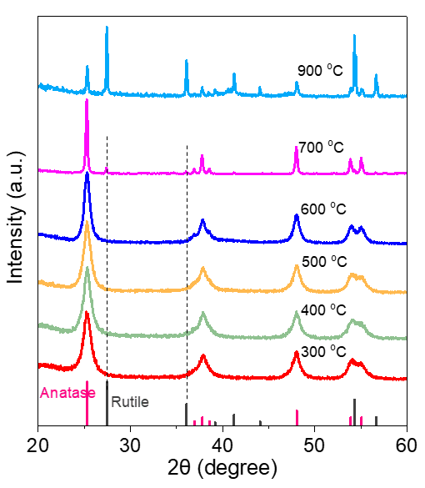
Fig. S1 XRD patterns of spiky TiO₂ treated at different temperatures.

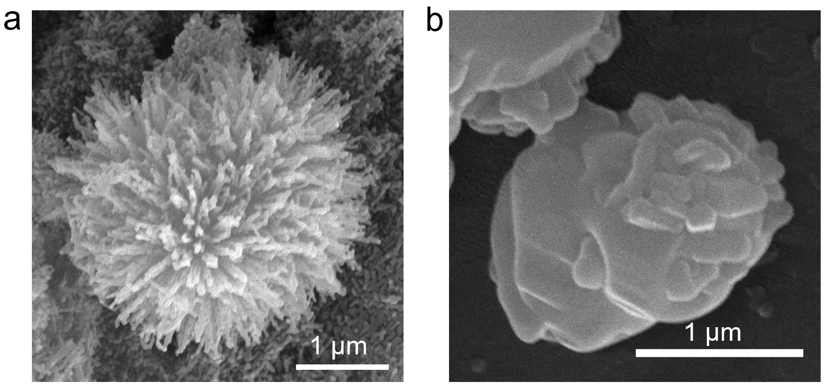
Fig. S2 SEM images of a TiO₂-700 and b TiO₂-900.

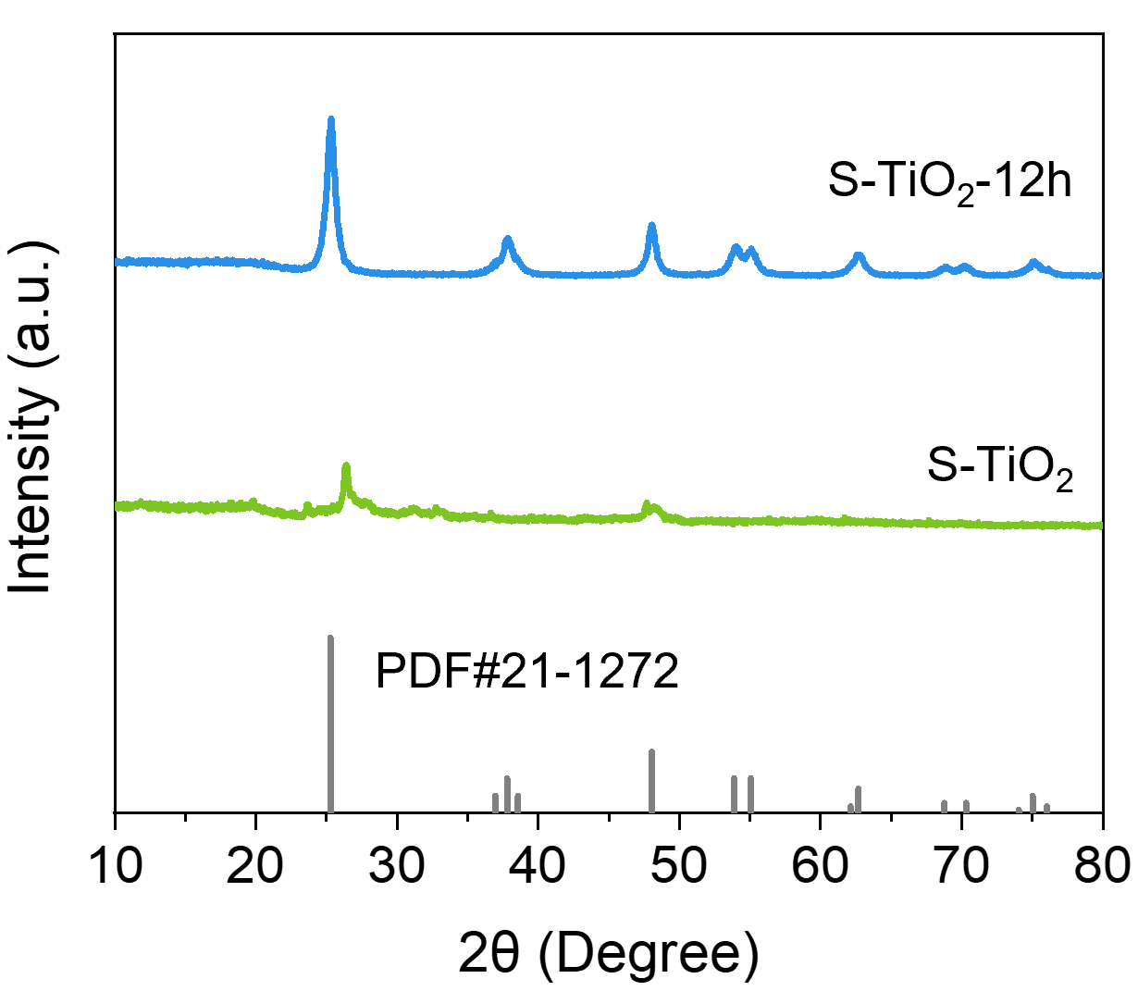
Fig. S3 XRD patterns of S-TiO₂ and S-TiO₂-12h.

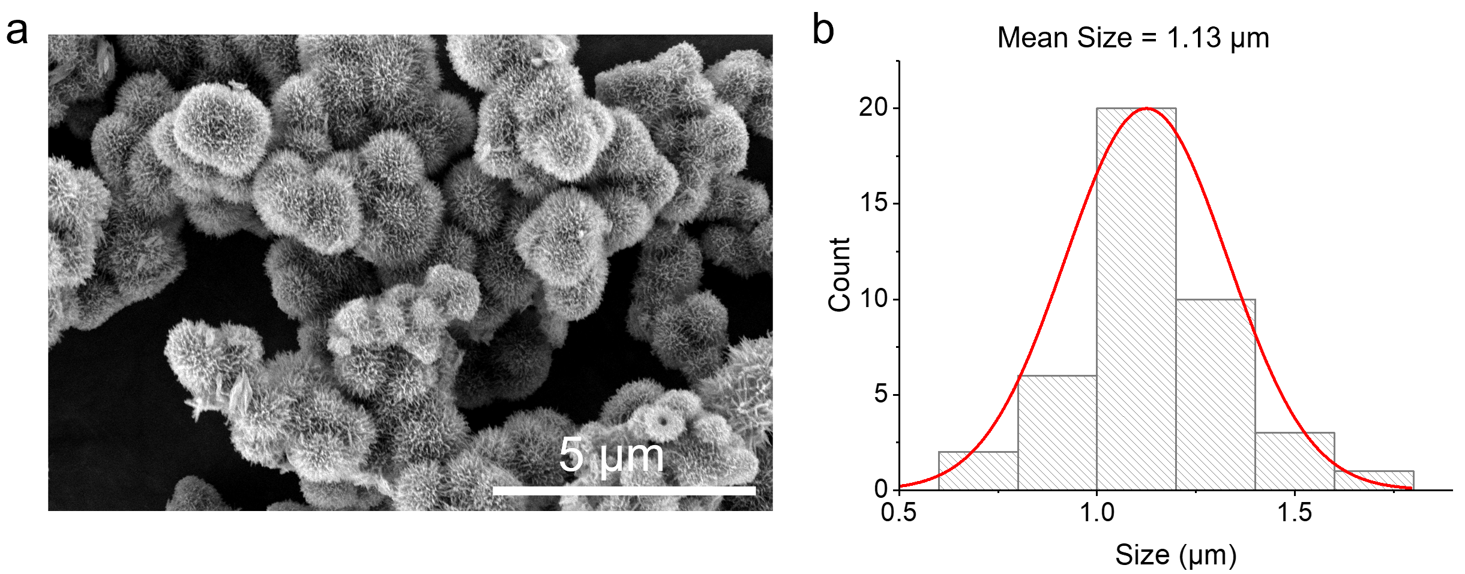
Fig. S4 a SEM image of S-TiO₂. b Corresponding average size of S-TiO₂.

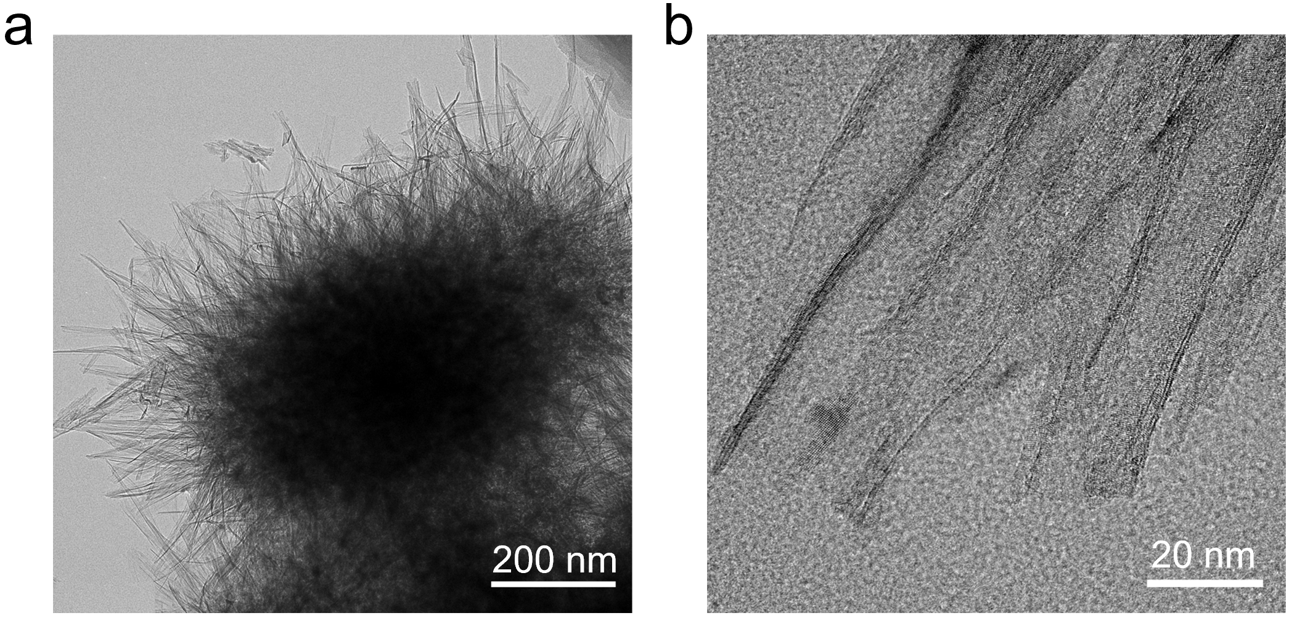
Fig. S5 a TEM and (b) high resolution TEM (HRTEM) image of S-TiO₂.

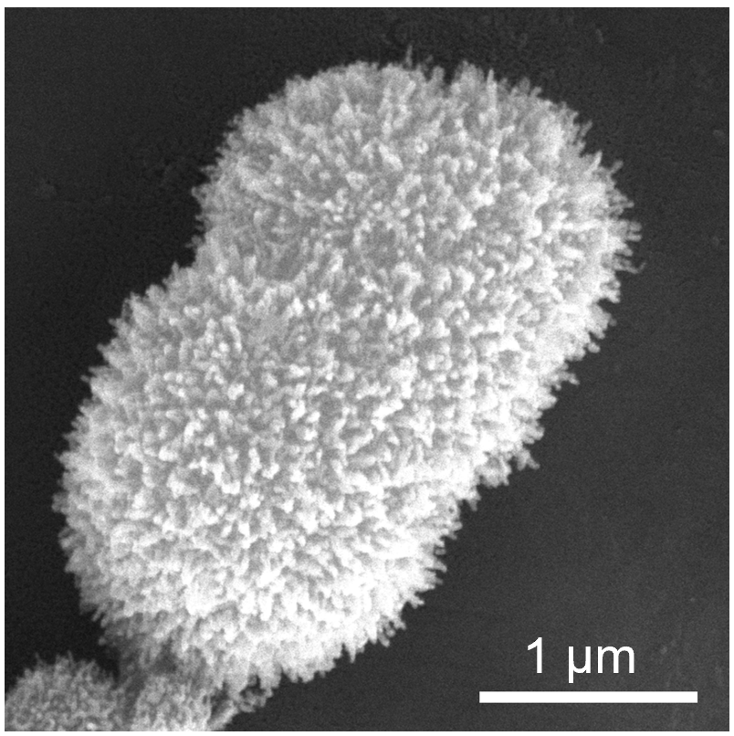
Fig. S6 SEM image of IrNC@TiO₂.

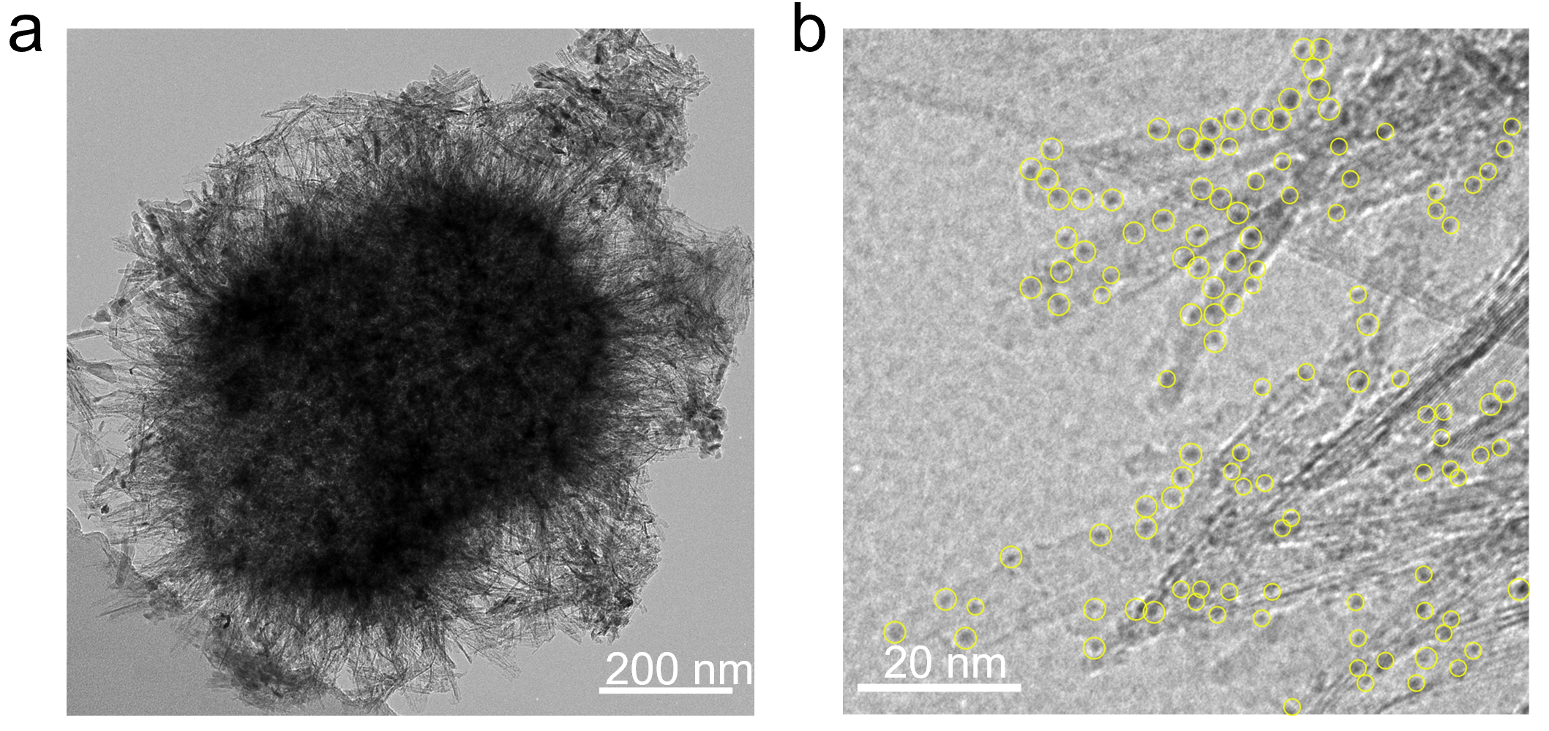
Fig. S7 a TEM and (b) HRTEM image of IrNC@TiO₂.

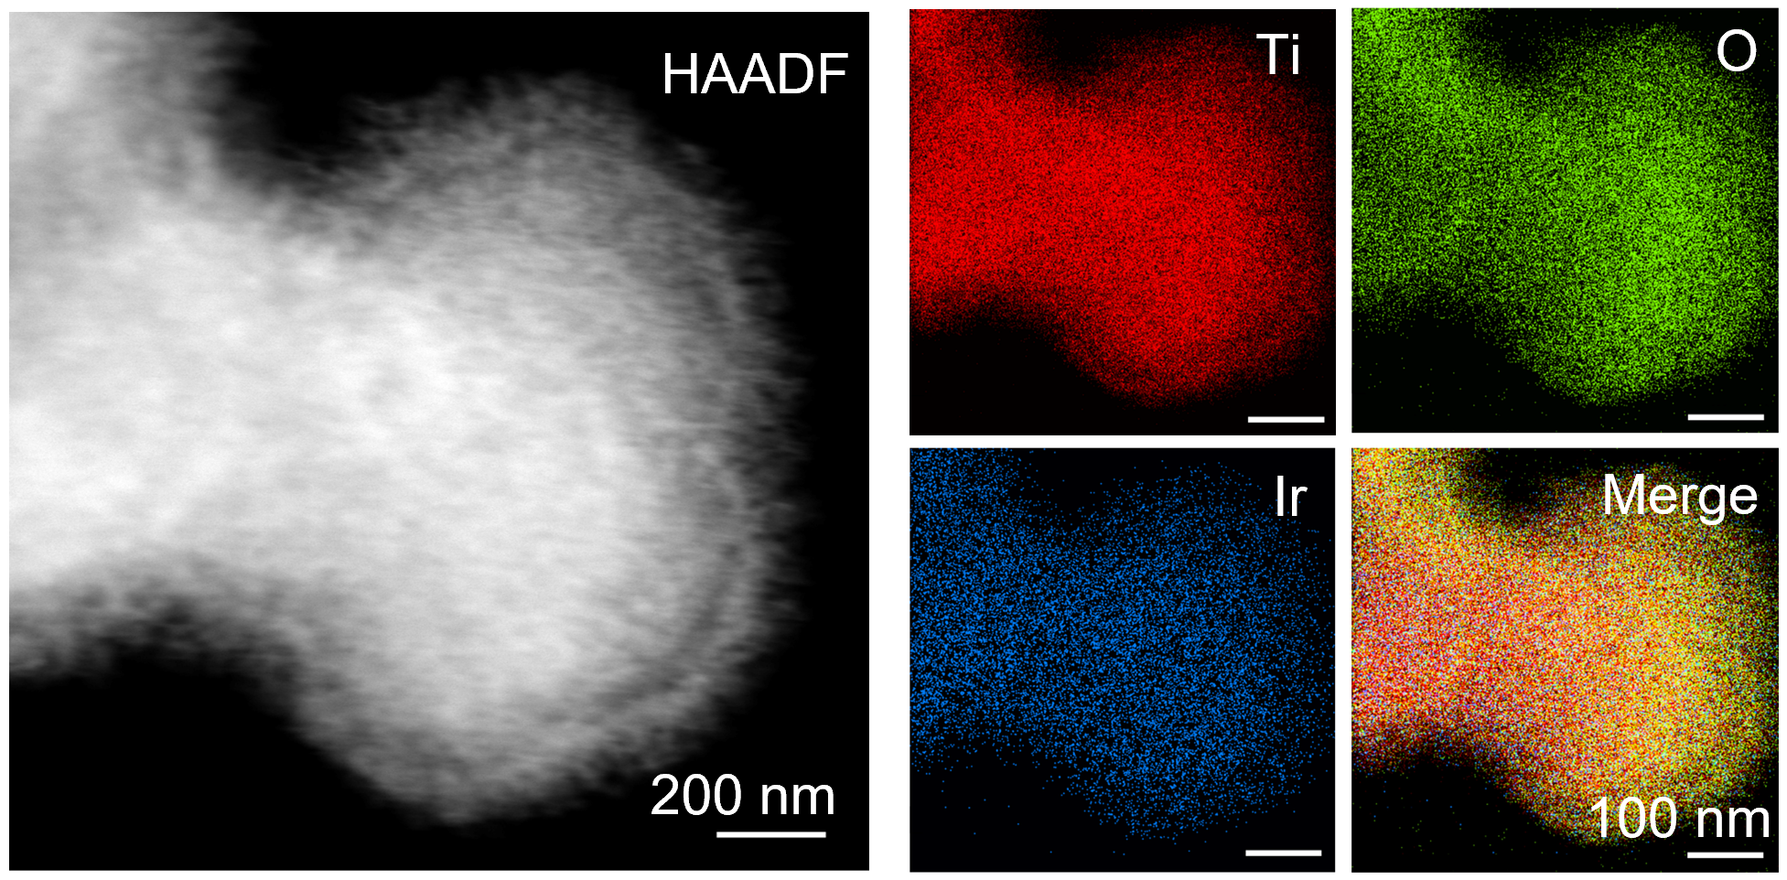
Fig. S8 HAADF images with EDX spectroscopy of IrNC@TiO₂.

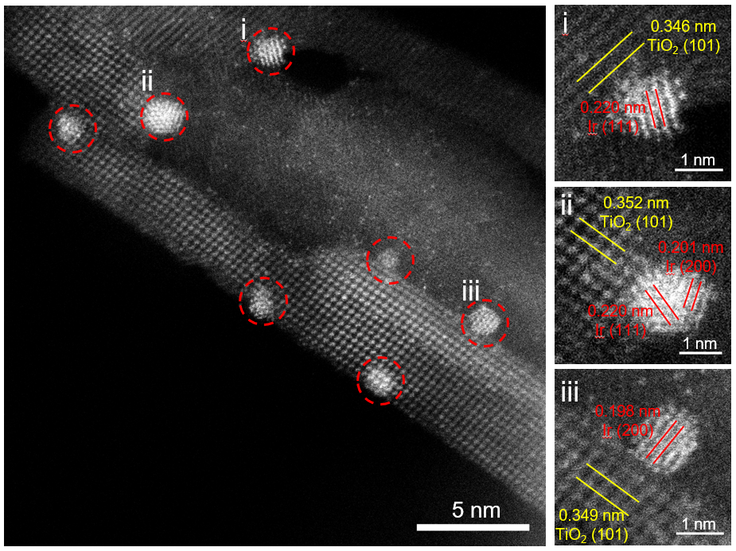
Fig. S9 STEM image of IrNC@TiO₂.

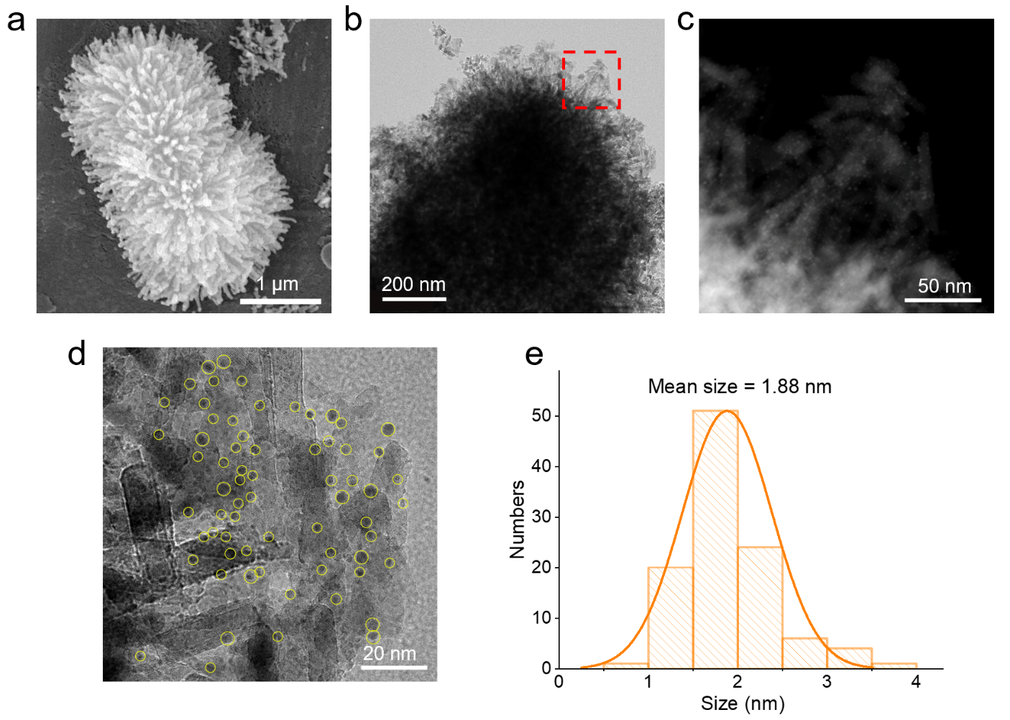
Fig. S10 a SEM, (b) TEM, and (c) HAADF-TEM images of IrNP@TiO₂. d HRTEM image of IrNP@TiO₂. e Corresponding average size of IrNP@TiO₂.

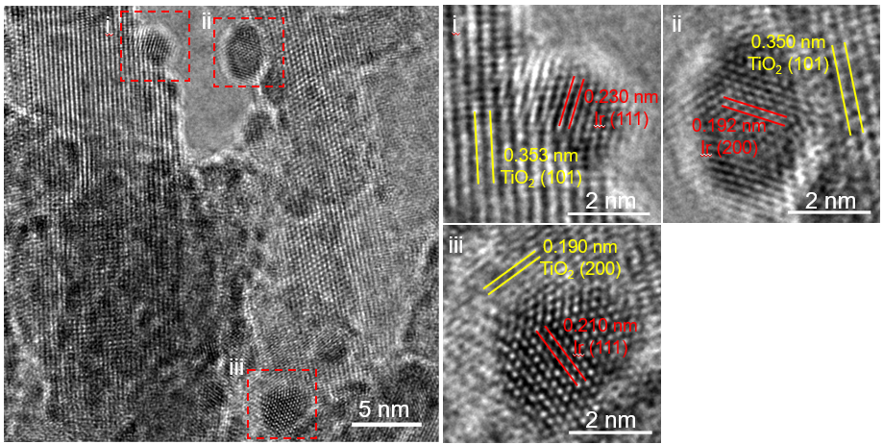
Fig. S11 HRTEM image of IrNP@TiO₂.

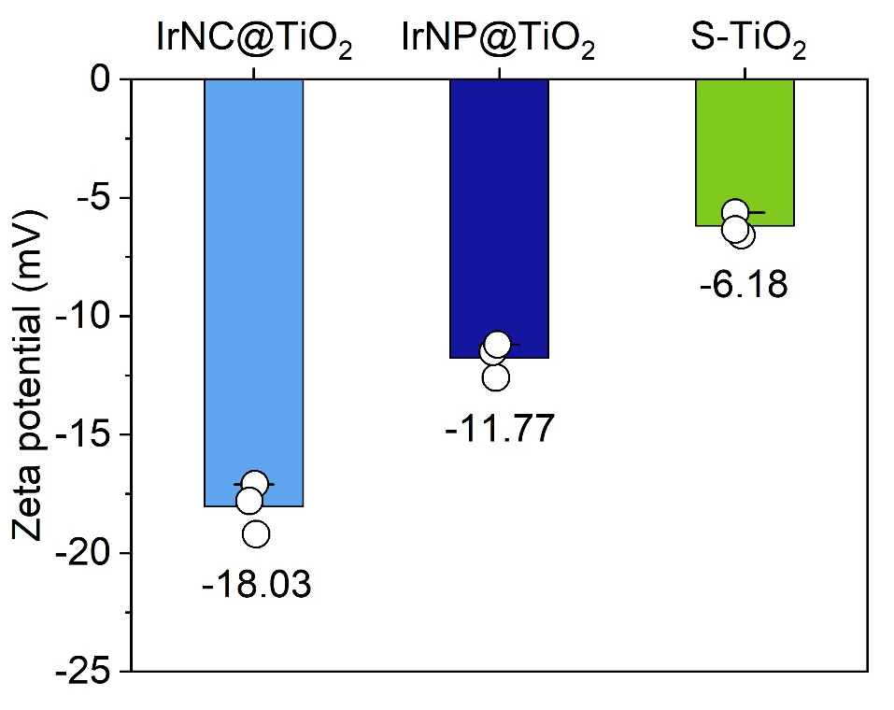
Fig. S12 Zeta potential of IrNC@TiO₂, IrNP@TiO₂, and S-TiO₂.

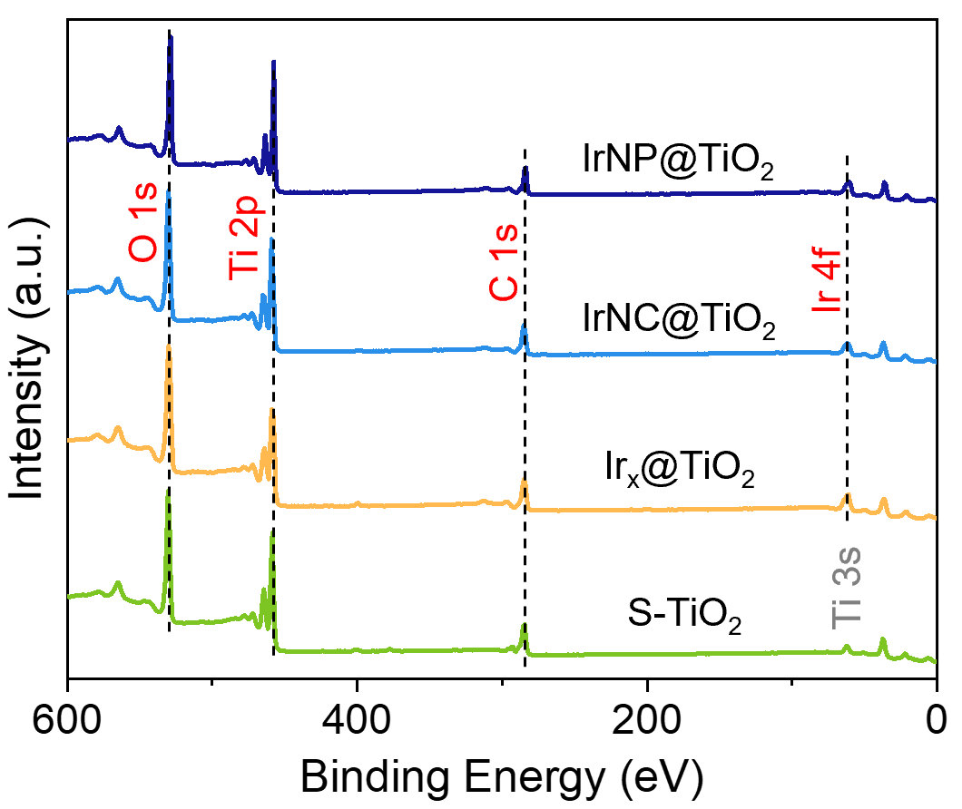
Fig. S13 XPS survey curves of samples.

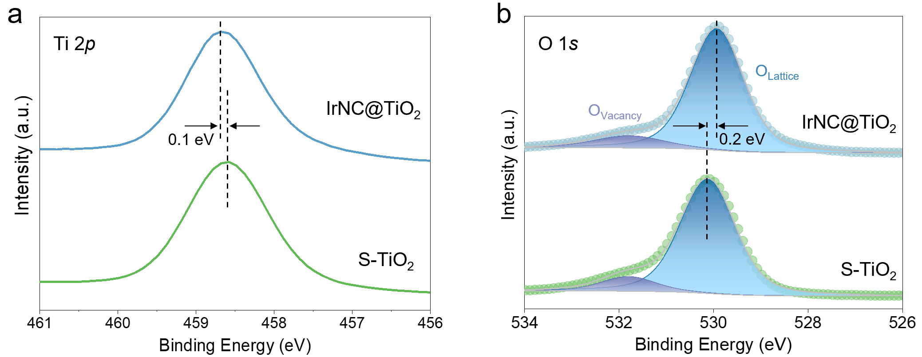
Fig. S14 a Ti 2p and (b) O 1s XPS spectra of S-TiO₂ and IrNC@TiO₂.

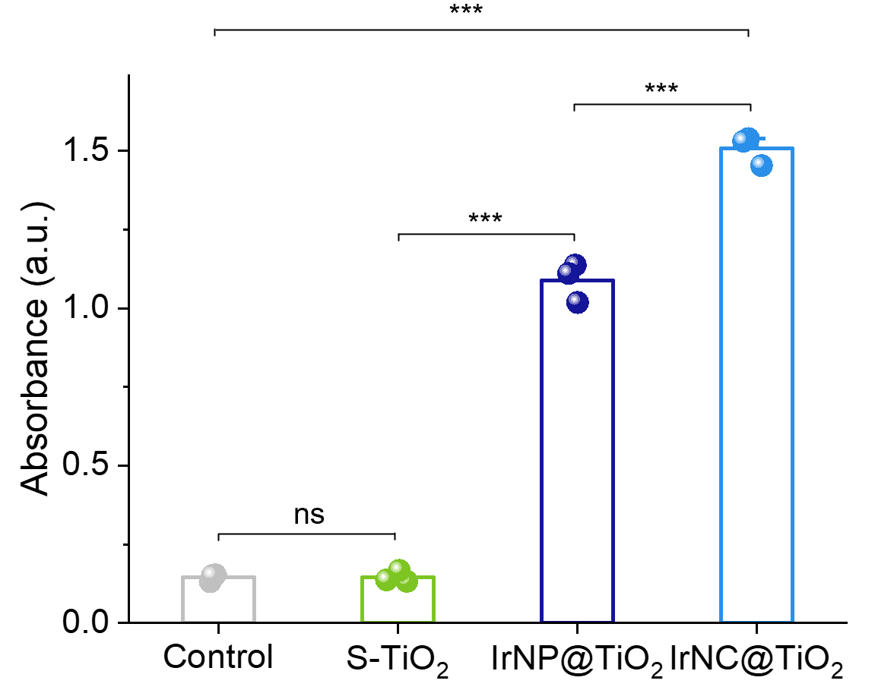
Fig. S15 The absorbance at 652 nm for different samples corresponds to the UV-vis spectra of TMB solutions in the POD-like activity test (n = 3 independent experiments, data are presented as mean ± SD, statistical significance was calculated using one-way ANOVA followed by Tukey’s post-hoc test for multiple comparisons, all tests were two-sided, ***p < 0.001, ns, no significance).

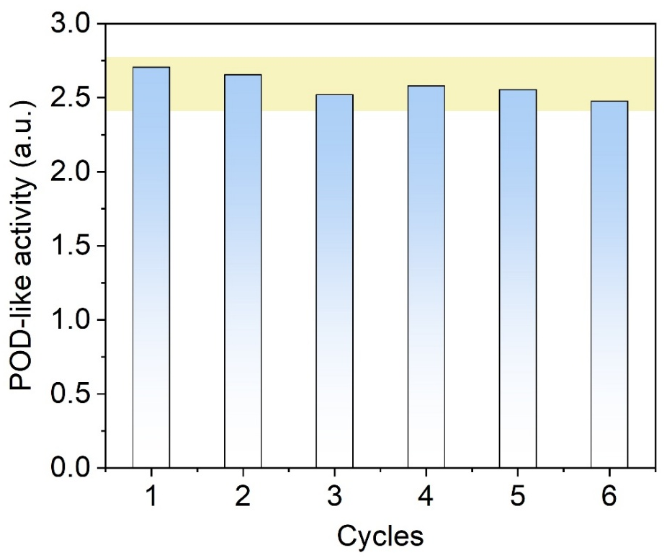
Fig. S16. Stability test of POD-like activity for IrNC@TiO₂.

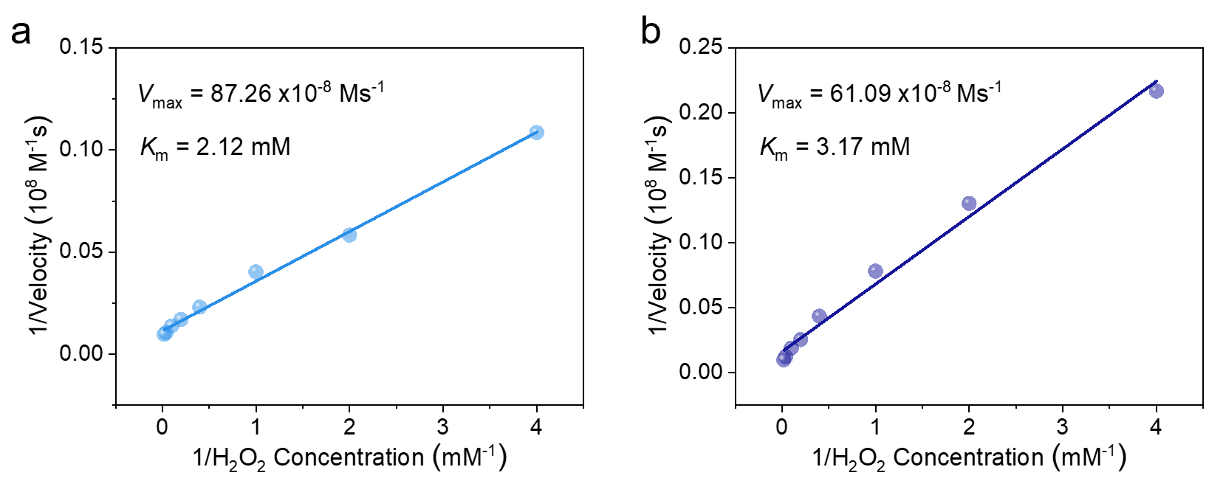
Fig. S17 Lineweaver-Burk plotting for (a) IrNC@TiO₂ and (b) IrNP@TiO₂ with H₂O₂ as substrate.
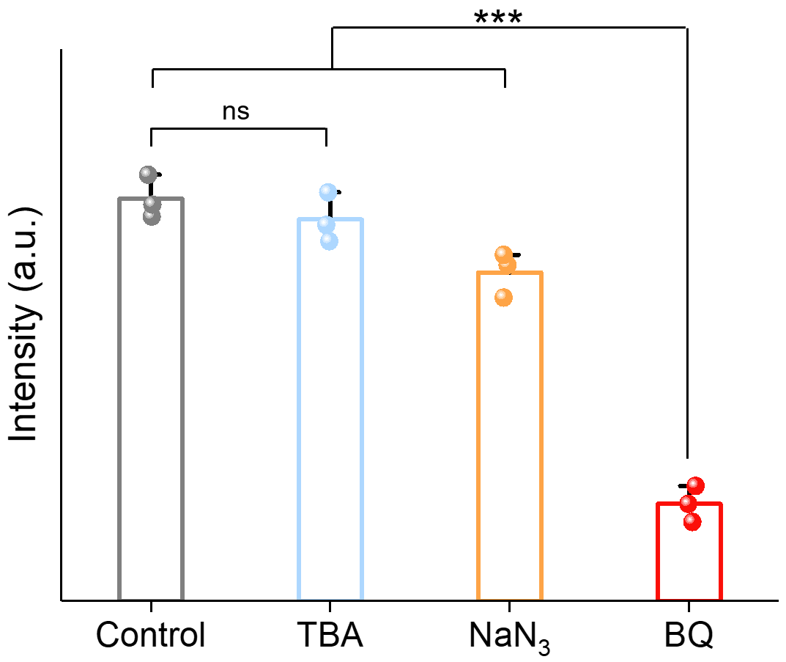
Fig. S18 •OH quenched by tert-butanol (TBA), •O₂⁻ quenched by benzoquinone (BQ), ¹O₂ quenched by NaN₃ in the catalytic oxidation process of TMB (n = 3 independent experiments, data are presented as mean ± SD, statistical significance was calculated using one-way ANOVA followed by Tukey’s post-hoc test for multiple comparisons, all tests were two-sided, ***p < 0.001, ns, no significance).

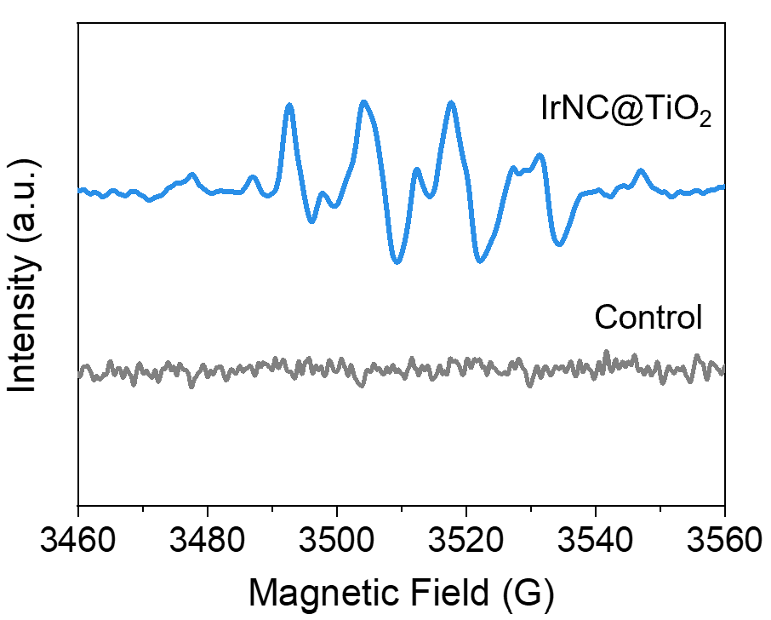
Fig. S19 DMPO spin-trapping EPR spectra for recording •O₂⁻ signal.

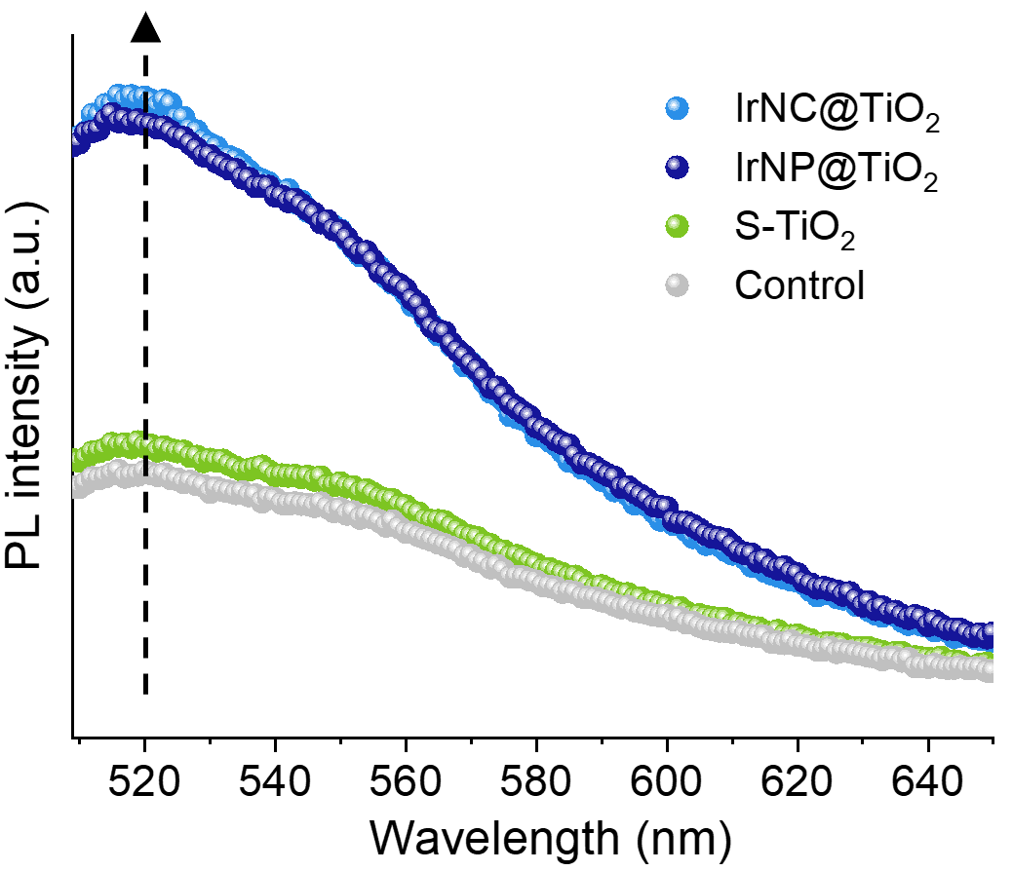
Fig. S20 The fluorescence spectra of aminophenyl fluorescein (APF) after reaction with HClO were produced by different samples.

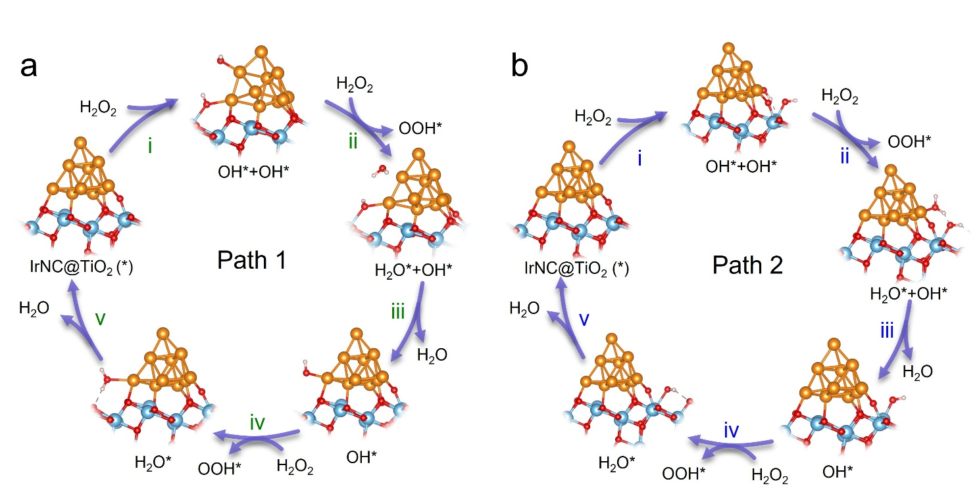
Fig. S21 Proposed POD-like reaction pathways on the IrNC@TiO₂ model.

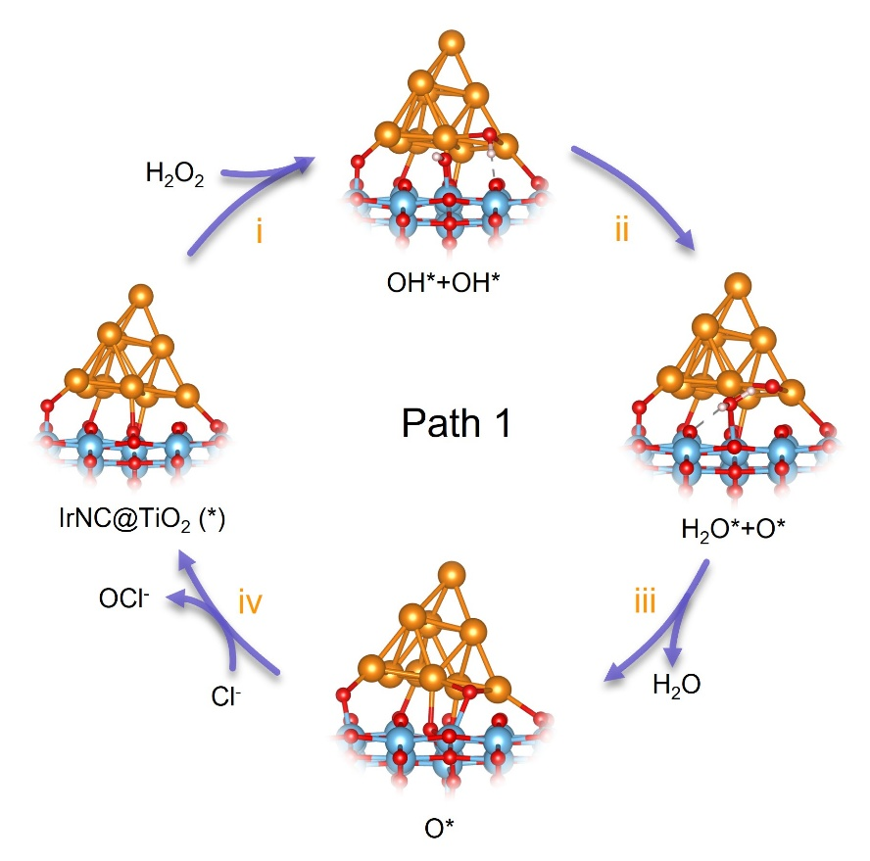
Fig. S22 Proposed HPO-like reaction pathway on the IrNC@TiO₂ model.

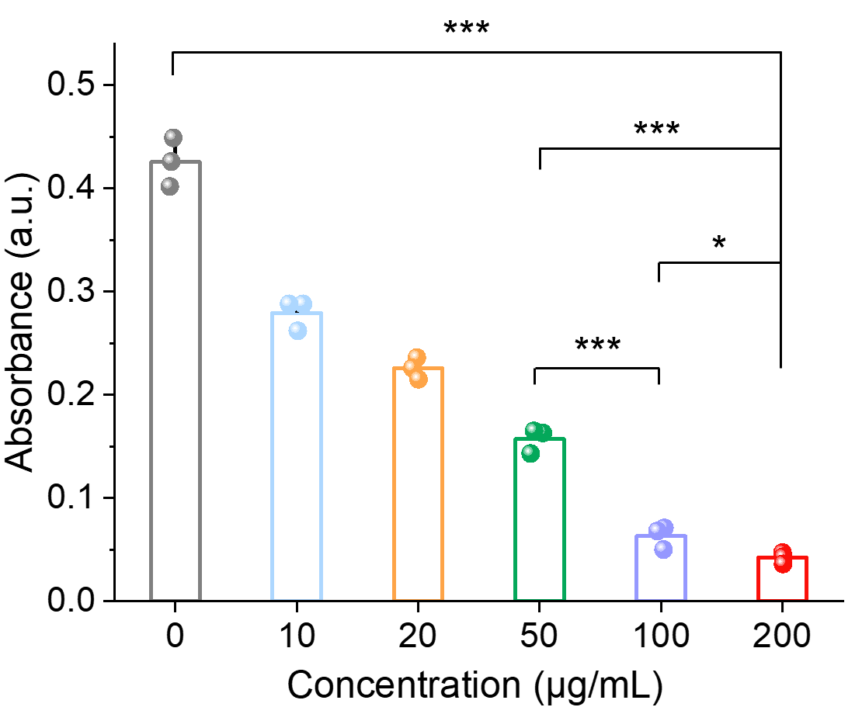
Fig. S23 OD₆₀₀ values of S. mutans floating after treatment with different concentrations of IrNC@TiO₂ (n = 3 independent experiments, data are presented as mean ± SD, statistical significance was calculated using one-way ANOVA followed by Tukey’s post-hoc test for multiple comparisons, all tests were two-sided, *p < 0.05, ***p < 0.001, ns, no significance).

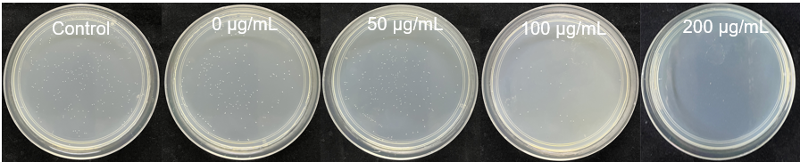
Fig. S24 Plate photos of free S. mutans floating treated with different concentrations of IrNC@TiO₂.

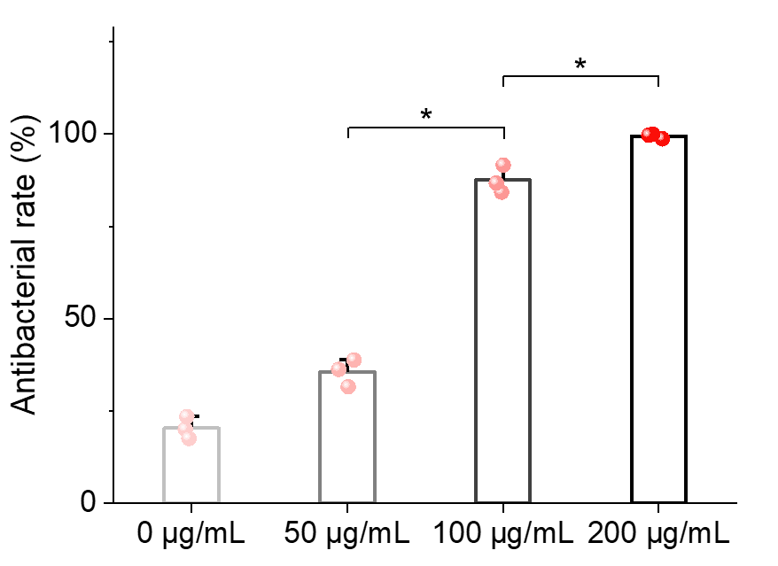
Fig. S25 The bactericidal rates of S. mutans treated under different concentrations of IrNC@TiO₂, as determined by the plate method (n = 3 independent experiments; data are presented as mean ± SD; statistical significance was calculated by Chi-square test for multiple comparisons, all tests were two-sided, *p < 0.05).

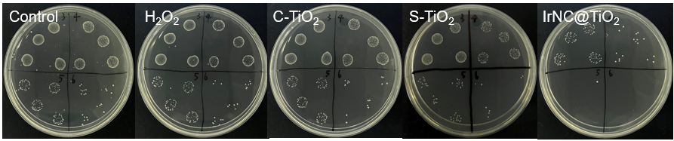
Fig. S26 Drop plate photos of S. mutans floating after treatment with different materials.

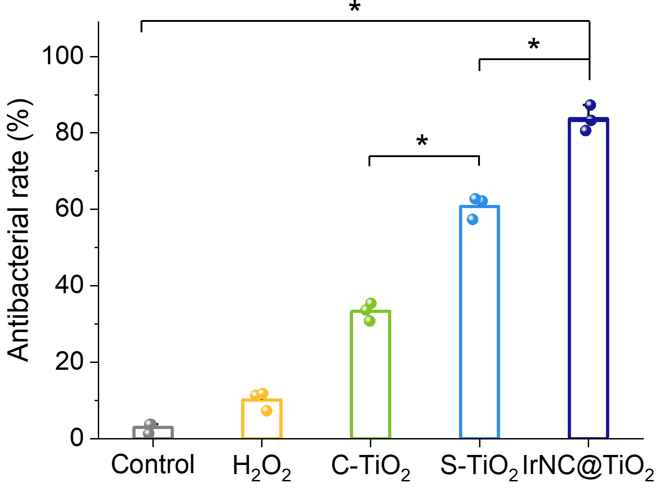
Fig. S27 The antibacterial rate of S. mutans treated with different materials based on the Live/Dead fluorescence analysis (n = 3 independent experiments, data are presented as mean ± SD, statistical significance was calculated by Chi-square test for multiple comparisons, all tests were two-sided, *p < 0.05).

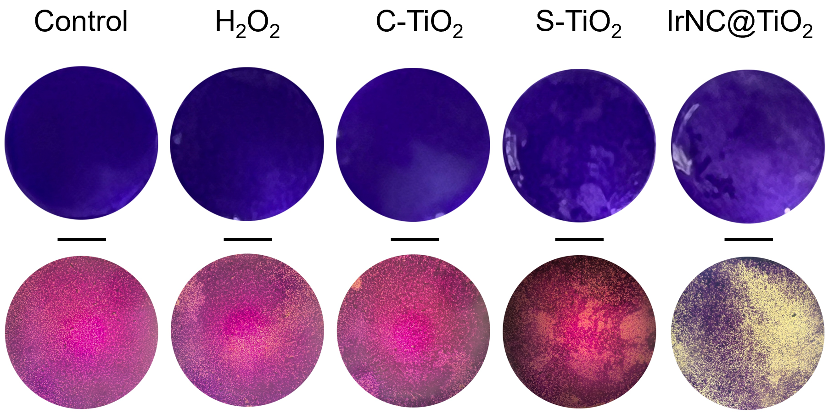
Fig. S28 Crystal violet-stained 96-well plates and optical microscope photos of biofilms treated with different materials (Scale bar: 2 mm).

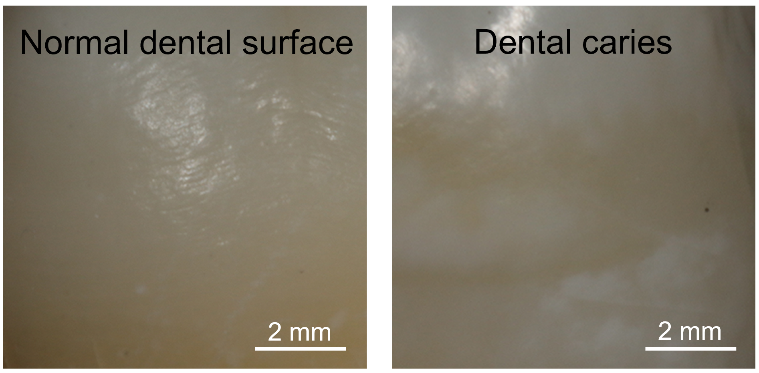
Fig. S29 Optical images of a normal dental surface (left) and dental caries (right).

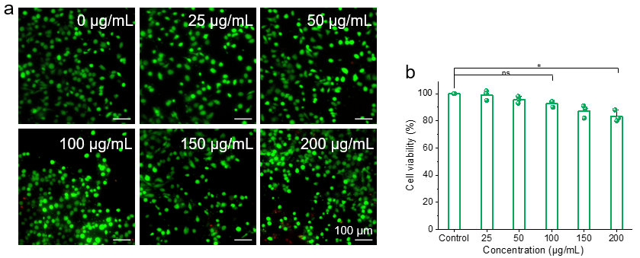
Fig. S30 a Live/Dead cell staining images of HUVECs treated with IrNC-TiO₂ at different concentrations after 24 h. b The relative viabilities of HUVEC cells when incubated with IrNC-TiO₂ at different concentrations after 24 h by CCK-8 assay (n = 3 independent experiments, data are presented as mean ± SD, statistical significance was calculated by Chi-square test for multiple comparisons, all tests were two-sided, *p < 0.05, ns, no significance).

Table S1 Comparison of the POD-like catalytic kinetic constants of this work to H₂O₂ and recently reported artificial enzymes.
Artificial enzymes | K_{m} (mM) | V_{max} (μΜ s⁻¹) | TON (10⁻³ s⁻¹) | Ref. | Year
IrNC@TiO₂ | 2.121 | 0.873 | 308.339 | This work | -
IrNP@TiO₂ | 3.172 | 0.611 | 145.083 | This work | -
Fe-N-C | 0.012 | 0.223 | 36.700 | [4] | 2020
Cu-N-C | 19.94 | 0.201 | 74.888 | [4] | 2020
Pt/C | 41.53 | 0.426 | 124.868 | [4] | 2020
Zn-N-C | 6.270 | 0.048 | 0.308 | [5] | 2020
MnBTC-Ru | 1.46 | 2.25 | 71.6 | [6] | 2025
ICTO | 0.655 | 0.351 | 21.601 | [7] | 2025
Fe-Art M | 2.53 | 0.115 | 74.9 | [8] | 2021
P-Por-Os | 0.0178 | 2.19 | 87.8 | [9] | 2024
Fe-PPc-AE | 0.165 | 0.882 | 27 | [10] | 2024
V-Fe₂O₃ | - | 1.07 | 22.38 | [11] | 2024
APCR | 0.51 | 0.542 | 11.86 | [12] | 2024
Pt-WO_{x} | 0.247 | 0.695 | 108.034 | [13] | 2024
Pt_{ads}@WO_{x} | 0.583 | 0.162 | 23.03 | [13] | 2024
VO_{x}-AE | 3.160×10⁻³ | 0.26 | 26 | [14] | 2021
V₂O₅ | 3.390×10⁻³ | 0.126 | 9 | [14] | 2021
ZnO | 40.900×10⁻³ | 0.069 | 0.27 | [14] | 2021
Fe-AME | 3.45 | 1.01 | 98.65 | [15] | 2022
Cu-AME | 0.28 | 0.81 | 101.04 | [15] | 2022
Re-AME | 0.26 | 0.37 | 84.15 | [15] | 2022
Ir-AME | 0.49 | 0.31 | 54.18 | [15] | 2022
FePorNW-DAP | 0.0106 | 0.524 | 18.5 | [16] | 2023
IrT-SCN | 9.81×10⁻⁴ | 1.731 | 115.591 | [17] | 2024
TON=V_{max}/[E], where [E] is the mole concentration of metal in all the nanomaterials.

Supplementary References
1. X. Ma, R. Li, Y. Sa, S. Liang, L. Sun et al., Separate contribution of enamel and dentine to overall tooth colour change in tooth bleaching. J. Dent. 39(11), 739-745 (2011).
2. S.T. Xiao, L. Xie, Y. Gao, M. Wang, W. Geng et al., Artificial Phages with Biocatalytic Spikes for Synergistically Eradicating Antibiotic-Resistant Biofilms. Adv. Mater. 36(32), 2404411 (2024). https://doi.org/10.1002/adma.202404411
3. X.Z. Wu, Z.Y. Xing, H.J. Huang, Z.Y. Ding, Y. Gao et al., Bacteriophage-like Nanobiocatalysts with Spiky Topography and Dual-Atom Sites for Treating Drug-Resistant Bacteria. ACS Nano 18(38), 26168-26183 (2024). https://doi.org/10.1021/acsnano.4c07406
4. Y. Wu, J. Wu, L. Jiao, W. Xu, H. Wang et al., Cascade Reaction System Integrating Single-Atom Nanozymes with Abundant Cu Sites for Enhanced Biosensing. Anal. Chem. 92(4), 3373-3379 (2020). https://doi.org/10.1021/acs.analchem.9b05437
5. L. Jiao, J. Wu, H. Zhong, Y. Zhang, W. Xu et al., Densely Isolated FeN₄ Sites for Peroxidase Mimicking. ACS Catal. 10(11), 6422-6429 (2020). https://doi.org/10.1021/acscatal.0c01647
6. R.D. Li, T. Wang, S.D. Mu, Z.Y. Xing, Z.Y. Ding et al., Bioinspired ruthenium-manganese-oxygen complex for biocatalytic and radiosensitization therapies to eradicate primary and metastatic tumors. Nat. Commun. 16(1), 7640 (2025). https://doi.org/10.1038/s41467-025-62999-x
7. X. Rong, S.T. Xiao, W. Geng, B.H. Zhu, P. Mou et al., Sono-activable and biocatalytic 3D-printed scaffolds for intelligently sequential therapies in osteosarcoma eradication and defect regeneration. Nat. Commun. 16(1), 6150 (2025). https://doi.org/10.1038/s41467-025-61377-x
8. Y.P. Long, L. Li, T. Xu, X.Z. Wu, Y. Gao et al., Hedgehog artificial macrophage with atomic-catalytic centers to combat Drug-resistant bacteria. Nat. Commun. 12(1), 6143 (2021). https://doi.org/10.1038/s41467-021-26456-9
9. Y. Lyu, Q. Li, S.N. Xie, Z.Y. Zhao, L. Ma et al., Synergistic Ultrasound-Activable Artificial Enzyme and Precision Gene Therapy to Suppress Redox Homeostasis and Malignant Phenotypes for Controllably Combating Hepatocellular Carcinoma. J. Am. Chem. Soc. 147(3), 2350-2368 (2024). https://doi.org/10.1021/jacs.4c10997
10. Q. Li, Z.Y. Zhao, F. Chen, X.H. Xu, L.Z. Xu et al., Delocalization Engineering of Heme-Mimetic Artificial Enzymes for Augmented Reactive Oxygen Catalysis. Angew. Chem. Int. Ed. 63(15), e202400838 (2024). https://doi.org/10.1002/anie.202400838
11. H.J. Huang, W. Geng, X.Z. Wu, Y.Y. Zhang, L. Xie et al., Spiky Artificial Peroxidases with V-O-Fe Pair Sites for Combating Antibiotic-Resistant Pathogens. Angew. Chem. Int. Ed. 63(1), e202310811 (2024). https://doi.org/10.1002/anie.202310811
12. Y. Gao, Y.T. Deng, W. Geng, S.T. Xiao, T. Wang et al., Infectious and Inflammatory Microenvironment Self-Adaptive Artificial Peroxisomes with Synergetic Co-Ru Pair Centers for Programmed Diabetic Ulcer Therapy. Adv. Mater. 36(38), 2408787 (2024). https://doi.org/10.1002/adma.202408787
13. C.Y. Han, S.T. Xiao, Z.Y. Xing, X.H. Xu, M. Wang et al., NADPH Oxidases-Inspired Reactive Oxygen Biocatalysts with Electron-Rich Pt Sites to Potently Amplify Immune Checkpoint Blockade Therapy. Adv. Mater. 37(3), 2407644 (2025). https://doi.org/10.1002/adma.202407644
14. L. Li, S.J. Cao, Z.H. Wu, R.Q. Guo, L. Xie et al., Modulating Electron Transfer in Vanadium-Based Artificial Enzymes for Enhanced ROS-Catalysis and Disinfection. Adv. Mater. 34(17), 2108646 (2022). https://doi.org/10.1002/adma.202108646
15. S.J. Cao, Z.Y. Zhao, Y.J. Zheng, Z.H. Wu, T. Ma et al., A Library of ROS-Catalytic Metalloenzyme Mimics with Atomic Metal Centers. Adv. Mater. 34(16), 2200255 (2022). https://doi.org/10.1002/adma.202200255
16. X.H. Wang, Q. Li, Z.Y. Zhao, L.L. Yu, S.C. Wang et al., Dual-Functional Artificial Peroxidases with Ferriporphyrin Centers for Amplifying Tumor Immunotherapies via Immunogenic Cell Death. Adv. Funct. Mater. 34(11), 2313143 (2024). https://doi.org/10.1002/adfm.202313143
17. X.T. Huang, H.J. Zhou, N. Lv, Z.Y. Zhao, T. Tian et al., Immunomodulating Sonocatalytic Nanoagents with Dual-Functional Ir-N Centers and Narrow Bandgap for Reversing Immunosuppression and Potentiating Ovarian Cancer Immunotherapy. Adv. Funct. Mater. 34(46), 2407349 (2024). https://doi.org/10.1002/adfm.202407349

