Supporting Information for
Dual-Functional Photonic Metacoating Integrating Fluorescence Thermometry and High-Performance Space Radiative Cooling
Hao Gong¹, Zhongyang Wang^{1,} *, Yan Zheng¹, Liping Tong², Hongchao Li¹, Zhiyuan Zhao¹, Junjia Liu¹, Gang Liu³, Xiao Zhou^{1,} *, Tongxiang Fan^{1,} *
¹State Key Laboratory of Metal Matrix Composites, School of Materials Science and Engineering, Shanghai Jiao Tong University, Shanghai 200240, P. R. China
²School of Materials, Shanghai Dianji University, Shanghai, 201306, P. R. China
³Shanghai Institute of Spacecraft Equipment, Shanghai, 200240, P. R. China
*Corresponding authors. E-mail: zy_wang@sjtu.edu.cn (Zhongyang Wang); zhouxiao113@sjtu.edu.cn (Xiao Zhou); txfan@sjtu.edu.cn (Tongxiang Fan)

S1 Supplementary Experiment Section
S1.1 Chemicals
Zirconium n-propoxide (Zr(OC₃H₇)₄, 70% in n-propanol, stored in a glovebox), ethanol (C₂H₅OH, ≥99.8%, chromatographic grade), stearic acid (C₁₇H₃₅COOH, 98%), triethylamine (C₆H₁₅N, 99%), potassium silicate (K₂O·nSiO₂·xH₂O), europium nitrate hexahydrate (Eu(NO₃)₃·6H₂O, 99.99%) were purchased from Shanghai Aladdin Biochemical Technology Co., LTD.
S1.2 Morphology, Structural and Compositional Characterizations
Surface morphologies were investigated by scanning electron microscopy (SEM, TESCAN RISE-MAGNA, Czech Republic) operated at 10 kV. Elemental distributions were examined by energy-dispersive X-ray spectroscopy (EDS, Oxford X-Max N20, UK) attached to the SEM. Submicrosphere size distributions and standard deviations were obtained using Nano Measurer software.
Microstructural and compositional analyses were carried out by high-resolution transmission electron microscopy (HR-TEM, Talos F200X, Thermo Fisher Scientific, USA) at 200 kV. Elemental mapping was conducted with a Super-X EDS detector in high-angle annular dark-field scanning TEM (HAADF-STEM) mode. Internal architectures were examined on ultrathin sections prepared at room temperature using an ultramicrotome (Leica EM UC7FC7, Germany). Atomic-resolution images were acquired on an aberration-corrected STEM (AC-STEM, JEM-ARM200F, JEOL, Japan) with a cold field-emission gun operated at 200 kV. EDS was performed with a JEOL JED-2300 detector using a probe convergence angle of 20.6 mrad and a collection semi-angle of 54-220 mrad.
The crystal structure was characterized by X-ray diffraction (XRD, Rigaku D/Max 2550 PC, Japan) using Cu Kα radiation (λ = 1.5406 Å) over 2θ = 10-80°, with an operating voltage of 45 kV and current of 200 mA.
FTIR spectra were recorded either in transmission mode or using an attenuated total reflection (ATR) accessory (Thermo Fisher Nicolet S6700, USA) over 4000-400 cm⁻¹, each spectrum was averaged over 64 scans.
Eu and Zr contents were quantified by inductively coupled plasma optical emission spectroscopy (ICP-OES, iCAP PRO, Thermo Fisher Scientific, USA) after dissolution in hydrofluoric acid.
X-ray photoelectron spectroscopy (XPS, Thermo Scientific K-Alpha, USA) was used to probe the chemical states of O, Zr and Eu with a monochromatic Al Kα source (hν = 1486.8 eV, 12 kV, 6 mA). Spectra were collected at a pass energy of 50 eV with 0.1 eV step size under a base pressure of ~5 × 10⁻⁷ Pa, and all binding energies were referenced to the C 1s peak at 284.8 eV.
Electron paramagnetic resonance (EPR) measurements were performed on a Bruker EMXplus-9.5/12 spectrometer (Germany) operating at X-band (9.826 GHz) with 100 kHz field modulation. Data were acquired at room temperature with a modulation amplitude of 0.5 G and a microwave power of 200 mW.
Infrared radiative behavior was assessed using a thermal imaging camera (Guide Sensmart PT650, China) with a 640 × 480 pixel uncooled vanadium oxide detector, operating at 30 Hz. The instrument covers a temperature range of -40 to 150 °C with a thermal sensitivity of 30 mK, an accuracy of ±1 °C, and a spectral response of 7.5-14 µm. The emittance was set to 0.92. Thermal images and videos were processed using Guide ThermoTools software.
S1.3 Fluorescence Lifetime and Thermometric Sensitivity Calculation
Fluorescence intensity is proportional to the population of ions in the excited state. After the excitation source is switched off, the emission decays with time, and the average fluorescence lifetime (τ) is defined as the time at which the intensity has decreased to 1/e of its initial value. The decay curves I(t) were fitted with a biexponential function [S1, S2]:
$I(t)=I_{0}+I_{1}e^{-t/τ_{1}}+I_{2}e^{-t/τ_{2}}$ (S1)
where $τ_{1}$ and $τ_{2}$represent the fast and slow decay components, I₁ and I₂ denote their amplitudes, and I₀ is the residual background. The mean lifetime was calculated as:
$τ=\frac{∑I_{n}τ_{n}^{2}}{∑I_{n}τ_{n}}$ (S2)
The absolute sensitivity (S_{a}) of the fluorescence intensity ratio (FIR) thermometry was evaluated from the Boltzmann-type relationship [S3, S4]:
$S_{a}=\frac{I_{548}}{I_{606}}=Aexp⁡(-\frac{ΔE}{k_{B}T})$ (S3)
where I₅₄₈ and I₆₀₆ are the integrated intensities corresponding to the ⁵D₁→⁷F₂ and ⁵D₀→⁷F₂ transitions of Eu³⁺, respectively. A is a proportionality constant related to the spontaneous emission probability and photon frequency, ΔE denotes the energy gap between the two thermally coupled levels, and k_{B} is the Boltzmann constant.
Relative sensitivity (S_{r}) is a key figure of merit for luminescent thermometers, is defined as:
$S_{r}=\left|\frac{1}{FIR}\frac{ⅆFIR}{ⅆT}\right|×100\%=\frac{ΔE}{k_{B}T}×100\%$ (S4)
These analyses enable a quantitative assessment of the luminescent and thermometric performance of EZS and the corresponding metacoatings.
S1.4 Data analysis
The solar absorptance (α_{s}) was evaluated from its measured reflectance R(λ) under the AM0 solar spectrum (I_{AM0}(λ)) as:
(S5)
The hemispherical emittance (ε) was obtained using Kirchhoff’s law, assuming that in the mid-infrared the emittance equals the spectral absorbance (α(T, λ)):
(S6)
where the ideal blackbody spectral radiance (I_{b}(λ, T)) is:
(S7)
Here, h is Planck’s constant, k is Boltzmann’s constant, and c is the speed of light in vacuum.
S1.5 Calculations of net cooling power
The net radiative cooling power was calculated as:
𝑃_{𝑛𝑒t}(𝑇) = 𝑃_{𝑟𝑎𝑑}(𝑇) − 𝑃_{𝑠𝑜𝑙𝑎𝑟} (S8)
with the radiative power exchanged with deep space (background temperature, T_{bg} ≈ 3K) given by:
$P_{\text{rad}}(T)=εσ(T^{4}-T_{\text{bg}}^{4})$ (S9)
where (σ = 5.67 × 10⁻⁸ W·m⁻²·K⁻⁴) is the Stefan-Boltzmann constant and T is the surface temperature. The absorbed solar power was evaluated as:
$P_{\text{solar}}=α_{s}Scos⁡(θ)$ (S10)
where α_{s} is the solar absorptance, S = 1367 W·m⁻² is the solar constant, and θ is the solar incidence angle. These expressions were used to compare the net cooling performance of the metacoating with other all-inorganic radiative cooling coatings and to assess their suitability for spacecraft thermal management.
S2 Supplementary Figures and Tables
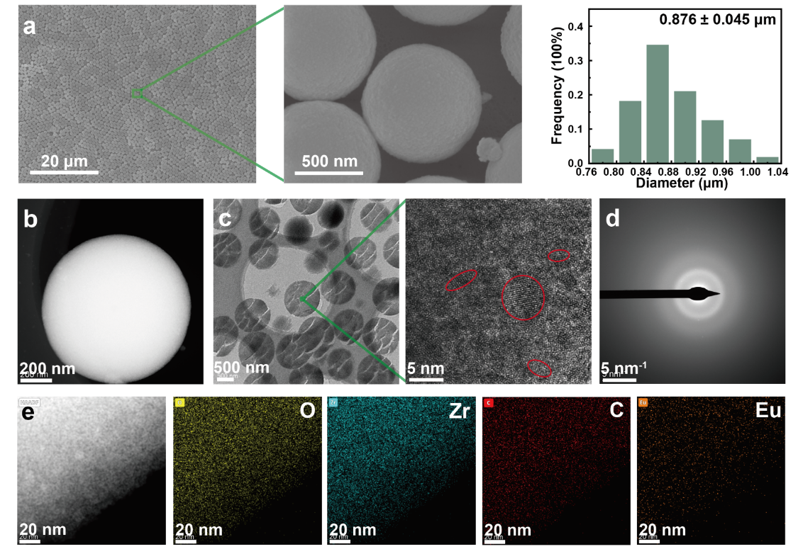
Fig. S1 Morphology and composition of EZS precursors synthesized by forced alkoxide hydrolysis with concurrent Eu³⁺ coordination under hydrothermal conditions. a Low- and high-magnification SEM images showing uniform spherical particles with an average diameter of 0.876 μm. b HAADF-TEM image confirming a symmetric spherical morphology. c HR-STEM image revealing a predominantly disordered interior with only localized nanocrystalline fringes a few nanometers in size. d SAED pattern without discernible diffraction rings, consistent with an amorphous precursor. e HAADF-STEM and EDS elemental maps (O, Zr, C, Eu) demonstrating homogeneous elemental distributions and absence of Eu segregation, indicative of uniform Eu³⁺ incorporation within the ZrO₂ submicrosphere precursor

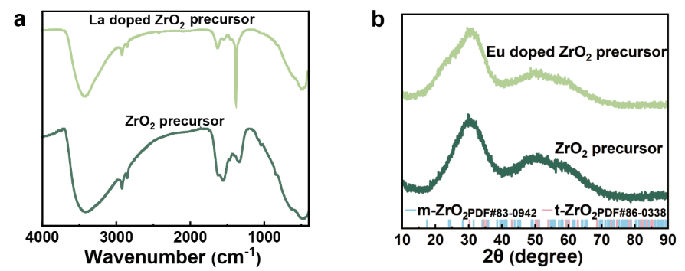
Fig. S2 a FTIR spectra and b XRD patterns of EZS and ZrO₂ submicrosphere precursors
FTIR and XRD analyses were performed to examine the chemical composition and structural evolution of EZS precursors. Both EZS and ZrO₂ submicrosphere precursors exhibit characteristic absorption peaks of organic functional groups, indicating residual organics in the as-prepared samples. After hydrothermal diffusion doping, the Zr−OH stretching vibrations at 3400-3560 cm⁻¹ weaken significantly, suggesting coordination between Eu³⁺ ions and surface Zr−OH groups [S5]. The alkyl stretching bands at 2920 cm⁻¹ and 2850 cm⁻¹, as well as the bending mode at 1460 cm⁻¹, are notably reduced, confirming that hydrothermal treatment promotes the hydrolysis and removal of propoxy groups [S6]. The sharper absorption bands between 400-600 cm⁻¹ correspond to metal-oxygen bond stretching, while the new peak at 1386 cm⁻¹ arises from the NO₃⁻ groups of europium nitrate solution. The XRD patterns of both EZS and ZS precursors display broad diffraction features, consistent with an amorphous structure. Together with HR-TEM observations, these results confirm that the EZS precursors remain predominantly amorphous after hydrothermal processing.

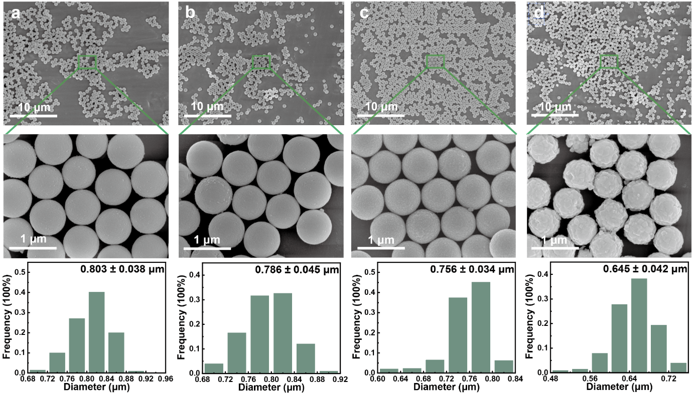
Fig. S3 Low- and high-magnification SEM images and corresponding diameter distributions of EZS precursors after calcination at different temperatures: a 600 °C, b 800 °C, c 1000 °C and d 1200 °C
To obtain highly crystalline and spherical EZS, we examined the effects of calcination on diameter and microstructure. As shown in Fig. S3, calcination effectively removes organics from the precursors and promotes crystallization. At 600 °C, the average diameter decreases to 0.803 µm. Further calcination at 800 °C and 1000 °C reduces the diameter to 0.786 µm and 0.745 µm, accompanied by increased surface roughness. At 1200 °C, enhanced atomic diffusion produces faceted grains and a denser surface, with the diameter decreasing to 0.645 µm, indicative of grain growth and particle densification at high temperature. Across the studied range, the EZS retain a spherical morphology up to 1200 °C, while exhibiting a monotonic size reduction with increasing temperature.

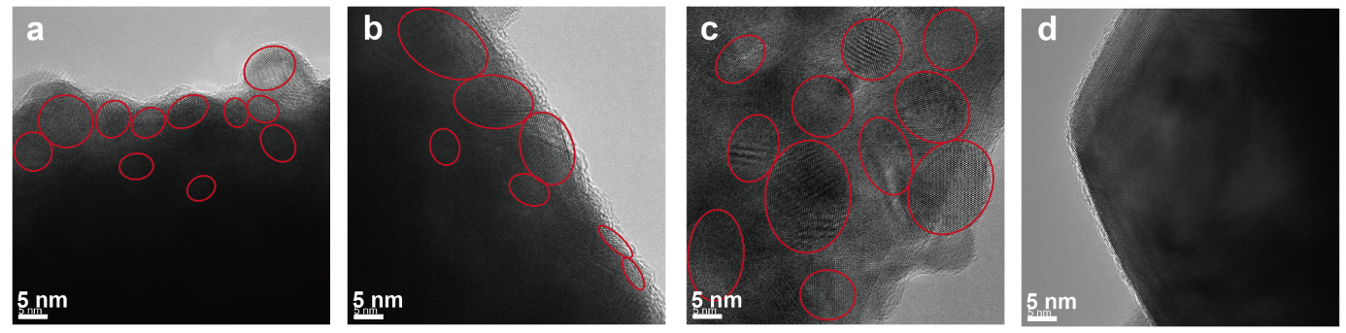
Fig. S4 HR-TEM images of EZS after calcination at different temperatures: a 600 °C, b 800 °C, c 1000 °C and d 1200 °C
HR-TEM analysis was performed to study the evolution of grain structure at the edge of EZS after heat treatment at different temperatures, as shown in Fig. S4. After calcination at 600 °C, a large number of small primary grains appeared at the edges of the EZS. As the temperature increased to 1000 °C, the crystal growth accelerated under thermal driving, resulting in noticeably larger grains. At 1200 °C, the grain size further increased to several tens of nanometers, with significantly improved crystallinity and structural integrity. The edge regions exhibited a trend toward densification, which is closely related to the enhanced atomic diffusion and grain fusion induced by high temperatures.

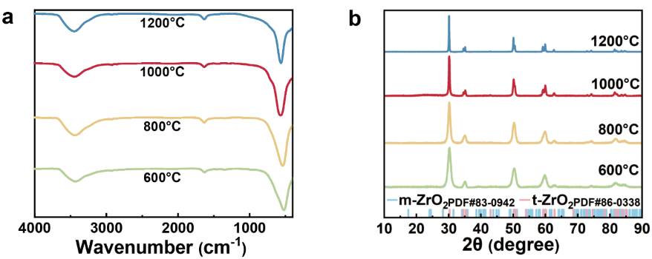
Fig. S5 a FTIR spectra and b XRD pattern of EZS after calcination at different temperatures
FTIR spectroscopy and XRD partterns were employed to characterize the chemical composition and crystal structure of the EZS after calcination. As shown in Fig. S5a, the FTIR spectra reveal a noticeable weakening and smoothing of the absorption peaks in the 900-4000 cm⁻¹ range at 600 °C, indicating the removal of most organic components. When the heat treatment temperature was increased from 600 °C to 1200 °C, the FTIR peaks in the 750-400 cm⁻¹ region became sharper, suggesting an improvement in crystallinity. These peaks correspond to localized bending and deformation vibration modes of metal-oxygen bonds. As shown in Fig. S5b, the XRD results indicate that the EZS transition from an amorphous state to a tetragonal phase after calcination. At 600 °C, characteristic diffraction peaks appear at 2θ = 30.1°, 35.1°, 50.3° and 59.9°, corresponding to the (101), (110), (112) and (211) planes of tetragonal ZrO₂ (PDF#86-0338) [S7]. When the temperature is increased to 1000 °C and 1200 °C, these diffraction peaks become sharper, indicating a significant improvement in crystallinity. Additionally, secondary diffraction peaks appear at 2θ = 34.5°, 50.5° and 59.2°, corresponding to the (002), (200) and (103) planes of tetragonal ZrO₂, respectively.

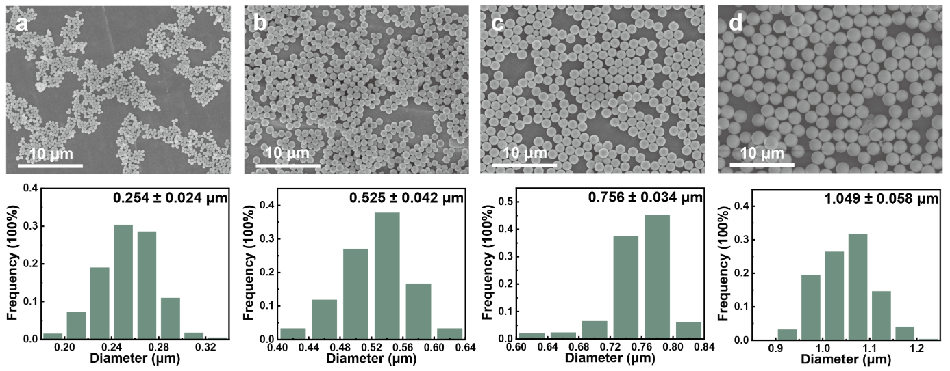
Fig. S6 SEM images of EZS with different diameters: a 0.254 μm, b 0.525 μm, c 0.756 μm and d 1.049 μm

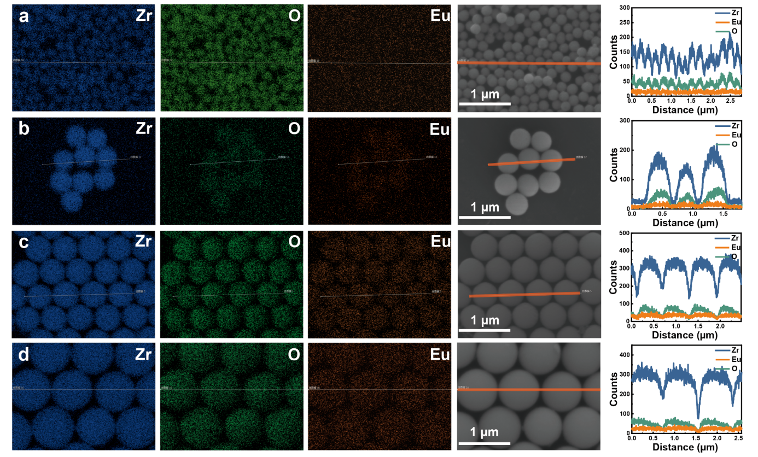
Fig. S7 The SEM images, Zr, O and Eu elemental EDS-mapping and line scanning of EZS with different diameters: a 0.254 μm, b 0.525 μm, c 0.756 μm and d 1.049 μm.

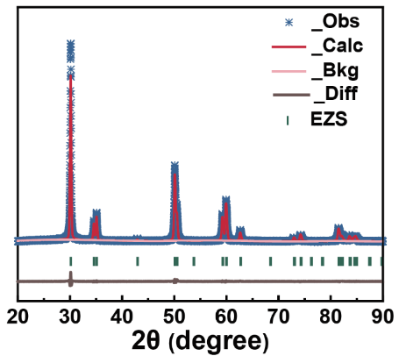
Fig. S8 Rietveld refinement of the XRD pattern for EZS

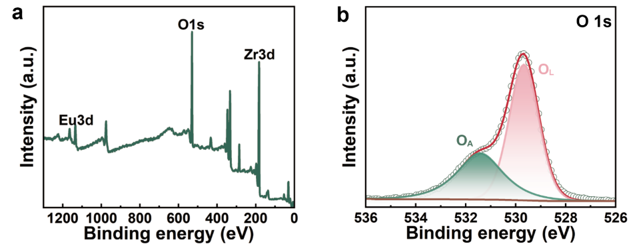
Fig. S9 XPS a survey and b O 1s high-resolution spectra of EZS

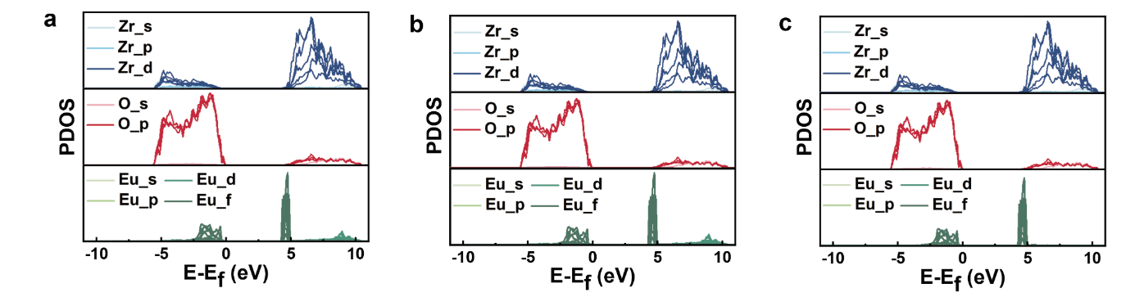
Fig. S10 PDOS of a 2.78, b 4.17% and c 12.50% Eu-doped ZrO₂

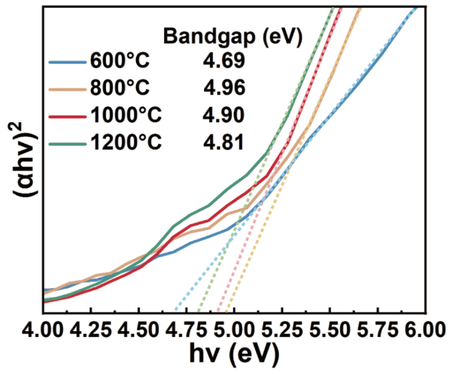
Fig. S11 Optical E_{g} of EZS after calcination at different temperatures
The optical E_{g} of EZS was determined from UV-Vis absorption spectra using Tauc-plot analysis. As the calcination temperature increased from 600 to 800 °C, E_{g} broadened from 4.69 to 4.96 eV, indicating improved crystallinity and a reduced defect density. When the temperature reached 1200 °C, E_{g} decreased to 4.81 eV, which is attributed to the higher concentration of V_{O} defects associated with aliovalent doping. These impurity states introduce defect levels, thereby narrowing the apparent E_{g}.

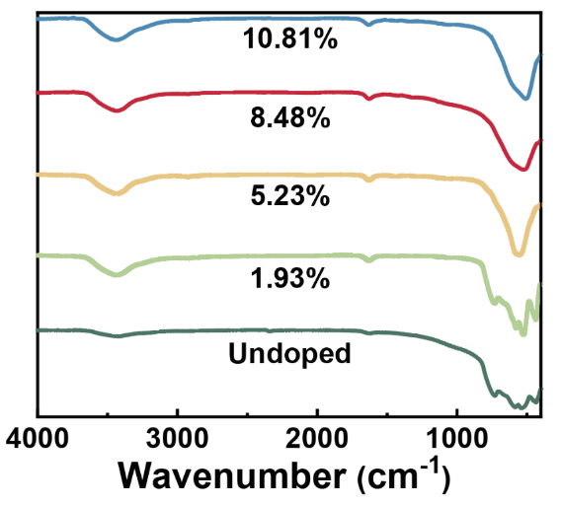
Fig. S12 FTIR spectra of EZS at different doping concentration
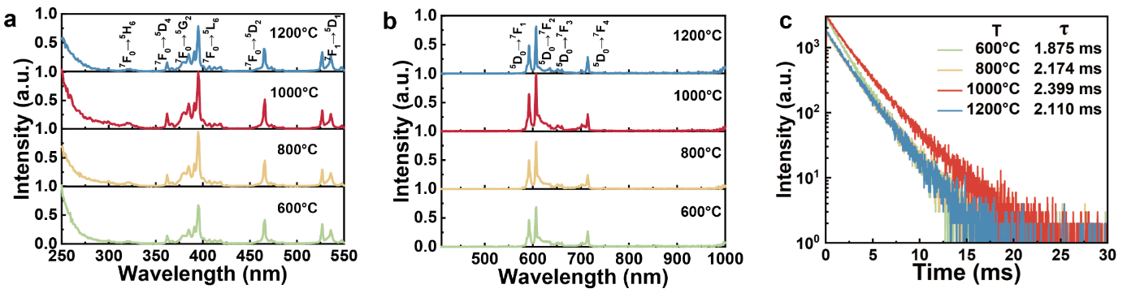
Fig. S13 a Excitation and b emission spectra, and c fluorescence decay curves of EZS after calcination at different temperatures recorded at λ_{em} = 606 nm and λ_{ex} = 395 nm
With increasing calcination temperature, the crystallinity of the EZS gradually improves, grain size enlarges, and the local coordination environment of Eu³⁺ becomes more stable, leading to a continuous enhancement in emission intensity. The sample treated at 1000 °C exhibits the strongest luminescence, while a slight decrease occurs at 1200 °C due to the generation of additional V_{O}, which act as quenching centers that trap excitation energy and reduce emission efficiency. Fig. S13c presents fluorescence decay curves recorded at an excitation wavelength of 395 nm and an emission wavelength of 606 nm. All samples exhibit lifetimes on the millisecond scale, indicating partially forbidden transitions. The decay profiles fit a biexponential model with time constants of 1.875, 2.174, 2.399 and 2.110 ms, respectively. The lifetime first increases and then decreases with temperature, which is attributed to changes in local symmetry. Moderate calcination temperature enhances structural order and suppresses nonradiative decay, while higher temperatures introduce lattice defects that open additional nonradiative channels, thus shortening the lifetime. Considering both excitation and emission behavior, 1000 °C is identified as the optimal annealing condition for achieving the highest luminescence performance.

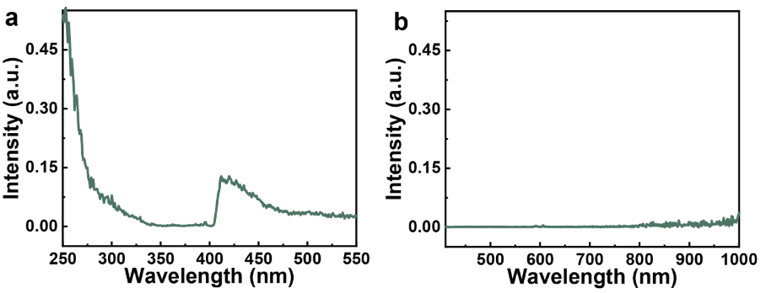
Fig. S14 a Excitation and b emission spectra of undoped ZrO₂ submicrosphere recorded at λ_{em} = 606 nm and λ_{ex} = 395 nm

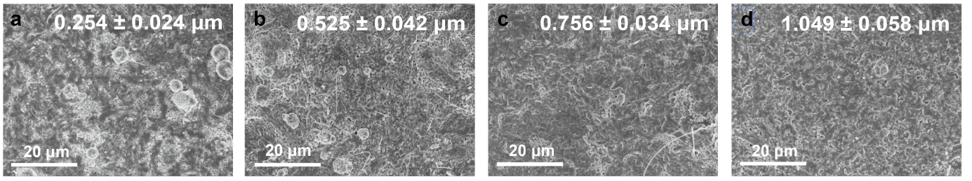
Fig. S15 The low-magnification SEM images of metaoating with different EZS diameter: a 0.254 μm, b 0.525 μm, c 0.756 μm and d 1.049 μm

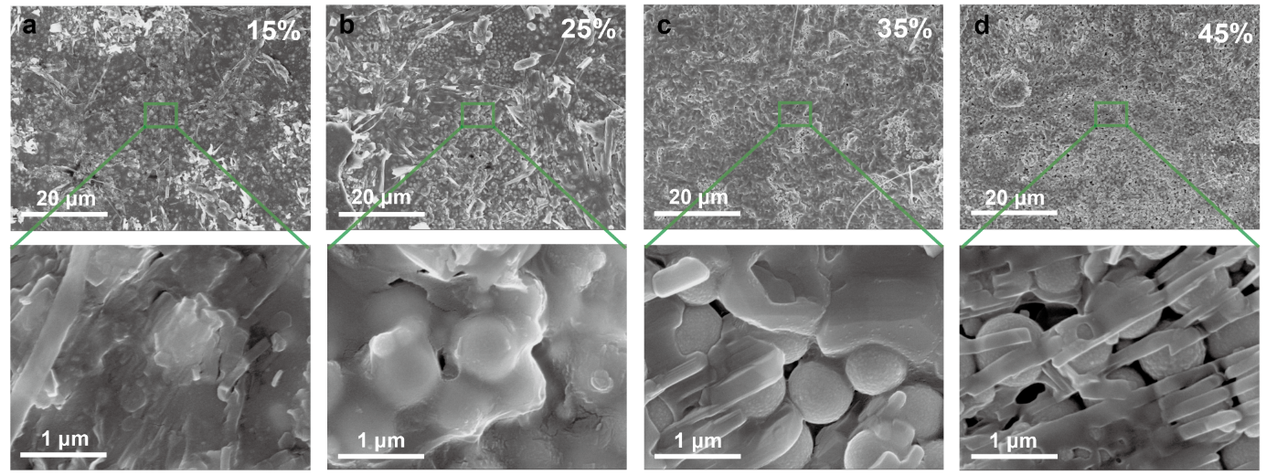
Fig. S16 The low and high-magnification SEM images of metaoating with different volume fraction: a 15%, b 25%, c 35% and d 45%

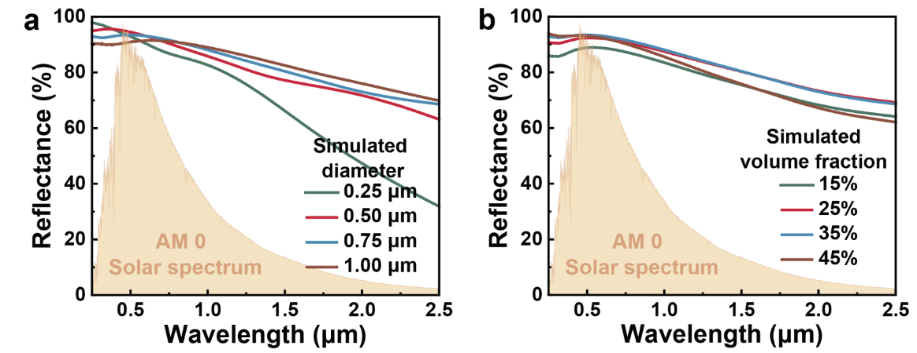
Fig. S17 Simulated reflectance spectra of metacoating with different a EZS diameter and b volume fraction. The typical experimental parameters are a diameter of 0.75 μm, a volume fraction of 35% and a thickness of 100 μm

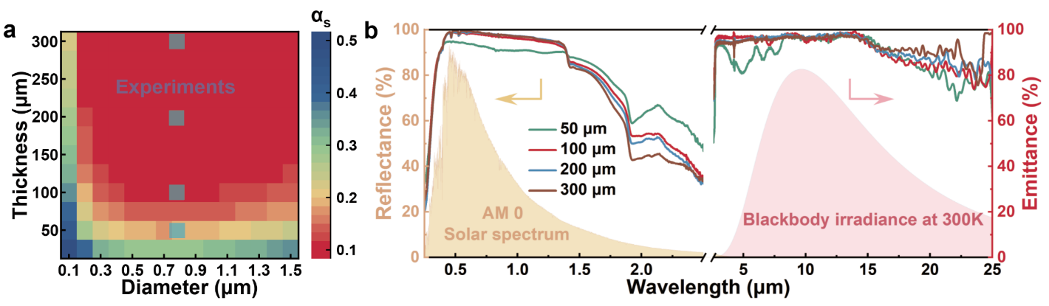
Fig. S18 a Grid search mapping of the optimal α_{s} region for metacoatings at 35% volume fraction as a function of diameter and thickness. b Reflectance and emittance spectra for metacoatings with varying thicknesses

Table S1 Comparison of α_{s}, ε and net cooling power of the all-inorganic space radiative cooling coatings
Materials | α_{s} | ε | Net cooling power (W·m⁻²) | References
Zn₂SiO₄ | 0.091 | 0.949 | 307.32 | [S9]
ZnO | 0.167 | 0.88 | 175.87 | [S9]
h-BN | 0.098 | 0.916 | 286.73 | [S9]
Ga₂O₃ | 0.094 | 0.877 | 274.28 | [S10]
Ca₃(PO₄)₂ | 0.095 | 0.878 | 273.37 | [S10]
Zn-MCM-41 | 0.154 | 0.914 | 209.26 | [S11]
Silica-supported ZnO | 0.145 | 0.945 | 235.80 | [S12]
Zn-SBA-15 | 0.151 | 0.936 | 223.46 | [S13]
Hollow glass | 0.16 | 0.85 | 171.66 | [S14]
ZrO₂ particles | 0.205 | 0.84 | 105.55 | [S15]
Mg_{0.13}Zr_{0.87}O_{1.87} | 0.405 | 0.873 | -152.69 | [S16]
Mg₃(PO)₄ and MgO | 0.33 | 0.85 | -60.73 | [S17]
SR107-ZK | 0.17 | 0.87 | 167.18 | [S18]
S781 | 0.18 | 0.87 | 153.51 | [S19]
NS-74 | 0.17 | 0.92 | 190.14 | [S20]
TSSZ-2 | 0.145 | 0.945 | 235.80 | [S12]
SAR-9 | 0.09 | 0.80 | 244.39 | [S21]
S13G | 0.22 | 0.90 | 112.60 | [S11]
YB-71 | 0.12 | 0.90 | 253.79 | [S13]
AZ-93 | 0.15 | 0.91 | 212.89 | https://www.aztechnology.com
AZW/LA-II | 0.09 | 0.91 | 294.91 | https://www.aztechnology.com
AZ-2000-IECW | 0.25 | 0.88 | 62.41 | https://www.aztechnology.com
AZ-2100-IECW | 0.15 | 0.90 | 208.29 | https://www.aztechnology.com
AZ-400-LSW | 0.17 | 0.89 | 177.73 | https://www.aztechnology.com
AZJ-4020 | 0.15 | 0.88 | 199.11 | https://www.aztechnology.com
SolarWhite | 0.18 | 0.89 | 162.69 | https://enbio.eu/thermal-control-coatings/
EZS metacoating | 0.076 | 0.931 | 323.688 | Our work
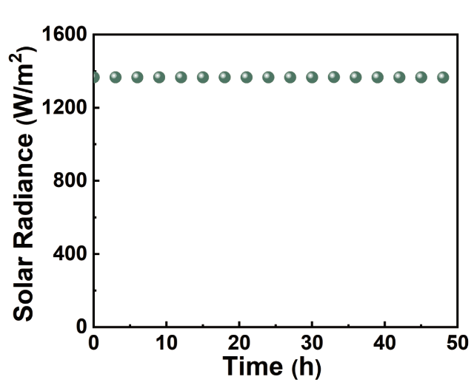
Fig. S19 Solar irradiance of the AM0 solar simulator as a function of time

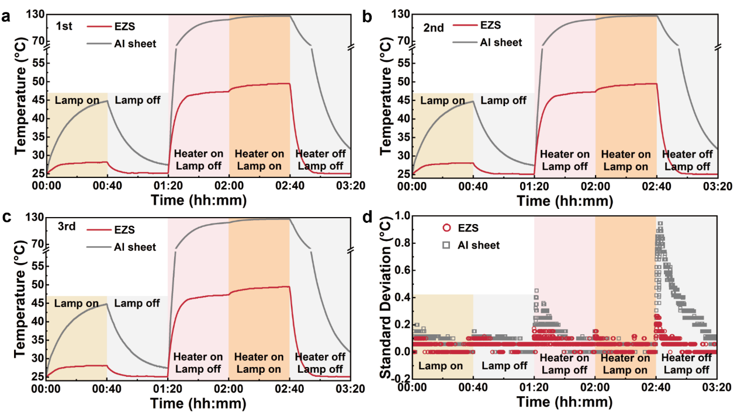
Fig. S20 Temperature evolution of the EZS metacoating and Al sheet during three independent measurements: a first, b second, c third measurement and d corresponding standard deviation

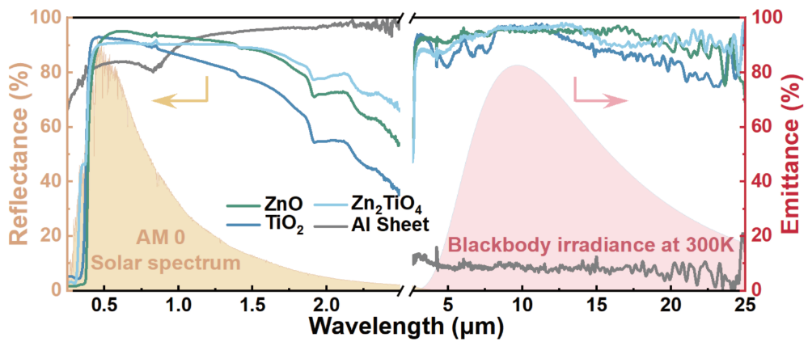
Fig. S21 The reflectance and emittance spectra of TiO₂, ZnO and Zn₂TiO₄ coatings with thickness of 100 μm at a volume fraction of 35%

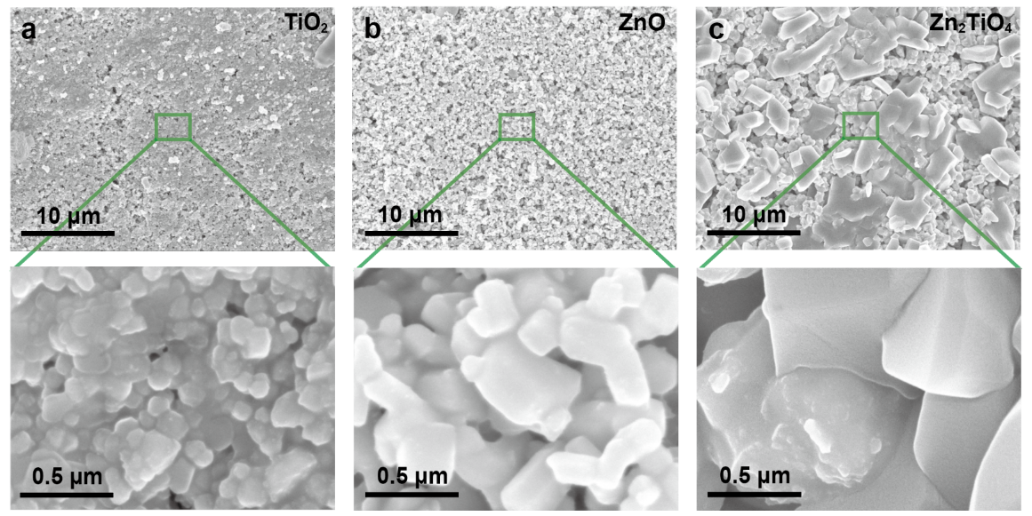
Fig. S22 The low and high-magnification SEM images of coatings using different oxide powders as pigments: a TiO₂, b ZnO and c Zn₂TiO₄
Bare Al sheet exhibits pronounced intrinsic absorption in the UV-visible range (0.25-0.78 µm), yielding α_{s} = 0.140 and ε = 0.081. Sprayed ZnO, TiO₂ and Zn₂TiO₄ powders form uniform, well-adhered white coatings [S8]. In reflectance, the UV absorption edges of ZnO, TiO₂ and Zn₂TiO₄ coatings occur at ~0.38, ~0.36, and ~0.32 µm, respectively, which leads to stronger UV absorption. SEM images at low and high magnification reveal granular surfaces. TiO₂ coating consists of smaller particles (~0.1-0.3 µm), which maximize reflectance in the visible region but lead to reduced reflectance in the NIR range. ZnO and Zn₂TiO₄ coatings have larger particles and maintain higher NIR reflectance. Because all coatings were prepared at the same pigment volume fraction, their mid-IR emittance spectra are broadly similar. Residual differences are concentrated in the 3-8 µm and 15-25 µm bands and likely arise from intrinsic vibrational absorptions of the oxides and particle-size-dependent interfacial scattering.

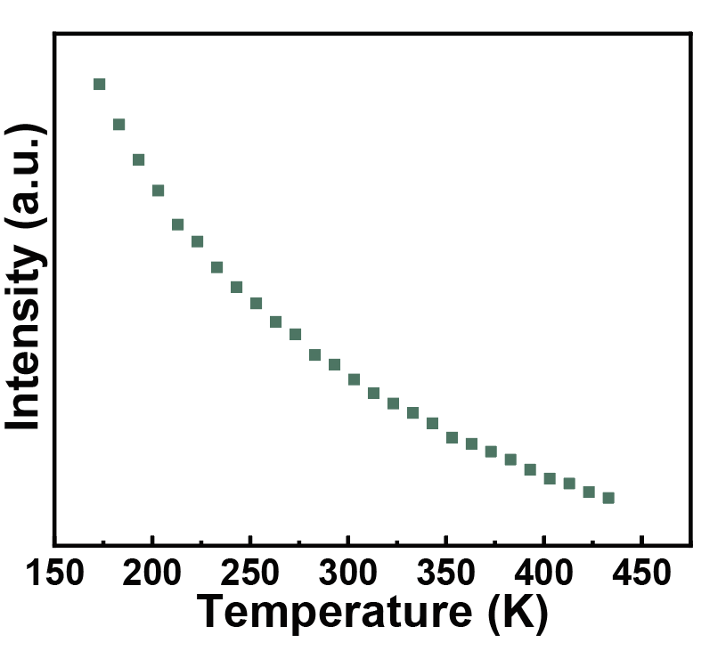
Fig. S23 Variation of intensity of 606 nm with temperature

Table S2 Comparison of λ_{g} and maximum S_{r} for the EZS metacoating and representative luminescent thermometric oxide
Materials | λ_{g} | S_{r} (% K⁻¹) | References
ZrO₂: Eu³⁺ | 0.258 | 0.33 | [S1]
LaScO₃: Eu³⁺ | 0.281 | 0.795 | [S22]
Sr₂NaMg₂V₃O₁₂: Eu³⁺ | 0.4133 | 1.61 | [S23]
ZrTiO₄: Eu³⁺ | 0.340 | 1.11 | [S4]
Ca_{0.75}Sr_{0.2}Mg_{1.05}Si₂O₆: Eu²⁺/Tb³⁺ | 0.448 | 0.6 | [S24]
La_{2.95}Li₃W_{1.99}O₁₂: Eu³⁺/Mn⁴⁺ | 0.320 | 0.7 | [S25]
Gd₂GaSbO₇: Bi³⁺/Eu³⁺ | 0.293 | 1.03 | [S26]
SrGa₂B₂O₇: Bi³⁺/Eu³⁺ | 0.276 | 1.03 | [S27]
CaLa₄(SiO₄)₃O: Dy³⁺ | 0.339 | 0.164 | [S28]
SrWO₄: Pr³⁺ | 0.272 | 0.65 | [S29]
BaLa_{0.92}La_{0.08}LiTeO₆ | 0.343 | 0.65 | [S30]
LiCa₂Mg₂V₃O₁₂: Dy³⁺ | 0.397 | 0.59 | [S31]
RbCaLa(VO₄)₂: Eu³⁺ | 0.362 | 1.125 | [S32]
La₂LiSbO₆: Bi³⁺/Eu³⁺ | 0.388 | 0.41 | [S33]
K₃Y₄Si₂O₇: Bi³⁺/Sm³⁺ | 0.292 | 0.673 | [S34]
Ba₂LuNbO₆: Er³⁺/Yb³⁺ | 0.334 | 1.81 | [S35]
Sr₃WO₆: Er³⁺ | 0.342 | 0.56 | [S36]
Gd₂Mo₃O₁₂: Er³⁺/Yb³⁺ | 0.343 | 0.89 | [S37]
NaLaCaWO₆: Bi³⁺/Eu³⁺ | 0.423 | 0.74 | [S38]
LiAl₅O₈: Cr³⁺ | 0.225 | 0.3 | [S39]
Ca₃Al₂O₆: Bi³⁺/Eu³⁺ | 0.299 | 0.3 | [S40]
Ba₂SrWO₆: Eu³⁺ | 0.332 | 0.33 | [S41]
Ba₂Al_{2/3}TeO₆: Eu³⁺ | 0.253 | 0.19 | [S42]
LiY₆(BO₃)₃O₅: Bi³⁺/Eu³⁺ | 0.426 | 1.87 | [S43]
Y₃TaO₇: Tm³⁺/Eu³⁺ | 0.251 | 0.541 | [S44]
EZS metacoating | 0.253 | 0.797 | Our work
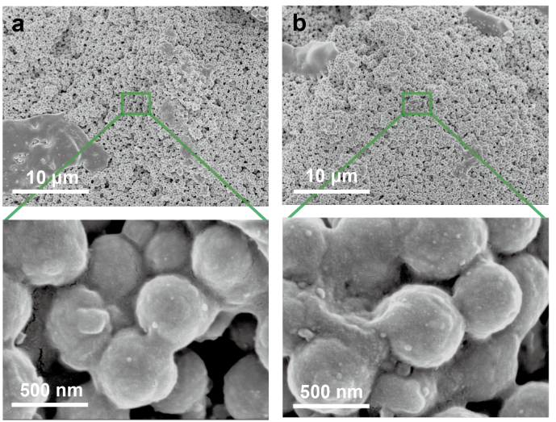
Fig. S24 The low and high-magnification SEM images of EZS metacoating after a UV and b combined irradiations

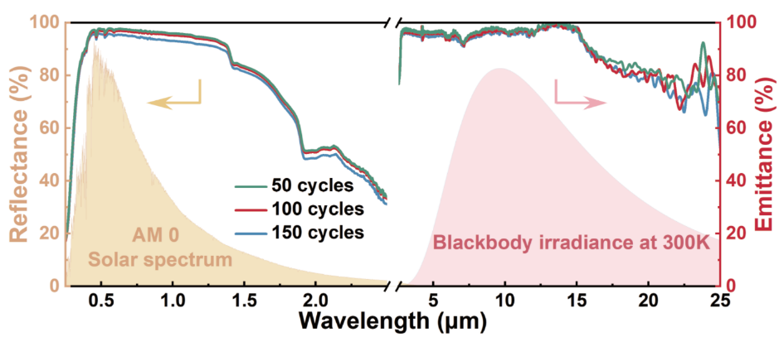
Fig. S25 Reflectance and emittance spectra of the EZS metacoating after 50, 100 and 150 thermal cycles between -196 °C and 150 °C

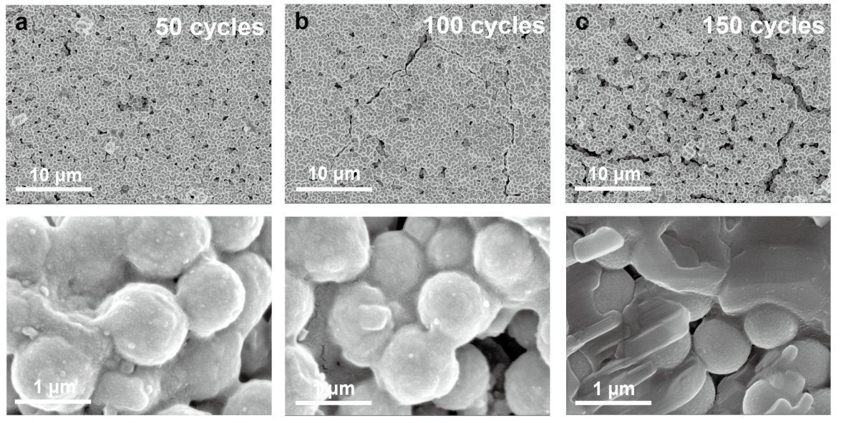
Fig. S26 The SEM images of EZS metacoating after thermal cycling between -196 °C and 150 °C: a 50 cycles, b 100 cycles and c 150 cycles

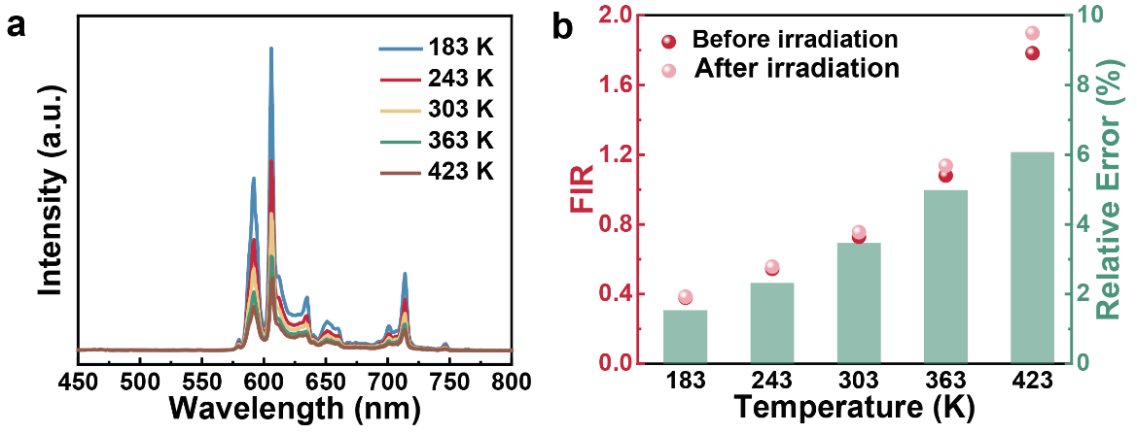
Fig. S27 a Temperature-dependent emission spectra (λ_{ex} = 395 nm) of the EZS metacoating after combined irradiations. b FIR values before and after combined irradiation at different temperatures and the corresponding relative error

Table S3 Comparison of α_{s} of the space radiative cooling coatings before and after different irradiations
Materials | Initial α_{s} | Irradiation type | Final α_{s} | References
Zn₂SiO₄ | 0.091 | Proton | 0.193 | [S9]
ZnO | 0.167 | Proton | 0.253 | [S9]
h-BN | 0.098 | Proton | 0.241 | [S9]
NaZnF₃/SiO₂ | 0.064 | Proton | 0.193 | [S45]
Ga₂O₃ | 0.085 | Proton | 0.174 | [S10]
Ca₃(PO₄)₂ | 0.093 | Proton | 0.143 | [S10]
ZnTiO₃ | 0.101 | Proton | 0.521 | [S46]
SrTiO₃ | 0.125 | Proton | 0.386 | [S46]
Z93C55 | 0.15 | Proton | 0.16 | [S47]
EZS | 0.076 | Proton | 0.090 | Our work
AZ-93 | 0.138 | Electron | 0.301 | [S48]
AZ-2100 | 0.272 | Electron | 0.336 | [S48]
AZ-2170 | 0.195 | Electron | 0.3 | [S48]
AZW/LA-II | 0.096 | Electron | 0.273 | [S48]
AZO/Al₂O₃-ZnO-Y₂O₃ | 0.409 | Electron | 0.426 | [S49]
ZnO | 0.138 | Electron | 0.192 | [S50]
BaSO₄ | 0.088 | Electron | 0.144 | [S51]
TiO₂ | 0.144 | Electron | 0.263 | [S51]
ZrO₂ | 0.081 | Electron | 0.171 | [S52]
Z93C55 | 0.15 | Electron | 0.36 | [S47]
EZS | 0.076 | Electron | 0.110 | Our work
AZW/LA-II | 0.096 | AO | 0.100 | [S53]
Z-93 | 0.12 | AO | 0.15 | [S54]
S13G/LO-1 | 0.13 | AO | 0.17 | [S54]
YB-71 | 0.08 | AO | 0.14 | [S54]
EZS | 0.076 | AO | 0.088 | Our work
PEO treated ZrO₂ | 0.205 | UV | 0.223 | [S15]
SolarWhite | 0.18 | UV | 0.24 | [S55]
SG121FD | 0.245 | UV | 0.452 | [S56]
Z-93 | 0.15 | UV | 0.18 | [S57]
YB-71 | 0.10 | UV | 0.19 | [S54]
EZS | 0.076 | UV | 0.159 | Our work
YB-71 | 0.090 | Electron and UV | 0.220 | [S58]
Z-93 | 0.136 | Electron and UV | 0.225 | [S57]
S13G/LO-1 | 0.165 | Electron and UV | 0.306 | [S57]
SG121FD | 0.245 | Electron and proton | 0.375 | [S56]
S781 | 0.193 | Proton, electron and UV | 0.392 | [S18]
SR107-ZK | 0.160 | Proton, electron and UV | 0.604 | [S18]
EZS | 0.076 | Proton, electron, AO and UV | 0.174 | Our work

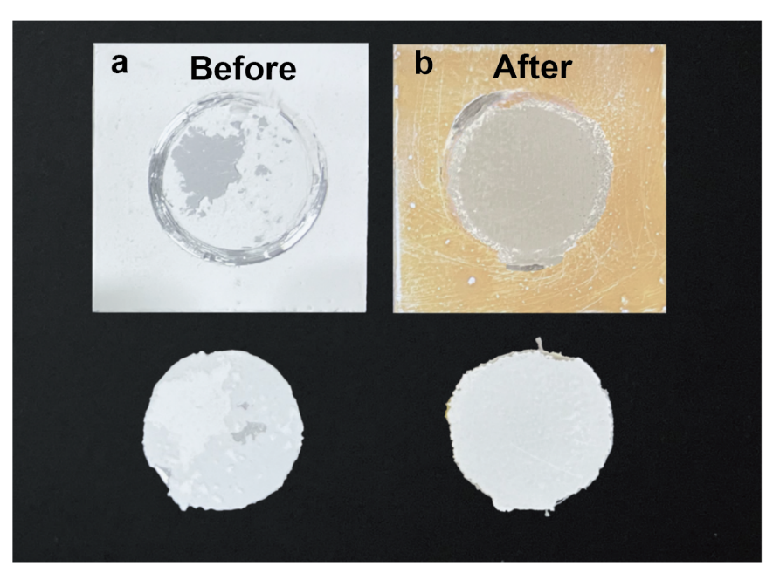
Fig. S28 Photographs of the EZS metacoating following pull-off testing: a before and b after combined irradiations

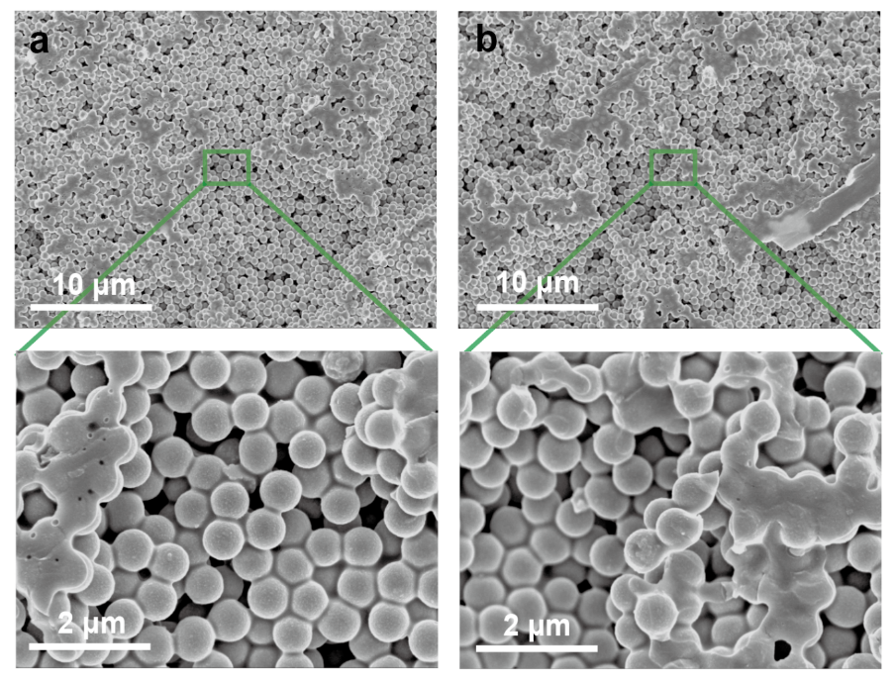
Fig. S29 The low and high-magnification SEM images of the interface between the EZS metacoating and the Al sheet a before and b after combined irradiations

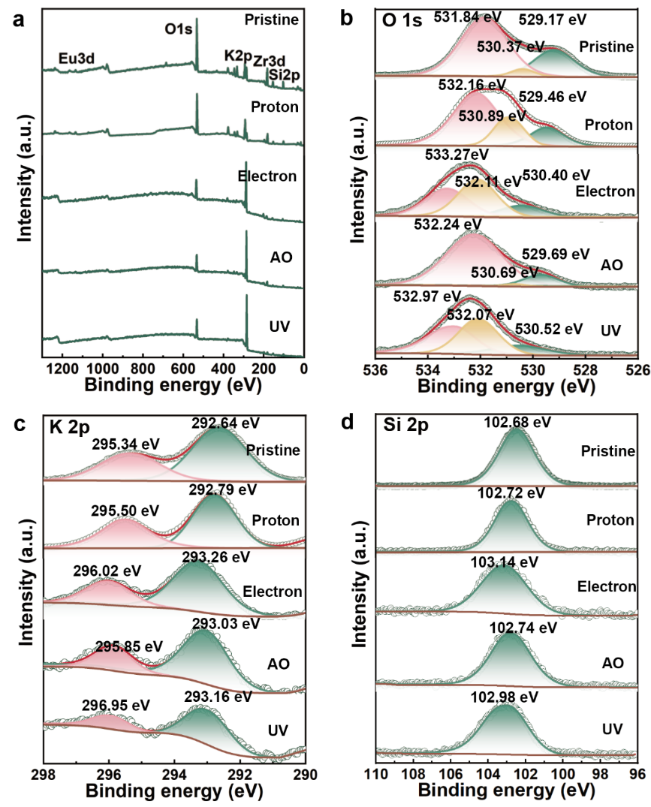
Fig. S30 XPS spectra of EZS metacoating before and after various irradiations: a survey spectra, b O 1s, c K 2p and d Si 2p high-resolution spectra
As shown in Fig. S30a, the XPS survey spectra confirm that the EZS metacoating primarily consists of Zr, O, Eu, K and Si. The high-resolution O 1s spectrum (Fig. S30b) of the pristine metacoating shows components at 529.17 eV (lattice oxygen, O_{L}), 530.37 eV (hydroxyl, −OH) and 531.84 eV (Si−O). After proton and AO irradiations, a slight binding-energy shift toward higher values occurs. The −OH increases under proton exposure but decreases after AO irradiation, reflecting their distinct redox mechanisms: proton irradiation introduces hydrogen-related defects, whereas AO exposure promotes surface oxidation. Electron and UV irradiations cause more significant changes, shifting the O 1s peaks to 530.40 eV, 532.11 eV and 533.27 eV (electron) and to 530.52 eV, 532.07 eV and 532.97 eV (UV), accompanied by enhanced −OH intensity. These shifts arise from charge accumulation induced by high-energy electron bombardment or photoexcitation, which increases surface potential and promotes hydroxyl enrichment.
The K 2p spectra (Fig. S30c) further elucidate the chemical state of potassium. In the pristine metacoating, the K 2p_{3/2} and K 2p_{1/2} peaks appear at 292.64 eV and 295.34 eV with a spin-orbit splitting of 2.7 eV, characteristic of monovalent K⁺. Proton and AO irradiations have negligible effects, while electron and UV exposures shift the peaks to 293.26/296.02 eV and 293.16/296.95 eV, respectively, with slightly increased splitting (2.76/2.79 eV). These shifts suggest enhanced localization of the K electron shell, likely due to local charge redistribution.
As shown in Fig. S30d, the Si 2p peak of the pristine metacoating is centered at 102.68 eV, corresponding to Si−O bonding. Proton and AO irradiations induce only minor changes, whereas electron and UV exposures shift the peak to 103.14 eV and 102.98 eV, accompanied by peak broadening. This behavior indicates partial bond-length variations and nonlocal charge rearrangement within the Si−O network under irradiations, reflecting perturbations of the local chemical environment.

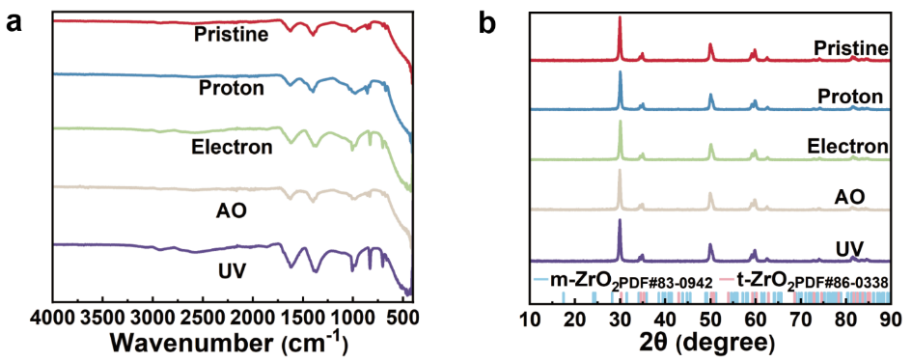
Fig. S31 a FTIR spectra and b XRD patterns of EZS metacoating after proton, electron, AO and UV irradiations
FTIR and XRD were employed to characterize the EZS metacoating after proton, electron, AO, and UV irradiations. As shown in Fig. S31a, the FTIR spectra display no discernible changes after proton or AO exposures. In contrast, electron and UV irradiations markedly increase the bands at 1629 cm⁻¹ and 1398 cm⁻¹, which are assigned to surface Si−OH vibrations or adsorbed H₂O and to carbonate (CO₃²⁻) or physiosorbed CO₂, respectively [S59–S61]. This enhancement suggests that high-energy electrons and UV irradiations generate surface defects that promote physisorption. XRD analysis (Fig. S31b) shows that the metacoatings after different irradiations retain the characteristic tetragonal ZrO₂ pattern with no peak shifts or emergent reflections, indicating the absence of lattice distortion, phase transformation, or amorphization. Peak intensities and full widths at half maximum also remain essentially unchanged, implying minimal variation in crystallite size and overall crystallinity.
Supplementary References
- J. Zhou, R. Lei, H. Wang, Y. Hua, D. Li et al., A new generation of dual-mode optical thermometry based on ZrO₂: Eu³⁺ nanocrystals. Nanophotonics 8(12), 2347–2358 (2018). https://doi.org/10.1515/nanoph-2019-0359
- J. Kaszewski, B.S. Witkowski, Wachnicki, T. Płociński, L.-I. Bulyk et al., Role of Zr³⁺ in excitation of Eu³⁺ ions in stabilized ZrO₂: Eu nanoparticles. J. Lumin. 273, 120654 (2024). https://doi.org/10.1016/j.jlumin.2024.120654
- X. Zhang, Y. Xu, X. Wu, S. Yin, C. Zhong et al., Optical thermometry and multi-mode anti-counterfeiting based on Bi³⁺/Ln³⁺ and Ln³⁺ doped Ca₂ScSbO₆ phosphors. Chem. Eng. J. 481, 148717 (2024). https://doi.org/10.1016/j.cej.2024.148717
- A. Gu, G.-H. Pan, H. Wu, L. Zhang, L. Zhang et al., Microstructure and photoluminescence of ZrTiO₄: Eu³⁺ phosphors: host-sensitized energy transfer and optical thermometry. Chemosensors 10(12), 527 (2022). https://doi.org/10.3390/chemosensors10120527
- Y. Xia, C. Zhang, J.-X. Wang, D. Wang, X.-F. Zeng et al., Synthesis of transparent aqueous ZrO₂ nanodispersion with a controllable crystalline phase without modification for a high-refractive-index nanocomposite film. Langmuir 34(23), 6806–6813 (2018). https://doi.org/10.1021/acs.langmuir.8b00160
- M.T. Colomer, Straightforward synthesis of Ti-doped YSZ gels by chemical modification of the precursors alkoxides. J. Sol Gel Sci. Technol. 67(1), 135–144 (2013). https://doi.org/10.1007/s10971-013-3059-9
- M. Tahmasebpour, A.A. Babaluo, M.K.R. Aghjeh, Synthesis of zirconia nanopowders from various zirconium salts via polyacrylamide gel method. J. Eur. Ceram. Soc. 28(4), 773–778 (2008). https://doi.org/10.1016/j.jeurceramsoc.2007.09.018
- H. Gong, L. Tong, Z. Wang, X. Song, H. Li et al., Material and structure tailored La-doped ZrO₂ submicrosphere metacoatings for high-performance space radiative cooling. Adv. Funct. Mater. e28343 (2026). https://doi.org/10.1002/adfm.202528343
- J. Lv, J. Xie, N. Vitaly, Development of Zn₂SiO₄ and hexagonal BN inorganic thermal-control coatings with novel thermophysical property. Int. J. Heat Mass Transf. 218, 124791 (2024). https://doi.org/10.1016/j.ijheatmasstransfer.2023.124791
- J. Lv, X. Wen, Development of Ca₃(PO₄)₂ inorganic thermal-control coating used in harsh space environments. Sol. Energy Mater. Sol. Cells 237, 111578 (2022). https://doi.org/10.1016/j.solmat.2022.111578
- N. Kiomarsipour, R. Shoja Razavi, K. Ghani, Improvement of spacecraft white thermal control coatings using the new synthesized Zn-MCM-41 pigment. Dyes Pigm. 96(2), 403–406 (2013). https://doi.org/10.1016/j.dyepig.2012.08.019
- V. Heydari, Z. Bahreini, Synthesis of silica-supported ZnO pigments for thermal control coatings and analysis of their reflection model. J. Coat. Technol. Res. 15(1), 223–230 (2018). https://doi.org/10.1007/s11998-017-9969-7
- V. Heydari, Z. Bahreini, M. Heidari, A. Sedrpoushan, Synthesis of Zn-SBA-15 as a new pigment for spacecraft white thermal control coatings. J. Coat. Technol. Res. 13(4), 727–733 (2016). https://doi.org/10.1007/s11998-015-9778-9
- Y. Yang, M. Jiang, Z. Ma, A.A. Rogachev, W. Tian et al., The coating with ZrO₂-coated hollow glass microspheres: Low solar absorption and high microwave transmittance. Mater. Des. 232, 112136 (2023). https://doi.org/10.1016/j.matdes.2023.112136
- J. Liang, Z. Peng, R. Li, B. Wang, Preparation of white ZrO₂ coating with low solar absorptance on aluminum alloy by plasma electrolytic oxidation. Ceram. Int. 49(17), 29133–29140 (2023). https://doi.org/10.1016/j.ceramint.2023.06.192
- H. Li, S. Lu, X. Wu, W. Qin, Influence of Zr⁴⁺ ions on solar absorbance and emissivity of coatings formed on AZ31 Mg alloy by plasma electrolytic oxidation. Surf. Coat. Technol. 269, 220–227 (2015). https://doi.org/10.1016/j.surfcoat.2015.01.070
- Z. Yao, P. Ju, Q. Xia, J. Wang, P. Su et al., Preparation of thermal control coatings on Mg–Li alloys by plasma electrolytic oxidation. Surf. Coat. Technol. 307, 1236–1240 (2016). https://doi.org/10.1016/j.surfcoat.2016.06.019
- W. Feng, Y. Ding, D. Yan, X. Liu, W. Wang et al., Combined low-energy environment stimulation test of geosynchronous satellite thermal control coatings. J. Spacecr. Rockets 46(1), 11–14 (2009). https://doi.org/10.2514/1.26291
- [S19] W.Q. Feng, Y.G. Ding, D.K. Yan. Space combined environment simulation test on α_{s} degradation of GEO satellite thermal control coatings. Spacecraft Environ. Eng. 24, 27 (2007). https://seejournal.cn/cn/article/pdf/preview/226c2a2f-ed28-497a-8ada-6e8d40e08c44
- V. Alcayde, A. Vercher-Martínez, F.J. Fuenmayor, Thermal control of a spacecraft: Backward-implicit scheme programming and coating materials analysis. Adv. Space Res. 68(4), 1975–1988 (2021). https://doi.org/10.1016/j.asr.2021.03.041
- W. Qin, X.H. Wu, G.M. Zhao, X.M. Lai, L.G. Zhang, Optical absorption properties of nanotitanium dioxide doped ZnO/silicone thermal control coating. Mater. Sci. Forum 546–549, 1725–1728 (2007). https://doi.org/10.4028/www.scientific.net/msf.546-549.1725
- D. Huang, Y. Wei, P. Dang, X. Xiao, H. Lian et al., Tunable color emission in LaScO₃: Bi³⁺, Tb³⁺, Eu³⁺ phosphor. J. Am. Ceram. Soc. 103(5), 3273–3285 (2020). https://doi.org/10.1111/jace.17007
- A. Bindhu, J.I. Naseemabeevi, S. Ganesanpotti, Vibrationally induced photophysical response of Sr₂NaMg₂V₃O₁₂: Eu³⁺ for dual-mode temperature sensing and safety signs. Adv. Photonics Res. 3(6), 2100159 (2022). https://doi.org/10.1002/adpr.202100159
- K. Su, Q. Guo, P. Shuai, N. Liu, L. Mei et al., A novel Eu²⁺/Tb³⁺ Co-doped phosphor with pyroxene structure applied for cryogenic thermometric sensing. J. Am. Ceram. Soc. 105(4), 2903–2913 (2022). https://doi.org/10.1111/jace.18275
- Q. Tang, N. Guo, Y. Xin, W. Li, B. Shao et al., Luminous tuning in Eu³⁺/Mn⁴⁺ Co-doped double perovskite structure by designing the site-occupancy strategy for solid-state lighting and optical temperature sensing. Mater. Res. Bull. 149, 111704 (2022). https://doi.org/10.1016/j.materresbull.2021.111704
- L. Ma, F. Lu, Q. Yu, P. Dai, F. Hu et al., A three-mode optical thermometry based on thermochromic Gd₂GaSbO₇: Bi³⁺, Eu³⁺ phosphors. Ceram. Int. 49(11), 16681–16689 (2023). https://doi.org/10.1016/j.ceramint.2023.02.029
- X. Liu, S. Shi, K. Yang, L. Chen, D. Deng et al., Temperature sensing characteristics of Bi³⁺/Eu³⁺ co-activated SrGa₂B₂O₇: Phosphor for dual-mode optical thermometry. J. Alloys Compd. 879, 160247 (2021). https://doi.org/10.1016/j.jallcom.2021.160247
- Q. Liu, M. Wu, B. Chen, X. Huang, M. Liu et al., Optical thermometry based on fluorescence intensity ratio of Dy³⁺-Doped oxysilicate apatite warm white phosphor. Ceram. Int. 49(3), 4971–4978 (2023). https://doi.org/10.1016/j.ceramint.2022.10.012
- J. Zheng, H. Shen, Y. Li, H. Li, Z. Yue, Structural and luminescent performance and optical thermometry of Pr³⁺ doped SrWO₄ down-conversion phosphors. J. Alloys Compd. 968, 172112 (2023). https://doi.org/10.1016/j.jallcom.2023.172112
- A.K. Sreelekshmi, S.P. Shamsudeen, S.D. Rani, D.N. Bhadran, R.G. Abhilash Kumar, Unraveling the photophysical response of BaLaLiTeO₆: Dy³⁺ double perovskites with excellent thermal stability for colour tunable LEDs and optical thermometry. Ceram. Int. 50(23), 50291–50308 (2024). https://doi.org/10.1016/j.ceramint.2024.09.374
- M. Fu, Z. Fan, P. Qiao, L. Hu, S. Liu et al., Dual-mode optical thermometers via the thermochromic Bi³⁺, Eu³⁺ Co-doped La₂LiSbO₆ phosphors for real-time chip temperature monitoring. Ceram. Int. 50(15), 26454–26463 (2024). https://doi.org/10.1016/j.ceramint.2024.04.372
- X. Huang, C. He, X. Zhu, C. Yang, Y. Liu et al., Synthesis and characterization of Eu³⁺-doped RbCaLa(VO₄)₂ phosphors and influence of temperature on fluorescence properties. Ceram. Int. 47(22), 32130–32137 (2021). https://doi.org/10.1016/j.ceramint.2021.08.104
- R. Raji, P.S. Anjana, N. Gopakumar, An insight into Judd-Ofelt analysis and non-contact optical thermometry of LiCa₂Mg₂V₃O₁: Dy³⁺ phosphors for multifunctional applications. Opt. Mater. 145, 114393 (2023). https://doi.org/10.1016/j.optmat.2023.114393
- Q. Wang, S. Zhao, J. Wen, X. Huang, C. Wei et al., A self-referenced fluorescence intensity ratio optical temperature sensing materials K₃YSi₂O₇: Bi³⁺/Sm³⁺based on multi-strategy combination. Ceram. Int. 49(24), 41264–41271 (2023). https://doi.org/10.1016/j.ceramint.2023.03.320
- Y. Chen, J. Chen, Y. Luo, Q. Wang, H. Guo, Ba₂LuNbO₆: Er³⁺, Yb³⁺ up-conversion phosphors for dual-mode thermometry based on fluorescence intensity ratio. J. Am. Ceram. Soc. 107(12), 8246–8255 (2024). https://doi.org/10.1111/jace.20058
- N. Degda, N. Patel, K. Chaudhari, K.V.R. Murthy, M. Srinivas, Ratiometric thermometry using down-conversion luminescence and solid-state lighting application of Er³⁺ activated strontium tungstate phosphor. Phys. B Condens. Matter 683, 415923 (2024). https://doi.org/10.1016/j.physb.2024.415923
- H. Gou, Q. Wu, L. Luo, W. Li, P. Du, Reengineering the thermometric behaviors of Er³⁺/Yb³⁺-codoped Gd₂Mo₃O₁₂ microparticles via dual-mode luminescence manipulation. Ceram. Int. 49(23), 38297–38304 (2023). https://doi.org/10.1016/j.ceramint.2023.09.162
- X. Xue, S. Yang, W. Liu, L. Dong, Q. Zhu et al., NaLaCaWO₆ double perovskite: Structure analysis, efficient Bi³⁺ to Eu³⁺ energy transfer and favourable visual optical thermometry. J. Mol. Struct. 1333, 141797 (2025). https://doi.org/10.1016/j.molstruc.2025.141797
- Y. Yan, F. Huang, G. Zhu, Y. Zhang, Z. Gao et al., Unique spectral broadening induced by exchange coupling between Cr³⁺ ions in LiAl₅O₈: Cr³⁺ phosphors for versatile optical applications. Laser Photonics Rev. 19(6), 2401588 (2025). https://doi.org/10.1002/lpor.202401588
- Y. Li, J. Song, L. Meng, M. Jiao, Q. Xu et al., Structure, luminescence property, and optical thermometry behavior of novel Bi³⁺-Eu³⁺ codoped tricalcium aluminate phosphor. J. Alloys Compd. 1010, 178079 (2025). https://doi.org/10.1016/j.jallcom.2024.178079
- N. Thakan, R. Lohan, A.S. Rao, N. Deopa, Structural and Luminescence attributes of Eu³⁺ ions activated Ba₂SrWO₆ phosphor for non-contact optical thermometry applications. J. Mol. Struct. 1346, 143169 (2025). https://doi.org/10.1016/j.molstruc.2025.143169
- G.L. Bhagyalekshmi, S. Ganesanpotti, Comprehension of the photoinduced charge transfer assisted energy transfer in Gd³⁺ based host sensitized tellurate phosphors for thermal sensing and anticounterfeiting labels. Dalton Trans. 53(19), 8229–8242 (2024). https://doi.org/10.1039/d4dt00259h
- X. Fan, L. Xu, W. Liu, F. Yin, J. Xu et al., Energy transfer in dual-emission LiY₆(BO₃)₃O₅: Bi³⁺, Eu³⁺ phosphors for temperature sensing applications. Ceram. Int. 50(18), 32583–32590 (2024). https://doi.org/10.1016/j.ceramint.2024.06.066
- Y. Xue, K. Qiang, F. Zhao, H. Yang, Q. Mao et al., Multiple linear regression-enhanced optical thermometry via phonon-assisted back energy transfer in Tm³⁺-Eu³⁺ Co-doped phosphors. Adv. Opt. Mater. 13(25), e01050 (2025). https://doi.org/10.1002/adom.202501050
- H. Chen, K. Xu, P. Li, J. Ma, Full solar-spectral reflectance and radiation stability of NaZnF₃ QDs/SiO₂ composite pigments as thermal control pigment. Ceram. Int. 48(23), 35432–35437 (2022). https://doi.org/10.1016/j.ceramint.2022.08.145
- M. Fang, J. Lv, Zn₂SiO₄ as an ultralow solar absorptive pigment for thermal control coating. Mater. Lett. 255, 126538 (2019). https://doi.org/10.1016/j.matlet.2019.126538
- M. Hasegawa, S. Freese, L. Kauder, J. Triolo, “Space Environmental Evaluation of White Conductive Thermal Control Coatings, ” in 42nd AIAA Thermophysics Conference, (2011): 3948. https://arc.aiaa.org/doi/abs/10.2514/6.2011-3948
- A. Sokolovskiy, E. Plis, R. Hoffmann, M. Bengtson, D. Ferguson, Study of the optical property degradation of white thermal control coatings under high energy electron irradiation. Surf. Coat. Technol. 451, 129030 (2022). https://doi.org/10.1016/j.surfcoat.2022.129030
- T. Li, H. Kang, S. Lu, W. Qin, X. Wu, Preparation of antistatic AZO/Al₂O₃-ZnO-Y₂O₃ composite thermal control coating and its study on electron-resistance radiation performance. Nucl. Instrum. Meth. Phys. Res. Sect. B Beam Interact. Mater. At. 518, 1–6 (2022). https://doi.org/10.1016/j.nimb.2022.03.004
- M.M. Mikhailov, A.N. Lapin, A.N. Sokolovskiy, S.A. Yuryev, Effect of atmosphere on recovery of diffuse reflection spectra of ZnO powder modified with nanoparticles upon irradiation in vacuum. Opt. Mater. 115, 111038 (2021). https://doi.org/10.1016/j.optmat.2021.111038
- M.M. Mikhailov, S.A. Yuryev, A.N. Lapin, Prospects for applying BaSO₄ powders as pigments for spacecraft thermal control coatings. Acta Astronaut. 165, 191–194 (2019). https://doi.org/10.1016/j.actaastro.2019.09.009
- M.M. Mikhailov, V.V. Neshchimenko, A.N. Sokolovskiy, V.Y. Yurina, Thermal control coatings based on pigments modified with Al₂O₃ nanoparticles. Prog. Org. Coat. 131, 340–345 (2019). https://doi.org/10.1016/j.porgcoat.2019.03.001
- [S53] M. Choi, “AZW-LA-II White paint on swift: lessons learned from first time flying on spacecraft radiators,” in 2nd International Energy Conversion Engineering Conference, (2004): 5685. https://arc.aiaa.org/doi/abs/10.2514/6.2004-5685
- [S54] J. Dever, E. Rodriguez, W. Slemp, J. Stoyack, “Evaluation of thermal control coatings for use on solar dynamic radiators in low earth orbit,” in 26th Thermophysics Conference, (1991): 1327. https://arc.aiaa.org/doi/abs/10.2514/6.1991-1327
- K.A.J. Doherty, B. Twomey, S. McGlynn, N. MacAuliffe, A. Norman et al., High-temperature solar reflector coating for the solar orbiter. J. Spacecr. Rockets 53(6), 1077–1084 (2016). https://doi.org/10.2514/1.A33561
- A.K. Sharma, N. Sridhara, Degradation of thermal control materials under a simulated radiative space environment. Adv. Space Res. 50(10), 1411–1424 (2012). https://doi.org/10.1016/j.asr.2012.07.010
- C.A. Cerbus, P.S. Carlin, Evaluation of reformulated thermal control coatings in a simulated space environment. Part 2. S-13GP/LO-1 and Z-93P. AIP Conf. Proc. 361(1), 851–856 (1996). https://doi.org/10.1063/1.49967
- D.A. Jaworske, S.E. Kline, “Review of end-of-life thermal control coating performance.” No. NASA/TM-2008-215173. 2008. https://ntrs.nasa.gov/citations/20080018585
- Z. Buniazet, J. Couble, S. Maury, A. Cabiac, S. Loridant et al., Acidity of SiO₂-supported metal oxides in the presence of H₂O using the AEIR method: 2. adsorption and coadsorption of NH₃ and H₂O on TiO₂/SiO₂ catalysts. Langmuir 36(45), 13383–13395 (2020). https://doi.org/10.1021/acs.langmuir.0c01717
- D.H. Lee, R.A. Condrate, An FTIR spectral investigation of the structural species found on alumina surfaces. Mater. Lett. 23(4–6), 241–246 (1995). https://doi.org/10.1016/0167-577X(95)00039-9
- Musyarofah, S. Soontaranon, W. Limphirat, Triwikantoro, S. Pratapa, XRD, WAXS, FTIR, and XANES studies of silica-zirconia systems. Ceram. Int. 45(12), 15660–15670 (2019). https://doi.org/10.1016/j.ceramint.2019.05.078

