Supporting Information for
3D Printing Plasmonic-Enhanced Sulfurized Polyacrylonitrile Cathodes for High-energy Li–S Microbatteries
Yu Liu¹, Penghao Fu¹, Jieshan Qiu³, and Zhiyu Wang^{1, 2,} *
¹ State Key Lab of Fine Chemicals, Frontiers Science Center for Smart Materials Oriented Chemical Engineering, Liaoning Key Lab for Energy Materials and Chemical Engineering, School of Chemical Engineering, Dalian University of Technology, Dalian 116024, P. R. China
² School of Chemical Engineering and Technology, Xinjiang University, Urumqi 830046, P. R. China
³ College of Chemical Engineering, Beijing University of Chemical Technology, Beijing 100029, P. R. China
*Corresponding author. E-mail: zywang@dlut.edu.cn (Zhiyu Wang)
S1 Experimental Section
Synthesis of Ti₃C₂T_{x} MXene
The Ti₃C₂T_{x} MXene was synthesized by etching 5.0 g of Ti₃AlC₂ MAX phase in a mixed solution of LiF (13.2 g) and hydrochloric acid (6 M, 200 mL) for 72 h at 45 °C. The obtained products were harvested by several centrifugation-rinsing cycles with deionized (DI) water, followed by ultrasonic treatment in DI water for 1 h [S1].
Material characterization
The morphology of the samples was examined by scanning electron microscopy (SEM, JSM-7900). The texture and composition of the materials were characterized by X-ray diffraction (XRD, Rigaku D/MAX-2400, Cu Kα), X-ray photoelectron spectroscopy (XPS, Shimadzu AXIS SUPRA+), Raman spectroscopy (Horiba LabRAM), Fourier transform infrared spectroscopy (FTIR, Thermo Fisher iS50), and an elemental analyzer (Elementar Vario EL cube). The rheological property of the ink was measured by a rheometer (DHR2, TA Instruments-Waters LLC). The localized surface plasmon resonance (LSPR) properties of MXene were measured by UV-vis spectroscopy (PerkinElmer Lambda 750) and femtosecond transient absorption spectroscopy (fs-TAS).
Measurement of ionic conductivity
The ionic conductivities (σ) of GPE and LE were obtained from the impedance spectroscopy of the symmetric cells employing stainless-steel (SS) foils as the working electrodes by the following equation:
σ = L / (A × R) (S1)
where R is the ohmic resistance, A is the electrode area, and L is the space between two SS electrodes. The data points from –20 °C to 60 °C were collected on a CHI 760E electrochemical workstation in a frequency range of 100 kHz–0.01 Hz. The E_{a} was calculated by the Arrhenius law:
σ = B exp (−E_{a} / RT) (S2)
where B is the frequency factor, R is the molar gas constant, and T is the absolute temperature.
Measurement of Li⁺ transference number
The Li⁺ transference numbers (t_{Li⁺}) of GPE and LE were determined by the potentiostatic polarization technique using Li||Li symmetric cells on a Vertex C.EIS electrochemical workstation (IVIUM). The t_{Li⁺} was calculated by the following equation:
t_{Li⁺} = [I_{ss} × (∆V – I₀ × R₀)] / [I₀ × (∆V – I_{ss} × R_{ss})] (S3)
where ΔV is the applied bias voltage, while the initial current (I₀) and the steady current (I_{ss}) can be obtained under a direct current voltage of 10 mV. The interface resistance before (R₀) and after polarization (R_{ss}) was determined through AC impedance with an amplitude of 10 mV in the frequency range of 100 kHz–0.01 Hz.
Measurement of electrochemical stability window and Tafel plots
The electrochemical stability window (ESW) of the GPE and LE was measured by linear sweep voltammetry (LSV) scan of an asymmetric coin cell utilizing Li metal foil against SS at a scan rate of 5 mV s⁻¹. The Li||Li symmetric cells were used to get Tafel plots within −0.1–0.1 V at a scan rate of 0.1 mV s⁻¹.
In-situ measurement and analysis
In-situ Raman and UV-vis analysis were performed using 3D-HSPAN as the working electrode against Li metal in GPE. For comparison, In-situ tests were also conducted for the SC-HSPAN cathodes against the Li metal anode in GPE. In-situ UV-vis analyses were conducted by using a customized battery device with a quartz window in reflection mode on a UV-vis-NIR spectrometer (PerkinElmer Lambda 750). The Li metal with a circular hole was used against the working electrode to enable access of the electrolyte to UV light. The UV-vis spectra were recorded every 300 s in a wavelength range of 450–600 nm during cell operation at a potential range of 1.0–3.0 V at 0.2 C on a LAND CT2001A battery tester. The intensity of the UV-vis signal was positively correlated with LiPS concentration based on the Beer-Lambert law. In-situ Raman analysis was performed by using a 3D-HSPAN cathode against Li metal foil in GPE in a homemade device with a quartz window on a Raman spectrometer (Zhongke Kaili, China) with a laser wavelength of 532 nm every 10 min. Meanwhile, the cell was discharged at 0.2 C on a LAND CT2001A battery tester. In-situ EIS measurements were conducted by using a 3D-HSPAN cathode against Li metal foil in GPE on a CHI 760E electrochemical workstation. The EIS patterns were recorded at different voltages in a frequency range of 100 kHz–0.01 Hz with 10 mV amplitude. Distribution of relaxation times (DRT) and the distribution of diffusion times (DDT) results were derived from these impedance data by using DRT tools based on Bayesian regularization with continuous function discretization.
Calculation of extinction coefficient and photothermal conversion efficiency of MXene [S2]
The extinction coefficient (ε) was calculated by performing a linear fit of UV-vis absorption spectra of MXene aqueous solution with varying concentrations at a wavelength (λ) of 780 nm based on the Beer–Lambert law:
$A\left(λ\right)=εCL$ (S4)
where A is the absorbance at a certain λ, L is the optical path length, and C is the concentration of MXene aqueous solution.
The photothermal conversion efficiency (η) was calculated as the ratio of the energy converted from light to heat to the total received optical energy. The energy balance of the entire system adheres to the following equation:
$∑_{i}m_{i}C_{p,i}\frac{dT}{dt}=Q_{MXene}+Q_{Dis}-Q_{surr}$ (S5)
where m and C_{p} are the mass and heat capacity of water, T is the temperature of MXene aqueous solutions, Q_{MXene} is the optical energy captured by MXene, Q_{Dis} is the baseline energy of the sample cell, and Q_{surr} is the heat energy dissipated from the system to the surrounding environment. Q_{MXene}, Q_{Dis,} and Q_{surr} are determined by the following equations:
$Q_{MXene}=I\left(1-{10}^{-A_{λ}}\right)η$ (S6)
$Q_{Dis}=hS(T_{max,water}-T_{surr,water})$ (S7)
$Q_{Surr}=hS(T-T_{surr})$ (S8)
where I is the laser power density, A_{λ} is the absorbance of MXene at λ = 808 nm, η is the photothermal conversion efficiency of MXene, T is the temperature of the system surface, T_{surr} is the temperature of the surrounding environment, T_{max, water} and T_{surr, water} are the temperature of pure water after exposure to the NIR light and under ambient conditions, respectively. The h is the heat transfer coefficient, and S is the surface area of the heat transfer.
The driving force for heat exchange (θ) and time constant of the sample system (τ_{s}) were calculated by the following equations:
$θ=\frac{T-T_{surr}}{T_{max}-T_{surr}}$ (S9)
$τ_{s}=\frac{∑_{i}m_{i}C_{p,i}}{hS}$ (S10)
During the cooling period of the MXene aqueous solution, no additional energy is input, namely:
$Q_{MXene}+Q_{Dis}=hS\left(T_{max}-T_{surr}\right)$ (S11)
The heat transfer time constant can be determined from the cooling curve, and integrating gives the expression as follows:
$dt=-τ_{s}\frac{dθ}{θ}$ (S12)
$t=-τ_{s}\ln{θ}$ (S13)
On this basis, the η was determined by the following equation:
$η=\frac{hS\left(T_{max}-T_{surr}\right)-Q_{Dis}}{I(1-{10}^{-A_{λ}})}$ (S14)
S2 Supplementary Figures

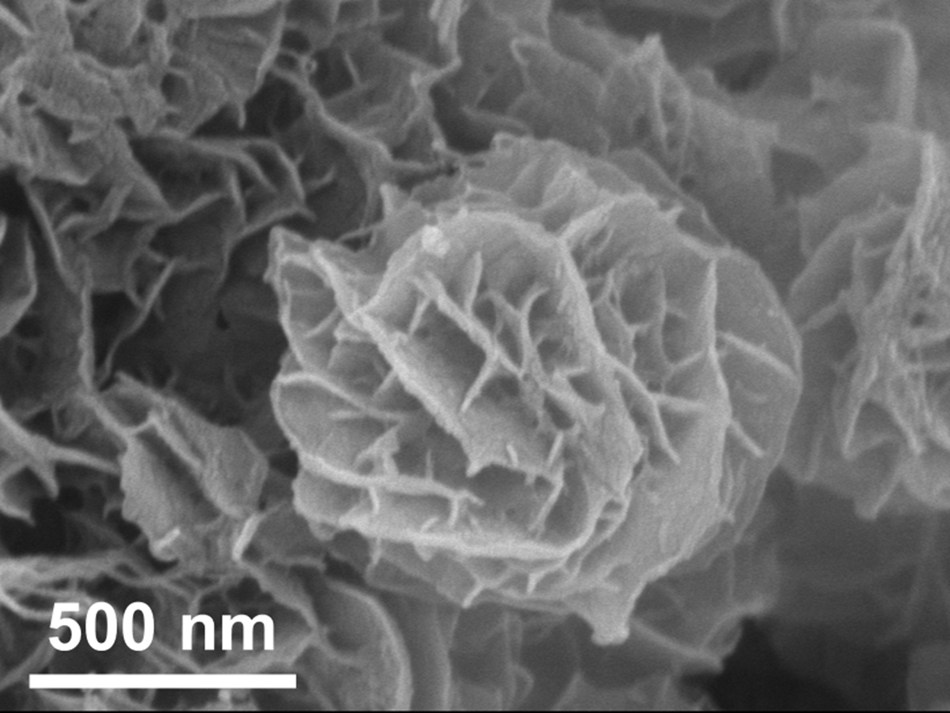
Fig. S1 SEM image of HPAN

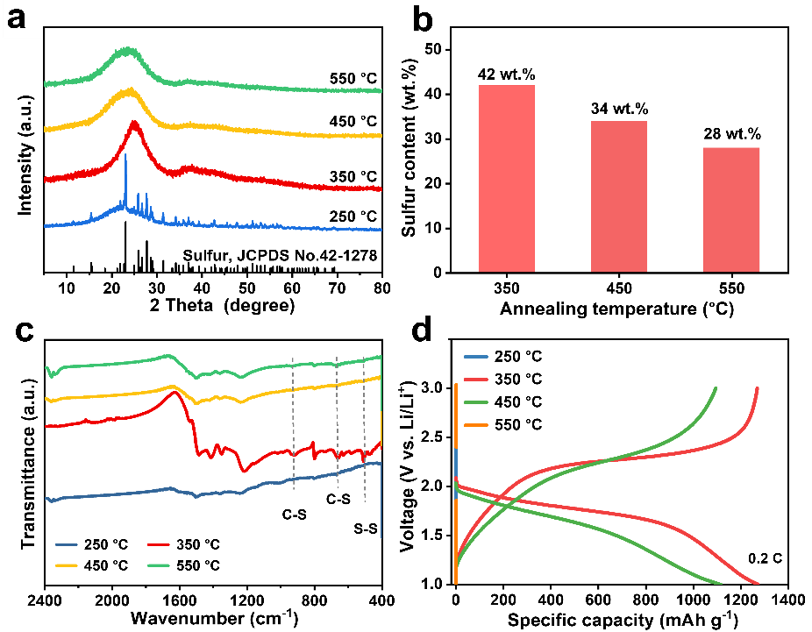
Fig. S2 a XRD patterns, b sulfur content, c FT-IR spectra, and d discharge-charge voltage curves of HSPAN cathodes synthesized at 250, 350, 450, and 550 ºC

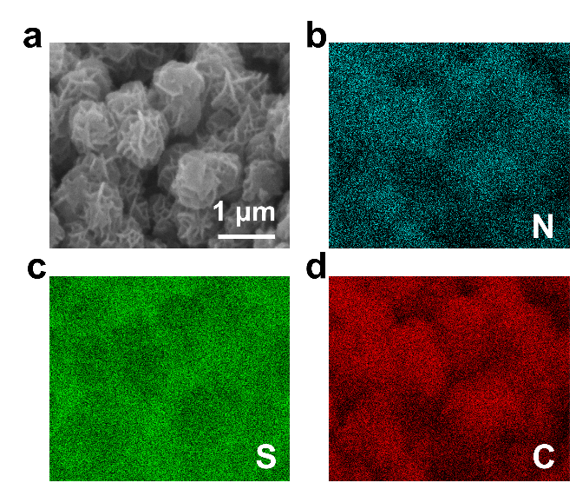
Fig. S3 a SEM image and b, c, d corresponding element mapping of HSPAN
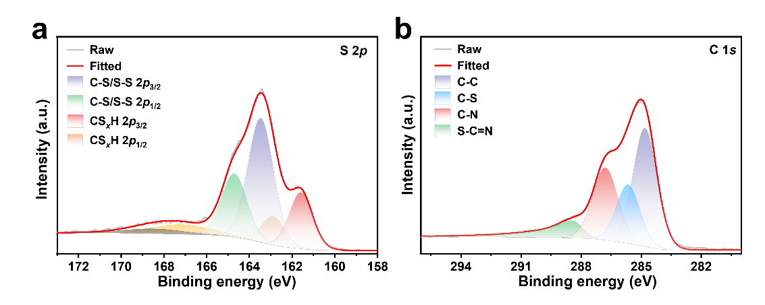
Fig. S4 a S 2p and b C 1s XPS spectra of HSPAN
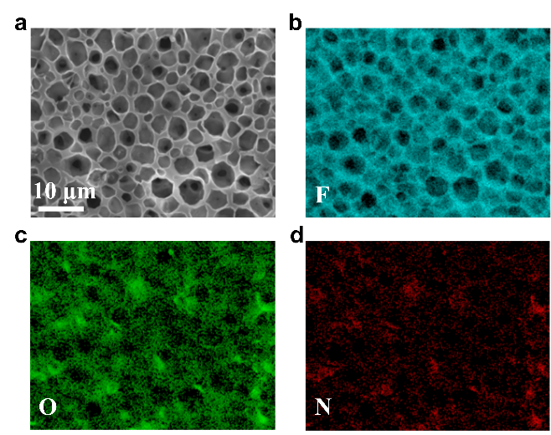
Fig. S5 a SEM image and b, c, d corresponding element mapping of LiNO₃@PVDF-HFP membrane

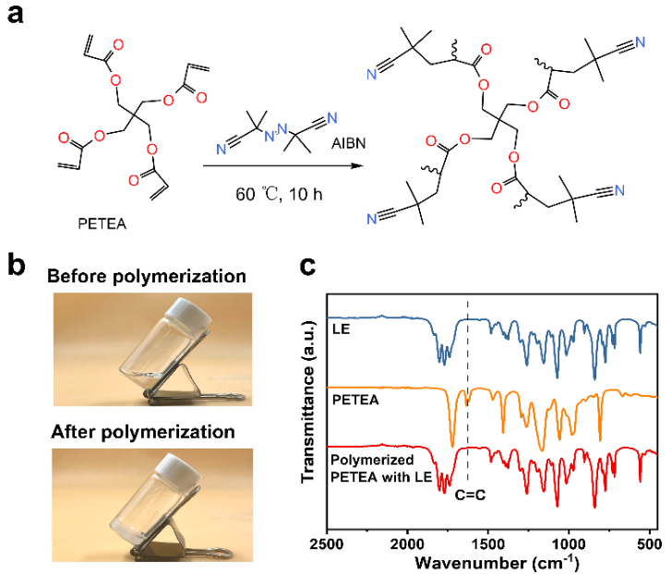
Fig. S6 a Thermal-driven radical polymerization route of PETEA with AIBN as a radical initiator. b Optical images of LE containing PETEA and AIBN before and after thermal polymerization. c FTIR spectra of LE, PETEA, and polymerized PETEA with LE
Fig. S7 a Temperature-dependent ionic conductivity of GPE and LE, fitted using the Arrhenius transport model. b Comparison of GPE and LE in ionic conductivity and Li⁺ transference number. The chronoamperometry profile of c Li|LE|Li and d Li|GPE|Li cells under a polarization voltage of 10 mV. The insets are the corresponding EIS spectra before and after polarization in a frequency range of 100 kHz–0.01 Hz
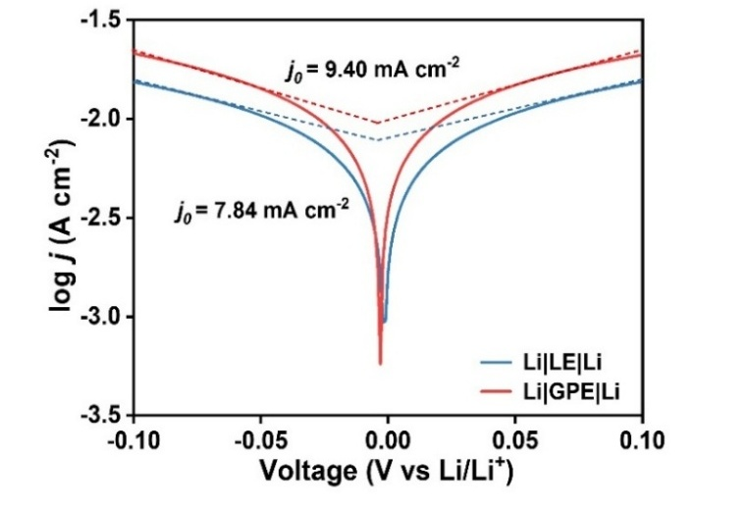
Fig. S8 Exchange current density of Li|LE|Li and Li|GPE|Li cells at a scan rate of 0.1 mV s⁻¹

Fig. S9 LSV curves of LE and GPE measured in asymmetric Li||SS cells at a scan rate of 5 mV s⁻¹

Fig. S10 a EIS patterns of 3D-HSPAN and SC-HSPAN electrodes after discharge in a frequency range of 100 kHz–0.01 Hz. b The correlation between Z’ and ω^{–1/2} at low frequency derived from EIS patterns

Fig. S11 GITT curves of 3D-HSPAN and SC-HSPAN cathodes in GPE

Fig. S12 In-situ EIS spectra of a, b 3D-HSPAN and c, d SC-HSPAN cathodes at different states of discharge and charge in a frequency range of 100 kHz–0.01 Hz

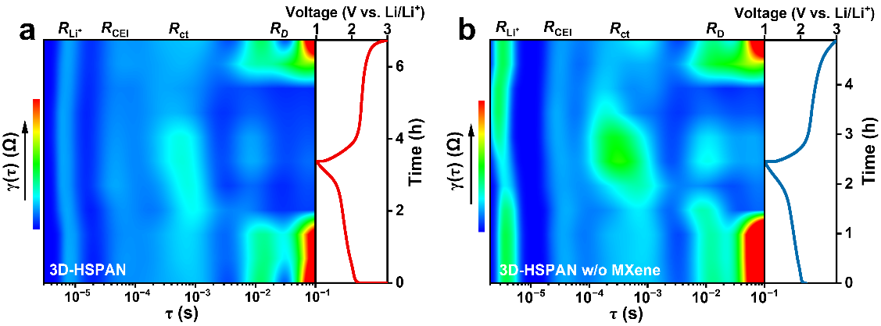
Fig. S13 DRT profiles derived from in-situ EIS patterns of 3D-HSPAN a with and b without MXene in GPE

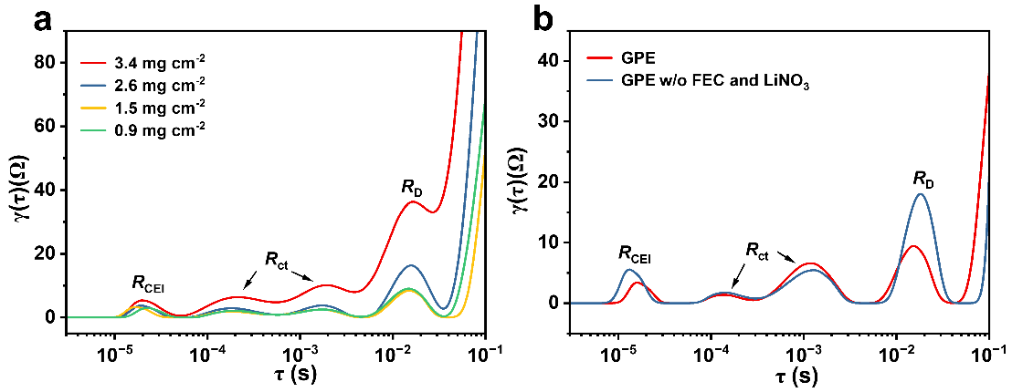
Fig. S14 DRT curves derived from EIS patterns of 3D-HSPAN electrodes a with varying mass loadings in GPE and b in GPE with and without FEC/LiNO₃ additives

Fig. S15 DDT curves derived from EIS patterns of 3D-HSPAN and SC-HSPAN cathodes

Fig. S16 a N 1s, b F 1s, and c C 1s XPS spectra of the SEI formed in LE and GPE

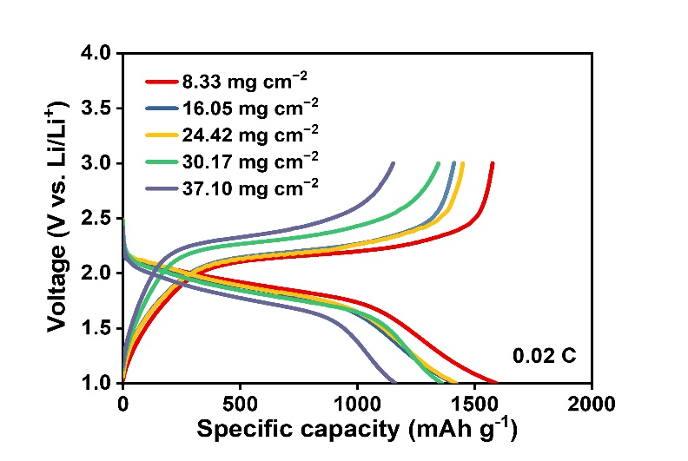
Fig. S17 Discharge-charge voltage curves of the 3D-HSPAN cathodes with various mass loadings at 0.02 C

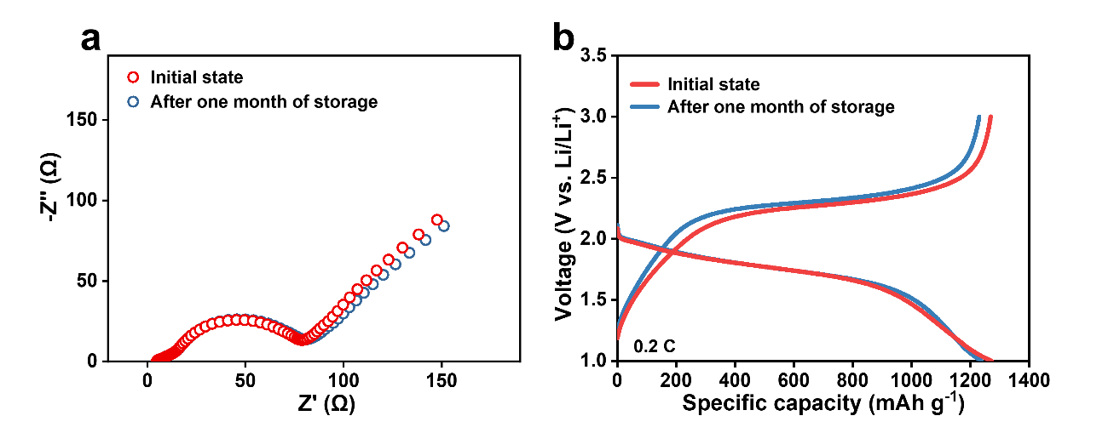
Fig. S18 a EIS plots and b discharge-charge voltage curves of 3D-HSPAN|GPE|Li before and after one month of storage
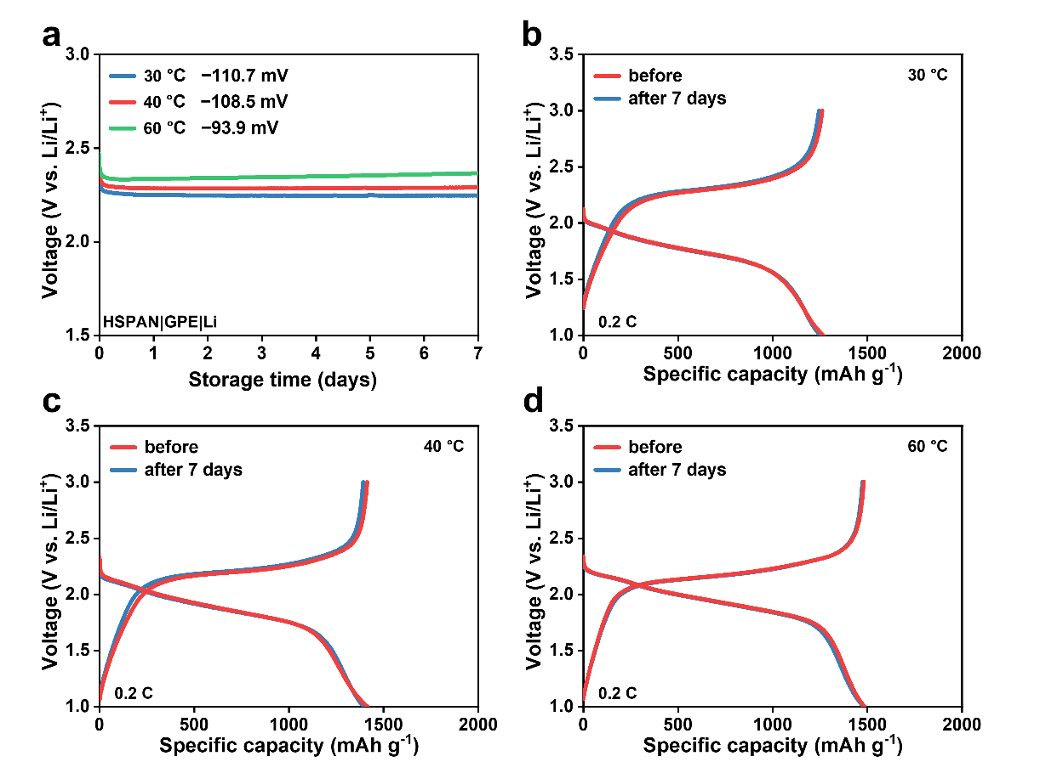
Fig. S19 a OCV of 3D-HSPAN|GPE|Li batteries at different temperatures over 7 days of standing. Discharge-charge voltage curves of 3D-HSPAN|GPE|Li batteries before and after 7 days of standing at b 30 ºC, c 40 ºC, and d 60 ºC

Fig. S20 CV curves of 3D-HSPAN|GPE|Li cell at a scan rate of 0.1 mV s^{–1}

Fig. S21 a UV-vis-NIR absorption spectra of MXene colloids with different concentrations. b Linear fitting of MXene colloid concentration with absorbance in UV-vis-NIR absorption spectra. c Photothermal response of the MXene colloid with different concentrations under NIR light at λ = 808 nm

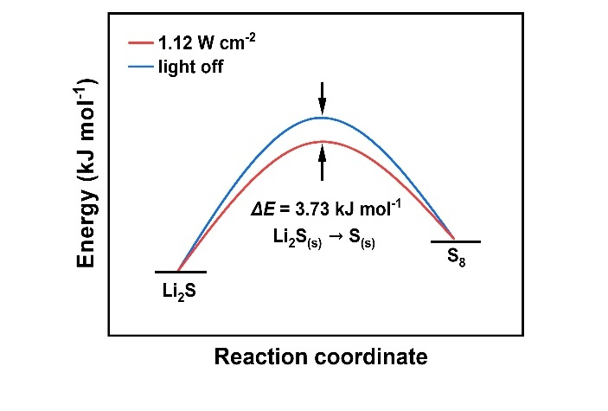
Fig. S22 Relative activation energies for Li₂S-to-S₈ conversion

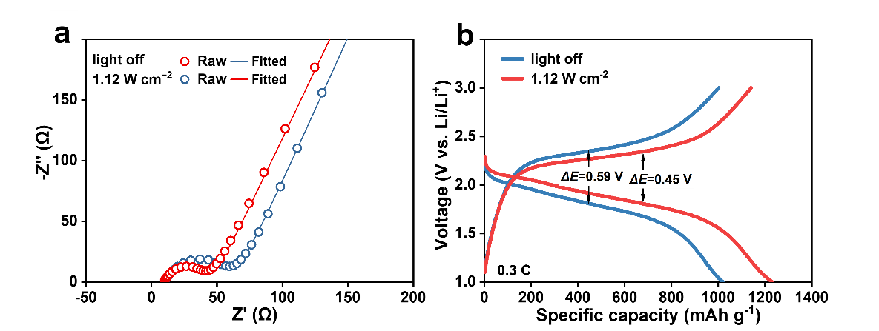
Fig. S23 a EIS plots and b discharge-charge voltage curves of 3D-HSPAN|GPE|Li cells under NIR irradiation or in the dark with 5 wt.% MXene

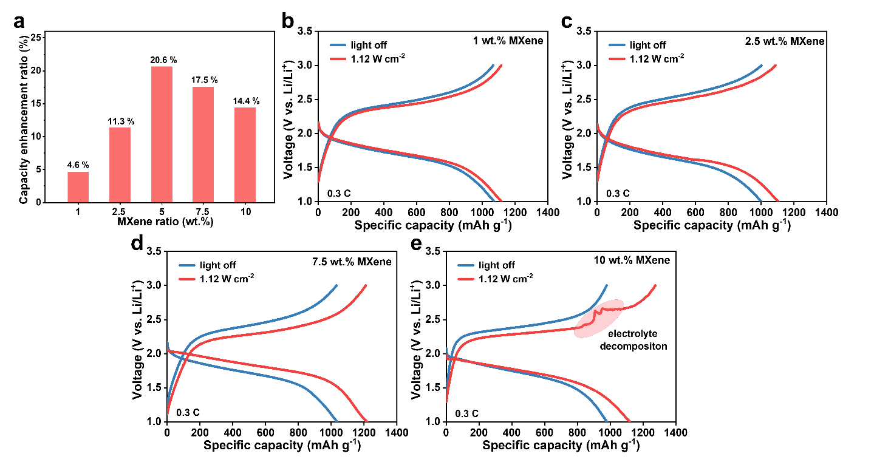
Fig. S24 a Capacity enhancement ratio of cathodes with different MXene contents under light illumination. Discharge-charge voltage curves of 3D-HSPAN|GPE|Li cells under NIR irradiation or in the dark with b 1 wt.%, c 2.5 wt.%, d 7.5 wt.%, and e 10 wt.%

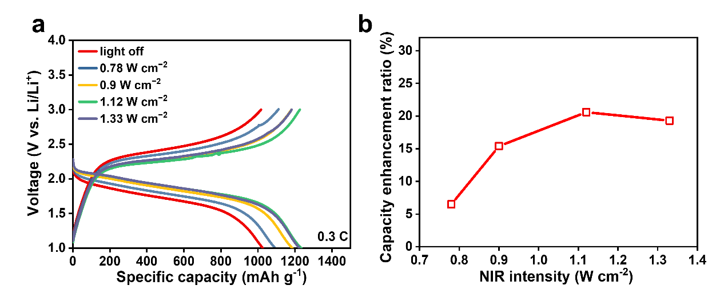
Fig. S25 a Discharge-charge voltage curves and b capacity enhancement ratio of 3D-HSPAN|GPE|Li batteries at different NIR irradiation powers

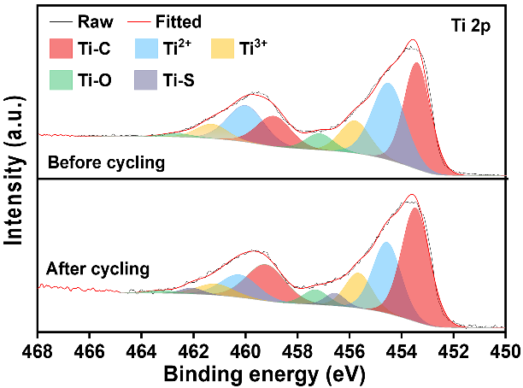
Fig. S26 Ti 2p XPS spectra of the 3D-HSPAN cathode after 45 cycles at 0.3 C under NIR irradiation (1.12 W cm⁻²)

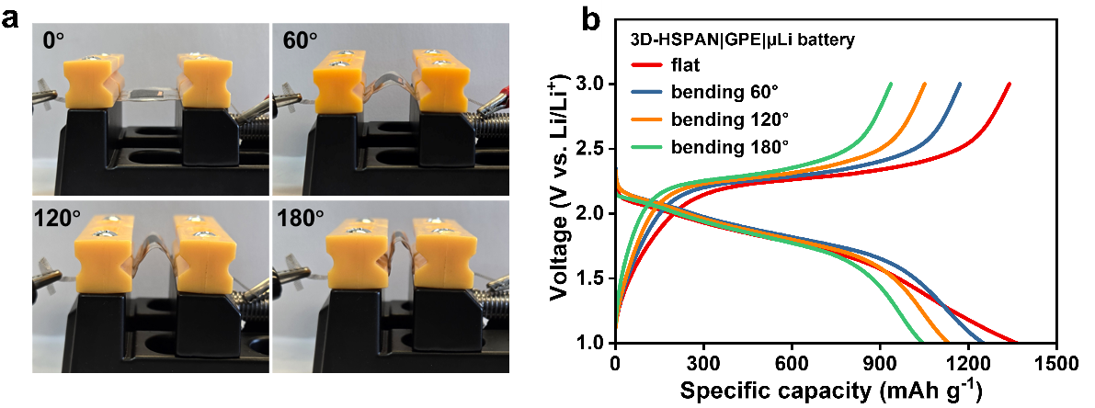
Fig. S27 a Optical images of 3D-HSPAN|GPE|μLi micro-batteries at different bending states. b Discharge-charge voltage curves of 3D-HSPAN|GPE|μLi micro-battery at different bending states
Supplementary References
[S1] Y. Liu, X. Meng, Z. Wang, J. Qiu, A Li₂S-based all-solid-state battery with high energy and superior safety. Sci. Adv. 8(1), eabl8390 (2022). https://www.science.org/doi/10.1126/sciadv.abl8390
[S2] H. Lin, S. Gao, C. Dai, Y. Chen, J. Shi, A two-dimensional biodegradable niobium carbide (MXene) for photothermal tumor eradication in NIR-I and NIR-II biowindows. J. Am. Chem. Soc. 139(45), 16235-16247 (2017). https://doi.org/10.1021/jacs.7b07818

