Bionic Cooling Skin for Infected Wound Healing
Shuo Shi^{1, #}, Huiqun Zhou^{2, #}, Yang Ming^{1, #}, Xiong Zhou², Hanbai Wu¹, Haipeng Ren¹, Lung Chow², Jing Su³, Daming Chen¹, Bin Fei¹, Joselito M. Razal¹, Xungai Wang^{4*}
¹ Joint Research Centre for Fiber Innovations and Renewable Materials, School of Fashion and Textiles, The Hong Kong Polytechnic University, 999077, Hong Kong S.A.R, P. R. China
² Department of Biomedical Engineering, City University of Hong Kong, 999077, Hong Kong S.A.R, P. R. China
³ College of Textile Science and Engineering, Jiangnan University, Wuxi 214122, P. R. China
⁴ State Key Laboratory of Bio-based Fiber Materials, College of Textile Science and Engineering, Zhejiang Sci-Tech University, Hangzhou 310016, P. R. China
# Shuo Shi, Huiqun Zhou, and Yang Ming contributed equally to this work.
* Corresponding author. E-mail: xwang@zstu.edu.cn (Xungai Wang)
Supplementary Tables and Figures
Table S1 Materials and formula for preparing PVDF@Fex-ZIF8
Items | Fe: Zn | FeCl₂•4H₂O | Zn(NO₃)₂•6H₂O | 2-Methylimidazole | Methanol | PVDF
Items | (mol: mol) | (mg) | (mg) | (g) | (g) | (g)
PVD@FZIF8 | 0:100 | 0 | 500.40 | 1.255 | 40 | 0.10
PVDF@Fe5-ZIF8 | 5:95 | 16.79 | 477.62 | 1.255 | 40 | 0.10
PVDF@Fe10-ZIF8 | 10:90 | 33.59 | 452.41 | 1.255 | 40 | 0.10
PVDF@Fe20-ZIF8 | 20:80 | 67.56 | 404.40 | 1.255 | 40 | 0.10
PVDF@Fe30-ZIF8 | 30:70 | 101.38 | 353.85 | 1.255 | 40 | 0.10

Table S2 The primer sequences used for qPCR
Gene name | Forwards primer | Reverse primer
VEGF | GCCTCTTCTTCCACCACT | GAAACACGACAAACCCAT
bFGF | ACCAGCCTTCCACCCAAA | CGCACCCTATCCCTTCACA
Col1 | TTGGGATGGAGGGAGTTTA | TACAGCACGCTTGTGGATG
Col3 | ACTGTCAGAGCTACTACGCA | CGGCATCTAACTCTCCGTAG
GAPDH | TGTCCCTAATGACAGCTCCTT | GCATCCACCCAAATGACACA
Table S3 Surface Element Composition (XPS) of ZIF8 and Fe20-ZIF8
XPS atomic % (at.%)
Sample | C | N | O | Zn | Fe
ZIF8 | 61.93 | 24.1 | 6.51 | 7.34 | 0.11
Fe20-ZIF8 | 66.4 | 18.88 | 6.75 | 4.69 | 1.27

Fig. S1 FT‐IR spectra of PVDF electrospun membrane.

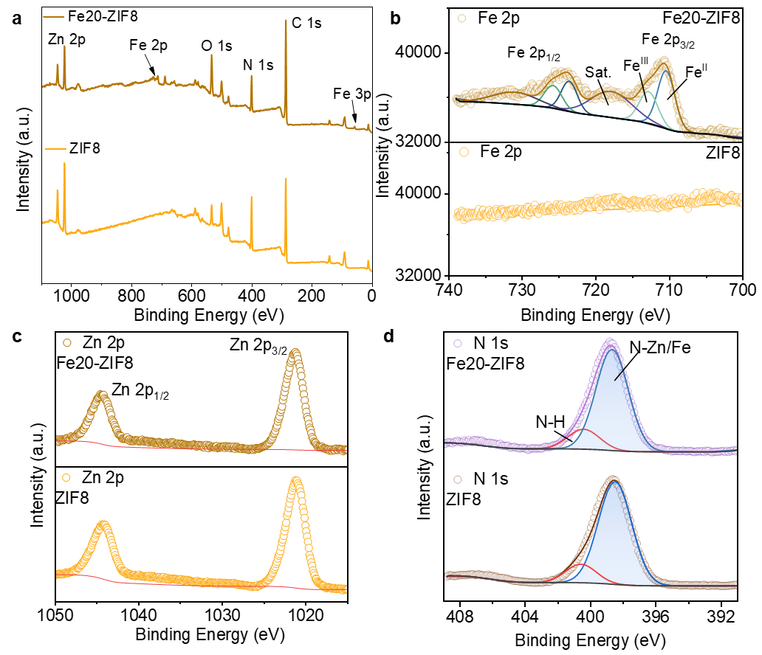
Fig. S2 (a) X-ray photoelectron spectroscopy survey (XPS), all XPS peaks are calibrated using C 1s peak of 284.8 eV of Fe20-ZIF8 and ZIF8; corresponding (b) Zn 2p, (c) Fe 2p and (d) N 1s high-resolution spectrum.
Fig. S3 The diameter distribution of PVDF nanofibers.
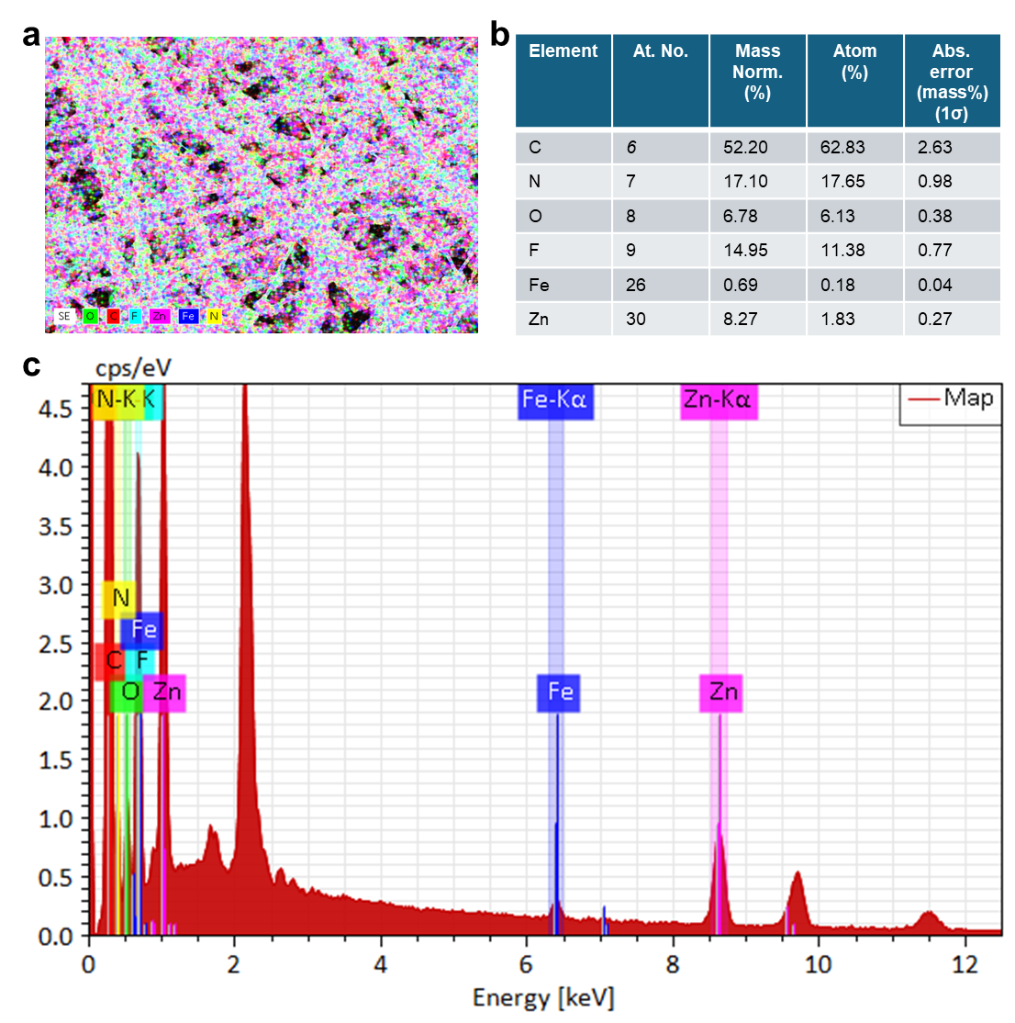
Fig. S4 EDS elemental mapping image of PVDF@Fe20-ZIF8 electrospun membrane, and atom percentages of the membrane.
Fig. S5 Band gap of PVDF@Fex-ZIF8 electrospun membrane.
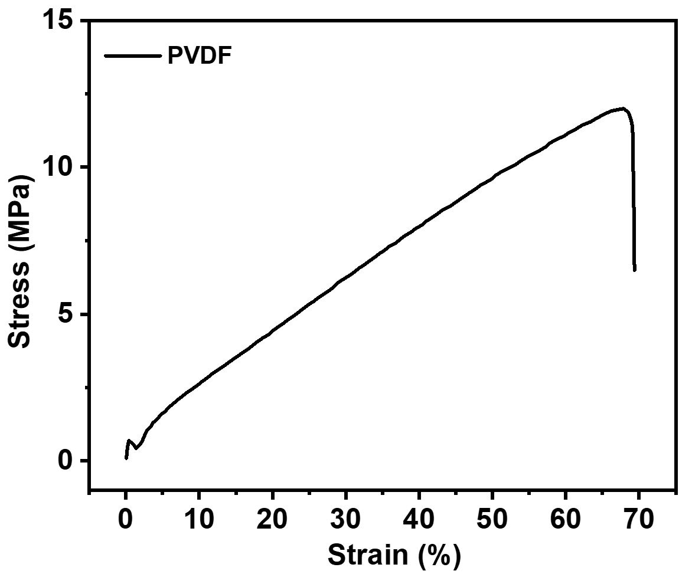
Fig. S6 Strain-stress curve of PVDF electrospun membrane before treatment.

Fig. S7 Filtration efficiency of PVDF@Fex-ZIF8 electrospun membrane.

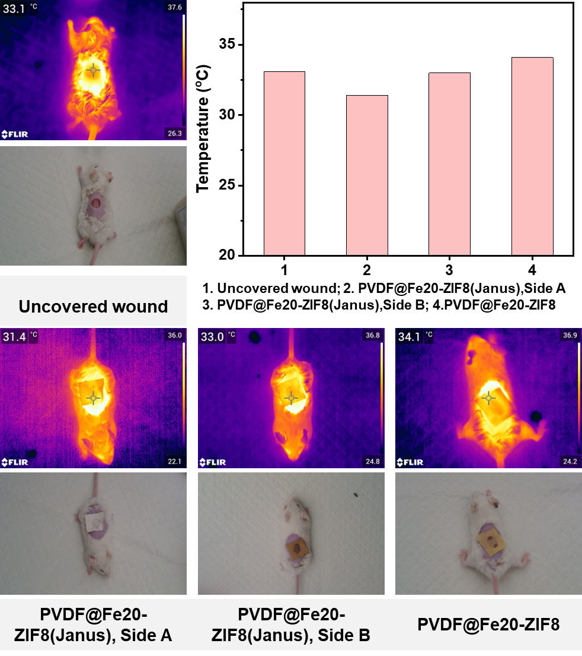
Fig. S8 Infrared camera pictures of the designed bionic wound dressing, such as PVDF@Fe20-ZIF8, and PVDF@Fe20-ZIF8(Janus) used for wound repair in mice outdoors.

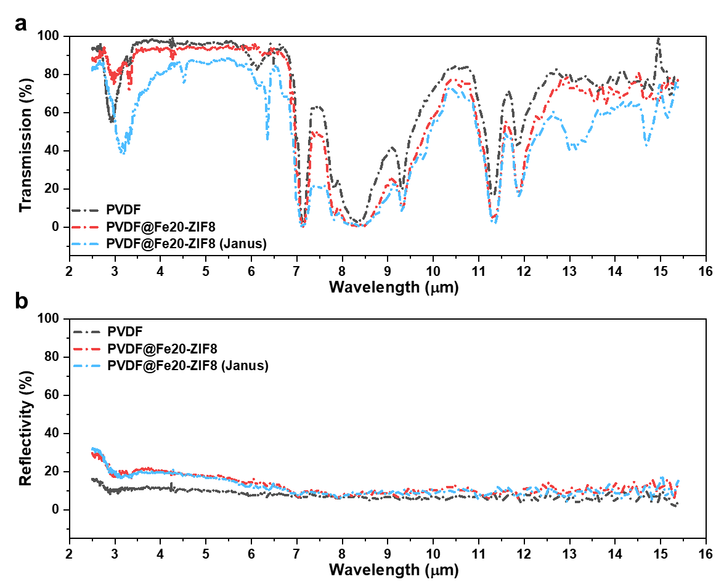
Fig. S9 Transmission and reflectivity spectra of PVDF, PVDF@ZIF8 (Janus), PVDF@Fe20-ZIF8 (Janus).
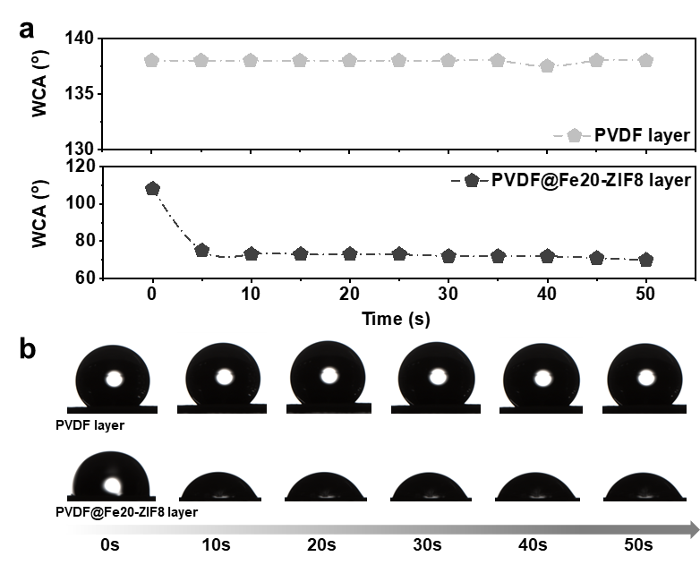
Fig. S10 The water contact angle of the PVDF layer and PVDF@Fe-ZIF8 layer of the Janus membrane.

Fig. S11 Body weight of different groups of mice during the wound healing process.

Fig. S12 White blood cell count, lymphocyte count, monocyte count, and neutrophil count of different groups of mice blood.

Fig. S13 Platelet count, platelet volume, and platelet distribution of mice blood.

Fig. S14 Red blood cell count, hemoglobin content, and mean corpuscular volume of mice blood.

Fig. S15 In vivo antibacterial efficiency of different experimental groups.

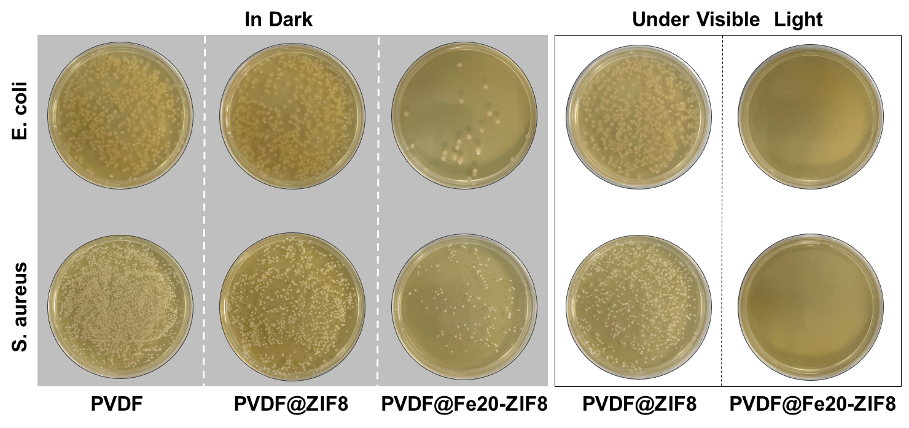
Fig. S16 In vitro antibacterial assays of PVDF, PVDF@ZIF8, PVDF@Fe20-ZIF8 in dark and under visible light environments.
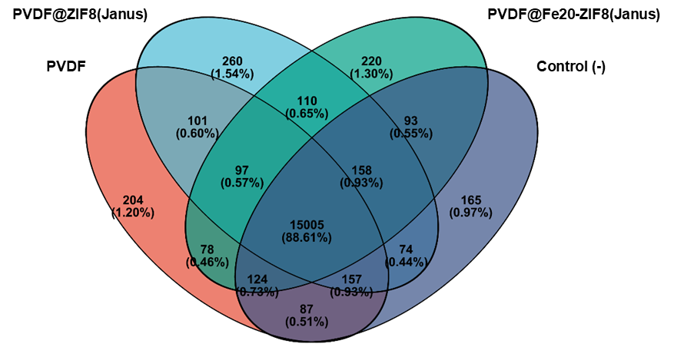
Fig. S17 Venn analysis of different groups.

Fig. S18 Differential gene statistics among different groups. S1: PVDF; S2: PVDF@ZIF8; S3: PVDF@ZIF8(Janus); S4: PVDF@Fe20-ZIF8(Janus).

Fig. S19 Protein interaction network analysis of the genes.

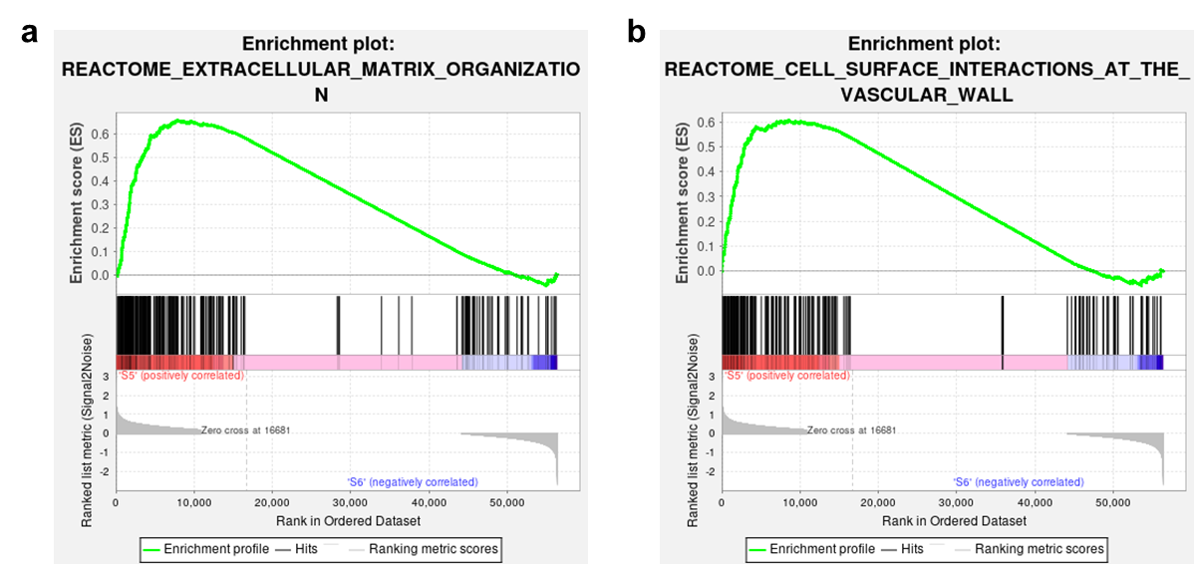
Fig. S20 GSEA of enrichment situation in the critical gene set.
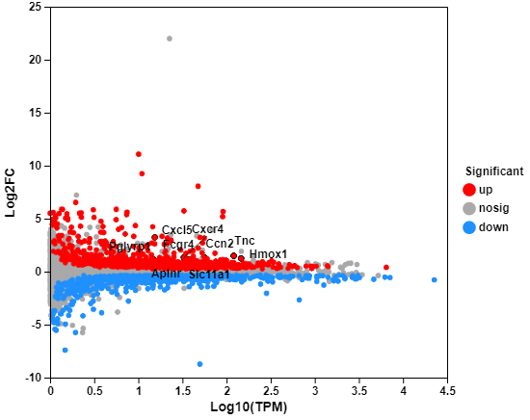
Fig. S21 MA plot of up and down-regulating genes of PVDF@Fe20-ZIF8 (Janus) group compared with pure PVDF group.
Fig. S22 GO enrichment analysis of PVDF@Fe20-ZIF8 (Janus) group compared with pure PVDF group with GO term.
Fig. S23 Rich factors and the P value of GO term of PVDF@Fe20-ZIF8 (Janus) group compared with pure PVDF group.
Fig. S24 KEGG enrichment analysis of PVDF@Fe20-ZIF8 (Janus) group compared with pure PVDF (Janus) group.
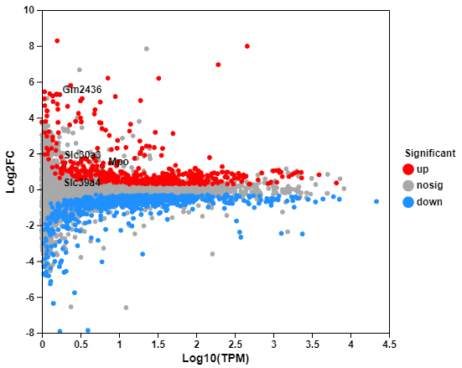
Fig. S25 MA plot of up and down-regulating genes of PVDF@Fe20-ZIF8 (Janus) group compared with PVDF@ZIF8 (Janus) group.
Fig. S26 GO enrichment analysis of PVDF@Fe20-ZIF8 (Janus) group compared with PVDF@ZIF8 (Janus) group with GO term.
Fig. S27 Rich factors and P value of GO term of PVDF@Fe20-ZIF8 (Janus) group compared with PVDF@ZIF8 (Janus) group.
Fig. S28 KEGG enrichment analysis of PVDF@Fe20-ZIF8 (Janus) group compared with PVDF@ZIF8 (Janus) group.

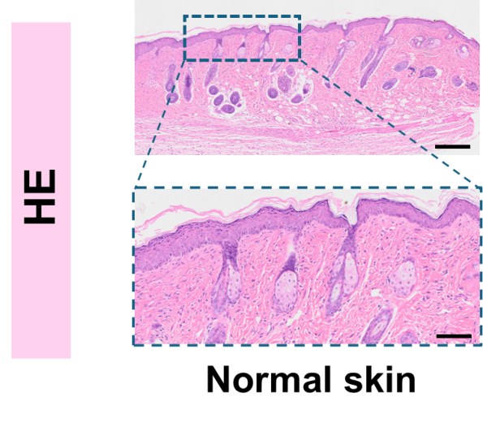
Fig. S29 H&E staining and Masson staining of normal skin.

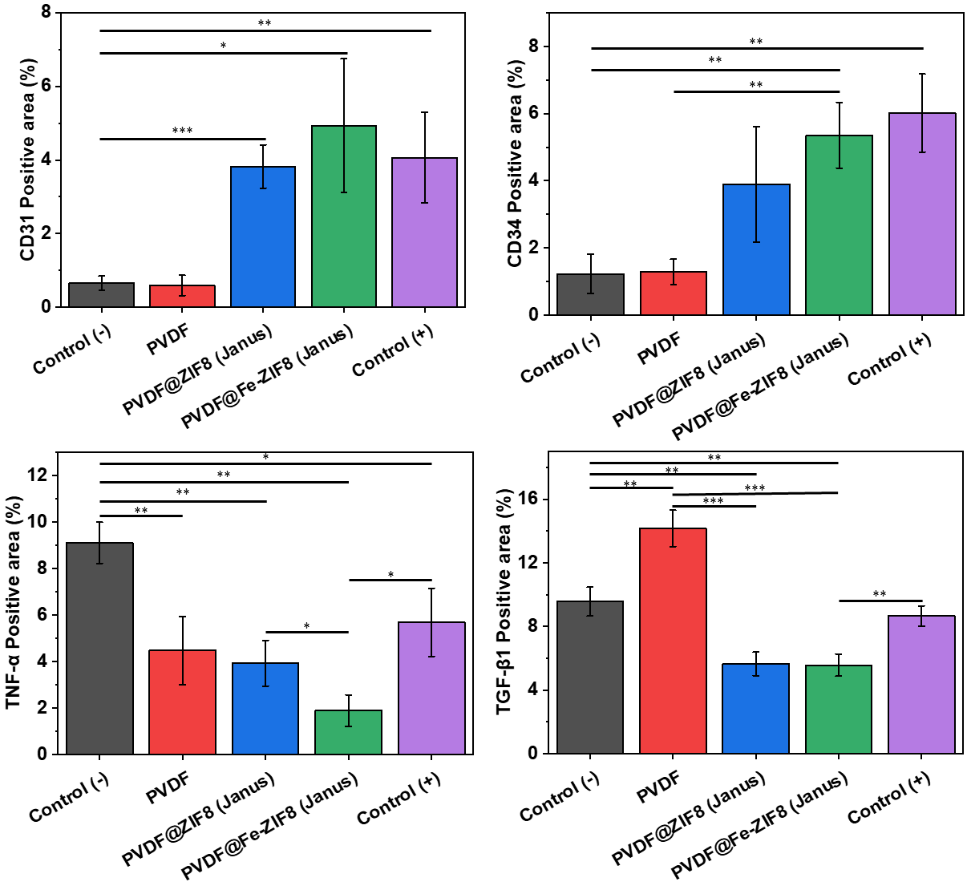
Fig. S30 Positive area percentages of CD31, CD34, TNF-α, and TGF-β1 in different groups. Data are displayed as mean ± SD, n = 3. *p < 0.05, **p < 0.01, and ***p < 0.001.

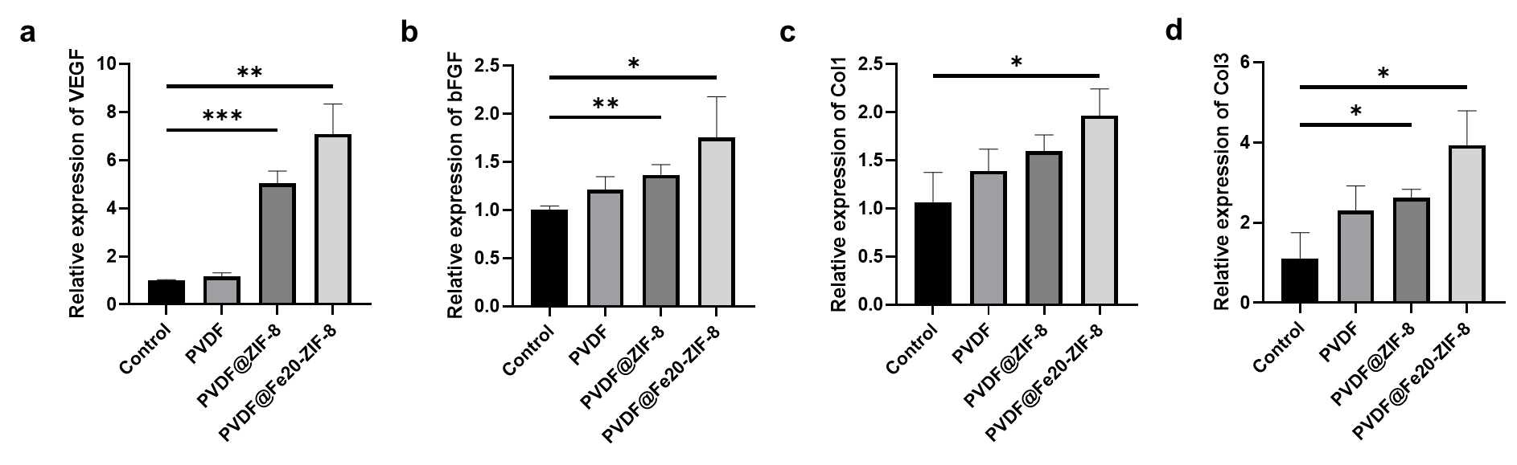
Fig. S31 PCR analysis of the genes expression related to angiogenesis and wound healing. a) Relative expression of VEGF; b) Relative expression of bFGF; c) Relative expression of Col1; d) Relative expression of Col3. Data are displayed as mean ± SD, n = 3. *p < 0.05, **p < 0.01, and ***p < 0.001.

