Supporting Information for
Electron Redistribution by Fluorine-Induced Dual Defects in Cu₃P Accelerated Charge Transfer towards High-Performance Electrochemical Chloride Ion Removal
Ziqing Zhou¹, Yifan Ren¹, Fei Yu³, Jie Ma^{1,2*}
¹ Research Center for Environmental Functional Materials, State Key Laboratory of Pollution Control and Resource Reuse, College of Environmental Science and Engineering, Tongji University, 1239 Siping Road, Shanghai 200092, P. R. China
² Water Resources and Water Environment Engineering Technology Center, Xinjiang Key Laboratory of Synthesis and Application of Carbon Nanomaterials, School of Civil Engineering, Kashi University, Kashi 844000, P. R. China
³ College of Oceanography and Ecological Science, Shanghai Ocean University, No 999, Huchenghuan Road, Shanghai, 201306, P. R. China
*Corresponding author. E-mail: jma@tongji.edu.cn (Jie Ma)
S1 Experimental
S1.1 Characterization
The morphological characteristics of the samples were investigated using scanning electron microscopy (SEM, Hitachi S-4800, Japan) and transmission electron microscopy (TEM, JEOL JEM-F200). The crystal structure was analyzed via X-ray diffraction (XRD, Bruker D2 PHASER). Furthermore, the oxidation states and surface chemical composition of the composites were examined by X-ray photoelectron spectroscopy (XPS, Thermo Scientific ESCALAB 250Xi).
S1.2 Electrochemical measurements
The electrochemical tests were performed in 1 M NaCl electrolyte using a three-electrode electrochemical cell, comprising a platinum (Pt) sheet as counter electrode, a silver/silver chloride (Ag/AgCl) electrode as reference electrode and prepared samples as working electrodes. An electrochemical workstation (CHI660D, Chenhua Instruments Co., China) was utilized to conduct cyclic voltammetry (CV) and electrochemical impedance spectroscopy (EIS) measurements. For CV tests, the scan rates were conducted at 10, 20, 50, and 100 mV s⁻¹ within a voltage window of −1.2 ~ 1.2 V. The EIS analysis was performed over a frequency range of 0.1 Hz to 100 kHz at the open-circuit potential.
The gravimetric special capacitance obtained from CV curve was calculated according to equation (S1).
$$\begin{aligned}C=\frac{\int{idV}}{2mvΔV}\#\left(S1\right)\end{aligned}$$
Where C represents the specific capacitance (F g⁻¹), i refers to the current (A), v is the scan rate (V s⁻¹), ΔV is the potential window (V), m corresponds the electrode material mass (g).
The power law relationship between the current and scan rates of CV plots conforms the follow equation (S2).
$$\begin{aligned}i=av^{b}\#\left(S2\right)\end{aligned}$$
where $i$ denotes the current (A), $v$ is scan rate (mV s⁻¹), $a$ and $b$ are constant value.
The Trasatti analysis method was utilized to assess the capacitance contributions, and the calculations were based on the following equations (S3) and (S4).
$$\begin{aligned}C_{t}\left(v\right)=C_{O}+kv^{-0.5}\#\left(S3\right)\end{aligned}$$
$$\begin{aligned}C_{t}=C_{o}+C_{i}\#\left(S4\right)\end{aligned}$$
Where $C_{t}\left(v\right)$ is the voltametric capacitance, $C_{t}$ is the total capacitance, $C_{o}$ is the outer capacitance, $C_{i}$ is the inner capacitance, k is a constant, and v represents the scan rate.
S1.3 Deionization measurements
The deionization experiment was conducted using the batch mode method in a EDI device with activated carbon and prepared materials as the cathode and anode, respectively. The EDI device consisted of a pair of acrylic plates, electrodes, rubber gaskets, and cation/anion exchange membranes. The feed water at a 20 mL min⁻¹ flow rate was 40 mL of NaCl solution with a concentration of 1000 mg L⁻¹. And the real-time solution conductivity during charged/discharged steps was monitored and recorded by a conductivity meter (METTLER TOLEDO S230, Switzerland). All deionization experiments were performed in constant voltage mode with voltage of 1.0 V, 1.2 V, 1.4 V, and 1.6 V for 30 min. The voltage in the long-term adsorption-desorption cycle was set to 1.2 V for 10 min, and all corresponding desorption processes were performed by applying the same duration of reverse voltage.
The areal deionization capacity (ADC) (mg-Cl⁻ cm⁻²) was calculated according to the equation (S5):
$$\begin{aligned}ADC=\frac{\left(C_{o}-C_{e}\right)×V×M}{S}\#\left(S5\right)\end{aligned}$$
Where C_{o} and C_{e} (mg L⁻¹) are the concentration of NaCl at initial and final stages, respectively; V is the volume of NaCl solution; M represents the molecular weight of Cl⁻ and S (cm²) is the total mass areal of active material in working electrode.
The time average areal deionization rate (ADR, mg-Cl⁻ cm⁻² min⁻¹) was acquired from the equation (S6).
$$\begin{aligned}ADR=\frac{ADC}{t}\#\left(S6\right)\end{aligned}$$
Where ADC (mg-Cl⁻ cm⁻²) is the areal deionization capacity, t is the deionization time (min).
The energy consumption (EC, kWh kg⁻-Cl⁻) was quantitatively determined according to equation (S7)
$$\begin{aligned}\text{EC}\text{= }\frac{\text{U}\int{Idt}}{\text{ADC}\text{×}\text{S}}\#\left(S7\right)\end{aligned}$$
Where U (V) and $\text{I}$ (A) are applied voltage and current, respectively.
S1.4 Density functional theory (DFT) calculations
All the calculations are performed in the framework of the density functional theory with the projector augmented plane-wave method, as implemented in the Vienna ab initio simulation package [S1]. The generalized gradient approximation proposed by Perdew, Burke, and Ernzerhof is selected for the exchange-correlation potential [S2]. The cut-off energy for plane wave is set to 450 eV. The energy criterion is set to 10⁻⁵ eV in iterative solution of the Kohn-Sham equation. A vacuum layer of 15 Å is added perpendicular to the sheet to avoid artificial interaction between periodic images. The Brillouin zone integration is performed using a 2×2×1 k-mesh. The Van der Waals dispersion-corrected DFT was also carried out, as proposed by Grimme et al [S3]. All the structures are relaxed until the residual forces on the atoms have declined to less than 0.02 eV/Å. The Gibbs free energy change (ΔG) of each elementary step was calculated by the following equation (S8)
$$\begin{aligned}ΔG=ΔE+ΔE_{ZPE}-TΔS\#\left(S8\right)\end{aligned}$$
where ΔE is the electronic energy change between the two intermediates. ΔE_{ZPE} and ΔS refer to the zero-point energy correction and entropy change, respectively. The temperature T corresponds to 298.15 K.
The P vacancy formation energy as calculated by using the equation (S9).
$$\begin{aligned}E_{f}^{vac}=E\left(F-\frac{Cu_{3}P_{v}}{Cu_{3}P_{v}}\right)+E\left(P\right)-E\left(F-\frac{{Cu}_{3}P}{{Cu}_{3}P}\right)\#\left(S9\right)\end{aligned}$$
Supplementary Figures and Tables
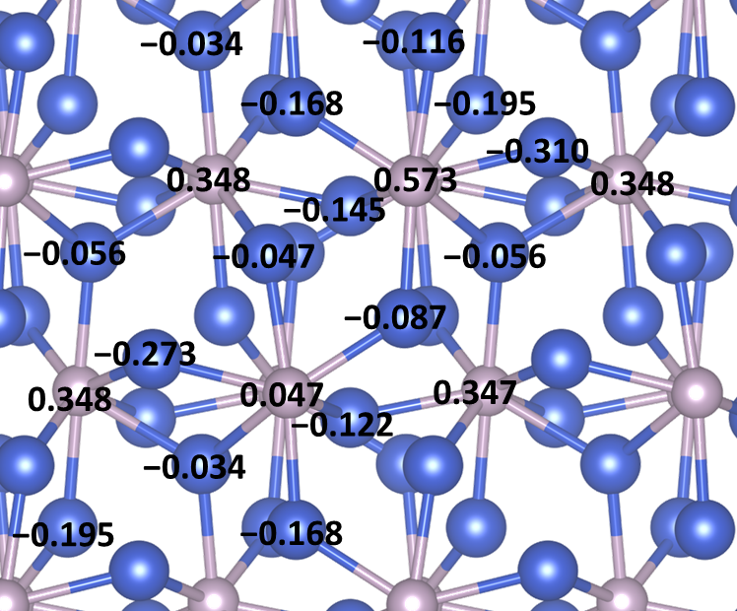
Fig. S1 The Bader charge numbers of atoms in Cu₃P.
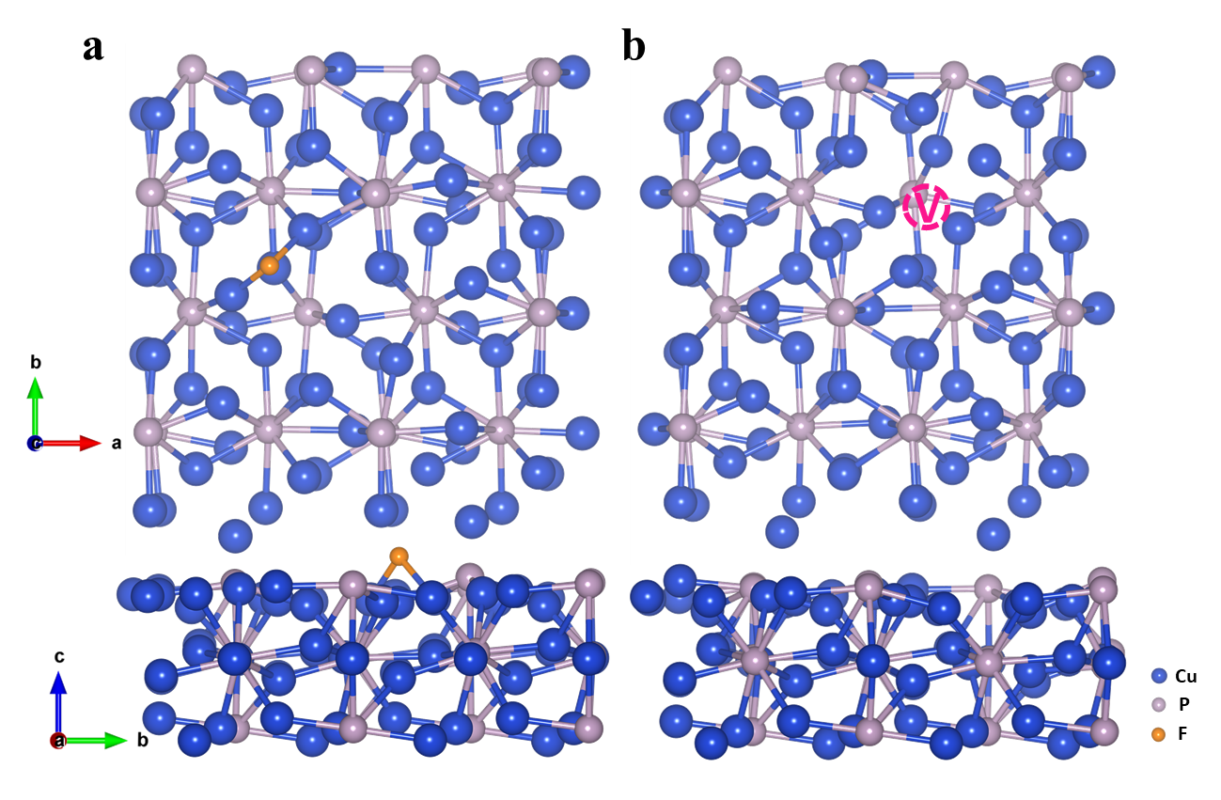
Fig. S2 The optimized structure of a F-Cu₃P and b Cu₃P_{V} models.
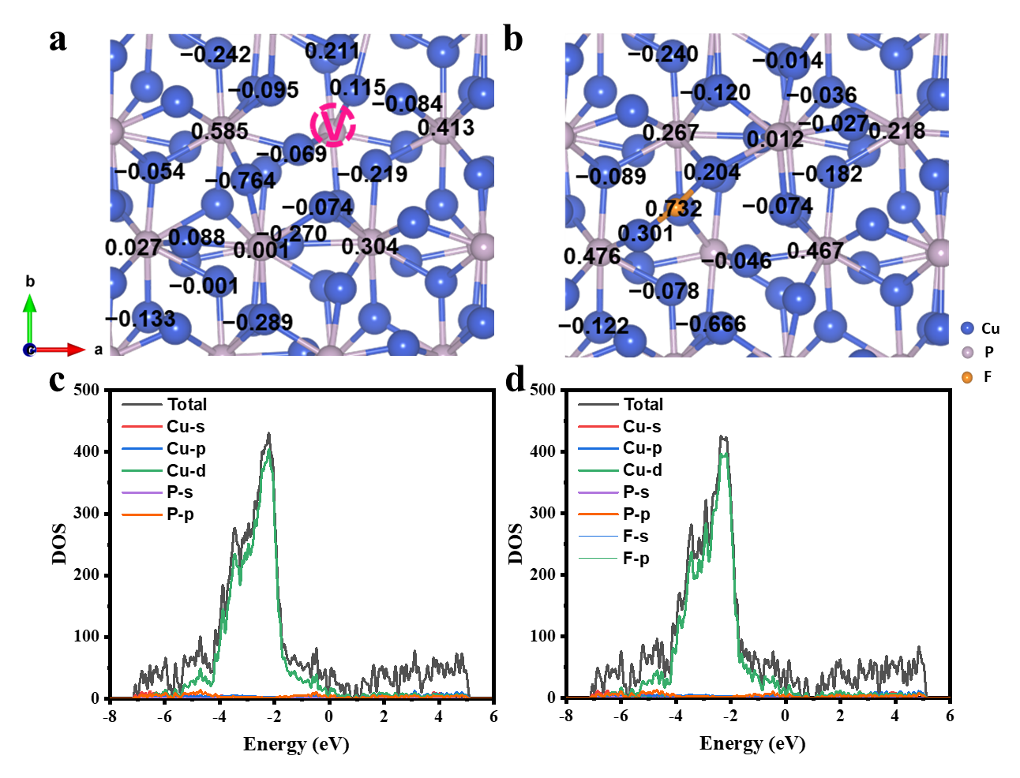
Fig. S3 The Bader charge numbers of atoms in a F-Cu₃P and b Cu₃P_{V} (Positive and negative values represent the accumulation and depletion of electrons, respectively.). Calculated DOS of c F-Cu₃P and d Cu₃P_{V}.
We constructed models with only F doping (F-Cu₃P) and only P vacancy (Cu₃P_{V}), with their optimized configurations shown in Fig. S2, and compared them with Cu₃P and F-Cu₃P_{V} models. The Bader charge results indicate that both F doping and P vacancy induce localized electronic redistribution (Fig. S3a-b). Specifically, F doping, due to high electronegativity, attracts electrons from neighboring Cu atoms, thereby affecting the electron distribution around Cu and P atoms. P vacancy causes electrons originally occupying the P 2p orbitals to delocalize to the Cu atoms around the vacancy, while the electron density around neighboring P atoms is also affected to a certain extent at the same time. In addition, the ordering of the electronic density of states near the Fermi energy level for the four models is as follows: F-Cu₃P_{V} > Cu₃P_{V} > F-Cu₃P > Cu₃P, indicating that both F doping and P vacancy can improve electrical conductivity, thereby enhancing electron-transfer kinetics (Fig. S3c-d). Moreover, compared with F doping, P vacancy displays a more significant enhancement in electronic conductivity.

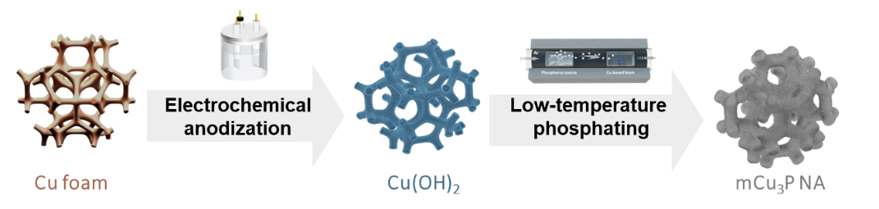
Fig. S4 Schematic illustration of mCu₃P NA synthesis process.
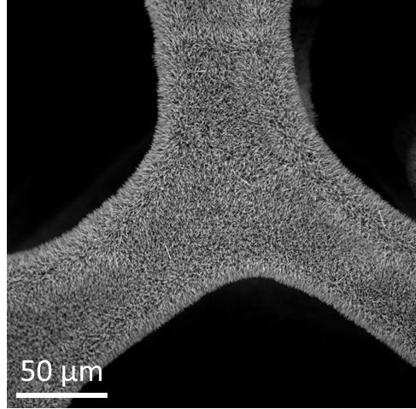
Fig. S5 SEM image of Cu(OH)₂ nanowire arrays.
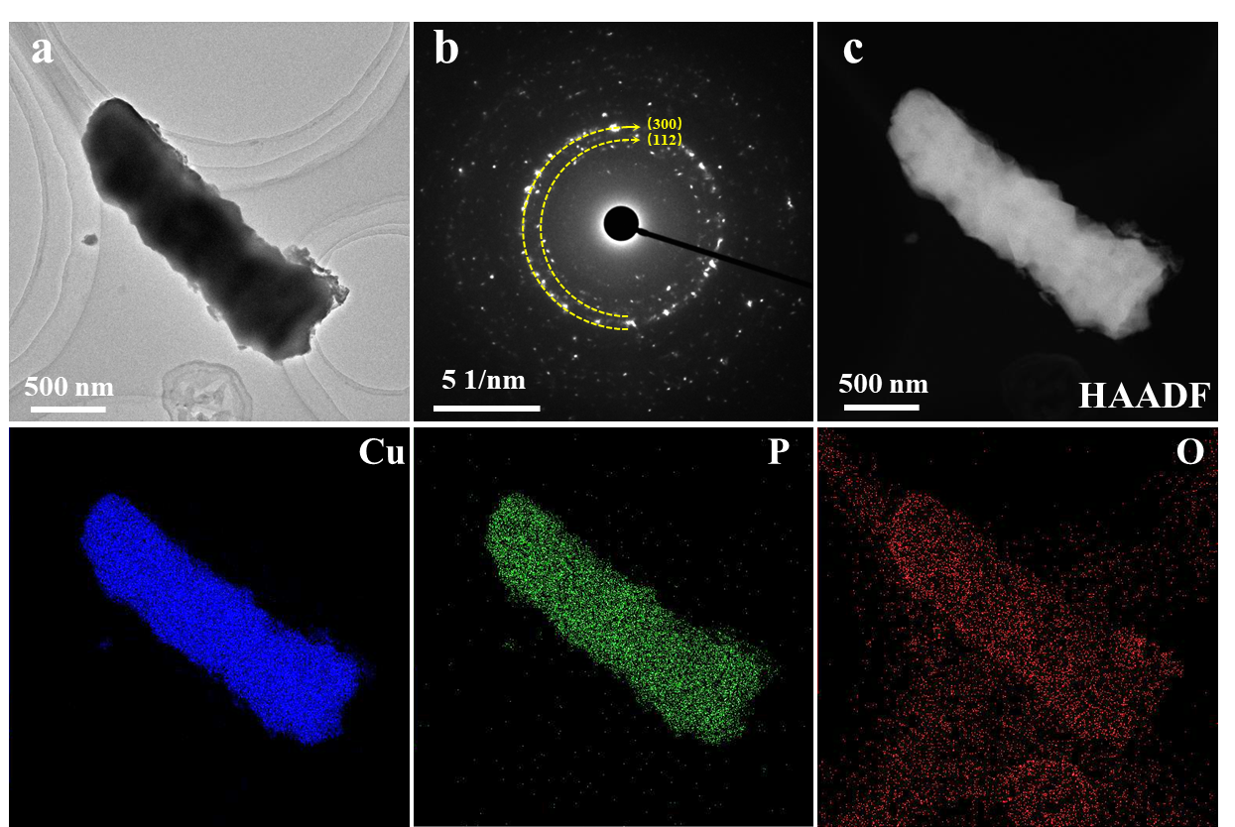
Fig. S6 a TEM image, b SEAD, and c HAADF scanning TEM image as well as corresponding EDS element mappings of mCu₃P NA.
Fig. S7 EPR spectra of prepared materials.
Fig. S8 The CV curves of F-Cu₃P_{V}-1 and F-Cu₃P_{V}-3 at scan rate of 10 mV s⁻¹.

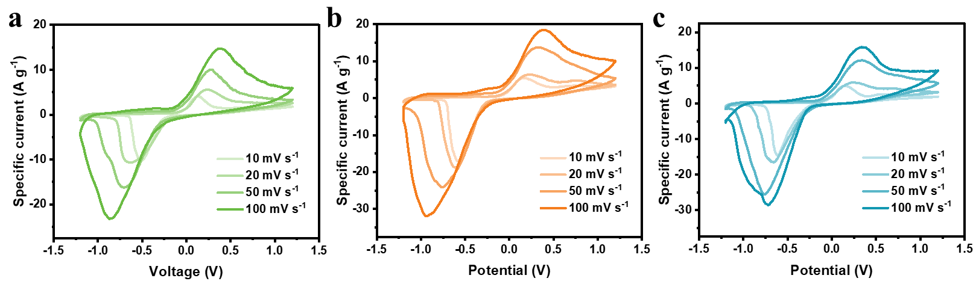
Fig. S9 The CV curves of a mCu₃P NA, b F-Cu₃P_{V}-1, and c F-Cu₃P_{V}-3 at different scan rates.

Fig. S10 Specific capacitances of F-Cu₃P_{V}-1 and F-Cu₃P_{V}-3 at different scan rates.
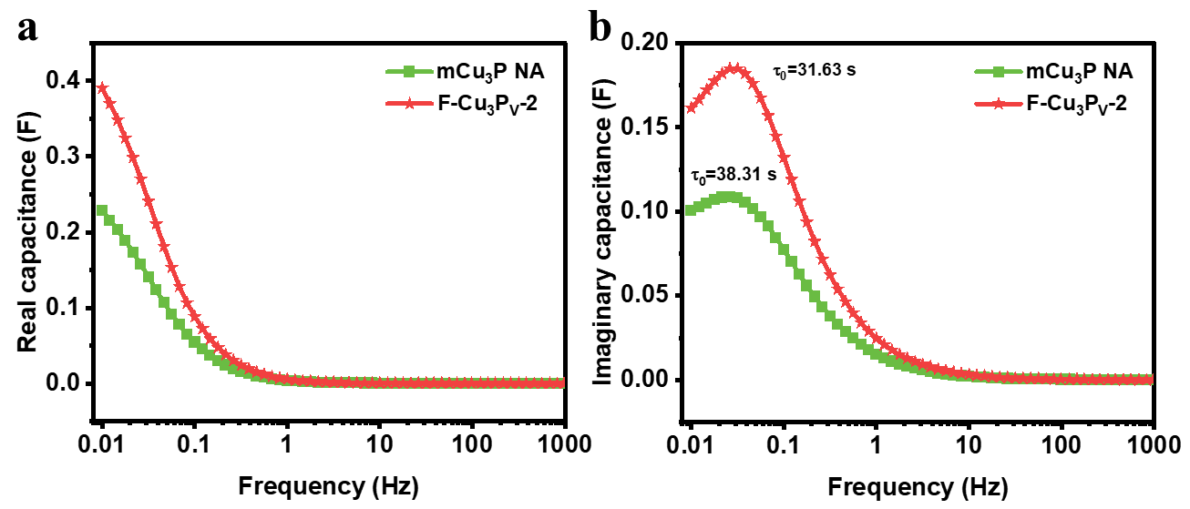
Fig. S11 a The real capacitance and b imaginary capacitance against frequency of mCu₃P NA and F-Cu₃P_{V}-2.

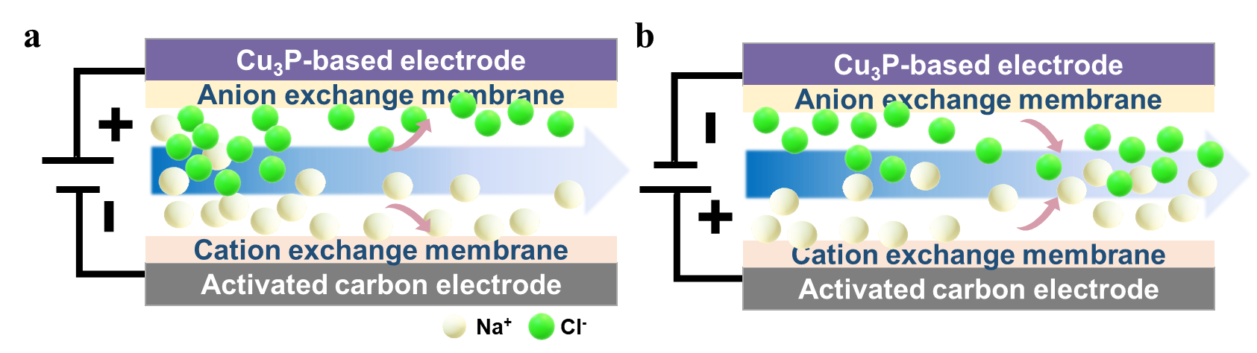
Fig. S12 Schematic illustrations of a capture and b release processes in EDI system.

Fig. S13 Temporal variation in the ADC of prepared materials at 1.2 V.
Fig. S14 Temporal variation in the ADR of mCu₃P NA and F-Cu₃P_{V}-2 at 1.2 V.

Fig. S15 Comparison of energy consumption of electrochemical chloride ion removal.
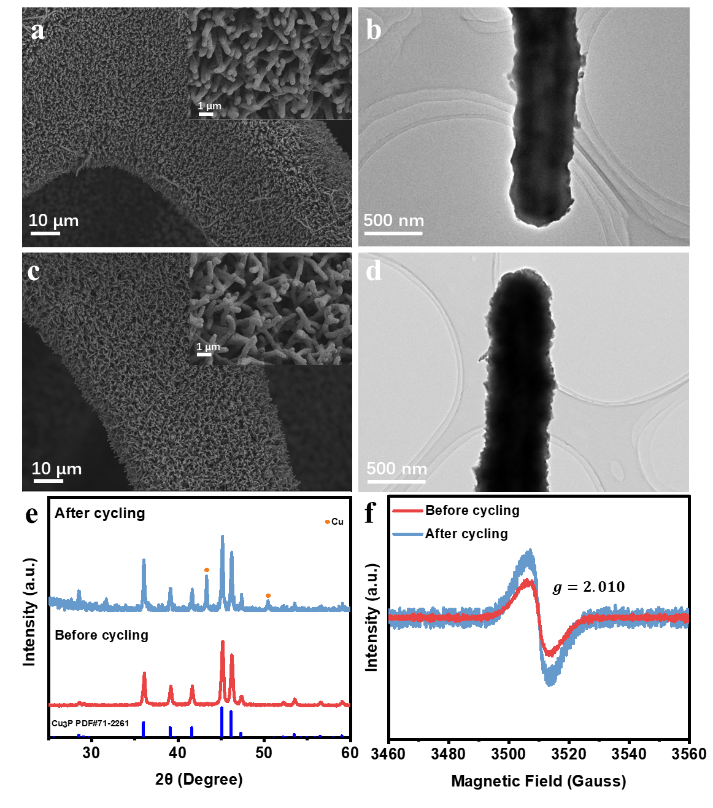
Fig. S16 SEM images and TEM images of F-Cu₃P_{V}-2 a-b before and c-d after cycling, e XRD, and f EPR of F-Cu₃P_{V}-2 before and after cycling. 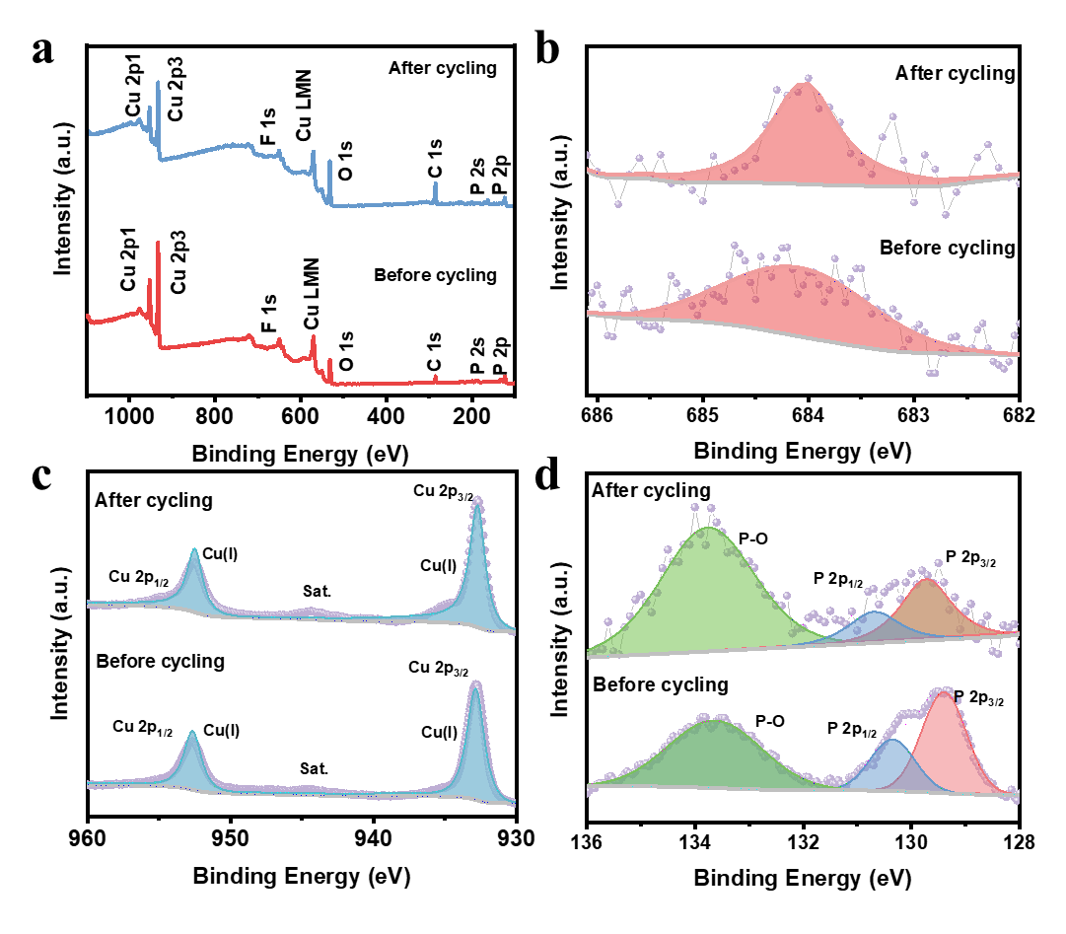
Fig. S17 a XPS survey, b High-resolution XPS of F 1s, c Cu 2p, and d P 2p of F-Cu₃P_{V}-2 before and after long-term cycling.
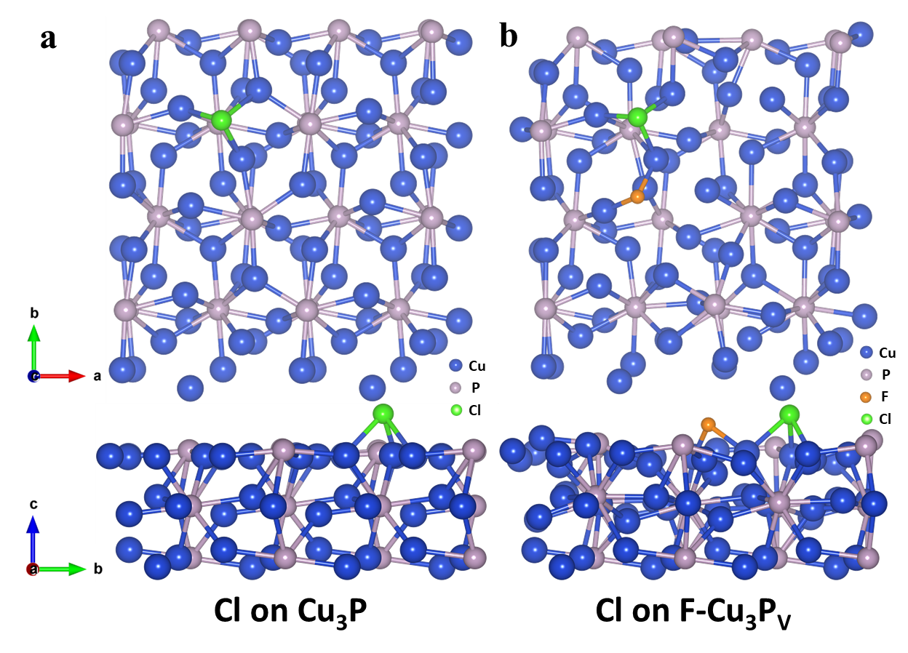
Fig. S18 Optimal structure of Cl on a Cu₃P model and b F-Cu₃P_{V} models.

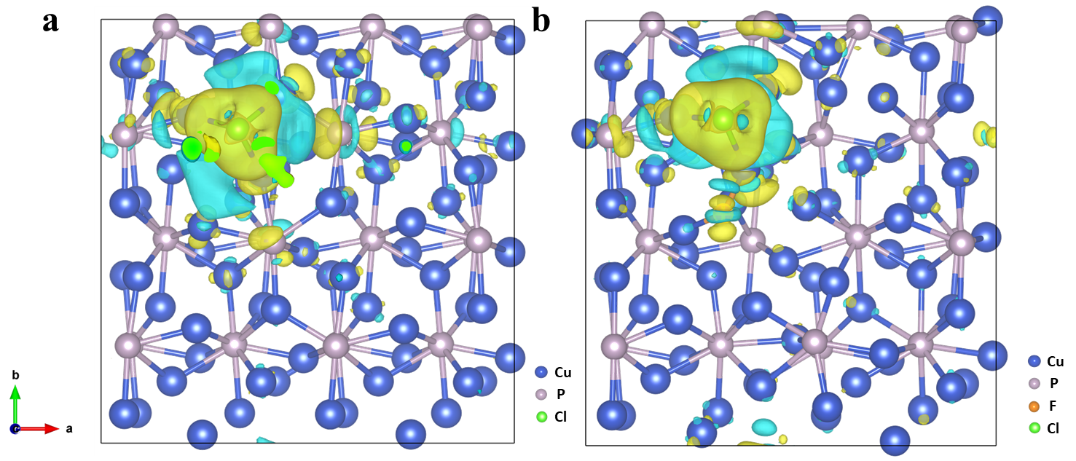
Fig. S19 Top views of the charge density difference during the Cl⁻ adsorption for a Cu₃P and b F-Cu₃P_{V}. (Yellow area indicates electron accumulation and green area indicates electron depletion.)

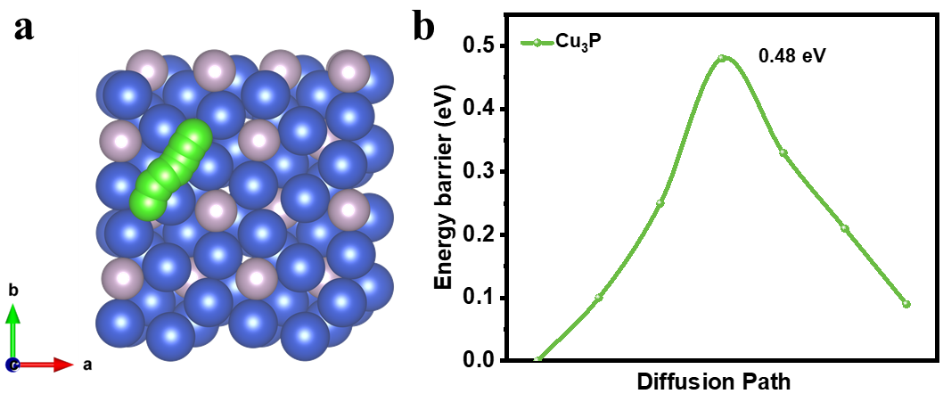
Fig. S20 a Top view of Cl⁻ diffusion path on Cu₃P and b corresponding energy barrier diffusion curves.
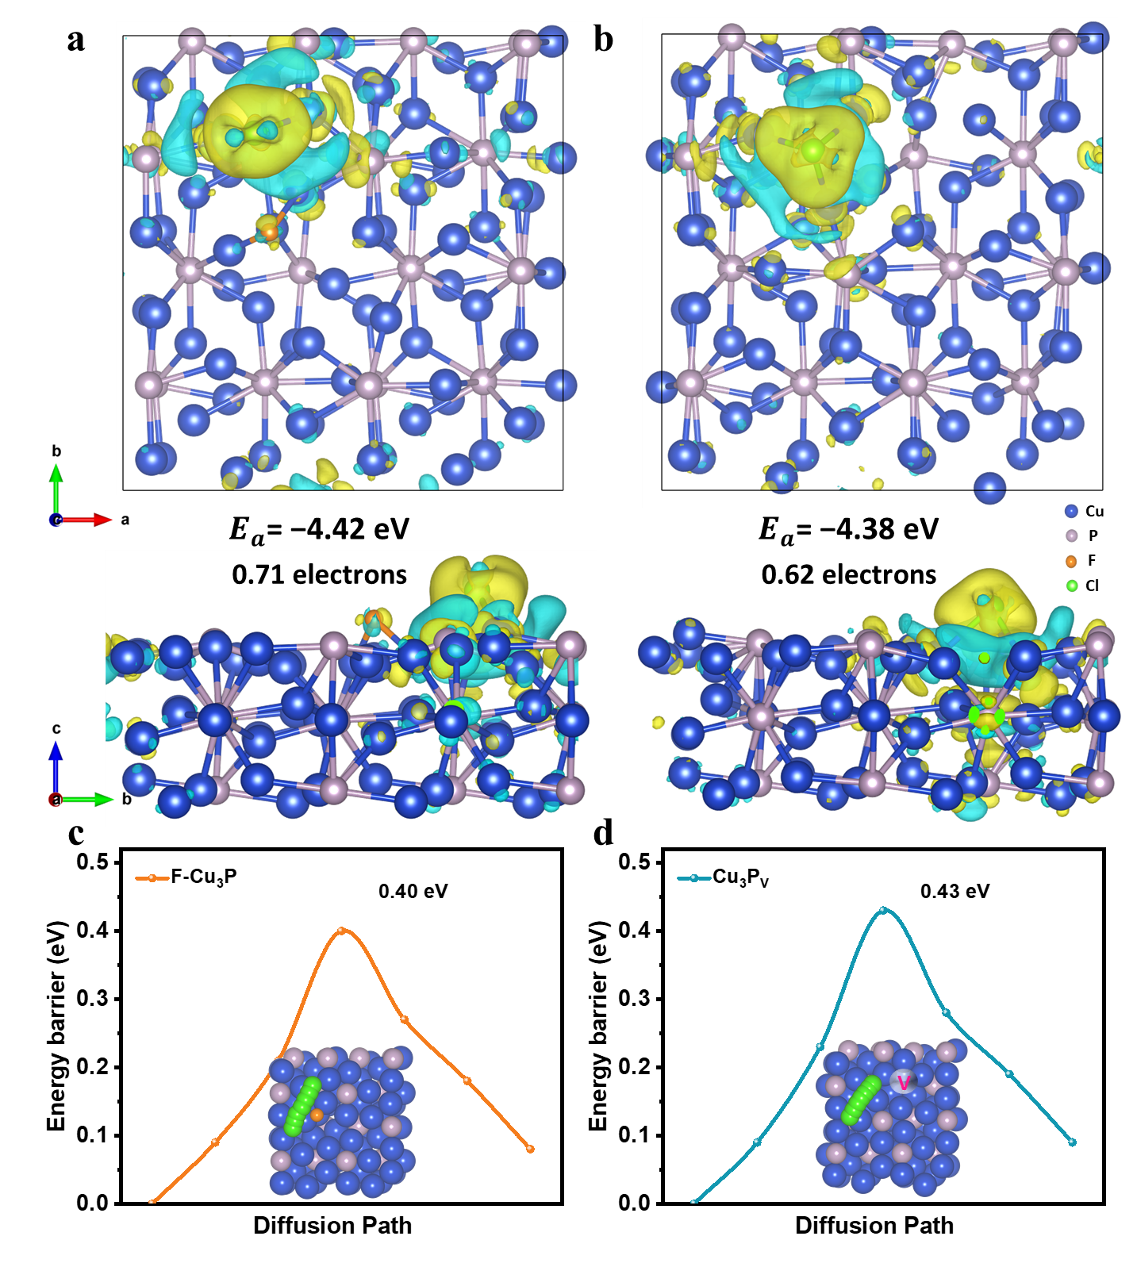
Fig. S21 Top and front views of the charge density difference during the Cl⁻ adsorption for a F-Cu₃P and b Cu₃P_{V}. (Yellow area indicates electron accumulation and green area indicates electron depletion.) Top view of Cl⁻ diffusion path on c F-Cu₃P and b Cu₃P_{V} and corresponding energy barrier diffusion curves.
The F-Cu₃P model exhibits more significant charge transfer and a more negative adsorption energy (−4.42 eV) compared to the Cu₃P_{V} model (−4.38 eV), suggesting that F doping shows a greater enhancement on Cl⁻ adsorption than P vacancy. Moreover, the ordering of diffusion energy barriers for the four models is F-Cu₃P_{V} < F-Cu₃P < Cu₃P_{V} < Cu₃P, indicating that F doping is more effective at optimizing ion diffusion kinetics than P vacancy.

Table S1 Comparison of areal EDI performance of Cl⁻ removal electrode materials
No. | Electrodes |  |  | Mass loading (mg cm⁻²) | Initial salt concentration (mg L⁻¹) | Applied voltage/ | Desalination capacity  (mg-Cl⁻ cm⁻²) | Deionization Rate  (mg-Cl⁻ cm⁻² min⁻¹) | Refs.
 |  |  |  |  |  | Current density | Desalination capacity  (mg-Cl⁻ cm⁻²) | Deionization Rate  (mg-Cl⁻ cm⁻² min⁻¹) | Refs.
1 | Carbon materials | Three-dimensional flexible graphene frameworks | 3DFGFs | 16.80 | 500 | 1.6 | 0.70 | 0.0117 | [S4]
2 | Carbon materials | Nitrogen-doped carbon obtained from HCl pretreatment | HCl-NC | 0.66 | 1000 | 1.2 | 0.08 | 0.0014 | [S5]
3 | Carbon materials | 3D graphene nanoscroll-nanosheet aerogels | GSSA | 1.13 | 1000 | 1.2 | 0.04 | 0.0006 | [S6]
4 | Carbon materials | Block copolymer-based porous carbon fibers | PCFs | 0.73 | 500 | 1.0 | 0.04 | 0.0036 | [S7]
5 | Carbon materials | 3D N-doped hierarchical porous carbon | 3DNHPC | 3.20 | 500 | 1.2 | 0.09 | 0.0304 | [S8]
6 | Carbon materials | Porous Carbon Fibers Cloth-CNTs | PCF-CNTs | 12.50 | 100 | 1.2 | 0.06 | 0.0021 | [S9]
7 | Carbon materials | Hollow carbon nanospheres | HCNSs | 3.80 | 584 | 1.2 | 0.05 | 0.0035 | [S10]
8 | Carbon materials | Cobalt benzimidazole frameworks derived carbon composites | ZC | 7.44 | 585 | 1.2 | 0.25 | 0.0418 | [S11]
9 | Carbon materials | Wood carbon framework | WCF | 50.00 | 100 | 1.2 | 0.36 | 0.0020 | [S12]
10 | Carbon materials | 3D graphene after Nirvana with 2 times | NvGII | 32.40 | 500 | 2.0 | 0.58 | 0.0467 | [S13]
11 | Carbon materials | Order-in-disorder nanosheet-like carbon | O/D NSLC | 2.22 | 1000 | 1.6 | 0.07 | 0.0022 | [S14]
12 | Conductive polymers | Bicontinuous mesoporous polypyrrole cubosomes | BM-PPy | 2.00 | 292.2 | 100 mA g⁻¹ | 0.76 | 0.0253 | [S15]
12 | Conductive polymers | Metal-organic framework/polypyrrole hybrid | MOF/PPy | 10.00 | 584 | 1.2 | 0.14 | 0.0138 | [S16]
13 | Conductive polymers | Polyaniline in situ grown on the Porous activated carbon surface composites | PAC/PANI | 5.00 | 500 | 1.2 | 0.17 | 0.0057 | [S17]
14 | Conductive polymers | Amino group-rich conjugated microporous polytriphenylamine | m-PTPA | 8.70 | 500 | 1.4 | 0.50 | 0.0335 | [S18]
 |  |  |  | 11.70 | 500 | 1.4 | 0.43 | 0.0284 | [S18]
15 | Bi/Ag based materials | Highly dispersed Ag nanocrystals on N-doped holey carbon (Ag@NHC) | Ag@NHC | 6.40 | 1500 | 1.4 | 0.93 | 0.0311 | [S19]
16 | Bi/Ag based materials | Bismuth nanoclusters (Bi NCs) within carbon nano-bundles | Bi NCs@CNBs | 3.13 | 1170 | 600 mA g⁻¹ | 0.16 | 0.0319 | [S20]
17 | Bi/Ag based materials | Bi NCs-impregnated 3D carbon nanofiber network | Bi NCs@CNF | 3.34 | 3000 | 220.0 | 0.21 | 0.0175 | [S21]
18 | Bi/Ag based materials | Ag-based MOFs | Ag-MOF | 1.80 | 500 | 1.2 | 0.21 | 0.0052 | [S22]
19 | Bi/Ag based materials | Ag-coated activated carbon | Ag/AC | 15.90 | 585 | 1.2 | 0.45 | 0.0450 | [S23]
20 | Other materials | FeOCl/Ti₃C₂T_{x} | FeOCl/Ti₃C₂T_{x} | 0.94 | 1000 | 1.6 | 0.21 | 0.0035 | [S24]
21 | Other materials | FeOOH hybrid heterostructures with Cl dopants | Cl-FeOOH | 2.27 | 584 | 1.2 | 0.05 | 0.0004 | [S25]
22 | Other materials | Cu₂O | Cu₂O | 5.43 | seawater | 200 mA g⁻¹ | 1.19 | 0.0149 | [S26]
23 | Other materials | CoNiPS@CF | CoNiPS@CF | 3.00 | 1000 | 1.6 | 0.37 | 0.0061 | [S27]
24 | Other materials | Copper(I) phosphide | Cu₃P | 32.70 | 1000 | 1.6 | 2.21 | 0.0736 | [S28]
25 | Other materials | F-Cu₃P_{V}-2 | F-Cu₃P_{V}-2 | 33.40 | 1000 | 1.2 | 3.17 | 0.1055 | This work

Table S2 Comparison of areal EDI performance of Cl⁻ removal high-mass-loading electrode materials
No. | Electrodes | Thickness (mm) | Mass loading (mg cm⁻²) | ADC (mg-Cl⁻ cm⁻²) | GDC (mg-Cl⁻ g⁻¹) | VDC (mg-Cl⁻ cm⁻³) | Refs.
1 | PCF-CNTs | 0.33 | 12.5 | 0.06 | 4.95 | 1.88 | [S9]
2 | WCF | 1.2 | 50 | 0.36 | 6.92 | 3.03 | [S12]
3 | NvGII | 0.6 | 32.4 | 0.58 | 18.03 | 9.73 | [S13]
4 | MOF/Ppy | 1 | 10 | 0.14 | 13.76 | 1.38 | [S16]
5 | m-PTPA | 0.6 | 11.7 | 0.43 | 36.41 | 7.10 | [S18]
6 | Ag/AC | 0.3 | 15.9 | 0.45 | 28.28 | 14.99 | [S23]
7 | Cu₃P-2 | 0.8 | 32.7 | 2.21 | 67.48 | 27.58 | [S28]
8 | F-Cu₃P_{V}-2 | 0.8 | 33.4 | 3.17 | 94.79 | 39.58 | This work

Supplementary References
- G. Kresse, D. Joubert, From ultrasoft pseudopotentials to the projector augmented-wave method. Phys. Rev. B 59(3), 1758–1775 (1999). https://doi.org/10.1103/physrevb.59.1758
- J.P. Perdew, K. Burke, M. Ernzerhof, Generalized gradient approximation made simple. Phys. Rev. Lett. 77(18), 3865–3868 (1996). https://doi.org/10.1103/physrevlett.77.3865
- S. Grimme, J. Antony, S. Ehrlich, H. Krieg, A consistent and accurate ab initio parametrization of density functional dispersion correction (DFT-D) for the 94 elements H-Pu. J. Chem. Phys. 132(15), 154104 (2010). https://doi.org/10.1063/1.3382344
- Q. Liu, X. Li, G. Tan, D. Xiao, Chemical bonding of flexible graphene to carbon paper: a new synthetic paradigm for freestanding electrode with high capacitive deionization performance. Desalination 538, 115890 (2022). https://doi.org/10.1016/j.desal.2022.115890
- M. Liang, N. Liu, X. Zhang, Y. Xiao, J. Yang et al., A reverse-defect-engineering strategy toward high edge-nitrogen-doped nanotube-like carbon for high-capacity and stable sodium ion capture. Adv. Funct. Mater. 32(49), 2209741 (2022). https://doi.org/10.1002/adfm.202209741
- W. Kong, X. Ge, X. Lu, Q. Zhang, M. Zhang et al., The simpler the better: ultrafast air-plasma synthesis of 3D crosslinked graphene nanoscroll-nanosheet aerogels at room temperature for capacitive deionization. Small 20(38), 2402057 (2024). https://doi.org/10.1002/smll.202402057
- T. Liu, J. Serrano, J. Elliott, X. Yang, W. Cathcart et al., Exceptional capacitive deionization rate and capacity by block copolymer-based porous carbon fibers. Sci. Adv. 6(16), eaaz0906 (2020). https://doi.org/10.1126/sciadv.aaz0906
- M. Shi, X. Hong, C. Liu, H. Qiang, F. Wang et al., Green double organic salt activation strategy for one-step synthesis of N-doped 3D hierarchical porous carbon for capacitive deionization. Chem. Eng. J. 453, 139764 (2023). https://doi.org/10.1016/j.cej.2022.139764
- C. Zhang, D. Wang, Z. Wang, G. Zhang, Z. Liu et al., Boosting capacitive deionization performance of commercial carbon fibers cloth via structural regulation based on catalytic-etching effect. Energy Environ. Mater. 6(1), e12276 (2023). https://doi.org/10.1002/eem2.12276
- Y. Tang, J. Ding, W. Zhou, S. Cao, F. Yang et al., Design of uniform hollow carbon nanoarchitectures: different capacitive deionization between the hollow shell thickness and cavity size. Adv. Sci. 10(9), 2206960 (2023). https://doi.org/10.1002/advs.202206960
- S. Cao, T. Chen, S. Zheng, Y. Bai, H. Pang, High-performance capacitive deionization and killing microorganism in surface-water by ZIF-9 derived carbon composites. Small Meth. 5(12), 2101070 (2021). https://doi.org/10.1002/smtd.202101070
- M. Liu, M. Xu, Y. Xue, W. Ni, S. Huo et al., Efficient capacitive deionization using natural basswood-derived, freestanding, hierarchically porous carbon electrodes. ACS Appl. Mater. Interfaces 10(37), 31260–31270 (2018). https://doi.org/10.1021/acsami.8b08232
- Y. Li, N. Chen, Z. Li, H. Shao, X. Sun et al., Reborn three-dimensional graphene with ultrahigh volumetric desalination capacity. Adv. Mater. 33(48), 2105853 (2021). https://doi.org/10.1002/adma.202105853
- M. Liang, Y. Ren, J. Cui, X. Zhang, S. Xing et al., Order-in-disordered ultrathin carbon nanostructure with nitrogen-rich defects bridged by pseudographitic domains for high-performance ion capture. Nat. Commun. 15, 6437 (2024). https://doi.org/10.1038/s41467-024-50899-5
- L. Xiang, X. Xu, Y. Liu, H. Zhang, R. Xu et al., Curvature-induced ion docking effect in capacitive deionization. Nat. Water 2(12), 1195–1206 (2024). https://doi.org/10.1038/s44221-024-00340-4
- Z. Wang, X. Xu, J. Kim, V. Malgras, R. Mo et al., Nanoarchitectured metal–organic framework/polypyrrole hybrids for brackish water desalination using capacitive deionization. Mater. Horiz. 6(7), 1433–1437 (2019). https://doi.org/10.1039/c9mh00306a
- B. Li, Q. Cao, Y. Liu, Y. Sun, X. Ma et al., Polyaniline-decorated porous carbons with engineered meso/macrochannels for high performance capacitive deionization. J. Mater. Chem. A 10(46), 24905–24914 (2022). https://doi.org/10.1039/d2ta07929a
- W. Kong, X. Lu, X. Ge, Q. Zhang, X. Jin et al., Conjugated microporous polytriphenylamine as a high-performance anion-capture electrode for hybrid capacitive deionization with ultrahigh areal adsorption capacity. J. Mater. Chem. A 12(32), 21124–21133 (2024). https://doi.org/10.1039/d4ta04010d
- W. Kong, X. Lu, Y. Wang, K. Tan, C. Liu et al., Highly dispersed Ag nanocrystals anchored on N-doped holey carbon aerogel as high-mass-loading electrode for Cl− capture in hybrid capacitive deionization. Small 21(5), 2409342 (2025). https://doi.org/10.1002/smll.202409342
- Y. Liu, L. Wang, Q. Yao, X. Gao, X. Du et al., In situ synthesis of bismuth nanoclusters within carbon nano-bundles from metal–organic framework for chloride-driven electrochemical deionization. Adv. Funct. Mater. 32(12), 2110087 (2022). https://doi.org/10.1002/adfm.202110087
- L. Wang, Z. Liu, Z. Wang, Q. Ma, Z. Guo et al., Up-shifting the desalination rate limit of capacitive deionization via integrating chloride-capturing Bi nanocluster with flow-through cell architecture. Chem. Eng. J. 460, 141726 (2023). https://doi.org/10.1016/j.cej.2023.141726
- D. Wei, B. Ouyang, Y. Cao, L. Yan, B. Wu et al., Coordination confined silver-organic framework for high performance electrochemical deionization. Adv. Sci. 11(28), 2401174 (2024). https://doi.org/10.1002/advs.202401174
- H. Yoon, J. Lee, T. Min, G. Lee, M. Oh, High performance hybrid capacitive deionization with a Ag-coated activated carbon electrode. Environ. Sci.: Water Res. Technol. 7(7), 1315–1321 (2021). https://doi.org/10.1039/d1ew00209k
- J. Lei, X. Zhang, J. Wang, F. Yu, M. Liang et al., Interlayer structure manipulation of FeOCl/MXene with soft/hard interface design for safe water production using dechlorination battery deionization. Angew. Chem. Int. Ed. 63(28), e202401972 (2024). https://doi.org/10.1002/anie.202401972
- J. Zhao, B. Wu, X. Huang, Y. Sun, Z. Zhao et al., Efficient and durable sodium, chloride-doped iron oxide-hydroxide nanohybrid-promoted capacitive deionization of saline water via synergetic pseudocapacitive process. Adv. Sci. 9(25), 2201678 (2022). https://doi.org/10.1002/advs.202201678
- S. Yang, X. Gu, X. Feng, R. Wang, X.-Y. Lou et al., Engineering the reversible redox electrochemistry on cuprous oxide for efficient chloride ion uptake. Nat. Commun. 16, 2282 (2025). https://doi.org/10.1038/s41467-025-57605-z
- S. Xing, N. Liu, Q. Li, M. Liang, X. Liu et al., Reactive P and S Co-doped porous hollow nanotube arrays for high performance chloride ion storage. Nat. Commun. 15, 4951 (2024). https://doi.org/10.1038/s41467-024-49319-5
- Z. Zhou, Y. Ren, F. Yu, J. Ma, Monolithic low-tortuous copper(I) phosphide nanorod arrays for exceptional areal performance in electrochemical chloride ion removal. Nano Energy 137, 110792 (2025). https://doi.org/10.1016/j.nanoen.2025.110792

