Supporting Information for
In-Situ Defect Healing Suppresses Mn Dissolution Chain Reactions in Aqueous Sodium-Ion Cathodes
Wenqing Du¹, Lin Xu¹, Yi Yang¹, Jingying Sun², Gongzheng Yang¹*, Chengxin Wang¹*
¹ School of Materials Science and Engineering, State Key Laboratory of Optoelectronic Materials and Technologies, Sun Yat-sen (Zhongshan) University, Guangzhou 510275, People’s Republic of China
² Instrumental Analysis and Research Center, Sun Yat-sen (Zhongshan) University, Guangzhou 510275, People’s Republic of China
*Corresponding authors. E-mail: wchengx@mail.sysu.edu.cn (Chengxin Wang); yanggzh5@mail.sysu.edu.cn (Gongzheng Yang)
Supplementary Figures and Tables
Fig. S1 TGA results of Mn-HCF and Fe-HCF samples.

Fig. S2 Charge-discharge curves of Mn-HCF electrodes in the voltage range from 0.8 to 1.4 V.
Fig. S3 The concentration changes of Mn and Fe in the WISE-17.6m electrolytes obtained at different cycle numbers.
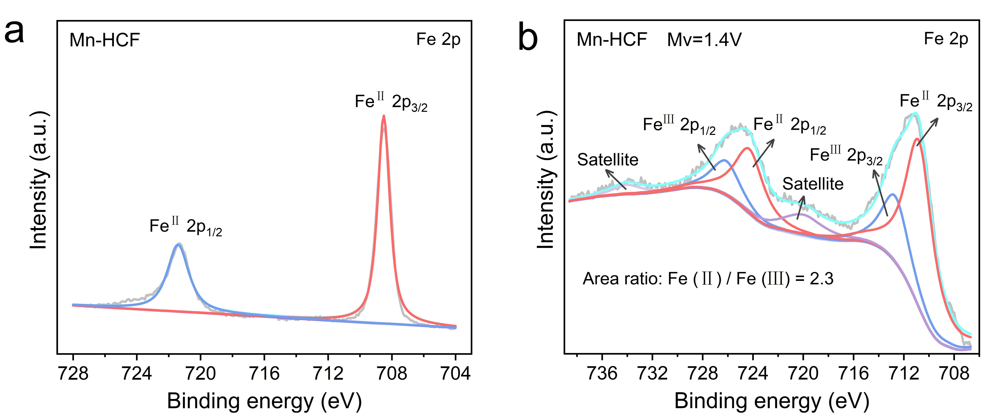
Fig. S4 Fe 2p spectra of the (a) pristine Mn-HCF electrode and (b) the Mn-HCF electrode with median voltage at 1.2 V.
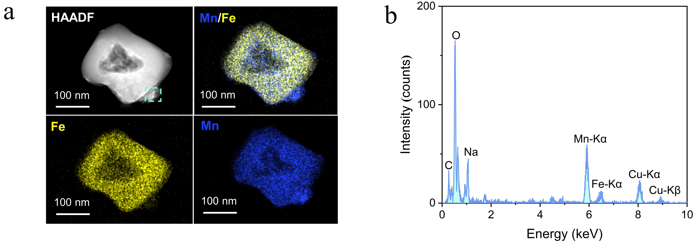
Fig. S5 (a) EDS mapping and (b) local energy spectra of electrode particles with median voltage at 1.2 V.
Fig. S6 LSV curves of 8.8 M and 17.6 M NaClO₄.
Fig. S7 In-situ pH monitoring of Mn-HCF electrodes during the initial charge-discharge cycle in the WISE-Fe(OTf)₃/17.6m.
Fig. S8 Variation in Mn and Fe content in Mn-HCF electrodes at different cycle numbers within the WISE-Fe(OTf)₃/17.6m.
Fig. S9 Volume fraction of the repaired phase at different cycle numbers.
Fig. S10 Long-term cycling stability of Mn-HCF electrodes versus median voltage in WISE-Fe(OTf)₃/17.6m.
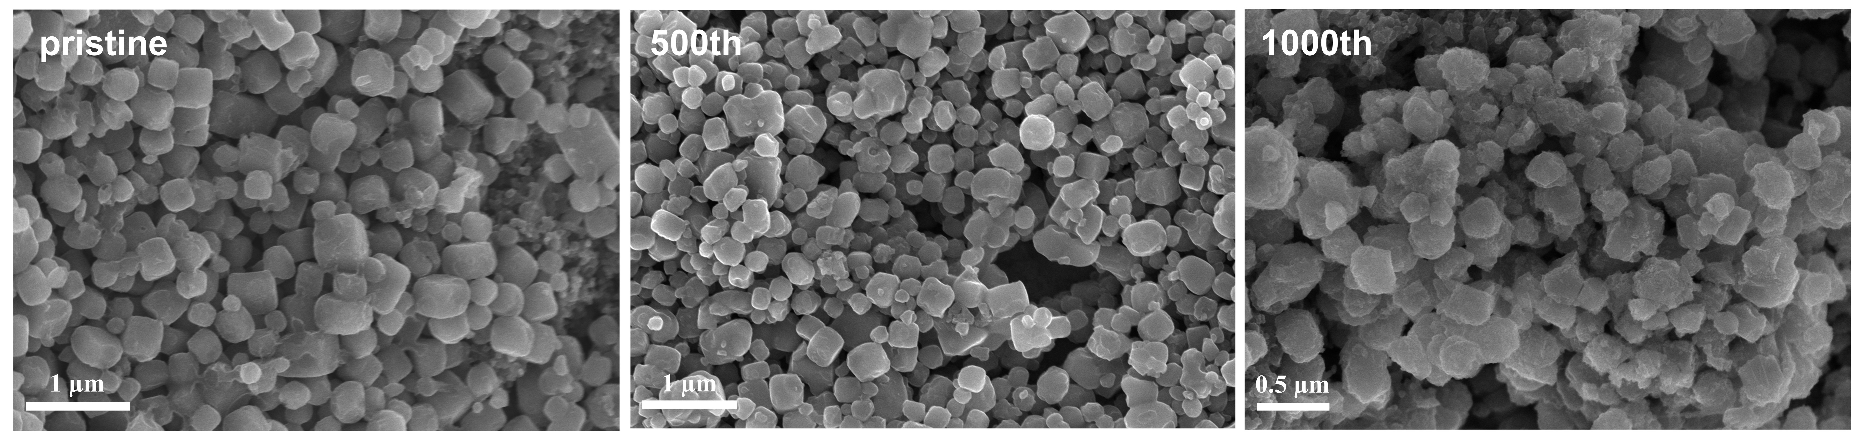
Fig. S11 SEM images of Mn-HCF electrodes at different cycle numbers in WISE-Fe(OTf)₃/17.6m.

Fig. S12 Powder X-ray Rietveld refinement profile of Mn-HCF electrodes in the fully charged state in WISE-Fe(OTf)₃/17.6m.

Fig. S13 Volume changes of Mn-HCF electrode during charging and discharging in WISE-17.6m and WISE-Fe(OTf)₃/17.6m, respectively.
Fig. S14 The proportion of the tetragonal phase of Mn-HCF electrode during charging and discharging in WISE-Fe(OTf)₃/17.6m.
Fig. S15 Raman spectra of the Mn-HCF electrode before and after vacuum drying at 120°C.
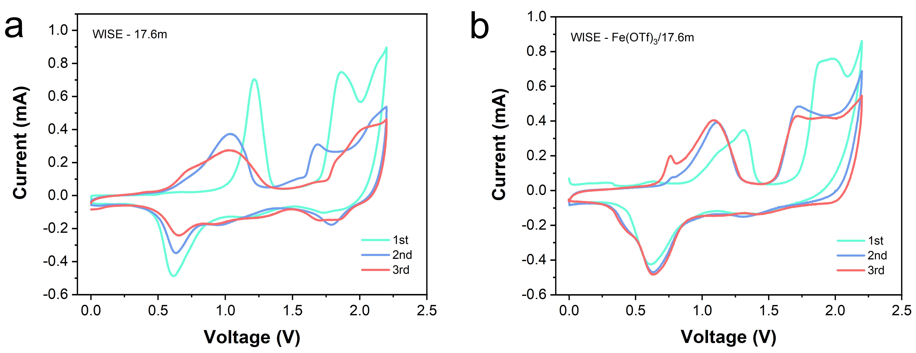
Fig. S16 Cyclic voltammetry curves of Mn-HCF electrodes in (a) WISE-17.6m and (b) WISE-Fe(OTf)₃/17.6m at 0.5 mV s⁻¹, respectively.
Fig. S17 Initial charging and discharging curves of Mn-HCF electrodes in WISE-17.6m and WISE-Fe(OTf)₃/17.6m at 1A g⁻¹, respectively.
Fig.S18 Calculated Na⁺ diffusion coefficients from the GITT test for Mn-HCF electrode in WISE-17.6m and WISE-Fe(OTf)₃/17.6m, respectively.
Fig.S19 Calculated Na⁺ diffusion coefficients from the GITT test for Mn-HCF electrode in WISE-Fe(OTf)₃/17.6m at different cycle numbers.
Fig. S20 CV curves of the Mn-HCF electrodes in the WISE-17.6m (a) and WISE-Fe(OTf)₃/17.6m (c) electrolytes at various scan rates. Plot of the peak current (ip) of Mn-HCF electrodes in the WISE-17.6m (b) and WISE-Fe(OTf)₃/17.6m (d) electrolytes as a function of the square root of scan rates (v^{1/2}). The apparent diffusion coefficients of the charge carriers could be calculated to be 4.1×10⁻⁹ cm² s⁻¹ (cathodic peak), and 4.78×10⁻⁹ cm² s⁻¹ (anodic peak B) in the WISE-17.6m electrolytes, 9.5×10⁻⁹ cm² s⁻¹ (cathodic peak) and 5.4×10⁻⁹ cm² s⁻¹ (anodic peak) in the WISE-Fe(OTf)₃/17.6m electrolytes.
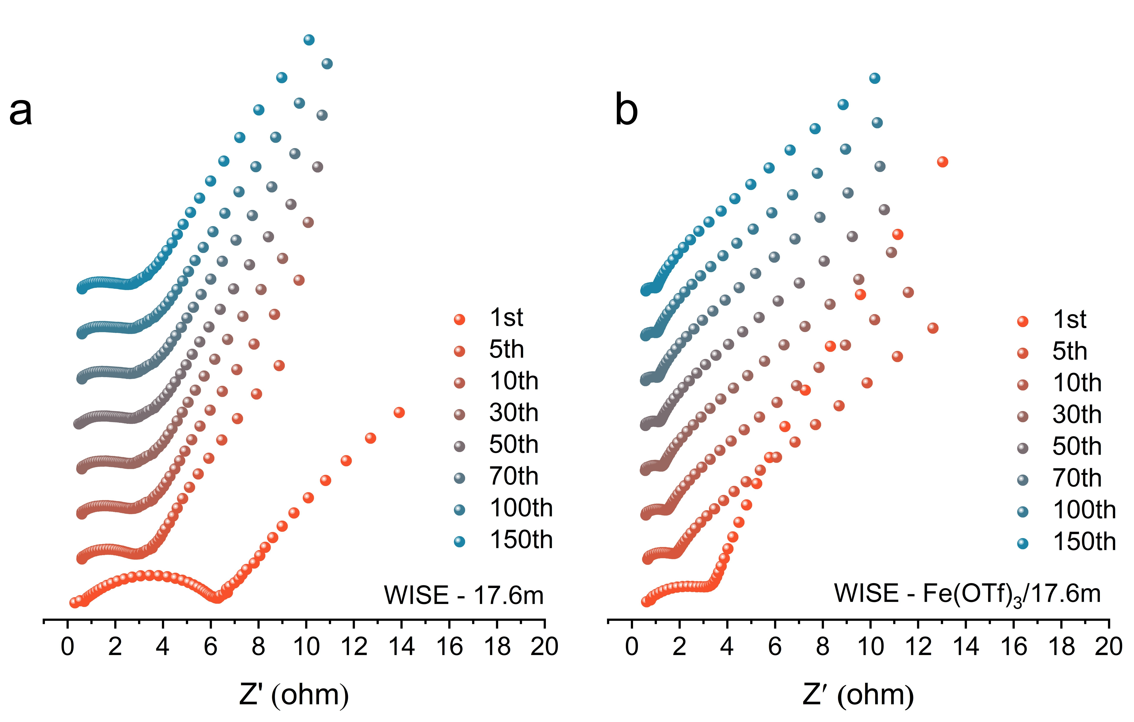
Fig. S21 EIS spectra of Mn-HCF electrode at different cycle number in (a) WISE-17.6m and (b) WISE-Fe(OTf)₃/17.6m, respectively.
Fig. S22 Electrochemical performance of the Mn-HCF||PTCDI full cell in WISE-17.6m, WISE-0.1m Fe(OTf)₃/17.6m and WISE-0.2m Fe(OTf)₃/17.6m electrolytes.
Fig. S23 Charge-discharge curves of Mn-HCF electrode in WISE- 17.6m at different cycle numbers.
Fig. S24 Electrochemical performance of the Mn-HCF||PTCDI full cell with WISE-Fe(OTf)₃/17.6m. The electrode active materials mass loading is 12 mg cm⁻².
Fig. S25 Electrochemical performance of the Fe-HCF||PTCDI full cell with WISE-17.6m and WISE-Fe(OTf)₃/17.6m electrolytes, respectively.
Fig. S26 Ratio of Fe to Na in the electrode at different cycle numbers.
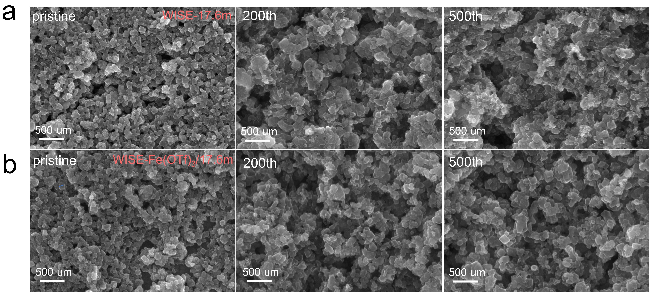
Fig. S27 SEM images of Fe-HCF electrode after cycling in (a) WISE-17.6m and (b) WISE-Fe(OTf)₃/17.6m at different cycle numbers, respectively.
Table S1 Detailed structural information on the cubic Mn-HCF powder after Rietveld refinement
Space group: Fm-3m; a=b=c=10.50739 Å
Atom | x | y | z | Occupation | Uiso
Mn1 | 0.5 | 0 | 0 | 1 | 0.021
Fe1 | 0 | 0 | 0 | 0.699 | 0.020
Na1 | 0.2194 | 0.22 | 0.22 | 0.153 | 0.037
C1 | 0.1753 | 0 | 0 | 0.769 | 0.048
N1 | 0.2911 | 0 | 0 | 0.769 | 0.048
O1 | 0.2911 | 0 | 0 | 0.175 | 0.048
O1 | 0.0463 | 0.25 | 0.25 | 0.287 | 0.117
Table S2 The ICP-AES analysis for Mn-HCF and Fe-HCF (unit: mg/g).
Sample | Na | Fe | Mn
Mn-HCF | 83 | 137 | 176
Fe-HCF | 89.2 | 343.9 | -
Table S3 Analyzed results of the elemental content of the samples (unit: %)
Sample | C | H | N
Mn-HCF | 17.68 | 2.46 | 20.62
Fe-HCF | 17.89 | 1.99 | 20.32

Table S4 Detailed structural information on the cubic Fe-HCF powder after Rietveld refinement
Space group: Fm-3m; a=b=c=10.26274 Å
Atom | x | y | z | Occupation | Uiso
Fe1 | 0 | 0 | 0 | 1 | 0.085
Fe2 | 0.5 | 0 | 0 | 0.699 | 0.040
Na1 | 0.21940 | 0.22 | 0.22 | 0.153 | 0.067
C1 | 0.16190 | 0 | 0 | 0.769 | 0.036
N1 | 0.27898 | 0 | 0 | 0.769 | 0.107
O1 | 0.27898 | 0 | 0 | 0.176 | 0. 107
O1 | 0.06427 | 0.25 | 0.25 | 0.287 | 0.145

Table S5 Comparison of lifespan of this work with reported aqueous sodium-ion full batteries.
Cathode || Anode | Capacity  (mAh/g) | Cycling | Current density (A/g) | Refs.
NaFeMnF || PTCDI | 157 | 15000 cycles, 73.4% | 2 | [S1]
MnHCF-Ni/C || NTP | 116 | 13000 cycles, 74.3% | 1.18 | [S2]
FeHCF-NCO || NTP | 144 | 15000 cycles, 85% | 1.7 | [S3]
HE-PBA || NTP | 118.6 | 1800 cycles, 81% | 0.17 | [S4]
MnHCF || NTOP | 140 | 800 cycles, 76% | 0.14 | [S5]
Na₄Fe(CN)₆ || NTP | 113 | 1000 cycles, 84.7% | 0.09 | [S6]
MnHCF || NTP@C | 75 | 5000 cycles, 83% | 1.7 | [S7]
PW || NTP | 122 | 10000 cycles, 70% | 1.4 | [S8]
NaCoPB || PTCDI | - | 1000 cycles, 76% | 1.7 | [S9]
NaFeMnPB || NTP | - | 5000 cycles, 70% | 1.36 | [S10]
MnCo-PBA || NTP@C | 119.94 | 5000 cycles, 85.82% | 0.2 | [S11]
KMnHCF || NTP | 108 | 10000 cycles, 80% | 0.2 | [S12]
NaMnPB || NTP | 118 | 1000 cycles, 74.5% | 0.5 | [S13]
NMO || NTP | 75.16 | 3500 cycles, 85% | 0.36 | [S14]
NMF || NTP | 105 | 4000 cycles, 80% | 1.5 | [S15]
MnHCF || PTCDI | 157.5 | 20000 cycles, 80% | 2 | This work

Supplementary References
- Z. Liang, F. Tian, G. Yang, C. Wang, Enabling long-cycling aqueous sodium-ion batteries via Mn dissolution inhibition using sodium ferrocyanide electrolyte additive. Nat. Commun. 14(1), 3591 (2023). https://doi.org/10.1038/s41467-023-39385-6.
- H. Wu, J. Hao, Y. Jiang, Y. Jiao, J. Liu et al., Alkaline-based aqueous sodium-ion batteries for large-scale energy storage. Nat. Commun. 15(1), 575 (2024). https://doi.org/10.1038/s41467-024-44855-6.
- C. Xu, Y. Liu, S. Han, Z. Chen, Y. Ma et al., Rational design of aqueous Na ion batteries toward high energy density and long cycle life. J. Am. Chem. Soc. 147(8), 7039-7049 (2025). https://doi.org/10.1021/jacs.4c18168.
- B. Ran, R. Cheng, Y. Zhong, X. Zhang, T. Zhao et al., High entropy activated and stabilized nickel-based prussian blue analogue for high-performance aqueous sodium-ion batteries. Energy Storage Mater. 71 103583 (2024). https://doi.org/https://doi.org/10.1016/j.ensm.2024.103583.
- L. Jiang, L. Liu, J. Yue, Q. Zhang, A. Zhou et al., High-voltage aqueous Na-ion battery enabled by inert-cation-assisted water-in-salt electrolyte. Adv. Mater. 32(2), 1904427 (2020). https://doi.org/https://doi.org/10.1002/adma.201904427.
- W. Zhou, Y. Zheng, M. Zartashia, Y. Shan, H. Noor et al., Aqueous dual-electrolyte full-cell system for improving energy density of sodium-ion batteries. ACS Appl. Mater. Interfaces 14(30), 34835-34843 (2022). https://doi.org/10.1021/acsami.2c06304.
- X. Zhao, Z. Xing, C. Huang, Investigation of high-entropy prussian blue analog as cathode material for aqueous sodium-ion batteries. J. Mater. Chem. A 11(42), 22835-22844 (2023). https://doi.org/10.1039/D3TA04349E.
- D. Peng, R. Sun, J. Han, T. Zhao, R. Tian et al., A low-concentrated electrolyte with a 3.5 V electrochemical stability window, made by restructuring the H-bond network, for high-energy and long-life aqueous sodium-ion batteries. ACS Energy Lett. 9(12), 6215-6224 (2024). https://doi.org/10.1021/acsenergylett.4c02901.
- L. Jiang, Y. Hu, F. Ai, Z. Liang, Y. Lu, Rational design of anti-freezing electrolyte concentrations via freeze concentration process. Energy Environ. Sci. 17(8), 2815-2824 (2024). https://doi.org/10.1039/D4EE00859F.
- L. Jiang, S. Han, Y. Hu, Y. Yang, Y. Lu et al., Rational design of anti-freezing electrolytes for extremely low-temperature aqueous batteries. Nat. Energy 9(7), 839-848 (2024). https://doi.org/10.1038/s41560-024-01527-5.
- J. Chen, Y. Chen, F. Ning, W. Shi, Y. Yang, An induced recrystallization self-healing separator for stabilizing ultra-long cycles of aqueous sodium ion batteries. Energy Storage Mater. 79 104318 (2025). https://doi.org/https://doi.org/10.1016/j.ensm.2025.104318.
- J. Liu, C. Yang, B. Wen, B. Li, Y. Liu, Ultra-long cycle of prussian blue analogs achieved by equilibrium electrolyte for aqueous sodium-ion batteries. Small 19(46), 2303896 (2023). https://doi.org/https://doi.org/10.1002/smll.202303896.
- T. Liu, H. Wu, X. Du, J. Wang, Z. Chen et al., Water-locked eutectic electrolyte enables long-cycling aqueous sodium-ion batteries. ACS Appl. Mater. Interfaces 14(29), 33041-33051 (2022). https://doi.org/10.1021/acsami.2c04893.
- Z. Hou, X. Zhang, J. Chen, Y. Qian, L. Chen et al., Towards high-performance aqueous sodium ion batteries: Constructing hollow NaTi₂(PO₄)₃@C nanocube anode with Zn metal-induced pre-sodiation and deep eutectic electrolyte. Adv. Energy Mater. 12(14), 2104053 (2022). https://doi.org/https://doi.org/10.1002/aenm.202104053.
- Z. Hou, W. Mao, Z. Zhang, J. Chen, H. Ao et al., Bipolar electrode architecture enables high-energy aqueous rechargeable sodium ion battery. Nano Res. 15(6), 5072-5080 (2022). https://doi.org/10.1007/s12274-022-4113-0.

