Supporting Information for
Atomic High-Spin Cobalt Unlocks Reversible Multi-Electron Transfer Chemistry for Superb Aqueous Zn-Mn Batteries
Yajun Zhao^{1,2,3#}, Qi Li^{1#}, Yanan Lv^{1#}, Shuoxiao Zhang⁴, Kai Jiang³, Meng Xu¹, Mudasir Muhammad¹, Yueyang Wang¹, Yang Ren⁴, Yi Zhao^{1*}, Xiaoming Sun^{1*}
¹ State Key Laboratory of Chemical Engineering, College of Chemistry, Beijing University of Chemical Technology, Beijing 100029, P. R. China
² Department of Chemical and Biomolecular Engineering, National University of Singapore, Singapore 117585, Singapore
³ Beijing Frontier Research Center on Clean Energy, Institute of Physics, Chinese Academy of Sciences, Beijing 100190, P. R. China
⁴ Department of Physics, City University of Hong Kong, Hong Kong 999077, P. R. China
# Yajun Zhao, Qi Li, and Yanan Lv contributed equally to this work.
*Corresponding authors. E-mail: zybattery@buct.edu.cn (Yi Zhao); sunxm@mail.buct.edu.cn (Xiaoming Sun)
S1 Calculation Methods
S1.1 Theoretical Calculations
All DFT calculations were performed using the Vienna ab initio Simulation Package (VASP).[S1] The Perdew-Burke-Ernzerhof (PBE) functional within the generalized gradient approximation (GGA) was employed to approximate the exchange and correlation effects of electronic interactions.[S2, S3] The interaction between electrons and ions was described using projector augmented wave (PAW) pseudopotentials.[S4] The DFT+U was applied to treat the strongly correlated cobalt 3d−orbital electrons, with effective parameter of Ueff = U-J for Mn for 4 eV.[S5] The plane wave cut-off energy was set to 450 eV. The cell for MnO₂ and Co-MnO₂ model was constructed with 8.5 × 8.5 × 10.2 Å. In structural optimizations, the Brillouin zone was sampled by 3×3×1 k-points using Monkhorst–Pack scheme and energy and force convergence were set at 1.0×10⁻⁵ eV and 0.01 eV Å⁻¹, respectively [S6]. A climbing image-nudged elastic band (CI-NEB) method was used to study the diffusion state using 2×2×2 K-point sampling. Grimme’s DFT-D3 to account for van der Waals interactions, and the dipole correction along the surface normal was considered.[S7]
The binding energies (E) of atom (Zn and/or H) on the slab of MnO₂ and Co-MnO₂ is determined by calculation:
E = E_{all}–E_{slab}–E_{atom}
where E_{all}, E_{slab} and E_{atom} represent the total energy with the atoms absorbed on cathode slab, and the energy of the isolated cathode slab in vacuum, the energy of the molecule, respectively.
S1.2 Diffusion Coefficient
Galvanostatic intermittent titration technique (GITT) measurements were conducted at a current density of 0.2 A g⁻¹, with a galvanostatic pulse time of 300 s followed by a relaxation time of 100 s for each step to achieve steady state equilibrium. The Zn²⁺ diffusion coefficient (D_{Zn}²⁺) was calculated based on the simplified Fick’s second law:
$$D=\frac{4}{τ}{(\frac{mV_{M}}{MS})}^{2}{(\frac{ΔE_{s}}{ΔE_{τ}})}^{2}$$where τ represents the pulse duration; m, M, and V_{M} are the mass, molar mass, and molar volume of active material, respectively; S is the contact area; ΔE_{s} is the steady state potential variation after relaxation; ΔE_{τ} is the transient potential change during the current pulse.
S1.3 Effective Magnetic Moment
The 1/χ versus temperature curve was fitted by Cuire-Weiss law as shown in the following equation:
χ=$\frac{C}{T-θ}$
where C is Curie constant, θ is the Curie-Weiss temperature. As a result, an effective magnetic moment μ_{eff} can be calculated by μ_{eff=}$\sqrt{8C}μ_{B}$.The calculated μ_{eff} is determined to be 3.83$μ_{B}$ for Co-MnO₂, which is higher than μ_{eff} of 3.77 contributed by Mn⁴⁺ in Co-MnO₂, thus the extra effective moment is contributed from high spin Co³⁺ (4.90$μ_{B}$) with t_{2g}⁴e_{g}² configuration.
S2 Supplementary Characterizations
Fig. S1 Electrochemical oxidation process of CoMn-LDH phase into MnO₂ phase of (a) Co-doped MnO₂ and (b) MnO₂.

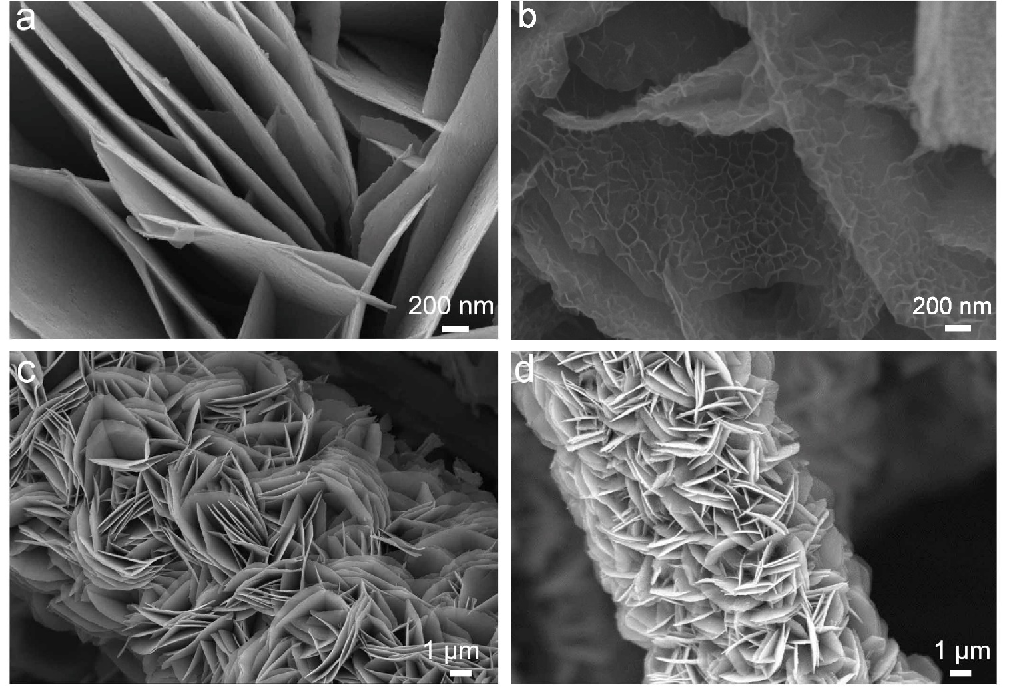
Fig. S2 SEM images at different magnifications of (a, c) CoMn-LDH and (b, d) Co-MnO₂.
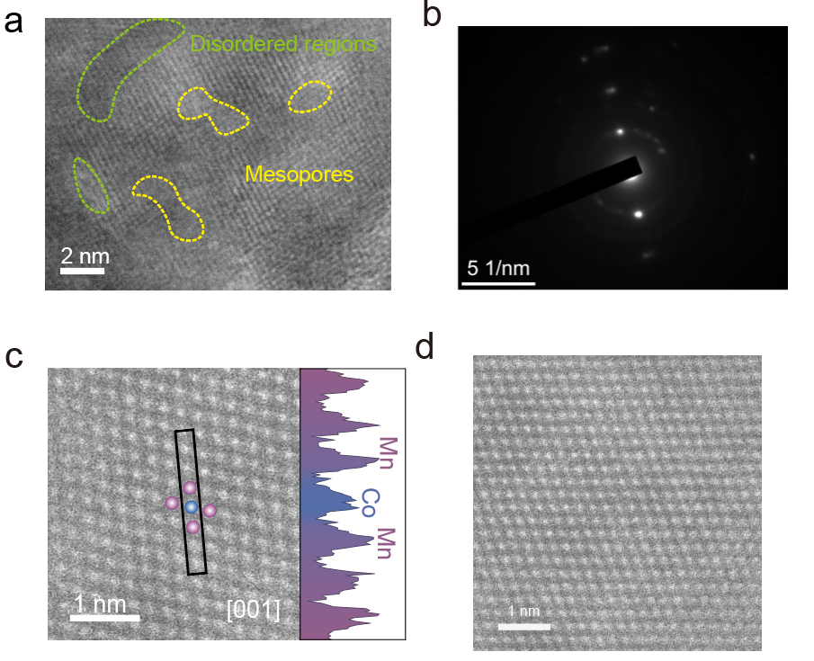
Fig. S3 (a) HRTEM of Co-MnO₂. (b) Selected area electron diffraction (SAED) pattern of Co-MnO₂. (c) Enlarged HAADF-STEM image of Co-MnO₂ and the corresponding contrast line profile. (d) HAADF STEM images of Co-MnO₂.

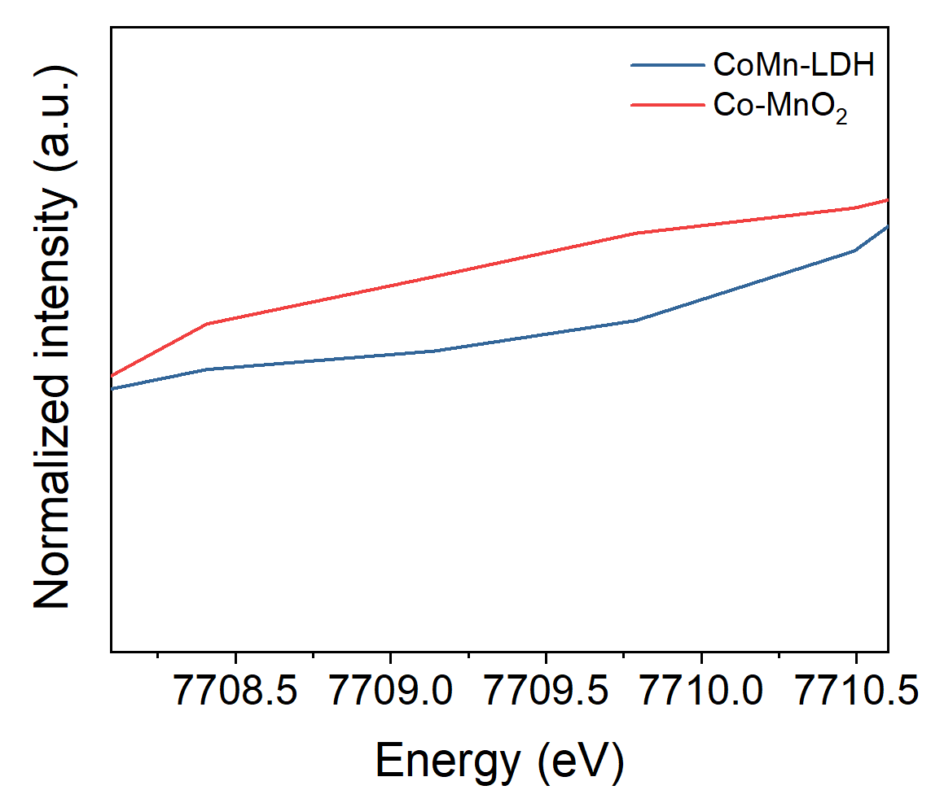
Fig. S4 The comparison of Co K-edge XANES spectra of CoMn-LDH and Co-MnO₂.

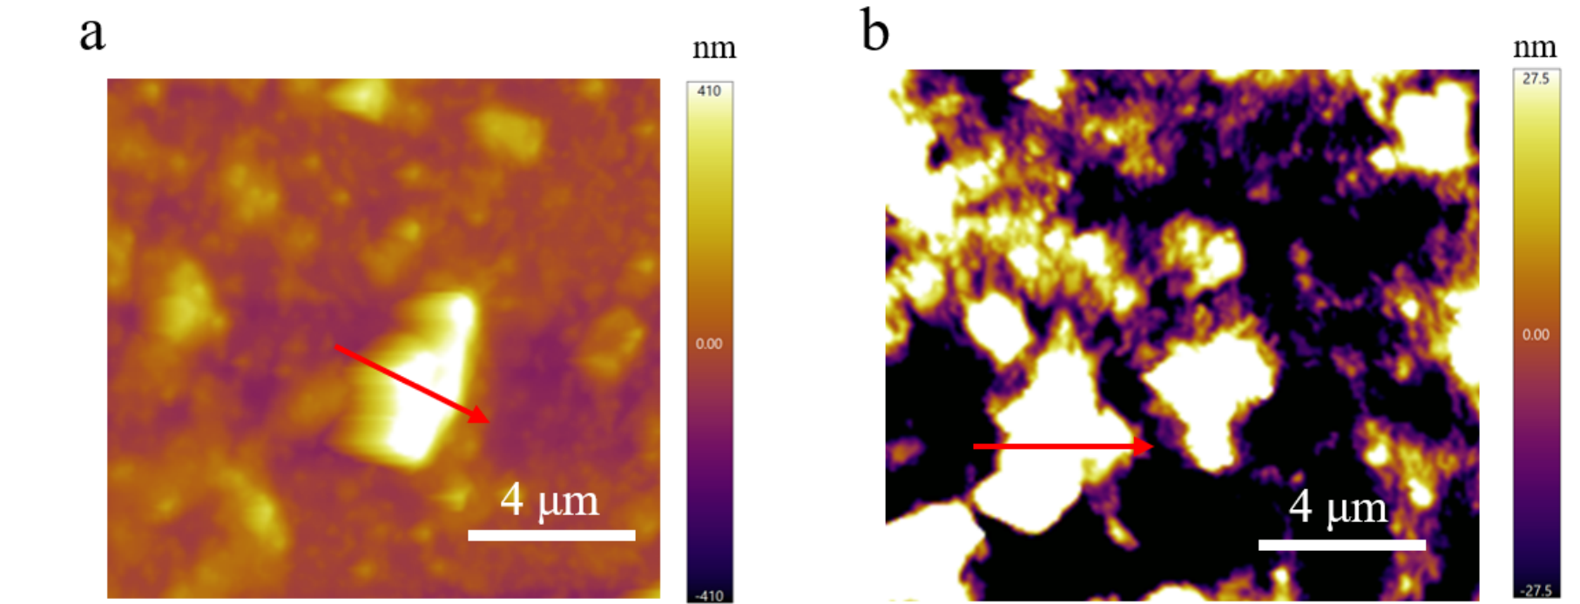
Fig. S5 The AFM images of a) CoMn-LDH and b) Co-MnO₂. Magnetization versus temperature curves.

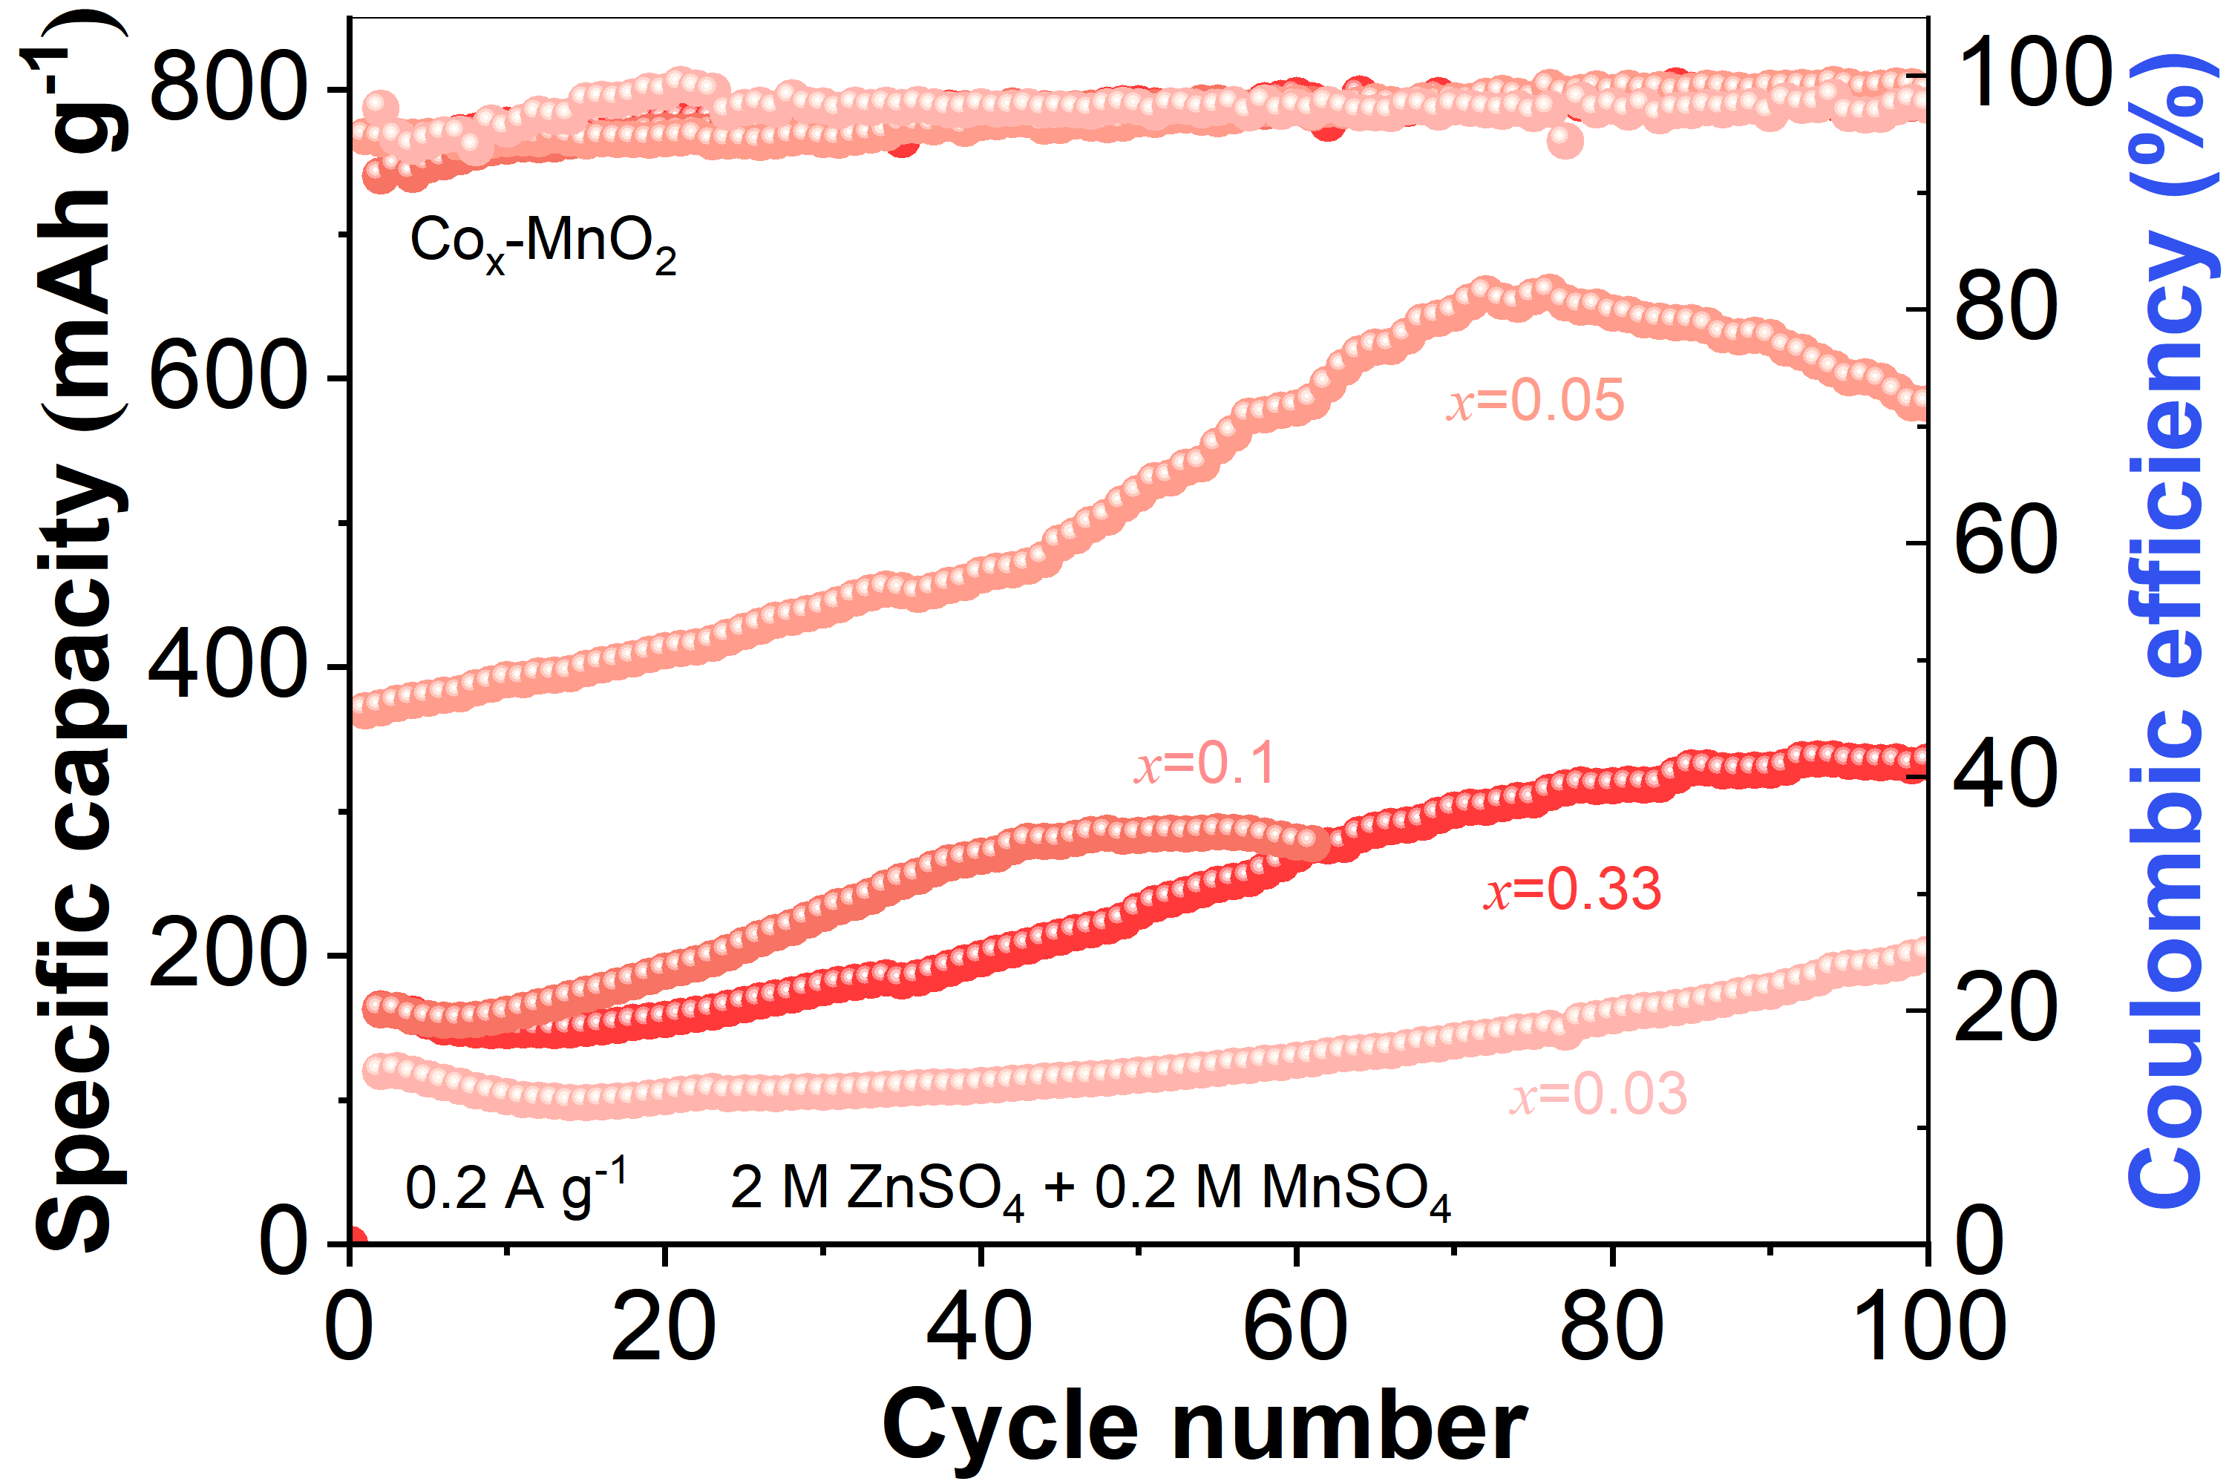
Fig. S6 Cycling performance of Co-MnO₂ cathodes with different Co/Mn ratios.

The electrolytic Mn²⁺ utilization was evaluated based on the electrolyte-driven Mn²⁺/MnO₂ interfacial conversion, rather than the bulk MnO₂/Mn³⁺ redox process. To separate these two contributions, the theoretical capacity of the one-electron MnO₂/Mn³⁺ reaction, 308 mAh g⁻¹, was taken as the upper limit of the bulk-phase capacity. Therefore, the capacity exceeding 308 mAh g⁻¹ was considered to originate from the electrolytic Mn²⁺/MnO₂ interfacial reaction. According to the cycling performance at 0.2 A g⁻¹, the Co-MnO₂ cathode delivers capacities of approximately 400, 510, and 658 mAh g⁻¹ at the initial, 50th, and 70th cycles, respectively. The electrolyte-derived Mn²⁺/MnO₂ capacities are therefore estimated to be 92, 202, and 350 mAh g⁻¹ at the above-mentioned corresponding cycles, giving apparent electrolytic Mn²⁺-derived capacity ratios of 23.0%, 39.6%, and 53.2%, respectively. According to the total addition of 0.4 M MnSO₄, the electrolytic Mn²⁺ utilization ratio was about 51.1% after 70 cycles for the high-capacity Co-MnO₂ cathode.

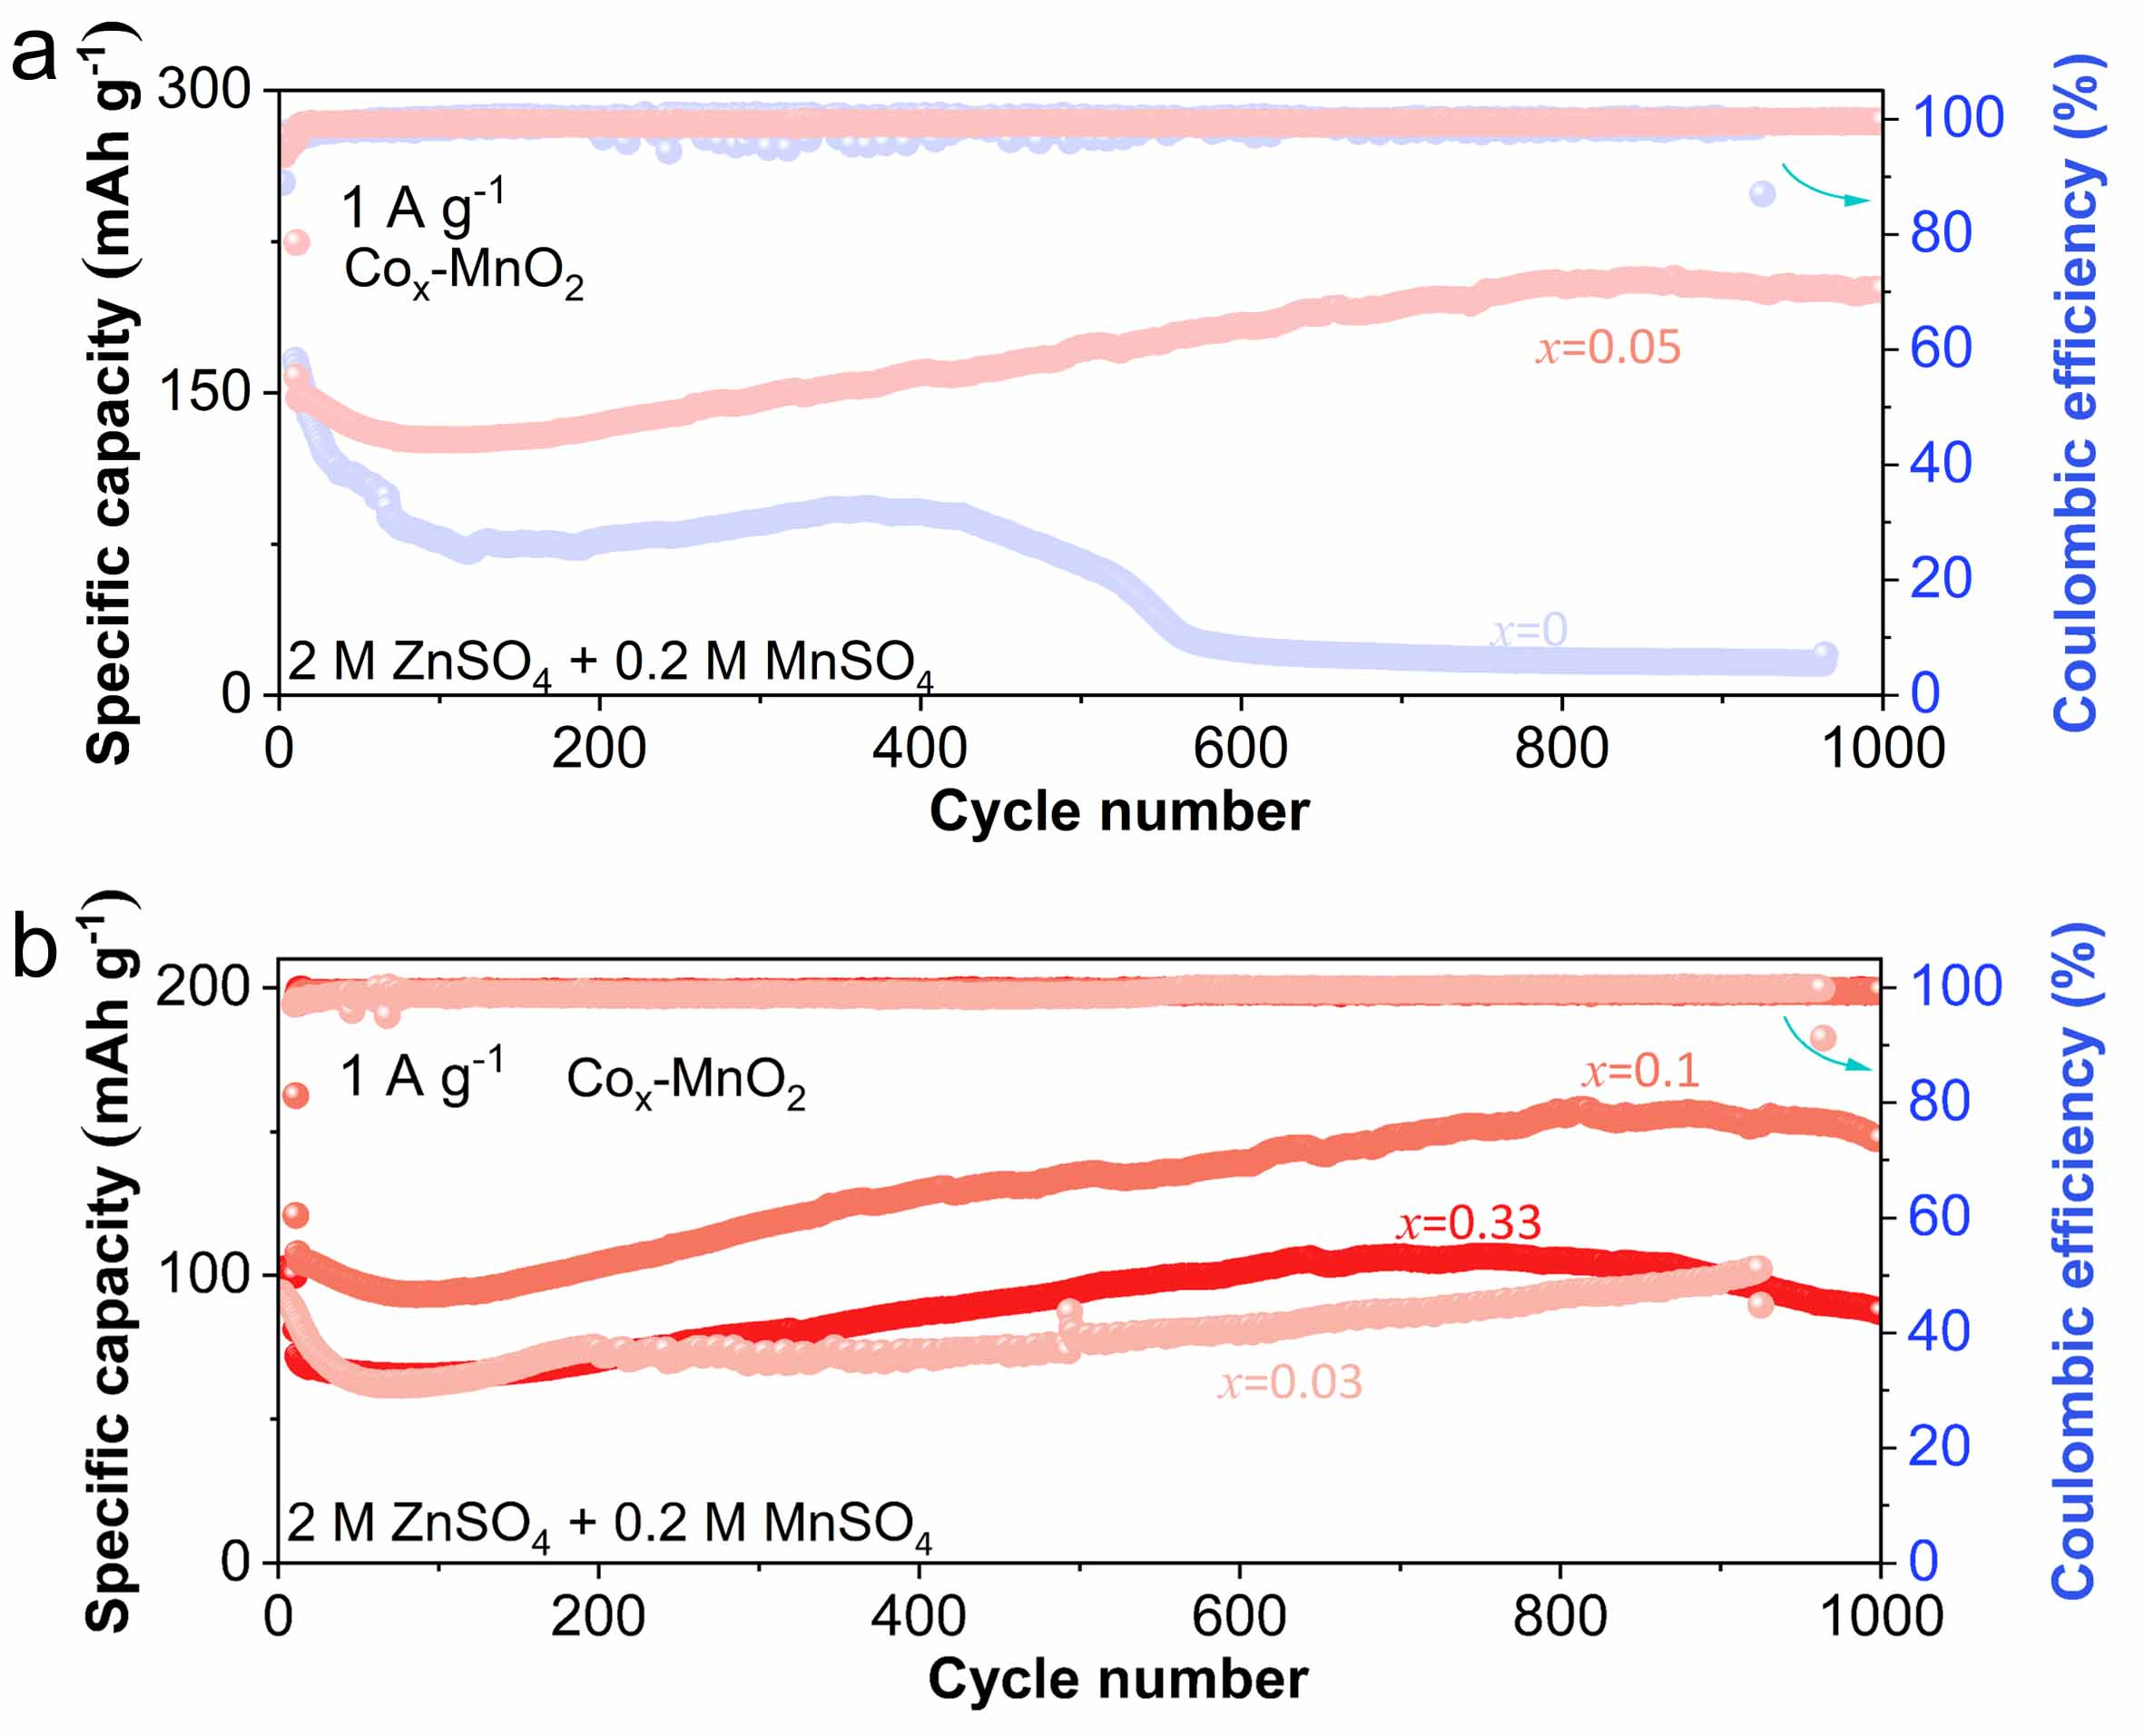
Fig. S7 Cycling performance of Co-MnO₂ cathodes with different Co/Mn ratios.

Fig. S8 Cycling performance of Co_{0.05}-MnO₂ cathodes at varied MnSO₄ concentrations.
Fig. S9 GCD profiles of Co-MnO₂ and MnO₂ cathodes at 0.2 A g⁻¹.

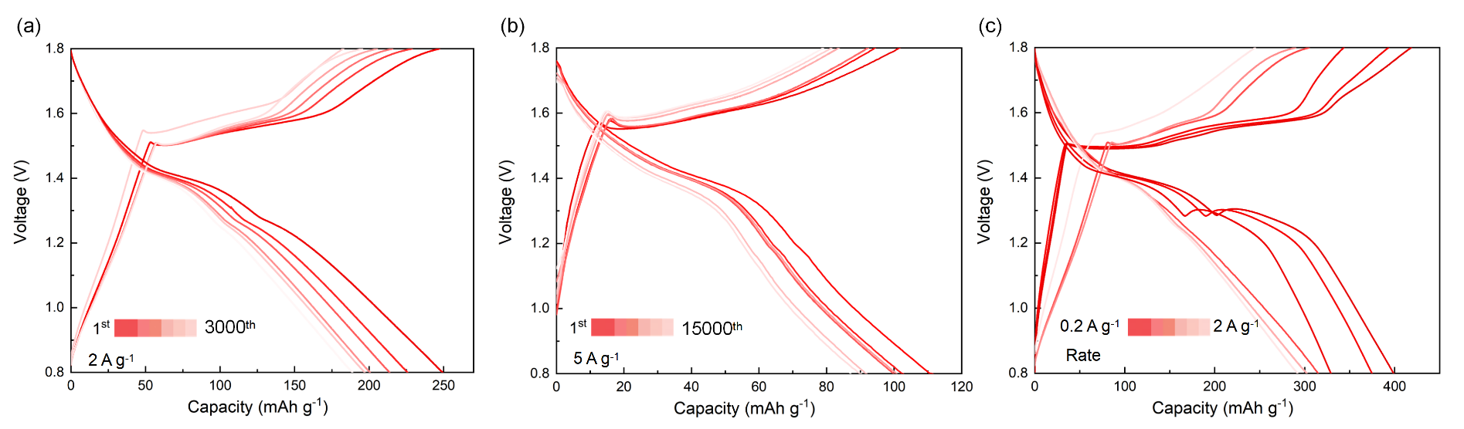
Fig. S10 GCD profiles of Co-MnO₂ cathode at (a) 2 A g⁻¹, (b) 5 A g⁻¹ and (c) various current densities.

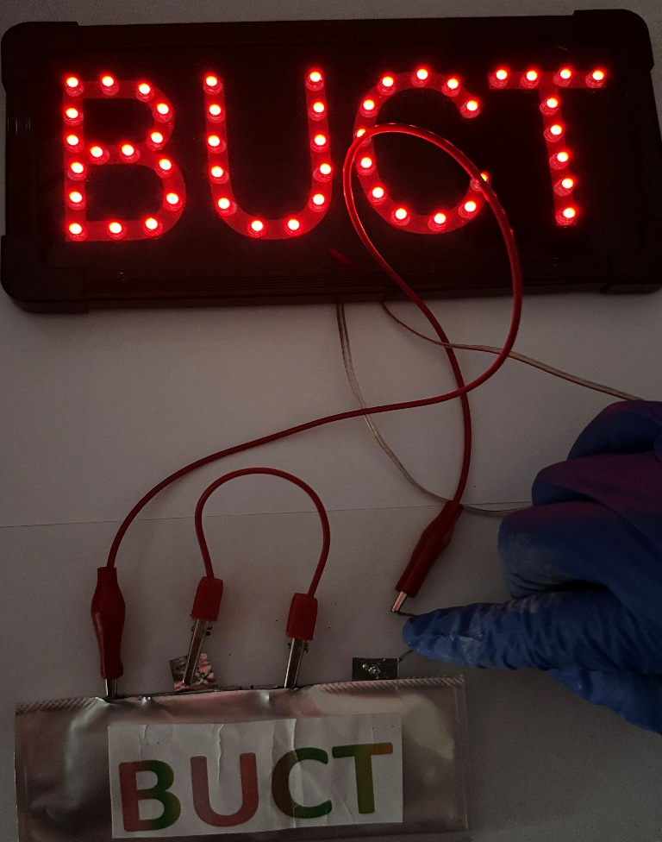
Fig. S11 LED device powered by a Zn//Co-MnO₂ pouch battery.
The specific-capacity calculation methods for both coin cells and pouch cells are provided, which were calculated from the GCD curves according to Equation (S1):
C_{s} = I × Δt / m (S1)
where C_{s} is the specific capacity, I is the applied current, Δt is the discharge time, and m is the mass of active Co-MnO₂ cathode material. For coin cells, m refers to the active mass of Co-MnO₂ loaded on the cathode.
For pouch cells, m refers to the total active mass of Co-MnO₂ in the pouch-cell cathode. Specifically, the as-obtained Co-MnO₂ electrode with an effective area of 3 × 3 cm² and a total active mass of 45 mg was directly used as the pouch-cell cathode. The 11.25 mAh Zn//Co-MnO₂ pouch cell was assembled with a 70 μm-thick Zn foil anode, corresponding to an areal mass of 50.4 mg cm⁻², and 2 M ZnSO₄ + 0.4 M MnSO₄ electrolyte, followed by vacuum sealing in aluminum laminate packaging. The applied current of 10 mA corresponds to a specific current of 0.22 A g⁻¹ based on the Co-MnO₂ active mass. Accordingly, the pouch cell delivered a high specific capacity of 250 mAh g⁻¹, corresponding to a total cell capacity of 11.25 mAh.
Based on the following Equation (S2), the negative/positive (N/P) ratio of the 11.25 mAh Zn//Co-MnO₂ pouch cell was 33. The Zn anode capacity was estimated based on the theoretical specific capacity (820 mAh g⁻¹) of Zn metal, while the measured cathode capacity of 250 mAh g⁻¹ was calculated from the active mass of Co-MnO₂ at 10 mA, as shown in Fig. 3h.
R_{N/P} = Q_{NE}/Q_{PE} = (820 mAh g⁻¹×50.4 mg cm⁻²)/(250 mAh g⁻¹×5 mg cm⁻²)=33 (S2)
When normalized by the active mass of Co-MnO₂, the energy density was calculated to be 325 Wh kg⁻¹ based on the measured capacity of 250 mAh g⁻¹ and an average voltage of 1.3 V according to Equation (S3).
E_{Energy} = Capacity × Average voltage = (250 mAh g⁻¹×1.3 V) = 325 Wh kg⁻¹ (S3)
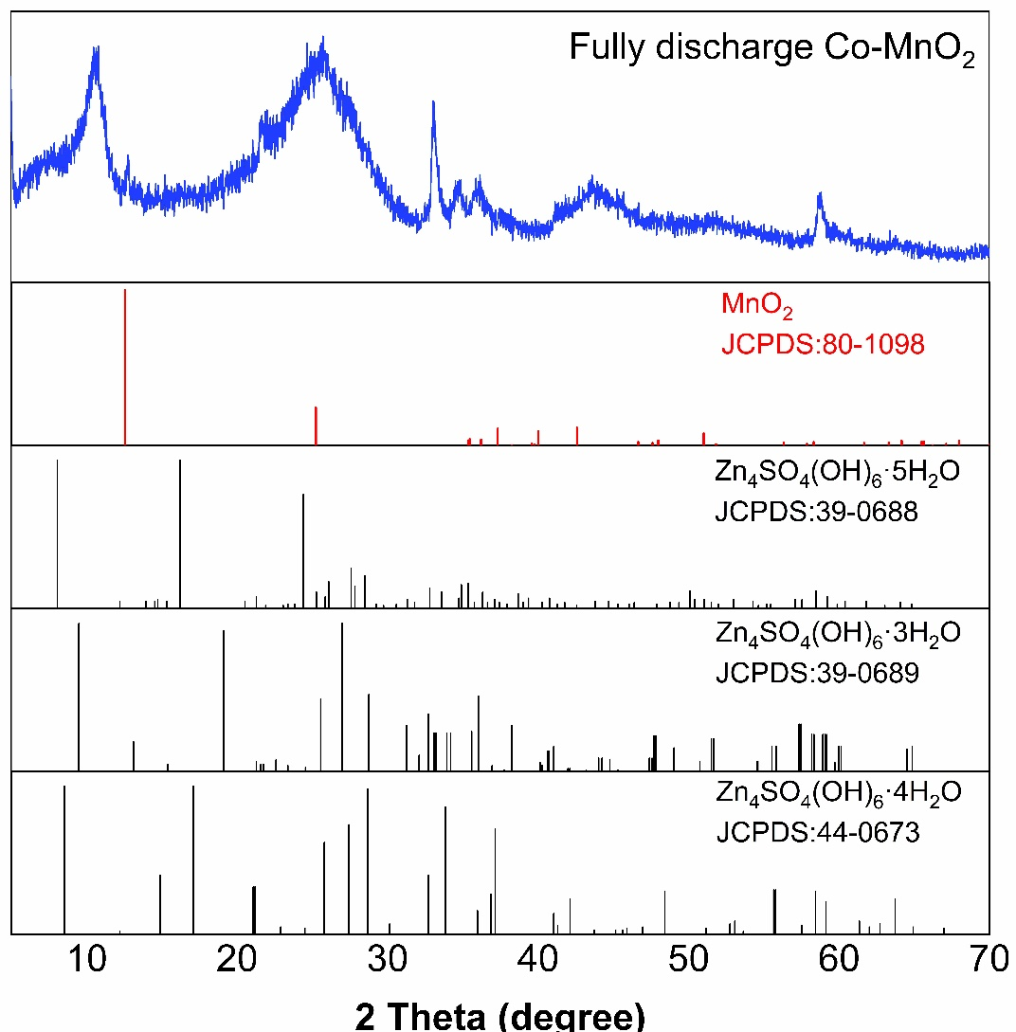
Fig. S12 XRD patterns of Co-MnO₂ cathode at fully discharged state.
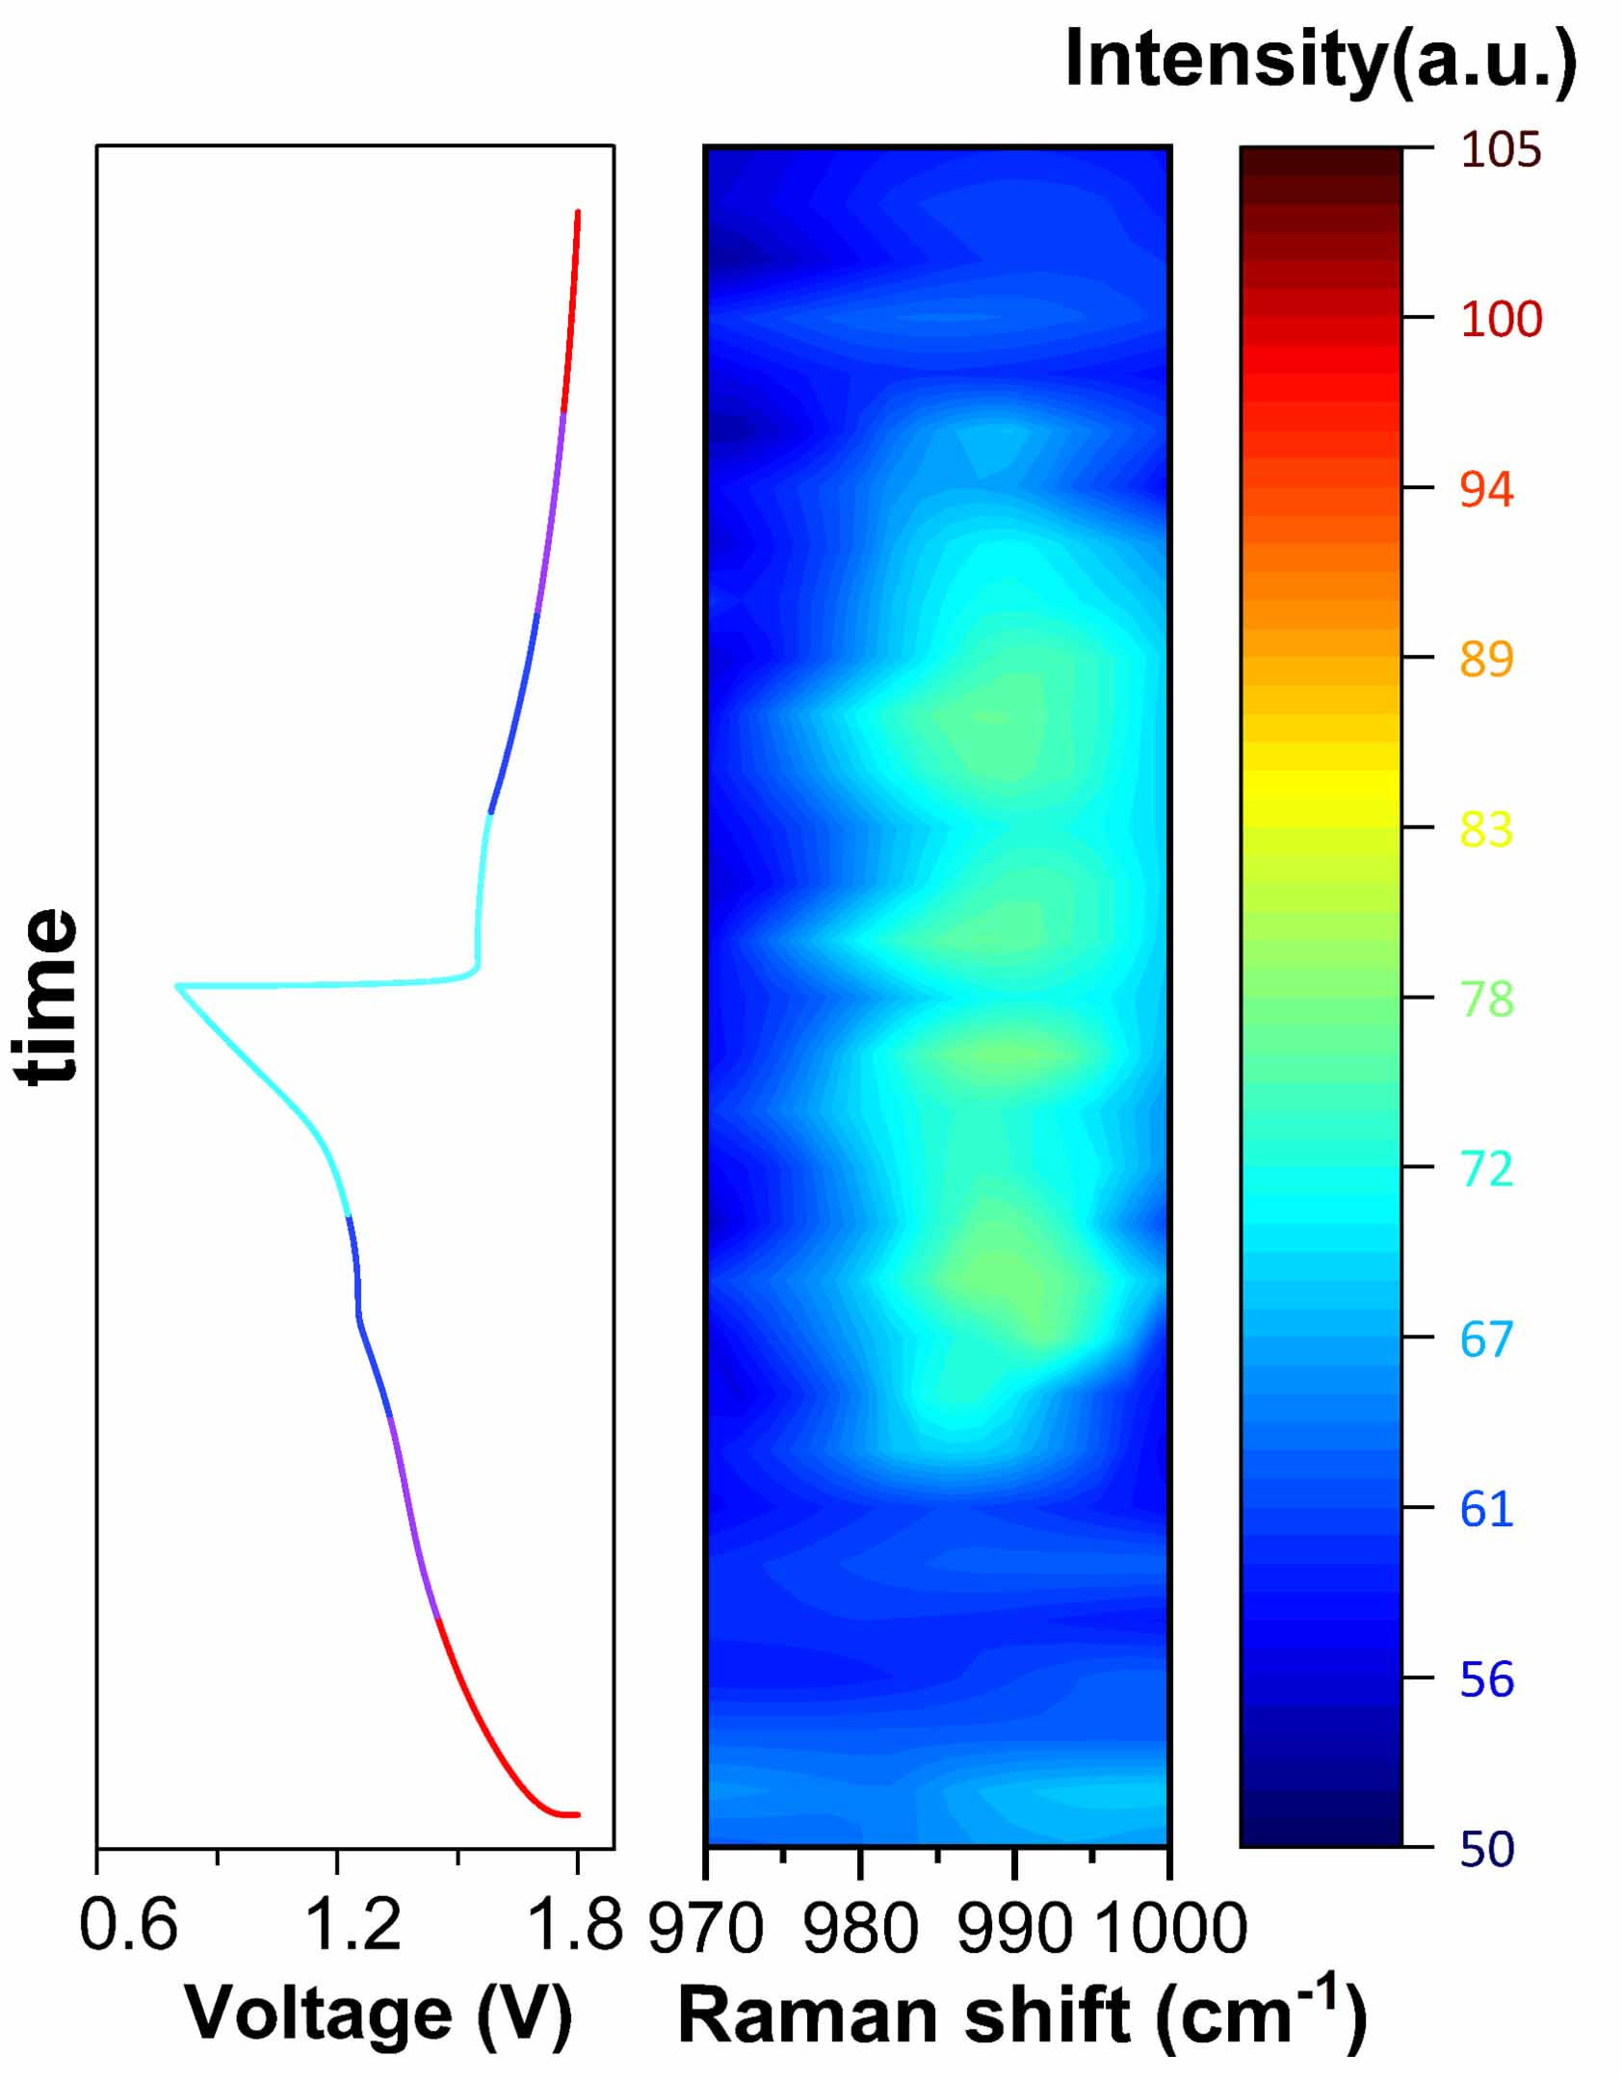
Fig. S13 In-situ Raman spectra (970~1000 cm⁻¹) for the Co-MnO₂ cathode.

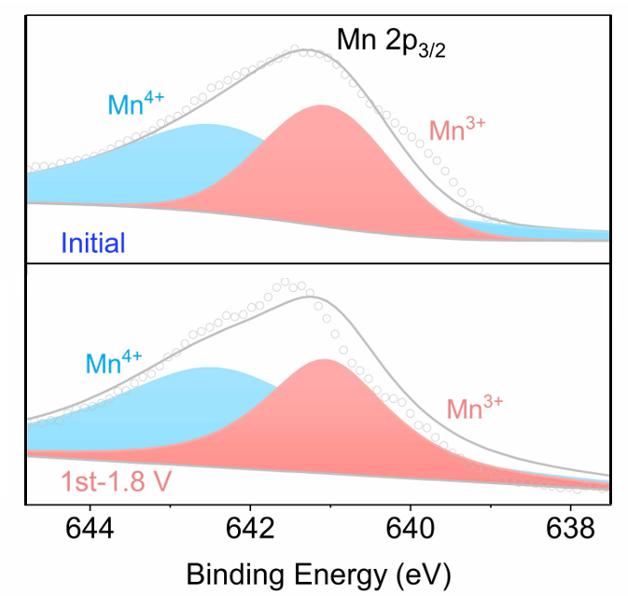
Fig. S14 ex-situ XPS profiles of MnO₂ cathode during battery cycling.

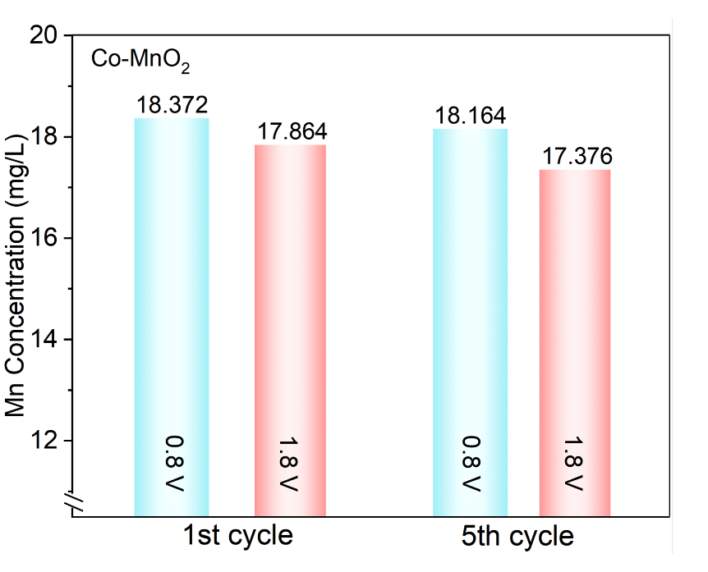
Fig. S15 ICP-OES analysis of Mn concentration variation after 1000 times dilution in 2 M ZnSO₄ + 0.4 M MnSO₄ electrolyte for Co-MnO₂ at 1st and 5th cycles.
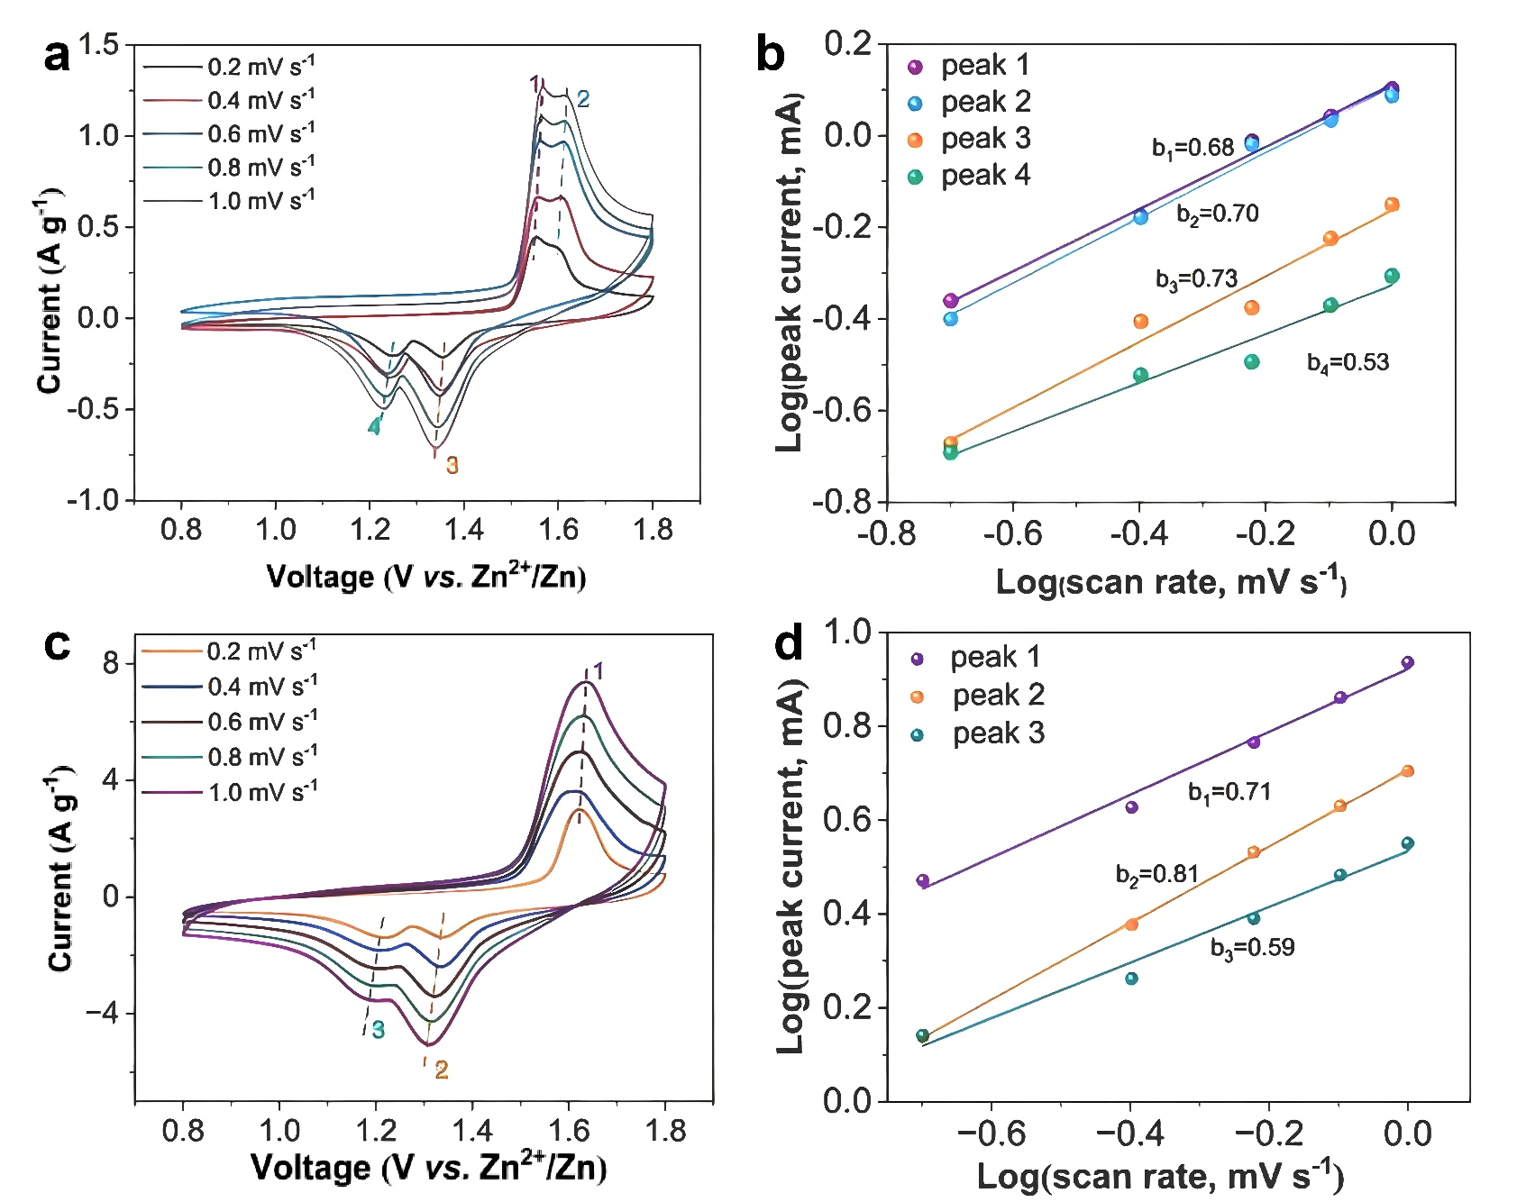
Fig. S16 CV curves electrode at different scan rates of (a) MnO₂ and (c) Co-MnO₂ electrode. The b-values of (b) MnO₂ and (d) Co-MnO₂ electrode.
In general, the relationship between the peak current (i) and scan rate (ν) follows the equation i = a ν^{b}, where the index b reflects a variable that predominantly indicates either a diffusion-controlled process (approximately 0.5) or capacitive-like behavior (approximately 1.0). Compared to bare MnO₂, the Co-MnO₂ cathode exhibited higher b values of 0.71, 0.81, and 0.59 for the redox peaks of O₁, R₁, and R₂, respectively. These results suggested that cobalt doping significantly enhances reaction kinetics at an atomic level.

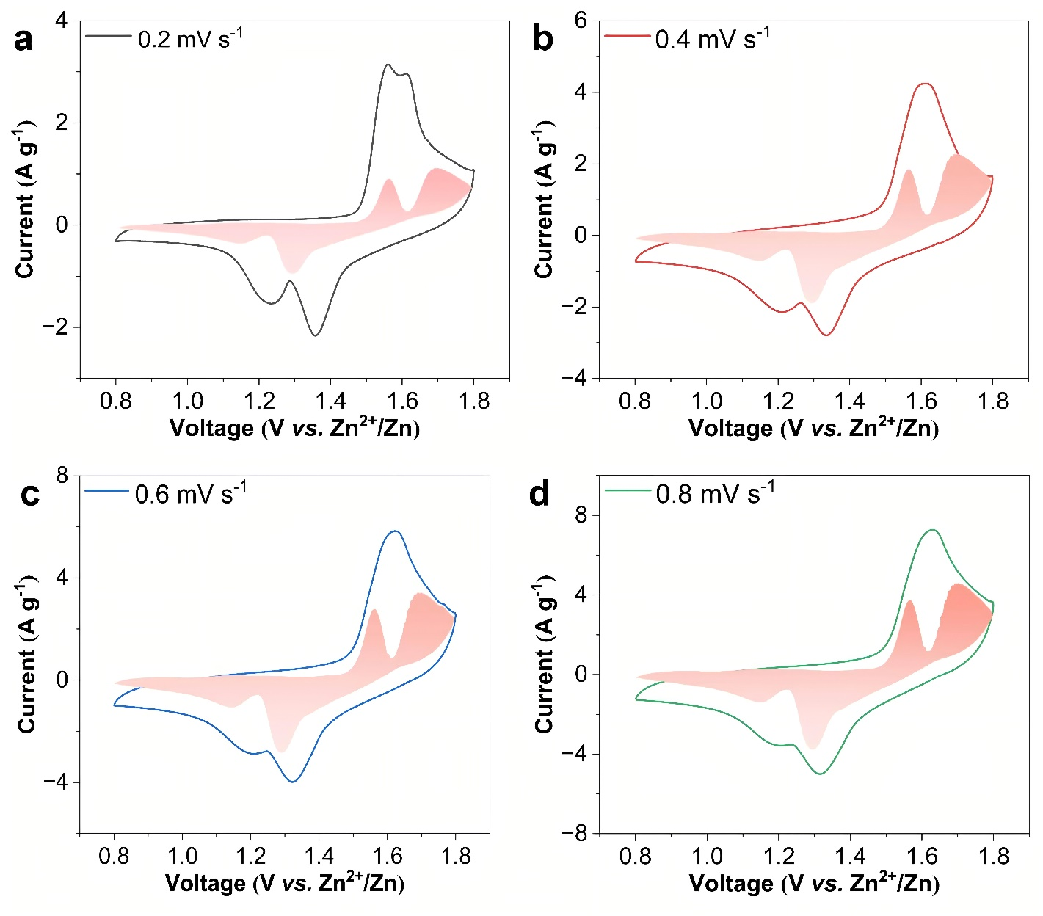
Fig. S17 The scanning rate of Co-MnO₂ electrode separates the capacitive and diffusion-controlled current contribution at different scan rates.

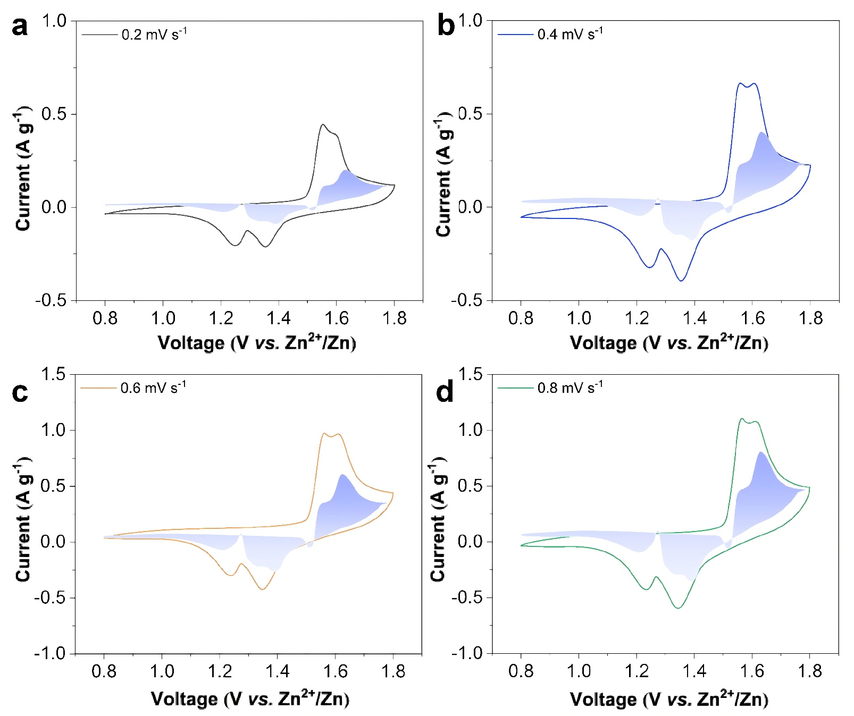
Fig. S18 The scanning rate of MnO₂ electrode separates the capacitive and diffusion-controlled current contribution at different scan rates.

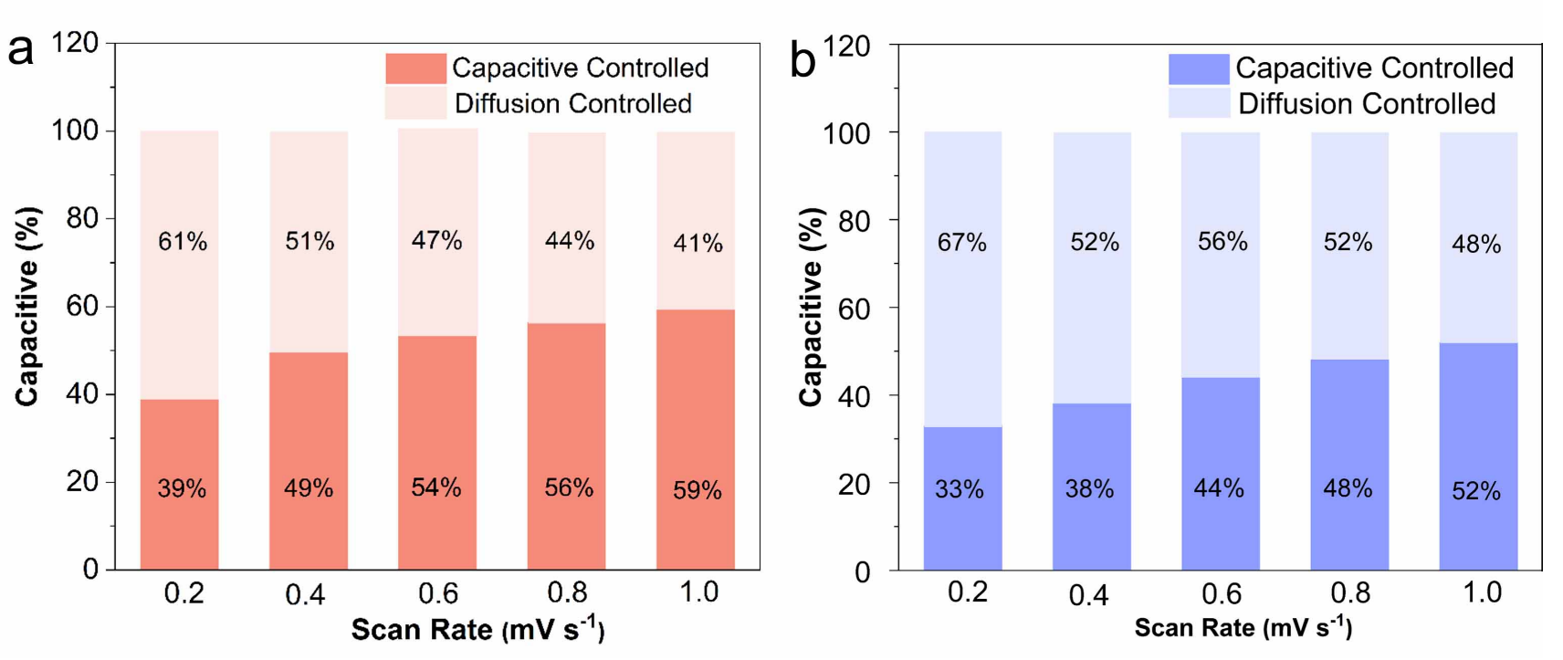
Fig. S19 Contribution ratios of the capacitive capacities and diffusion-limited capacities at different scan rates in (a) Co-MnO₂ and (b) MnO₂ electrodes.

As shown in Fig. S19, Co-MnO₂ cathode demonstrates a higher percentage of capacitive-contributed capacity compared to that of MnO₂ cathode, confirming the improved ion diffusion kinetics for facilitated rate capability of AZMBs.

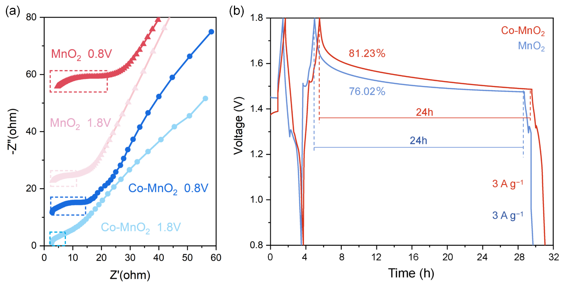
Fig. S20 (a) EIS Nyquist plots of Co-MnO₂ and MnO₂ cathodes at fully charged and discharged states. (b) The self-discharge tests of Co-MnO₂ and MnO₂ cathodes after 24 hours.

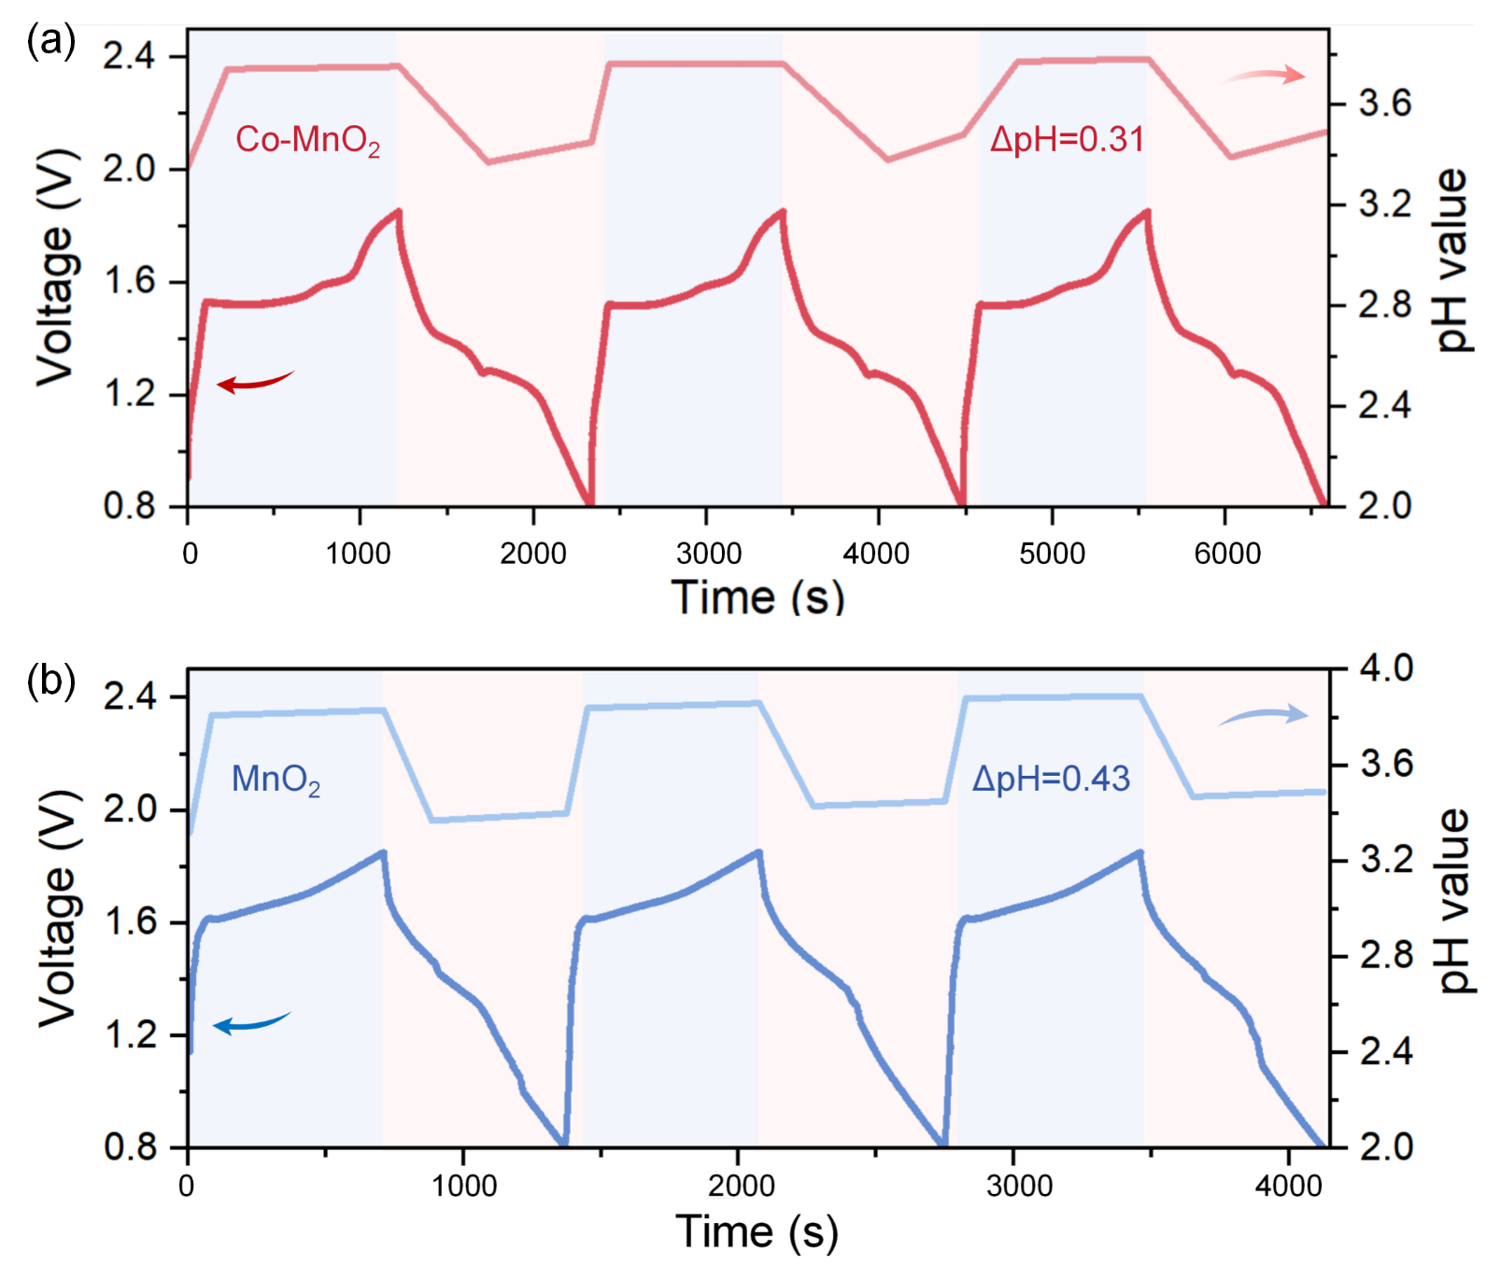
Fig. S21 In-situ pH characterizations of (a) Co-MnO₂, (b) MnO₂ in 2 M ZnSO₄ + 0.4 M MnSO₄ electrolyte, and the active mass loading are same for both cathodes.

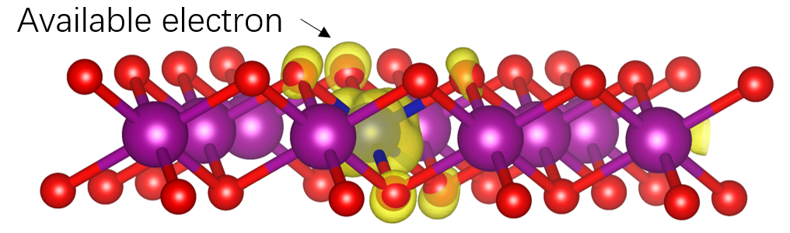
Fig. S22 The partial charge density of the highest occupied states for Co-MnO₂. The excessive electron accumulated on one side of O 2p orbital around to Co atom, indicating high electron-donating ability of O atom in Co-MnO₂.

Table S1 EXAFS fitting parameters at the Co and Mn K-edge for various samples
Sample | Path | N | R(Å) | σ²(10⁻³Å) | ΔE₀(eV) | R-factor
CoMn-LDH | Mn-O | 5.8±1.0 | 1.82±0.07 | 6.9±1.3 | -4.04±3.71 | 0.05
CoMn-LDH | Co-O | 5.45±0.9 | 1.98±0.09 | 14±1.2 | -3.15±5.13 | 0.05
Co-MnO₂ | Mn-O | 5.5±0.6 | 1.95±0.05 | 9.78±3.2 | -8.5±1.6 | 0.06
Co-MnO₂ | Co-O | 5.6±1.01 | 1.91±0.01 | 18.60±0.7 | -8.8±4.7 | 0.06
N is the coordination number; R is distance between absorber and backscatter atoms; σ² is Debye-Waller factor (represents the thermal and static disorder in absorber-scatterer distances); ΔE₀ is the edge energy shift (the difference between the zero kinetic energy value of the sample and that of the theoretical model). R factor is used to assess the goodness of the fitting.
Table S2 Battery performance comparison of Co-MnO₂ with reported Mn-based cathodes
Cathode | Rate performance | Cycling performance
Ru-MnO₂ [S1] | 314 mAh g⁻¹ at 0.2 A g⁻¹  120 mAh g⁻¹ at 1.0 A g⁻¹ | 83% capacity retention  (2000 cycles at 1.0 A g⁻¹ )
Ce-MnO₂ [S2] | 349 mAh g⁻¹ at 0.3 A g⁻¹  149 mAh g⁻¹ at 3.0 A g⁻¹ | 89% capacity retention  (100 cycles at 0.3 A g⁻¹ )  100% capacity retention  (2000 cycles at 3.0 A g⁻¹ )
Al–MnO₂ [S3] | 328 mAh g⁻¹ at 0.2 A g⁻¹ | 98% capacity retention  (200 cycles at 0.2 A g⁻¹ )
Ni-MnO_{2-x}-F_{x} [S4] | 352 mAh g⁻¹ at 0.5 A g⁻¹  180 mAh g⁻¹ at 2.0 A g⁻¹ | 100% capacity retention  (100 cycles at 0.5 A g⁻¹ )  89% capacity retention  (1000 cycles at 2.0 A g⁻¹ )
S-MnO₂ [S5] | 324 mAh g⁻¹ at 0.2 A g⁻¹  150 mAh g⁻¹ at 3.0 A g⁻¹ | 100% capacity retention  (100 cycles at 0.2 A g⁻¹ )  90% capacity retention  (1000 cycles at 3.0 A g⁻¹ )
CaMnO [S6] | 290 mAh g⁻¹ at 0.3 A g⁻¹  140 mAh g⁻¹ at 1.5 A g⁻¹ | 99% capacity retention  (200 cycles at 0.3 A g⁻¹ )  90% capacity retention  (1000 cycles at 1.5 A g⁻¹ )
IC@MnO₂ [S7] | 336 mAh g⁻¹ at 0.2 A g⁻¹  200 mAh g⁻¹ at 2.0 A g⁻¹ | 80.3% capacity retention  (1300 cycles at 2.0 A g⁻¹ )
C@PODA/MnO₂ [S8] | 140 mAh g⁻¹ at 2.0 A g⁻¹ | 89.3% capacity retention  (2000 cycles at 2.0 A g⁻¹ )
BiO/MnO₂ [S9] | 113 mAh g⁻¹ at 2.0 A g⁻¹ | 100% capacity retention  (2000 cycles at 2.0 A g⁻¹ )
MnO₂@AEPA [S10] | 223 mAh g⁻¹ at 0.5 A g⁻¹  146 mAh g⁻¹ at 1.0 A g⁻¹ | 100% capacity retention  (200 cycles at 0.5 A g⁻¹ )  97% capacity retention  (1700 cycles at 1.0 A g⁻¹ )
Se-MnO₂ [S11] | 386 mAh g⁻¹ at 0.1 A g⁻¹ | 100% capacity retention  (100 cycles at 0.1 A g⁻¹ )
This work | 658 mAh g⁻¹ at 0.2 A g⁻¹  180 mAh g⁻¹ at 2.0 A g⁻¹  100 mAh g⁻¹ at 5.0 A g⁻¹ | 175% capacity retention  (100 cycles at 0.2 A g⁻¹ )  80% capacity retention  (3000 cycles at 2.0 A g⁻¹ )  80% capacity retention  (15000 cycles at 5.0 A g⁻¹ )
Table S3 ICP results of Mn concentrations in Zn//Co-MnO₂ batteries at the fully charged and discharged states during battery cycling
Sample name | Dilution ratio | C (mg/L) | C₀ (mg/L)
1st-0.8 V | 1000 | 18.37 | 18,370
1st-1.8 V | 1000 | 17.86 | 17,860
5th-0.8 V | 1000 | 18.16 | 18,160
5th-1.8 V | 1000 | 17.38 | 17,380
10th-0.8 V | 1000 | 19.35 | 19,350
10th-1.8 V | 1000 | 18.64 | 18,640
(Test element is Mn, C is instrument reading concentration, Dilution ratio is 1000, C₀ is the concentration of the original sample solution.)
Supplementary References
- S. Wang, S. Yao, F. Zhang, K. Ji, Y. Ji et al., Quantum spin exchange interactions trigger O_{p} band broadening for enhanced aqueous zinc-ion battery performance. Angew. Chem. Int. Ed. 64(4), e202415997 (2024). https://doi.org/10.1002/anie.202415997
- Y. Chen, C. Lin, X. Chen, Z. Lu, K. Zhang et al., Modulating the structure of interlayer/layer matrix on δ-MnO₂ via cerium doping-engineering toward high-performance aqueous zinc ion batteries. Adv. Energy Mater. 14(35), 2304303 (2024). https://doi.org/10.1002/aenm.202304303
- Y. Zhao, S. Zhang, Y. Zhang, J. Liang, L. Ren et al., Vacancy-rich Al-doped MnO₂ cathodes break the trade-off between kinetics and stability for high-performance aqueous Zn-ion batteries. Energy Environ. Sci. 17(3), 1279-1290 (2024). https://doi.org/10.1039/D3EE01659E
- J. Lin, Y. Wang, M. Chen, J. Lu, H. Mi et al., Regulating the Gibbs free energy to design aqueous battery-compatible robust host. Adv. Energy Mater., 14(31), 2401275 (2024). https://doi.org/10.1002/aenm.202401275
- Y. Zhao, P. Zhang, J. Liang, X. Xia, L. Ren et al., Uncovering sulfur doping effect in MnO₂ nanosheets as an efficient cathode for aqueous zinc ion battery. Energy Storage Mater., 47, 424-433 (2022). https://doi.org/10.1016/j.ensm.2022.02.030
- T. Wang, J. Jin, X. Zhao, X. Qu, L. Jiao et al., Unraveling the anionic redox chemistry in aqueous zinc-MnO₂ batteries. Angew. Chem. Int. Ed., 63(47), e202412057 (2024). https://doi.org/10.1002/anie.202412057
- N. Jiang, Y. Zeng, Q. Yang, P. Lu, K. Qu et al., Deep ion mass transfer addressing the capacity shrink challenge of aqueous Zn-MnO₂ batteries during the cathode scaleup. Energy Environ. Sci., 17(22), 8904-8914 (2024). https://doi.org/10.1039/D4EE02871F
- Y. Zhao, R. Zhou, Z. Song, X. Zhang, T. Zhang et al., Interfacial designing of MnO₂ half-wrapped by aromatic polymers for high-performance aqueous zinc-ion batteries. Angew. Chem. Int. Ed. 61(49), e202212231 (2022). https://doi.org/10.1002/anie.202212231
- X. Zhao, F. Zhang, H. Li, H. Dong, C. Yan et al., Dynamic heterostructure design of MnO₂ for high-performance aqueous zinc-ion batteries Energy Environ. Sci., 17(10), 3629-3649 (2024). https://doi.org/10.1039/D4EE00341A
- X. Xiao, L. Zhang, W. Xin, M. Yang, Y. Geng et al., Self-assembled layer of organic phosphonic acid enables highly stable MnO₂ cathode for aqueous zinc batteries. Small, 20(24), 2309271 (2024). https://doi.org/10.1002/smll.202309271
- J. Ye, P. H. Li, Z. Hou, W. Zhang, W. Zhu et al., Se-dopant modulated selective Co-insertion of H⁺ and Zn²⁺ in MnO₂ for high-capacity and durable aqueous Zn-ion batteries. Angew. Chem. Int. Ed. 63(43), e202410900 (2024). https://doi.org/10.1002/anie.202410900

