Supporting Information for
Polar-Twisted Electron-Transport Layer Simultaneously Breaks Efficiency-Flexibility-Cost Limits in Organic Solar Cells
Thi Le Huyen Mai¹, Zhe Sun¹*, Won Jung Kang², Seunglok Lee¹, Taek-Soo Kim², and Changduk Yang^{1,3,4}*
¹Department of Energy Engineering, School of Energy and Chemical Engineering, Ulsan National Institute of Science and Technology (UNIST), 50 UNIST-gil, Ulju-gun, Ulsan 44919, Republic of Korea
² Department of Mechanical Engineering, Korea Advanced Institute of Science and Technology (KAIST), 291 Daehak-ro, Yuseong-gu, Daejeon, 34141, Republic of Korea
³Graduate School of Carbon Neutrality, Ulsan National Institute of Science and Technology (UNIST), 50 UNIST-gil, Ulju-gun, Ulsan 44919, Republic of Korea
⁴UNIST InnoCORE AI-Space Solar Initiative, Ulsan National Institute of Science and Technology (UNIST), Ulsan, 44919, Republic of Korea
*Corresponding authors. E-mail: yang@unist.ac.kr (Changduk Yang); zhesun@unist.ac.kr (Zhe Sun)
Supporting Experiments
Synthesis of 6-bromo-N,N-dimethyl-2-naphthamide (1): A solution of 6-bromo-2-naphthoic acid (5.0 g, 19.91 mmol) in dichloromethane (40 mL) was prepared and stirred at ambient temperature. Oxalyl chloride (2.80 mL, 31.86 mmol) was added carefully, followed by a catalytic trace of DMF, and the mixture was allowed to stir for 2 h. The reaction was then cooled to 0 °C, after which dimethylamine (25 mL) was introduced dropwise. Stirring was continued overnight at room temperature. The reaction was quenched with water, and the organic layer was separated with dichloromethane, washed successively with 1 M HCl, saturated NaHCO₃, and brine. The combined organic extracts were dried over MgSO₄, filtered, and concentrated under reduced pressure. Purification of the residue by flash chromatography on silica gel furnished compound 1 in 84 % yield (4.60 g) as a colourless oil that crystallises to a white solid upon refrigeration. ¹H NMR (400 MHz, CDCl₃, δ): 8.02 (s, 1H), 7.88 (s, 1H), 7.77 (dd, J= 8.0 Hz, 2H), 7.61 (dd, J= 8.0 Hz, 2H), 3.16 (s, 3H), 3.03 (s, 3H).
Synthesis of N,N-dimethyl-2-naphthamide-6-boronic acid pinacol ester (2): Combine compound 1 (3.0 g, 10.79 mmol), Pd(dppf)Cl₂.DCM (0.14 g, 0.53 mmol), bis(pinacolato)diboron (4.10 g, 16.17 mmol) and potassium acetate (3.17 g, 32.35 mmol) in 100 mL of 1,4-dioxane. Stir the mixture under argon at 100 °C for 24 h. After it cools to room temperature, extract with ethyl acetate and wash the organic phase successively with water and brine. Dry over anhydrous MgSO₄, filter, and remove the solvent under reduced pressure. Purify the residue by silica-gel column chromatography (ethyl acetate : hexane) to obtain compound 2 as a white solid (3.20 g, 91 % yield). ¹H NMR (400 MHz, CDCl₃, δ): 8.37 (s, 1H), 7.88 (m, 4H), 7.51 (d, J= 7.8 Hz, 1H), 3.16 (s, 3H), 3.02 (s, 3H), 1.39 (s, 12H).
Synthesis of PDIN-NAP: PDIN-Br₂ (0.20 g, 0.27 mmol), naphthalene-2-boronic acid (0.14 g, 0.84 mmol), potassium carbonate (0.77 g, 5.56 mmol) and Pd(pph₃)₄ (0.016 g, 0.013 mmol) was dissolved in 24 mL/12 mL/6 mL toluene/ethanol/water. Then, the mixture reaction was stirred at 100 °C for 24 h under the argon atmosphere. After cooling down to room temperature, the crude mixture was extracted with chloroform, washed with water, brine. Next, solvents were evaporated under reduced pressure after the combined organic layer was dried with anhydrous MgSO₄. The residue was purified by column chromatography on silica gel (chloroform : triethylamine : methanol) to obtain PDIN-NAP as the red solid (0.19 g, 82%). ¹H NMR (400 MHz, CDCl₃, δ): 8.74 (s, 2H), 7.92 (m, 14H), 7.61 (m, 4H), 4.25 (m, 4H), 2.45 (m, 4H), 2.26 (s, 12H), 1.93 (m, 4H). ¹³C NMR (151 MHz, CDCl₃, δ): 163.33, 140.84, 139.40, 135.59, 134.60, 133.01, 132.39, 130.38, 129.70, 129.39, 129.10, 128.44, 128.27, 127.94, 127.47, 127.15, 126.96, 126.71, 122.28, 121.83, 57.20, 45.33, 38.96, 26.04. HRMS (MALDI-TOF): calcd for C₅₄H₄₄N₄O₄, 812.97. Found: 813.24.
Synthesis of H75-DMA: Synthesized according to a similar procedure to PDIN-NAP by utilizing PDIN-Br₂ (0.10 g, 0.14 mmol), 2 (0.14 g, 0.42 mmol), potassium carbonate (0.38 g, 2.78 mmol) and Pd(pph₃)₄ (0.008 g, 0.006 mmol) and toluene/ethanol/water (18 mL/9 mL/4.5 mL). H75-DMA as dark red solid (0.11 g, 85% yield). ¹H NMR (400 MHz, CDCl₃, δ): 8.75 (s, 2H), 7.99 (m, 14H), 7.63 (m, 2H), 4.24 (m, 4H), 3.22 (d, 12H), 2.44 (m, 4H), 2.26 (s, 12H), 1.92 (m, 4H). ¹³C NMR (151 MHz, CDCl₃, δ): 171.21, 163.29, 140.52, 135.50, 134.95, 134.53, 132.47, 132.30, 130.46, 130.20, 129.50, 129.12, 128.69, 128.11, 127.60, 127.57, 126.76, 125.60, 122.42, 121.98, 57.18, 45.35, 39.79, 38.98, 35.50, 26.08. HRMS (MALDI-TOF): calcd for C₆₀H₅₄N₆O₆, 954.41. Found: 955.54.
Supplementary Figures and Tables
Table S1 Optical and electrochemical properties of PDIN, PDIN-NAP, and H75-DMA
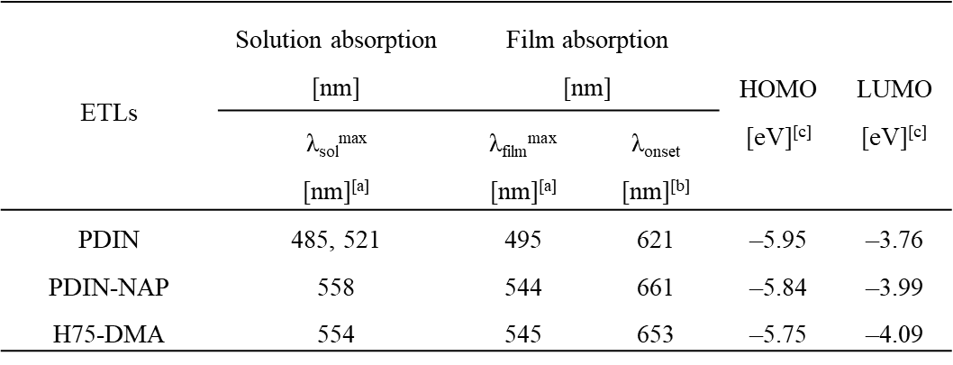
[a] Data collected both from the samples dissolved in methanol and from their corresponding thin films cast onto glass substrates. [b] Obtained from the onset wavelength of the UV–vis absorption spectra of the thin films. [c] HOMO and LUMO energies were derived from the initial oxidation and reduction potentials using E_{HOMO} = −(E_{ox}^{onset} − E_{Fc}^{onset} + 4.8) eV, E_{LUMO} = −(E_{red}^{onset} − E_{Fc}^{onset} + 4.8 ) eV; the electrochemical bandgap E_{g}^{CV} was then calculated as E_{HOMO} – E_{LUMO.}

Table S2 The work function and the injection barriers for hole of ETLs
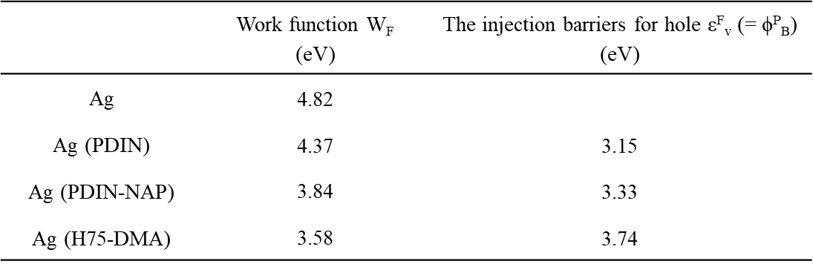

Table S3 The electron mobility and conductivity of ETLs
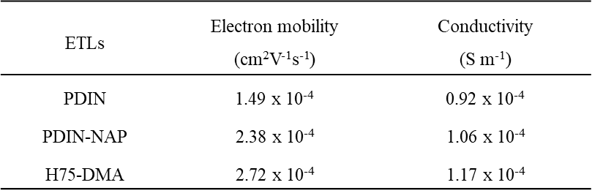

Table S4 Normalized photovoltaic parameters (%) of devices based on PDIN, PDINN, PDIN-NAP, and H75-DMA as the ETL on D18-Cl:N3 under ambient environment stability (40-60% RH, 25 ℃, unencapsulated)
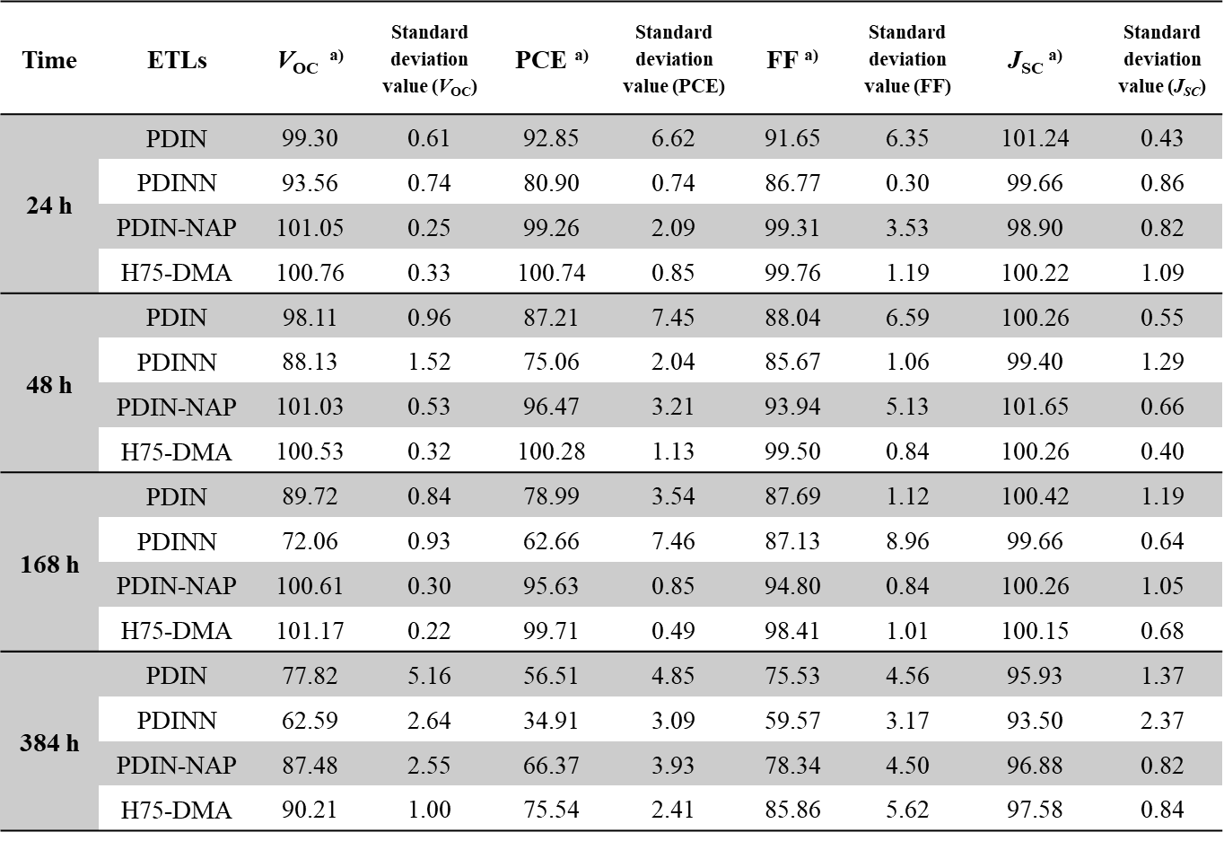
[a] the average PCE values are obtained from at least 8 cells.
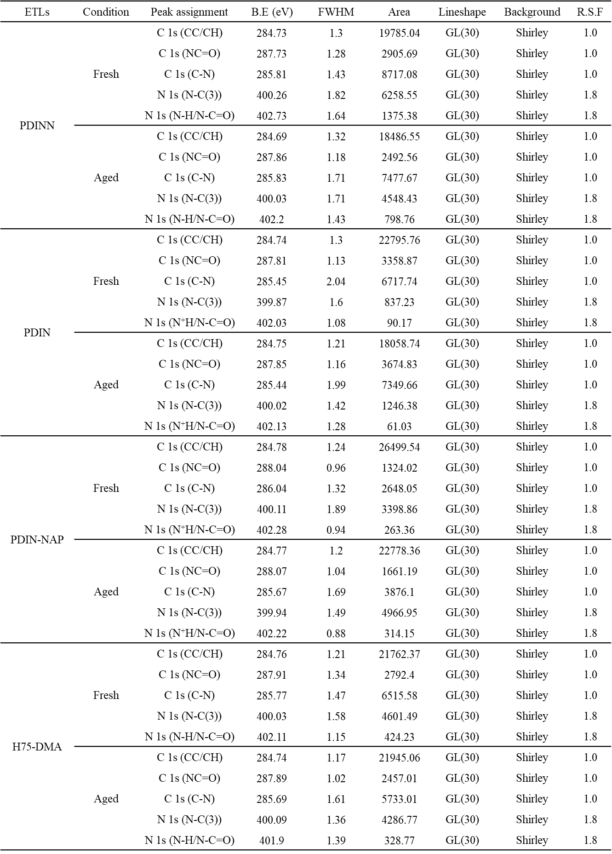
Table S5 Summary of XPS fitting parameters for the C 1s and N 1s spectra of fresh and aged ETL films
Table S6 The exciton dissociation probability and charge collection probability values of fresh and aged devices with PDIN, PDINN, PDIN-NAP, and H75-DMA ETLs
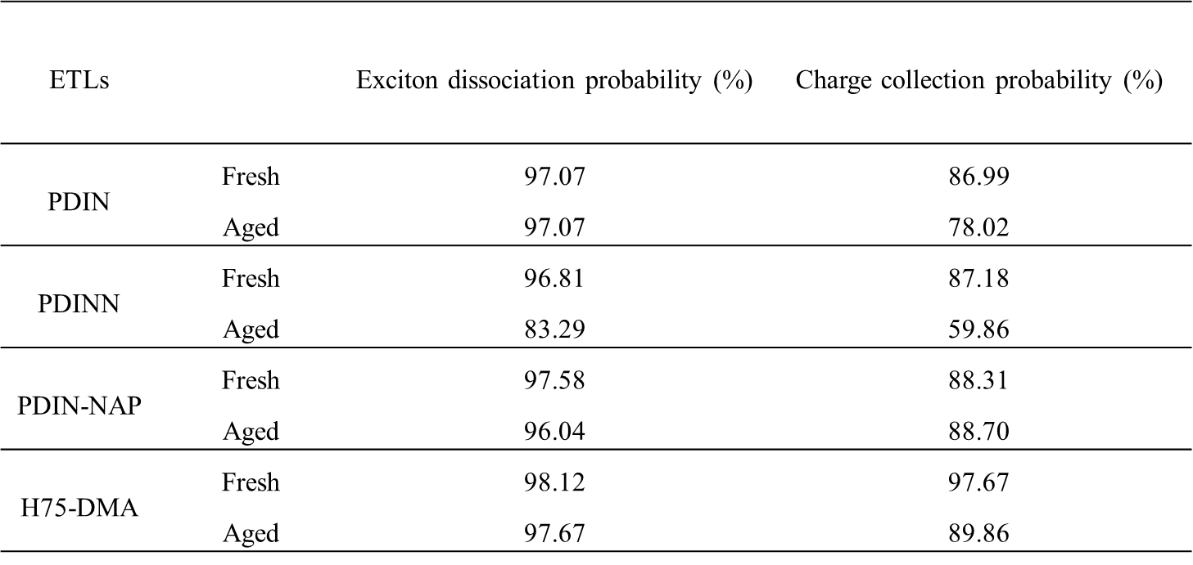

Table S7 The TPV and TPC lifetime values of fresh and aged devices with PDIN, PDINN, PDIN-NAP, and H75-DMA ETLs.
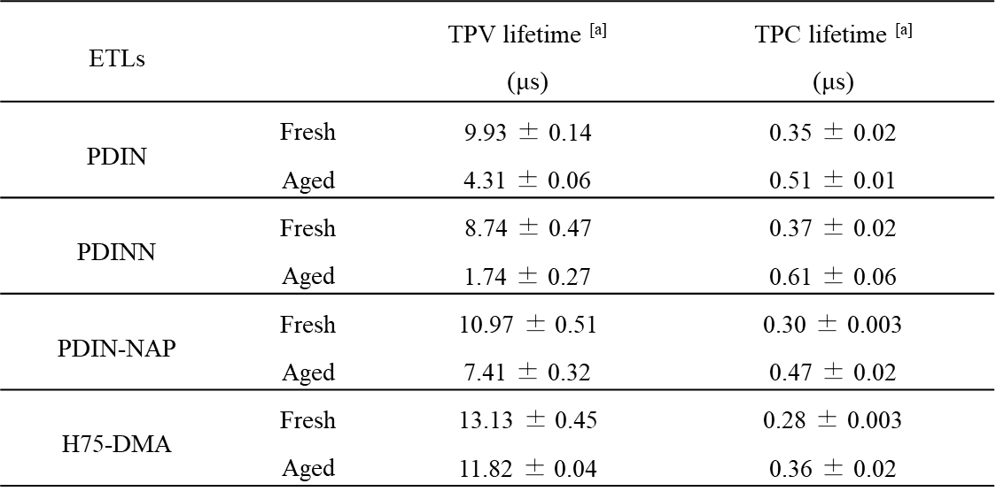
[a] the average values are obtained from 3 cells.

Table S8 Normalized photovoltaic parameters of devices based on PDIN, PDIN-NAP, and H75-DMA as the ETL on D18-Cl:N3 under bending cycles
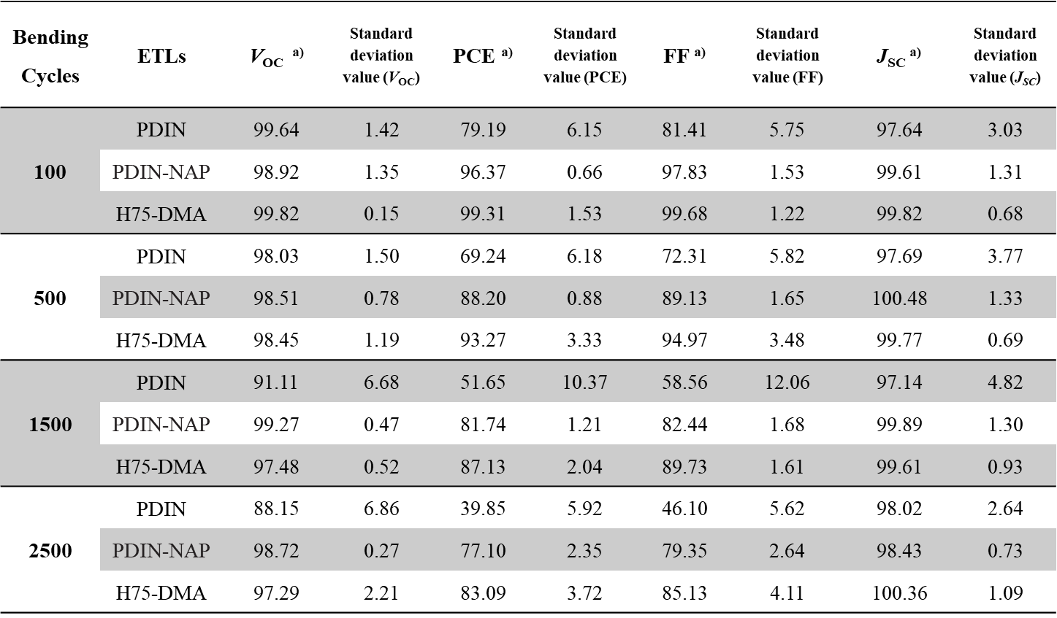
[a] the average PCE values are obtained from at least 6 cells.

Table S9 Surface-energy components calculated from three-liquid contact-angle measurements using the Owens–Wendt method

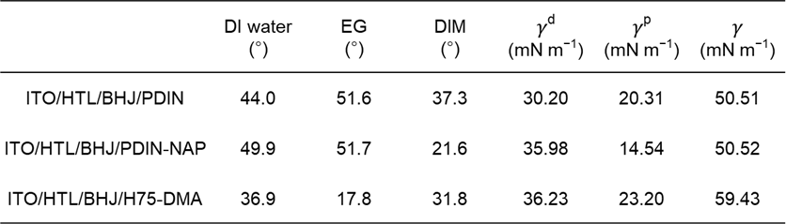

Table S10 Summary of PCE, AVT and LUE values for comparative literature data in Fig. 6h
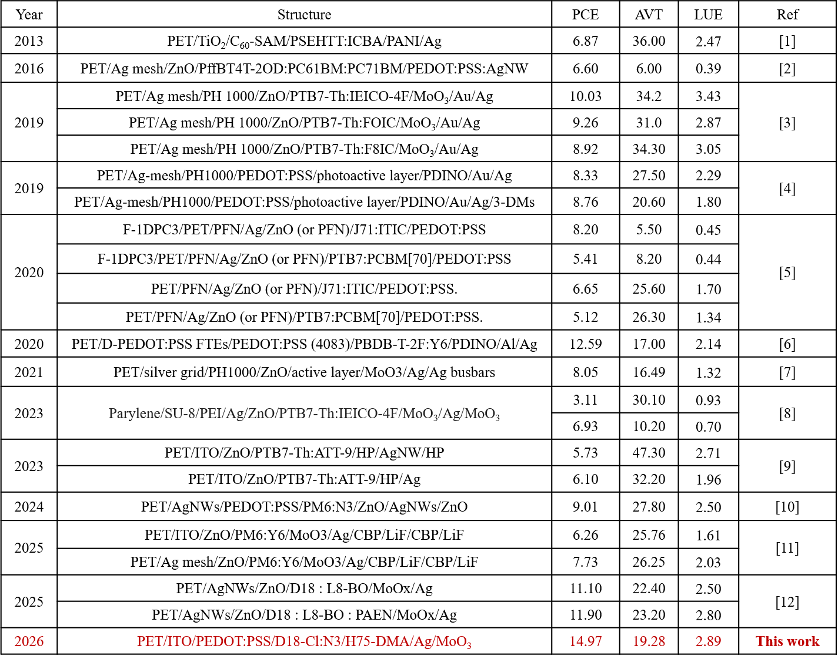

Fig. S1 The synthetic route of PDIN-NAP and H75-DMA
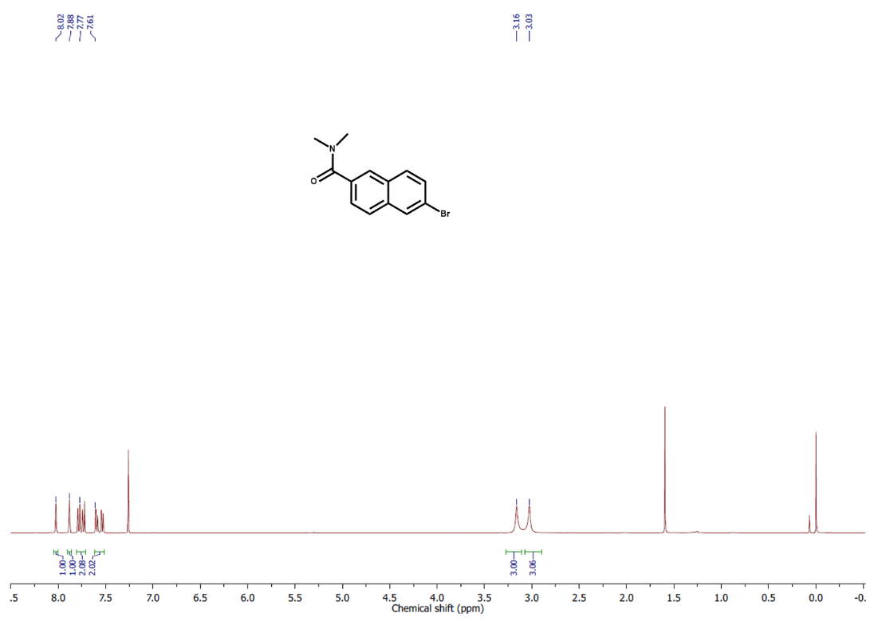
Fig. S2 ¹H NMR spectrum of 6-bromo-N,N-dimethyl-2-naphthamide

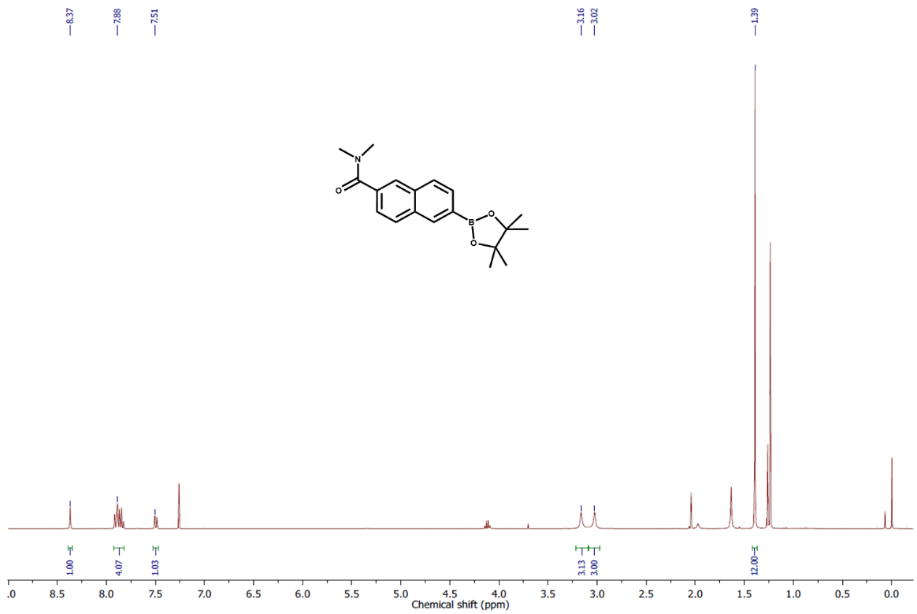
Fig. S3 ¹H NMR spectrum of N,N-dimethyl-2-naphthamide-6-boronic acid pinacol ester

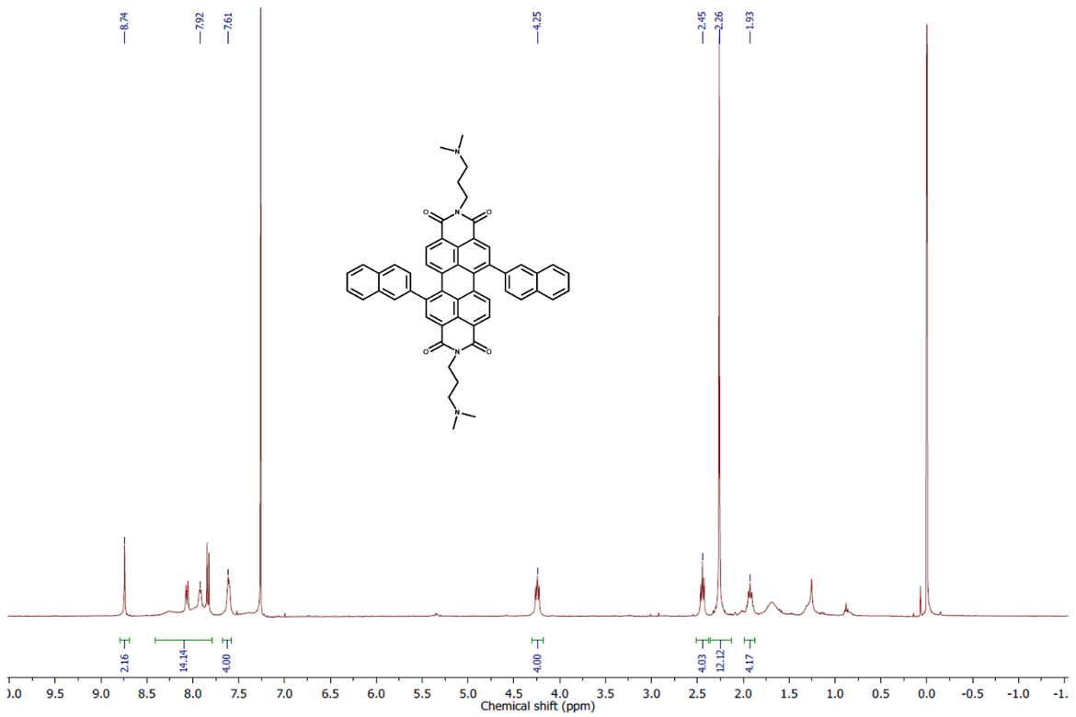
Fig. S4 ¹H NMR spectrum of PDIN-NAP

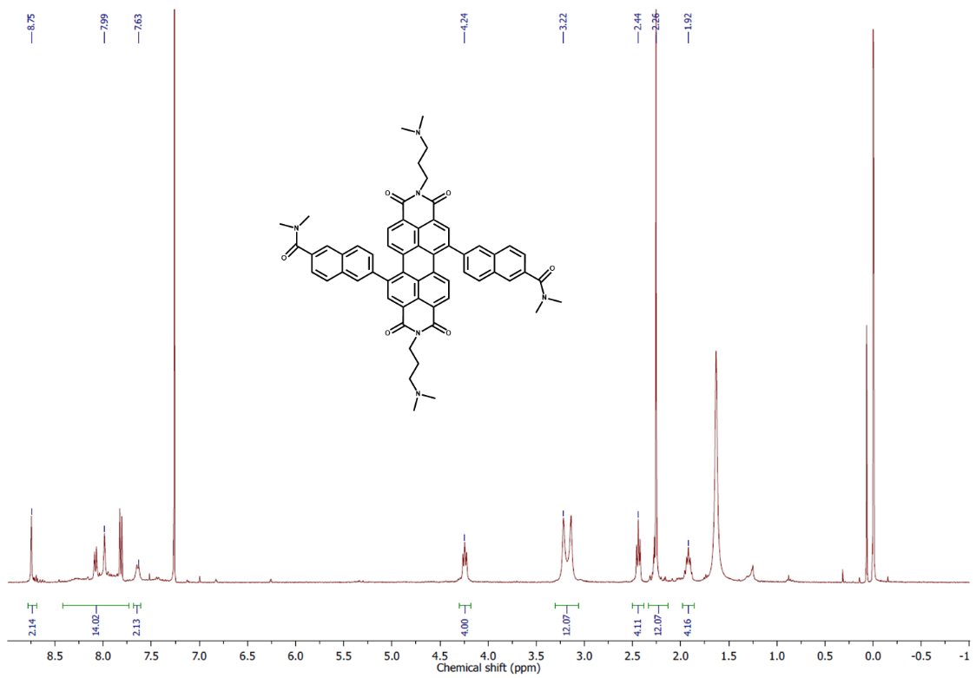
Fig. S5 ¹H NMR spectrum of H75-DMA
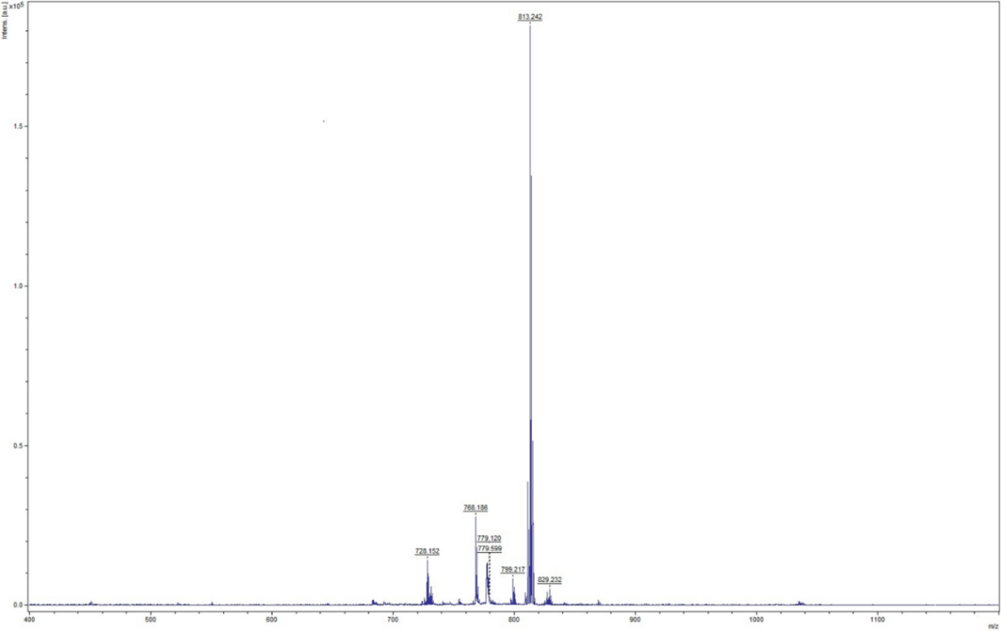
Fig. S6 MALDI-TOF mass spectrometry of PDIN-NAP

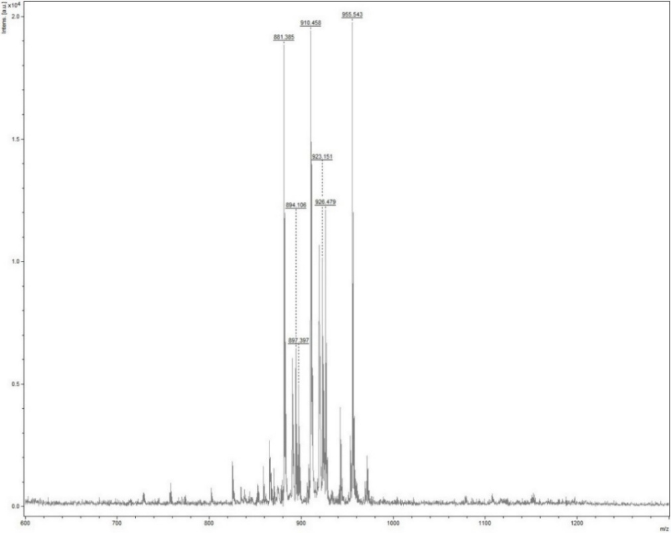
Fig. S7 MALDI-TOF mass spectrometry of H75-DMA
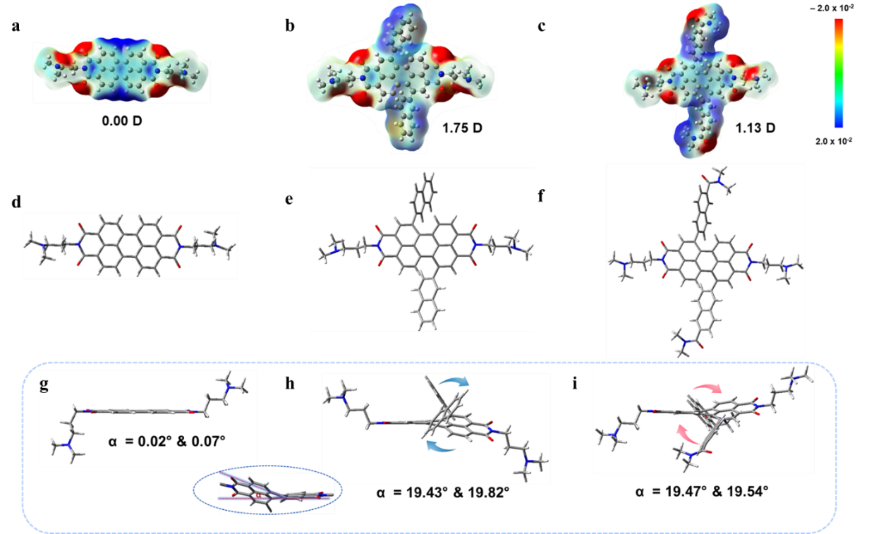
Fig. S8 The B3LYP/6-31G levels optimize geometries. Electrostatic potential (ESP) distribution and dipole moment for PDIN (a), PDIN-NAP (b), and H75-DMA (c). The front and side views of (d, g) PDIN, (e, h) PDIN-NAP, and (f, i) H75-DMA

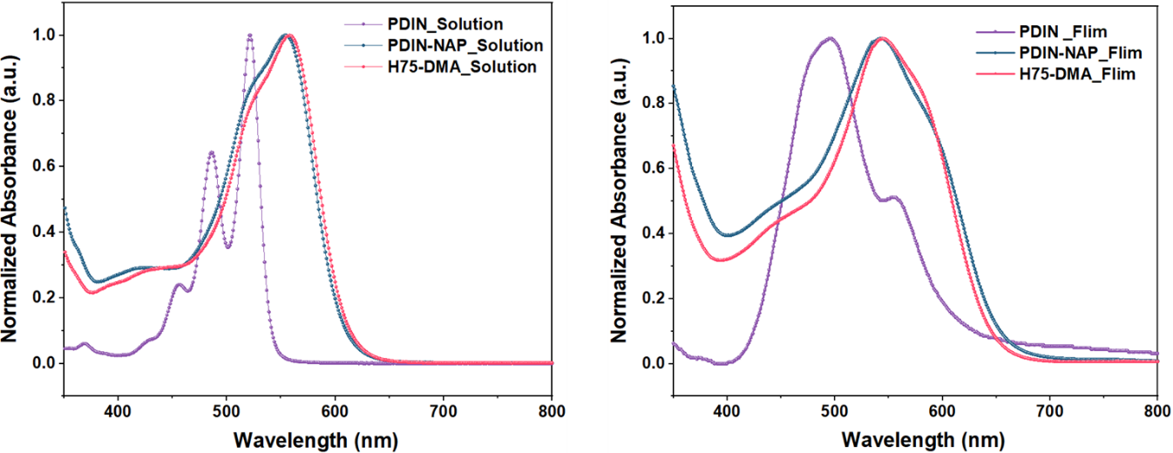
Fig. S9 Normalized UV–vis absorption spectra of PDIN, PDIN-NAP, and H75-DMA in methanol solution and film states
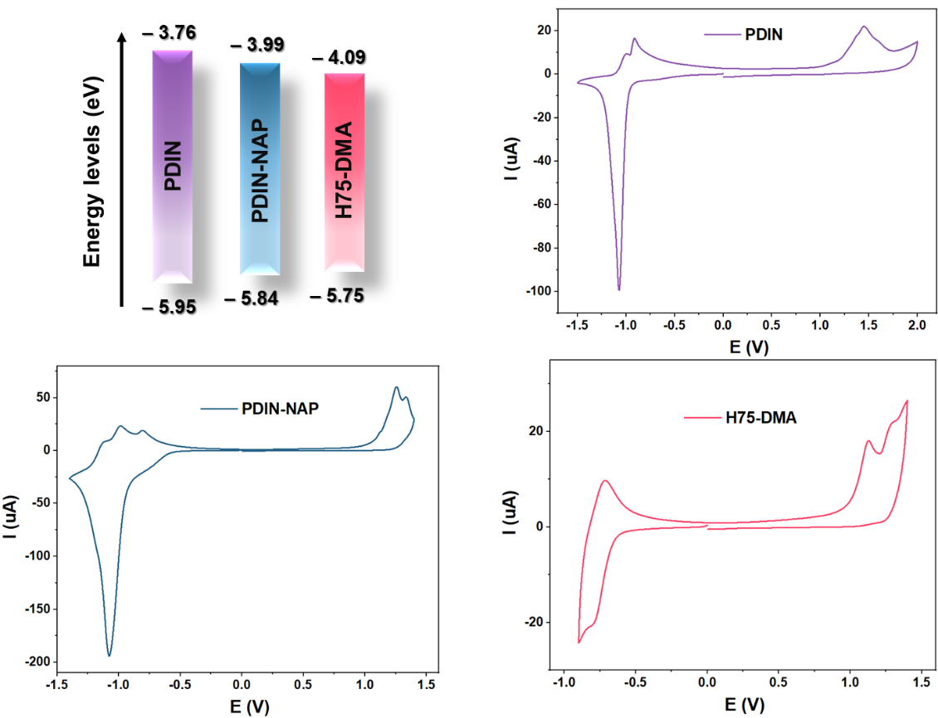
Fig. S10 Schematic diagram of energy level and the cyclic voltammetry of PDIN, PDIN-NAP, and H75-DMA

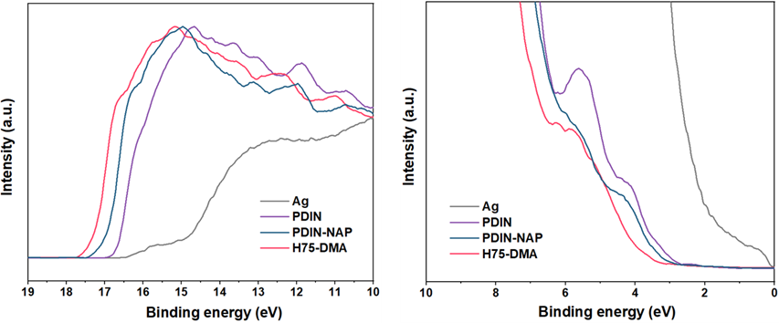
Fig. S11 UPS spectra of without and with PDIN, PDIN-NAP, and H75-DMA ETL-deposited on Ag electrode
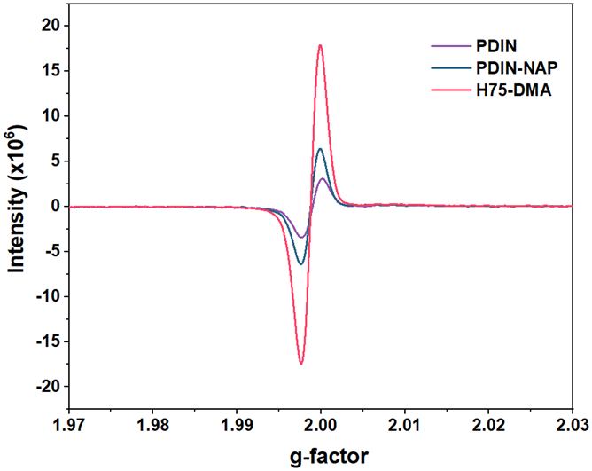
Fig. S12 Electron spin resonance spectra of PDIN, PDIN-NAP, and H75-DMA in solid

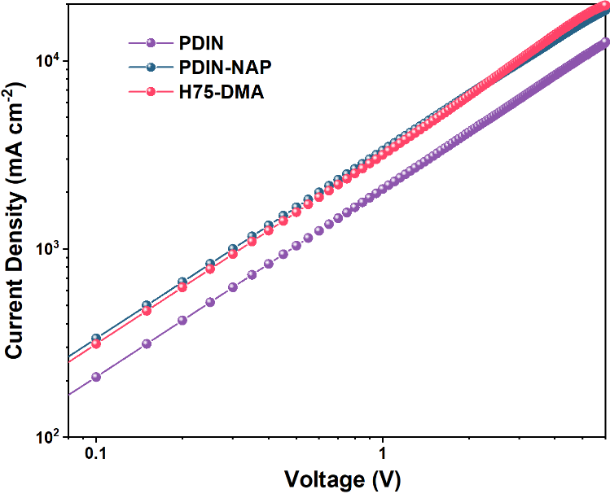
Fig. S13 SCLC plots of electron only devices with the configuration of ITO/ZnO/ETL/Ag
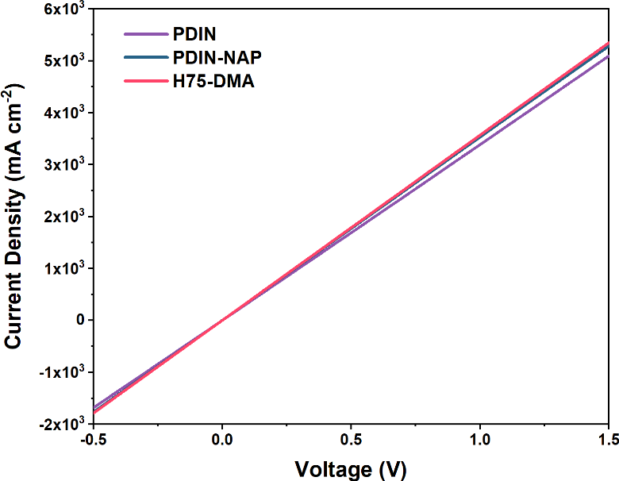
Fig. S14 The J-V curve of devices with configuration of ITO/ETL/Ag

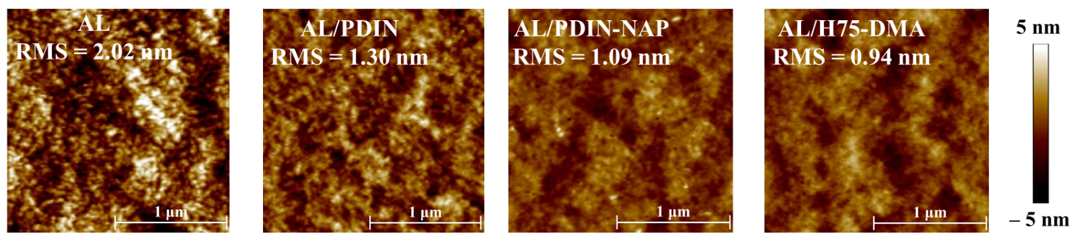
Fig. S15 The AFM height images of without and with PDIN, PDIN-NAP, and H75-DMA ETL-deposited on active layer (AL) films

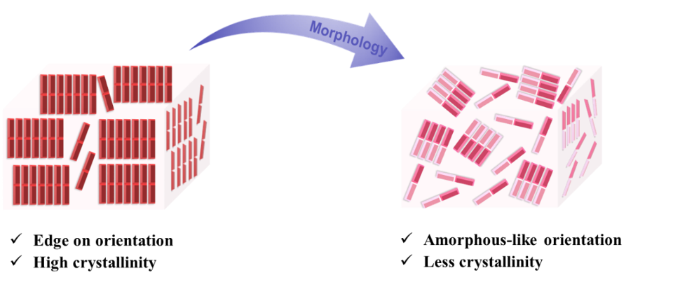
Fig. S16 Illustration of the morphology transition from the highly crystalline, edge-on orientation of PDIN to the amorphous-like orientation, low-crystallinity texture achieved with H75-DMA
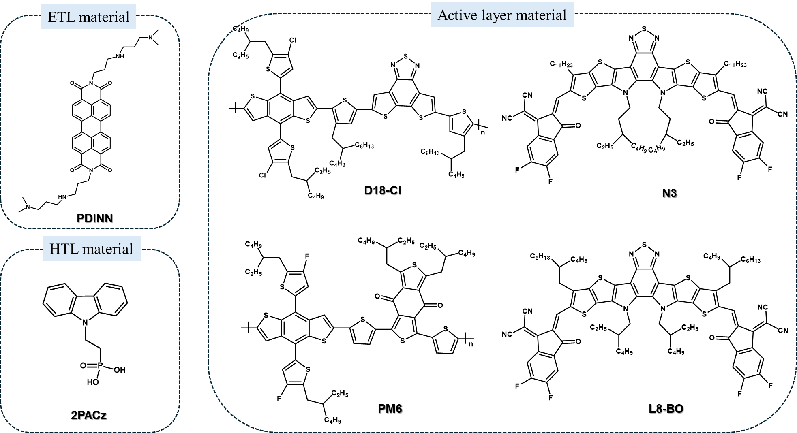
Fig. S17 Chemical structures of the ETL, HTL and active layer materials used in this work

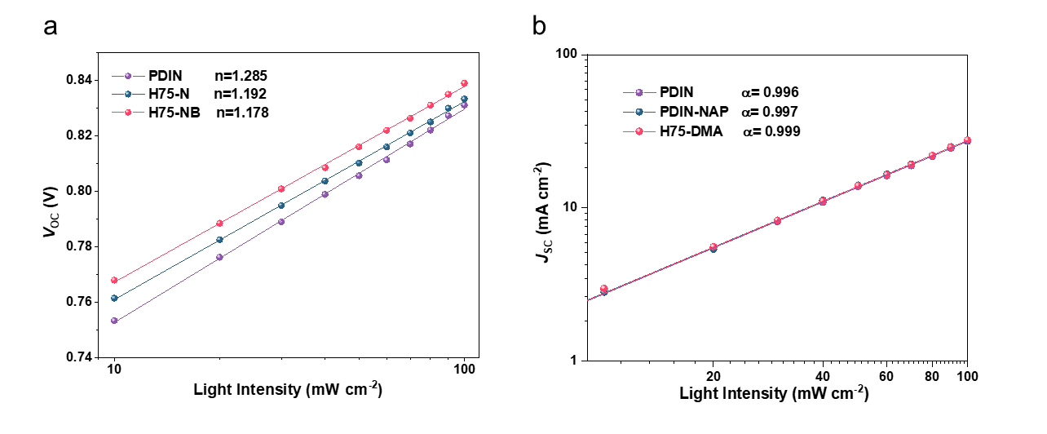
Fig. S18 a) Light intensity (I_{light}) dependence of V_{OC} and J_{SC} plots of the optimized device with PDIN, PDIN-Naph and H75-NB as ETLs based on D18-Cl:N3 system. Note: V_{OC} versus I_{light} can be described by the equation of V_{OC} ∝ n (kT/q) ln(I_{light}), where k, T, and q denote the Boltzmann constant, Kelvin temperature, and elementary charge, respectively. b) J_{SC} versus I_{light} can be described by the equation of J_{SC} ∝ I^{α}_{light}, where α should be equal to 1 if the bimolecular recombination of the device is negligible
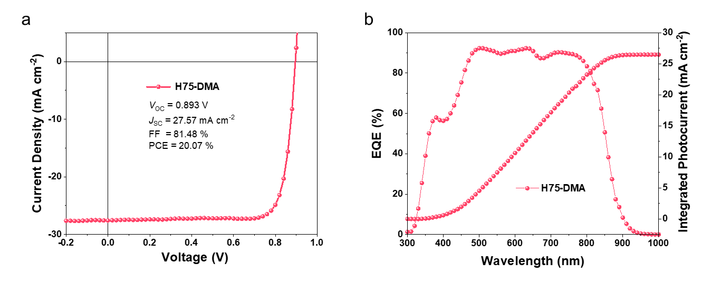
Fig. S19 a The J-V curves of the optimized devices based on PM6:L8-BO with H75-DMA ETLs under illumination of AM 1.5 G, 100 mW cm⁻². b The EQE spectra and integrated current densities of the representative devices
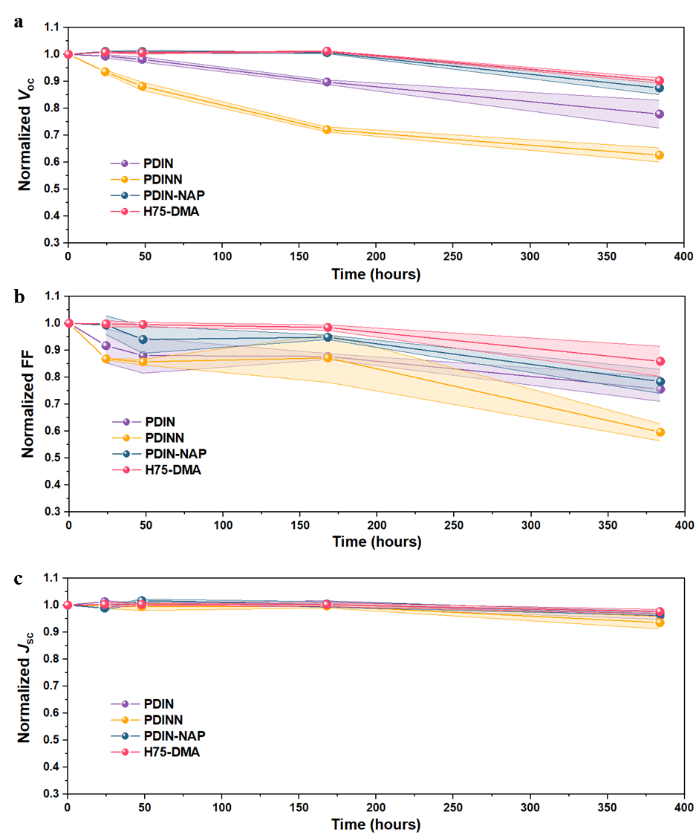
Fig. S20 The normalized stability test a V_{OC} , b FF, and c J_{SC} of the unencapsulated devices with PDIN, PDINN, PDIN-NAP and H75-DMA under 40-60% RH environment at 25 °C.
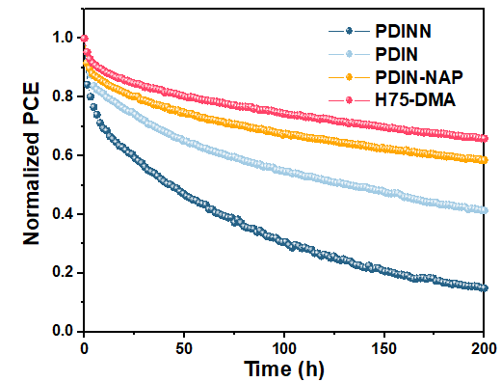
Fig. S21 Normalized PCE evolution of unencapsulated OSCs employing different ETLs under continuous 1 sun illumination at 55 °C and 40–60% RH.
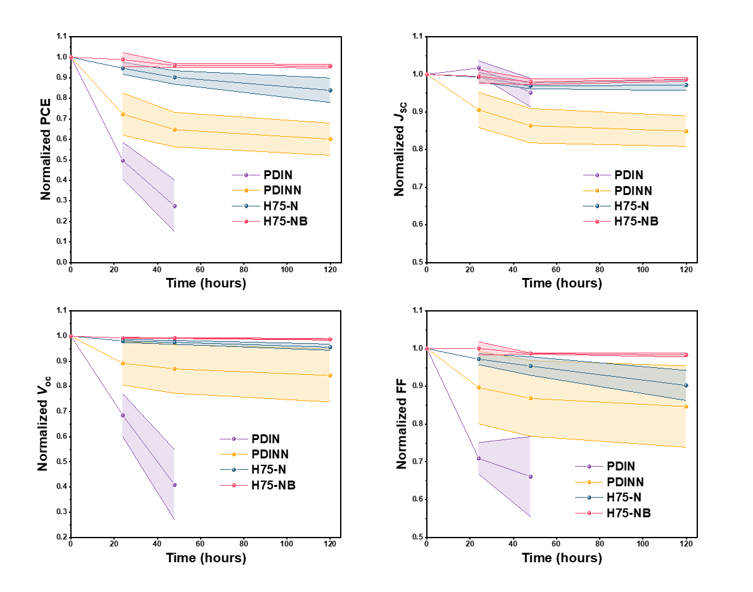
Fig. S22 Dark thermal aging stability of OSCs under N₂ at 85 °C.
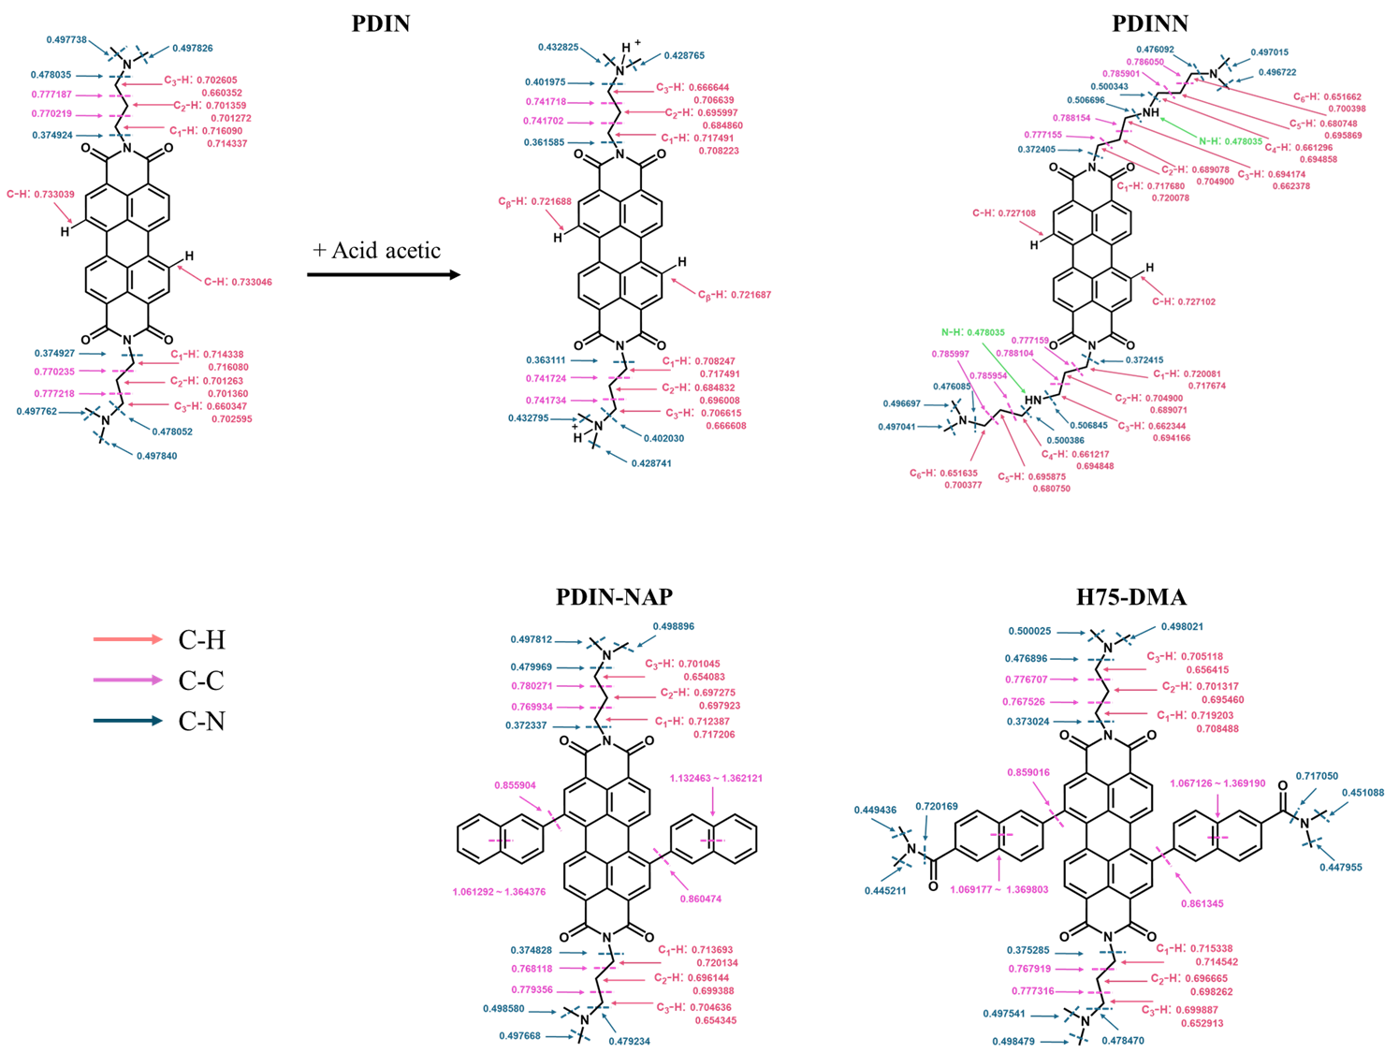
Fig. S23 LBO values for C-H bonds, C-C bonds, and C-N bonds of PDIN, PDINN, PDIN-NAP, and H75-DMA
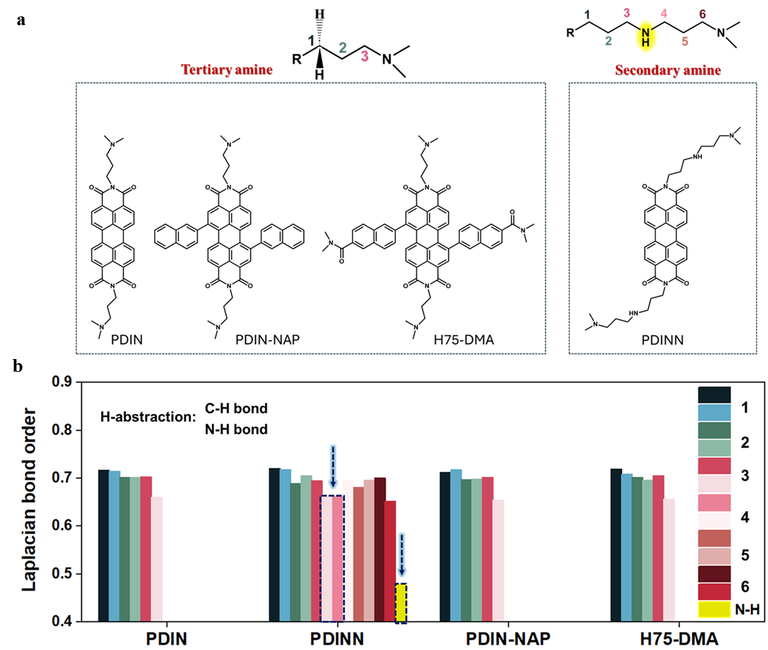
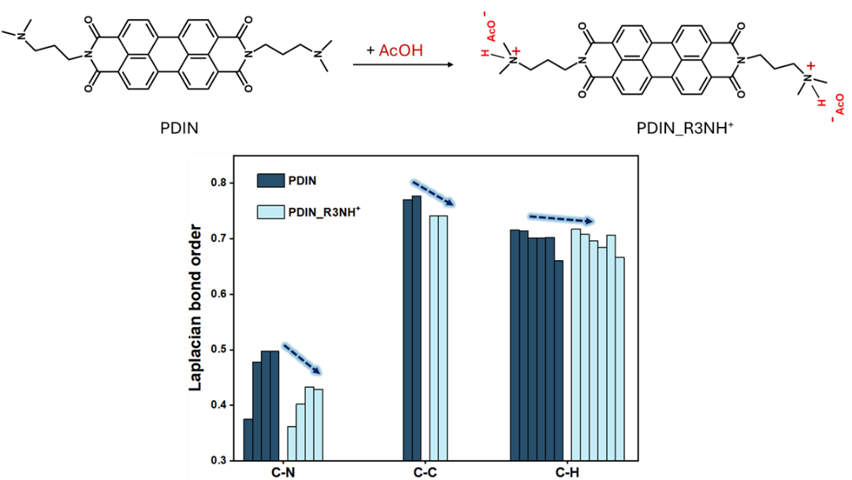
Fig. S24 a Schematic diagram of the C–H/N-H bonds in the ETLs (secondary amine: PDINN, tertiary amine: PDIN, PDIN-NAP, and 75-DMA) for calculating LBO values. b Laplacian bond order values for the hydrogen abstraction of amine side-chains

Fig. S25 Laplacian bond order values for C-H/C-C/C-N of PDIN after protonation by acid

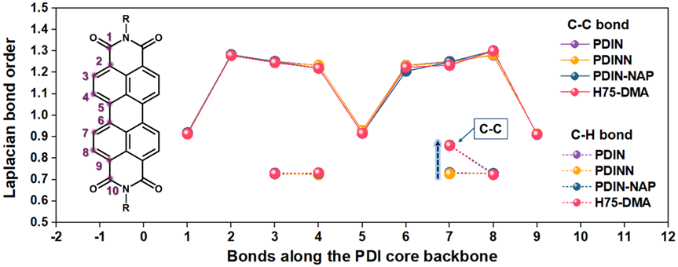
Fig. S26 Laplacian bond order values for C-C/C-H belong to the PDI backbone
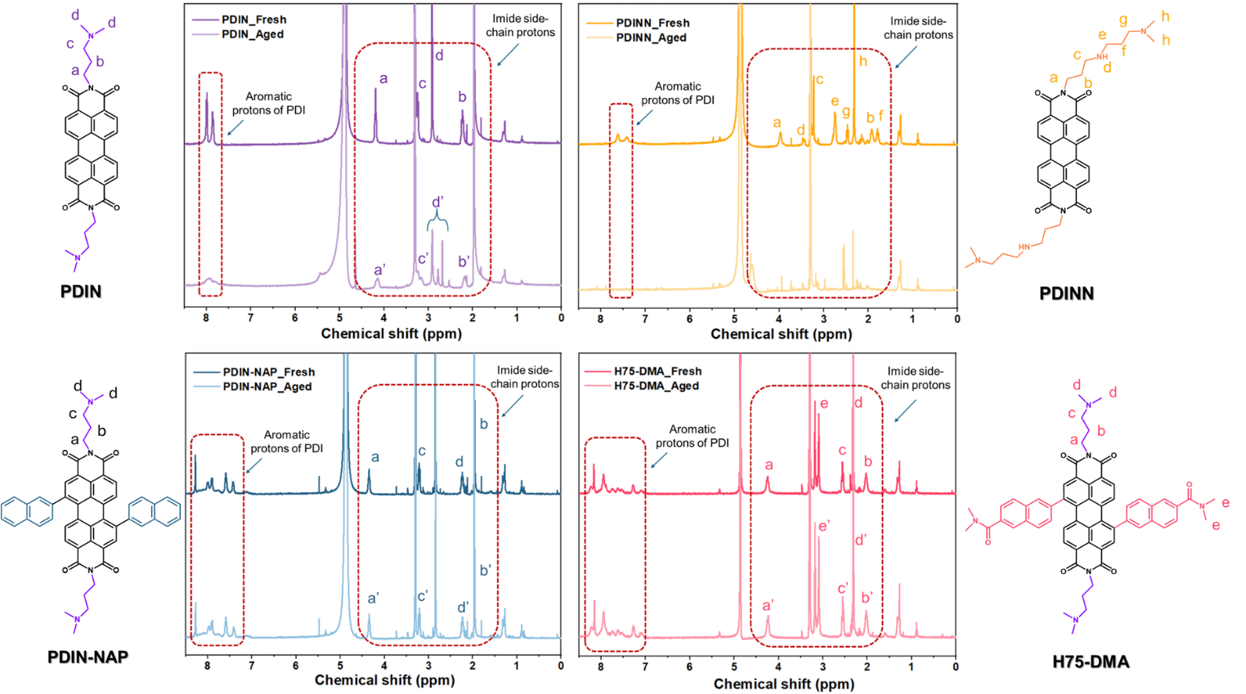

Fig. S27 The ¹H NMR spectra of fresh PDIN, PDINN, PDIN-NAP, and H75-DMA solutions in methanol-d₄, as well as those aged under ambient conditions (before and after one week (168 hours) at 25 °C and 40-60% relative humidity)

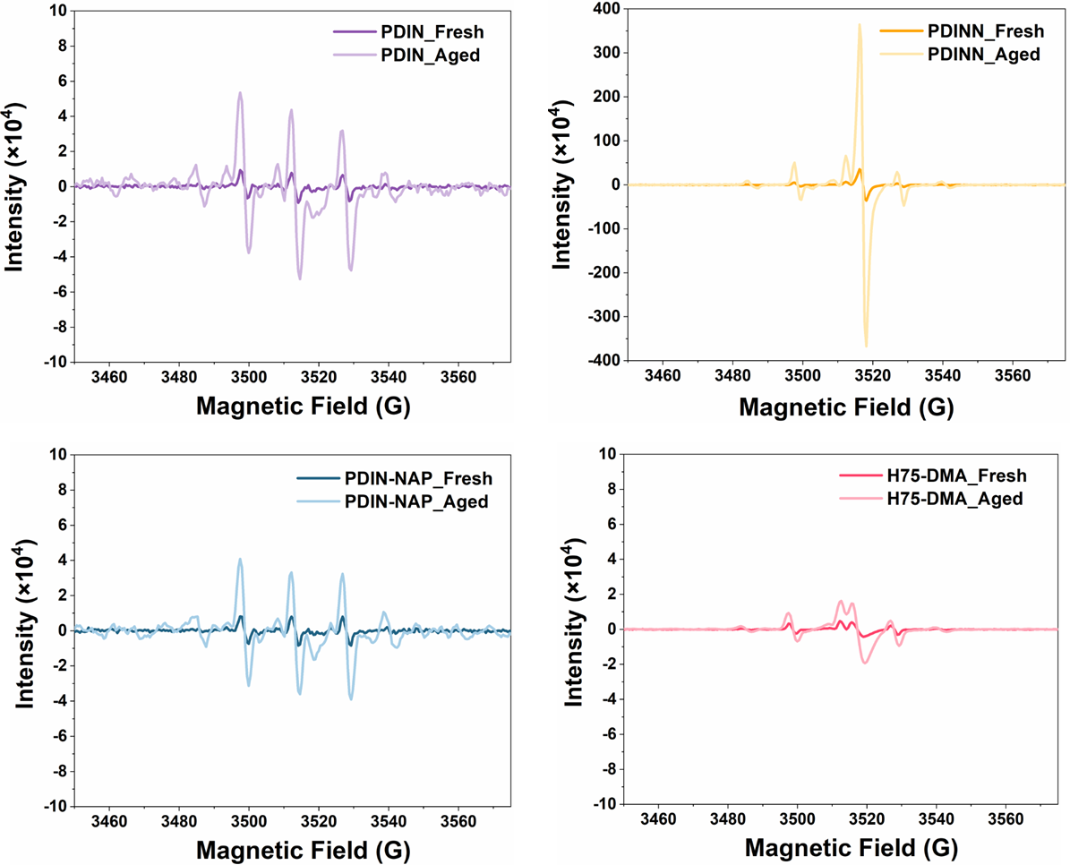
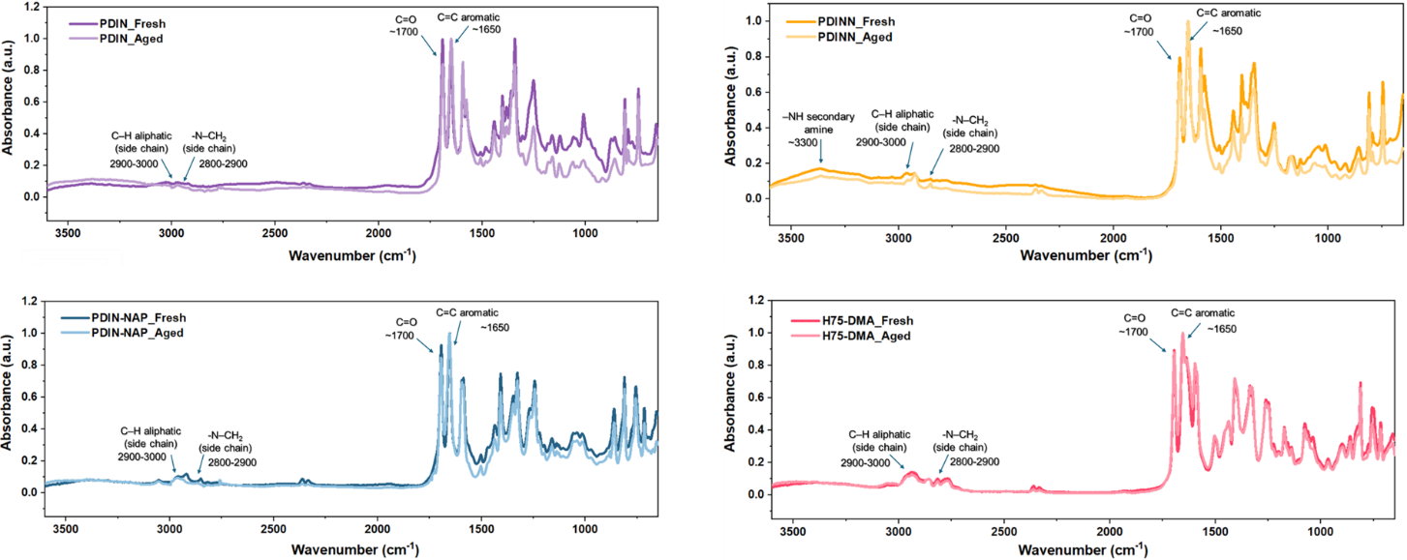
Fig. S28 The ESR signals of OH• (DMPO–•OH) for fresh and aged samples under ambient conditions over 168 hours of PDIN, PDINN, PDIN-NAP, and H75-DMA in water

Fig. S29 The FT-IR spectra from fresh and aged PDIN, PDINN, PDIN-NAP, and H75-DMA thin films
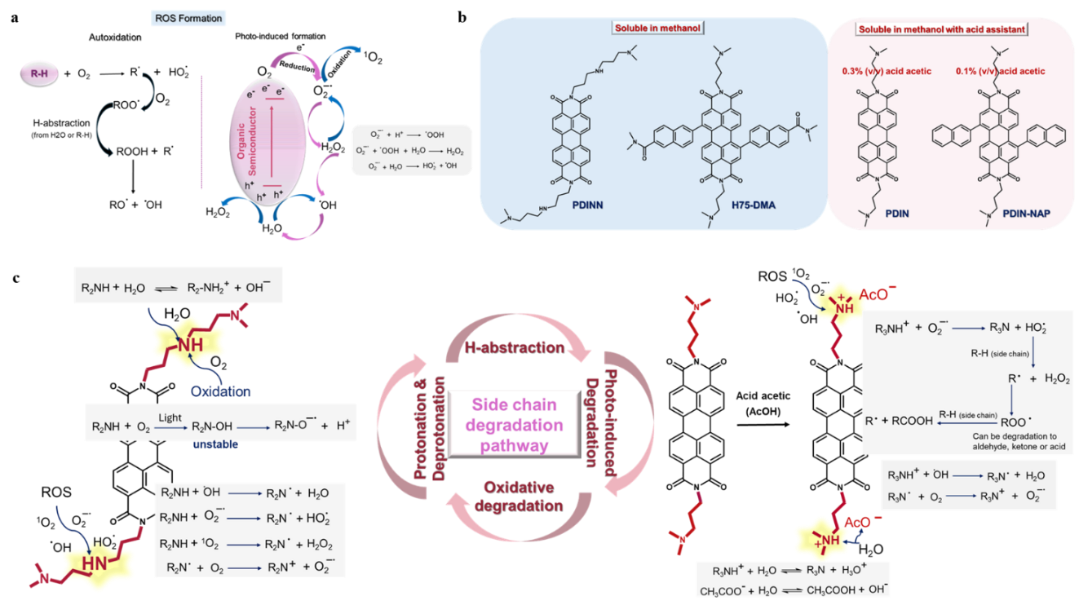
Fig. S30 a Reactive Oxygen-Species (ROS) generation pathways in organic semiconductors. b Acid-assisted methanol solubility of PDI-based interlayers. c Protonation- and ROS-Driven Degradation Routes of PDIN and PDINN

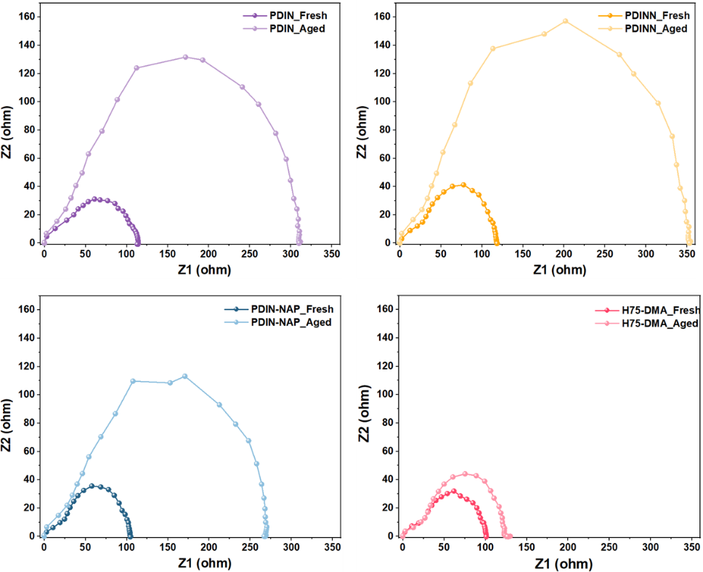
Fig. S31 The Nyquist plot from fresh and aged PDIN, PDINN, PDIN-NAP, and H75-DMA thin films
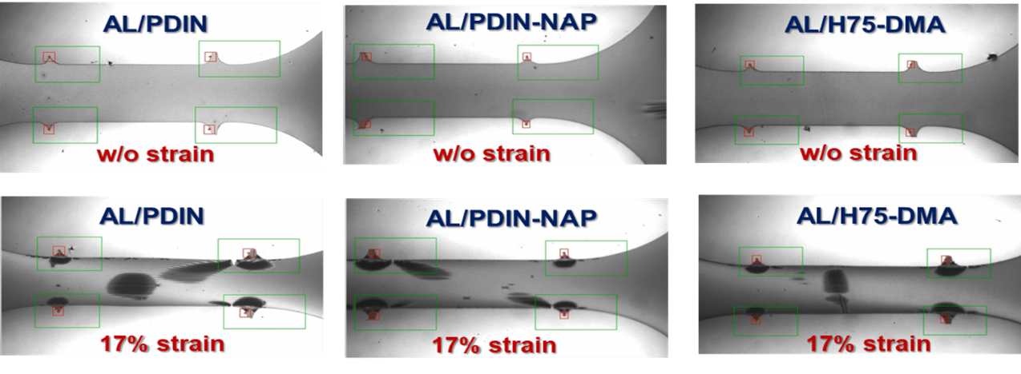
Fig. S32 Optical microscope images of active layer (AL)/PDIN, AL/PDIN-NAP, and AL/H75-DMA films obtained during pseudo-free-standing tensile testing

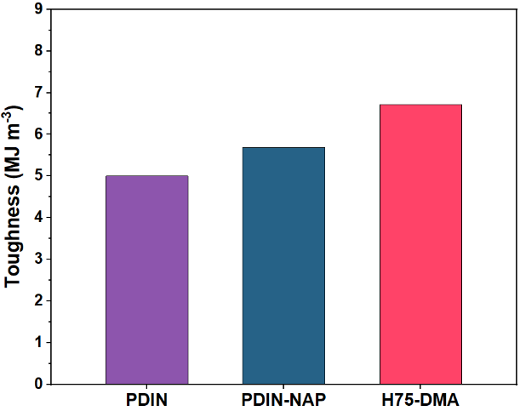
Fig. S33 Toughness of PDIN, PDIN-NAP and H75-DMA on active layer
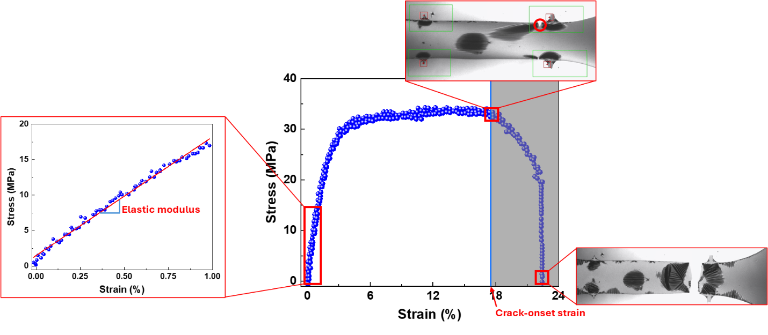
Fig. S34 Crack-onset strain identification for PDIN, PDIN-NAP, and H75-DMA on the active layer
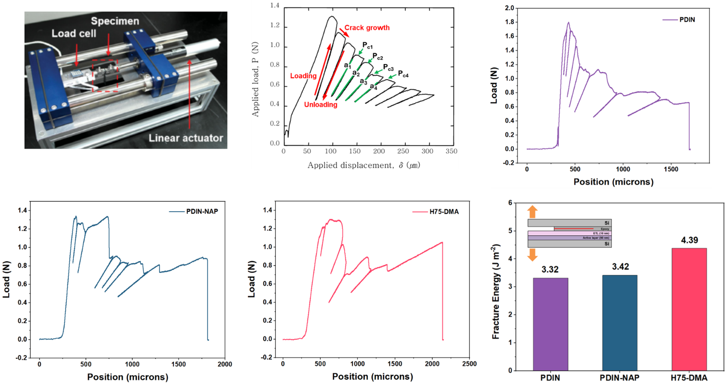

Fig. S35 Cohesive fracture energy (G_{c}) of PDIN, PDIN-NAP and H75-DMA on active layer
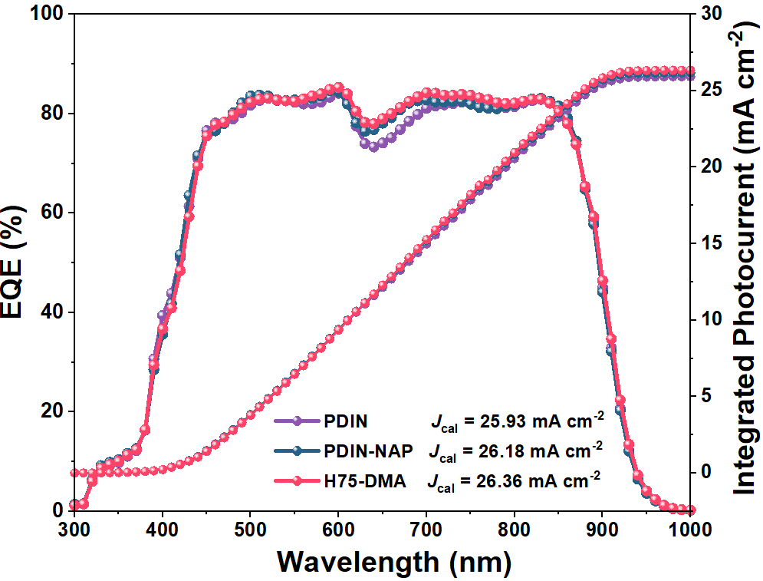

Fig. S36 The EQE spectra and integrated current densities of the best flexible devices utilizing PDIN, PDIN-NAP, and H75-DMA ETLs.

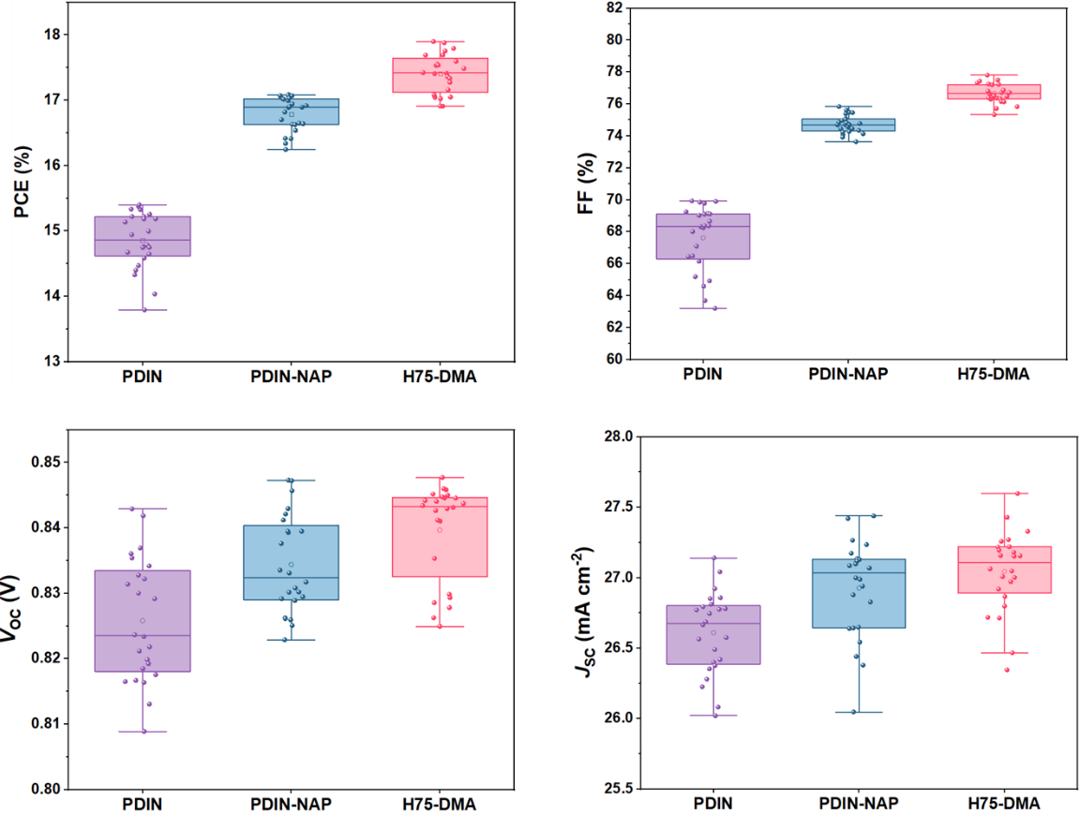
Fig. S37 PCE, FF, V_{OC}, and J_{SC} histograms of the flexible devices utilizing PDIN, PDIN-NAP, and H75-DMA ETLs.
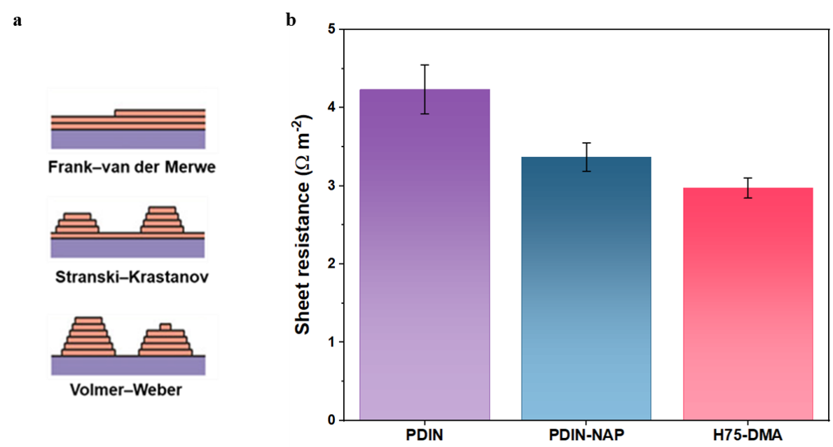
Fig. S38 a Schematic of Ag thin-film nucleation and growth on ETL surfaces, illustrating layer-by-layer (Frank–van der Merwe), island (Volmer–Weber), and layer-plus-island (Stranski–Krastanov) modes. b Sheet resistance of 20 nm Ag films deposited on the ETLs

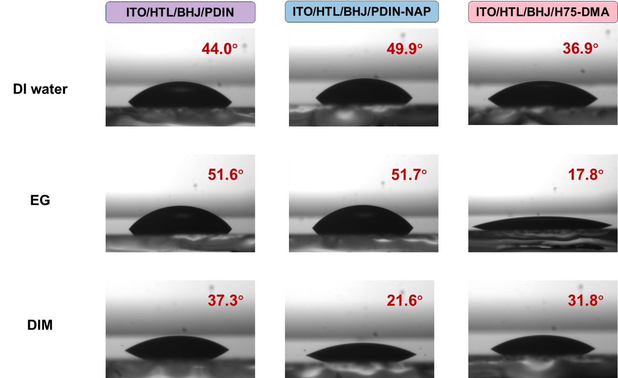
Fig. S39 Contact-angle images of three probe liquids for surface-energy analysis. From top to bottom: deionized water (DI), ethylene glycol (EG), and diiodomethane (DIM) droplets on ITO/HTL/BHJ/PDIN, ITO/HTL/BHJ/PDIN-NAP, and ITO/HTL/BHJ/H75-DMA substrates

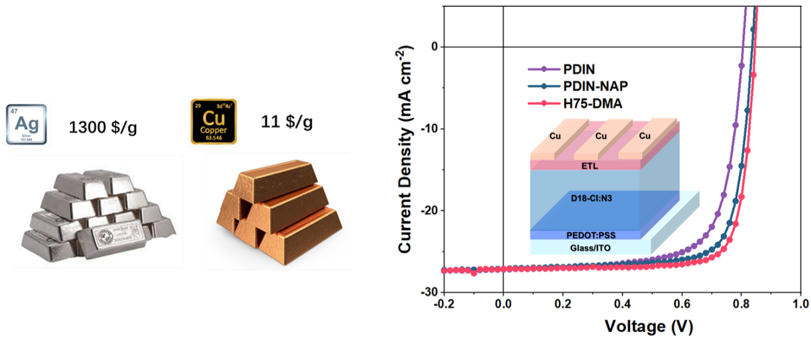
Fig. S40 Indicative market prices: Ag vs Cu and the J-V curves of the optimized devices utilizing a Cu electrode with PDIN, PDIN-NAP, and H75-DMA ETLs in the D18-Cl:N3 system under AM 1.5 G illumination at 100 mW cm⁻²

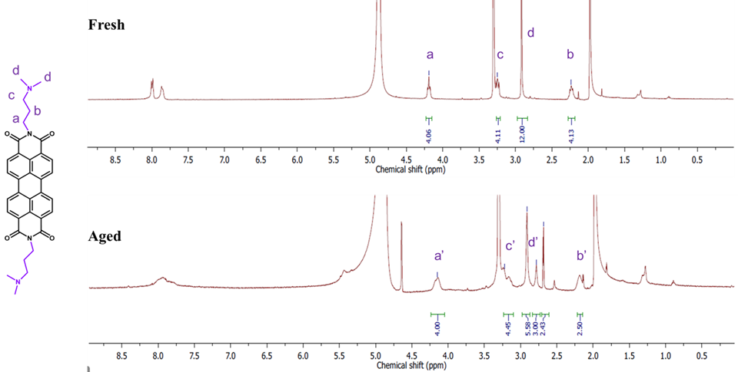
Fig. S41 ¹H NMR integrated profiles of fresh and aged PDIN in methanol–d₄

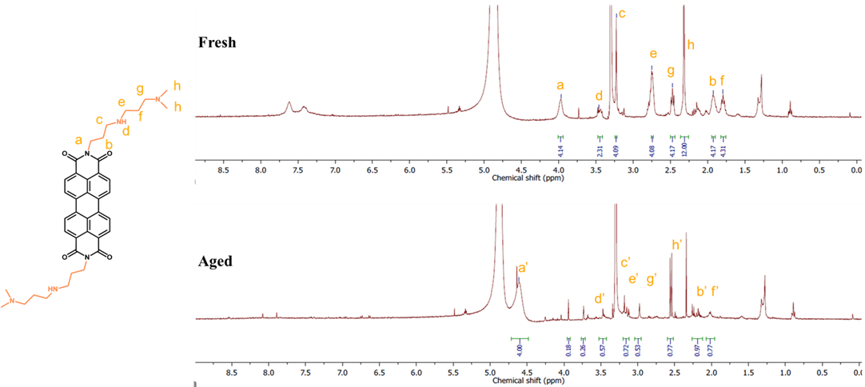
Fig. S42 ¹H NMR integrated profiles of fresh and aged PDINN in methanol–d₄

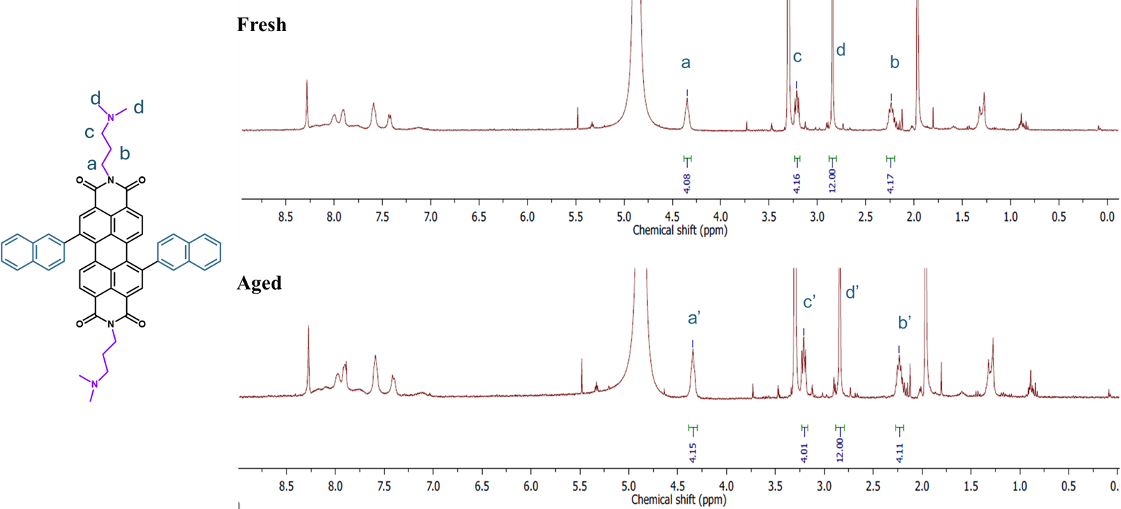
Fig. S43 ¹H NMR integrated profiles of fresh and aged PDIN-NAP in methanol–d₄

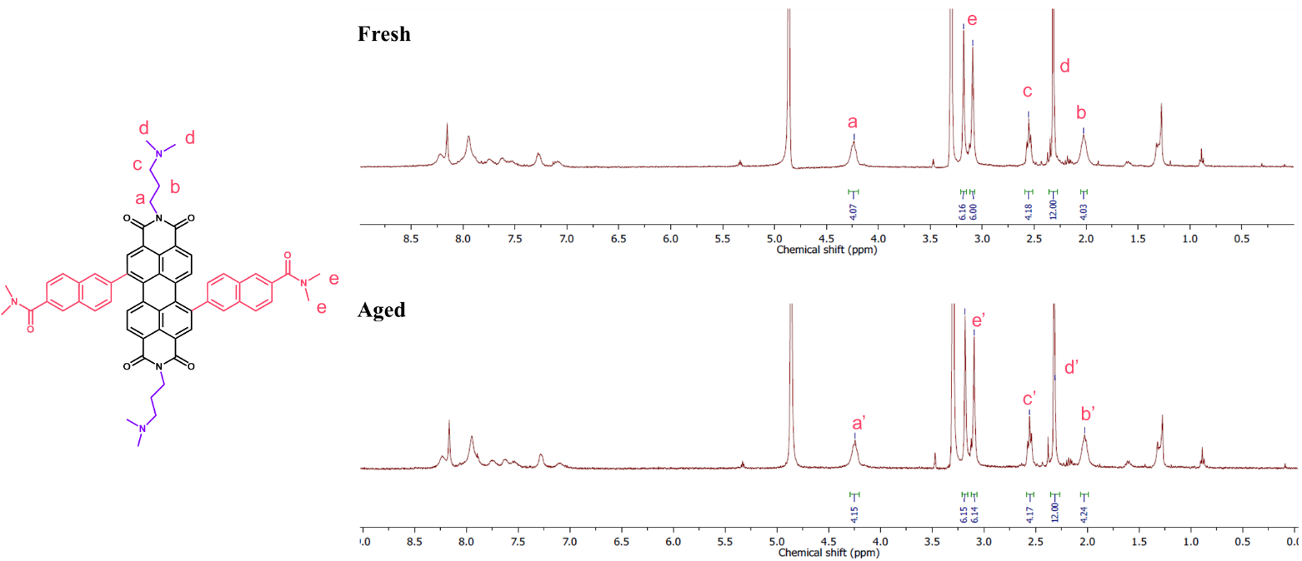
Fig. S44 ¹H NMR integrated profiles of fresh and aged H75-DMA in methanol–d₄
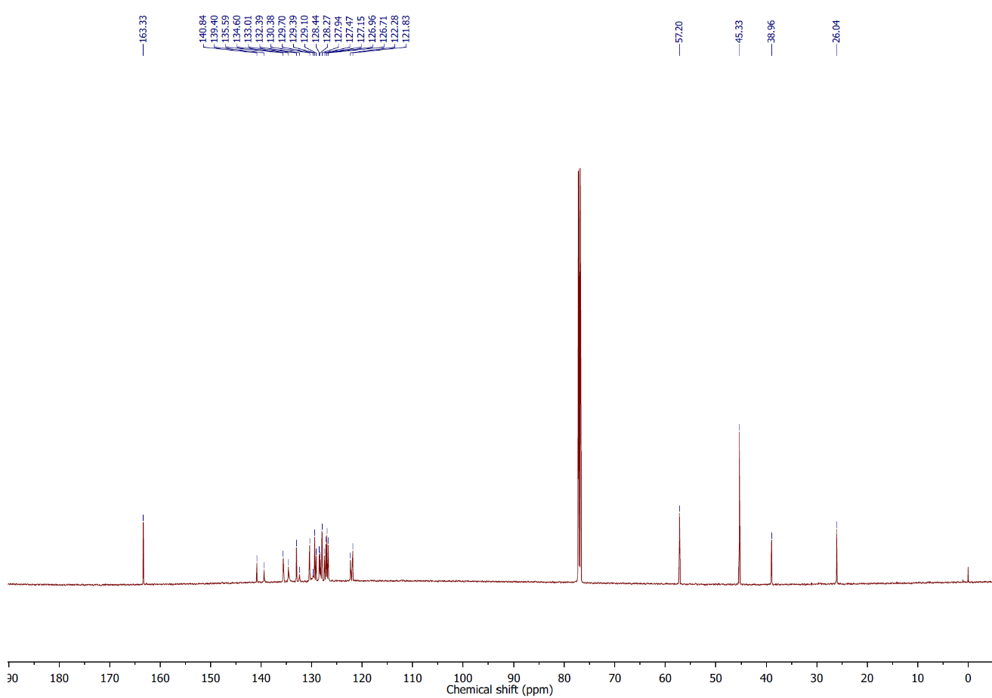

Fig. S45 ¹³C NMR spectrum of PDIN-NAP
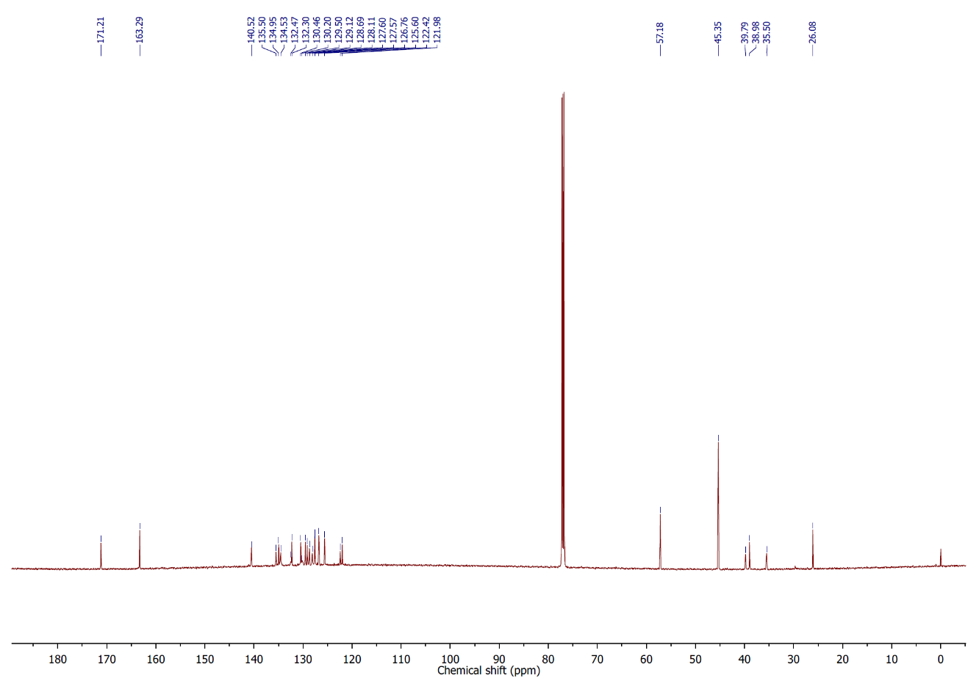
Fig. S46 ¹³C NMR spectrum of H75-DMA
Supplementary References
- W. Jose da Silva, H.P. Kim, A. Rashid bin Mohd Yusoff, J. Jang, Transparent flexible organic solar cells with 6.87% efficiency manufactured by an all-solution process. Nanoscale 5(19), 9324 (2013). https://doi.org/10.1039/c3nr03011c
- J. Czolk, D. Landerer, M. Koppitz, D. Nass, A. Colsmann, Highly efficient, mechanically flexible, semi-transparent organic solar cells doctor bladed from non-halogenated solvents. Adv. Mater. Technol. 1(9), 1600184 (2016). https://doi.org/10.1002/admt.201600184
- Y. Liu, P. Cheng, T. Li, R. Wang, Y. Li et al., Unraveling sunlight by transparent organic semiconductors toward photovoltaic and photosynthesis. ACS Nano 13(2), 1071–1077 (2019). https://doi.org/10.1021/acsnano.8b08577
- J. Zhang, G. Xu, F. Tao, G. Zeng, M. Zhang et al., Highly efficient semitransparent organic solar cells with color rendering index approaching 100. Adv. Mater. 31(10), 1807159 (2019). https://doi.org/10.1002/adma.201807159
- W. Zheng, X. Luo, Y. Zhang, C. Ye, A. Qin et al., Efficient low-cost all-flexible microcavity semitransparent polymer solar cells enabled by polymer flexible one-dimensional photonic crystals. ACS Appl. Mater. Interfaces 12(20), 23190–23198 (2020). https://doi.org/10.1021/acsami.0c03508
- W. Song, B. Fanady, R. Peng, L. Hong, L. Wu et al., Foldable semitransparent organic solar cells for photovoltaic and photosynthesis. Adv. Energy Mater. 10(15), 2000136 (2020). https://doi.org/10.1002/aenm.202000136
- Y. Wang, G. Wang, Y. Xing, M.A. Adil, W. Ali Memon et al., Top and bottom electrode optimization enabled high-performance flexible and semi-transparent organic solar cells. Mater. Chem. Front. 5(11), 4310–4316 (2021). https://doi.org/10.1039/d1qm00151e
- H. Lee, S. Jeong, J.-H. Kim, Y.-R. Jo, H.J. Eun et al., Ultra-flexible semitransparent organic photovoltaics. npj Flex. Electron. 7, 27 (2023). https://doi.org/10.1038/s41528-023-00260-5
- S. Sun, W. Zha, C. Tian, Z. Wei, Q. Luo et al., Solution processed semi-transparent organic solar cells over 50% visible transmittance enabled by silver nanowire electrode with sandwich structure. Adv. Mater. 35(46), 2305092 (2023). https://doi.org/10.1002/adma.202305092
- H. Liu, X. Yi, J. Wu, Y. Li, H. Tang et al., All-solution-processed flexible semitransparent organic solar cells based on sprayed silver nanowire composites as top electrodes. Mater. Sci. Semicond. Process. 173, 108113 (2024). https://doi.org/10.1016/j.mssp.2024.108113
- Y. Liao, K. Xie, J. Wu, N. Zhao, Y. Lin et al., Enhancing the durability and efficiency of flexible semi-transparent organic solar cells with silver mesh electrode. IEEE Trans. Electron Devices 72(6), 3099–3105 (2025). https://doi.org/10.1109/ted.2025.3559887
- B. Shi, J. Wang, X. Bao, W. Ma, H. Yan, One plastic improves the shortages of photovoltaic and mechanical properties in flexible semitransparent organic photovoltaics. Chem. Commun. 61(100), 19861–19864 (2025). https://doi.org/10.1039/d5cc05795g

