Supporing Information for
Enhanced Antibiotics Sieving by Exfoliated TiS₂ Membranes via Surface Functionalization and Passivation
Ruixin Yan¹†, Mingzi Sun²†, Honglu Hu¹, Ruijie Yang¹, Zhen Zhang¹, Weikang Zheng¹, Liang Mei¹, Ting Ying¹, Yue Zhang¹, Alicia Kyoungjin An³, Chuyang Y. Tang⁴, Jingyun Fang⁵*, Bolong Huang²*, Zhiyuan Zeng^{1,6}*
¹Department of Materials Science and Engineering, and State Key Laboratory of Marine Environmental Health, City University of Hong Kong, 83 Tat Chee Avenue, Kowloon, Hong Kong S.A.R. 999077, P. R. China
²Department of Chemistry, City University of Hong Kong, Hong Kong S.A.R. 999077, P. R. China.
³Department of Chemical and Biological Engineering, The Hong Kong University of Science and Technology, Clear Water Bay, Kowloon, Hong Kong S.A.R. 999077, P. R. China
⁴Department of Civil Engineering, The University of Hong Kong, Hong Kong S.A.R. 999077, P. R. China
⁵Guangdong Provincial Key Laboratory of Environmental Pollution Control and Remediation Technology, School of Environmental Science and Engineering, Sun Yat-Sen University, Guangzhou 510275, P. R. China
⁶Shenzhen Research Institute, City University of Hong Kong, Shenzhen 518057, P. R. China
†Ruixin Yan and Mingzi Sun contributed equally to this work.
*Corresponding authors. E-mail: zhiyzeng@cityu.edu.hk (Zhiyuan Zeng); b.h@cityu.edu.hk (Bolong Huang); fangjy3@mail.sysu.edu.cn (Jingyun Fang)
Supplementary Figures
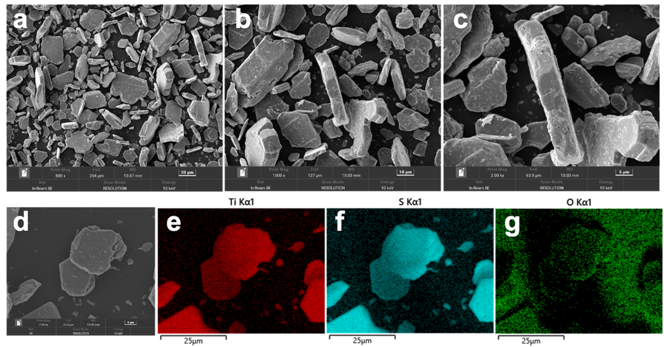
Fig. S1 SEM images of commercial TiS₂ powder and their elemental mapping distribution.

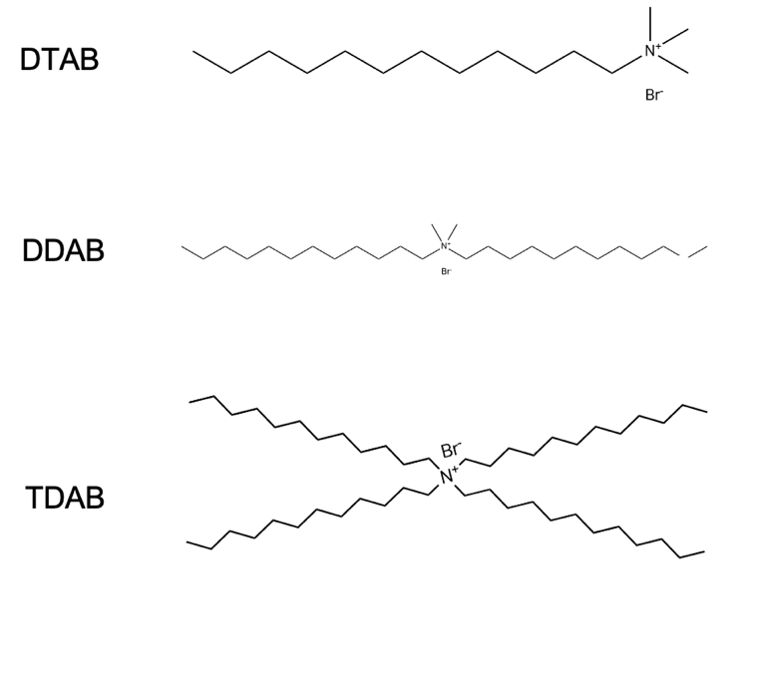
Fig. S2 Chemical structure of three quaternary ammonium molecules: DTAB, DDAB, TDAB.

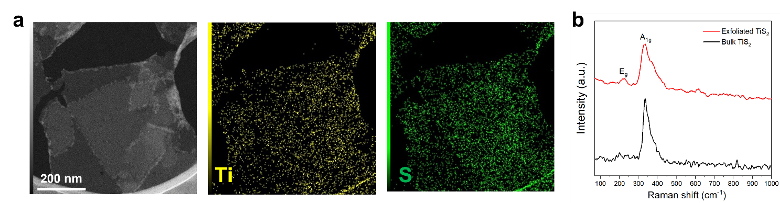
Fig. S3 a) TEM images and elemental mapping of pristine TiS₂ nanosheets. b) Raman spectra of bulk and exfoliated TiS₂ nanosheets.

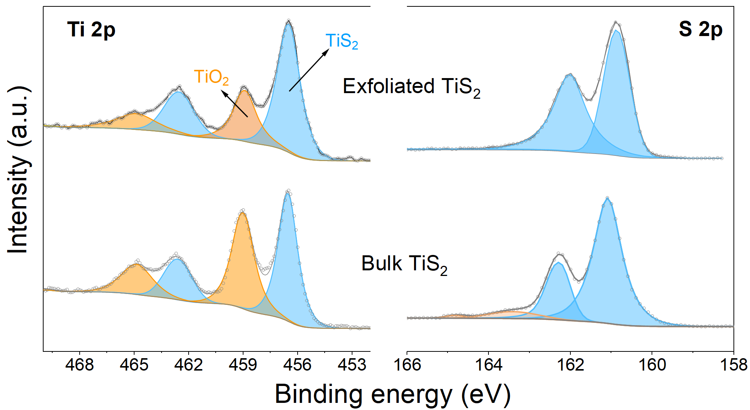
Fig. S4 XPS image of bulk TiS₂ powders and exfoliated TiS₂ nanosheets.

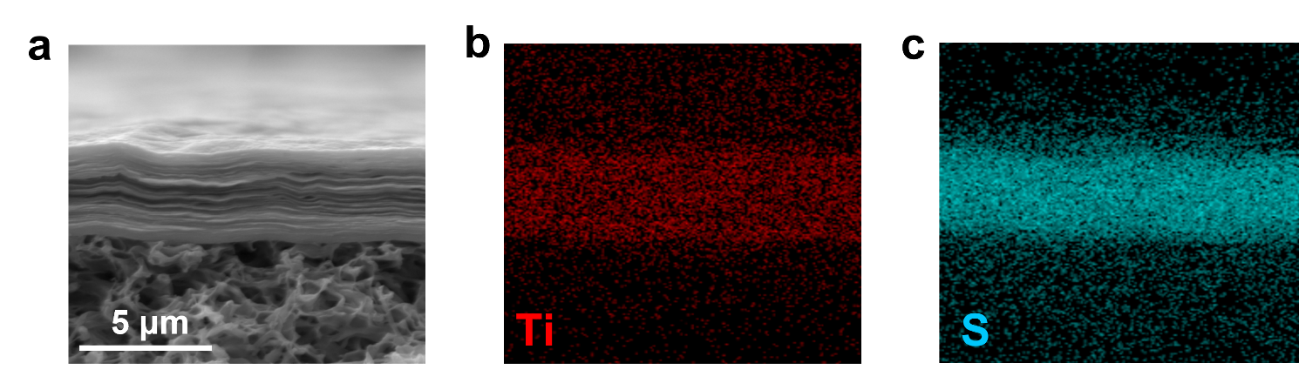
Fig. S5 SEM EDS mapping images of pristine TiS₂ membrane. (The porous region corresponds to the PVDF substrate, while the tightly packed layered structure directly above it represents the restacked film.)
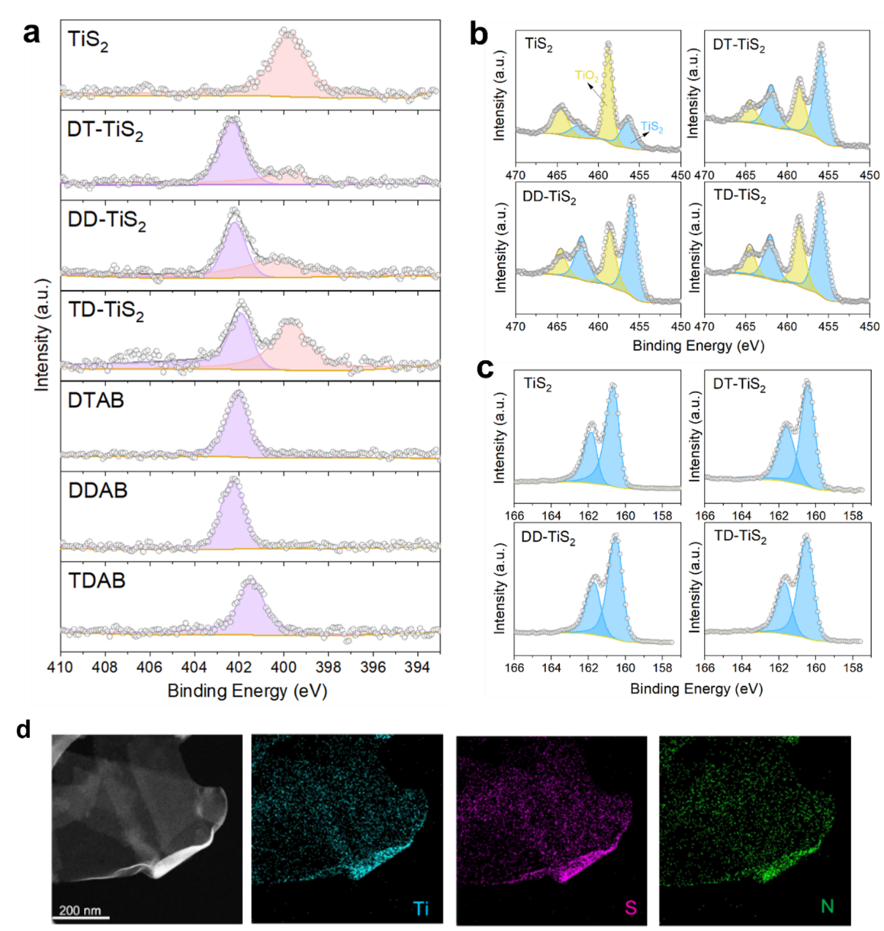
Fig. S6 XPS spectra of a) N1s of membranes of TiS₂/DT-TiS₂/DD-TiS₂/TD-TiS₂ and DTAB/DDAB/TDAB powders. b, c) Ti2p and S2p of membranes of TiS₂/DT-TiS₂/DD-TiS₂/TD-TiS₂. From the XPS spectra before and after the reaction, changes in the binding energies of surface elements can be observed. The N 1s peaks show the presence of ammonium peaks on the surface of TiS₂ modified with quaternary ammonium salts, corresponding to the N positions in the three modifiers' powders. This indicates that the positively charged ammonium ends have successfully attached to the TiS₂ surface [S1, S2]. The N peak on the unmodified TiS₂ surface may originate from nitrogen in the air, with adsorption sites competing with quaternary ammonium ions. After modification, its relative content decreases. From the Ti 2p spectrum, the peaks for TiS₂ (456 eV) and TiO₂ (459 eV) can be directly identified [S3, S4]. It can be observed that pure TiS₂ shows a significant number of oxides during the exfoliation and drying process. In contrast, the samples protected by a quaternary ammonium salt hydrophobic layer maintain a TiS₂ content similar to the original powder. Correspondingly, the S 2p spectrum shows only one pair of peaks, indicating that no phase transformation occurred during the exfoliation and modification process. d) EDS mapping of DD-TiS₂ nanosheets.

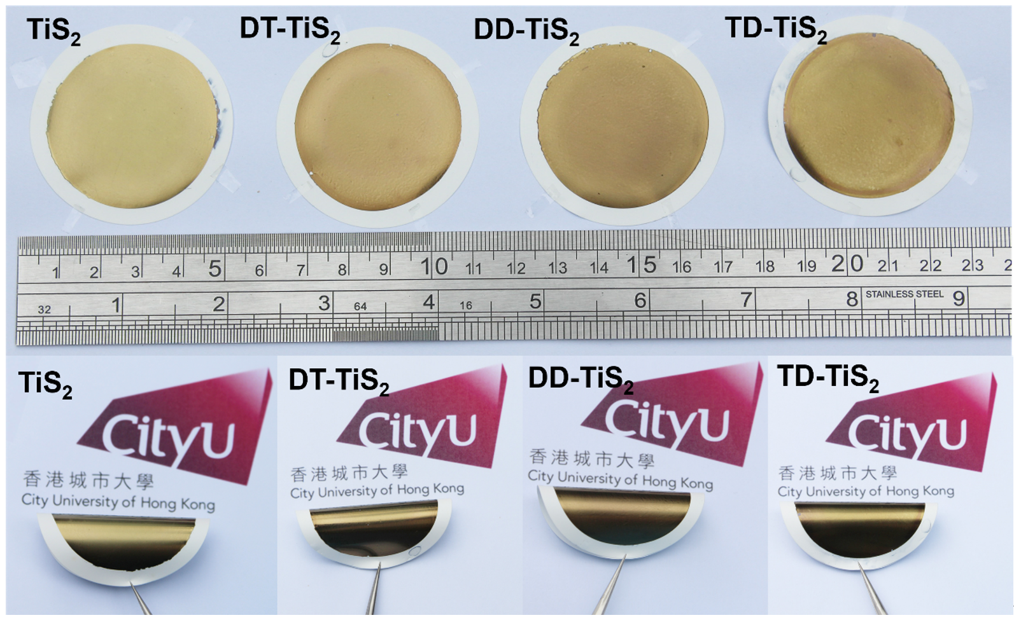
Fig. S7 Optical images of four kinds of modified membranes.

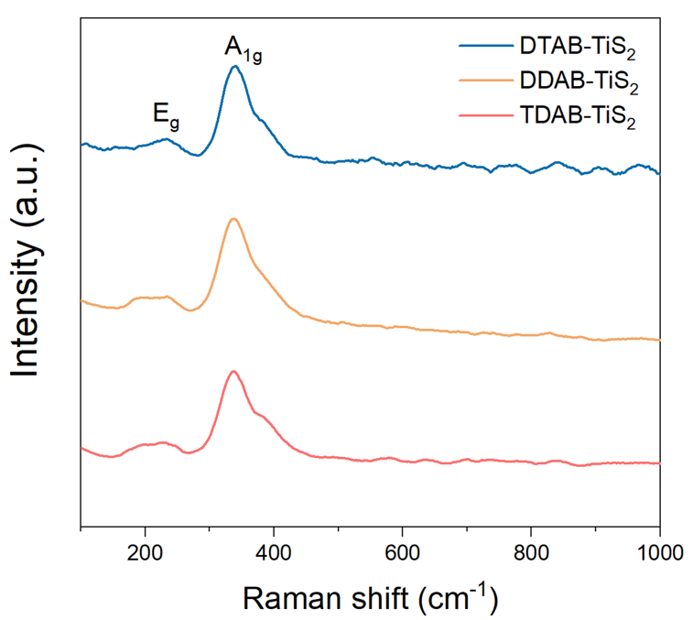
Fig. S8 Raman shift of DTAB/DDAB/TDAB modified TiS₂ membrane. The Raman shift of bulk TiS₂, identified as the 1T polytype, exhibits two distinct active modes: A_{1g} and E_{g}, positioned at approximately 332 cm⁻¹ and 230 cm⁻¹, respectively [S5]. The A_{1g} mode is characterized by the out-of-plane vibrations of sulfur atoms, while the E_{g} mode encompasses both in-plane and out-of-plane vibrations of sulfur atoms. The A_{1g} mode remains largely unchanged, indicating that the modified TiS₂ membrane has retained its 1T phase without significant phase transformation. The E_{g} mode in the modified membrane exhibits a degree of broadening, which could likely be attributed to the surface modification by quaternary ammonium molecules.

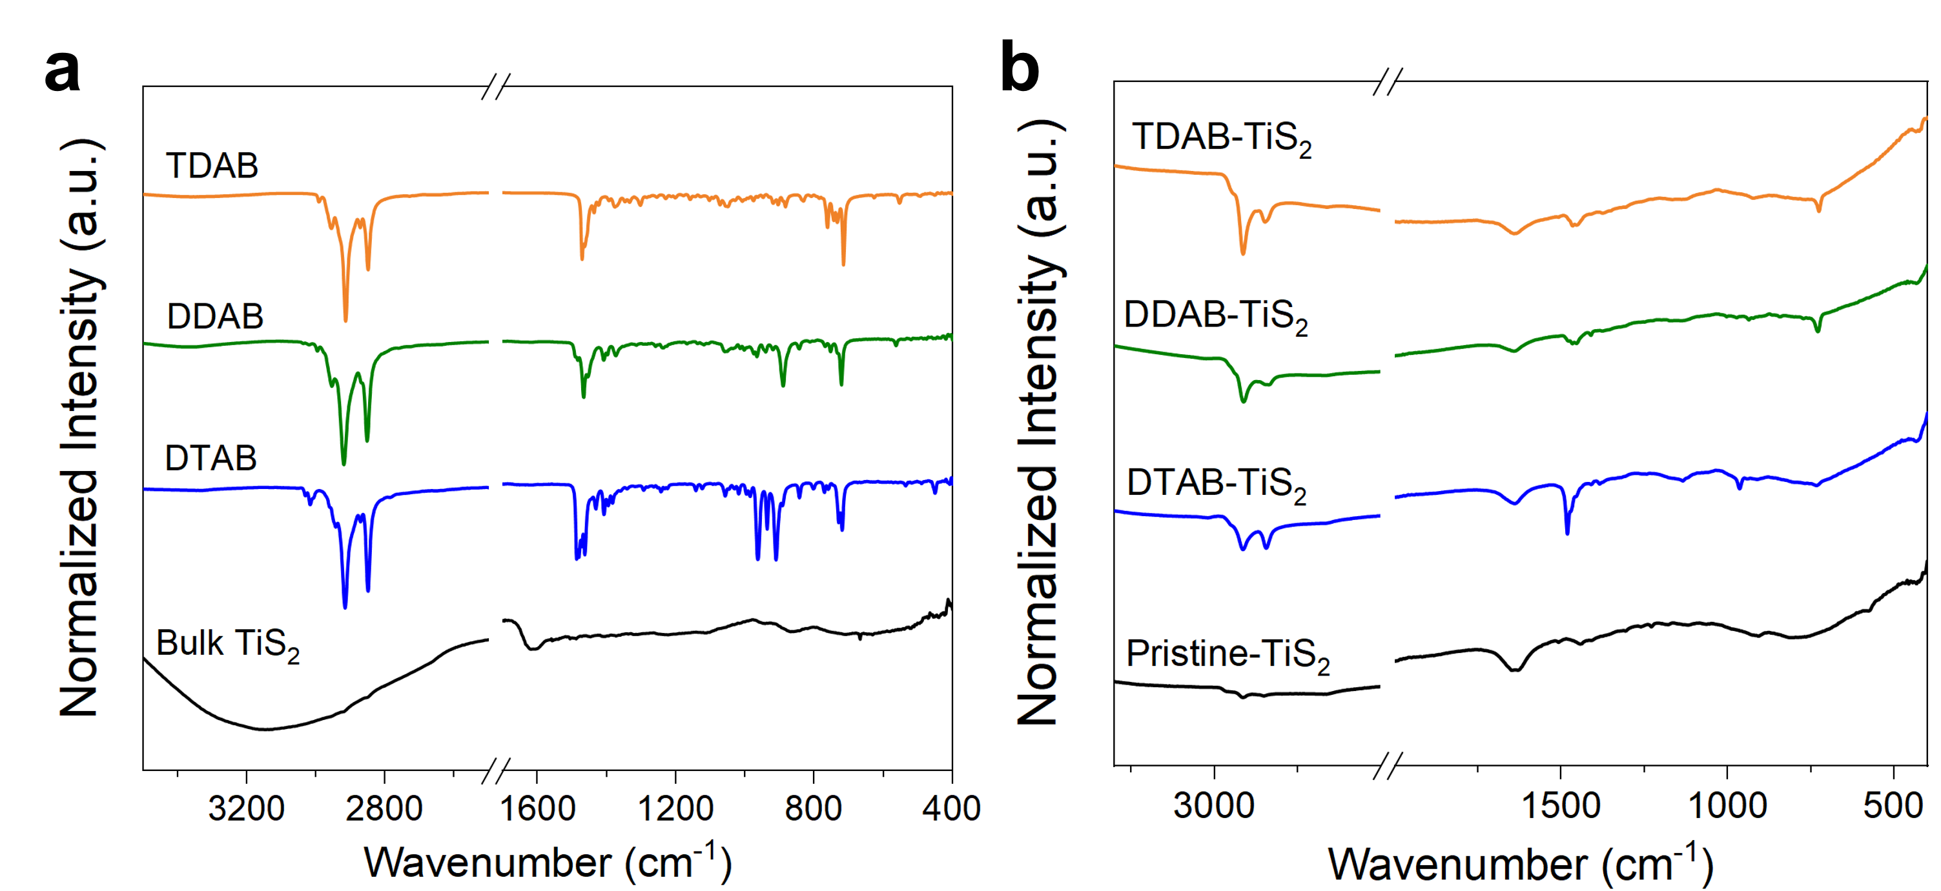
Fig. S9 FTIR images of a) commercial DTAB/DDAB/TDAB/bulk TiS₂ powders. b) pristine and modified TiS₂ membranes. A strong absorption of the -CH₂- peak was found in the 2800-3000 cm⁻¹ range and 720 cm⁻¹ for all three modifiers [S6]. After reaction with TiS₂ nanosheets, excepts the pristine TiS₂, all TiS₂ membranes modified with the three quaternary ammonium salts show enhanced absorption of methylene groups, this indicates the successful grafting of alkyl chains on the surface of the membranes.

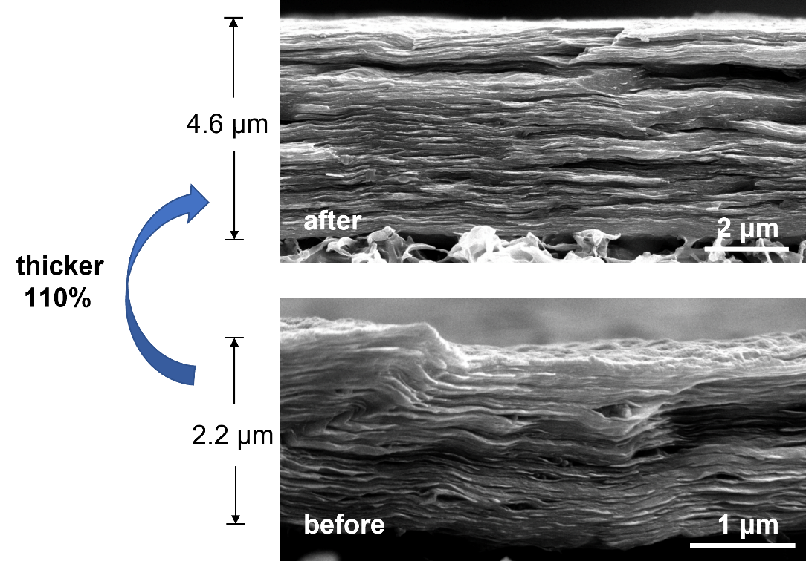
Fig. S10 SEM images of membrane thickness changes before and after DDAB modification. (The porous region corresponds to the PVDF substrate, while the tightly packed layered structure directly above it represents the restacked film.)

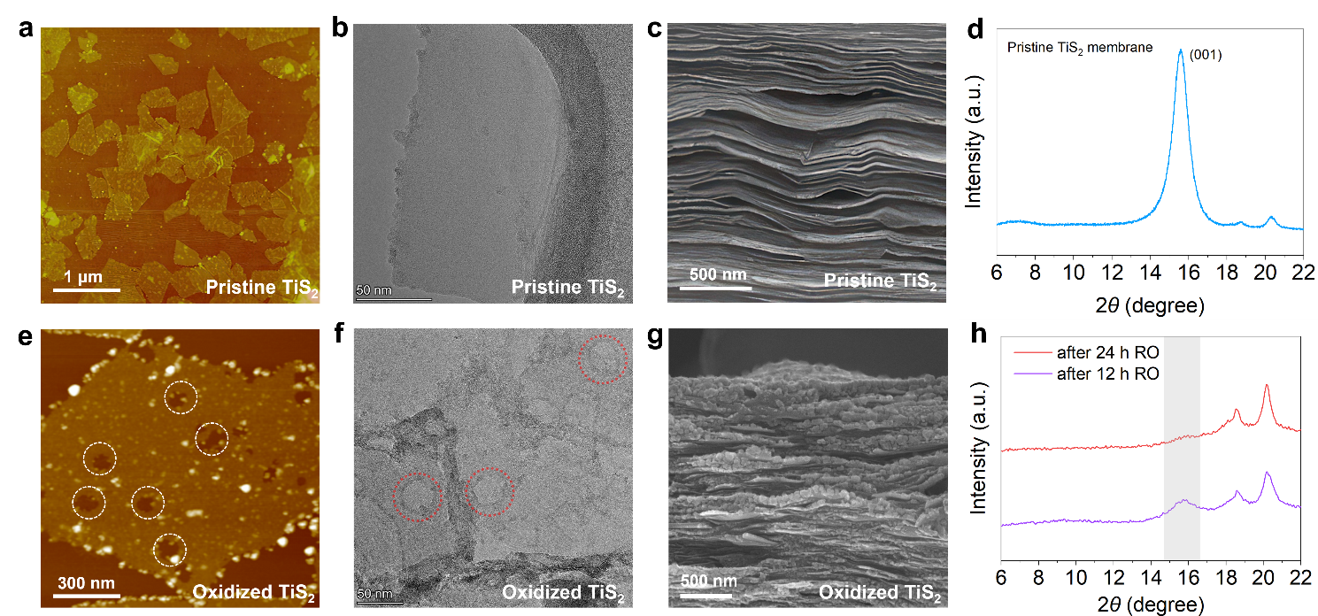
Fig. S11 Structural and morphological comparison between pristine and oxidized TiS₂. a) AFM image of a pristine TiS₂ nanosheet, showing a smooth and intact surface morphology. b) TEM image of pristine TiS₂, revealing a continuous lattice without observable oxidation-induced defects. c) Cross-sectional SEM image of a pristine TiS₂ membrane, displaying well-defined and orderly lamellar stacking. d) XRD pattern of the pristine TiS₂ membrane, characterized by a sharp (001) reflection, indicative of preserved layered crystallinity. e) AFM image of an oxidized TiS₂ nanosheet, where multiple oxidation-induced voids are observed (highlighted by white dashed circles). f) TEM image of oxidized TiS₂, showing pronounced voids and contrast variations associated with oxidation (marked by red dashed circles). g) Cross-sectional SEM image of the oxidized TiS₂ membrane, exhibiting disrupted lamellar stacking and partial structural collapse after oxidation. h) XRD patterns of TiS₂ membranes after 12 h and 24 h RO operation, showing weakened and broadened diffraction features, suggesting a gradual loss of layered order upon oxidation.
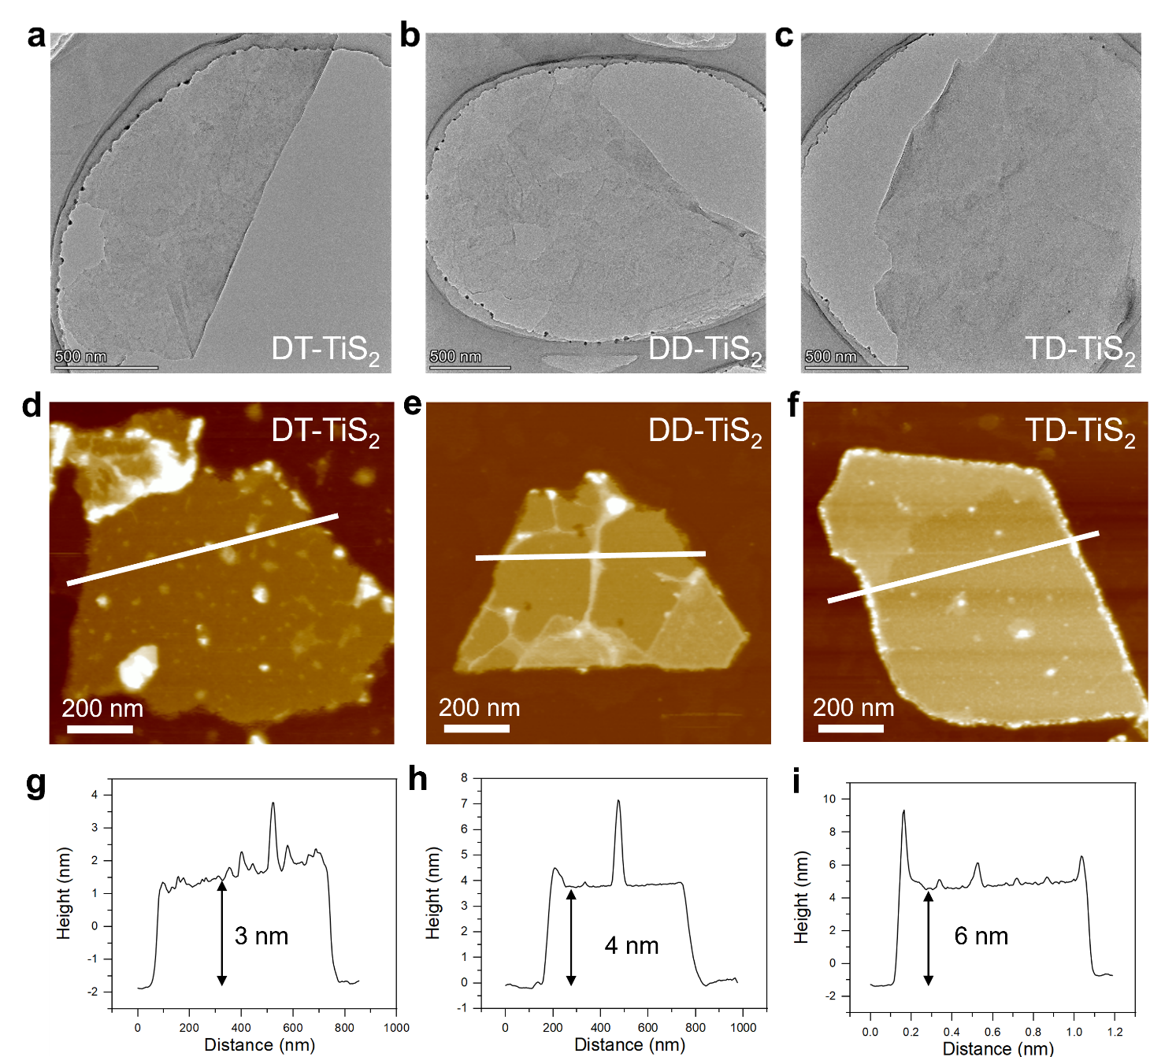
Fig. S12 Morphology and thickness characterization of functionalized TiS₂ nanosheets. a–c) TEM images of DT-TiS₂ (a), DD-TiS₂ (b), and TD-TiS₂ (c) nanosheets. d–f) AFM topographic images of DT-TiS₂ (d), DD-TiS₂ (e), and TD-TiS₂ (f). g–i) Corresponding AFM height profiles extracted along the indicated lines, showing average thicknesses of ~3 nm for DT-TiS₂ (g), ~4 nm for DD-TiS₂ (h), and ~6 nm for TD-TiS₂ (i).
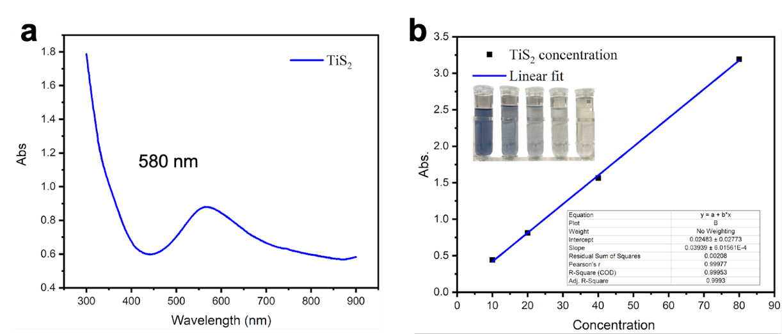

Fig. S13 a) UV-vis spectra absorbance of TiS₂ ink solution. b) linear relationship between TiS₂ concentration and absorbance.

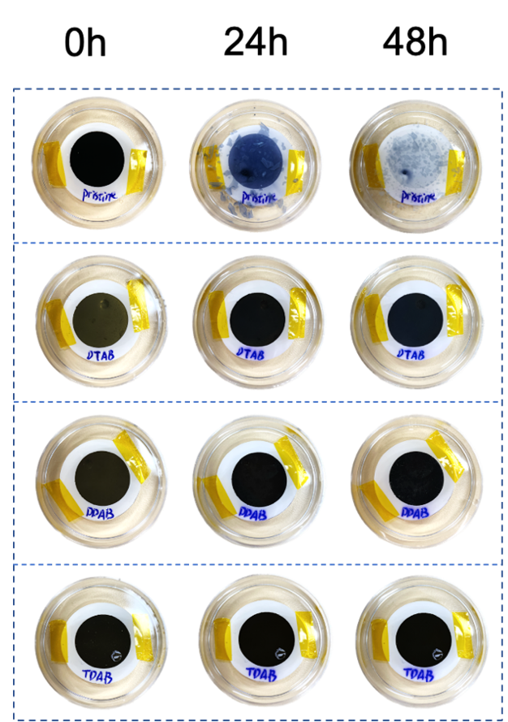
Fig. S14 This presented a significant color change from the metallic luster of TiS₂ before reverse osmosis, directly illustrating the water sensitivity of the TiS₂ membrane. Notably, the surfaces of membranes modified with three types of DTA ions maintained their original metallic luster even after the reverse osmosis test, directly confirming the significant anti-oxidative effect of DTA ions on TiS₂ films. The immersion experiments were also conducted in water sink that further validate the protective effect of DTA ions on TiS₂. As shown, the unmodified TiS₂ membrane exhibits significant cracking and discoloration after 48 hours of immersion, and these damaged areas pose a potential risk of secondary contamination during practical applications. In contrast, the modified TiS₂ membrane, which remains stable after modification, not only demonstrates excellent antioxidation properties but also exhibits some degree of swelling inhibition. This remarkable effect is largely due to the rapid electrostatic forces at play during the post-treatment process, which enable the DTA ions to swiftly self-assemble. This results in the N⁻terminal end aligning closely with the TiS₂ side, while the hydrophobic long chains orient towards the water molecules.

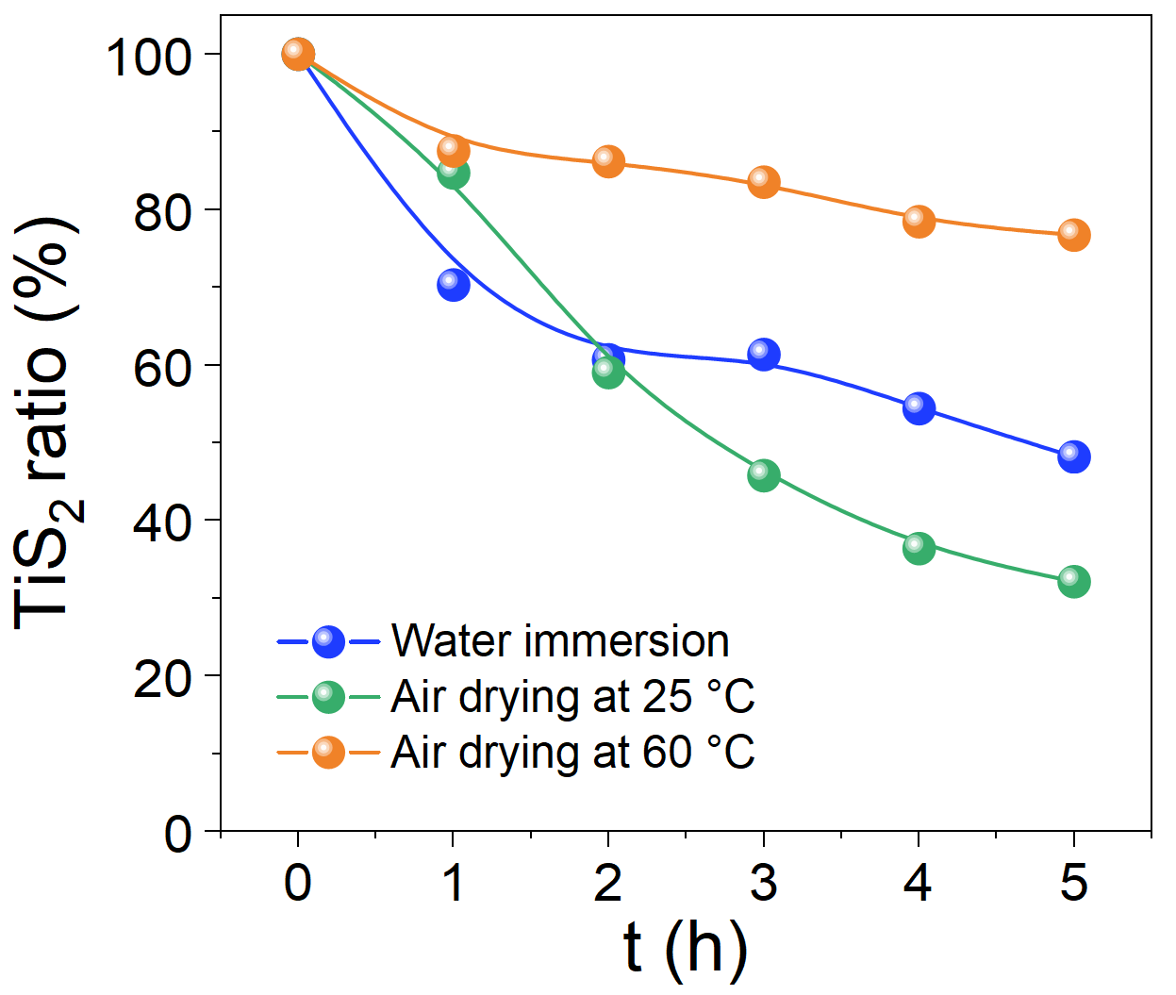
Fig. S15 Quantitative oxidation kinetics of pristine TiS₂ under three representative conditions: water immersion (blue, derived from time-resolved UV-vis absorbance decay), ambient air drying at 25 °C (green, derived from time-resolved Ti 2p XPS deconvolution), and forced air drying at 60 °C (orange, derived from time-resolved Ti 2p XPS deconvolution). The comparison demonstrates that hydrolysis by H₂O, rather than oxidation by molecular O₂, is the dominant degradation pathway of TiS₂.

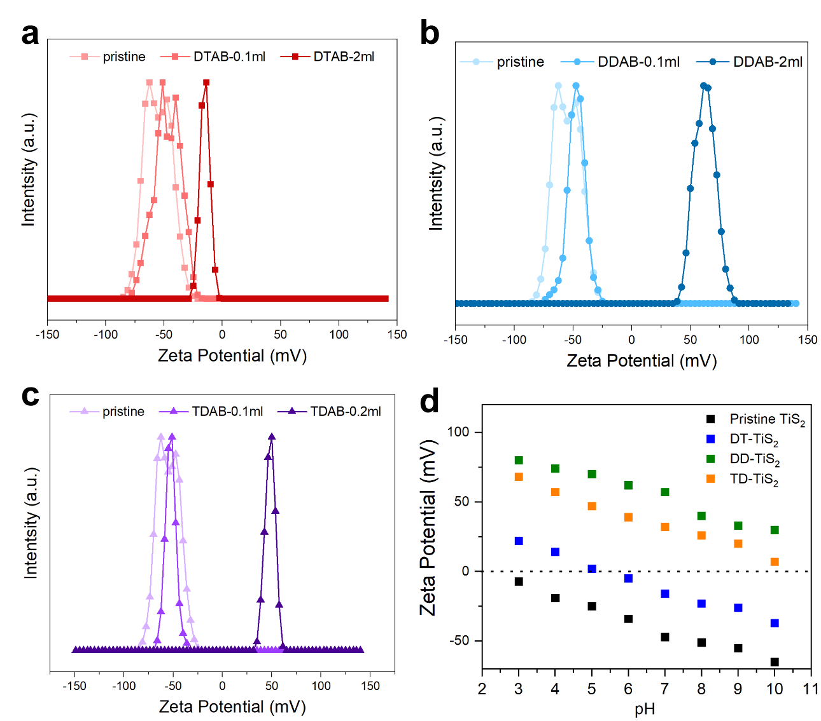
Fig. S16 Zeta potential evolution of pristine and ammonium-modified TiS₂ nanosheets. a–c) Zeta potential distributions of TiS₂ modified with increasing amounts of DTAB (a), DDAB (b), and TDAB (c). Pristine TiS₂ exhibits a strongly negative surface potential (≈ –50 to –60 mV). Progressive addition of the quaternary ammonium salts leads to a systematic shift toward positive values, indicating successful adsorption of the cationic headgroups and formation of a surface-stabilizing layer. Complete charge reversal to +70~100 mV is observed at sufficiently high modifier concentrations. d) pH-dependent zeta potentials of pristine TiS₂ and the three modified TiS₂ samples. While pristine TiS₂ becomes unstable and approaches neutral/negative charge across the pH range, all modified samples maintain strongly positive and relatively stable surface potentials from pH 3 to 10, demonstrating the robustness of the interfacial ammonium layers and improved aqueous stability.
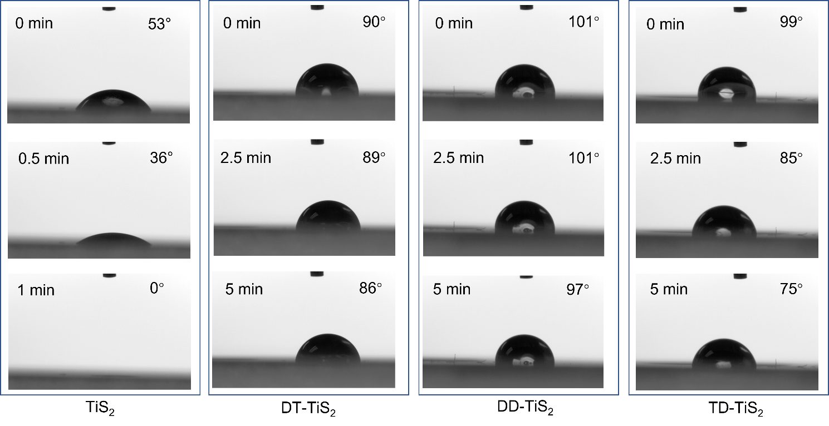
Fig. S17 Time‐dependent static contact angles of pristine TiS₂, DT‐TiS₂, DD‐TiS₂, and TD‐TiS₂ membranes, showing distinct wetting evolution from 0 ~ 5 min. Pristine TiS₂ rapidly loses hydrophobicity, whereas modified membranes retain high contact angles (>85°) over time.

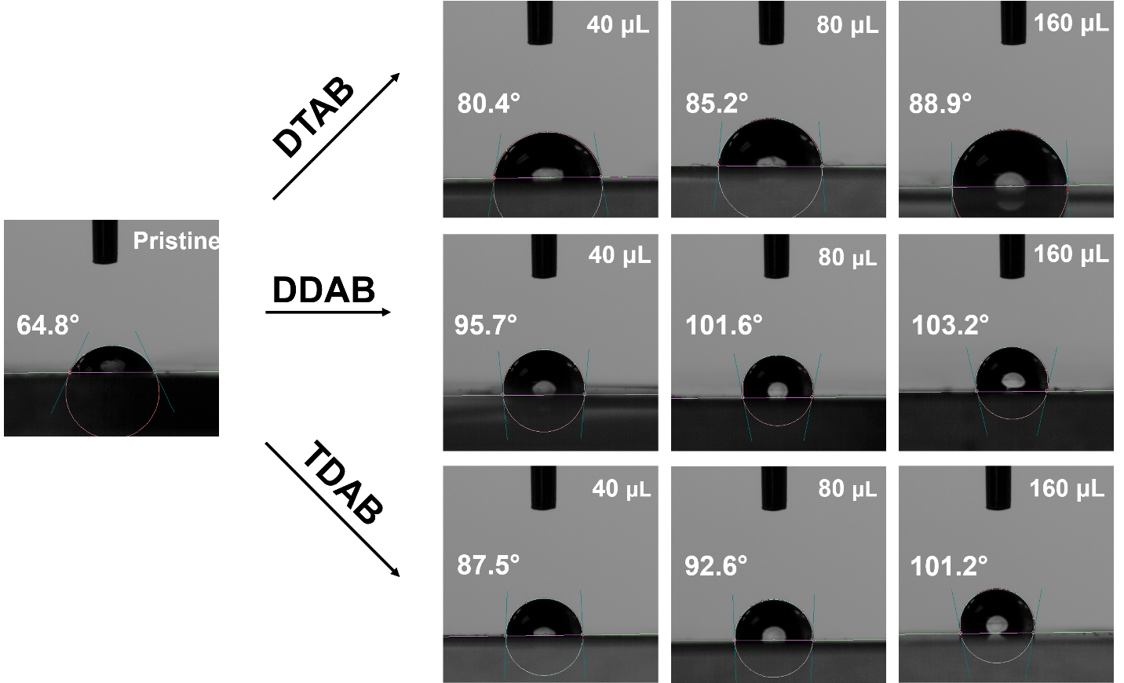
Fig. S18 Contact angle of membranes decorated by different concentrations (40 μL, 80 μL, 160 μL) of DTAB/DDAB/TDAB.

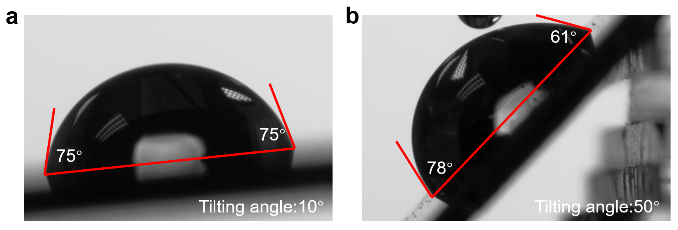
Fig. S19 Advancing and receding contact angle measurements on a DT‐TiS₂ membrane under tilting angles of 10° and 50°. The calculated hysteresis (Δθ = θ_{adv} − θ_{rec} = 17°) indicates a homogeneous and low‐adhesion surface favorable for dynamic water repellence.

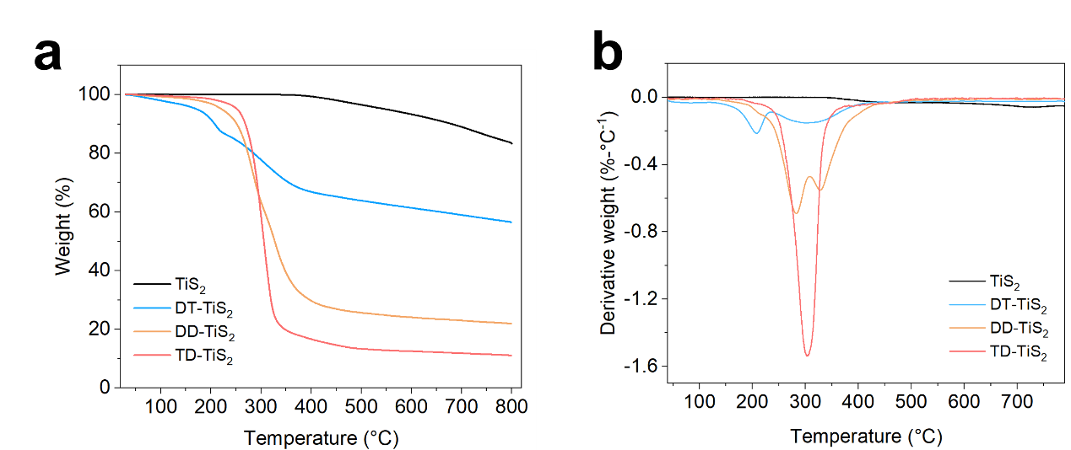
Fig. S20 TGA of bulk TiS₂ powders and DT/DD/TD-TiS₂. 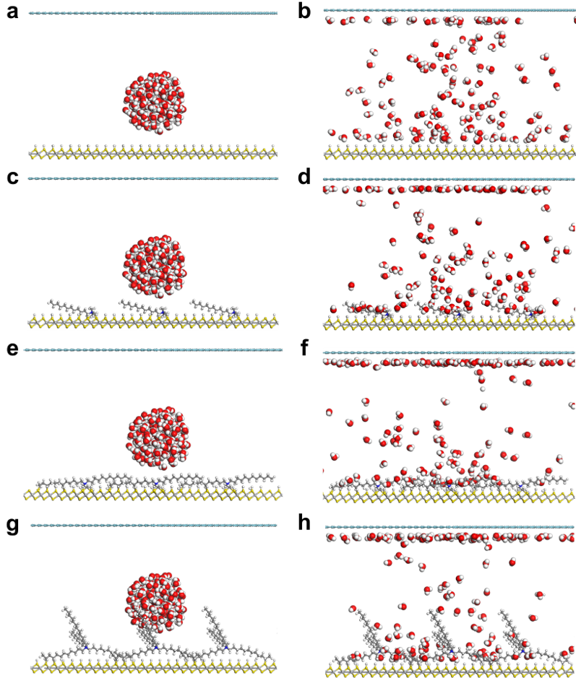
Fig. S21 MD simulations of water droplet before and after interactions with pristine and modified TiS₂ surfaces. (a, b) TiS₂, (c, d) DT-TiS₂, (e, f) DD-TiS₂, and (g, h) TD-TiS₂. Color bars: Silver balls = Ti, Yellow balls = S, Red balls = O, Grey balls = C, white balls = H. The top blue balls are inert atoms as the block for water molecules during the MD simulations¹⁻⁵.
Fig. S22 Ratio of water molecules from the droplets located near the surface of pristine and modified TiS₂ surfaces.
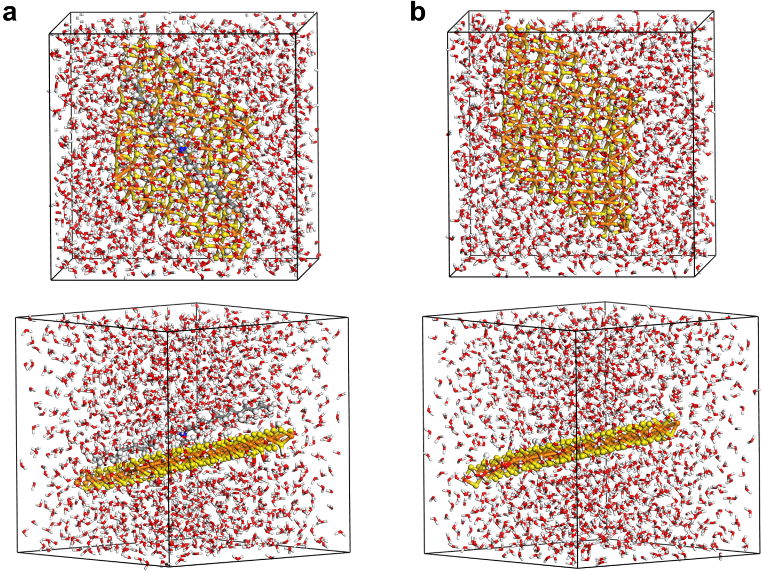
Fig. S23 The MD simulation models of (a) DD-TiS₂ and (b) TiS₂ interact with water molecules in the solutions at different angles.

Fig. S24 Adsorption energies of O₂ on TiS₂, DT-TiS₂, DD-TiS₂, and TD-TiS₂.

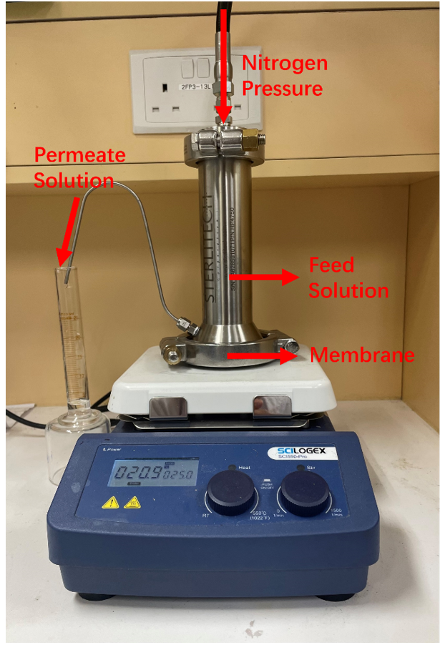
Fig. S25 The image of RO test system. A homemade dead-end filtration cell was used to evaluate membrane permeance under nitrogen pressure. The feed solution was loaded into the stainless-steel filtration cell and pressurized by nitrogen gas applied from the top. The membrane was placed at the bottom of the cell, and the permeate solution was collected through the outlet tubing into a graduated cylinder for volume measurement. The entire setup was placed on a magnetic stirring plate to minimize concentration polarization during filtration.

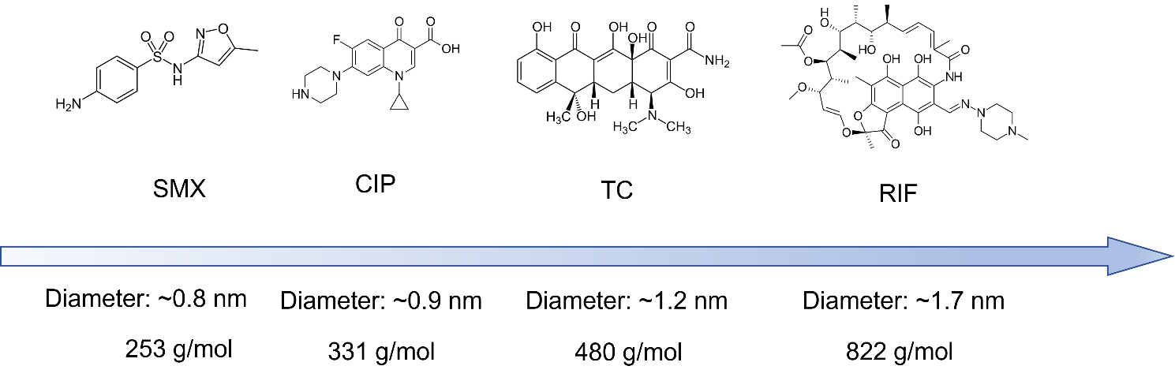
Fig. S26 Chemical structure of four kinds of antibiotics and their molecular weight.

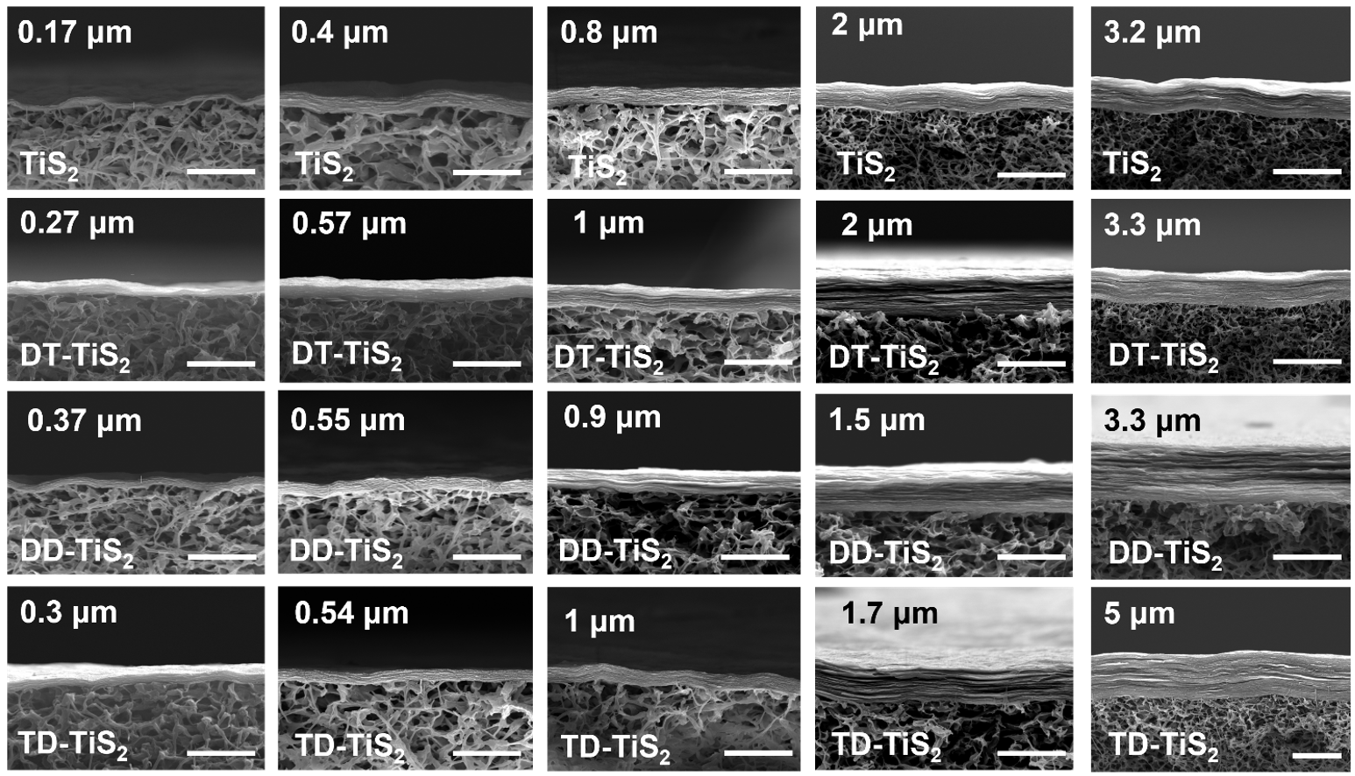
Fig. S27 Cross-sectional SEM images of pristine and functionalized TiS₂ membranes with tunable thicknesses. All membranes were prepared under identical conditions: TiS₂ nanosheet dispersions (0.5 mg mL⁻¹ in DI water) were vacuum-filtered onto PVDF substrates (220 nm pore size, 25 mm in diameter) at a constant vacuum of −0.1 MPa and room temperature. Membrane thickness was tuned solely by adjusting the filtered volume (2, 5, 10, 20, or 40 mL), yielding ~200, ~600, ~1000, ~2000, and ~3000 nm stacks, respectively. For the functionalized membranes, 2 mL of 0.1 mM DTAB/DDAB/TDAB (ethanol/water = 1:1 v/v) was subsequently filtered through the freshly wet TiS₂ layer under the same vacuum, followed by rinsing with 20 mL DI water. All samples were then vacuum-dried at 100 °C for 12 h. (scale bar: 2 μm)

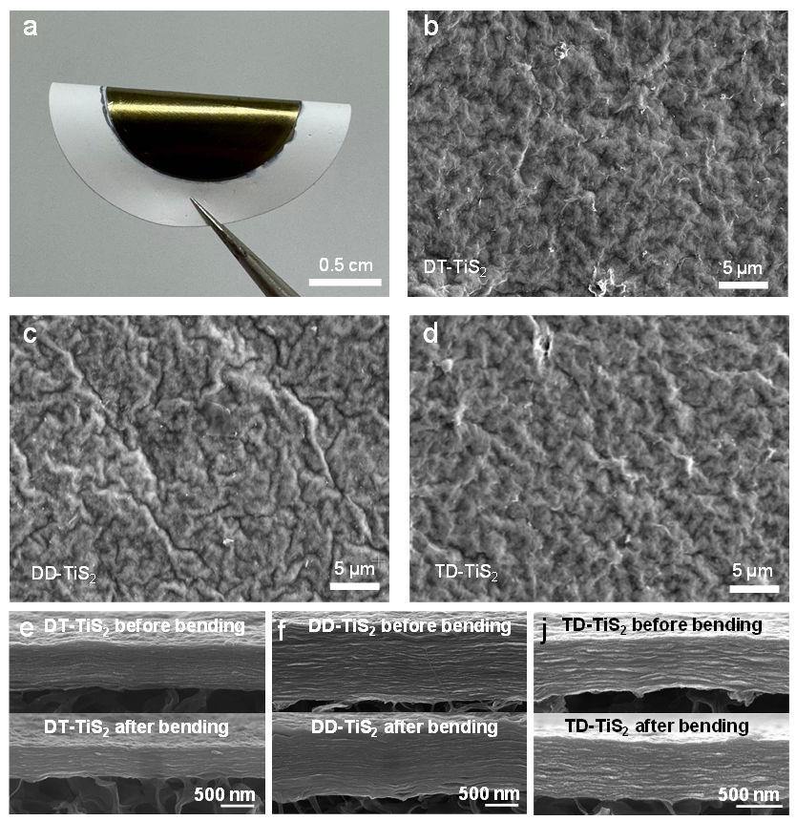
Fig. S28 Mechanical flexibility and tensile performance of TiS₂-based membranes. a) Optical photograph showing the free-standing DT-TiS₂ membrane bent into a semicircular shape without visible cracks or delamination, demonstrating excellent flexibility. b–d) SEM images of the membrane surface after bending, confirming continuous and compact morphology for DT-TiS₂, DD-TiS₂, and TD-TiS₂ samples without structural failure. e-j) Cross-sectional SEM images of e) DT-TiS₂, f) DD-TiS₂, and j) TD-TiS₂ membranes before (top row) and after (bottom row) bending. The tightly packed, layered internal structures remain fully intact, further verifying their excellent structural integrity under mechanical deformation.

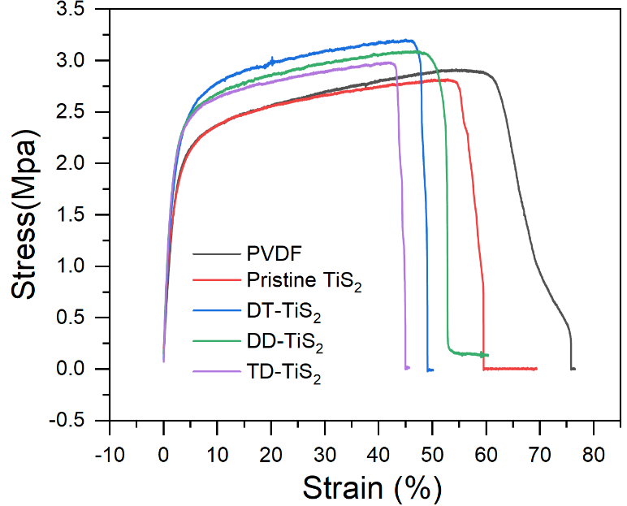
Fig. S29 Stress–strain curves of PVDF, pristine TiS₂, and modified TiS₂ membranes (DT-TiS₂, DD-TiS₂, TD-TiS₂), showing improved tensile strength (2.8–3.1 MPa) and good elongation (30–45%) for all modified membranes.
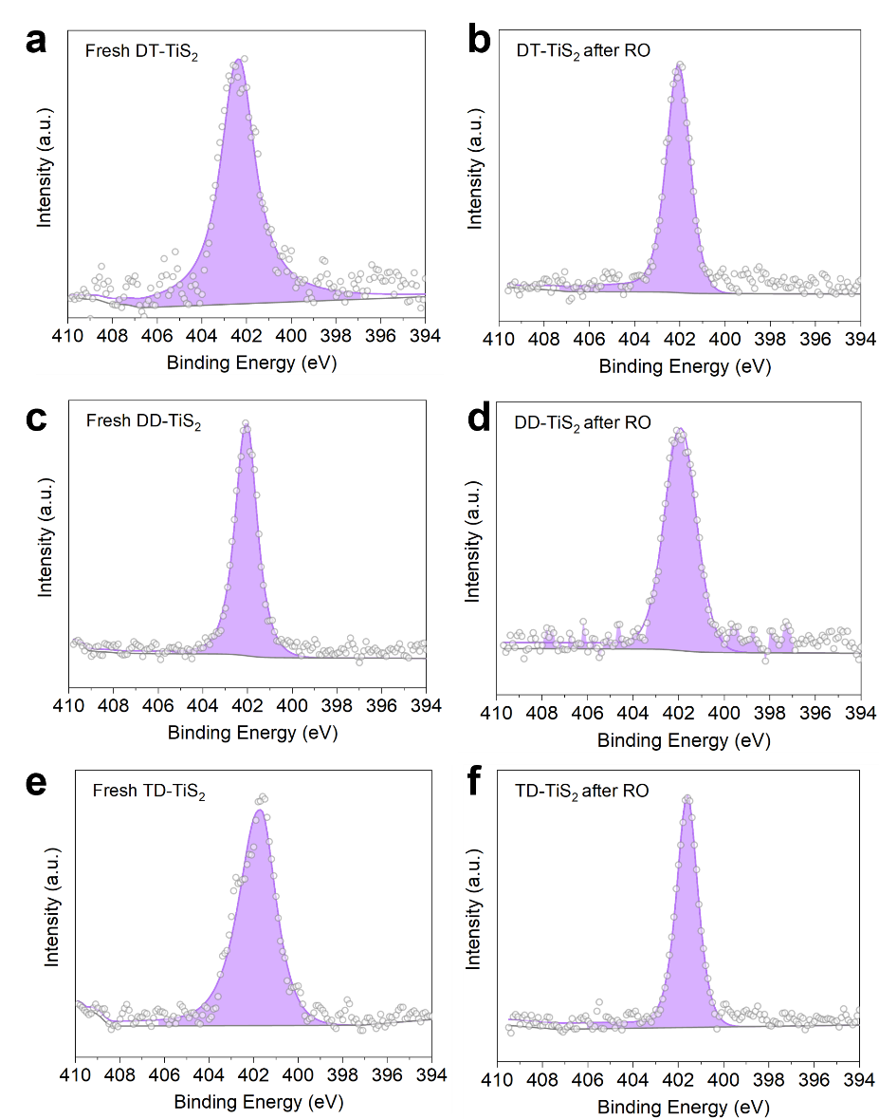
Fig. S30 XPS N 1s spectra of functionalized TiS₂ membranes before and after RO tests. a) Fresh DT-TiS₂ membrane. b) DT-TiS₂ membrane after RO test. c) Fresh DD-TiS₂ membrane. d) DD-TiS₂ membrane after RO test. e) Fresh TD-TiS₂ membrane. f) TD-TiS₂ membrane after RO test.
Fig. S31 Ti 2p XPS spectra of pristine and modified TiS₂ membranes before and after RO operation. a–d) High-resolution Ti 2p spectra of fresh TiS₂, DT-TiS₂, DD-TiS₂, and TD-TiS₂ membranes. e–h) Corresponding Ti 2p spectra after RO tests. The blue peaks correspond to Ti⁴⁺ (TiS₂) and the yellow peaks to Ti⁴⁺ (TiO₂) species. The integrated areas of these deconvoluted peaks were used to evaluate the TiS₂/TiO₂ ratio, reflecting the degree of surface oxidation before and after RO operation.

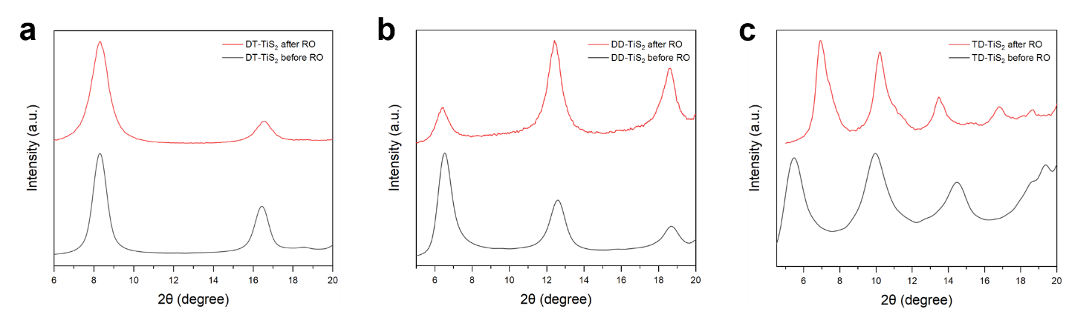
Fig. S32 XRD patterns of a) DT-TiS₂, b) DD-TiS₂, and c) TD-TiS₂ membranes before and after RO operation.
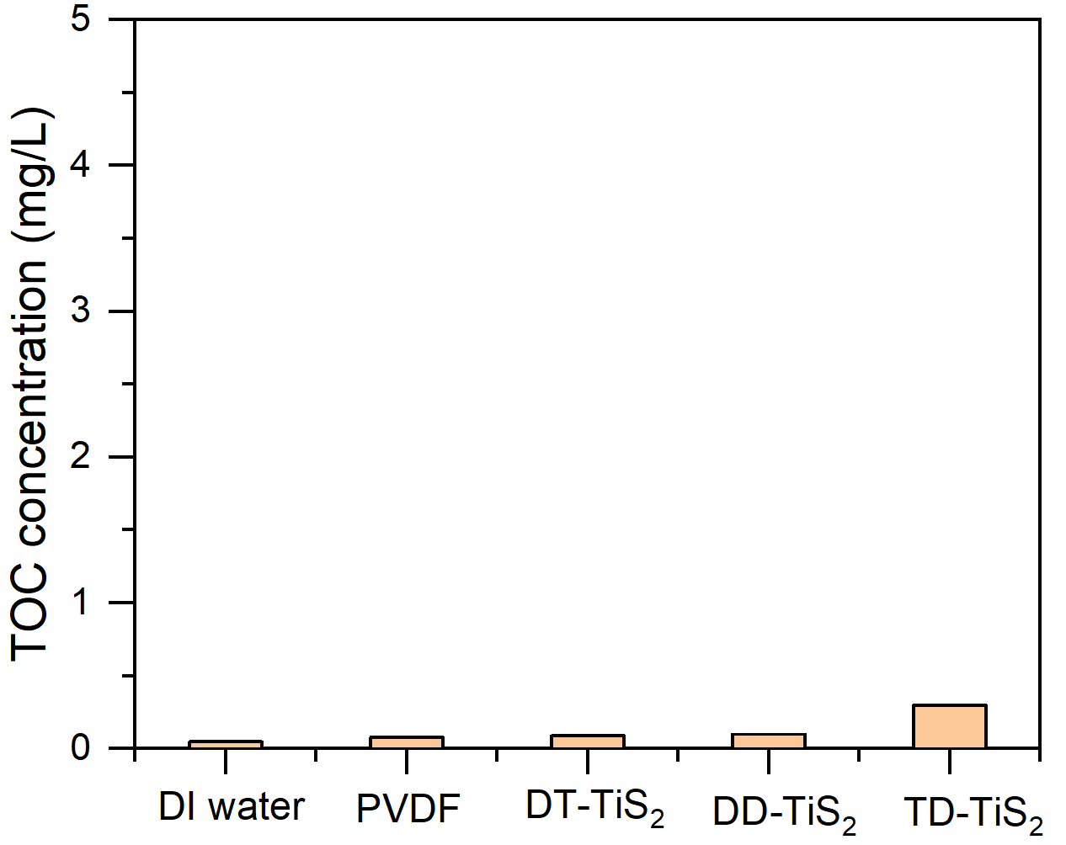
Fig. S33 Total organic carbon (TOC) concentrations of permeate water after filtration through different membranes.
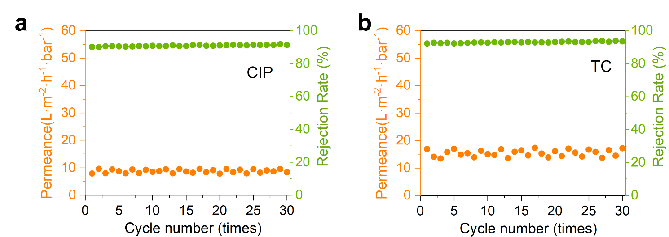
Fig. S34 Cyclic stability of DD-TiS₂ membranes in antibiotic rejection tests. Permeance (orange, left axis) and rejection rate (green, right axis) of DD-TiS₂ membranes tested over 30 consecutive filtration cycles for a) CIP, b) TC (25 mg/L, 25°C).
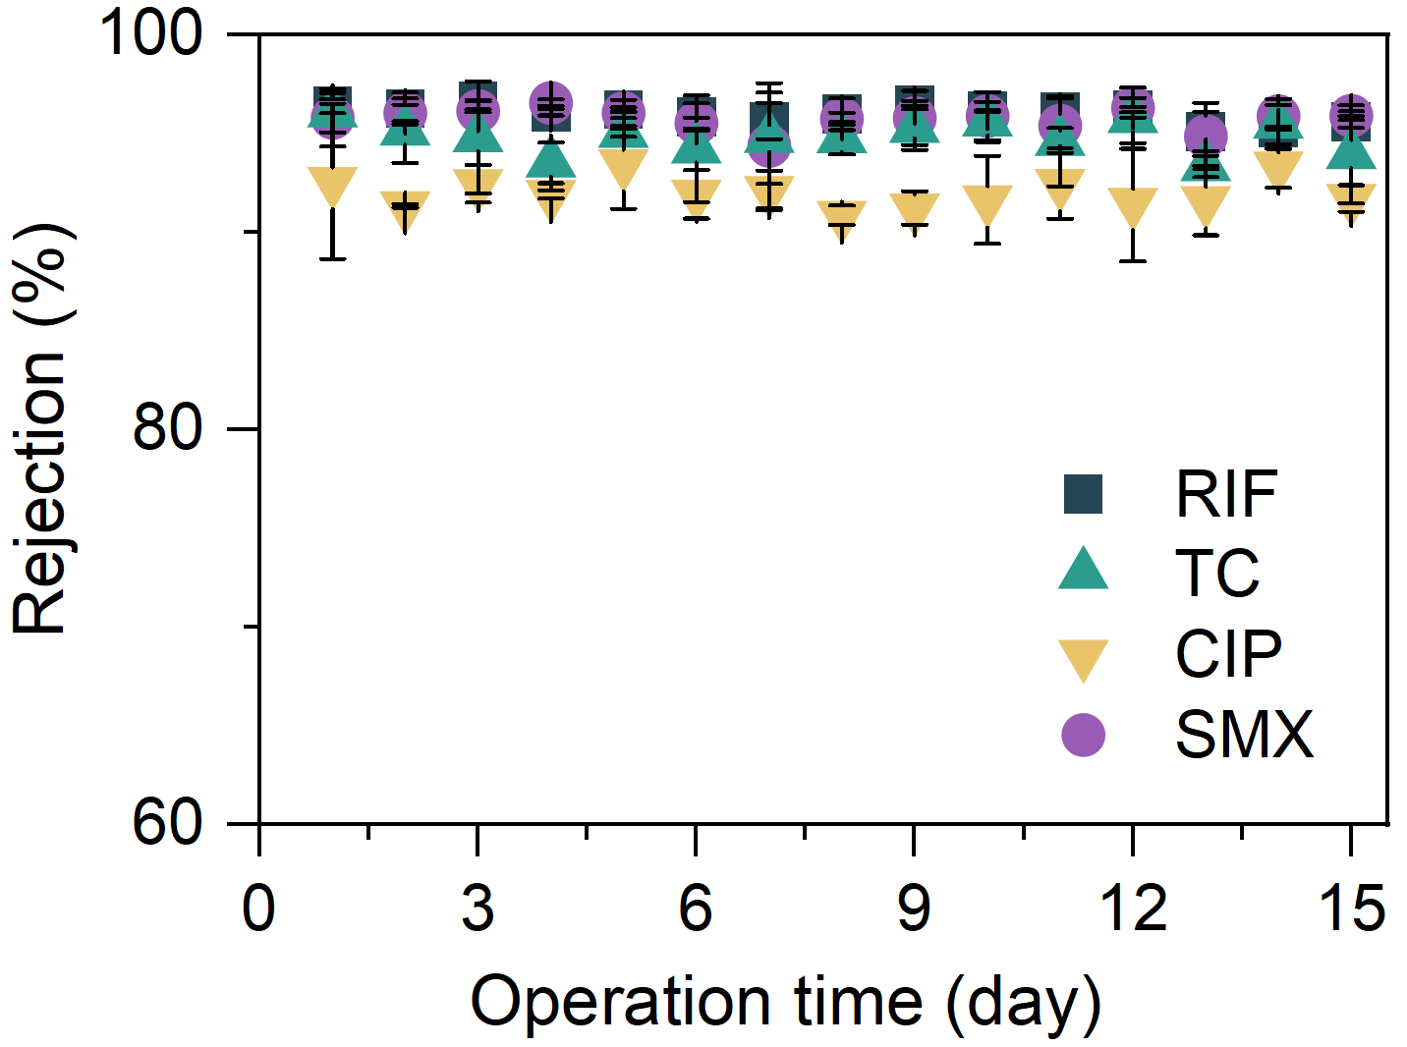
Fig. S35 Long-term operation stability of DD-TiS₂ membranes. (RIF, TC, CIP, and SMX, 25 mg/L, 25 °C)
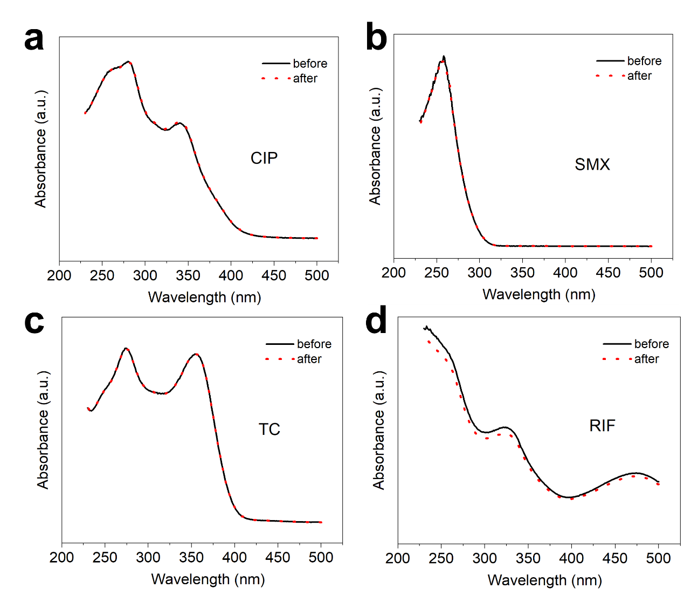
Fig. S36 UV-vis absorbance before and after adsorption of four kinds of antibiotics.
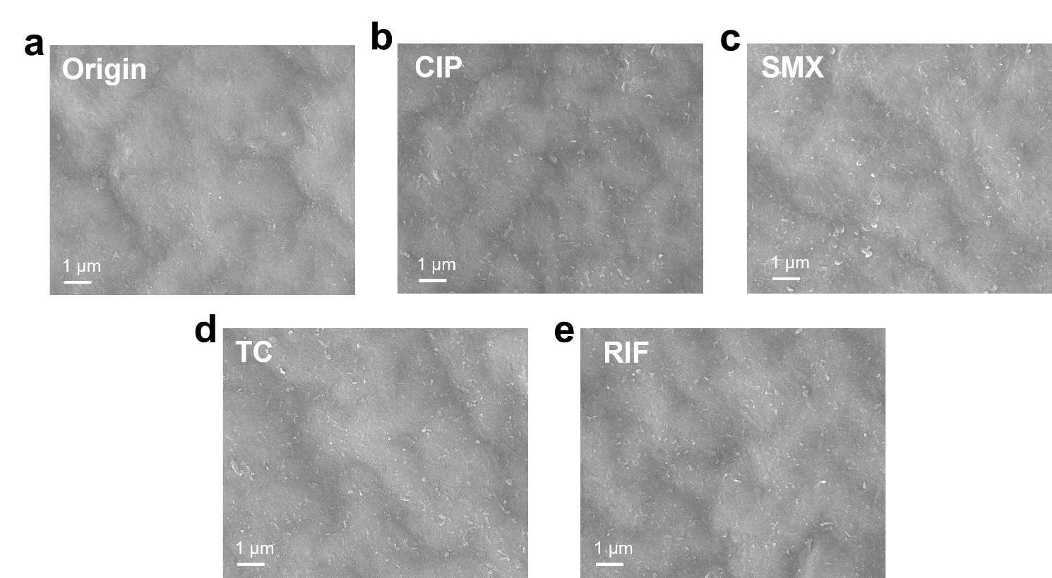
Fig. S37 SEM images of RO-tested DD-TiS₂ membrane.
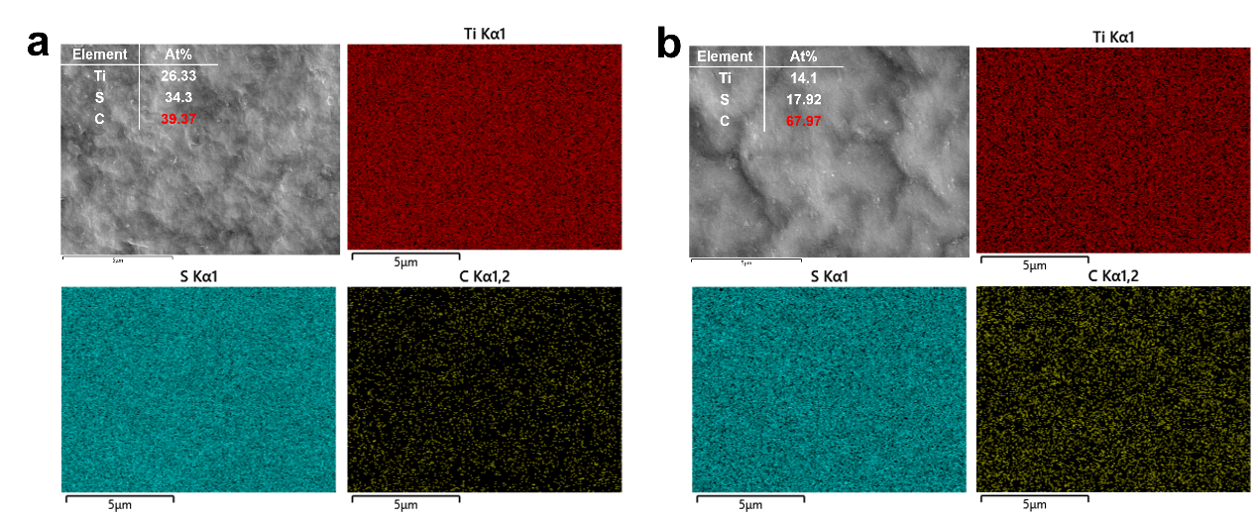
Fig. S38 SEM EDS mapping of a) fresh DD-TiS₂ membrane and b) RO-tested DD-TiS₂ membrane.
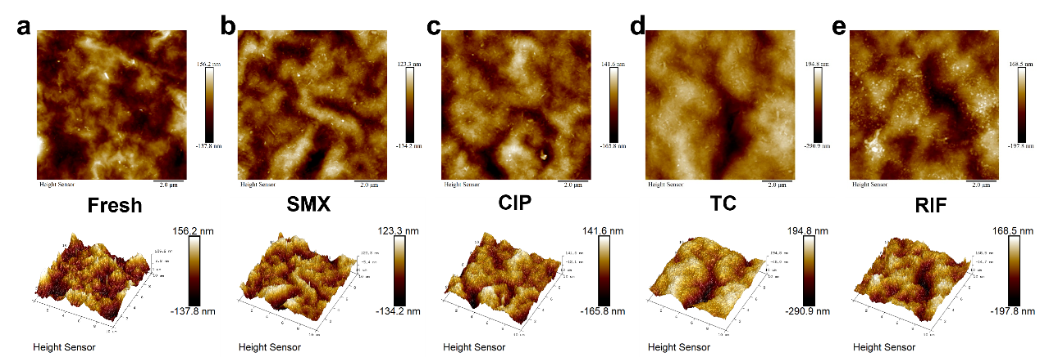
Fig. S39 AFM images of DD-TiS₂ membranes after RO test of SMX/CIP/TC/RIF.
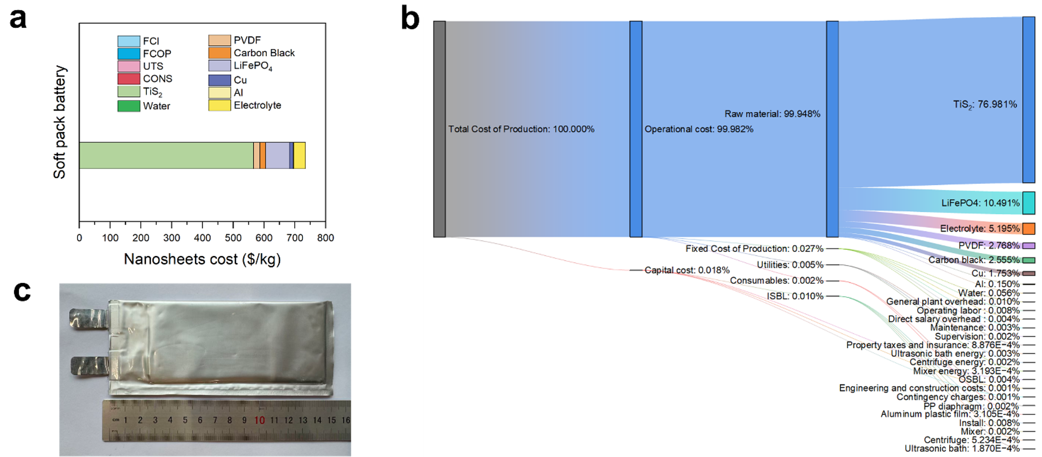
Fig. S40 Techno-economic assessment of TiS₂ nanosheet production via the soft-pack battery exfoliation route. a) Cost distribution of producing 1 kg TiS₂ nanosheets, showing total cost ≈ $700 kg⁻¹, dominated by TiS₂ and LiFePO4 raw materials. b) Sankey diagram detailing the cost flow from raw materials, capital, and utilities to individual components. Operational and capital expenses contribute < 0.05%, confirming that the exfoliation and filtration processes are economically scalable. Abbreviations: FCI, fixed capital investment; FCOP, fixed costs of production; UTS, total utilities; CONS, total consumables. c) optical image of pouch-cell using TiS₂ as electrode for scalable production.
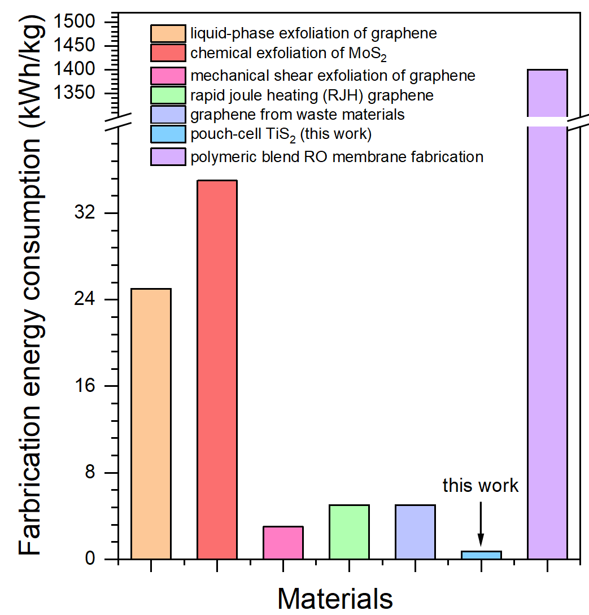
Fig. S41 Comparison of fabrication energy consumption for different membrane and 2D-material production routes. Energy consumption (kWh·kg⁻1 of material) for several representative fabrication processes, including liquid-phase exfoliation of graphene, chemical exfoliation of MoS₂, mechanical shear exfoliation of graphene, rapid Joule-heating (RJH) graphene, graphene obtained from waste precursors, and polymeric blend RO membrane fabrication (literature values).
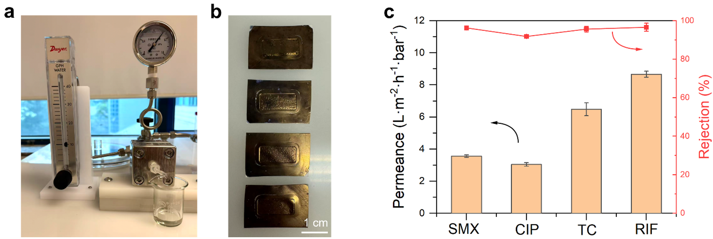
Fig. S42 Cross-flow filtration performance of the DD-TiS₂ membrane. a) Photograph of the laboratory-scale cross-flow filtration setup used in this study. b) Optical images of the DD-TiS₂ membranes (effective area ≈ 2 cm²) installed in the stainless-steel cross-flow module. c) Permeance and rejection of four representative antibiotics (SMX, CIP, TC, and RIF at a concentration of 25 ppm, 25°C) under cross-flow operation.
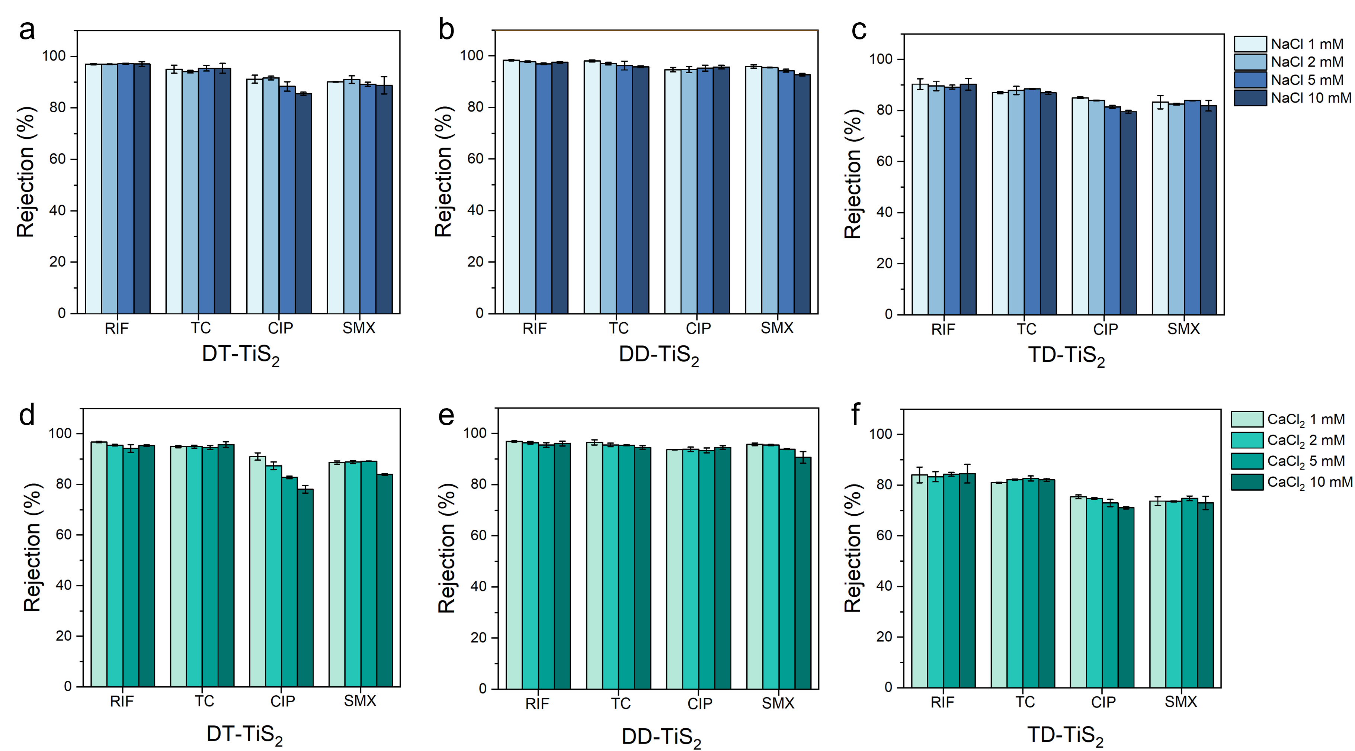
Fig. S43 Antibiotic rejection performance of the three functionalized TiS₂ membranes in mixed-antibiotic feeds (RIF + TC + CIP + SMX, each at 25 mg/L) under varying ionic-strength backgrounds. a–c) Rejection rates in NaCl backgrounds of 1, 2, 5, and 10 mM for a) DT-TiS₂, b) DD-TiS₂, and c) TD-TiS₂ membranes. d–f) Corresponding rejection rates under CaCl₂ backgrounds of 1, 2, 5, and 10 mM for d) DT-TiS₂, e) DD-TiS₂, and f) TD-TiS₂ membranes. All measurements were performed under dead-end RO operation at 6 bar transmembrane pressure with a 1 cm effective membrane diameter. DD-TiS₂ retains the highest rejection (>88% for all four antibiotics) across the entire ionic-strength range in both monovalent and divalent backgrounds, demonstrating robust performance in mixed-solute feeds.
Table S1 Summary of the membrane materials, filtration modes, and operating conditions of the reference works compared in Fig. 5i
Membrane | Filtration Mode | Operating Pressure | Target Solute & Concentration | Ref.
PES-GO | Dead-end | 3 bar | Reactive Red 195, 100 mg/L; BSA, 250 mg/L | [S7]
NF (PEI/PI) | Dead-end | 13.8 bar | Sulfamerazine, 1 mg/L | [S8]
PA-MoS₂ | Cross-flow | 8 bar | Four parabens (methyl-, ethyl-, propyl-, benzyl-paraben), 200 μg/L each | [S9]
MOF/PI | Cross-flow | 5–11 bar | 21 PhACs, 20 μg/L each; NaCl and MgSO₄, 2000 mg/L each | [S10]
SW30-GO | Cross-flow | 400 psi | NDMA, 890 μg/L | [S11]
PEI | Dead-end | 13.8 bar | Cefadroxil, 1 mg/L; Enrofloxacin, 1 mg/L | [S12]
COF | Cross-flow | 5 bar | Five dyes (chrome black T, methyl blue, Congo red, acid fuchsin, rose bengal), 100 mg/L | [S13]
TFC | Dead-end | 5 bar | MR, MnB, RosB, BB, 10 mg/L each | [S14]
PEI/PAI | Cross-flow | 10 bar | Ciprofloxacin, 1 ppm | [S15]
All-carbon | Vacuum filtration | 0.9 bar | Tetracycline hydrochloride (TCH), 500 μM, 20 mL | [S16]

Table S2 Energy flow data
Parameter | Value | Unit | Ref
Battery | -2800 | kW | = – (industrial-scale output / laboratory-scale output) × (battery power × discharge time)
Ultrasonic bath | 418 | kW | = Ultrasonic bath scale* unit volumetric energy consumption of the ultrasonic bath
Centrifuge | 256 | kW | a
Mixer | 47 | kW | =15*Mixer scale^1[S17]
a：The power consumption of the centrifuge is calculated according to Ref [S18]. As:
$$Centrifuge Power \left(W\right)= ω^{2}（m_{s}r_{DS}^{2}+m_{L}r_{DL}^{2}）$$
r_{DS}=0.21 m，r_{DL}=0.285 m
m_{S}(solid feed rate) =0.87 kg/s，m_{L} (liquid feed rate)=3.47 kg/s (obtained from the material flow data)
Two operating speeds were evaluated: 3000 rpm (314 rad/s) and 8000 rpm (838 rad/s)
Note: The negative battery energy term is treated as a recoverable energy credit under an idealized industrial energy-recovery assumption.

Table S3 Results of production cost calculation
Basic Data
Capacity |  | 1000 | kg/h | Shift position |  | 3 |  | d/y
Plant life |  | 20 | y | Numbers of operators per shift |  | 5 |  | h/y
Annual operating days |  | 333 | d/y | Operating labor cost |  | 30000 |  | $/y
Annual operating hours |  | 8000 | h/y | Nominal Interest Rate |  | 0.1
YIELD ESTIMATE |  |  |  | CAPITAL COSTS
Scale of production set to 1000 kg/h  product unit: kg |  |  |  |  |  |  |  | $
 |  |  |  | ISBL |  |  |  | 5211333
 |  |  |  | OSBL |  |  |  | 2084533
 |  |  |  | Engineering and construction costs |  |  |  | 729587
 |  |  |  | Contingency charges |  |  |  | 729587
 |  |  |  | Fixed Capital Investment (FCI) |  |  |  | 8755039
ANNUALIZED CAPITAL CHARGES
 |  | $ | Annual capital charge ratio(ACCR) |  |  | $/y |  | $/unit product
Fixed capital investment |  | 8755039 | 0.117 |  |  | 1028364 |  | 0.129
Total Annual Capital Charge(ACC) |  |  |  |  |  | 1028364 |  | 0.129
FIXED OPERATING COSTS
 |  |  |  |  |  | $/y |  | $/unit product
Operating labor |  | 15 | Operators: 30000 $/y each |  |  | 450000 |  | 0.056
Supervision |  | 25% | of Operating Labor |  |  | 112500 |  | 0.014
Direct salary overhead |  | 40% | of Labor & Superv |  |  | 225000 |  | 0.028
Maintenance |  | 3% | of ISBL |  |  | 156340 |  | 0.020
Property taxes and insurance |  | 1% | of ISBL |  |  | 52113 |  | 0.007
General plant overhead |  | 65% | of Labor + Superv+Direct salary overhead +Maint. |  |  | 613496 |  | 0.077
Fixed costs of production (FCOP) |  |  |  |  |  | 1609449 |  | 0.20
UTILITIES
 | Units | Units/Unit product |  | Units/y | Price $/units |  | $/y |  | $/unit product
Battery | kwh | -2.80 |  | -22400000 | 0.05 |  | -1120000 |  | -0.14
Ultrasonic bath | kwh | 0.418 |  | 3343434 | 0.05 |  | 167172 |  | 0.0209
Centrifuge | kwh | 0.256 |  | 2051370 | 0.05 |  | 102568 |  | 0.0128
mixer | kwh | 0.0469 |  | 375000 | 0.05 |  | 18750 |  | 0.00234
Total Utilities (UTS) |  |  |  |  |  |  | -831510 |  | -0.10
CONSUMABLES
 | Units |  |  | life time(y) | Price $/units |  | $/y |  | $/unit product
PP separator | 5y |  |  | 5 | 561000 |  | 112200 |  | 0.0140
Aluminum coater | 5y |  |  | 5 | 91155 |  | 18231 |  | 0.0023
Total Consumables (CONS) |  |  |  |  |  |  | 130431 |  | 0.016
RAW MATERIAL COSTS
 | Units | Units/Unit product |  | Units/y | Price $/units |  | $/y |  | $/unit product
TiS₂ | kg | 2.5 |  | 20000000 | 226 |  | 4520000000 |  | 565
SupperP carbon | kg | 0.3 |  | 2500000 | 60 |  | 150000000 |  | 19
PVDF | kg | 0.3 |  | 2500000 | 65 |  | 162500000 |  | 20
water | kg | 762.5 |  | 6100000000 | 0.00054 |  | 3294000 |  | 0.41
LiFePO4 | kg | 5.5 |  | 44000000 | 14 |  | 616000000 |  | 77
Cu | kg | 1.2 |  | 9800000 | 10.5 |  | 102900000 |  | 13
Al | kg | 0.5 |  | 4200000 | 2.1 |  | 8820000 |  | 1.1
electrolyte | kg | 0.1 |  | 1000000 | 305 |  | 305000000 |  | 38
Total Raw Materials (RM) |  |  |  |  |  |  | 5868514000 |  | 734
REVENUES
Key Products | Units | Units/Unit product |  | Units/y | Price $/units |  | $/y |  | $/unit product
TiS₂ nanosheets | kg | 1 |  | 8000000 | 4300 |  | 34400000000 |  | 4300
Total Key Product Revenues (REV) |  |  |  |  |  |  | 34400000000 |  | 4300
SUMMARY
 |  |  |  |  |  |  | $/y |  | $/unit product
Variable Cost of Production (VCOP = RM + CONS + UTS) |  |  |  |  |  |  | 5867812921 |  | 733.5
Fixed Cost of Production (FCOP) |  |  |  |  |  |  | 1609449 |  | 0.20
Cash Cost of Production (CCOP) |  |  |  |  |  |  | 5869422371 |  | 733.7
Total Annual Capital Charge (ACC) |  |  |  |  |  |  | 1028364 |  | 0.13
Gross Profit (GP=REV-CCOP) |  |  |  |  |  |  | 28530577629 |  | 3566
Total Cost of Production |  |  |  |  |  |  | 5870450734 |  | 733.8

Supplementary References
- N. Saito, A. Urayama, M. Ikezawa, Y. Kondo, Water-durable cesium lead halide perovskite nanocrystals passivated with a cationic gemini surfactant. Adv. Mater. Interfaces 9(5), 2101836 (2022). https://doi.org/10.1002/admi.202101836
- Y. Deng, Y. Xie, K. Zou, X. Ji, Review on recent advances in nitrogen-doped carbons: preparations and applications in supercapacitors. J. Mater. Chem. A 4(4), 1144–1173 (2016). https://doi.org/10.1039/c5ta08620e
- P. Lu, Y. Xia, G. Sun, D. Wu, S. Wu et al., Realizing long-cycling all-solid-state Li-In||TiS(2) batteries using Li(6+x)M(x)As(1-x)S(5)I (M=Si, Sn) sulfide solid electrolytes. Nat. Commun. 14(1), 4077 (2023). https://doi.org/10.1038/s41467-023-39686-w
- C. Wan, X. Gu, F. Dang, T. Itoh, Y. Wang et al., Flexible n-type thermoelectric materials by organic intercalation of layered transition metal dichalcogenide TiS₂. Nat. Mater. 14(6), 622–627 (2015). https://doi.org/10.1038/nmat4251
- R. Yang, L. Mei, Q. Zhang, Y. Fan, H.S. Shin et al., High-yield production of mono- or few-layer transition metal dichalcogenide nanosheets by an electrochemical lithium ion intercalation-based exfoliation method. Nat. Protoc. 17(2), 358–377 (2022). https://doi.org/10.1038/s41596-021-00643-w
- M. Ly, T.H. Mekonnen, Cationic surfactant modified cellulose nanocrystals for corrosion protective nanocomposite surface coatings. J. Ind. Eng. Chem. 83, 409–420 (2020). https://doi.org/10.1016/j.jiec.2019.12.014
- V. Vatanpour, S.S. Mousavi Khadem, A. Dehqan, M.A. Al-Naqshabandi, M.R. Ganjali et al., Efficient removal of dyes and proteins by nitrogen-doped porous graphene blended polyethersulfone nanocomposite membranes. Chemosphere 263, 127892 (2021). https://doi.org/10.1016/j.chemosphere.2020.127892
- S. Zhao, Y. Yao, C. Ba, W. Zheng, J. Economy et al., Enhancing the performance of polyethylenimine modified nanofiltration membrane by coating a layer of sulfonated poly(ether ether ketone) for removing sulfamerazine. J. Membr. Sci. 492, 620–629 (2015). https://doi.org/10.1016/j.memsci.2015.03.017
- R. Dai, H. Han, T. Wang, X. Li, Z. Wang, Enhanced removal of hydrophobic endocrine disrupting compounds from wastewater by nanofiltration membranes intercalated with hydrophilic MoS₂ nanosheets: Role of surface properties and internal nanochannels. J. Membr. Sci. 628, 119267 (2021). https://doi.org/10.1016/j.memsci.2021.119267
- L.-X. Dong, X.-C. Huang, Z. Wang, Z. Yang, X.-M. Wang et al., A thin-film nanocomposite nanofiltration membrane prepared on a support with in situ embedded zeolite nanoparticles. Sep. Purif. Technol. 166, 230–239 (2016). https://doi.org/10.1016/j.seppur.2016.04.043
- H. Croll, A. Soroush, M.E. Pillsbury, S. Romero-Vargas Castrillón, Graphene oxide surface modification of polyamide reverse osmosis membranes for improved N-nitrosodimethylamine (NDMA) removal. Sep. Purif. Technol. 210, 973–980 (2019). https://doi.org/10.1016/j.seppur.2018.08.070
- S. Zhao, C. Ba, Y. Yao, W. Zheng, J. Economy et al., Removal of antibiotics using polyethylenimine cross-linked nanofiltration membranes: Relating membrane performance to surface charge characteristics. Chem. Eng. J. 335, 101–109 (2018). https://doi.org/10.1016/j.cej.2017.10.140
- H. Fan, J. Gu, H. Meng, A. Knebel, J. Caro, High-flux membranes based on the covalent organic framework COF-LZU1 for selective dye separation by nanofiltration. Angew. Chem. Int. Ed. 57(15), 4083–4087 (2018). https://doi.org/10.1002/anie.201712816
- Y.T. Nam, J. Choi, K.M. Kang, D.W. Kim, H.-T. Jung, Enhanced stability of laminated graphene oxide membranes for nanofiltration via interstitial amide bonding. ACS Appl. Mater. Interfaces 8(40), 27376–27382 (2016). https://doi.org/10.1021/acsami.6b09912
- S.P. Sun, T.A. Hatton, T.-S. Chung, Hyperbranched polyethyleneimine induced cross-linking of polyamide-imide nanofiltration hollow fiber membranes for effective removal of ciprofloxacin. Environ. Sci. Technol. 45(9), 4003–4009 (2011). https://doi.org/10.1021/es200345q
- G.-H. Yang, D.-D. Bao, D.-Q. Zhang, C. Wang, L.-L. Qu et al., Removal of antibiotics from water with an all-carbon 3D nanofiltration membrane. Nanoscale Res. Lett. 13(1), 146 (2018). https://doi.org/10.1186/s11671-018-2555-9
- Q. Dai et al., EverBatt: A closed-loop battery recycling cost and environmental impacts model. Argonne National Laboratory, ANL-19/16 (2019). https://doi.org/10.2172/1530874
- G.R.A. Bell, D.D. Symons, J.R. Pearse, Mathematical model for solids transport power in a decanter centrifuge. Chem. Eng. Sci. 107, 114–122 (2014). https://doi.org/10.1016/j.ces.2013.12.007

