Supporting Information for
Multicomponent Nitride/High-Entropy Alloy Heterostructures as Highly Active and Stable Electrocatalysts for Ampere-Level Water Oxidation
Xin-Ying Sun¹, Tian-Yi Dai¹, Rui-Qi Yao², Yun-Fei Chang¹, Zhi-Lan Zhou¹, Ying Wang¹, Tong-Hui Wang¹, Gao-Feng Han¹, Zi Wen¹, Hang Shi¹*, Xing-You Lang¹*, Qing Jiang¹*
¹ Key Laboratory of Automobile Materials (Jilin University), Ministry of Education, School of Materials Science and Engineering, Jilin University, Changchun 130022, P. R. China
² Key Laboratory of Polyoxometalate and Reticular Material Chemistry of Ministry of Education, Faculty of Chemistry, Northeast Normal University, Changchun 130024, P. R. China
Xin-Ying Sun and Tian-Yi Dai contributed equally to this work.
* Corresponding authors. E-mail: xylang@jlu.edu.cn (Xing-You Lang); shihang@jlu.edu.cn (Hang Shi); jiangq@jlu.edu.cn (Qing Jiang)
S1 Supplementary Figures
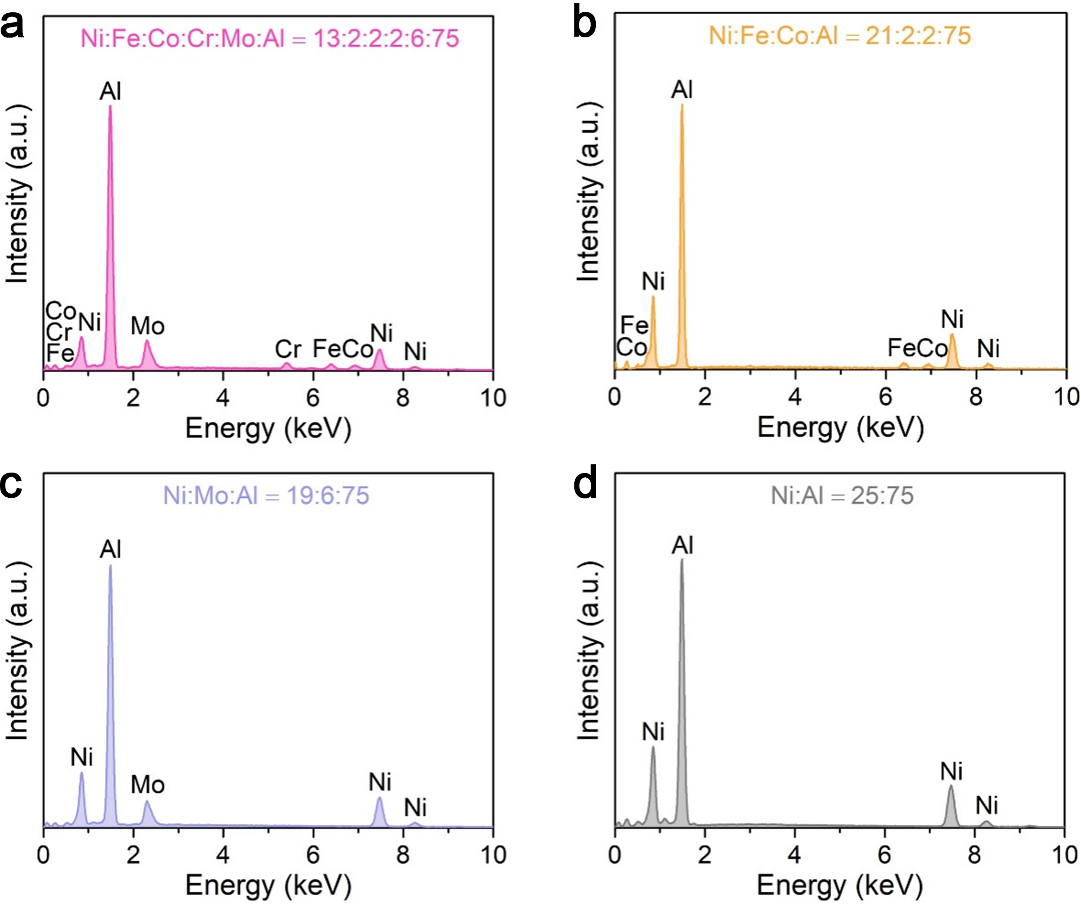
Fig. S1 EDS elemental characterizations of precursor alloys. EDS spectra of precursor Ni₁₃Fe₂Co₂Mo₆Cr₂Al₇₅ (a), Ni₂₁Fe₂Co₂Al₇₅ (b), Ni₁₉Mo₆Al₇₅ (c) and Ni₂₅Al₇₅ (d) alloys.
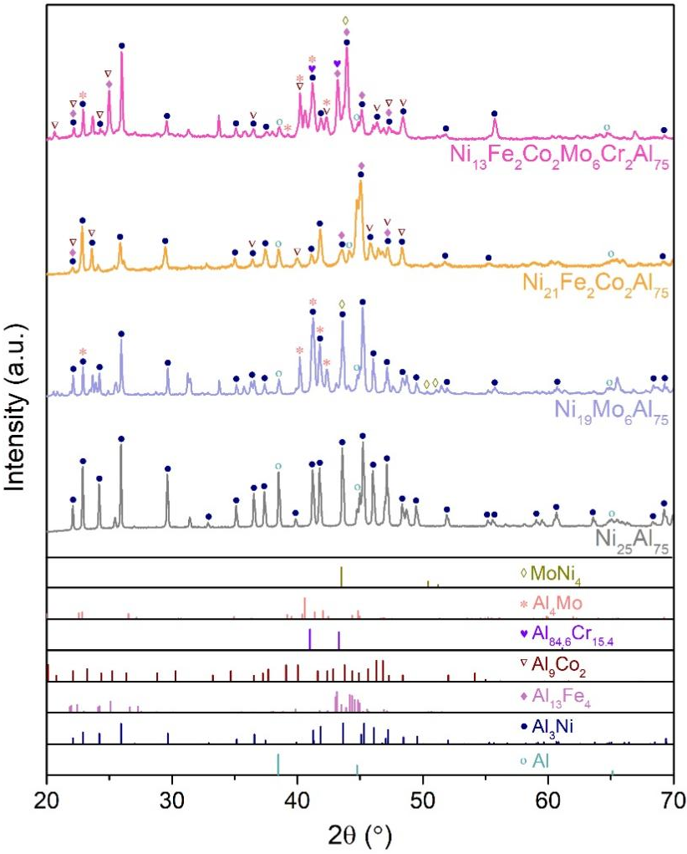
Fig. S2 XRD characterizations of precursor alloys. XRD patterns of precursor Ni₁₃Fe₂Co₂Mo₆Cr₂Al₇₅, Ni₂₁Fe₂Co₂Al₇₅, Ni₁₉Mo₆Al₇₅ and Ni₂₅Al₇₅ alloys. The line patterns show reference cards 04-0787 for α-Al (dark cyan line), 97-005-8040 for Al₃Ni (navy line), 29-0042 for Al₁₃Fe₄ (lilac line), 06-0699 for Al₉Co₂ (wine line), 48-1564 for Al_{84.6}Cr_{15.4} (purple line), 65-7072 for Al₄Mo (light red line), and 65-5480 for MoNi₄ (dark yellow line) according to JCPDS.
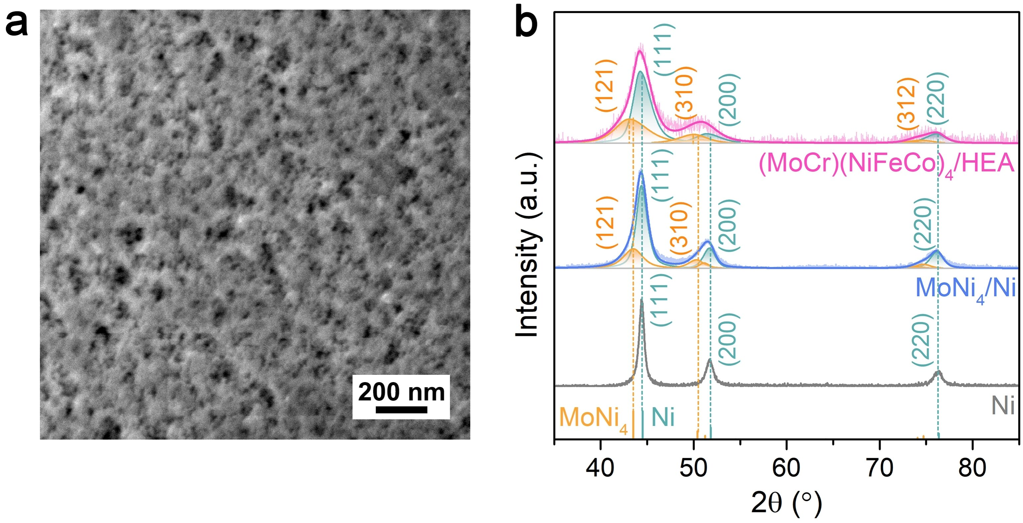
Fig. S3 (a) SEM image of nanoporous (MoCr)(NiFeCo)₄/HEA electrode, which is fabricated by chemically dealloying Ni₁₃Fe₂Co₂Cr₂Mo₆Al₇₅ precursor alloy. (b) XRD patterns of nanoporous (MoCr)(NiFeCo)₄/HEA, MoNi₄/Ni, and Ni electrodes. The line patterns show reference cards 65-5480 and 04-0850 for MoNi₄ and Ni according to JCPDS, respectively.
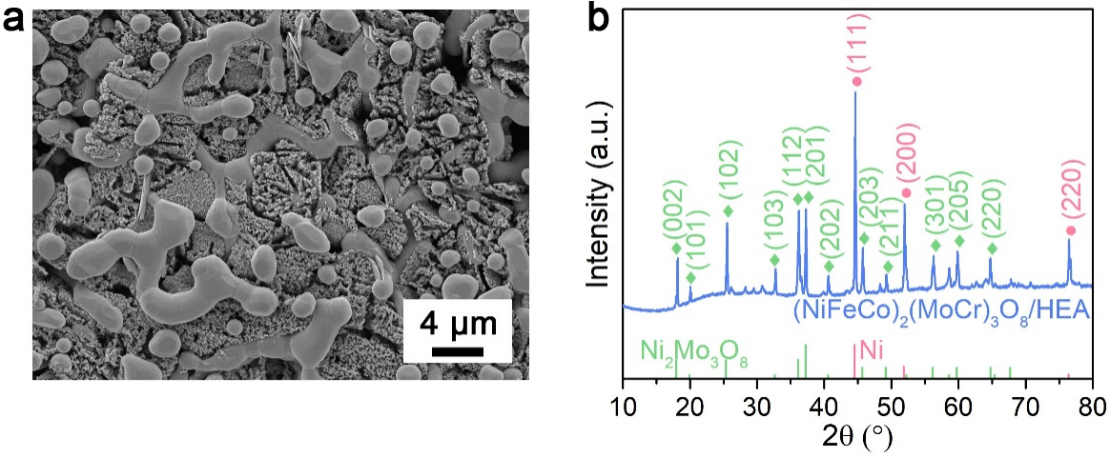

Fig. S4 (a) SEM images of nanoporous (NiFeCo)₂(MoCr)₃O₈/HEA electrode. (b) XRD pattern of (NiFeCo)₂(MoCr)₃O₈/HEA electrode. The line patterns show reference cards 37-0855 and 04-0850 for Ni₂Mo₃O₈ and Ni according to JCPDS, respectively.

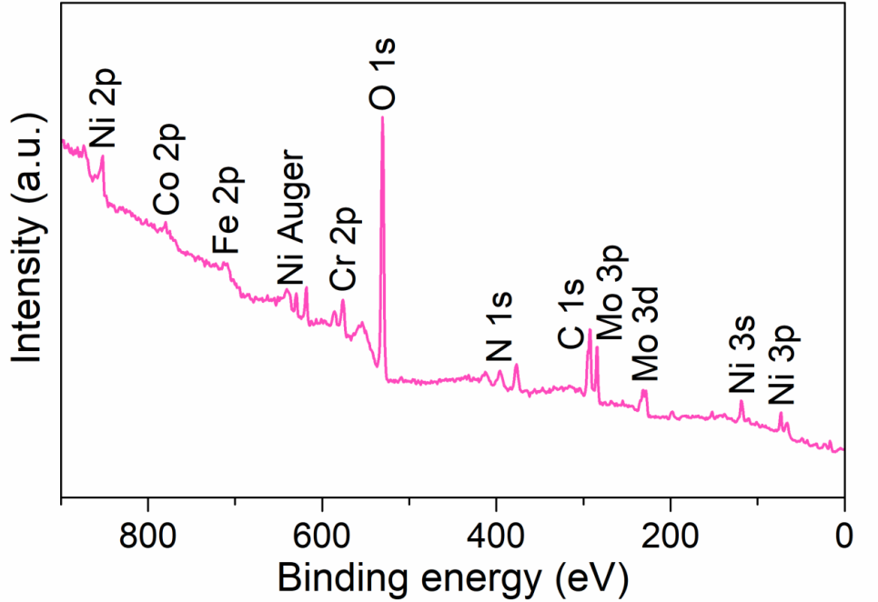
Fig. S5 XPS survey spectra of nanoporous (NiFeCo)₃(MoCr)₃N/HEA electrode.

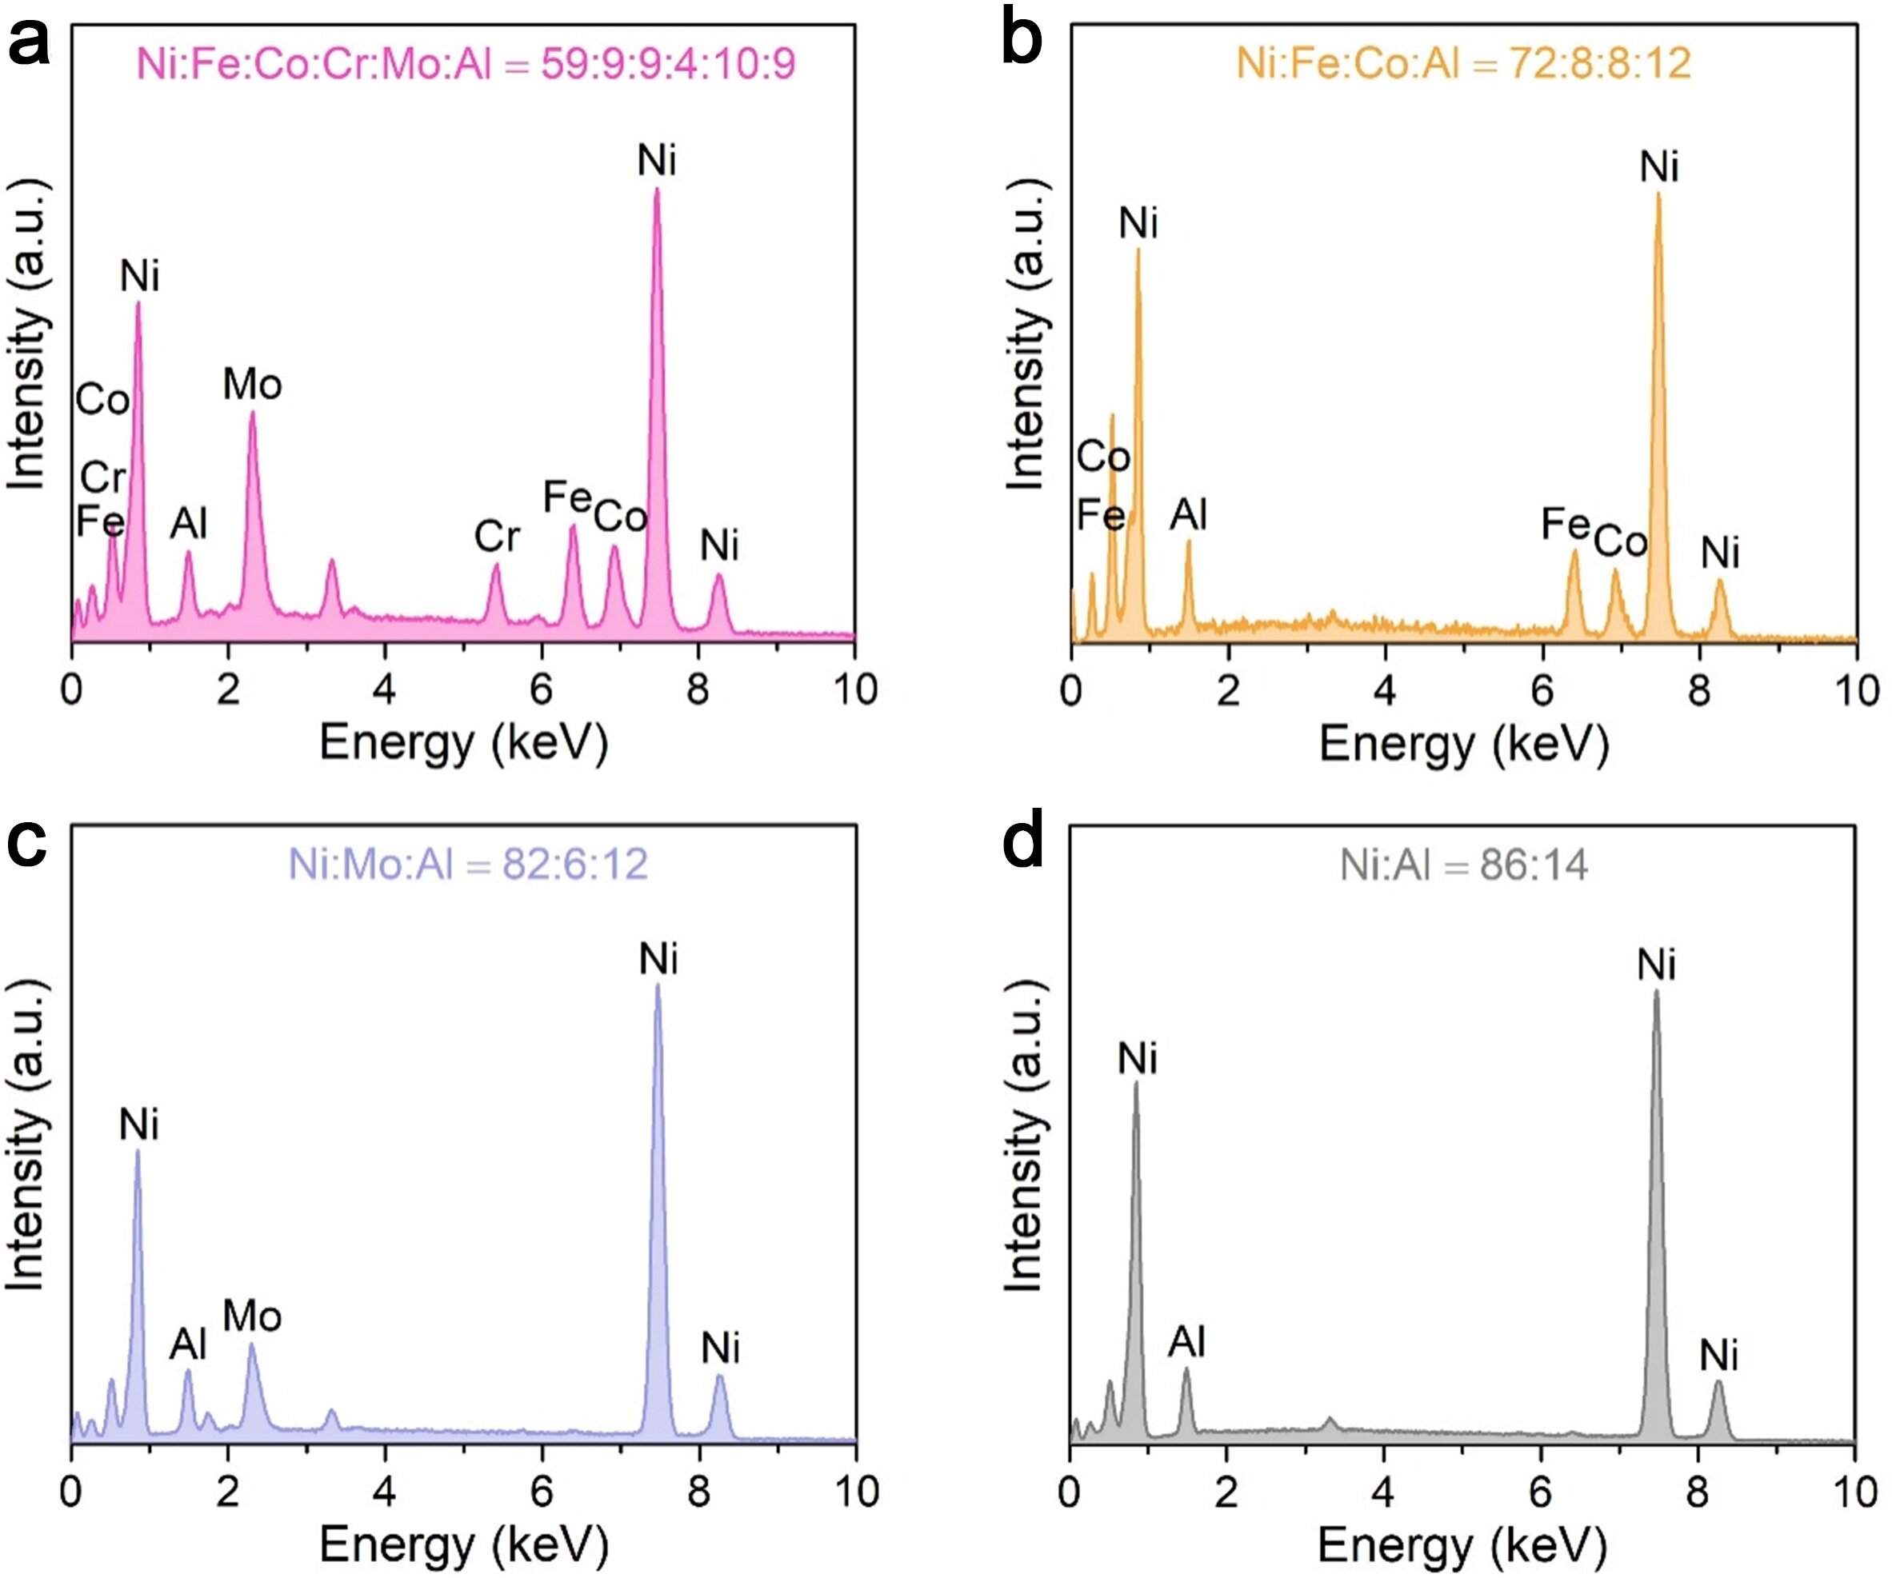
Fig. S6 EDS elemental characterizations of nanoporous hybrid electrodes. EDS spectra of nanoporous (NiFeCo)₃(MoCr)₃N/HEA (a), N-NiFeCo/NiFeCo (b), Ni₃Mo₃N/Ni (c) and N-Ni/Ni (d) electrodes.
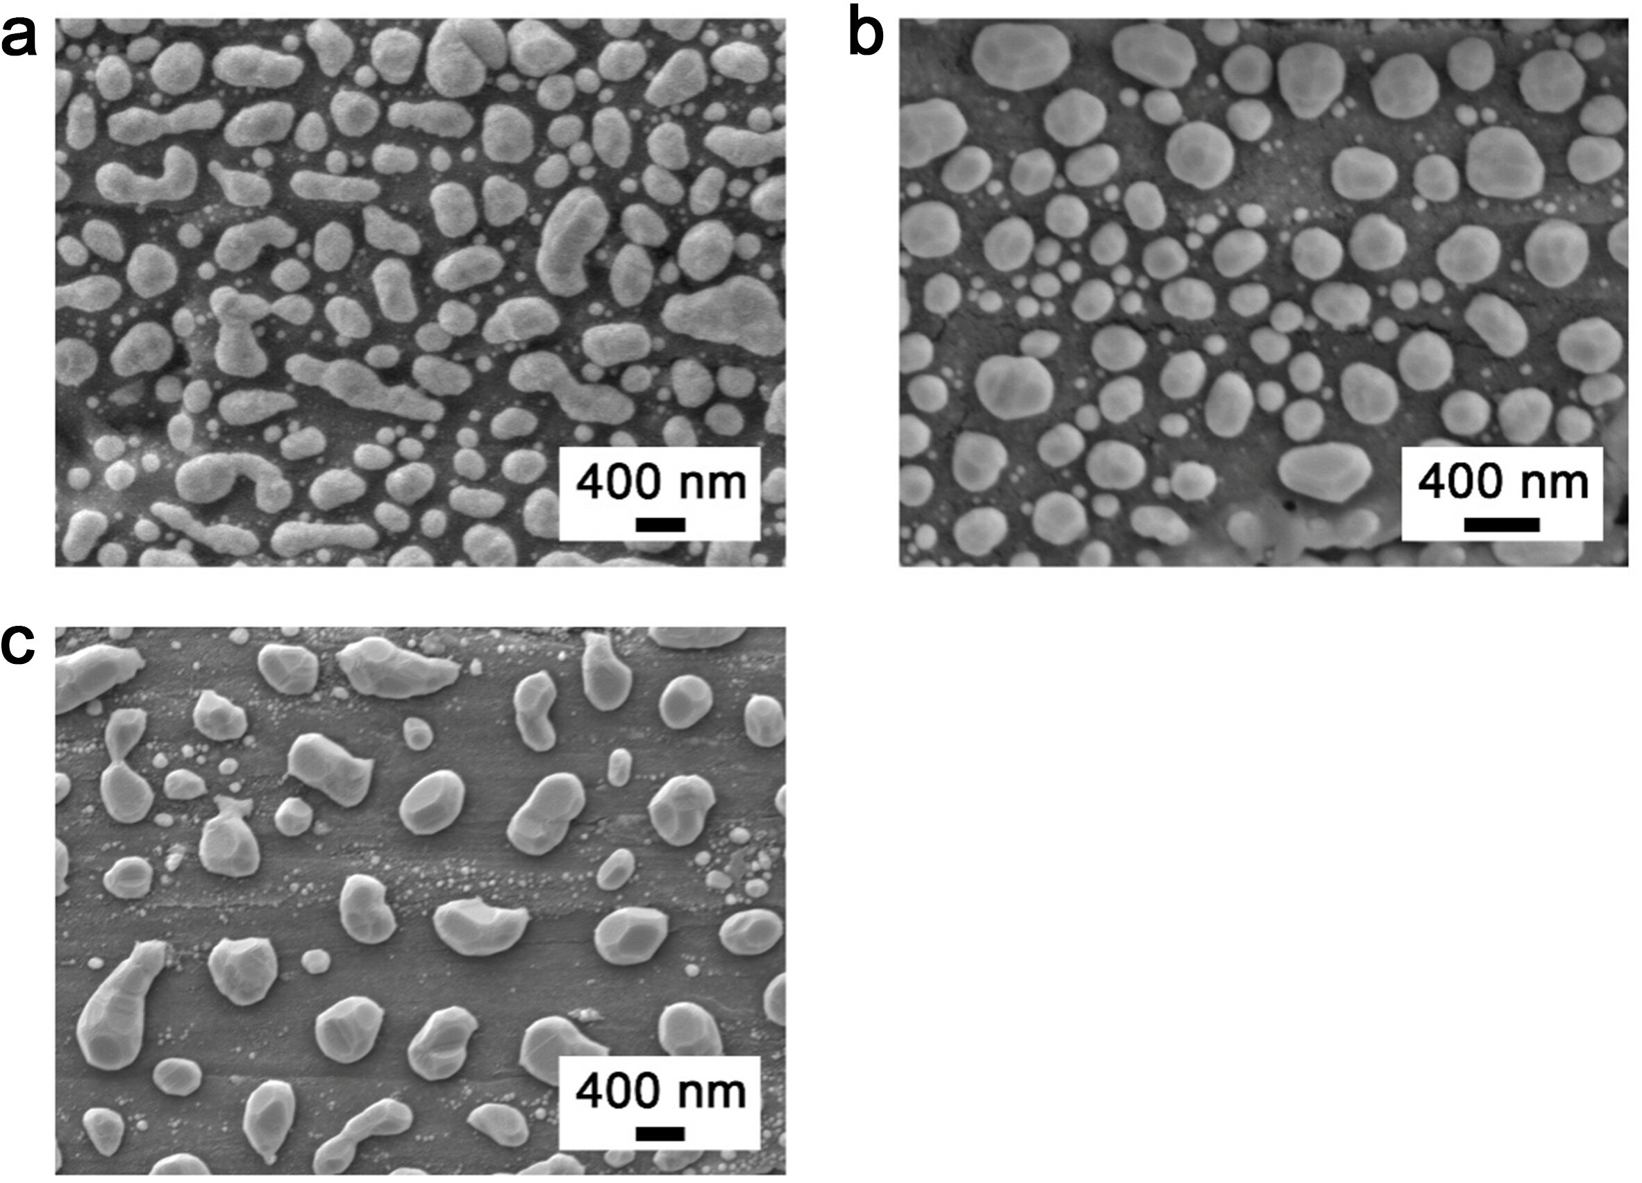
Fig. S7 Morphology characterization of electrodes. Typical SEM images of nanoporous N-NiFeCo/NiFeCo (a), Ni₃Mo₃N/Ni (b) and N-Ni/Ni (c) electrodes.
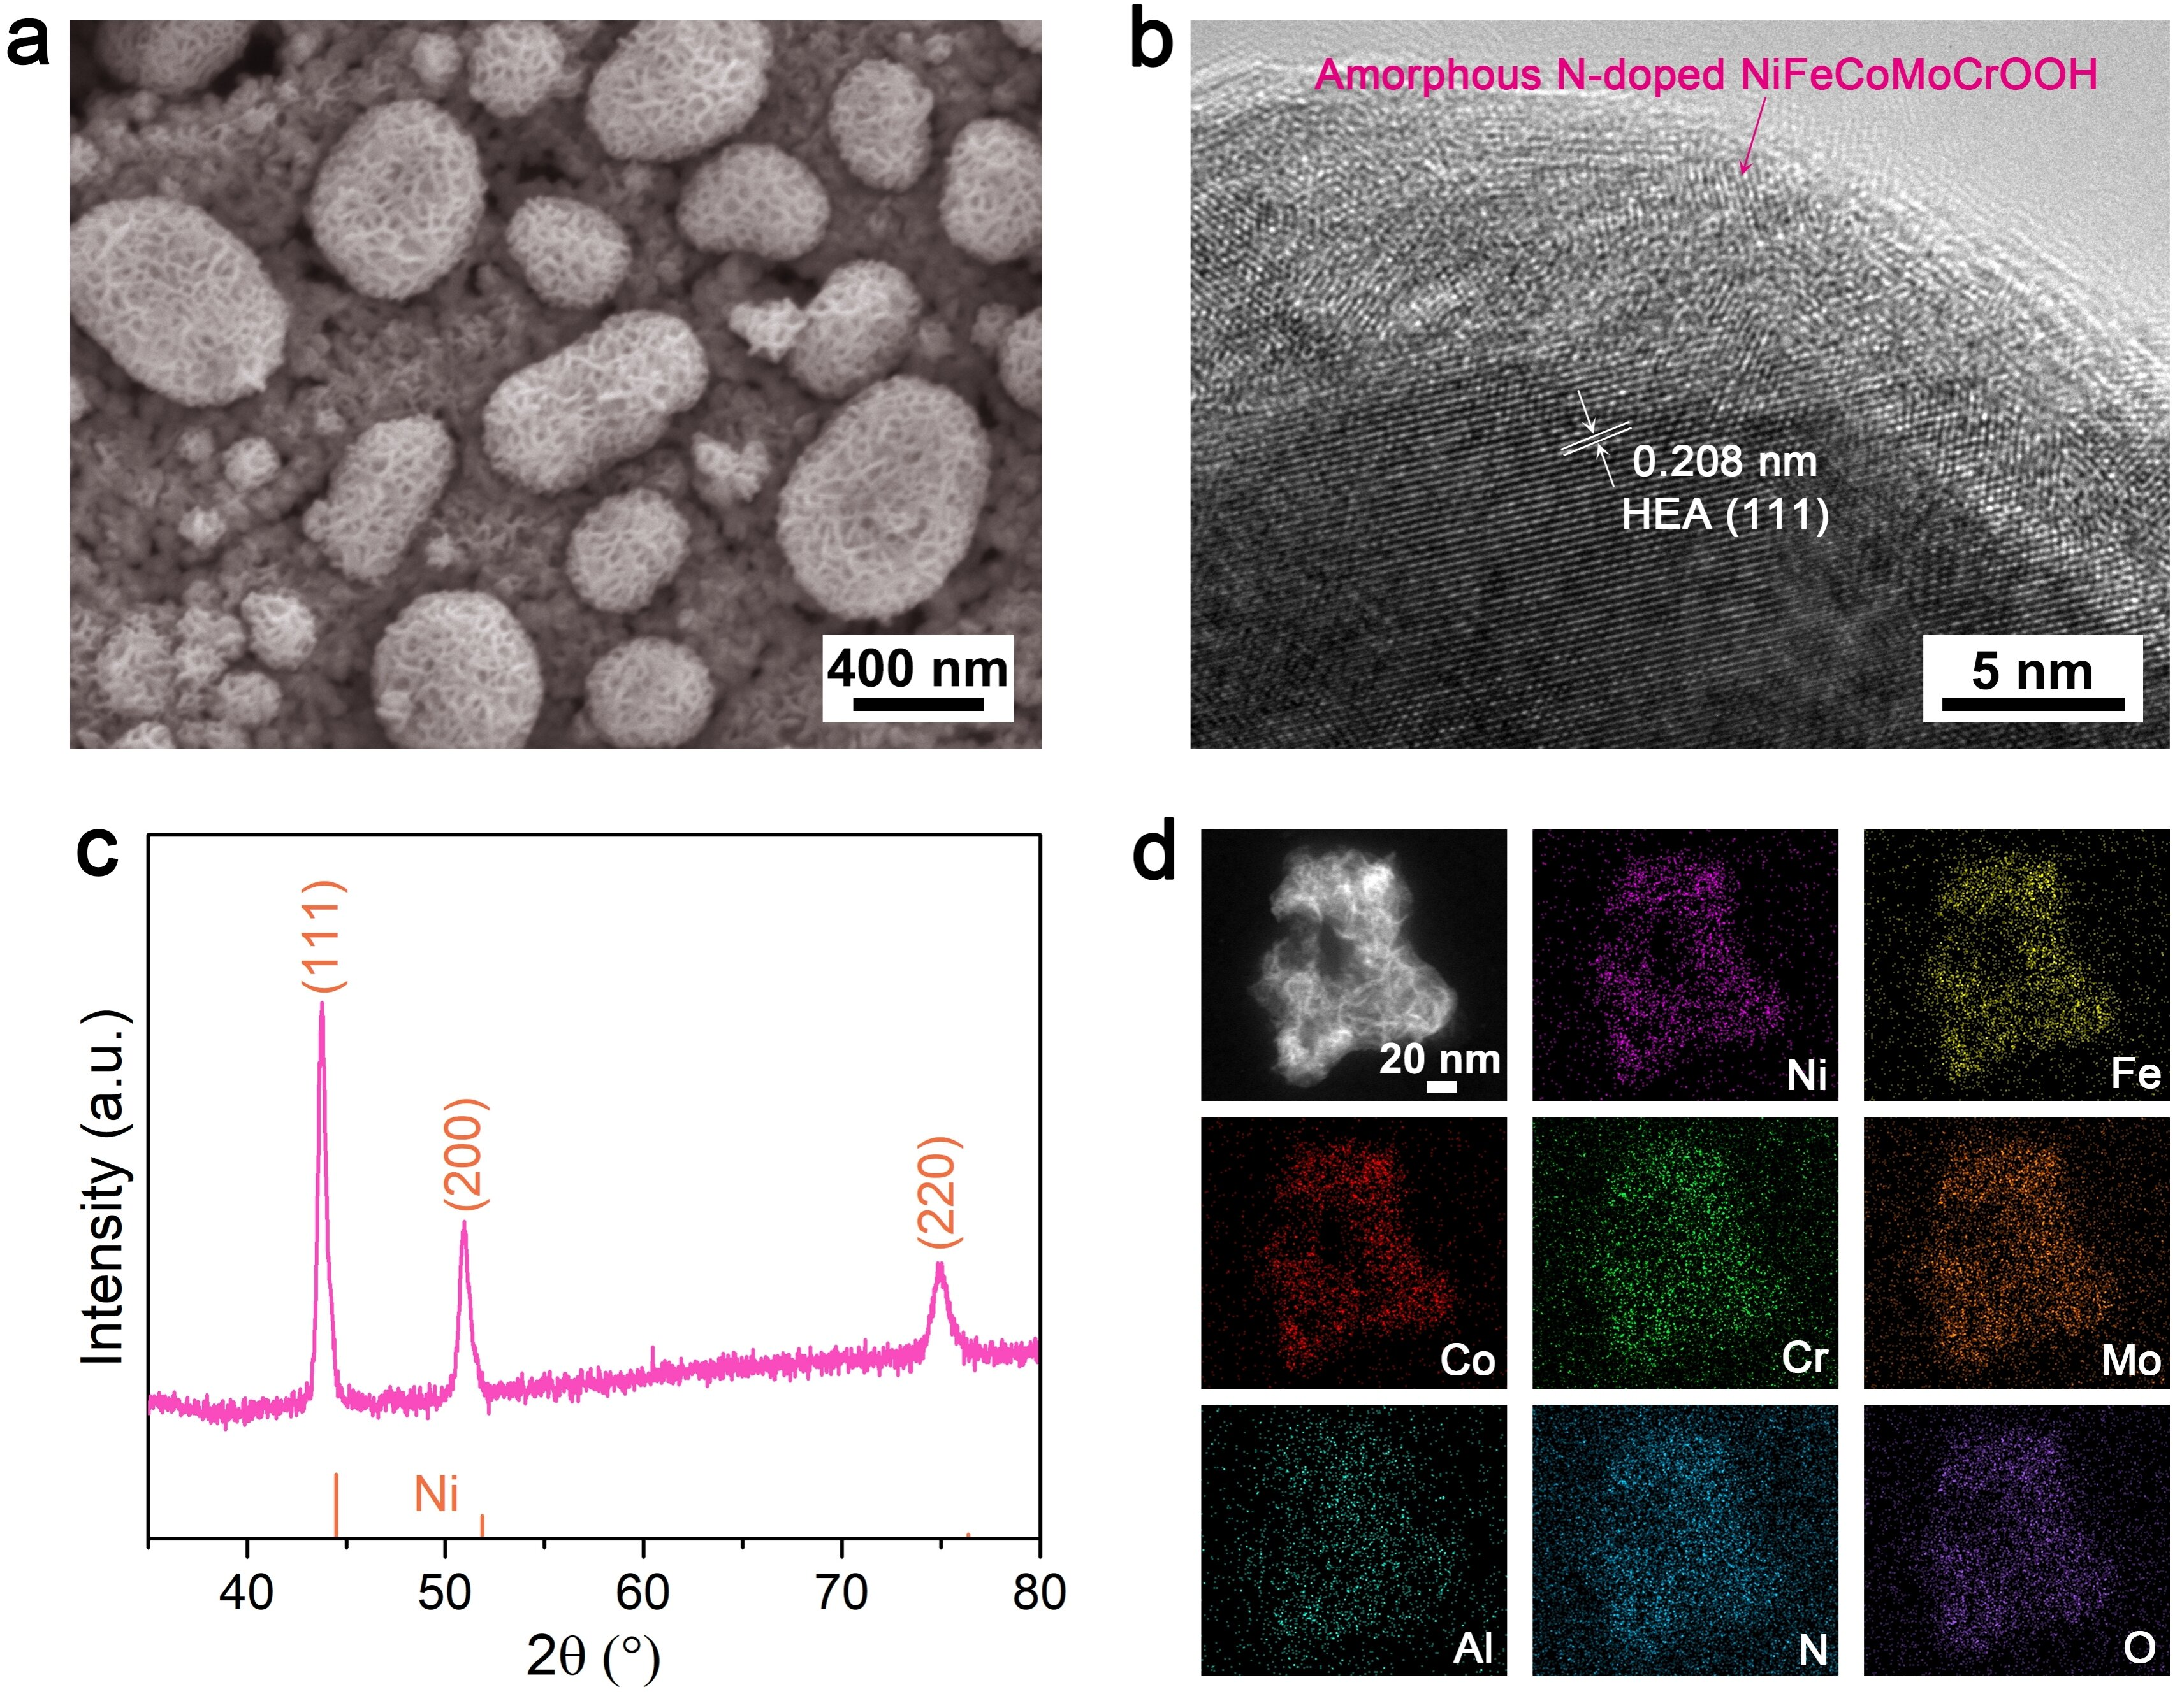
Fig. S8 SEM image (a), HRTEM image (b), XRD pattern (c), STEM and the corresponding EDS elemental mappings of Ni, Fe, Co, Cr, Mo, Al, N and O (d) for phase-reconstructed nanoporous (NiFeCo)₃(MoCr)₃N/HEA electrode, i.e., nanoporous NiFeCoMoCr.

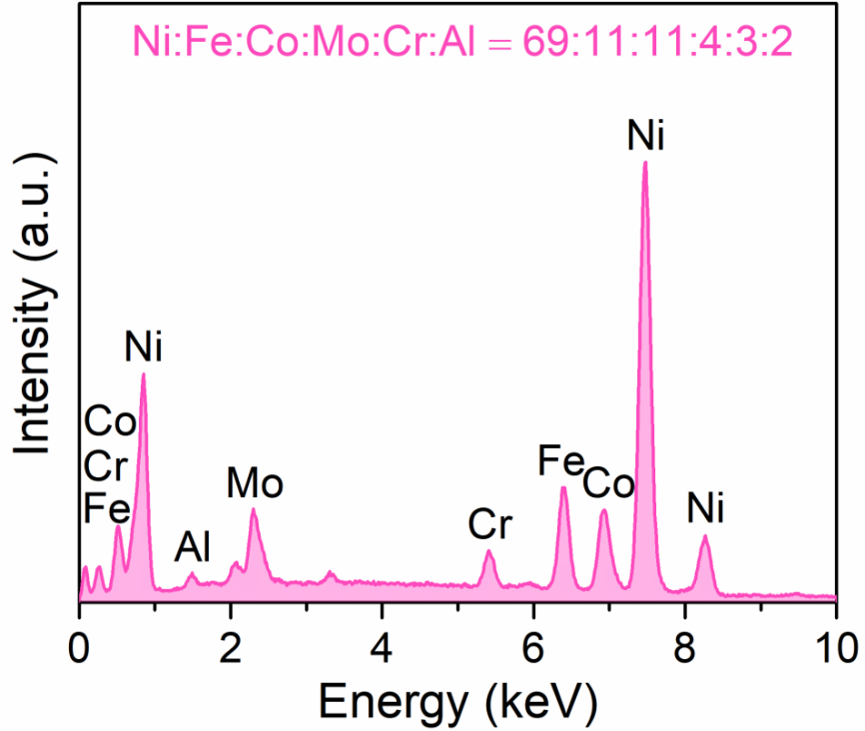
Fig. S9 EDS spectra of phase-reconstructed (NiFeCo)₃(MoCr)₃N/HEA electrode.

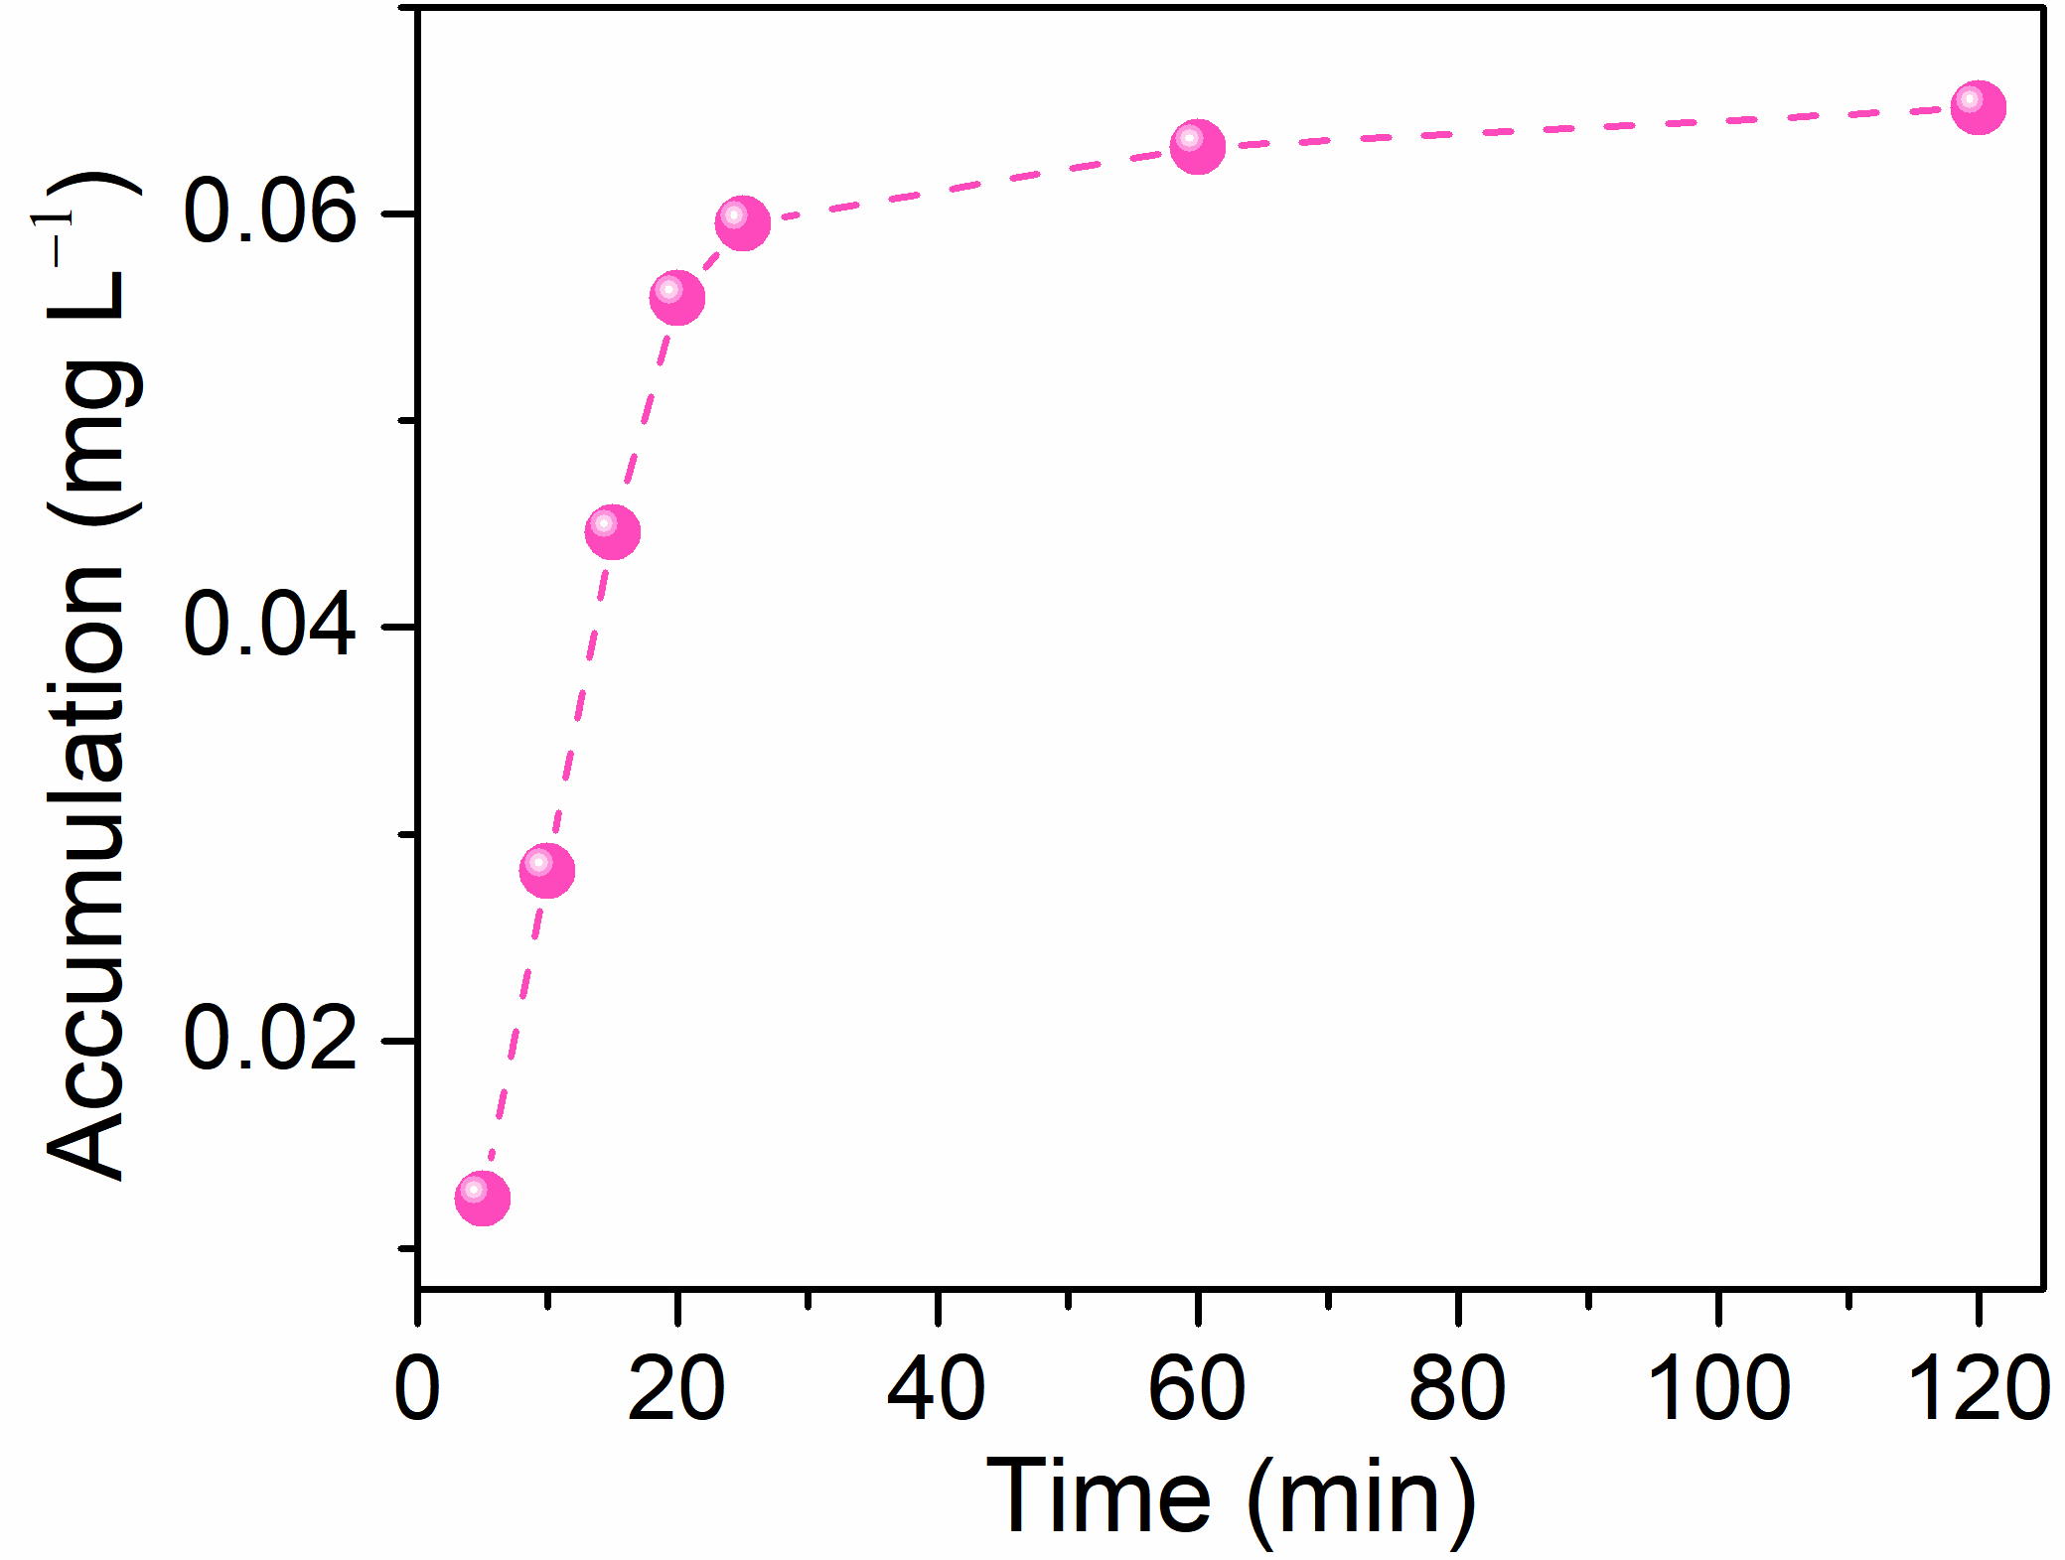
Fig. S10 The concentration of Cr ions in the KOH electrolyte as a function of OER proceeding time. Here the Cr ions result from the dissolution of Cr from nanoporous (NiFeCo)₃(MoCr)₃N/HEA electrode during the OER.
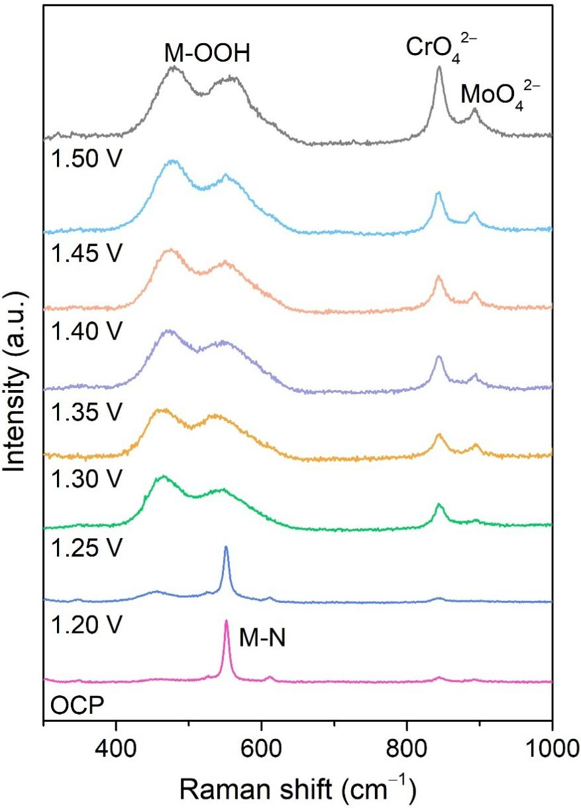
Fig. S11 In-situ Raman spectra of nanoporous (NiFeCo)₃(MoCr)₃N/HEA electrode at various applied potentials in 1 M KOH.
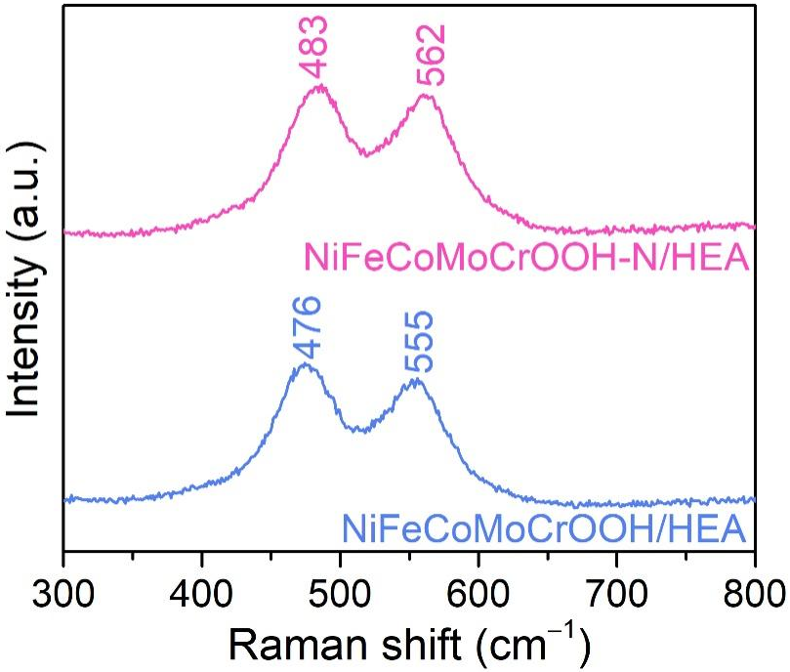
Fig. S12 Raman spectra of NiFeCoMoCrOOH-N/HEA and NiFeCoMoCrOOH/HEA.
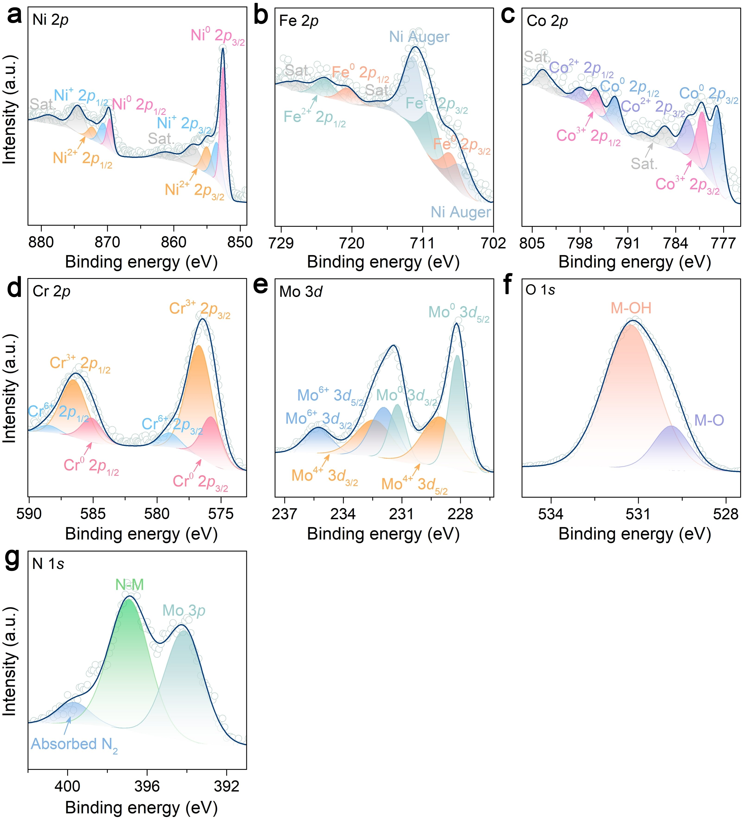
Fig. S13 High-resolution Ni 2p, Co 2p, Fe 2p, Cr 2p, O 1s, N 1s and Mo 3d XPS spectra of nanoporous (NiFeCo)₃(MoCr)₃N/HEA.

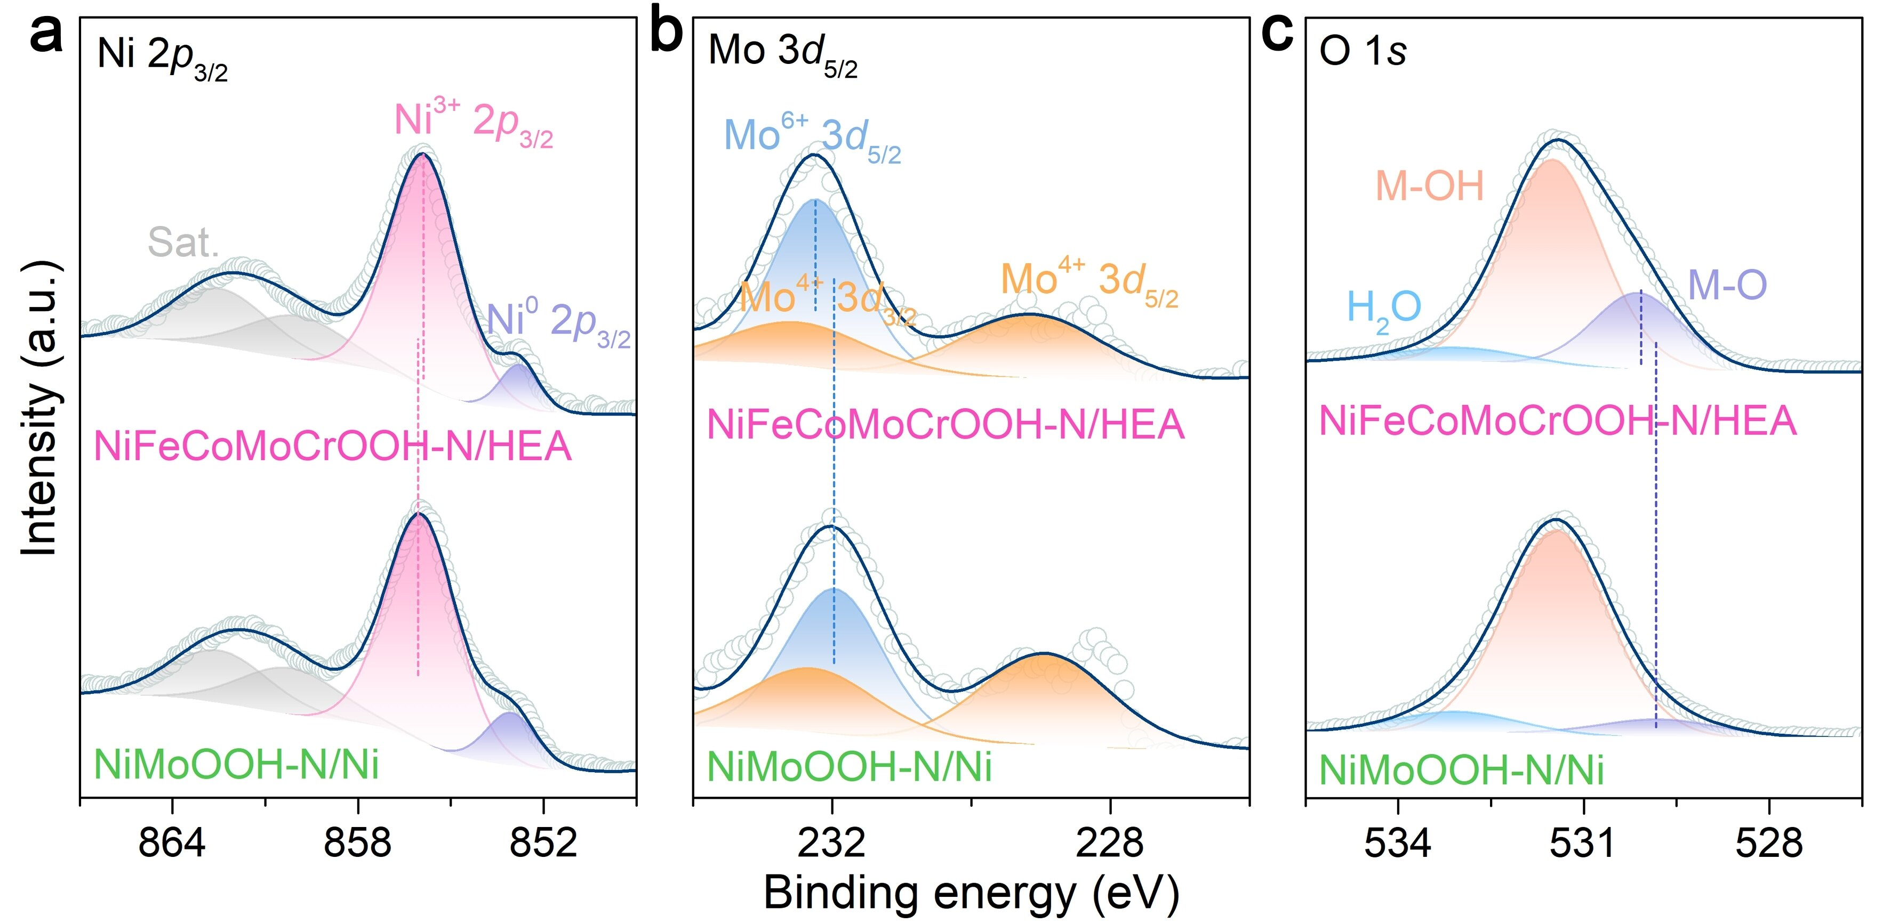
Fig. S14 Comparisons of high-resolution Ni 2p_{3/2}, Mo 3d_{5/2} and O 1s XPS spectra of NiFeCoMoCrOOH-N/HEA and NiMoOOH-N/Ni.
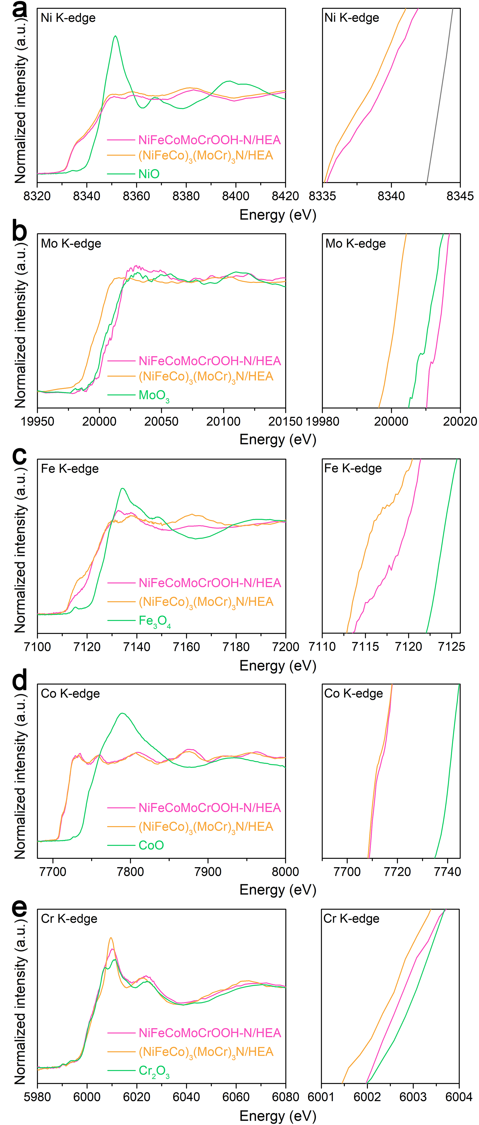
Fig. S15 (a) Ni K-edge XANES spectra of NiFeCoMoCrOOH-N/HEA, NiFeCoMoCrOOH/HEA and (NiFeCo)₃(MoCr)₃N/HEA. (b) Mo K-edge XANES spectra of NiFeCoMoCrOOH-N/HEA, NiFeCoMoCrOOH/HEA and (NiFeCo)₃(MoCr)₃N/HEA. (c) Fe K-edge XANES spectra of NiFeCoMoCrOOH-N/HEA, (NiFeCo)₃(MoCr)₃N/HEA and Fe₃O₄. (d) Co K-edge XANES spectra of NiFeCoMoCrOOH-N/HEA, (NiFeCo)₃(MoCr)₃N/HEA and CoO. (e) Cr K-edge XANES spectra of NiFeCoMoCrOOH-N/HEA, (NiFeCo)₃(MoCr)₃N/HEA and Cr₂O₃.
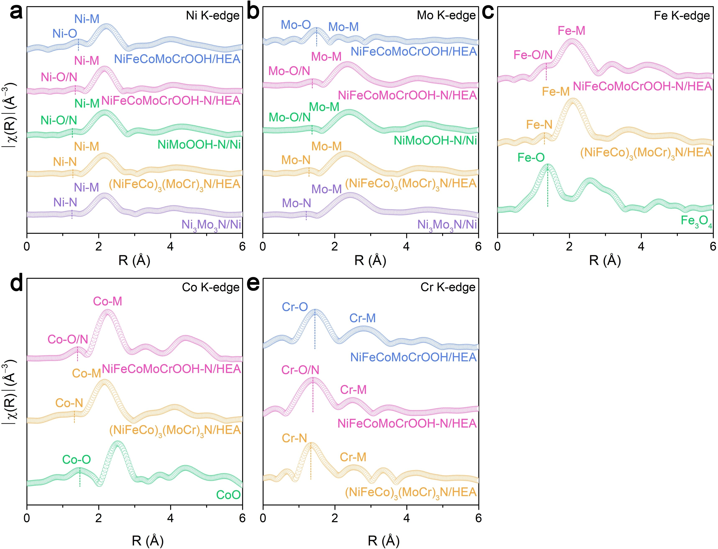
Fig. S16 (a-b) Fourier-transformed R-space Ni K-edge (a) and Mo K-edge (b) EXAFS spectra of nanoporous (NiFeCo)₃(MoCr)₃N/HEA, (NiFeCo)₂(MoCr)₃O₈/HEA, Ni₃Mo₃N/Ni after phase reconstruction, comparing with the pristine (NiFeCo)₃(MoCr)₃N/HEA and Ni₃Mo₃N/Ni electrodes. (c) Fourier-transformed R-space Fe K-edge EXAFS spectra of NiFeCoMoCrOOH-N/HEA, (NiFeCo)₃(MoCr)₃N/HEA and Fe₃O₄. (d) Fourier-transformed R-space Co K-edge EXAFS spectra of NiFeCoMoCrOOH-N/HEA, (NiFeCo)₃(MoCr)₃N/HEA and CoO. (e) Fourier-transformed R-space Cr K-edge EXAFS spectra of nanoporous (NiFeCo)₃(MoCr)₃N/HEA and (NiFeCo)₂(MoCr)₃O₈/HEA after phase reconstruction, comparing with the pristine (NiFeCo)₃(MoCr)₃N/HEA electrode.
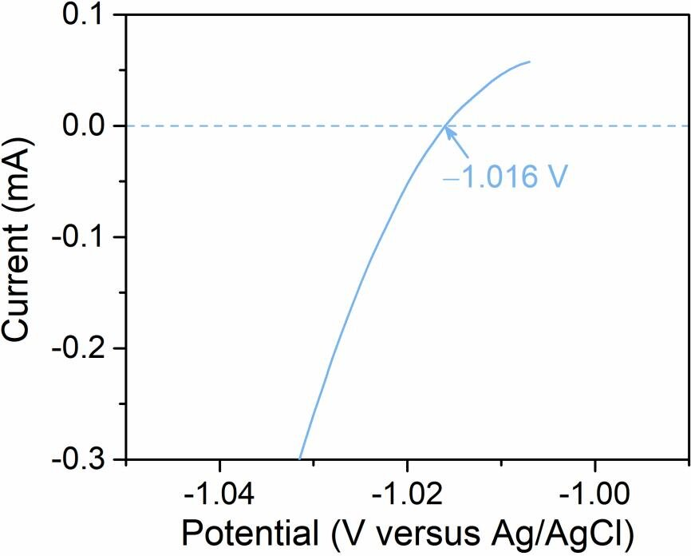
Fig. S17 Current-potential curve of Pt wire used as the working electrode in H₂-saturated 1 M KOH electrolyte with the scan rate of 1 mV s⁻¹ to calibrate the Ag/AgCl electrode with respect to RHE. E_{RHE} = E_{Ag/AgCl} + 1.016 V.
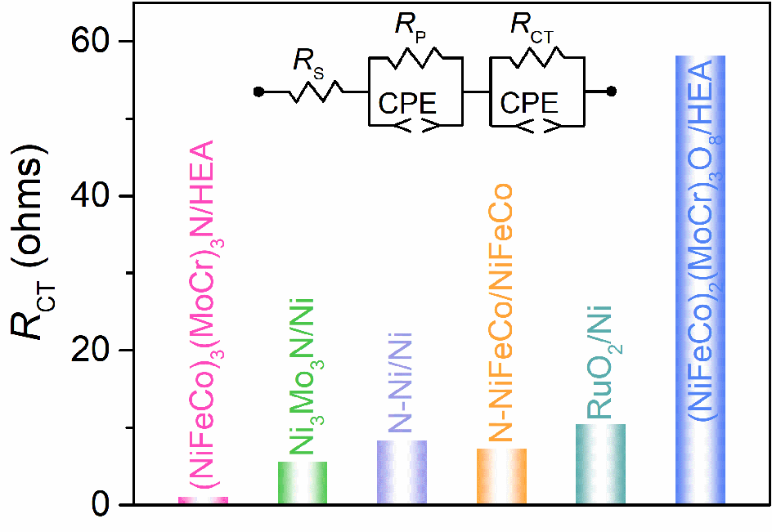
Fig. S18 Comparison of charge transfer resistance (R_{CT}) for nanoporous (NiFeCo)₃(MoCr)₃N/HEA, Ni₃Mo₃N/Ni, N-NiFeCo/NiFeCo, N-Ni/Ni, RuO₂/Ni and (NiFeCo)₂(MoCr)₃O₈/HEA electrodes according to EIS analysis for OER.
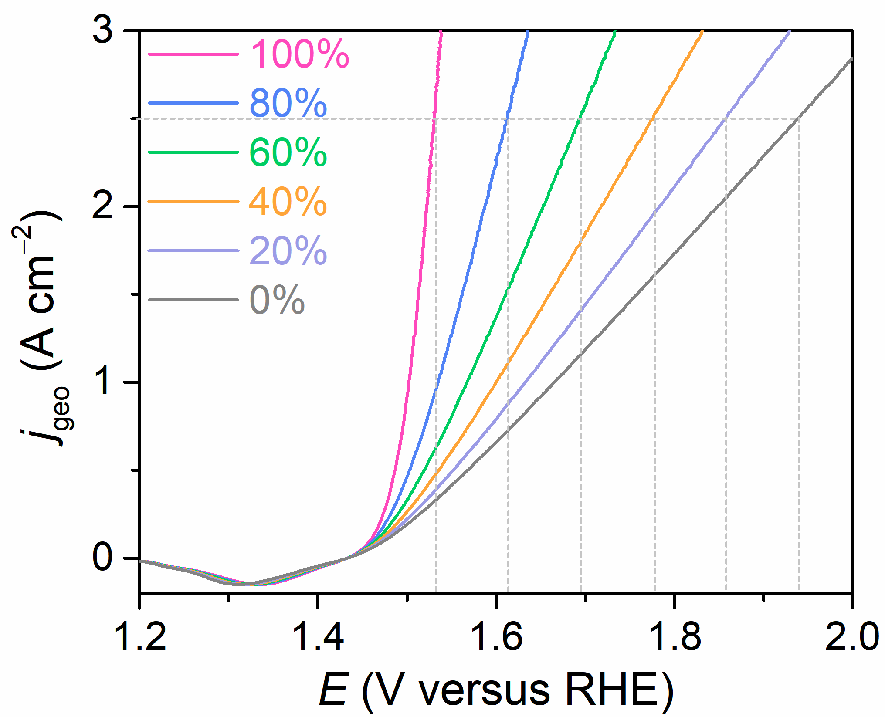
Fig. S19 OER polarization curves of nanoporous (NiFeCo)₃(MoCr)₃N/HEA electrodes with 0% to 100% iR compensation in 1 M KOH electrolyte. Scan rate: 1 mV s⁻¹.
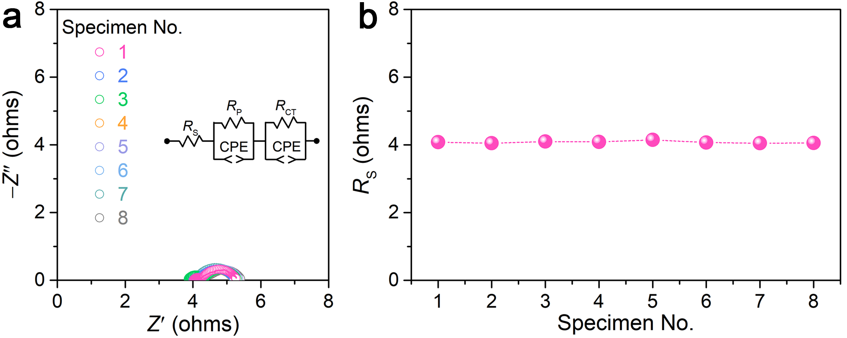
Fig. S20 (a) EIS spectra for eight nanoporous (NiFeCo)₃(MoCr)₃N/HEA electrodes, which are prepared by the same alloying/dealloying and annealing procedures. (b) Series resistance (R_{S}) of eight nanoporous (NiFeCo)₃(MoCr)₃N/HEA electrodes.

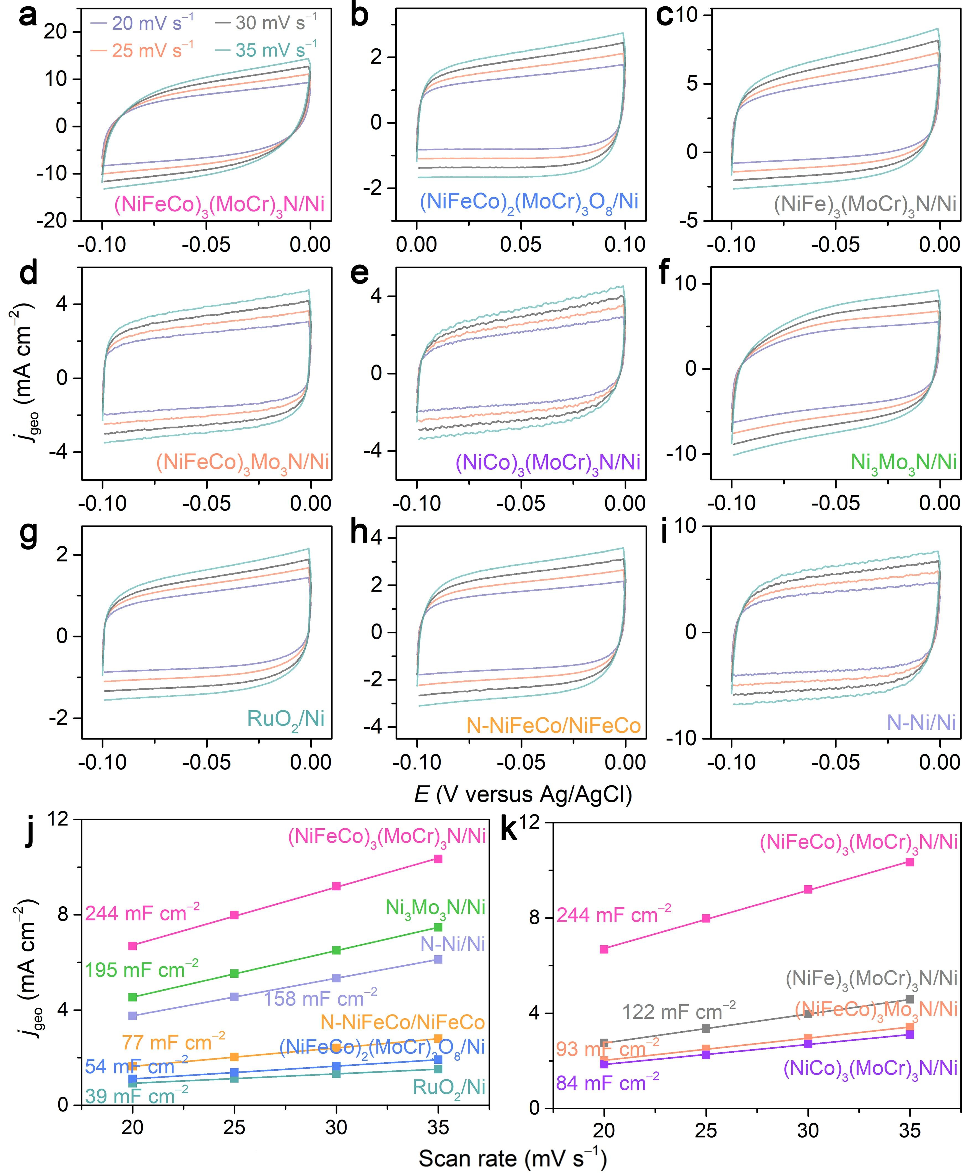
Fig. S21 Electrochemical double-layer capacitance measurements. (a-i) CV curves in the potential windows ranging from −0.85 V to −0.00 V (vs. Ag/AgCl) for reconstructed (NiFeCo)₃(MoCr)₃N/HEA (a), (NiFeCo)₂(MoCr)₃O₈/HEA (b), (NiFe)₃(MoCr)₃N/HEA (c), (NiFeCo)₃Mo₃N/HEA (d), (NiCo)₃(MoCr)₃N/HEA (e), Ni₃Mo₃N/Ni (f), RuO₂/Ni (g), N-NiFeCo/NiFeCo (h), N-Ni/Ni (i) electrodes at different scan rates in 1 M KOH. (j, k) Double-layer capacitances (C_{dl}) calculated by the differences of current densities at −0.05 V (vs. Ag/AgCl) for the investigated electrodes as a linear function of scan rates.

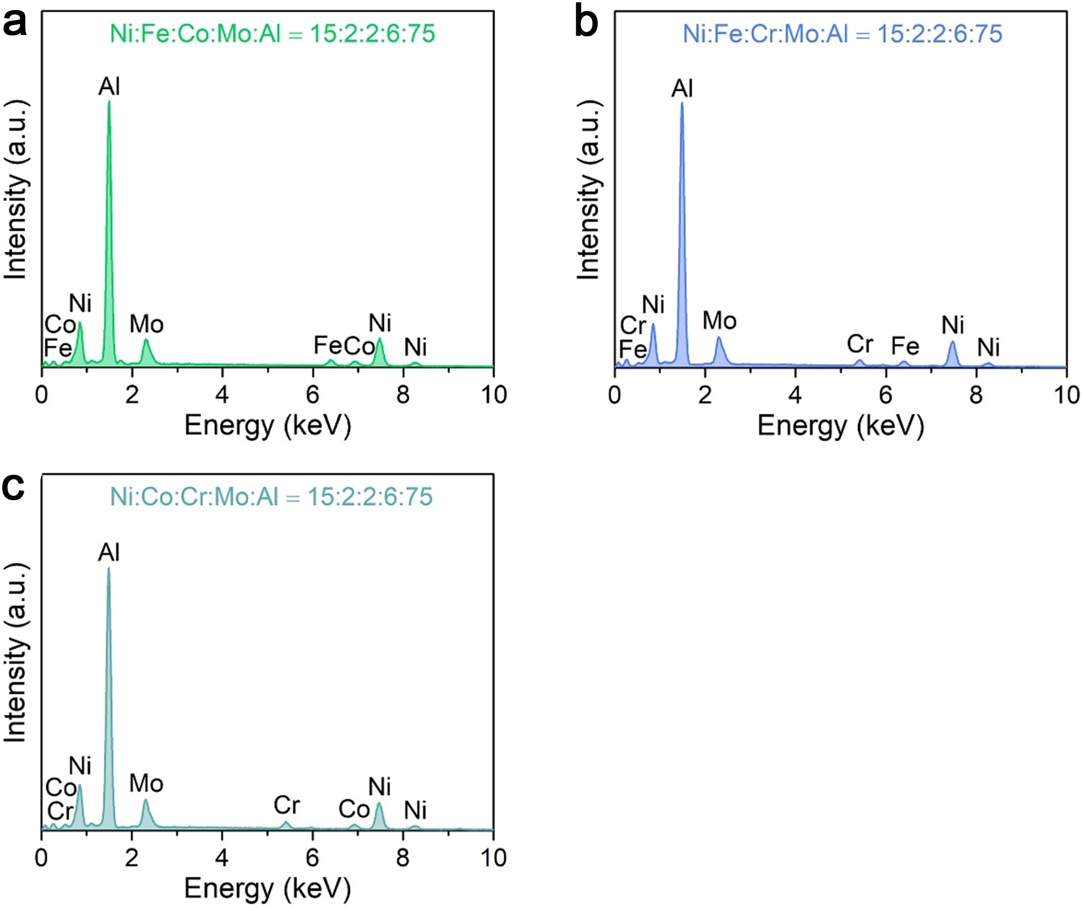
Fig. S22 EDS elemental characterizations of precursor alloys. EDS spectra of precursor Ni₁₅Fe₂Co₂Mo₆Al₇₅ (a), Ni₁₅Fe₂Cr₂Mo₆Al₇₅ (b) and Ni₁₉Co₂Cr₂Mo₆Al₇₅ (c) alloys.
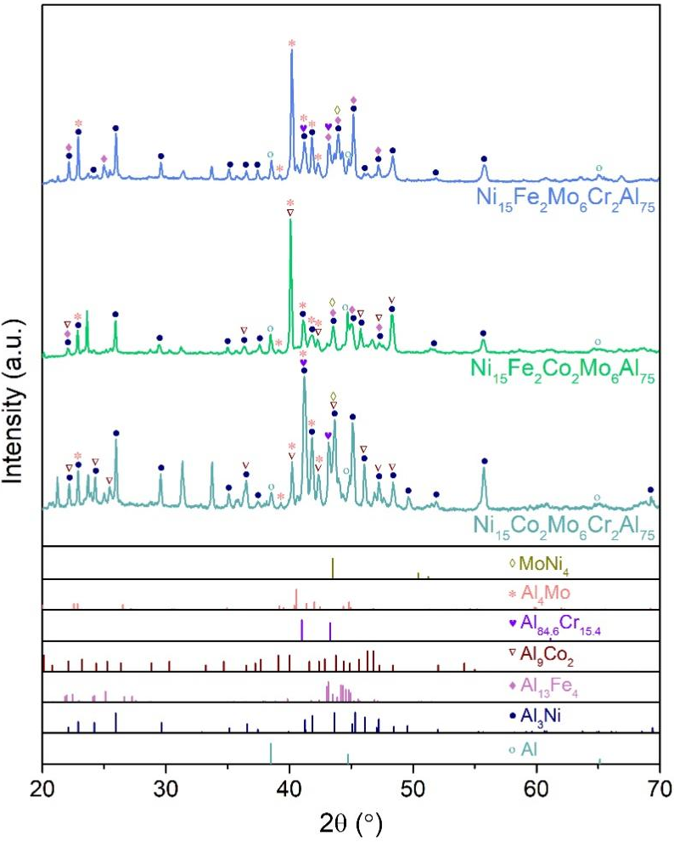
Fig. S23 XRD characterizations of precursor alloys. XRD patterns of precursor Ni₁₅Fe₂Mo₆Cr₂Al₇₅, Ni₁₅Fe₂Co₂Mo₆Al₇₅ and Ni₁₅Co₂Mo₆Cr₂Al₇₅. The line patterns show reference cards 04-0787 for α-Al (dark cyan line), 97-005-8040 for Al₃Ni (navy line), 29-0042 for Al₁₃Fe₄ (lilac line), 06-0699 for Al₉Co₂ (wine line), 48-1564 for Al_{84.6}Cr_{15.4} (purple line), 65-7072 for Al₄Mo (light red line), and 65-5480 for MoNi₄ (dark yellow line) according to JCPDS.
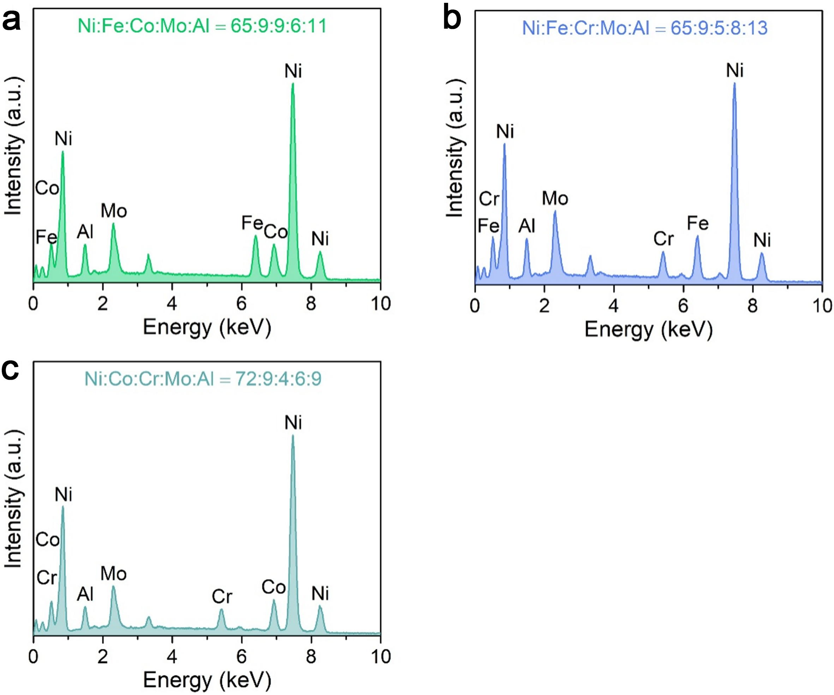
Fig. S24 EDS elemental characterizations of nanoporous hybrid electrodes. EDS spectra of nanoporous (NiFeCo)₃Mo₃N/HEA (a), (NiFe)₃(MoCr)₃N/HEA (b) and (NiCo)₃(MoCr)₃N/HEA (c) electrodes.
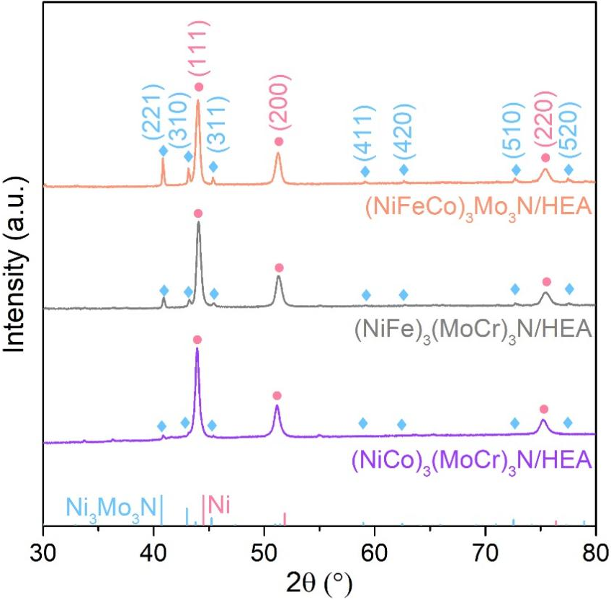
Fig. S25 XRD patterns of (NiFeCo)₃Mo₃N/HEA, (NiFe)₃(MoCr)₃N/HEA and (NiCo)₃(MoCr)₃N/HEA electrodes. The line patterns show reference cards 49-1336 and 04-0850 for Ni₃Mo₃N and Ni according to JCPDS, respectively.
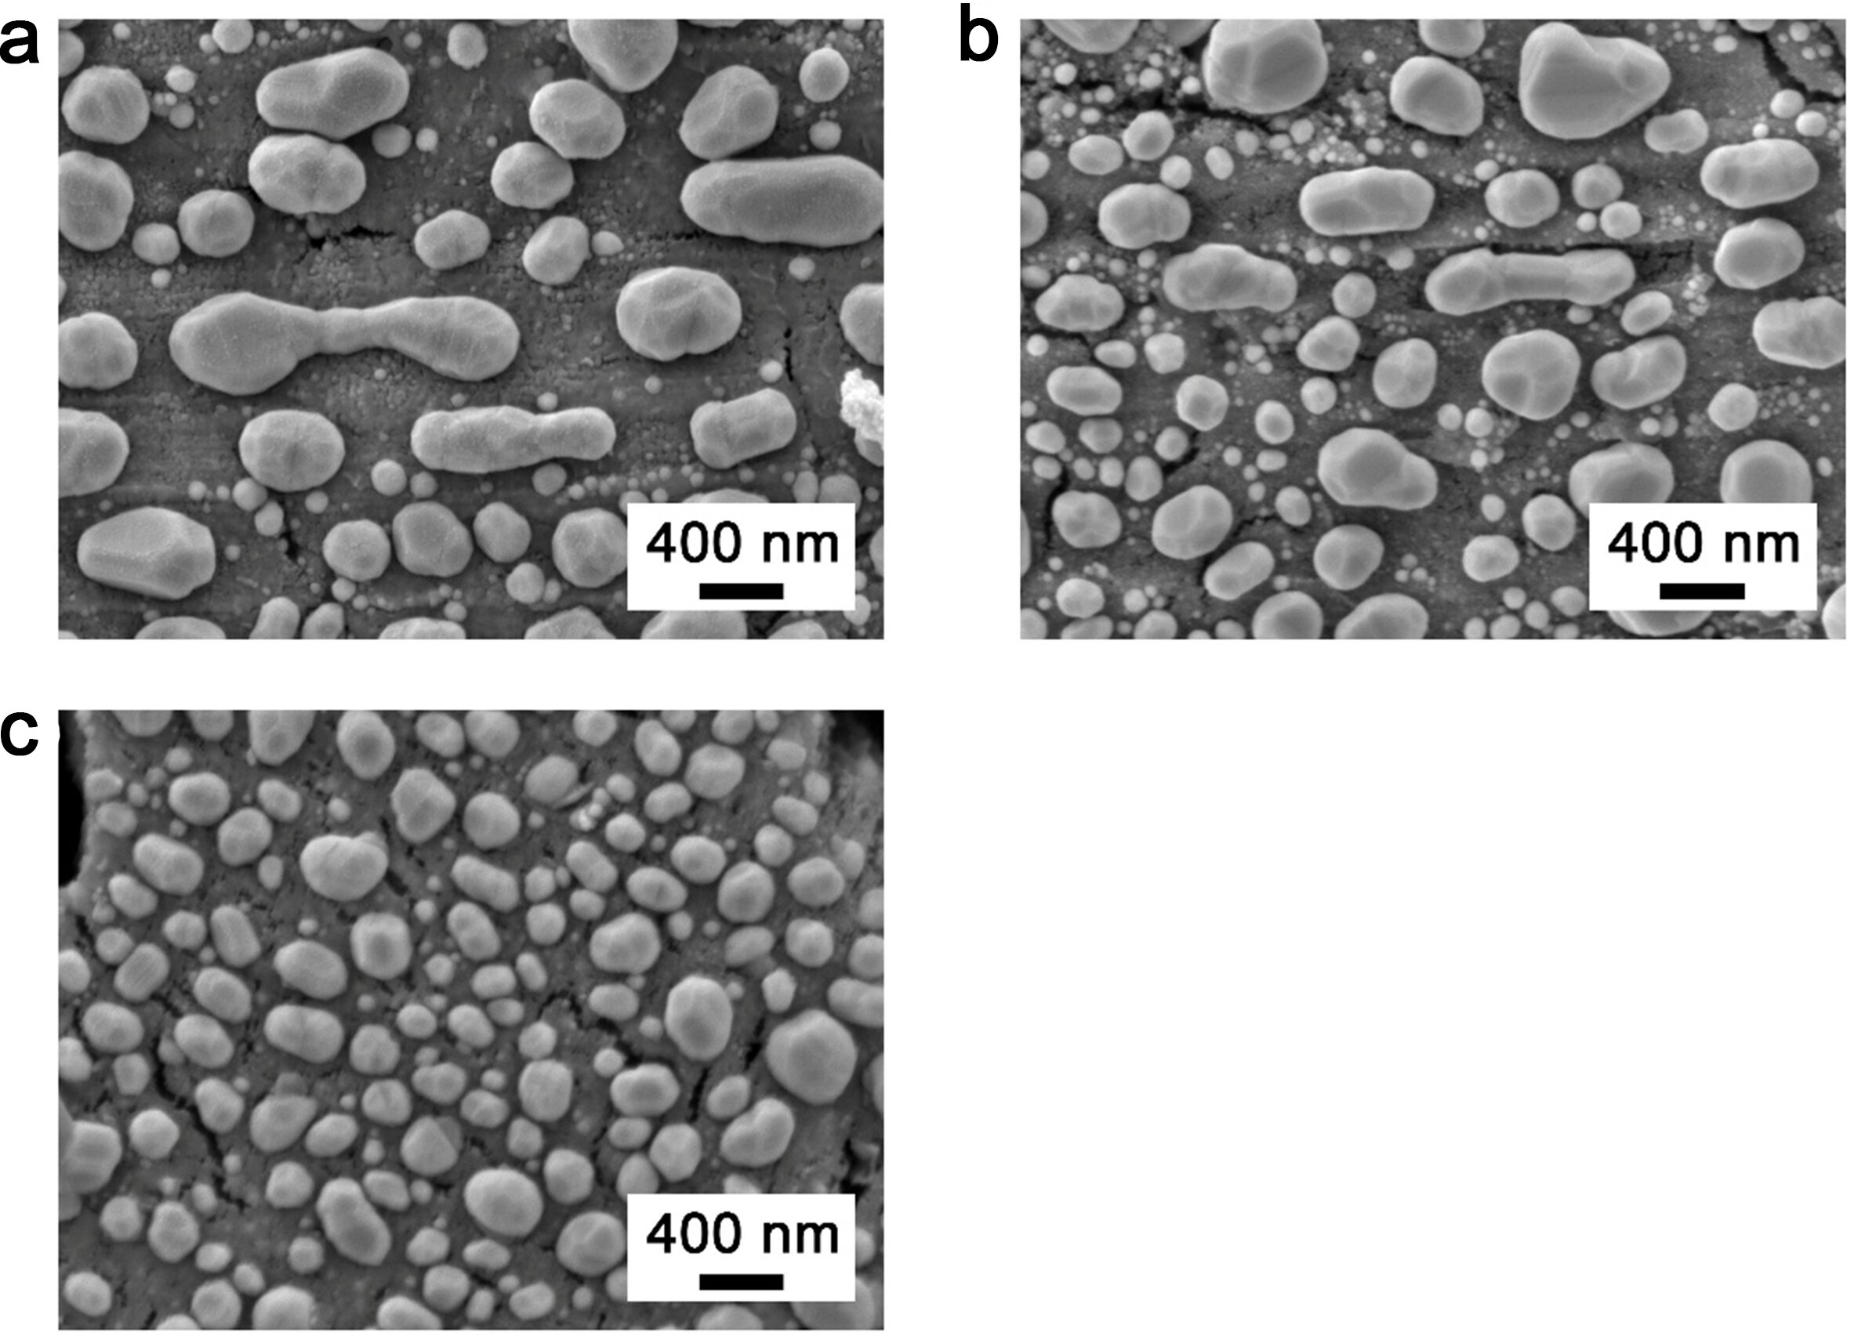
Fig. S26 Morphology characterization of electrodes. Typical SEM images of (NiFe)₃(MoCr)₃N/HEA (a), (NiFeCo)₃Mo₃N/HEA (b) and (NiCo)₃(MoCr)₃N/HEA (c) electrodes.

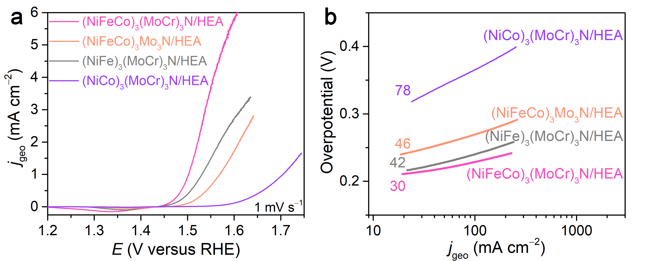
Fig. S27 (a) OER polarization curves of nanoporous (NiFeCo)₃(MoCr)₃N/HEA, (NiFeCo)₃Mo₃N/HEA, (NiFe)₃(MoCr)₃N/HEA and (NiCo)₃(MoCr)₃N/HEA electrodes in 1 M KOH electrolyte. Scan rate: 1 mV s⁻¹. (b) Tafel slopes for different electrodes according to the OER polarization curves in panel (a).

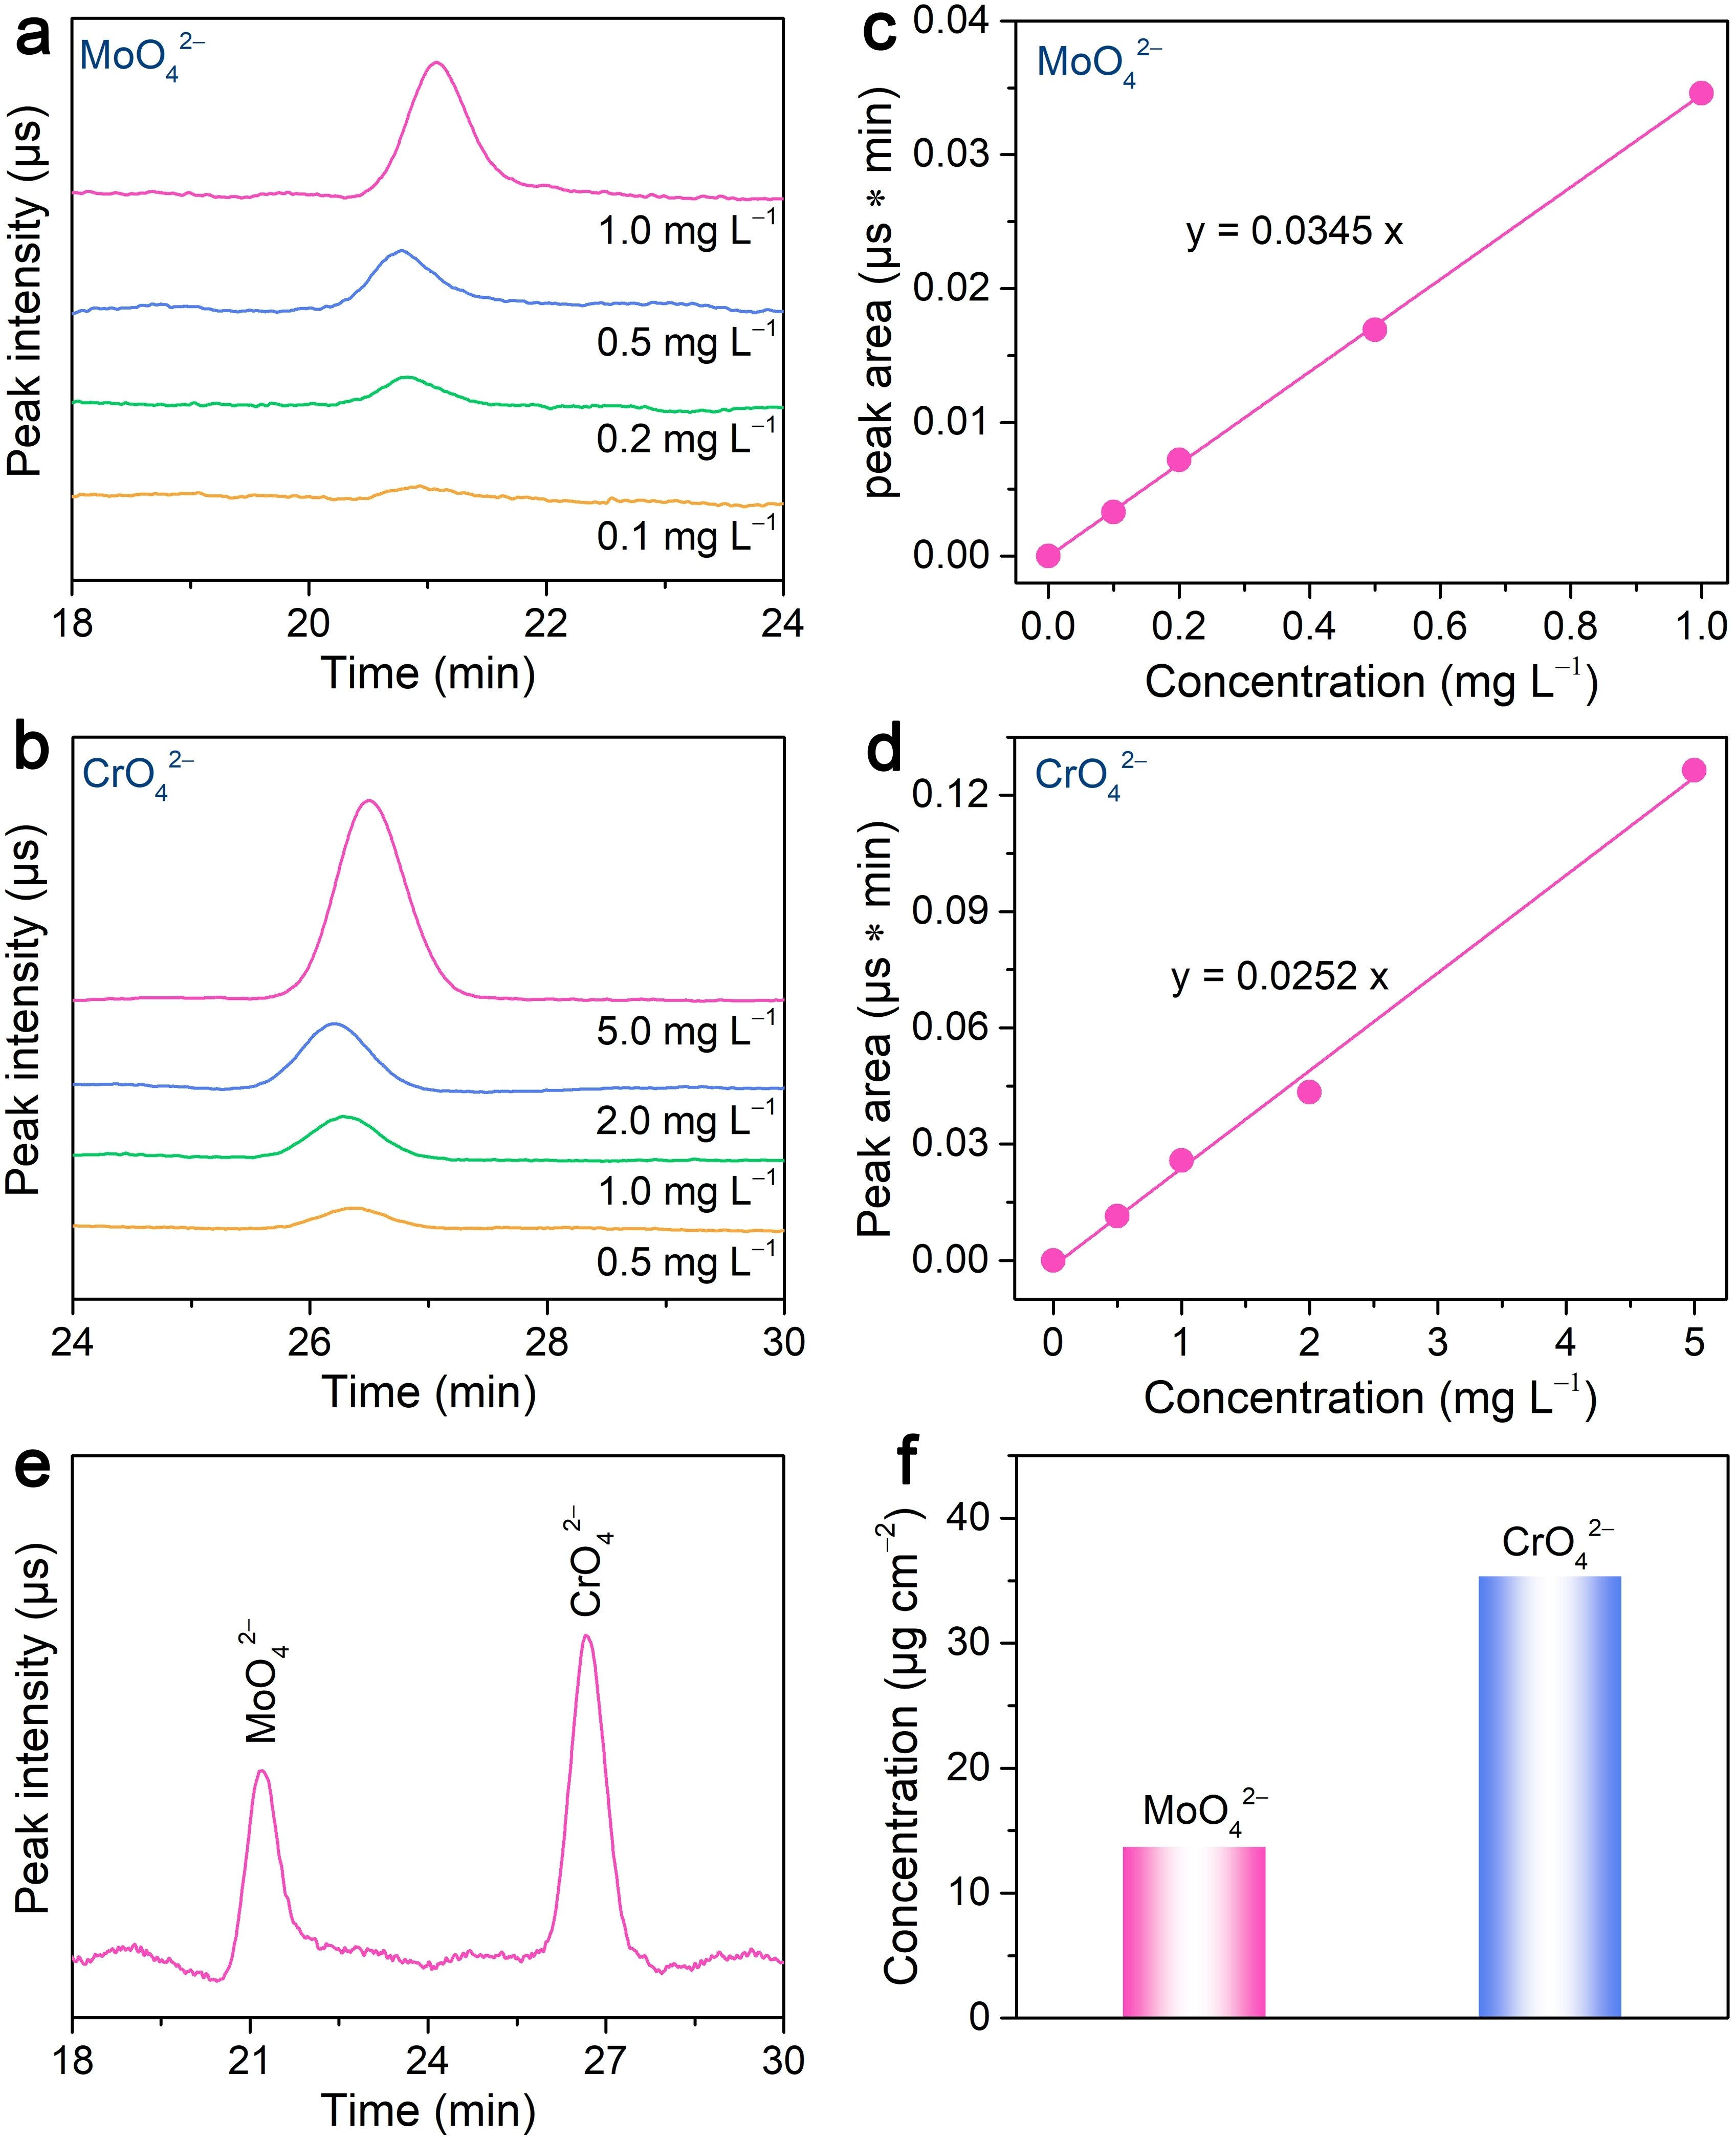
Fig. S28 (a, b) Ion Chromatograph (IC) of various concentrations of MoO₄^{2–} (a) and CrO₄^{2–} (b). (c, d) Calibration curves for MoO₄^{2–} (c) and CrO₄^{2–} (d) via IC measurement. (e) The IC spectra of MoO₄^{2–} and CrO₄^{2–}adsorbed on the nanoporous (NiFeCo)₃(MoCr)₃N/HEA electrode. (f) The concentrations of adsorbed MoO₄^{2–} and CrO₄^{2–} normalized by electrode area.

Fig. S29 OER polarization curves of nanoporous (NiFeCo)₃(MoCr)₃N/HEA with and without MoO₄²⁻ and CrO₄²⁻ [(MoCr)O₄²⁻] anions. Electrolyte: 1 M KOH.
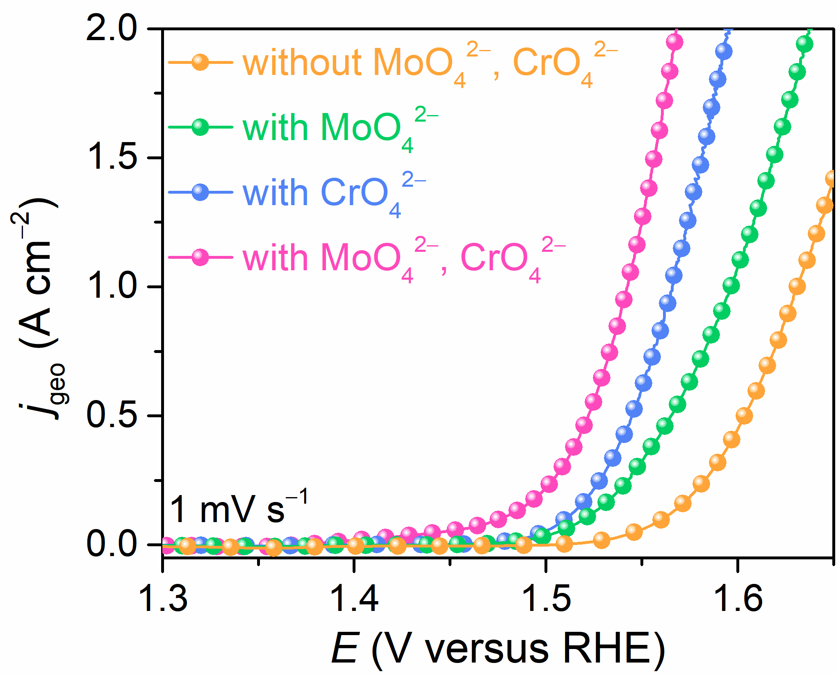
Fig. S30 OER polarization curves of nanoporous N-NiFeCo/NiFeCo electrodes in 1 M KOH electrolyte with and without 5 mM MoO₄²⁻ and/or 5 mM CrO₄²⁻ anions.
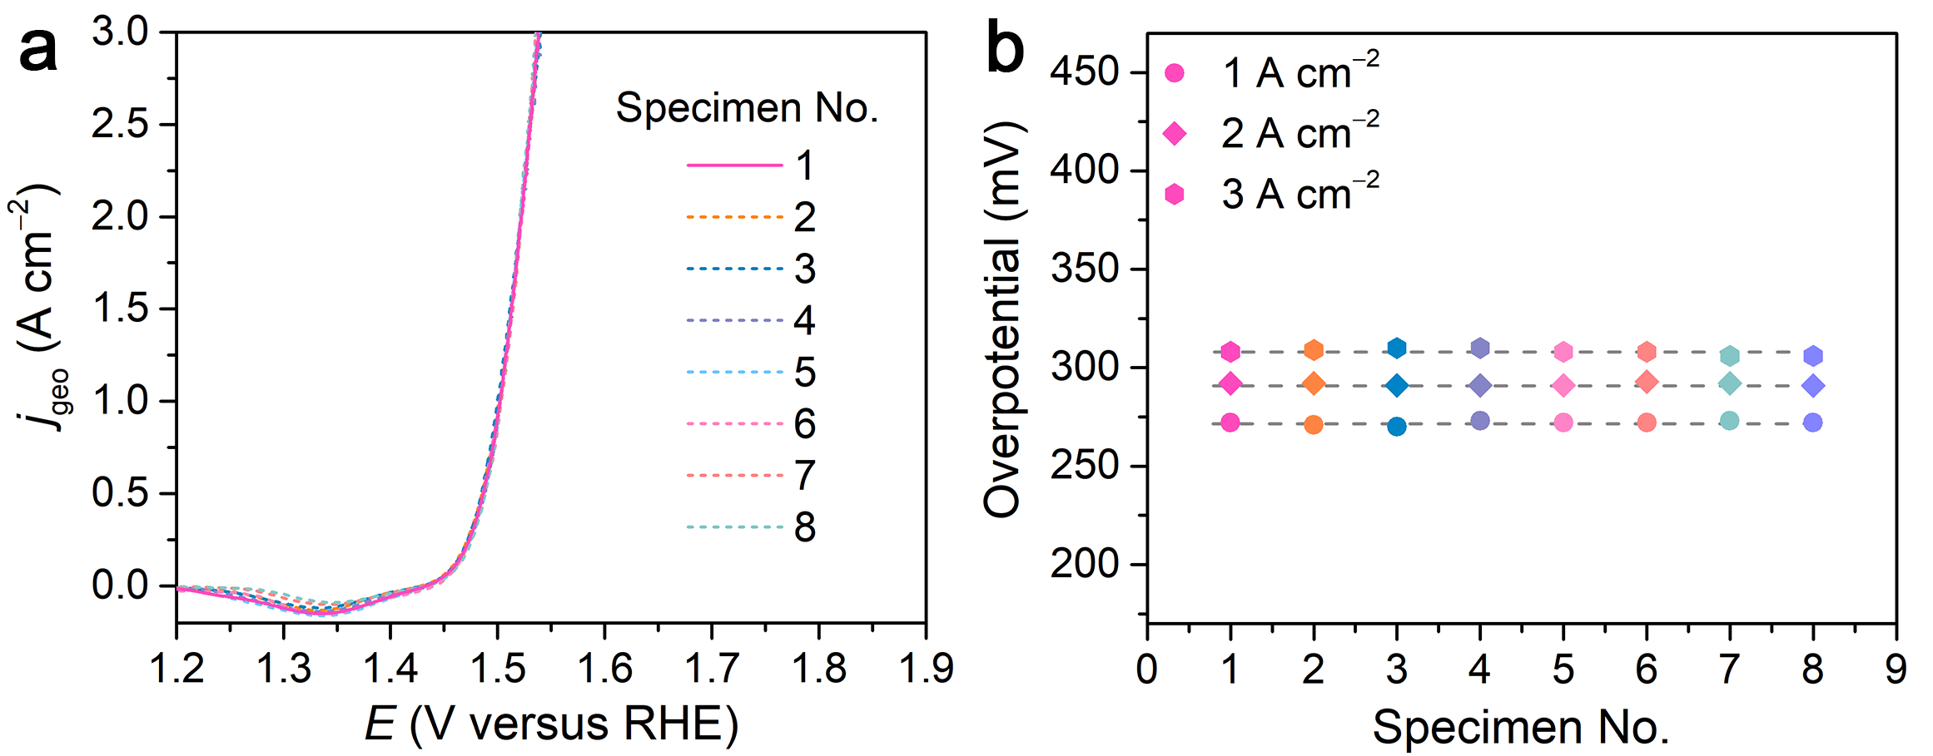
Fig. S31 Reproducibility of nanoporous (NiFeCo)₃(MoCr)₃N/HEA electrode in 1 M KOH electrolyte. (a) The OER polarization curves for eight nanoporous (NiFeCo)₃(MoCr)₃N/HEA electrodes, which are prepared by the same alloying/dealloying and annealing procedures. (b) Overpotentials at different current densities of 1, 2 and 3 A cm⁻² for eight (NiFeCo)₃(MoCr)₃N/HEA electrodes from panel a.
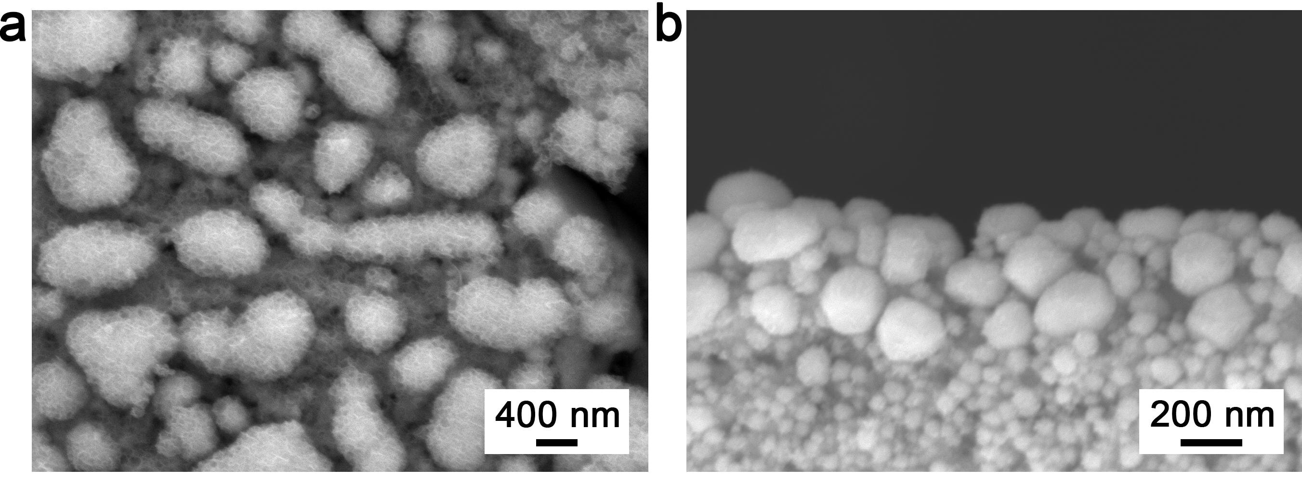
Fig. S32 Typical surface (a) and cross-sectional (b) SEM images of the (NiFeCo)₃(MoCr)₃N/HEA electrode after OER stability measurement.
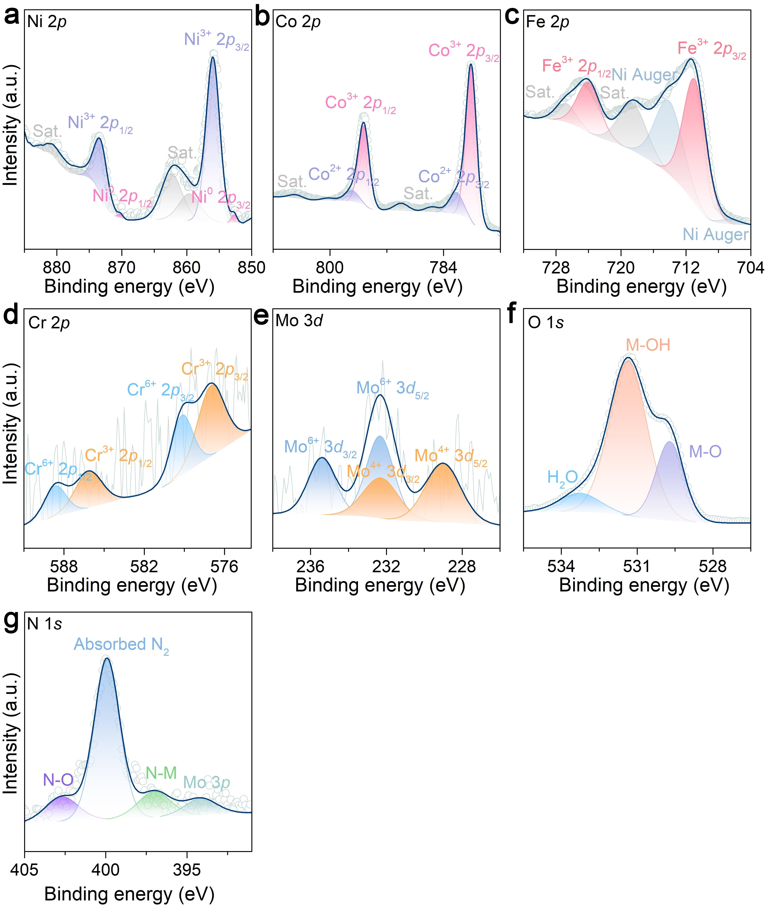
Fig. S33 High-resolution Ni 2p (a), Co 2p (b), Fe 2p (c), Cr 2 (d), Mo 3d (e), O 1s (f) and N 1s (g) XPS spectra of (NiFeCo)₃(MoCr)₃N/HEA after OER stability measurement.
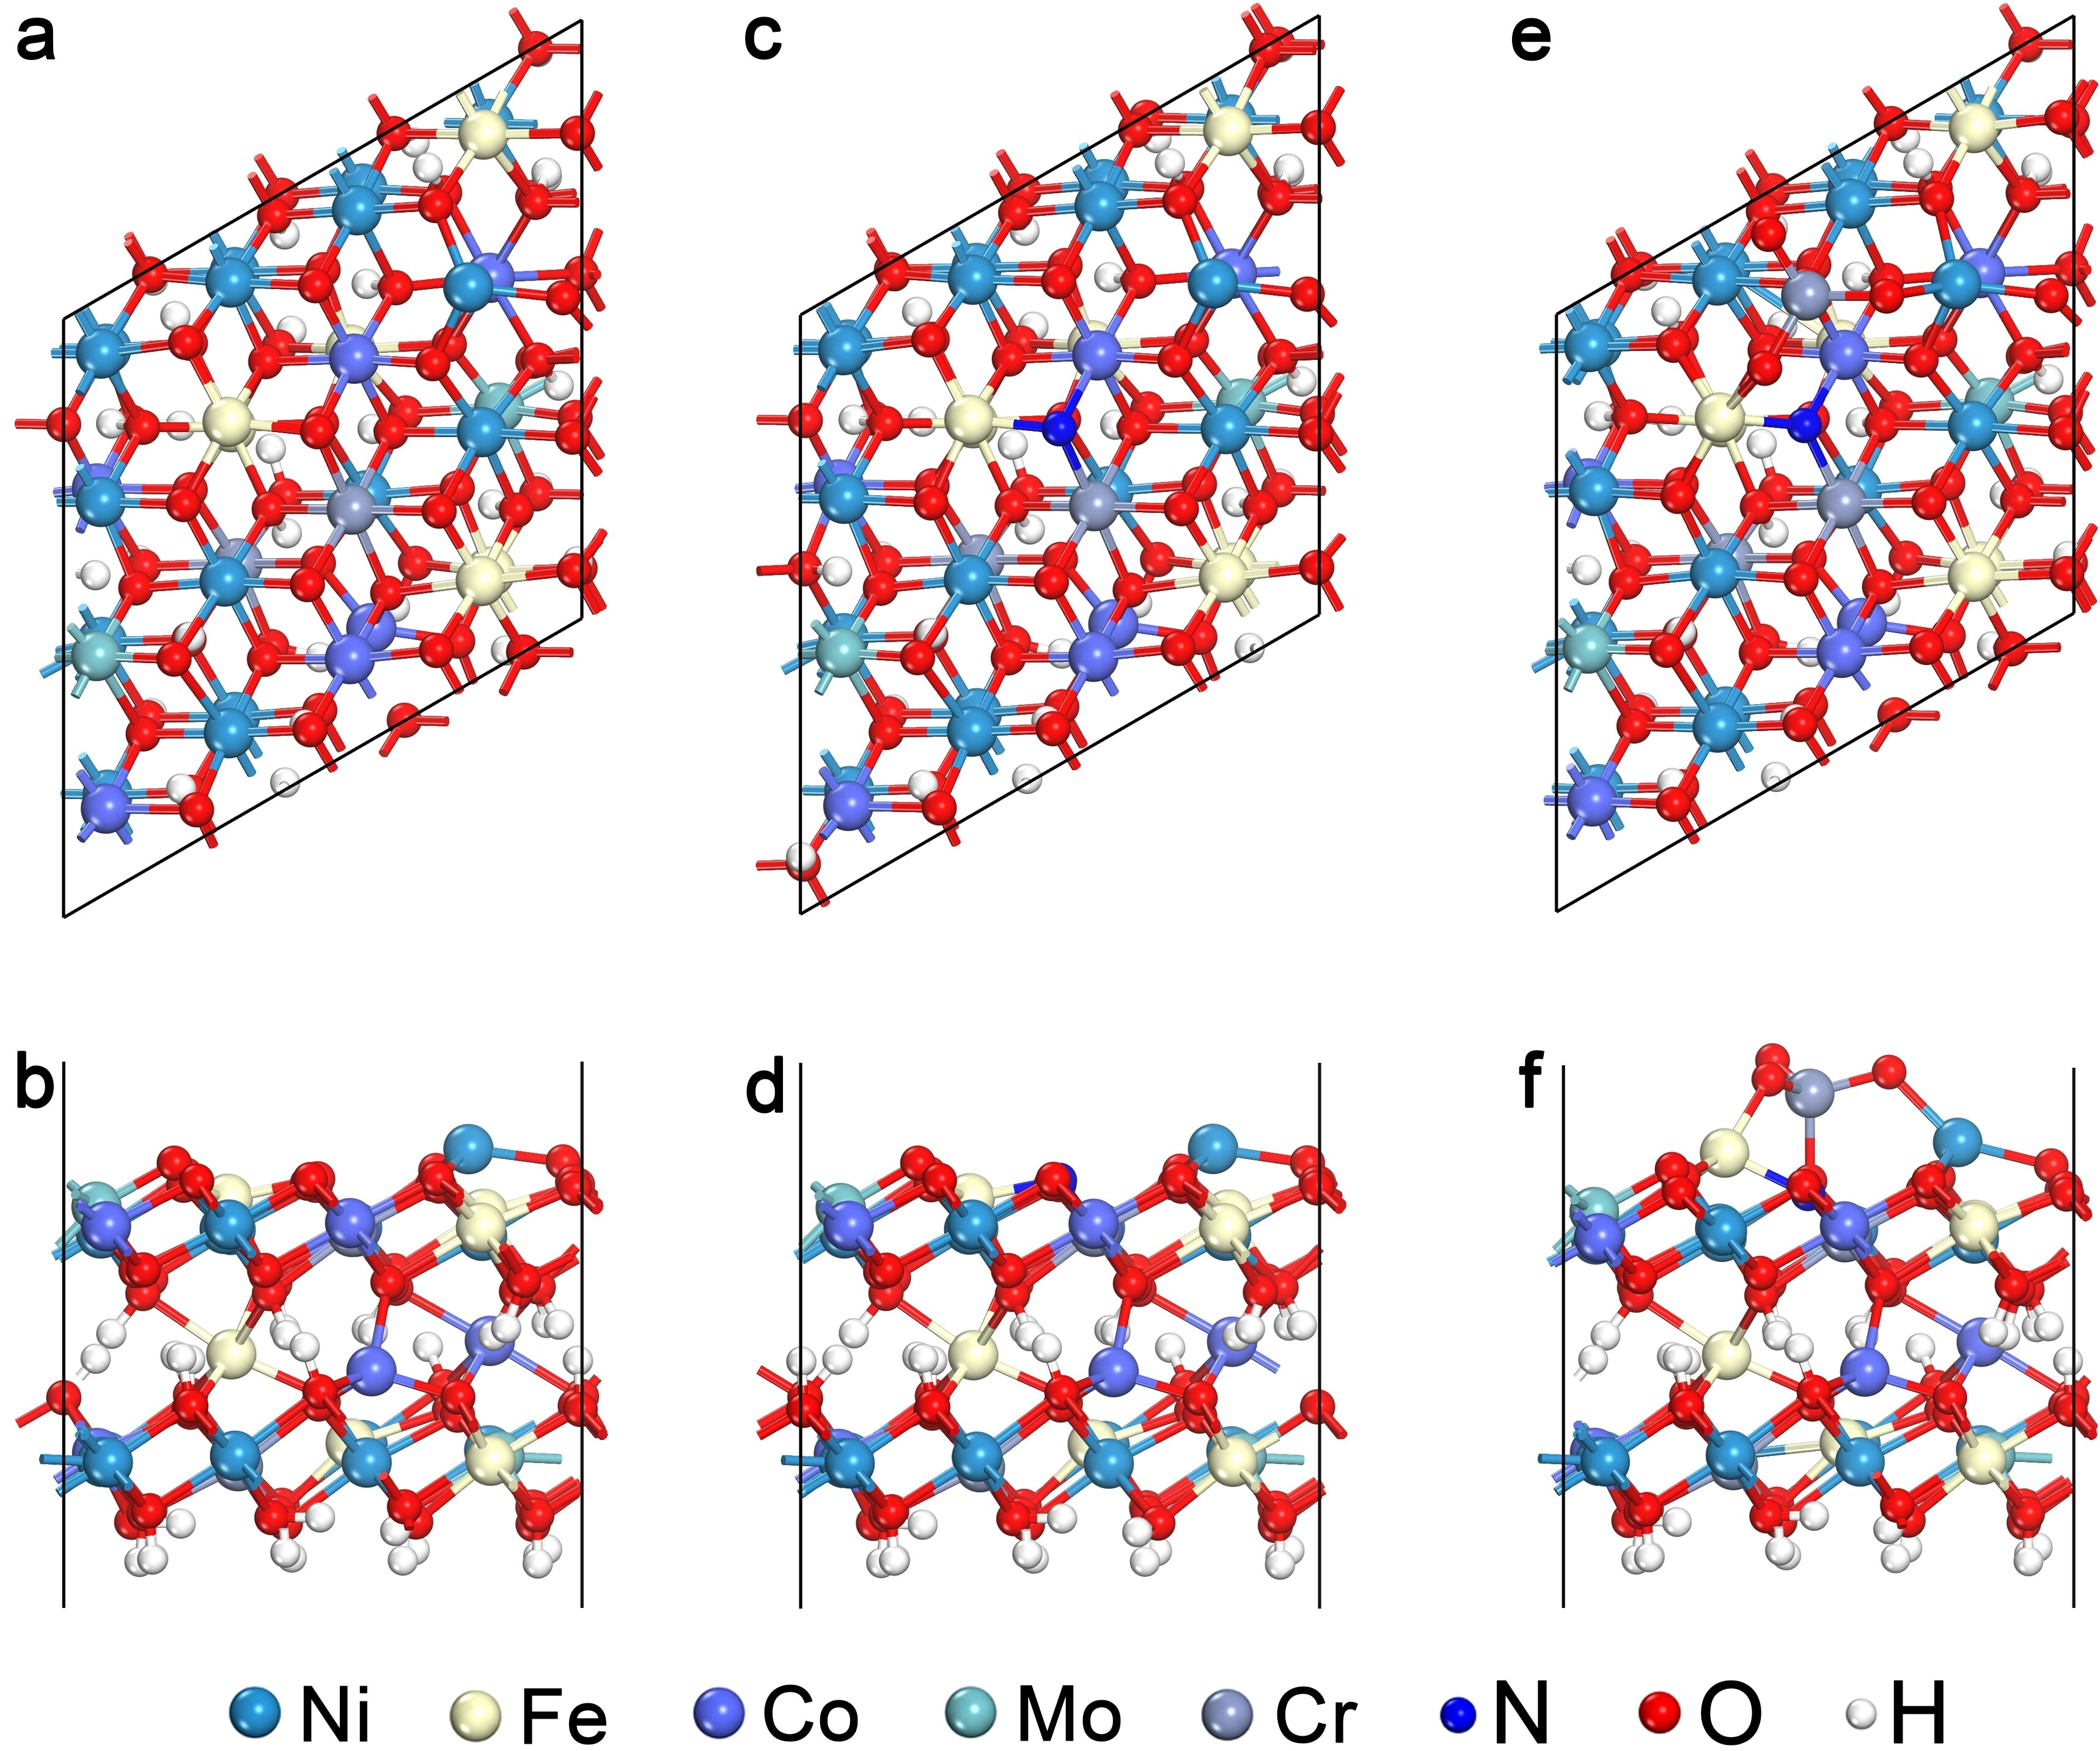
Fig S34 Atomic structures of NiFeCoCrMoOOH (a, b), NiFeCoCrMoOOH-N (c, d), and NiFeCoCrMoOOH-N with CrO₄²⁻ (e, f) for DFT calculations.

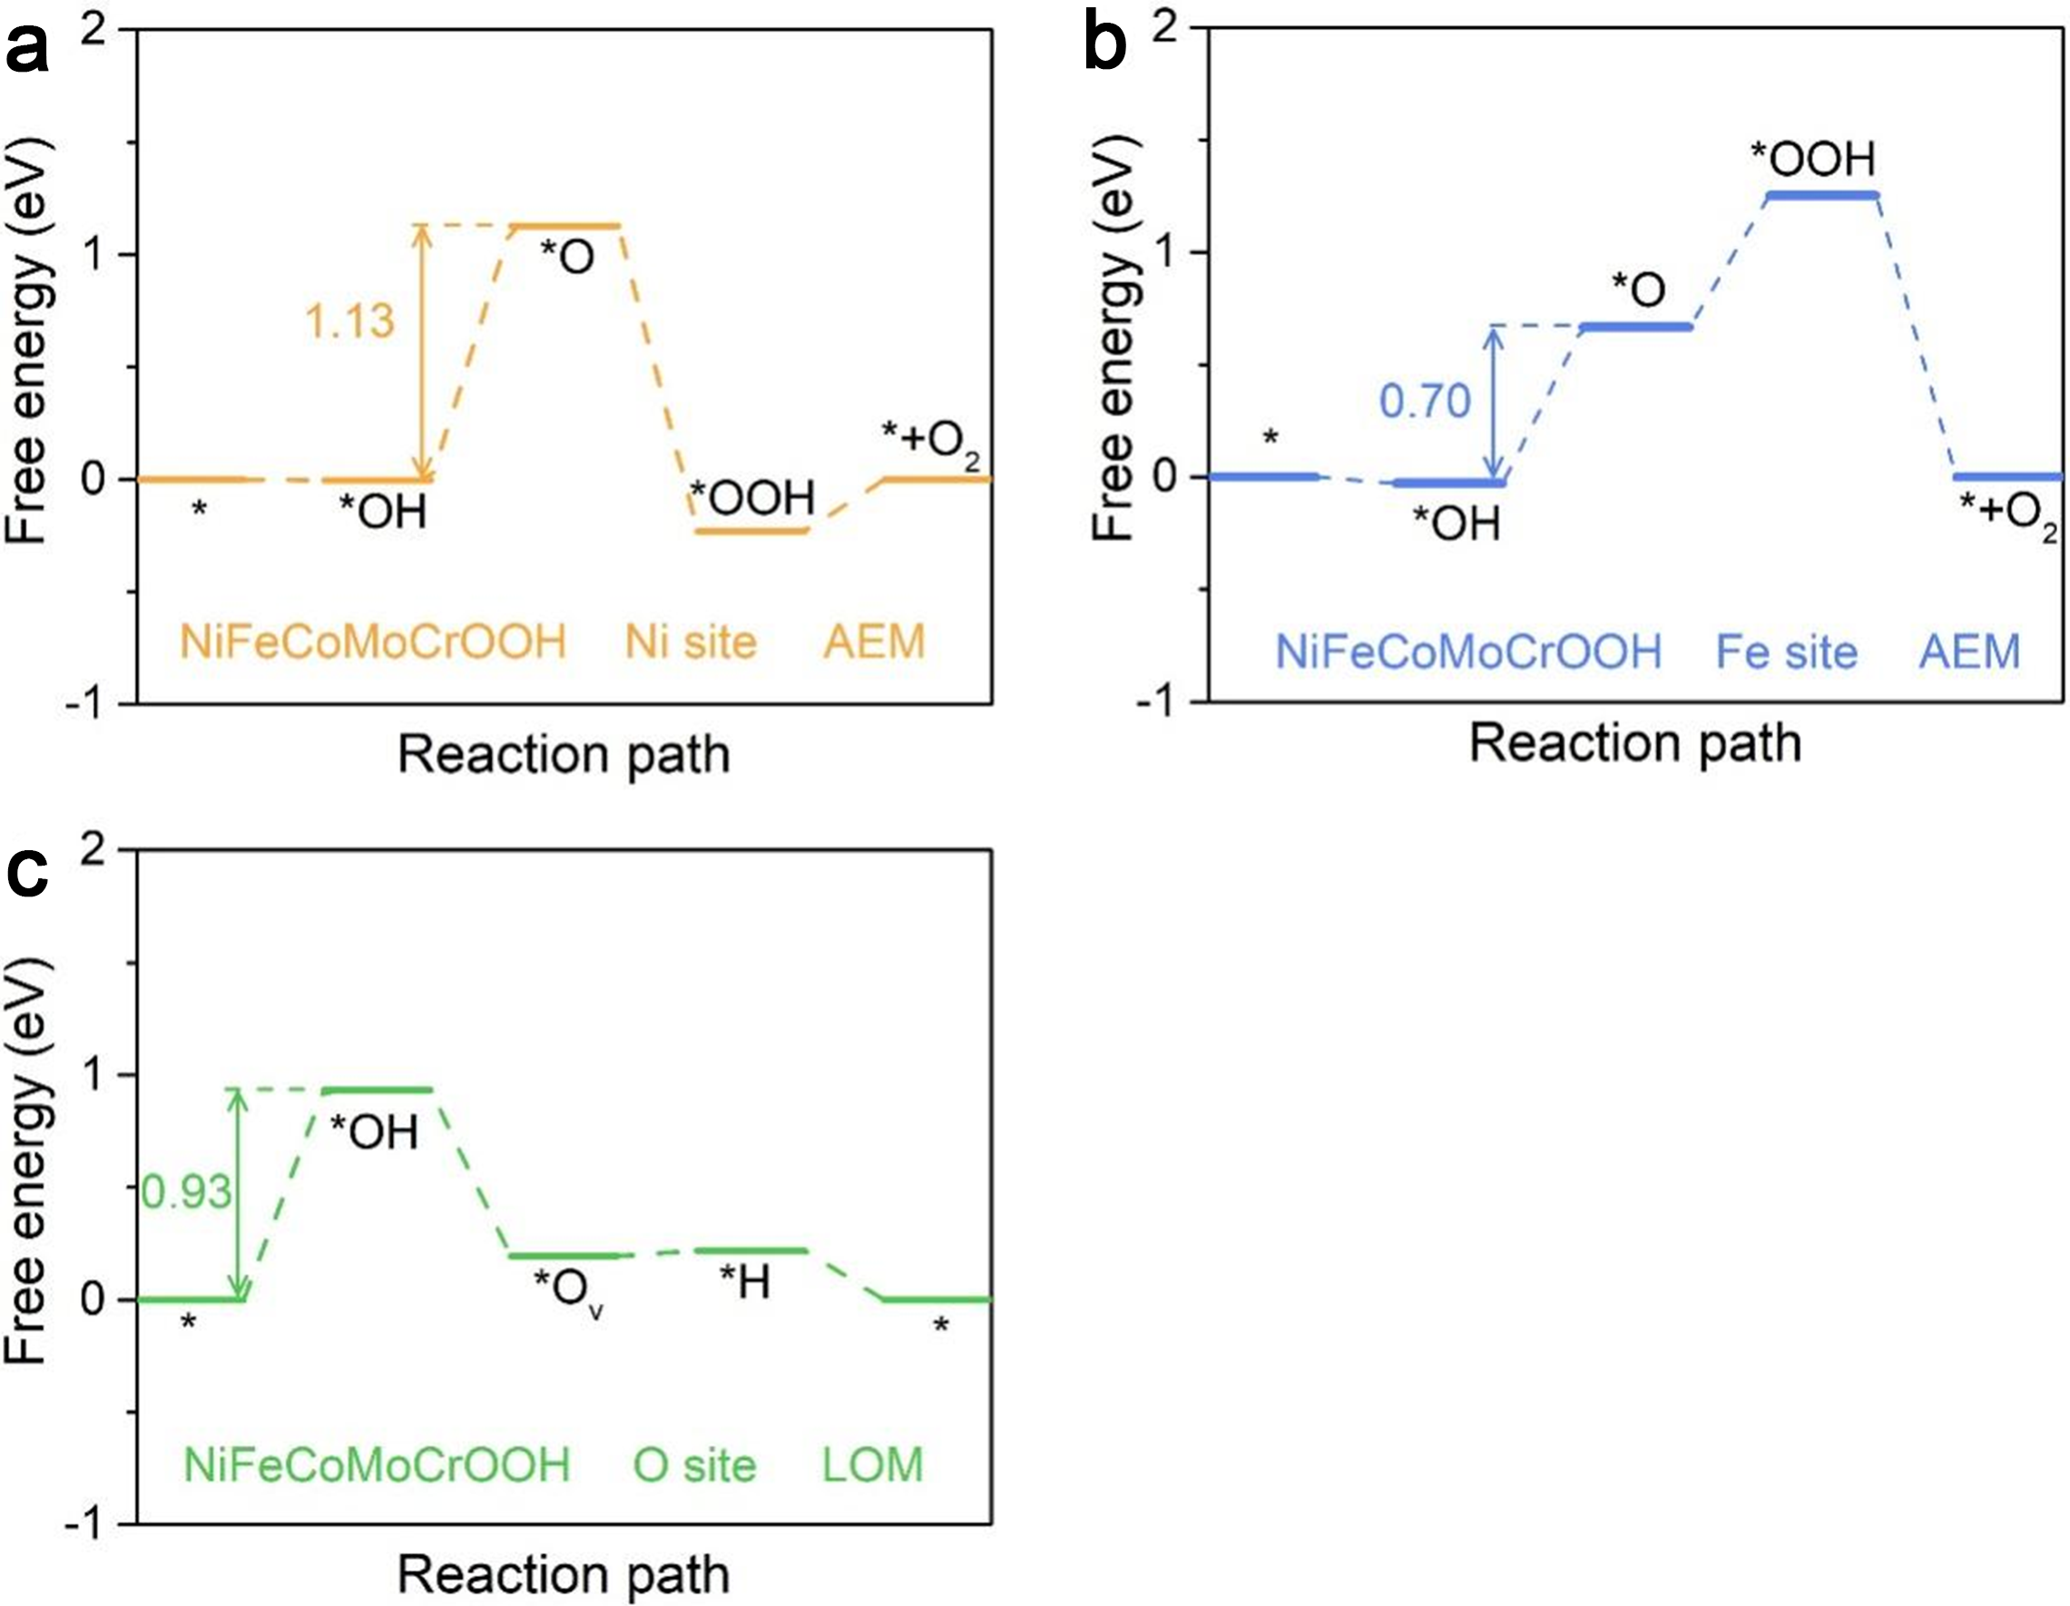
Fig. S35 Gibbs free energy diagram of OER on the Ni, Fe and O sites of NiFeCoMoCrOOH.

Fig. S36 The PDOS of p-orbital in *OH and d-orbital in Fe of NiFeCoMoCrOOH-N. Inset: The differential charge density distribution of *OH adsorbed on Fe site of NiFeCoMoCrOOH-N, where pink and yellow isosurfaces denote electron density accumulation and depletion, respectively. The isosurface level is 0.002 |e| Å⁻³.

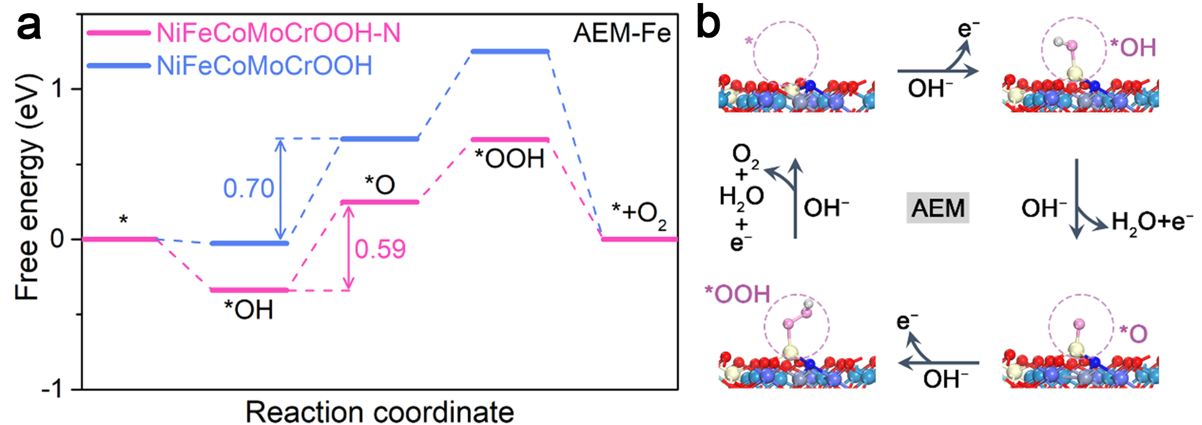
Fig. S37 (a) Gibbs free energy diagram of OER on NiFeCoMoCrOOH and NiFeCoMoCrOOH-N following AEM path. (b) Interface configuration of NiFeCoMoCrOOH-N at four different stages via AEM path.

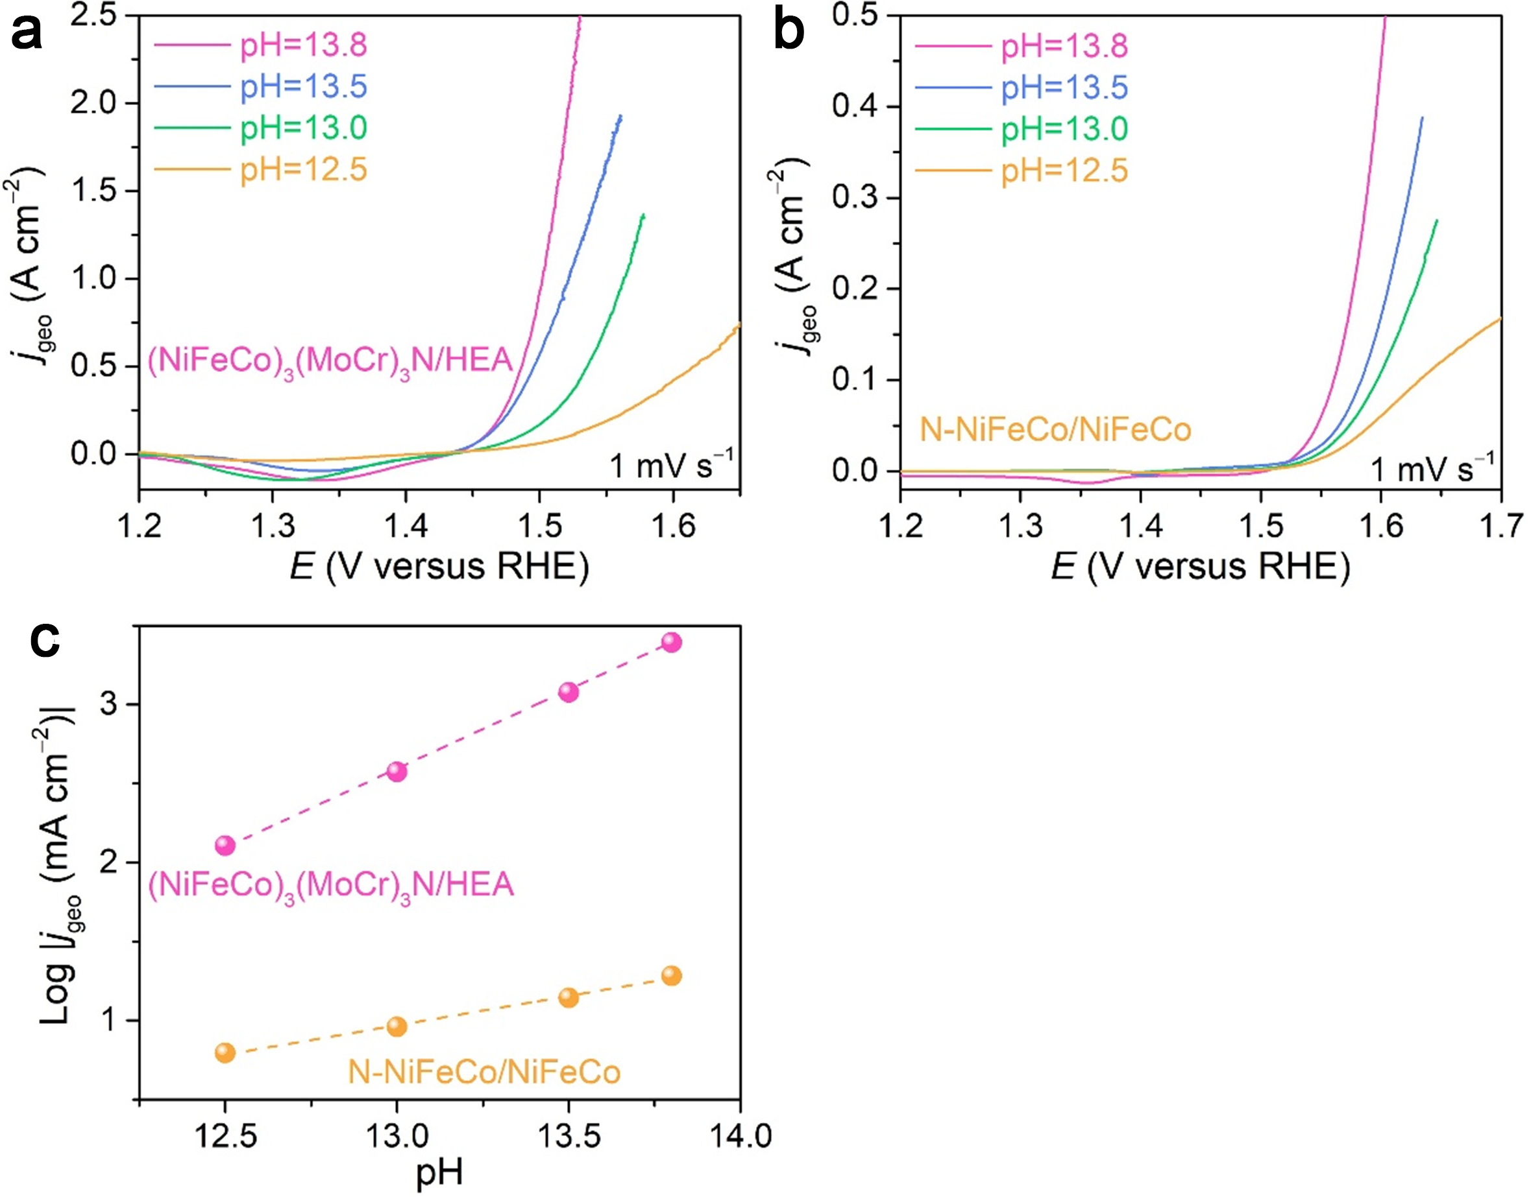
Fig. S38 (a, b) OER polarization curves of nanoporous (NiFeCo)₃(MoCr)₃N/HEA (a) and N-NiFeCo/NiFeCo (b) electrodes in KOH electrolytes with different pH. (c) The pH dependence of OER current densities at the overpotential of 300 mV for nanoporous (NiFeCo)₃(MoCr)₃N/HEA and N-NiFeCo/NiFeCo electrodes.

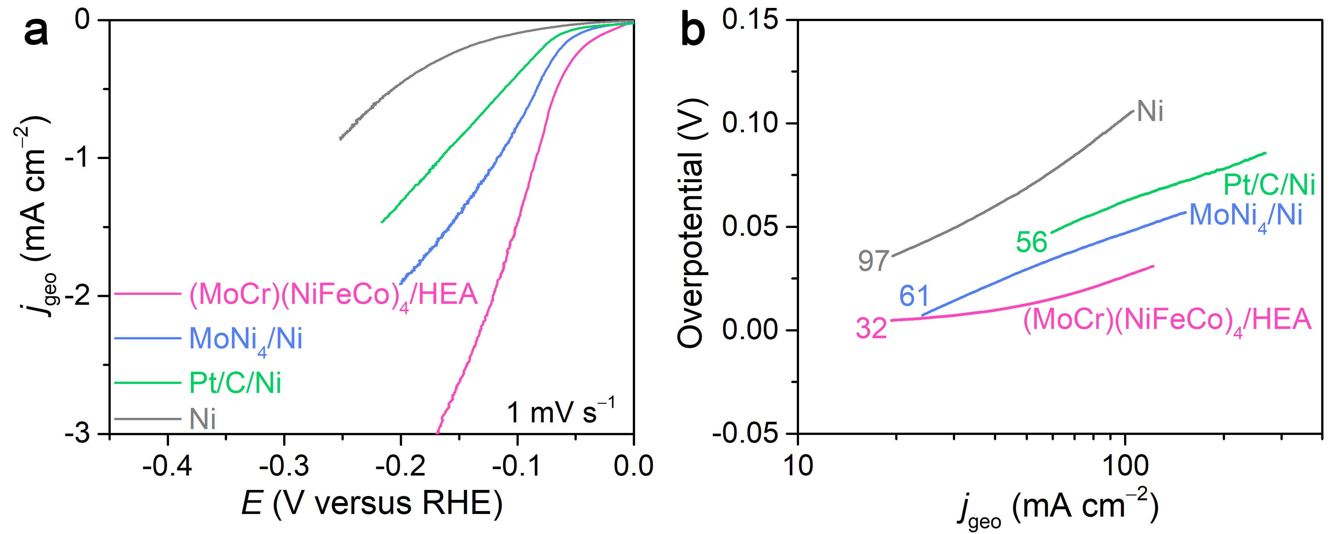
Fig. S39 Alkaline HER electrocatalytic properties. (a) Representative HER polarization curves for (MoCr)(NiFeCo)₄/HEA, MoNi₄/Ni, Pt/C/Ni and Ni electrodes. Scan rate: 1 mV s⁻¹. Electrolyte: 1 M KOH. (b) Tafel plots for (MoCr)(NiFeCo)₄/HEA, MoNi₄/Ni, Pt/C/Ni and Ni electrodes based on the polarization curves in (a).

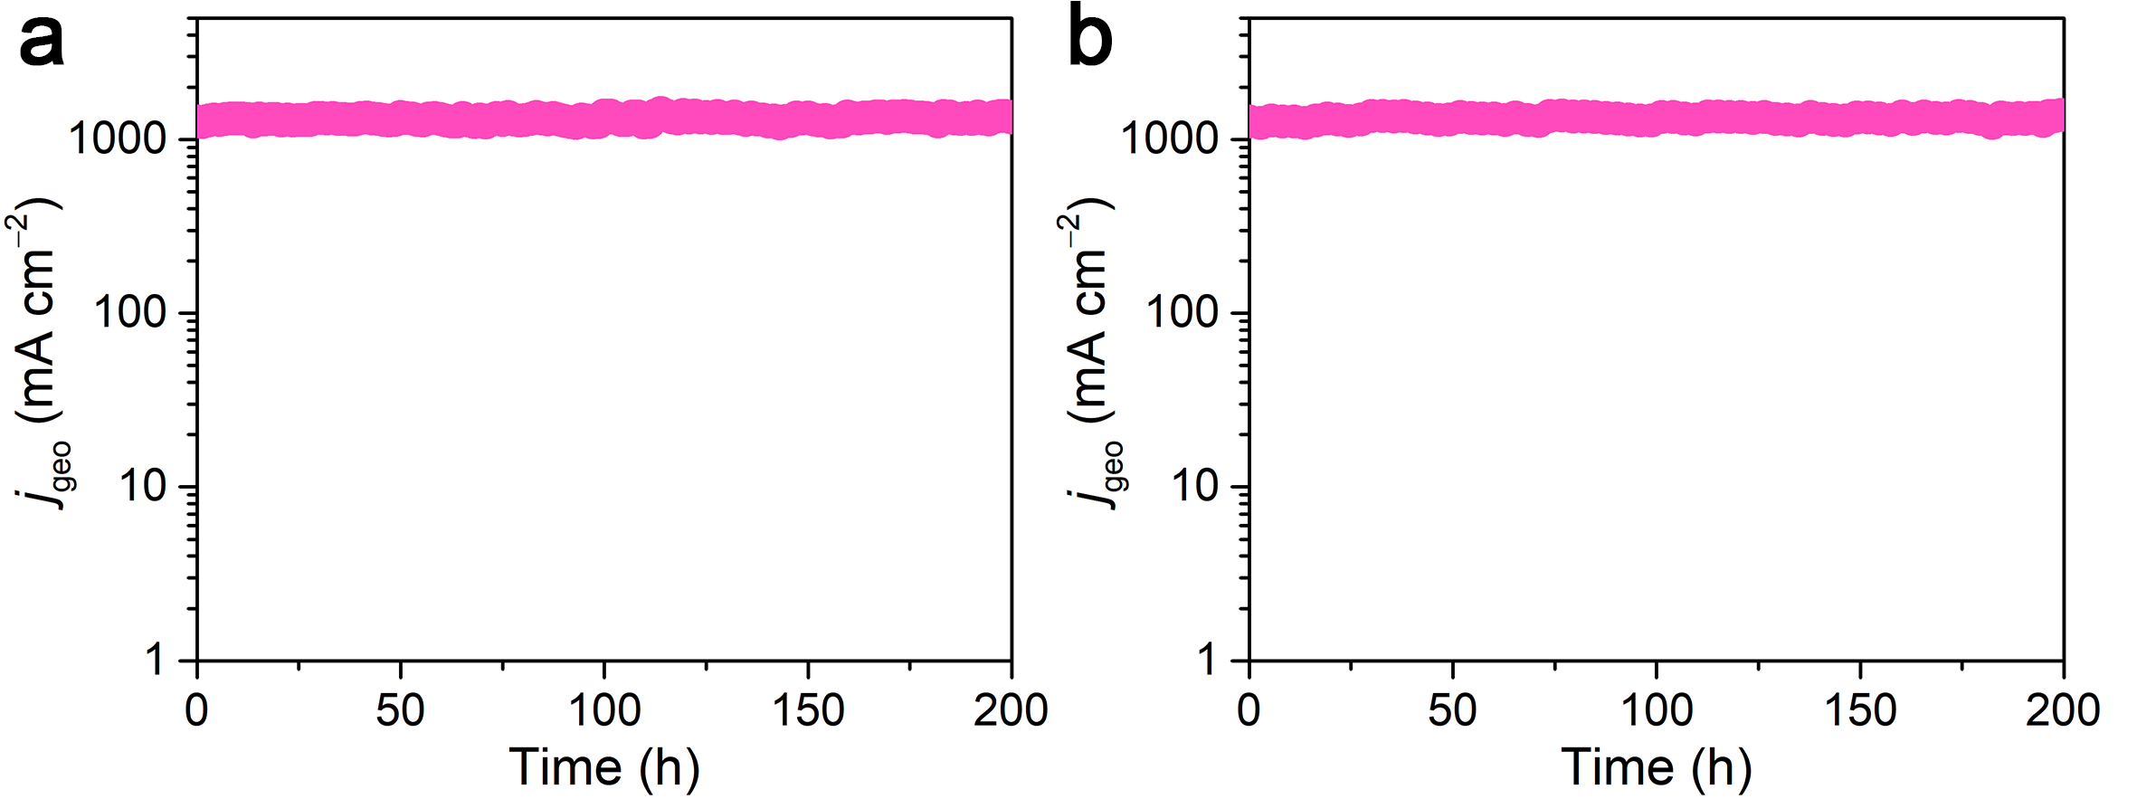
Fig. S40 Durability of two (NiFeCo)₃(MoCr)₃N/HEA||(MoCr)(NiFeCo)₄/HEA electrolysers at the input voltage of 1.92 V.
S2 Supplementary Notes
Note S1 Calculation of specific current density (j_{s})
j_{s} = j_{geo}/A_{ECSA} (S1)
A_{ECSA} = C_{dl}/C_{s} (S2)
Herein, j_{geo} and j_{s} refer to the current per geometric area and electrochemical specific area, respectively. A_{ECSA} is electrochemical specific area per geometric area and C_{s} is the specific capacitance.
At the overpotential of 300 mV,
j_{s, (NiFeCo)3(MoCr)3N/HEA} = 0.404 mA cm^{–2}, j_{s, (NiFeCo)2(MoCr)3O8/HEA} = 0.009 mA cm^{–2},
j_{s, (NiFeCo)3Mo3N/HEA} = 0.155 mA cm^{–2}, j_{s, (NiFe)3(MoCr)3N/HEA} = 0.320 mA cm^{–2},
j_{s, (NiCo)3(MoCr)3N/HEA} = 0.007 mA cm^{–2}, j_{s, Ni3Mo3N/Ni} = 0.011 mA cm^{–2},
j_{s, N-NiFeCo/NiFeCo} = 0.009 mA cm^{–2}, j_{s, N-Ni/Ni} = 0.005 mA cm^{–2},
j_{s, RuO2/Ni} = 0.023 mA cm^{–2}.
Note S2 Measurement of adsorbed MoO₄²⁻ and CrO₄²⁻
The concentrations of MoO₄²⁻ and CrO₄²⁻ around nanoporous (NiFeCo)₃(MoCr)₃N/HEA electrode was measured by ion chromatograph. Briefly, the activated nanoporous (NiFeCo)₃(MoCr)₃N/HEA electrode was operated at the overpotential of 300 mV for 180 s in 1 M KOH electrolyte, and then immersed in 10 mL ultrapure water with shaking for 60 s to completely release surface-adsorbed MoO₄²⁻ and CrO₄²⁻. After repeating the above process ten times, the collected solution was ultrasonicated for 600 s to ensure homogeneous dispersion and subsequently directly analyzed via ion chromatography.
Note S3 Calculation of TOF values
TOF = N_{TH}/N_{AS} (S3)
Herein, N_{TH} and N_{AS} correspond to the number of total oxygen turnovers per geometric area and the number of active sites per geometric area, respectively. The values of N_{TH} and N_{AS} are calculated according to the equations:
N_{TH} = ($\text{j}\frac{\text{mA}}{\text{cm²}}$)($\frac{{\text{1 Cs}}^{\text{­1}}}{\text{1000 mA}}$)($\frac{{\text{1}\text{ mol e}}^{\text{­}}}{\text{96485.3 C}}$)($\frac{\text{1 mol }{\text{O}}_{\text{2}}}{\text{4}\text{ mol }{\text{e}}^{\text{­}}}$)($\frac{\text{6.022}\text{*}{\text{10}}^{\text{23}} {\text{O}}_{\text{2}}\text{ molecules}}{\text{1 mol }{\text{O}}_{\text{2}}}$) (S4)
N_{AS} = ${\text{(}\frac{\text{Number of atoms/unit cell}}{\text{Volume/unit cell}}\text{)}}^{\frac{\text{2}}{\text{3}}}$ (S5)
Herein, the ideal NiOOH model is adopted to replace N-doped NiFeCoCrMoOOH for subsequent computational estimation. For the Hexagonal NiOOH with a = b = 2.82 Å and c = 20.57 Å, the volume of unit cell containing 4 atoms is 141.5 Å³. Therefore, the N_{AS} = 0.928 × 10¹⁵ atoms cm⁻².
At the overpotential of 300 mV,
TOF_{(NiFeCo)3(MoCr)3N/HEA} = 0.680 s⁻¹.
Note S4 The reaction steps of the CrO₄²⁻-mediated AAM pathway
OH⁻ + * → *OH + e⁻ (S6)
*OH + OH⁻ + CrO₄²⁻ → *OOH + HCrO₄⁻ + 2e⁻ (S7)
*OOH + OH⁻ → * + O₂ + H₂O + e⁻ (S8)
HCrO₄⁻ + OH⁻ → CrO₄²⁻ + H₂O (S9)
The Gibbs free energy change for each step in the CrO₄²⁻-mediated AAM pathway
∆G₁ = G_{*OH} − G_{OH−} − G* − eU (S10)
∆G₂ = G_{*OOH+*H} − G_{*OH} − G_{OH−} − eU (S11)
∆G₃ = G_{*H} + G_{O2} + G_{H+} − G_{*OOH+*H} − eU (S12)
∆G₄ = G* + G_{H+} − G_{*H} − eU (S13)
where e was the energy of the electron and U was the electrode potential versus RHE.
Note S5 Calculation of energy efficiency
Energy efficiency (%) = $\frac{E_{output}}{E_{input}}$ = $\frac{M_{H2} ×{ HHV}_{H2} (kJ g^{-1}) × 1000}{I (A) × U (V) × t (s)}$ (S14)
Here, M_{H2} is the mass of hydrogen generated over a specific time interval, HHV_{H2} is the higher heating value of hydrogen (141.7 kJ g_{H2}⁻¹), I is the current, U is the cell voltage, t is the time.
Note S6 Calculation of hydrogen production cost
The hydrogen production cost is calculated based on an ideal 1 MW alkaline water electrolysis system. The annual expenditure of the system consists of capital expenditure (CAPEX) and operational expenditure (OPEX), with CAPEX further divided into the cost of the electrolyzer stack and balance of plant (BOP). Assuming the plant has a daily hydrogen production capacity of 330 kg and the electrolyzer stack and BOP have an expected service life of 10 years with 350 operating days per year. The price of a typical alkaline water electrolyzer stack is 1070.6 USD, and the cost for electrode and diaphragm replacement is 171.3 USD. The BOP accounts for 58% of CAPEX, with an annual maintenance cost at 2.5% of CAPEX and a discount rate of 10% [S1, S2]. The annual labor cost for plant operation equals 0.3% of CAPEX. The base electricity price and renewable energy electricity price are 0.05 USD kWh^{–1} and 0.02 USD kWh^{–1} respectively [S3]. Based on the above assumptions, the production cost of hydrogen is calculated according to the following equations:
Total current (A) = $\frac{330 ({kg day}^{–1}) × 2 (e^{–}) × 96485 ({C mol}^{–1})}{2 ({kg mol}^{–1}) × 24 ({hour day}^{–1}) × 3600 ({s hour}^{–1}) × Energy efficiency (\%)}$
(S15)
Power consumed (kW) = $\frac{Total current (A) × Electrolyzer stack voltage (V)}{1000}$
(S16)
Electricity cost (USD year^{–1}) = Power consumed (kW) × 24 (hour day^{–1}) × 350 (day year^{–1}) × Electricity price (USD kWh^{–1}) (S17)
Total stack area required (m²) = $\frac{Total current (A)}{Current density (A cm^{–2}) × 10000}$ (S18)
Stack cost (USD) = Total stack area required (m²) × Stack price (USD m^{–2})
(S19)
BOP cost (USD) = $\frac{\text{Stack cost (USD) × 58\%}}{\text{1 }\text{–}\text{ 58\%}}$ (S20)
Capital recovery factor = $\frac{Discount rate × {(1 + Discount rate)}^{Plant lifetime}}{{(1 + Discount rate)}^{Plant lifetime}–1}$ (S21)
Annual CAPEX (USD year^{–1}) = (Stack cost + BOP cost) × Capital recovery factor
(S22)
Maintenance cost (USD year^{–1}) = CAPEX (USD) × 2.5% (S23)
Labor cost (USD year^{–1}) = CAPEX (USD) × 0.3% (S24)
Electrode/diaphragm replacement cost (USD year^{–1}) = $\frac{Electrode/diaphragm total price (USD m^{–2} ) × Total stack area required (m^{–2})}{Electrode/diaphragm lifetime (year)}$
(S25)
Water cost (USD year⁻¹) = 330 (kg day⁻¹) × 350 (day year⁻¹) × 45 (kg_{water} kg_{H2}⁻¹) × DI water price (USD kg⁻¹) (S26)
Annual OPEX (USD year⁻¹) = Electricity cost + (Maintenance cost + Electrode/diaphragm replacement cost) + Labor cost + Water cost (S27)
Hydrogen levelized production cost (USD kg⁻¹) = $\frac{Annual CAPEX (USD {year}^{–1}) + Annual OPEX (USD {year}^{–1})}{350 (day {year}^{–1}) × 330 (kg {day}^{–1})}$ (S28)
S3 Supplementary Tables
Table S1. Comparisons of current density at the overpotential of 300 mV, Tafel slope and long-term stability for (NiFeCo)₃(MoCr)₃N/HEA electrode with representative electrocatalysts reported previously
Electrocatalysts | Current  density  (mA cm^{–2}) | Tafel slope  (mV dec^{–1}) | Stability |  | Refs.
Electrocatalysts | Current  density  (mA cm^{–2}) | Tafel slope  (mV dec^{–1}) | Current density  (mA cm^{–2}) | Time  (h) | Refs.
(NiFeCo)₃(MoCr)₃N/HEA | 2466 | 30 | 1000 | 1600 | This work
(NiFeCo)₂(MoCr)₃O₈/HEA | 18 | 295 | 1 | 238 | This work
Ni₃Mo₃N/Ni | 55 | 53 | 17 | 470 | This work
NiFeOOH@SO₄ | 675 | 56 | 500 | 300 | [S4]
FeNiHOF | 1900 | 35 | 1000 | 1000 | [S5]
Fe, F-CoO | 675 | 42 | 500 | 300 | [S6]
NiMoN@NiFeN | 198 | 59 | 100 | 48 | [S7]
FeCoNiZnMo | 282 | 49 | 500 | 800 | [S8]
FeOOH/Co(OH)₂ | 817 | 38 | 100 | 150 | [S9]
FeZnNNiCoV | 709 | 36 | 1000 | 1030 | [S10]
FeCoNiMnCr HEA-HEO/C | 95 | 42 | 100 | 100 | [S11]
Co₂Fe_{0.25}V_{0.75}O₄ | 331 | 41 | 500 | 600 | [S12]
Bi/BiCeO_{1.8}H | 271 | 36 | 200 | 500 | [S13]
(FeCoNiCrCu)Se_{x} | 84 | 56 | 100 | 500 | [S14]
(FeCoNi)₂Nb | 100 | 64 | 500 | 1600 | [S15]
F-NiFeO | 1096 | 47 | 1000 | 100 | [S16]
Fe₂O₃@CeO₂ | 791 | 58 | 1000 | 100 | [S17]
Fe-Ni(P₄O₁₁) | 187 | 43 | 100 | 100 | [S18]
CoFeMoO | 168 | 54 | 10 | 1000 | [S19]
NiRuCoO_{x} | 68 | 54 | 10 | 110 | [S20]
Ir@FeNiSe₂ | 911 | 29 | 10 | 50 | [S21]
Zn-NiOOH/NF | 450 | 31 | 200 | 800 | [S22]
Ir-NiO | 100 | 41 | 20 | 20 | [S23]

Table S2 ICP-OES results of the electrolyte after the long-term OER stability test of nanoporous (NiFeCo)₃(MoCr)₃N/HEA electrode at the overpotential of 270 mV in 1 M KOH electrolyte for 1600 h
 | Concentration (mg/L)
Ni | 0.0020
Fe | 0.0075
Co | 0.0020
Cr | 0.0691
Mo | 0.1571
Al | 0.1335

Table S3 Comparisons of the overall splitting water performance of (NiFeCo)₃(MoCr)₃N/HEA||(MoCr)(NiFeCo)₄/HEA electrolyser with representative electrolysers reported previously in 1 M KOH electrolyte
Electrocatalysts | η₁₀₀  (V) | Stability |  | Refs.
Electrocatalysts | η₁₀₀  (V) | Current density  (mA cm^{–2}) | Time  (h) | Refs.
(NiFeCo)₃(MoCr)₃N/HEA||(MoCr)(NiFeCo)₄/HEA | 1.43 | 1250 | 1700 | This work
FeNiHOF||Ni | 1.71 | 1000 | 500 | [S5]
NiMoN@NiFeN||NiMoN | 1.56 | 500 | 100 | [S7]
MoNi₄/MoO₂||FeOOH/Co(OH)₂ | 1.54 | 100 | 40 | [S9]
FeZnNNiCoV||FeZnNNiCoV | 1.54 | 1000 | 80 | [S10]
Bi/BiCeO_{1.8}H||Pt/C | 1.57 | 1000 | 100 | [S13]
(FeCoNi)₂Nb||(FeCoNi)₂Nb | 1.56 | 500 | 140 | [S15]
Fe₂O₃@CeO₂||Pt/C | 1.60 | 1000 | 100 | [S17]
NiRuCoO_{x}||Pt/C | 1.66 | 500 | 1500 | [S20]
NiO/Mo₂C||NiO/Mo₂C | 1.86 | 10 | 120 | [S21]
NiFeMo/NF||NiFeMo/NF | 1.66 | 500 | 600 | [S24]
Ag/CoV-LDH||Pt/C | 1.55 | 10 | 24 | [S25]
P-CoVO@NF||CoN/VN@NF | 1.61 | 500 | 1000 | [S26]
Ru-Ni(OH)₂||Ru-Ni(OH)₂ | 1.5 | 30 | 65 | [S27]
Co₉S₈-Fe@C||Co₉S₈-Fe@C | 1.82 | 10 | 24 | [S28]
Co_{0.15}-Ni(NO₃)₂OH₂||Co_{0.15}-Ni(NO₃)₂OH₂ | 1.46 | 1000 | 24 | [S29]
FeCoNi-C-N||FeCoNi-N-C | 1.60 | 500 | 720 | [S30]
NiFe_{0.25}Cr_{1.75}O₄||NiFe_{0.25}Cr_{1.75}O₄ | 1.45 | 200 | 80 | [S31]
WC_{1-x}/Mo₂C@C||WC_{1-x}/Mo₂C@C | 1.82 | 200 | 100 | [S32]
Co₃Mo₃N/Co₄N/Co||Co₃Mo₃N/Co₄N/Co | 1.87 | 200 | 100 | [S33]
Ir||Pt-Ir | 1.65 | 500 | 100 | [S34]
Supplementary References
- X. G. Sun, W. Shen, H. Liu, P. X. Xi, M. Jaroniec et al., Corrosion-resistant NiFe anode towards kilowatt-scale alkaline seawater electrolysis. Nat. Commun. 15, 10351 (2024). https://doi.org/10.1038/s41467-024-54754-5
- M. F. Lagadec, A. Grimaud, Water electrolysers with closed and open electrochemical systems. Nat. Mater. 19, 1140–1150 (2020). https://doi.org/10.1038/s41563-020-0788-3
- Y. Zuo, S. Bellani, M. Ferri, G. Saleh, D. M. Shinde et al., High-performance alkaline water electrolyzers based on Ru-perturbed Cu nanoplatelets cathode. Nat. Commun. 14, 4680 (2023). https://doi.org/10.1038/s41467-023-40319-5
- X. Luo, H. Y. Zhao, X. Tan, S. Lin, Y. S. Yu et al., Fe-S dually modulated adsorbate evolution and lattice oxygen compatible mechanism for water oxidation. Nat. Commun. 15, 8293 (2024). https://doi.org/10.1038/s41467-024-52682-y
- Y. Z. Chen, Q. H. Li, Y. X. Lin, J. Liu, J. Pan et al., Boosting oxygen evolution reaction by FeNi hydroxide-organic framework electrocatalyst toward alkaline water electrolyzer. Nat. Commun. 15, 7278 (2024). https://doi.org/10.1038/s41467-024-51521-4
- P. C. Ye, K. Q. Fang, H. Y. Wang, Y. H. Wang, H. Huang et al., Lattice oxygen activation and local electric field enhancement by co-doping Fe and F in CoO nanoneedle arrays for industrial electrocatalytic water oxidation. Nat. Commun. 15, 1012 (2024). https://doi.org/10.1038/s41467-024-45320-0
- L. Yu, Q. Zhu, S. W. Song, B. McElhenny, D. Z. Wang et al., Non-noble metal-nitride based electrocatalysts for high-performance alkaline seawater electrolysis. Nat. Commun. 10, 5106 (2019). https://doi.org/10.1038/s41467-019-13092-7
- Y. J. Mei, J. L. Chen, Q. Wang, Y. Q. Guo, H. W. Liu et al., MoZn-based high entropy alloy catalysts enabled dual activation and stabilization in alkaline oxygen evolution. Sci. Adv. 10(47), eadq6758 (2024). https://doi.org/10.1126/sciadv.adq6758
- D. Y. Li, R. Xiang, F. Yu, J. S. Zeng, Y. Zhang et al., In situ regulating cobalt/iron oxide-oxyhydroxide exchange by dynamic iron incorporation for robust oxygen evolution at large current density. Adv. Mater. 36(5), 2305685 (2024). https://doi.org/10.1002/adma.202305685
- J. X. Zhang, Y. H. Tu, X. M. Xu, J. Ke, L. H. Zhang et al., A high-entropy antiperovskite nitride enables efficient anion exchange membrane water electrolysis. Adv. Mater. 37(38), 2509042 (2025). https://doi.org/10.1002/adma.202509042
- J. Hu, T. Q. Guo, X. Y. Zhong, J. Li, Y. J. Mei et al., In situ reconstruction of high entropy heterostructure catalysts for stable oxygen evolution electrocatalysis under industrial conditions. Adv. Mater. 36(14), 2310918 (2024). https://doi.org/10.1002/adma.202310918
- A. Li, X. X. Tang, R. J. Cao, D. C. Song, F. Z. Wang et al., Directed surface reconstruction of Fe modified Co₂VO₄ spinel oxides for water oxidation catalysts experiencing self-terminating surface deterioration. Adv. Mater. 36(31), 2401818 (2024). https://doi.org/10.1002/adma.202401818
- S. Jo, J. I. Jeon, K. H. Shin, L. T. Zhang, K. B. Lee et al., Stabilization of lattice oxygen evolution reactions in oxophilic Ce-mediated Bi/BiCeO_{1.8}H electrocatalysts for efficient anion exchange membrane water electrolyzers. Adv. Mater. 36(27), 2314211 (2024). https://doi.org/10.1002/adma.202314211
- F. R. Qian, L. S. Peng, D. F. Cao, W. Jiang, C. S. Hu et al., Asymmetric active sites originate from high-entropy metal selenides by joule heating to boost electrocatalytic water oxidation. Joule 8(8), 2342–2356 (2024). https://doi.org/10.1016/j.joule.2024.06.004
- Z. B. Li, R. Y. Wu, D. B. Duan, X. J. Liu, R. Li et al., Empowering multicomponent alloys with unique nanostructure for exceptional oxygen evolution performance through self-replenishment. Joule 8(10), 1–18 (2024). https://doi.org/10.1016/j.joule.2024.06.023
- Y. J. Zhang, W. Y. Zhang, X. W. Zhang, X. Wang, J. J. Wang et al., Activating lattice oxygen based on energy band engineering in oxides for industrial water/saline oxidation. Energy Environ. Sci. 17(10), 3347–3357 (2024). https://doi.org/10.1039/d4ee00214h
- Q. P. Huang, G. J. Xia, B. Huang, D. L. Xie, J. Wang et al., Activating lattice oxygen by a defect-engineered Fe₂O₃-CeO₂ nano-heterojunction for efficient electrochemical water oxidation. Energy Environ. Sci. 17(14), 5260–5272 (2024). https://doi.org/10.1039/d4ee01588f
- H, S. Cao, X. Wen, X. Z. Luo, L. L. Ma, Z. A. Xu et al., Dual-site bridging mechanism for bimetallic electrochemical oxygen evolution. Angew. Chem. Int. Ed. 63(46), e202411683 (2024). https://doi.org/10.1002/anie.202411683
- B. H. Yao, Y. T. Chen, Y. Y. Yan, Y. Yang, H. H. Xing et al., Iron-induced localized oxide path mechanism enables efficient stable water oxidation. Angew. Chem. Int. Ed. 64(4), e202416141 (2025). https://doi.org/10.1002/anie.202416141
- M. T. Huo, H. Sun, Z. Jin, W. Liu, Y. Liang et al., Tailoring octahedron-te hedron synergism in spinel catalysts for acidic water electrolysis. J. Am. Chem. Soc. 147(12), 10678–106895 (2025). https://doi.org/10.1021/jacs.5c00665
- Z. H. Yin, Y. Huang, K. P. Song, T. T. Li, J. Y. Cui et al., Ir single atoms boost metal-oxygen covalency on selenide-derived NiOOH for direct intramolecular oxygen coupling. J. Am. Chem. Soc. 146(10), 6846–6855 (2024). https://doi.org/10.1021/jacs.3c13746
- Y. Huang, Z. Wang, H. Xiao, Q. Liu, X. Wang, Activating and stabilizing lattice oxygen via self-adaptive Zn-NiOOH sub-nanowires for oxygen evolution reaction. J. Am. Chem. Soc. 146(42), 29006–29016 (2024). https://doi.org/10.1021/jacs.4c09931
- A. Kumar, M. Gil-Sepulcre, J. P. Fandré, O. Rüdiger, M. G. Kim et al., Regulating local coordination sphere of Ir single atoms at the atomic interface for efficient oxygen evolution reaction. J. Am. Chem. Soc. 146(48), 48, 32953–32964 (2024). https://doi.org/10.1021/jacs.4c08847
- L. Y. Xiao, C. Q. Cheng, T. T. Yang, J. T. Zhang, Y. J. Han et al., A “two-pronged” strategy to boost hydrogen evolution kinetics on NiFe-based (oxy)hydroxides via oxygen deficient Ni-Mo-Fe coordinate structures for ultra-stable ampere-level alkaline overall water splitting. Adv. Mater. 36(44), 2411134 (2024). https://doi.org/10.1002/adma.202411134
- X. Y. Lu, Z. Y. Ma, Y. N. Chang, S. S. Wang, X. X. Li et al., Mott-schottky construction boosted plasma thermal and electronic effects on the Ag/CoV-LDH nanohybrids for highly efficient water oxidation. Adv. Mater. 36(29), 2313057 (2024). https://doi.org/10.1002/adma.202313057
- Z. J. Liang, D. Shen, Y. Wei, F. F. Sun, Y. Xie et al., Modulating the electronic structure of cobalt vanadium bimetal catalysts for high-stable anion exchange membrane water electrolyzer. Adv. Mater. 36(41), 2408634 (2024). https://doi.org/10.1002/adma.202408634
- C. Q. Li, B. Kim, Z. P. Li, R. Thapa, Y. F. Zhang et al., Direct electroplating ruthenium precursor on the surface oxidation nickel foam for efficient and stable bifunctional alkaline water electrolysis. Adv. Mater. 36(31), 2403151 (2024). https://doi.org/10.1002/adma.202403151
- N. Wang, D. Chen, S. L. Ning, J. Y. Lao, J. C. Xu et al., Fe cluster modified Co₉S₈ heterojunction: highly efficient photoelectrocatalyst for overall water splitting and flexible zinc-air batteries. Adv. Mater. 36(2), 2306138 (2024). https://doi.org/10.1002/adma.202306138
- Y. Zhou, F. Li, B. Dong, Y. Chai, Double self-reinforced coordination modulation constructing stable Ni⁴⁺ for water oxidation. Energy Environ. Sci. 17(4), 1468 (2024). https://doi.org/10.1039/d3ee02627b
- M. M. Jiang, J. Xu, Y. J. Chen, L. Q. Wang, Q. Zhou et al., Interstitial doping in ultrafine nanocrystals for efficient and durable water splitting. Angew. Chem. Int. Ed. 64(14), e202424195 (2025). https://doi.org/10.1002/anie.202424195
- S. Z. Luo, C. C. Dai, Y. K. Ye, Q. Wu, J. R. Wang et al., Elevated water oxidation by cation leaching enable tunable surface reconstruction. Angew. Chem. Int. Ed. 63(31), e202402184 (2024). https://doi.org/10.1002/anie.202402184
- W. J. Zhang, L. Yang, Z. Li, G. Z. Nie, X. J. Cao et al., Regulating hydrogen/oxygen species adsorption via built-in electric filed-driven electron transfer behavior at the heterointerface for efficient water splitting. Angew. Chem. Int. Ed. 63(16), e202400888 (2024). https://doi.org/10.1002/anie.202400888
- Y. W. Liu, L. R. Wang, R. Hübner, J. Kresse, X. M. Zhang et al., Cobalt-based Co₃Mo₃N/Co₄N/Co metallic heterostructure as a highly active electrocatalyst for alkaline overall water splitting. Angew. Chem. Int. Ed. 63(14), e202319239 (2024). https://doi.org/10.1002/anie.202319239
- J. L. Gu, L. X. Li, Q. Yang, F. B. Tian, W. Zhao et al., Twinning engineering of platinum/iridium nanonets as turing-type catalysts for efficient water splitting. J. Am. Chem. Soc. 146(8), 5355–5365 (2024). https://doi.org/10.1021/jacs.3c12419

