Supporting Information for
Aligning Out-of-Plane Polarization in 2D Ferroelectric Perovskite Wafer Boosts Interlayer Carrier Transport for Efficient X-Ray Detection
Chenhao Deng¹, Shihai You^{1,} *, Haiqing Zhong², Xiankan Zeng¹, Xiaolong Hao¹, Jiasheng Xie¹, Zheng Zhou¹, Zhangjian Jin¹, Huang Ye², Lijun Xu², Jianbo Wu³, Panpan Dong¹, Wen Li¹, Xingxing Jiao¹, Weiqing Yang^{1,} *
¹ Key Laboratory of Advanced Technologies of Materials (Ministry of Education), School of Materials Science and Engineering, Research Institute of Frontier Science, Southwest Jiaotong University, Chengdu 610031, P. R. China
² State Key Laboratory of Functional Crystals and Devices, Fujian Institute of Research on the Structure of Matter, Chinese Academy of Sciences, Fuzhou 350002, P. R. China
³ Department of Materials Science and Engineering, City University of Hong Kong, Hong Kong SAR 999077, P. R. China
* Corresponding authors. E-mail: shihai.you@swjtu.edu.cn (Shihai You); wqyang@swjtu.edu.cn (Weiqing Yang)
S1 Supporting Figures

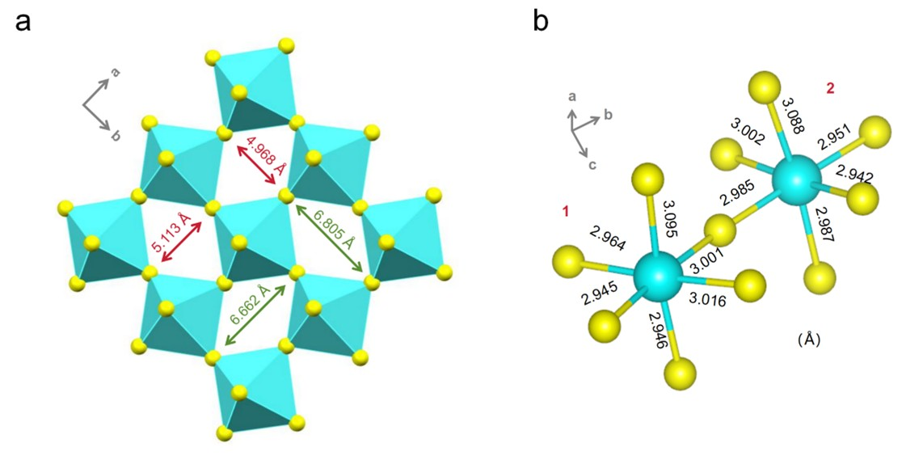
Fig. S1 a) Inorganic layer of (Mpda)PbBr₄ constructed by distorted [PbBr₆] octahedra through corner-sharing. b) Pb-Br bond lengths in two distinct [PbBr₆] octahedra (labeled with 1 and 2).
According to the formula [S1],
$$\begin{aligned}\text{∆d=}\frac{\text{1}}{\text{6}}\sum_{\text{1}}^{\text{6}}{{\left|\frac{{\text{d}}_{\text{i}}\text{-}{\text{d}}_{\text{0}}}{{\text{d}}_{\text{0}}}\right|}^{\text{2}}}\#(S1)\end{aligned}$$
in which Δd denotes the degree of distortion, and d_{i} and d₀ are individual and average Pb-Br bond lengths. The distortion degrees of the two [PbBr₆] octahedra are calculated to be 30×10⁻⁵ (1) and 25×10⁻⁵ (2), respectively, showing they are highly distorted.

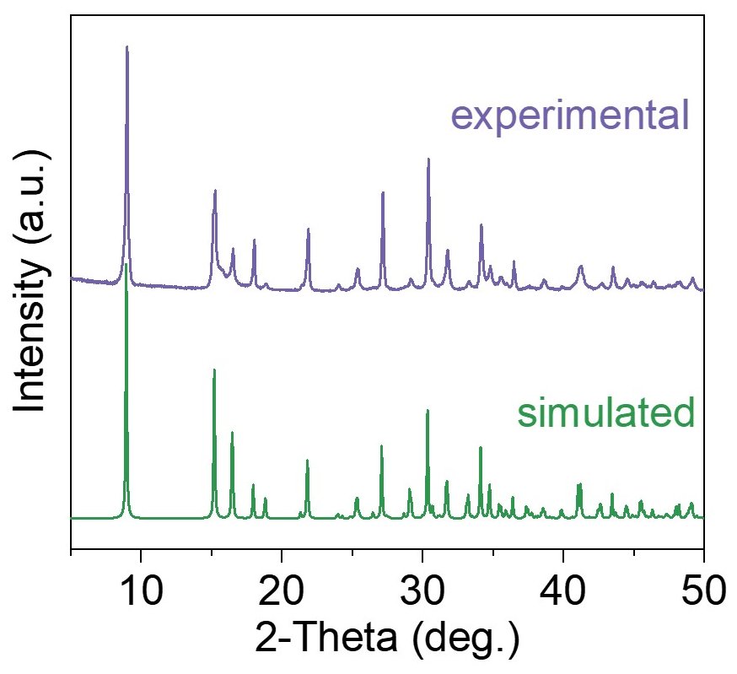
Fig. S2 Comparison of simulated and experimental powder XRD patterns of (Mpda)PbBr₄.

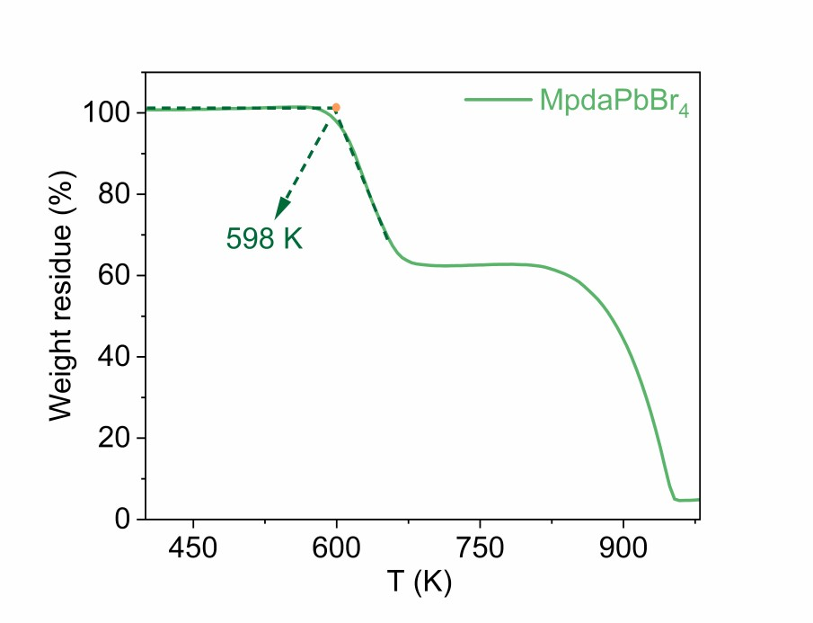
Fig. S3 TG curve of (Mpda)PbBr₄ powders under N₂ atmosphere.

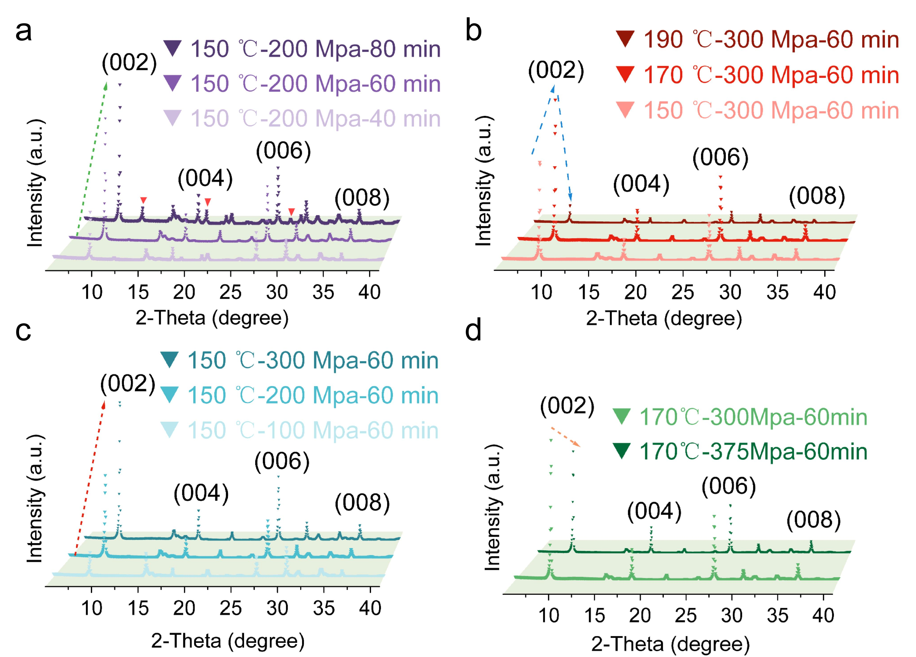
Fig. S4 XRD patterns of (Mpda)PbBr₄ wafers under different hot-pressing parameters: a) holding time, b) temperature, c) pressure, and d) different pressure with temperature of 170 °C. This systematically study gives the optimal fabrication parameters: 170 °C, 300 MPa, and 60 min.

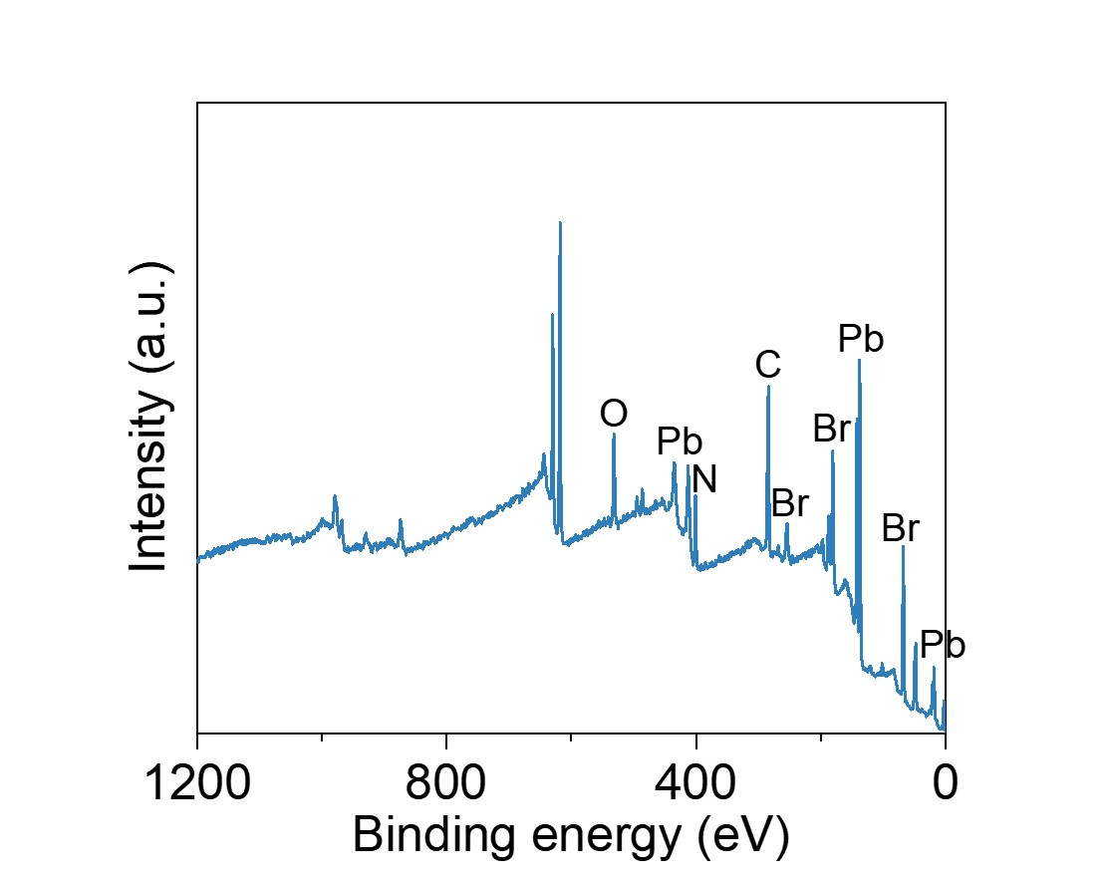
Fig. S5 XPS spectrum of (Mpda)PbBr₄ scanning from 0 to 1200 eV.

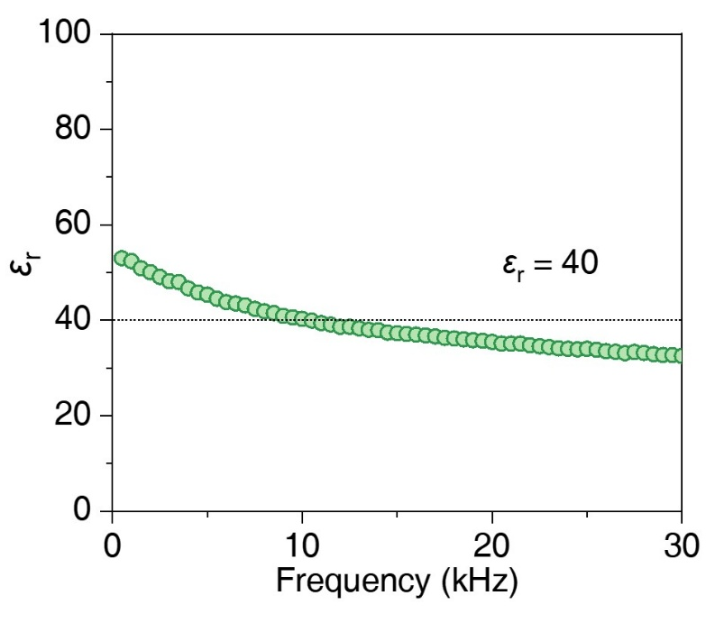
Fig. S6 Frequency-dependent relative dielectric constant of (Mpda)PbBr₄ wafer.

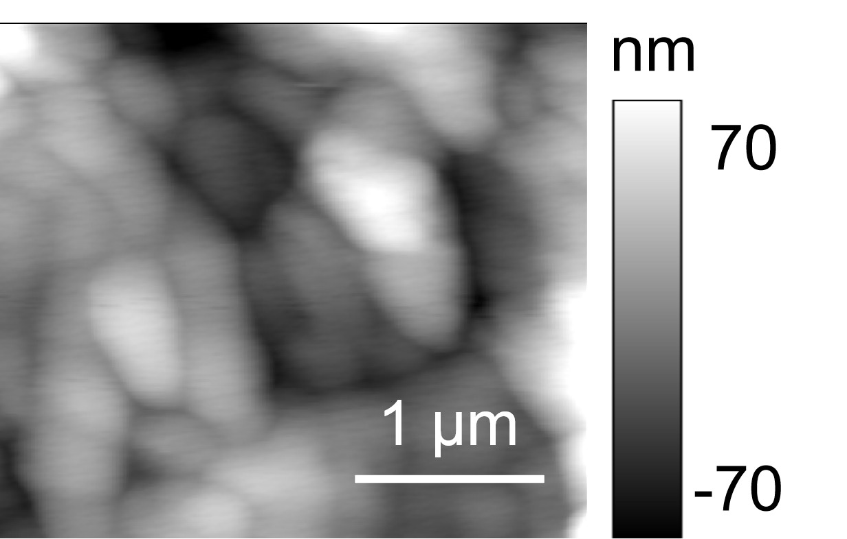
Fig. S7 The PFM topography of (Mpda)PbBr₄ film.

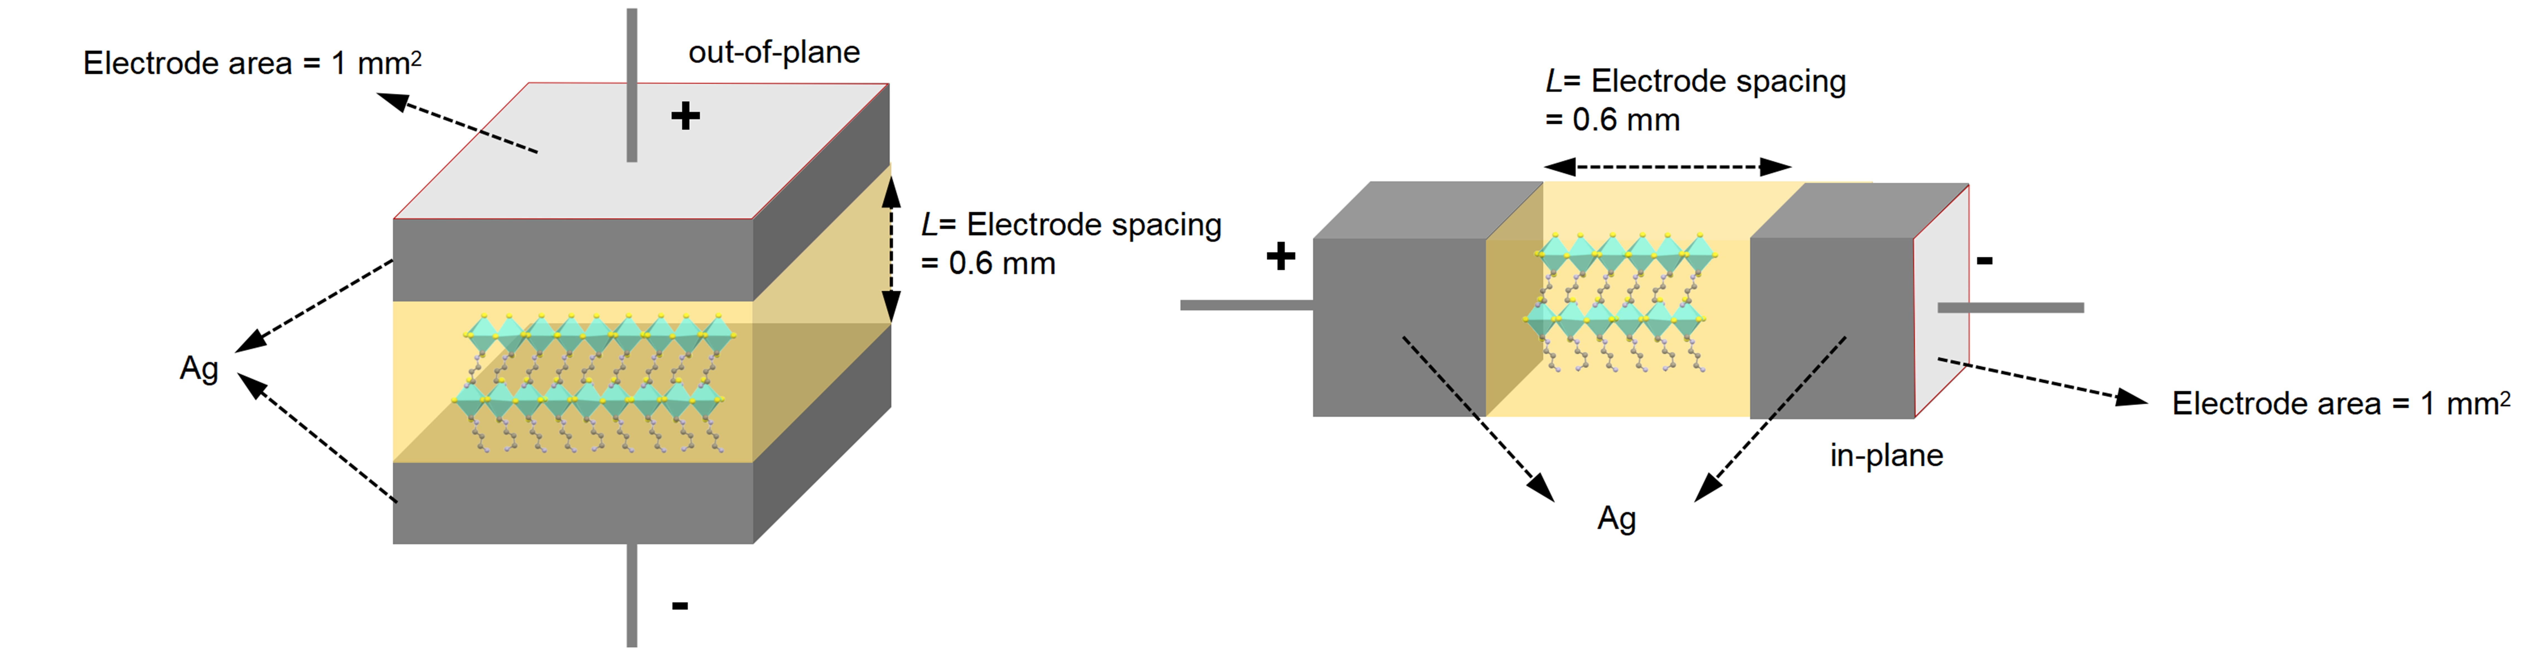
Fig. S8 Schematic configuration of the (a) out-of-plane (vertical) and (b) in-plane (lateral) directions in (Mpda)PbBr₄ wafer.
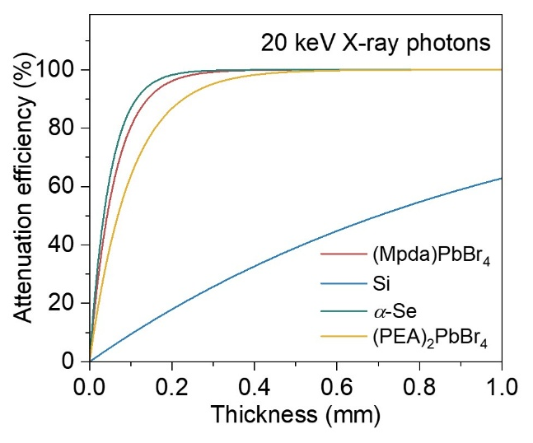
Fig. S9 Attenuation efficiency of (Mpda)PbBr₄, Si, α-Se, and (PEA)₂PbBr₄ for 20 keV X-rays versus thickness.

Fig. S10 Photograph of Ag/(Mpda)PbBr₄ wafer/Ag vertical device.

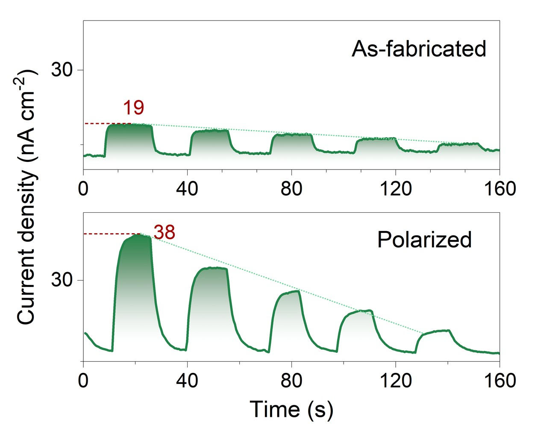
Fig. S11 Comparison of photocurrent response of (Mpda)PbBr₄ wafer as fabricated and after poling under X-ray irradiation (external bias of 1 V), showing a significant enhancement.

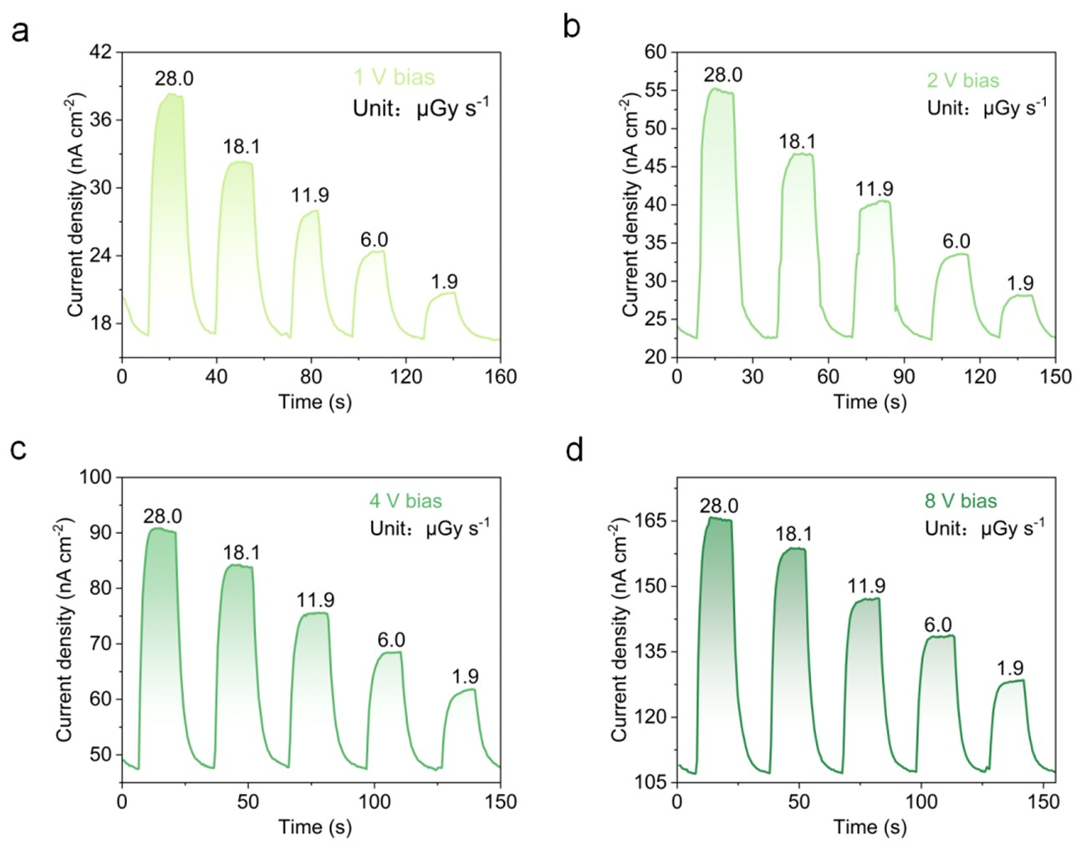
Fig. S12 J-t curves of (Mpda)PbBr₄ wafer detector under X-ray irradiation operated under different external bias voltages (e.g., 1, 2, 4, and 8 V).
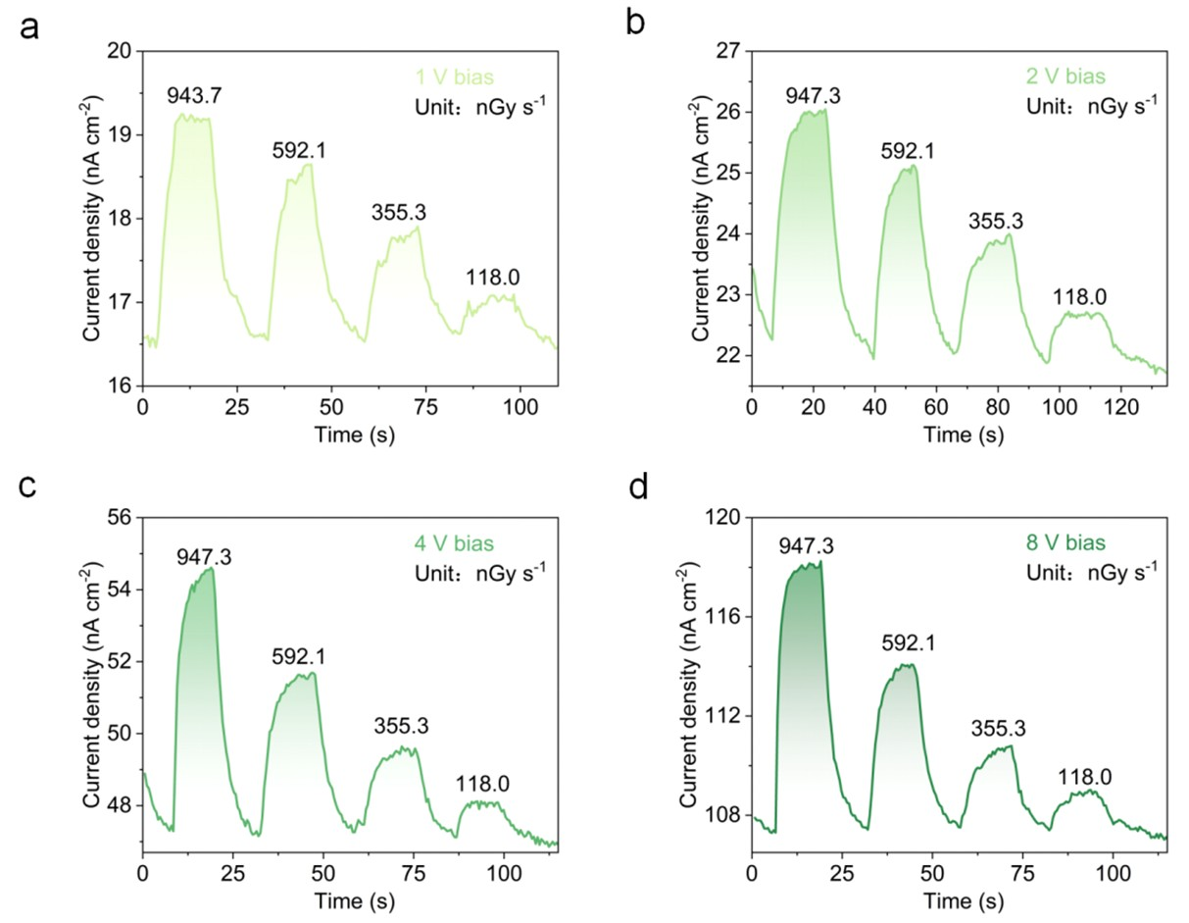
Fig. S13 J-t curves of (Mpda)PbBr₄ wafer detector under low dose rate X-ray irradiation.
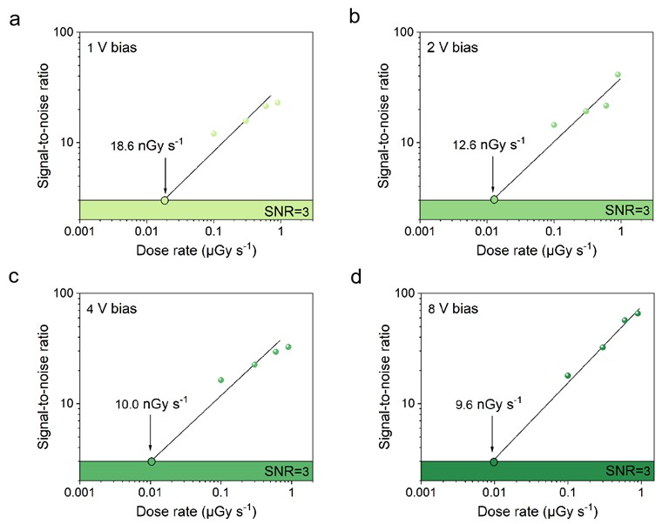
Fig. S14 Detection limits of (Mpda)PbBr₄ wafer detector operated at different bias voltages.

S2 Supporting Tables
Table S1 The atomic coordinates of Pb and N in crystal structure of (Mpda)PbBr₄ collected at 293 K [S2]
Atom | Atomic coordinate |  | Coordinate of charge center
Pb | Pb1^{i} (0.74103, 0.60812, 0.04472) | Pb1^{ii} (0.24103, 0.39188, 0.54472) | (0.49103, 0.5, 0.29472)
Pb | Pb2^{i} (0.23971, 0.09787, 0.04251) | Pb2^{ii} (0.73971, 0.90213, 0.54251) | (0.48971, 0.5, 0.29251)
N | N1^{i} (0.75060, 0.17830, 0.93020) | N1^{ii} (0.25060, 0.82170, 0.43020) | (0.50060, 0.5, 0.68020)
N | N2^{i} (0.42340, 0.99500, 0.71321) | N2^{ii} (0.92340, 0.00500, 0.21321) | (0.67340, 0.5, 0.46321)
N | N3^{i} (0.24680, 0.52590, 0.92020) | N3^{ii} (0.74680, 0.47410, 0.42020) | (0.49680, 0.5, 0.67020)
N | N4^{i} (0.93550, 0.50800, 0.71320) | N4^{ii} (0.43550, 0.49200, 0.21320) | (0.68550, 0.5, 0.46320)
According to the point charge model, we assume that the centers of the positive charges of Mpda cation and the centers of negative charges of [PbBr₆] octahedra are locating at N and Pb atoms, respectively.
Thus, spontaneous polarization intensity (P_{s}) along the c-axis,
P_{s} = (q_{N}r_{N} + q_{Pb}r_{Pb}) × Z × c / V
= [(e × 0.68020) × 2 + (e × 0.46321) × 2 + (e × 0.67020) × 2 + (e × 0.46320) × 2 + (-2e × 0.29472) ×2 + (-2e × 0.29251) ×2] × 20.13716 ×10⁻¹⁰ / (1366.35 ×10⁻³⁰)
= 1.6 × 10⁻¹⁹ × 2.2047 × 20.13716 / 1366.35 × 10²⁰ C m⁻²

Table S2 Detection performance comparison between (Mpda)PbBr₄ wafer and some recently reported 2D MHP X-ray detectors
Compound | Electric field (V mm⁻¹) | Sensitivity  (µC Gy⁻¹ cm⁻²) | Detection limit  (nGy s⁻¹) | Form | Direction | Refs
(Mpda)PbBr₄ | 0 | 483.6 | 15.5 | wafer | out-of-plane | This work
(Mpda)PbBr₄ | 1.67 | 705.4 | 18.6 | wafer | out-of-plane | This work
(Mpda)PbBr₄ | 3.33 | 1011.5 | 12.6 | wafer | out-of-plane | This work
(Mpda)PbBr₄ | 6.67 | 1112.1 | 10 | wafer | out-of-plane | This work
(Mpda)PbBr₄ | 13.33 | 1395.5 | 9.6 | wafer | out-of-plane | This work
(Mpda)PbBr₄ | 26.67 | 2285 | 7.2 | wafer | out-of-plane | This work
(F-PEA)₃BiI₆ | 100 | 52.6 | 30 | wafer | out-of-plane | [S3]
(PEA)₂PbI₄ | 50 | 28.1 | - | film | in-plane | [S4]
(HIS)₂AgBiBr₈ | 3.1 | 252.38 | 68.9 | single crystal | out-of-plane | [S5]
(NH₄)₃Bi₂I₉ | 6.5 | 803 | 55 | single crystal | out-of-plane | [S6]
(PEA)₂PbBr₄ | 100 | 1303.9 | 8.8 | single crystal | out-of-plane | [S7]
(HIS)₂AgSbBr₈ | 33.3 | 223 | 84.2 | single crystal | out-of-plane | [S8]
(Br-PEA)₂PbI₄ | 80 | 1003 | 36 | single crystal | in-plane | [S9]
(4ABA)PbI₄ | 25 | 572 | 7.5 | single crystal | out-of-plane | [S10]
(Br-BA)₂PbBr₄ | 150 | 531.33 | 100 | single crystal | out-of-plane | [S11]
(o-F-PEA)₂PbI₄ | 1250 | 1724.5 | 460 | single crystal | in-plane | [S12]
(BA)₂PbI₄ | 10 | 148 | 241 | single crystal | out-of-plane | [S13]
(BA)₂PbBr₄ | 12.5 | 544.8 | 523.3 | wafer | out-of-plane | [S14]
(PA)₂PbBr₄ | 12.5 | 827.3 | 60 | wafer | out-of-plane | [S14]
(PEA)₂PbBr₄ | 12.5 | 3416.4 | 27 | wafer | out-of-plane | [S14]
(BDA)PbI₄ | 310 | 242 | 430 | single crystal | out-of-plane | [S15]
EA₄Pb₃Br₁₀ | 60 | 2228.9 | - | wafer | in-plane | [S16]
*PEA = phenylethylamine, HIS = histamine, 4ABA = 4-aminobenzylamine, BA = butylamine, PA = propylamine, BDA = 1,4-butanediamine, EA = ethylamine.
Supplementary References
- S. You, P. Yu, J. Wu, Z.-K. Zhu, Q. Guan et al., Weak X-ray to visible lights detection enabled by a 2D multilayered lead iodide perovskite with iodine-substituted spacer. Adv. Sci. Weinheim Baden Wurttemberg Ger. 10(21), e2301149 (2023). https://doi.org/10.1002/advs.202301149
- C.-C. Fan, C.-D. Liu, B.-D. Liang, M.-L. Jin, T.-Y. Ju et al., A two-dimensional hybrid lead bromide ferroelectric semiconductor with an out-of-plane polarization. Inorg. Chem. 62(32), 12634–12638 (2023). https://doi.org/10.1021/acs.inorgchem.3c02057
- M. Li, H. Li, W. Li, B. Li, T. Lu et al., Oriented 2D perovskite wafers for anisotropic X-ray detection through a fast tableting strategy. Adv. Mater. 34(8), 2108020 (2022). https://doi.org/10.1002/adma.202108020
- F. Liao, L. Lei, X. Gan, P. Li, G. Yao, Flexible 2D perovskite film for dual-mode X-ray detection and imaging. IEEE Electron Device Lett. 45(9), 1610–1613 (2024). https://doi.org/10.1109/LED.2024.3424470
- Y. Zhou, L. Huang, M. Wu, F. Kuang, K. An et al., A two-dimensional lead-free double perovskite for self-powered and high performance X-ray detection. J. Mater. Chem. C 12(44), 18048–18057 (2024). https://doi.org/10.1039/d4tc03465a
- R. Zhuang, X. Wang, W. Ma, Y. Wu, X. Chen et al., Highly sensitive X-ray detector made of layered perovskite-like (NH₄)₃Bi₂I₉ single crystal with anisotropic response. Nat. Photonics 13(9), 602–608 (2019). https://doi.org/10.1038/s41566-019-0466-7
- B. Jia, D. Chu, Y. Hu, Z. Zhao, J. Pi et al., Reducing energy loss of 2D perovskite single crystal for stable and efficient X-ray detection by quenching the radioluminescence. Adv. Mater. 38(5), e03463 (2026). https://doi.org/10.1002/adma.202503463
- Q. Fan, H. Xu, S. You, Y. Ma, Y. Liu et al., Centimeter-sized single crystals of Dion-jacobson phase lead-free double perovskite for efficient X-ray detection. Small Weinheim Der Bergstrasse Ger. 19(34), e2301594 (2023). https://doi.org/10.1002/smll.202301594
- H. Zhong, S. You, J. Wu, Z.-K. Zhu, P. Yu et al., Multiple interlayer interactions enable highly stable X-ray detection in 2D hybrid perovskites. JACS Au 4(6), 2393–2402 (2024). https://doi.org/10.1021/jacsau.4c00345
- Q. Fan, Y. Ma, S. You, H. Xu, W. Guo et al., Dion–jacobson phase perovskite crystal assembled by π-conjugated aromatic spacer for X-ray detectors with an ultralow detection limit. Adv. Funct. Mater. 34(9), 2312395 (2024). https://doi.org/10.1002/adfm.202312395
- Q. Gu, K. Chen, X. Zhang, S. Wang, S. Wu et al., Butylammonium-based chiral 2D perovskite single crystals for efficient UV circularly polarized light differentiation and high-performance X-ray detection. ACS Appl. Mater. Interfaces 17(11), 17127–17134 (2025). https://doi.org/10.1021/acsami.5c01035
- B. Zhang, Z. Xu, C. Ma, H. Li, Y. Liu et al., First-principles calculation design for 2D perovskite to suppress ion migration for high-performance X-ray detection. Adv. Funct. Mater. 32(15), 2110392 (2022). https://doi.org/10.1002/adfm.202110392
- Yukta, J. Ghosh, M.A. Afroz, S. Alghamdi, P.J. Sellin et al., Efficient and highly stable X-ray detection and imaging using 2D (BA)₂PbI₄ perovskite single crystals. ACS Photonics 9(11), 3529–3539 (2022). https://doi.org/10.1021/acsphotonics.2c00776
- W. Wu, J. Zhang, C. Liu, J. Zhang, H. Lai et al., Spontaneous cooling enables high-quality perovskite wafers for high-sensitivity X-ray detectors with a low-detection limit. Adv. Sci. Weinheim Baden Wurttemberg Ger. 11(46), e2410303 (2024). https://doi.org/10.1002/advs.202410303
- Y. Shen, Y. Liu, H. Ye, Y. Zheng, Q. Wei et al., Centimeter-sized single crystal of two-dimensional halide perovskites incorporating straight-chain symmetric diammonium ion for X-ray detection. Angew. Chem. Int. Ed. 59(35), 14896–14902 (2020). https://doi.org/10.1002/anie.202004160
- J. Wu, Q. Yin, S. You, R. Li, C. Lin et al., Oriented perovskite ferroelectric wafers for sensitive self-driven X-ray detection. Nano Res. 19(7), 94908302 (2026). https://doi.org/10.26599/nr.2025.94908302

